Original Research Paper

A Discovery Study on SEA-AD Spatial Transcriptomics (MERFISH) Data Reveals Shift in Expression Pattern of NRG1, PEX5L, FGF13, SEMA3E, and SCUBE1

ABSTRACT
Aims: To examine how spatial organization of gene expression and cell-type relationships changes across Alzheimer’s disease (AD) progression using the SEA-AD MERFISH spatial transcriptomics dataset. Study design: Secondary computational discovery study using publicly available human brain spatial transcriptomics data. Place and Duration of Study: Biomedical Sciences Division, STEM Science Center, Englewood Cliffs, NJ, USA; analysis of the publicly released SEA-AD dataset was conducted using archived data. Methodology: Sixty-nine middle temporal gyrus sections from 27 donors spanning Braak stages 0–VI were grouped as low Braak (0–III) or high Braak (IV–VI). Moran’s I, neighborhood enrichment, and co-occurrence metrics were calculated with Squidpy. Group differences were evaluated using Mann-Whitney U tests with Benjamini-Hochberg false discovery rate correction, and Pearson and Spearman correlations with Braak stage were calculated. Results: Twenty-two genes showed significantly altered spatial autocorrelation between low and high Braak groups, and 13 genes showed progressive correlation with Braak stage. NRG1, PEX5L, FGF13, SEMA3E, and SCUBE1 consistently showed higher Moran’s I values in advanced stages. L6b neurons displayed significant self-enrichment, and oligodendrocyte-L4 intratelencephalic neuron co-occurrence increased in high Braak tissue. Conclusion: AD progression was associated with increased spatial clustering of selected genes and selective reorganization of cell-type neighborhoods, supporting spatial autocorrelation as a useful computational remote-sensing-like biomarker dimension for future validation in neurodegenerative disease research.
Keywords: Alzheimer’s disease; spatial transcriptomics; MERFISH; Moran’s I; Braak staging; SEA-AD; neighborhood enrichment; spatial biomarkers.
Abbreviations: AD, Alzheimer’s disease; MERFISH, Multiplexed Error-Robust Fluorescence In Situ Hybridization; MTG, middle temporal gyrus; SEA-AD, Seattle Alzheimer’s Disease Brain Cell Atlas; FDR, false discovery rate.

1. INTRODUCTION
Alzheimer's disease (AD) is a progressive neurodegenerative disorder and the most common cause of dementia, affecting approximately 50 million people worldwide (Patterson, 2018). This number is projected to rise to 152 million by 2050, placing an enormous burden on global healthcare systems (Patterson, 2018). Currently, no effective disease-modifying therapies exist, and treatment remains largely palliative (Yiannopoulou and Papageorgiou, 2020). AD is defined by two core neuropathological hallmarks: extracellular amyloid-beta plaques, which accumulate through the misprocessing of amyloid precursor protein, and intracellular neurofibrillary tangles (NFTs) composed of hyperphosphorylated tau protein (Busche and Hyman, 2020). The progressive accumulation and spread of tau pathology follows a stereotyped anatomical trajectory, classified by Braak and Braak into six stages (Braak stages I–VI) that correlate with the severity of cognitive impairment and neuronal loss (Braak and Braak, 1991). Beyond these proteinopathies, AD is further complicated by neuroinflammation, blood-brain barrier dysfunction, and the involvement of diverse non-neuronal cell types including microglia, astrocytes, and oligodendrocytes (Busche and Hyman, 2020). This multicellular complexity makes understanding the full mechanistic basis of AD a substantial challenge.
A key limitation in previous molecular studies of AD has been the reliance on conventional transcriptomic approaches, including bulk RNA sequencing and single-cell RNA sequencing (scRNA-seq). While single-cell RNA sequencing has enabled the identification of AD-associated transcriptional states at single-cell resolution — revealing disease-relevant changes in excitatory neurons, microglia, and oligodendrocytes (Kumar et al., 2022) — these methods require tissue dissociation, which irreversibly destroys the spatial context of individual cells. As a result, critical information about where cells are located relative to one another, how cell types are organized within tissue microenvironments, and how these organizational patterns shift with disease progression is lost (Chen et al., 2023). Since the brain is a highly structured organ in which the spatial arrangement of hundreds of interacting cell types is fundamental to its function (Siletti et al., 2023), the lack of spatial information represents a meaningful gap in our understanding of AD pathogenesis.
Spatial transcriptomics addresses this limitation by enabling the simultaneous measurement of gene expression and physical location at single-cell or subcellular resolution within intact tissue sections (Chen et al., 2023). Among the available spatial transcriptomics technologies, Multiplexed Error-Robust Fluorescence In Situ Hybridization (MERFISH) stands out for its ability to image hundreds to thousands of RNA species in single cells with high accuracy, using combinatorial barcoding and sequential rounds of FISH imaging (Chen et al., 2015). By preserving the native spatial organization of cells within tissue sections, MERFISH enables the identification of region-specific expression changes, cell-cell interactions, and spatial patterning that cannot be captured by dissociation-based methods. When applied to brain tissue across disease stages, MERFISH data can therefore reveal how the spatial architecture of gene expression and cellular organization deteriorates as AD pathology advances.
Despite the growing availability of spatial transcriptomics datasets for AD, systematic analysis of how spatial gene expression patterns — specifically spatial autocorrelation and cell type co-localization — change progressively across Braak stages has remained underexplored. In particular, while prior work has focused on identifying differentially expressed genes between disease states, the question of whether genes and cell types become more or less spatially clustered as pathology advances has not been comprehensively addressed at the tissue level. This distinction is meaningful: a gene may be upregulated in AD without any change in its spatial distribution, or it may become increasingly concentrated in discrete tissue regions — a pattern that could reveal localized pathological processes invisible to expression-level analysis alone.
To address this gap, we built on the publicly released Seattle Alzheimer's Disease Brain Cell Atlas (SEA-AD) MERFISH dataset — comprising 27 donors, 69 tissue sections, and 180 genes spanning Braak stages 0–VI (Gabitto et al., 2024) — and applied spatial pattern analysis to characterize how gene expression organization shifts across disease progression. Spatial metrics were computed using Squidpy, a scalable Python framework for spatial omics analysis that implements Moran's I spatial autocorrelation, neighborhood enrichment, and co-occurrence analysis (Palla et al., 2022). Tissue sections were stratified into low Braak (stages 0–III) and high Braak (stages IV–VI) groups, and statistical comparisons were performed using non-parametric tests with false discovery rate correction to identify genes and cell type interactions with significantly altered spatial organization across disease stages.
The aim of this study is to identify genes whose spatial expression patterns shift with AD severity, characterize changes in cell type spatial organization across Braak stages, and establish a foundation for future in situ hybridization probe development targeting the most spatially informative genes identified.

2. METHODOLOGY

2.1 Data acquisition
Spatial transcriptomics data were obtained from the Seattle Alzheimer’s Disease Brain Cell Atlas (SEA-AD) (Gabitto et al., 2024). The dataset includes 27 human donors spanning Braak stages 0–VI, 69 middle temporal gyrus sections, and expression data for 180 genes measured by MERFISH across approximately 370,000 cells.
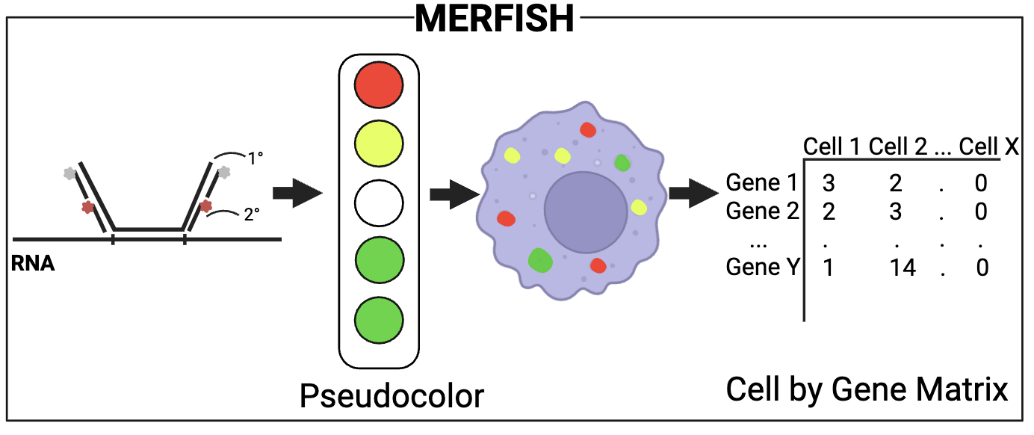
Fig. 1. MERFISH model. RNA molecules are labeled with probes and detected through sequential fluorescent imaging. Each gene is assigned a unique combinatorial barcode and quantified into a cell-by-gene matrix.

2.2 Data preprocessing and group assignment
Raw H5AD files were filtered to retain cells with valid Merscope imaging run identifiers. Sections were grouped into low Braak (0–III) and high Braak (IV–VI) categories for primary comparisons, while continuous Braak scores (0–6) were used in correlation analyses.
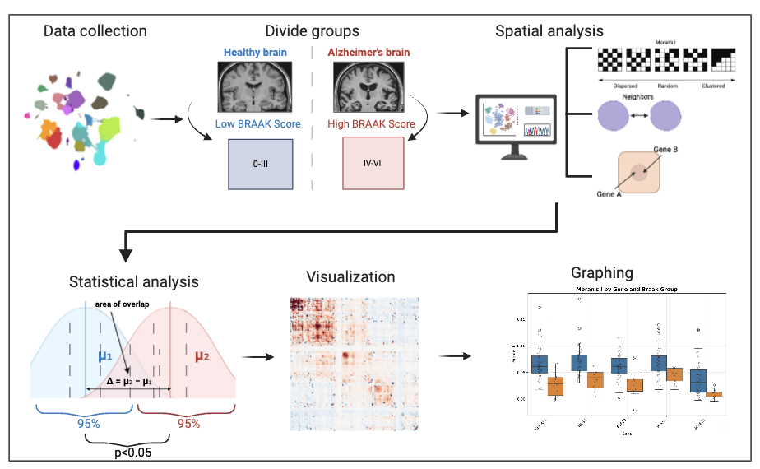
Fig. 2. Experimental workflow. Raw MERFISH data were divided into low Braak (stages 0–III) and high Braak (stages IV–VI) groups. Three spatial analyses (Moran’s I, neighborhood enrichment, and co-occurrence) were performed per section, followed by statistical comparison and visualization.

2.3 Spatial metrics computation
Using Squidpy, three spatial metrics were computed for each section (Palla et al., 2022). Moran’s I was calculated for all 180 genes. Neighborhood enrichment generated Z-scores for subclass cell-type pairs, and co-occurrence analysis quantified pairwise spatial association across distance intervals. Spatial binning was adaptively defined to target at least 20 cells per bin.

2.4 Statistical analysis
Group comparisons used two-sided Mann-Whitney U tests. Effect size was summarized with Cliff’s delta, and p-values were adjusted by the Benjamini-Hochberg false discovery rate method. Pearson and Spearman correlations with Braak score were additionally calculated. Analyses were performed in Python using Squidpy, SciPy, statsmodels, and pandas (Palla et al., 2022; Virtanen et al., 2020; Seabold and Perktold, 2010; The pandas development team, 2020).

3. RESULTS AND DISCUSSION

3.1 Spatial organization of cell types across Braak stages
Spatial organization was examined at the supertype and subclass levels to determine whether cell-type proximity patterns changed with AD severity.
At the supertype level, co-occurrence and neighborhood enrichment heatmaps outlined the baseline architecture of middle temporal gyrus tissue (Figure 3). Most supertype pairs showed low co-occurrence, whereas related supertypes showed stronger spatial association. These plots provided a reference for stage-based comparisons.
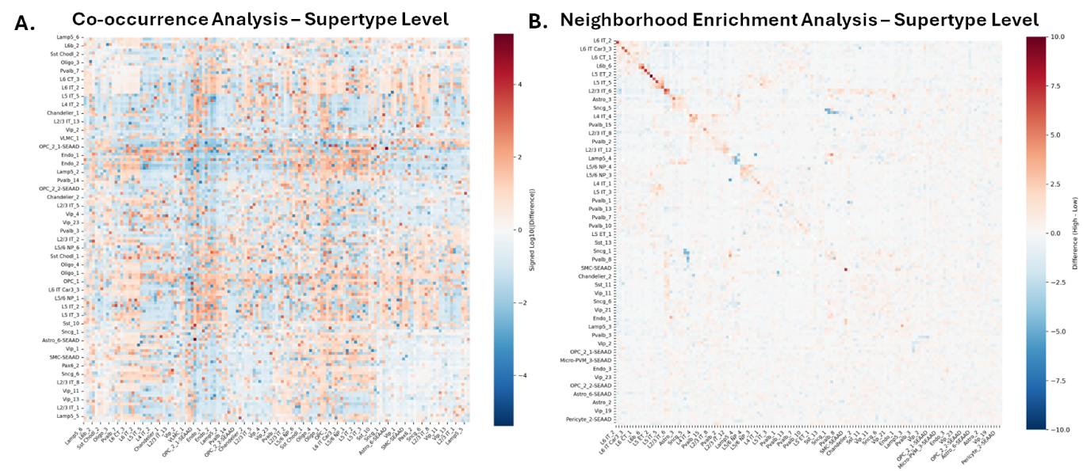
Fig. 3. Supertype-level analysis. (A) Patterns of supertype co-localization in MTG brain tissue. Warmer colors show high co-occurrence, while cooler colors show low co-occurrence. (B) Depiction of preferential spatial associations between supertypes. Warmer colors indicate proximity while cooler colors represent avoidance.
At the subclass level, neighborhood enrichment identified a significant change involving L6b neurons (Figure 4). In high Braak tissue, L6b cells showed stronger self-enrichment than in low Braak tissue, suggesting greater local clustering or selective preservation with advancing pathology. Other subclass pairs did not reach significance.
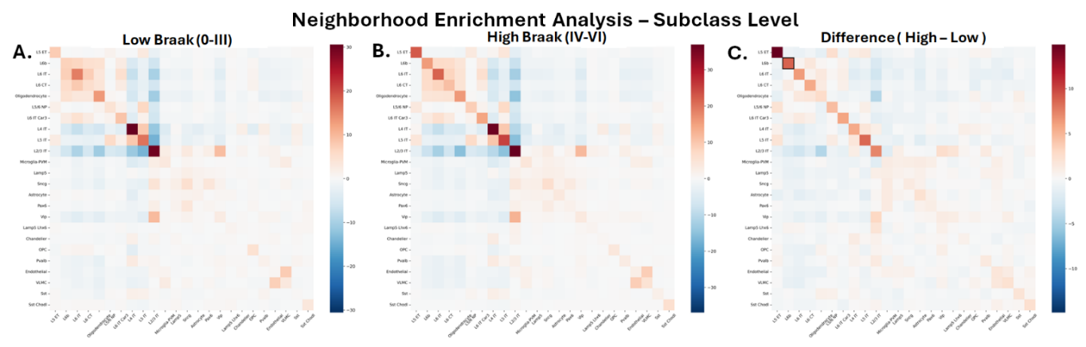
Fig. 4. Neighborhood enrichment analysis at the Subclass level. (A) Enrichment and depletion patterns in low Braak stages. (B) Enrichment and depletion patterns in high Braak stages. (C) Changes in enrichment between high Braak compared to low Braak. L6b cells show statistically significant self-enrichment in advanced disease stages.
Co-occurrence analysis also showed increased spatial association between oligodendrocytes and L4 intratelencephalic neurons in high Braak sections (Figure 5). This finding suggests disease-related reorganization of interactions between myelinating glia and a cortical excitatory neuron subtype.
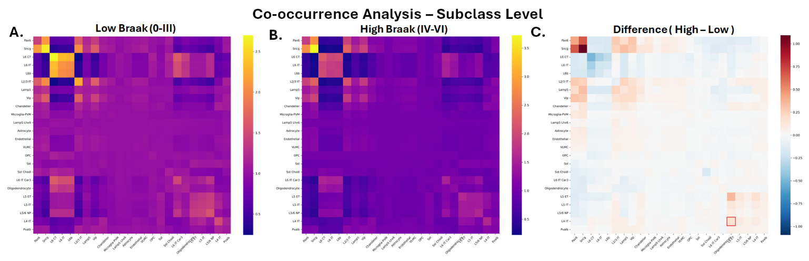
Fig. 5. Co-occurrence analysis at the Subclass level. (A) Co-occurrence patterns in low Braak stages. (B) Co-occurrence patterns in high Braak stages. (C) Changes in co-occurrence between high Braak compared to low Braak. An increase in co-occurrence between oligodendrocytes and L4 IT neurons is observed in advanced Braak stages.

3.2 Spatial gene expression patterns across Braak stages
Moran’s I was computed for all 180 genes to identify disease-related changes in spatial gene-expression patterning. Both a binary group comparison and a continuous Braak-stage correlation analysis were performed.
The group comparison identified 22 genes with significantly altered spatial autocorrelation (q < 0.05; Figure 6A). All significant genes showed positive effect sizes, indicating greater spatial clustering in high Braak tissue. The overall distribution of Moran’s I values also shifted rightward in advanced disease (Figure 6B), and the heatmap of significant genes showed progressive increases across Braak stages, particularly for NRG1, PEX5L, and SLC24A2 (Figure 6C).
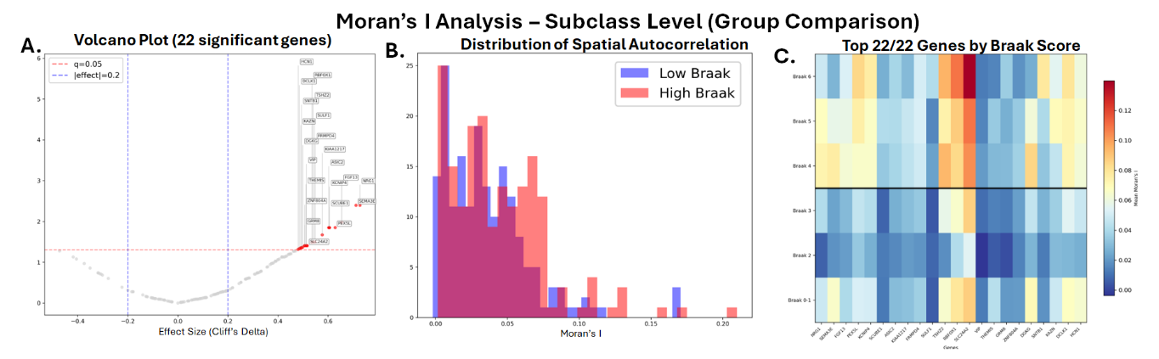
Fig. 6. Moran's I group comparison at the Subclass level. (A) Volcano plot showing 22 genes with significant changes in spatial autocorrelation (q < 0.05). All significant genes show positive effect sizes, indicating increased clustering in high Braak stages. (B) Distribution of Moran's I values across sections; the high Braak group (orange) is shifted rightward relative to the low Braak group (blue). (C) Heatmap of the top 22 genes across Braak stages 0–VI, showing a progressive increase in spatial clustering, notably in NRG1, PEX5L, and SLC24A2.
Correlation analysis identified 13 genes whose Moran’s I values increased significantly with Braak stage (q < 0.05; Figure 7). This supports the interpretation that spatial reorganization is progressive rather than limited to a single threshold between early and advanced disease.
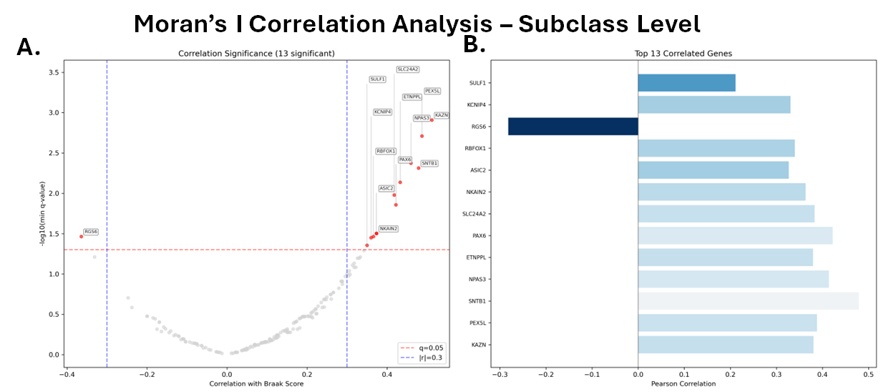
Fig. 7. Moran's I correlation analysis at the Subclass level. (A) Thirteen genes show a significant progressive correlation between Moran's I and Braak stage (q < 0.05). (B) Top 13 correlated genes ranked by Pearson correlation coefficient.
The five genes with the most robust and consistent spatial changes across both analyses — SEMA3E, NRG1, FGF13, PEX5L, and SCUBE1 — are shown as boxplots in Figure 8, comparing Moran's I values between the low Braak (blue) and high Braak (orange) groups. All five genes display consistently higher Moran's I in the high Braak group, with minimal overlap between distributions, indicating progressively stronger spatial clustering with AD advancement. SEMA3E, a semaphorin involved in axon guidance and neural circuit maintenance, showed the largest separation between groups. NRG1 and FGF13, both implicated in synaptic function and neural development respectively, also exhibited pronounced increases in spatial clustering. PEX5L, associated with peroxisomal function and neuronal maintenance, and SCUBE1 represent novel spatial findings not previously reported in the context of AD pathology.
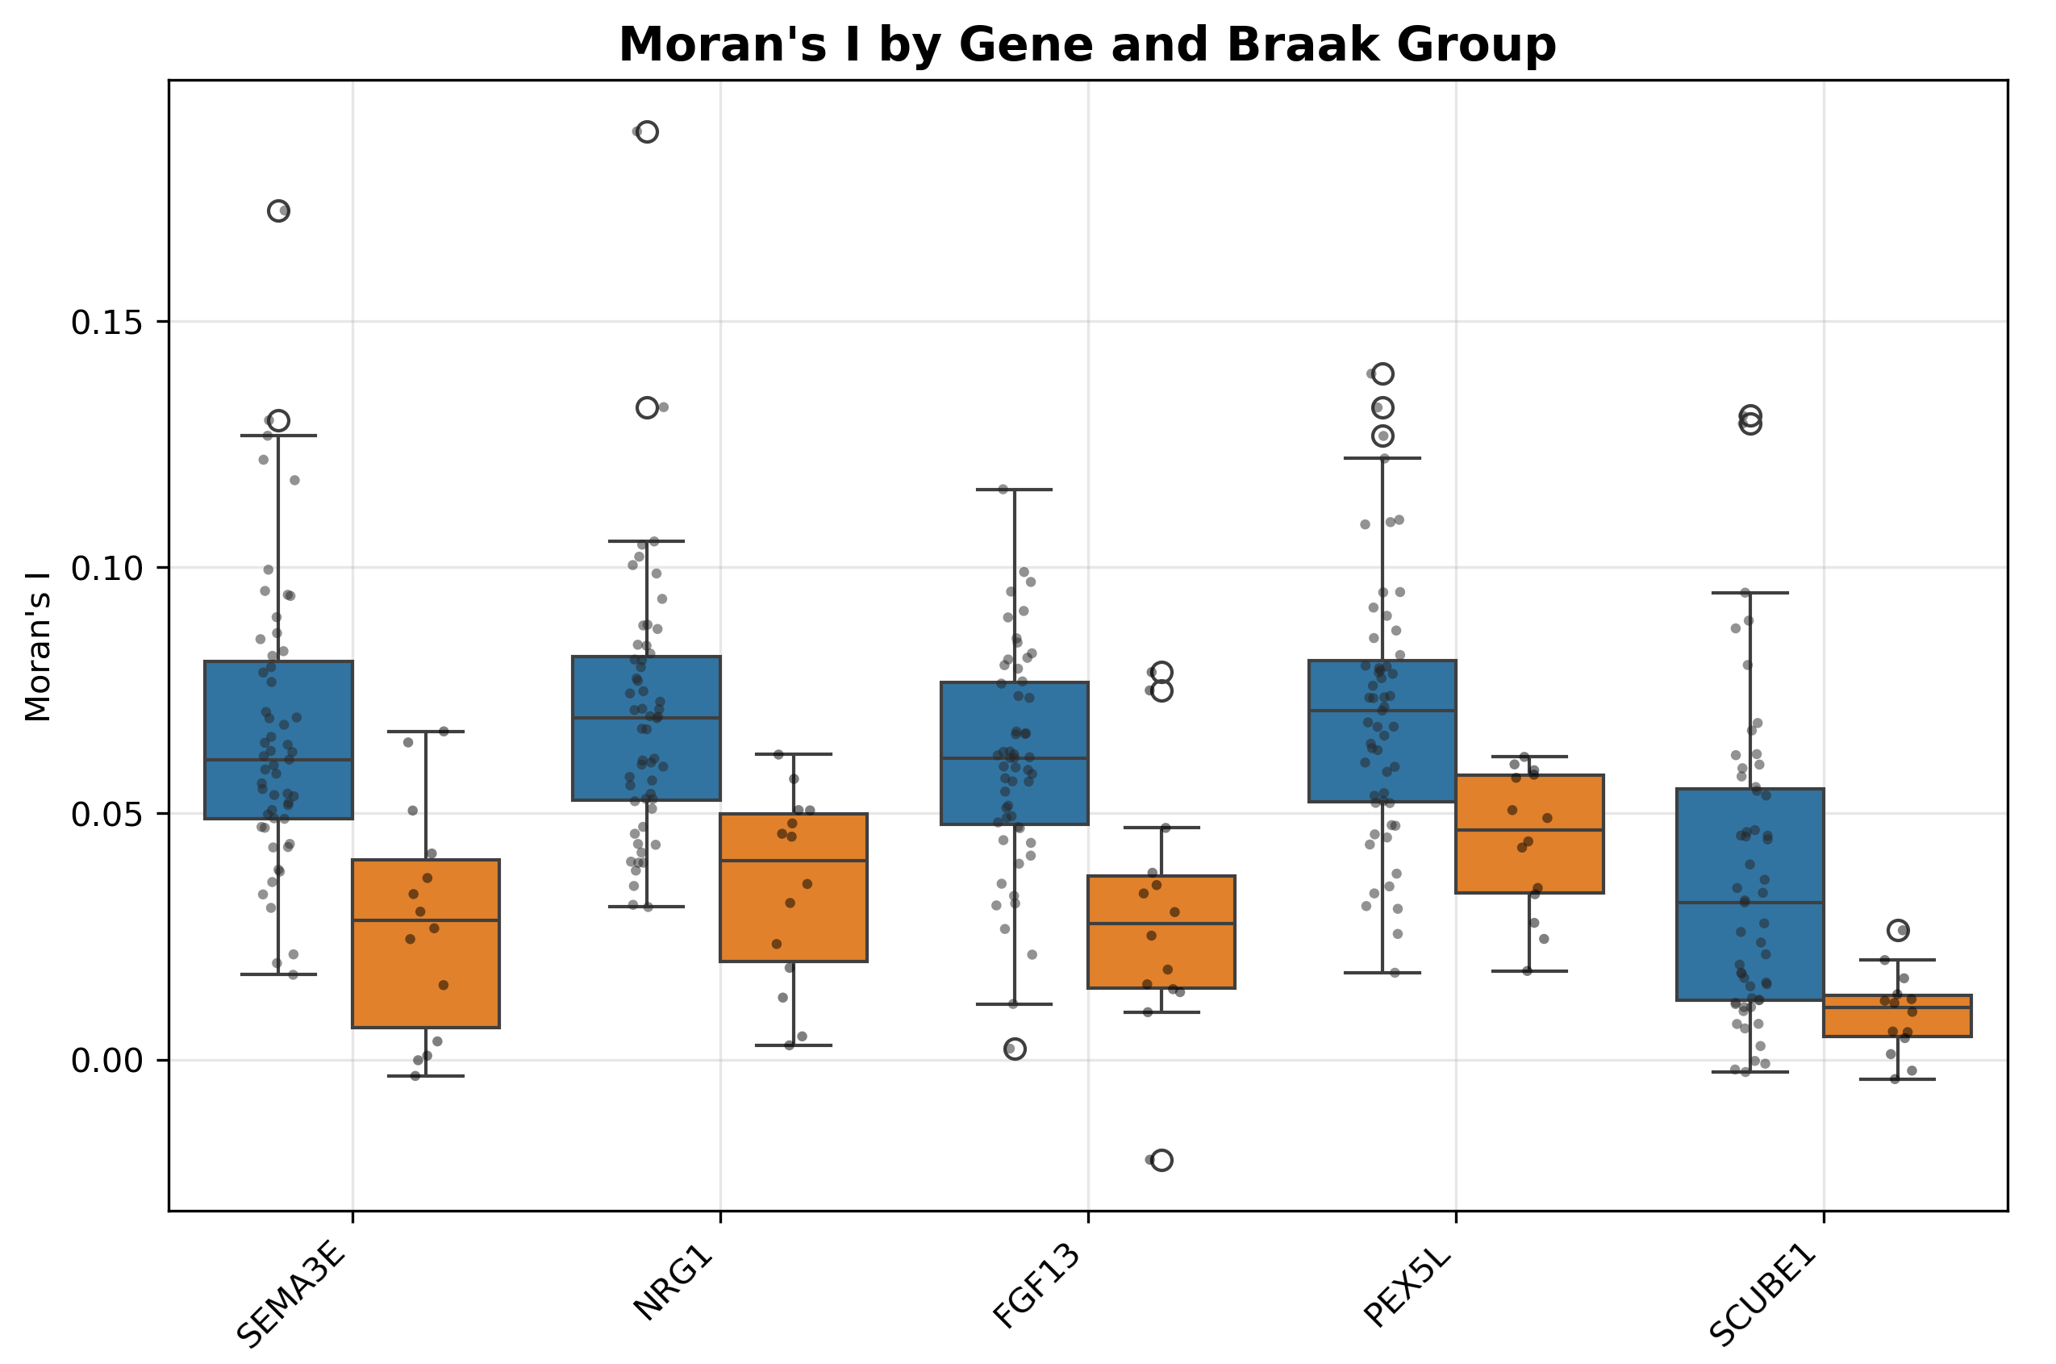

3.3 Discussion
Fig. 8. Boxplots of Moran's I values for the top five significant genes (SEMA3E, NRG1, FGF13, PEX5L, SCUBE1). All five genes show consistently higher Moran's I in the high Braak group (orange) compared to the low Braak group (blue), indicating progressively stronger spatial clustering with AD advancement.

3.3.1 Overview of findings
This study performed secondary analysis of the SEA-AD MERFISH dataset to characterize how the spatial organization of gene expression and cell type co-localization shifts across Alzheimer’s disease progression. Two complementary analyses — binary group comparison and continuous Braak score correlation — converged on a consistent directional finding: spatial clustering of gene expression universally increases, rather than decreases, with advancing pathology. Of the 180 genes examined, 22 reached significance in the group comparison (q < 0.05) and 13 showed progressive correlation with Braak stage. The top five genes by robustness and consistency — NRG1, PEX5L, FGF13, SEMA3E, and SCUBE1 — all share involvement in synaptic maintenance, axonal integrity, or neuronal support functions that are known to deteriorate in AD. The uniformly positive direction of spatial autocorrelation changes suggests that increased gene clustering is a consistent tissue-level signature of AD progression, possibly reflecting the spatial consolidation of pathological processes or compensatory responses in affected regions.

3.3.2 NRG1: Spatial clustering as a readout of synaptic stress
NRG1 (Neuregulin-1) showed a strong and progressive increase in spatial clustering across Braak stages, consistent with its known role in synaptic function. NRG1 is a growth and differentiation factor that plays a key role in the development and maintenance of synaptic transmission, and its signaling is critically involved in the plasticity of glutamatergic and cholinergic circuits (Gunther et al., 2022). Synaptic dysfunction is recognized as one of the earliest and most clinically relevant features of AD, closely correlating with cognitive decline (Busche and Hyman, 2020). The progressive spatial clustering of NRG1 observed here may reflect a compensatory upregulation concentrated in neurons attempting to sustain synaptic connections under pathological stress — a spatially localized response rather than a global increase. This spatial pattern gives NRG1 particular value as a potential biomarker: its increased clustering in tissue may be detectable before widespread neuronal loss, positioning it as a candidate for early-stage spatial imaging diagnostics.

3.3.3 FGF13: Microtubule stability and neuronal resilience
FGF13 has roles in neuronal development and microtubule regulation, and its increased clustering may be relevant to tau-associated cytoskeletal disruption. NRG1 is linked to synaptic maintenance, making its spatial concentration compatible with localized synaptic stress. Together with SEMA3E, these findings support the idea that genes involved in circuit organization become spatially reorganized as pathology advances.

3.3.4 SEMA3E: Axon guidance dysregulation in affected circuits
SEMA3E (Semaphorin 3E) showed the largest separation between low and high Braak groups among the top five genes, suggesting it may be the most spatially informative gene in this panel. SEMA3E is a secreted class 3 semaphorin that signals through its receptor PlexinD1, uniquely among semaphorins, independent of neuropilin co-receptors (Gu et al., 2005). It plays an established role in hippocampal circuit formation, specifically in regulating the laminar termination of entorhino-hippocampal axonal connections (Tran et al., 2018). The broader semaphorin family has long been implicated in AD: semaphorins are highly expressed in adult brain tissue and show abnormal neurohistological patterns in affected cortical and hippocampal areas of AD brains (Lanzillotta et al., 2019). Accumulation of Sema3A, a closely related family member, has been directly linked to degeneration of hippocampal CA1 neurons and co-localizes with phosphorylated tau and neurofibrillary tangles (Lanzillotta et al., 2019). Given that SEMA3E governs the same hippocampal circuitry that is among the first to be affected in AD, its spatial clustering may reflect dysregulated axon guidance signaling in regions of early tau pathology. The spatial pattern identified here provides initial evidence warranting further investigation of SEMA3E’s specific role in AD neurodegeneration.

3.3.5 PEX5L: A novel spatial finding implicating peroxisomal biology
PEX5L (Peroxisomal Biogenesis Factor 5-Like) represents one of the most novel findings in this study. Peroxisomes are organelles essential for lipid metabolism, reactive oxygen species detoxification, and the biosynthesis of myelin precursors, and their dysfunction has been associated with age-related neurodegenerative diseases (Jo and Cho, 2019). Peroxisomes play important roles in brain function by regulating neuronal migration and myelination during development (Jo and Cho, 2019). However, despite their relevance to neurodegeneration, peroxisomal biology in the context of AD has been largely understudied. The study of ABCD3-positive peroxisomes in the frontal neocortex of AD patients represents one of the few data points available, and no prior evidence of PEX5L showing increased spatial clustering with AD severity has been reported (Jo and Cho, 2019). The progressive clustering of PEX5L with Braak stage identified here therefore constitutes a genuinely novel spatial finding, suggesting that peroxisomal activity may become spatially concentrated in specific tissue microenvironments as AD pathology advances. Whether this reflects compensatory metabolic activity, vascular remodeling, or a response to localized oxidative stress requires further investigation.

3.3.6 SCUBE1 and cell-type spatial reorganization
The cell-type findings were more selective than the gene-level results. Increased L6b self-enrichment and increased oligodendrocyte–L4 intratelencephalic neuron co-occurrence suggest that a subset of cortical cell relationships is reorganized as pathology advances, possibly through selective vulnerability, altered laminar structure, or compensatory support responses.

3.3.7 Limitations
Several limitations should be acknowledged. This was a secondary analysis of a fixed 180-gene panel, mRNA clustering may not directly reflect protein-level changes, and the number of sections per Braak stage was limited. Future work should expand gene coverage, examine additional brain regions, and integrate protein-level or orthogonal spatial validation.

3.3.8 Future directions
In summary, spatial autocorrelation provided a useful dimension of AD-related change beyond conventional differential expression. NRG1, FGF13, SEMA3E, PEX5L, and SCUBE1 emerged as leading candidates for future in situ validation, and the observed cell-type reorganization further supports the idea that AD progression involves measurable remodeling of tissue spatial architecture.

4. CONCLUSION
In summary, this study identifies spatial autocorrelation as a sensitive and informative dimension of gene expression change in AD that complements conventional differential expression approaches. The five genes with the most consistent spatial changes — NRG1, FGF13, SEMA3E, PEX5L, and SCUBE1 — are united by their involvement in synaptic function, axonal guidance, and neuronal support, processes that are progressively disrupted as tau pathology advances. These spatial patterns provide tissue-level context to prior molecular findings and establish a foundation for the development of in situ hybridization probes targeting these genes, which will enable their spatial validation in tissue with morphological resolution.

CONSENT
Not applicable. This study used publicly available, de-identified secondary dataset resources and did not report any individual patient case details.

ETHICAL APPROVAL
Not applicable. This manuscript reports a secondary computational analysis of publicly available, de-identified human brain atlas data and did not involve new recruitment, intervention, or direct interaction with human participants.

DATA AVAILABILITY
The data analyzed in this study were obtained from the publicly released Seattle Alzheimer’s Disease Brain Cell Atlas (SEA-AD) MERFISH dataset. Additional analysis files may be made available by the author upon reasonable request, where permitted by the source dataset terms.

REFERENCES
1. Patterson, C. (2018). World Alzheimer report 2018. Alzheimer’s Disease International. Available from: https://apo.org.au/node/260056
2. Yiannopoulou, K. G., & Papageorgiou, S. G. (2020). Current and future treatments in Alzheimer disease: An update. Journal of Central Nervous System Disease, 12, 1179573520907397. https://doi.org/10.1177/1179573520907397
3. Busche, M. A., & Hyman, B. T. (2020). Synergy between amyloid-beta and tau in Alzheimer’s disease. Nature Neuroscience, 23, 1183-1193. https://doi.org/10.1038/s41593-020-0687-6
4. Braak, H., & Braak, E. (1991). Neuropathological stageing of Alzheimer-related changes. Acta Neuropathologica, 82(4), 239-259. https://doi.org/10.1007/BF00308809
5. Kumar, S., et al. (2022). Extracellular matrix signature identifies Alzheimer’s disease subtype associated with vascular injury. Nature Neuroscience, 25, 939-950. https://doi.org/10.1038/s41593-022-01095-5
6. Chen, J., Wang, Y., & Ko, J. (2023). Single-cell and spatially resolved omics: Advances and limitations. Journal of Pharmaceutical Analysis, 13(8), 833-835. https://doi.org/10.1016/j.jpha.2023.07.002
7. Siletti, K., et al. (2023). Transcriptomic diversity of cell types across the adult human brain. Science, 382, eadd7046. https://doi.org/10.1126/science.add7046
8. Chen, K. H., Boettiger, A. N., Moffitt, J. R., Wang, S., & Zhuang, X. (2015). Spatially resolved, highly multiplexed RNA profiling in single cells. Science, 348, aaa6090. https://doi.org/10.1126/science.aaa6090
9. Gabitto, M. I., et al. (2024). Integrated multimodal cell atlas of Alzheimer’s disease. Nature Neuroscience, 27, 2366-2383. https://doi.org/10.1038/s41593-024-01774-5
10. Palla, G., Spitzer, H., Klein, M., Fischer, D., Schaar, A. C., Kuemmerle, L. B., et al. (2022). Squidpy: A scalable framework for spatial omics analysis. Nature Methods, 19, 171-178. https://doi.org/10.1038/s41592-021-01358-2
11. Virtanen, P., et al. (2020). SciPy 1.0: Fundamental algorithms for scientific computing in Python. Nature Methods, 17, 261-272. https://doi.org/10.1038/s41592-019-0686-2
12. Seabold, S., & Perktold, J. (2010). Statsmodels: Econometric and statistical modeling with Python. Proceedings of the 9th Python in Science Conference, 57-61. https://doi.org/10.25080/Majora-92bf1922-011
13. The pandas development team. (2020). pandas-dev/pandas: pandas. Zenodo. https://doi.org/10.5281/zenodo.3509134
14. Gunther, E. C., et al. (2022). NRG1 as a biomarker for synaptic dysfunction in Alzheimer’s disease. Alzheimer’s Research & Therapy, 14, 130. https://doi.org/10.1186/s13195-022-01014-7
15. Munoz-Mayorga, D., et al. (2017). FGF13 in cortical neurons and neural migration defects. Frontiers in Neuroscience, 11, 113. https://doi.org/10.3389/fnins.2017.00113
16. Gu, C., et al. (2005). Semaphorin 3E and plexin-D1 control vascular pattern independently of neuropilins. Science, 307, 265-268. https://doi.org/10.1126/science.1105416
17. Tran, T. S., et al. (2018). New functions of Semaphorin 3E and its receptor PlexinD1 during developing and adult hippocampal formation. Scientific Reports, 8, 2245. https://doi.org/10.1038/s41598-018-19794-0
18. Lanzillotta, A., et al. (2019). Roles of semaphorins in neurodegenerative diseases. IntechOpen. https://doi.org/10.5772/intechopen.81549
19. Jo, D. S., & Cho, D. H. (2019). Peroxisomal dysfunction in neurodegenerative diseases. Archives of Pharmacal Research, 42(5), 393-406. https://doi.org/10.1007/s12272-019-01131-2
20. Grimmond, S., et al. (2000). Cloning, mapping, and expression analysis of a gene encoding a novel mammalian EGF-related protein (SCUBE1). Genomics, 70, 74-81. https://doi.org/10.1006/geno.2000.6370
21. Turkmen, S., Eryigit, U., Karaca, Y., Mentese, A., Sumer, A. U., Yulug, E., et al. (2015). Diagnostic value of plasma signal peptide-Cub-Egf domain-containing protein-1 (SCUBE-1) in an experimental model of acute ischemic stroke. American Journal of Emergency Medicine, 33(2), 262-265. https://doi.org/10.1016/j.ajem.2014.11.051

