Original Research Article

Pharmacognostic Standardization and HPTLC Fingerprint Profiling of Nardostachys jatamansi DC. Rhizome with Comparative Phytochemical Analysis of Extracts

ABSTRACT
Background: Nardostachys jatamansi DC. (Jatamansi), a perennial rhizomatous herb of the family Valerianaceae, is widely used in Ayurveda for the management of neurological and psychiatric disorders. The rhizome, being the most therapeutically active part, possesses diverse pharmacological properties including antioxidant, antimicrobial, neuroprotective, and anticonvulsant activities.
Aim and objective: The present study aimed to establish pharmacognostical standards and evaluate the phytochemical profile of the rhizome of Nardostachys jatamansi for its identification and quality control.
Methodology: Pharmacognostical evaluation was carried out through macroscopic, powder microscopic, and physicochemical analyses following standard protocols. Preliminary phytochemical screening of aqueous and hydroalcoholic extracts was performed to identify major secondary metabolites. Chromatographic profiling was conducted using High Performance Thin Layer Chromatography (HPTLC), along with UV–Visible spectroscopic analysis.
Results: Macroscopically, the rhizome was dark brown, cylindrical, fibrous, brittle, aromatic, and slightly bitter. Microscopic examination revealed diagnostic features including cork cells with oil globules, cortex canals, phloem patches, cambium, xylem vessels, and stellate cork rings. Powder microscopy showed fibres, vessels, tracheids, parenchyma containing starch grains, oil globules, and stone cells. Physicochemical parameters were found within acceptable limits, with loss on drying (2.53%), ash value (7.64%), water-soluble extractive (8.43%), and ethanol-soluble extractive (5.62%). Phytochemical screening confirmed the presence of alkaloids, flavonoids, glycosides, tannins, and proteins. HPTLC profiling of the ethanolic extract revealed a characteristic chromatographic pattern with a prominent band at Rf 0.95 under UV 254 nm and 366 nm.
Conclusion: The study provides a comprehensive set of pharmacognostical and phytochemical standards for Nardostachys jatamansi rhizome, which can serve as reliable parameters for its identification, authentication, and quality control, and may support further pharmacological and formulation-based studies.
KEYWORDS: Jatamansi, Nardostachys jatamansi, phytochemical, pharmacogonostical

INTRODUCTION
Nardostachys jatamansi DC., commonly referred to as Jatamansi or Spikenard, is a perennial rhizomatous herb of the family Valerianaceae. It is distributed in the Alpine regions of the Himalayas, Nepal, and Sikkim, thriving at elevations between 3000 and 5000 meters. In Ayurvedic medicine, Jatamansi is highly esteemed for its therapeutic applications, particularly in the management of neuropsychiatric disorders such as anxiety, depression, and cognitive impairment. Among the plant parts, the rhizome is regarded as the most potent and forms the basis of numerous medicinal formulations. Traditionally, the rhizome has been used in the preparation of medicated oils, serving both as an aromatic additive for promoting hair health and as a therapeutic agent. The essential oil extracted from the roots exhibits diverse pharmacological activities, including antibacterial, antifungal, hypotensive, and anticonvulsant effects, which support its traditional claims. It is a perennial, dwarf, rhizomatous herb (5–50 cm tall) with hairy stems and clusters of small, purple-red bisexual flowers. Leaves are linear or oblanceolate (15–18 × 2.5 cm), sessile, and arise from both stem and rootstock. Fruits are small (≈4 mm), hairy, and crowned with dentate calyx teeth. Rhizomes measure 2.5–7 cm, dark grey externally with reddish-brown tufted fibres, cylindrical, aromatic, acrid, slightly bitter, brittle, and reddish-brown internally. Considering its traditional importance, pharmacological potential, and distinct morphological features, systematic pharmacognostical and phytochemical investigations of N. jatamansi are essential for establishing diagnostic parameters, validating therapeutic claims, and supporting future drug development.
MATERIALS AND METHODS
Collection of plant material and storage
The roots of Nardostachys jatamansi DC (Jatamansi) were procured from Khari Baoli, Delhi, in October. The plant material was authenticated by scientists at NIScPR (formerly NISCAIR), New Delhi, with authentication number NIScPR/RHMD/Consult/2023/4573-74 dated 23/08/2023, by comparison with diagnostic features described in standard floras (Document attached below).
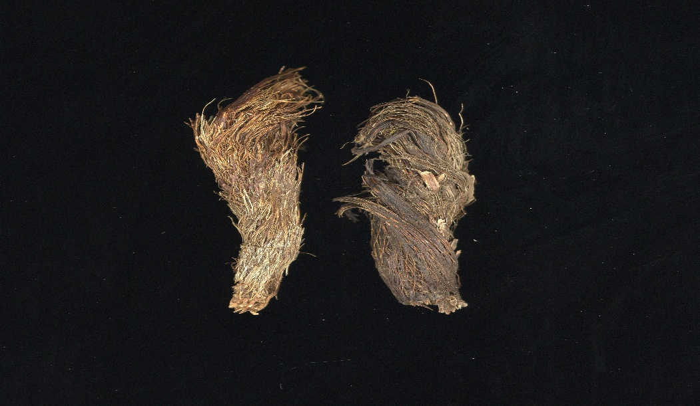

Figure 1: Nardostachys jatamansi Dried Rhizome

Extraction
Two different extraction methods were employed in this study. A water-soluble extract was first prepared for qualitative phytochemical analysis, followed by the preparation of an ethanol-soluble extract. For chromatographic analysis, the ethanol extract was compared with a heat-dried drug preparation, and methanol-soluble fractions of the samples were used.
- PHARMACOGNOSTICAL STUDIES
- Macroscopic evaluation
Macroscopic evaluation of Nardostachys jatamansi was carried out at the Pharmacognosy Laboratory, Department of Dravyaguna, A&U Tibbia College and Hospital, Karol Bagh, New Delhi. Organoleptic features, including size, shape, colour, odour, taste, and texture, were assessed using sense organs, a magnifying lens, and measuring tools. Microscopic evaluation was performed through powder microscopy to observe characteristic histological features.
- Powder microscopy
The powdered rhizome of Nardostachys jatamansi was mounted on a glass slide using glycerin and observed under a compound microscope. The preparation was stained with safranin and methylene blue to enhance visualization of lignified and non-lignified tissues.
- PHYSICO-CHEMICAL PARAMETERS
Physicochemical evaluation of the powder of Jatamansi (Nardostachys jatamansi D.C.) was performed as per the guidelines mentioned in the API
- Loss on drying
- Ash value
- Water-soluble extractive
- Ethanol-soluble extractive

- Loss on Drying (LOD)
The moisture content of a drug should be determined for the percentage of its active chemical constituents because its percentage depends upon air dried basis. So, the moisture content of the drug should be minimised in order to prevent decomposition of the crude drugs either due to chemical change or microbial contamination.
Procedure: 1 gram of the drug sample was taken in a pre-weighed dried petri dish. It was dried in an oven at 110ºC until reaching a constant weight. The petri dish was taken out, self-cooled and weighed immediately. The weight loss, i.e. loss on drying, was calculated and expressed as % w/w.
- Ash Value (AV)
This test was conducted to evaluate the percentage of inorganic salts naturally occurring in the drug or adhering to it or deliberately added as a form of adulteration.
Procedure: 2 grams accurately weighed sample was taken in a pre-weighed dried crucible. It was incinerated in a muffle furnace up to 500ºC. The crucible was taken out, self-cooled and weighed immediately. From the weight of the ash, the ash value was derived with reference to the air-dried drug. It was calculated and expressed as % w/w.
- Water Soluble Extractive (WSE)
This test was carried out to determine the water-soluble extractive and approximate measures of the chemical constituents of the test drug.
Procedure: 5 gm. of the sample was weighed accurately. To it 100 ml of distilled water was added and kept covered overnight. It was stirred intermittently in the initial period. It was filtered. 20 ml of the filtrate was accurately measured with a pipette and transferred to the already weighed evaporating dish. The evaporating dish was placed on a water bath for evaporation of the water. After evaporation of the water it was dried in an oven, allowed cooling and weighed immediately. From the weight of the residue obtained, the percentage of water-soluble extractive was calculated and expressed as % w/w.
- Ethanol Soluble Extractive (MST)
This test was carried out to determine the ethanol soluble extractive of the test drug.
Procedure: The method adopted for this experiment was same as that of water-soluble extract but by using ethanol instead of water. Percentage of ethanol soluble extract was calculated and expressed as % w/w.

- PHYTOCHEMICAL ANALYSIS
Phytochemical analysis of the powdered rhizome of Jatamansi (Nardostachys jatamansi D.C.) was carried out at the Pharmacognosy Laboratory, Department of Dravyaguna, A&U Tibbia College and Hospital. Both alcoholic and hydroalcoholic extracts of the rhizome, along with their respective chemical constituent fractions, were examined for the presence of various secondary metabolites, including total alkaloids, flavonoids, carbohydrates, glycosides, phenolic compounds, tannins, saponins, and steroids.
- Alkaloids
- With Mayer’s reagent: The ethanol extract of the samples was taken in a watch glass, solvent was evaporated. It was added with 2N HCl and few drops of Mayer’s reagent when alkaloids gave a white precipitate.
- With Dragendroff’s reagent: The ethanol extract of the sample was evaporated. On addition of a few drops of dilute 2N HCl and Dragendroff’s reagent alkaloids gave orange precipitate.
- Flavonoid
- When treated with neutral lead acetate gave yellow, orange, red or brick colour precipitation.
- Shinoda test: The aqueous extract of test samples was taken in test tubes. 5ml 95% ethanol, few drops of conc. HCl and 0.5 g magnesium turnings were added to the test samples. Pink colour indicated presence of flavonoids.
- Glycosides
- Legal’s test: To the aqueous extract of test sample add 1 ml pyridine and 1 ml sodium nitroprusside. Pink to red colour indicates presence of glycosides.
- Keller-Killiani test: to 2 ml extract, add glacial acetic acid, one drop 55 FeCl3 and conc. H2SO4. Appearance of reddish brown clour at the junction of the two liquid layers and bluish green colour of upper layer indicates presence of deoxysugars.
- Phenols
- The aqueous extract of test samples was taken in test tubes. Addition of dilute NH4OH and potassium ferricyanide solution to the test solution did not give red colour indicating absence of phenolic compounds.
- The aqueous extract of test samples was taken in test tubes. On addition of dilute potassium permanganate solution to the test sample did not cause discoloration indicating absence of phenolic compounds.
- Amino Acids
- Ninhydrin test: On heating 3 ml test solution and 3 drops of 5% Ninhydrin solution in boiling water bath for 10 minutes purple or bluish colour appears which indicates presence of amino acids.
- Proteins
- Biuret test: To 3 ml test solutions add 4% NaOH and few drops of 1% CuSO4 solution. Violet or pink colour indicates presence of proteins.
- Milion’ s test: Mix 3 ml test solution with 5 ml Million’s reagent. White precipitate turns brick red or the precipitates dissolve giving red colour which is indicative of presence of proteins.
- Tannins
- The aqueous extract of test samples was taken in test tubes. A very dilute solution of ferric chloride was added into the test samples. Development of blue / olive green colour indicates the presence of tannins.
- The aqueous extract of test samples was taken in test tubes by adding 5% lead acetate solution, it gives precipitate which turns red on addition of KOH solution. Addition of excess KOH dissolved the precipitate.
- Carbohydrate
- Molisch test: 2ml of test drug was taken in test tubes. To it, 2 drops of fresh 10% a-Naphthol reagent and 2ml of conc. H2SO4 were added and mixed so as to form a layer below the mixture. A red violet ring indicates the presence of carbohydrate.
- Fehling’s test: Boil for one minute after combining 1 mL Fehling's A and 1 mL Fehling's B solutions. Add an equal amount of test solution. 5-10 minutes in a hot water bath. The presence of reducing sugars is indicated by yellow and later brick red precipitates.

- HPTLC PROFILE
High Performance Thin Layer Chromatography (HPTLC) was employed for fingerprint profiling of Nordostachys jatamansi. The analysis was carried out on 10 × 10 cm aluminium-backed precoated silica gel 60 F254 plates (Merck). Before analysis, the plates were pre-conditioned and air-dried.
Sample solutions of the ethanolic extract of Nordostachys jatamansi were applied as bands using a CAMAG Linomat 5 automatic sample applicator. Application was performed in band mode with a band length of 8.0 mm, maintaining a distance of 15.0 mm from the lower edge and 11.4 mm between tracks. Different volumes of the sample (2, 4, 6, 8, 10, 12 and 14 µL) were applied on the plate.
Chromatographic development was carried out in a CAMAG twin-trough glass chamber previously saturated for 20 minutes with the mobile phase consisting of toluene: ethyl acetate: formic acid (6:4:0.3, v/v/v). Ascending development was performed up to a migration distance of 70 mm. After development, the plates were dried at room temperature.
Densitometric scanning was performed using a CAMAG TLC Scanner 4 in absorbance mode. The developed plates were scanned at 254 nm and 366 nm using deuterium and tungsten lamps as radiation sources. The slit dimensions were set at 5.0 mm × 0.45 mm with a scanning speed of 20 mm/s and data resolution of 100 µm/step. Data acquisition and processing were carried out using Vision CATS software.
RESULTS & OBSERVATIONS
- PHARMACOGNOSTICAL EVALUATION

- Macroscopic evaluation
Features | Observations
Colour | Dark brown
Size/ length | 2.5 to 7.5 cm long
Shape | Cylindrical
Surface | Covered with reddish brown fibres forming a network (skeletons of sheathing leaf bases)
fracture | Brittle
Internal colour | Reddish brown
Odour | Strongly aromatic
Taste | Acrid and slightly bitter

Table 1- Macroscopic Observations
- Powder microscopy
The powder of Nardostachys jatamansi DC. (Jatamansi, Root) Stained with safranin and examined under 40× magnification, revealed several characteristic diagnostic features. The powder shows fragments of cork cells that are polygonal, thin-walled, and brownish in colour. Numerous fibres are seen elongated with tapering ends and thick lignified walls, indicating the presence of secondary xylem tissue. Pitted and spiral xylem vessels are conspicuous, exhibiting distinct lignified thickenings. Stone cells appear thick-walled, irregular, and often occur in groups, providing rigidity to the tissue. Parenchymatous cells are abundant, mostly thin-walled, and some contain oil globules and oleoresin deposits, imparting a reddish-orange hue. Elongated parenchymatous cells with prominent intercellular spaces and simple starch grains of varying sizes are also present. The presence of tracheids, xylem vessels, fibres, stone cells, and oil globules serves as valuable diagnostic characters confirming the identity and purity of the powdered root drug Nardostachys jatamansi.
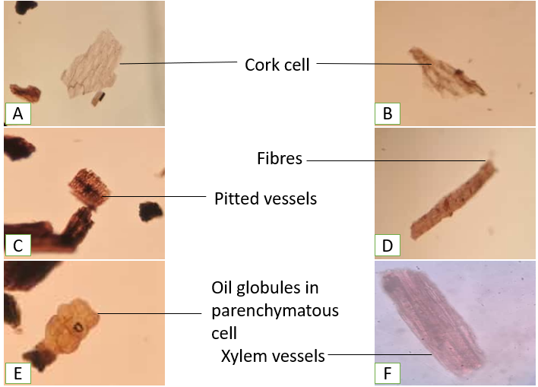

Figure 2: Jatamansi, Root Powder at 40X stained in safranin showing A & B. Cork cell C. Pitted vessels D. Fibres E. Oil globules in parenchymatous F. Xylem vessels

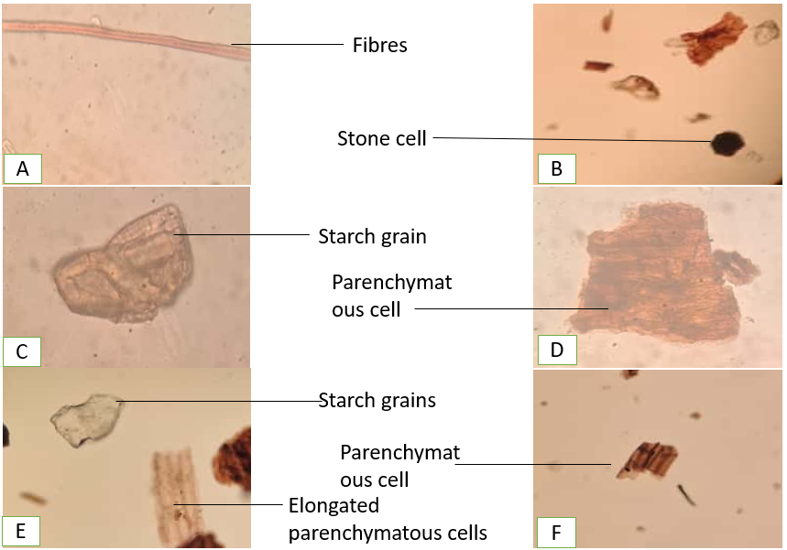

Figure 3: Jatamansi, Root Powder at 40X stained in safranin showing A. Fibres B. Stone cell C. Starch grain D. Parenchymatous cell E. Elongated parenchymatous cells F. Parenchymatous cell

- Physicochemical analysis of Nardostachys jatamansi

Sr. no. | Test | Sample (Nardostachys jatamansi)
 | Loss on drying | 2.53% w/w
 | Ash value | 7.64% w/w
 | Water soluble extract | 8.43% w/w
 | Ethanol soluble extract | 5.62% w/w

Table 2: Physicochemical Test
- Phytoconstituents present in Nardostachys jatamansi

Sr. no. | Tests | Name of reagents | Alcoholic extract | Hydroalcoholic extract
 | Alkaloids | Dragondroff’s reagent | + | +
 | Flavonoids | Alkaline reagent | + | +
 | Glycosides | Keller killiani | + | +
 | Saponins | - | - | -
 | Proteins | Millon’s test | + | -
 | Tannins | Ferric chloride | + | +
 | Carbohydrates | Fehling test | + | -

Table 3: Phytoconstituents derived from Nardostachys jatamansi
- HPTLC PROFILING
The HPTLC done on the alcoholic extract of Nardostachys jatamansi is as follows:

- Mobile phase-
Toluene, Ethyl acetate, formic acid 6:4:0.3 (v/v/v)

- Chromatographic conditions
Application mode: CAMAG Linomat 5
Development Chamber: CAMAG twin-trough chamber
Plates: Precoated silica gel 60 F254 aluminium plates
Chamber Saturation: 20 min
Development distance: 70 min.
Scanner: CAMAG TLC Scanner 4.
Detection: Deuterium lamp and Tungsten lamp
Data System: visionCATS software
The ethanolic extract of Nordostachys jatamansi was subjected to HPTLC fingerprint analysis using silica gel 60 F254 plates and the optimised mobile phase toluene: ethyl acetate: formic acid (6:4:0.3 v/v/v).
At 254 nm, the extract's chromatogram showed a single, sharp, well-resolved peak with an average Rf of 0.963 (2 µL) and 0.950 (4 µL). The peak exhibited 100% area in both tracks, indicating the predominance of one major UV-absorbing phytoconstituent in the ethanolic extract.
At 366 nm, the chromatogram revealed fluorescent bands, indicating the presence of additional phytoconstituents in the extract. However, densitometric numerical data were not recorded at this wavelength.
Visualization
The developed plates were visualised under UV light at 254 nm and 366 nm. At 254 nm, a distinct dark band corresponding to Rf 0.95 was observed. At 366 nm, fluorescent bands of varying intensities were noted, indicating the presence of multiple chemical constituents in the extract.
Evaluation
The HPTLC fingerprint profile of the ethanolic extract of Nordostachys jatamansi is characterised by a major band at Rf 0.95 along with minor constituents observed at other Rf values. This characteristic chromatographic pattern can be utilised as a reference fingerprint for identification, authentication and quality control of Nordostachys jatamansi.
Track | Vol. applied (µL) | Wavelength  (nm) | Peak # | Start | Max | End | Max H | Area A | Area %
1 | 2.0 | 254 | 1 | 0.898 | 0.963 | 1.000 | 0.0394 | 0.00307 | 100.00
2 | 4.0 | 254 | 1 | 0.856 | 0.950 | 1.000 | 0.0361 | 0.00302 | 100.00
Table 4: HPTLC Evaluation
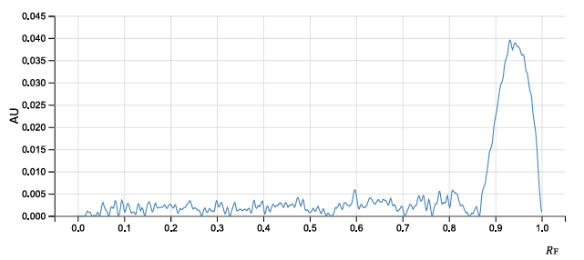

Graph 1: HPTLC densitogram of Nardostachys jatamansi at 254 nm (2 µL)

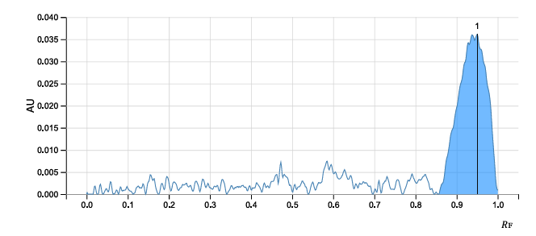

Graph 2: HPTLC densitogram of Nardostachys jatamansi at 254 nm (4 µL)
Discussion
The pharmacognostical evaluation of Nardostachys jatamansi rhizome in this study provides detailed insights into its macroscopic, powder microscopic, physicochemical, phytochemical, and chromatographic characteristics. Macroscopically, the rhizome was cylindrical, dark brown, aromatic, and brittle, with a fibrous surface composed of sheathing leaf bases—features that align with classical descriptions and can aid in visual authentication. Powder microscopy confirmed the presence of lignified fibres, parenchyma cells with starch granules, vessel elements, oil globules, calcium oxalate crystals, and fibro-vascular bundles, which are characteristic diagnostic features used in quality control.
Physicochemical parameters, including loss on drying, ash values, and water- and ethanol-soluble extractives, indicate the purity, stability, and extractive potential of the rhizome. Phytochemical screening, using both alcoholic and hydroalcoholic extracts to identify the presence of major secondary metabolites. The alcoholic extract tested positive for alkaloids, flavonoids, glycosides, tannins, proteins, and carbohydrates, indicating a rich composition of bioactive constituents. In contrast, the hydroalcoholic extract also showed the presence of alkaloids, flavonoids, glycosides, and tannins, but proteins and carbohydrates were absent. Saponins were not detected in either extract. These differences suggest that the solubility of certain phytoconstituents varies with the extraction solvent; alcoholic extraction appears more efficient in isolating proteins and carbohydrates, whereas hydroalcoholic extraction primarily yields alkaloids, flavonoids, glycosides, and tannins.
The presence of these compounds is significant, as alkaloids and flavonoids are known for their neuroprotective, antioxidant, and sedative activities, glycosides contribute to tonic effects, and tannins offer astringent and stabilizing properties. In addition, the HPTLC fingerprint analysis of the ethanolic extract revealed a characteristic chromatographic pattern with a single dominant peak at Rf around 0.95 at 254 nm with 100% area, indicating the predominance of one major UV-absorbing phytoconstituent. The observation of fluorescent bands at 366 nm further suggests the presence of additional minor constituents in the extract. The established HPTLC fingerprint profile, together with the pharmacognostical and phytochemical findings, provides a comprehensive set of parameters for the identification, authentication and quality control of Nardostachys jatamansi.
Overall, the comparative phytochemical profile of both extracts, supported by chromatographic fingerprinting, offers valuable guidance for the selection of suitable extracts for pharmacological evaluation and formulation development.
Conclusion
The present study establishes comprehensive pharmacognostical, physicochemical, phytochemical and chromatographic standards for the rhizome of Nardostachys jatamansi. The macroscopic and powder microscopic features provide reliable diagnostic characters for the identification and authentication of the crude drug. Physicochemical parameters indicate acceptable purity and stability, while extractive values reflect good extraction potential. Phytochemical screening revealed the presence of important bioactive groups such as alkaloids, flavonoids, glycosides, and tannins, with the alcoholic extract showing a broader range of constituents than the hydroalcoholic extract.
Furthermore, the HPTLC fingerprint profile of the ethanolic extract, characterised by a single dominant peak at Rf around 0.95 at 254 nm, offers a simple and reproducible chromatographic marker for quality control. Collectively, these findings provide a scientific basis for the standardisation of Nardostachys jatamansi rhizome and support its future use in pharmacological studies and herbal formulation development.

REFERENCES
N. Shah Biren, Seth A.K., Textbook of pharmacognosy and phytochemistry, Elsevier, division of read Elsevier India Pvt. Ltd. 2010 Elsevier, first edition 2010, p 301.
2 Kumar G, Behera B. Exploring the Benefits of Jatamansi (Nardostachys jatamansi): A Comprehensive Review.
3 Pant HC, Jalal S, Rautela I, Ali Y, Thapa A, Verma P, Pant HV, Gaurav N. A Review on Endangered Medicinal Plant Nardostachys jatamansi: An Important Himalayan Herb. Sci. Temper. 2022 Jun 25;13:82-8.
4 Mohammad E, Kushwaha AK. Jatamansi (nardostachys jatamansi): insight of its morphological, Ethno-pharmacological and therapeutical aspect. World Journal of Current Medical and Pharmaceutical Research. 2021 Oct 16:127-30.
5 Kokate CK, Purohit AP, Gokhale SB. Practical Pharmacognosy. 5th ed. New Delhi: Vallabh Prakashan; 2014.
6 Ayurvedic Pharmacoepia of India, Anonymous (2001), 1st edi., Govt. of India, Ministry of Healtlh and Family Welfare, Dept. of Indian Systems of Medicine & Homeopathy, New Delhi. Part – I, Vol. III,

