Cervical Cancer Control in Cameroon: Health System Constraints and Missed Opportunities for Prevention — A Systematic Review

Abstract
Background
Cervical cancer remains one of the most preventable yet still devastating malignancies affecting women worldwide. Despite the availability of highly effective preventive tools, including human papillomavirus (HPV) vaccination and screening for precancerous lesions, the disease continues to impose a disproportionate burden on low- and middle-income countries. Sub-Saharan Africa accounts for some of the highest incidence and mortality rates globally, reflecting persistent weaknesses in health systems and limited access to preventive and therapeutic services. In Cameroon, cervical cancer remains a leading cause of cancer-related morbidity and mortality among women and illustrates the broader challenges faced by many countries in the region.
Methods
A systematic review was conducted in accordance with the Preferred Reporting Items for Systematic Reviews and Meta-Analyses (PRISMA) guidelines. Relevant publications issued between January 2010 and March 2025 were identified through PubMed/MEDLINE, Scopus, African Journals Online, and Google Scholar. Studies reporting epidemiological, clinical, virological, therapeutic, or health system data related to cervical cancer in Cameroon were included. When Cameroonian data were limited, evidence from comparable sub-Saharan African settings was used to provide contextual interpretation. Data were synthesized narratively because of substantial methodological heterogeneity.
Results
Thirty-five studies met the inclusion criteria. The reviewed literature consistently showed that cervical cancer in Cameroon is diagnosed predominantly in women aged 45–55 years and that more than two-thirds of patients present with advanced disease, usually FIGO stages III or IV. Squamous cell carcinoma accounted for the majority of histological subtypes. Persistent infection with high-risk HPV, particularly genotypes 16 and 18, was the principal etiological factor, while HIV infection, multiparity, early sexual debut, and poverty amplified disease risk. Major health system barriers included low screening coverage, inadequate public awareness, insufficient HPV vaccination uptake, limited pathology and radiotherapy capacity, concentration of oncology services in major cities, and substantial out-of-pocket expenditures. These structural constraints frequently resulted in delayed diagnosis, interrupted treatment, and poor survival outcomes.

Conclusion
The continued high burden of cervical cancer in Cameroon reflects a failure to translate well-established scientific knowledge into effective public health practice. Although cervical cancer is largely preventable, many women still reach healthcare facilities only when curative options are limited. Strengthening HPV vaccination, scaling up organized screening, decentralizing oncology services, and reducing financial barriers should be considered national priorities. Without sustained and coordinated reforms, cervical cancer will remain a major and largely avoidable cause of death among Cameroonian women.
Keywords: Cervical cancer; Cameroon; Human papillomavirus; Screening; HPV vaccination; Radiotherapy; Health systems; Oncology.
1. Introduction
Cervical cancer remains one of the most compelling examples of preventable cancer mortality worldwide. Few malignant diseases are so clearly linked to a single infectious agent and so amenable to effective intervention across the entire continuum of care. Persistent infection with high-risk human papillomavirus (HPV) is now recognized as the necessary cause of nearly all cases of cervical cancer, and the long interval between initial infection and invasive disease provides an exceptional opportunity for both primary and secondary prevention [1–4]. Yet, despite the availability of highly effective vaccines and screening technologies, cervical cancer continues to cause substantial morbidity and mortality, particularly in low- and middle-income countries.
According to recent estimates from the International Agency for Research on Cancer and the World Health Organization, cervical cancer accounts for more than 660,000 new cases and approximately 350,000 deaths annually worldwide [1,3,5]. Nearly 90% of these deaths occur in low- and middle-income countries, where health systems frequently lack the infrastructure needed to implement large-scale prevention and treatment programs [3–6]. This unequal distribution has transformed cervical cancer into a widely recognized marker of global disparities in women's health.
The epidemiological contrast between high-income and resource-constrained settings is striking. In countries that introduced organized cytology-based screening several decades ago, followed by HPV testing and prophylactic vaccination, both incidence and mortality have declined dramatically [2,5,7]. In some nations, including Australia, the incidence of cervical cancer is projected to fall below the threshold commonly used to define elimination as a public health problem [8,9]. By contrast, sub-Saharan Africa continues to report some of the highest incidence and mortality rates in the world, with many women still diagnosed only after the onset of advanced symptoms [3,6,10].
In 2020, the World Health Organization launched the Global Strategy to Accelerate the Elimination of Cervical Cancer, establishing the 90–70–90 targets: vaccination of 90% of girls against HPV by 15 years of age, screening of 70% of women with a high-performance test at least twice during adulthood, and treatment of 90% of women with precancerous lesions or invasive disease [5]. Modeling studies indicate that achieving these objectives could avert millions of deaths over the coming decades and reduce cervical cancer incidence to very low levels in most countries [11,12].
The natural history of cervical cancer is among the best understood in oncology. Although HPV infection is common and often transient, persistent infection with oncogenic genotypes—particularly HPV 16 and 18—can lead to progressive disruption of cell-cycle control through the viral oncoproteins E6 and E7 [4,13–15]. These proteins inactivate the tumor suppressors p53 and retinoblastoma protein, thereby promoting genomic instability and malignant transformation [14,15]. The progression from infection to invasive carcinoma usually spans many years, creating a broad window during which precancerous lesions can be identified and treated [4,7].
Several cofactors influence the likelihood of progression from HPV infection to invasive disease. Human immunodeficiency virus infection is particularly important in sub-Saharan Africa, where immunosuppression reduces viral clearance and accelerates carcinogenesis [16–18]. Other established determinants include early sexual debut, multiparity, tobacco exposure, long-term oral contraceptive use, and socioeconomic deprivation [4,19]. These factors interact with structural barriers to healthcare, amplifying disparities in incidence and survival.
Cameroon exemplifies many of the challenges faced by countries in the region. Cervical cancer remains one of the most common gynecological malignancies and a major cause of cancer-related death among women [20–23]. Although national initiatives have expanded HPV vaccination and screening, coverage remains uneven and is often concentrated in urban centers. Hospital-based studies from Douala and Yaoundé consistently show that most women present with FIGO stage III or IV disease, reflecting delayed consultation, limited awareness, and inadequate access to organized preventive services [21–24].
The consequences of late presentation are considerable. Women diagnosed with advanced cervical cancer frequently require concurrent chemoradiation and brachytherapy, modalities that depend on specialized infrastructure and multidisciplinary expertise [25,26]. In Cameroon, as in many low-resource settings, radiotherapy services remain limited, diagnostic pathways are often prolonged, and treatment costs are largely borne by patients and their families [23,27–29]. These constraints contribute to treatment interruption, abandonment, and poor survival outcomes.
Beyond its clinical impact, cervical cancer has profound social and economic implications. The disease commonly affects women during the most productive years of adult life, when they play essential roles in child-rearing, household organization, and family income generation [30]. Premature illness or death therefore has repercussions that extend well beyond the individual patient, affecting entire households and communities.
Although numerous studies have examined specific aspects of cervical cancer in Cameroon, including screening uptake, stage at diagnosis, HPV prevalence, and therapeutic challenges, a comprehensive synthesis of the available evidence remains particularly valuable at a time when global elimination has become an explicit public health objective. Bringing together epidemiological, clinical, virological, and health system data can help identify the principal barriers that continue to impede progress and highlight the most realistic opportunities for improvement.
The aim of this systematic review was to assess the epidemiological profile, risk factors, clinical presentation, treatment constraints, and health system determinants of cervical cancer control in Cameroon. By situating national findings within the broader African and international context, this review seeks to clarify why cervical cancer remains a major cause of preventable mortality and to outline practical priorities for strengthening prevention and care.

2. Materials and Methods
This systematic review was conducted according to the Preferred Reporting Items for Systematic Reviews and Meta-Analyses (PRISMA) recommendations and was designed to provide a comprehensive overview of the epidemiology, risk factors, clinical presentation, treatment challenges, and health system determinants of cervical cancer control in Cameroon.
Search Strategy
A structured literature search was carried out using PubMed/MEDLINE, Scopus, African Journals Online (AJOL), and Google Scholar. The search covered publications released between January 1, 2010 and March 31, 2025. This time window was chosen to capture contemporary evidence reflecting recent advances in HPV vaccination, screening technologies, and oncology care.
Search terms were combined using Boolean operators and included the following expressions: “cervical cancer”, “cancer of the cervix”, “uterine cervix neoplasms”, “human papillomavirus”, “HPV”, “Cameroon”, “sub-Saharan Africa”, “screening”, “Pap smear”, “visual inspection with acetic acid”, “HPV testing”, “radiotherapy”, “chemoradiation”, “oncology”, and “health system”. Medical Subject Headings (MeSH) were used when applicable. To maximize retrieval, the reference lists of all eligible publications and relevant review articles were examined manually.
Eligibility Criteria
Studies were considered eligible when they met the following criteria:
- Reported epidemiological, virological, clinical, therapeutic, economic, or health system data related to cervical cancer.
- Included participants from Cameroon.
- Were conducted in sub-Saharan African countries with comparable healthcare contexts when Cameroonian evidence was limited.
- Were published in peer-reviewed journals.
- Were written in English or French.
- Provided sufficient methodological information and accessible full text.
Original observational studies, randomized trials, systematic reviews, and meta-analyses were included.
The following publications were excluded:
- Case reports and case series involving fewer than ten patients.
- Laboratory studies without clinical or public health relevance.
- Editorials, letters, conference abstracts without full reports, and opinion papers.
- Duplicate publications.
- Articles for which the full text could not be obtained.
Study Selection
All records identified through database searching were imported into a reference management system, and duplicates were removed. Titles and abstracts were screened independently by two reviewers. Potentially relevant articles underwent full-text evaluation. Disagreements were resolved by discussion and consensus with the senior author.
A total of 512 records were initially identified. After removal of duplicates and exclusion of clearly irrelevant publications, 73 full-text articles were assessed for eligibility. Thirty-five studies fulfilled the predefined criteria and were included in the final qualitative synthesis.
Data Extraction
A standardized extraction form was used to collect the following information:
- First author and year of publication.
- Country and study setting.
- Study design.
- Sample size.
- Mean or median age.
- Histological subtype.
- FIGO stage distribution.
- HPV genotype data.
- HIV prevalence when reported.
- Screening and vaccination indicators.
- Treatment modalities.
- Barriers to diagnosis and care.
- Principal findings and conclusions.
Data extraction was performed independently and subsequently cross-checked to ensure consistency.
Quality Assessment
The methodological quality of observational studies was appraised using the Newcastle–Ottawa Scale. Systematic reviews and meta-analyses were evaluated according to established methodological standards. Most studies were judged to be of moderate to good quality, although several were limited by retrospective design, single-center recruitment, and incomplete reporting.
Data Synthesis
Because substantial heterogeneity existed in study design, population characteristics, and outcome definitions, quantitative meta-analysis was not considered appropriate. Findings were synthesized narratively and organized into six thematic domains:
- Epidemiological patterns and age distribution.
- Stage at diagnosis.
- Histopathological profile.
- HPV infection and associated risk factors.
- Treatment access and health system constraints.
- Strategic opportunities for improving cervical cancer control.
Where possible, Cameroonian findings were compared with data from other African countries and with international benchmarks.
Reporting Framework
The study selection process was summarized using a PRISMA flow diagram (Figure 1). Summary tables and conceptual figures were developed to facilitate interpretation and to highlight the interrelationship between biological, clinical, and health system determinants of cervical cancer burden in Cameroon.
Ethical Considerations
Ethics committee approval was not required because this study was based exclusively on previously published literature and did not involve direct contact with human participants or access to identifiable personal information.
A PRISMA flow diagram was constructed to summarize the study selection process, including identification, screening, eligibility, and inclusion phases.
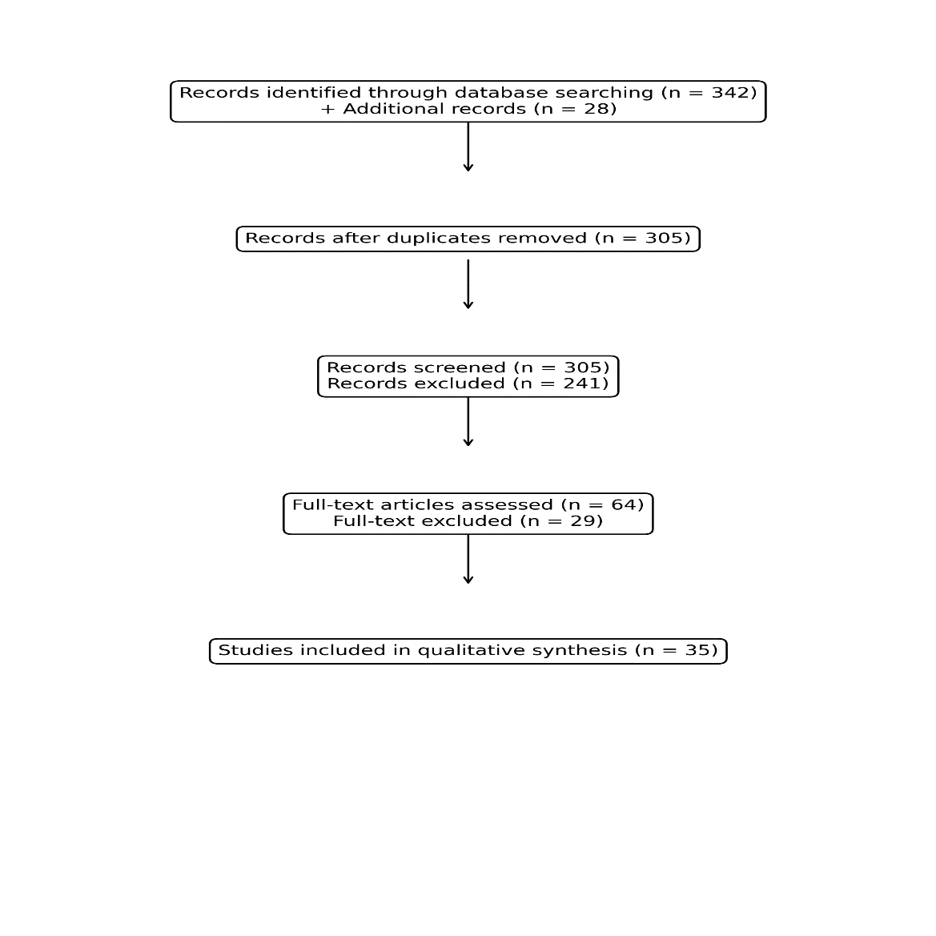
Figure 1. PRISMA flow diagram of study selection.
The diagram presents the process of identification, screening, eligibility assessment, and inclusion of studies in this systematic review.

3. Results
3.1 Epidemiological Patterns and Age Distribution
The studies included in this review consistently identified cervical cancer as one of the most common malignancies affecting women in Cameroon and one of the leading gynecological cancers encountered in routine clinical practice. Although precise national incidence estimates vary depending on the source and methodology used, all available data indicate that the disease remains a major public health concern and contributes substantially to cancer-related mortality among women.
Across the reviewed publications, the mean age at diagnosis generally ranged from 45 to 55 years, with the highest concentration of cases occurring between 40 and 59 years of age. This age distribution is broadly consistent with reports from other countries in sub-Saharan Africa, where cervical cancer tends to affect women during the most socially and economically productive period of adult life. Compared with high-income countries, where organized screening often detects precursor lesions or early-stage cancers at older ages, women in Cameroon frequently present when symptomatic disease has already developed.
Several factors may account for this relatively younger age at diagnosis. Persistent exposure to high-risk HPV, high parity, early sexual debut, and limited access to preventive services likely contribute to earlier progression from precancerous lesions to invasive disease. The burden of HIV infection in certain populations further accelerates the natural history of HPV-related carcinogenesis by impairing viral clearance and promoting persistence of oncogenic genotypes.
The public health implications of this age profile are substantial. Women affected by cervical cancer are often central to household stability, child care, and family income generation. Illness or premature death during these years can therefore produce far-reaching consequences for families and communities, extending the impact of the disease beyond the individual patient.
Table 1. Comparative Epidemiological Profile of Cervical Cancer
Region | Mean Age at Diagnosis | Advanced Stage at Presentation | Relative Disease Burden
Cameroon | 50–55 years | 70–85% | High
Sub-Saharan Africa | 48–58 years | 65–90% | Very high
High-income countries | 55–65 years | <30% | Substantially lower
These findings underscore the extent to which differences in screening coverage, public awareness, and healthcare accessibility shape disease patterns. The burden observed in Cameroon is not attributable to a distinct biological phenotype, but rather to delayed detection and incomplete implementation of proven preventive interventions.
3.2 Stage at Diagnosis
One of the most striking and consistent observations across Cameroonian studies is the predominance of advanced-stage disease at initial presentation. More than two-thirds of women are diagnosed at FIGO staging system stages III or IV, and some hospital-based series report proportions exceeding 80%.
This stage distribution reflects a clinical pathway in which diagnosis is usually triggered by symptoms rather than by screening. Women often seek medical attention only after experiencing persistent vaginal bleeding, postcoital bleeding, offensive vaginal discharge, pelvic pain, urinary symptoms, or severe anemia. By the time these manifestations become pronounced, tumors are frequently locally advanced and may already involve the parametrium, pelvic sidewall, bladder, or rectum.
Multiple determinants contribute to delayed presentation:
- Limited knowledge of cervical cancer warning signs.
- Social stigma surrounding gynecological symptoms.
- Financial constraints and transportation difficulties.
- Initial recourse to traditional healers or self-medication.
- Restricted availability of trained providers and diagnostic services.
- Long referral pathways between peripheral and tertiary facilities.
The clinical consequences of late-stage diagnosis are profound. Advanced disease requires more complex treatment, relies heavily on radiotherapy and concurrent chemotherapy, and is associated with lower cure rates, greater toxicity, and increased costs. In contrast, early-stage disease may often be treated surgically with substantially better long-term outcomes.
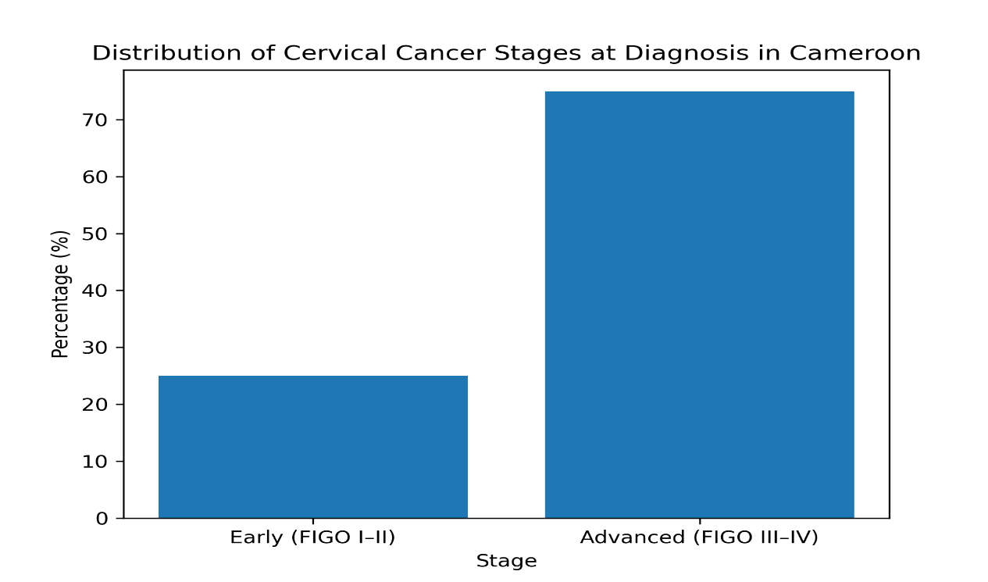
Figure 2. Distribution of cervical cancer stages at diagnosis in Cameroon..
The overwhelming predominance of stage III and IV disease illustrates the cumulative effect of inadequate screening, delayed health-seeking behavior, and barriers within the referral system. This pattern remains one of the strongest indicators of the unmet need for organized prevention and early detection programs.
3.3 Histopathological Distribution
The histopathological profile of cervical cancer in Cameroon closely mirrors patterns described worldwide, with squamous cell carcinoma accounting for the overwhelming majority of cases. Across the studies included in this review, this subtype represented approximately 80–85% of all invasive cervical malignancies. Adenocarcinoma was consistently the second most frequent histological category, contributing 10–15% of cases, while adenosquamous carcinoma, neuroendocrine tumors, and other uncommon variants together accounted for fewer than 5%.

Table 2. Histological Distribution of Cervical Cancer in Cameroon
Histological Type | Approximate Frequency
Squamous cell carcinoma | 80–85%
Adenocarcinoma | 10–15%
Other rare histological subtypes | <5%
The predominance of squamous cell carcinoma is biologically expected because this subtype arises from the transformation zone of the cervix, where metaplastic squamous epithelium is particularly susceptible to persistent infection with oncogenic HPV types. The transformation zone remains the principal site of HPV-induced neoplastic change and explains why squamous lesions continue to dominate the histological spectrum.
Although the overall distribution resembles that reported internationally, several contextual factors may influence the relative proportions observed in Cameroon. Limited access to routine screening may favor the detection of larger and more symptomatic squamous tumors, while adenocarcinomas—often located higher within the endocervical canal—may remain clinically occult for longer periods. In addition, variability in pathology expertise and immunohistochemical resources may affect diagnostic precision in some centers.
From a prognostic standpoint, histological subtype has important implications. Squamous cell carcinoma generally responds well to standard chemoradiation protocols when treatment is available and completed. Adenocarcinoma, by contrast, has been associated in some studies with a slightly less favorable response to radiotherapy and a higher propensity for distant dissemination, although stage at diagnosis remains the dominant determinant of outcome.
The predominance of squamous cell carcinoma also reinforces the central role of HPV-related carcinogenesis. Most of these tumors are linked to persistent infection with HPV 16, whereas adenocarcinomas are more frequently associated with HPV 18. The histological distribution observed in Cameroon is therefore entirely consistent with the known virological landscape of cervical cancer.
3.4 Risk Factors and HPV Infection
Persistent infection with high-risk HPV is the indispensable etiological event in the development of virtually all cervical cancers. Among the studies reviewed, HPV DNA was detected in the vast majority of tumors, and genotypes 16 and 18 were consistently identified as the predominant oncogenic types. Together, these two genotypes account for most invasive cervical cancers worldwide and are the principal targets of currently available prophylactic vaccines.
Table 3. Major Risk Factors Associated with Cervical Cancer
Risk Factor | Relative Contribution
High-risk HPV infection (especially types 16 and 18) | Very high
HIV infection | High
Multiparity | Moderate
Early sexual debut | Moderate
Multiple sexual partners | Moderate
Low socioeconomic status | Indirect but substantial
Limited access to screening | Major systemic factor
Tobacco exposure | Additional contributory factor
Although HPV infection is common in sexually active populations, most infections are transient and are cleared spontaneously by the immune system. Progression to cancer occurs primarily when infection persists over several years, leading to the accumulation of molecular alterations that disrupt normal cell-cycle control. Viral oncoproteins E6 and E7 play a pivotal role by inactivating the tumor suppressor proteins p53 and retinoblastoma (Rb), thereby promoting genomic instability and malignant transformation.
In Cameroon and other countries in sub-Saharan Africa, HIV infection is a particularly important cofactor. Immunosuppression reduces the ability to eliminate oncogenic HPV, increases the likelihood of persistent infection, and accelerates progression from cervical intraepithelial neoplasia to invasive carcinoma. Women living with HIV are therefore at substantially increased risk of both incident cervical cancer and recurrence after treatment.
Reproductive and behavioral determinants also contribute to disease risk. Early initiation of sexual activity prolongs lifetime exposure to HPV. Multiple pregnancies may enhance susceptibility through hormonal and immunological changes affecting the cervical epithelium. Socioeconomic deprivation influences access to education, preventive services, and timely healthcare, thereby amplifying the downstream consequences of HPV infection.
The close relationship between HPV and cervical cancer underscores one of the most important opportunities in modern cancer prevention. Unlike many malignancies whose causes are multifactorial and incompletely understood, cervical cancer has a clearly established infectious etiology and a highly effective vaccine-based prevention strategy. The persistence of a substantial disease burden in Cameroon therefore reflects the incomplete implementation of a well-defined and scientifically validated preventive model.
3.5 Access to Treatment and Health System Constraints
The studies reviewed consistently demonstrate that the burden of cervical cancer in Cameroon is sustained not only by failures in prevention and early detection, but also by substantial obstacles encountered after diagnosis. For many women, confirmation of malignancy marks the beginning of a difficult and often fragmented therapeutic journey in which logistical, financial, and structural barriers compromise the timely delivery of potentially curative treatment.

Table 4. Major Health System Constraints in Cervical Cancer Management
Health System Constraint | Clinical Consequences
Limited radiotherapy capacity | Delayed or incomplete treatment
High out-of-pocket expenditures | Treatment abandonment or interruption
Centralization of oncology services | Geographic inequities in access
Shortage of oncology specialists | Delays in multidisciplinary care
Limited pathology and imaging resources | Prolonged diagnostic intervals
Inadequate supportive care services | Increased treatment-related morbidity
Weak referral systems | Loss to follow-up
Insufficient public health financing | Persistent inequities
The standard treatment for locally advanced cervical cancer is concurrent chemoradiation followed by brachytherapy. This approach has been established as the cornerstone of curative management in women with FIGO stage IB3 to IVA disease. However, successful implementation depends on reliable access to radiation equipment, specialized personnel, pathology services, chemotherapy, and supportive care infrastructure.
In Cameroon, as in many low- and middle-income countries, radiotherapy remains one of the most constrained components of cancer care. Even when radiation facilities are available, demand frequently exceeds capacity, resulting in prolonged waiting times. Delays of several weeks or months are not uncommon and may allow continued tumor progression before treatment begins. In some circumstances, technical interruptions or equipment maintenance issues further complicate care.
Financial barriers are equally important. A large proportion of healthcare expenditures is paid directly by patients and their families. The cumulative costs of consultations, diagnostic imaging, histopathology, laboratory testing, surgery, chemotherapy, radiotherapy, transportation, and accommodation can be prohibitive. Families may sell assets, borrow money, or discontinue treatment when resources are exhausted. Consequently, some women initiate therapy but are unable to complete the prescribed course.
The geographic concentration of oncology services in major urban centers such as Douala and Yaoundé creates additional disparities. Women living in remote or underserved regions must travel long distances, often repeatedly, to access specialized care. Transportation costs, time away from work, and the need for temporary housing add to the overall burden and may discourage adherence to treatment schedules.
Human resource limitations further constrain service delivery. The number of gynecologic oncologists, radiation oncologists, medical oncologists, pathologists, oncology nurses, and medical physicists remains insufficient relative to national needs. Multidisciplinary tumor boards are not universally available, and treatment decisions may be influenced by local resource constraints rather than ideal evidence-based standards.
Diagnostic capacity also affects therapeutic outcomes. Delays in obtaining histopathological confirmation or advanced imaging may postpone staging and treatment planning. In settings where immunohistochemistry and molecular testing are limited, diagnostic refinement may be incomplete, although this is less critical in cervical cancer than in several other solid tumors.
Supportive care is another frequently overlooked dimension. Women undergoing chemoradiation may require management of anemia, infection, malnutrition, pain, and psychosocial distress. Inadequate supportive services can reduce tolerance to therapy and contribute to treatment interruptions.
Taken together, these findings indicate that the management of cervical cancer in Cameroon is constrained by a continuum of health system limitations extending from diagnosis to treatment completion. The resulting pattern is one in which potentially curable disease is often managed under suboptimal conditions, reducing the effectiveness of otherwise well-established therapeutic strategies.
3.6 Summary Figure: Integrated Model of Disease Burden
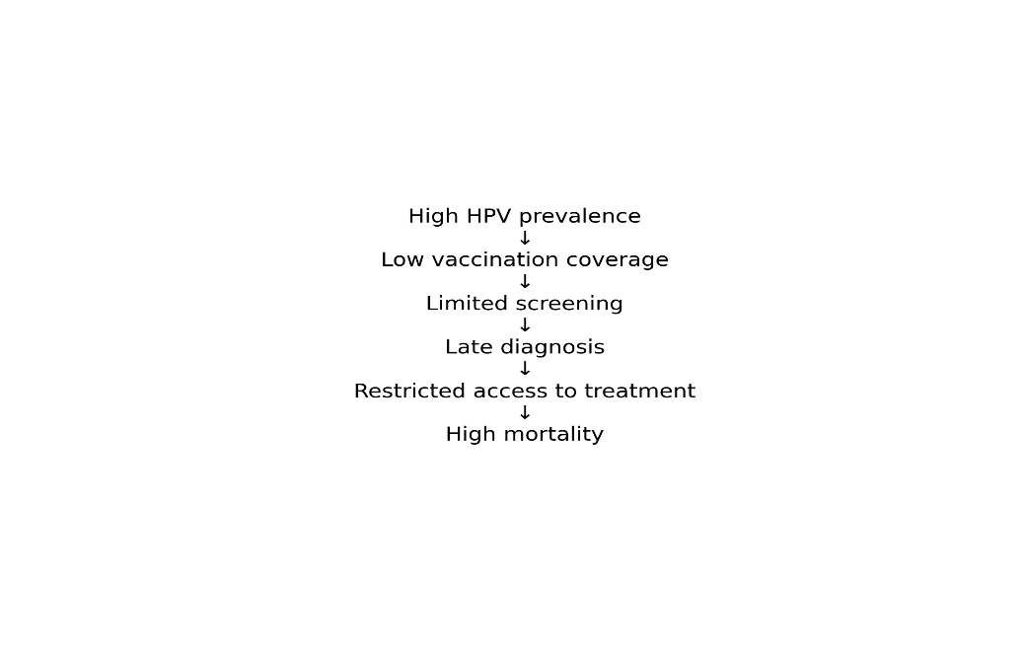

Figure 3. Conceptual framework of cervical cancer burden in Cameroon..
The burden of cervical cancer in Cameroon can be understood as the cumulative result of interacting biological, social, and health system determinants. At the biological level, widespread exposure to high-risk HPV provides the essential causal foundation. This risk is amplified by cofactors such as HIV infection, high parity, and early sexual debut.
At the community level, limited awareness, stigma, poverty, and gender-related barriers reduce participation in preventive services and delay healthcare seeking. At the health system level, low vaccination coverage, fragmented screening initiatives, restricted pathology and radiotherapy capacity, shortages of specialized personnel, and substantial out-of-pocket expenditures compromise both prevention and treatment.
These interacting factors lead to delayed diagnosis, advanced-stage presentation, treatment interruption, and high mortality. The conceptual model highlights that cervical cancer is not simply the consequence of viral infection, but rather the end result of cumulative failures across multiple levels of the healthcare system.
4. Discussion
The findings of this systematic review indicate that cervical cancer in Cameroon remains a major cause of preventable morbidity and mortality despite the availability of highly effective strategies for vaccination, screening, and treatment. The predominance of advanced-stage disease at diagnosis, the persistently low uptake of preventive services, and the substantial barriers to timely treatment collectively illustrate the gap between scientific knowledge and routine clinical practice [1–5,20–24].
One of the most consistent observations across the reviewed studies is that the majority of women present with FIGO stage III or IV disease [21–24]. This pattern contrasts sharply with the situation in countries where organized screening programs have been implemented for several decades. In those settings, most lesions are detected at the precancerous or early invasive stage, when treatment is simpler and survival rates are substantially higher [2,5,7–9]. The contrast highlights the extent to which cervical cancer reflects differences in health system performance rather than differences in tumor biology.
The biological determinants of cervical cancer are remarkably uniform across populations. Persistent infection with oncogenic HPV, particularly genotypes 16 and 18, remains the essential causal event in nearly all cases [3,4,13–15]. Consequently, the continued high mortality observed in Cameroon cannot be attributed to unique biological characteristics, but rather to delayed diagnosis and incomplete implementation of proven preventive interventions [5,11,12]. In this respect, cervical cancer serves as a revealing indicator of inequities in women’s health.
The interaction between HPV and HIV is especially relevant in sub-Saharan Africa. Women living with HIV are more likely to acquire persistent HPV infection, develop high-grade cervical intraepithelial neoplasia, and progress more rapidly to invasive carcinoma [16–18]. Several studies have also shown that HIV-positive women face higher recurrence rates after treatment and poorer long-term outcomes [17,18]. These observations support the integration of cervical cancer prevention and screening into existing HIV care services, an approach that has demonstrated feasibility and effectiveness in several African countries [31,32].
The age distribution reported in Cameroon, with most diagnoses occurring between 45 and 55 years, deserves particular attention [20–24]. This period often corresponds to the peak of women’s family and socioeconomic responsibilities. As a result, the consequences of illness extend beyond the patient herself, affecting childcare, household stability, and economic productivity [30]. From a broader public health perspective, reducing cervical cancer mortality may therefore yield substantial social and developmental benefits.
Our review confirms that squamous cell carcinoma remains the predominant histological subtype, accounting for approximately four out of five cases. This finding is entirely consistent with the known susceptibility of the cervical transformation zone to HPV-induced carcinogenesis [13–15]. The histopathological profile observed in Cameroon mirrors global patterns and further supports the central role of HPV-directed prevention.
The persistence of low screening coverage remains one of the most important determinants of late diagnosis. While visual inspection with acetic acid, cytology, and HPV-based testing have all demonstrated effectiveness in reducing incidence and mortality [7,25,33], their implementation in Cameroon remains largely opportunistic and geographically uneven [21,22]. Women are often screened only during isolated awareness campaigns or after the onset of symptoms, thereby limiting the preventive impact of these interventions.
Recent advances in HPV DNA testing and self-collected sampling may provide practical solutions for improving coverage in resource-constrained environments. Several studies have demonstrated that self-sampling is highly acceptable and diagnostically reliable, particularly among women who face cultural, logistical, or financial barriers to clinic-based examinations [34–36]. In Cameroon, where access to gynecological services is uneven, this approach could represent an important strategy for expanding screening participation.
HPV vaccination remains the cornerstone of primary prevention. The effectiveness of prophylactic vaccination in preventing infections with high-risk HPV types and reducing cervical precancer has been established conclusively [37–39]. The experience of Rwanda is particularly instructive. Through strong political commitment, school-based delivery, and extensive community mobilization, Rwanda achieved one of the highest HPV vaccination coverage rates in Africa [40]. Similar progress has been reported in Uganda and Botswana [41,42]. These experiences demonstrate that substantial achievements are possible in African settings when prevention is treated as a national priority.
Although Cameroon has introduced HPV vaccination, coverage remains below the levels required to generate the full population benefits predicted by mathematical models [5,11,12,43]. Public concerns about vaccine safety, limited awareness, and logistical challenges continue to affect uptake. Addressing these barriers will require sustained communication efforts, engagement with teachers and community leaders, and reliable vaccine delivery systems.
The treatment challenges identified in this review are equally important. Concurrent chemoradiation followed by brachytherapy remains the standard of care for locally advanced cervical cancer [25,26]. However, radiotherapy services in many African countries remain insufficient to meet demand [27,44]. In Cameroon, oncology care is concentrated primarily in Douala and Yaoundé, creating substantial geographic disparities. Women living in remote areas often face long travel distances, accommodation expenses, and repeated interruptions in care.
Financial barriers represent another major obstacle. In the absence of comprehensive health insurance coverage, most diagnostic and treatment costs are paid directly by patients and their families [28,29]. These expenditures can be catastrophic and frequently lead to delays in treatment initiation or premature discontinuation. Economic analyses have consistently shown that vaccination and screening are considerably more cost-effective than the management of advanced disease [45,46].
Human resource shortages further limit the capacity of the health system. The number of gynecologic oncologists, radiation oncologists, pathologists, oncology nurses, and medical physicists remains insufficient relative to national needs [47]. Strengthening specialist training and developing multidisciplinary oncology networks should therefore be regarded as strategic priorities.
Community awareness and cultural perceptions also influence the effectiveness of prevention programs. Fear of cancer, misconceptions about HPV vaccination, embarrassment related to gynecological examinations, and reliance on traditional medicine may delay healthcare seeking [22,48,49]. Experiences from community-based interventions suggest that educational programs involving religious leaders, women’s associations, and local influencers can substantially improve acceptance of preventive services [50,51].
The findings of this review should be interpreted in the context of several limitations. Much of the available evidence is derived from retrospective hospital-based studies, which may not fully reflect the experiences of women who never reach specialized care. Regional differences and variations in study design also limit direct comparison. Nevertheless, the consistency of the principal observations across multiple sources strengthens the validity of the conclusions.
Taken together, the evidence indicates that cervical cancer in Cameroon remains a paradigmatic example of avoidable mortality. The causal mechanisms are well established, effective vaccines and screening technologies are available, and evidence-based treatment protocols are clearly defined [3–7,25–27]. The principal challenge lies in translating this knowledge into accessible, equitable, and sustainable public health practice.
Meaningful progress will require coordinated action to expand HPV vaccination, implement organized screening, integrate services with HIV care, strengthen pathology and radiotherapy infrastructure, reduce financial barriers, and enhance public awareness [5,11,12,31–36,43–51]. The experience of countries that have achieved major reductions in incidence and mortality demonstrates that these goals are attainable. With sustained political commitment and strategic investment, Cameroon has the opportunity to transform cervical cancer from a major cause of premature death into a largely preventable and increasingly uncommon disease.
Conclusion
Cervical cancer remains one of the most preventable yet still one of the most lethal malignancies affecting women in Cameroon. Although the biological mechanisms of the disease are well understood and highly effective preventive tools are available, many women continue to be diagnosed only after the disease has reached an advanced stage, when treatment becomes more complex, more expensive, and less likely to achieve long-term survival.
Persistent infection with high-risk human papillomavirus, particularly genotypes 16 and 18, remains the fundamental cause of the disease, while HIV infection, multiparity, early sexual debut, and socioeconomic disadvantage further increase the risk of progression to invasive cancer. Limited vaccination coverage, inadequate screening, restricted access to pathology and radiotherapy services, and substantial out-of-pocket costs continue to hinder effective control.
The consequences extend beyond individual patients, affecting families, communities, and the broader health system. Because cervical cancer frequently strikes women during the most productive years of life, the disease carries important social and economic repercussions.
The experience of countries that have successfully reduced cervical cancer incidence and mortality demonstrates that meaningful progress is achievable. For Cameroon, the priority is to translate existing scientific knowledge into coordinated and accessible public health action. Strengthening HPV vaccination, implementing organized screening programs, expanding treatment capacity, reducing financial barriers, and promoting community awareness should form the cornerstone of a comprehensive national strategy.
With sustained political commitment and strategic investment, Cameroon has the opportunity to transform cervical cancer from a major cause of premature death into a largely preventable and increasingly uncommon disease. Without such action, however, the current burden is likely to persist for many years to come.

References
- Sung H, Ferlay J, Siegel RL, Laversanne M, Soerjomataram I, Jemal A, et al. Global cancer statistics 2020: GLOBOCAN estimates of incidence and mortality worldwide for 36 cancers in 185 countries. CA Cancer J Clin. 2021;71(3):209–249. doi:10.3322/caac.21660.
- Bray F, Ferlay J, Soerjomataram I, Siegel RL, Torre LA, Jemal A. Global cancer statistics 2018: GLOBOCAN estimates of incidence and mortality worldwide. CA Cancer J Clin. 2018;68(6):394–424. doi:10.3322/caac.21492.
- Arbyn M, Weiderpass E, Bruni L, de Sanjosé S, Saraiya M, Ferlay J, et al. Estimates of incidence and mortality of cervical cancer worldwide in 2018. Lancet Glob Health. 2020;8(2):e191–e203. doi:10.1016/S2214-109X(19)30482-6.
- Crosbie EJ, Einstein MH, Franceschi S, Kitchener HC. Human papillomavirus and cervical cancer. Lancet. 2013;382(9895):889–899. doi:10.1016/S0140-6736(13)60022-7.
- World Health Organization. Global strategy to accelerate the elimination of cervical cancer as a public health problem. Geneva: WHO; 2020.
- Vaccarella S, Laversanne M, Ferlay J, Bray F. Cervical cancer elimination: progress and challenges. Lancet Public Health. 2021;6(2):e95–e106. doi:10.1016/S2468-2667(20)30224-5.
- Ronco G, Dillner J, Elfström KM, Tunesi S, Snijders PJF, Arbyn M, et al. Efficacy of HPV-based screening for prevention of invasive cervical cancer. Lancet. 2014;383(9916):524–532. doi:10.1016/S0140-6736(13)62218-7.
- Hall MT, Simms KT, Lew JB, Smith MA, Brotherton JML, Saville M, et al. The projected timeframe until cervical cancer elimination in Australia. Lancet Public Health. 2019;4(1):e19–e27. doi:10.1016/S2468-2667(18)30183-X.
- Canfell K. Towards the global elimination of cervical cancer. Papillomavirus Res. 2019;8:100170. doi:10.1016/j.pvr.2019.100170.
- Denny L, de Sanjosé S, Mutebi M, Anderson BO, Kim J, Jeronimo J, et al. Interventions to close the divide for women with breast and cervical cancer between low-income and middle-income countries and high-income countries. Lancet. 2017;389(10071):861–870. doi:10.1016/S0140-6736(16)31795-0.
- Canfell K, Kim JJ, Brisson M, Keane A, Simms KT, Caruana M, et al. Mortality impact of achieving WHO cervical cancer elimination targets. Lancet Public Health. 2020;5(4):e213–e222. doi:10.1016/S2468-2667(20)30068-4.
- Brisson M, Kim JJ, Canfell K, Drolet M, Gingras G, Burger EA, et al. Impact of HPV vaccination and cervical screening on cervical cancer elimination. Lancet. 2020;395(10224):575–590. doi:10.1016/S0140-6736(20)30068-4.
- Bosch FX, Lorincz A, Muñoz N, Meijer CJLM, Shah KV. The causal relation between human papillomavirus and cervical cancer. J Clin Pathol. 2002;55(4):244–265.
- Muñoz N, Bosch FX, de Sanjosé S, Herrero R, Castellsagué X, Shah KV, et al. Epidemiologic classification of human papillomavirus types. N Engl J Med. 2003;348(6):518–527.
- de Sanjosé S, Brotons M, Pavón MA. The natural history of human papillomavirus infection. Lancet Oncol. 2018;19(3):e136–e144.
- Liu G, Sharma M, Tan N, Barnabas RV. HIV-positive women have higher risk of HPV infection and cervical cancer. J Infect Dis. 2018;218(10):1515–1525.
- Dryden-Peterson S, Bvochora-Nsingo M, Suneja G, Efstathiou JA, Grover S, Chiyapo S, et al. HIV infection and survival among women with cervical cancer. J Clin Oncol. 2016;34(31):3749–3757.
- Stelzle D, Tanaka LF, Lee KK, Khalil AI, Baussano I, Shah ASV, et al. Estimates of the global burden of cervical cancer associated with HIV. Lancet Glob Health. 2021;9(2):e161–e169.
- Franco EL, Cuzick J, Hildesheim A, de Sanjosé S. Chapter 20: Issues in planning cervical cancer screening in the era of HPV vaccination. Vaccine. 2006;24 Suppl 3:S3/171–S3/177.
- Tebeu PM, Fokom-Domgue J, Crofts V, Catarino R, Untiet S, Vassilakos P. Effectiveness of cervical cancer screening in Cameroon. BMC Cancer. 2022;22:843.
- Ngowa JD, Kasia JM, Yomi J, Fongang E, Ndom P. Sociocultural barriers to cervical cancer screening in Cameroon. Pan Afr Med J. 2018;30:120.
- Ndom P, Fouelifack FY, Essame Oyono JL, Obama Abena MT, Mbakop A, et al. Delays in diagnosis and treatment of cancer in Cameroon. J Cancer Epidemiol. 2020;2020:3456172.
- Mapoko BSE, et al. Clinical presentation of cervical cancer in Cameroon. Gynecol Oncol Rep. 2022;42:100927.
- Mapanga W, Ndom P, Mbatchou Ngahane HB, Wepngong EN, Sando Z, et al. Cervical cancer in Cameroon: disease burden, challenges of care, and perspectives for prevention and control. Pan Afr Med J. 2021;39:214. doi:10.11604/pamj.2021.39.214..
- Bhatla N, Aoki D, Sharma DN, Sankaranarayanan R. FIGO Cancer Report 2018. Int J Gynaecol Obstet. 2018;143 Suppl 2:22–36.
- National Comprehensive Cancer Network. NCCN Clinical Practice Guidelines in Oncology: Cervical Cancer. Version 2025.
- Atun R, Jaffray DA, Barton MB, Bray F, Baumann M, Vikram B, et al. Expanding global access to radiotherapy. Lancet. 2015;385(9973):1153–1186.
- Sullivan R, Alatise OI, Anderson BO, Audisio R, Autier P, Aggarwal A, et al. Global cancer surgery and systems strengthening. Lancet Oncol. 2015;16(11):1193–1224.
- Horton S, Gauvreau CL. Cancer in low-income countries: an economic overview. Lancet. 2017;389(10071):80–82.
- Ginsburg O, Bray F, Coleman MP, Vanderpuye V, Eniu A, Kotha SR, et al. The global burden of women’s cancers. Lancet. 2017;389(10071):847–860.
- Kinyanjui DW, Mugo NR, Bukusi EA, Huchko MJ. Integration of cervical cancer screening into HIV care in sub-Saharan Africa: a systematic review. Int J Gynaecol Obstet. 2020;148(2):145–152.
- Abraham AG, D’Souza G, Jing Y, Gange SJ, Sterling TR, Silverberg MJ, et al. Invasive cervical cancer risk among women with HIV in the antiretroviral therapy era. J Acquir Immune Defic Syndr. 2013;62(4):405–413.
- Arbyn M, Smith SB, Temin S, Sultana F, Castle PE. Detecting cervical precancer and reaching underscreened women by using HPV testing. Lancet. 2018;392(10161):2218–2227.
- Arbyn M, Verdoodt F, Snijders PJF, Verhoef VMJ, Suonio E, Dillner L, et al. Accuracy of human papillomavirus testing on self-collected versus clinician-collected samples: a meta-analysis. Lancet Oncol. 2014;15(2):172–183.
- Yeh PT, Kennedy CE, de Vuyst H, Narasimhan M. Self-sampling for human papillomavirus testing. BMJ Glob Health. 2019;4(3):e001351.
- Serrano B, Ibáñez R, Robles C, Peremiquel-Trillas P, de Sanjosé S, Bruni L. Worldwide use of HPV self-sampling for cervical cancer screening. Cancers (Basel). 2022;14(9):2215.
- Garland SM, Kjaer SK, Muñoz N, Block SL, Brown DR, DiNubile MJ, et al. Impact and effectiveness of the quadrivalent HPV vaccine. Lancet. 2016;387(10016):313–323.
- Drolet M, Bénard É, Pérez N, Brisson M. Population-level impact and herd effects following HPV vaccination programmes. Lancet. 2019;394(10197):497–509.
- Falcaro M, Castañon A, Ndlela B, Checchi M, Soldan K, Lopez-Bernal J, et al. The effects of the national HPV vaccination programme in England. Lancet. 2021;398(10316):2084–2092.
- Binagwaho A, Wagner CM, Gatera M, Karema C, Nutt CT, Ngabo F. Achieving high coverage in Rwanda’s national HPV vaccination programme. Lancet. 2012;380(9846):214–215.
- Watson-Jones D, Baisley K, Brown J, Kavishe B, Andreasen A, Changalucha J, et al. Uptake and acceptability of HPV vaccination in Tanzania and Uganda. Vaccine. 2012;30(34):5207–5214.
- Mugo C, Heffron R, Donnell D, Wald A, Were E, Rees H, et al. Implementation of HPV prevention strategies in southern Africa. Vaccine. 2018;36(32 Pt A):4776–4783.
- Bruni L, Saura-Lázaro A, Montoliu A, Brotons M, Alemany L, Diallo MS, et al. HPV vaccination introduction worldwide and estimated coverage. Lancet Glob Health. 2021;9(2):e161–e169.
- Grover S, Xu MJ, Yeager A, Rosman L, Groen RS, Chackungal S, et al. A systematic review of radiotherapy capacity in low- and middle-income countries. Front Oncol. 2015;4:380.
- Campos NG, Tsu V, Jeronimo J, Mvundura M, Kim JJ. Cost-effectiveness of cervical cancer prevention in low-resource settings. Vaccine. 2017;35(48 Pt B):6744–6751.
- Kim JJ, Burger EA, Regan C, Sy S. Screening and vaccination strategies for cervical cancer elimination. Curr Opin Obstet Gynecol. 2020;32(1):67–73.
- Vanderpuye V, Grover S, Hammad N, Pooja B, Simonds H, Olopade F, et al. An update on the management of breast and gynecologic cancers in Africa. Lancet Oncol. 2017;18(4):e142–e152.
- Catarino R, Vassilakos P, Tebeu PM, Petignat P. Barriers to cervical cancer screening in developing countries. J Low Genit Tract Dis. 2015;19(3):185–188.
- Black E, Hyslop F, Richmond R. Barriers and facilitators to HPV vaccination. BMC Public Health. 2019;19:1617.
- Ports KA, Reddy DM. HIV, cervical cancer, and women’s health in sub-Saharan Africa. Womens Health Issues. 2015;25(3):257–260.
- Spencer JC, Brewer NT, Trogdon JG, Wheeler SB. Predictors of HPV vaccine acceptance in low-resource settings. Prev Med. 2020;132:105980.
- Sankaranarayanan R, Basu P, Kaur P, Bhaskar R, Singh GB, Denzongpa P, et al. Current status of human resources and infrastructure for cancer care in developing countries. Lancet Oncol. 2019;20(11):e573–e583.
- World Health Organization. WHO guideline for screening and treatment of cervical pre-cancer lesions for cervical cancer prevention. 2nd ed. Geneva: WHO; 2021.
- International Agency for Research on Cancer. Cancer Today. Lyon: IARC; 2024.
- Ferlay J, Ervik M, Lam F, Colombet M, Mery L, Piñeros M, et al. Global Cancer Observatory: Cancer Today. Lyon: IARC; 2024.
- United Nations Children's Fund. Human papillomavirus vaccine coverage estimates. New York: UNICEF; 2024.
- Simms KT, Steinberg J, Caruana M, Smith MA, Lew JB, Soerjomataram I, et al. Impact of scaling up cervical cancer prevention globally. Lancet Oncol. 2019;20(3):394–407.
- Rodin D, Grover S, Elmore SNC, et al. The Lancet Oncology Commission on radiotherapy and theranostics. Lancet Oncol. 2025;26(2):e1–e72.
- Wagstaff A, Flores G, Hsu J, Smitz MF, Chepynoga K, Buisman LR, et al. Catastrophic health expenditure and impoverishment in low-income settings. Lancet Glob Health. 2018;6(2):e169–e179.
- Jit M, Brisson M, Laprise JF, Choi YH. Economic evaluation of HPV vaccination and screening. Vaccine. 2014;32 Suppl 5:F129–F138.
- Farmer P, Frenk J, Knaul FM, Shulman LN, Alleyne G, Armstrong L, et al. Expansion of cancer care and control in countries of low and middle income. Lancet. 2010;376(9747):1186–1193.
- Perlman S, Wamai RG, Bain PA, Welty T, Welty E, Ogembo JG. Knowledge and awareness of HPV and cervical cancer in sub-Saharan Africa. J Cancer Educ. 2014;29(4):783–789.
- Finocchario-Kessler S, Wexler C, Maloba M, Mabachi N, Ndikum-Moffor F, Bukusi E. Community engagement to improve cervical cancer prevention. J Community Health. 2016;41(3):592–601.
- Ebu NI, Ameyaw EK, Amoah S, et al. Religious and sociocultural influences on cervical cancer prevention in Africa. BMC Womens Health. 2021;21:26.
- World Health Organization Regional Office for Africa. Framework for cervical cancer prevention and control in Africa. Brazzaville: WHO AFRO; 2023.

