Case report
Integrating Guided Bone Regeneration with Digital Implant Surgery and Delayed Loading for Anterior Maxillary Tooth Replacement: A Case Report

ABSTRACT
Guided bone regeneration (GBR) is a well-established technique for managing alveolar ridge deficiencies, particularly in the esthetic anterior maxilla¹,². Various graft materials, such as deproteinized bovine bone mineral (Bio-Oss®), provide an osteoconductive scaffold that preserves ridge volume and supports implant stability⁴,⁵.
This report describes a 23-year-old male patient with missing maxillary incisors (12, 11, and 21) who underwent guided implant surgery followed by simultaneous GBR using Bio-Oss® and a resorbable collagen membrane (T-Gen membrane)³,⁴. Delayed loading protocols were employed to enhance osseointegration and long-term functional outcomes⁵,⁶. Digital planning and surgical guides ensured precise implant placement². Clinical and radiographic evaluation demonstrated successful ridge augmentation, stable peri-implant bone levels, and favorable esthetic outcomes³,⁷. This case highlights the predictability of GBR combined with guided implant surgery and delayed loading in restoring both function and esthetics in the anterior maxilla.

INTRODUCTION
Rehabilitation of the anterior maxilla is challenging due to post-extraction alveolar resorption and high esthetic demands¹,². Guided bone regeneration (GBR) is a predictable technique for restoring deficient ridges by promoting bone growth within the defect while preventing soft tissue invasion³,⁴.
Deproteinized bovine bone mineral (Bio-Oss®) combined with resorbable collagen membranes serves as an osteoconductive scaffold and preserves ridge dimensions⁵,⁶. Digital workflows and guided implant surgery enhance placement accuracy and prosthetic outcomes²,⁷. Delayed loading protocols further support osseointegration and long-term implant stability⁸,⁹.
Ridge morphology and defect type are critical determinants of regenerative success¹⁰,¹¹. Clinical evidence suggests that delayed implant placement protocols improve functional and esthetic outcomes in grafted anterior sites¹⁴,¹⁵. This case illustrates the integration of guided implant surgery, GBR, and delayed loading in the rehabilitation of a young adult with anterior maxillary tooth loss⁶,¹¹.

CASE DESCRIPTION
A 23-year-old male presented with missing maxillary anterior teeth (12, 11, and 21)¹. The patient reported compromised esthetics². CBCT revealed horizontal ridge deficiency, indicating the need for guided implant placement and bone augmentation³,⁴.
Figure 1. Pre-operative Assessment
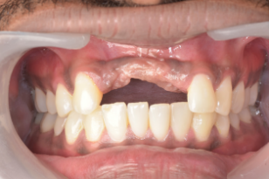
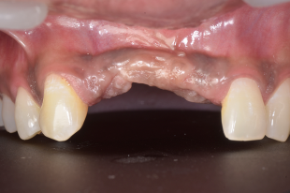
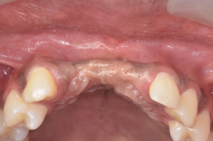
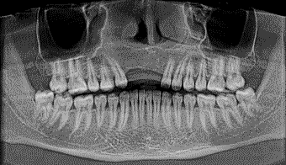
FIGURE 1- PRE OPERATIVE PHOTOGRAPHS AND OPG - 12, 21

Figure 1 illustrates the pre-operative clinical and radiographic assessment, where (Figure 1A) shows the intraoral view of missing maxillary anterior teeth (12 and 21), and (Figure 1B) depicts the orthopantomogram (OPG) confirming edentulous spaces with associated horizontal alveolar ridge deficiency in the anterior maxilla.
Figure 2. Guided Implant Surgery
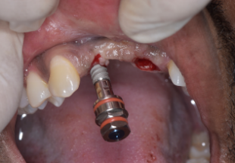
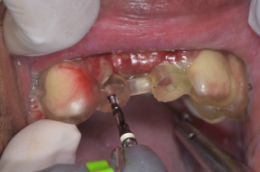
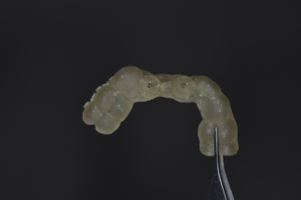
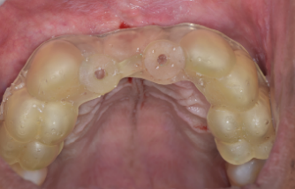
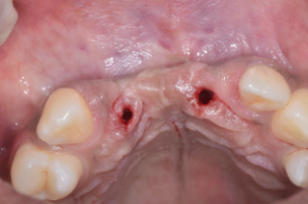
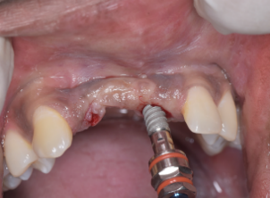
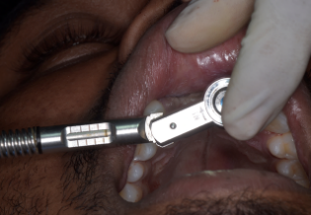
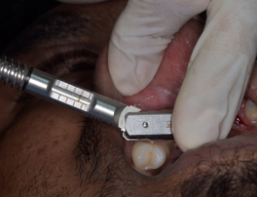
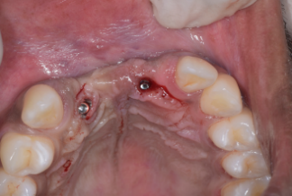
FIG 2A IMPLANT PILOT GUIDE IN 12 AND 21
FIG 2B SEQUENTIAL DRILLING AND OSTEOTOMY SITE PREPARED
FIGURE 2-GUIDED IMPLANT SURGERY
FIG 2C NORIS IMPLANT 4.2× 13MM IN 12 PRIMARY STABILITY > 40 NCM

FIG 2D NORIS IMPLANT 4.2× 13MM IN 21 PRIMARY STABILITY > 45 NCM

FIG 2E IMPLANT PLACED IN 12 AND 21

Figure 2 demonstrates the guided implant surgical protocol, where (Figure 2A) shows the implant pilot guide positioned in sites 12 and 21, (Figure 2B) illustrates sequential drilling and osteotomy site preparation using the surgical guide, (Figure 2C) shows placement of a NORIS implant (4.2 × 13 mm) in site 12 achieving primary stability greater than 40 Ncm, (Figure 2D) shows placement of a NORIS implant (4.2 × 13 mm) in site 21 achieving primary stability greater than 45 Ncm, and (Figure 2E) confirms final implant positioning in both sites following guided implant placement.

Figure 3. Guided Bone Regeneration
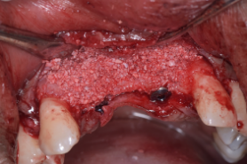
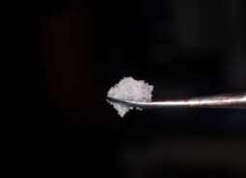
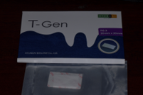
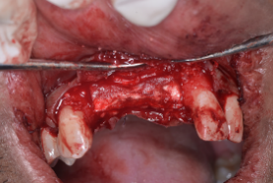
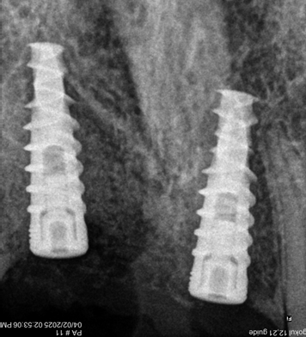
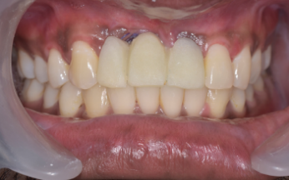
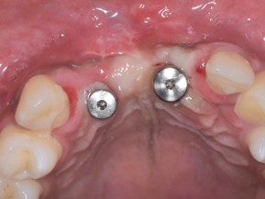
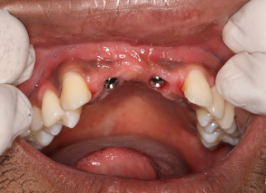
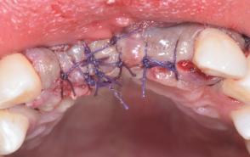
FIG 3A FULL THICKNESS MUCOPERIOSTEAL FLAP ELEVATED BIO OSS BONE GRAFT PLACED IN DEFECT AREA AND T GEN MEMBRANE PLACED AND STABILISED WITH PALATAL SUTURE

FIG 3B FLAP APPROXIMATED WITH 4.0 VICRYL SUTURE

FIG 3C IMMEDIATE POST OP RVG

FIG 3D IMMEDIATE

TEMPORIZATION

FIG 3E HEALING ABUTMENT PLACED AFTER 5 MONTHS

FIG 3F EMERGENCE PROFILE

FIGURE 3- GUIDED BONE REGENERATION

Figure 3 depicts the guided bone regeneration procedure and healing sequence, which (Figure 3A) shows elevation of a full-thickness mucoperiosteal flap with placement of Bio-Oss® bone graft in the buccal defect area and coverage with a T-Gen resorbable collagen membrane stabilized using palatal sutures, (Figure 3B) illustrates flap approximation achieved with 4-0 Vicryl sutures, (Figure 3C) shows the immediate post-operative radiovisiograph, (Figure 3D) depicts immediate temporization, (Figure 3E) shows placement of the healing abutment after 5 months of healing, and (Figure 3F) demonstrates a well-developed emergence profile following soft tissue maturation.

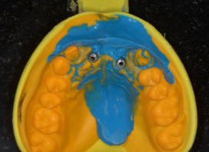
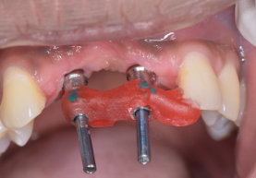
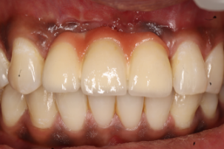
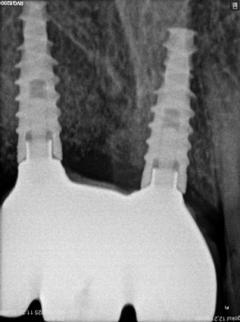
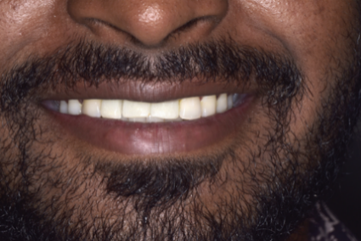
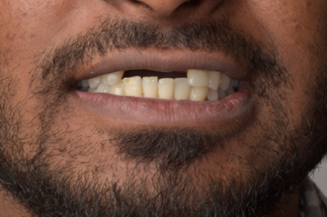
FIG 5A PRE OP

FIG 4A OPEN TRAY COPING IMPRESSION AND JIG TRIAL DONE

FIG 4B SCREW RETAINED PFM CROWN PLACED AND POST OP RVG

FIG 5B POST OP

FIGURE 4- PROSTHETIC PHASE DELAYED LOADING
FIGURE 5

Figure 4. Prosthetic Phase – Delayed Loading
Figure 5. Pre- and Post-operative Comparison

Figure 4 illustrates the prosthetic phase with delayed loading, where (Figure 4A) shows the open-tray impression coping with jig trial, and (Figure 4B) depicts placement of the screw-retained porcelain-fused-to-metal crown with post-operative radiovisiograph confirming prosthetic fit and peri-implant bone stability.
Figure 5 presents the comparative clinical outcomes, where (Figure 5A) shows the pre-operative intraoral view of missing maxillary anterior teeth, and (Figure 5B) demonstrates the post-operative intraoral view highlighting restoration of esthetics and function following guided implant surgery, guided bone regeneration, and delayed prosthetic rehabilitation.
DISCUSSION
This case demonstrates that the combination of guided implant surgery and GBR can achieve predictable functional and esthetic outcomes in the anterior maxilla¹,³. GBR restores ridge volume by guiding osteogenic cells into the defect and preventing soft tissue interference³,⁴.
Bio-Oss® provides a stable osteoconductive scaffold that maintains ridge dimensions and supports long-term bone preservation⁴,⁵. Collagen membranes, such as T-Gen, enhance regenerative outcomes by stabilizing the graft and controlling soft tissue ingress⁵,¹¹. Experimental and clinical studies confirm that this combination promotes bone formation and maintains ridge contours in esthetically critical regions⁴,⁵.
Precise implant positioning is critical for both esthetic and functional success²,⁶. Digital planning and guided surgical templates facilitate accurate three-dimensional implant placement, reduce surgical errors, and ensure prosthetic-driven positioning²,⁶.
Delayed loading was employed to improve implant stability and osseointegration⁷,⁸. Clinical studies show that delayed loading in grafted sites reduces marginal bone loss and enhances soft tissue outcomes⁹,¹⁴. Preoperative evaluation of ridge width and defect morphology allows proper graft adaptation, which is essential for successful horizontal augmentation⁹,¹⁰.
Long-term follow-up in this case demonstrated stable peri-implant bone levels, healthy soft tissue contours, and favorable esthetics³,⁶,¹⁵. The results align with existing literature showing predictable outcomes when GBR is combined with guided implant surgery and delayed loading²,³,⁷.
Overall, this case highlights that careful planning, appropriate material selection, and adherence to GBR principles enable predictable anterior maxillary rehabilitation with excellent functional and esthetic results.
CONCLUSION
Guided implant surgery followed by GBR with Bio-Oss® and T-Gen collagen membrane offers a predictable approach¹,². Delayed loading ensures stable osseointegration⁵,⁶. Proper case selection and surgical technique resulted in favorable long-term functional and esthetic outcomes³,⁷.

REFERENCES
- Wang HL. Principles in guided bone regeneration. Dent Implantol Update. 1998;9(5):33–7.
- Lanka M, Dhir S, Lahori M. Guided bone regeneration in anterior maxillary zone: A 3-year case report. Private Practice, New Delhi.
- Minetti E, Inchingolo AM, Inchingolo AD, Ferrante L, Marinelli G, Palermo A, Dipalma G. Six-year implants follow-up after guided bone regeneration using autologous tooth graft: Innovative biomaterial for bone regeneration Tooth Transformer®. J Oral Implantol. 2020;46(2):123–30.
- Kasuya S, Inui S, Kato-Kogoe N, Omori M, Yamamoto K, Inoue K, Ito Y, Nakajima Y, Hirata A, Ueno T. Evaluation of guided bone regeneration using Bio-Oss® and collagen membrane in a rat cranial bone defect model. Clin Oral Investig. 2020;24(10):3515–24.
- Duarte ND, Frigério PB, Buchaim RL, Amaya Chica GE, Okamoto R, Vieira Buchaim D, Issa JP. Biomaterials for guided tissue regeneration and guided bone regeneration: A review. J Mater Sci Mater Med. 2020;31:122.
- Todaro C, Cerri M, Rodriguez y Baena R, Lupi SM. Full-arch guided restoration and bone regeneration: A complete digital workflow case report. Int J Prosthodont. 2020;33(3):293–8.
- Peitsinis PR, Blouchou A, Chatzopoulos GS, Vouros I. Optimizing implant placement timing and loading protocols for successful functional and esthetic outcomes: A narrative literature review. Implant Dent. 2019;28(3):258–65.
- Chen J, Cai M, Yang J, Aldhohrah T, Wang Y. Immediate versus early or conventional loading dental implants with fixed prostheses: A systematic review and meta-analysis of randomized controlled clinical trials. J Prosthet Dent. 2021;125(4):622–33.
- Sekar S, Suthanthiran T, Thangavelu A, Karupannan SK, Prem F, Rajendran D. Clinical and radiological evaluation of delayed and early loading of single-tooth implant placement: A 6-month prospective follow-up. Clin Implant Dent Relat Res. 2020;22(2):185–94.
- Gan LM, Zhou QR, Zhang Y, Yu YC, Yu ZZ, Sun Y, Li RX, Wu XW, Yang F. Alveolar bone morphologic predictors for guided bone regeneration outcome in anterior maxilla. Clin Implant Dent Relat Res. 2019;21(5):929–36.
- Mutthineni RB. Third generation barrier membranes: Role in periodontal regeneration. J Indian Soc Periodontol. 2018;22(1):3–10.
- Botros KH, Adel-Khattab D, Eldabe AK, Abuel Ela HA. Early versus conventional loading for fully guided immediate implant placement in molar sites: A randomized controlled clinical study. Clin Oral Implants Res. 2019;30(8):777–86.
- Ma F, Wei T, Du Y, Wu B, Sun F. Accuracy of dynamic navigation for immediate and delayed anterior dental implant placement: A retrospective study. BMC Oral Health. 2020;20:130.
- Thoma D, Gil A, de Bruyckere T, Jung RE, Fukuba S, Ickroth A, Strauss FJ, Cosyn J. Early implant placement versus ridge preservation and delayed implant placement: Analysis of profilometric, clinician- and patient-reported outcomes from a two-centre RCT. Clin Oral Implants Res. 2018;29(9):895–906.
- Sekar S, Suthanthiran T, Thangavelu A, Karupannan SK, Prem F, Rajendran D. Clinical and radiological evaluation of delayed and early loading of single-tooth implants. J Clin Diagn Res. 2020;14(5):ZC12–17.

