Case Report
Broken Trephine Biopsy Needle: A Case Report of a Rare but not Impossible Complication

.
ABSTRACT

Bone marrow trephine biopsy is a common procedure carried out in haematology practice. It is important for diagnostic, prognostic, and follow up of haematologic conditions. Amongst the possible complications of the procedure, reports of broken trephine biopsy needles are few. The aim of this report is to contribute to the body of literature reporting the possibility of this complication.

Keywords: {Bone marrow aspiration, trephine biopsy needle, needle fragment, complications}

1. INTRODUCTION

Blood cells are produced from a single progenitor that is domiciled in the bone marrow, but also circulates in blood. These cells are sustained in the marrow by cellular interactions, and their growth and differentiation are encouraged by nutrients, growth factors, and oxygen supplied by blood vessels. In addition to the haemopoietic cells, the other cells which make up and contribute towards providing conducive space for haemopoiesis to take place in the marrow micro-environment are megakaryocytes, fibroblast, macrophages, osteoblasts and osteoclasts, adipocytes, and endothelial cells. With the marrow being the primary site of blood cells production, diseases affecting these cells can be diagnosed, not just by examining the blood, but also by analysing samples of the bone marrow.
Bone marrow aspiration and trephine biopsy are two common procedures utilized by haematologist in the diagnostic workup, and follow-up management of some haematologic diseases. While marrow aspiration produces marrow sample, biopsy obtains bone core. The diagnostic utility of these samples differs as aspiration allows for morphologic assessment of individual marrow cellular elements, while biopsy provides an actual picture of the marrow, showing cells in relation to other cells, and to components of the marrow architecture. In practice, both are very relevant in confirming a wide range of benign and malignant diseases affecting the different blood cells.
The aspiration procedure requires collection of liquid marrow while the biopsy requires that a bone core of at least 1.5 – 2cm in length is obtained;¹ biopsy thus requires deeper drilling into the bone and manipulations of the needle in order to harvest the core. These procedures are most commonly done under local anaesthesia, but use of regional or general anaesthesia is possible. The most commonly used site is the posterior superior iliac spine, PSIS; this provides good yield of marrow and is relatively safe since major organs or vessels are not present in that area. Complications likely with BMA/BMB are minor bleeding and significant pain at the site and time of the procedure. Haematoma development is possible but unlikely, while localized infection is also uncommon due to the aseptic measures employed before and during the procedure. A rarer but not impossible complication is a broken marrow canula with part of it stuck in the bone.
In this article we report the case of broken canula of bone marrow needle as it was being withdrawn in an attempt to harvest bone core during trephine biopsy procedure. The patient was an elderly adult male who was being investigated for recurrent anaemia that had necessitated several blood transfusions. Patient went ahead to have a minor surgical operation done by the orthopaedic surgeons, and an extraction of the needle fragment which was lodged within his posterior ilium.

2. case presentation

Our patient was a 67-year-old retired engineer who presented to our facility via the accident and emergency unit on self-referral on account of episodes of dizziness and recurrent body weakness of 5 months duration; index episodes were noticed two (2) days prior to presentation. Within the period of first episode until presentation, he had been transfused with up to twelve (12) units of whole blood at different peripheral facilities, and was also placed on haematinics intermittently at various times. There was no associated passage of coke-coloured urine, exertional dyspnoea, paroxysmal nocturnal haemoglobinaemia, or pedal oedema, and patient was not in pains or respiratory distress on examination, however, he was moderately pale. Pulse rate was 68 b/m, full and regular on palpation, and blood pressure was 110/70mmHg; pulse oximetry showed oxygen saturation of 96%. There was equal chest expansion, and breath sounds were vesicular; abdominal findings were nil of note. Laboratory investigations requested showed packed cell volume of 17%, haemoglobin concentration of 6.0g/dl, mean corpuscular volume of 77fL, and mean corpuscular haemoglobin of 28pg. White cell count was 3.4 x 10⁹/l with neutrophils and lymphocytes differentials of 14% and 77% respectively. Platelets count was 314 x 10⁹/l. Urinalysis and faecal occult blood tests requested were not contributory. Transfusion with two units of red cells was requested by the managing physicians in the emergency unit, following which the haematology team was invited to review the patient. Peripheral blood film showed markedly sparsely distributed red cells of various sizes with predominance of microcytic cells in a background of normocytic and macrocytic forms; few fragmented forms, significant rouleaux, and polychromasia were also seen. There was reduction in the neutrophil count on film but cells seen showed typical mature morphology, and platelets were adequate in number on the film and granular. Bone marrow aspiration and biopsy were done under local infiltration of plain lidocaine, but this was obviously not sufficient as patient was still in significant pains and was very anxious, requiring some physical supporting restraints. Marrow aspirate yield was scanty with few fragments on the slide. Afterwards, the trephine biopsy was done but in the course of manoeuvring the needle as it was withdrawn, the needle canula broke with about 3cm of it stuck in the bone. The orthopaedic surgeons were invited and reviewed; requested X-rays of the lumbosacral spine (anteroposterior and lateral) showed a completely lodged needle fragment in the posterior ilium. Due to patient’s poor haemodynamic state, the surgical removal of the stuck needle canula was done under local infiltration and monitored anaesthetic care. The procedure was well tolerated and patient was placed on tablets antibiotics, tablets analgesics, and tablets haematinics, all for two weeks. He was transfused with two (2) units of sedimented red cells in the course of his admission, and was discharged home and followed up at the outpatient clinic.
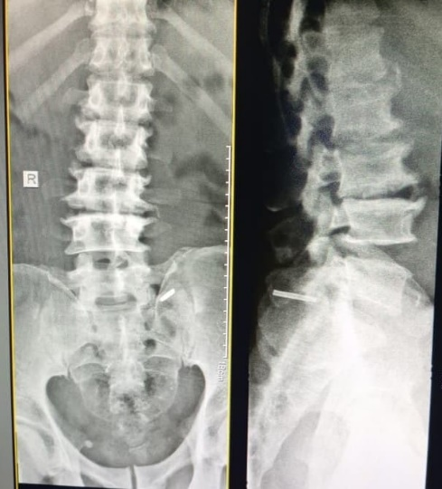
figure 1 shows AP & lateral lumbosacral spine X-ray with needle fragment in situ.
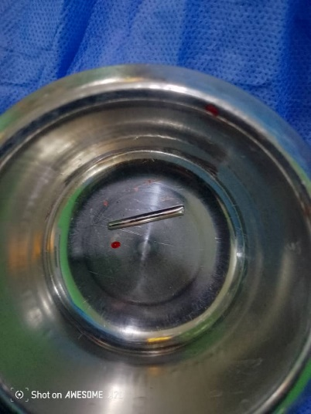
figure 2 showing extracted marrow needle fragment

3. discussion

Our patient had recurrent anaemia that was not responding to haematinics and was refractory to numerous blood transfusions. Recurrent, refractory anaemia is a clear indication for BMA/BMB.^{2, 3} This is especially correct where there is no evidence of haemorrhage as it was in this patient who did not have history of epistaxis, haematuria, melena or any other suggestive history, and who had negative faecal occult blood test, and urinalysis which was negative for red cells.
Persistent, unexplained neutropaenia is another indication for the procedure;^{4, 5} Although index case had severe neutropaenia with neutrophil differential of 14% for a WBC of 3.4 x 10⁹/l (ANC – 0.48 x 10⁹/l), he did not show any clinical features that were suggestive of or consistent with the degree of neutropaenia. Neutropaenia is an indication of the likelihood of the individual being most susceptible to infections, and not a sign that there is underlying infection. Index case confirms the possibility of absence of infection even in the setting of severe neutropaenia.
Local infiltration of the skin overlying the PSIS and the surface of the bone is the most common method of anaesthesia in the BMA/BMB procedures,⁶ and this was the method we used in our patient. In spite of the generous local anaesthesia, our patient was still very anxious and required some form of physical restraining for the procedure to be carried out. This contributed to the difficulty of the process and his struggling may have contributed to the incident.
In aspiration, the tip of the needle is advanced until the marrow space is entered, then the stylet is withdrawn and a syringe is used to aspirate the liquid marrow. On the other hand, biopsy requires that the canula be driven deep into the bone so that a core of bone of about 2cm is obtained, and retrieving the bone core requires manoeuvres which really test the strength of the canula. As such, while complications such as puncture injuries and damage to neurovascular bundles are likely during both aspiration and biopsy procedures, a broken canula is more likely during trephine biopsy. In index case, marrow aspiration was successfully concluded, and the needle broke in the biopsy procedure. This is consistent with an Indian report in which the breakage also happened during the trephine biopsy part of the procedure.⁷ Other reports did not clearly state the part of the procedure the incident occurred,^{8, 9} perhaps because the authors were orthopaedic surgeons and are unlikely to have been directly involved in BMA/BMB, however, it is plausible to conjecture that it was during the trephine biopsy, as that is the part in which the needle is subjected to the most strain. The broken needle fragment was extracted in theatre with the aid of intraoperative image guidance. This was to enhance spatial localization of the fragment which was lodged in the posterior ilium.

4. Conclusion

Broken trephine biopsy needle is a rare but possible complication of bone marrow biopsy procedure. The skill of the operator, adequacy of anaesthesia, strength and integrity of the trephine biopsy needle are some factors which could influence the occurrence.

References

- Lee S‑H, Erber WN, Porwit A, Tomonaga M, Peterson LC; International Council for Standardization in Haematology. ICSH guidelines for the standardization of bone marrow specimens and reports. Int J Lab Hematol. 2008;30(5):349‑364. doi:10.1111/j.1751-553X.2008.01055.x
- Yuguda S, Abubakar A, Aliyu A, et al. Indications and diagnostic utility of bone marrow aspiration cytology: A 12‑year experience at a tertiary health center in Gombe, Northeastern Nigeria. Ann Trop Pathol. 2023;14(2):123‑129. doi:10.4103/atp.atp_45_22
- Gau I, Benitez L, Chouaib R, Boyer D, Fox H, Bixby D. Evaluating bone marrow sample quality derived using a non‑redirection versus a traditional bone marrow aspiration and biopsy technique. Blood. 2025;146(Suppl 1):2649. doi:10.1182/blood-2025-2649
- Min KI, Byeon S. Diagnosis and management of neutropenia. Blood Res. 2025;60:30. doi:10.5045/br.2025.60.30
- Connelly JA, Walkovich K. Diagnosis and therapeutic decision‑making for the neutropenic patient. Hematology Am Soc Hematol Educ Program. 2021;2021(1):492‑503. doi:10.1182/hematology.202100028
- Chandrakantan A, Schraga ED. Infiltrative administration of local anesthetic agents. Medscape. Updated 16 Dec 2022. Available from: https://emedicine.medscape.com/article/1833991-overview
- Sheoran A, Rohilla R, Sharma P, Mohabey AV, Sharma P, Sehrawat A. Retrieval of broken Bone Marrow Biopsy Needle: a Case Report. J Med Sci Clin Res. 2017;5(11):213–216. DOI:https://doi.org/10.18535/jmscr/v5i11.213
- Bhayana H, Dhillon M, Reddy GP, Lad DP, Mallik N, Malhotra P, Das R. Retrieval of Broken Trephine Biopsy Needle in the Sacro-Iliac Joint. Indian J Hematol Blood Transfus. 2025;41:994–996. Published online 2024 Dec 3. DOI:https://doi.org/10.1007/s12288-024-01692-5
- Nkosi CS, Tlhabane SM, Ntombela PI, Linda ZA. Broken needle during bone marrow aspiration: a rare complication. J Area Health Sci. 2023; (case report)

