Original Research Article
Influence of Different Land Use Systems on Soil Physico-Chemical Properties in the Arid Region of Western Rajasthan, India

Abstract
Soil physico-chemical properties are important indicators of soil quality and are greatly influenced by land use systems, particularly in arid regions where climatic conditions limit soil development. The present study was conducted to evaluate the influence of different land use systems on soil physico-chemical properties in the Balesar block of Jodhpur district, Rajasthan, India. A total of 60 surface soil samples (0–15 cm) were collected from irrigated cropland, rainfed cropland, and pasture land, with 20 samples from each land use system. The samples were analyzed for bulk density (BD), particle density (PD), water holding capacity (WHC), soil pH, electrical conductivity (EC), and organic carbon (OC) using standard laboratory procedures.
Results showed that soils of the study area were slightly to moderately alkaline in reaction, with pH ranging from 7.36 to 8.32. Irrigated cropland recorded higher pH and EC compared to rainfed and pasture lands, indicating accumulation of soluble salts under irrigated conditions. Bulk density was lowest in irrigated soils, whereas rainfed soils showed comparatively higher values, suggesting the effect of organic matter and management practices on soil compaction. Water holding capacity was higher in irrigated and pasture soils than in rainfed soils, while organic carbon content was generally low in all land use systems due to arid climatic conditions. Correlation analysis revealed negative relationship between bulk density and organic carbon, while water holding capacity showed positive association with organic carbon, indicating the role of soil organic matter in improving soil physical properties.
The study concludes that land use systems significantly influence soil physico-chemical properties in the arid region of western Rajasthan, and improved management practices such as irrigation and organic matter addition can enhance soil quality and sustainability.
Keywords: Land use system, soil physico-chemical properties, arid region, organic carbon, bulk density, water holding capacity, Rajasthan

Introduction
Soil is one of the most dynamic and complex natural systems on Earth and forms the foundation of terrestrial life. It plays a central role in sustaining agricultural production, supporting ecosystem functions, and ensuring food, fodder, fiber, and energy security. Soil is composed of mineral matter (45%), organic matter (5%), water (25%), and air (25%), and its physical and chemical properties directly influence plant growth by regulating nutrient availability and water retention (Brady & Weil, 2017). Understanding these properties is essential for efficient soil resource management and sustainable agricultural development.
Soil physical properties such as texture, bulk density, structure, and water holding capacity, along with chemical properties including pH, electrical conductivity (EC), organic carbon, and nutrient status, determine soil fertility and productivity. These properties vary widely depending on land use systems, management practices, and environmental conditions. Therefore, assessing soil physico-chemical characteristics under different land use systems is crucial for improving soil health and long-term agricultural sustainability.
Land use change is one of the major drivers of soil degradation globally. Unsustainable land management practices often result in deterioration of soil quality, loss of nutrients, and decline in productivity, thereby affecting food security and livelihoods (Kebebew et al., 2022). Land use refers to the transformation of natural landscapes into managed systems such as agriculture, forestry, and urban development for socio-economic benefits (IPCC, 2000). With increasing population pressure and limited land resources, sustainable land use planning has become essential (Rathee, 2014).
India, with only 2.4% of the world’s geographical area, supports nearly 18% of the global population, leading to significant pressure on land resources (Ram, 2009). Per capita land availability has drastically declined over time, necessitating efficient soil and land management strategies. In arid and semi-arid regions, these challenges are further intensified due to low rainfall, high evapotranspiration, and poor soil fertility.
The arid region of India, covering approximately 38.7 million hectares, is predominantly located in north-western India, with Western Rajasthan accounting for about 62% of the desert area. The region is characterized by sandy soils, low organic matter, high temperatures, erratic rainfall (100–500 mm annually), and frequent droughts (Goyal et al., 2013; Rao & Roy, 2012). These harsh climatic conditions, coupled with wind erosion and limited irrigation, result in poor soil structure and low nutrient availability (Sharma et al., 2006).
Land use systems such as irrigated agriculture, rainfed farming, and pasture lands significantly influence soil properties in arid ecosystems. Changes in land use can alter soil structure, organic matter content, nutrient cycling, and overall soil quality (Maddoni et al., 1999). Previous studies have shown that intensive agriculture and irrigation can improve soil fertility and organic carbon content, whereas continuous cultivation without proper management may lead to nutrient depletion (Lal, 1995; Woomer et al., 2004; Fallahzadeh & Hajabbasi, 2010).
In Western Rajasthan, rapid expansion of agriculture and increasing pressure on natural resources have led to degradation of soil quality. Cultivated lands often exhibit faster nutrient depletion compared to pasture or tree-based systems due to continuous cropping and inadequate nutrient replenishment (Mahesh Kumar et al., 2017; Singh et al., 2007). Soil organic matter, a key indicator of soil quality and sustainability, is generally low in arid regions due to rapid decomposition and limited biomass input (Gregorich et al., 1994; Blair et al., 1995).
Despite the importance of land use in influencing soil properties, limited information is available on the comparative assessment of physico-chemical characteristics of soils under different land use systems in the arid region of Western Rajasthan. Therefore, the present study was undertaken to evaluate the influence of different land use systems on soil physico-chemical properties and to generate information useful for sustainable soil management in the region.

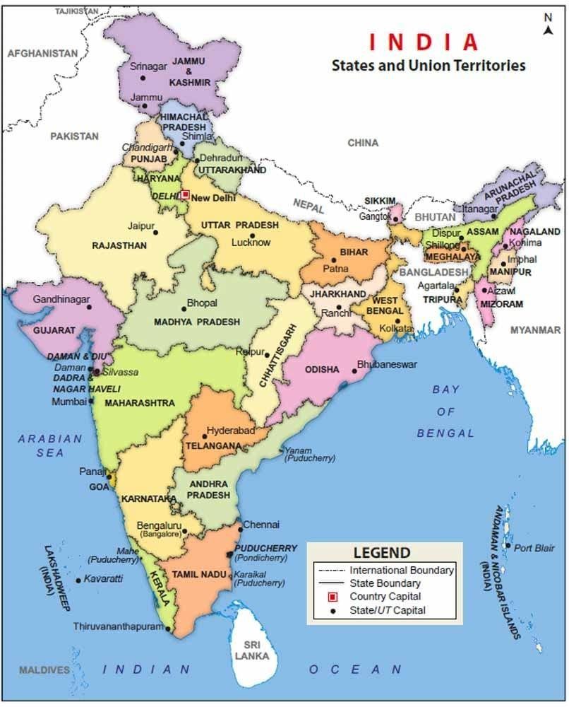
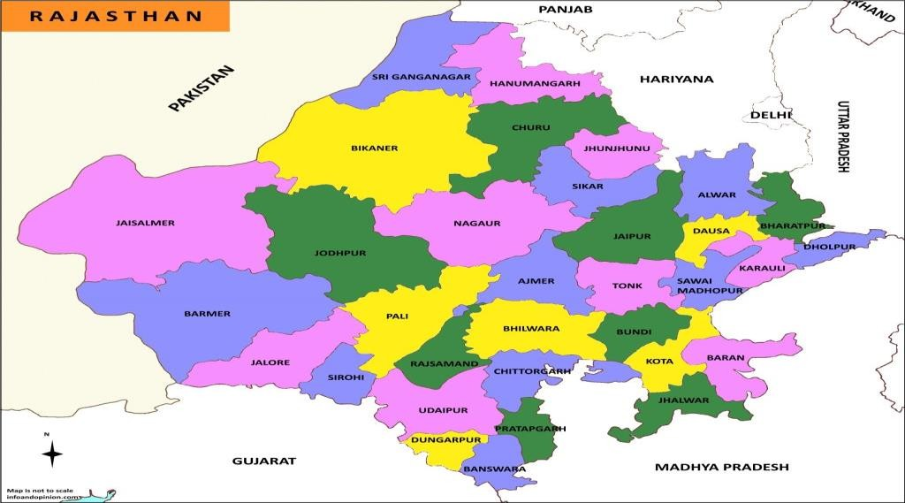
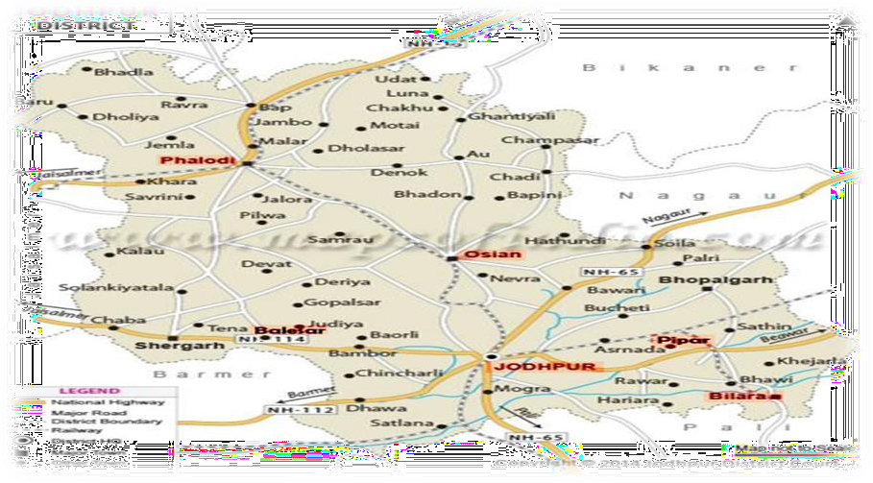
Materials and Methods

Fig. 1 Map of India, Rajasthan and Jodhpur

Study Area
The present investigation was conducted in the Balesar block of Jodhpur district, Rajasthan, India, located in the arid western plains of the Thar Desert. Geographically, the study area lies between 26°22′ N latitude and 72°29′ E longitude at an elevation of approximately 230 m above mean sea level (Fig.1). The region falls under Agro-climatic Zone IA (Arid Western Plains), characterized by hot arid climatic conditions. The climate is marked by extreme temperature variations, with summer temperatures reaching up to 49°C and winter temperatures dropping to approximately 1°C. The mean annual rainfall ranges between 300 and 360 mm, of which nearly 85% is received during the southwest monsoon (July to September). The soils of the region are predominantly sandy to sandy loam in texture, well-drained, and low in organic matter content.

Soil Sampling and Processing
A total of 60 surface soil samples (0–15 cm depth) were collected during June 2021 from three distinct land use systems, namely irrigated cropland, rainfed cropland, and pasture land, with 20 samples from each category. Soil samples were collected randomly using a khurpi by adopting a ‘V’-shaped sampling pattern. At each sampling location, several subsamples were collected and composited to obtain a representative sample. The geographical coordinates of sampling sites were recorded using a Global Positioning System (GPS). The collected samples were air-dried under shade conditions, gently ground using a wooden pestle, and passed through a 2 mm sieve prior to laboratory analysis.
Analytical Methods
The soil samples were analyzed for selected physico-chemical properties using standard procedures as described below.
Physical Properties
Bulk density (BD) and particle density (PD) were determined using the pycnometer method (Black et al., 1965). Water holding capacity (WHC) was estimated by the Keen box method following the procedure described by Piper (1966).
Chemical Properties
Soil pH was determined in a 1:2.5 soil-water suspension using a digital pH meter (Jackson, 1973). Electrical conductivity (EC) was measured in the same extract using a conductivity meter and expressed in dS m⁻¹ (Jackson, 1973). Organic carbon (OC) content was determined by the wet oxidation method as described by Walkley and Black (1934).
Calculation of Organic Carbon
$$OC(\%)=\frac{(B-S)×0.003×10×100}{B×W}$$
where B is the volume of ferrous ammonium sulphate used for blank titration (mL), S is the volume used for sample titration (mL), and W is the weight of soil sample (g).
Statistical Analysis
The experimental data were subjected to descriptive statistical analysis to evaluate the variation in soil physico-chemical properties under different land use systems. Mean values were calculated and used for comparative assessment.
Result and Discussion
Physico-chemical properties of soil under different land use systems
Land use systems play a significant role in influencing soil physico-chemical properties, particularly in arid and semi-arid ecosystems where soil formation processes are slow and management practices strongly affect soil quality. In the present study, variations in bulk density (BD), particle density (PD), water holding capacity (WHC), soil reaction (pH), electrical conductivity (EC), and organic carbon (OC) were observed under irrigated cropland, rainfed cropland, and pasture land in the Balesar block of Jodhpur district (Table 1).
Table 1. Physico-chemical properties of soil under different land use systems
Parameter | Irrigated Cropland (Mean) | Rainfed Cropland (Mean) | Pasture Land (Mean)
BD (Mg m⁻³) | 1.52 | 1.56 | 1.55
PD (Mg m⁻³) | 2.63 | 2.67 | 2.62
WHC (%) | 26.51 | 25.00 | 26.27
pH | 8.09 | 8.00 | 7.93
EC (dS m⁻¹) | 0.343 | 0.215 | 0.243
OC (%) | 0.19 | 0.13 | 0.18

Soil Reaction (pH)
The soils of the study area were found to be slightly to moderately alkaline, with pH values ranging from 7.36 to 8.32 (fig. 2). The mean soil pH was highest in irrigated cropland (8.09), followed by rainfed cropland (8.00) and pasture land (7.93). The higher pH under irrigated conditions may be attributed to the accumulation of soluble salts and exchangeable bases due to continuous irrigation and limited leaching in arid environments. Alkaline soil reaction is a common characteristic of arid region soils because of high evapotranspiration and low rainfall. Similar observations were reported by Brady and Weil (2008), who indicated that arid soils often show alkaline reaction due to accumulation of basic cations such as calcium and magnesium. Comparable findings were also reported by Kumar et al. (2021) in hot arid soils of Rajasthan.
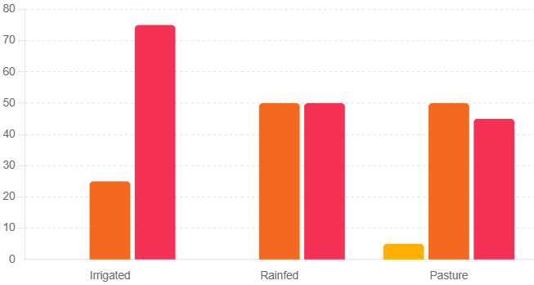Figure 2: Soil pH under different land use systems
Electrical Conductivity (EC)
Electrical conductivity of soils ranged from 0.089 to 0.621 dS m⁻¹ across different land use systems. The mean EC was highest in irrigated cropland (0.343 dS m⁻¹), followed by pasture land (0.243 dS m⁻¹) and rainfed cropland (0.215 dS m⁻¹). The relatively higher EC in irrigated soils may be due to the addition of irrigation water and fertilizer inputs which can contribute to the accumulation of soluble salts. However, all soils were within the non-saline category (<2 dS m⁻¹), indicating no salinity hazard for crop production. These findings are in agreement with Richards (1954), who reported that soils having EC values below 2 dS m⁻¹ are generally considered non-saline and suitable for agricultural crops.
Bulk Density (BD)
Bulk density varied from 1.40 to 1.63 Mg m⁻³ among the different land use systems. The lowest mean bulk density was observed in irrigated cropland (1.52 Mg m⁻³), while rainfed cropland showed the highest value (1.56 Mg m⁻³), followed by pasture land (1.55 Mg m⁻³). Lower bulk density in irrigated soils may be attributed to better soil management practices, higher organic matter content, and improved aggregation resulting from irrigation and crop residue addition. In contrast, relatively higher bulk density in rainfed soils may be associated with lower organic matter content and compaction. These results are consistent with the findings of Hillel (2004), who reported that soil bulk density decreases with increasing organic matter and improved soil structure. Similar trends were also observed by Gurjar et al. (2017) in soils of Bhilwara district, Rajasthan.
Particle Density (PD)
Particle density ranged from 2.36 to 2.94 Mg m⁻³, with mean values of 2.63, 2.67, and 2.62 Mg m⁻³ for irrigated cropland, rainfed cropland, and pasture land, respectively. The variation in particle density among land use systems was relatively small, indicating that particle density is largely influenced by the mineral composition of the soil rather than land use practices. According to Brady and Weil (2008), particle density of mineral soils generally ranges from 2.60 to 2.75 Mg m⁻³ and is primarily controlled by soil mineralogy.
Water Holding Capacity (WHC)
Water holding capacity varied from 15.42 to 34.01% among the soil samples. The mean WHC was slightly higher in irrigated cropland (26.51%) and pasture land (26.27%) compared to rainfed cropland (25.00%). Higher WHC in irrigated and pasture soils may be attributed to better soil aggregation and relatively higher organic matter content, which enhances the soil’s ability to retain water. Soil texture and organic matter are considered the major factors influencing water retention characteristics of soils, as reported by Hillel (2004).
Organic Carbon (OC)
Organic carbon content ranged from 0.01 to 0.31% across the different land use systems. The highest mean OC was observed in irrigated cropland (0.19%), followed by pasture land (0.18%) and rainfed cropland (0.13%). All soils were categorized as low in organic carbon (<0.5%). The low organic carbon content may be attributed to arid climatic conditions, characterized by high temperature, low rainfall, and sparse vegetation cover, which accelerate the decomposition of organic matter and reduce organic carbon accumulation. Similar findings were reported by Lal (2004), who stated that soil organic carbon levels are generally low in arid and semi-arid regions due to rapid mineralization and limited biomass input. Likewise, Panwar et al. (2016) reported low organic carbon content in arid soils of western Rajasthan due to coarse soil texture and limited organic matter addition.

Correlation among physico-chemical properties of soil
Correlation analysis among bulk density (BD), particle density (PD), water holding capacity (WHC), soil pH, electrical conductivity (EC) and organic carbon (OC) revealed that soil properties were closely related to each other under different land use systems. Bulk density showed negative association with organic carbon and water holding capacity, indicating that soils having higher organic matter content possess better aggregation and lower compaction. Water holding capacity exhibited positive correlation with organic carbon, suggesting that organic matter improves moisture retention in sandy soils of arid regions. Soil pH and electrical conductivity showed positive relationship, which may be due to accumulation of soluble salts and basic cations under irrigated conditions. Particle density showed very little correlation with other parameters, indicating that it is mainly controlled by mineral composition rather than management practices. Overall, the correlation results indicate that organic carbon plays an important role in improving soil physical condition and moisture retention, while land use and irrigation practices influence soil reaction and salt concentration in arid soils. Similar relationships among soil properties have also been reported by Brady and Weil (2008) and Hillel (2004), who stated that soil organic matter and management practices are the key factors controlling soil physical and chemical behaviour.
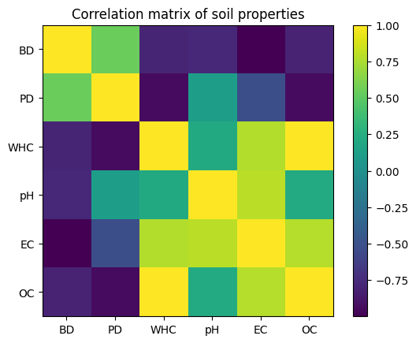
Correlation matrix of soil properties

Conclusion
The study clearly demonstrated that land use systems significantly influence the physico-chemical properties of soils in the arid region of western Rajasthan. Irrigated cropland showed comparatively better soil physical condition with lower bulk density and higher water holding capacity, while rainfed soils exhibited higher compaction and lower moisture retention. All soils were slightly to moderately alkaline and non-saline, which is typical of arid environments. Organic carbon content was low in all land use systems, indicating poor organic matter accumulation under harsh climatic conditions.
Correlation analysis revealed that organic carbon plays a key role in improving soil structure and water retention, whereas bulk density showed an inverse relationship with soil quality parameters. The results suggest that proper land management practices, including efficient irrigation and addition of organic residues, are essential to maintain soil fertility and sustainability in arid regions. The findings provide useful information for sustainable land use planning and soil resource management in western Rajasthan.

COMPETING INTERESTS DISCLAIMER:
Authors have declared that they have no known competing financial interests OR non-financial interests OR personal relationships that could have appeared to influence the work reported in this paper.

References
- Blair, G. J., Lefroy, R. D. B., & Lisle, L. (1995). Soil carbon fractions based on their degree of oxidation and the development of a carbon management index for agricultural systems. Australian Journal of Agricultural Research, 46(7), 1459–1466. https://doi.org/10.1071/AR9951459
- Brady, N. C., & Weil, R. R. (2017). The nature and properties of soils (15th ed.). Pearson Education, Inc.
- Brady, N. C., and Weil, R. R. (2008). The Nature and Properties of Soils. 14th ed. Pearson Education, New Jersey.
- Fallahzadeh, R. A., & Hajabbasi, M. A. (2010). The effects of irrigation on soil physical and chemical properties in arid regions of Iran. Geoderma, 159(1–2), 1–8. https://doi.org/10.1016/j.geoderma.2010.07.003
- Goyal, R. K., Singh, H., & Sharma, S. (2013). Climate variability and its impact on agriculture in arid regions of India. Indian Journal of Agricultural Sciences, 83(3), 255–260.
- Gregorich, E. G., Carter, M. R., Angers, D. A., Monreal, C. M., & Ellert, B. H. (1994). Towards a minimum data set to assess soil organic matter quality in agricultural soils. Canadian Journal of Soil Science, 74(4), 367–385. https://doi.org/10.4141/cjss94-051
- Gurjar, R., Yadav, B. L., and Choudhary, R. (2017). Assessment of soil fertility status under different land use systems in Bhilwara district of Rajasthan. Journal of the Indian Society of Soil Science, 65(4), 421–427.
- Hillel, D. (2004). Introduction to Environmental Soil Physics. Elsevier Academic Press, San Diego.
- Intergovernmental Panel on Climate Change (IPCC). (2000). Land use, land-use change, and forestry. Cambridge University Press.
- Jackson, M. L. (1973). Soil chemical analysis. Prentice Hall of India Pvt. Ltd., New Delhi.
- Kebebew, Z., Alemayehu, M., & Tesfaye, B. (2022). Effects of land use change on soil physicochemical properties: A review. Environmental Systems Research, 11(1), 15. https://doi.org/10.1186/s40068-022-00248-9
- Kumar, S., Meena, R. S., and Yadav, R. S. (2021). Soil fertility status under different land use systems in hot arid region of Rajasthan. Journal of Soil Science and Plant Nutrition, 21, 1752–1763.
- Lal, R. (1995). Sustainable management of soil resources in the tropics. Soil Science, 160(1), 1–15. https://doi.org/10.1097/00010694-199501000-00001
- Lal, R. (2004). Soil carbon sequestration impacts on global climate change and food security. Science, 304, 1623–1627.
- Maddoni, G. A., Otegui, M. E., & Cirilo, A. G. (1999). Plant population density, row spacing and hybrid effects on maize canopy architecture. Agriculture, Ecosystems & Environment, 72(3), 255–265. https://doi.org/10.1016/S0167-8809(99)00074-9
- Mahesh Kumar, M., Yadav, R. S., & Singh, B. (2017). Soil fertility status under different land use systems in arid regions of Rajasthan. Journal of Arid Environments, 140, 1–10. https://doi.org/10.1016/j.jaridenv.2017.01.005
- Olsen, S. R., Cole, C. V., Watanabe, F. S., & Dean, L. A. (1954). Estimation of available phosphorus in soils by extraction with sodium bicarbonate. USDA Circular No. 939.
- Pandey, C. B., Singh, J. S., & Singh, R. P. (2010). Soil nitrogen and carbon dynamics in agricultural ecosystems. Agriculture, Ecosystems & Environment, 139(3), 271–280. https://doi.org/10.1016/j.agee.2010.08.012
- Panwar, N. R., Sharma, V., and Yadav, B. L. (2016). Soil fertility evaluation of arid soils under different land use systems of western Rajasthan. Annals of Arid Zone, 55(3), 151–158.
- Ram, B. (2009). Land use pattern and agricultural development in India. Indian Journal of Agricultural Economics, 64(3), 456–468.
- Rao, A. S., & Roy, M. M. (2012). Rainfall variability and drought occurrence in arid Rajasthan. Journal of Climate Research, 26(2), 123–130.
- Rathee, S. (2014). Land resource management and sustainable development in India. Economic Affairs, 59(3), 321–326. https://doi.org/10.5958/0976-4666.2014.00018.5
- Richards, L. A. (1954). Diagnosis and Improvement of Saline and Alkali Soils. USDA Handbook 60. United States Department of Agriculture, Washington, D.C.
- Sharma, S. K., Bhandari, S. C., & Sharma, R. (2006). Soil properties and fertility status of Jodhpur district of Rajasthan. Annals of Arid Zone, 45(2), 123–130.
- Singh, R., Singh, H., & Kumar, A. (2007). Soil conservation practices in arid regions of India. Indian Journal of Soil Conservation, 35(1), 1–8.
- Subbiah, B. V., & Asija, G. L. (1956). A rapid procedure for estimation of available nitrogen in soils. Current Science, 25, 259–260.
- Walkley, A., & Black, I. A. (1934). An examination of the Degtjareff method for determining soil organic matter. Soil Science, 37(1), 29–38. https://doi.org/10.1097/00010694-193401000-00003
- Woomer, P. L., Touré, A., Sall, S., & Karanja, N. (2004). Carbon sequestration and organic matter dynamics in arid soils. Soil Biology and Biochemistry, 36(1), 65–72. https://doi.org/10.1016/j.soilbio.2003.08.009

