Original Research Article

Uses and conservation practices of two plants with melliferous potential in the Binah prefecture of Togo: Vitex doniana Sweet (Lamiaceae) and Diospyros mespiliformis Hochst. ex A. DC. (Ebenaceae)

.
ABSTRACT

Background: The Sudanese savannas of Togo are rich in wild fruit trees with significant beekeeping and socioeconomic potential, including Vitex doniana Sweet and Diospyros mespiliformis Hochst. These natural melliferous resources are overexploited in certain areas of the country, thus reducing their ecosystem benefits.
Aims: This study, conducted in the Binah prefecture, contributes to improving the sustainable management of spontaneous woody resources.
Methodology: Ethnobotanical data were collected through semi-structured individual interviews and focus groups with a sample of 205 people. These interviews were conducted using a pre-established questionnaire or an interview guide, allowing for the targeting of individuals with proven knowledge of the species or resource persons designated by the groups.
Result: The seven (7) uses of Vitex doniana and Diospyros mespiliformis reported by local populations are: food, medicinal, fodder, timber, fuelwood, crafts, and oral hygiene. Food use was the most frequently cited. Conservation in agroecosystems and home gardens is identified as a key local strategy for managing natural resources. The vulnerability of these two species is a combined consequence of their high use value and their limited local domestication.
Conclusion: It is imperative to provide technical and financial support to local communities in implementing sustainable management strategies for these natural resources of high ecosystem value.

Keywords: Uses, Conservation strategies, Vitex doniana, Diospyros mespiliformis, Binah, Togo.

1. INTRODUCTION

In Africa, local populations are extremely dependent on products derived from spontaneous vegetation, such as non-timber forest products (NTFPs) (Ali et al., 2021). Beyond agriculture, livestock farming, and fishing, the harvesting of NTFPs constitutes an important source of income, food, and medicine for rural communities (Mawunu et al., 2017; Tchatchambe et al., 2017a, b; Mawunu et al., 2019; Masengo & Ngbolua, 2022). Wild fruit trees are natural resources that play a vital role in the daily lives of these rural communities. Today, they occupy a significant place in the food, pharmaceutical, and medicinal industries worldwide (Mapongmetsem et al., 2012; Idohou et al., 2013). The resources derived from these fruit trees constitute important dietary supplements during lean periods (Diarra et al., 2016; Daanon et al., 2021).
However, these wild fruit trees are subjected to enormous anthropogenic pressures due to overexploitation (Sinsin et al., 2004; Akpona et al., 2009). Poor harvesting practices also lead to the risk of extinction of these local species. This degradation of natural vegetation is increasingly exacerbated by the harvesting of plant parts, particularly for medicinal (Faye, 2010) and energy purposes. Wild plant resources continue to degrade at an alarming rate, hence the need for new strategies for the sustainable management of natural resources, especially wild fruit trees. Several research projects have been initiated worldwide to enhance the value of natural resources, particularly the sustainable management of wild fruit trees (Akpona et al., 2009; Akpavi et al., 2013; Dipama et al., 2019). Indeed, local knowledge of wild plant species is crucial for boosting the socioeconomic resilience of communities in the face of climate change (Bellefontaine, 2010; Mapongmetsem et al., 2012; Garba et al., 2019).
Among these natural resources, our study focused on the black plum (Vitex doniana Sweet) and the African ebony (Diospyros mespiliformis Hochst. Ex A. DC), two wild fruit species with a wide distribution, belonging respectively to the Lamiaceae (V. doniana) and Ebenaceae (D. mespiliformis) families according to the APG III classification. These are multi-purpose resources recognized for their medicinal, nutritional, and beekeeping properties. They constitute excellent nectar sources for bees, with flowers, fruits, and leaves used locally. In traditional medicine, these two species are used to treat several illnesses, including malaria, diarrhea, and anemia (Mapongmetsem et al., 2008; Kouagbede, 2020; Ali et al., 2021).
In Togo, particularly in the Binah prefecture, these two species have very strong socio-cultural values. Despite their socio-economic importance in the lives of local communities, little information is available on their conservation status, ecological value, and vulnerability. Furthermore, they are subject to multiple degradation factors, primarily anthropogenic, in the Binah prefecture. Given the persistent degradation of the vegetation cover of these two species due to human activities (Binah PIT-DD, 2015). The implementation of a sustainable management policy is becoming essential.
The overall objective of this study is to promote local knowledge on the conservation and sustainable management of natural resources in the Binah Prefecture. Specifically, it aims, firstly, to determine the different ways in which V. doniana and D. mespiliformis are used by communities in the Binah Prefecture, and secondly, to identify conservation strategies for these two species in this prefecture of Togo.

2. material and methods

2.1 Study Area

The Binah Prefecture is located between 9°30' North latitude and 1°25' East longitude. It is bordered to the north by the Doufelgou Prefecture, to the south by the Kozah Prefecture, to the east by the Republic of Benin, and to the west by the Kozah and Doufelgou Prefectures (Figure 1).
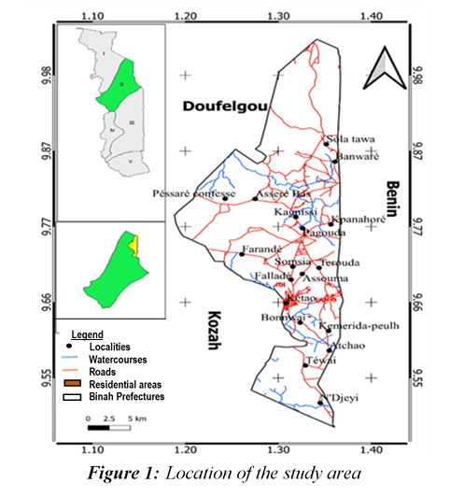
This study area has a highly varied topography and diverse soils. The Binah prefecture is drained by the Binah River. The climate is Sudano-Guinean, characterized by two distinct seasons. Rainfall varies between 1100 and 1700 mm annually. Average annual temperatures range from 17° to 27°C. The vegetation is characterized by a predominantly herbaceous savanna with some remnants of gallery forests (Binah PIT-DD, 2015). Covering an area of 534.7 km², the Binah prefecture has a population of 84,199 inhabitants, with a density of 157.5 inhabitants/km² (Regional Directorate of Statistics, 2022). It is dominated by the Kabye (79.80%), followed by minority ethnic groups such as the Solla, Logba, Kotokoli, and Fulani (PIT-DD of Binah, 2015).

2.2 Study Method

2.2.1 Ethnobotanical Surveys

A preliminary survey was conducted to determine the GPS coordinates of the localities in the study area. Information was obtained from the populations of 18 villages distributed across 7 cantons in the two communes of the Binah prefecture (Figure 2).
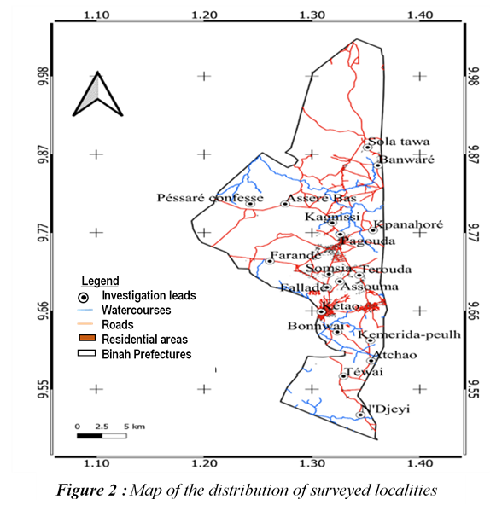

These locations were chosen based on sampling guided by the presence of these species (Uprety et al., 2012; Garba et al., 2019). Two criteria were used to select the locations: the first was the actual presence of both species in the location, and the second was the presence of signs or evidence of harvesting of woody parts (wood, bark, roots).

2.2.2 Data Collection

Data were collected through focus groups using an interview guide designed to target individuals with proven knowledge of the species or resource persons designated by the groups (Ali et al., 2021), as well as through individual interviews using a pre-established questionnaire. The questionnaire primarily inquired about the respondent's age, sex, ethnicity, occupation or main activity, level of education, and place of origin. The questions about the species relate to the various forms of use, the organs used and their preservation methods, the availability of organs, the status of the population, the different threats facing these species, and the conservation and restoration strategies. The questionnaires are administered in the local language, Kabye, to ensure that respondents understand the questions.

2.3. Data Analysis and Processing

The collected data were entered and processed using Microsoft Excel® 2016. Ethnobotanical indices, as defined by previous work (Assogba et al., 2017), are calculated using the following formulas:
• Citation Frequency (CF)
FC = $\frac{Number of citations from a part }{Total number of respondents}$ × 100
• The total number of reported uses for the plant (reported use, RU) is equal to the sum of the reported uses per plant part: RU = Σ RUplant part.l

3. results and discussion

3.1 Results

3.1.1 Respondent Profile

The surveys included a total of 205 people in the study area. Categorizing all respondents allowed us to present their percentage representation based on factors such as ethnicity, education level, occupation, age, and sex. The majority of respondents were Kabye. Most of these individuals were farmers with a primary school education. More men than women responded to the questionnaires (Table 1).

Table 1. Distribution of Respondents According to Certain Social Criteria

Criteria evaluated | Ethnic group |  |  |  | Level of education
Investigators | Kabyè | Kotokoli | Peulhs | Sola | Primary | Secondary | Illiterate
Rate (%) | 71 | 7 | 17 | 5 | 46.82 | 20 | 32.68
Criteria evaluated | Profession |  |  |  | Age range
Investigators | Farmers | Resellers | Housewives | Artisans | 20 - 39 | 40 – 59 | ≥ 60
Rate (%) | 38.5 | 33.17 | 9.76 | 5.37 | 45.54 – 47.12 | 40.38 – 49.59 | 12.50 – 13.86
Criteria evaluated | Sex
Investigators | Woman | Man
Rate (%) | 42.93 | 57.07

3.1.2 Used Plant Parts of V. doniana and D. mespiliformis and Their Areas of Use

A total of twenty (20) specific uses of the species D. mespiliformis and sixteen (16) of V. doniana were identified by the respondents and grouped into seven (7) areas. These species are used for food, crafts, medicine, animal feed, construction timber, fuelwood, and as toothpicks. Only six (6) plant parts are used in both species, namely: the trunk, the leaf, the fruit, the branch, the trunk bark, and the root (Figures 3 and 4).

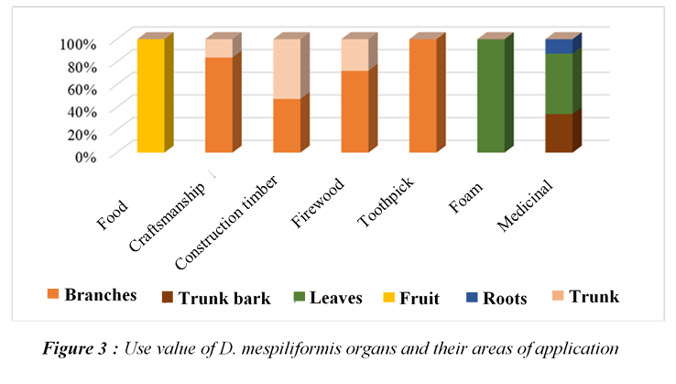
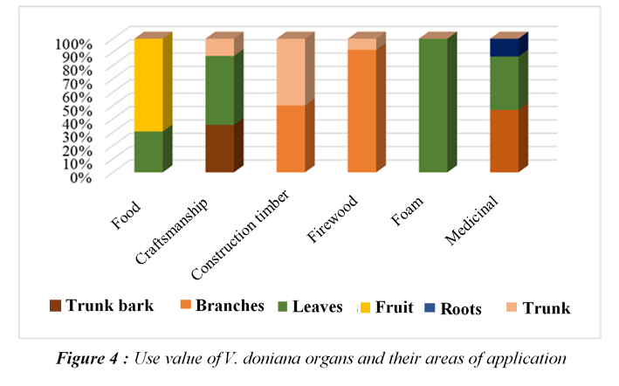

Analysis of Figure 4 also shows that in D. mespiliformis, the branches are the most used plant parts (4 uses: crafts, timber, fuelwood, and toothpicks), followed by the trunk (3 uses: crafts, timber, and fuelwood). In contrast, in V. doniana, the leaves have the most uses (4 uses: crafts, food, fodder, and medicinal), followed by the trunk (3 uses: crafts, timber, and fuelwood).

3.1.2.1 Food Uses

In this area, all respondents stated that they only use the fruits of D. mespiliformis. Whereas with V. doniana, in addition to the fruits, which are used by 69.47% of respondents, the leaves are also used (30.53%).
3.1.2.2 Medicinal Uses
In this area, women have more knowledge about both plants (67.57%). Three (3) types of organs are used in both plants: leaves, trunk bark, and roots. In terms of frequency, leaves are the most used (63.19%), followed by trunk bark (34.04%) for D. mespiliformis, while in V. doniana, bark (46.67%) is used, followed by leaves (40%) (Figure 5).
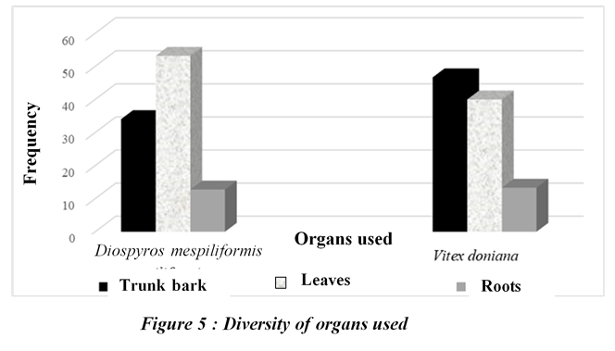
A total of thirteen (13) diseases were identified, eight (8) of which were treated with V. doniana and five (5) with D. mespiliformis. The most frequently reported ailments and symptoms were malaria (52.17%) and diarrhea (39.13%) for D. mespiliformis. In contrast, body rashes (35.71%) and anemia (21.43%) were the diseases most often treated with V. doniana (Figure 6).

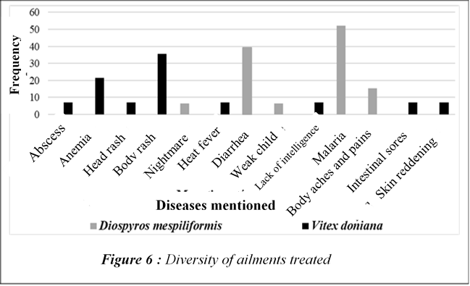

In general, the preparation methods recorded were: decoction, calcination, and maceration. Decoction is the most commonly used method. Various methods of drug administration were also identified: oral administration and body baths are used with D. mespiliformis; cutaneous and local application are used for V. doniana.
Indeed, according to respondents, with D. mespiliformis, local or oral administration of decocted leaves cures malaria; these young leaves, bark, or roots are crushed fresh and drunk, or preferably roasted with millet powder and sucked to stop diarrhea. A decoction of the bark and roots is also used to treat malaria. Regarding V. doniana, not only is a decoction of the bark and roots drunk to combat anemia, but it is also used in combination with the bark of Parkia biglobosa (African locust bean) and Khaya senegalensis to treat intestinal wounds. The leaf buds are harvested, then decocted and used as a bath, or roasted in a mixture with natural oil and applied to the body to treat skin conditions.
3.1.2.3 Artisanal Uses
In total, 30.69% (V. doniana) and 29.81% (D. mespiliformis) of respondents use these plants in this context. Respondents use only the trunk, leaves, and bark of V. doniana, with the leaf being the most frequently used part (51.61%); in contrast, only the branches (83.87%) and trunks (16.13%) are used for D. mespiliformis (Figure 7).

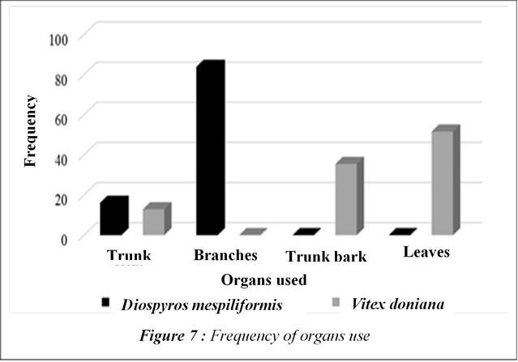

The wood of D. mespiliformis is used to make clubs, agricultural handles, yokes, walking sticks, poultry cages, pestles, and mortars. The club (27.81%) is the most frequently cited item (Figure 8). Along with V. doniana, the trunk of the tree is used to make drums; its leaves and bark are prepared to obtain writing ink (Figure 8, Photos 1 and 2).

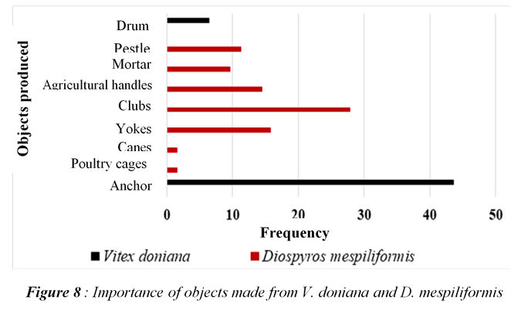
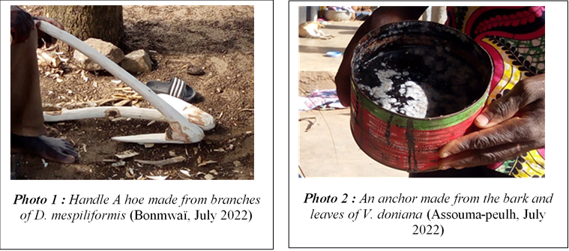

3.1.2.4 Forage Use
This area received few responses from respondents (0.99% for V. doniana and 14.42% for D. mespiliformis). The leaves remain the most commonly used part for forage. They are harvested by cutting and fed to tethered goats and sheep. The fruits of both species, once ripe, fall easily and are highly valued by livestock, especially cattle in the case of D. mespiliformis.
3.1.2.5 Fuelwood and Construction Wood Use
The V. doniana plant is more frequently mentioned in the fuelwood category than in the construction category, with the branch being the most commonly used part (86.84%). The wood is used in households for cooking and also for sale. As for the D. mespiliformis plant, the branches are the most commonly used parts. Its timber is sawn to obtain the rafters and planks used for formwork and building construction (Figure 9)

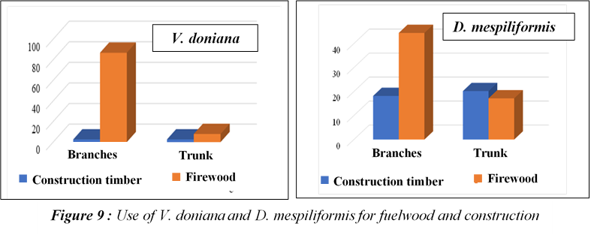

3.1.2.6 Sociocultural Considerations
The D. mespiliformis plant is considered a family fetish by some Kabye people. Indeed, rituals are performed under the tree by family members to obtain favors. For them, their ancestors reside within it. Also among the Kabye, the tree's branches are cut to obtain a club-shaped spear called Agaraou, used by the young initiate « Evalou » who has just entered the adult community. This tool is the only weapon of defense during the initiation period. As for V. doniana, the Fulani consider it the « tree of intelligence ». They claim that using the ink obtained from the plant to write the Holy Quran awakens the human mind, and its decoction is given to those deemed unintelligent to drink.
3.3. Conservation of Vitex doniana and Diospyros mespiliformis
3.3.1 Local population perceptions of natural population dynamics of the two species
Almost all respondents are local people. All categories of respondents state that D. mespiliformis and V. doniana are found in the wild and are aware of the decline in the populations of these two species. The reasons for this decline are primarily anthropogenic: excessive logging, agriculture (93.17%), and bushfires (29.81%). However, 38.46% of respondents believe that very small seedlings and shoots of D. mespiliformis are present in natural environments (mountains and riverbanks). 21.78% of respondents also stated that V. doniana is conserved along riverbanks.
3.3.2 Conservation of Plant Parts
All respondents use both plants. However, 98.07% of respondents stated that they do not preserve the plant parts they use, being aware that not all parts are available year-round. Among them, 16.83% pay for V. doniana parts and 14% for D. mespiliformis parts. The remaining respondents dry the fruits of D. mespiliformis (1.92%) and the leaves of V. doniana after cooking (5.94%). These parts (fruit and leaves) are stored in jerrycans or plastic bags for use during periods of scarcity.
The population stated that temporary parts (fruit, flowers, and leaves) are used only when available, while other parts are harvested at any time on the plant.
3.3.3 Preservation of the Whole Plant
Three forms were provided by respondents for these two species. These are:
- Conservation of the species in agroforestry parks,
- Conservation in front of the house,
- Conservation in the backyard.
The second conservation method is the most common. It is adopted by 37.5% for D. mespiliformis and 21.78% for V. doniana (Table 2).

Table 2. Relative frequency of preservation methods

Conservation strategies | Diospyros mespiliformis (%) | Vitex doniana (%)
Floor in agricultural parks | 1,92 | 7,92
Floor in front of the house | 37,5 | 21,78
Floor in home gardens | 0 | 1,98

The local population explains that the tree preserved in front of their house (Photo 3) provides shade, creating a place to rest. Other reasons were given depending on the location of the trees (preservation in fields and in gardens). Unfortunately, these trees are most often pruned in fields.
Observations during surveys and botanical inventories showed that many D. mespiliformis trees are present in the mountains, particularly in the localities of Pessaré, Farendè, and Asséré. This preservation is also observed in sacred places (family or community sacred forests) and burial sites. Some D. mespiliformis trees (3 to 5) are present in the small markets of certain villages: the Pessaré market in Pessaré, the Kadjanga market in Pagouda, and the Tchalaidè market in Sirka.
Information was also gathered from six (6) village chiefs regarding the current state of preservation. They assert that no initiative has yet been taken to restore the stands of the two species. Nevertheless, some stands exist in their natural (unplanted) state within the newly established community forests and have the same protection rights as the companion species.

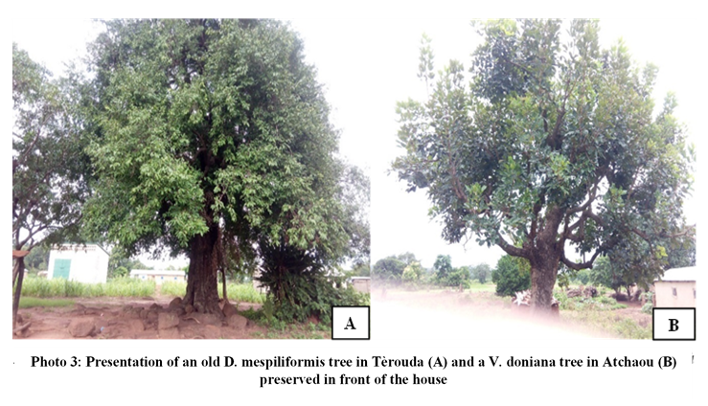
3.2 Discussion

3.2.1 Uses of V. doniana and D. mespiliformis
This study has shown that V. doniana and D. mespiliformis are multi-purpose species in rural areas of the Binah prefecture in Togo. Twenty (20) and sixteen (16) specific uses were reported by the communities for D. mespiliformis and V. doniana, respectively. These two species are used relatively less than other local species in Togo, such as Khaya senegalensis (Kouagbede, 2020; Issa et al., 2018) or Sterculia setigera (Atakpama W., 2010). The differences in terms of value and diversity of uses are probably linked to the specificity of the species used and the cultural variability of the study area.
The reported uses are: food, medicinal, crafts, animal feed, construction timber, fuelwood, and toothpicks. The types of plant organs used are: the trunk, leaf, fruit, branch, bark, and root. The results of our research corroborate, in terms of plant organ diversity, those of Garba et al. (2019), conducted on Tamarindus indica in Niger. In the food sector, the fruit is the most used organ for both plants in the Binah region. Similar results were reported by Adomou et al. (2009) in Benin in their study on Annona senegalensis. Indeed, due to the nutritional value of the fruits of V. doniana and D. mespiliformis, they are essential for human health and well-being, particularly in rural areas (Ebbo et al., 2020; Ebbo et al., 2022). The branches and leaves are the most valued parts of these multifunctional fruit trees. However, these organs are obtained through pruning, which disrupts the plants' vegetative cycle. Medicinally, eight reported human ailments are treated with V. doniana and five with D. mespiliformis. However, this list is relatively small compared to the more than 32 diseases treated with V. doniana in Benin (Gbenou, 2014), or the more than 29 diseases reported by Ali et al. (2021) in studies conducted in Niger on D. mespiliformis that are not included in our study. Nevertheless, the organs used for treatment—leaves, bark, and roots—in our study are all cited by these authors. These different organs of both plants, D. mespiliformis and V. doniana, are used to treat malaria and diarrhea; Body blemishes and anemia. Obtaining a sufficient quantity of hard-to-extract molecules like tannins explains this result. These various medicinal uses represent an asset for future exploration of several medicinal properties through ethnopharmacological studies. The area of use ranks second. This result is explained by the use of their wood by women in households for cooking and also for sale. This wood, obtained through felling and pruning, suggests strong anthropogenic pressure on these species.
3.2.2 Conservation of V. doniana and D. mespiliformis
For planned use, only the fruits of D. mespiliformis and the leaves of V. doniana, used by 1.92% and 5.94% respectively, are preserved by drying. These results show a near-total absence of preservation of the organs of these species in the area. This could be due to the low value placed on these species. Processing its dried parts allows for the production of powder, juice, or preserves, making them available year-round (Diarra et al., 2016). The lack of preservation of these parts could also be due to the low density of mature trees. Domestication of these plants (37.5% for D. mespiliformis and 21.78% for V. doniana) is the most common form of conservation in the prefecture.
In terms of local strategy, domestication is the most prevalent. These local species are kept in fields, gardens, and in front of houses to take advantage of their parts and the shade they provide. This form of local conservation is likely a palliative solution to their heavy use and ensures their availability. Cultural and artisanal values, intrinsically linked to traditions, add another dimension to the sustainable management of this natural resource. Indeed, both species also hold significant totemic value for certain communities. The dense stands in mountainous areas are due to the difficulty of accessing these resources. In this area, both plants grow wild while new community forests are being established through planting. This attitude demonstrates the lack of investment by the local population in the restoration of these two species. Therefore, integrating these two fruit trees into the agroforestry system is crucial in the Binah prefecture.
4. Conclusion

This study shows that the local population is familiar with V. doniana and D. mespiliformis and uses them in various ways. Food and fuelwood are the most frequently cited uses by respondents. The plant parts used include leaves, fruit, branches, trunk, bark, and roots. The fruit is the most commonly used part of both species for food. Harvesting their wood for fuel and construction poses a significant threat to the survival of these species. Logging and agricultural activities promote the establishment of invasive species.
Despite all the services these two fruit-bearing plants provide, they are not being cultivated. However, some residents have chosen to preserve them in front of their houses, in their fields, and in their gardens. These methods do not guarantee the future of these stands. Much effort must be made to ensure the long-term viability of these two plant resources. The only way to successfully conserve them is through the integration of these species into agroforestry.

COMPETING INTERESTS DISCLAIMER:
Authors have declared that they have no known competing financial interests OR non-financial interests OR personal relationships that could have appeared to influence the work reported in this paper.

References

Adomou, A. C., Mama, A., Missikpode, R., & Sinsin, B. (2009). Mapping and characterization flora of the Lokoli swamp forest (Benin). International Journal of biological and chemical sciences, 3(3), 492-503pp. [Fr.]
Akpavi, S., Kanda, M., Odah, K., Akpakpah, K. E., Kossi-Titrikou, K., Boutaré, I., & Akpagana K. (2013). Socio-cultural value of food plants: A preservation factor. European Scientific Journal, 9(32), 383-389pp. [Fr.]
Akpona, T. J. D., Glèlè Kakaï, R. L., & Akpona, A. H. (2009). Ethnobotany and plant species stand structure in southern and central Benin. Bulletin of Agronomic Research of Benin, 63, 1-12 pp. [Fr.]
Ali, A., Oumarou, M., Mounkaila, S., Mahamane, A., & Saadou, M. (2021). Farmers' perception of the use of Diospyros mespiliformis Hochst. Ex A. Rich in Niger. Journal of Applied Biosciences, 160, 16460-16474 pp. [Fr.]
Assogba, G. A., Fandohan, A. B., Salako, V. K., & Assogbadjo, A. E. (2017). Uses of Bombax costatum (Malvaceae) in the riparian areas of the Pendjari Biosphere Reserve, Republic of Benin. Tropical Woods & Forests, 333, pp. 17–29. [Fr.]
Atakpama, W. (2010). Study of Sterculia setigera Del. Formations in ecofloristic zone I of Togo: Structural and socio-economic aspects. DEA thesis. Togo: University of Lomé, Togo. 55 pp. [Fr.]
Bellefontaine, R. (2010). From domestication to varietal improvement of the argan tree (Argania spinosa L. Skeels)? Sécheresse, 21 (1): 42–53. [Fr.]
Daanon, A., Padonou, E., Akakpo, B., & Marcel, H. (2021). Variability in the uses of Diospyros mespiliformis Hochst. According to socio-demographic factors in northern Benin. Tropical Woods & Forests, 347, pp. 27–38. [Fr.]
Diarra, N., Togola, A., Denou, A., Willcox, M., Daou, C., & Diallo, D. (2016). Ethnobotanical study of food plants used during the lean season in the southern regions of Mali. International Journal of Biological and Chemical Sciences, 10(1), 184-197 pp. [Fr.]
Dipama, A., Savadogo, S., Zongo, B., Djomo, A., & Boussim, J. (2019). Conservation strategies and stand structure of Detarium microcarpum Guill. & Perr. in unmanaged protected forests of Ziro Province (Burkina Faso). Revue de l’Environnement et de la biodiversité-programme d’appui stratégique à la recherche scientifique, 4(2), 81-93 pp. [Fr.]
Ebbo A.A., D. Sani, M.M. Suleiman, A. Ahmed, A.Z. Hassan (2020). Acute and sub-chronic toxicity evaluation of the crude methanolic extract of Diospyros mespiliformis Hochst. ex A. DC. (Ebenaceae) and its fractions. Toxicol. Rep., 7, pp. 1138-1144.
Ebbo A.A., Sani D., Suleiman M.M., Ahmad A., Hassan A.Z. (2022). Assessment of antioxidant and wound healing activity of the crude methanolic extract of Diospyros mespiliformis Hochst. ex A. DC. (Ebenaceae) and its fractions in Wistar rats. South African Journal of Botany, 150, pp. 305-312.
Faye, E. H. (2010). Partial diagnosis of the flora and vegetation of the Niayes and the groundnut basin in Senegal: Application of floristic, phytosociological, ethnobotanical and cartographic methods. Doctoral thesis. Free University of Brussels, 253 pp. [Fr.]
Garba, A., Abdou, A., Abdou, L., & Mahamane, A. (2019). Perceptions and socioeconomic uses of tamarind (Tamarindus indica L.) in southwestern Niger: Implications for domestication and sustainable conservation, 40 (2), 6584-6602 pp. [Fr.]
Gbenou, B. (2014). Ethnobotanical study of Vitex doniana (Sweet) (Verbenaceae) in the commune of Bonou, Benin. EPAC/UAC, 48 pp. [Fr.]
Idohou, R., Assogbadjo, A. E., Fandohan, B., Gouwakinnou, G. N., Glele Kakai, R. L., Sinsin, B., & Maxted, N. (2013). National inventory and prioritization of crop wild relatives: Case study for Benin. Genetic Resources and Crop Evolution, 60(4), 1337–1352 pp.
Issa, I., Wala, K., Dourma, M., Atakpama, W., Kanda, M., & Akpagana, K. (2018). Ethnobotanical value of the species Khaya senegalensis (Desr.) A. Juss (Meliaceae) among the populations living along the Atacora mountain range in Togo. Moroccan Journal of Agronomic and Veterinary Sciences, 6(1), 64–72 pp. [Fr.]
Kouagbede, T. (2020). Ecology and distribution of Vitex doniana sweet (Lamiaceae) in the plateau region (Togo). Thesis, University of Lomé, Togo, p. 53. [Fr.]
Mapongmetsem, P. M., Hamawa, Y., Djeumene, P., Maissele, D., Kossebe, C. F., Ndoum, J. F., Nduryang, J. B., Bebbe, F., Bouba, D., Zigro, L., & Barbi, M. (2008). Valorization of wild food plants in the Sudanian-Guinean savannas of Cameroon. Proceedings of the International Conference. Eds. Kapseu, C., Mbofung, C.M. and Amvam Zollo, P. H. Ngaoundéré, Cameroon, pp. 50-61. [Fr.]
Mapongmetsem, P. M., Kapchie, V. N., & Tefempa, B. H. (2012). Diversity of Local Fruit Trees and Their Contribution in Sustaining the Rural Livelihood in the Northern Cameroon. Ethiopian Journal of Environmental Studies and Management, 5(1), 32-46pp.
Masengo, C. A., & Ngbolua, J.-P. K.-N. (2022). Ethnobotanical study and vulnerability of Vitex doniana Sweet (Lamiaceae) in the peri-urban forest of Gbado-Lite, Democratic Republic of Congo. Moroccan Journal of Agronomic and Veterinary Sciences, 10(1), 179-184pp. [Fr.]
Mawunu M., Eduardo A.S, Balomba P., Mohindo A.A., Bongo G., Ngbolua K.N. (2017). Food Security and Livelihood of Rural Households of Songololo Territory in Kongo Central Province, Democratic Republic of the Congo. International Journal of Health Economics and Policy 2(3): 97-103.
Mawunu M., Dionisio C.A., Lukoki L., Ngbolua, Luyindula N. (2019). Ethnobotanical and Socio-economics of Dracaena camerooniana Baker in Uíge Province, Northern Angola. Journal of Agriculture and Ecology Research International 20(2): 1-15.
Binah's PIT-DD. (2015). Territorial Integration Plan for the Sustainable Development of Binah prefecture, p. 18-22. [Fr.]
Sinsin B., Eyog Matig O., Assogbadjo A.E., Gaoue O.G and Sinadouwirou T. (2004). Dendrometric characteristics as indicators of pressure of Afzelia africana Sm. dynamic changes in trees found in different climatic zones of Benin. Biodiversity and Conservation 13:1555–1570.
Tchatchambe N.B.J., Solomo E.B., Kirongozi B.F., Lebisabo B.C., Dhed’a D.B., Tchatchambe W.B.J., Ngombe K.N., Mpiana P.T., Mbemba F.T., Ngbolua K.N. (2017a). Evaluation of the nutritional value and antinutritional factors of four wild food vegetables consumed in Kisangani and its surroundings (Tshopo Province, Democratic Republic of Congo). International Journal of Innovation and Scientific Research, 30: 75-90. [Fr.]
Tchatchambe N.B.J., Solomo E.B., Kirongozi B.F., Lebisabo B.C., Dhed’a D.B., Tchatchambe W.B.J., Ngombe K.N., Mpiana P.T., Mbemba F.T., Ngbolua K.N. (2017b). Nutritional and toxicological analyzes of three traditional food plants from Tshopo in the Democratic Republic of Congo. International Journal of Innovation and Scientific Research, 30: 105-118. [Fr.]
Uprety Y., Poudel R., Shrestha K., Rajbhandary S., Tiwari N., Asselin H. (2012). Diversity of use and local knowledge of wild edible plant resources in Nepal. Journal of ethnobiology and ethnomedicine. 8 (16) DO - 10.1186/1746-4269-8-16.

