Isolation and Characterization of native Pseudomonas isolates from mid and high hills of Uttarakhand and their evaluation against Fusarium oxysporum f. sp. lycopersici

ABSTRACT
Fluorescent Pseudomonas spp. are widely recognized for their potential as biocontrol agents against soil-borne phytopathogens However, information on the diversity and efficacy of native fluorescent Pseudomonas isolates from different agro-ecological regions of Uttarakhand remains limited. The present investigation was therefore carried out during 2025-26 in the Biocontrol Laboratory, Department of Plant Pathology, College of Hill Agriculture, Campus-Ranichauri, Tehri Garhwal, V.C.S.G. Uttarakhand University of Horticulture and Forestry, Uttarakhand, to isolate, characterize and evaluate fluorescent Pseudomonas spp. for their antagonistic potential against major soil-borne pathogens. Seventy rhizospheric soil samples were collected from seven districts (Tehri, Nainital, Pauri, Bageshwar, Uttarkashi, Almora and Chamoli) covering altitudes from 1370 m to 3200 m above mean sea level. Twenty-three fluorescent Pseudomonas isolates were obtained using the serial dilution technique on King’s B medium. All isolates tested positive for Catalase, KOH and Ammonification tests, while twelve showed positive reaction towards Starch hydrolysis. Antagonistic activity against major soil-borne pathogens was assessed through dual culture assay. Isolates PB1, PB4 and PS40 showed more than 75% inhibition of Fusarium oxysporum f.sp. lycopersici, while PU2 exhibited the highest inhibition against Rhizoctonia solani (94.44%) and PU1 was found most effective against Sclerotium rolfsii (86.67%) over control. Screening for biocontrol traits revealed that thirteen isolates produced hydrogen cyanide (HCN), while ten isolates showed siderophore production and phosphate solubilization. Promising putative candidates were further evaluated under glasshouse conditions against tomato wilt caused by F. oxysporum f.sp. lycopersici. Among the treatments, T5 (Fusarium inoculated soil +Seeds bioprimed with PB1) recorded the highest seed germination (93.33%), lowest disease incidence (10.00%) and the maximum disease reduction (90.00%) over T2 (Negative control). The study concludes that isolate PB1 is a potent biocontrol agent with significant potential for managing tomato wilt caused by Fusarium oxysporum f.sp. lycopersici.
Keywords: Biocontrol; Pseudomonas; Rhizospheric soil; Antagonistic activity; Tomato wilt; Fusarium oxysporum f.sp. lycopersici

Introduction
Beneficial microorganisms present in soil play a crucial role in sustainable agriculture by improving soil health, enhancing nutrient availability, and suppressing plant pathogens. Among microorganisms, plant growth-promoting rhizobacteria (PGPR) have gained significant attention for their ability to colonize the rhizosphere and support plant growth through multiple mechanisms (de Sosa et al., 2023). PGPR enhance crop growth, yield and stress tolerance by increasing nutrient uptake from the soil and through a variety of mechanisms such as phosphate solubilization, siderophore production, biological nitrogen fixation, phytohormone production, antifungal activity, and induction of systemic resistance (Abd El-Mageed et al., 2022). Species of Pseudomonas represent an important group of plant growth-promoting rhizobacteria (PGPR), known for their ability to enhance plant growth and confer tolerance to biotic and abiotic stresses through multiple mechanisms.
Pseudomonas spp., a group of ubiquitous, Gram-negative, rod-shaped bacteria belonging to the family Pseudomonadaceae, is widely recognized for its effectiveness in biological control of plant diseases (Kumaran et al., 2010). Fluorescent Pseudomonas solubilizes phosphate in plants and it also produces various hydrolytic enzymes like amylase, protease, cellulase and chitinase in addition to production of hydrogen cyanide (HCN), siderophore and indole acetic acid (Khalil et al., 2022). The genus Pseudomonas secretes extracellular enzymes to fend off pathogen invasion. The antifungal compound 2,4-diacetylphloroglucinol is a key factor contributing to the biocontrol potential of Pseudomonas spp. (Delany et al., 2000). Besides fending off the pathogens, the genus is also known for enhancing growth and yield of various crops like canola, wheat, rice, maize, soybean, cucumber, brinjal and tomato (Cattelan et al. 1999) by breaking down phosphorus, potassium into plant available forms (Wang et al., 2020). In tomato, Pseudomonas has been extensively studied for its ability to manage several soil-borne and foliar pathogens, thereby improving plant health and productivity.
Solanum lycopersicum (tomato) is an important solanaceous crop worldwide, ranking just after potato and sweet potato in terms of cultivated area, while standing as the most extensively processed vegetable crop (Tamburino et al., 2020). The crop suffers from many fungal diseases such as Early blight (Alternaria solani), Late blight (Phytophthora infestans), Septoria leaf spot (Septoria lycopersici), Leaf Mold (Passalora fulva), Buckeye rot (Phytophthora parasitica), Anthracnose (Colletotrichum coccoides) and Fusarium wilt (Fusarium oxysporum f.sp. lycopersici) (Ketelaar and Kumar, 2002). Among all these diseases, Fusarium wilt caused by Fusarium oxysporum f. sp. lycopersici is the most devastating fungal disease of tomato which is known to cause yield loss from 10 to 100% (Haq and Ijaz, 2020). In India the disease causes yield loss up to 47.94% (Choudhary et al., 2023). The management of this disease remains to be a challenging task due to its soil-borne nature. The conventional management of Fusarium wilt relies on the use of synthetic fungicides, which are often expensive, hazardous to the environment and pose significant risks to human health (Jaiswal et al., 2016). Therefore, making use of eco-friendly control methods for management of Fusarium wilt of tomato has become a necessity. In this context, seed biopriming has emerged as an effective and widely recognized approach for improving plant health and biotic stress tolerance (Haruna et al., 2024).
Seed biopriming, defined as the coating of seeds with beneficial microorganisms (Mathre et al., 1999), is an effective approach to enhance seed germination, seedling vigour and tolerance to biotic and abiotic stresses (Harman and Taylor, 1988). It also improves plant resistance against pathogens and overall plant performance under stressed conditions (Rawat et al., 2016). In this context, the use of bacterial biocontrol agents such as Pseudomonas spp. has gained importance for disease management and growth promotion. Building on this potential, the present study was undertaken to manage Fusarium wilt of tomato through seed biopriming in the mid and high hills of Uttarakhand using effective Pseudomonas isolates.

Material and Methods
The study was carried out in the Biological Control Laboratory of the Department of Plant Pathology, College of Hill Agriculture, Campus- Ranichauri, Tehri Garhwal, V.C.S.G., Uttarakhand University of Horticulture and Forestry, Uttarakhand.

Source of Materials (Soil, Pathogen, Plant material) and Isolation of fluorescent Pseudomonas

Soil Samples
Survey and collection of rhizospheric soil samples was done from seven districts (viz., Tehri, Nainital, Pauri, Bageshwar, Uttarkashi, Almora and Chamoli) of Uttarakhand from various crops. Seventy rhizospheric soil samples were collected covering altitudes from 1370 m to 3200 m above mean sea level. The soil attached to secondary roots was gently removed using a brush, thoroughly mixed and about 10 g of composite soil was collected per field in properly labelled sample bags for further analysis.

Fungal Plant Pathogens
Fungal plant pathogens viz., Fusarium oxysporum f.sp. lycopersici, Rhizoctonia solani and Sclerotium rolfsii. were obtained from the microbial repository of the Department of Plant Pathology, College of Hill Agriculture, Campus- Ranichauri, Tehri Garhwal, V.C.S.G., Uttarakhand University of Horticulture and Forestry, Uttarakhand.
Seed Material
The seed material for the present investigation, comprised of the local tomato variety “S-21” (Solanum lycopersicum) was obtained from the local market of Ranichauri, Tehri Garhwal.
Isolation of fluorescent Pseudomonas
For the selective isolation of fluorescent Pseudomonas isolates, 'serial dilution' technique was used on Nutrient Agar Medium (NAM) plates followed by incubation at 28± 2 °C for 48 hr. After incubation, plates were examined under UV light and colonies giving yellow-green fluorescence were isolated on KB media. Mother cultures were then maintained at 4 °C for further study.

In vitro characterization of isolated Pseudomonas isolates
Morphological and Biochemical characterization of bacterial isolates
The Pseudomonas isolates form characteristic colonies on the King’s B media, which was taken as a tool for preliminary identification. Cultural characterization of isolates was observed by different characteristics of colonies such as shape, nature, and colour pigmentation of the colony (Srinivasa et al., 2015). Biochemical characterization of bacterial isolates was performed using various test like Gram’s staining Catalase test, KOH test, Starch hydrolysis and Ammonification test (Bagul et al., 2023).
In vitro evaluation for biocontrol and other traits of fluorescent Pseudomonas isolates (Antagonistic activity, HCN production, Phosphate solubilization and Siderophore production)

Evaluation for Antagonistic Activity
In vitro antagonistic activity of Pseudomonas spp. against R. solani, S. rolfsii and F. oxysporum f.sp. lycopersici was studied using dual culture technique (Jishma et al., 2021). A three to four day old culture of bacterial isolate was streaked at one side of petri dish (1 cm away from the edge) and 5 mm mycelial plug from three to four day old cultures of pathogens were placed at the opposite side of the petri dish perpendicular to the bacterial streak on PDA medium. Petri dishes were then incubated at 28± 2 °C for 7 days. Petri dishes inoculated with sole fungal discs were served as a control. Each treatment was replicated five times. Observations on the width of mycelial growth of tested pathogens were recorded and the percent inhibition of pathogen growth was calculated using the following formula (Kamaruzzaman et al., 2021).
The percent fungal growth inhibition was estimated by I =$\frac{C-T}{C}$×100,
Where:
I = percent mycelial growth inhibition of the test pathogen.
C = mycelial growth of the pathogen in the control plate
T = mycelial growth of the pathogen in the test plate.

Evaluation for HCN production, Phosphate solubilization and Siderophore production
The isolates were evaluated for plant growth-promoting traits, namely hydrogen cyanide (HCN) production, siderophore production, and phosphate solubilization. HCN production was determined by the modified method (Miller and Higgins, 1970) where a colour change from white to yellow-orange, brown, or brick red indicated a positive reaction. Siderophore production was assessed using the Chrome Azurol S (CAS) agar plate assay (Schwyn and Neilands, 1987) after incubation at 28 ± 2 °C for 72 hours, and the appearance of an orange halo zone confirmed the production. Phosphate solubilization was tested on Pikovskaya’s agar medium (Linu et al., 2019) incubated at 28 ± 2 °C for 48 hours, where the formation of clear halo zone around bacterial colonies indicated tricalcium phosphate solubilization.
Developing bioformulations of promising Pseudomonas isolates exhibiting broad action properties

Putative candidates (PS1, PS2, PS10, PB1, and PB4) of fluorescent Pseudomonas spp. were selected for preparing talc-based bioformulation based on their performance in the above studied traits. Sterilized King’s broth was inoculated with the selected isolates separately and incubated at 28 ± 2°C for 48–72 hrs on an incubator shaker at 150 rpm. (Sendhilvel et al., 2007). After 72 hrs the inoculated broth was mixed with pre-sterilized raw talc (1:2 v/w) having 1.0 % carboxymethyl cellulose (CMC). The talc-based bioformulation was dried and the final CFU value was maintained at 10⁻⁷ g⁻¹. Talc-based bioformulation with calculated CFU value (Gupta and Dohroo, 2014) was packed in pre-autoclaved bags and stored at -20 °C till further use.
Evaluation of putative candidates of Pseudomonas isolates for wilt disease (caused by F. oxysporum f.sp. lycopersici) supression in tomato under glass house conditions
Fusarium inoculum preparation
A pure culture of F. oxysporum f. sp. lycopersici was prepared on sterilized barnyard millet grains and incubated at 28 °C for 12 days (Saber et al., 2015). Colonized grains were air-dried and grained to obtain a fine powder, which was passed through 80 mesh sieve to obtain a pure spore powder.
Pot preparation
Soil sample was prepared by adding mixture of Soil: Sand: Farmyard manure (3:1:1), then transferred (5 kg/pot) into sterilized plastic pots (30 cm diameter). Infestation was done by thoroughly mixing 10 g of prepared fungal inoculum per pot up to 5 cm depth and incubating under warm, humid conditions for eight days, except for T1(Positive control) as described by (Saber et al., 2015).

Seed biopriming and seed sowing
Seeds were bioprimed with talc-based bioformulations of five putative candidates of fluorescent Pseudomonas isolates separately while T1 (Positive control) and T2 (Negative control) received non bioprimed seeds (Table 1). Ten seeds per pot were sown.

Percent Disease Incidence (PDI) was calculated first after 30 days of sowing and was next calculated 60 days after sowing (when all plants in T2 (Negative control) wilted) by using the formula (Shiva et al., 2020).
No. of plants wilted
PDI % = X 100
Total number of plants examined

Percent Disease Reduction (PDR) over Negative control was recorded according to Alwathnani et al., (2012).
DIC -DIT
PDR % = X 100
DIC

Where:
DIC = Disease incidence in Negative control
DIT = Disease incidence in treatment

Statistical Analysis
The replicated data of each treatment obtained in laboratory observations were statistically analysed using a Complete Randomised Design (CRD), using MS-Excel and OPSTAT. The mean value of the data was subjected to analysis of variance, as accepted by (Gomez and Gomez, 1984).
Results and Discussion
Isolation of Pseudomonas isolates from rhizospheric soil samples
Out of 70 soil samples tested (Table 2), 23 soil samples harboured Pseudomonas isolates. The number of Pseudomonas isolates isolated from soil samples varied across seven different districts. Maximum number of Pseudomonas isolates (six) were isolated from Tehri district followed by Nainital and Pauri district (four isolates each). Similar approach for the isolation of Pseudomonas from rhizospheric soils has been documented where the respective researchers successfully employed serial dilution technique, highlighting its reliability and widespread applicability in microbial studies (Suman et al., 2018; Joshi et al., 2018; Kipgen et al., 2021).

In vitro characterization of fluorescent Pseudomonas isolates
Morphological and Biochemical Characterization
A total of 23 fluorescent Pseudomonas isolates were morphologically characterized on King’s B medium and exhibited considerable variation in colony traits. All isolates produced characteristic fluorescence under UV light (Fig. 1). Six bacterial isolates (PS1, PS32, PS40, PS43, PS45 and PU2) showed spreading type growth and remaining 17 showed non- spreading type growth (Fig. 2a). Colony colour ranged from cream white to white, pale yellow and white pink (Fig. 2a and Fig. 2b). These observations are in agreement with the findings of Soesanto et al., (2010).
Further, biochemical characterization revealed that all isolates were Gram negative, rod shaped and tested positive for Catalase and KOH tests, indicating typical Pseudomonas characteristics (Table 4 and Fig. 3). In Starch hydrolysis test, 12 isolates exhibited positive results, and the rest 11 showed negative results. All the isolates showed positive results for Ammonification test (Table 4). These findings are consistent with earlier reports by Behrendt et al., (2003) and (Hugh and Leifson, 1953) confirming the identity and functional diversity of fluorescent Pseudomonas isolates.

In vitro evaluation for biocontrol and other traits of fluorescent Pseudomonas isolates (Antagonistic activity, HCN production, Phosphate solubilization and Siderophore production)

All 23 rhizobacterial isolates were evaluated for their antagonistic efficacy against major soil-borne fungal pathogens F. oxysporum f. sp. lycopersici, R. solani and S. rolfsii using the dual culture assay with four-days-old pathogen cultures, which revealed significant variability among fluorescent Pseudomonas isolates. Isolates PB1, PB4 and PS40 showed strong inhibition (>75%) against F. oxysporum f. sp. lycopersici while PU2 exhibited maximum inhibition (94.44%) against R. solani. PS40 also recorded high inhibition (86.67%) against S. rolfsii, whereas PU1, PA1, PS45, PB4 and PS43 showed moderate inhibition (>50%) indicating their potential as effective biocontrol agents as shown in Table 3. These findings are in agreement with Singh et al., (2019) who earlier reported that Pseudomonas fluorescens and Pseudomonas aeruginosa exhibited maximum mycelial inhibition against F. oxysporum and also suppressed R. solani. Further screening of plant growth-promoting traits revealed that 13 isolates showed positive results for hydrogen cyanide (HCN) production, indicated by a colour change from yellow to orange or brick red to brown with increasing intensity from day 4 to day 7 (Table 4 and Fig. 4). In the phosphate solubilisation assay 10 isolates showed clear zone formation on Pikovskaya’s agar and also produced siderophores on Chrome Azurol S medium (Table 4 Fig. 5). These results are consistent with earlier findings by Kipgen et al., (2021) and (Kamei and Simon, 2018) indicating that HCN production, siderophore production and phosphate solubilisation contributes significantly to the antagonistic and plant growth-promoting potential of fluorescent Pseudomonas isolates.

Effect of Pseudomonas isolates on wilt disease suppression in tomato caused by F. oxysporum f. sp. lycopersici under glass house conditions

The antagonistic activity of putative Pseudomonas isolates against F. oxysporum f. sp. lycopersici in tomato was evaluated using selected Pseudomonas isolates (PS1, PS2, PB1, PS10, and PB4) applied through seed biopriming. The bioprimed treatments performed significantly better than T2 (Negative control) in terms of wilt suppression and seed germination. Germination ranged from 53.33% to 100% with maximum germination (100%) recorded in T1(Positive control), while Percent Disease Incidence ranged from 0% to 100% with the highest disease incidence in T2 (Negative control). Among treatments, T5 (Fusarium inoculated soil +Seeds bioprimed with PB1) recorded the highest Percent Disease Reduction over Negative control (90%), indicating strong antagonistic efficiency (Table 5). The reduction in wilt may be attributed to the production of secondary metabolites such as siderophores, antibiotics, volatile compounds and lytic enzymes by Pseudomonas isolates. Similar findings were reported by Saraf et al., (2014) who demonstrated that Pseudomonas spp. inhibits phytopathogens by producing antimicrobial metabolites and detoxifying enzymes that degrade fungal cell walls and neutralize toxins. Shiva et al., (2020) observed significant suppression of tomato wilt caused by F. oxysporum f.sp. lycopersici where Pseudomonas isolates reduced disease incidence to 7.8% and achieved 85.6% control in artificially inoculated pots. These results confirm the potential of Pseudomonas isolates as effective biocontrol agents for managing Fusarium wilt disease through seed biopriming in tomato.
Conclusion
The present study revealed that native Pseudomonas isolates, collected from the mid and high hills of Uttarakhand effectively reduced Fusarium wilt of tomato caused by Fusarium oxysporum f. sp. lycopersici when applied through seed biopriming. Among the five putative candidates of Pseudomonas (PS1, PS2, PS10, PB1 and PB4) selected after various biochemical and biocontrol tests, PB1 was identified as the most promising one for wilt disease suppression in tomato. Also, it was found effective in various in vitro biochemical tests, including catalase activity, KOH solubility, starch hydrolysis and ammonification test, as well as in biocontrol traits such as phosphate solubilization, siderophore production and hydrogen cyanide (HCN) production, producing the highest HCN among the five putative candidates of Pseudomonas isolates. The enhanced effectiveness observed through seed biopriming highlights its potential for early-stage plant protection and improving seedling vigour. Hence, this isolate is of considerable value and may be further exploited for improving plant health and productivity. However, further evaluation under field conditions and across different crops and pathogens is necessary to validate its broader applicability.

COMPETING INTERESTS DISCLAIMER:
Authors have declared that they have no known competing financial interests OR non-financial interests OR personal relationships that could have appeared to influence the work reported in this paper.

References
Abd El-Mageed, T. A., Abd El-Mageed, S. A., El-Saadony, M. T., Abdelaziz, S., & Abdou, N. M. (2022). Plant growth-promoting rhizobacteria improve growth, morph-physiological responses, water productivity, and yield of rice plants under full and deficit drip irrigation. Rice, 15(1), 16.
Alwathnani, H. A., Perveen, K., Tahmaz, R., & Alhaqbani, S. (2012). Evaluation of biological control potential of locally isolated antagonist fungi against Fusarium oxysporum under in vitro and pot conditions. African Journal of Microbiology Research, 6(2), 312–319.
Bagul, V., Magar, S., Markad, H., & Khillare, P. (2023). Isolation and characterization of Pseudomonas fluorescens isolates from different rhizospheric soils of Latur district of Maharashtra. Bakli, M., & Zenasni, A. (2019). Isolation of fluorescent Pseudomonas spp. strains from rhizosphere agricultural soils and assessment of their role in plant growth and phytopathogen biocontrol. Research Journal of Agricultural Science, 51(1), 20–29.
Behrendt, U., Ulrich, A., & Schumann, P. (2003). Fluorescent pseudomonads associated with the phyllosphere of grasses; Pseudomonas trivialis sp. nov., Pseudomonas poae sp. nov. and Pseudomonas congelans sp. nov. International Journal of Systematic and Evolutionary Microbiology, 53(5), 1461–1469.
Cattelan, A. J., Hartel, P. G. and Fuhrmann, J. J. (1999). Screening for plant growth-promoting rhizobacteria to promote early soybean growth. Soil Science Society of America Journal. 63(06), 1670-1680.
Choudhary, S., Bagri, R. K., Chaurasiya, D. K., Moond, V., & Choudhary, R. (2023). Physiological Studies of the Fusarium oxysporum f. sp. lycopersici causing Tomato Fusarium Wilt. In Biological Forum–An International Journal, 15 (1), 582-587.
de Sosa, L. L., Sánchez-Pinero, M., Girón, I., Corell, M., & Madejón, E. (2023). Addition of compost changed responses of soil-tree system in olive groves in relation to the irrigation strategy. Agricultural Water Management, 284, 108328.
Delany, I, Sheehan, M.M., Fenton, A., Bardin, S., Aarons & S., O’Gara, F. (2000). Regulation of production of the antifungal metabolite 2,4-diacetylphloroglucinol in Pseudomonas fluorescens F113: genetic analysis of ph1F as a transcriptional repressor. Microbiology Reading 146, 537-546.
Gomez, K. A., & Gomez, A. A. (1984). Statistical procedures for agricultural research. John Wiley & Sons.
Gupta, M., and Dohroo, N. P. (2014). Shelf-life study of formulations of fungal and bacterial antagonists as bioinoculants. Agricultural Science Digest-A Research Journal. 34(04): 281-284.
Haq, I. U., & Ijaz, S. (Eds.). (2020). Plant disease management strategies for sustainable agriculture through traditional and modern approaches. Springer Nature, 13.
Harman, G. E., and Taylor, A. G. (1988). Improved seedling performance by integration of biological control agents at favourable pH levels with solid matrix priming. Phytopathology, 78, (05), 520-525.
Haruna, S. G., Muhammad, A. I., Adamu, S. H., and Ahmed, S. (2024). Efficacy of Fungicides and Plant Extracts against Fusarium oxysporum f. sp. batatas Incitant of Fusarium Wilt of Sweet Potato (Ipomeae batatas L.). Asian Journal of Agricultural and Horticultural Research, 11, (02), 160-167.
Hugh, R., & Leifson, E. (1953). The taxonomic significance of fermentative versus oxidative metabolism of carbohydrates by various gram-negative bacteria. Journal of Bacteriology, 66(1), 24–26.
Jaiswal, D. K., Verma, J. P., & Yadav, J. (2016). Microbe induced degradation of pesticides in agricultural soils. In Microbe-induced degradation of pesticides Cham: Springer International Publishing, 167-189.
Jishma, P., Shad, K. S., Athulya, E. C., Sachidanandan, P., & Radhakrishnan, E. K. (2021). Rhizospheric Pseudomonas spp. with plant growth promotion and antifungal properties against Sclerotium rolfsii mediated pathogenesis in Vigna unguiculata. Plant Biotechnology Reports, 15(4), 483–491.
Joshi, M. L., Tewari, R., Tripathi, R., & Adhikari, R. S. (2018). Potentialities of Pseudomonas fluorescens for management of Fusarium wilt disease of tomato in Central Himalayas. International Journal of Current Microbiology and Applied Sciences, 7(7), 1167–1174.
Kamaruzzaman, M., Islam, M. S., Mahmud, S., Polash, S. A., Sultana, R., Hasan, M. A., Wang, C., & Jiang, C. (2021). In vitro and in silico approach of fungal growth inhibition by Trichoderma asperellum HbGT6-07 derived volatile organic compounds. Arabian Journal of Chemistry, 14(9), 103290.
Kamei, D., & Simon, S. D. (2018). Comparison of selected fungicides and Pseudomonas fluorescens on brown spot disease incidence and plant growth parameters of paddy. The Pharma Innovation, 7(5), 702.
Ketelaar, J. W. and Kumar, P. (2002). Vegetable integrated production and pest management: the case for farmers as IPM experts. In International Conference on Vegetables. 1-14
Khalil, M. S. M., Hassan, M. H. A. R., Mahmoud, A. F., & Morsy, K. M. M. (2022). Involvement of secondary metabolites and extracellular lytic enzymes produced by plant growth promoting rhizobacteria in inhibiting soilborne pathogens in faba bean plants. Journal Hama dan Penyakit Tumbuhan Tropika, 22(2), 100–108.
Kipgen, T. L., Bora, L. C., Goswami, G., Barooah, M., Borah, P. K., & Puzari, K. C. (2021). Isolation and characterization of fluorescent Pseudomonas with biocontrol potential against Ralstonia solanacearum. Indian Phytopathology, 74(4), 1055–1064.
Kumaran, S., Deivasigamani, B., Alagappan, K. M., Sakthivel, M., & Guru Prasad, S. (2010). Isolation and characterization of Pseudomonas sp. KUMS3 from Asian sea bass (Lates calcarifer) with fin rot. World Journal of Microbiology and Biotechnology, 26(2), 359–363.
Linu, M. S., Asok, A. K., Thampi, M., Sreekumar, J., & Jisha, M. S. (2019). Plant growth promoting traits of indigenous phosphate solubilizing Pseudomonas aeruginosa isolates from chilli (Capsicum annuum L.) rhizosphere. Communications in Soil Science and Plant Analysis, 50(4), 444–457.
Mathre, D. E., Cook, R. J., and Callan, N. W. (1999). From discovery to use: traversing the world of commercializing biocontrol agents for plant disease control. Plant Disease.,83(11), 972-983.
Miller, R. L., & Higgins, V. J. (1970). Association of cyanide with infection of birds’ foot trefoil by Stemphylium loti. Phytopathology, 60(1), 104–110.
Rawat, L., Bisht, T. S., Kukreti, A., and Prasad, M. (2016). Bioprospecting drought tolerant Trichoderma harzianum isolates promote growth and delay the onset of drought responses in wheat (Triticum aestivum L.). Molecular Soil Biology, 7.
Saber, F. M., Abdelhafez, A. A., Hassan, E. A., & Ramadan, E. M. (2015). Characterization of fluorescent pseudomonads isolates and their efficiency on growth promotion of tomato plant. Annals of Agricultural Sciences, 60(1), 131–140.
Saraf, M., Pandya, U., & Thakkar, A. (2014). Role of allelochemicals in plant growth promoting rhizobacteria for biocontrol of phytopathogens. Microbiological Research, 169(1), 18–29.
Schwyn, B., & Neilands, J. B. (1987). Siderophores from agronomically important species of the Rhizobiaceae.
Sendhilvel, V., Marimuthu, T. and Samiappan, R. (2007). Talc-based formulation of Pseudomonas fluorescens induced defence genes against powdery mildew of grapevine. Archives of Phytopathology and Plant Protection. 40(02): 81-89.
Shiva, B., Srinivas, P., & Khulbe, D. (2020). Evaluation of rhizosphere bacterial antagonists for management of Fusarium wilt in tomato plants. Current Journal of Applied Science and Technology, 39(15), 147–154.
Singh, N., Sharma, D. P., Kumari, S., & Kaushal, R. (2019). Characterization of fluorescent Pseudomonas sp. from rhizospheric soil of declining apple orchards of Shimla and Sirmaur districts of Himachal Pradesh. Agricultural Research Journal, 56(4), 688–697.
Soesanto, L., Mugiastuti, E., & Rahayuniati, R. F. (2010). Study on antagonistic mechanism of Pseudomonas fluorescens P60 against Fusarium oxysporum f. sp. lycopersici in tomato (in vivo). Jurnal Hama dan Penyakit Tumbuhan Tropika, 10(2), 108–115.
Srinivasa, N., Rymbai, H., Rajesh, A. M., Ganeshamoorthi, P., Ramanujam, B., & Yathish, K. R. (2015). Morphological and biochemical characterization of antagonist Pseudomonas isolates. International Journal of Agricultural Sciences, 9, 14–23.
Suman, B., Gopal, A. V., Reddy, R. S., & Triveni, S. (2018). Cultural and morphological characterization of native Pseudomonas fluorescens isolates from Telangana. International Journal of Pure and Applied Bioscience, 6(4), 592–597.
Tamburino, R., Sannino, L., Cafacco, D., Cantarella, C., Orru, L., Cardi, T., Cozzolino, S., D’Agostino, N., Scotti, N. (2020) Cultivated tomato (Solanum lycopersicum L.) suffered a severe cytoplasmic bottleneck during domestication: Implications from cytoplast genomes. Plants, 29 (11), 1443.
Wang, J., Li, R., Zhang, H., Wei, G., & Li, Z. (2020). Beneficial bacteria activate nutrients and promote wheat growth under conditions of reduced fertilizer application. BMC Microbiology, 20(1), 38.

Table 1. Details for assessing the efficacy of putative candidates of fluorescent Pseudomonas isolates applied through seed biopriming for the suppression of wilt disease in tomato caused by F. oxysporum f. sp. lycopersici under glasshouse conditions are presented below:
Symbol | Treatment
T1 | Positive control (Untreated control): Non-Fusarium inoculated soil + Non bioprimed seeds
T2 | Negative control: Fusarium inoculated soil+ Non bioprimed seeds
T3 | Fusarium inoculated soil + Seeds bioprimed with Pseudomonas isolate PS1
T4 | Fusarium inoculated soil + Seeds bioprimed with Pseudomonas isolate PS2
T5 | Fusarium inoculated soil + Seeds bioprimed with Pseudomonas isolate PB1
T6 | Fusarium inoculated soil + Seeds bioprimed with Pseudomonas isolate PS10
T7 | Fusarium inoculated soil + Seeds bioprimed with Pseudomonas isolate PB4

Table 2. Details of the rhizospheric soil samples collected from mid and high hills of Uttarakhand
S. No. | Soil sample code | Crop | Location  (Village) | District | Elevation (m) | Harboured Pseudomonas | Pseudomonas isolate code
1 | S1 | Cabbage | Ranichauri | Tehri | 1950 | Yes | PS1
2 | S2 | Brinjal | Ranichauri | Tehri | 1950 | Yes | PS2
3 | S3 | Chilli | Ranichauri | Tehri | 1950 | No | -
4 | S4 | Capsicum | Ranichauri | Tehri | 1950 | No | -
5 | S5 | Potato | Salamkhet | Tehri | 2300 | No | -
6 | S6 | Rye | Salamkhet | Tehri | 2300 | No | -
7 | S7 | Rajma | Salamkhet | Tehri | 2300 | No | -
8 | S8 | Beans | Salamkhet | Tehri | 2300 | No | -
9 | S9 | Amaranth | Salamkhet | Tehri | 2300 | No | -
10 | S10 | Cabbage | Salamkhet | Tehri | 2300 | Yes | PS10
11 | S11 | Rajma | Ruichanu | Tehri | 1930 | No | -
12 | S12 | Maize | Ruichanu | Tehri | 1930 | No | -
13 | S13 | Barnyard | Ruichanu | Tehri | 1930 | No | -
14 | S14 | Finger millet | Ruichanu | Tehri | 1930 | Yes | PS14
15 | S15 | Rajma | Kainchu | Tehri | 1918 | No | -
16 | S16 | Barnyard | Kainchu | Tehri | 1918 | No | -
17 | S17 | Soybean | Kainchu | Tehri | 1918 | No | -
18 | S18 | Rajma | Kotdwara | Tehri | 1948 | No | -
19 | S19 | Barnyard | Kotdwara | Tehri | 1931 | No | -
20 | S20 | Maize | Kotdwara | Tehri | 1931 | No | -
21 | S21 | Tomato | Kotdwara | Tehri | 1900 | Yes | PS21
22 | S22 | Chilli | Kotdwara | Tehri | 1900 | No | -
23 | S23 | Amaranth | Kotdwara | Tehri | 1880 | No | -
24 | S24 | Rye | Maun | Tehri | 1950 | No | -
25 | S25 | Raddish | Maun | Tehri | 1950 | No | -
26 | S26 | Potato | Maun | Tehri | 1950 | No | -
27 | S27 | Barnyard | Maun | Tehri | 1950 | No | -
28 | S28 | Amaranth | Maun | Tehri | 1900 | No | -
29 | S29 | Chilli | Maun | Tehri | 1900 | Yes | PS29
30 | S30 | Rajma | Guriyali | Tehri | 1868 | No | -
31 | DG | Pea | Guriyali | Tehri | 1868 | No | -
32 | S32 | Chilli | Pangot | Nainital | 2250 | Yes | PS32
33 | S33 | Okra | Pangot | Nainital | 2250 | Yes | PS33
34 | S34 | Maize | Sigri | Nainital | 2200 | No | -
35 | S35 | Turmeric | Sigri | Nainital | 2200 | Yes | PS35
36 | S36 | Pumpkin | Sigri | Nainital | 2200 | No | -
37 | S37 | Bitter gourd | Sattal | Nainital | 1370 | Yes | PS37
39 | S38 | Sponge gourd | Sattal | Nainital | 1370 | No | -
40 | S39 | Cucumber | Sattal | Nainital | 1370 | No | -
41 | S40 | Barnyard millet | Kaproli | Pauri | 2200 | Yes | PS40
42 | S41 | Pumpkin | Kaproli | Pauri | 2180 | No | -
43 | S42 | Maize | Kaproli | Pauri | 2180 | Yes | PS42
44 | S43 | Rice | Kaproli | Pauri | 2150 | Yes | PS43
45 | S44 | Finger millet | Mursheti | Pauri | 1770 | No | -
46 | S45 | Amaranth | Mursheti | Pauri | 1800 | Yes | PS45
47 | S46 | Urad | Mursheti | Pauri | 1800 | No | -
48 | S47 | Amaranth | Buranshi | Pauri | 1650 | No | -
49 | S48 | Maize | Buranshi | Pauri | 1700 | No | -
50 | B1 | Soybean | Kafligair | Bageshwar | 1245 | Yes | PB1
51 | B2 | Colocasia | Kafligair | Bageshwar | 1245 | No | -
52 | B3 | Barnyard | Bharadi | Bageshwar | 1522 | No | -
53 | B4 | Ginger | Vijaypur | Bageshwar | 1530 | Yes | PB4
54 | B5 | Marigold | Vijaypur | Bageshwar | 1530 | No | -
55 | B6 | Raddish | Vijaypur | Bageshwar | 1520 | No | -
56 | B7 | Urad | Sama | Bageshwar | 2500 | No | -
57 | U1 | Soybean | Purola | Uttarkashi | 1500 | Yes | PU1
58 | U2 | Rajma | Purola | Uttarkashi | 1500 | Yes | PU2
59 | U3 | Beefsteak plant | Mainjni | Uttarkashi | 2059 | No | -
60 | A1 | Beans | Kausani | Almora | 1890 | Yes | PA1
61 | A2 | Cabbage | Kausani | Almora | 1890 | No | -
62 | A3 | Summer squash | Ranikhet | Almora | 1869 | No | -
63 | A4 | Pumpkin | Ranikhet | Almora | 1869 | No | -
64 | A5 | Cucumber | Jageshwar | Almora | 1870 | Yes | PA5
65 | CH1 | Torai | Bhadura | Chamoli | 1500 | No | -
66 | CH2 | Pumpkin | Bhadura | Chamoli | 1500 | Yes | PCH2
67 | CH3 | Brinjal | Malari | Chamoli | 3050 | Yes | PCH3
68 | CH4 | Cucumber | Malari | Chamoli | 3050 | No | -
69 | CH5 | Okra | Mana | Chamoli | 3200 | Yes | PCH5
70 | CH6 | Bottle gourd | Mana | Chamoli | 3200 | No | -

Table 3. Antagonistic activity and performance of fluorescent Pseudomonas isolates against F. oxysporum f. sp. lycopersici, R. solani and S. rolfsii
S. No. | Pseudomonas  isolate code | % Inhibition of F. oxysporium f. sp. lycopersici | % Inhibition of R. solani | % Inhibition of S. rolfsii | F. oxysporum f. sp. lycopersici | R. solani | S. rolfsii
1 | PS1 | 59.26*± 0.98 | 55.19*± 0.37 | 19.26*± 1.61 | ++^{ve} | ++ ^{ve} | + ^{ve}
2 | PS2 | 67.04*± 0.98 | 55.93*± 0.37 | 13.33*± 1.11 | ++^{ve} | ++ ^{ve} | + ^{ve}
3 | PB1 | 75.93*± 0.98 | 77.04*± 0.74 | 17.41*± 0.74 | +++ ^{ve} | +++ ^{ve} | + ^{ve}
4 | PS10 | 29.63*± 0.98 | 44.82*± 0.37 | 31.85*± 0.98 | + ^{ve} | ++ ^{ve} | ++ ^{ve}
5 | PS14 | 42.59*± 0.98 | 50.00*± 1.28 | 22.22*± 1.28 | ++ ^{ve} | ++ ^{ve} | + ^{ve}
6 | PB4 | 79.26*± 0.74 | 87.04*± 0.98 | 55.19*± 0.98 | +++ ^{ve} | +++ ^{ve} | ++ ^{ve}
7 | PS21 | 10.37*± 0.74 | 61.48*± 1.61 | 41.11*± 1.28 | + ^{ve} | ++ ^{ve} | ++ ^{ve}
8 | PS29 | 12.22*± 0.64 | 57.41*± 0.37 | 33.33*± 1.28 | + ^{ve} | ++ ^{ve} | ++ ^{ve}
9 | PS32 | 36.67*± 0.64 | 56.30*± 0.74 | 11.85*± 0.74 | ++ ^{ve} | ++ ^{ve} | + ^{ve}
10 | PS33 | 32.59*± 0.74 | 60.74*± 0.98 | 15.93*± 0.74 | ++ ^{ve} | ++ ^{ve} | + ^{ve}
11 | PS35 | 65.56*± 0.64 | 51.11*± 0.64 | 13.33*± 1.28 | ++ ^{ve} | ++ ^{ve} | + ^{ve}
12 | PS37 | 42.59*± 0.98 | 71.48*± 0.74 | 31.85*± 0.98 | ++ ^{ve} | +++ ^{ve} | ++ ^{ve}
13 | PS40 | 77.04*± 0.74 | 54.82*± 0.74 | 86.67*± 1.70 | +++ ^{ve} | ++ ^{ve} | +++ ^{ve}
14 | PS42 | 49.26*± 0.74 | 52.22*± 1.28 | 21.85*± 0.98 | ++ ^{ve} | ++ ^{ve} | + ^{ve}
15 | PS43 | 67.04*± 0.37 | 53.33*± 1.28 | 53.33*± 1.70 | ++ ^{ve} | ++ ^{ve} | ++ ^{ve}
16 | PS45 | 32.96*± 0.37 | 50.00*± 1.70 | 64.07*± 1.61 | ++ ^{ve} | ++ ^{ve} | ++ ^{ve}
17 | PU1 | 51.85*± 0.98 | 56.67*± 1.11 | 77.04*± 0.74 | ++ ^{ve} | ++ ^{ve} | +++ ^{ve}
18 | PU2 | 67.04*± 0.98 | 94.44*± 3.21 | 21.11*± 0.64 | ++ ^{ve} | +++ ^{ve} | + ^{ve}
19 | PA1 | 11.85*± 0.74 | 52.22*± 1.11 | 75.56*± 1.28 | + ^{ve} | ++ ^{ve} | +++ ^{ve}
20 | PA5 | 37.04*± 0.98 | 60.74*± 0.98 | 34.07*± 0.74 | ++ ^{ve} | ++ ^{ve} | ++ ^{ve}
21 | PCH2 | 66.30*± 0.37 | 75.56*± 1.28 | 13.33*± 1.28 | ++ ^{ve} | +++ ^{ve} | + ^{ve}
22 | PCH3 | 60.37*± 0.74 | 65.19*± 0.98 | 26.30*± 0.98 | ++ ^{ve} | ++ ^{ve} | + ^{ve}
23 | PCH5 | 11.85*± 0.74 | 52.59*± 1.61 | 42.59*± 0.98 | + ^{ve} | ++ ^{ve} | ++ ^{ve}
24 | Control | 0.00± 0.00 | 0.00± 0.00 | 0.00± 0.00
 | SE (d) | 1.11 | 1.69 | 1.61
 | C.D_{(0.05)} | 2.23 | 3.42 | 3.24
Key words: + <30 %, ++ 30-70 %, +++ >70 %, *Significant at 5% level of significance as compared to Control
Table 4. Performance of fluorescent Pseudomonas isolates towards different biochemical tests (Gram's staining, catalase test, KOH test, starch hydrolysis, and ammonification test), along with evaluation for biocontrol traits including HCN production, phosphate solubilization, and siderophore production.
S. No. | Pseudomonas  isolate code | Biochemical Tests |  |  |  |  | Biocontrol Traits
S. No. | Pseudomonas  isolate code | Gram's straining | Catalase test | KOH test | Starch hydrolysis | Ammonification test | HCN Production | Phosphate Solubilisation | Siderophore Production
1 | PS1 | -ve | +ve | +ve | -ve | +ve | -ve | -ve | -ve
2 | PS2 | -ve | +ve | +ve | +ve | +ve | +ve | +ve | +ve
3 | PB1 | -ve | +ve | +ve | +ve | +ve | +ve | +ve | +ve
4 | PS10 | -ve | +ve | +ve | -ve | +ve | +ve | -ve | -ve
5 | PS14 | -ve | +ve | +ve | -ve | +ve | +ve | -ve | -ve
6 | PB4 | -ve | +ve | +ve | +ve | +ve | +ve | +ve | +ve
7 | PS21 | -ve | +ve | +ve | -ve | +ve | +ve | -ve | +ve
8 | PS29 | -ve | +ve | +ve | +ve | +ve | -ve | -ve | -ve
9 | PS32 | -ve | +ve | +ve | +ve | +ve | -ve | +ve | -ve
10 | PS33 | -ve | +ve | +ve | -ve | +ve | +ve | +ve | +ve
11 | PS35 | -ve | +ve | +ve | -ve | +ve | -ve | +ve | -ve
12 | PS37 | -ve | +ve | +ve | -ve | +ve | +ve | +ve | -ve
13 | PS40 | -ve | +ve | +ve | +ve | +ve | -ve | -ve | +ve
14 | PS42 | -ve | +ve | +ve | -ve | +ve | +ve | +ve | -ve
15 | PS43 | -ve | +ve | +ve | -ve | +ve | -ve | -ve | -ve
16 | PS45 | -ve | +ve | +ve | +ve | +ve | -ve | -ve | +ve
17 | PU1 | -ve | +ve | +ve | +ve | +ve | -ve | -ve | -ve
18 | PU2 | -ve | +ve | +ve | +ve | +ve | +ve | +ve | +ve
19 | PA1 | -ve | +ve | +ve | -ve | +ve | +ve | -ve | -ve
20 | PA5 | -ve | +ve | +ve | -ve | +ve | -ve | -ve | -ve
21 | PCH2 | -ve | +ve | +ve | +ve | +ve | +ve | +ve | +ve
22 | PCH3 | -ve | +ve | +ve | +ve | +ve | -ve | -ve | -ve
23 | PCH5 | -ve | +ve | +ve | +ve | +ve | +ve | -ve | +ve
+ = Positive reaction, - = Negative reaction

Table 5. Evaluation of Pseudomonas isolates applied through seed biopriming for wilt disease suppression in tomato caused by Fusarium oxysporium f. sp. lycopersici under glass house conditions
S. No. | Treatments | Germination (%) | PDI (%) |  | PDR (%)
 |  |  | 30 DAS | *60 DAS
1 | T1 | 100.00*± 0.00 | 0.00± 0.00 | 0.00± 0.00 | 100.00*± 0.00
2 | T2 | 53.33*± 3.33 | 60.00*± 5.57 | 100.00*± 0.00 | 0.00± 0.00
3 | T3 | 76.67*± 3.33 | 20.00*± 0.00 | 30.00*± 0.00 | 70.00*± 0.00
4 | T4 | 83.33*± 3.33 | 23.33*± 3.33 | 26.67*± 3.33 | 73.33*± 3.33
5 | T5 | 93.33*± 3.33 | 06.67*± 3.33 | 10.00*± 0.00 | 90.00*± 0.00
6 | T6 | 70.00*± 0.00 | 16.67*± 3.33 | 33.33*± 3.33 | 66.67*± 3.33
7 | T7 | 86.67*± 3.33 | 13.33*± 6.66 | 16.67*± 3.33 | 83.33*± 3.33
SE(d) |  | 3.98 | 5.63 | 3.09 | 3.09
C.D_{(0.05)} |  | 8.63 | 12.20 | 6.68 | 6.68
Where, PDI = Percent Disease Incidence, PDR = Percent Disease Reduction over Negative control
*Significant at 5% level of significance

DAS=Days after sowing
*60 DAS= All plants in T2 (Negative control) wilted/died









PCH3
PCH2
PS43
PB1
PS2
PU1
PB4
PS37

Fig. 1 Bacterial isolates exhibiting green fluorescence under UV light on King’s B medium

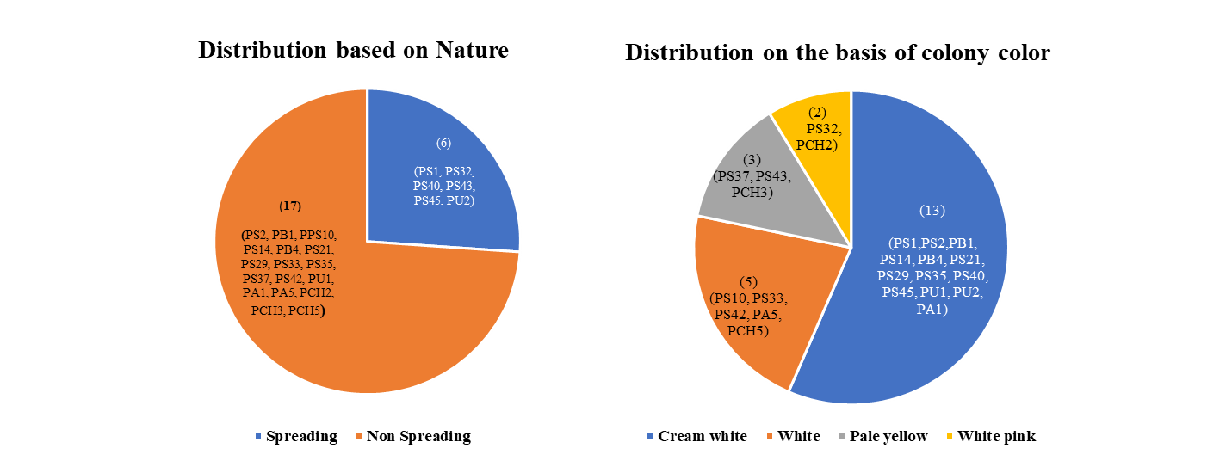

Fig. 2a Morphological characteristics of Pseudomonas isolates

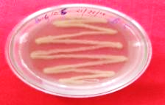
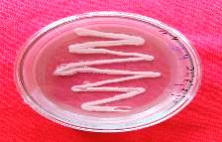
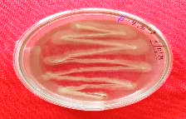
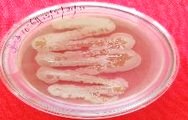
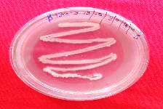
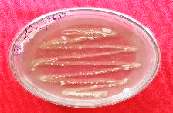
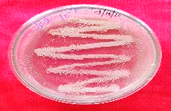
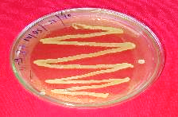
PCH3
PCH2
PS43
PB1
PS2
PU1
PB4
PS37
Fig. 2b Pure culture of Pseudomonas isolates producing slimy, cream white, white, pale yellow, and white pink colonies on King’s B medium.

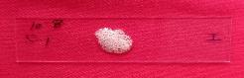





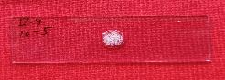







A
B
PCH3
PS2
PCH2
PB4
PS43
PS2
PCH3

PU1
PCH2
PU1

PS43
PB40

PS37
PB1
PB1
PS37
Fig. 3 Biochemical characterization of fluorescent Pseudomonas isolates (A) KOH test (B) Catalase test

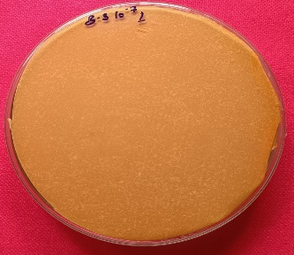
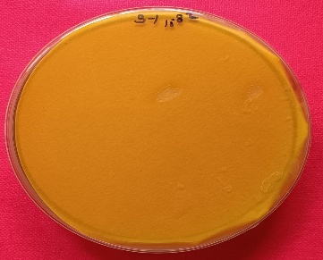
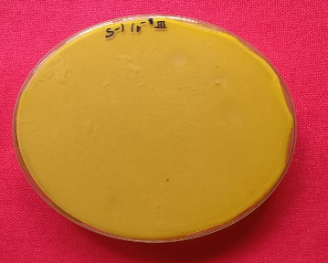
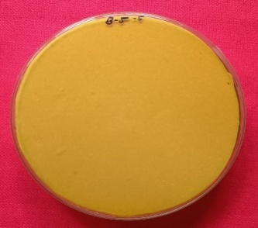
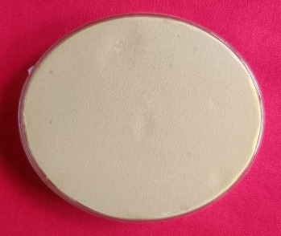
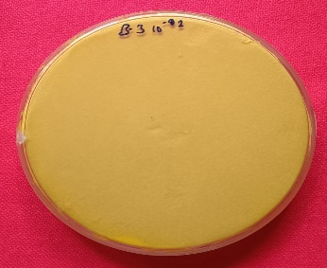
PB1
PB4
PS1
PS10
Control
PS10

Fig. 4 Evaluation of fluorescent Pseudomonas isolates for HCN production. Change of white coloured filter paper from yellow to orange indicates positive reaction.

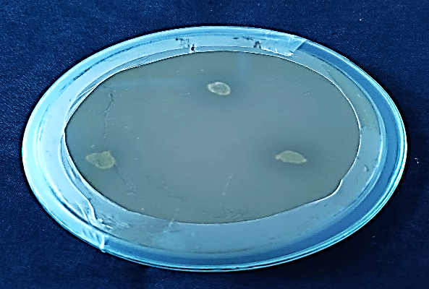
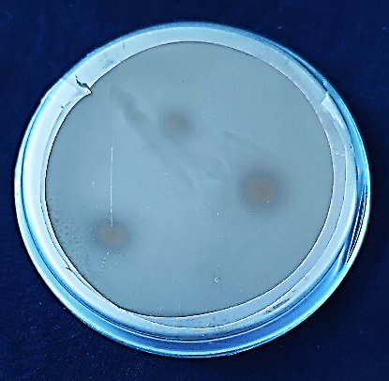
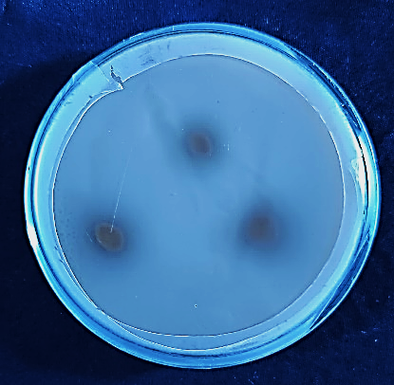
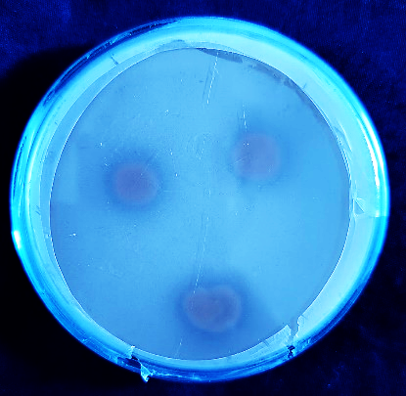
PB1
PB4
PS40
PS2

Fig. 5 Evaluation of fluorescent Pseudomonas isolates for phosphate solubilization on Pikovskaya's agar medium. Phosphate solubilizers were screened with a clear zone of solubilization around the bacterial growth.

