Original Research Article

Impacts of Market Gardening Activities on Land Use in the Meskine Area, Far North Cameroon

Abstract

Human activities significantly alter land use, leading to changes in the natural environment. This impact necessitates providing authorities with land cover maps and information on their current state and dynamics. It is with this in mind that an impact study of market gardening activities on land use was conducted in the Meskine area of the Far North Cameroon. Its objective is to analyze the dynamics of land use in the Meskine area under the effects of market gardening activities. It contributes to the characterization of the main spatial entities of the area between 1972 and 2024. The strategy used to produce the results is a combination of approaches and methods tailored to the specific objectives. Thus, the data collection techniques include documentary research, direct observation, and semi-structured interviews. Next, a sample of one hundred and fifty (150) farmers was selected using Wade's method (2003) and distributed according to social group (indigenous: 105; non-indigenous: 45), as this determines land access patterns. Mapping techniques based on multi-date satellite image analysis were used and supplemented by field verification. The EPIR (State, Pressures, Impacts, and Responses) model was used to analyze the pressure factors, manifestations, and consequences of land use. The research results showed that population growth and the search for fertile land to meet subsistence needs lead to profound changes in the different land-use units. This dynamic is driven by several factors, including population growth, access to land, and the ongoing search for agricultural land, which results in constant pressure on the agricultural landscape. The changes in the ecological parameters of the area are as follows: wooded savannas, agricultural land/bare soil, and water bodies, representing decreases of 9.92%, 2.43%, and 0.64%, respectively. The built-up area is increasing, with an average annual expansion rate of 0.13%. These changes, resulting from activities carried out in the area, particularly agriculture, cause, among other things, the destruction of vegetation cover, soil degradation, soil erosion, and soil contamination. These results can serve as a basis for defining priority areas for the restoration of degraded zones and the management of natural formations.
Keywords: Dynamics, land use, natural environment, Meskine.

INTRODUCTION

In Central Africa, and particularly in Cameroon, land-use change is resulting in deforestation and vegetation degradation, which are accelerating at a rapid and alarming rate. The main cause of these factors is generally the intensification of human activities (Biaou et al., 2019). The evolution of natural formations is becoming increasingly critical due to deforestation, overgrazing, overexploitation of forage resources, wildfires, and agricultural techniques (Djohy et al., 2016). In this regard, Akpassonou and Hoindo (1994) note that human activities influence agricultural areas and landscape dynamics. In the Meskine area, pressure on the land is due to extensive farming and agricultural practices. Nearly 61.1% of the rural population depends on agriculture for their livelihoods. Indeed, poorly managed rural development, various forms of pollution linked to the uncontrolled use of different agricultural inputs, declining water quality, increased erosion, soil depletion, and the continuous loss of forest cover are the most visible manifestations of this degradation (Roufaï, 2005). Thus, the degradation of agricultural land results in the qualitative and quantitative depletion of arable land and a reduction in fallow periods (Hounkpodoté, 2001). Furthermore, the agricultural production systems practiced in the area and current farming techniques have a negative impact on the natural environment. Moreover, the spatio-temporal changes in land use, due in most cases to farming systems, affect soil fertility and, consequently, agricultural production. Today, nearly 50% of land areas not covered by ice have undergone changes in land cover and land use (Samuel, 2014). Land cover changes in Sahelian regions, such as in the far north, in the locality of Meskine, have reached unprecedented levels in recent decades, making it particularly important to document the state of local ecosystems (OSS, 2013). The work of Koffi et al. (2016) reveals that studying land cover dynamics through multi-date diachronic analysis of land cover maps is becoming increasingly essential, both for understanding a territory and for its planning. It helps to gain a better understanding of the various trends in spatial transformation processes. It is therefore both wise and essential to provide decision-makers with land cover maps of their localities and information on their current state and dynamics for better understanding and management of their land. To understand land cover dynamics in the West African sub-region, several authors have used Geographic Information System (GIS) methods in conjunction with remote sensing (Avakoudjo et al., 2014; Gildas et al., 2016). This technique, through the analysis and interpretation of multi-date satellite images, allows for an understanding of landscape evolution. The objective of this article is to analyze the influence of production activities on land cover dynamics in the locality of Meskine.

Materials and Methods

Presentation of the Study Area

The geographical area of this study was the Far North Region of Cameroon, Diamaré Department, Maroua 1st District. It extends from 10°29’ to 10°34’ North latitude and from 14°15’ to 14°20’ East longitude (Figure 1). It is located in the locality of Meskine, approximately 8 km from the city center of Maroua. It covers an estimated area of 248 km². It is bordered to the south by the neighborhoods of Salak and Gakle, to the east by Ourotchedé, to the north by the villages of Zokok Laddeo and Kaliao, and to the west by the village of Katoual. The region has a Sudano-Sahelian climate, characterized by two seasons: a rainy season and a dry season. The average annual rainfall in the Maroua 1st district is approximately 815 mm. The average annual temperature is 28°C, with an annual range of 7.4°C, ranging from a minimum of 20°C to a maximum of 45°C. The hottest months are March, April, and May, while the coldest are December, January, and February (Segnobos and Lyebi Mandjek, 2000). Rainfall exhibits significant interannual and intraseasonal variations, with irregular and insufficient rainfall at the beginning and end of the season. These rainfall irregularities lead to a late start to the agricultural season and, more importantly, a reduction in the time available for adequate soil preparation. Consequently, farmers tend to rent tractors for tilling the soil, as draft animals are weakened after a long dry season. Difficulties in soil preparation lead to late sowing (Blanc et al., 2008; Sultan et al., 2010; Traoré et al., 2014). Agricultural soils are primarily poorly developed soils on recent alluvial deposits, coarse sands, and low-humus soils, but with good texture and drainage. These are vertisols, generally shallow, poorly differentiated, and ranging in color from light to dark. These soils are fertile, known to be rich in exchangeable elements, but they are so clayey that they require specific cultivation methods. They have a very fine texture, leading to waterlogging, and generally have low levels of organic matter and phosphorus. They experience water deficits during the dry season. When dry, they consist of compact, low-porosity prismatic units, ranging in size from decimeters to meters (Seiny Boukar, 1990). According to the 2010 census, the population of Meskine is estimated at approximately 20,235 inhabitants. It is a predominantly rural population (90%) with significant socio-ethnic diversity, a result of migration. However, rural land management, as in the rest of the country, is still largely governed by the customary law of the local population.

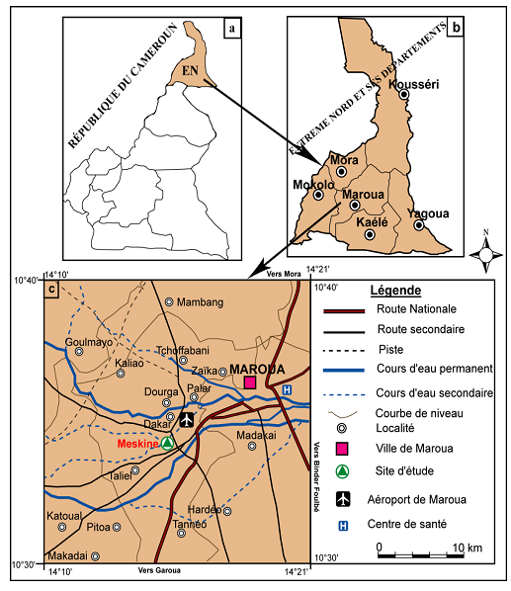

Figure 1: Map showing the location of the study area

Several data points were collected using appropriate techniques. These data were both qualitative and quantitative. The sample was determined based on the number of people in each social group (native and non-native) within each farming household. In each concession, the head of household was selected and interviewed. The sample size was determined using the method of Wade (2003). It is given by the following formula: n = p x q (1.9/0.1)²; or n = 0.2 x 0.2 (1.9/0.1)², n = 154. A total of 150 market gardeners were surveyed in the study area. The sample was constructed taking into account the social group (native: 105; non-native: 45) since this determines the modes of access to land.

Data Processing and Results Analysis

- Socio-economic Data Processing
The questionnaires and field data sheets were manually and statistically analyzed. The socio-economic data were presented in diagram form. These diagrams notably concern the evolution of the population size between 1950 and 2022, the different modes of land access, and the evolution of cultivated areas in the Meskine locality. However, the distribution of the surveyed agricultural households is by sex and age group.

- Satellite Image Processing
Supervised maximum likelihood classification was performed using Envi 5.0 software. This pixel-based classification method is based on the assumption that the spectral signature of each pixel is representative of the vegetation class in which it is located.
- Export to a Geographic Information System
The raster files of the interpreted images were converted to vector format using ArcGIS 9.3 software. In this Geographic Information System, the areas of the different vegetation formations and other land cover units were calculated.
- Evaluation of land covers dynamics
The different forms of conversion by land cover unit between these dates (1972 and 2001; 1972 and 2024; 2001 and 2024) and the description of any changes were highlighted using the transition matrix (Schlaepfer, 2002). Combining the information allowed for the creation of change maps for the periods before the market gardening revolution (1972-2001) and after the market gardening revolution (2001-2024). Several layers (1972 and 2001; 2001 and 2024; and 1972 and 2024) are open, and the result is the intersection of these open layers in the attribute tables after creating change columns. These changes are presented as undisturbed natural environments and disturbed environments. The resulting images underwent geometric corrections based on the UTM32N WGS84 Datum projection. The assessment of observable changes in land cover was carried out by determining the areas occupied by the different land cover units during the periods before the market gardening revolution (1972-2001) and after the market gardening revolution (2001-2024). This assessment was conducted as follows:
The calculation encompasses the overall balance, including the concepts of regression, stability, or progression of land cover units. Let U0-1972 be the area of a land cover unit in 1972 (U0), and U1-2001 be the area of the same unit in 2001 (U1). βU = U1-2001 - U0-1972. βU represents the change in this unit between 1972 and 2001. For this area unit, the following three cases are possible (Obalè, 2018):
- If βU < 0, then there is a regressive change in this unit;
- If βU = 0, then there is stability in this unit;
- If βU > 0, then there is a progressive change in this unit.
The calculations of the changes and the graphs of land cover evolution were performed using Excel.
- Statistical Analysis of Vegetation State Changes
The rate of spatial expansion is obtained by calculating the rates of change, which are the annual rate of expansion and the overall rate of change in the areas of land cover classes between the following years: 1972 and 2001; 1972 and 2024; and 2001 and 2024. These rates are determined respectively by the equation proposed by the FAO (1996) and that of Bernier (1992), cited by Mama and Oloukoi (2003), Oloukoi et al. (2006), and Soro et al. (2014). It is expressed mathematically by the following relationships:
- FAO (1996)

s2 – s1
Tg = × 100………………………………1
s1

Where Tc: Average annual rate of spatial expansion; Tg: Overall rate of change; s1: Area of a unit class at time t1 and s2: Area of the same unit class at time t2.

- Bernier (1992)

lns2 – lns1
Tc = × 100………………………………….2
(t2– t1) × lne

s1: Area of a unit class at time t1 and s2: Area of the same unit class at time t2; ln: natural logarithm; e: base of natural logarithms (e=2.71828).

Analysis of Results

The EPIR (Pressure-State-Impact-Response) environmental model was used to study the dynamics of agricultural land in the Meskine area, based on the causes and effects of various changes. The EPIR model has been applied by several stakeholders, including NESS (2010), in a study on the environmental impacts of petroleum activities.

1Land Use Factors

The main land use factors identified in Meskine during this study are: population growth and the need for arable land, farming systems and land use, and land access methods.
1.1 Population Growth and the Need for Arable Land
Human pressure on the natural environment in Meskine is very high. Indeed, to meet population growth and alleviate poverty in the area, cultivated land is expanding. According to population census reports conducted in the Meskine area, the population increased from approximately 5,500 inhabitants in 1950 to approximately 20,360 in 2022 (Figure 2). This population growth has led to significant human impact on the landscape. This human impact is evidenced by agricultural land and settlements (villages and camps). Analysis of Figure 2 shows the population trends in Meskine by site from 1950-1986 to 1986-2022. When examining the figures from 1986-2022, we observe that the population of each site increased by more than 50%, demonstrating a population increase over time. This represents demographic growth over the years. This population growth would put pressure on the natural resources of the Meskine area and, consequently, exacerbate environmental degradation and the destruction of vegetation cover for housing and agricultural operations.

Figure 2: Population Growth in the Meskine Area

1.2 Cropping Systems and Land Use

Cropping systems encompass all the practices implemented by farmers in their production process. In the Meskine area, fieldwork has allowed us to understand the realities of farming techniques and practices, as well as the level of awareness among stakeholders in this area regarding the legislation governing their activities. To this end, farmers make significant use of crop rotation, monoculture, intercropping, and slash-and-burn agriculture.

1.2.1 Slash-and-burn Agriculture
Soil preparation before sowing requires the use of local techniques, which can be summarized as clearing, burning, and the application of herbicides. During the dry season, clearing involves cutting grasses and shrubs that have been left to dry in a given area for two to four weeks before being burned. The objective of this technique is to fertilize the soil and promote sowing. During the rainy season, when burning and fires become less common, farmers use herbicides as a weed control method. This farming system is used by 72% of the surveyed local farmers and 28% of non-local farmers (Figure 4). However, when the field is left fallow because it is no longer productive, it is not cleared but simply burned (Photos 1 and 2). These clearing fires and cultivation fires are used to clear patches of vegetation and fallow land and to establish or expand crops.

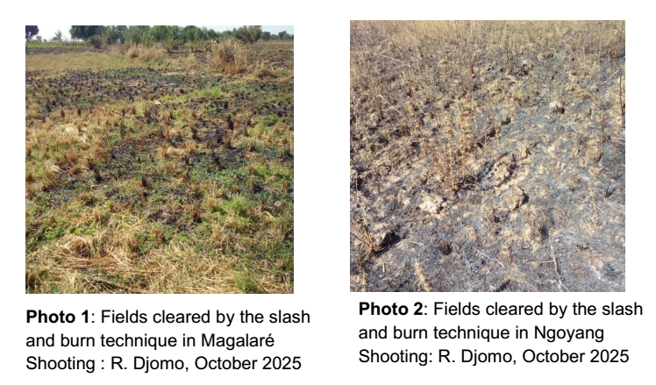

Photos 1 and 2 illustrate a field prepared using the slash-and-burn technique, where a farmer, after clearing part of his field, sets fire to clear it. Slash-and-burn agriculture is one of the factors contributing to the disappearance of certain plant species. After the fields are burned, the wind carries away certain microorganisms that the soil needs for fertilization, leaving areas bare.

1.2.2 Monoculture

This technique allows for the cultivation of a single species on the same plot year after year. It is a specific case of crop rotation in agriculture. It aims to simplify farming practices and maximize the efficient use of land. The cultivated species are varied and follow a well-established agricultural calendar (Table 1).
Table 1 shows some examples of possible monocultures in the locality.

Table 1: Monoculture
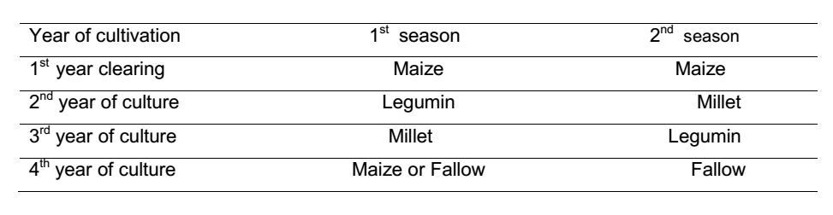
Source: Field survey, October 2025
Table 1 show that farmers cultivate a single species on the same plot of land, season after season or year after year. This farming system is used by 90% of agricultural workers. Almost all cultivated species are monocultures, both among indigenous farmers (70.4%) and non-indigenous farmers (29.6%) (Figure 4). This monoculture practice significantly impacts ecosystems and soil structure.

Table 2: Agricultural Activity Calendar
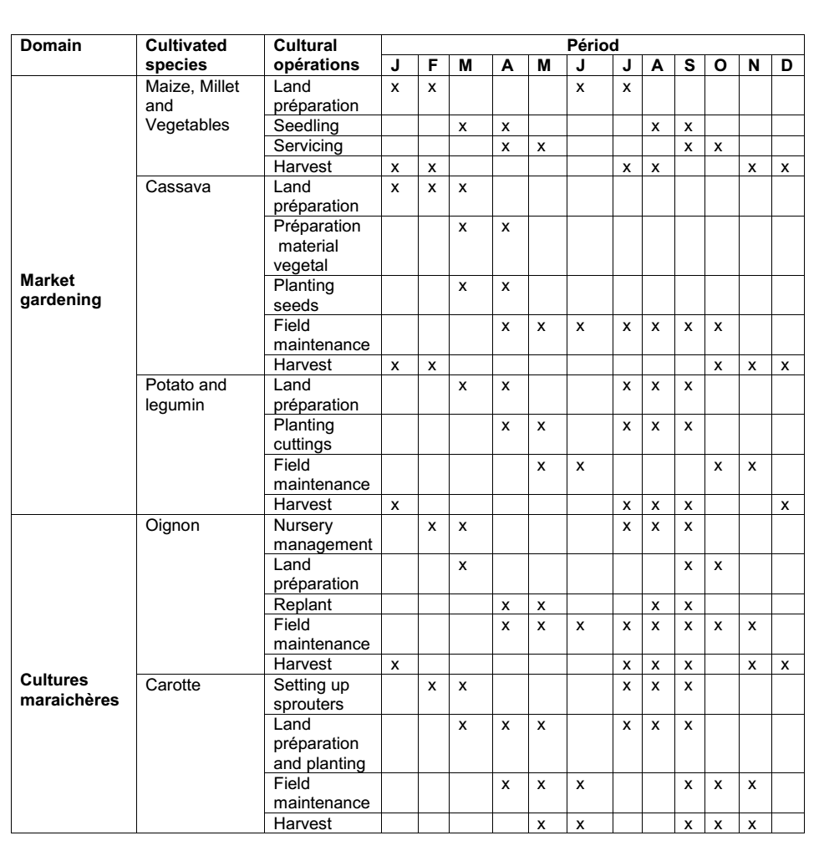
Source : Maroua I District Delegation of Agriculture and Rural Development and field observations, 2025
Table 2 shows that the agricultural calendar in the study area has a very tight production rhythm. The land is used continuously throughout the year. The production system can be summarized in three main operations: field preparation and sowing, crop maintenance during growth, and harvesting.

1.2.3 Intercropping

This is a cropping system that involves growing several types of crops on the same plot of land. By planting multiple crops, farmers can optimize land use while reducing the risks associated with crop failures. Intercropping creates biodiversity, which attracts a variety of beneficial and predatory insects to minimize pests and can also increase soil organic matter and manure, and prevent weed growth. According to surveys, some of the agricultural workforce (10%), specifically 33.3% of indigenous farmers and 66.7% of non-indigenous farmers, practice this traditional cropping system (Figure 4). Plates 1 and 2 show the intercropping system used by farmers in the Meskine area to maximize production.
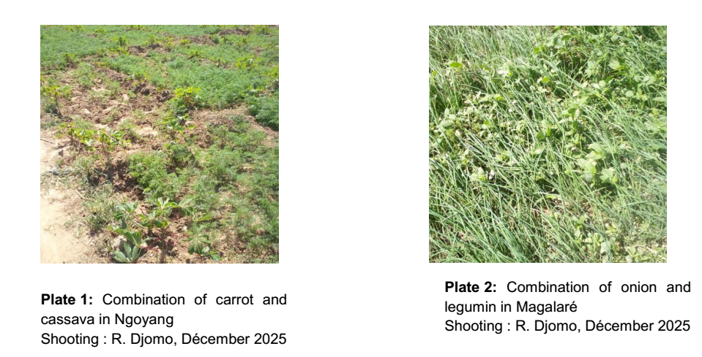
Plate 1 show a carrot field interspersed with cassava, and Plate 2 shows an onion field interspersed with legumes. These associations are observed throughout the Meskine area. According to the farmers surveyed, this strategy allows them to maximize profits and conserve resources for new land clearing.

1.2.4 Crop Rotation

This is a system of alternating crops in time and space. In fact, crop rotation is an efficient management technique not only for soil fertility but also for fallow land. It allows for the simultaneous or alternating use of all soil layers while promoting regeneration. Cereals are often rotated with legumes, which help fix nitrogen in the soil. After harvesting, farmers plant a short-term crop to avoid leaving the land bare. This system lasts a few months. According to the survey, some of the agricultural workforce (12.7%), representing 63.2% of the local population and 36.8% of non-native farmers respectively, practice this traditional cropping system (Figure 4). Figure 3 shows a diagram describing the rotation system in the research sector.

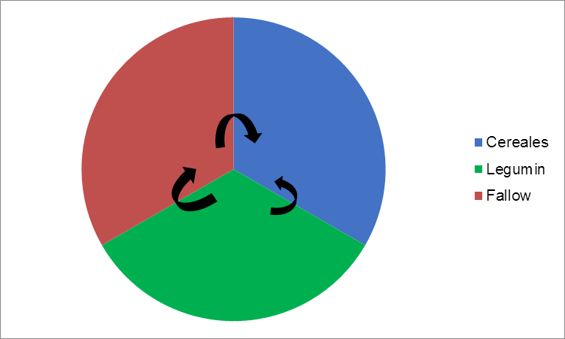

Figure 3: Schematic representation of the crop rotation system in the study area

The analysis of Figure 3 highlights the crop rotation system. This system lasts several months and follows three stages: legumes are planted after a fallow period, followed by cereals. In other words, legumes are cultivated first, then fallow, and finally cereals, or fallow followed by legumes and cereals; but not the reverse.

1.2.5 Fallow

Fallow, a period of non-cultivation, is a traditional land-use system consisting of a cultivation phase lasting from 5 to 15 years, followed by abandonment after crop yields decline. The fallow period in the study area lasts two to three months. This duration is short enough to allow grasses to grow, regenerate soil fertility, and protect the field from erosion. Today, under the pressure of population growth, the expansion of cash crops, and changes in farming systems, the practice of fallowing is evolving. Fallow periods are shortening, their use is becoming less frequent, and their nature is changing. According to our surveys, many agricultural workers (96%), including 70.8% of native farmers and 29.2% of non-native farmers, do not practice this traditional farming system (Figure 4).

Figure 4: Percentage of producers' opinions on their farming systems

Slash-and-burn agriculture, fallowing, monoculture, and crop rotation are all land-intensive systems. Market gardeners do not apply the improved production techniques developed by leading agricultural production organizations, such as the Ministry of Agriculture and Rural Development (MINADER) and the Institute of Agricultural Research for Development (IRAD), because these organizations do not always receive adequate support.

1.3 Land Availability and Modes of Access to Arable Land for Farmers

The methods of acquiring plots differ according to social groups. Among indigenous farmers, the most common method of acquiring land is inheritance (86.4%), while non-indigenous farmers have benefited from leasing (69.5%) (Figure 5A). The fact that these market gardeners report difficulties accessing land (62.3%) is explained by the fact that the land is primarily owned by non-indigenous people. Conversely, the vast majority of market gardeners report no difficulty accessing land (86.4%) because the land is primarily owned by indigenous people (Figure 5B). Figure 5 shows the proportion of the different methods (A) and difficulties (B) of land access recorded in the Meskine locality.

Figure 5: Percentage of Producers' Opinions on Land Acquisition Method (A) and Difficulties (B) of Land Access

Figure 5(A) shows the types of land access in the Meskine area. Indeed, the uncontrolled exploitation of land resources in Meskine has led to a reduction in arable land and a decrease in agricultural production, negatively impacting land use dynamics in the area.

2. Land Use Dynamics in Meskine

Land use dynamics in Meskine illustrate the evolution of the rural environment. This area has undergone numerous changes in the last 52 years due to several factors. We will begin this section by presenting the results of remote sensing, and then we will analyze the changes the area has experienced during the period (1972-2024). Finally, we will examine the reliability of our results using several studies and data found in the literature.
2.1 Land Cover Status in 1972
The results from the 1972 land cover mapping show a significant presence of agricultural land (bare soil). Indeed, out of a total area of 1361.52 ha, agricultural land (bare soil) covers 53.99%. Wooded savanna occupies 471.6 ha, or 34.64%. Buildings and bodies of water represent 3.20% and 8.17%, respectively, or 43.56 ha and 111.24 ha (Table 3). They are scattered throughout the study area (Figure 6).

Table 3: Land cover unit in 1972 in the locality of Meskine before the industrial revolution

Land cover unit | Area in hectares | Percentage in %
Wooded savannah | 471,6 | 34,64
Agricultural zone - bare soil | 735,12 | 53,99
Buildings | 43,56 | 3,20
Water body | 111,24 | 8,17
Total | 1361,52 | 100
Source: Interpretation results, December 2025
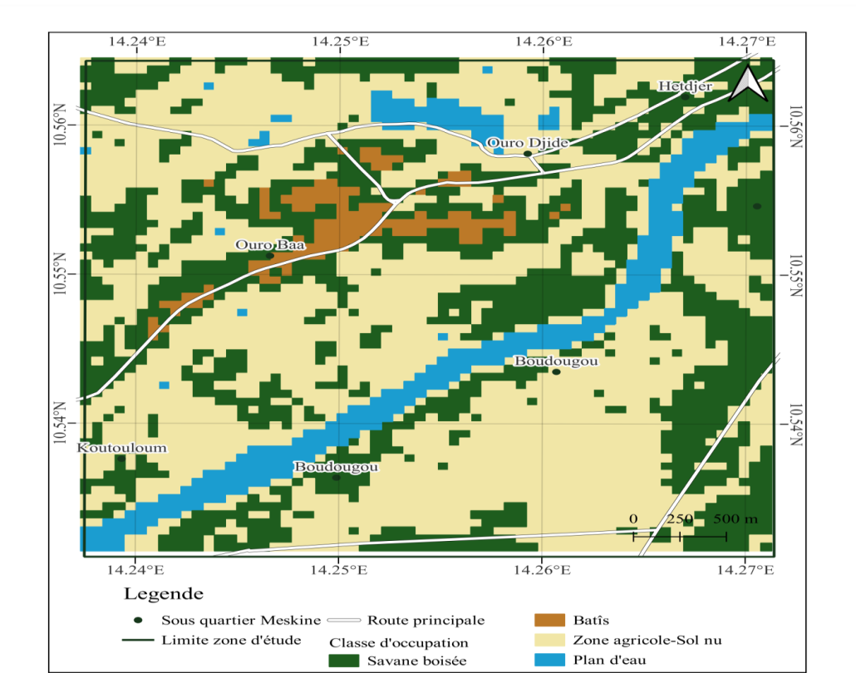Figure 6: Land cover in the locality of Meskine in 1972 before the industrial revolution

2.2 State of land cover units in 2001

The situation changed completely in 2001 (Figure 7). Indeed, there was a decline in natural vegetation in favor of developed areas. Humanized areas occupy 80.63% of the total area, of which 60.08% is agricultural land (bare soil) and 20.55% is built-up. Agricultural land (bare soil) covers 824.67 ha and represents 60.08%. Wooded savanna and a body of water extend over 151.02 ha (11.00%) and 114.84 ha (8.37%), respectively. Built-up areas cover 282.15 ha (20.55%) (Table 4).

Table 4: Land cover unit in 2001 in the locality of Meskine after the industrial revolution

Land cover unit | Area in hectares | Percentage in %
Wooded savannah | 151,02 | 11,00
Agricultural zone - bare soil | 824,67 | 60,08
Buildings | 282,15 | 20,55
Water body | 114,84 | 8,37
Total | 1372,68 | 100
Source: Interpretation results, December 2025
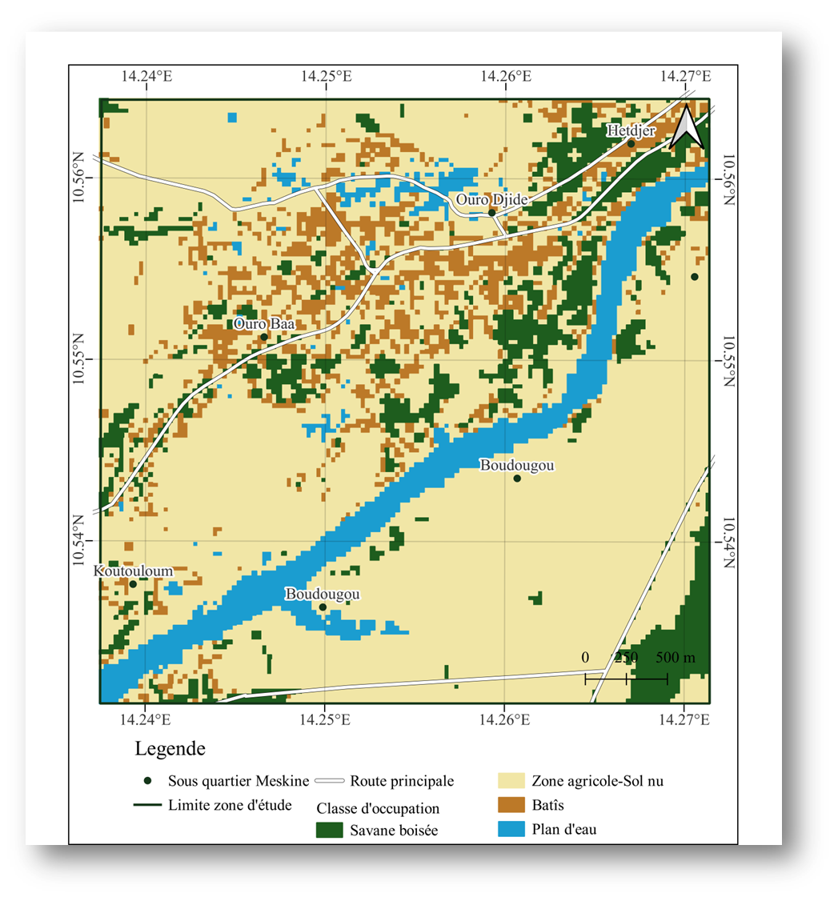
Figure 7: Land cover in the locality of Meskine in 2001 after the industrial revolution
2.3 State of land cover units in 2024

In the locality of Meskine, the land cover map for the year 2024 (Figure 8) shows that the agricultural zone – bare soil – occupies 51.56% of the area. Next comes the wooded savanna with 24.72%. Buildings (16.19%) are poorly represented, and bodies of water (7.53%) even less so. The statistical analysis of the areas represented by these entities in the locality of Meskine (Table 5) shows that: the agricultural zone – bare soil – represents an area of 707.67 ha, or 51.56% of the total area of the zone. The wooded savanna has an area of 339.39 ha and represents 24.72%. The built-up area covers 222.3 ha, representing 16.19% of the total area. Water bodies cover 103.32 ha, representing 7.53%.

Table 5: Land Use Unit in 2024 in the Meskine Locality after the Industrial Revolution

Land cover unit | Area in hectares | Percentage in %
Wooded savannah | 339,39 | 24,72
Agricultural zone - bare soil | 707,67 | 51,56
Buildings | 222,3 | 16,19
Water body | 103,32 | 7,53
Total | 1372,68 | 100
Source: Interpretation results, December 2025
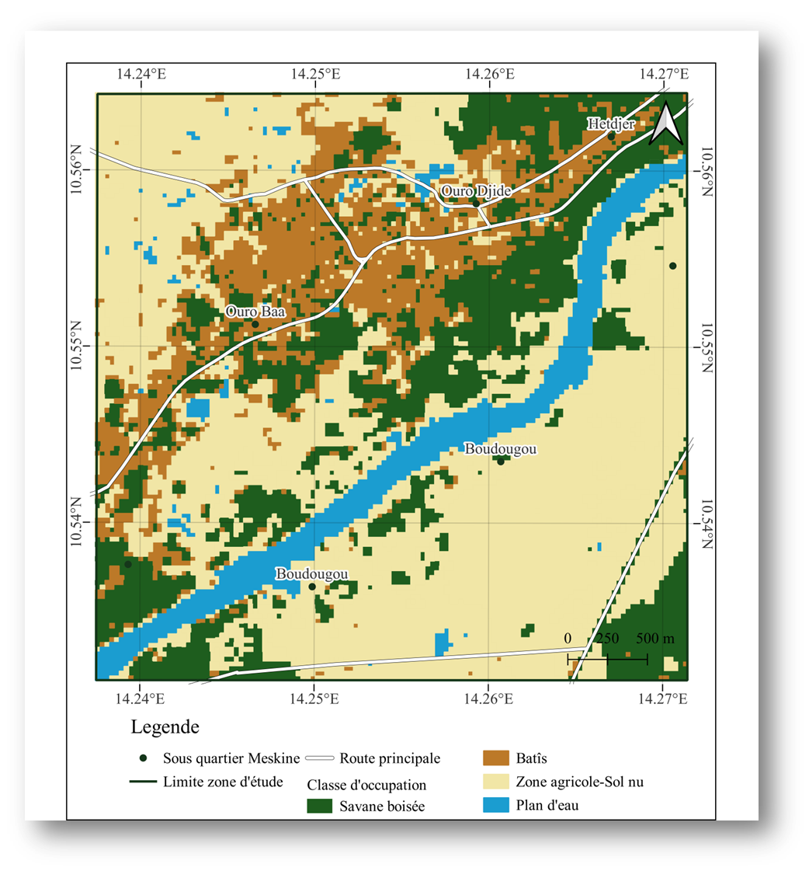
Figure 8: Land cover in the locality of Meskine in 2024

2.4 Spatial dynamics of ecological parameters in areas of influence

The statistical analysis of the surface area of ecological parameters obtained by comparing the land cover features of the locality of Meskine in 1972 before the Industrial Revolution (Figure 6) and in 2001 after the Industrial Revolution (Figure 7) shows that the area of agricultural land (bare soil) increased by +89.55 ha, or +6.09%, while the wooded savanna decreased by -320.58 ha, or -23.64%. Built-up areas increased by +238.59 ha, or 17.35% (Table 6 and Figure 9). Water bodies increased by +3.6 ha, or +0.2% (Table 6 and Figure 9).

Table 6: Spatial Change in Ecological Parameters in the Meskine Locality between 1972 and 2001
Land Cover Units | 1972 |  | 2001 |  | Balance (in %) | Observations
Land Cover Units | Area in hectares | U1 (%) | Area in hectares | U2 (%) | ΔU= U2- U1 | Observations
Wooded savannah | 471,6 | 34,64 | 151,02 | 11,00 | -23,64 | Decline
Agricultural zone - bare soil | 735,12 | 53,99 | 824,67 | 60,08 | 6,09 | Progression
Buildings | 43,56 | 3,20 | 282,15 | 20,55 | 17,35 | Progression
Water body | 111,24 | 8,17 | 114,84 | 8,37 | 0,2 | Progression
Total | 1361,52 | 100 | 1372,68 | 100
Source: Interpretation results of Landsat-MSS images, 1972 and Landsat-7 ETM, 2001
U1 represents the proportion of the area of a land cover unit in 1972 and U2 the proportion of the area of the same land cover unit in 2001. ΔU is the change in the proportion of the area of this land cover unit from 1972 to 2001.
Based on the ΔU values, it is possible to determine whether there is stability, progression, or regression for a given land cover unit.

Figure 9: Evolution of cartographic units between 1972 and 2001

Examination of Table 7 shows that the statistical analysis of the change in ecological parameters observed after overlaying the 1972 and 2001 maps of the area under exploitation reveals that the non-anthropogenic environment covers 3.6 ha, or 0.2% of the surface area; the anthropogenic environment covers 328.14 ha, or 23.44%; and the regressed natural environment has a reduced area of 320.58 ha, or 23.64%.

Table 7: Change in ecological parameters after overlaying the 1972 and 2001 maps of the exploited area under Development

Change in exploited area under Development | 1972 | 2001 | Difference between 1972-2001 | Percentage
Non-anthropogenic natural environment | 111,24 | 114,84 | 3,6 | 0,2%
Anthropogenic environment | 778,68 | 1106,82 | 328,14 | 23,44%
Regressed natural environment | 471,6 | 151,02 | -320,58 | -23,64%
Total | 1361,52 | 1372,68

From the year 2001 after the industrial revolution (Figure 7) to the year 2024 during the industrial revolution (Figure 8), a near-regularity of the different types of land use. Statistical analysis of the surface area of ecological parameters, based on the differences between entities on the land use map of the Meskine locality, shows that the following changes have occurred: the agricultural zone (bare soil) is -117 ha, or -8.52%; the wooded savanna is +188.37 ha, or -13.72%; built-up areas are -59.85 ha, or -4.36%; and the water body is -11.52 ha, or -0.84% (Table 8 and Figure 10).

Table 8: Spatial Change in Ecological Parameters in the Meskine Locality between 2001 and 2024

Land Cover Units | 2001 |  | 2024 |  | Balance (in %) | Observations
Land Cover Units | Area in hectares | U1 (%) | Area in hectares | U2 (%) | ΔU= U2- U1 | Observations
Wooded savannah | 151,02 | 11,00 | 339,39 | 24,72 | 13,72 | Progression
Agricultural zone - bare soil | 824,67 | 60,08 | 707,67 | 51,56 | - 8,52 | Decline
Buildings | 282,15 | 20,55 | 222,3 | 16,19 | - 4,36 | Decline
Water body | 114,84 | 8,37 | 103,32 | 7,53 | -0,84 | Decline
Total | 1372,68 | 100 | 1372,68 | 100
Source: Interpretation results of Landsat-7 ETM images, 2001 and Landsat-7 ETM, 2024

U1 represents the proportion of the area of a land cover unit in 2001 and U2 the proportion of the area of the same land cover unit in 2024. ΔU is the change in the proportion of the area of this land cover unit from 2001 to 2024. Based on the ΔU values, it is possible to determine whether there is stability, progression, or regression for a given land cover unit.

Figure 10: Evolution of mapping units between 2001 and 2024

Statistical analysis of the change in ecological parameters observed after overlaying the 2001 and 2024 maps of the area shows that the non-anthropogenic environment covers 188.37 ha, or 13.72% of the surface area; the anthropogenic environment represents -176.85 ha, or -12.84%; and the regressed natural environment represents -11.52 ha, or -0.84% (Table 9).

Table 9: Change in Ecological Parameters after Overlaying the 2001 and 2024 Maps of the Area under Development
Change in exploited area under Development | 2001 | 2024 | Difference between 2001-2024 | Percentage
Non-anthropogenic natural environment | 151,02 | 339,39 | 188,37 | 13,72%
Anthropogenic environment | 1106,82 | 929,97 | -176,85 | -12,84%
Regressed natural environment | 114,84 | 103,32 | -11,52 | -0,84%
Total | 1372,68 | 1372,68

Statistical analysis of the surface area of ecological parameters obtained by overlaying the land cover features of the area in 1972 (before the revolution) The industrial zone (Figure 6) and the year 2024 during the industrial revolution (Figure 8) show that the change in the area of agricultural land (bare soil) is -27.45 ha, or -2.43%, while the wooded savanna is -132.21 ha, or -9.92%. Built-up areas are +178.74 ha, or +12.99%. Water bodies are -7.92 ha, or -0.64% (Table 10 and Figure 11).

Table 10: Spatial Change in Ecological Parameters in the Meskine Locality between 1972 and 2024.
Land Cover Units | 1972 |  | 2024 |  | Balance (in %) | Observations
Land Cover Units | Area in hectares | U1 (%) | Area in hectares | U2 (%) | ΔU= U2- U1 | Observations
Wooded savannah | 471,6 | 34,64 | 339,39 | 24,72 | -9,92 | Decline
Agricultural zone - bare soil | 735,12 | 53,99 | 707,67 | 51,56 | -2,43 | Decline
Buildings | 43,56 | 3,20 | 222,3 | 16,19 | 12,99 | Progression
Water body | 111,24 | 8,17 | 103,32 | 7,53 | -0,64 | Decline
Total | 1361,52 | 100 | 1372,68 | 100
Source: Interpretation results of Landsat-MSS images, 1972 and Landsat-7 ETM, 2024
U1 represents the proportion of the area of a land cover unit in 1972 and U2 the proportion of the area of the same land cover unit in 2024. ΔU is the change in the proportion of the area of this land cover unit from 1972 to 2024. Based on the ΔU values, it is possible to determine whether there is stability, progression, or regression for a given land cover unit.

Figure 11: Evolution of map units between 1972 and 2024
Statistical analysis of the changes in ecological parameters observed after overlaying the 1972 and 2024 maps of the area shows that the non-anthropogenic environment is -132.2 ha, or -9.92% of the surface area; the anthropogenic environment is 151.31 ha, or 10.56%; and the regressed natural environment is -7.92 ha, or -0.64% (Table 11).

Table 11: Change in ecological parameters after overlaying the 1972 and 2024 maps of the exploited area under Development
Change in exploited area under Development | 1972 | 2024 | Difference between 1972-2024 | Percentage
Non-anthropogenic natural environment | 471,6 | 339,39 | -132,21 | -9,92%
Anthropogenic environment | 778,68 | 929,97 | 151,31 | 10,56%
Regressed natural environment | 111,24 | 103,32 | -7,92 | -0,64%
Total | 1361,52 | 1372,68

2.5 Rate of spatial change between 1972 and 2024 of the areas of influence

The rate of spatial change of ecological parameters in the area of influence of market gardening in the locality of Meskine shows that these ecological parameters of land use have undergone significant changes (Table 12). Observation of this table presents the rates of change of land use units between the years 1972 and 2024 in the locality of Meskine. It clearly indicates that the classes representing the agricultural zone – bare soil – declined during this period by -3.73%. Built-up areas have a very high rate of increase of 410.33%, while those in decline are the water body and the wooded savanna, with overall rates of decline of -7.12% and -28.03% respectively (Table 12).
Regarding the rate of change in the area of influence between 1972 and 2001, Table 13 shows that the agricultural zone (bare soil), built-up areas, and bodies of water all increased, with respective areas of 89.55 ha (an annual expansion rate of 0.37%), 238.59 ha (an annual expansion rate of 6.44%), and 3.6 ha (an annual expansion rate of 0.10%). Conversely, the wooded savanna decreased, with an area of 320.58 ha (a decrease of 3.93%) (Table 13). It is simply observed that natural vegetation formations have declined in favor of anthropogenic formations.
Regarding the rate of change in the areas of influence between 2001 and 2024, the analysis of the results shows that the agricultural area (bare soil), built-up areas, and water bodies have respectively decreased by 117 ha (with a rate of decrease of 0.65%), 59.85 ha (1.04%), and 11.52 ha (0.47%) (Table 14). Conversely, the wooded savanna has increased by 188.37 ha, representing an annual expansion rate of 3.52%. It is clear that natural vegetation formations have declined in favor of non-anthropogenic formations.
Table 12: Rate of spatial change between 1972 and 2024 in the area of influence
Land cover classes | Area (ha) |  | Tc(%) | Tg(%)
Land cover classes | 1972 | 2024 | Tc(%) | Tg(%)
Wooded savannah | 471,6 | 339,39 | -0,63 | -28,03
Agricultural zone - bare soil | 735,12 | 707,67 | -0,07 | -3,73
Buildings | 43,56 | 222,3 | 0,13 | 410,33
Water body | 111,24 | 103,32 | -0,15 | -7,12
Note: Tc: average annual rate of spatial expansion; Tg: overall rate of change.
Table 13: Rate of spatial change in the locality of Meskine between 1972 and 2001
Land cover classes | Area (ha) |  | Tc(%) | Tg(%)
Land cover classes | 1972 | 2001 | Tc(%) | Tg(%)
Wooded savannah | 471,6 | 151,02 | -3,93 | -67,97
Agricultural zone - bare soil | 735,12 | 824,67 | 0,37 | 12,18
Buildings | 43,56 | 282,15 | 6,44 | 547,72
Water body | 111,24 | 114,84 | 0,10 | 3,23
Note: Tc: average annual rate of spatial expansion; Tg: overall rate of change.
Table 14: Rate of spatial change in the locality of Meskine between 2001 and 2024
Land cover classes | Area (ha) |  | Tc(%) | Tg(%)
Land cover classes | 2001 | 2024 | Tc(%) | Tg(%)
Wooded savannah | 151,02 | 339,39 | 3,52 | 124,73
Agricultural zone - bare soil | 824,67 | 707,67 | - 0,65 | -14,18
Buildings | 282,15 | 222,3 | - 1,04 | -21,21
Water body | 114,84 | 103,32 | - 0,47 | -10,03
Note: Tc: average annual rate of spatial expansion; Tg: overall rate of change

3. Analysis of Land Use Dynamics between 1972 and 2024 in Areas of Influence

In the market gardening area of influence, built-up areas increased by 12.99%, bare agricultural land decreased by 2.43%, and wooded savanna and water bodies decreased by 9.92% and 0.64%, respectively (Table 10). These parameters illustrate an annual growth rate between 1972 and 2024 of -0.07% for bare agricultural land, 0.13% for built-up areas, -0.15% for water bodies, and -0.63% for wooded savanna (Table 12). Consequently, the impact of market gardening activities on the original natural environment is -9.92% (Table 11). Indeed, the dynamic land-use analysis in the area influenced by the market gardening operations shows significant environmental degradation due to the destruction of vegetation and the disappearance of some wetlands to make way for housing.

4. Discussion on the Impacts of Market Gardening Activities on Land Use

The environmental problems faced by the local population are linked to population growth and the need for arable land, farming systems and land use, land access methods, and land-use dynamics in the Meskine area, as presented in the results.

4.1 Discussion on Land Use Factors

4.1.1 Population Pressure and the Expansion of Agricultural Activities

Our results are consistent with those obtained by Konan et al. (2016) in a study on anthropogenic factors and land use dynamics in another region. Their study revealed that population growth and the intensification of agricultural activities exert significant pressure on natural spaces. Given the rapid population growth in the Meskine area, anthropogenic pressure is increasing rapidly. According to our results, agriculture is the main activity in Meskine. However, since pressure on the land is caused by human activity, it becomes anthropogenic pressure in Meskine, as observed by Agodo (2009). Due to agricultural practices and population pressure, the soil, the primary support for this agriculture, is experiencing degradation that affects its fertility (Natta, 1999). In this regard, Agbahungba (2012) noted that human actions on the environment play a significant role in soil degradation. Analysis of the pressure factors reveals that population growth and human activities are the main determinants of natural resource degradation in the Meskine area. These results are consistent with those obtained by Ogouwalé (2009), who demonstrated that humans are the primary driver of environmental degradation. Similarly, Lieugomg and Foudoussia (2006) clearly showed that the combined effect of population growth and poverty leads to the unsustainable exploitation of natural resources. This observation corroborates the conclusions of Démon (1991), who asserts that the loss of vegetation cover and soil depletion are attributable to human activities. This lack of vegetation cover makes the soils vulnerable primarily to erosion and weed growth (Lefebvre, Eilers, and Chunn, 2005). Migrant and displaced populations have contributed significantly to the development of agriculture and the expansion of market gardening. The use of increasingly powerful mechanized equipment for plowing agricultural land is damaging the soil; this, combined with the application of high doses of fertilizers and pesticides over several years, is also noted by Donfack et al. (1988), who support this theory by observing that often inappropriate methods of managing rural space in arid zones lead to the deterioration of the natural environment. The search for arable land has led these farmers to seek agricultural areas suitable for crop development. These results, obtained from interviews with producers, are consistent with those observed by the researcher Boserup (1965).

4.1.2 Cropping Systems and Land Use

Population pressure is pushing farmers to adopt new, more intensive practices that accelerate harvests on the same plot. The survey results revealed that farmers make significant use of crop rotation, monoculture, intercropping, fallow periods, and slash-and-burn agriculture. This observation has been made by several authors (Fondio et al., 2011; Kouakou et al., 2019). Population pressure in the western cotton-growing region of Burkina Faso has led to a sharp reduction in fallow periods, or even the abandonment of this practice (Yoni et al., 2005). Fallow is rarely used by farmers, who prefer intercropping because the banks of the Mayo River can be cultivated almost year-round. In the long term, this degrades the soil, which is stripped of its nutrients. This observation corroborates the conclusions of Jekalbe (2010), who believe that the decline in soil fertility in the Far North region of Cameroon is due to the intensive use of inputs (NPK fertilizers, herbicides, etc.) and the reduction of fallow periods. Contrary to Somé et al. (2007), fallow periods promote an improvement in soil organic matter status and, consequently, an improvement in physical and biological properties (Zombré, 2006). Our results conclude that intercropping on the same plot is increasingly adopted on farms, not only to compensate for a shortage of arable land but also to improve the yield of these plots. These results are consistent with the work of Adou et al. (2019), who demonstrated the use of cultivation techniques to improve yields. The intense pressure on land due to reduced fallow periods further degrades soils, which are subject to erosion and depletion. In this regard, Djohy et al. (2016) noted that the evolution of natural formations is increasingly critical due to deforestation, overgrazing, overexploitation of forage resources, wildfires, and agricultural techniques. During the dry season, pre-sowing agricultural practices are characterized by clearing land by burning almost all the grasses in the fields (Photo 6) and by the use of herbicides that leave the soil bare during the dry seasons (Photo 4L). These results are similar to those of Vounserbo (2011) and Boukeng (2015), who observed that extensive slash-and-burn agriculture was responsible for the destruction of vegetation cover in the corridors. It should be noted that wildfires deplete soils of humus, as demonstrated by a ten-year study conducted in Kenya on several plots (Ramade, 1991). The first protected plot recorded an increase in humus content, unlike the other plots, which were burned annually. According to Arouna (2012) and Kombienou et al. (2016), the practice of clearing land for cultivation leaves the soil bare and deprives it of its protective vegetation cover for a period of the year. For the farmers surveyed, this crop rotation technique impacts agricultural yields. This is especially true since plants do not draw the same nutrients from the soil and can therefore recover the original soil quality between two plantings. This is also noted by Azontondé et al. (1998) and Koundé (1998), who support this idea by observing that inappropriate farming practices degrade soils and that cropping systems without amendments significantly reduce organic matter and nitrogen content. Contrary to other research conducted elsewhere, three-year crop rotations appear to improve profitability (Sovoie, 2014). In addition to increasing yields, crop rotation helps reduce the environmental impact of agriculture in several ways (MAPAQ, 2005). Regardless of the farmers' origin, our survey results revealed that farmers practice monoculture on previously cleared land.In this regard, these soils are depleted due to intensive farming, sometimes in monoculture, and occasionally due to a combined effect of a lack of fallow periods and land management. Indeed, the degradation of natural resources (soils, vegetation) is largely a consequence of the farming system. These results confirmed the hypothesis of Djohy et al. (2016), who reported that these practices contribute to the decline of vegetation in the Commune of Sinendé. According to Thibeault (2000), the intensive labor associated with monoculture also leads to a significant loss of organic matter. It contributes to accelerating the mineralization process of organic matter by promoting soil aeration and microorganism activity, results obtained by CPVQ (2000a).

4.1.3 Land Difficulty and Modes of Access to Arable Land for Farmers

According to the results of our surveys, confirmed by Schmengler (2011), agricultural land has been continuously cultivated since 1950. However, the methods of acquiring plots differ according to social groups. Among the indigenous population, the most common method of acquiring land is inheritance (86.4%), while non-indigenous farmers have benefited from leasing (69.5%) (Figure 6). This can be explained by the fact that indigenous people are generally recognized as the true landowners. Indeed, indigenous people who have been settled for many years own portions of land that they either lease or sell. Analysis of the results regarding difficulties in accessing land shows that these market gardeners believe they have difficulty accessing land (62.3%), which is explained by the fact that the majority of farmers are non-native residents. Conversely, the vast majority of market gardeners believe they do not have difficulty accessing land (86.4%), which is explained by the fact that the majority of farmers are native to the area (Figure 6). Indeed, access to land did not appear to be a major problem for farmers. The rules governing access to land depend on rural societies, their socio-political and family organization, and their methods of controlling land and their workforce, as well as their social and political history. These results are consistent with those of Berry (1989), who states that access to land and its resources remains closely linked to social identities. In this regard, land dynamics have also led to the emergence of a new means of accessing land: leasing. These statements are confirmed by Kouamé, (2014) who shows that the rental only concerns plots intended for subsistence farming and non-agricultural activities and is done by individuals, allochthonous laborers, foreigners and their wives.

4.2. Discussion on Land Cover Dynamics in the Meskine Locality

Based on the mapping results, four land cover units were identified in the Meskine locality. These units are not always well differentiated, likely due to the similar spectral responses of these natural vegetation formations. These difficulties have been reported by several authors, including in other countries (Avakoudjo et al., 2014; Mamane et al., 2018). These difficulties may be related to the definition of homogeneous plots when selecting training sites. However, despite these challenges, the results obtained remain satisfactory.
The analysis of land cover dynamics in the Meskine locality of the Far North Region of Cameroon is of paramount importance for this locality. In this locality, the establishment of various market gardening activities highlights different landscape evolution processes during the period from 1972 to 2024. In the locality of Meskine, there is an accelerated degradation of the landscape, characterized by regressions and progressions, as well as conversions and modifications. As an illustration, the calculated areas, allowing for an assessment of the overall trends in land use from 1972 to 2024, are presented in Figure 11. There has been an increase in built-up areas of 178.74 ha, or 12.99%. Significant regressions are also observed in the herbaceous savanna (agricultural zone) of -27.45 ha, or -2.43%, the wooded savanna of -132.21 ha, or -9.92%, and the water body of -7.92 ha, or -0.64%. These same ecological parameters in the developed area are also declining, with an average annual rate of spatial expansion of -0.07% for the agricultural/bare soil zone, -0.63% for the wooded savanna, and -0.15% for the water body. Conversely, the average annual rate of spatial expansion for built-up areas is increasing at 0.13% (Table 12). Furthermore, the agricultural/bare soil zone is declining during this period, with an overall rate of change of -3.73%. Built-up areas have experienced a very high rate of expansion of 410.33%, while the water body and the wooded savanna are declining, with overall rates of change decreasing by -7.12% and -28.03%, respectively (Table 12). The human-modified environment is expanding by 10.56% (Table 11), leading to the growth of housing, the destruction of vegetation, and the disappearance of some wetlands. Based on field observations, this could be due to increasing population pressure on plant resources, leading to a degrading environmental situation through soil exposure to water and wind erosion. This also results in the expansion of degraded areas (agricultural zones) and the disappearance of water bodies through siltation. The high population density in this area is also a contributing factor to the degradation of these natural plant formations. This conquest of farmland to feed a growing population is very often at the expense of natural formations. The decline of vegetation in favor of human-modified areas confirms the results of other studies, namely those by Mamane et al. (2018) in the Tamou Total Wildlife Reserve, Tidjani et al. (2009) in Gouré, Mahamane et al. (2007) in Gabi, Niger, as well as those by Kpedenou et al. (2016) in southeastern Togo, and Millogo et al. (2017) in the Bam province in Burkina Faso, and Bamba et al. (2008) in the Bas Congo province.This phenomenon of soil vegetation cover regression has also been observed in agricultural areas of Northwest Siberia by Qin Yu et al. (2015). This regression is explained by the obvious direct impacts of buildings, roads, and routes for vehicles and heavy machinery associated with agricultural activities (Qin Yu et al., 2015). According to surveys and observations, the regression of the agricultural zone could be linked to population growth and housing development. This shows that humans and their activities bear the greatest responsibility for the conversion or modification of the natural environment (Alemayehu F., 2016). The trajectories of these natural formations are now following a regressive dynamic (Ntoupka, 1999). Furthermore, the presence of institutions such as hospitals, health centers, and educational establishments in the area could certainly be a cause of the reduction of natural formations in the Meskine locality. Indeed, the establishment of these companies led to a massive population shift towards the Meskine area, resulting in an increase in inhabited areas (Assoua, 2013). These findings are remarkably similar to those of Kpedenou et al. (2017), whose urban areas experienced an overall increase of over 138%. This growth is the result of rural land subdivision, which contributes to the reduction of agricultural production areas for rural populations. The correlation between demographic and economic variables also highlights an imbalance between population needs and available resources (Onibon, 1999).
Furthermore, the spatial dynamics of land use types between 1972 and 2001 (before the Industrial Revolution) and between 2001 and 2024 (after the Industrial Revolution) demonstrate an evolving landscape. The most obvious changes are the strong presence of built-up areas and bare agricultural land in 1972-2001, and of wooded savanna in 2001-2024. Indeed, the statistical analysis of the surface area of the ecological parameters obtained by the difference between the entities of the land cover map of the year 1972 before the industrial revolution (Figure 6) and in the year 2001 after the industrial revolution (Figure 7) is strongly marked by the evolution of the surface area of the bare agricultural land area of +89.55 ha or +6.09%, of the wooded savanna of -320.58 ha or -23.64%, of built-up areas of +238.59 ha or 17.35% and of the water body of +3.6 ha or +0.2% (Table 6 and Figure 9). Furthermore, according to Table 6, the statistical analysis of changes in ecological parameters observed after overlaying the 1972 and 2001 maps of the area under cultivation shows that the non-anthropogenic environment covers 3.6 ha, or 0.2%, while the anthropogenic environment covers 328.14 ha, or 23.44%. These observed changes are attributable to the growth and expansion of buildings and the conversion of agricultural areas for market gardening. Similarly, these changes in landscape units could be explained by three major factors stemming from the population explosion: the harvesting of firewood, the cultivation of fallow land, and the expansion of cultivated areas and buildings (Atta et al., 2010; Kpedenou et al., 2016).Furthermore, these changes are primarily influenced by human activity. Negative human interventions (fires, urbanization, deforestation, and poor understanding of agricultural techniques) lead to significant degradation of vegetation cover. This results in altered natural soil conditions, which in turn disrupts the natural water cycle. Consequently, these changes lead to increased runoff volumes. These factors have resulted in the gradual disappearance of vegetation and significant chemical and physical degradation of cultivated land (Pieri, 1989). As a result, soils become highly susceptible to erosion. Several studies on the dynamics of vegetation landscapes have confirmed these variations in Land Use Types (LUTs) using Landsat satellite imagery with remote sensing techniques and GIS (Hountondji, 2008; Madjigoto et al., 2015; Brun et al., 2018; Kpedenou, 2016; Temgoua et al., 2018). The results obtained reflect the reality of landscape dynamics trends throughout the country, where population growth is accompanied by high land demand for agricultural activities (Ama et al., 2020). For example, an analysis of satellite images of the outskirts of the city of Maroua in the Far North region, conducted in the 2000s, shows that 34% of the land area has been cleared for agricultural purposes (Fotsing, 2006). According to surveys and observations, the expansion of the agricultural zone could be linked to land occupation by farmers, with a 6.09% increase in the area of bare soil (Table 6), and to rising food demand, which leads to increased agricultural production and land use (Saheed et al., 2017). Many studies have shown that population growth has a direct impact on the expansion of arable land and on the increase in housing. In the Sahel region, these changes particularly affect pastoral rangelands (Sylla et al., 2019). Furthermore, the increase in water levels during this period could be a consequence of poor agricultural practices, overgrazing, and the establishment of camps by herders.
However, from 2001, after the Industrial Revolution (Figure 7), to 2024, during the Industrial Revolution (Figure 8), a near-consistent pattern of environmental changes is observed. These changes are shown after overlaying the 2001 and 2024 maps of the area. Statistical analysis of the surface area of ecological parameters, based on the differences between land cover features, shows that the following areas have decreased: agricultural land (bare soil) by -117 ha, or -8.52%; wooded savanna by +188.37 ha, or -13.72%; and built-up areas by -59.85 ha, or -4.36%. The water body area has decreased by -11.52 ha, or -0.84% (Table 10 and Figure 11). These data highlight clear expansion trends for wooded savanna, while agricultural land (bare soil), buildings, and water bodies show significant decreases. These results contradict those of Biga et al., 2000, whose study showed an expansion of cultivated areas in three of the studied locations.However, the low annual rate of increase (-0.65%) in the area of bare agricultural land in the locality raises questions about the availability of arable land in relation to population growth. This overall evolution of land cover and land use is driven by environmental, socio-economic, and political factors. These factors have influenced these dynamics to varying degrees over time. Based on field observations and statistical data, the decrease in bare agricultural land and the increase in wooded savanna are linked to vegetation recovery after a period of drought, reforestation efforts, or the effects of reforestation. This demonstrates that humans and their activities bear the greatest responsibility for the conversion or modification of the natural environment (Alemayehu, 2016). The phenomenon of water body and built-up area regression is also noted by Kpedenou et al. (2016), who show that these changes in landscape units could be explained by three major factors stemming from the population explosion: the harvesting of firewood, the cultivation of fallow land, and the expansion of cultivated areas and buildings. The intensification of market gardening activities negatively impacts the human-modified environment, which has declined sharply by 12.84%, compared to the non-human-modified environment, which has increased by 13.72%. This regression is partly due to the abandonment (cessation of production) or rehabilitation of land and its return to villagers. This is clearly observed in the regression of the natural environment, which has decreased by 0.84% (Table 9). The increase in wooded savanna area (13.72%) during this period can be attributed to the agricultural land management and restoration efforts undertaken by NGOs in collaboration with agricultural and environmental technical services.

Application of the DPSIR Method to Land Use by Market Gardening Activities
By applying DPSIR to the results of satellite image processing on land use by market gardening activities, we obtain:
Driving Forces (D)
Location of areas by market gardening activities
Urbanization, human population growth, and land use
Growth in demand for agricultural products, Agriculture, Households
Pressures (P)
Land use by market gardening activities exerts pressures on:
Land areas and savannas
Urbanization and housing
Water bodies and floodplains
States (S)
Due to these pressures, the state of the market gardening areas in Meskine is affected by:
Overexploited soils
Short fallow
Unconserved forest
Reduced use of chemical inputs
Impacts (I)
Changes in soil conditions have impacts on the survival of residents of various market gardening sites in Meskine:
Loss of biodiversity and water stress
Decreased agricultural production and income
Degradation of agrobiodiversity
Decreased soil fertility
Responses (Responses), R
Lack of studies, monitoring, and short-, medium-, and long-term strategies developed by the government and businesses for the management of agricultural land, the improvement of agricultural production systems, and organic farming of market gardening sites in Meskine.

Conclusion

Population growth and the search for fertile land to meet subsistence needs are leading to profound changes in land use patterns. The objective of this study was to analyze land use dynamics in the Meskine area under the influence of market gardening activities. These dynamics are driven by several factors, including population growth, access to land, and the ongoing search for agricultural land, all of which result in constant pressure on the agricultural landscape. These changes, created by activities carried out in the area, particularly agriculture, cause, among other things, the destruction of vegetation cover, soil degradation, soil erosion, and soil contamination. However, investigations revealed changes in farming practices and management, such as the adoption of cultivation techniques and the use of inputs. These changes have, to some extent, contributed to soil depletion, degradation, and contamination. A diachronic analysis of land use based on maps from 1972 and 2024 revealed that population growth exerts significant pressure on natural resources (soil). Indeed, one consequence of soil degradation is population migration in search of new land or the development of market gardening areas, with its associated negative impacts. To address this situation, it is crucial to implement reforestation campaigns, review the use and occupation of agricultural land, and clearly define rational land management policies aimed at improving living conditions and protecting the natural and human environment.

COMPETING INTERESTS DISCLAIMER:
Authors have declared that they have no known competing financial interests OR non-financial interests OR personal relationships that could have appeared to influence the work reported in this paper.

References

Alemayehu, 2016. "Land Use and Land Cover Change in the Coastal Area of Watamu Mida Creek, Kenya", Open Journal of Forestry, 6230–242.
Arouna, 2002. The exploitation of biological resources and the dynamics of the classified forest of Upper Alibori in Benin. Master's thesis in Geography, FLASH, University of Abomey-Calavi, Abomey-Calavi, p. 115.
Avakoudjo Julien, Mama Adji, Toko Ismaïla, Kindomihou Valentin, and Sinsin Brice, 2014. "Land cover dynamics in W National Park and its periphery in northwestern Benin", Int. J. Biol. Chem. Sci., vol. 8, no. 6, pp. 2608-2625
Boserup, 1965: The Conditions of Agricultural Growth: The Economics of Agrarian Change Under Population Pressure. London, United Kingdom: G. Allen & Unwin, 124 p.
Quebec Plant Production Council. 2000a. Guide to Conservation Practices in Field Crops: Organic Matter Management. Agri-Network, Agri-environmental Section. Agri-environment/documents/Feuillet3. p. 63.
Donfack P., Moukouri H., Mainam F., Seiny L., Abega R., Ayangma A., Djoko A., Naah E., Ntonga J.C., Sighomnou D., Carré P., Pontanier R., Sayol R., Seghieri J., Thebé B., and Floret C., 1988. Use and conservation of soil and water resources in Northern Cameroon, Final Report, Commission of the European Communities, Contract T.S.D. A.216 CAM (5), IRA, ORSTOM and Centre L. Emberger, 238 p.
Fotsing, 2009. SMALL Savannah: an information system for the integrated analysis of land-use changes in the far north of Cameroon. (S.l.): Leiden University. Pp. 16-21.
Koffi Djagnikpo Kpedeno, Ousmane Drabo, Awa Pounyala Ouoba, Dapola Constant, Thiou Tanzidani Tchamie, 2017. Land cover analysis for monitoring landscape evolution in the Ouatchi territory of southeastern Togo between 1958 and 2015. pp. 203–228. Hal-01701176.
Konan Kouadio Eugène, Amani Konan Romaric Parfait, 2021. “Contributions of Landsat imagery to land cover dynamics and the analysis of land-use conflicts in the Dianra department of northern Côte d’Ivoire.” French Journal of Photogrammetry and Remote Sensing, Vol. 223, pp. 232 – 249
Kpedenou Djagnikpo Koffi, Drabo Ousmane, Ouoba Pounyala Awa, DA Constant Evariste Dapola and Tchamie Thiou TanzidaniKomlan, 2017: Analysis of land use for monitoring landscape evolution in the Ouatchi territory in Southeast Togo between 1958 and 2015. In Cahiers du CERLESHS number 55 October 2017, pp. 203-227.
Kpedenou, Boukpessi, Tanzidani, Tchamie. 2016. Quantification of land cover changes in the Yoto prefecture (Southeast Togo) using Landsat satellite imagery. Rev. Sc. Env., 13: 137-156.
Mahamane, Saadou, Bakasso, Abassa, Aboubacar, Karim. 2007. Diachronic analysis of land cover and vegetation characteristics in the commune of Gabi (Maradi region, Niger). Sécheresse, 18(4): 296-304.
Mama, Oloukoi. 2003. Evaluation of the accuracy of analog processing of satellite images in the study of land cover dynamics , pp. 227-230.
Mamane, Amadou, Baragé, Comby, Ambouta. 2018. Spatiotemporal dynamics of land cover in the Tamou Total Wildlife Reserve in a context of climate variability (Western Niger). Int. J. Biol. Chem. Sci., 12(4): 1667-1687.
Millogo, Nikiéma, Koulibaly, Zombré. 2017. Analysis of land cover change from aerial photographs of the locality of Loaga in Bam Province, Burkina Faso. Int. J. Biol. Chem. Sci., 11(5): 2133-2143.
NESS, B., 2010. Structuring problems in sustainability science: The multi-level DPSIR framework. Geoforum, 41, 479-488. doi:10.1016/j.geoforum.2009.12.005
Oloukoi, Mama, and Agbo. 2006. Modeling land cover dynamics in the Collines department of Benin, Remote Sensing Review, vol. 6, no. 4, pp. 305-323.
OSS, 2013. Land cover mapping. Technical specifications: Improving the Resilience of Sahelian Populations to Environmental Changes, REP-SAHEL, p. 28.
Piéri, C., 1989. Fertility of savanna lands. Review of 30 years of agricultural research and development in sub-Saharan Africa. CIRAD/Ministry of Cooperation and Development, 444 pp.
Qin Y., Howard E., Ryan E., Nikolay S., 2015. Land cover and land use changes in the oil and gas regions of Northwest Siberia under changing climatic conditions.
Samuel, 2014. Study of land cover and land use changes in an agricultural context using remote sensing and data fusion. Habilitation thesis, University of Rennes, Rennes, p. 134.
Schlaepfer, 2002. Landscape dynamics analysis. Course outline 4.2. Lausanne. Ecosystem Management Laboratory (GECOS), Swiss Federal Institute of Technology Lausanne (EPFL), Lausanne, p. 11.
Seiny-Boukar L., 1990. Water regime and soil degradation in Northern Cameroon. Doctoral thesis. University of Yaoundé, 226 p.Remote Sensing, 3(5): 429-441.

Thibeault É., 2000. Soil degradation: Identifying the causes and finding solutions. Quebec Ministry of Agriculture, Fisheries and Food, Publications section. Pp 27.
Tidjani, Ozer, Karimoune. 2009. Contributions of remote sensing to the study of environmental dynamics in the Tchago region (northwest of Gouré, Niger). Geo-Eco-Trop, 33: 69-80.
Wade C., 2003. The use of pesticides in peri-urban agriculture and its impact on the environment, Doctoral thesis in pharmacy, Cheikh Anta Diop University of Dakar, pp. 27-28.

