Original Research Article

Seroprevalence of hepatitis c virus, associated comorbidities and risk factors among HIV-infected adults in Bamenda, Cameroon

Abstract
Background: Hepatitis C virus (HCV) infection is a major cause of chronic liver disease worldwide and may substantially worsen outcomes in people living with HIV (PLHIV). Data on HIV/HCV co-infection in Cameroon particularly in the North West Region, are limited.
Aim: This study assessed the seroprevalence of HCV, associated comorbidities, liver enzyme abnormalities, and risk factors among HIV-infected adults attending the Bamenda Regional Hospital.
Methods: A hospital-based cross-sectional study was conducted among 132 HIV-positive adults. Sociodemographic, clinical, comorbidity, and behavioral data were collected using structured questionnaires. Participants were screened for anti-HCV antibodies using rapid diagnostic tests and ELISA. Serum alanine aminotransferase (ALT) and aspartate aminotransferase (AST) levels were measured using a RANDOX MONACO automated biochemistry analyzer. Associations were assessed using appropriate statistical tests, with significance set at p<0.05.
Results: The seroprevalence of HCV among HIV-infected participants was 1.5% (95% CI: 0.3–4.6). All HIV/HCV co-infected individuals were female, and co-infection was more frequent among participants aged ≥40 years. Mean AST levels were higher in HIV/HCV co-infected participants compared with HIV mono-infected individuals (105.0±13.4 U/L vs 95.9±39.5 U/L), while mean ALT levels were comparable between groups; however, these differences were not statistically significant (p>0.05). No comorbidity or assessed risk factor showed a significant association with HIV/HCV co-infection.
Conclusions: HIV/HCV co-infection prevalence was low in this setting, with no significant liver enzyme derangements or associated comorbidities detected. Routine HCV screening among PLHIV and larger multicenter studies are necessary to guide policy and optimize care.
Keywords: HIV/HCV co-infection, prevalence, comorbidities.

Introduction
Hepatitis C virus (HCV) and human immunodeficiency virus (HIV) infections are major global public health problems. An estimated 50 million people live with HCV infection worldwide, while approximately 40.8 million individuals are living with HIV (WHO, 2024; UNAIDS, 2024). This co-infection complicates disease management, enhances the risk of severe liver disease, and amplifies overall morbidity and mortality rates (Wei et al., 2019; Koziel and Peters, 2007). HIV is a retrovirus that primarily attacks the immune system, particularly CD4+ T cells, leading to progressive immunosuppression and the potential development of Acquired Immuno-deficiency Syndrome (AIDS). Without antiretroviral therapy (ART), HIV can lead to various opportunistic infections and cancers (Vidya Vijayan et al., 2017; Shaw and Matin 2022). Similarly, HCV, a member of the Flavivirus family, primarily affects the liver, often leading to chronic hepatitis, cirrhosis, and hepatocellular carcinoma (Kim and Chang 2013). HIV and HCV are both RNA viruses and share common transmission routes including parenteral exposure, sexual contact, and vertical transmission (Tovo et al., 2016). HIV infection accelerates the natural history of HCV through impaired immune control, resulting in higher HCV viral loads, more rapid progression to liver fibrosis and cirrhosis, increased risk of hepatocellular carcinoma, and higher liver-related mortality (Graham et al., 2015; Maggi P et al., 2015). The life expectancy among people living with HIV (PLHIV) has improved substantially, as a result of widespread access to antiretroviral therapy (ART), hence shifting morbidity and mortality towards non-AIDS-related conditions, particularly chronic liver disease (Grzeszczuk et al., 2015). Sub-Saharan Africa bears a burden of HIV infection, accounting for over two-thirds of the global PLHIV population (UNAIDS, 2024.). In Cameroon, adult HIV prevalence is estimated at 3.7%, with marked regional variation, disparities in awareness as well as access to ART and HCV treatment considerably impacting patient outcomes (Marceline et al., 2018). HCV prevalence and HIV/HCV co-infection rates vary widely across the country, ranging from negligible to over 7% depending on population and setting (Luma et al., 2016; Eboumbou et al., 2014). Despite the clinical importance of co-infection, routine HCV screening among PLHIV remains inconsistently implemented due to financial and infrastructural constraints (Thomas et al., 2011). Local epidemiological data are essential for guiding screening strategies and resource allocation. This study aimed to determine the seroprevalence of HCV among HIV-infected adults at the Bamenda Regional Hospital, assess associated comorbidities and selected liver enzyme levels, and identify potential risk factors for HIV/HCV co-infection.
Methods
Study design and setting
A cross-sectional study was conducted From February to May 2025, at the Bamenda Regional Hospital, a major referral facility in the North West Region of Cameroon, providing comprehensive HIV care services.
Study population
The study included HIV-positive adults on any ART, aged 21 years and above, attending the HIV clinic of the Bamenda Regional Hospital for routine follow-up visits during the study period. Individuals who declined consent or had incomplete data were excluded. A total of 132 eligible participants were consecutively enrolled during the study period from February to May 2025.
Data collection
Sociodemographic characteristics, clinical history, comorbidities, and potential risk factors (including transfusion history, scarification, surgery, and substance use) were collected using a structured questionnaire and medical records review.
Laboratory procedures
Venous blood samples were collected under aseptic conditions. Anti-HCV antibodies were detected using the Anti-HCV Rapid Diagnostic Test kits (LabAcon®), and confirmed using the Accu-Tell® HCV ELISA Test Kit. Serum ALT and AST levels were measured using a RANDOX MONACO automated biochemistry analyzer according to manufacturer instructions. A known control was run for each batch to ensure accuracy, and the reference ranges was noted according to the user’s manual.
Statistical analysis
Data was entered into a Microsoft Excel spread sheet, checked for completeness and coded. International Business Machine Statistical Software Package for Social Sciences (IBM SPSS) version 23 was used for analyses. Continuous variables were summarized as means ± standard deviations, while categorical variables were expressed as frequencies and percentages. Differences between subgroups for demographic characteristics such as the age, gender, marital status, occupation, education level and clinical characteristics like comorbidities were assessed by Chi-square analysis. The mean AST and ALT liver enzyme levels for HIV/HCV co-infected and HIV mono-infected persons were compared using the Mann-Whitney U test. The level of statistical significance was set at p< 0.05 at 95% confidence interval.
Ethical considerations
This study was ethically cleared by an appropriate institutional review board. Ethical approval and administrative authorization to carry out the study were obtained from the North West Regional Ethics Committee for Human Health Research (CERSH), at the Regional Delegation of Public Health in Bamenda, Cameroon. The study was performed in accordance with the ethical standards laid down in the 1964 Declaration of Helsinki. Participants voluntarily enrolled into this study after they had been educated on the study objectives, methods, risks and benefits using a participant information sheet. Each participant who accepted to participate in the study voluntarily signed an informed consent form. Written informed consent was obtained from all participants, and confidentiality was strictly maintained.

Results
General characteristics of study population
A total of 132 participants were enrolled into this study, with females constituting the majority with a percentage of 78% (n=103), versus 22% (n=29) for males. The distribution of participants according to their age group, gender, level of education, marital status, monthly family income, occupation and residency are shown in Table 1. The median age of participants was 52 years (IQR; 46 – 60.3) with majority of them (31.8%) in the age group 30 - 39 years.
Table 1: Sociodemographic characteristics of study participants
Variables | Categories | Frequency (n) | Percent (%)
Age group | 21 - 29 | 9 | 6.8
Age group | 30 - 39 | 46 | 31.8
Age group | 40 - 49 | 37 | 28.0
Age group | 50 - 59 | 32 | 24.2
Age group | 60 - 69 | 8 | 6.1
Gender | Male | 29 | 22.0
Gender | Female | 103 | 78.0
Educational level | Primary | 91 | 68.9
Educational level | Secondary | 34 | 25.8
Educational level | Tertiary | 7 | 5.3
Marital status | Single | 20 | 15.2
Marital status | Married | 63 | 47.7
Marital status | Divorced | 6 | 4.5
Marital status | Widow/Widower | 43 | 32.6
Monthly family income | < 7500cfa | 54 | 40.9
Monthly family income | > 7000cfa | 78 | 59.1
Occupation | Teacher | 6 | 4.5
Occupation | Farmer | 44 | 33.3
Occupation | Trader | 15 | 11.4
Occupation | Others | 67 | 50.8
Residence | Rural | 25 | 18.9
Residence | Urban | 107 | 81.1
 | Total | 132 | 100
Seroprevalence of HCV
Two participants (2/132) tested positive for anti-HCV antibodies, yielding a seroprevalence of 1.5%. Co-infection was observed exclusively among females and was more frequent in participants aged 40 years and above.
Liver enzyme levels
Mean AST levels were higher among HIV/HCV co-infected participants compared with HIV mono-infected individuals, while mean ALT levels were similar between groups. These differences did not reach statistical significance (P > 0.05). The average AST enzyme level in HIV/HCV coinfection cases was 105 ± 13.36U/L, while in HIV mono-infection cases, this was 95.93 ± 39.51U/L (Fig 1). It was also observed that for both sexes (females and males) the mean AST values were higher than their normal ranges (F < 32u/l and M <40 u/l) for both co-infected and mono-infected individuals. This difference was however not statistically significant (p = 0.48).
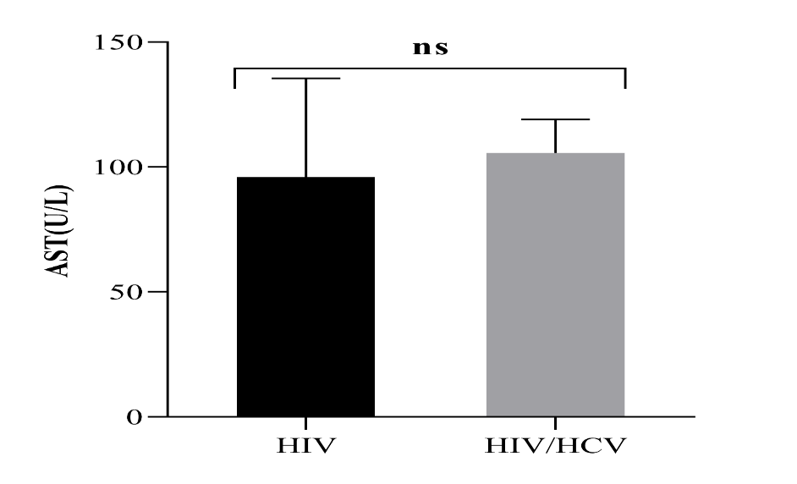
Fig 1: Serum AST levels of patients with HIV/HCV coinfection and HIV mono-infection with error bars of standard deviation.
Serum ALT levels of patients with HIV/HCV co-infection and HIV mono-infection
The average ALT enzyme level in HIV mono-infection cases was 30.66 ± 13.38U/L, while in HIV/HCV coinfected cases, this average was 28.7 ± 3.96U/L. Both females and males had low ALT mean values (30.66U/L and 28.7U/L respectively) lower than the normal values (F < 33 U/L and M < 44 U/L). This difference was not statistically significant, t (1.382) = 0.65, P >0.05, (Figure 2).
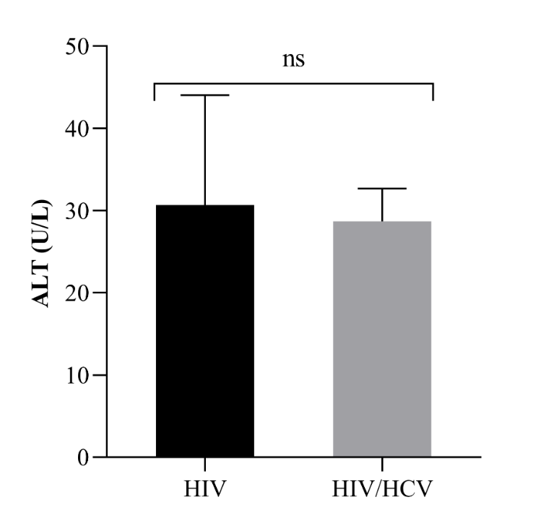
Fig 2: Serum ALT levels of patients with HIV/HCV coinfection and HIV mono-infection with error bars of standard deviation
Assessment of risk factors of HIV/HCV co-infection
No statistically significant associations were found between demographic factors like gender, age group, marital status, educational level, and occupation (p- value > 0.05), as shown on Table 2.
Table 2: Assessment of risk factors of HIV/HCV co-infection
Variables | Category | HIV/HCV Co-infection n(%) | p-value
Gender | Male | 0(0) | 0.45
Gender | Female | 2(1.9) | 0.45
Educational level | Primary | 2(2.2) | 0.642
Educational level | Secondary | 0(0) | 0.642
Educational level | Tertiary | 0(0) | 0.642
Marital status | Single | 1(5) | 0.497
Marital status | Married | 1(1.6) | 0.497
Marital status | Divorced | 0(0) | 0.497
Marital status | Widow/Widower | 0(0) | 0.497
Monthly family income | < 7500cfa | 1(1.9) | 0.792
Monthly family income | > 7000cfa | 1(1.3) | 0.792
Occupation | Teacher | 0(0) | 0.255
Occupation | Farmer | 2(4.5) | 0.255
Occupation | Trader | 0(0) | 0.255
Occupation | Others | 0(0) | 0.255
Residence | Rural | 0(0) | 0.491
Residence | Urban | 2(1.9) | 0.491
Age group | 21 - 29 | 0(0) | 0.866
Age group | 30 - 39 | 0(0) | 0.866
Age group | 40 - 49 | 1(2.7) | 0.866
Age group | 50 - 59 | 1(3.1) | 0.866
Age group | 60 - 69 | 0(0) | 0.866

Clinical and behavioural factors associated with HCV among study participants
Study findings showed two (1.5%) of patients with HCV were currently on ART. This result was not statistically significant (P-value = 0.901). Other clinical and behavioural factors such as history of operation, received blood transfusion before 1992, alcohol consumption, circumcised, unprotected sex, tooth removed, sharing injections/needles, drawing tattoo and piercing skin, working in healthcare setting, travelled to country with high HCV prevalence, family history of liver disease, and regular exercise showed no statistically significant association with HCV infection among HIV patients (P – value > 0.05) (Table 3).
Table 3: Clinical and behavioural factors associated with HCV among HIV patients
Variable | Categories | Negative  n (%) | Positive  n (%) | 𝜒2 | p-value
Currently on ARTs | Yes | 129(98.5) | 2(1.5) | 0.016 | 0.901
Currently on ARTs | No | 1(100) | 0(0) | 0.016 | 0.901
History of operation | Yes | 39(97.5) | 1(2.5) | 0.373 | 0.541
History of operation | No | 91(98.9) | 1(1.1) | 0.373 | 0.541
Alcohol consumption | Yes | 85(97.7) | 2(2.3) | 1.05 | 0.305
Alcohol consumption | No | 45(100) | 0(0) | 1.05 | 0.305
Circumcised | Yes | 25(100) | 0(0) | 0.474 | 0.491
Circumcised | No | 105(98.1) | 2(1.9) | 0.474 | 0.491
Received blood transfusion before 1992 | Yes | 27(96.4) | 1(3.6) | 1.007 | 0.316
Received blood transfusion before 1992 | No | 103(99) | 1(1) | 1.007 | 0.316
Unprotected sex | Yes | 52(100) | 0(0) | 1.320 | 0.251
Unprotected sex | No | 78(97.5) | 2(2.5) | 1.320 | 0.251
Tooth removed | Yes | 56(100) | 0(0) | 1.496 | 0.221
Tooth removed | No | 74(97.4) | 2(2.6) | 1.496 | 0.221
Share injections/needles | Yes | 8(100) | 0(0) | 0.131 | 0.717
Share injections/needles | No | 122(98.4) | 2(1.6) | 0.131 | 0.717
Drawing tattoo and piercing skin | Yes | 5(100) | 0(0) | 0.080 | 0.777
Drawing tattoo and piercing skin | No | 125(98.4) | 2(1.6) | 0.080 | 0.777
Working in healthcare setting | Yes | 40(97.6) | 1(2.4) | 0.34 | 0.56
Working in healthcare setting | No | 90(98.9) | 1(1.1) | 0.34 | 0.56
Travelled to country with high HCV prevalence | Yes | 3(100) | 0(0) | 0.047 | 0.828
Travelled to country with high HCV prevalence | No | 127(98.4) | 2(1.6) | 0.047 | 0.828
Family history of liver disease | Yes | 7(100) | 0(0) | 0.114 | 0.736
Family history of liver disease | No | 123(98.4) | 2(1.6) | 0.114 | 0.736
Regular exercise | Yes | 58(100) | 0(0) | 1.592 | 0.207
Regular exercise | No | 72(97.3) | 2(2.7) | 1.592 | 0.207

Comorbidities among study participants
Most participants had no documented chronic comorbidities according to their hospital records. No significant differences were observed in the prevalence of comorbid conditions or assessed behavioral and clinical risk factors between the HIV/HCV coinfected cases compared to HIV mono-infected cases as shown on Table 4.
Table 4: Comorbidities in HIV/HCV coinfection compared to HIV mono-infection
Variable | Categories | HIV mono-infection  n (%) | HIV/HCV co-infection  n (%) | 𝜒² | p-value
Diabetes | Yes | 14(100) | 0(0) | 0.241 | 0.624
Diabetes | No | 116(98.3) | 2(1.7) | 0.241 | 0.624
Hypertension | Yes | 36(100) | 0(0) | 0.762 | 0.383
Hypertension | No | 94(97.9) | 2(2.1) | 0.762 | 0.383
Heart attack/stroke | Yes | 10(100) | 0(0) | 0.166 | 0.683
Heart attack/stroke | No | 120(98.4) | 2(1.6) | 0.166 | 0.683
Chronic skin disease | Yes | 10(100) | 0(0) | 0.166 | 0.683
Chronic skin disease | No | 120(98.4) | 2(1.6) | 0.166 | 0.683
Tuberculosis | Yes | 21(100) | 0(0) | 0.384 | 0.535
Tuberculosis | No | 109(98.2) | 2(1.8) | 0.384 | 0.535
Liver infection | Yes | 4(100) | 0(0) | 0.063 | 0.801
Liver infection | No | 126(98.4) | 2(1.6) | 0.063 | 0.801

Discussion
This study evaluated the seroprevalence of HCV, associated comorbidities and risk factors among HIV infected adults at the Bamenda Regional Hospital in the North West Region of Cameroon. The overall prevalence of HIV/HCV coinfection was 2% (95%CI: 0.003 – 0.046, p < 0.001) among HIV adults. These findings are in line with a global systematic review that reported 2.4% HIV/HCV coinfection prevalence rates. Previous studies have reported varying HIV/HCV coinfection rates of 1.7% prevalence in the South West region of Cameroon (Agbor et al., 2018), 4.7% in Nigeria, (Nnakenyi et al., 2020) 8.6% in Ethiopia (Ayelign et al., 2021) 12.5% in Rwanda (Munyemana et al., 2021), 16.1% in Malaysia (Akhtar et al., 2022). These prevalence rates vary significantly depending on the geographic region and may be linked to lifestyle practices. The low prevalence observed in this study may reflect limited injection drug use, improvements in blood transfusion safety, and differences in dominant transmission pathways within the study population.
Co-infection was observed exclusively among females and was recorded in participants aged 40 years and above. Reports from studies carried out in Rwanda showed higher coinfection prevalence in female subjects as compared to male subjects. However, reports from a study carried out in Malaysia showed higher prevalence in males participants compared to the females (Munyemana et al., 2021; Akhtar et al., 2022). These differences may be due to sample size, and geographical distribution of recruited participants. Increased age has interestingly been highlighted in previous studies as one of the factors, which possibly influence HCV infection. (Umutesi et al., 2017; Munyemana et al., 2021)
Although AST levels were higher among HIV/HCV co-infected participants, the difference was not statistically significant, and ALT levels were comparable between groups. Similar findings have been reported in African cohorts, where co-infected individuals often present with minimal or subclinical biochemical liver abnormalities (Munyemana et al., 2021). Contrary to these findings, elevated AST levels were reported among HIV/HCV coinfected participants as compared to HIV mono-infected individuals in a study carried out in Yaoundé Cameroon (Dobseu et al., 2020). The small number of HCV-positive cases in this study likely limited the statistical power to detect significant differences.
No significant associations were observed between HIV/HCV co-infection and assessed comorbidities or behavioral risk factors in this study. Contrarily, diabetes mellitus, hypertension, liver damage, renal failure, and active TB disease were the observed comorbidities in a study carried out in Rwanda, where the HIV/HCV coinfected group showed an increased risk of having comorbidities as compared to the group of HIV mono-infected group (Munyemana et al., 2021). The absence of such associations here may be attributable to early-stage infection, effective ART, or underdiagnosis of subclinical disease. The emergence of comorbidities with an increased rate of progression to cirrhosis, decompensated liver disease, hepatocellular carcinoma, and death remains a critical challenge as far as global public health is concerned (Maggi P et al., 2015; Wei et al., 2019; Koziel and Peters, 2007).
Despite the low prevalence identified, HIV/HCV co-infection remains clinically relevant due to its established association with accelerated liver disease progression and increased mortality (Chen et al., 2014; Debes et al., 2016). Integration of routine HCV screening into HIV care services is therefore warranted, particularly as access to direct-acting antiviral therapy expands.
This study is limited by its single-center design and modest sample size, which may restrict generalizability. Nevertheless, it provides valuable baseline data for the North West Region of Cameroon and underscores the need for larger, multicenter studies.

Lay Summary
Hepatitis C infection was uncommon among adults living with HIV at the Bamenda Regional Hospital. Liver test results were similar in patients with and without hepatitis C. Regular hepatitis C testing in people with HIV can help ensure early detection and long-term liver health.

Conclusions
HIV/HCV co-infection prevalence was low among HIV-infected adults at the Bamenda Regional Hospital, with no significant liver enzyme abnormalities or associated comorbidities identified. A large-scale multicenter study is needed to reveal nation-wide prevalence rates. More importantly, continued integration of HCV screening into HIV care and expanded surveillance are recommended.

Data availability statement
The data that support the findings of this study are not publicly available due to privacy or ethical restrictions, but are available from the corresponding author on reasonable request.

References
Agbor, V. N., Tagny, C. T., Kenmegne, J. B., Awazi, B., Ngansop, C., Mbanya, D., & Ndembi, N. (2018). Prevalence of anti-hepatitis C antibodies and its co-infection with HIV in rural Cameroon. BMC research notes, 11(1), 459. https://doi.org/10.1186/s13104-018-3566-4
Akhtar, A., Fatima, S., Saeed, H., Soo, C. T., & Khan, A. H. (2022). HIV-HCV Coinfection: Prevalence and Treatment Outcomes in Malaysia. Intervirology, 65(2), 87–93. https://doi.org/10.1159/000518836
Ayelign, M., Aynalem, M., & Berhane, N. (2021). Hepatitis and HIV Co-infection at University of Gondar Specialized Referral Hospital: Northwest Ethiopia. Hepatic medicine: evidence and research, 13, 113–120. https://doi.org/10.2147/HMER.S337817
Dobseu, R., Nanfack, A., Kowo, M., Ambada, G., Kamgaing, R., Chenwi, C., Fainguem, N., Ka'e, A., Ngangoum, E., Sosso, S., Tchiegang, C., & Ndjolo, A. (2020). Evaluation of hepatic fibrosis in HIV/HCV co-infected individuals in Yaoundé, Cameroon: usefulness of APRI score in resource-constrained settings. BMC infectious diseases, 20(1), 758. https://doi.org/10.1186/s12879-020-05477-7
Eboumbou Moukoko, C. E., Ngo Sack, F., Essangui Same, E. G., Mbangue, M., & Lehman, L. G. (2014). HIV, HBV, HCV and T. pallidum infections among blood donors and Transfusion-related complications among recipients at the Laquintinie hospital in Douala, Cameroon. BMC hematology, 14(1), 5. https://doi.org/10.1186/2052-1839-14-5
Grzeszczuk, A., Wandalowicz, A. D., Jaroszewicz, J., & Flisiak, R. (2015). Prevalence and Risk Factors of HCV/HIV Co-Infection and HCV Genotype Distribution in North-Eastern Poland. Hepatitis monthly, 15(7), e27740. https://doi.org/10.5812/hepatmon.27740v2
Kim, C. W., & Chang, K. M. (2013). Hepatitis C virus: virology and life cycle. Clinical and molecular hepatology, 19(1), 17–25. https://doi.org/10.3350/cmh.2013.19.1.17
Koziel, M. J., & Peters, M. G. (2007). Viral hepatitis in HIV infection. New England Journal of Medicine, 356(14), 1445-1454.
Luma, H. N., Eloumou, S. A., Ekaney, D. S., Lekpa, F. K., Donfack-Sontsa, O., Ngahane, B. H., & Mapoure, Y. N. (2016). Sero-prevalence and Correlates of Hepatitis B and C Co-infection Among HIV-infected Individuals in Two Regional Hospitals in Cameroon. The open AIDS journal, 10, 199–208. https://doi.org/10.2174/1874613601610010199
Maggi, P., Altizio, S., DI Biagio, A., Nicolini, L., Volpe, A., Tancorre, T., Leone, A., Bellacosa, C., Ladisa, N., & Angarano, G. (2015). Prevalence and Risk Factors for Significant Liver Fibrosis in Patients with HIV Infection. In vivo (Athens, Greece), 29(6), 771–775.
Marceline, D. N., Marlene, G. T. I., Cyriaque, A. A., Armelle, F. K. G., & Moundipa, F. P. (2018). Current status of human immunodeficiency virus and hepatitis C virus (HIV/HCV) co-infection in Cameroon: Sero-prevalence, risk factors and correlation with markers of liver function and CD4 cells rate in patients diagnosed in three hospital settings. Journal of AIDS and HIV Research, 10(3), 22-30. https://doi.org/10.5897/JAHR2017.0456
Matthews, P. C., Geretti, A. M., Goulder, P. J., & Klenerman, P. (2014). Epidemiology and impact of HIV coinfection with hepatitis B and hepatitis C viruses in Sub-Saharan Africa. Journal of clinical virology, 61(1), 20-33.
Munyemana, J. B., Mukanoheli, E., Nsabimana, T., & Niringiyumukiza, J. D. (2021). HCV Seroprevalence among HIV Patients and Associated Comorbidities at One Primary Health Facility in Rwanda. The American journal of tropical medicine and hygiene, 104(5), 1747–1750. https://doi.org/10.4269/ajtmh.20-0500
Nnakenyi, I. D., Uchechukwu, C., & Nto-Ezimah, U. (2020). Prevalence of hepatitis B and C virus co-infection in HIV positive patients attending a health institution in southeast Nigeria. African health sciences, 20(2), 579–586. https://doi.org/10.4314/ahs.v20i2.5
Shaw, J., & Matin, N. (2022). Opportunistic infections in HIV. Medicine, 50(5), 294-297.
Thomas, D. L., Leoutsakas, D., Zabransky, T., & Kumar, M. S. (2011). Hepatitis C in HIV-infected individuals: cure and control, right now. Journal of the International AIDS Society, 14, 22. https://doi.org/10.1186/1758-2652-14-22
Tovo, P. A., Calitri, C., Scolfaro, C., Gabiano, C., & Garazzino, S. (2016). Vertically acquired hepatitis C virus infection: Correlates of transmission and disease progression. World journal of gastroenterology, 22(4), 1382–1392. https://doi.org/10.3748/wjg.v22.i4.1382
Umutesi, J., Simmons, B., Makuza, J. D., Dushimiyimana, D., Mbituyumuremyi, A., Uwimana, J. M., Ford, N., Mills, E. J., & Nsanzimana, S. (2017). Prevalence of hepatitis B and C infection in persons living with HIV enrolled in care in Rwanda. BMC infectious diseases, 17(1), 315. https://doi.org/10.1186/s12879-017-2422-9
UNAIDS 2024; Global HIV & AIDS statistics — Fact sheet. accessed March 2025 https://www.unaids.org/en/resources/fact-sheet
Vidya Vijayan, K. K., Karthigeyan, K. P., Tripathi, S. P., & Hanna, L. E. (2017). Pathophysiology of CD4+ T-Cell Depletion in HIV-1 and HIV-2 Infections. Frontiers in immunology, 8, 580. https://doi.org/10.3389/fimmu.2017.00580
Wei, Y., Li, W., Du, T., Hong, Z., & Lin, J. (2019). Targeting HIV/HCV Coinfection Using a Machine Learning-Based Multiple Quantitative Structure-Activity Relationships (Multiple QSAR) Method. International journal of molecular sciences, 20(14), 3572. https://doi.org/10.3390/ijms20143572
WHO, Global Hepatitis C report 2024, accessed March 2025 https://www.who.int/news-room/fact-sheets/detail/hepatitis-c

