Three-Dimensional Canopy Architecture and Light Interception Dynamics: A New Perspective for Crop Productivity Enhancement

Abstract
Agriculture strives to balance productivity and sustainability worldwide. The future of both non-perennial and perennial crops may depend on how solar radiation within plant canopies is managed. This review examines the complex physics, eco-physiology, and art of canopy architecture to improve light interception, essential for photosynthesis and resource allocation. It extends beyond traditional concepts such as the Law of Beer and classical models by incorporating modern simulations, AI-based phenomics, three-dimensional structural mapping, vertical stratification, and remote sensing. Emphasis is placed on the interaction between diffuse and direct light and on the spatial organisation of leaf angles, azimuth, and inclination, which influence microclimates, stress resilience, and source-sink relationships. The review covers orchard and crop management techniques such as pruning, training systems, mulching, and growth regulators, supported by quantum measurements and UAV imagery, analysed with advanced tools such as RATP, MAESTRA, and DART. This integration of ecological, economic, and technological factors demonstrates how light interception impacts crop quality, yield, and climate resilience. It calls for a transformation in canopy science, linking molecular advances to large-scale agricultural practices, which are vital for developing sustainable solutions to global food security.
Keywords: Canopy architecture, Light interception, Leaf orientation, Photosynthetically Active Radiation (PAR), Stratification, Remote sensing
- Introduction
Strategic investment in perennial crops such as orchards, vineyards, and plantations is crucial in global agriculture, where crop stability and productivity depend on canopy structure and management. Canopy architecture—the spatial arrangement of leaves, branches, and reproductive organs—is key to the performance of perennial crops and serves as the main interface between plants and their environment. It significantly influences the microclimate within the canopy and enhances light interception efficiency, which is vital for photosynthesis and carbon assimilation (Kumar & Sharma, 2020). A well-designed canopy optimises light distribution, supporting photosynthesis across multiple leaf layers. In contrast, dense or poorly managed canopies limit light penetration, decrease photosynthetic activity, and negatively affect yield and fruit uniformity (Chavez et al., 2022). Linking canopy architecture to yield potential involves effective light interception that promotes electron transport during photosynthesis and increases assimilate production. This helps maintain a balance between source and sink, ensuring sustained vegetative growth and reproductive success over successive years (Korner, 2015). Advances in understanding light capture and use have been driven by theoretical models of canopy-light interactions, beginning with Beer's Law, which describes the exponential decrease in light as it passes through a medium. Monsi and Saeki (2005) introduced the extinction coefficient to quantify the effects of leaf orientation and density on light attenuation in canopies. Their pioneering work transformed crop physiology by enabling the measurement of canopy performance in natural and controlled environments, setting the stage for further modelling of light interception and carbon assimilation. Over time, models have evolved from simple 1D approaches to advanced three-dimensional canopy and functional-structural plant models (FSPMs), offering greater accuracy in analysing, predicting, and optimising canopy effects on yield and quality. These models form the basis for precision agriculture tools that integrate remote sensing, canopy imaging, and physiological data to guide management practices such as pruning, training, and planting density (Robles-Zazueta et al., 2021). The ongoing dialogue between traditional theory and modern practices highlights the enduring importance of canopy science in managing perennial crops. This review aims to: (1) emphasise the role of canopy architecture in the productivity and sustainability of perennial crops; (2) elucidate the physiological mechanisms linking light interception, carbon assimilation, and yield; (3) review the development of models describing canopy-light interactions; and (4) establish a framework connecting classical ideas with modern approaches. In sum, this review synthesises ecological, crop physiological, and agronomic knowledge to offer an integrated view of how canopy architecture and light interception remain essential strategies for improving perennial cropping systems amid climate change and rising productivity demands.
- Fundamentals of light interception in plant canopies
Plants, with their canopy system diversity, must regulate light interception, which is vital for crop growth models used to optimise management, evaluate the effects of climate change on crop yields, and support plant breeders (Liu B et al., 2016). These models depend on processes such as photosynthesis; the manner in which leaves capture, absorb, reflect, and transmit sunlight affects the efficiency of how plants use light energy (Chenu K et al., 2017).
  - PAR (400–700 nm) and its importance
Monitoring and enhancing plant yield per unit area depends critically on both the quantity and quality of the crop. Solar radiation naturally supports this process because light plays a key role in photosynthesis, where it transforms water and carbon dioxide into glucose and oxygen, releasing oxygen as a byproduct and leading to the buildup of organic matter (Zafar et al., 2022).
The primary driver of plant photosynthesis is photosynthetically active radiation (PAR), which comprises wavelengths absorbed and used by green plants for photosynthesis (Noriega et al., 2021). PAR, ranging from 400 to 700 nanometres, constitutes the portion of the solar spectrum used for photosynthesis. This range spans the visible light spectrum, including violet, blue, green, and red wavelengths, each of which plays a specific role in plant growth and development (Xing, 2018). Fig. 1 shows the wavelength ranges of visible and ultraviolet light, highlighting the wavelengths critical for regulating plant physiological processes, particularly in fruit crops. Table 1 complements this by summarising the specific wavelengths, corresponding photoreceptors, and the resulting plant responses in major fruit crops.
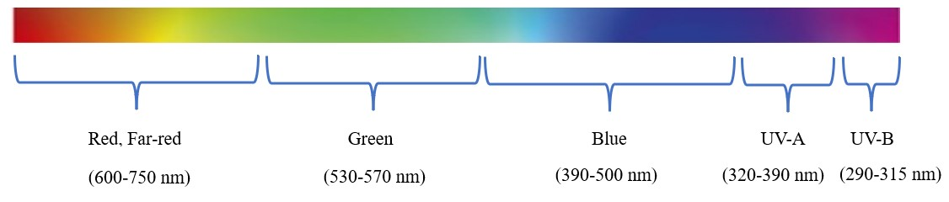
Fig.1 Different wavelength ranges of light affecting plant responses in fruit crops
Table 1 Plant responses to spectral wavelength specificity of the main plant photoreceptors in fruit tree growth and development
Sr.no | Light wavelength ranges | Photoreceptors activated | Plant responses | Fruit crops
1. | Red, Far-red  (600-750 nm) | PHYs | Germination, De-etiolation, Shade avoidance, Inhibition of stem and petiole elongation, Leaf expansion and flattening, Circadian rhythms, Flowering, Branching | Mango, Banana, Grape, Strawberry, Fig
2. | Green  (530-570 nm) | CRYs | De-etiolation, Inhibition of stem and petiole elongation, Leaf expansion, Circadian rhythms, Flowering, Flavonoid biosynthesis. Response to shade by B/G photoperception | Papaya, Sapota, Aonla, Apple, Plum
3. | Blue  (390-500 nm) | PHOTs | Leaf flattening, Phototropism, Stomatal Chloroplast relocation | Pineapple, Avocado, Peach, Olive, Guava
4. | UV-A  (320-390 nm) | TL/FKF1/LKP2 | Circadian rhythms, Flowering | Passionfruit, Litchi, Cherry, Apricot
5. | UV-B  (290-315 nm) | UVR8 | De-etiolation, Flavonoid biosynthesis | Jackfruit, Guava, Pomegranate, Fig, Pear
(Mawphlang et al., 2017; Fazi et al., 2019)
  - Diffuse vs. direct light and seasonal effects
Solar radiation enters the atmosphere and scatters as it interacts with components such as cloud droplets, gas molecules, and aerosol particles. It splits into diffuse and direct parts. Diffuse light is caused by scattering by molecules or larger particles and appears from many directions at once, while direct light comes straight from the sun without scattering (Iqbal, 1983). Understanding the direct and diffuse components of solar radiation is crucial for comprehending how light quality influences plant growth. However, there is no systematic explanation of how the threshold between these two components is determined (Knohl & Baldocchi, 2008). The roles of diffuse and direct radiation in plant biophysical mechanisms vary because leaves in sunny and shaded areas have different light requirements for functions like transpiration and photosynthesis. Sunlit leaves tend to be light-saturated, while shaded leaves are light-limited (Pedruzo-Bagazgoitia et al., 2017). Plants generally absorb diffuse light more efficiently than direct light since it scatters in all directions, providing more uniform radiation and better light penetration to shaded leaves, which enhances overall canopy photosynthesis (Li et al., 2014). Climate-change models project future increases in diffuse light due to rising atmospheric water vapour and cloud cover (Schiermeier, 2006).
  - Canopy as a three-dimensional structure (leaf orientation, azimuth, inclination)
A highly dynamic three-dimensional structure governs how sunlight is intercepted, distributed, and used. Leaf orientation (angle relative to the horizontal), azimuth (direction), and inclination are key determinants of light penetration and distribution. The three-dimensional (3D) CPMs calculate the light intercepted by each leaf using a 3D canopy model (Evers et al., 2010), accounting for leaf size, angle, curvature, and azimuth. The 0D, 1D, and 2D approaches are common in crop growth models to assess how cultivar choices, farming methods, and climate change affect crop yield potential. The leaf’s angular position relative to the stem and ground indicates its orientation. Vertical leaves maximise light capture, while horizontal leaves capture more light at lower sun angles during midday (Evers et al., 2010). Azimuth, or the direction of leaf placement, describes the compass direction of leaf orientation relative to north, south, east, and west. This significantly influences the daily pattern of light interception. Advances in robotics, unmanned aerial vehicles (UAVs), and image processing have enabled new methods in plant phenomics research. These techniques enable the determination of a plant's azimuth angle using aerial and ground-based phenotyping systems, thereby enabling efficient measurement (Kai et al., 2010). The leaf inclination angle (LIA), or the angle of the leaf or needle relative to the horizontal, is vital for processes such as radiative transfer, precipitation interception, evapotranspiration, photosynthesis, and hydrological activities. It can be measured directly or indirectly. Direct methods include LiDAR, photography, and contact techniques, whereas indirect methods include four-component analysis, polarisation, and gap-fraction measurement (Mantilla-Perez et al., 2017). Direct methods provide accurate LIA measurements at the leaf, crown, or plot level, whereas indirect techniques are better suited for crop-scale assessments. LIA results from genetic, hormonal, and environmental factors such as light, water, temperature, and nutrients. Typically, LIA is expressed as the simple or area-weighted average of all segments of long, thin, curving leaves. By contrast, large and flat leaves allow easier direct measurement of LIA (Atzberger et al., 2012).
  - Vertical stratification of light within canopies
The vertical structure of the plant micro-environment aims to optimise light interception and to separate canopy elements such as leaves, stems, branches, and trunks. This organisation helps improve light absorption, CO2 exchange, and pollination (Leuning et al., 1998). According to the Beer-Lambert-Bouguer law, as radiation passes through successive layers, it is absorbed. It decreases exponentially, causing light intensity in the canopy to decline from top to bottom. Upper-canopy leaves tend to have more photoprotective pigments, thicker mesophyll, and higher leaf mass per area (LMA); in contrast, lower leaves are thinner with a higher specific leaf area (SLA) to better capture light in shaded zones (Niinemets, 2007). Fig. 2 illustrates how light intensity diminishes as sunlight moves through different canopy layers, showing that the upper canopy receives the most light, with a progressive reduction as light penetrates deeper into the canopy.

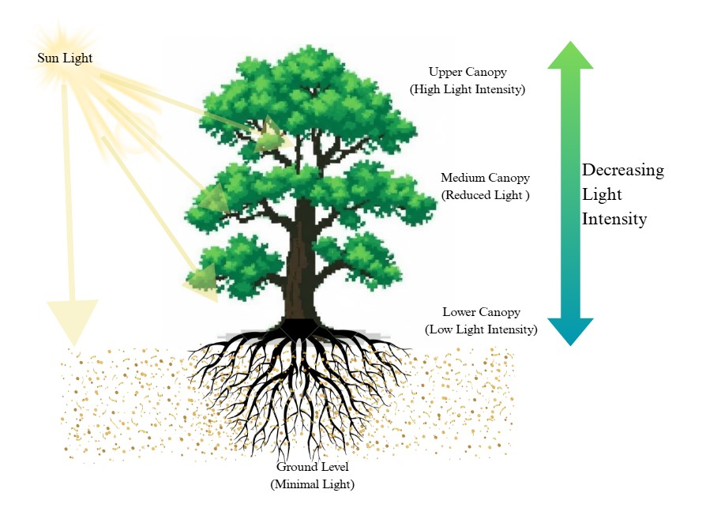
Fig.2 Conceptual diagram of light attenuation through a tree canopy

- Principles of light distribution in three-dimensional canopy systems
Within a canopy, light interception depends on factors such as leaf area index, leaf orientation, leaf inclination, and the arrangement of leaves and branches. These structural features generate complex patterns of light intensity and quality, with high exposure in the upper layers and diffuse, scattered light in the shaded lower parts.
  - Leaf area index (LAI) and extinction coefficient
Light availability in a canopy depends on variations in leaf and canopy structural features (Zhang et al., 2016). Leaf traits, such as leaf area index (LAI) and extinction coefficient (k), greatly affect how effectively leaves capture light and perform photosynthesis during canopy development. LAI measures the total one-sided leaf area per unit ground area and indicates canopy density, photosynthetic ability, and transpiration potential. As LAI increases, more surface area is available for light absorption; however, excessive LAI can lead to self-shading, which reduces light reaching the lower layers (Yang et al., 2017). Proper nutrients, moisture, and growth regulators such as gibberellins are also important. Moreover, improving photosynthesis in agriculture can be achieved by expanding and integrating C4 photosynthesis traits into C3 plants (Éva et al., 2019). In crop development, the canopy extinction coefficient (K) is critical and is influenced by canopy structure, plant species, and sowing patterns (Soleymani, 2018). This concept stems from Beer–Lambert’s law, which states that:
I=I0⋅e−k⋅LAI
where I stand for the radiation intensity below the canopy, I₀ is the intensity above, k is the extinction coefficient, and LAI reflects canopy leafiness. The extinction coefficient varies with leaf angle distribution, sun position, and species-specific traits. The combined use of LAI and k allows estimation of the proportion of incident radiation intercepted by a canopy.

  - Canopy depth, density, and layering effects
The plant's canopy exhibits some depth and density, combined with vertical layering. Research on crops such as rice and maize shows that more upright leaves in the upper layers facilitate deeper light penetration, thereby optimising photosynthesis in dense canopies. In maize, higher planting density increases the Leaf Area Index (LAI) and canopy depth; however, it also reduces the average light transmittance through the lower and middle layers (Du et al., 2023). Greater canopy depth enhances light capture as more leaf area receives incoming radiation. Shallow canopies in some vegetables allow uniform light penetration. In contrast, taller fruit trees or cereals with deep canopies often require management techniques such as pruning or adjusting row spacing to achieve balanced light distribution. Canopy density refers to how compact and close the foliage is. Higher density, indicated by a high LAI, typically results in greater total interception of photosynthetically active radiation (PAR) but may limit light reaching lower layers, leading to shading-induced leaf senescence and reducing photosynthetic efficiency over time (Dahiya et al., 2023). In contrast, sparser canopies with lower density permit more even light distribution but may not maximise radiation use. The extinction coefficient K decreases as density and canopy development stages increase, indicating a steeper decline in light. The process of dividing leaves into functional zones is called canopy layering (Vierling et al., 2008).
  - Radiation transfer models: ray tracing, gap-fraction analysis
The radiation transfer model is essential in virtual plant models for estimating energy balance and crop evapotranspiration (ET). It tracks individual light rays, allowing analysis of their complex interactions with canopy leaves, including absorption, reflection, and refraction (Kim et al., 2020). Common approaches include ray-tracing models and gap-fraction analysis, which offer complementary methods for measuring canopy light environments. Ray-tracing effectively examines how light interacts with three-dimensional canopy structures, capturing phenomena such as scattering, reflection, absorption, and shadowing at the level of individual organs. It also helps observe spatial light variability, such as sun flecks and the penetration of diffuse light. Gap-fraction analysis estimates canopy openness by measuring the visible sky through gaps, typically with an optical instrument, applying the Beer–Lambert law to evaluate light attenuation. This parameter is key for understanding radiative transfer within vegetation canopies and is valuable for light interception and reflectance modelling (Gower et al., 1999). A comprehensive overview of key radiation characteristics and plant canopy parameters that influence the spatial distribution of light within plant stands is presented in Table 2.
Table 2 Radiation characteristics affecting spatial light distribution through plant canopies
Sr.no | Parameters | Impact on light distribution | Refrences
1. | Leaf area index (LAI) | LAI (↑) light interception (↑)  Excessive LAI reduces light within the canopy | Bréda et al., 2003
2. | Leaf angle distribution  (LAD) | Horizontal leaves- (↑) Direct sunlight interception  Vertical leaves- (↑) Light penetration | Campbell et al., 1998
3. | Extinction coefficient (k) | Controls quickly light attenuates with canopy depth  (↑) k = faster drop, more shading | Bréda et al., 2003
4. | Gap fraction | (↑) Gap fraction allows more light and better fruit development | Fang et al., 2021
5. | Vertical stratification/layering | Upper layers intercept most light  Lower layers intercept less light | Béland et al., 2021
6. | Photosynthetically active radiation (PAR) | Total PAR received influences photosynthesis, yield, fruit size, and sugar content. | Paradiso et al., 2022
7. | Diurnal variation | Midday maximises photosynthesis, but dense canopies show midday depression in carbon assimilation. | Ventre-Lespiaucq et al., 2018
8. | Optical properties of leaves | Pigment and structure determine wavelength-specific reflectance and transmission. | Bréda et al., 2003
9. | Clumping index (CI) | If CI < 1, then clumped leaves produce less light  It influences total intercepted PAR | Fang et al., 2021
10. | Sun vs shade leaf area | Outer leaves are thicker, with higher photosynthetic rates  Inner shade leaves are thinner, adapted for diffuse light | Bréda et al., 2003

- Canopy Geometry and Its Influence on Light Distribution
The structure of the plant canopy provides a framework that interacts with sunlight, helping to optimise plant density, develop canopy ideotypes, and improve light-use efficiency. It encompasses leaf angle, orientation, and spatial arrangement.
  - Types of canopy forms (conical, spherical, vase, espalier, hedgerow)
Plant canopies come in various shapes, such as conical, spherical, vase-shaped, espalier, and hedge, each affecting light interception and distribution differently. In natural settings, canopies often remain unpruned, but commercial orchards frequently modify their shapes to optimise management and yield. For instance, a Christmas tree-like tapering shape allows better light penetration to lower foliage by reducing self-shading, facilitating diffuse light to reach deeper. Some canopies are nearly round or spherical, with similar height and width, and are evenly lit from all sides but tend to be thicker in the centre. Vase-shaped trees have a main trunk that extends outward and upward, creating open lower and middle canopy levels to enhance light distribution. Practices such as reducing tree numbers and increasing inner-canopy light are common. Espalier systems, which train branches to grow along support wires, have been found to improve fruit quality. High-density orchard hedgerows, with narrow rows and controlled height, width, and alley orientation, aim to maximise light, airflow, and accessibility while reducing shading at the orchard base. Table 3 details how different structural forms influence the distribution and penetration of sunlight, linking each canopy type to specific fruit crops and highlighting the importance of canopy management for optimal light capture, fruit development, and yield.
Table 3: Comparative light interception efficiencies of different canopy shapes
Sr.no | Canopy shapes | Light interception efficiency | Fruit crops
1. | Conical  (Pyramidal) | Proper light penetration throughout the canopy supports lower fruit quality. | Mango, Avocado, Apple
2. | Globular  (Round) | Dense inner shading reduces light, and lower fruit quality inside | Pomegranate, Citrus, Litchi
3. | Open centre  (Vase-shaped) | Proper light access to the interior | Peach, Apricot, Plum
4. | Trellis  (Y or V shaped) | Maximises light interception, good for uniform fruit quality | Kiwi, Grapevine, Cherry, Macadamia
5. | Spindle  (Spindle bush) | Moderate interception; requires pruning to reduce shading | Rubber, Nectarine
6. | Espalier  (Planar) | Highest light interception in a trained plane; space-efficient | Apricot, Fig, Guava
7. | Columnar  (Fastigiate form) | Very efficient vertical light interception; suited to high-density orchards | Oil palm, Pear, Currant
8. | Fan-shaped | Proper light penetration requires moderate space for expansion | Guava, Plum, Banana
9. | Hedgerow | Maximises sunlight capture in dense orchards; improves yield per area | Litchi, Citrus
(Robinson et al., 1991; Anthony et al., 2021)
  - Influence of planting systems and row orientation on radiation capture
Row crop systems are frequently employed for horticultural and agronomic crops. In these systems, some light reaches the ground between the rows (Sarlikioti et al., 2011a). Factors such as row spacing, narrow-wide rows, planting patterns (like uniform versus alternating or paired rows), intercropping versus monocropping, and row or seed orientation significantly influence how crops capture light (photosynthetically active radiation, PAR), distribute it within the canopy, and convert it into biomass and yield (Liu T et al., 2011). The arrangement of rows affects plant density and spatial configuration, which in turn influence shading and light penetration. For instance, Liu et al. (2012) studied maize with narrow-wide row patterns, such as alternating narrow and wide rows, compared to uniform row planting. They found that narrow-wide patterns allowed more incoming PAR to reach the middle- and lower-canopy layers, thereby enhancing the net photosynthetic rate (Pₙ), stomatal conductance, and light use in shaded leaf layers.
  - Impact of pruning and training
Pruning and training significantly shape the canopy and enhance light penetration. More intensive pruning typically allows more light into the inner and lower parts of the canopy. For instance, Sharma et al. (2001) found that in a dense mango orchard, pruned trees received more light at all levels compared to unpruned ones. Similarly, in 'Red Fuji' apple trees, both light and heavy pruning improved light distribution compared to no pruning. Heavy pruning increased the proportion of canopy areas with very high light intensity (>80%) and reduced the proportion of shaded zones (<30%). Although heavy pruning may decrease fruit yield in the pruning year, it often improves fruit quality—size, soluble solids content, and colour (Song et al., 2010). Training systems also influence canopy form, branch angles, leaf orientation, spread, and spacing. A recent study on Korla fragrant pear showed that different training methods (Reduction, Falling Head, Thinning) significantly changed canopy structure and light distribution. For instance, reducing canopy spread and increasing spacing improved light penetration to the middle and lower layers, while lowering canopy height increased internal light and overall distribution (Yan et al., 2025). Fig.3 visually compares the effects of pruning and training on light distribution by showing unmanaged and managed trees.
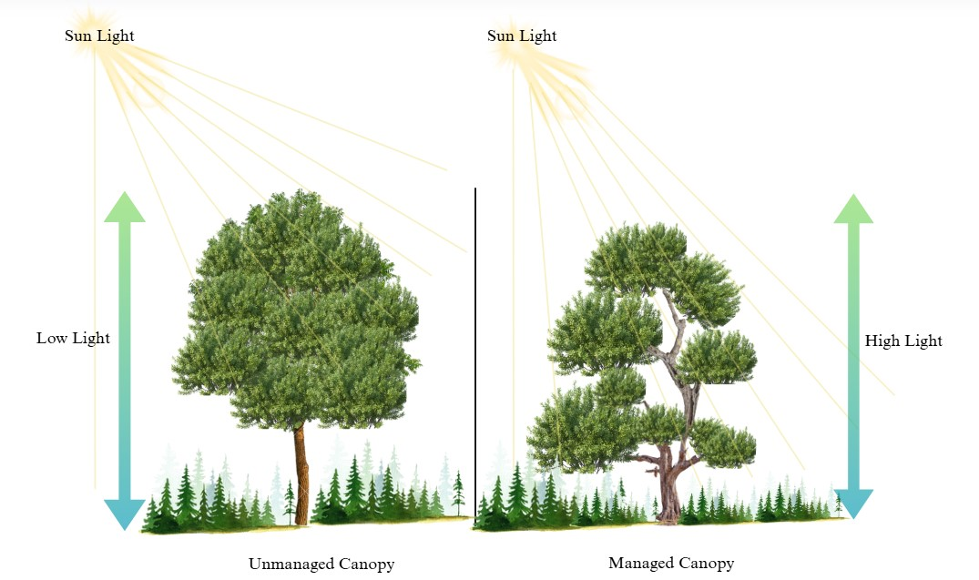

Fig.3 Effect of training and pruning on light distribution in plant canopy: comparison of unmanaged vs. Managed canopy structures

- Eco-physiological responses to light interception
Understanding eco-physiological factors—such as photosynthetic responses, morphological adaptations like leaf orientation and angle adjustments, physiological changes like carbon allocation, stress responses, and protective mechanisms—and their measurement is essential for developing and selecting the most effective management practices (Andrade et al., 2005).
  - Carbon assimilation and net photosynthesis in different canopy layers
Photosynthetic carbon fixation relies heavily on efficient light capture. One method to boost CO2 assimilation is to enhance photosynthetic efficiency. This involves improving the plant’s ability to convert absorbed light into essential energy molecules like ATP and NADPH for CO2 fixation by Rubisco, reducing carbon loss through photorespiration, and protecting against photoinhibition. Excess solar radiation can damage light-harvesting complexes through photooxidative stress (Baroli & Niyogi, 2000). After exposure to light, the increase in photosynthetic activity can take minutes to reach optimal levels, delaying peak performance (Soleh et al., 2017). Adjusting these responses could improve net photosynthesis under certain conditions (Murchie & Niyogi, 2011). Strategies include accelerating protein activation in the electron transport chain, boosting carbon fixation capacity by increasing Rubisco and Rubisco activase levels, and enhancing CO2 entry via stomatal and mesophyll conductance (Yamori, 2021). Another avenue involves modifications to reduce photorespiration, further increasing the efficiency of net photosynthesis.
  - Photoinhibition in shaded leaves
Photosynthetic capacity decreases when photosynthetic organisms, structures, or organelles are exposed to visible light. This includes processes such as photoinhibition, photooxidation, photoinactivation, photolability, solarisation, and photodynamic reactions. Leaf photosynthesis can be inhibited by shading or prolonged exposure to intense light, which can destroy chlorophyll pigments. Photooxidation is a secondary process that follows an initial lag phase, during which photosynthesis declines in a light- and time-dependent manner (photoinhibition) without reducing pigment levels (Warner et al.,1983). Land plants inhabit a variety of environments, from heavily shaded to fully exposed areas, influencing their susceptibility to photoinhibition. Experiments with shade-grown clones of Solanum dulcamara grown under higher photon flux density (PFD) confirmed photoinhibition of maximum photosynthetic capacity and photon yield. These studies also showed that photoinhibition starts within minutes of moving shade clones from low to high PFD.
  - Source-sink balance and implications for fruit set and growth
The “source–sink balance" describes how photosynthetic “source” leaves generate carbohydrates and allocate them to “sink” organs such as fruits, roots, and shoots for growth. When sink demand increases—for example, during fruit setting and early development—plants enhance photosynthesis and direct more assimilates toward fruits or storage tissues. The connection between sugar export from leaves and sink demand has been studied to boost plant productivity (White et al., 2016). Moving materials from source to sink involves a complex signalling network activated by resource availability. Multiple sinks result in higher carbon assimilation rates than a single sink, promoting better fruit growth and quality. Managing this balance through thinning, girdling, or canopy modifications can increase fruit yield and size, whereas neglecting sink stimuli may harm long-term performance (Rossi et al., 2015).
- Methods of measuring light interception and distribution
Various methods include direct measurements using quantum sensors and ceptometers, as well as indirect techniques such as hemispherical photography, radiative transfer models, and remote sensing methods for assessing light interception and distribution. Table 4 summarises a range of techniques and principles used to measure light interception and evaluate canopy structure in fruit crops across various regions.
  - Direct methods: quantum sensors, ceptometers:
Direct methods for evaluating light capture and distribution in plant canopies involve quantum sensors, ceptometers, and spectroradiometers, as they deliver precise, real-time measurements of photosynthetically active radiation (Thimonier et al., 2010). Quantum sensors are the most accurate tools for measuring PAR (PPFD), utilising advanced optical detectors that provide reliable readings across the entire PAR spectrum (400–700 nm), even under modern narrow-band LED lighting. Ceptometers, on the other hand, are portable, lightweight linear sensors used to measure PAR and can determine leaf area index (LAI) and canopy PAR interception at any point within a plant or forest canopy. These non-destructive measurements, combined with other climate data, enable estimates of biomass production (Mattera et al., 2013).
  - Indirect methods: hemispherical photography, UAV imaging, NDVI
Various indirect methods for measuring light interception and distribution include UAV (Unmanned Aerial Vehicle) imaging, NDVI, gap-fraction analysis (Sunfleck Distribution Method), and hemispherical photography. Unlike direct methods, these rely on mathematical calculations or assumptions to estimate parameters from easily measurable proxies. They are divided into contact methods, needing physical contact with the plant, and non-contact methods, which operate without touching the plant (Jonckheere et al., 2004). Hemispherical photography employs a 180° wide-angle lens to capture canopy structures from below, with images analyzed to determine gap fraction, leaf angle distribution, and LAI. Light interception and transmission are modelled based on solar path trajectories across the hemisphere. This technique also allows analysis of other parameters such as light penetration and leaf angles (Rich, 1990). UAV remote sensing offers high-resolution, rapid coverage of multiple plots, providing data on canopy cover, NDVI, PRI, and 3D canopy structure with high spatial and temporal resolution (Yang et al., 2023). Vegetation indices like NDVI use spectral reflectance to evaluate plant health and canopy structure by measuring differences between near-infrared and red light, reflecting photosynthetic activity and light capture efficiency. These indices are especially useful in large-scale field or orchard studies.
  - Remote sensing and GIS applications
Remote sensing is crucial for assessing Radiation Use Efficiency (RUE), which is the ratio of biomass generated to the solar radiation a plant or ecosystem receives. Using satellite and ground sensors, remote sensing captures important biophysical parameters related to RUE, such as canopy reflectance, chlorophyll levels, LAI, and photosynthetic activity (Thenkabail et al., 2024). GIS software enables the integration of spatial field data with remote sensing outputs, allowing for georeferenced analysis of LAI, canopy gaps, and light absorption. It supports predictive modeling, yield forecasts, stress detection, and automated resource management reporting. Fig.4 illustrates how inclination and azimuth angles of leaves are defined in three-dimensional space (relative to the X, Y, and Z axes), facilitating precise measurement and analysis of canopy structure from satellite or aerial sensors.
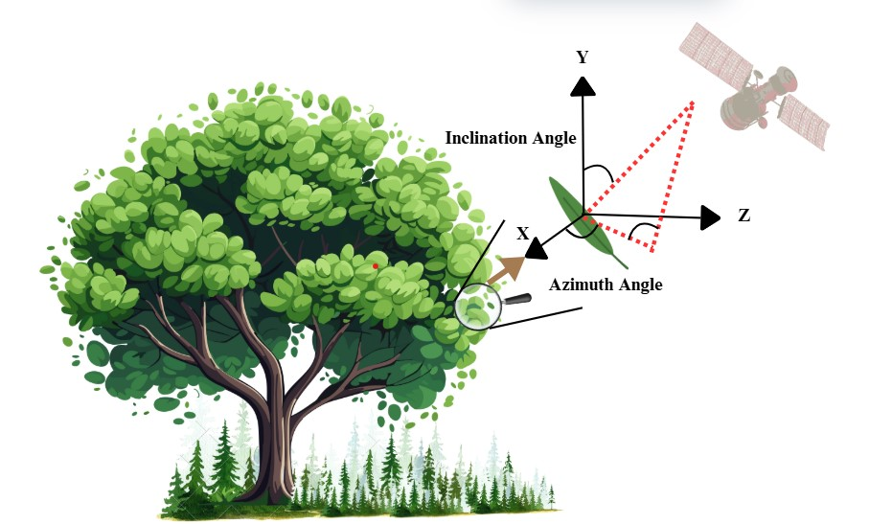

Fig.4 Schematic representation of leaf angular geometry for remote sensing in the tree canopy
Table 4 Techniques and principles for measuring light interception and canopy structure in fruit crops across regions
Sr.no | Techniques | Principles | Region | Fruit crops
1. | Ceptometers  (Line Quantum Sensors) | Using quantum photodiodes to estimate intercepted light | USA, China | Almond, Citrus
2. | Hemispherical Photography  (Fish-eye lens) | Capture canopy images, analyze gap fraction, and calculate leaf area | USA, India | Apple, Mango
3. | LAI-2000/2200 Plant Canopy Analyzer | Works on Beer-Lambert law to compute leaf area index (LAI) and light interception | India, Japan | Mango, Rice, Grape
4. | Spectral Reflectance / NDVI Imaging | Monitors canopy density and light capture remotely | China, Iran, USA | Citrus, Almond
5. | UAV-based LiDAR / 3D Canopy Reconstruction | Laser pulses reconstruct 3D canopy structure | India, China, USA | Mango, Citrus, Apple
6. | Radiation Transfer Modeling | Simulation of light paths based on structural and optical parameters | Korea, Australia | Mango, Grape
7. | Simple Optical Transmittance (Single-point Sensors) | Estimate transmittance and interception | Europe | Apple, Pear
8. | Densiometers (Spherical, Angular) | Visual estimate of canopy cover and gap fraction | USA, India | Apple, Mango
9. | Digital Cover Photography (Standard Upward-Facing Cameras) | Standard images are analyzed using thresholding algorithms | China | Apple
10. | 3D Virtual Plant/Functional-Structural Plant Models (FSPM) | Combine architectural plant models and directional light models for organ-level simulation of intercepted light. | Korea, Australia, EU | Mango, Peach, Grape, Apple
(Seidel et al., 2011; Rani et al., 2025)
- Management practices for optimizing light interception
Practices designed to enhance light capture in fruit crops and orchards to improve fruit quality and support sustainable yields include strategic training methods, precise pruning, reflective mulches, canopy adjustment techniques, and the use of growth regulators.
  - Training systems (tatura trellis, espalier, palmette) and pruning to improve light penetration
Pruning and training methods are crucial in HDP for maintaining tree shape, enhancing sunlight exposure, and improving air circulation. Common systems include espalier, cordon, and trellis setups. These techniques help manage growth, control size, and foster desirable traits in orchards and landscapes. Incorrect application can damage trees and affect their health. Regular pruning and training ensure trees remain attractive, productive, and easy to manage. Environmental factors such as temperature, light, humidity, and tree vigor influence fruit yield and quality, with canopy management, training systems, pruning practices, and growth retardants playing key roles in optimising harvests (Singh Jitendra, 2014).

  - Reflective mulches and canopy modification practices
Farmers worldwide use various mulches made from organic and inorganic materials placed on the soil surface. One effective method combines reflective mulches with canopy modification techniques to improve light distribution, particularly in dense orchards where shading can reduce photosynthesis and affect fruit quality (Yu et al. 2018). Reflective mulches, such as white, silver, or aluminized films, reflect sunlight into the lower canopy, aiding in better color development, even ripening, and increased yield. The bright, reflective surface also disrupts insects like aphids, thrips, and whiteflies by affecting their ability to navigate and locate hosts. This decreases pest pressure and reduces dependence on chemical pesticides, making reflective mulches a sustainable component of integrated pest management (IPM).
The study examined how reflective mulch beneath apple trees affects light exposure within the canopy and the fruit quality of ‘Pinova’, ‘Jonagold’, and ‘Jonagored’ over three growing seasons. In ‘Pinova’ trees, leaf shading reduced light penetration to 26% at 0.5 m, 31% at 1.0 m, 42% at 1.5 m, and 48% at 2.0 m above ground, compared to the sunlight above the tree. Reflective mulch increased reflected light by 8 times at 0.5 m, 4 times at 1.0 m, 2 times at 1.5 m, and 10% at 2.0 m relative to bare soil. Additionally, reflective mulch enhanced the red colour of ‘Pinova’ apples only in the bottom zone of the canopy (Mika, 1980).
  - Role of growth regulators
Plant growth regulators (PGRs) affect canopy structure, shoot development, leaf expansion, and fruit growth. Some PGRS and inhibitors are effective for canopy management, such as applying Auxin paste to increase apple crotch angles or using NAA to limit shoot growth and control canopy size in high-density orchards (Gaurha et al., 2021). Foliar sprays of cytokinins can enhance chlorophyll content and sustain photosynthesis in older leaves, boosting light efficiency. They also promote lateral bud break, leading to a more balanced canopy, reducing apical shoot dominance, and creating a more uniform light environment. Excessive vegetative growth, like in grapevines, can cause shading and reduce light in the lower canopy. Gibberellin inhibitors such as prohexadione-Ca, paclobutrazol, and uniconazole are used to restrict shoot elongation by interfering with gibberellin biosynthesis. This results in shorter internodes and less dense, more open canopies that allow better light penetration. Improved light conditions enhance photosynthesis in shaded leaves and improve fruit colouration in species like apples, peaches, and grapes. Ethephon, an ethylene-releasing agent, helps regulate canopy growth and promote fruit ripening. It controls vegetative vigor and speeds up maturity, indirectly improving light distribution. Ethylene also affects leaf abscission, which can help expose fruit clusters to sunlight, enhancing coloration and marketability. Fig.5 illustrates how plant hormones are used strategically to optimize canopy architecture for increased productivity and easier management.

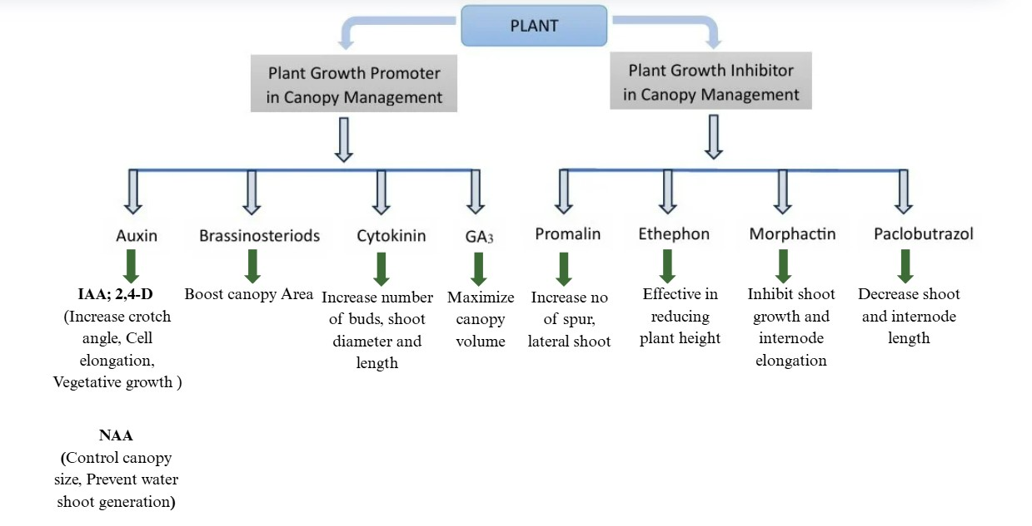
Fig.5 Role of different plant growth regulators in canopy management
- Impact of light distribution on crop productivity and quality
Enhancing the spatial and spectral characteristics of intercepted light can improve yields, fruit color, total soluble solids (TSS), and anthocyanin content, while also benefiting post-harvest crop performance.
  - Yield improvement and uniformity of fruit development
Uniform and efficient light distribution across the canopy directly correlates with higher crop yields and more consistent fruit development. Typically, increases in yield are proportional to reductions in light heterogeneity. Modifying canopy structure to enhance light distribution has been proven to increase yields in certain crops. For example, rice (Oryza sativa) cultivars bred with more upright upper canopy leaves have contributed to the development of "super” hybrid rice in China (Slattery et al., 2021). Likewise, maize (Zea mays) yields have risen due to changes in leaf angle, which may be influenced by higher planting densities (Duvick et al., 2005).
  - Fruit quality attributes (color, tss, anthocyanin content)

Measuring fruit quality attributes like color, total soluble solids (TSS), and anthocyanin content helps assess the intensity, direction, and uniformity of light reaching different canopy parts. Fruits exposed to higher light levels typically show better coloration due to increased pigmentation. Conversely, shaded fruits tend to be less colored, with lower sugar and reduced anthocyanin levels (Zhang et al., 2022). Anthocyanins accumulate quickly during ripening, reaching peak levels in ripe fruits, with their stability affected by light, temperature, pH, and other factors. Increasing light intensity can enhance coloring and promote anthocyanin buildup (Kadomura-Ishikawa et al., 2013). Additionally, different light wavelengths influence soluble solids and acid content in fruits (Wang et al., 2022). The distinct flavor of blueberries, which appeals to consumers, largely depends on their soluble solids, acid contents, and their ratio in the fruit (Gilbert et al., 2015).
  - Effects on post-harvest quality
Food safety concerns have gained more attention towards harvested commodities to ensure consumer acceptance and enhance the precision of postharvest grading of fruits and vegetables.
Plant biological processes such as growth, development, and ripening depend on photoreceptors and light signalling pathways (Kim and Eom, 2025). In postharvest management, light is increasingly recognised as a tool to control ripening, improve fruit quality, and prolong shelf life (Alonso-Salinas et al., 2024). Using specific wavelengths of light, we can influence physiological and biochemical processes in harvested fruits, offering an alternative or supplementary approach to traditional ripening and preservation methods (Sanders, 2024). Like other plants, fruits have various photoreceptors that detect and respond to different light spectra. These receptors manage ripening, pigmentation, secondary metabolite synthesis, and stress responses (Mujahid et al., 2025).
- Abiotic and biotic factors affecting canopy light use
Perception of light quality and quantity effectively reacts to various abiotic and biotic stresses. The interplay among temperature, drought, wind, and frost, combined with competition for light from weeds, intercrops, and pests or diseases, influences the canopy structure.
  - Role of temperature, drought, wind, frost
Canopy responses to environmental stressors are highly interconnected, as temperature, drought, wind, and frost all influence light interception and use. Increased temperatures can promote canopy growth but may also stress photosystems, triggering protective pigments, altering stomatal conductance, and reducing light-use efficiency. Conversely, low temperatures slow metabolic processes, decrease chlorophyll levels, and reduce the light captured by photosynthetically active tissues. Heatwaves intensify drought effects by increasing transpiration rates, causing premature ageing of upper leaves, and reducing the functional canopy. Drought also restricts leaf growth, reduces canopy cover, and diminishes photosynthetic surface area; extreme stress can result in leaf loss, trapping light in drought-resistant areas. Constant winds reshape the canopy by flattening leaves and decreasing density, which improves air circulation and microclimate light conditions; however, severe winds can cause leaf abscission and damage, reducing productive surface area. Frost effects are also influenced by canopy structure: dense canopies absorb sudden temperature changes due to heat retention, while sparse canopies expose tissues to radiative cooling, increasing frost damage. All these stresses highlight the vulnerability of canopy structure and light interception, balance plant survival, and emphasise the importance of adaptive mechanisms to maintain productivity in a changing environment.
  - Competition for light: weeds and intercropping
Weeds growing beneath or between plants compete for sunlight. Rapidly expanding weeds can overshadow young crops, creating dense shade that significantly hampers photosynthesis, resulting in poor plant vigor, slow development, and notable yield reductions- especially when weeds grow alongside crops. In this scenario, intercropping systems provide a practical approach by mixing species with different canopy structures and growth habits, thereby optimizing light utilisation. For instance, tall or deep-rooting crops like maize can be combined with shade-tolerant understory plants such as beans or celery, enabling vertical layering of light and better resource efficiency. Overall, integrating effective weed control with strategic intercropping offers the dual benefit of safeguarding light access for crops.
  - Pest/disease-induced canopy modification
Pathogen infestation and pest attacks significantly impact canopy architecture by causing leaf abscission, shoot dieback, or abnormal tissue growth. Some pests, like borers or leaf miners, target internal leaf tissues, leading to localised damage that reduces light capture and canopy function. Excessive shading can inhibit the production of defence compounds, weakening the plant's natural resistance. This increases vulnerability to further pest and disease attacks, creating a cycle of stress and reduced productivity.
- Modeling and Simulation Approaches
Mathematical, computational, and conceptual frameworks are used to represent, analyze, and predict the behavior of variables like environmental factors, physiological processes, and management practices within virtual models that simulate real-world scenarios using modeling and simulation techniques.
  - Functional–structural plant models (FSPM)
Simulation tools like RATP, MAESTRA, and DART, combined with artificial intelligence (AI) and machine learning (ML), are crucial for improving predictive models of canopy light interception and their impact on plant growth and productivity in functional-structural plant models (FSPM). These models represent individual structural units such as stems, leaves, internodes, and buds, along with their spatial arrangements, to simulate how light is intercepted, absorbed, and used at both organ and canopy levels (Hanan and Prusinkiewicz, 2008).
  - Simulation tools: RATP, MAESTRA, DART
RATP (Radiation Absorption, Transpiration, and Photosynthesis) models how radiation absorption, transpiration, and photosynthesis are distributed within plant canopies with high spatial detail. It combines canopy structure with local energy and mass balance equations (voxels) to predict carbon uptake and water loss in different organs, accounting for microclimatic differences. This enables accurate yield forecasting (Daudet et al. 1999).
MAESTRA is a three-dimensional model crafted for forest and crop canopies, simulating photosynthesis and light absorption. It incorporates detailed plant structural data to capture canopy complexity and utilises ray tracing or Monte Carlo methods for simulating radiation transfer. MAESTRA has been applied to estimate how productivity responds to canopy manipulation in forest stands and agricultural crops.
DART (Discrete Anisotropic Radiative Transfer) models bidirectional reflectance and canopy spectral images from landscape to leaf scale. It uses Monte Carlo ray tracing to simulate the complex interactions of photons with canopy surfaces and backgrounds, supporting remote sensing applications and the validation of spectral data with physical canopy properties.
  - AI and machine learning in canopy light prediction
The rise of artificial intelligence (AI), machine learning (ML), and deep learning (DL) has revolutionised canopy light management. Essentially, AI automates and improves the analysis of intricate datasets collected from digital sources such as satellites, drones, and aerial images, simulating human intelligence. These technologies work together to improve data integration, forecasting, and operational effectiveness, allowing for real-time monitoring and decision-making in complex agricultural systems (Buchelt et al., 2024).
- Integration into Sustainable Orchard Systems
Orchard designs often focus on productivity over autonomy and reproducibility. However, as perennial and multi-layered systems, orchards offer complex design opportunities to encourage natural regulation and tackle sustainability challenges.
  - Canopy management in high-density orchards
Much of the planning for HDP orchard design relies on the average light interception over the lifespan of the planting. This strategy aims to reduce ground-level light exposure and create canopy structures that allow the largest canopy to receive optimal light intensity. Therefore, management practices focus on optimising the plant model to maximise light interception through tree training, pruning, branch management, and tree orientation. In high-density plantings, pruning and growth retardants- used alone or together- are common methods to control canopy development.
  - Applications in protected cultivation (polyhouse, shade net)
Crop cultivation and preservation utilise polyhouse technology and shade net houses. Different cost levels—low, medium, and high—are used for crop production. Traditionally, polyhouses have been employed for growing, storing, and managing crops (Itigi et al., 2017). Nowadays, shade net houses are also used for crop multiplication. Both approaches help prevent soil issues and pollution, safeguard the environment, and create opportunities for education, training, employment, and security.
  - Economic and ecological implications
Economic issues highlight the need for input-autonomy features, adapting to market and consumption trends, and diversifying production systems to reduce vulnerability. Spread and growth retardants significantly influence the economic yield of fruit crops by enabling more trees to be planted on the same land, leading to increased fruit production at the cost of chemical use and application (Umar and Akash 2008). Ecological and evolutionary knowledge are essential tools for understanding natural interactions and for developing long-term management strategies in human-managed agroecosystems. Ecological intensification aims to achieve high yields while minimising environmental harm by integrating ecosystem service management into crop production systems (Bommarco et al. 2013).
- Conclusions and future perspectives

  - Synthesis of knowledge on 3D light distribution
The geometry and orientation of leaves can be reconstructed with models of photosynthetic canopies (3D CPMs), allowing for a detailed recreation of the heterogeneity in photosynthetically active radiation (PAR) interception within the canopy. This higher spatial resolution enhances the accuracy of predictions related to canopy photosynthesis, radiation use efficiency (RUE), and crop yield potential, surpassing the limitations of 0D, 1D, and 2D models that rely on aggregated leaf area index (LAI) or average extinction coefficients (Xia et al., 2023).
  - Emerging technologies in canopy studies
Technologies like LiDAR scanning, UAV imaging, and structure-from-motion photogrammetry facilitate the generation of detailed 3D point clouds of canopy structures. The use of spectral vegetation indices and hyperspectral imaging helps monitor canopy health, biomass growth, and radiation utilisation through remote sensing. Additionally, machine learning and artificial intelligence (AI) are advancing phenotyping and remote sensing, allowing for trait predictions and estimations of light environments within canopies and the RUE (Sultana et al., 2023).

  - Future research directions
Contemporary research in canopy light aims to unify AI, remote sensing, and robotics, leading to significant breakthroughs. AI analysis of combined data from satellites, UAVs, LiDAR, and proximal sensors will enable large-scale studies of canopy structure and function under diverse conditions (Wang et al., 2022). Robotic-interacting platforms have achieved precise 3D measurements that can enhance crop growth models by improving simulations of photosynthesis and radiation use. Investigating direct and diffuse radiation and parameterizing 3D models under environmental stresses will yield more accurate predictions. Ultimately, AI-powered high-throughput phenotyping of light interception will revolutionise modelling and help develop resilient, high-yield crops for improved food security (Rani et al., 2025).

COMPETING INTERESTS DISCLAIMER:
Authors have declared that they have no known competing financial interests OR non-financial interests OR personal relationships that could have appeared to influence the work reported in this paper.

References
Alonso-Salinas, R., López-Miranda, S., Pérez-López, A. J., & Acosta-Motos, J. R. (2024). Strategies to delay ethylene-mediated ripening in climacteric fruits: Implications for shelf-life extension and postharvest quality. Horticulturae, 10(8), 840.
Andrade, F. H., Sadras, V. O., Vega, C. R. C., & Echarte, L. (2005). Physiological determinants of crop growth and yield in maize, sunflower, and soybean: their application to crop management, modeling, and breeding. Journal of Crop Improvement, 14(1-2), 51-101.
Anthony, B. M., & Minas, I. S. (2021). Optimizing peach tree canopy architecture for efficient light use, increased productivity, and improved fruit quality. Agronomy, 11(10), 1961.
Atzberger, C., & Richter, K. (2012). Spatially constrained inversion of radiative transfer models for improved LAI mapping from future Sentinel-2 imagery. Remote Sensing of Environment, 120, 208-218.
Baroli, I., & Niyogi, K. K. (2000). Molecular genetics of xanthophyll–dependent photoprotection in green algae and plants. Philosophical Transactions of the Royal Society of London. Series B: Biological Sciences, 355(1402), 1385-1394.
Béland, M., & Baldocchi, D. D. (2021). Vertical structure heterogeneity in broadleaf forests: Effects on light interception and canopy photosynthesis. Agricultural and Forest Meteorology, 307, 108525.
Bommarco, R., Kleijn, D., & Potts, S. G. (2013). Ecological intensification: harnessing ecosystem services for food security. Trends in ecology & evolution, 28(4), 230-238.
Bréda, N. J. (2003). Ground‐based measurements of leaf area index: a review of methods, instruments and current controversies. Journal of Experimental Botany, 54(392), 2403-2417.
Buchelt, A.; Adrowitzer, A.; Kieseberg, P.; Gollob, C.; Nothdurft, A.; Eresheim, S.; Tschiatschek, S.; Stampfer, K.; Holzinger, A. Exploring artificial intelligence for applications of drones in forest ecology and management. For. Ecol. Manag. 2024, 551, 121530
Campbell, G. S., & Norman, J. M. (1998). The light environment of plant canopies. In An Introduction to Environmental Biophysics (pp. 247-278). New York, NY: Springer New York.
Chavez, J. C., Ganjegunte, G. K., Jeong, J., Rajan, N., Zapata, S. D., Ruiz-Alvarez, O., & Enciso, J. (2022). Radiation use efficiency and agronomic performance of biomass sorghum under different sowing dates. Agronomy, 12(6), 1252.
Chenu, K., Porter, J. R., Martre, P., Basso, B., Chapman, S. C., Ewert, F., ... & Asseng, S. (2017). Contribution of crop models to adaptation in wheat. Trends in plant science, 22(6), 472-490.
Chrispeels, M. J., & Sadava, D. E. (2003). Plants, genes, and crop biotechnology. Jones & Bartlett Learning.
Dahiya, S., Rana, M., Khedwal, R. S., & Chaudhary, A. (2023). Significance of plant canopy maintenance in crop yield. International Journal of Environment and Climate Change, 13(8), 2265-2272.
Daudet, F. A., Le Roux, X., Sinoquet, H., & Adam, B. (1999). Wind speed and leaf boundary layer conductance variation within tree crown: consequences on leaf-to-atmosphere coupling and tree functions. Agricultural and Forest Meteorology, 97(3), 171-185.
Du, X., Wang, Z., Lei, W., & Kong, L. (2021). Increased planting density combined with reduced nitrogen rate to achieve high yield in maize. Scientific reports, 11(1), 358.
Duvick, D. N. (2005). Genetic progress in the yield of United States maize (Zea mays L.). Maydica, 50(3/4), 193.
Éva, C., Oszvald, M., & Tamás, L. (2019). Current and possible approaches for improving photosynthetic efficiency. Plant Science, 280, 433-440.
Evers, J. B., Vos, J., Yin, X., Romero, P., Van Der Putten, P. E. L., & Struik, P. C. (2010). Simulation of wheat growth and development based on organ-level photosynthesis and assimilate allocation. Journal of Experimental Botany, 61(8), 2203-2216.
Fang, H., Li, S., Zhang, Y., Wei, S., & Wang, Y. (2021). New insights into global vegetation structural properties through an analysis of canopy clumping index, fractional vegetation cover, and leaf area index. Science of Remote Sensing, 4, 100027.
Fazi, B., Proserpio, C., Galardi, S., Annesi, F., Cola, M., Mangiola, A., ... & Ciafrè, S. A. (2019). The expression of the chemokine CXCL14 correlates with several aggressive aspects of glioblastoma and promotes key properties of glioblastoma cells. International Journal of Molecular Sciences, 20(10), 2496.
Gauhl, E. (1976). Photosynthetic response to varying light intensity in ecotypes of Solanum dulcamara L. from shaded and exposed habitats. Oecologia, 22(3), 275-286.
Gaurha, A., Prasad, V. M., Bahadur, V., & Topno, S. E. (2021). Effect of different plant growth regulators on growth, canopy, and flowering of (Litchi litchi chinensis Sonn.) cv Purvi [C]. In Biol Forum An Int J (Vol. 13, No. 1, pp. 123-126).
Gilbert, J. L., Guthart, M. J., Gezan, S. A., Pisaroglo de Carvalho, M., Schwieterman, M. L., Colquhoun, T. A., ... & Olmstead, J. W. (2015). Identifying breeding priorities for blueberry flavor using biochemical, sensory, and genotype by environment analyses. PLoS One, 10(9), e0138494.
Gower, S. T., Kucharik, C. J., & Norman, J. M. (1999). Direct and indirect estimation of leaf area index, fAPAR, and net primary production of terrestrial ecosystems. Remote sensing of environment, 70(1), 29-51.
Hanan, J., & Prusinkiewicz, P. (2008). Foreword: studying plants with functional–structural models. Functional Plant Biology, 35(10), vi-viii.
He, W., Gage, J. L., Rellán-Álvarez, R., & Xiang, L. (2024). Swin-Roleaf: A new method for characterizing leaf azimuth angle in large-scale maize plants. Computers and Electronics in Agriculture, 224, 109120.
Iqbal, M. (2012). An introduction to solar radiation. Elsevier.
Itigi Prabhakar, I. P., Vijayaragavan, K., Premlata Singh, P. S., Balraj Singh, B. S., Janakiram, J., Manjunatha, B. L., ... & Sekar, I. (2017). Constraints in adoption and strategies to promote polyhouse technology among farmers: a multi-stakeholder and multi-dimensional study.
Jonckheere, I., Fleck, S., Nackaerts, K., Muys, B., Coppin, P., Weiss, M., & Baret, F. (2004). Review of methods for in situ leaf area index determination: Part I. Theories, sensors and hemispherical photography. Agricultural and forest meteorology, 121(1-2), 19-35.
Kadomura-Ishikawa, Y., Miyawaki, K., Noji, S., & Takahashi, A. (2013). Phototropin 2 is involved in blue light-induced anthocyanin accumulation in Fragaria x ananassa fruits. Journal of Plant Research, 126(6), 847-857.
Kai, S. O. N. G., Qin-ping, W., Yu-ling, Y., Xiao-wei, W., & Ji-xiang, Z. (2010). Effects of different pruning modes on the light distribution characteristics and fruit yield and quality in densely planted'Red Fuji' apple orchard. Chinese Journal of Applied Ecology/Yingyong Shengtai Xuebao, 21(5).
Kim, C. K., & Eom, S. H. (2025). Light controls in the regulation of carotenoid biosynthesis in leafy vegetables: a review. Horticulturae, 11(2), 152.
Kim, D., Kang, W. H., Hwang, I., Kim, J., Kim, J. H., Park, K. S., & Son, J. E. (2020). Use of structurally accurate 3D plant models for estimating light interception and photosynthesis of sweet pepper (Capsicum annuum) plants. Computers and Electronics in Agriculture, 177, 105689.
Knohl, A., & Baldocchi, D. D. (2008). Effects of diffuse radiation on canopy gas exchange processes in a forest ecosystem. Journal of Geophysical Research: Biogeosciences, 113(G2).
Körner, C. (2015). Paradigm shift in plant growth control. Current opinion in plant biology, 25, 107-114.
Kumar, K., & Sharma, S. (2020). Canopy Management in Fruit Crops. Just Agriculture, 1(4).
Li, T., Heuvelink, E., Dueck, T. A., Janse, J., Gort, G., & Marcelis, L. F. M. (2014). Enhancement of crop photosynthesis by diffuse light: quantifying the contributing factors. Annals of botany, 114(1), 145-156.
Liu, B., Asseng, S., Müller, C., Ewert, F., Elliott, J., Lobell, D. B., ... & Zhu, Y. (2016). Similar estimates of temperature impacts on global wheat yield by three independent methods. Nature Climate Change, 6(12), 1130-1136.
Liu, T., Song, F., Liu, S., & Zhu, X. (2011). Canopy structure, light interception, and photosynthetic characteristics under different narrow-wide planting patterns in maize at the silking stage. Spanish Journal of Agricultural Research, 9(4), 1249-1261.
Mantilla-Pérez, M. B., & Salas Fernández, M. G. (2017). Differential manipulation of leaf angle throughout the canopy: current status and prospects. Journal of Experimental Botany, 68(21-22), 5699-5717.
Mattera, J., Romero, L. A., Cuatrín, A. L., Cornaglia, P. S., & Grimoldi, A. A. (2013). Yield components, light interception, and radiation use efficiency of lucerne (Medicago sativa L.) in response to row spacing. European Journal of Agronomy, 45, 87-95.
Mawphlang, O. I., & Kharshiing, E. V. (2017). Photoreceptor-mediated plant growth responses: implications for photoreceptor engineering toward improved performance in crops. Frontiers in Plant Science, 8, 1181.
Mika, A. (1981). The influence of reflective mulch on illumination of the apple tree canopy and on fruit quality.
Monsi, M., & Saeki, T. (2005). On the factor light in plant communities and its importance for matter production. Annals of botany, 95(3), 549-567.
Mujahid, M., Ambreen, A., Zarlashat, Y., Sarfraz, Z., Iqbal, M. S., Waheed, A., & Iqbal, M. S. (2025). Integration of Light and Circadian Signaling in Plant Gene Regulatory Networks: Implications for Photomorphogenesis and Stress Adaptation. Biology, 14(10), 1375.
Murchie, E. H., & Niyogi, K. K. (2011). Manipulation of photoprotection to improve plant photosynthesis. Plant physiology, 155(1), 86-92.
Niinemets, U. (2007). Photosynthesis and resource distribution through plant canopies. Plant, cell & environment, 30(9), 1052-1071.
Noriega Gardea, M. M. Á., Corral Martínez, L. F., Anguiano Morales, M., Trujillo Schiaffino, G., & Salas Peimbert, D. P. (2021). Modeling photosynthetically active radiation: A review. Atmósfera, 34(3), 357-370.
Paradiso, R., & Proietti, S. (2022). Light-quality manipulation to control plant growth and photomorphogenesis in greenhouse horticulture: The state of the art and the opportunities of modern LED systems. Journal of Plant Growth Regulation, 41(2), 742-780.
Pedruzo-Bagazgoitia, X., Ouwersloot, H. G., Sikma, M., Van Heerwaarden, C. C., Jacobs, C. M. J., & Vilà-Guerau de Arellano, J. (2017). Direct and diffuse radiation in the shallow cumulus–vegetation system: Enhanced and decreased evapotranspiration regimes. Journal of Hydrometeorology, 18(6), 1731-1748.
Rani, P., Mamrutha, H. M., Wadhwa, Z., Kumar, Y., Kumar, A., Khobra, R., ... & Tiwari, R. (2025). Low and high-throughput phenotyping for radiation use efficiency and its importance. Plant Physiology Reports, 1-12.
Rani, P., Mamrutha, H. M., Wadhwa, Z., Kumar, Y., Kumar, A., Khobra, R., ... & Tiwari, R. (2025). Low and high-throughput phenotyping for radiation use efficiency and its importance. Plant Physiology Reports, 1-12.
Rich, P. M. (1990). Characterizing plant canopies with hemispherical photographs. Remote sensing reviews, 5(1), 13-29.
Robinson, T. L., Lakso, A. N., & Ren, Z. (1991). Modifying apple tree canopies for improved production efficiency. HortScience, 26(8), 1005-1012.
Robles-Zazueta, C. A., Molero, G., Pinto, F., Foulkes, M. J., Reynolds, M. P., & Murchie, E. H. (2021). Field-based remote sensing models predict radiation use efficiency in wheat. Journal of Experimental Botany, 72(10), 3756-3773.
Rossi, M., Bermudez, L., & Carrari, F. (2015). Crop yield: challenges from a metabolic perspective. Current Opinion in Plant Biology, 25, 79-89.
Sanders, T. D. (2024). LEDs for Controlled Environment Agriculture: Leveraging Light to Optimize Crops (Master's thesis, West Virginia University).
Sarlikioti, V., De Visser, P. H. B., & Marcelis, L. F. M. (2011). Exploring the spatial distribution of light interception and photosynthesis of canopies by means of a functional–structural plant model. Annals of Botany, 107(5), 875-883.
Schiermeier, Q. (2006). Oceans cool off in the hottest years. Nature, 442(7105), 854-856.
Seidel, D., Fleck, S., Leuschner, C., & Hammett, T. (2011). Review of ground-based methods to measure the distribution of biomass in forest canopies. Annals of Forest Science, 68(2), 225-244.
Sharma, R. R., Singh, C. N., Saxena, S. K., Pandey, S. N., & Chhonkar, O. P. (2001). Cluster planting favours malformation and influences yield and fruit quality in mango.
Singh Jitendra (2014). Training and pruning in the orchard. Basic Horticulture, Eds Fourth, 158-167
Slattery, R. A., & Ort, D. R. (2021). Perspectives on improving light distribution and light use efficiency in crop canopies. Plant Physiology, 185(1), 34-48.
Soleh, M. A., Tanaka, Y., Kim, S. Y., Huber, S. C., Sakoda, K., & Shiraiwa, T. (2017). Identification of large variation in the photosynthetic induction response among 37 soybean [Glycine max (L.) Merr.] genotypes that is not correlated with steady-state photosynthetic capacity. Photosynthesis Research, 131(3), 305-315.
Soleymani, A. (2018). Corn (Zea mays L.) yield and yield components as affected by light properties in response to plant parameters and N fertilization. Biocatalysis and agricultural biotechnology, 15, 173-180.
Sultana, F., Dev, W., Zhang, Z. G., Wang, Y. R., Chen, J. L., Wang, J., ... & Li, Y. B. (2023). The consequences of plant architecture and spatial distribution of light interception on cotton growth and yield.
Thenkabail, P. S., Aneece, I., & Teluguntla, P. (2024). Special Issue Introduction: Ushering a New Era of Hyperspectral Remote Sensing to Advance Remote Sensing Science in the Twenty-first Century. Photogrammetric Engineering & Remote Sensing, 90(8).
Thimonier, A., Sedivy, I., & Schleppi, P. (2010). Estimating leaf area index in different types of mature forest stands in Switzerland: a comparison of methods. European Journal of Forest Research, 129(4), 543-562.
Umar, I., & Akash Sharma, A. S. (2008). Control of height through growth retardants in fruit trees.
Ventre-Lespiaucq, A., Flanagan, N. S., Ospina-Calderón, N. H., Delgado, J. A., & Escudero, A. (2018). Midday depression vs. midday peak in diurnal light interception: contrasting patterns at crown and leaf scales in a tropical evergreen tree. Frontiers in Plant Science, 9, 727.
Vierling, K. T., Vierling, L. A., Gould, W. A., Martinuzzi, S., & Clawges, R. M. (2008). Lidar: shedding new light on habitat characterization and modeling. Frontiers in Ecology and the Environment, 6(2), 90-98.
Vos, J., Evers, J. B., Buck-Sorlin, G. H., Andrieu, B., Chelle, M., & De Visser, P. H. (2010). Functional–structural plant modelling: a new versatile tool in crop science. Journal of Experimental Botany, 61(8), 2101-2115.
Wang, S., Jin, N., Jin, L., Xiao, X., Hu, L., Liu, Z., ... & Yu, J. (2022). The response of tomato fruit quality depends on the period of LED supplementary light. Frontiers in Nutrition, 9, 833723.
Wang, Y. P., & Leuning, R. (1998). A two-leaf model for canopy conductance, photosynthesis, and partitioning of available energy I: Model description and comparison with a multi-layered model. Agricultural and Forest Meteorology, 91(1-2), 89-111.
Wang, Y., Zhang, J., Trentmann, J., Fiedler, S., Yang, S., Sanchez‐Lorenzo, A., ... & Wild, M. (2022). Observations and implications of diurnal climatology and trends in direct and diffuse solar radiation over China. Journal of Geophysical Research: Atmospheres, 127(15), e2022JD036769.
Warner, C. W., & Caldwell, M. M. (1983). Influence of photon flux density in the 400–700 nm waveband on inhibition of photosynthesis by UV‐B (280–320 nm) irradiation in soybean leaves: separation of indirect and immediate effects. Photochemistry and Photobiology, 38(3), 341-346.
White, A. C., Rogers, A., Rees, M., & Osborne, C. P. (2016). How can we make plants grow faster? A source–sink perspective on growth rate. Journal of Experimental Botany, 67(1), 31-45.
Xia, T., Sheng, W., Song, R., Li, H., & Zhang, M. (2023). A Review of Three-Dimensional Multispectral Imaging in Plant Phenotyping. Sensing Technologies for Field and In-House Crop Production: Technology Review and Case Studies, 1-18.
Xing, F., Han, Y., Feng, L., Zhi, X., Wang, G., Yang, B., ... & Li, Y. (2018). Genotypic variation in spatiotemporal distribution of canopy light interception in relation to yield formation in cotton. Journal of Cotton Research, 1(1), 13.
Yamori, W. (2021). Strategies for engineering photosynthesis for enhanced plant biomass production. In Rice improvement: Physiological, molecular breeding and genetic perspectives (pp. 31-58). Cham: Springer International Publishing.
Yan, P., Deng, Y., An, S. J., Ma, L., Li, T., Chen, Q. L., & Zheng, Q. (2025). Training systems affect the spatial distribution of Korla fragrant pear (Pyrus sinkiangensis Yu) fruits by altering canopy structure and light distribution. Frontiers in Plant Science, 16, 1615019.
Yang ChuanBang, Y. C., Yu ZhenWen, Y. Z., Zhang YongLi, Z. Y., & Shi Yu, S. Y. (2017). Effect of soil depth with supplemental irrigation on canopy photosynthetically active radiation interception and chlorophyll fluorescence parameters in Jimai 22.
Yang, W., Doonan, J. H., Guo, X., Yuan, X., & Ling, F. (2023). State-of-the-art technology and applications in crop phenomics, volume II. Frontiers in Plant Science, 14, 1195377.
Yu, Y. Y., Turner, N. C., Gong, Y. H., Li, F. M., Fang, C., Ge, L. J., & Ye, J. S. (2018). Benefits and limitations of straw-and plastic-film mulch on maize yield and water use efficiency: A meta-analysis across hydrothermal gradients. European Journal of Agronomy, 99, 138-147.
Zafar, M. M., Jia, X., Shakeel, A., Sarfraz, Z., Manan, A., Imran, A., ... & Ren, M. (2022). Unraveling heat tolerance in upland cotton (Gossypium hirsutum L.) using univariate and multivariate analysis. Frontiers in Plant Science, 12, 727835.
Zhang, J., Li, S., An, H., Zhang, X., & Zhou, B. (2022). Integrated transcriptome and metabolome analysis reveals the anthocyanin biosynthesis mechanisms in blueberry (Vaccinium corymbosum L.) leaves under different light qualities. Frontiers in Plant Science, 13, 1073332.
Zhang, Z., Zhou, X. B., & Chen, Y. H. (2016). Effects of irrigation and precision planting patterns on the photosynthetic product of wheat. Agronomy Journal, 108(6), 2322-2328.

