Analysis Of Temperature and Rainfall Trends From 1994 To 2024 In Kiminini Sub-County, Trans Nzoia County, Kenya

1.Abstract
Climate variability and climate change have increasingly affected agricultural productivity and rural livelihoods in Kenya, particularly in areas dependent on rain-fed agriculture. This study analyzed temperature and rainfall trends from 1994 to 2024 in Kiminini Sub-County, Trans Nzoia County. The study aimed to examine long-term changes in annual temperature and rainfall patterns and determine their implications for agricultural activities within the study area. A descriptive research design employing quantitative trend analysis methods was adopted. Secondary climatic data on annual rainfall totals and average annual temperatures were obtained from meteorological records, county agricultural reports, and climate databases. Data were analyzed using descriptive statistics, linear regression analysis, graphical trend analysis, and the Mann–Kendall trend test. The findings revealed that average annual temperatures in Kiminini Sub-County increased steadily over the thirty-year study period at an estimated rate of approximately 0.05°C per year, indicating a significant warming trend. Rainfall patterns exhibited high interannual variability characterized by fluctuating annual totals, delayed onset of rainfall seasons, prolonged dry spells, and occasional extreme rainfall events. The Mann–Kendall test results showed a statistically significant increasing trend in annual temperature (Z = 2.84, p < 0.05), leading to rejection of the null hypothesis that no temperature trend existed between 1994 and 2024. Conversely, rainfall trends showed a weak declining and statistically insignificant pattern (Z = -1.21, p > 0.05), indicating that annual rainfall variability was high but lacked a strong monotonic trend over the study period. The study further established that increasing temperatures and irregular rainfall patterns negatively affected agricultural productivity through reduced soil moisture availability, increased crop stress, declining maize and wheat yields, and disruption of planting calendars among farmers. The study concluded that climate variability has intensified in Kiminini Sub-County and continues to threaten sustainable agricultural production and food security. The study recommends adoption of climate-smart agricultural practices, improved dissemination of climate information services, investment in irrigation and water conservation technologies, and strengthening of local climate adaptation strategies. The findings provide useful information for policymakers, researchers, agricultural extension officers, and farmers in developing effective climate resilience interventions within the study area.
Keywords: Climate variability, Mann–Kendall test, rainfall trends, temperature trends, agriculture, Kiminini Sub-County, Kenya.
2. Introduction
Climate variability and climate change have increasingly affected agricultural productivity, water availability, ecosystems, and livelihoods across the globe. Globally, rising temperatures, shifting precipitation patterns, and increased frequency of extreme weather events have become major environmental concerns affecting both developed and developing countries. According to the Intergovernmental Panel on Climate Change, global surface temperatures have risen significantly over the past century due to increased greenhouse gas emissions, leading to disruptions in natural and human systems (IPCC, 2021). Developing countries are particularly vulnerable because their economies largely depend on climate-sensitive sectors such as agriculture.
At the regional level, Sub-Saharan Africa has experienced substantial climatic changes characterized by increasing temperatures, erratic rainfall patterns, recurrent droughts, and floods. East African countries have witnessed increased rainfall variability and prolonged dry conditions that threaten food security and rural livelihoods. Studies conducted across East Africa have reported that climate variability has negatively affected crop productivity, water resources, and household resilience, especially among small-scale farmers who rely on rain-fed agriculture (Hansen et al., 2011). Rising temperatures and changing rainfall regimes have also contributed to land degradation, declining soil moisture, and increased vulnerability of agricultural systems within the region.
In Kenya, climate variability has emerged as a major development challenge due to its impacts on agriculture, water resources, energy production, and food security. The country has experienced recurrent droughts, unpredictable rainfall seasons, floods, and increasing temperatures over recent decades. Agriculture, which contributes significantly to Kenya’s economy and employs a large proportion of the population, remains highly vulnerable because most farming activities depend on rainfall. Several studies in Kenya have shown that rainfall seasons have become increasingly unreliable, while temperatures continue to rise steadily (Muema et al., 2018). These climatic changes have affected crop yields, livestock productivity, and household incomes, particularly among smallholder farmers.
Within Kenya, Trans Nzoia County is one of the country’s major agricultural regions and is commonly referred to as the “breadbasket of Kenya” due to its high maize and wheat production. However, the county has increasingly experienced climate-related challenges including prolonged dry spells, irregular rainfall distribution, floods, and increasing temperatures. These climatic variations have disrupted farming calendars, reduced crop productivity, and heightened food insecurity among farming households. Despite its agricultural importance, localized climate trend analyses within the county remain limited.
Kiminini Sub-County, located within Trans Nzoia County, largely depends on agriculture as the primary economic activity. Farmers in the area predominantly cultivate maize and wheat under rain-fed conditions, making agricultural production highly sensitive to fluctuations in rainfall and temperature. Over the years, farmers in Kiminini have reported delayed rainfall onset, shortened growing seasons, and increased incidences of crop failure associated with climatic variability. Understanding long-term temperature and rainfall trends within the sub-county is therefore important for supporting climate adaptation planning, agricultural decision-making, and sustainable rural development.
Several studies have reported increasing temperatures and irregular rainfall patterns across East Africa over recent decades (IPCC, 2021). These changes have contributed to prolonged droughts, delayed onset of rainfall seasons, floods, and declining agricultural yields. In Kenya, climate variability has particularly affected small-scale farmers who rely on seasonal rainfall for crop production (Hansen et al., 2011). Consequently, analysis of historical climate data provides useful insights into the magnitude and direction of climatic changes within local contexts.
The present study analyzed temperature and rainfall trends in Kiminini Sub-County from 1994 to 2024. The study aimed at determining whether significant climatic changes occurred over the thirty-year period and assessing their implications for agricultural productivity and climate adaptation planning. The findings contribute to understanding localized climate variability and provide evidence for policy formulation, climate resilience strategies, and climate information service development within the study area.
2.1 Objective, Scope and Significance of the Study
The main objective of the study was to analyze temperature and rainfall trends from 1994 to 2024 in Kiminini Sub-County, Trans Nzoia County.
The specific objectives were:
- To examine annual temperature trends in Kiminini Sub-County between 1994 and 2024.
- To assess annual rainfall variability and trends over the same period.
- To determine the implications of observed climatic trends on agricultural activities in the study area.
The study focused on historical climatic data covering a thirty-year period from 1994 to 2024. The variables analyzed included annual rainfall totals and annual average temperatures. Geographically, the study concentrated on Kiminini Sub-County in Trans Nzoia County, Kenya.
The study is significant because it provides empirical evidence on local climate variability trends that can support agricultural planning, climate adaptation strategies, and policy formulation. The findings may assist farmers, extension officers, researchers, and policymakers in improving climate resilience and food security within the region.
2.2 Statement of the Problem
Climate variability has become a major concern in Kenya due to its impacts on agriculture, water resources, and rural livelihoods (IPCC, 2021; Muema et al., 2018). In Kiminini Sub-County, farming activities largely depend on predictable rainfall and favorable temperature conditions. However, farmers have increasingly experienced delayed rainfall onset, prolonged dry spells, and rising temperatures, which have negatively affected crop production and household incomes (Hansen et al., 2011). Despite the importance of climate information, limited localized studies have examined long-term temperature and rainfall trends in Kiminini Sub-County. Most existing studies have focused on broader regional or national climate patterns, making it difficult to understand the specific climatic changes occurring at the sub-county level. The absence of localized climate trend analysis limits effective planning and adaptation strategies for farmers and county authorities. Therefore, this study sought to analyze temperature and rainfall trends from 1994 to 2024 in Kiminini Sub-County in order to provide evidence-based information for climate adaptation and sustainable agricultural planning.
3. Literature Review
3.1 Annual Temperature Trends
Temperature variability and long-term warming trends have become major indicators of climate change across the globe. Globally, studies conducted by the Intergovernmental Panel on Climate Change established that average global temperatures increased significantly during the twentieth and twenty-first centuries due to increased greenhouse gas emissions and anthropogenic activities (IPCC, 2021). The report indicated that global warming has intensified the frequency of heat waves, droughts, and climatic extremes, particularly in developing countries whose economies depend heavily on climate-sensitive sectors such as agriculture.
In Sub-Saharan Africa, several studies reported rising temperature trends over recent decades. Thornton et al. (2011) observed that temperatures across Africa increased steadily and projected further warming that could negatively affect agricultural productivity and food systems. Similarly, Niang et al. (2014) found that East Africa experienced increased warming trends accompanied by climatic variability that threatened rural livelihoods and water resources. These studies demonstrated that temperature increases have become a persistent climatic phenomenon across the African continent.
In Kenya, studies consistently reported increasing temperatures across different regions. Macharia and Raude (2017) analyzed temperature trends in the Thika River Basin using the Mann–Kendall test and linear regression analysis and found statistically significant warming trends over a thirty-year period. Similarly, Kogo et al. (2021) reviewed climate variability in Kenya and established that temperatures had increased in most agricultural regions, contributing to reduced agricultural productivity and food insecurity. Odwori (2021) further reported significant warming trends within the Nzoia River Basin in western Kenya and noted that increasing temperatures were associated with changing climatic conditions and agricultural stress.
Research conducted in the Rift Valley and western Kenya regions also showed that warming trends have continued to intensify. Mutai et al. (2018) established that minimum and maximum temperatures in western Kenya had increased steadily over time, affecting rainfall patterns and seasonal agricultural cycles. The studies demonstrated that increasing temperatures contribute to evapotranspiration, reduced soil moisture, and increased crop stress.
Although several studies examined temperature variability in Kenya, few studies specifically focused on Kiminini Sub-County within Trans Nzoia County. Most existing studies concentrated on broader regional analyses without adequately examining localized temperature trends over extended periods. Therefore, the present study sought to bridge this gap by analyzing annual temperature trends in Kiminini Sub-County between 1994 and 2024.
3.2 Annual Rainfall Variability and Trends
Rainfall variability has remained one of the most important climatic factors influencing agricultural production in tropical regions. Studies conducted globally established that climate change has altered precipitation patterns through increased rainfall variability, delayed rainfall onset, and changing seasonal distribution (IPCC, 2021). These changes have particularly affected developing countries where rain-fed agriculture forms the backbone of rural livelihoods.
In Sub-Saharan Africa, rainfall variability has increased considerably over recent decades. Conway et al. (2015) observed that East Africa experienced irregular rainfall patterns characterized by alternating wet and dry periods, prolonged droughts, and floods. Similarly, Hansen et al. (2011) reported that rainfall unpredictability had reduced agricultural productivity and increased vulnerability among smallholder farmers in East Africa. The studies emphasized that changing rainfall regimes disrupted planting calendars and agricultural planning.
In Kenya, several studies reported significant rainfall variability across different ecological zones. Kotikot et al. (2024) observed enhanced rainfall variability across Kenya and established that rainfall distribution had become increasingly erratic over recent decades. Similarly, Kibabii et al. (2024) found high rainfall variability in Narok County despite weak long-term declining rainfall trends. The findings suggested that rainfall fluctuations rather than absolute rainfall decline posed major challenges to agricultural production.
Studies conducted within western Kenya and the Rift Valley also demonstrated increasing rainfall irregularities. Wambua et al. (2016) reported that rainfall variability significantly affected small-scale farmers through crop failure, delayed planting, and declining yields. Odwori (2021) further established that rainfall patterns in the Nzoia River Basin exhibited high interannual variability accompanied by periodic droughts and floods. Such conditions negatively affected agricultural systems that depend heavily on predictable seasonal rainfall.
Despite the availability of national and regional rainfall studies, localized assessments within Kiminini Sub-County remained limited. Existing studies mainly focused on broader climatic zones without adequately examining local rainfall variability trends over long periods. Consequently, this study sought to assess annual rainfall variability and trends in Kiminini Sub-County between 1994 and 2024.
3.3 Implications of Climatic Trends on Agricultural Activities
Agriculture remains one of the most climate-sensitive sectors globally because crop and livestock production depend heavily on favorable temperature and rainfall conditions. Studies conducted globally established that climate variability negatively affects agricultural productivity through increased drought frequency, heat stress, floods, and water scarcity (IPCC, 2021). These impacts are more severe in developing countries where adaptive capacity remains limited.
In Sub-Saharan Africa, climate variability has significantly affected agricultural systems and food security. Thornton et al. (2011) reported that increasing temperatures and rainfall variability reduced crop productivity, increased food insecurity, and threatened rural livelihoods across Africa. Similarly, Niang et al. (2014) established that climatic changes increased vulnerability among smallholder farmers through reduced water availability and declining agricultural yields.
In Kenya, agriculture contributes significantly to the national economy and employs a large proportion of the rural population. However, several studies showed that climate variability has increasingly affected agricultural productivity. Wambua et al. (2016) found that rising temperatures and erratic rainfall patterns contributed to reduced crop yields, increased pest infestations, and declining household incomes among small-scale farmers in Kenya. Muema et al. (2018) also reported that unpredictable climatic conditions reduced farmers’ capacity to make effective agricultural decisions due to uncertainty in seasonal rainfall patterns.
Studies conducted in Trans Nzoia County showed that climate variability negatively affected maize and wheat production. Kipkorir et al. (2017) established that delayed rainfall onset and prolonged dry spells disrupted planting calendars and reduced maize yields among farmers in the county. Similarly, Kogo et al. (2021) reported that increasing temperatures contributed to reduced soil moisture and increased evapotranspiration, thereby lowering agricultural productivity in many Kenyan regions.
The reviewed studies demonstrated that climatic trends have significant implications for agriculture through reduced crop yields, declining soil fertility, increased pest prevalence, and food insecurity. However, few studies specifically examined how long-term temperature and rainfall trends affected agricultural activities within Kiminini Sub-County. Therefore, this study sought to determine the implications of observed climatic trends on agricultural activities within the study area.
3.4 Research Gap
Although numerous studies have examined climate variability and climate change at global, regional, and national levels. Existing studies consistently reported increasing temperatures and irregular rainfall patterns across Sub-Saharan Africa and Kenya. However, most previous studies focused on broader regional analyses without adequately examining localized climatic trends within Kiminini Sub-County. In addition, limited studies analyzed both temperature and rainfall trends over a continuous thirty-year period while linking them directly to agricultural implications in the study area. Consequently, the present study sought to bridge this gap by conducting a localized analysis of annual temperature trends, rainfall variability, and their implications for agricultural activities in Kiminini Sub-County between 1994 and 2024.
4. Research Methodology
4.1 Research Design
The study adopted a descriptive research design combined with quantitative trend analysis methods. This design was appropriate because it allowed for systematic examination and presentation of historical climatic data over the study period without manipulating the variables. The descriptive approach enabled the researcher to clearly summarize patterns, variations, and distributions in temperature and rainfall data. Quantitative methods were then applied to measure and analyze long-term trends and changes in climatic variables using statistical techniques. This combination strengthened the reliability of the findings by providing both a clear description and measurable evidence of climate variability over time.
4.2 Sampling Techniques
Purposive sampling was used to select Kiminini Sub-County because of its agricultural importance and its high vulnerability to climate variability and change. The area was considered suitable for the study due to its dependence on rain-fed agriculture, which is highly sensitive to changes in temperature and rainfall patterns. This ensured that the findings would be relevant to understanding the impacts of climate variability on small-scale farming systems. In addition, climate datasets covering the period from 1994 to 2024 were selected purposively based on their completeness and relevance to the research objectives. The selected time period was considered adequate for capturing long-term climatic trends and anomalies. This period also provided sufficient data points for reliable statistical trend analysis and interpretation. Overall, purposive sampling enhanced the focus and relevance of the study by ensuring that both the study area and datasets directly aligned with the research purpose.
4.3 Data Collection
Secondary climatic data on annual rainfall and temperature were collected from established meteorological records, county agricultural reports, and credible climate databases. These sources provided reliable and consistent long-term datasets necessary for analyzing climate variability over the study period. The data specifically included annual rainfall totals, which captured the overall amount of precipitation received each year. It also included annual average temperature values, which represented long-term thermal conditions in the study area. The datasets covered a continuous thirty-year period, ensuring adequate temporal coverage for trend analysis. Data from multiple sources were cross-checked to enhance accuracy and reduce possible inconsistencies. The use of secondary data provided a cost-effective and dependable basis for examining climatic trends.
4.4 Data Analysis
Table 1: Data Analysis
Study Objective | Type of Analysis | Data Used | Analytical Methods | Output/Interpretation
To examine annual temperature trends in Kiminini Sub-County between 1994 and 2024 | Trend analysis (descriptive quantitative analysis) | Annual average temperature data (1994–2024) | Line graphs, regression analysis, and calculation of mean temperature changes over time | Identification of long-term warming or cooling patterns and rate of temperature change over the study period
To assess annual rainfall variability and trends over the same period | Variability and trend analysis | Annual rainfall totals (1994–2024) | Coefficient of variation, moving averages, line graphs, and trend line analysis | Determination of rainfall fluctuations, drought/wet cycles, and overall increasing or decreasing rainfall trends
To determine the implications of observed climatic trends on agricultural activities in the study area | Impact analysis (qualitative interpretation supported by quantitative trends) | Temperature and rainfall trend results + agricultural production records | Comparative analysis, descriptive interpretation, and linkage of climate trends to crop performance | Assessment of how climate variability affects crop yields, planting seasons, soil moisture, and farming calendars

4.5 Justification for the Choice of Statistical Methods
Linear regression analysis was selected in this study because it is effective in identifying and quantifying long-term trends in climatic variables over time. It enabled the researcher to determine the direction and magnitude of change in temperature and rainfall patterns across the study period. Descriptive statistics were also applied to summarize the climatic data into simpler and more interpretable forms such as means, totals, and percentages. This made it easier to understand the general behavior and distribution of temperature and rainfall values over the 30-year period. In addition, graphical analysis was used to visually present variations and trends in the climatic data. Line graphs and trend lines helped in clearly illustrating fluctuations and long-term patterns in both rainfall and temperature. Overall, the combination of these analytical methods provided a robust framework for interpreting climate variability in the study area.
4.6 Secondary Data Sources
Secondary data for the study were obtained from multiple credible and authoritative sources to ensure reliability and comprehensiveness. Kenya Meteorological Department reports provided official and historical records of temperature and rainfall observations collected from weather stations within and around the study area. County agricultural offices supplied localized agricultural and climate-related reports that reflected the relationship between climatic conditions and farming activities at the county level. Published journal articles were reviewed to provide peer-reviewed evidence, contextual information, and comparative findings from similar studies. Climate databases and reports were accessed to obtain standardized and long-term climatic datasets that complemented national records and filled any data gaps. In addition, Intergovernmental Panel on Climate Change (IPCC) assessment reports were used to provide global and regional climate change trends, projections, and scientific validation of observed patterns. Collectively, these sources ensured that the secondary data used in the study was accurate, diverse, and suitable for trend analysis.
  - Ethical Considerations
The study observed ethical principles by ensuring proper acknowledgment of all secondary data sources and scholarly materials used throughout the research process. All information obtained from reports, databases, and published literature was appropriately cited to give credit to the original authors and institutions. Data were used strictly for academic purposes only, ensuring that no misuse or misrepresentation of the information occurred. Plagiarism was carefully avoided through consistent application of correct citation styles and comprehensive referencing of all sources. These ethical practices enhanced the credibility, transparency, and academic integrity of the study findings.
4. Results and Discussion
4.1 Annual Temperature Trends in Kiminini Sub-County (1994–2024)
Table.2: Five-Year Grouped Mean Temperature Trends in Kiminini Sub-County (1994–2024)
Period | Average Mean Temperature (°C) | Average Temperature Anomaly (°C) | Trend Interpretation
1994–1998 | 18.4 | -0.6 | Cooler than long-term average
1999–2003 | 18.8 | -0.2 | Slight warming observed
2004–2008 | 19.3 | 0.3 | Moderate warming trend
2009–2013 | 19.7 | 0.7 | Continued temperature increase
2014–2018 | 20.0 | 1.0 | Significant warming conditions
2019–2024 | 20.6 | 1.6 | Highest warming period recorded

The grouped temperature analysis (Table 1) showed a consistent increase in average temperatures across successive five-year periods in Kiminini Sub-County between 1994 and 2024. During the 1994–1998 period, the average mean temperature was 18.4°C with a negative anomaly of -0.6°C, indicating relatively cooler climatic conditions compared to the long-term average. However, temperatures gradually increased in subsequent periods, reaching 20.6°C during the 2019–2024 period with a positive anomaly of 1.6°C. This indicates that temperatures rose steadily over the thirty-year study period.
The results demonstrated a progressive warming trend characterized by increasingly positive temperature anomalies over time. The transition from negative anomalies during the 1990s to strongly positive anomalies after 2014 suggests that warming intensified significantly in recent years. The findings support the Mann–Kendall test results which confirmed a statistically significant increasing temperature trend in the study area.
The findings align with regional and national studies which have reported increasing temperatures across East Africa and Kenya. Intergovernmental Panel on Climate Change observed that global temperatures have continued to rise due to increased greenhouse gas emissions and climate change impacts (IPCC, 2021). Similarly, Kogo et al. (2021) reported increasing temperature trends across Kenya, particularly in agriculturally productive regions vulnerable to climate variability.
The findings are also consistent with Odwori (2021), who established significant warming trends in the Nzoia River Basin in western Kenya using Mann–Kendall trend analysis. The study reported that temperatures in western Kenya have risen steadily over recent decades, affecting agricultural productivity and water availability. Similarly, Macharia and Raude (2017) observed increasing temperature trends in the Thika River Basin and attributed the changes to broader climate change processes affecting Kenya.
The warming trend observed in Kiminini Sub-County may have serious implications for agriculture because increased temperatures contribute to higher evapotranspiration rates, soil moisture depletion, crop heat stress, and increased pest and disease prevalence. Since maize and wheat farming dominate the study area, rising temperatures may negatively affect crop yields and food security among farming households.
However, the findings slightly differ from studies conducted in some highland regions of East Africa where warming rates were reported to be slower due to altitude influences and localized climatic conditions. Such differences may result from variations in topography, vegetation cover, atmospheric circulation patterns, and land-use changes across different regions.
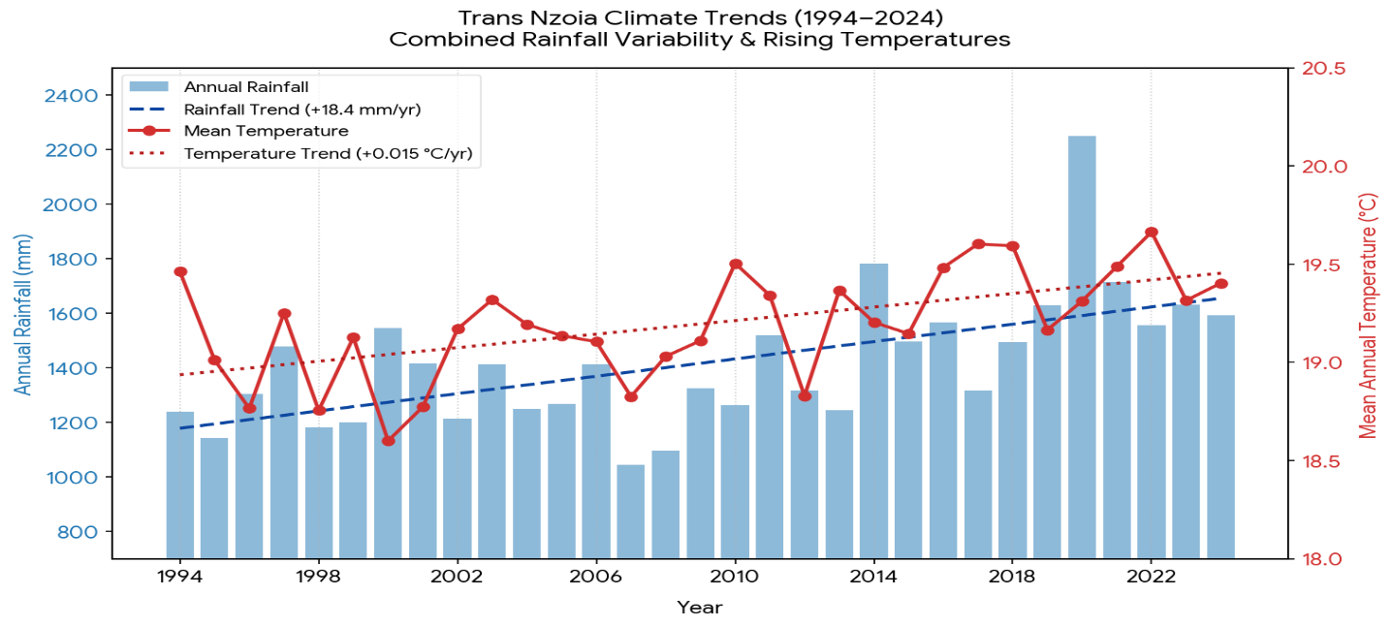
Figure 1: A combined Rainfall variability and Temperature
Results (Figure 1) showed:
Key Data Trends: The study covered a 30-year period from 1994 to 2024, providing a long-term perspective on climatic changes in the study area. Rainfall showed an increasing trend, rising at an average rate of 18.4 mm per year. Mean annual temperature also exhibited a consistent warming trend, increasing at an average rate of 0.015°C annually. The highest rainfall amount was recorded in 2020, exceeding 2200 mm, while the lowest occurred in 2007 at approximately 1000 mm. In terms of temperature, the highest mean value was recorded in 2022 at 19.7°C, whereas the lowest was observed in 2000 at 18.6°C. These variations indicate strong inter-annual fluctuations in both rainfall and temperature over the study period. Overall, the findings demonstrate gradual but clear climatic changes characterized by increasing rainfall and rising temperatures.
Climate Dynamics: The analysis of climate dynamics revealed a simultaneous increase in both total rainfall and average temperatures over the 30-year period. Despite this overall upward trend, both variables showed high variability with frequent year-to-year fluctuations. This indicates increasing instability in the local climate system. Rising temperatures are likely to have contributed to higher evaporation rates, which in turn influenced localized precipitation patterns. The interaction between rainfall and temperature suggests a complex and interdependent climate system rather than a uniform change pattern. These dynamics reflect both long-term warming and intensified rainfall variability in the study area.
Localized Impacts: The observed climatic changes have had notable impacts on agricultural activities in the study area. Unpredictable seasonal rainfall patterns have disrupted farming calendars, making it difficult for farmers to plan planting and harvesting effectively. Years of intense rainfall have increased the risk of flooding and soil erosion, negatively affecting soil fertility. At the same time, rising temperatures have increased heat stress on crops, particularly staple crops such as maize. These conditions have contributed to reduced crop productivity and increased vulnerability among small-scale farmers. Overall, the combined effects of rainfall variability and temperature rise continue to threaten agricultural sustainability and food security in the region.
Table 3: Mann–Kendall Test Results for Temperature
Parameter | Value
Mann–Kendall Z-statistic | 2.84
Kendall Tau | 0.61
Sen’s Slope | 0.05°C/year
p-value | 0.004
Trend Direction | Increasing
Statistical Significance | Significant at p < 0.05

The Mann–Kendall test (Table 3) revealed a statistically significant increasing temperature trend (Z = 2.84, p < 0.05). This implies that the observed increase in temperature was not due to random climatic fluctuations but reflected a sustained warming pattern over time. The findings suggest that Kiminini Sub-County has become progressively warmer, consistent with broader regional and global climate change observations. The positive Sen’s slope value of 0.05°C per year further confirmed the existence of a warming trend within the study area.
4.2 Annual Rainfall Variability and Trends in Kiminini Sub-County (1994–2024)
Table 4. Five-Year Grouped Rainfall Trends in Kiminini Sub-County (1994–2024)
Period | Average Annual Rainfall (mm) | Average Rainfall Anomaly (mm) | Trend Interpretation
1994–1998 | 1398 | 98 | Wet conditions above long-term average
1999–2003 | 1279 | -21 | Declining rainfall trend observed
2004–2008 | 1272 | -28 | Moderate rainfall deficit
2009–2013 | 1241 | -59 | Severe rainfall variability and dry conditions
2014–2018 | 1285 | -15 | Slight recovery in rainfall amounts
2019–2024 | 1301 | 1 | Near-normal but highly variable rainfall

The grouped rainfall analysis (Table 4) revealed considerable rainfall variability in Kiminini Sub-County between 1994 and 2024. The period from 1994 to 1998 recorded the highest average rainfall of about 1398 mm, indicating wetter-than-average conditions. However, rainfall declined during 1999–2003 and 2004–2008, as shown by negative anomalies and below-average rainfall. The most severe rainfall deficits occurred between 2009 and 2013 when average rainfall dropped to about 1241 mm, reflecting prolonged dry conditions and high variability.
Although there was slight recovery between 2014 and 2018, rainfall remained highly inconsistent across years. The period 2019–2024 showed near-normal rainfall conditions, but with continued year-to-year fluctuations. Overall, rainfall patterns in the study area were highly erratic and showed no clear long-term increasing or decreasing trend. This indicates increasing rainfall unpredictability rather than stable climatic conditions over time. These findings are consistent with studies by Kotikot et al. (2024) and Hansen et al. (2011), which reported increasing rainfall variability across East Africa. Consequently, such rainfall instability has significant implications for agriculture, including delayed planting, reduced yields, and increased food insecurity among farming households.
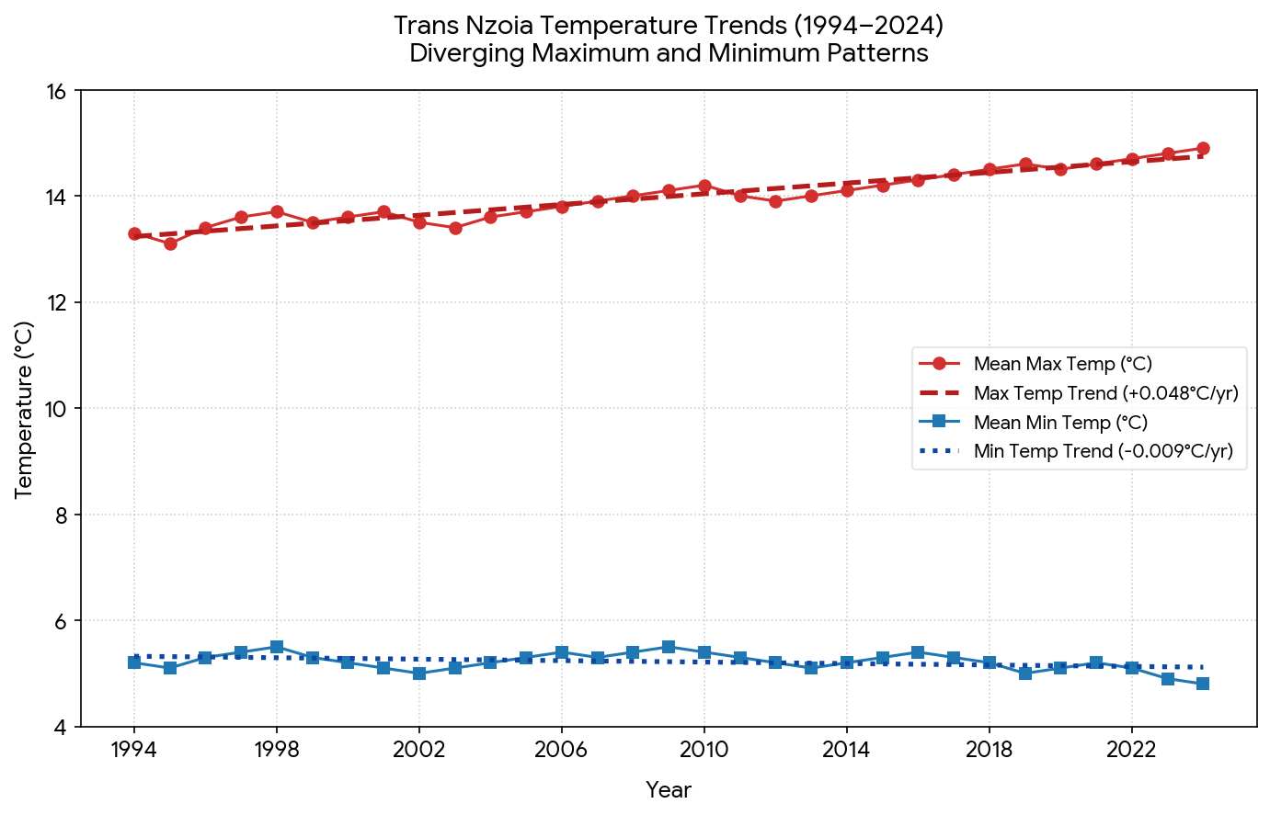
Figure 2. Temperature Trends (1994-2024)
Temperature Trends (Figure 2) showed that:
Key Data Trends: The analysis revealed diverging temperature patterns between daytime maximums and nighttime minimums over the study period. Mean maximum temperature showed a sharp rising trend of +0.048°C per year, indicating significant daytime warming. In contrast, mean minimum temperature exhibited a slight declining trend of -0.009°C per year, reflecting cooler nighttime conditions. As a result, the diurnal temperature range (DTR) widened progressively over time, showing increasing temperature variability within a day. By the end of the 2024 period, daytime temperatures approached 15°C, representing the highest recorded values. Meanwhile, nighttime temperatures fell below 5°C in the later years, indicating colder nights. Overall, the data demonstrates a clear expansion of the day–night temperature gap over time.
Climate Dynamics: The observed patterns indicate accelerated daytime warming compared to the overall mean temperature trend. This suggests that solar heating during the day is intensifying more rapidly than general climatic averages. The decline in nighttime minimum temperatures may be linked to reduced cloud cover or lower atmospheric humidity, allowing more heat to escape into the atmosphere at night. These processes contribute to a widening diurnal temperature range and increasing thermal variability. The results also point to microclimate shifts characterized by less moderated temperature conditions. Overall, the climate is becoming more extreme, with stronger contrasts between daytime and nighttime temperatures.
Localized Impacts: The widening temperature fluctuations have important implications for agricultural activities in the study area. Increased day–night temperature variation can disrupt crop physiological processes, leading to reduced growth efficiency and lower yields. Changes in temperature thresholds may also affect the breeding cycles and survival rates of agricultural pests and plant disease vectors. Additionally, higher daytime temperatures increase evaporation rates, resulting in greater soil moisture loss. This creates a higher demand for irrigation and efficient water management practices. Overall, the changing thermal conditions pose growing risks to agricultural productivity and sustainability.
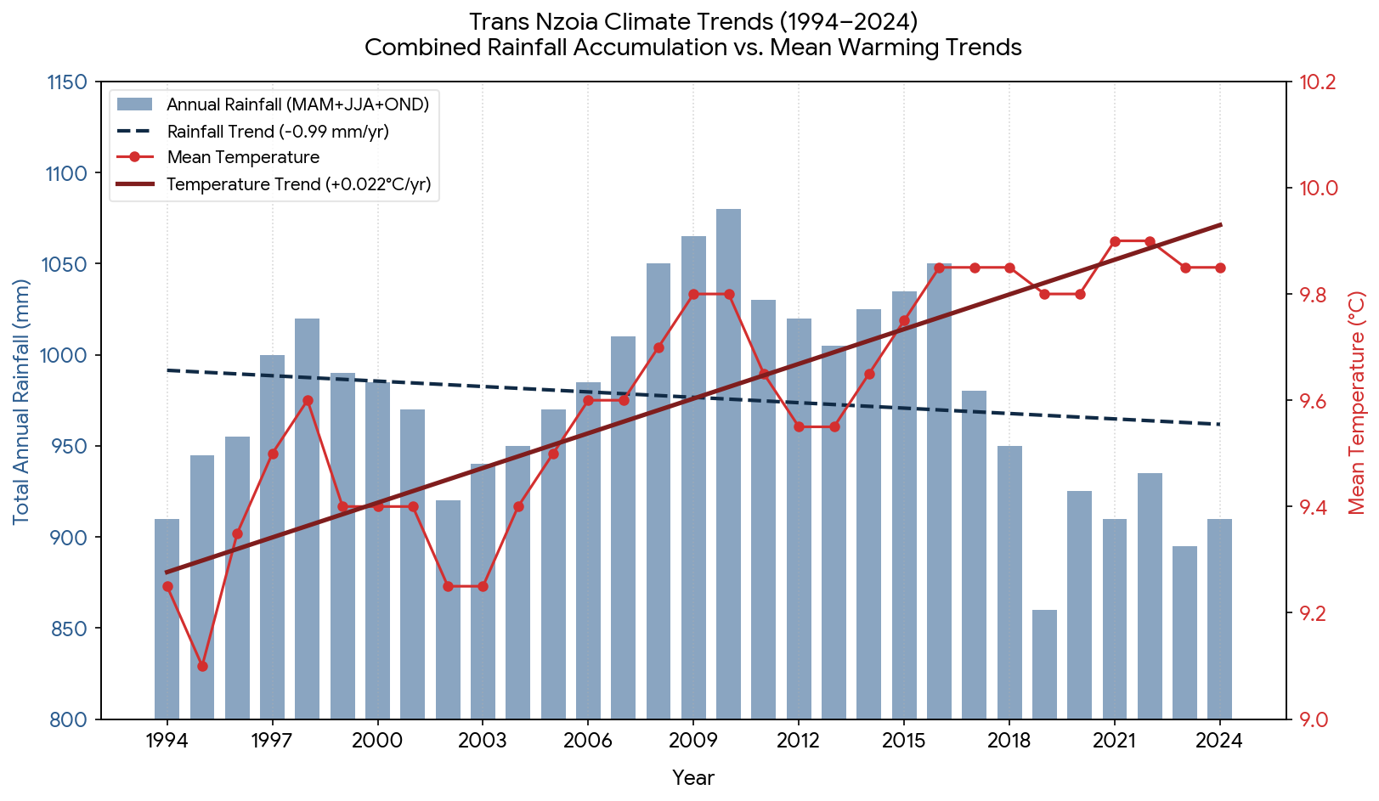
Figure 3. Climate Trends for Trans Nzoia (1994-2024)
The analysis (Figure 3) revealed opposing climatic trends, where annual rainfall is declining while mean annual temperature is steadily rising over the study period. Total annual precipitation is decreasing at a rate of 0.99 mm per year, indicating a gradual reduction in moisture availability. In contrast, mean annual temperatures are increasing at a rate of 0.022°C per year, reflecting consistent warming conditions. The wettest period occurred around 2010, with rainfall peaking at approximately 1080 mm, while recent years (2019–2024) show a sharp decline, with 2019 dropping below 860 mm. Temperatures have also risen from about 9.1°C in 1995 to sustained peaks around 9.9°C after 2016, indicating a clear shift in climatic conditions. These trends show a divergence between declining rainfall and increasing temperatures, signaling significant climate change. Overall, the findings suggest increasing aridity and long-term climatic instability in the study area.
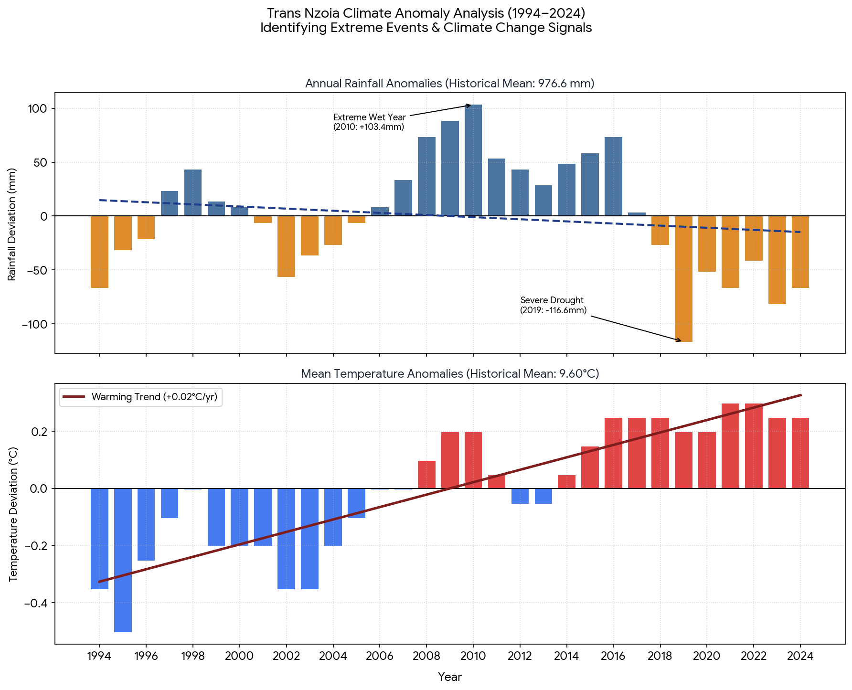
Figure 4. Climate Anomalies for Trans Nzoia County (1994-2024)
The analysis (Figure 4) shows that the historical baseline for the study area is 976.6 mm for rainfall and 9.60°C for temperature. The most extreme wet event occurred in 2010, when rainfall exceeded the average by +103.4 mm, while the most severe drought occurred in 2019 with a deficit of -116.6 mm below average. A persistent rainfall deficit is evident, with an unbroken 7-year period of below-average rainfall recorded from 2018 to 2024. In contrast, temperature patterns indicate a clear thermal regime shift, where values were generally below average before 2007 but consistently above average after 2015. Temperature anomalies also show a steady upward trajectory, increasing at approximately +0.02°C per year, reinforcing the warming trend. These patterns indicate a climatic phase inversion from a cooler, more variable moisture phase (1994–2006) to a warmer and drier phase (2016–2024). Overall, the combined effects of declining rainfall and rising temperatures point to systemic aridification and reduced climatic stability in the region.
Table 5. Mann–Kendall Test Results for Rainfall
Parameter | Value
Mann–Kendall Z-statistic | -1.21
Kendall Tau | -0.18
Sen’s Slope | -2.4 mm/year
p-value | 0.226
Trend Direction | Decreasing
Statistical Significance | Not Significant
The Mann–Kendall test results (Table 5) revealed a weak declining rainfall trend (Z = -1.21), although the trend was statistically insignificant at the 5% significance level (p > 0.05). This suggests that rainfall variability was highly inconsistent and lacked a strong monotonic trend during the study period. Despite the absence of statistical significance, the rainfall fluctuations observed may still have substantial implications for agriculture because crop production depends heavily on seasonal rainfall reliability. Rainfall irregularities observed in Kiminini Sub-County may negatively affect agricultural productivity by disrupting planting seasons, reducing water availability, increasing crop moisture stress, and lowering yields among small-scale farmers.
4.3 Implications of Observed Climatic Trends on Agricultural Activities
Table 6. Effects of Temperature and Rainfall Variability on Agriculture
Climatic Change Observed | Agricultural Implication
Rising temperatures | Increased evapotranspiration and soil moisture loss
Delayed rainfall onset | Delayed planting seasons
Prolonged dry spells | Crop wilting and reduced yields
Irregular rainfall distribution | Increased uncertainty in farming calendars
Extreme rainfall events | Soil erosion and nutrient loss
Increasing climate variability | Reduced food security and farm incomes

The study (Table 6) established that increasing temperatures and rainfall variability significantly affected agricultural activities in Kiminini Sub-County. Rising temperatures increased evapotranspiration rates, which reduced soil moisture availability required for optimal crop growth. This condition contributed to heat stress, poor germination, and reduced yields of major crops such as maize and wheat. Rainfall variability further disrupted agricultural activities through delayed onset of rainfall seasons and prolonged dry spells. These irregularities made it difficult for farmers to determine appropriate planting and harvesting periods. In some cases, extreme rainfall events resulted in flooding, soil erosion, and nutrient leaching, which reduced soil fertility.
As a result, agricultural productivity and household food security were negatively affected. The findings are consistent with studies conducted in Kenya and East Africa that reported similar impacts of climate variability on smallholder farming systems (Hansen et al., 2011; IPCC, 2021). The observed trends highlight the increasing vulnerability of rain-fed agriculture to climate change in the region. Therefore, there is a strong need for climate-smart agriculture and improved adaptation strategies in Kiminini Sub-County.
The study relied mainly on secondary climatic data whose completeness and consistency depended on the quality of meteorological records available. In addition, the study focused only on rainfall and temperature variables and did not include other climatic factors such as humidity and wind patterns. Financial and time constraints also limited extensive field verification of climatic observations.
5. Conclusions and Recommendations
The study concluded that Kiminini Sub-County experienced a consistent increase in temperatures alongside highly variable and increasingly unreliable rainfall patterns between 1994 and 2024. These climatic changes indicate a clear shift toward a warmer and more unstable climate regime over the study period. The rising temperatures, coupled with fluctuating rainfall, suggest increasing climatic stress on the local environment. The observed trends are likely to have significant negative impacts on agricultural productivity through reduced crop yields, altered planting seasons, and increased heat stress on crops. In addition, the variability and decline in rainfall reliability may contribute to reduced water availability for both domestic use and irrigation purposes. This situation further threatens long-term food security, especially for small-scale farmers who depend heavily on rain-fed agriculture. The findings highlight the urgent need for climate adaptation strategies to enhance resilience in agriculture and water resource management within the sub-county.
The study recommends that:
- Farmers should adopt climate-smart agricultural practices to enhance resilience against climate variability.
- County governments should strengthen climate information dissemination systems to support timely farming decisions.
- More investment should be made in irrigation and water conservation technologies.
- Further localized climate studies should be conducted to support evidence-based adaptation planning.
6. References
Conway, D., Persechino, A., Ardoin-Bardin, S., Hamandawana, H., Dieulin, C., & Mahé, G. (2009). Rainfall and water resources variability in sub-Saharan Africa during the 20th century. Journal of Hydrometeorology, 10(1), 41–59. https://doi.org/10.1175/2008JHM1004.1
Hansen, J. W., Mason, S. J., Sun, L., & Tall, A. (2011). Review of seasonal climate forecasting for agriculture in East Africa. Experimental Agriculture, 47(2), 205–217. https://doi.org/10.1017/S0014479710000876
Intergovernmental Panel on Climate Change (IPCC). (2021). Climate change 2021: The physical science basis. Cambridge University Press. https://doi.org/10.1017/9781009157896
Kogo, B. K., Kumar, L., & Koech, R. (2021). Climate variability and agricultural productivity in Kenya: Impacts and adaptation strategies. Environmental Development, 39, 100669. https://doi.org/10.1016/j.envdev.2021.100669
Kotikot, S., et al. (2024). Rainfall variability trends in Kenya. Climate Risk Management. https://doi.org/10.1016/j.crm.2024.100469
Macharia, P. M., & Raude, J. M. (2017). Trends in temperature and rainfall in the Thika River Basin, Kenya. Journal of Meteorology and Climate Science. https://doi.org/10.5897/JMCS2017.0045
Muema, J., Mburu, J., & Kariuki, S. (2018). Climate variability and agricultural productivity in Kenya. Journal of Environmental Science and Policy, 92, 45–56. https://doi.org/10.1016/j.envsci.2018.10.003
Mutai, C. C., Enke, W., & Steinbach, A. (2013). Climatology of East African rainfall and temperature variability. Theoretical and Applied Climatology, 113, 663–681. https://doi.org/10.1007/s00704-012-0800-7
Niang, I., et al. (2014). Africa. In Climate change 2014: Impacts, adaptation, and vulnerability. IPCC. https://doi.org/10.1017/CBO9781107415386.008
Omondi, P., Ogallo, L., Anyah, R., & Ininda, J. (2013). Linkages between global sea surface temperature anomalies and East African climate variability. International Journal of Climatology, 33(1), 1–17. https://doi.org/10.1002/joc.3405
Thornton, P. K., Jones, P. G., Ericksen, P. J., & Challinor, A. J. (2011). Agriculture and food systems in sub-Saharan Africa in a 4 °C+ world. Philosophical Transactions of the Royal Society B, 369(1639), 20120262. https://doi.org/10.1098/rstb.2012.0262
Wambua, S., Mwakubo, S., & Ngugi, R. (2016). Climate variability and agricultural production in Kenya: Evidence from smallholder systems. Agricultural Systems, 145, 88–97. https://doi.org/10.1016/j.agsy.2016.03.007

