Original Research Article

Sustainable Transportation Systems and Climate Change in Developing Countries: Evidence from India

ABSTRACT
India's transport sector has emerged as one of the foremost climate and public-health challenges of the twenty-first century. Road transport alone contributes 12 per cent of India's energy-related CO₂ emissions, and the sector's greenhouse gas (GHG) output is expanding faster than any other segment of the national economy. Against the backdrop of India's Nationally Determined Contribution (NDC) target to reduce the emission intensity of GDP by 45 per cent from 2005 levels by 2030 and its net-zero commitment by 2070, this paper undertakes a systematic empirical analysis of the nexus between sustainable transportation and climate change mitigation in a rapidly urbanising developing country. Drawing on data from the Ministry of Road Transport and Highways (MoRTH), the International Energy Agency (IEA), the Central Pollution Control Board (CPCB), the Council on Energy, Environment and Water (CEEW), NITI Aayog, and peer-reviewed literature (2015–2025), the study examines: (i) the magnitude and trajectory of transport-sector GHG emissions; (ii) co-pollutant air-quality impacts on urban populations; (iii) progress and gaps in electric-vehicle (EV) deployment; (iv) the performance of mass rapid transit (MRT) systems; and (v) policy pathways to sustainable mobility. Key findings reveal that while EV registrations grew eleven-fold—from 1.30 million in 2018 to 15.29 million by 2023—they constituted only 7.6 per cent of total new-vehicle sales in 2024, far below the national target of 30 per cent by 2030. India's metro network, the world's third largest at 1,013 km across 23 cities by 2025, carries over 11.2 million daily passengers but falls well short of projected ridership in many corridors. Average annual PM₂.₅ concentrations of 54.4 µg/m³ in 2023—more than ten times the WHO guideline—underscore the urgency of modal shift. The paper concludes with a multi-pronged policy framework encompassing stricter fuel-economy standards, accelerated fleet electrification, integrated multimodal transit, and green urban-freight reforms, offering transferable lessons for other developing economies confronting the intersection of climate commitments and mobility needs.
Keywords: Sustainable transportation; climate change; greenhouse gas emissions; electric vehicles; mass rapid transit; urban air quality; decarbonisation.
1. INTRODUCTION
Transportation is the lifeblood of modern economies, enabling the movement of people, goods, and services. Globally, the transport sector contributed 8.7 Gt CO₂-equivalent in 2019—a 75 per cent increase over 1990—and remains among the fastest-growing sources of greenhouse gas (GHG) emissions worldwide (IPCC, 2022). For developing countries at the nexus of rapid urbanisation, burgeoning middle classes, and constrained fiscal space, the challenge is especially acute: they must simultaneously provide affordable mobility to millions while avoiding the carbon-intensive growth trajectories of industrialised economies.
India epitomises this dilemma. As the world's most populous nation and its fourth-largest automotive market, India registered over 326 million motor vehicles as of 2022 (MoRTH, 2023), and projections indicate this fleet could double by 2040 if current trends persist. Road transport already contributes 12 per cent of India's energy-related CO₂ emissions (IEA, 2023), and the sector's share is on an upward trajectory. Concurrently, 83 of the world's 100 most polluted cities in 2023 were located in India, with average national PM₂.₅ concentrations of 54.4 µg/m³—exceeding the World Health Organization's recommended limit of 5 µg/m³ by more than ten-fold (IQAir, 2024).
India's climate commitments under the Paris Agreement and its domestic NDCs—to reduce emission intensity of GDP by 45 per cent from 2005 levels by 2030 and achieve net-zero by 2070—make the decarbonisation of transport not merely desirable but imperative. The government has introduced successive policies: the Bharat Stage (BS)-VI emission standards (2020), the Faster Adoption and Manufacturing of Hybrid and Electric Vehicles (FAME) scheme, the National Electric Mobility Mission Plan (NEMMP), and an expanding metro-rail network. Yet significant gaps remain between ambition and implementation.
This paper addresses four interconnected research questions: (1) What is the current and projected magnitude of GHG and co-pollutant emissions from India's transport sector? (2) How has the EV transition progressed relative to stated targets? (3) What role does mass rapid transit play, and where does it underperform? (4) What integrated policy pathways can accelerate sustainable mobility? The remainder of the paper is structured as follows: Section 2 reviews relevant literature; Section 3 outlines the methodology; Section 4 presents empirical findings across six thematic dimensions; Section 5 provides an integrated discussion; and Section 6 concludes with policy recommendations.

2. LITERATURE REVIEW
2.1 Transport Emissions and Climate Change: Global Context
The scientific consensus on the transport–climate nexus is well-established. The IPCC's Sixth Assessment Report (AR6) identifies transport as one of the hardest-to-abate sectors, emphasising the need for both technological solutions—such as electrification, hydrogen, and sustainable fuels—and demand-side management through urban form, modal shift, and pricing instruments (IPCC, 2022). Creutzig et al. (2015) demonstrated that, at the global level, avoided car travel could reduce emissions by 0.7 GtCO₂ yr⁻¹ by 2050, underscoring the importance of mode shift alongside improvements in vehicle technology. Similarly, Sims et al. (2014) emphasised that the highest mitigation potential in transport lies in modal shifts towards public transit and non-motorised transport.
2.2 Sustainable Transport in Developing Country Contexts
The literature on sustainable transport in developing economies highlights unique structural challenges. Pojani and Stead (2015) found that rapid motorisation in Asian cities—driven by income growth, poor public-transit quality, and urban sprawl—has consistently outpaced infrastructure investment. Zusman et al. (2012) demonstrated that in South and Southeast Asian cities, the share of trips by private vehicle doubles with every doubling of per capita income unless countervailing policies are enacted. For India specifically, Mohan et al. (2019) documented the health co-benefits of modal shift, estimating that tripling bus share in Delhi could avert 2,200 premature deaths annually. Badami and Haider (2007) noted that the fragmented institutional landscape—with transport policy shared among central ministries, state governments, and urban local bodies—systematically impedes coordinated planning for sustainable mobility. More recently, Dawda (2024) identified that the over-emphasis on metro rail at the expense of bus-based transit has widened accessibility gaps for low-income urban commuters.
2.3 Electric Vehicles and Decarbonisation Pathways
EV adoption has attracted substantial scholarly attention. Kamboj et al. (2022), through the CEEW India Transport Energy Outlook, projected that under a business-as-usual scenario, India's transport energy demand and CO₂ emissions could double by 2050, while accelerated electrification combined with grid decarbonisation could reduce transport-sector emissions by 45–60 per cent. The CEEW study highlighted the critical role of the electricity generation mix: EVs charged from a coal-heavy grid may offer only marginal GHG benefits in the short term. Aggarwal et al. (2021) examined outcomes of the FAME scheme, concluding that purchase subsidies have been effective for two-wheelers and three-wheelers but have had a limited impact on the passenger-car and heavy-vehicle segments.
2.4 Mass Rapid Transit and Urban Mobility
Metro-rail investment in Indian cities has generated a substantial body of evaluative literature. Singh (2018) found significant reductions in road traffic and fuel consumption in corridors served by the Delhi Metro but noted that benefits were geographically concentrated. An IIT Delhi study (cited in Business Standard, 2024) documented that Indian metros achieve, on average, only 25–35 per cent of their projected ridership, attributing this to poor last-mile connectivity, land-use fragmentation, and inadequate feeder services. Dawda (2024) argued that bus-based transit—despite chronic underinvestment—carries passengers 0.9 to 19.7 times as many as parallel metro corridors, pointing to a systemic misallocation of public investment. The literature converges on the need for integrated, multimodal transit planning that combines high-capacity rail, quality bus services, and active transport infrastructure.

3. METHODOLOGY
This study adopts a mixed-methods research design combining: (i) systematic review of peer-reviewed literature published between 2015 and 2025; (ii) secondary analysis of national and international datasets; and (iii) scenario-based trend analysis.
3.1 Data Sources
Primary empirical data were drawn from the following authoritative sources: the Ministry of Road Transport and Highways (MoRTH) Road Transport Yearbooks (2019–2023) for vehicle registration and modal-share statistics; the International Energy Agency (IEA) report 'Transitioning India's Road Transport Sector' (2023) for energy-use and emission projections; Central Pollution Control Board (CPCB) National Ambient Air Quality Monitoring Programme data for PM₂.₅ concentrations; NITI Aayog EV target frameworks and the 2025 report 'Unlocking a $200 Billion Opportunity'; the Council on Energy, Environment and Water (CEEW) India Transport Energy Outlook (2022) for business-as-usual and mitigation scenario modelling; and IQAir World Air Quality Reports (2023–2024) for ambient PM₂.₅ data.
3.2 Analytical Framework
Emission trends were analysed using a decomposition approach informed by the Kaya Identity, partitioning transport CO₂ changes into population growth, per capita economic output, transport energy intensity, and transport fuel carbon intensity. EV adoption trajectories were benchmarked against NITI Aayog targets using compound annual growth rate (CAGR) extrapolation. Metro-system performance was assessed using a Ridership Attainment Index (RAI), calculated as the ratio of actual to projected daily ridership. Policy evaluation drew on a comparative assessment of instruments across the AVOID–SHIFT–IMPROVE (ASI) framework, widely used in sustainable transport literature.
3.3 Limitations
This study relies primarily on secondary data, which introduces inherent constraints around comparability across reporting years and methodological differences between agencies. Ridership projections for metro systems have, in many cases, been revised downwards since the original Detailed Project Reports (DPRs), creating ambiguity in benchmarking. The analysis focuses on road and rail; aviation and maritime transport are outside the scope of this paper. Projections carry scenario-dependent uncertainty and should be interpreted as indicative rather than deterministic.

4. RESULTS AND ANALYSIS
4.1 Transport-Sector GHG Emissions: Magnitude and Trajectory
India's transport sector currently contributes approximately 12 per cent of national energy-related CO₂ emissions (IEA, 2023), equivalent to roughly 277–330 MtCO₂ annually. Road transport overwhelmingly dominates, accounting for 92 per cent of transport energy demand and 94 per cent of transport-related CO₂ emissions (ORF, 2024). Within road transport, trucks and heavy goods vehicles represent the single largest-emitting sub-segment, followed by passenger cars and two- and three-wheelers.
Crucially, the sector's emissions are growing faster than any other major economic segment in India. CEEW (2022) projects that under a BAU scenario, transport CO₂ could nearly double by 2050 relative to 2021 levels. The IEA (2023) similarly warns that energy use and CO₂ emissions from road transport could double by 2050 in the absence of decisive policy intervention. The modal composition of these emissions is disaggregated in Table 1, and Figure 1 presents the sub-sector contributions to national CO₂ as a horizontal bar chart for visual clarity.
Table 1. Estimated GHG Emission Share by Road Transport Sub-Sector in India (2021)
Vehicle Category | Share of Transport CO₂ (%) | Share of National CO₂ (%) | Primary Fuel
Heavy Goods Vehicles (Trucks) | ~34% | ~3.9% | Diesel
Passenger Cars (4-Wheeler) | ~22% | ~2.5% | Petrol/Diesel
Two-Wheelers & Three-Wheelers | ~17% | ~2.0% | Petrol/CNG
Buses (Public & Private) | ~14% | ~1.6% | Diesel/CNG
Light Commercial Vehicles | ~9% | ~1.0% | Diesel/Petrol
Other (Rail, Aviation, etc.) | ~4% | ~0.5% | Various
Source: Authors' compilation from IEA (2023); CEEW (2022); MoRTH (2023); ORF (2024).
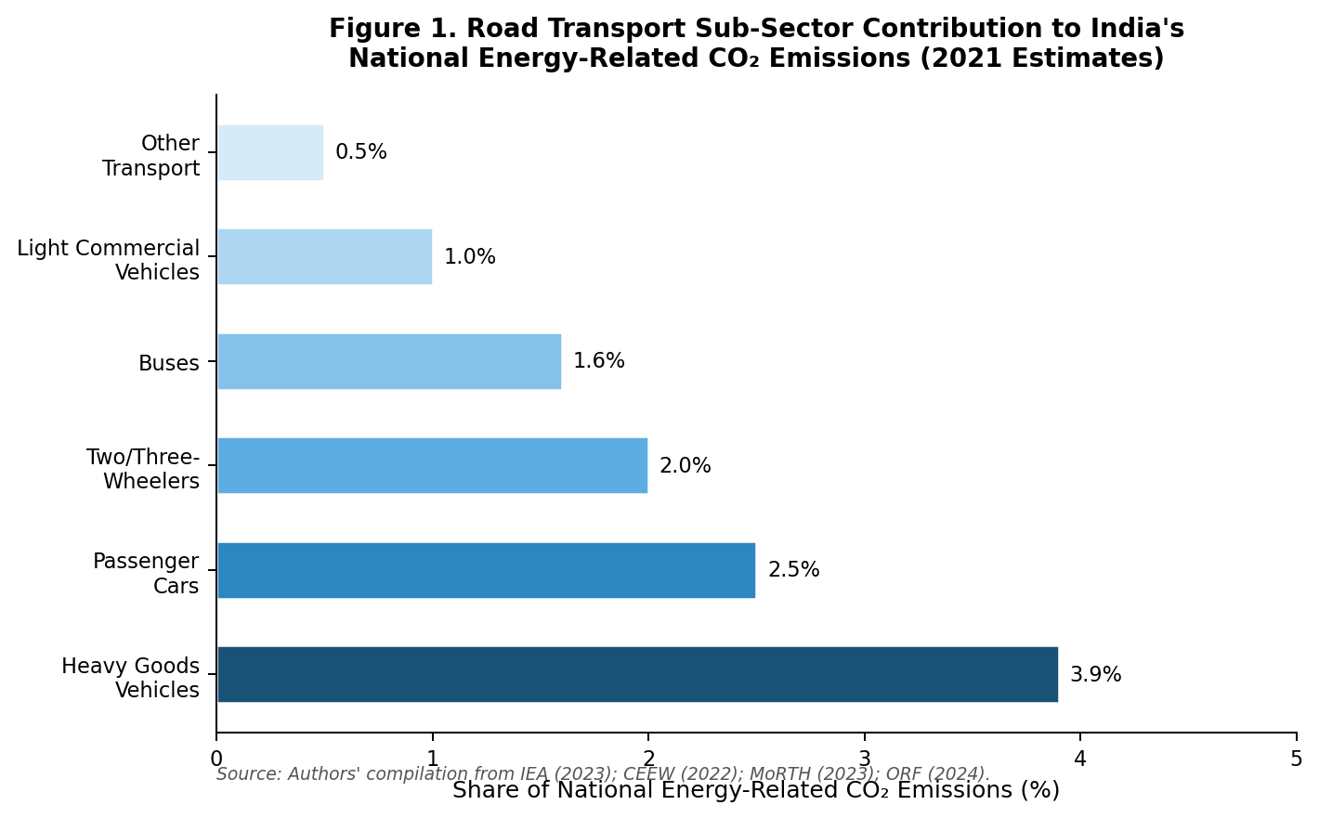
Figure 1. Road transport sub-sector contribution to India's national energy-related CO₂ emissions (2021 estimates). Source: Authors' compilation from IEA (2023); CEEW (2022); MoRTH (2023); ORF (2024).
The freight sector warrants particular concern. India's road freight modal share climbed from 37.4 per cent in 1990 to 78.7 per cent in 2017 (MoRTH, 2021), while the far more energy-efficient rail freight declined correspondingly. Emissions from medium and heavy-duty vehicles and buses currently account for approximately 50 per cent of all road transport emissions (Accelerating to Zero Coalition, 2025).

4.2 Urban Air Quality: The Co-Pollutant Dimension
Beyond CO₂, India's transport sector is a major source of co-pollutants with acute public-health consequences. Vehicular emissions contribute 20–30 per cent of PM₂.₅ at street level in urban areas, and annually account for approximately 290 gigagrams (Gg) of PM₂.₅ nationally (CPCB, 2022). In megacities, the transport contribution is disproportionately high: vehicles contribute 40 per cent of PM₂.₅ in Bengaluru (CSTEP, 2022) and 20–25 per cent in Delhi during winter months (IEA, 2023).
India's overall ambient air quality position is alarming. According to the IQAir World Air Quality Report 2023, India was the third most polluted country globally, and 83 of the world's 100 most polluted cities were located within its borders. National average PM₂.₅ stood at 54.4 µg/m³ in 2023—down from a peak of 58.1 µg/m³ in 2018 but still more than ten times the WHO guideline of 5 µg/m³ (IQAir, 2024). A 2024 study published in The Lancet Planetary Health estimated that 7.2 per cent of daily deaths in ten of India's most polluted cities were attributable to PM₂.₅ levels exceeding WHO guidelines. Table 2 documents the temporal trend of national average PM₂.₅ concentrations from 2018 to 2023.
Table 2. Annual Average PM₂.₅ Concentrations in India (2018–2023) and Key Benchmarks
Year | National Avg. PM₂.₅ (µg/m³) | vs. WHO Limit (5 µg/m³) | Context
2018 | 58.1 | 11.6× limit | Pre-COVID baseline
2019 | 58.0 | 11.6× limit | Pre-COVID baseline
2020 | 51.9 | 10.4× limit | COVID lockdowns reduced traffic
2021 | 56.2 | 11.2× limit | Post-lockdown rebound
2022 | 53.3 | 10.7× limit | Gradual improvement
2023 | 54.4 | 10.9× limit | India ranked 3rd most polluted globally
WHO Guideline | 5.0 | — | Safe annual average (WHO, 2021)
India NAAQS | 40.0 | 8× WHO limit | National Ambient Air Quality Standard
Source: IQAir World Air Quality Reports (2019–2024); WHO (2021); CPCB (2023). NAAQS = National Ambient Air Quality Standard.

4.3 Electric Vehicle Deployment: Progress, Gaps, and Targets
India's EV transition has been shaped by successive policy interventions. The FAME Phase I (2015–2019) and Phase II (2019–2024, budget ₹11,500 crore / approximately USD 1.31 billion) schemes have provided demand-side subsidies and supply-side incentives. By June 2025, the government had supported over 16.29 lakh (1.629 million) EVs under FAME II, including 14.35 lakh e-two-wheelers, 1.65 lakh e-three-wheelers, 22,644 e-four-wheelers, and 5,165 electric buses (IBEF, 2025). The successor PM e-Drive Scheme (2024–2026) aims to support an additional 2.5 million e-two-wheelers and 320,000 e-three-wheelers.
Total EV registrations in India grew from 1.30 million cumulative units in 2018 to 15.29 million by 2023—an eleven-fold increase over five years (IBEF, 2025). By 2024, EV sales reached approximately 2.08 million units (NITI Aayog, 2025), representing a 25.6 per cent year-on-year increase. Despite this impressive absolute growth, EVs constituted only 7.6 per cent of total new vehicle sales in 2024, far short of the NITI Aayog target of 30 per cent by 2030 (NITI Aayog, 2025). The trajectory of EV adoption against national targets is presented in Figure 2, which traces cumulative registrations from 2018 to 2023 against the 2030 policy target trajectory.
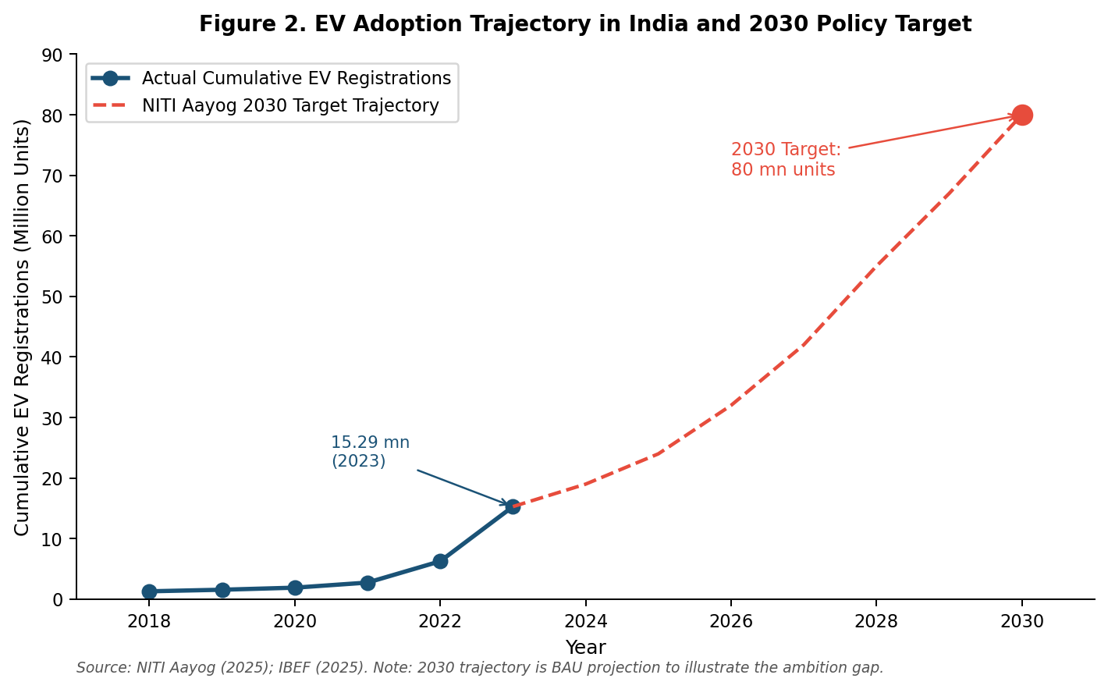
Figure 2. EV adoption trajectory in India and 2030 policy target. Source: NITI Aayog (2025); IBEF (2025). Note: 2030 trajectory is BAU projection illustrating the ambition gap.
Table 3. NITI Aayog EV Sales Penetration Targets by Vehicle Segment (2030) vs. 2024 Actuals
Vehicle Segment | 2024 Sales Penetration (%) | 2030 Target (%) | Gap (percentage points)
Two-Wheelers | ~5.5% | 80% | ~74.5 pp
Three-Wheelers | ~53% | 80% | ~27.0 pp
Private Cars (4-Wheeler) | ~2.5% | 30% | ~27.5 pp
Commercial Vehicles | ~1.2% | 70% | ~68.8 pp
Buses | ~3.8% | 40% | ~36.2 pp
Overall Fleet | ~7.6% | 30% (new sales) | ~22.4 pp
Source: NITI Aayog (2025); IBEF (2025); Accelerating to Zero Coalition (2025). pp = percentage points.
Structural barriers explain much of the gap. The charging infrastructure deficit is acute: as of 2025, only 8,885 public EV charging stations had been installed, against a sanctioned total of 9,332 (IBEF, 2025), grossly insufficient for a country the size of India. Heavy dependence on battery imports raises both cost and supply-chain resilience concerns. The EV finance industry, expected to reach ₹3.7 lakh crore (~USD 50 billion) by 2030 (NITI Aayog/RMI), remains underdeveloped for low-income purchasers. The heavy-vehicle and long-haul freight segments, which contribute disproportionately to emissions, have seen minimal EV adoption owing to range constraints and high upfront costs.

4.4 Mass Rapid Transit Systems: Expansion and Performance
India's metro rail network has expanded from 248 km across five cities in 2014 to 1,013 km across 23 cities by 2025, representing a fourfold increase in operational length. The network carries approximately 11.2 million passengers daily, and annual ridership across fifteen major cities is reported at 36.5 billion passenger-trips. The Delhi Metro alone carries an average of 4.63 million passengers daily in 2025. Budgetary allocations for metro projects have risen from ₹5,798 crore in 2013–14 to ₹29,550–34,807 crore in 2025–26.
However, the ridership performance picture is considerably more nuanced. The IIT Delhi study (2024) found that most metro corridors achieve only 25–35 per cent of their originally projected ridership. City-level data reveal significant variation: Delhi achieved 38–79 per cent of projections over 2017–2020, Mumbai (Phase 1) reached 89 per cent—a relative outlier—while Chennai attained 35 per cent and Hyderabad 26 per cent. Smaller systems fare worse still: Lucknow reached 8.6 per cent of forecast volumes, Kochi 14.5 per cent, and Jaipur 7.6 per cent (Indrastra, 2026). Table 4 summarises the Ridership Attainment Index for selected cities; Figure 4 provides a visual comparison across the eight cities studied.
Table 4. Metro Rail System Performance: Ridership Attainment Index (RAI) for Selected Indian Cities
City / System | Operational Length (km) | Daily Ridership (mn, 2024–25) | RAI (% of DPR Projection) | Key Constraint
Delhi Metro | 392.5 | 4.63 | ~65–79% | Last-mile, feeder gaps
Mumbai Metro (Ph. 1) | 33.5 | 0.35 | ~89% | Overcrowding—above target
Bengaluru Namma Metro | 73.9 | 0.71 | ~27% | Poor land-use integration
Hyderabad Metro | 69.2 | 0.45 | ~26% | Competing road capacity
Chennai Metro | 54.1 | 0.28 | ~35% | Feeder bus deficit
Kochi Metro | 29.0 | 0.07 | ~14.5% | Low catchment density
Lucknow Metro | 22.9 | 0.04 | ~8.6% | Weak land-use planning
Jaipur Metro | 12.0 | 0.03 | ~7.6% | Very low urban density
Source: Indrastra (2026); IIT Delhi study cited in Business Standard (2024); ORF (2024). RAI = Ridership Attainment Index. DPR = Detailed Project Report.
Paradoxically, buses—despite chronic underinvestment and fleet shortages—carry passengers at volumes 0.9 to 19.7 times those of parallel metro services in the same cities (Dawda, 2024; ORF, 2025). No Indian city meets the Ministry of Housing and Urban Affairs (MoHUA) guideline of 40–60 buses per lakh population. This systematic under-provisioning of bus services—combined with overemphasis on capital-intensive metro investment—represents a significant structural inefficiency in India's urban transport investment portfolio.

4.5 Fuel Economy and Emission Standards
India's leap from BS-IV to BS-VI emission standards in April 2020—bypassing BS-V entirely—was a landmark regulatory achievement. BS-VI standards broadly align with Euro-6/VI norms and have led to measurable reductions in tailpipe NOx and PM emissions. Real-world emissions testing by the International Council on Clean Transportation (ICCT) in Delhi and Gurugram (December 2022–April 2023), measuring over 100,000 vehicles across 20 sites, confirmed that the BS-IV-to-BS-VI transition led to significant reductions in tailpipe emissions across all vehicle types (ICCT, 2024). Nonetheless, the ICCT study also revealed that real-world emissions can be multiple times higher than laboratory limits, particularly for commercial vehicles. To align with India's 2070 net-zero goal, truck fleet efficiency must improve by more than 35 per cent by 2050 (IEA, 2023).

4.6 Projected Emission Trajectories Under Alternative Scenarios
Table 5 synthesises projected transport-sector CO₂ emissions under three scenarios to 2050, drawing on the IEA Announced Pledges Scenario (APS), CEEW BAU and mitigation scenarios, and TERI (2024) roadmap modelling. Figure 3 presents the indexed emission trajectory for each scenario, illustrating the divergence between BAU, Stated Policies, and Net-Zero Aligned pathways.
Table 5. India Transport-Sector CO₂ Emission Projections to 2050 Under Three Scenarios (Index: 2021 = 100)
Scenario | Description | 2030 Index | 2040 Index | 2050 Index | Key Levers
Business-as-Usual (BAU) | Current policies, no new interventions | 130 | 170 | 195 | None
Stated Policies (STEPS) | FAME, BS-VI, metro expansion | 110 | 115 | 105 | EV uptake, standards
Net-Zero Aligned (NZA) | Accelerated EV, 100% clean grid, modal shift | 90 | 60 | 20–30 | All ASI measures
Source: Authors' synthesis from IEA (2023); CEEW (2022); TERI (2024). Index: 2021 baseline = 100. STEPS = Stated Policies Scenario; NZA = Net-Zero Aligned scenario.
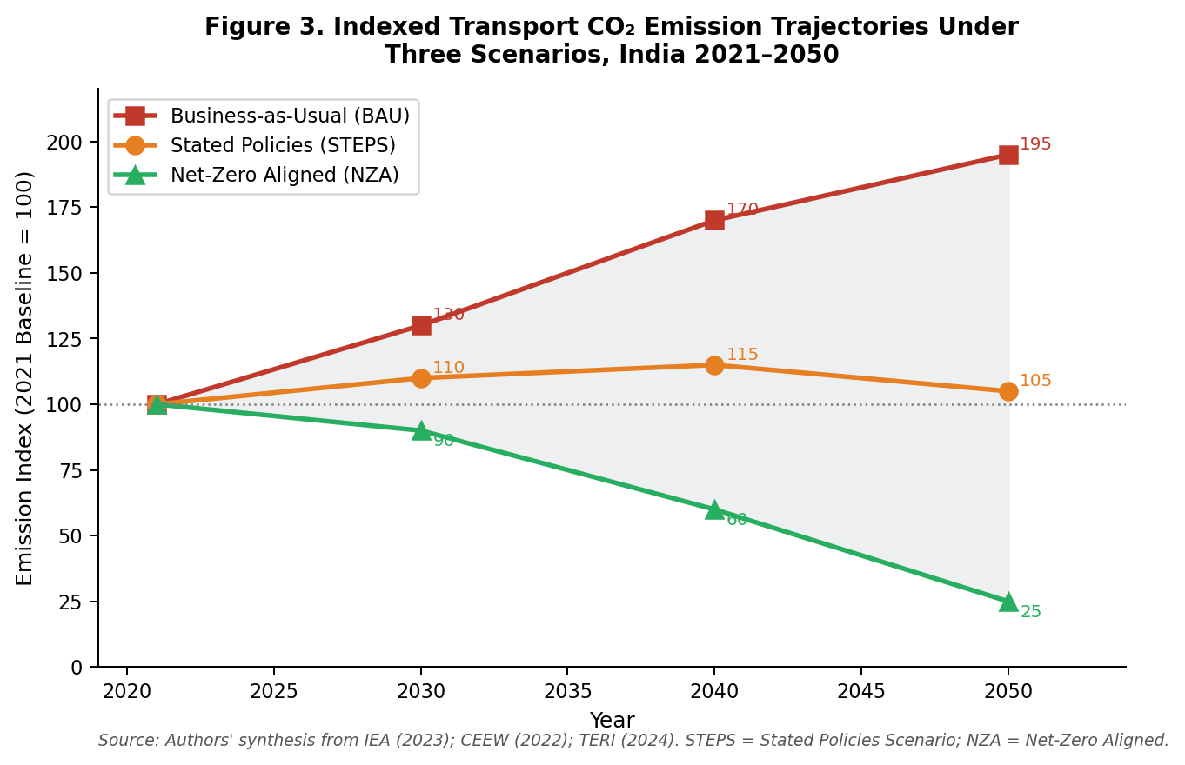
Figure 3. Indexed transport CO₂ emission trajectories under three scenarios, India 2021–2050. Source: Authors' synthesis from IEA (2023); CEEW (2022); TERI (2024).
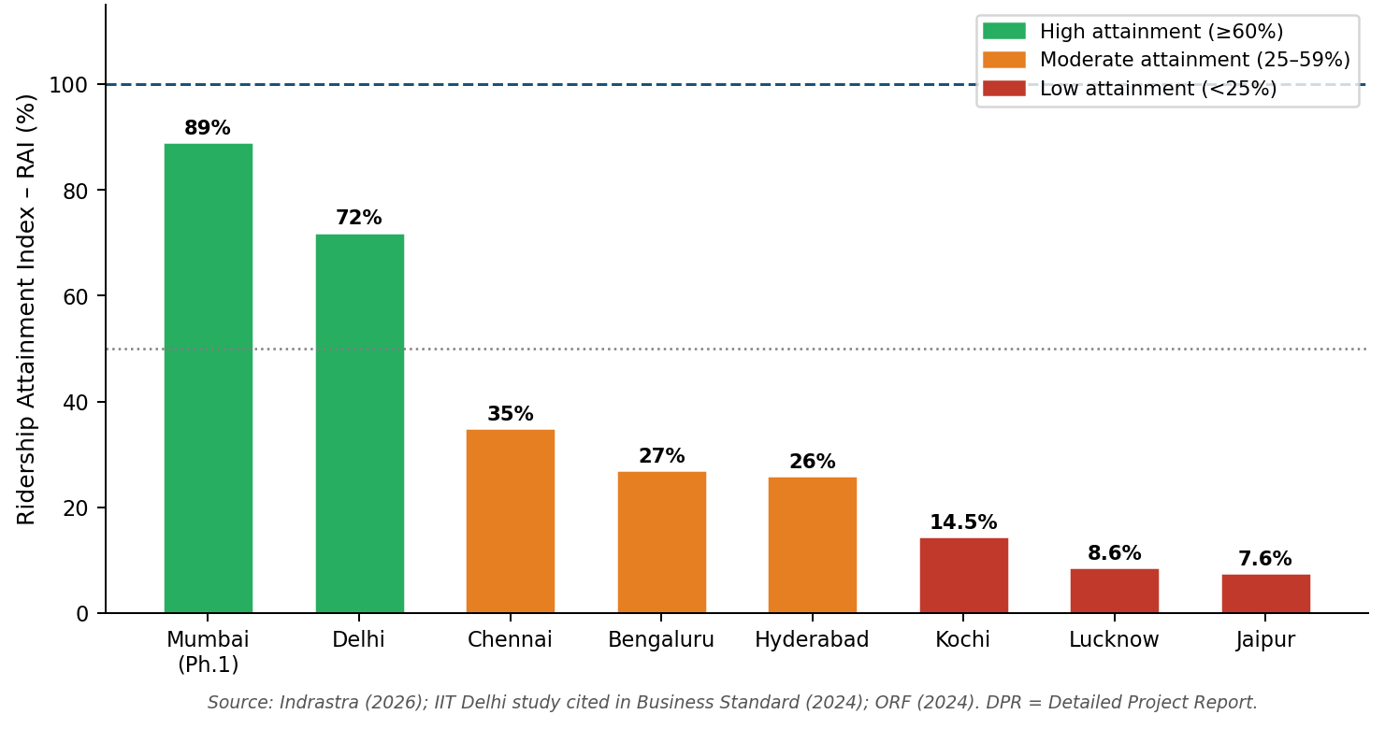
Figure 4. Metro rail Ridership Attainment Index (RAI) for selected Indian cities (% of DPR projected ridership). Source: Indrastra (2026); IIT Delhi study cited in Business Standard (2024); ORF (2024).

5. DISCUSSION
5.1 The Structural Tension Between Mobility and Sustainability
The findings reveal a fundamental structural tension in India's transport system: the forces driving mobility demand—rapid urbanisation, rising incomes, and economic integration—are the same forces accelerating carbon emissions and air-quality degradation. India's urbanisation rate, currently around 36 per cent, is expected to reach 50–55 per cent by 2050, adding over 400 million urban residents (UN, 2022). Each percentage point of urbanisation is historically associated with increased motorisation unless countervailing policies are in place. Without transformative intervention, the IEA (2023) projects that transport CO₂ could double by 2050, directly undermining India's net-zero commitment.
This tension is not unique to India. Brazil, Indonesia, Nigeria, and other large developing economies face analogous dilemmas. However, India's scale makes it particularly consequential for global climate outcomes. A BAU trajectory for India's transport sector alone could contribute 0.03–0.05°C of additional global warming by 2100, through the lens of IPCC integrated-assessment models. The lessons India learns will therefore reverberate across the developing world.
5.2 The AVOID–SHIFT–IMPROVE Framework Applied to India
The AVOID–SHIFT–IMPROVE (ASI) framework provides a useful organising structure for policy analysis. AVOID strategies focus on reducing the need for motorised travel through compact urban development, mixed land-use planning, and telecommuting. SHIFT strategies move demand from private motorised vehicles to public transit, cycling, and walking. IMPROVE strategies raise the environmental performance of vehicles and fuels. India's current policy portfolio is heavily weighted towards the IMPROVE pillar—BS-VI standards, FAME subsidies, ethanol blending—with relatively limited institutional capacity for AVOID and SHIFT interventions. The evidence that bus-based transit outperforms metro rail in ridership per rupee invested in most Indian cities argues strongly for rebalancing the investment portfolio.
5.3 The Grid-EV Nexus: When Is Electrification Truly Green?
A nuanced finding of this study concerns the actual GHG benefits of EV deployment in the Indian context. India's electricity generation remains approximately 55–60 per cent coal-dependent (2023 data), though this proportion is declining rapidly as solar and wind capacity expands—India added nearly 35 GW of renewable capacity in 2024 alone. CEEW (2022) estimates the break-even point—at which EVs offer unambiguous lifecycle GHG benefits—to be approximately 2025–2028 for the Indian grid mix, assuming continued rapid renewable-energy growth. This underscores the importance of co-ordinating transport and energy policy: the environmental dividend of EV adoption scales with grid decarbonisation. Kerala, Delhi, Karnataka, and Maharashtra—which lead in EV penetration—also have relatively cleaner grid mixes, suggesting an emergent virtuous cycle.
5.4 Equity, Access, and the Political Economy of Sustainable Mobility
Any sustainable transport transition in a country as economically diverse as India must contend with equity imperatives. Low-income urban residents rely disproportionately on buses, auto-rickshaws, and cycles—modes least served by current investment priorities. Metro-rail systems, while providing environmental benefits, often serve middle- and upper-income commuters and generate land-value uplift that can displace lower-income communities. FAME subsidies, concentrated in the two-wheeler and three-wheeler segments, have been relatively more equitable, as these vehicles are accessible to lower-income buyers. Political economy analysis suggests that institutional fragmentation is the central weakness of India's sustainable transport agenda—with responsibility spread across MoRTH, Ministry of Power, Bureau of Energy Efficiency, Ministry of Heavy Industry, NITI Aayog, state transport departments, and urban local bodies.

6. POLICY RECOMMENDATIONS
Based on the foregoing analysis, an integrated policy framework is proposed, structured around the ASI hierarchy and organised in three-time horizons.
6.1 Near-Term Actions (2025–2027)
Accelerate PM e-Drive implementation: Ensure timely disbursement of subsidies for 2.5 million e-two-wheelers and 320,000 e-three-wheelers; extend comparable incentives to e-buses in Tier-2 and Tier-3 cities. Undertake rapid charging infrastructure roll-out, targeting deployment of 50,000 public charging stations by 2027, financed through public-private partnerships. Launch a National Bus Mission providing central grants for acquisition of 50,000 electric and CNG buses by 2027, with performance-linked funding tied to ridership and emission targets. Notify the Automotive Industry Standard (AIS) 170 for remote sensing and deploy equipment in the 20 most polluted cities. Expand the Vehicle Scrappage Policy to accelerate retirement of pre-BS-VI commercial vehicles, which disproportionately contribute to PM₂.₅ and NOx.
6.2 Medium-Term Actions (2027–2032)
Introduce Zero-Emission Vehicle (ZEV) supply mandates requiring a minimum ZEV share (10% by 2027, 20% by 2030) for all automakers. Adopt a roadmap for 15 per cent improvement in heavy-truck fuel efficiency by 2027 and 35 per cent by 2050, aligned with IEA recommendations, with non-compliance penalties. Mandate joint Detailed Project Report preparation for metro and bus systems in cities above 0.5 million population, with feeder-network design as a prerequisite for metro approvals. Set a target to raise rail's freight modal share from 21 to 35 per cent by 2032 through dedicated freight corridors and competitive rail-freight pricing. Pilot Low-Emission Zones (LEZs) in Delhi, Mumbai, and Bengaluru restricting pre-BS-VI vehicles from central business districts, coupled with affordable public-transit alternatives.
6.3 Long-Term Actions (2032–2070)
Establish a National Sustainable Mobility Authority with cross-ministerial mandate, technical capacity, and fiscal authority to plan, fund, and regulate the full transport system. Integrate land-use and transport planning through mandatory Transit-Oriented Development (TOD) corridors around metro and BRTS stations, capturing land-value uplift to cross-subsidise public transit operations. Accelerate the Production-Linked Incentive (PLI) scheme for Advanced Chemistry Cell (ACC) battery manufacturing to reduce import dependence and EV cost. Develop a National Hydrogen Freight Corridor strategy targeting long-haul trucking segments where battery EVs face range limitations, building on India's National Green Hydrogen Mission.
Table 6. Integrated Policy Recommendation Matrix
Policy Instrument | ASI Pillar | Time Horizon | Primary Target Segment | Expected Impact
PM e-Drive / FAME extension | IMPROVE | Near-term | 2W, 3W, Bus | Moderate–High EV uptake
Public charging infrastructure | IMPROVE | Near-term | All EVs | Range anxiety reduction
National Bus Mission | SHIFT | Near-term | Urban commuters | High modal shift
ZEV supply mandates | IMPROVE | Medium-term | All segments | Structural fleet shift
Heavy-truck fuel standards | IMPROVE | Medium-term | Freight | Large CO₂ reduction
Integrated multimodal planning | SHIFT | Medium-term | Urban mobility | Ridership & efficiency
Rail freight modal shift | SHIFT | Medium-term | Freight | Major emission cut
Low-Emission Zones | AVOID/SHIFT | Medium-term | Urban centres | Air quality
Nat'l Sustainable Mobility Auth. | All | Long-term | System-level | Coordination & scale
Transit-Oriented Development | AVOID/SHIFT | Long-term | Urban form | Reduced car demand
Domestic battery manufacturing | IMPROVE | Long-term | EV supply chain | Cost & resilience
Green hydrogen freight corridors | IMPROVE | Long-term | Long-haul trucks | Deep decarbonisation
Source: Authors' analysis. ASI = Avoid–Shift–Improve framework.

7. CONCLUSION
This paper has presented a comprehensive empirical assessment of the intersection between sustainable transportation systems and climate change in India, the world's most populous nation and one of its fastest-growing transport markets. The findings are sobering but not without cause for cautious optimism.
India's transport sector is growing rapidly in both size and emissions, with road transport responsible for 12 per cent of national energy-related CO₂ and 94 per cent of transport-sector emissions. Urban air quality remains gravely compromised, with national average PM₂.₅ concentrations more than ten times the WHO guideline, and 83 of the world's 100 most polluted cities located in India. Without decisive policy action, transport CO₂ could nearly double by 2050 under the BAU scenario.
At the same time, India has demonstrated meaningful ambition and early-mover advantage in several domains. The eleven-fold growth in cumulative EV registrations between 2018 and 2023, the world's third-largest metro network, the leapfrog to BS-VI standards, and the rapid expansion of renewable energy constitute genuine building blocks for a sustainable mobility transition. The challenge is to convert these building blocks into a coherent, system-level transformation at the pace and scale that the climate crisis demands.
The multi-pillar policy framework presented in Section 6—spanning near-term demand incentives, medium-term supply mandates and modal-shift investments, and long-term institutional and spatial planning reforms—offers a roadmap calibrated to India's political economy and institutional realities. The framework's emphasis on integrating the AVOID, SHIFT, and IMPROVE pillars addresses a persistent weakness in India's historically technology-centric approach to transport sustainability. The re-centring of bus-based transit as the workhorse of urban mobility, alongside but not subordinate to metro rail, is a particularly critical reorientation. Sustainable transportation is not merely a climate imperative; it is a public-health necessity, an economic efficiency opportunity, and a social equity requirement.

DECLARATIONS
Competing Interests
The author declares that no competing interests exist. The research was conducted independently without financial support from any private-sector organisation.
Ethical Approval
Not applicable. This study is a secondary data analysis and systematic review; no human subjects, animals, or patient data were involved.
Consent
Not applicable.

REFERENCES
Accelerating to Zero Coalition. (2025). India's electric vehicle transition offers lessons for the global landscape. A2Z Coalition. Available: https://acceleratingtozero.org/indias-electric-vehicle-transition-offers-lessons-for-the-global-landscape/ [Accessed 10 May 2025].
Aggarwal, P., Chandrasekar, V., & Agarwala, M. (2021). Driving electric vehicle adoption in India. ORF Issue Brief No. 478. Observer Research Foundation, New Delhi.
Badami, M. G., & Haider, M. (2007). An assessment of public bus transit performance in Indian cities. Transportation Research Part A: Policy and Practice, 41(10), 961–981.
Central Pollution Control Board (CPCB). (2022). National Ambient Air Quality Monitoring Programme: Status Report. Ministry of Environment, Forest and Climate Change, Government of India, New Delhi.
Centre for Study of Science, Technology and Policy (CSTEP). (2022). Source Apportionment Study of PM₂.₅ in Bangalore. CSTEP, Bengaluru.
Council on Energy, Environment and Water (CEEW). (2022). India Transport Energy Outlook. Kamboj, P., Malyan, A., Kaur, H., Jain, H., & Chaturvedi, V. New Delhi: CEEW.
Creutzig, F., Jochem, P., Edelenbosch, O. Y., Mattauch, L., van Vuuren, D. P., McCollum, D., & Minx, J. (2015). Transport: a roadblock to climate change mitigation? Science, 350(6263), 911–912.
Dawda, N. (2024). A matter of choice: Determining public transport systems for urban India. ORF Expert Speak, Observer Research Foundation. Available: https://www.orfonline.org/expert-speak/a-matter-of-choice-determining-public-transport-systems-for-urban-india [Accessed 12 April 2025].
Dawda, N. (2024). Energy transition in India's transport sector: Current policies, key challenges, and potential pathways. ORF Occasional Paper No. 459. Observer Research Foundation, New Delhi.
IBEF (India Brand Equity Foundation). (2025). Electric Vehicle Industry in India: Growth, Trends and Policy. New Delhi: IBEF. Available: https://www.ibef.org/industry/electric-vehicle [Accessed 10 May 2025].
ICCT (International Council on Clean Transportation). (2024). Real-world motor vehicle exhaust emissions in Delhi and Gurugram. TRUE Initiative / ICCT, Washington DC.
IEA (International Energy Agency). (2023). Transitioning India's Road Transport Sector. IEA, Paris. Licence: CC BY 4.0.
Indrastra. (2026). Metro rail ridership attainment indices across Indian cities. Indrastra Global, New Delhi.
IPCC. (2022). Climate Change 2022: Mitigation of Climate Change. Contribution of Working Group III to the Sixth Assessment Report. Cambridge University Press, Cambridge.
IQAir. (2024). World Air Quality Report 2023. IQAir, Goldach, Switzerland.
ITF (International Transport Forum). (2024). Decarbonising Transport in Emerging Economies – India. ITF-OECD, Paris.
Lancet Planetary Health. (2024). PM₂.₅-attributable mortality in Indian cities. The Lancet Planetary Health, 8(3).
Ministry of Road Transport and Highways (MoRTH). (2021). Road Transport Yearbook 2019–20. Transport Research Wing, Government of India, New Delhi.
Ministry of Road Transport and Highways (MoRTH). (2023). Road Transport Yearbook 2021–22. Transport Research Wing, Government of India, New Delhi.
Mohan, D., Tiwari, G., & Bhalla, K. (2019). Road safety in India: Status Report 2018. Transportation Research and Injury Prevention Programme, IIT Delhi.
NITI Aayog. (2025). Electric Vehicles in India: Unlocking a $200 Billion Opportunity. Government of India, New Delhi.
ORF (Observer Research Foundation). (2024). Energy Transition in India's Transport Sector: Current Policies, Key Challenges, and Potential Pathways. ORF Occasional Paper No. 459, New Delhi.
ORF (Observer Research Foundation). (2025). Pathways to Integrated Multimodal Transport Systems in Indian Cities. ORF, New Delhi.
Pojani, D., & Stead, D. (2015). Sustainable urban transport in the developing world: beyond megacities. Sustainability, 7(6), 7784–7805.
Sims, R., Schaeffer, R., Creutzig, F., Cruz-Núñez, X., D'Agosto, M., Dimitriu, D., et al. (2014). Transport. In: Climate Change 2014: Mitigation of Climate Change. IPCC Working Group III. Cambridge University Press.
Singh, S. K. (2018). Urban transport in India: Issues, challenges, and the way forward. European Transport/Trasporti Europei, 68(5), 1–26.
TERI (The Energy and Resources Institute). (2024). Roadmap for India's Energy Transition in the Transport Sector. TERI, New Delhi.
United Nations. (2022). World Urbanization Prospects 2022. UN Department of Economic and Social Affairs, New York.
WHO (World Health Organization). (2021). WHO Global Air Quality Guidelines: Particulate Matter (PM₂.₅ and PM₁₀), Ozone, Nitrogen Dioxide, Sulfur Dioxide and Carbon Monoxide. WHO, Geneva.
Zusman, E., Srinivasan, A., & Dhakal, S. (Eds.). (2012). Low Carbon Transport in Asia: Capturing Climate and Development Co-benefits. Earthscan / Routledge, London.

