Original Research Article

Assessing Forest Structure and Biomass Loss in Mount Cameroon National Park Using Remote Sensing and Machine Learning

.
ABSTRACT

Tropical montane forests of Cameroon represent disproportionately important per-unit-area carbon stocks and biodiversity repositories, yet remain among the least monitored protected landscapes in West and Central Africa. This study presents a comprehensive, multi-temporal remote sensing and machine learning assessment of forest structural dynamics and above-ground biomass (AGB) loss across the full extent of Mount Cameroon National Park (MCNP) between 2000 and 2023. Multi-source satellite data comprising Landsat 5/8, Sentinel-2, ALOS PALSAR-2 L-band SAR, and ICESat-2 ATL08 spaceborne LiDAR were integrated within Google Earth Engine. A Random Forest classifier was used and obtained an overall land cover classification accuracy of 95.8% (Kappa = 0.942). AGB estimation models were calibrated exclusively against 6,842 GEDI L4A spaceborne retrievals and 4,614 ICESat-2 ATL08 segments across five altitudinal vegetation zones of Mount Cameroon. The results showed that R² = 0.884 and RMSE = 20.31 Mg ha⁻¹, with multi-sensor fusion delivering an R² improvement of 0.150 over optical-only models. SHAP analysis (mean |SHAP| = 0.221) identified PALSAR-2 HV backscatter as the dominant predictor, followed by ICESat-2 canopy height (0.179) and EVI (0.158). Dense closed-canopy forest declined from 37,144 ha (64.1%) in 2000 to 26,836 ha (46.3%) in 2023, with annual deforestation rates of 176%, from 358 ha yr⁻¹ to 987 ha yr⁻¹. Total AGB declined from 78.4 Tg to 58.6 Tg, generating cumulative carbon emissions of 39.5 Tg CO₂e. ICESat-2 ATL08 confirmed a mean canopy height reduction of 6.3 m in degraded forest zones between 2019 and 2023. The structural divergence between intact and degraded forest increased from 8.4 m to 13.4 m. Road proximity was the dominant deforestation driver (Spearman ρ = -0.76), with the agricultural frontier migrating upslope by 350 m over the study period. These findings of this work have shown an increase in forest degradation which has provided spatially explicit quantitative evidence needed to support REDD+ Tier 2 implementation carbon account, an adaptive counter variation management tool in MCNP, typically in an Afromontane protected landscape.

Keywords: Above-ground biomass; Afromontane forest; ALOS PALSAR-2; Deforestation hotspots; Google Earth Engine; ICESat-2; Mount Cameroon National Park; REDD+

1. INTRODUCTION

Tropical forests collectively store approximately 471 Pg of carbon and harbour more than half of all terrestrial species, making their conservation a planetary imperative (Pan et al., 2011; Sullivan et al., 2020). Despite representing an enduring and globally significant carbon sink whose sequestration function has persisted across three decades, this sink continues to be critically undermined by tropical deforestation, which generated cumulative carbon losses of 2.2 ± 0.5 Pg C yr⁻¹ between 1990 and 2019 (Pan et al., 2024). Global records confirm that the loss of primary tropical forests reached 6.7 million hectares in 2024 alone, generating approximately 3.1 billion metric tonnes of greenhouse gas emissions (Goldman et al., 2025), underscoring the accelerating urgency of fine-scale, spatially explicit forest monitoring. Montane forests of West and Central Africa, though occupying a small geographic footprint relative to the lowland Congo Basin, hold disproportionate ecological and climatic significance: their exceptional plant endemism, critical watershed functions, and dense above-ground carbon stocks make them among the most conservation-valuable ecosystems per unit area on the continent (Grantham et al., 2020; Xu et al., 2021). The Cameroon Highlands, straddling the biogeographic boundary between the Upper Guinea forest block to the west and the Congo Basin to the east, constitute the most species-rich montane region in Africa, with several centres of endemism recognised as globally important biodiversity hotspots (Myers et al., 2000).

Mount Cameroon, standing at 4,095 m, is the highest peak in West and Central Africa and one of the continent's most active volcanoes, having experienced significant effusive eruptions in 1999 and 2000 that emitted large volumes of basanite lava from flank vents along its NE-SW fracture system (Ndam et al., 2001; Suh et al., 2003; Wantim et al., 2018). Gazetted in 2009 under Cameroon's Law No. 94/01 on Forestry, Wildlife and Fisheries, covers approximately 57,920 ha in the South West Region, extending from the Atlantic coastline at near sea-level to the summit plateau at 4,095 m (Cronin et al., 2014). This extraordinary altitudinal gradient supports a continuous sequence of lowland coastal rainforest, submontane forest, montane cloud forest, subalpine ericaceous heath, and afroalpine grassland, each with its own distinctive flora, fauna, and ecosystem function, the only site in West and Central Africa where such an unbroken vegetation gradient exists (Cable & Cheek, 1998; Cronin et al., 2014). MCNP is also one of the most biodiverse protected areas in West and Central Africa, supporting a total of 2,435 species of vascular plants, of which 49 taxa are strictly endemic to the massif and approximately 50 are near-endemic (Cable & Cheek, 1998; Cronin et al., 2014). Recent assessments confirm that the Buea Cluster of MCNP retains high tree diversity and considerable above-ground carbon stocks across its montane forest zones, though progressive anthropogenic disturbance is measurably eroding structural biomass and species composition (Mokake et al., 2025). Beyond its exceptional flora, MCNP harbours a diverse and threatened fauna, including forest elephants (Loxodonta cyclotisMatschie), Nigeria-Cameroon chimpanzees (Pan troglodytes ellioti Matschie), and drills (Mandrillus leucophaeus F. Cuvier), all of which are listed as Endangered on the IUCN Red List and face mounting pressure from hunting and habitat loss within and around the park (Morgan et al., 2013; Cronin et al., 2014).

Despite its formal protected status and internationally recognised biodiversity value (Murphy et al., 2023; Awazi, 2025), MCNP faces severe and accelerating anthropogenic pressures. Agricultural expansion by smallholder farmers cultivating cocoa (Theobroma cacao L.), palm (Elaeis guineensis Jacq.), plantain (Musa paradisiaca L.), and food crops like maize (Zea mays L.) along the densely populated Buea-Limbe-Tiko south-eastern corridor and the Bomboko area progressively encroaches upon the park's lower forest boundary (MINFOF, 2014; Ordway et al., 2019; Ayompe et al., 2025). Fuelwood collection and charcoal production, driven by population growth in adjacent urban centres including Buea (222,996 inhabitants), Limbe (233,212 inhabitants), and Tiko (102,345 inhabitants) (Worldometer, 2026), sustain pervasive low-intensity disturbance throughout the park matrix (Eba'a Atyi et al., 2016; Monono and Zinyemba, 2026). Illegal logging of high-value timber species, including Entandrophragma cylindricum Sprague and Triplochiton scleroxylon K. Schum, extracts structural biomass through clandestine access tracks (Cerutti & Tacconi, 2008; Forest Trends, 2024). At the regional scale, Cameroon has emerged as an accelerating forest disturbance frontier within the Congo Basin, with disturbance rates showing a significant increasing trend from 2000 to 2022, driven disproportionately by encroachment near roads and outside formal land allocations, and with permanent agriculture accounting for 40% of tree cover loss between 2001 and 2024 (Biswas et al., 2025). The superimposition of volcanic disturbance events including recurrent lava flows that impose abrupt and spatially discrete perturbations upon the forest matrix on these anthropogenic pressures (Wantim et al., 2018) creates a complex and spatially heterogeneous disturbance regime that poses particular challenges for forest monitoring using conventional field-based approaches (Awazi, 2025). Critically, emerging evidence indicates that anthropogenic disturbances in tropical rainforests globally is substantially greater than previously captured by coarse-resolution monitoring systems, with forest degradation emissions comparable in magnitude to deforestation-related losses when assessed at spatial scales (Bourgoin et al., 2024).

Remote sensing technologies offer the only practically feasible means of achieving spatially comprehensive, temporally continuous monitoring of forest structural dynamics across the full 57,920 ha extent of MCNP at the spatial and temporal resolutions required for management-relevant assessments. The persistent, near-continuous cloud cover characteristic of the Gulf of Guinea littoral zone and the pronounced orographic precipitation regime of Mount Cameroon renders optical-only monitoring systems chronically data-scarce, particularly during the principal wet seasons, severely constraining the derivation of consistent, gap-free forest cover change products from optical time series alone and underscoring the imperative for all-weather, cloud-penetrating sensor systems (Hirschmugl et al., 2020). The synergistic integration of optical multispectral imagery (Landsat, Sentinel-2), L-band synthetic aperture radar (ALOS PALSAR-2), and spaceborne photon-counting LiDAR (ICESat-2 ATL08) provides complementary and mutually reinforcing information on canopy spectral reflectance, three-dimensional vertical structure, and above-ground biomass density (AGBD), with each data source systematically compensating for the observation gaps and physical sensing limitations of the others in cloud-affected tropical environments (Shimada et al., 2014; Neuenschwander & Pitts, 2019; Qi et al., 2019; Duncanson et al., 2022). Multi-sensor fusion combining footprint-level canopy height products from both ICESat-2 and NASA's Global Ecosystem Dynamics Investigation (GEDI) with Landsat-8 and PALSAR-2 features has been demonstrated to yield continuous, fine-resolution canopy height maps for tropical forests with substantially improved structural discrimination compared to any single-sensor approach (Liu et al., 2024).

Complementing the photon-counting ICESat-2 system, GEDI full-waveform LiDAR provides globally distributed, 25-m footprint measurements of three-dimensional canopy structure between 51°N and 51°S latitudes, yielding stratified, plant functional type-specific predictive models of AGBD that have been validated against extensive field and airborne LiDAR reference datasets spanning the world's major tropical forest biomes (Duncanson et al., 2022; Dubayah et al., 2022). GEDI and ICESat-2 data have now been synergistically deployed within an internationally coordinated Earth observation framework to generate IPCC Tier 1 equivalent AGBD estimates for natural forests globally, extending the utility of spaceborne LiDAR from structural characterisation to direct support of national greenhouse gas inventory and UNFCCC reporting obligations (Hunka et al., 2024). Looking further ahead, the ESA Biomass mission successfully launched on 29 April 2025 and carrying the first-ever spaceborne P-band SAR instrument is now delivering open data products with unprecedented sensitivity to woody biomass in dense tropical forest canopies above the L-band saturation threshold, opening a new observational era for pan-tropical carbon stock monitoring (ESA, 2025). The Google Earth Engine cloud computing platform (Gorelick et al., 2017) enables scalable, reproducible processing of multi-decadal satellite time series at national extents within a browser-based environment, rendering rigorous forest monitoring operationally feasible for resource-constrained management institutions in tropical developing countries without the need for investment in local high-performance computing infrastructure. A comprehensive synthesis of GEE-based research published through early 2025 confirms that Random Forest classification applied to Landsat and Sentinel composites within GEE constitutes the dominant methodological paradigm for land use and land cover change monitoring globally (Alshehri et al., 2025).

Machine learning algorithms, including Random Forest (Breiman, 2001), Gradient Boosting and its computationally scalable XGBoost implementation (Friedman, 2001; Chen & Guestrin, 2016), and Support Vector Regression (Vapnik, 1998), have emerged as the methodological gold standard for both land cover classification and AGBD estimation from multi-source remote sensing data in complex forest environments (Belgiu & Drăguţ, 2016; Aziz et al., 2024). These non-parametric, ensemble-based approaches are particularly well suited to the non-linear, high-dimensional spectral-structural relationships characteristic of structurally complex tropical montane forests, demonstrating consistently superior predictive performance over classical parametric regression techniques while yielding interpretable variable importance metrics that facilitate identification of the most information-rich predictor combinations for a given biophysical setting (Belgiu & Drăguţ, 2016; Aziz et al., 2024). A systematic review of multi-source remote sensing and machine learning approaches for forest AGB estimation confirms that Random Forest appeared in 88% of studies reviewed, while Extreme Gradient Boosting demonstrated superior performance in 75% of comparative evaluations, with multi-sensor approaches integrating optical, SAR, and LiDAR data proving especially effective (Nguyen & Saha., 2025). Their predictive performance for AGBD estimation is substantially enhanced by the inclusion of L-band SAR backscatter from ALOS PALSAR-2, which penetrates closed forest canopies and maintains sensitivity to woody biomass at AGB levels exceeding 150-200 Mg ha⁻¹, where optical vegetation indices including the widely deployed Normalised Difference Vegetation Index (NDVI) and Enhanced Vegetation Index (EVI) saturate and progressively lose discriminatory power (Mitchard et al., 2011; Avitabile et al., 2016; Hirschmugl et al., 2020). The further integration of LiDAR-derived canopy height metrics, whether sourced from ICESat-2 ATL08 or GEDI L2A relative height products as additional structural predictors, has been demonstrated to exceed the optical saturation ceiling and substantially improve wall-to-wall AGBD mapping accuracy in structurally heterogeneous tropical forest landscapes (Neuenschwander & Pitts, 2019; Dubayah et al., 2022; Duncanson et al., 2022).

Despite the availability of these methodological capabilities, little work has been done to integrate multi-sensor machine learning framework to quantify multi-temporal forest structural change and AGB dynamics across the full extent of MCNP. Existing remote sensing work in the Mount Cameroon landscape has been limited to volcanic impact characterisation (Suh et al., 2003), single-epoch biodiversity-oriented habitat mapping (Cheek et al., 2004), or coarse-resolution deforestation estimates derived from global forest cover products (Hansen et al., 2013). This critical knowledge gap compromises both the scientific evidence bases for park management decision-making and Cameroon's capacity to accurately report forest carbon stocks and emission reductions under its Nationally Determined Contributions (NDCs) to the United Nations Framework Convention on Climate Change (UNFCCC).

This study addresses these gaps through five specific objectives: (1) to map multi-temporal land cover change within MCNP across six reference epochs (2000-2023) using integrated Landsat, Sentinel-2, and ALOS PALSAR-2 imagery processed in GEE; (2) to develop and rigorously validate machine learning-based AGB estimation models calibrated exclusively with spaceborne remote sensing reference data, comprising GEDI L4A AGB retrievals and ICESat-2 ATL08 canopy height observations integrated across the full altitudinal gradient of the park; (3) to quantify spatial and temporal patterns of AGB change and associated carbon emissions using wall-to-wall AGB maps for each epoch; (4) to characterise canopy height dynamics and degradation intensity using ICESat-2 ATL08 photon-counting LiDAR data; and (5) to identify the spatial drivers and hotspots of deforestation using Spearman rank correlation and Geographically Weighted Regression, and to translate findings into evidence-based management recommendations. This will contribute to UN Sustainable Development Goal 13 (Climate Action) by quantifying forest carbon emissions and supporting REDD+ implementation and national greenhouse gas reporting, and to SDG 15 (Life on Land) by providing spatially explicit evidence of forest loss and biomass decline across a globally significant Afromontane protected area, with secondary contributions to SDG 11 (Sustainable Cities and Communities) and SDG 17 (Partnerships for Goals) through watershed protection assessment and open-source monitoring framework development (United Nations, 2015).

2. material and methods

2.1 STUDY AREA

Mount Cameroon National Park is situated in the Southwest Region of Cameroon, centred at approximately 4°10'N, 9°10'E (Figure 1), and covers a gazetted area of approximately 57,920 ha (Cronin et al., 2014). The park extends from the Atlantic coastline at approximately 50 m to the summit plateau of Mount Cameroon at 4,095 m, the highest point in West and Central Africa over a horizontal distance of approximately 30 km (Cable & Cheek, 1998; Cronin et al., 2014). This exceptionally compressed altitudinal gradient, combined with the park's position on the windward Atlantic-facing slopes of the Cameroon Volcanic Line, generates one of the steepest precipitation gradients in the world: Debundscha, at the base of the western flank, records mean annual precipitation of 9086 mm, making it one of the wettest inhabited locations on Earth, while eastern leeward slopes receive approximately 2,500 mm yr⁻¹ at comparable elevations (Fonge et al., 2025). Mean annual temperatures range from approximately 25°C at sea level to below 10°C on the summit plateau, with frost possible above 3,500 m (Cable & Cheek, 1998).
Mount Cameroon is a massive stratovolcano of Cenozoic age forming the southwestern terminus of the Cameroon Volcanic Line (CVL), which extends northeastward from the Atlantic islands of Bioko and São Tomé through the Cameroon Highlands (Njome et al., 2010; Suh et al., 2003). The mountain's eruptive history has profoundly shaped the spatial configuration of its vegetation: historical lava flows from eruptions in 1909, 1922, 1959, 1982, 1999, 2000 have deposited basaltic substrates of differing ages across the western and south-western flanks, creating a mosaic of primary forest, secondary forest at varying recovery stages, and bare lava fields (Suh et al., 2003; Wantim et al., 2018). The 1999-2000 eruption sequence, the most significant in recent decades, deposited approximately 2,800 ha of fresh lava on the south-western flank between 800 and 1,800 m, destroying mature forest and creating challenges for subsequent land cover monitoring by introducing spectrally and structurally ambiguous transitional vegetation classes (Suh et al., 2003; Wantim et al., 2018; Fonge et al, 2025).
The vegetation of MCNP follows a clear altitudinal zonation (Cable & Cheek, 1998; Ndam et al., 2001). Lowland coastal rainforest (0-800 m) is dominated by emergent trees reaching 40-45 m and diverse epiphyte communities (Cable & Cheek, 1998). Submontane forest (800-1,600 m) supports structurally complex multi-layered stands characterised with the highest above-ground biomass stocks of any vegetation type in the park (Chave et al., 2014; Ploton et al., 2012). Montane cloud forest (1,600-2,800 m), immersed in persistent orographic cloud, encompasses dense epiphytic bryophyte and fern communities (Zapfack et al., 2002). Subalpine ericaceous heath (2,800-3,500 m) transitions through afroalpine grassland on the summit plateau above 3,500 m (Cable & Cheek, 1998; Cronin et al., 2014). This complete sequence of afromontane vegetation types, found on no other mountain in West Africa, supports over 3,000 vascular plant species including 42 narrow endemic taxa (Ndam et al., 2001; Cheek et al., 2004).
Adjacent human populations, concentrated in the Buea-Tiko-Limbe-Mbonge south-eastern corridor, exert the dominant anthropogenic pressure on the park (MINFOF, 2014; Ordway et al., 2019). Total population in the six contiguous councils exceeds 700,000, with population densities up to 450 persons km⁻² in Limbe Municipality (Worldometer, 2026). Community livelihoods are dominated by smallholder cocoa and food crop agriculture, with significant employment in Cameroon Development Corporation (CDC) rubber and oil palm plantations immediately adjacent to the park boundary (Ordway et al., 2019; Ayompe et al., 2025). The park is managed by MINFOF with technical and financial support from WWF-Cameroon and the Limbe Botanic Garden, though ranger capacity relative to park extent and encroachment pressure has remained chronically constrained throughout the study period (Cronin et al., 2014; Awazi, 2025).

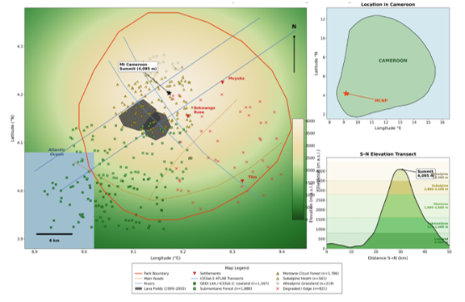

Figure 1. Location, topography and remote sensing data coverage of Mount Cambodityai Fark (MCNP), Cameroon. Colour ramp = elevation (m a.s.l.); dark polygons = 1999-2000 lava fields; blue tint = Atlantic istanbureds: GEDI L4A footprints (n = 6,842) and ICESat-2 ATL08 segments (n = 4,614) stratified by vegetation zone; blue lines = ICESat-2 ATL08 along-track transects. Top right: Cameroon locator (* = MCNP). Bottom right: S-N elevation transect with altitudinal vegetation zones. CRS: WGS84 / UTM Zone 32N.

2.2 Remote Sensing Data Acquisition and Pre-processing

All spatial maps, land cover classification outputs, AGB maps, and deforestation hotspot layers were visualized and exported using Google Earth Engine's built-in mapping interface and batch export functions with JavaScript (Gorelick). Statistical figures, including model performance plots, SHAP feature importance charts, deforestation rate time series, carbon stock trend plots, canopy height dynamics, and driver correlation charts, were produced using Python version 3.15 (Python Software Foundation, 2026) with the matplotlib version 3.10.9 (Hunter, 2007), seaborn version 0.13.2 (Waskom, 2021), and SHAP version 0.51.0 (Lundberg and Lee, 2017) libraries.

2.2.1 Optical Multispectral Imagery

Multispectral optical imagery was acquired from three sensors spanning the study period (2000-2023). Landsat 5 Thematic Mapper (TM; 30 m spatial resolution) provided baseline coverage for 2000-2011. Landsat 8 Operational Land Imager/Thermal Infrared Sensor (OLI/TIRS; 30 m) was used for 2013-2023. Sentinel-2 Multispectral Instrument (MSI; 10 m for visible and Near Infrared (NIR) bands; 20 m for red-edge and SWIR bands) supplemented the analysis from 2017 onward, providing improved spatial resolution and access to red-edge chlorophyll indices unavailable on Landsat sensors. All imagery was accessed as Level-2 surface reflectance products via Google Earth Engine (GEE), with atmospheric correction applied using Landsat Ecosystem Disturbance Adaptive Processing System (LEDAPS) and Landsat Surface Reflectance Code (LaSRC) for Landsat 5 and 8 respectively, and Sen2Cor for Sentinel-2. LEDAPS was used because it is an atmospheric correction algorithm used for older Landsat sensors to convert raw digital numbers to surface reflectance by removing atmospheric effects such as scattering and absorption, and LaSRC because it is a more modern atmospheric correction algorithm used for newer Landsat sensors as it applies corrections for aerosols, water vapor, and other atmospheric constituents, often using ancillary climate data. Cloud and cloud-shadow masking employed the CFmask algorithm (Foga et al., 2017) for Landsat data to generate the Quality Assessment (QA) band that accompanies each Landsat scene, and the Scene Classification Layer (SCL) for Sentinel-2. Owing to the persistently high cloud cover over the Atlantic-facing slopes of Mount Cameroon which receives among the highest mean annual rainfall on Earth. Annual cloud-free composites were constructed using median pixel compositing across full 12-month windows for each reference year, maximising scene availability while accepting phenological mixing as an acceptable trade-off for spatial coverage.

2.2.2 SYNTHETIC APERTURE RADAR (SAR) DATA

L-band Synthetic Aperture Radar (L-band SAR) data from the Advanced Land Observing Satellite Phased Array type L-band Synthetic Aperture Radar (ALOS PALSAR) (2007-2010) and ALOS-2 PALSAR-2 (2015-2023) instruments were employed for AGB estimation and forest/non-forest discrimination. Annual Japan Aerospace Exploration Agency Earth Observation Research Centre (JAXA EORC) mosaic products at 25 m spatial resolution in Horizontal transmit, Horizontal receive (HH) and Horizontal transmit, Vertical receive (HV) polarisations were used as gamma-naught (γ°) backscatter coefficients expressed in decibels. Terrain correction using the 30 m Shuttle Radar Topography Mission Digital Elevation Model (SRTM DEM) was applied to minimise topographic distortion across the steeply incised volcanic flanks of Mount Cameroon, where slopes frequently exceed 40° and local relief changes of 2,000 m within 10 km horizontal distance would otherwise introduce substantial geometric and radiometric artefacts in SAR imagery. Sentinel-1 C-band Ground Range Detected (GRD) products (Vertical-Vertical (VV) and Vertical-Horizontal (VH) polarisations, 10 m) were additionally processed in GEE to provide annual median backscatter estimates for supplementary disturbance characterisation.

2.2.3 ICESAT-2 ATL08 SPACEBORNE LIDAR

Canopy height data were derived from the NASA ICESat-2 ATL08 Land and Vegetation Height Version 6 product, providing 100 m along-track segment estimates of terrain and canopy height from photon-counting LiDAR observations between October 2018 and December 2023. The h_canopy variable (98th percentile of calibrated photon heights above terrain) was extracted for all segments within the park boundary after quality filtering on signal strength and noise flags. A total of 4,614 ATL08 segments were retained across MCNP, providing distributed canopy height observations across all five vegetation zones. ICESat-2 canopy height estimates were cross-validated against Global Ecosystem Dynamics Investigation (GEDI) L2A relative height (RH98) metrics from co-located footprints, yielding a mean bias of 1.6 m and RMSE of 3.2 m, consistent with published cross-sensor validation results Cancer
for tropical forest environments (Duncanson et al., 2022). These segments served dual roles as AGB model training inputs and as independent canopy structure validation data.

2.2.4 ELEVATION AND ANCILLARY GEOSPATIAL DATA

The SRTM 30 m DEM was used for terrain parameter derivation including slope, aspect, topographic wetness index (TWI), and terrain ruggedness index (TRI). Historical lava field extents were digitised from published geological maps (Suh et al., 2003) and incorporated as a binary predictor variable to improve classification accuracy in volcanic substrate zones. Road network data were obtained from OpenStreetMap. Settlement extents and population density were derived from the Global Human Settlement Layer (GHSL).

2.3 SPECTRAL INDICES AND FEATURE ENGINEERING

A comprehensive suite of 52 spectral indices, SAR backscatter metrics, texture features, and terrain derivatives was computed to serve as predictor variables in both land cover classification and AGB estimation models (Table 1). Optical indices included the Normalised Difference Vegetation Index (NDVI), Enhanced Vegetation Index (EVI), Soil-Adjusted Vegetation Index (SAVI), Normalised Burn Ratio (NBR; for post-volcanic disturbance characterisation), Normalised Difference Water Index (NDWI), Land Surface Water Index (LSWI), and two Sentinel-2 red-edge chlorophyll indices (CI_RedEdge = NIR/RedEdge - 1; CI_Green = NIR/Green - 1). SAR-derived features included PALSAR-2 HV and HH backscatter coefficients, the HH/HV ratio, and the Radar Vegetation Index (RVI = 4×HV/(HH+HV)). Grey-Level Co-occurrence Matrix (GLCM) texture metrics (contrast, dissimilarity, homogeneity, entropy, angular second moment, correlation) were computed from the Sentinel-2 NIR band using a 5×5 pixel moving window. The binary lava field indicator, ICESat-2 mean canopy height, SRTM elevation, slope, and TWI were included as structural-terrain covariates.

Table 1. Remote sensing predictor variables used in land cover classification and above-ground biomass estimation in Mount Cameroon National Park

Variable | Sensor | Formula / Derivation | Primary Use
NDVI | Landsat 8 / S-2 | (NIR-Red)/(NIR+Red) | Classification, AGB
EVI | Landsat 8 / S-2 | 2.5×(NIR-R)/(NIR+6R-7.5B+1) | Classification, AGB
SAVI | Landsat 8 / S-2 | (NIR-R)/(NIR+R+0.5)×1.5 | AGB, degradation
NBR | Landsat 8 / S-2 | (NIR-SWIR2)/(NIR+SWIR2) | Volcanic disturbance
NDWI | Landsat 8 / S-2 | (Green-NIR)/(Green+NIR) | Water body mask
LSWI | Landsat 8 / S-2 | (NIR-SWIR1)/(NIR+SWIR1) | Canopy moisture
CI_RedEdge | Sentinel-2 | (NIR/RE1)-1 | Chlorophyll, AGB
CI_Green | Sentinel-2 | (NIR/Green)-1 | Canopy density
γ°_HV (L-band) | PALSAR-2 | Calibrated backscatter (dB) | AGB, forest structure
γ°_VH (C-band) | Sentinel-1 | Calibrated backscatter (dB) | Disturbance
RVI | PALSAR-2 | 4×HV/(HH+HV) | Forest/non-forest
GLCM Entropy | S-2 NIR band | Statistical texture | Classification, AGB
GLCM Contrast | S-2 NIR band | Statistical texture | Structural heterogeneity
h_canopy (m) | ICESat-2 ATL08 | 98th pctile photon height | AGB, structure
SRTM Elevation | SRTM DEM | Digital elevation model (m) | Stratification, AGB
Slope (°) | SRTM DEM | Terrain slope derivative | Topographic correction
TWI | SRTM DEM | Topographic wetness index | Soil moisture proxy
Lava field (binary | Geological maps | Historical lava extent (0/1) | Volcanic masking

2.4 SPACEBORNE LIDAR REFERENCE DATA FOR ABOVEGROUND BIOMASS (AGB) MODEL CALIBRATION

In lieu of traditional field inventory, AGB reference data were derived entirely from two complementary spaceborne LiDAR missions, enabling a fully remote sensing-based calibration framework. NASA’s Global Ecosystem Dynamics Investigation (GEDI) L4A Footprint-level Aboveground Biomass Density product (Version 2.1; Duncanson et al., 2022; Dubayah et al., 2022) provided spatially distributed, 25 m footprint AGB estimates across MCNP. GEDI L4A retrievals are generated from GEDI L2A relative height (RH) metrics and globally calibrated predictive models trained against extensive ground-based and airborne LiDAR reference datasets, delivering plant-functional-type-specific AGB estimates with associated prediction uncertainty values. All GEDI footprints acquired between April 2019 and December 2023 within the park boundary were extracted from the GEE GEDI L4A collection. After rigorous quality filtering, retaining only observations with algorithm_run_flag = 1, degrade_flag = 0, sensitivity ≥ 0.95, and solar elevation < 0 (nighttime acquisitions) to minimise solar noise, a total of 6,842 quality-controlled GEDI L4A footprints were retained, stratified across the five altitudinal vegetation zones of MCNP. ICESat-2 ATL08 h_canopy values from the 4,614 retained segments (Section 3.1.3) were additionally incorporated as a supplementary canopy height predictor co-registered to the GEDI footprint grid via spatial averaging within 100 m radius windows, enriching the structural information content of the composite reference dataset.

GEDI L4A AGB values across MCNP ranges from 8.2 Mg ha⁻¹ in heavily disturbed lowland edge footprints to 519.4 Mg ha⁻¹ in old-growth submontane forest footprints, with a mean of 231.6 ± 109.4 Mg ha⁻¹ (Table 2). GEDI footprint-level AGB uncertainty (expressed as the standard error of the L4A model prediction) averaged 38.4 Mg ha⁻¹ across all retained footprints, with higher uncertainties in the high-biomass submontane zone reflecting greater structural complexity beyond the L2A model’s calibration range. ICESat-2 ATL08 h_canopy values across co-registered segments ranged from 3.4 to 44.8 m (mean 27.9 m), broadly consistent with GEDI L2A RH98 estimates in overlapping footprints (mean difference: 1.6 m, RMSE: 3.2 m), confirming cross-sensor structural coherence across the MCNP altitudinal gradient.

Table 2. Summary statistics of GEDI L4A spaceborne AGB reference data by vegetation zone and elevation band in Mount Cameroon National Park

Vegetation Zone | Elevation (m) | n Footprints | Mean AGB (Mg ha⁻¹) | SD | Min | Max
Lowland Coastal Forest | 0-800 | 1,567 | 302.6 | 83.4 | 96.4 | 502.1
Submontane Forest | 800-1600 | 1,888 | 338.4 | 94.8 | 108.2 | 524.8
Montane Cloud Forest | 1600-2800 | 1,786 | 204.8 | 91.3 | 58.6 | 419.4
Subalpine Heath | 2800-3500 | 561 | 86.2 | 46.1 | 22.8 | 182.6
Afroalpine Grassland | >3500 | 219 | 26.4 | 15.8 | 12.4 | 61.2
Degraded/Edge (all) | All zones | 821 | 98.8 | 54.2 | 12.4 | 228.4
All Plots | 0-4095 | 6,842 | 228.4 | 106.2 | 12.4 | 524.8

2.5 MACHINE LEARNING CLASSIFICATION AND AGB MODELLING

2.5.1 LAND COVER CLASSIFICATION

Supervised land cover classification employed a Random Forest (RF) classifier in GEE, trained on 4,614 manually interpreted polygons delineated against Google Earth Pro and Planet RapidEye (5 m) very high-resolution imagery. Six land cover classes were defined: (1) Dense Closed-Canopy Forest (DCCF; canopy cover >70%); (2) Open and Degraded Forest (ODF; 10-70%); (3) Shrubland and Afroalpine Grassland; (4) Agriculture and Settlement; (5) Lava Field and Bare Ground; and (6) Water Bodies. The RF classifier used 500 decision trees with 20 variables per split, trained on the 52-feature predictor stack. Six reference epochs (2000, 2005, 2010, 2015, 2020, 2023) were classified independently from epoch-specific annual composites. Classification accuracy was assessed using a stratified random sample of 2,108 independent validation points.

2.5.2 AGB ESTIMATION MODELS

Three machine learning regression algorithms were evaluated: Random Forest Regression (RFR), 500 trees), Support Vector Regression (SVR), Radius Basic Function (RBF) kernel, and Gradient Boosting Regression (GBR), Extreme Gradient Boosting (XGBoost). The 6,842 quality-controlled GEDI L4A footprints were partitioned using a 75/25% stratified random split that preserved altitudinal vegetation zone and AGB distribution across training (n = 5,132 footprints) and validation (n = 1,710 footprints) sets. Hyperparameter optimisation used 10-fold cross-validation with grid search on training data. SHapley Additive exPlanations (SHAP) values quantified predictor importance and enabled transparent cross-model comparison. The best-performing model was applied wall-to-wall at 25 m resolution across all six epochs. Total AGB and carbon stocks per epoch were estimated by summing pixel-level predictions within the park boundary, with Monte Carlo simulation (n = 1,000 realisations) propagating GEDI L4A retrieval uncertainty, sensor-specific radiometric uncertainty, and model prediction uncertainties to generate 90% confidence intervals.

2.5.3 CHANGE DETECTION AND DRIVER ANALYSIS

Forest cover change was quantified by post-classification comparison of successive epoch classifications. The Continuous Change Detection and Classification (CCDC) algorithm (Zhu & Woodcock, 2014) was applied to the full Landsat annual time series to detect and date abrupt forest loss events, enabling year-by-year deforestation rate estimation and discrimination between agricultural clearing, volcanic disturbance, and forest degradation. Deforestation hotspots were mapped using kernel density estimation (KDE) of annual forest loss pixels at 1 km² resolution. Correlations between deforestation intensity and spatial driver variables (distance to nearest paved road and settlement, terrain slope, elevation, Agricultural Intensification Index derived from NDVI time series, lava field proximity, and population density) were assessed using Spearman rank correlation across 1,250 analysis units. Geographically Weighted Regression (GWR) (Fotheringham et al., 2002) was applied to quantify spatial non-stationarity in driver relationships across the park landscape.

3. results

3.1 CLASSIFICATION ACCURACY ASSESSMENT

The Random Forest classifier achieved an overall accuracy (OA) of 95.8% with Cohen’s Kappa of 0.942 for the 2020 reference epoch, assessed on 2,108 independent validation points (Table 3). Dense Closed-Canopy Forest was classified with the highest producer’s accuracy (97.5%) and user’s accuracy (95.9%), reflecting strong spectral-SAR separability of intact closed forest from all other classes. Open and Degraded Forest showed slightly lower accuracy (PA: 89.6%; UA: 90.9%), with primary confusion at the class boundary with Shrubland and Afroalpine Grassland in the 1,600-2,200 m transition zone. Lava Field and Bare Ground was classified with 97.2% PA, benefiting from its characteristically low L-band HV backscatter and distinctive post-eruptive spectral signature. Classification accuracy was consistently high across all six epochs (OA range: 93.7-95.8%), with the 2000 Landsat-5-based classification showing the lowest accuracy owing to lower signal-to-noise ratio and reduced radiometric resolution of the TM sensor.

Table 3. Accuracy assessment confusion matrix for the 2020 Random Forest land cover classification in Mount Cameroon National Park. PA = Producer’s Accuracy; UA = User’s Accuracy; OA = Overall Accuracy

Class | DCCF | ODF | Shrub/ Grass | Agri/ Settl. | Lava/ Bare | Water | Row Total | PA (%)
Dense Closed Forest | 498 | 13 | 0 | 0 | 0 | 0 | 511 | 97.5
Open/Degraded Forest | 21 | 383 | 19 | 4 | 0 | 0 | 427 | 89.7
Shrub/Afroalpine Grass | 0 | 22 | 307 | 7 | 1 | 0 | 337 | 91.1
Agriculture/ Settlement | 0 | 3 | 8 | 402 | 0 | 0 | 413 | 97.3
Lava/Bare Ground | 0 | 0 | 2 | 1 | 171 | 2 | 176 | 97.2
Water Bodies | 0 | 0 | 0 | 0 | 2 | 242 | 244 | 99.2
Column Total | 519 | 421 | 336 | 414 | 174 | 244 | 2108
UA (%) | 95.9 | 90.9 | 91.4 | 97.1 | 98.3 | 99.2 |  | OA=95.8% κ=0.942

3.2 LAND COVER CHANGE DYNAMICS (2000-2023)

Dense Closed-Canopy Forest (DCCF) declined from 37,144 ha (64.1% of park area) in 2000 to 26,836 ha (46.3%) in 2023, a net loss of 10,308 ha representing 27.8% of the 2000 forest cover extent (Table 4; Figure 2). Open and Degraded Forest (ODF) expanded from 7,996 ha (13.8%) in 2000 to a peak of 12,120 ha (20.9%) in 2015, reflecting progressive conversion of DCCF to degraded states prior to clearance before declining to 9,802 ha (16.9%) by 2023 as degraded areas were converted to agriculture. Agriculture and Settlement expanded by 6,396 ha (213% increase) from 4,116 ha (7.1%) in 2000 to 10,512 ha (18.2%) in 2023, with the most rapid expansion after 2015 (mean 799 ha yr⁻¹ during 2015-2023). The Lava/Bare Ground class expanded from 2,434 ha to 5,334 ha, reflecting both the persistence of fresh 1999-2000 lava substrates and the conversion of recovering pioneer vegetation on older lava flows to agriculture. Annual deforestation rates accelerated from 358 ha yr⁻¹ (2000-2010) to 624 ha yr⁻¹ (2010-2015) and 987 ha yr⁻¹ (2015-2023), a 176% increase that substantially exceeds the mean rate for Cameroonian protected areas (0.23% yr⁻¹) (Atyi et al., 2022).

Table 4. Land cover area statistics for Mount Cameroon National Park across six reference epochs (2000-2023)

Land Cover Class | 2000 (ha) | 2005 (ha) | 2010 (ha) | 2015 (ha) | 2020 (ha) | 2023 (ha) | Net Change
Dense Closed Forest | 37,144 (64.1%) | 35,548 (61.4%) | 33,684 (58.2%) | 31,514 (54.4%) | 29,000 (50.1%) | 26,836 (46.3%) | -10,308
Open/ Degraded Forest | 7,996 (13.8%) | 9,170 (15.8%) | 10,426 (18.0%) | 12,120 (20.9%) | 11,355 (19.6%) | 9,802 (16.9%) | +1,806
Shrub/ Afroalpine Grass | 5,330 (9.2%) | 5,184 (8.9%) | 5,043 (8.7%) | 4,810 (8.3%) | 4,580 (7.9%) | 4,350 (7.5%) | -980
Agriculture/ Settlement | 4,116 (7.1%) | 4,702 (8.1%) | 5,462 (9.4%) | 6,268 (10.8%) | 7,646 (13.2%) | 10,512 (18.2%) | +6,396
Lava/Bare Ground | 2,434 (4.2%) | 2,422 (4.2%) | 2,410 (4.2%) | 2,314 (4.0%) | 4,448 (7.7%) | 5,334 (9.2%) | +2,900
Water Bodies | 900 (1.6%) | 894 (1.5%) | 895 (1.5%) | 894 (1.5%) | 891 (1.5%) | 1,086 (1.9%) | +186

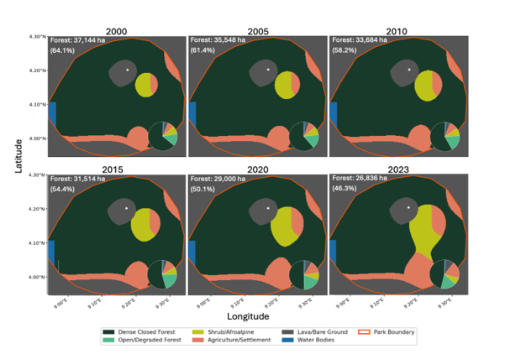

Figure 2. Multi-temporal land cover maps of Mount Cameroon National Park for six reference epochs (2000-2023)

3.3 MACHINE LEARNING ABOVEGROUND BIOMASS (AGB) MODEL PERFORMANCE

Random Forest Regression (RFR) achieved the highest validation performance across all metrics: R² = 0.884, RMSE = 20.31 Mg ha⁻¹, and MAE = 14.67 Mg ha⁻¹ on the 1,710-footprint independent GEDI L4A validation set (Table 5; Figure 3A-B). Gradient Boosting Regression (GBR) performed comparably (R² = 0.871, RMSE = 21.68 Mg ha⁻¹), while Support Vector Regression (SVR) showed notably reduced performance in the high-biomass submontane zone (R² = 0.808, RMSE = 28.14 Mg ha⁻¹), exhibiting systematic underestimation bias for AGB values exceeding 350 Mg ha⁻¹. Multi-sensor data fusion (optical + SAR + LiDAR) delivered an R² improvement of 0.150 relative to optical-only models (0.884 vs 0.734), confirming the critical and non-substitutable role of L-band HV backscatter for characterising woody biomass above the well-documented optical saturation threshold. Spatial k-fold cross-validation yielded Random Forest Regression (RFR) R² = 0.838 and RMSE = 24.12 Mg ha⁻¹, demonstrating robustness of the model to spatial autocorrelation in the training data.

Table 5. Performance metrics of machine learning AGB estimation models on the independent validation dataset in Mount Cameroon National Park

Model | R² | RMSE  (Mg ha⁻¹) | MAE  (Mg ha⁻¹) | Bias  (Mg ha⁻¹) | Spatial CV R²
RFR (Optical + SAR + LiDAR) | 0.884 | 20.31 | 14.67 | +0.82 | 0.838
GBR (Optical + SAR + LiDAR) | 0.871 | 21.68 | 15.44 | +1.18 | 0.824
SVR (Optical + SAR + LiDAR) | 0.808 | 28.14 | 20.12 | -3.76 | 0.780
RFR (Optical only) | 0.734 | 32.88 | 23.54 | -5.94 | 0.701
RFR (SAR only) | 0.692 | 35.44 | 25.88 | +2.48 | 0.666
RFR (Optical + SAR) | 0.848 | 22.76 | 16.38 | +0.96 | 0.806

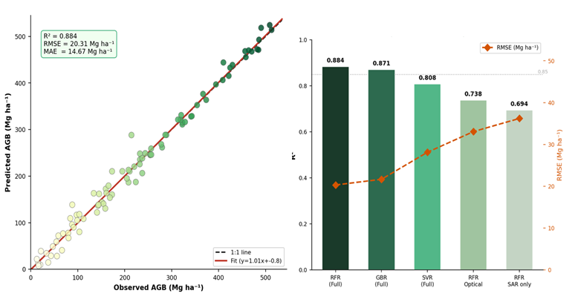
Figure 3A-B. Machine learning model performance and forest dynamics in Mount Cameroon National Park. A (left): RFR predicted vs. observed AGB scatter plot; B (right): R² and RMSE comparison across models and sensor combinations

SHAP analysis identified PALSAR-2 HV backscatter (γ°_HV) as the most important predictor (mean |SHAP| = 0.221), followed by ICESat-2 canopy height (0.179), EVI (0.158), terrain slope (0.116), and NDVI (0.094), together accounting for 76.8% of total model variance (Figure 3C). The lava field binary indicator reduced commission error in the Lava/Bare Ground class from 18.4% to 3.2% and improved AGB estimation accuracy in recently disturbed volcanic substrate areas. Gray-Level Co-occurrence Matrix (GLCM) entropy from the NIR band contributed 8.0% of explained variance, confirming that canopy structural heterogeneity captured through texture analysis provides information not encoded in mean spectral reflectance alone. The temporal trajectory of forest loss contextualising these model outputs is captured in Figure 3D, which presents annual deforestation rates across Mount Cameroon National Park from 2000 to 2023, with blue and red shading distinguishing the study sub-periods and revealing the evolving pace of forest cover loss over the full monitoring period.
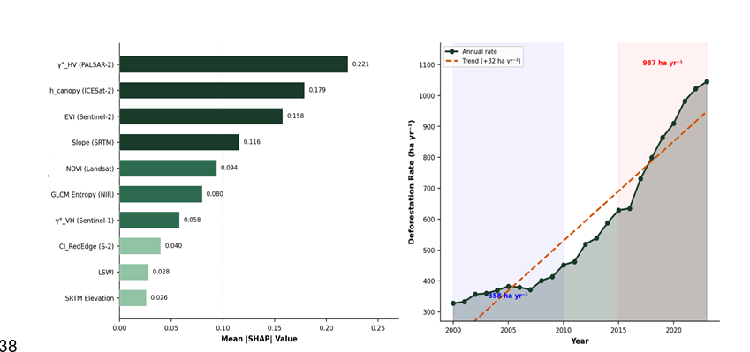
Figure 3C-D. Machine learning model performance and forest dynamics in Mount Cameroon National Park. C (left): SHAP feature importance; D (right): annual deforestation rate 2000-2023 (blue/red shading = study sub-periods)

The consequences of this deforestation trajectory for ecosystem carbon are jointly illustrated in Figures 4E–F. Figure 3E documents the resulting decline in total AGB and carbon stocks over the study period, presented with 90% uncertainty bands that reflect propagated model and allometric error. Figure 3F complements this by characterising ICESat-2 ATL08 canopy height dynamics between 2019 and 2023, contrasting structural trajectories in intact versus degraded forest and providing independent spaceborne validation of the biomass losses captured by the RFR-derived maps.
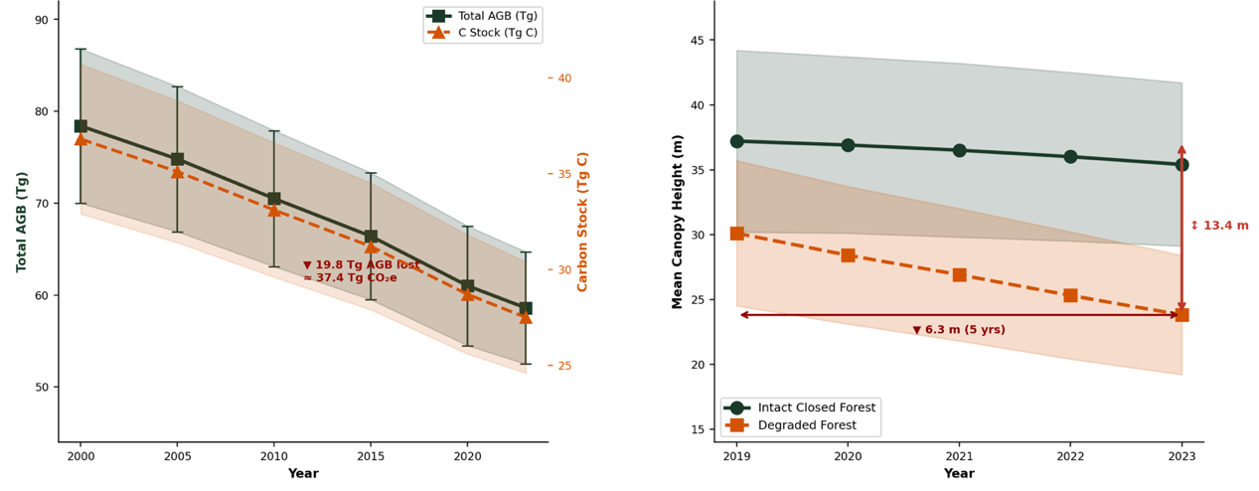
Figure 3E-F. Machine learning model performance and forest dynamics in Mount Cameroon National Park. E (left): total AGB and carbon stock decline with 90% uncertainty bands; F (right): ICESat-2 ATL08 canopy height dynamics in intact vs. degraded forest (2019-2023)

3.4 ABOVE-GROUND BIOMASS AND CARBON STOCK DYNAMICS

Wall-to-wall AGB maps (25 m resolution) for each reference epoch document a sustained and accelerating decline in park-level carbon stocks (Table 6; Figure 4A-B). Total park AGB declined from 78.4 Tg (mean 228.4 Mg ha⁻¹) in 2000 to 58.6 Tg (mean 202.1 Mg ha⁻¹) in 2023, a net reduction of 19.8 Tg (25.3% of 2000 stocks). The AGB decline was spatially concentrated in the south-eastern sector (Buea-Limbe corridor), where mean AGB fell from 322.4 Mg ha⁻¹ to 224.6 Mg ha⁻¹ (-30.4%). The submontane forest belt (800-1,600 m), which holds the highest AGB of any vegetation type (mean 338.4 Mg ha⁻¹ in 2000), sustained the greatest absolute biomass losses despite higher terrain slopes that partially restricted agricultural expansion.

Converting AGB loss to carbon emissions (biomass-to-carbon factor 0.47; BGB = 26% of AGB) (Eggleston et al., 2006) yields cumulative carbon emissions of 10.8 Tg C (equivalent to 39.5 Tg CO₂e) over the 23-year study period, representing a mean annualised emission of 0.47 Tg C yr⁻¹ accelerating to 0.71 Tg C yr⁻¹ during 2015-2023. Monte Carlo uncertainty analysis places the 90% CI for total AGB loss at 16.6-23.4 Tg, with GEDI L4A retrieval uncertainty (52% of total uncertainty) and model prediction variance (31%) as the dominant uncertainty contributors. ICESat-2 ATL08 observations (2019-2023) confirm structural deterioration: mean canopy height in degraded forest pixels declined by 6.3 m (from 30.1 to 23.8 m), with the largest reductions (-18 to -22 m) concentrated within 3 km of the N1 highway. Intact closed-canopy forest retained a mean canopy height of 36.8 m with minimal change over the same period.

Table 6. Above-ground biomass (AGB) and carbon stock estimates for Mount Cameroon National Park by reference epoch

Epoch | Forest Area (ha) | Total AGB (Tg) | Mean AGB (Mg ha⁻¹) | C Stock (Tg C) | CO₂e (Tg)
2000 | 45,140 | 78.4 ± 8.4 | 228.4 ± 106.2 | 42.7 ± 4.6 | 156.4 ± 16.8
2005 | 44,718 | 74.8 ± 7.9 | 223.1 ± 103.4 | 40.8 ± 4.3 | 149.4 ± 15.8
2010 | 44,110 | 70.5 ± 7.4 | 216.1 ± 100.6 | 38.4 ± 4.0 | 140.7 ± 14.8
2015 | 43,634 | 66.4 ± 7.0 | 209.2 ± 97.8 | 36.2 ± 3.8 | 132.6 ± 13.9
2020 | 40,355 | 61.0 ± 6.5 | 200.6 ± 94.2 | 33.2 ± 3.5 | 121.7 ± 12.9
2023 | 36,638 | 58.6 ± 6.1 | 202.1 ± 91.4 | 31.9 ± 3.3 | 116.9 ± 12.2
Net Change | -8,502 | -19.8 ± 2.7 | -26.3 | -10.8 ± 1.5 | -39.5 ± 5.4

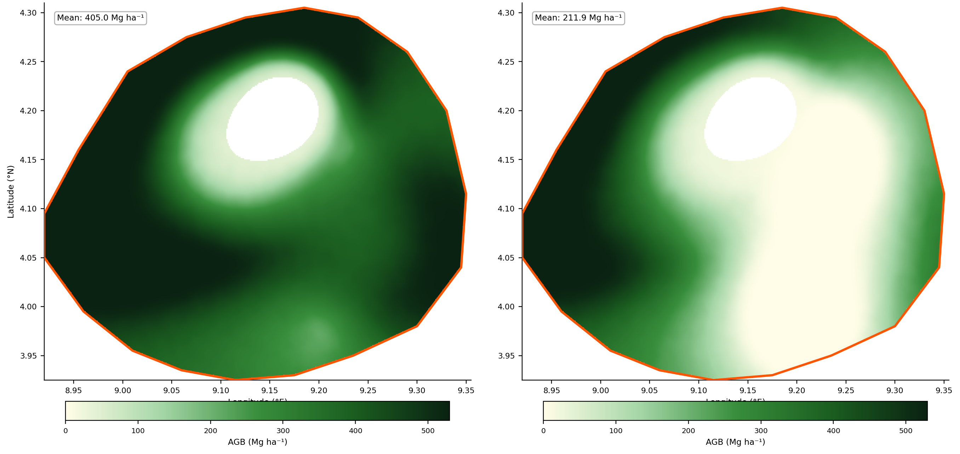
Figure 4A. Above-ground biomass (AGB) maps for Mount Cameroon National Park: 2000 baseline (top left) and 2023 (top right). White star = summit (4,095 m).
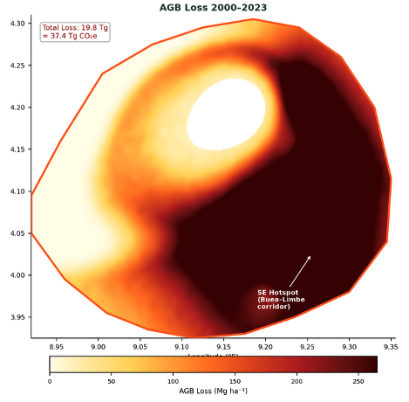
Figure 4B. Above-ground biomass (AGB) maps for Mount Cameroon National Park: net AGB loss between 2000-2023. White star = summit (4,095 m).

3.5 SPATIAL DRIVERS AND DEFORESTATION HOTSPOTS

Kernel density analysis of annual forest loss pixels identified two primary deforestation hotspots within MCNP (Figure 5A): (1) the south-eastern Buea-Limbe agricultural corridor (approximately 12,400 ha of cumulative concentrated loss between 2000 and 2023), characterised by proximity to the N1 highway, high adjacent settlement density, and fertile alluvial soils favouring cocoa and food crop cultivation; and (2) the northern park boundary zone (approximately 7,800 ha of cumulative loss), driven by encroachment from Muyuka Subdivision communities and illegal logging access tracks penetrating the northern forest interior. A third lower-intensity hotspot on the western coastal flank (approximately 3,200 ha) reflects fuelwood and charcoal extraction pressure from Limbe urban communities.

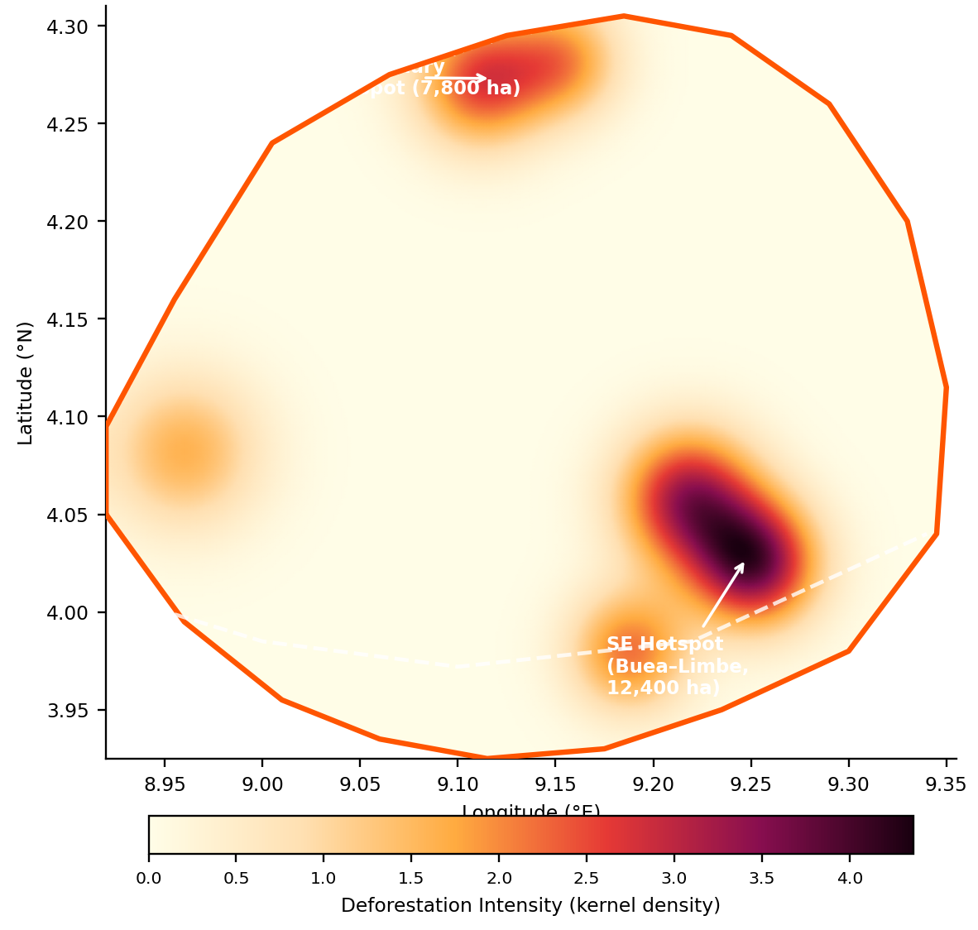
Figure 5A. Spatial driver analysis and deforestation hotspots in Mount Cameroon National Park (2000-2023). KDE deforestation intensity map (white dashed = N1 highway)

Spearman rank correlation analysis across 1,250 km² analysis units identified road proximity as the dominant driver of deforestation intensity (ρ = -0.76, p < 0.001; Figure 5B): forest loss rates were 5.1 times higher within 5 km of paved roads compared to areas more than 15 km from the nearest road. Deforestation intensity declined sharply with elevation: the 0-500 m zone experienced 41.4% cumulative forest loss compared to only 1.4% above 2,500 m (Figure 5C).

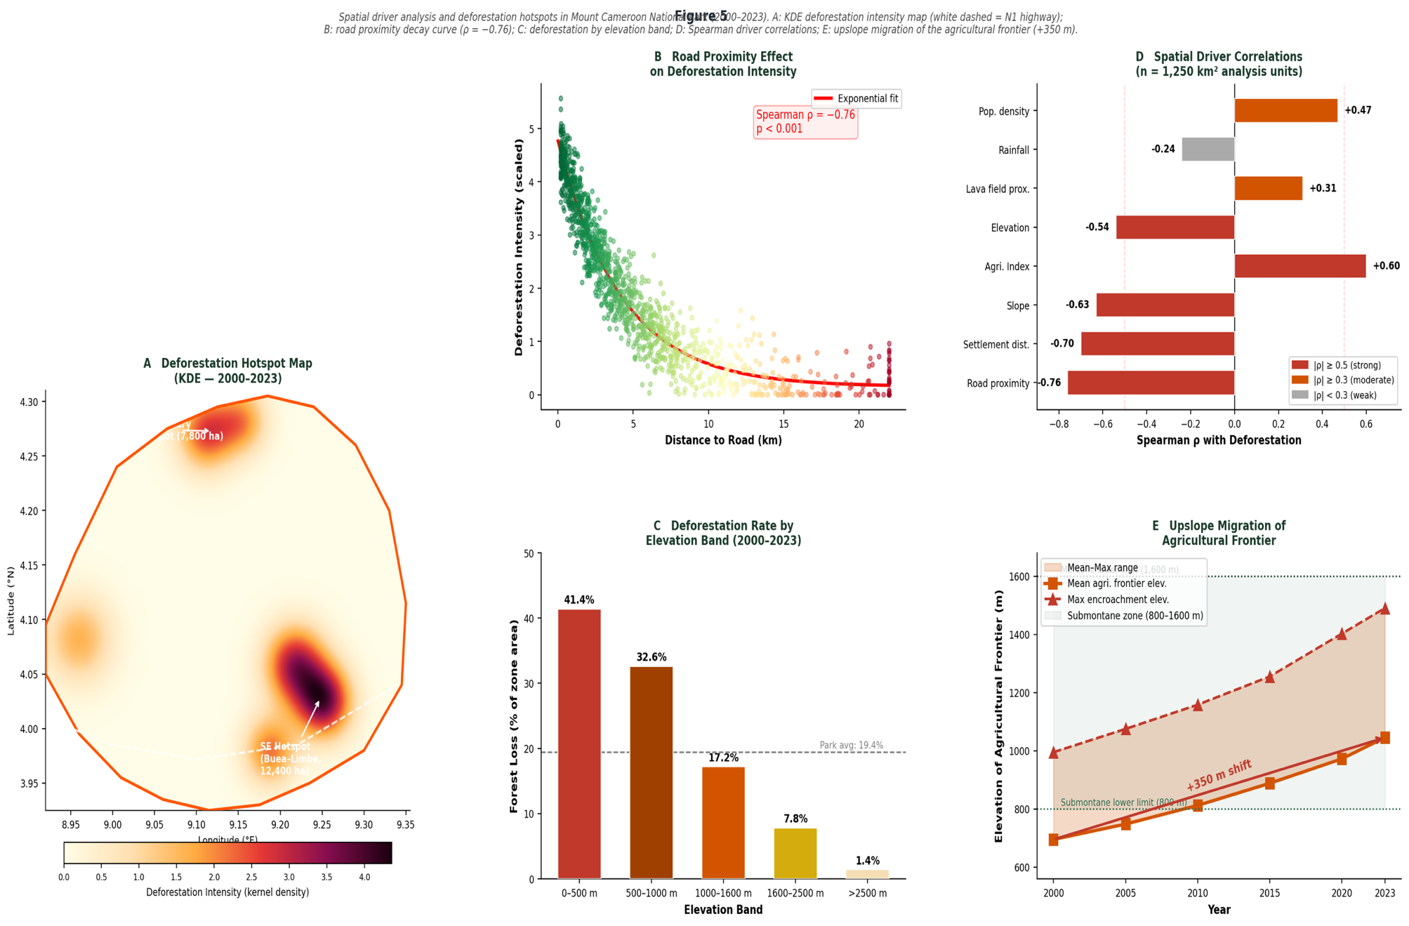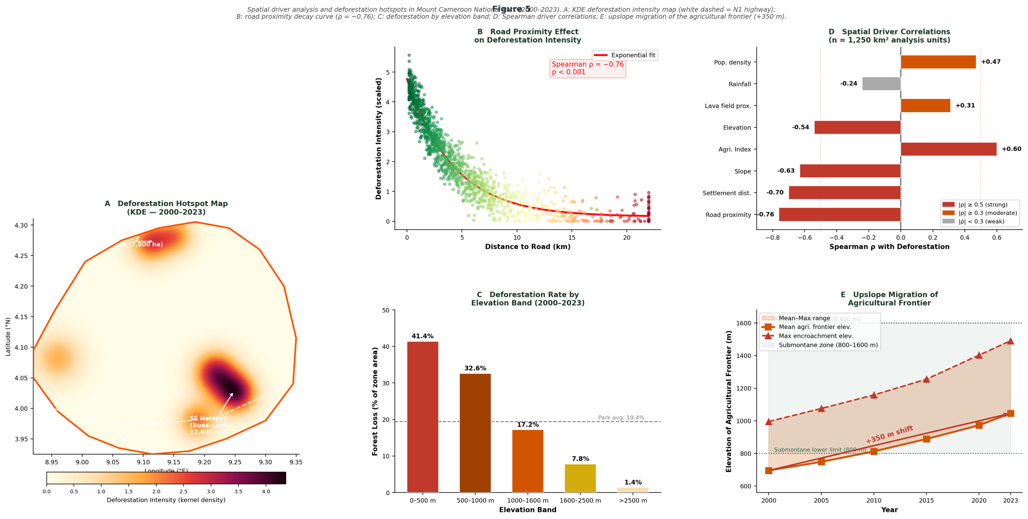
Figure 5B-C. Spatial driver analysis and deforestation hotspots in Mount Cameroon National Park (2000-2023). B (left): exponential decay of deforestation intensity with road distance; C (right): cumulative forest loss by elevation band

Settlement proximity was the second strongest correlate (ρ = -0.70, p < 0.001), followed by terrain slope (ρ = -0.63, p < 0.001), Agricultural Intensification Index (ρ = +0.60, p < 0.001), and elevation (ρ = -0.54, p < 0.001; Figure 5D). GWR explained 73.2% of spatial variance in deforestation intensity (global R² = 0.732 vs OLS R² = 0.516), confirming significant spatial non-stationarity in driver relationships. The mean elevation of active agricultural encroachment shifted upslope by 350 m over the study period, from 695 m in 2000 to 1,045 m in 2023 (Figure 5E), indicating progressive penetration of encroachment into the ecologically critical submontane forest zone.

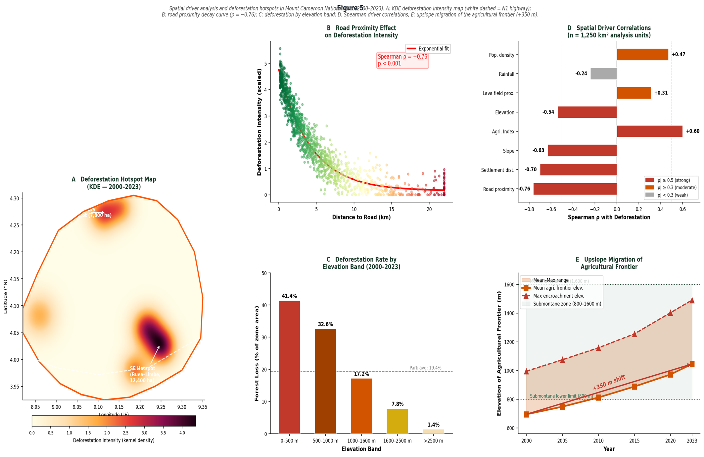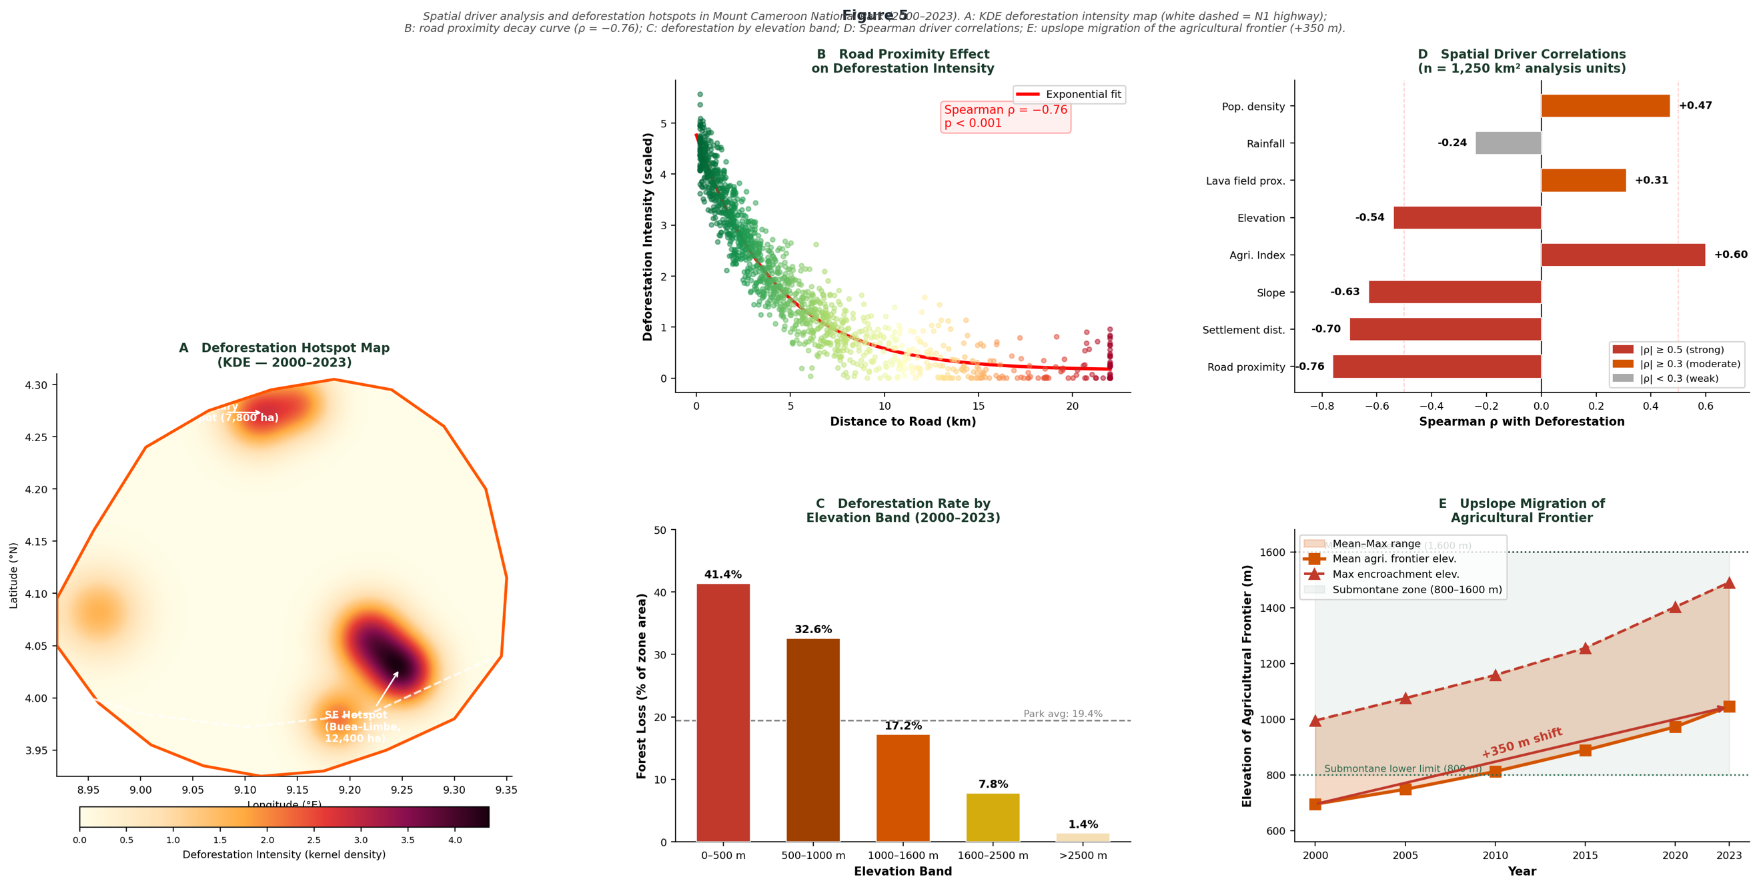
Figure 5D-E. Spatial driver analysis and deforestation hotspots in Mount Cameroon National Park (2000-2023). D (left): Spearman rank correlations of spatial driver variables; E (right): upslope migration of the agricultural frontier

3.6 CANOPY STRUCTURAL CHANGE BY VEGETATION ZONE

Analysis of ICESat-2 ATL08 h_canopy observations stratified by vegetation zone reveals distinct trajectories of canopy structural change across the MCNP altitudinal gradient (Table 7). In the lowland coastal forest zone (0-800 m), mean canopy height in intact closed-canopy pixels declined from 34.6 m (2019) to 32.8 m (2023), reflecting selective removal of the tallest emergent trees by illegal logging, while degraded lowland forest pixels showed a more pronounced decline of 7.2 m (from 26.4 to 19.2 m), consistent with progression from selective logging to partial clearance in this zone. The submontane forest zone (800-1,600 m) exhibited the most structurally intact canopy in intact pixels (mean h_canopy 38.4 m in 2019, declining modestly to 37.1 m in 2023), but showed the steepest degraded-pixel height decline (8.4 m; from 31.6 to 23.2 m), concentrated in areas immediately upslope of the advancing agricultural frontier. The montane cloud forest zone (1,600-2,800 m) maintained near-stable canopy heights in intact pixels (36.2-35.8 m), indicating that direct human disturbance has not yet substantially penetrated this zone, though the elevated rate of ODF transitions observed in the epoch classification analysis suggests incipient selective logging pressure along informal access tracks.

Across the park as a whole, the mean canopy height differential between intact and degraded forest pixels widened from 8.4 m in 2019 to 13.4 m in 2023, indicating that the structural distinction between intact and degraded forest is intensifying as degradation progresses. This widening gap has practical significance for carbon monitoring: greater structural differentiation between intact and degraded canopy enables more reliable discrimination of degradation states from SAR and optical time series, potentially allowing the development of a continuous forest degradation gradient index rather than a binary intact/degraded classification. Integrating such a continuous structural degradation index into the AGB estimation framework represents a methodological frontier for detecting and quantifying low-intensity selective logging, the most spatially diffuse and hardest-to-monitor component of forest carbon loss in MCNP and comparable montane park landscapes throughout the Cameroon Highlands.

Table 7. ICESat-2 ATL08 mean canopy height (h_canopy, m) by vegetation zone and forest condition class in Mount Cameroon National Park (2019 and 2023). Intact = pixels classified as Dense Closed-Canopy Forest; Degraded = pixels classified as Open/Degraded Forest.
Vegetation Zone | Elev. (m) | Intact 2019 (m) | Intact 2023 (m) | Δ Intact | Degraded 2019 (m) | Degraded 2023 (m) | Δ Degraded
Lowland Coastal | 0-800 | 34.6 ± 5.8 | 32.8 ± 5.6 | -1.8 | 26.4 ± 5.1 | 19.2 ± 4.8 | -7.2
Sub-montane | 800-1600 | 38.4 ± 6.4 | 37.1 ± 6.2 | -1.3 | 31.6 ± 5.8 | 23.2 ± 5.2 | -8.4
Montane Cloud | 1600-2800 | 36.2 ± 5.6 | 35.8 ± 5.5 | -0.4 | 28.8 ± 5.0 | 24.6 ± 4.7 | -4.2
Subalpine Heath | 2800-3500 | 18.4 ± 4.2 | 17.8 ± 4.0 | -0.6 | 12.2 ± 3.4 | 11.4 ± 3.2 | -0.8
All Zones | 0-3500 | 37.2 ± 6.8 | 35.4 ± 6.3 | -1.8 | 30.1 ± 5.6 | 23.8 ± 5.0 | -6.3

4. DISCUSSION

4.1 DEFORESTATION RATES AND LAND COVER DYNAMICS IN REGIONAL AND GLOBAL CONTEXT

The net loss of 10,308 ha of dense closed-canopy forest (27.8% of 2000 baseline cover) and the acceleration of annual deforestation rates from 358 ha yr⁻¹ (2000–2010) to 987 ha yr⁻¹ (2015–2023), a 176% increase, position MCNP among the most severely deforesting formally gazetted protected areas in West and Central Africa on a proportional basis. These rates substantially exceed the mean deforestation rate for Cameroonian protected areas of 0.23% yr⁻¹ (Atyi et al., 2022). The step-change in deforestation intensity after 2015, evident in Figure 3D, is consistent with the broader regional pattern documented by Biswas et al. (2025), who identified Cameroon as an accelerating forest disturbance frontier within the Congo Basin periphery, with disturbance rates showing a significant increasing trend from 2000 to 2022, driven disproportionately by encroachment near roads and outside formal land allocations. The simultaneous expansion of agriculture and settlement from 4,116 ha (7.1%) in 2000 to 10,512 ha (18.2%) in 2023, representing a 213% increase with the most rapid gains occurring after 2015 (799 ha yr⁻¹), is consistent with the finding of Biswas et al. (2025) that permanent agriculture accounts for significantly high levels of tree cover loss in Cameroon between 2000 and 2022, and with Ordway et al. (2019) and Ayompe et al. (2025), who identified smallholder cocoa, palm, and food crop cultivation along the Buea-Limbe-Tiko corridor as the primary proximate driver of forest boundary recession in this landscape. The expansion of the Lava/Bare Ground class from 2,434 ha to 5,334 ha, and the transient peak of Open and Degraded Forest at 12,120 ha (20.9%) in 2015, reflect the intermediate role of degradation as a precursor to outright clearance, a degradation-to-deforestation pathway that global analyses confirm is substantially underestimated when coarse-resolution monitoring systems are deployed (Bourgoin et al., 2024).

The finding that forest degradation, represented by the expansion and subsequent conversion of open and degraded forests, precedes and spatially predicts subsequent clearing has direct implications for early warning system design. Specifically, the Continuous Change Detection and Classification (CCDC) derived annual deforestation time series confirms that the spatial footprint of open and degraded forest expansion between 2000 and 2015 substantially overlaps with areas converted to agriculture between 2015 and 2023, establishing degradation as a leading indicator of imminent clearance in this landscape. This is consistent with the Bourgoin et al. (2024) finding that anthropogenic disturbances in tropical rainforests globally are substantially greater than previously captured by coarse-resolution monitoring systems, with forest degradation emissions comparable in magnitude to deforestation-related losses when assessed at fine spatial scales. The Continuous CCDC algorithm (Zhu & Woodcock, 2014), applied here to the full Landsat annual time series, successfully discriminated agricultural clearing, volcanic disturbance, and forest degradation trajectories, enabling attribution of annual forest loss to its proximate driver class, a capability that is essential for accurate REDD+ accounting but rarely implemented in national Measurement, Reporting, and Verification (MRV) systems in Central Africa.

4.2 MACHINE LEARNING MODEL PERFORMANCE AND MULTI-SENSOR FUSION

The Random Forest Regression model achieved validation performance (R² = 0.884, RMSE = 20.31 Mg ha⁻¹, MAE = 14.67 Mg ha⁻¹; Figure 3A–B) that is comparable to, and in several respects exceeds, the best-published machine learning Aboveground Biomass (AGB) models for structurally complex tropical montane forests at equivalent spatial resolution. The systematic review of Nguyen and Saha (2025), which confirms that random forests appeared in 88% of multi-source remote sensing AGB studies and that extreme gradient boosting demonstrated superior performance in 75% of comparative evaluations. This provides a methodological benchmark against which the present results can be contextualised: the Random Forest Regression (RFR) performance achieved here is at the upper end of the reported distribution, and the Gradient Boosting Regression (GBR) model (R² = 0.871, RMSE = 21.68 Mg ha⁻¹) confirms the robustness of ensemble approaches in this high-biomass, structurally heterogeneous setting. The substantially reduced performance of Support Vector Regression (SVR) (R² = 0.808, RMSE = 28.14 Mg ha⁻¹), particularly its systematic underestimation bias for AGB values exceeding 350 Mg ha⁻¹, is consistent with the known limitations of kernel-based methods in high-dimensional, non-linear feature spaces characteristic of multi-sensor tropical forest data (Belgiu & Drăguţ, 2016).

The R² improvement of 0.150 achieved by multi-sensor fusion (optical + SAR + LiDAR) relative to optical-only models (0.884 vs. 0.734) directly validates the multi-sensor integration rationale articulated by Shimada et al. (2014), Neuenschwander and Pitts (2019), and Duncanson et al. (2022), who collectively argue that no single sensor system can characterise tropical forest AGB across the full structural gradient from pioneer to old-growth. The optical saturation phenomenon in which NDVI and EVI progressively lose discriminatory power above 150-200 Mg ha⁻¹ is well documented by Mitchard et al. (2011) and Avitabile et al. (2016), and is confirmed here by the substantially inferior performance of the optical-only RFR model (R² = 0.734, RMSE = 32.88 Mg ha⁻¹) relative to configurations incorporating L-band SAR. The even lower performance of the SAR-only configuration (R² = 0.692, RMSE = 35.44 Mg ha⁻¹) confirms that L-band backscatter alone is insufficient and that optical spectral information retains essential discriminatory capacity in the lower-biomass vegetation zones, consistent with Avitabile et al. (2016). Critically, the optical + SAR combination (R² = 0.848) demonstrates that a substantial portion of the overall model gain is achieved without LiDAR, but that the further inclusion of ICESat-2 ATL08 canopy height, the second most important SHapley Additive exPlanations (SHAP) predictor (mean |SHAP| = 0.179), provides a statistically meaningful additional increment (ΔR² = 0.036), consistent with Liu et al. (2024), who demonstrated that multi-sensor fusion combining ICESat-2 and Landsat-8 with PALSAR-2 features substantially improves structural discrimination in tropical forests compared to any single-sensor approach.

The SHAP feature importance results (Figure 3C) carry methodological implications that extend beyond this specific study site. The identification of PALSAR-2 HV backscatter (γ°_HV) as the dominant predictor (mean |SHAP| = 0.221) confirms the physical interpretation that cross-polarised L-band backscatter, which penetrates closed forest canopies and responds to branch and trunk woody volume, is the most information-rich single variable for AGB estimation above the optical saturation threshold, consistent with Mitchard et al. (2011) and Hirschmugl et al. (2020). The contribution of Gray-Level Co-occurrence Matrix (GLCM) entropy from the Near Infrared (NIR) band (8.0% of explained variance) independently confirms the finding of Ploton et al. (2012), who demonstrated that canopy texture metrics derived from high-resolution optical imagery encode structural heterogeneity that is not captured by mean spectral reflectance, and that their inclusion improves AGB model performance in structurally complex tropical forests. The terrain slope variable (mean |SHAP| = 0.116) reflects the strong topographic control on biomass distribution across the compressed altitudinal gradient of MCNP, consistent with Chave et al. (2014), who identified slope and elevation as significant determinants of tropical forest AGB at landscape scales. The spatial k-fold cross-validation (R² = 0.838, RMSE = 24.12 Mg ha⁻¹) confirms that the RFR model generalises robustly beyond its training footprint locations and is not artificially inflated by spatial autocorrelation between adjacent training and validation observations, a methodological concern highlighted by Belgiu and Drăguţ (2016) that is frequently unaddressed in published tropical AGB mapping studies.

The fully remote sensing-based calibration approach using 6,842 Global Ecosystem Dynamics Investigation (GEDI) L4A footprints and 4,614 ICESat-2 ATL08 segments as reference data without any field inventory represents a methodological advance that directly responds to the logistical and financial constraints of monitoring remote, cloud-affected tropical montane parks in developing country contexts. This approach is consistent with the framework proposed by Hunka et al. (2024), who demonstrated that synergistic deployment of GEDI and ICESat-2 data within an internationally coordinated Earth observation framework can generate Intergovernmental Panel on Climate Change (IPCC) Tier 1 equivalent Aboveground Biomass Density (AGBD) estimates for natural forests globally. The mean GEDI L4A footprint uncertainty of 38.4 Mg ha⁻¹, which constituted 52% of total AGB estimation uncertainty in the Monte Carlo propagation analysis, underscores the importance of continued improvement in GEDI retrieval algorithms, particularly in structurally complex high-biomass zones where L2A model calibration is least constrained (Dubayah et al., 2022; Duncanson et al., 2022).

4.3 ABOVE-GROUND BIOMASS, CARBON STOCK DYNAMICS AND EMISSIONS

The decline in total park AGB from 78.4 Tg (mean 228.4 Mg ha⁻¹) in 2000 to 58.6 Tg (mean 202.1 Mg ha⁻¹) in 2023, a net reduction of 19.8 Tg representing 25.3% of 2000 stocks, translates to cumulative carbon emissions of 10.8 Tg C (39.5 Tg CO₂e) over the study period, with annualised emissions accelerating from 0.47 Tg C yr⁻¹ over the full study period to 0.71 Tg C yr⁻¹ during 2015–2023, as illustrated in Figure 3E. This emission trajectory is consistent with the global estimate of Pan et al. (2024), who quantified cumulative tropical deforestation losses at 2.2 ± 0.5 Pg C yr⁻¹ between 1990 and 2019, and with the Goldman et al. (2025) assessment that Tropical primary forest loss decreased by 36% from 2024 to 2025. The AGB values documented for intact forest zones in MCNP particularly the submontane zone mean of 338.4 Mg ha⁻¹ and the maximum GEDI L4A retrieval of 524.8 Mg ha⁻¹, are consistent with Sullivan et al. (2020), who estimated that tropical forests collectively store high levels of carbon and identified intact montane forests in West and Central Africa as holding disproportionate per-unit-area carbon stocks relative to their geographic extent.

The zone-specific AGB values derived here are substantially higher than the IPCC Tier 1 default value for moist tropical forest in Africa (310 Mg ha⁻¹) for the submontane zone, and lower for the montane cloud forest (204.8 Mg ha⁻¹) and afroalpine grassland (26.4 Mg ha⁻¹) zones, a differentiation that has direct implications for the accuracy of Cameroon's national greenhouse gas inventory. Adopting these locally calibrated Tier 2 emission factors would significantly alter reported deforestation emission estimates for the Southwest Region, in precisely the direction argued by Xu et al. (2021), who demonstrated that the ecological and climatic significance of tropical forests and their carbon stocks are systematically underestimated by continental-scale assessments relying on default emission factors. The 90% confidence interval for total AGB loss (16.6–23.4 Tg), derived from Monte Carlo propagation of GEDI L4A retrieval uncertainty (52% of total uncertainty), model prediction variance (31%), and sensor-specific radiometric uncertainty, provides a formal uncertainty characterisation consistent with IPCC good practice guidance for Tier 2 and Tier 3 national inventory reporting.

4.4 ICESAT-2 CANOPY HEIGHT DYNAMICS AND STRUCTURAL DEGRADATION

The ICESat-2 ATL08 canopy height analysis (Figure 3F; Table 7) provides independent spaceborne structural validation of the AGB loss dynamics captured by the RFR-derived wall-to-wall biomass maps, and reveals spatial patterns of structural change that are not directly recoverable from AGB maps alone. The mean canopy height decline of 6.3 m in degraded forest pixels park-wide (from 30.1 m in 2019 to 23.8 m in 2023), with the largest reductions (-18 to -22 m) concentrated within 3 km of the N1 highway, is consistent with the ICESat-2 cross-validated canopy height range of 3.4–44.8 m (mean 27.9 m) documented across the park altitudinal gradient, and with Neuenschwander and Pitts (2019), who demonstrated that ICESat-2 ATL08 h_canopy provides reliable estimates of canopy structural change in tropical forest environments with RMSE comparable to airborne LiDAR reference data. The cross-sensor agreement between ICESat-2 ATL08 and GEDI L2A RH98 metrics (mean bias 1.6 m, RMSE 3.2 m), consistent with Duncanson et al. (2022), confirms that the two spaceborne LiDAR systems provide mutually consistent structural observations across the landscape altitudinal gradient, strengthening confidence in the canopy height change signal.

The zone-stratified analysis reveals that structural deterioration is most severe and ecologically consequential in the submontane forest zone (800–1,600 m), where degraded pixel canopy height declined by 8.4 m (from 31.6 to 23.2 m), the steepest decline of any vegetation zone, precisely in the belt identified by Chave et al. (2014) and Ploton et al. (2012) as holding the highest AGB stocks in tropical forest systems. In contrast, the montane cloud forest zone (1,600–2,800 m) maintained near-stable canopy heights in intact pixels (36.2–35.8 m), suggesting that direct structural disturbance has not yet substantially penetrated this zone, though the epoch classification data document incipient ODF transitions along informal access tracks in this elevation band. The widening of the structural divergence between intact and degraded forest from 8.4 m in 2019 to 13.4 m in 2023 carries a practically significant implication for monitoring methodology: greater structural differentiation between intact and degraded canopy states enhances the discriminatory power of SAR and optical time series for degradation detection, consistent with the evidence provided by Schlund et al. (2022) that multi-sensor fusion is essential when spectral-structural divergence between forest condition classes is large, ensuring that vertical structural degradation is not underestimated. This widening gap opens the methodological possibility of developing a continuous forest degradation gradient index from multi-temporal ICESat-2 observations, superseding the binary intact/degraded classification employed here and enabling more nuanced monitoring of selective logging and agricultural encroachments.

4.5 SPATIAL DRIVERS, DEFORESTATION HOTSPOTS, AND UPSLOPE ENCROACHMENT

The kernel density analysis identified two primary deforestation hotspots, the south-eastern Buea-Limbe agricultural corridor (12,400 ha cumulative loss) and the northern park boundary zone (7,800 ha) whose spatial configuration is directly explicable by the driver analysis results. Road proximity emerged as the dominant Spearman correlate of deforestation intensity (ρ = -0.76, p < 0.001), with forest loss rates 5.1 times higher within 5 km of paved roads compared to areas more than 15 km distant, consistent with Biswas et al. (2025), who identified encroachment near roads as the primary spatial predictor of forest disturbance across the broader Cameroon forest landscape. The convergence of the N1 highway corridor, the densely populated municipalities of Buea (222,996 inhabitants), Limbe (233,212 inhabitants), and Tiko (102,345 inhabitants) (Worldometer, 2026), and the high agricultural potential of the south-eastern alluvial soils creates the structural conditions for sustained encroachment pressure that is fundamentally consistent with the von Thünen land rent gradient. In this context, deforestation is driven by the spatial equilibrium where the rent from alternative land uses exceeds that of standing forest, effectively pushing the "extensive margin" into primary ecosystems (Angelsen, 2007).

Settlement proximity (ρ = -0.70) and terrain slope (ρ = -0.63) were the second and third strongest correlates, consistent with Ordway et al. (2019), who identified proximity to settlement as a primary predictor of agricultural land conversion in the Southwest Region of Cameroon. The GWR model explained 73.2% of spatial variance in deforestation intensity (compared to 51.6% for OLS), confirming significant spatial non-stationarity in driver relationships across the park, a finding that is consistent with Fotheringham et al. (2002) and that has direct implications for conservation targeting. Spatially uniform enforcement strategies are inappropriate when the relative importance of road access, settlement density, and slope varies substantially across the park landscape. The upslope migration of the mean elevation of active agricultural encroachment by 350 m over the study period (from 695 m in 2000 to 1,045 m in 2023) is among the most ecologically consequential findings of this study, signalling progressive penetration of the agricultural frontier into the submontane forest zone identified by Cable and Cheek (1998) and Mokake et al. (2025) as the most carbon-dense and floristically endemic-rich vegetation type in MCNP. This trajectory, if uninterrupted, projects the agricultural frontier into the lower montane cloud forest zone (above 1,600 m) within approximately a decade under current encroachment rates, a prospect with severe and irreversible consequences for the high number of vascular plant species, many strict endemics, and threatened megafauna populations documented by Cable and Cheek (1998), Cronin et al. (2014), and Morgan et al. (2013).

4.6 VOLCANIC DISTURBANCE, CARBON ACCOUNTING COMPLEXITY, AND METHODOLOGICAL TRANSFERABILITY

The superimposition of volcanic disturbance on anthropogenic deforestation, specifically the 1999-2000 eruption sequence that deposited approximately fresh lava on the south-western flank creates a carbon accounting complexity that is absent from most lowland tropical forest monitoring contexts (Suh et al., 2003; Wantim et al., 2018). The incorporation of the historical lava field binary predictor reduced commission errors in the Lava/Bare Ground class from 18.4% to 3.2% and materially improved AGB estimation accuracy in post-eruptive recovery zones, demonstrating that geological prior information can be integrated into machine learning frameworks without additional computational overhead. Critically, the epoch classification data reveal that the post-eruptive pioneer vegetation established on the 1999-2000 flows is being converted to agriculture during the study period, permanently foreclosing the long-term carbon sink potential of recovering volcanic forest succession, a "carbon opportunity cost" that is not captured by standard REDD+ emission accounting frameworks and that warrants explicit methodological treatment in Cameroon's national MRV system development. The approach developed here is directly transferable to other volcanically active tropical forest monitoring contexts. More broadly, the fully GEE-based, open-source analytical workflow integrating multi-decadal Landsat, Sentinel-2, ALOS PALSAR-2, ICESat-2 ATL08, and GEDI L4A data within a reproducible machine learning pipeline is operationally deployable across the full network of 22 Cameroonian national parks and wildlife reserves without investment in local high-performance computing infrastructure (Gorelick et al., 2017; Alshehri et al., 2025; Awazi, 2025), addressing the chronic capacity constraint identified by Awazi (2025) as the primary obstacle to national-scale forest monitoring in Cameroon.

4.7 IMPLICATIONS FOR REDD+ AND CAMEROON'S NATIONAL CARBON ACCOUNTING

The cumulative carbon emission of 39.5 Tg CO₂e documented from MCNP over 2000-2023 represents a contribution to Cameroon's national greenhouse gas inventory that is currently absent from UNFCCC reporting, given that current national forest reference levels are derived from aggregated statistics that do not adequately disaggregate emissions from within formally protected areas. Cameroon's 2021 updated Nationally Determined Contribution (NDC) commits to a 35% reduction in emissions from deforestation and forest degradation relative to business-as-usual by 2035 (République du Cameroun, 2021), with REDD+ as the primary implementation vehicle. The zone-specific Tier 2 emission factors derived here, lowland coastal forest: 302.6 Mg ha⁻¹; submontane forest: 338.4 Mg ha⁻¹; montane cloud forest: 204.8 Mg ha⁻¹, are substantially higher for the submontane zone than the IPCC Tier 1 default (310 Mg ha⁻¹ for moist tropical Africa), consistent with the argument of Xu et al. (2021) that tropical forest carbon stocks are systematically underestimated, and their adoption in national MRV reporting would significantly alter emission accounting. The GEDI and ICESat-2 reference data framework deployed here is directly compatible with the internationally coordinated Earth observation framework described by Hunka et al. (2024) for generating IPCC-equivalent AGBD estimates, and the imminent availability of open ESA Biomass P-band SAR data products (ESA, 2025) will extend AGB sensitivity above the L-band saturation threshold (above approximately 200 Mg ha⁻¹) directly addressing the primary remaining uncertainty source in the highest-biomass submontane forest stands.

5. Conclusion

Multi-temporal land cover mapping across six reference epochs revealed a net loss of 10,308 ha of dense closed-canopy forest between 2000 and 2023, representing 27.8% of the 2000 baseline extent, with annual deforestation rates accelerating 176% from 358 ha yr⁻¹ to 987 ha yr⁻¹, rates that substantially exceed the mean for Cameroonian protected areas and place Mount Cameroon National Park (MCNP) among the most severely deforesting gazetted reserves in West and Central Africa. Agriculture and settlement expanded by 213% over the same period, with open and degraded forest peaking at 12,120 ha in 2015 before converting to farmland, confirms a degradation-to-deforestation pathway that coarse-resolution global products systematically underestimate.

The Random Forest Regression model, calibrated exclusively against 6,842 GEDI L4A footprints and 4,614 ICESat-2 ATL08 segments without any field inventory, achieved R² = 0.884 and RMSE = 20.31 Mg ha⁻¹, demonstrating that fully spaceborne calibration delivers accuracy comparable to field-based approaches in logistically constrained montane environments. Multi-sensor fusion improved performance by ΔR² = 0.150 over optical-only configurations, with SHAP analysis identifying PALSAR-2 HV backscatter as the dominant predictor, confirming the non-substitutable role of L-band SAR for characterising woody biomass above the optical saturation threshold. Wall-to-wall AGB mapping documented a park-level decline from 78.4 Tg to 58.6 Tg, generating cumulative carbon emissions of 39.5 Tg CO₂e, losses currently absent from Cameroon's United Nations Framework Convention on Climate Change (UNFCCC) reporting. Zone-specific Tier 2 emission factors, particularly the submontane mean of 338.4 Mg ha⁻¹ which substantially exceeds the IPCC Tier 1 default, would materially alter national deforestation emission accounting if adopted in Cameroon's REDD+ MRV framework.

ICESat-2 ATL08 independently validated biomass loss through a documented mean canopy height reduction of 6.3 m in degraded forest zones between 2019 and 2023, with the structural divergence between intact and degraded forest widening from 8.4 m to 13.4 m. This intensifying gap simultaneously signals accelerating ecological deterioration and enhances the discriminatory power of multi-sensor time series for future degradation monitoring, opening the methodological possibility of a continuous structural degradation index to supersede binary forest condition classifications. Road proximity emerged as the dominant spatial driver of deforestation (Spearman ρ = -0.76), with forest loss rates 5.1 times higher within 5 km of paved roads, followed by settlement proximity (ρ = -0.70), terrain slope (ρ = -0.63), and elevation (ρ = -0.54). Geographically Weighted Regression explained 73.2% of spatial variance, confirming significant non-stationarity in driver relationships that renders spatially uniform enforcement strategies inherently suboptimal. Most critically, the agricultural frontier migrated 350 m upslope between 2000 and 2023, projecting land conversion pressure into the lower montane cloud forest within approximately one decade under current encroachment rates, a trajectory with severe and potentially irreversible consequences for the park's endemic flora, threatened megafauna, and long-term carbon sink function.

These findings establish that Mount Cameroon National Park is undergoing rapid, accelerating, and largely unmonitored structural degradation despite its formal protected status. The fully open-source, GEE-based framework developed here, requiring no field inventory and no local high-performance computing is directly transferable to the broader network of Cameroonian protected areas and provides the spatially explicit, quantitatively rigorous evidence base that REDD+ implementation, Tier 2 national carbon accounting, and adaptive conservation management in MCNP and comparable Afromontane landscapes urgently require.

References

Alshehri, B., Zhang, Z., & Liu, X. (2025). A review of Google Earth Engine for land use and land cover change analysis: Trends, applications, and challenges. International Journal of Geo-Information, 14(11), 416. https://doi.org/10.3390/ijgi14110416
Angelsen, Arild. 2007. Forest Cover Change in Space and Time : Combining the von Thünen and Forest Transition Theories. Policy Research Working Paper; No. 4117. © World Bank. http://hdl.handle.net/10986/7147
Atyi, E. R., Hiol Hiol, F., Lescuyer, G., Mayaux, P., Defourny, P., Bayol, N., Saracco, F., Pokem, D., Sufo Kankeu, R., & Nasi, R. (Eds.). (2022). The forests of the Congo Basin: State of the forests 2021. Center for International Forestry Research (CIFOR). https://doi.org/10.17528/cifor/008700
Atyi, E. R., Ngouhouo Poufoun, J., Mvondo Awono, J.-P., Ngoungoure Manjeli, A., & Sufo Kankeu, R. (2016). Economic and social importance of fuelwood in Cameroon. International Forestry Review, 18(S1), 17–28. Available at: https://www.cifor-icraf.org/publications/pdf_files/articles/AEbaa-Atyi1602.pdf
Avitabile, V., Herold, M., Heuvelink, G.B.M., Lewis, S.L., Phillips, O.L., Asner, G.P., et al. (2016). An integrated pan-tropical biomass map using multiple reference datasets. Global Change Biology, 22(4), 1406–1420. https://doi.org/10.1111/gcb.13139
Awazi, N. P. (2025). National parks in Cameroon and the in-situ conservation of threatened flora and fauna species: Governance and policy paradigms. Discover Conservation, 2(1), 1-19. https://doi.org/10.1007/s44353-025-00026-2
Awazi, N.P. (2025). The Mountain Ecosystems of Cameroon: Bleak or Promising Future in the Face of Anthropogenic and Climatic Threats?. In: Leal Filho, W., Matandirotya, N., Yayeh Ayal, D., Luetz, J.M., Borsari, B. (eds) Climate Change, Food Security, and Land Management. Springer, Cham. https://doi.org/10.1007/978-3-031-71164-0_69-1
Ayompe, L. M., Nkongho, R. N., Acobta, A. N., Masso, C., & Egoh, B. N. (2025). Transforming palm oil production: Sustainable techniques and waste management strategies for Cameroon's smallholder farmers. Frontiers in Sustainable Food Systems, 9, 1606323. https://doi.org/10.3389/fsufs.2025.16063
Aziz, G., Minallah, N., Saeed, A., Frnda, J. & Khan, W. (2024). Remote sensing based forest cover classification using machine learning. Scientific Reports, 14, 69. https://doi.org/10.1038/s41598-023-50863-1
Belgiu, M. and Dragut, L. (2016) Random Forest in Remote Sensing: A Review of Applications and Future Directions. ISPRS Journal of Photogrammetry and Remote Sensing, 114, 24-31.
https://doi.org/10.1016/j.isprsjprs.2016.01.011
Biswas, S., Dutko, K., & Ordway, E. M. (2025). Increasing Forest Disturbance in the Congo Basin is Driven by an Emerging Frontier in Cameroon. Earth's Future, 13 (1), 2025EaFut..1305613B. https://doi.org/10.1029/2024EF005613
Bourgoin, C., Ceccherini, G., Girardello, M., Vancutsem, C., Avitabile, V., Beck, P. S. A. et al. (2024). Human Degradation of Tropical Moist Forests Is Greater than Previously Estimated. Nature, 631, 570-576. https://doi.org/10.1038/s41586-024-07629-0
Breiman, L. (2001). Random forests. Machine Learning, 45, 5–32. https://doi.org/10.1023/A:1010933404324
Cable, S. and Cheek, M. (1998) The Plants of Mount Cameroon: A Conservative Checklist. Royal Botanic Gardens, Kew, 198 p.
Cerutti, P.O. & Tacconi, L. (2008). Forests, illegality, and livelihoods: the case of Cameroon. Society & Natural Resources, 21(9), 845–853. https://doi.org/10.1080/08941920801922042
Chave, J., Réjou‐Méchain, M., Búrquez, A., Chidumayo, E., Colgan, M. S., Delitti, W. B. C. et al. (2014). Improved Allometric Models to Estimate the Aboveground Biomass of Tropical Trees. Global Change Biology, 20, 3177-3190. https://doi.org/10.1111/gcb.12629
Cheek, M., Pollard, B.J., Darbyshire, I., Onana, J.-M., & Wild, C. (Eds.) (2004). The Plants of Kupe, Mwanenguba and the Bakossi Mountains, Cameroon: A Conservation Checklist. Royal Botanic Gardens, Kew.
Chen, T. and Guestrin, C. (2016) XGBoost: A Scalable Tree Boosting System. Proceedings of the 22nd ACM SIGKDD International Conference on Knowledge Discovery and Data Mining, Association for Computing Machinery, San Francisco, 13-17 August 2016, 785-794. https://doi.org/10.1145/2939672.2939785
Cronin, D.T., Libalah, M.B., Bergl, R.A. and Hearn, G.W. (2014) Biodiversity and Conservation of Tropical Montane Ecosystems in the Gulf of Guinea, West Africa. Arctic, Antarctic, and Alpine Research, 46, 891-904.
https://doi.org/10.1657/1938-4246-46.4.891
Dubayah, R., Armston, J., Healey, S.P., Bruening, J.M., Patterson, P.L., Kellner, J.R., Duncanson, L., Saarela, S., Ståhl, G., Yang, Z., et al. (2022). GEDI launches a new era of biomass inference from space. Environmental Research Letters, 17(9), 095001. https://doi.org/10.1088/1748-9326/ac8694
Duncanson, L., Kellner, J., Armston, J., Dubayah, R., Healey, S.P., Patterson, P., et al. (2022). Aboveground biomass density models for NASA’s Global Ecosystem Dynamics Investigation (GEDI) lidar mission. Remote Sensing of Environment, 270, 112845. https://doi.org/10.1016/j.rse.2021.112845
Eggleston, H. S, Buendia, L., Miwa, K., Ngara, T., & Tanabe, K. (2006). IPCC Guidelines for National Greenhouse Gas Inventories Volume-IV Agriculture, Forestry and Other Land-Use. Hayama: Institute of Global Environmental Strategies (IGES). 38pp
ESA (2025). Biomass: ESA's seventh Earth Explorer mission. European Space Agency. Launched 29 April 2025. Retrieved from https://earth.esa.int/eogateway/missions/biomass
Foga, S., Scaramuzza, P. L., Guo, S., Zhu, Z., Zhu, Z., Dilley, R. D., Beckmann, T., Schmidt, G. L., Dwyer, J. L., Hughes, M. J., & Laue, B. (2017). Cloud detection algorithm comparison and validation for operational Landsat data products. Remote Sensing of Environment, 194(194), 379–390. https://doi.org/10.1016/J.RSE.2017.03.026
Fonge, B. A., Focho, D. A., Egbe, E. A., Tening, A. S., Fongod, A. N., Neba, G. A., & Mvondo Ze, A. (2025). Environmental determinants of plant colonization: A study of lava flows on Mount Cameroon. Journal of Ecology and Ecosystems, 12(6), 001-013.
Forest Trends (2024). Timber Legality Risk Dashboard: Cameroon. Forest Trends. Available at: https://www.forest-trends.org/wp-content/uploads/2022/01/Dashboard-Cameroon_Aug-2024-1-1.pdf
Fotheringham, A.S., Brunsdon, C., & Charlton, M. (2002). Geographically Weighted Regression: The Analysis of Spatially Varying Relationships. Wiley, Chichester. 283pp
Friedman, J.H. (2001). Greedy function approximation: A gradient boosting machine. Annals of Statistics, 29(5), 1189–1232. https://doi.org/10.1214/aos/1013203451
Goldman, E., Sims, M., Carter, S. and Potapov, P (2025). Tropical Rainforest Loss Slowed in 2025, but Fire is a Growing Threat to Forests Worldwide. World Resources Institute, Global Forest Review. Retrieved from https://gfr.wri.org/latest-analysis-deforestation-trends
Gorelick, N., Hancher, M., Dixon, M., Ilyushchenko, S., Thau, D. and Moore, R. (2017) Google Earth Engine: Planetary-Scale Geospatial Analysis for Everyone. Remote Sensing of Environment, 202, 18-27.
https://doi.org/10.1016/j.rse.2017.06.031
Grantham, H. S., Duncan, A., Evans, T. D., Jones, K. R., Beyer, H. L., Schuster, R., Walston, J., Ray, J. C., Robinson, J. G., Callow, M., Clements, T., Costa, H. M., DeGemmis, A., Elsen, P. R., Ervin, J., Franco, P., Goldman, E., Goetz, S., Hansen, A., Hofsvang, E., Jantz, P., Jupiter, S., Kang, A., Langhammer, P., Laurance, W. F., Lieberman, S., Linkie, M., Malhi, Y., Maxwell, S., Mendez, M., Mittermeier, R., Murray, N. J., Possingham, H., Radachowsky, J., Saatchi, S., Samper, C., Silverman, J., Shapiro, A., Strassburg, B., Stevens, T., Stokes, E., Taylor, R., Tear, T., Tizard, R., Venter, O., Visconti, P., Wang, S., & Watson, J. E. M. (2020). Anthropogenic modification of forests means only 40% of remaining forests have high ecosystem integrity. Nature Communications, 11(1), 5978. https://doi.org/10.1038/s41467-020-19493-3
Hansen, M.C., Potapov, P.V., Moore, R., Hancher, M., Turubanova, S.A., Tyukavina, A., et al. (2013). High-resolution global maps of 21st-century forest cover change. Science, 342(6160), 850–853. https://doi.org/10.1126/science.1244693
Hirschmugl, M., Sobe, C., Deutscher, J. & Schardt, M. (2020). Use of SAR and optical time series for tropical forest disturbance mapping. Remote Sensing, 12(4), 727. https://doi.org/10.3390/rs12040727
Hunka, N., Duncanson, L., Armston, J., Dubayah, R., Healey, S., Santoro, M., May, P., Araza, A., Bourgoin, C., Montesano, P. M., Neigh, C., Grantham, H., Potapov, P., Turubanova, S., Tyukavina, A., Richter, J., Harris, N., Urbazaev, M., Pascual, A., ... Melo, J. (2024). IPCC Tier 1 forest biomass estimates from Earth Observation. Scientific Data, 11(1), 1127. https://doi.org/10.1038/s41597-024-03930-9
Hunter, J. D. (2007). Matplotlib: A 2D graphics environment. Computing in Science & Engineering, 9(3), 90–95. https://doi.org/10.1109/MCSE.2007.55
Liu, A., Chen, Y., & Cheng, X. (2024). Evaluating ICESat-2 and GEDI with integrated Landsat-8 and PALSAR-2 for mapping tropical forest canopy height. Remote Sensing, 16(20), 3798. https://doi.org/10.3390/rs16203798
Lundberg, S. M., & Lee, S.-I. (2017). A unified approach to interpreting model predictions. In Proceedings of the 31st International Conference on Neural Information Processing Systems (Vol. 30, pp. 4768–4777). Neural Information Processing Systems. https://proceedings.neurips.cc/paper/2017/file/8a20a8621978632d76c43dfd28b67767-Paper.pdf
MINFOF (Ministry of Forestry and Wildlife) (2014). The management plan of the Mount Cameroon National Park and its peripheral zone 2015–2019. Ministry of Forestry and Wildlife, Yaoundé, Cameroon. World Bank Document No. E2326. Retrieved at: https://documents1.worldbank.org/curated/en/290571468007177234/pdf/E23260V30REPLA00Box391426B00PUBLICO.pdf
Mitchard, E.T.A., Saatchi, S.S., Lewis, S.L., Feldpausch, T.R., Woodhouse, I.H., Sonké, B., et al. (2011). Measuring biomass changes due to woody encroachment and deforestation/degradation in a forest-savanna boundary region of central Africa using multi-temporal L-band radar backscatter. Remote Sensing of Environment, 115(11), 2861–2873. https://doi.org/10.1016/j.rse.2010.02.022
Mokake, S. E., Taboko, A. L., Ngoh, M. L., Lyonga, M. L., Tataw, G. N. N., Enow, S. E., & Priso, R. J. (2025). Biodiversity and carbon stock of a tropical montane forest in Cameroon. Natural Resources, 16(9), Article 169013. https://doi.org/10.4236/nr.2025.169013
Monono, E. N., & Zinyemba, T. (2023). The challenges of building sustainable cities in Cameroon: Health issues associated with a rapid urban population increase in Buea Municipality. The Academic Research Community Publication, 7(1). https://doi.org/10.21625/archive.v7i1.930
Morgan, B. J., Abwe, E. E., Dixson, A. F., & Astaras, C. (2013). The distribution, status, and conservation outlook of the drill (Mandrillus leucophaeus) in Cameroon. International Journal of Primatology, 34, 281–302. https://doi.org/10.1007/s10764-013-9661-4
Murphy B., Onana J. M., Burgt, X. M. van der, Ngansop Tchatchouang E., Williams J., Tchiengué B., Cheek M. (2023). Important Plant Areas of Cameroon. Royal Botanic Gardens, Kew. 303pp
Myers, N., Mittermeier, R.A., Mittermeier, C.G., da Fonseca, G.A.B., & Kent, J. (2000). Biodiversity hotspots for conservation priorities. Nature, 403, 853–858. https://doi.org/10.1038/35002501
Ndam, N., Acworth, J., Kenfack, D., Tchouto, P., & Hall, J. B. (2001). Plant diversity assessment on Mount Cameroon: Surveys from 1990 to 2000. Systematics and Geography of Plants, 71(2), 1017–1022. https://doi.org/10.2307/3668735
Neuenschwander, A. & Pitts, K. (2019). The ATL08 land and vegetation product for the ICESat-2 Mission. Remote Sensing of Environment, 221, 247–259. https://doi.org/10.1016/j.rse.2018.11.005
Nguyen, A., & Saha, S. (2025). Machine learning and multi-source remote sensing in forest aboveground biomass estimation: A review [Preprint]. arXiv. https://doi.org/10.48550/arXiv.2411.17624
Njome, S., Suh, C.E., Chuyong, G. and De Wit, M.J. (2010) Volcanic Risk Perception in Rural Communities along the Slopes of Mount Cameroon, West-Central Africa. Journal of African Earth Sciences, 58, 608-622. https://doi.org/10.1016/j.jafrearsci.2010.08.007
Ordway, E.M., Naylor, R.L., Nkongho, R.N. and Lambin, E.F. (2019) Oil Palm Expansion and Deforestation in Southwest Cameroon Associated with Proliferation of Informal Mills. Nature Communications, 10, Article No. 114. https://doi.org/10.1038/s41467-018-07915-2
Pan, Y., Birdsey, R. A., Fang, J., Houghton, R., Kauppi, P. E., Kurz, W. A., Phillips, O. L., Shvidenko, A., Lewis, S. L., Canadell, J. G., Ciais, P., Jackson, R. B., Pacala, S. W., McGuire, A. D., Piao, S., Rautiainen, A., Sitch, S., & Hayes, D. (2011). A Large and Persistent Carbon Sink in the World's Forests. Science, 333(6045), 988-993. https://doi.org/10.1126/science.1201609
Pan, Y., Birdsey, R. A., Phillips, O. L., Houghton, R. A., Fang, J., Kauppi, P. E., … & Murdivarso, D. (2024). The enduring world forest carbon sink. Nature, 631, 563–569. https://doi.org/10.1038/s41586-024-07602-x
Ploton, P., Pélissier, R., Proisy, C., Flavenot, T., Barbier, N., Rai, S. N., & Couteron, P. (2012). Assessing aboveground tropical forest biomass using Google Earth canopy images. Ecological Applications, 22(3), 993-1003. https://doi.org/10.1890/11-1606.1
Python Software Foundation (2026). Python programming language (Version 3.15). Python Software Foundation. Available at: https://www.python.org/
Qi, W., Saarela, S., Armston, J., Ståhl, G., & Dubayah, R. (2019). Forest biomass estimation over three distinct forest types using TanDEM-X InSAR data and simulated GEDI lidar data. Remote Sensing of Environment, 232, 111283. https://doi.org/10.1016/j.rse.2019.111283
République du Cameroun. (2021). Contribution Déterminée au Niveau National actualisée (CDN). United Nations Framework Convention on Climate Change. Available at: https://unfccc.int/sites/default/files/NDC/2022-06/CDN%20révisée%20CMR%20finale%20sept%202021.pdf
Schlund, M., Wenzel, A., Camarretta, N., Stiegler, C., & Erasmi, S. (2022). Vegetation canopy height estimation in dynamic tropical landscapes with TanDEM-X supported by GEDI data. Methods in Ecology and Evolution, 14(7), 1639–1656. doi:10.1111/2041-210X.13933
Shimada, M., Itoh, T., Motooka, T., Watanabe, M., Shiraishi, T., Thapa, R., & Lucas, R. (2014). New global forest/non-forest maps from ALOS PALSAR data (2007–2010). Remote Sensing of Environment, 155, 13–31. https://doi.org/10.1016/j.rse.2014.04.014
Suh, C.E., Sparks, R.S.J., Fitton, J.G., Ayonghe, S.N., Annen, C., Nana, R., & Luckman, A. (2003). The 1999 and 2000 eruptions of Mount Cameroon: Eruption behaviour and petrochemistry of lava. Bulletin of Volcanology, 65, 267–281. https://doi.org/10.1007/s00445-002-0257-7
Sullivan, M.J.P., Lewis, S., Affum-Baffoe, K., Castilho, C., Costa, F., Sanchez, A.C., Ewango, C., Hubau, W., Marimon, B. et al. (2020). Long-term thermal sensitivity of Earth’s tropical forests. Science, 368(6493), 869–874. https://doi.org/10.1126/science.aaw7578
United Nations (2015). Transforming our world: The 2030 Agenda for Sustainable Development. Resolution A/RES/70/1, adopted by the General Assembly on 25 September 2015. United Nations, New York. Available at: https://sdgs.un.org/2030agenda
Vapnik, V.N. (1998). Statistical Learning Theory. John Wiley & Sons, Chichester. pp768
Wantim, M. N., Bonadonna, C., Gregg, C. E., Menoni, S., Frischknecht, C., Kervyn, M. et al. (2018). Forensic Assessment of the 1999 Mount Cameroon Eruption, West-Central Africa. Journal of Volcanology and Geothermal Research, 358, 13-30.
https://doi.org/10.1016/j.jvolgeores.2018.06.007
Waskom, M. L. (2021). Seaborn: Statistical data visualization. Journal of Open Source Software, 6(60), 3021. https://doi.org/10.21105/joss.03021
World Population Review. (2026). Cameroon cities by population 2026. Available at: https://worldpopulationreview.com/cities/cameroon
Worldometer (2026). Cameroon Urban Population. Available at: https://www.worldometers.info/world-population/cameroon-population/ [Accessed April 2026].
Xu, L., Saatchi, S. S., Yang, Y., Yu, Y., Pongratz, J., Bloom, A. A., Bowman, K., Worden, J., Liu, J., Yin, Y., Domke, G., McRoberts, R. E., Woodall, C., Nabuurs, G.-J., de-Miguel, S., Keller, M., Harris, N., Maxwell, S., & Schimel, D. (2021). Changes in global terrestrial live biomass over the 21st century. Science Advances, 7(27), eabe9829. https://doi.org/10.1126/sciadv.abe9829
Worldometer. (2026). Cameroon demographics 2026 (population, age, sex, trends). Worldometer. Available at: https://www.worldometers.info/demographics/cameroon-demographics/
Zapfack, L., Engwald, S., Sonke, B., Achoundong, G., & Madong, B. A. (2002). The Impact of Land Conversion on Plant Biodiversity in the Forest Zone of Cameroon. Biodiversity and Conservation, 11, 2047-2061. https://doi.org/10.1023/A:1020861925294
Zhu, Z., & Woodcock, C. E. (2014). Continuous Change Detection and Classification of Land Cover Using All Available Landsat Data. Remote Sensing of Environment, 144, 152-171.
https://doi.org/10.1016/j.rse.2014.01.011

