Original Research Article

Population assessment and conservation of Paris polyphylla - An endangered medicinal plant in North East India

ABSTRACT
Aims: To study the ecological parameters, population assessments and interactions with traditional local people to learn about the P. polyphylla 's ethno-medicinal applications in Manipur, which is known for its rich biodiversity and cultural diversity.
Study design: Assessment of population and ecological parameters for the conservation strategies.
Place and Duration of Study: Three different habitat sites of P. polyphylla in Manipur: Makhel (Senapati), Purul Akutpa (Senapati) and Langdang Village (Ukhrul) during February, 2022 to January, 2023.
Methodology: Field surveys were carried out in the habitat sites of P. polyphylla at different intervals during February, 2022 to January, 2023. Vegetation sampling was done using the Quadrat method, with fifteen 1x1 m quadrats placed randomly at 2–3 m intervals. Physicochemical properties and soil of the soil are studied using the soil testing kit. Moreover, climatic parameters of the study areas are also added.
Results: The present study shows the highest population density (2.4 individual m⁻²) and frequency (60%) in Makhel village, Senapati District and the lowest density (1.3 individual m⁻²) and frequency (26.67%) in Purul akutpa village, Senapati District, Manipur. The species prefers shady and swampy habitats with acidic soil (pH 4.3–4.7). However, overexploitation and illegal export have severely threatened its survival.
Conclusion: Makhel Village in Senapati District, Manipur showed the highest P. polyphylla density and frequency in this study. However, it is found rarely in the human occupied areas. Different factors like unsustainable and over-harvesting, urbanization, grazing, etc. has led to gradual decline of the plant population. To address this, conservation efforts such as rhizome and seed propagation, ecological niche models, and awareness programmes are essential.
Keywords: Population assessment, Conservation, Manipur, North east India, Paris polyphylla Smith.
Graphical Abstract:
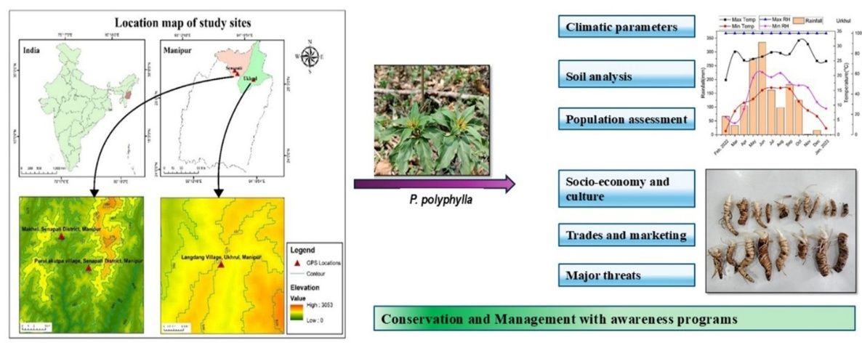

- INTRODUCTION
The North-Eastern region of India has rich biodiversity of flora and fauna. Manipur, a north-eastern state of India, falls under the Indo-Burma hotspot region which is at 8th rank among the 34-biodiversity hotspot region of the world (Jain and Das, 2022). Medicinal plants are also abundantly available in these areas. Paris polyphylla, locally known as Singpan in Manipuri, Kazeapai in Tangkhul and Kotu pa by Senapati villagers. It is found abundantly in Senapati District and Ukhrul District of Manipur, which lies in the North-Eastern region of India. It thrives in semi-evergreen forests of subtropical regions, often found in bamboo forests, rocky slopes, thickets, stream-sides, and other shady, moist areas (Kshetrimayum et al., 2023a). It is a rhizomatous herb belonging to the family Melanthiaceae which has been medicinally used in the Himalayan region (Long et al., 2003). It is an erect plant with spider-like flower that throws out long, thread-like, and yellowish-green petals (Shah et al., 2012). They are found in China, India, Bhutan, Laos, Myanmar, Nepal, Thailand, and Vietnam (Long et al., 2003). In India, the species is found in the Himalayan states like Manipur (Gogoi, 2010), Meghalaya (Mao et al., 2009; Mir et al., 2014), Arunachal Pradesh (Chowdhery et al., 2009), Mizoram (Lalsangluaii et al., 2013), Nagaland (Jamir et al., 2012), Sikkim (Maity et al., 2004), Himachal Pradesh (Goraya et al., 2013) and Uttarakhand (Paul et al., 2015).
Because of its medicinal properties, it has been used extensively in the treatment of diseases. A root decoction of P. polyphylla is used for treating various infections, inflammatory conditions, and cancers of the breast, liver, stomach, nose, lung, and throat (Kavita, 2015) while the rhizome is widely used in ethnomedicine to treat tumors, fever, inflammation, pain, immune disorders, wounds, snake bites, diarrhoea, dysentery, vomiting, headache, and helminthic infections, and is also administered to cattle for gastrointestinal ailments (Baral and Kurmi, 2006; Dutta, 2007; Lee et al., 2005; Paul et al., 2015; Pfoze et al., 2013; Sharma et al., 2015; Sharma et al., 2017) and also used to treat headache, vomiting and worms (Uprety et al., 2010). From the saponin extract of P. polyphylla, Gong Xue Ning (GXN) capsule, a drug used for the treatment of abnormal uterine bleeding was developed (Zhao and Shi, 2005; Guo et al., 2008).
P. polyphylla rhizome extract has the potential to serve as a natural remedy for colon cancer (Kshetrimayum et al., 2023a) and diabetes (Kshetrimayum et al., 2023b). The main reason responsible for the potency of high medicinal values is because of the presence of saponins in P. polyphylla which constitute more than 80% of the total compounds. The major compound among them is diosgenin, followed by Paris saponin II, Paris saponin III, polyphyllin VI and VII (Sharma et al., 2015; Puwein et al., 2020; Wu et al., 2004).
The plant is heavily exploited for its medicinal properties, especially in the Indo-China and Indo-Myanmar regions, leading to its endangered status due to overharvesting, human activities, and natural calamities. Other human activities responsible for the species’ habitat destruction includes urbanisation, industrialisation, road construction, tourist development, etc. which causes tremendous pressure in the survival of the species (Mao et al., 2009). Another reason for the species’ population decline is the unsustainable methods of harvesting. So, designing effective strategies to conserve and meet the increasing demand of this plant is needed (Raomai et al., 2015).
For the assessment of species distribution, habitat preference, and conservation status, study of the population structure through ecological parameters such as density and relative frequency are required. Comparative studies across different geographical regions had revealed the significant variation in these parameters (Madhav et al., 2010; Paul et al., 2015). Thus, the ecological variations emphasize the need for region-specific conservation and management strategies.
Similarly, Manipur, rich in biodiversity and cultural heritage, faces threats to P. polyphylla due to overexploitation, pushing it toward endangerment. No prior study has assessed its population in the region. This study focuses on its population status, ecological factors, traditional knowledge and ethnomedicinal uses. It also focuses on the threatened status of the plant and its conservation strategies. Makhel village and Purul akutpa village of Senapati District, Langdang Village of Ukhrul District, Manipur are the present study areas which are in the Himalayan ranges.
- MATERIALS AND METHODS
2.1 Survey and Assessment
Field surveys were carried out in the habitat sites of P. polyphylla at different intervals during February, 2022 to January, 2023. The climatic parameters of the study areas were obtained from the Department of Environment and Climate Change, Government of Manipur, and are represented in Fig.1. The plant's life cycle, including sprouting, maturation, and fruit ripening, was studied, as illustrated in Fig.2. During the survey, data on growth period, habitat, phenology and fruiting period were recorded. Interaction programs were conducted with the local people of the villages about the suitable climatic conditions, life span, growth pattern, and also the common plants associated with it. Additionally, the traditional uses and trading systems were noted down.
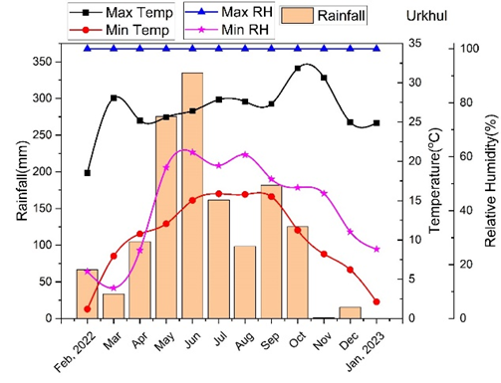
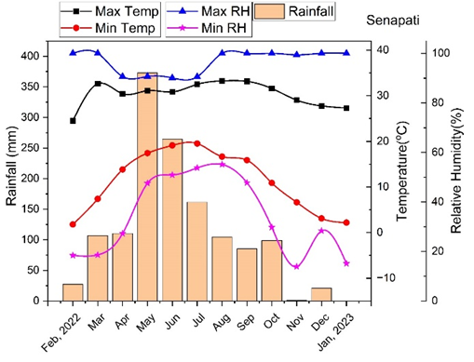
Fig. 1: Mean monthly maximum and minimum air temperature, relative humidity, and precipitation at Senapati and Ukhrul, Manipur, Northeast India

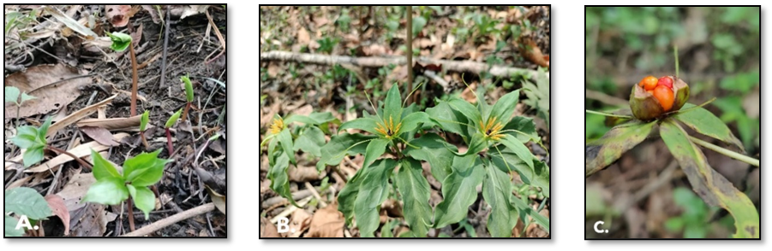
Fig. 2: Growth stages of Paris polyphylla. A. Young shoot, B. Flowering stage C. Fruiting stage

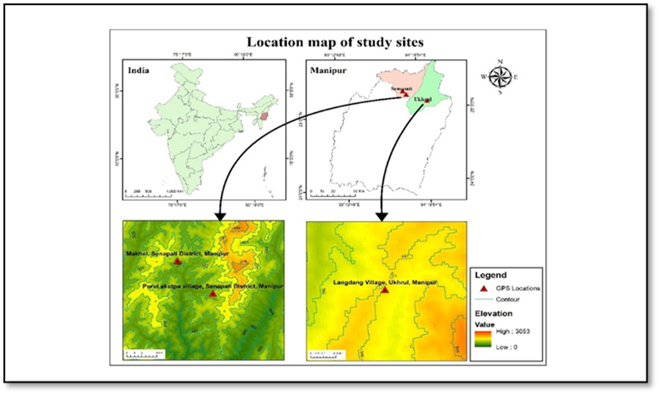
Fig. 3: Location map of study sites
To assess the population status of P. polyphylla in Manipur, three different sites (Fig. 3) were studied: Makhel (Senapati), Purul Akutpa (Senapati) and Langdang Village (Ukhrul). Vegetation sampling was done using the Quadrat method, with fifteen 1x1 m quadrats placed randomly at 2–3 m intervals. In each quadrat, the number of P. polyphylla and associated plants was recorded. Then, frequency and population density were then calculated ((Mueller-Dombois and Ellenberg, 1974).
2.2 Sample Collection and Identification
Plant samples were collected from each site for identification, propagation, and other further research purposes. Identification of the plant species was conducted at the Botanical Survey of India (BSI), Shillong, Meghalaya, with specimen number BSI/ERC/Tech/2023-24/1372/100402. Additionally, 100-gram soil samples were collected at a 25 cm depth from each site. Available nitrogen, phosphorous, potassium, magnesium, calcium contents and pH of the collected soils were determined using Palintest soil kit (United Kingdom). GPS readings were recorded for latitude, longitude and altitude of the studied sites. The collected plants were identified at the Botanical Survey of India (BSI), Shillong, Meghalaya.
3. RESULTS AND DISCUSSION
3.1 P. polyphylla in Manipur
Based on the survey report, it prefers humus-rich, well-drained soils, especially in riparian and swampy habitats. The plant sprouts in March–April, matures by September–October, and its seed-bearing fruits are harvested in November–December. It grows at altitudes of 1521–1792 m. The region has a subtropical climate, with temperatures ranging from 1.2°C in February to 33.24°C in June. Rainfall peaks in May–June and is lowest in November. The morphology of the plant is depicted in Fig. 2. Mature plants are 30–70 cm tall, with rhizomes 1–2.5 cm in diameter and 3–5 cm long. They have 5–10 whorled leaves (6–15 cm long) with long petioles and spider-like yellow-green flowers with leafy bracts. Leaves are simple, green, and reticulate with three main veins. The fruit is a red, oval or round berry containing 25–40 seeds per pod. Seeds are 0.3–0.5 cm in diameter, with a red, fleshy aril; fresh seeds weigh about 85–100 mg, and dry seeds about 55–60 mg.
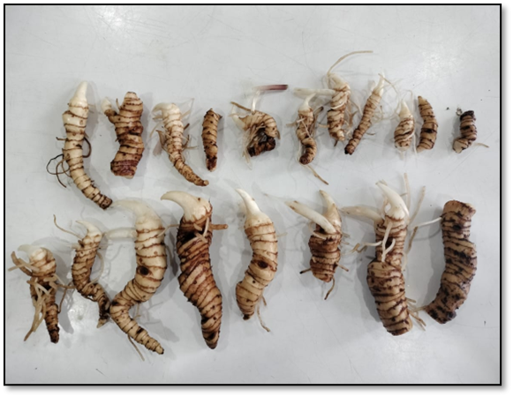
Fig. 4: Fresh rhizomes for exporting
3.2 Soil analysis
The soil composition and pH may also influence the plant's survival. As shown in table 1, nitrogen and magnesium content were found to be the highest in Makhel Village followed by Purul akutpa Village. Phosphorus, Potassium, and Calcium content were found to be maximum in Langdang Village. The soil pH of the study sites ranged from 4.2 – 4.6 (Modification to Lepcha, 2019).
The soil physicochemical properties influences the survival and distribution of the plant species across the study sites. The soil pH across all study sites is strongly acidic. Such acidic soils can influence nutrient solubility and availability, often increasing the availability of certain micronutrients while limiting others. The narrow pH range suggests that the plant is well adapted to acidic environments, and this acidic condition may be a key ecological factor governing its natural habitat preference (Wan et al., 2020).
Table 1: Physiochemical properties of soil collected from study sites of Paris polyphylla.
Collection site | pH | Nitrogen (mg/L) | Phosphorous  (mg/L) | Potassium  (mg/L) | Magnesium  (mg/L) | Calcium  (mg/L)
Makhel, Senapati District, Manipur | 4.3 | 2.3 | 3 | 95 | 150 | 750
Purul akutpa village, Senapati District, Manipur | 4.2 | 2.2 | 3 | 90 | 143 | 750
Langdang Village, Ukhrul, Manipur | 4.6 | 1.6 | 11 | 325 | 110 | 1250
3.3 Population assessment
The study area's varied climatic conditions have led to a diversity of vegetation types. These variations in altitude and ecological parameters may result in difference in frequency and density of P. polyphylla. Among the studied sites, the highest density (2.4 Individual m⁻²) and frequency (60%) were observed in Makhel village of Senapati District and the lowest density (1.3 Individual m⁻²) and frequency (26.67%) were recorded in Purul akutpa village of Ukhrul District, Manipur as represented in table 2. The frequency % observed in the present study is almost similar with the frequency (60.83 %) reported by Madhu et al., 2010 while density of the present study is higher than the reported record (1.78) from Nepal (Madhu et al.,2010). A comparative study table is also represented in table 3. Ageratum conyzoides, Bidens pilosa, Drymaria cordata, Eupatorium adenophorum, Anemone canadensis, Melastoma sp., Litsea monopetala, Oplismenus undulatifolius, Triumfetta rhomboidea, Arisaema serratum (Thunb.) Schott, Crytomium sp., Viburnum erubescens, Dryopteris sp., Costus sp., Urena lobata, Sellaginella sp., Alternanthera sp., Centella aciatica, Desmodium sp., Galium sp. etc. are the associated plants growing in the present study sites.

Table 2: Frequency and density of P. polyphylla in the study sites of Manipur
Study Sites | GPS | Altitude |  | Frequency (%) |  | Density  (Ind. m⁻²)
Makhel, Senapati District, Manipur | N25°16’24.13’’  E94°5’27.56’’ | 1521m |  | 60.00 |  | 2.4
Purul akutpa village, Senapati District, Manipur | N25°13’29.17’’  E94°8’2.27’’ | 1701m |  | 26.67 |  | 1.3
Langdang Village, Ukhrul, Manipur | N25°6’42.15’’  E94°24’28.15’’ | 1792m |  | 33.33 |  | 1.6

Table 3: Comparative table of Density and Relative Frequency
SL. No. | Density  (Ind. M⁻²) | Relative Frequency (%) | Place of Study | References
1 | 0.45 to 3.89 | 2.14 to 4.85 | Sikkim | Lepcha et al., 2019
2 | 1.17 | - | Nepal | Madhu et al., 2010
3 | 1.07 | - | Arunachal Pradesh | Paul et al., 2015
4 | 0.50 to 2.00 | - | Uttarakhand | Tariq et al., 2021
5 | 8.2 to 2.48 | - | Arunachal Pradesh | Kalita et al., 2024
6 | 2.4 | 60 | Makhel, Senapati, Manipur | Present study
7 | 1.3 | 26.67 | Purul Akutpa Village, Senapati, Manipur | Present study
8 | 1.6 | 33.33 | Ukhrul,  Manipur | Present study

3.4 Socio-economy and culture
The major community inhabited in the Makhel village is the Mao Naga tribe, Poumai Naga tribe in the Purul Akutpa village and Tangkhul tribe in the Ukhrul areas of Manipur. Their main occupation is cultivation. P. polyphylla, locally known as Singpan in Manipuri, Kazeapai in Tangkhul (Ukhrul), and Kotu pa in Naga (by Senapati villagers), has high medicinal importance. This herb was used in external wound healing and swelling. The rhizome is crushed and applied on the affected areas. They also added that chewing 2-3 leaves of the plant helps in the treatment of diarrhoea. Trading of the rhizome has been going on through Indo-Myanmar border for economic and commercial purposes. P. polyphylla has been used by local inhabitants traditionally since ancient times. They use it for fever, headache, burns, wounds and many livestock diseases mainly to neutralise poison when the livestock feed on poisonous herbs. But the younger generations in the region were unaware of the herb’s uses. The plant's seeds were found to be edible, and the locals consumed them for food rather than for medicinal reasons.
3.5 Trades and marketing
Based on interactions with the villagers, we learned that P. polyphylla has been illegally exported to China via Myanmar in recent times. They reported that trading of the rhizome has been going on through Indo-Myanmar border by the local traders in the name of ‘Ginseng’ without knowing its actual properties and medicinal uses. They have been selling the fresh rhizome at Rs 800/- upto Rs 1300/- per kg. (Fig.4) while dried rhizomes at Rs 2500/- upto Rs 3000/- per kg. Nowadays, they are cultivating the plant for economic and commercial purposes. While, Paul et al. (2015) reported that P. polyphylla rhizome are traded from Arunachal Pradesh to Mynamar and South East countries through Assam and Manipur illegally. Similarly, illegal exportation from Arunachal Pradesh to China was also reported (Basar, 2014). Mao et al. (2009) revealed that the rhizome of P. polyphylla has been exported illegally from North-Eastern Indian States to Myanmar.
3.6 Major threats
According to the social interactions with the local people done in this study, P. polyphylla population has gradually declined as compared to a decade ago where the plant grew in the wild as weeds, unnoticed by humans. As the popularity of the plant grew in recent years, it has become a challenge to find it even in its natural habitat. Information was gathered in this study from the inhabitants in the study sites of Manipur that the herb is being illegally exported to China through Myanmar. The plant species is highly depleted because of over-exploitation due to its market demand. To meet the commercial demands, it is overly extracted in an unsustainable manner. Arunachal Pradesh (Paul et. al., 2015) and Sikkim (Lepcha et al., 2019) have also reported the decline in P. polyphylla population due to illegal extraction and export of the plant rhizome to meet its commercial demands. They have also mentioned other human activities responsible for the species’ habitat destruction including urbanisation, industrialisation, road construction, tourist development, etc. which causes tremendous pressure in the survival of the species. Another reason for the species’ population decline is the unsustainable methods of harvesting. The present study also confirms the unsustainable harvesting methods used by local inhabitants at the study sites for P. polyphylla. Uprooting of whole plant and harvesting of plant before maturity may cause serious population decline if not controlled at the earliest. Studies have also mentioned the same methods followed while harvesting the species by inhabitants of Arunachal Pradesh, India and Ghandruk Village, Nepal which has caused failure of regeneration to the species (Paul et. al., 2015; Madhav et al., 2010).
3.7 Conservation and Management
To overcome the issues faced by the herb, community leaders need to organize awareness programmes to help impart more knowledge about the species’ medicinal values. This would help the local inhabitants to conserve the herb and to avoid illegal trading in international borders. Knowledge about sustainable harvest techniques should also be introduced to the harvesters so that the plant can successfully regenerate in the next growing season. To boost P. polyphylla populations, Ecological Niche Models (ENMs) can identify new suitable habitats. This study recorded key environmental factors such as climate, altitude (1521–1792 m), and soil properties. The species thrives in shady, swampy, high-altitude areas with acidic soils (pH 4.3–4.6).These factors can be referred upon for identifying successful ENM of new habitats in Manipur. ENMs are already available from Sikkim (India) (Lepcha et al., 2019) and Nepal (Kunwar et al., 2020) for suitable new locations. The scientific committee needs to expand and apply this modelling technique in other P. polyphylla growing regions of the state and introduce the species to new suitable habitats to be save it from extinction.
Government officials and other leaders should closely monitor the status of plant species listed as vulnerable and endangered before it is too late. These highly valuable plants including P. polyphylla needs to be focused on as the economy of the nation can also be greatly affected if these high value plants get extinct before fully utilizing its potential. Other P. polyphylla growing regions of the world have already taken up steps to conserve and repopulate the plant species. A study in Nepal mentioned that people used to trade large amount of P. polyphylla collected from the wild areas to other commercial areas of the country but this has been discontinued recently because the area is protected as a conservation area (Madhav et al., 2010). This not only protects the herb from human interference but also from cattle grazing and trampling which was listed as one of the threats faced by the species according to some studies (Paul et al., 2015; Madhav et al., 2010). Also, large scale cultivation of the plant has already begun in other countries like Nepal (Kunwar et al., 2020) and China (Long et al., 2003). Steps have also been taken up in India where the Arunachal Pradesh State Medicinal Plants Board (APSMPB) has recommended that the local government monitor the species' exploitation before it becomes extinct in the state. As a part of this study, the survey team organised an awareness cum training programmes for the villagers of the Makhel village, Senapati, Manipur for conservation and plantation. To conserve the species in its natural habitat, the survey team also sets up a proper fencing for in-situ conservation in Makhel Village, Manipur, where the frequency and density of the plant are highest. These steps taken up for conservation of P. polyphylla is the first of its kind in Manipur. More initiatives should be taken to do the same in other P. polyphylla growing regions of the state. Conservation and cultivation of the plant along with invitro micropropagation would help the species’ population to increase from its present vulnerable state. Government officials, scientific committees, and community leaders must take significant steps to prevent the loss of this plant from the region.
There is constraint in our study as we focus only in some forest areas. Therefore, we cannot conclude the study by our results only. A study on ecology and economics of the plant for future sustainable harvest through cultivation is needed. The community leaders also require regulating the collection and minimizing harvest. It will be helpful in the conservation of this species for future generation by imposing rules and regulations that ensure sustainable harvest.
4. Conclusion
P. polyphylla thrives in shady, swampy areas with acidic soils at high altitudes. This study highlights its morphology, seed traits, and the ecological conditions favorable for its growth in the region. Makhel Village in Senapati District, Manipur showed the highest P. polyphylla density and frequency in this study. It also records the uses of this plant by the indigenous people of the region. However, P. polyphylla is found rarely in the human occupied areas. Therefore, there is a need of exploring more sites in the state and also other North-Eastern regions of India where the herb can naturally grow to better understand its characteristics. With this, the favourable conditions can be set up in vitro or in a greenhouse to propagate the plant which will help in conserving the plant species. Ecological Niche Modelling can also be applied for increasing the plant population in the state using the factors recorded in this study. Also, different factors like unsustainable and over-harvesting, urbanization, grazing, etc. has led to gradual decline of the plant population. Therefore, there is also an urgent need for organizing awareness programmes and interaction programmes with the local people of the area to help educate them about the medicinal values of the herb and its sustainable harvesting methods. Conservation of Paris polyphylla requires a multifaceted approach, including habitat protection, sustainable harvesting, propagation techniques, genetic studies, and community involvement. These strategies aim to balance the plant's economic value with ecological sustainability, ensuring its survival and availability for future generations.
Declaration of Generative AI and AI-assisted technologies in the writing process: No
Data availability: Open access
Ethical approval: Not applicable
References
Baral, S. R., & Kurmi, P. P. (2006). Compendium of medicinal plants in Nepal. Rachana Sharma.

Chowdhery, H. J., Giri, G. S., & Pramanik, A. (2009). Materials for the flora of Arunachal Pradesh (Vol. 3). Botanical Survey of India.

Deb, C. R., Jamir, S. L., & Jamir, N. S. (2015). Studies on vegetative and reproductive ecology of Paris polyphylla Smith: A vulnerable medicinal plant. American Journal of Plant Sciences, 6, 2561–2568.

Dutta, I. C. (2007). Non-timber forest products of Nepal: Identification, classification, ethnic uses and cultivation. Institute of Forestry.

Gogoi, R. (2010). The family Liliaceae in Manipur, India. Bulletin of Arunachal Forest Research, 26, 73–81.

Goraya, G. S., Jishtu, V., Rawat, G. S., & Ved, D. K. (2013). Wild medicinal plants of Himachal Pradesh: An assessment of their conservation status and management prioritisation. Himachal Pradesh Forest Department.

Guo, L., Su, J., Deng, B. W., Yu, Z. Y., Kang, L. P., Zhao, Z. H., & Cong, Y. W. (2008). Active pharmaceutical ingredients and mechanisms underlying phasic myometrial contractions stimulated with the saponin extract from Paris polyphylla Sm. var. yunnanensis used for abnormal uterine bleeding. Human Reproduction, 23, 964–971.

Jain, A., & Das, A. (2022). North-East India: A unique biodiversity paradise unexplored or lost? International Journal of Scientific Research and Publications, 12, 112–119.

Jamir, N. S., & Lanusunep, P. N. (2012). Medico-herbal medicine practiced by the Naga tribes in the state of Nagaland (India). Indian Journal of Fundamental and Applied Life Sciences, 2, 328–333.

Kalita, B., Roy, S. J., Aran, K., Sarma, K., Bawri, A., Sahariah, D., & Tanti, B. (2024). Extended distribution of Trillium govanianum Wall. ex D. Don (Melanthiaceae), an endangered species from Arunachal Pradesh, India. Journal of Threatened Taxa, 16, 26049–26052.

Kavita, K. D., Adhikari, R. S., Pande, V., Kumar, M., & Pratibha, P. R. (2015). Vegetative propagation of an endangered medicinal plant of Himalayan region, Paris polyphylla Smith. International Journal of Current Microbiology and Applied Sciences, 4, 660–665.

Kshetrimayum, V., Heisnam, R., Keithellakpam, O. S., Radhakrishnanand, P., Akula, S. J., Mukherjee, P. K., & Sharma, N. (2023a). Paris polyphylla Sm. induces reactive oxygen species and caspase 3-mediated apoptosis in colorectal cancer cells in vitro and potentiates the therapeutic significance of fluorouracil and cisplatin. Plants, 12, 1–22.

Kshetrimayum, V., Chanu, K. D., Ghosh, S., Haldar, P. K., Mukherjee, P. K., & Sharma, N. (2023b). Paris polyphylla Sm. extract enriched with diosgenin as an antidiabetic agent: In vitro and in vivo study. Phytomedicine Plus, 3, 1–9.

Kunwar, R. M., Adhikari, Y. P., Sharma, H. P., Rimal, B., Devkota, H. P., Charmakar, S., ... & Jentsch, A. (2020). Distribution, use, trade and conservation of Paris polyphylla Sm. in Nepal. Global Ecology and Conservation, 23, 1–14.

Lalsangluaii, F., Chinlampianga, M., & Shukla, A. C. (2013). Efficacy and potency of Paris polyphylla Smith, an ethno-medicinal plant of Mizoram. International Journal of Science Research Technology, 1, 36–40.

Lee, M. S., Chan, J. Y. W., Kong, S. K., Yu, B., Eng-Choon, V. O., Nai-Ching, H. W., Mak, C. W. T., & Fung, K. P. (2005). Effects of polyphyllin D in growth inhibition of human breast cancer cells and in xenograft. Cancer Biology & Therapy, 4, 1248–1254.

Lepcha, D. L., Pradhan, A., & Chhetri, D. R. (2019). Population assessment and species distribution modeling of Paris polyphylla in Sikkim Himalaya, India. Biodiversitas, 20, 1299–1305.

Long, C. L., Li, H., Ouyang, Z., Yang, X., Li, Q., & Trangmar, B. (2003). Strategies for agrobiodiversity conservation and promotion: A case from Yunnan, China. Biodiversity and Conservation, 12, 1145–1156.

Madhav, K. C., Phoboo, S., & Jha, P. K. (2010). Ecological study of Paris polyphylla Sm. Ecoprint, 17, 87–93.

Maity, D., Pradhan, N., & Chauhan, A. S. (2004). Folk uses of some medicinal plants from North Sikkim. Indian Journal of Traditional Knowledge, 3, 66–71.

Mao, A. A., Hynniewta, T. M., & Sanjappa, M. (2009). Plant wealth of Northeast India with reference to ethnobotany. Indian Journal of Traditional Knowledge, 8, 96–103.

Mir, A. H., Upadhaya, K., & Choudhury, H. (2014). Diversity of endemic and threatened ethnomedicinal plant species in Meghalaya, North-East India. International Research Journal of Environmental Sciences, 3, 64–78.

Mueller-Dombois, D., & Ellenberg, H. (1976). Aims and methods of vegetation ecology. Wiley.

Paul, A., Gajurel, P. R., & Das, A. K. (2015). Threats and conservation of Paris polyphylla. Biodiversitas, 16, 295–302.

Pfoze, N. L., Kumar, Y., & Myrboh, B. (2013). Screening of bioactive phytochemicals. Pleione, 7, 489–490.

Puwein, A., Thomas, K. A., & Bordoloi, D. (2020). Anti-proliferative activity of Paris polyphylla. Current Cancer Therapy Reviews, 17, 82–86.

Raomai, S., Kumaria, S., Kehie, M., & Tandon, P. (2015). Plantlet regeneration of Paris polyphylla. Plant Growth Regulation, 75, 341–353.

Shah, S. A., Mazumder, P. B., & Choudhury, M. D. (2012). Medicinal properties of Paris polyphylla: A review. Journal of Herbal Medicine and Toxicology, 6, 27–33.

Sharma, A., Kalita, P., & Tag, H. (2015). Distribution and phytomedicinal aspects of Paris polyphylla. Tang (Humanitas Medicine), 5, 15.1–15.12.

Sharma, P., & Samant, S. S. (2017). Diversity and conservation of orchids. International Journal of Biodiversity and Endangered Species, 5, 1–5.

Tariq, M., Nandi, S. K., Bhatt, I. D., Bhavsar, D., Roy, A., & Pande, V. (2021). Phytosociological study of Paris polyphylla. Tropical Ecology, 62, 163–173.

Uprety, Y., Asselin, H., Boon, E. K., Yadav, S., & Shrestha, K. K. (2010). Indigenous use and bio-efficacy of medicinal plants. Journal of Ethnobiology and Ethnomedicine, 6, 1–10.

Wan, W., Tan, J., Wang, Y., Qin, Y., He, H., Wu, H., Zuo, W., & He, D. (2020). Responses of the rhizosphere bacterial community to pH. Science of the Total Environment, 700, 134418.

Wu, S. S., Gao, W. Y., & Duan, H. Q. (2004). Advances in chemical constituents of Rhizoma Paridis. Chinese Traditional and Herbal Drugs, 35, 344–346.

Zhao, L., & Shi, Q. (2005). Therapeutic effect on colporrhagia treated by Gongxuening. Journal of Practical Traditional Chinese Medicine, 21, 455–456.

