Crop inventory studies using Optical and Microwave Remote Sensing data in the Kommamuru canal command area
Abstract
Accurate mapping of croplands and crop types is critical for food security assessment and climate-resilient agricultural planning. However, discrimination of individual crop types and cropping patterns using spaceborne observations remains challenging due to spectral similarity among crops. This study developed a machine-learning methodology for cropland and crop-type classification using time-series Sentinel-2 optical data and Sentinel-1 synthetic aperture radar (SAR) data implemented on the Google Earth Engine (GEE) platform. The methodology involved (i) Preprocessing and temporal composition of Sentinel-2 visible, near-infrared, red-edge, and shortwave infrared (SWIR) bands; (ii) Extraction of vegetation indices; (iii) Integration of Sentinel-1 backscatter features; and (iv) Supervised classification using a transfer learning-based approach. The framework was applied to identify cropland and non-cropland in the first step and to classify specific major cropping patterns paddy, tobacco, black gram, maize, green gram, chilli, jowar, and groundnut. The comparison between Optical-based crop classification and SAR-based crop classification for the Kharif and Rabi seasons over three consecutive years (2022–2024). The comparison was based on sensor characteristics, classification behaviour, and seasonal crop condition accuracies. Cropland and non-cropland classification achieved producers’ accuracies of across different feature combinations. Quantitative analysis showed that inclusion of SWIR bands significantly improved classification accuracy compared to visible and near-infrared bands alone, while the addition of red-edge bands further enhanced crop discrimination. Sentinel-2 spectral bands and crop classification accuracies with between 70-85% Sentinel-1 SAR data decreased overall classification accuracy by 27-47% respectively. The results demonstrated that integrating optical and microwave remote sensing data within a transfer learning framework on GEE enables more accurate crop-type and cropping-pattern mapping, providing robust support for precision agriculture and food security monitoring.
Key words: Sentinel-1, Sentinel-2, NDVI, EVI, Crop inventory, Unsupervised classification, Accuracy Assessment.
1.Introduction
Remote sensing technologies have emerged as indispensable tools for generating crop inventory due to their synoptic coverage, multi-temporal repetition, and ability to capture biophysical and phenological characteristics of vegetation. The development of cloud computing and storage platforms, such Google Earth Engine (GEE), has greatly accelerated the crop mapping on a regional to worldwide scale (Xiong et al., 2017). With the help of this GEE, crop mapping has been carried out throughout the ten years since GEE launched (2010–2019) by Tamiminia et al., 2020.
Accurate crop inventory generation is a critical component of agricultural monitoring, particularly within canal command areas where irrigation scheduling, water allocation, and crop-water requirement assessment are closely linked to spatial and temporal variations in cropping patterns. Canal command regions often exhibit heterogeneous agricultural practices influenced by canal water availability, groundwater interactions, and farmer-specific cultivation strategies. (Adiga, S. 1992).
Optical remote sensing systems, such as Sentinel-2, Landsat-8/9, and other multispectral sensors, provide high-resolution spectral information that is sensitive to crop chlorophyll content, canopy structure, and vegetation vigor. Spectral indices (e.g., NDVI, EVI, SAVI, RE-NDVI) derived from these datasets facilitate the discrimination of crop types based on their unique temporal reflectance profiles and phenological signatures ( Skakun et al., 2017). However, optical data acquisition is often constrained in canal command areas, especially during monsoon and Kharif seasons, due to persistent cloud cover. The frequent cloud cover during irrigation seasons often causes data gaps, leading to underestimation or temporal inconsistency in area change detection.
In contrast, microwave remote sensing is an active system that penetrates clouds and operates day and night, providing consistent observations of crop extent irrespective of weather. Microwave signals are sensitive to surface roughness, crop structure, and soil moisture, which are strongly influenced by irrigation practices in canal command areas, enabling better detection of actual cropped area expansion or contraction. While optical data captures spectral variability linked to crop type, microwave data captures structural and moisture-related changes, making it more reliable for monitoring dynamic area changes. Synthetic Aperture Radar (SAR) systems, such as Sentinel-1, complement optical sensors by offering cloud-penetrating, day-night, all-weather imaging capability (Panigrahy et al., 2000). Microwave backscatter coefficients (σ°) from SAR data are sensitive to surface roughness, dielectric properties, plant moisture content, and biomass accumulation parameters that are highly correlated with crop growth stages. Time-series SAR analysis and polarimetric decomposition techniques enable enhanced crop discrimination through structural and phenological behaviour captured at regular temporal intervals (Chan and Kho. 2008) .
In canal command areas, this integrated approach allows precise estimation of crop extent, spatial distribution, and irrigated acreage. It also supports evaluation of water-use efficiency through crop-water relationships, assists in irrigation scheduling, and enables monitoring of deviations from planned cropping patterns. Thus the crop classification study comparison between Optical-based crop classification and SAR-based crop classification for the Kharif and Rabi season over three consecutive years (2022–2024). The comparison can be explained theoretically based on sensor characteristics, classification behavior, and seasonal crop condition accuracies. (Meerasha and Sagayam, 2025)
Google introduced GEE, a cloud-based Javascript platform in 2010, which comprehensively stores, composes, processes, and analyzes remote sen-sing data (Gorelick et al. 2017). In developing satellite-based remote sensing methods, advanced platforms such as Google Earth Engine (GEE) play a pivotal role in agriculture. This versatile tool has become increasingly popular in research and has played a crucial role in improving crop classification (Clemente et al. 2020; Luo et al. 2021). GEE allows users to mask, filter, and process large datasets to map agricultural areas with high accuracy over 85-90% ( Xue et al. 2023, Shinde et al. 2023).
Advanced classification approaches such as Random Forest (RF), Support Vector Machines (SVM), Gradient Boosting, and state-of-the-art deep learning architectures (e.g., CNNs, LSTMs) further enhance classification accuracy by exploiting multi-temporal, multi-source data structures (Chen and Zhang, 2023). With this background, a roboust and explict methodology was developed to generate a crop inventory map using optical and microwave remote sensing in GEE platform. This provides a scientifically robust and operationally feasible pathway for agricultural management, policy planning, and sustainable water governance in irrigated command regions.
2. Materials and Methods
Study area
The Study was carried out in Kommamuru canal command area of Krishna Western Delta (KWD), which is the part of lower Krishna basin in Andhra Pradesh. The location map of the Kommamuru canal command area is shown in Fig.1 It is located between North latitude 15⁰40’ and 16⁰25’ / East longitude 80⁰12’ and 80⁰40’ and falls in the Survey of India topographic sheets 65D8, 65D11, 65D12, 66A5 and 66A9 with 1: 50000 scale. It spreads in 14 mandals in Bapatla district with command area 77802 ha and 6 mandals in Prakasam district with command area 29198 ha and having total command area of 107000 ha. It is surrounded by Krishna western main canal command on north, Nagarjuna Sagar Project command area on west and south, Tenali drain and Bay of Bengal on east. The command area having gentle slope of topography having elevation ranges from +11 m at starting to +3 m at the end above MSL for the length of 91km. This project area operates by Krishna western division, Tenali.

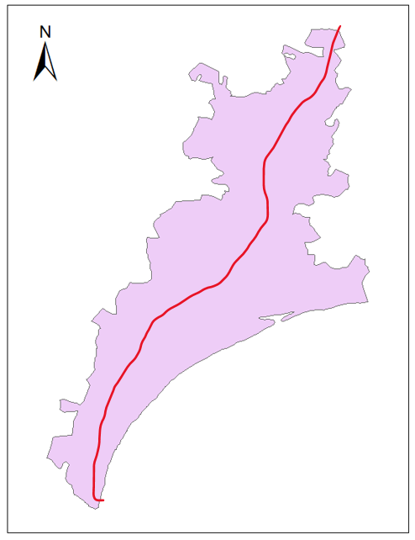
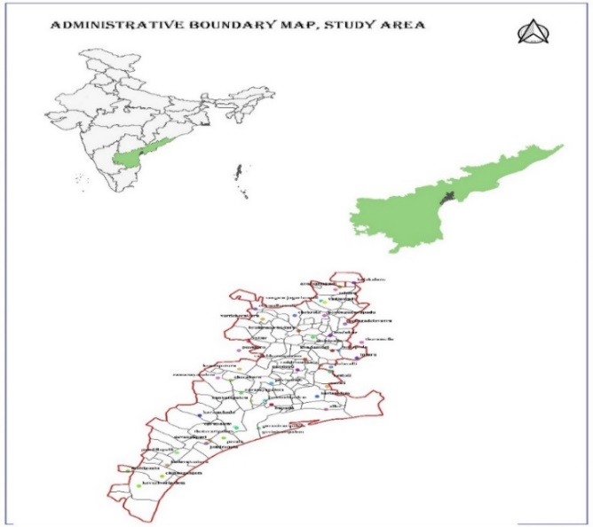

Feature | Sentinel-1 SAR | Sentinel-2 Optical
Sensor Type | Radar (C-band SAR) | Multispectral (optical)
Weather Dependency | Cloud- and sun-independent | Affected by clouds, requires cloud masking
Sensitivity | Surface structure & moisture | Spectral reflectance  (e.g., chlorophyll)
Vegetation Detection | Less accurate in crop type detection | Better separation by crop/vegetation type
Soil / Bare Land Detection | Limited | Clear soil/crop separation
Water Body Identification | Moderate (depends on backscatter) | High (strong NIR absorption)
Field Boundaries | Blurred in SAR | Clearly defined in optical
Best Use | All-weather monitoring, flood, wetness | Crop classification, vegetation indices

Fig.1 Study area and main canal map of Kommamuru canal command area

Table: - 1 Details of the sensors used in the present study

Remote sensing sensors selection
Sensor is a device that gathers energy (EMR or other), converts it into a signal and presents it in a form suitable for obtaining information about the target under investigation. These may be active or passive depending on the source of energy. Sensors used for remote sensing can be broadly classified as those operating in Optical-Infrared (OIR) region and those operating in the microwave region. OIR and microwave sensors can further be subdivided into passive and active. Active sensors use their own source of energy. Earth surface is illuminated through energy emitted by its own source, a part of it is reflected by the surface in the direction of the sensor, which is received to gather the information. Passive sensors receive solar electromagnetic energy reflected from the surface or energy emitted by the surface itself. These sensors do not have their own source of energy and cannot be used at night time, except thermal sensors. Again, sensors (active or passive) could either be imaging, like camera or sensor, which acquire images of the area and non-imaging types like non-scanning radiometer or atmospheric sounders.
Sentinel-1
The Sentinel-1 mission, operated by the European Space Agency (ESA), provides C-band Synthetic Aperture Radar (SAR) data with a spatial resolution of approximately 10 m. For this study, Level-1 Ground Range Detected (GRD) products were downloaded from the Copernicus Open Access Hub. SAR imagery is advantageous as it operates in the microwave region of the spectrum and can penetrate through clouds and haze, thereby providing reliable data under all weather conditions. This characteristic is particularly useful for the Kharif season, when persistent cloud cover limits the availability of usable optical imagery.
Sentinel-2
Sentinel-2 provides multispectral optical data at a spatial resolution of 10–20 m across 13 spectral bands, ranging from the visible to shortwave infrared regions. The revisit time is 5 days, which allows for frequent monitoring of vegetation growth. The optical sensor captures spectral reflectance properties of vegetation, soil, and water, making it highly effective for differentiating crop types and monitoring crop phenology. Level-1C (Top-of-Atmosphere reflectance) products were obtained and later processed to Level-2A (Bottom-of-Atmosphere reflectance) for further analysis.
Crop inventory
The classification of different satellite images is an information extraction process that would involve about pattern recognition of spectral properties of various surface features that would integrate and categorize similar features (Meng and Wu 2008). The Spectral recognition of a target surface feature could be enhanced by adding both spectral and temporal dimensions to the spectral pattern. Traditionally, the classification strategies are grouped into two broad categories, viz., the supervised and unsupervised categories according to the procedure that was employed to obtain training statistics. In case of supervised classification, the analysis specifies about the areas of known cover type in the image as training areas, which would statistically characterize the different informational categories of interest. The supervised technique is subjective in that the analyst would try to classify different thematic categories, which are composed of several spectral classes. The unsupervised approach would attempt to identify spectrally homogeneous groups within the image and these groups have to be identified from the point of view of actual users.
Normalized Difference Vegetation Index (NDVI) values of different crop pixels for different years have been used for crop condition assessment. Normalized Difference Vegetation Index (NDVI) image will be generated for each date data of respective crop and other vegetation (Gu et al., 2007)
For an analysis of the data, following formula of NDVI values applied.
NDVI= (NIR-R)/(NIR+R)
(Where NIR= Near Infra-Red & R= Red)
EVI= 2.5 * ((B8 - B4) / (B8 + 6 * B4 - 7.5 * B2 + 1))
where B8 is NIR (Band 8), B4 is Red (Band 4), and B2 is Blue (Band 2)
SOFTWARE USED
Google Earth Engine Platform
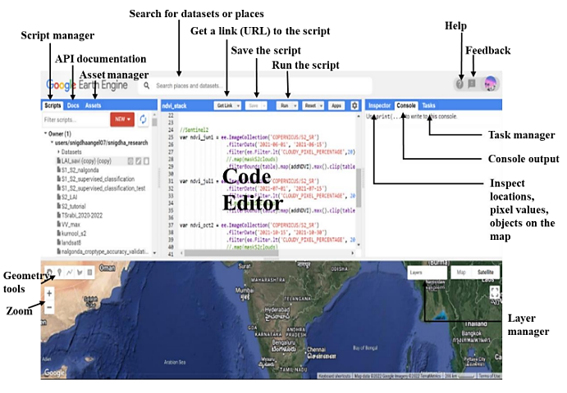
GEE is a computing platform that allows users to run geospatial analysis on Google's infrastructure. The GEE computing engine supports both JavaScript and Python application programming interfaces (APIs), allowing developers to quickly create algorithms that run in parallel on Google's data processing systems. Data from Landsat 4, 5, 7, and 8 processed by the US Geological Survey (USGS), many MODIS products, including global composites, recent imagery from Sentinel-1, 2, and three satellites, and much more may be found in the GEE. The Code Editor (code.earthengine.google.com) is a web-based IDE (Integrated Development Environment) for writing and running scripts.

Fig.2 Google Earth Engine Software

Methodology followed for Crop Classification in Optical Remote Sensing
The methodology for crop classification using optical remote sensing data involves several systematic steps to ensure accurate identification and mapping of crop types. Initially, remote sensing data acquisition is conducted using multispectral satellite sensors such as Sentinel-2 or Landsat, which provide high-resolution spectral information over the study area during relevant crop growth periods. The raw satellite data undergoes essential preprocessing steps, including atmospheric and geometric corrections, to remove atmospheric disturbances and spatial misalignments. This preprocessing ensures that the reflectance values accurately represent ground conditions and are consistent across multi-temporal datasets. Following preprocessing, feature extraction is performed where spectral bands and vegetation indices such as the Normalized Difference Vegetation Index (NDVI), Normalized Difference Water Index (NDWI), and Bare Soil Index (BSI) are computed to highlight key biophysical properties of crops, such as chlorophyll content, water stress, and soil exposure. Texture features may also be extracted to capture spatial variability in crop canopy structure. These features serve as the input data for the classification process, which can be either supervised or unsupervised. In supervised classification, the algorithm is trained using labelled samples representing known crop types, enabling it to classify the entire image based on learned spectral signatures. Unsupervised classification, on the other hand, groups pixels into spectrally homogeneous clusters without prior knowledge, requiring post-classification interpretation. This structured approach leverages spectral and spatial information to differentiate crops effectively, facilitating crop monitoring, yield estimation, and agricultural management at regional scales.

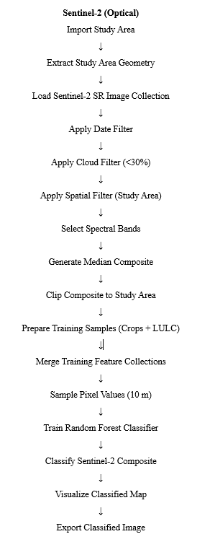

Fig.3 Flow chart for crop inventory in optical remote sensing
Methodology followed for Crop Classification in Microwave Remote Sensing
Microwave remote sensing, particularly Synthetic Aperture Radar (SAR), plays a crucial role in crop inventory due to its all-weather and day-night imaging capabilities, which are indispensable for monitoring crops under diverse climatic conditions. The methodology begins with clearly defining the objectives, such as identifying specific crop types, acreage estimation, or seasonal monitoring. This step guides the selection of appropriate SAR datasets and analysis techniques tailored to the crop type and study period. The study area and ancillary data, including soil characteristics, Digital Elevation Models (DEM) and field boundaries, are then compiled to contextualize the remote sensing data and improve classification accuracy.
The next phase involves pre-processing of SAR data, which is essential to correct for sensor-specific distortions and environmental interferences. Radiometric calibration ensures that backscatter values reflect true ground properties, while speckle filtering reduces the inherent granular noise of radar images. Terrain correction, using DEM data, rectifies geometric distortions caused by varying topography, thus ensuring precise geolocation of pixels. These preprocessing steps standardize the SAR data for further analysis.
Feature extraction in microwave remote sensing focuses on deriving meaningful indicators from the radar backscatter and its polarization properties. Common features include the ratio of VV (vertical transmit, vertical receive) to VH (vertical transmit, horizontal receive) polarization channels, entropy, anisotropy, and polarimetric parameters such as those from the decomposition of the Polarimetric SAR Interferometry (PolSAR) data. These features capture structural and dielectric properties of crops and soil, enabling differentiation between crop types. Temporal change curves, constructed from multi-temporal SAR acquisitions, provide dynamic information on crop phenology, enhancing classification robustness.
Post-processing steps include the application of smoothing filters to remove salt-and-pepper noise and enhance the spatial coherence of classified maps. Integration with optical remote sensing data is often performed to leverage complementary spectral and structural information, thereby improving overall classification accuracy.
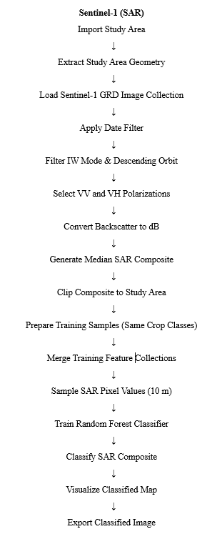
Fig.4 Flow chart for crop inventory in microwave remote sensing
Ground truth data collection
In this study, ground samples were taken from fields and several Index values were calculated for selected point coordinates through March 2022-24 using Sentinel-1 and Sentinel-2 satellite images. For this, the study centered on the phenology of all crops (specifically at peak growing months). The crops experienced observable growth between 2022 to 2024, which also represented the peak season for growing in kharif and Rabi. This data enables tracking the health and growth of all crops over time and aid in precision farming practices leading to improved yield.
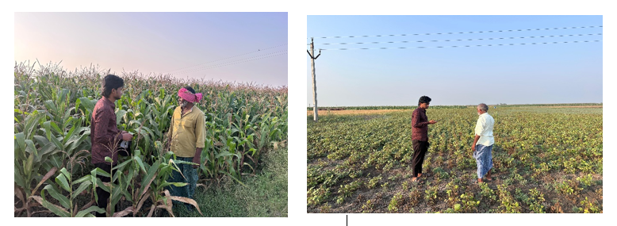
Fig.5 Collecting Ground truth data
Accuracy Assessment
To evaluate the reliability of classification results, accuracy assessment was carried out using ground truth reference points collected during field surveys. Confusion matrices were generated, and accuracy metrics including Overall Accuracy (OA), Producer’s Accuracy (PA), User’s Accuracy (UA), and the Kappa Coefficient (κ) were computed. These metrics were used to quantitatively compare the performance of compared Sentinel-1 and Sentinel-2 datasets. Results showed that optical data generally yielded higher classification accuracy, especially for crop type mapping, whereas SAR data proved useful in cloudy periods when optical data was unavailable.
3. Results and Discussion
Optical remote sensing (Sentinel 2) Crop classification (2022-24)
The three maps illustrated the spatial distribution of major Kharif crops across the study area for the years 2022, 2023, and 2024, derived using Sentinel-2 optical remote sensing data. Sentinel-2’s multispectral capabilities particularly its visible, near-infrared, and red-edge bands allow precise discrimination of vegetation types based on their spectral reflectance. Using supervised classification techniques, the major crops cultivated in the command area, namely Paddy, Tobacco, Chilli, and Lemon, were identified and mapped(Fig. 6). Each map shows the classified output within the delineated study area boundary, with individual crops represented through distinct colours to visualize their spatial extent and temporal changes.

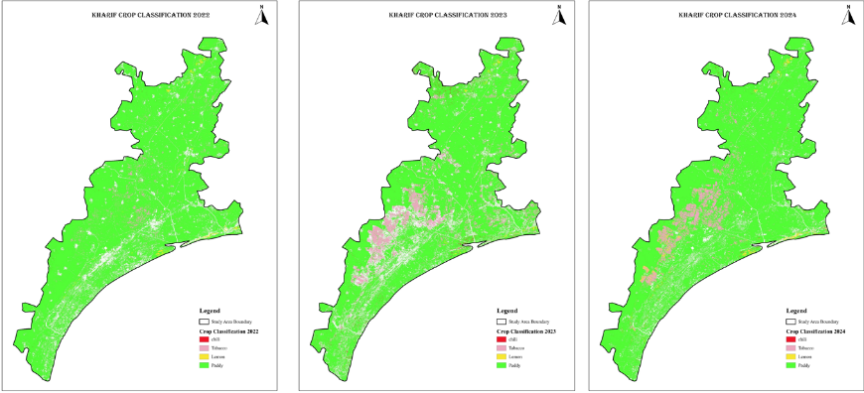
Fig.6 Classified Crop maps of Kommamuru canal command area in Kharif Season during 2022, 2023 and 2024
Paddy dominated the cropping pattern throughout 2022–2024, with a slight decline in 2023 followed by a notable increase in 2024, indicating strong dependence on irrigation and monsoon conditions (Table 2). Tobacco showed a decrease in 2023 and partial recovery in 2024, reflecting market and management influences. Chilli area consistently declined over the three years, suggesting reduced farmer preference during the Kharif season. Lemon occupied a very small area and showed only minor inter-annual fluctuations. Overall, crop area variations highlight farmer adaptability, with paddy remaining the most stable and preferred crop. (Andhra Pradesh Agriculture Information & Management System 2025)
Table 2:- Evolution of Cropping Patterns Across Major Crops in Kharif (2022–2024)
Year | 2022 | 2023 | 2024
Paddy (ha) | 58857 | 56485 | 62584
Tobacco (ha) | 6748 | 5458 | 6398
Chilli (ha) | 2847 | 2765 | 2654
Lemon (ha) | 802 | 915 | 759

The three maps represented the Rabi season crop classification for the years 2022, 2023, and 2024, generated using multispectral optical remote sensing data from Sentinel-2. The maps show the spatial distribution of major Rabi crops cultivated in the study area, namely Chilli, Black Gram, Maize, Green Gram, Groundnut, and Jowar, each displayed using distinct colours. Sentinel-2 imagery, due to its high spectral resolution in the visible, NIR, and red-edge regions, allows for accurate differentiation of these crops based on their phenological signatures and reflectance properties. Supervised classification techniques supported by field data and vegetation indices such as NDVI and EVI were used to delineate crop boundaries and map their spatial extent within the defined study area (Fig. 7).
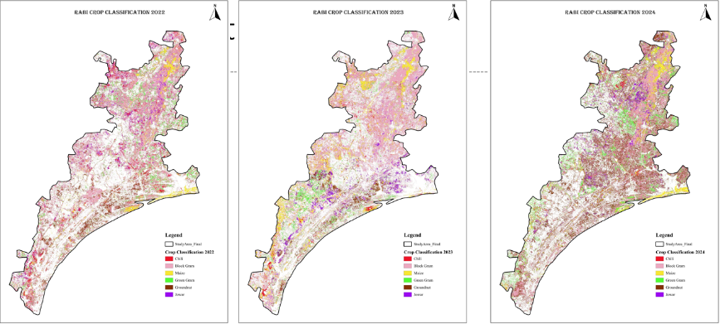
Fig.7 Classified Crop maps of Kommamuru canal command area in Rabi Season during 2022, 2023 and 2024

Maize showed a steady increased from 2022 to 2024, indicating its growing importance as a stable Rabi crop. Black gram area consistently declined over the years, suggesting a gradual shift away from pulse cultivation (Table 3). Jowar expanded significantly in 2023 but slightly reduced in 2024, reflecting year-to-year climatic or market influences. Green gram and chilli exhibited moderate fluctuations, indicating variable farmer preference and management conditions. Groundnut occupied a small area with minor changes.
Table 3 :- Evolution of Cropping Patterns Across Major Crops in Rabi (2022–2024)
Crop Type | 2022 | 2023 | 2024
Maize (ha) | 22586 | 23654 | 24586
Black Gram (ha) | 17231 | 16524 | 15984
Jowar (ha) | 12689 | 15624 | 14856
Green gram (ha) | 6589 | 7486 | 6589
Chilli (ha) | 5869 | 6895 | 6598
Ground nut (ha) | 965 | 1256 | 1123
Microwave remote sensing (SAR) Crop classification (2022-24)
The three maps illustrated the Kharif season crop classification for the years 2022, 2023, and 2024 using microwave remote sensing (SAR) data, most likely from Sentinel-1. Unlike optical remote sensing, which relies on reflected sunlight, SAR sensors operate in the microwave region, allowing uninterrupted data acquisition even under cloudy, rainy, or monsoon conditions. This is particularly valuable during the Kharif season, when optical imagery frequently suffers from cloud cover. SAR backscatter characteristics sensitive to crop structure, canopy density, water content, and surface roughness were used to discriminate the major crops grown in the study area: Paddy, Tobacco, Chilli, and Lemon (Fig. 8).
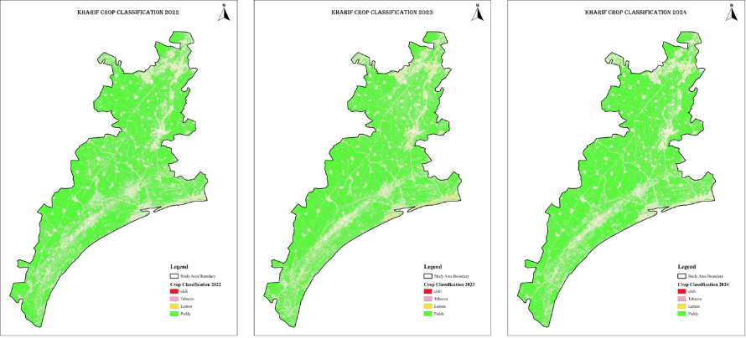
Fig.8 Classified Crop maps of Kommamuru canal command area in Kharif Season during 2022, 2023 and 2024
Paddy remained the dominant Kharif crop during 2022–2024, with a clear increase in cultivated area in 2024, reflecting favorable water availability and farmer preference (Table 4). Tobacco showed a decline in 2023 followed by a recovery in 2024, indicating sensitivity to market and management conditions. Chilli cultivation consistently decreased over the study period, suggesting a gradual shift away from this crop. Lemon occupied a very small area and exhibited minor inter-annual fluctuations. Overall, the Kharif cropping pattern was strongly paddy-centric with limited diversification.
Table 4 :- Evolution of Cropping Patterns Across Major Crops in Kharif (2022–2024)
Crop | 2022 | 2023 | 2024
Paddy (ha) | 56247 | 56414 | 61254
Tobacco (ha) | 6235 | 5457 | 6478
Chilli (ha) | 2457 | 2325 | 2124
Lemon (ha) | 811 | 974 | 714

The three maps illustrated the spatial distribution of major Rabi season crops including Chilli, Black Gram, Maize, Green Gram, Groundnut, and Jowar across the study area for the agricultural years 2022, 2023, and 2024 using microwave (SAR) remote sensing data . Each map highlights crop-specific spectral backscatter differences, enabling clear differentiation of crop types based on their structural and phenological characteristics during the Rabi season. The classification for 2022 shows a mixed mosaic of the six major crops, with noticeable concentrations of Maize and Groundnut across the central and lower parts of the command area. In 2023, the crop pattern appears slightly more spatially consolidated, with improved continuity in Black Gram and Green Gram distribution due to better SAR signal separation during key growth stages. By 2024, the maps show further refinement in classification, with enhanced detection of Groundnut and Jowar areas, indicating improved mapping accuracy and more uniform crop pattern representation across the region.
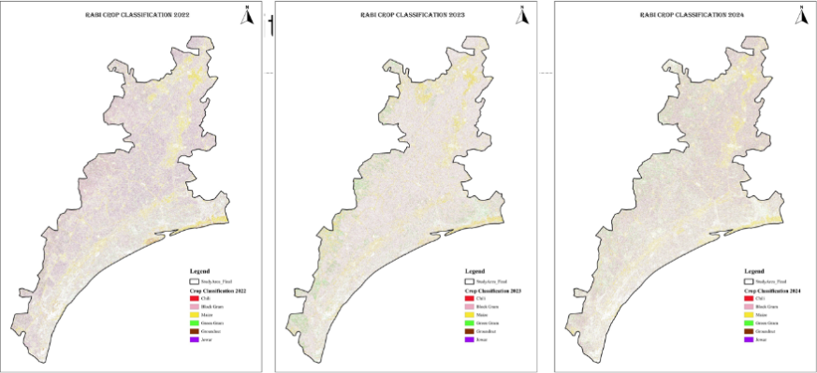
Fig.9 Classified Crop maps of Kommamuru canal command area in Rabi Season during 2022, 2023 and 2024
Table 5 :- Evolution of Cropping Patterns Across Major Crops in Rabi (2022–2024)
Crop Type | 2022 | 2023 | 2024
Maize (ha) | 24587 | 21458 | 23587
Black Gram (ha) | 16458 | 14253 | 15487
Jowar (ha) | 11254 | 14253 | 12578
Green gram (ha) | 6458 | 7124 | 6326
Chilli (ha) | 5124 | 6102 | 6253
Ground nut (ha) | 954 | 1123 | 1363

Maize continued to dominate the Rabi season across all three years, indicating its reliability under irrigated and residual moisture conditions, although the temporary decline in 2023 suggests sensitivity to climatic variability or input availability (Table 5). Black gram showed a noticeable reduction in area in 2023 with partial recovery in 2024, reflecting fluctuating farmer preference and possible yield or market constraints. Jowar expanded significantly in 2023 before declining in 2024, indicating short-term adaptive responses to weather and fodder demand. Green gram exhibited only minor variations, suggesting relatively stable but limited adoption during the Rabi season. Chilli and groundnut showed a gradual increase toward 2024, highlighting a slow but clear trend toward crop diversification and higher-value cropping under Rabi conditions.
In Google Earth Engine (GEE), a composite image was created incorporating spectral bands from Sentinel-1 and Sentinel-2, along with various spectral indices such as EVI and NDVI Additionally, elevation data from NASA’s Shuttle Radar Topography Mission (SRTM) at 30 m resolution was included. Generated variables like class value, class names, columns, and features. The class value had values from 0 to 2, representing Cropland, and non-cropland as class names. The samples were created based on these class names and split the data into training (80%) and testing (20%) sets. Samples were extracted using the sample region’s function, where each pixel was treated as a feature with an associated class value. The results were assessed using a confusion matrix, overall accuracy, and kappa coefficient.

Accuracy assessment for Crop classification
Optical remote sensing during the Kharif seasons (2022–2024) showed consistently high classification performance, with overall accuracy ranging from 80.24% to 84.32%. Paddy was reliably classified across all years with high producer’s and consumer’s accuracies. Tobacco and lemon generally showed good performance, though lemon had low accuracy in 2022 before improving in later years. Chilli exhibited variability, particularly a sharp decline in 2023, which influenced yearly accuracy trends (Table 6).
Table 6. Accuracy assessment in Optical Remote sensing in kharif season using Sentinel-2 datas
2022 (Kharif)
Class | Producer’s Accuracy (PA) % | Consumer’s Accuracy (CA) % | Overall Accuracy (OA)  %
Paddy | 89.47 | 87.32 | 80.65
Tobacco | 83.25 | 82.35 | 80.65
Lemon | 36.25 | 41.25 | 80.65
Chilli | 76.50 | 71.25 | 80.65
2023
Paddy | 96.41 | 93.24 | 84.32
Tobacco | 85.35 | 84.25 | 84.32
Lemon | 80.08 | 75.86 | 84.32
Chilli | 35.67 | 47.60 | 84.32
2024
Paddy | 90.35 | 88.58 | 80.24
Tobacco | 78.78 | 76.78 | 80.24
Lemon | 82.65 | 81.26 | 80.24
Chilli | 63.31 | 61.75 | 80.24

Microwave remote sensing for Kharif recorded lower accuracies compared to optical data, with overall accuracy improving from 35.28% (2022) and 36.42% (2023) to 46.41% (2024). Paddy consistently performed better than other crops, while tobacco and lemon showed moderate improvement over time. Chilli remained the least accurately classified crop, though it improved notably in 2024(Table 7).

2022 (Kharif)
Class | Producer’s Accuracy (PA) % | Consumer’s Accuracy (CA) % | Overall Accuracy (OA)  %
Paddy | 55.64 | 52.64 | 35.28
Tobacco | 40.65 | 39.56 | 35.28
Lemon | 38.12 | 36.56 | 35.28
Chilli | 29.65 | 27.45 | 35.28
2023
Paddy | 57.68 | 51.81 | 36.42
Tobacco | 46.56 | 41.85 | 36.42
Lemon | 38.65 | 36.51 | 36.42
Chilli | 28.75 | 26.53 | 36.42
2024
Paddy | 61.76 | 65.75 | 46.41
Tobacco | 49.21 | 47.56 | 46.41
Lemon | 43.35 | 45.21 | 46.41
Chilli | 44.54 | 42.24 | 46.41
Table 7. Accuracy assessment in Microwave Remote sensing in kharif season using Sentinel-2 data

Table 8. Accuracy assessment in Optical Remote sensing in Rabi season using Sentinel-1 data

2022 (Rabi)
Class | Producer’s Accuracy (PA) % | Consumer’s Accuracy (CA) % | Overall Accuracy (OA)  %
Maize | 80.12 | 78.26 | 74.34
Green gram | 90.56 | 91.02 | 74.34
Black gram | 56.86 | 54.23 | 74.34
Ground nut | 91.46 | 88.25 | 74.34
Jowar | 62.05 | 61.25 | 74.34
Chillie | 51.06 | 49.26 | 74.34
2023
Maize | 76.12 | 74.12 | 76.42
Green gram | 91.02 | 85.26 | 76.42
Black gram | 61.25 | 62.23 | 76.42
Ground nut | 94.52 | 92.36 | 76.42
Jowar | 69.25 | 65.35 | 76.42
Chillie | 58.23 | 45.36 | 76.42
2024
Maize | 79.21 | 69.02 | 79.41
Green gram | 92.01 | 86.36 | 79.41
Black gram | 65.87 | 64.23 | 79.41
Ground nut | 92.12 | 90.58 | 79.41
Jowar | 68.23 | 69.34 | 79.41
Chillie | 49.23 | 42.34 | 79.41
For the Rabi seasons, optical remote sensing demonstrated moderate to high classification accuracy, increasing from 74.34% (2022) to 79.41% (2024). Groundnut and green gram were consistently classified with high accuracy, while maize showed stable performance. Black gram and jowar were moderate, whereas chilli showed very low accuracy in 2023 and 2024, affecting class-level reliability (Table 8).
In contrast, microwave remote sensing during Rabi produced relatively low overall accuracies, ranging from 27.42% to 37.41%. Groundnut, maize, and green gram showed comparatively better performance, especially in 2024. However, black gram, jowar, and chilli consistently recorded lower accuracies, indicating greater class confusion. Overall, optical remote sensing outperformed microwave data in both seasons across all three years (Table 9).
Table 9. Accuracy assessment in Microwave Remote sensing in Rabi season using Sentinel-1 data
2022 (Rabi)
Class | Producer’s Accuracy (PA) % | Consumer’s Accuracy (CA) % | Overall Accuracy (OA)  %
Maize | 47.52 | 45.26 | 35.21
Green gram | 55.36 | 52.03 | 35.21
Black gram | 38.01 | 35.26 | 35.21
Ground nut | 55.26 | 54.15 | 35.21
Jowar | 35.24 | 33.26 | 35.21
Chillie | 26.35 | 27.15 | 35.21
2023
Maize | 46.25 | 44.12 | 27.42
Green gram | 56.32 | 20.13 | 27.42
Black gram | 36.25 | 28.45 | 27.42
Ground nut | 52.31 | 49.32 | 27.42
Jowar | 36.21 | 35.24 | 27.42
Chillie | 24.15 | 22.15 | 27.42
2024
Maize | 50.12 | 48.65 | 37.41
Green gram | 48.32 | 47.25 | 37.41
Black gram | 28.35 | 25.14 | 37.41
Ground nut | 51.24 | 55.32 | 37.41
Jowar | 39.21 | 35.62 | 37.41
Chillie | 27.56 | 25.61 | 37.41

Comparison between Optical-based and SAR-based crop classification performance during the Kharif season for the years 2022, 2023, and 2024. The comparison clearly shows differences in classification accuracy due to the fundamental working principles of both sensors. Optical remote sensing data recorded overall classification accuracies of 80.65% (2022), 84.31% (2023), and 80.24% (2024). Optical classification remains stable around 80–84%, demonstrating strong discrimination capability during the vegetative Kharif season. SAR-based classification shows significantly lower overall accuracies of 35.42% (2022), 36.50% (2023), and 46.25% (2024). The values for 2022 and 2023 are relatively low (around 35–36%), indicating high confusion among crop classes when relying solely on radar backscatter. For the Rabi season, optical remote sensing consistently outperforms SAR, achieving moderate to high accuracies (74–80%), whereas SAR shows low performance (27–36%).
4.Conclusions
Optical and microwave remote sensing differ fundamentally in the type of energy they use and the kind of information they provide for agricultural monitoring. Optical remote sensing relies on reflected sunlight captured in visible, near-infrared, and shortwave infrared bands, making it highly effective for assessing vegetation vigour, chlorophyll content, canopy structure, and phenological changes. However, its performance is strongly limited by atmospheric conditions cloud cover, shadows, and haze can obstruct data acquisition, especially during the monsoon-driven Kharif season. In contrast, microwave or SAR remote sensing uses actively transmitted microwave signals that can penetrate clouds, fog, and light rain, allowing all-weather, day-and-night imaging capability. SAR backscatter is sensitive to surface roughness, crop moisture, biomass, and structural properties, making it particularly suitable for mapping crops like paddy that undergo distinct waterlogged and growth stages. Together, both systems offer a robust, multi-source approach for accurate crop classification and seasonal crop inventory preparation.
A comparative assessment of the Kharif and Rabi seasons from 2022 to 2024 reveals distinct differences in cropping patterns, crop dominance, and overall agricultural dynamics within the command area. The Kharif season is strongly characterized by monsoon-driven agriculture, where Paddy overwhelmingly dominates the landscape, resulting in a low-diversity cropping system with only minor occurrences of crops like Chilli, Tobacco, and Lemon. This uniformity remains highly consistent across all three years, indicating a stable and water-dependent cultivation practice. In contrast, the Rabi season showcases a more diversified and balanced agricultural profile, supported primarily by controlled irrigation rather than rainfall. Crops such as Maize and Groundnut emerge as major contributors, while pulses including Black Gram and Green Gram, along with smaller pockets of Chilli and Jowar, create a more heterogeneous spatial distribution. Although Rabi crop patterns show slight interannual variations, the overall crop mix remains steady, highlighting the flexibility and adaptability of farmers during the post-monsoon period. The confusion matrix compared the model’s predicted classifications with the actual ones, yielding an overall accuracy of 85% and a kappa coefficient of 0.80
References
Adiga, S. 1992. Tobacco crop inventory through satellite remote sensing. Bulletin of National Natural Resources Management System NNRMS (B) 15: 5.
Chan, Y.K. and Koo, V., 2008. An introduction to synthetic aperture radar (SAR). Progress In Electromagnetics Research B, 2, pp.27-60.
Chen, J., & Zhang, Z. (2023). An improved fusion of Landsat7/8, Sentinel-2, and Sentinel-1 data for monitoring alfalfa: Implications for crop remote sensing. International Journal of Applied Earth Observation and Geoinformation, 124, 103533. https://doi.org/10.1016/J.JAG.2023.103533
Clemente, J. P., G. Fontanelli, G. G. Ovando, Y. L. B. Roa, A. Lapini, and E. Santi, 2020. “Google Earth Engine: Application of Algorithms for Remote Sensing of Crops in Tuscany (Italy).” In 2020 IEEE Latin American GRSS & ISPRS Remote Sensing Conference (LAGIRS), 195–200. Santiago, Chile: IEEE. https://doi.org/10.1109/ lagirs48042.2020.9165561 .
Gadiraju, K.K. and Vatsavai, R.R., 2023. Remote sensing-based crop type classification via deep transfer learning. IEEE Journal of Selected Topics in Applied Earth Observations and Remote Sensing, 16, pp.4699-4712.
Gorelick, N., M. Hancher, M. Dixon, S. Ilyushchenko, D. Thau, and R. Moore. 2017. “Remote Sensing of Environment Google Earth Engine: Planetary-Scale Geospatial Analysis for Everyone.” Remote Sensing of Environment 202:18–27. https://doi.org/10.1016/j.rse. 2017.06.031

Gu Y, Brown J F, Verdin J P and Wardlow B 2007. A five year analysis of MODIS NDVI and NDWI for grassland drought assessment over the central great plains of the United States. Geophys Res Lett 34: L06407.
Huang, Y., Tang, L., Jing, D., Li, Z., Tian, Y. and Zhou, S., 2019, December. Research on crop planting area classification from remote sensing image based on deep learning. In 2019 IEEE International Conference on Signal, Information and Data Processing (ICSIDP) (pp. 1-4). IEEE.
Jia, K., Wu, B. and Li, Q., 2013. Crop classification using HJ satellite multispectral data in the North China Plain. Journal of Applied Remote Sensing, 7(1), pp.073576-073576.
Krupavathi, K., Babu, M.R., Mani, A., Parasad, P.R.K. and Edukondalu, L., 2018. Use of Landsat-8 OLI Imagery Multi-Temporal Vegetation Indices for Crop Classification in the Irrigated Areas of Krishna Central Delta. The Andhra Agric. J, 65, pp.313-319.
Krupavathi, K., Raghubabu, M., Mani, A., Parasad, P.R.K. and Edukondalu, L., 2022. Field-scale estimation and comparison of the sugarcane yield from remote sensing data: A machine learning approach. Journal of the Indian society of remote sensing, 50(2), pp.299-312.
Luo, C., B. Qi, H. Liu, D. Guo, L. Lu, Q. Fu, and Y. Shao. 2021. “Using Time Series Sentinel-1 Images for Object-Oriented Crop Classification in Google Earth Engine.” Remote Sensing 13 (4): 561. https://doi.org/10. 3390/RS13040561

Meng Ji-Hua and Wu Bing-Fang, (2008). Study On The Crop Condition Monitoring Methods With Remote Sensing, The International Archives of the Photogrammetry, Remote Sensing and Spatial Information Sciences. Vol. XXXVII, Part B8

Meerasha, B. and Sagayam, M., 2025. Cotton Crop Classification using Optical and Microwave Remote Sensing Datasets in Google Earth Engine. The International Archives of the Photogrammetry, Remote Sensing and Spatial Information Sciences, 48, pp.1055-1062.
Orynbaikyzy, A., Gessner, U. and Conrad, C., 2019. Crop type classification using a combination of optical and radar remote sensing data: A review. International journal of remote sensing, 40(17), pp.6553-6595.
Panigrahy, S., M. Chakraborty, K.R. Manjunath, N. Kundu & J.S. Parihar. 2000. Evaluation of radarsat ScanSAR synthetic aperture radar data for rice crop inventory and modeling. Journal of Indian Society of Remote Sensing 28: 59-65.
Sharma, T., K.S. Sudha, N. Ravi, R.R.Navalgund, K.P. Tomar, N.V.K. Chakravarty & D.K. Das. 1998. Procedures for wheat yield prediction using Lansat MSS and IRS-1A data. International Journal of Remote Sensing 14: 2509-2519.
Shinde, S., C. B. Pande, V. N. Barai, S. D. Gorantiwar, and A. A. Atre. 2023. “Flood Impact and Damage Assessment Based on the Sentitnel-1 SAR Data Using Google Earth Engine.” In Climate Change Impacts on Natural Resources, Ecosystems and Agricultural Systems (pp. 483–502). Springer International Publishing
Siesto, G., Fernández-Sellers, M. and Lozano-Tello, A., 2021. Crop classification of satellite imagery using synthetic multitemporal and multispectral images in convolutional neural networks. Remote Sensing, 13(17), p.3378.
Singh, R.P., Sridhar, V.N., Dadhwal, V.K., Navalgund, R.R. and Singh, K.P., 2002. Comparative evaluation of indian remote sensing multi‐spectral sensors data for crop classification. Geocarto International, 17(2), pp.7-12.
Skakun, S., Franch, B., Vermote, E., Roger, J.C., Becker-Reshef, I., Justice, C. and Kussul, N., 2017. Early season large-area winter crop mapping using MODIS NDVI data, growing degree days information and a Gaussian mixture model. Remote Sensing of Environment, 195, pp.244-258.
Tamiminia, H., Salehi, B., Mahdianpari, M., Quackenbush, L., Adeli, S., & Brisco, B. (2020). Google Earth Engine for geo-big data applications: A meta-analysis and systematic review. ISPRS Journal of Photogrammetry and Remote Sensing, 164, 152–170. https://doi.org/10.1016/J.ISPRSJPRS.2020.04.001
Tennakoon, S.B., Murty, V.V.N. and Eiumnoh, A., 1992. Estimation of cropped area and grain yield of rice using remote sensing data. International Journal of Remote Sensing, 13(3), pp.427-439.
Vizzari, M., Lesti, G., & Acharki, S. (2025). Crop classification in Google Earth Engine: leveraging Sentinel-1, Sentinel-2, European CAP data, and object-based machine-learning approaches. Geo-Spatial Information Science, 28(3), 815-830.

Wang, L., Wang, J., Liu, Z., Zhu, J. and Qin, F., 2022. Evaluation of a deep-learning model for multispectral remote sensing of land use and crop classification. The Crop Journal, 10(5), pp.1435-1451.
Xiong, J., Thenkabail, P. S., Gumma, M. K., Teluguntla, P., Poehnelt, J., Congalton, R. G., Yadav, K., & Thau, D. (2017). Automated cropland mapping of continental Africa using Google Earth Engine cloud computing. ISPRS Journal of Photogrammetry and Remote Sensing, 126, 225–244. https://doi.org/10.1016/J.ISPRSJPRS.2017.01.019
Xue, H., X. Xu, Q. Zhu, G. Yang, H. Long, H. Li, X. Yang, et al. 2023. “Object-Oriented Crop Classification Using Time Series Sentinel Images from Google Earth Engine.” Remote Sensing 15 (5): 1353. https://doi.org/10.3390/rs15051353 .
Zhou, Z., Li, S. and Shao, Y., 2018, July. Crops classification from sentinel-2a multi-spectral remote sensing images based on convolutional neural networks. In IGARSS 2018-2018 IEEE International Geoscience and Remote Sensing Symposium (pp. 5300-5303). IEEE.

