Influence of Agricultural Feedstock on the Physicochemical Properties and Performance of Biochar

Abstract
This study investigates the impact of coconut shell–modified biochar on physicochemical characteristics and its suitability for environmental applications. Via oxygen-limited pyrolysis, biochar was derived at 600°C by controlling the heating rate of 5°C min⁻¹. Yield characteristics from literature indicate char production ranging from 22–31 wt% under optimized conditions (400–600°C), while controlled experiments report up to 70% yield at 300°C. X-ray diffraction analysis revealed a predominantly amorphous structure with broad peaks at 2θ ≈ 23.15° (d-spacing 3.838 Å) and 43.80° (2.065 Å), and a low crystallinity index of 30.3%, indicating high structural disorder favorable for adsorption processes. Dynamic light scattering showed a unimodal particle size distribution centered at ~1550 nm, with ~47% frequency dominance, suggesting homogeneous particle formation. Zeta potential measurements indicated a mean surface charge of −17 mV, confirming moderate colloidal stability and strong affinity toward cationic contaminants. BET and BJH analyses demonstrated a hierarchical pore structure, with cumulative pore volume reaching ~77 cc g⁻¹ in the 40–51 nm range and a micropore volume of ~0.13 cc g⁻¹, supporting high adsorption capacity. The presence of functional groups, such as –OH, C=O, and aromatic C=C, is confirmed by the FTIR analysis, contributing to surface reactivity. The combined structural (amorphous, porous), chemical (functionalized surface), and electrokinetic (negative charge) properties highlight coconut shell biochar as a low-cost, high-performance material for environmental remediation and wastewater treatment.
Keywords: Biochar; Amorphous; Crystallinity Index; Zeta potential; Wastewater treatment.
1. Introduction
By heating biomass, carbon-rich material biochar is produced (e.g., wood, leaves, manure) at temperatures below 700 °C in a low-oxygen environment. This process known as thermal decomposition, is similar to the traditional production of charcoal one of the oldest human industrial methods [1]. It differs from charcoal because it is intentionally produced for soil application to improve productivity, enhance carbon sequestration, and aid water filtration, with its classification based on intended use and production method. Unlike complete combustion that forms mineral-rich ash, limited oxygen conditions preserve part of the biomass as carbon-rich char [2]. From a chemical perspective, biochar is complex and troublesome to define due to the broad variation in biomass sources and production Parameters. It is mainly composed of carbon-rich aromatic structures arranged irregularly with elements like hydrogen, oxygen, and minerals, making it challenging to fully characterize [3]. It is a relatively recent improvement, emerging in combination carbon sequestration issues soil management [4]. It also clarifies related terms like “agrichar,” “char,” and “activated carbon,” emphasizing biochar’s biological origin and broader environmental applications beyond agriculture [5]. The term “black carbon” broadly includes all carbon-rich residues formed from heat or combustion of biomass and fossil fuels, ranging from char and biochar to soot and graphite [6]. Processes like charring and pyrolysis describe the formation and transformation of these materials, with pyrolysis also used in analytical studies and bioenergy production [7]. Improving soil quality is essential for global food security, especially in regions like South Asia and sub-Saharan Africa where malnutrition remains high despite past gains from the Green Revolution. Biochar presents a sustainable solution by enhancing soil organic matter and increasing the efficiency of agricultural inputs, supporting the goals of a “Doubly Green Revolution [8].
The limited success of the Green Revolution in Africa is largely due to the high cost of agrochemicals, making sustainable alternatives like biochar more attractive. Using locally available resources, biochar improves fertility of soil and nutrient efficacy, while also addressing widespread soil degradation and declining productivity despite intensive agricultural inputs [9]. Ground and surface water pollution results from the management of agricultural animal and crop wastes, which is a major environmental burden [10]. Various organic wastes, including agricultural, urban, and certain industrial byproducts, can be utilized as resources for pyrolysis-based bioenergy production. Charring not only generates energy but also significantly reduces the volume and weight of waste materials, making them easier to manage [11]. These organic by-products or waste might occasionally present business prospects, with a sizable, dependable source of feedstock produced at a single place [12]. The economic returns from managing waste and by-products remain uncertain and depend on market conditions, but effective organic waste management offers significant environmental benefits. It helps to neutralize the change of climate by reducing methane emissions, lowering energy use and emissions, recovering energy, enhancing carbon sequestration, and decreasing transportation-related energy demand [13]. Biochar production from waste requires strict quality control, but pyrolysis above 350°C effectively destroys harmful microorganisms, making it safer for soil application. Unlike manure or compost, biochar is highly stable and long-lasting, reducing the need for repeated applications and minimizing risks of heavy metal accumulation in soil [14]. Capturing energy at the time of biochar production and by using the resulting biochar as a soil amendment can decrease overall emissions and improve environmental benefits, even though it lowers pyrolysis energy efficiency compared to using biochar as fuel [15]. While pyrolysis and other bioenergy systems cannot fully meet global energy demand, they still provide cleaner, more efficient energy than traditional biomass burning and help reduce indoor air pollution in developing regions [16]. The environmental performance of biochar systems must be assessed within ecological and economic constraints using complete emission balances compared to baseline scenarios [17]. Until sufficient location-specific data are available, global carbon flux comparisons can be used to estimate the potential of biochar for carbon sequestration [18]. Biochar’s effectiveness as a soil amendment largely depends on its physical properties, which influence soil structure, water and air availability, and plant growth. It improves soil porosity, aggregation, infiltration, and nutrient retention while also supporting microbial activity by providing additional surface area and habitat, thereby enhancing overall soil fertility and resilience [19]. The final structure of biochar is strongly maintained by pyrolysis conditions and feedstock type, and it often retains the original plant’s cellular and porous structure even after thermal conversion [20]. Lower-dimension pores, such as meso and micro-holes, are fed by these large-sized pores [21]. The physical characteristics of biochar are strongly influenced by the chemical composition of the biomass, with different components such as hemicellulose, cellulose, and lignin decomposing at distinct temperature ranges. Inorganic content, especially ash, along with pyrolysis conditions like temperature, heating rate, pressure, and residence time, significantly determines the final structure, porosity, and reactivity of the biochar [22]. Water treatment systems based on biochar as a possible affordable and sustainable method for the supply of clean water [23].
Biochar is an emerging and low-cost material for drinking water treatment due to its strong ability to remove a wide range of contaminants, including chemical, biological, and physical pollutants [24]. Unlike conventional methods such as chlorination or boiling, biochar-based treatment can avoid harmful by-products, maintain water quality, and also provide co-benefits such as energy production and improved soil fertility when spent biochar is reused [25].
This exploration shows that the biochars derived from the anaerobically digested biomass are effective adsorbents for eliminating heavy metals from aqueous solutions, with digested whole sugar beet biochar performing better for certain metals like Ni and Cd [26]. Experimental and analytical results (including SEM–EDS, XRD, and FTIR) indicate that metal removal mainly occurs through surface precipitation, and the sorption capacity can reach levels comparable to commercial activated carbon [27]. Overall, it is an effective low-cost material for heavy metal removal, but its efficiency and reuse potential can be improved through surface modification to enhance adsorption performance and reduce environmental risks [28]. Biochar is increasingly used for waste recycling, soil improvement, environmental remediation, and carbon sequestration, with its performance strongly influenced by pyrolysis conditions and feedstock type [29]. Its contaminant removal ability depends on properties like surface area, pore structure, and functional groups, where low-temperature biochars are more effective for inorganic pollutants and high-temperature biochars for organic pollutants [30]. Studies also show that biochar can significantly improve acid soils by increasing pH, reducing aluminum toxicity, and enhancing plant growth, while its characteristics vary widely depending on the original biomass and carbonization temperature [31].

2. Materials and Methods
2.1 Coconut shell
Coconut shells, an abundant agricultural byproduct in tropical regions, are often disposed of through open burning, contributing to significant emissions of CO₂ and methane. They are widely utilized as a feedstock for biochar production; however, conventional pit-based methods yield only 25–30% charcoal (based on dry weight) and often produce material of inconsistent quality, contaminated with soil and other impurities. Additionally, emissions from this process pose environmental and health concerns.
Owing to their high calorific value (~20.8 MJ/kg), coconut shells represent a promising resource for the generation of steam, energy-rich gases, bio-oil, and biochar. Compared to coconut husk, shells are particularly well-suited for pyrolysis due to their lower ash content, higher volatile matter, and low cost. Their elevated fixed carbon content further enables the production of high-quality solid residues, which can be effectively utilized as activated carbon in wastewater treatment applications. Furthermore, coconut shells are readily available and easily collected, especially in regions where coconut meat is extensively used in food processing.
2.2 Pyrolysis of Coconut Shell
Coconut shell pyrolysis is mainly performed for the production of char that can be used as activated carbon, but a bit of work is done according to the utilization of the bio-oil, which are produced from coconut shell pyrolysis. Elisabeth Schröder, Klaus Thomauske, Benjamin Oechsler, Sabrina Herberger, Sabine Baur, and Andreas Hornung (2011) produced active carbon from different waste biomass, including coconut shell [32]. Earlier work by Prabhakar and Maheshwari (1986) investigated the impact of residence time and temperature on charcoal yield under both controlled experimental and field conditions. Their findings indicated a maximum yield efficiency of 70% at 300 °C and 180 s under laboratory conditions, compared to significantly lower yields (27%) observed in field operations.
Subsequently, Ganapathy Sundaram and Natarajan (2009) conducted fixed-bed slow pyrolysis experiments to evaluate the effects of key process parameters, including temperature, heating rate, and vapor residence time, particle size, on product distribution [33]. Experiments is done in the temperature range of 400–600 °C revealed that optimal liquid yield was achieved at 550 °C, with a particle size of 1.18–1.80 mm and a heating rate of 60 °C/min in a 200 mm reactor. Under these conditions, the yields of char, liquid, and gas were reported to be 22–31 wt%, 38–44 wt%, and 30–33 wt%, respectively. The study further concluded that pyrolysis temperature and particle size exert a more significant influence on product yields than heating rate and vapor residence time.
2.3 Collection of raw materials and preparation of bio-char
Coconut shell (Coconus nucifera) is found in various regions in Bangladesh. For the investigation, a coconut shell was collected from Dhaka. The coconut shell was collected from the coconut plant when it matured. The collected agricultural waste is washed using distilled water to eliminate dirt particles from the surface of the charcoal, then dried in an oven at 105℃ for about 1 hour. Biochar was prepared via an oxygen-limited pyrolysis method. In detail, a 50g sample of coconut husk was weighed and put in a furnace (Nabertherm, made in W-Germany). The heating rate was maintained at 5 degrees Celsius per minute, and the pyrolysis process was continued till 600 degrees Celsius was reached [34].

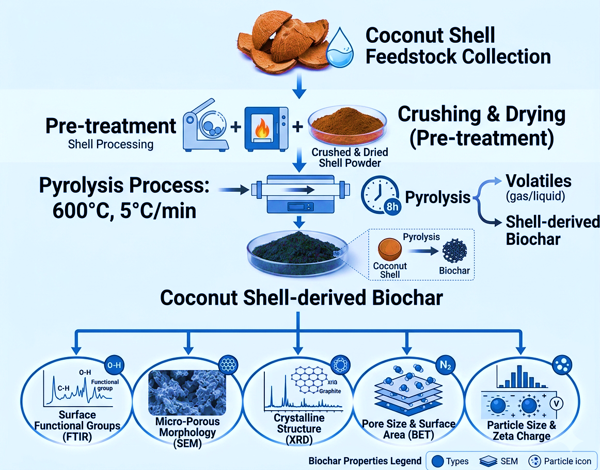
Figure 1: Coconut shell biochar production and its structural and surface characterization
The prepared biochar was weighed for characterization, as shown in the figure. Different types of agricultural wastes were then prepared for characterization by FTIR, SEM, XRD, BET analysis, and nanoparticle analyzer. The feedstock of biochar is diverse, which is why the product after pyrolysis is diverse. It shows Structural heterogeneity, that the particles do not have a strictly identical chemical.
3. Sample Preparation
3.1 Specimen preparation for SEM analysis of Biochar
Specimen preparation represents a critical step in the scanning electron microscopy (SEM) analysis of biochar. It is imperative that the sample maintains structural stability under vacuum conditions and remains resistant to potential damage induced by high-energy electron beam exposure. In this study, the biochar samples were mounted directly onto specimen stubs using carbon-based conductive adhesive tape, without the need for additional preparation procedures [35].
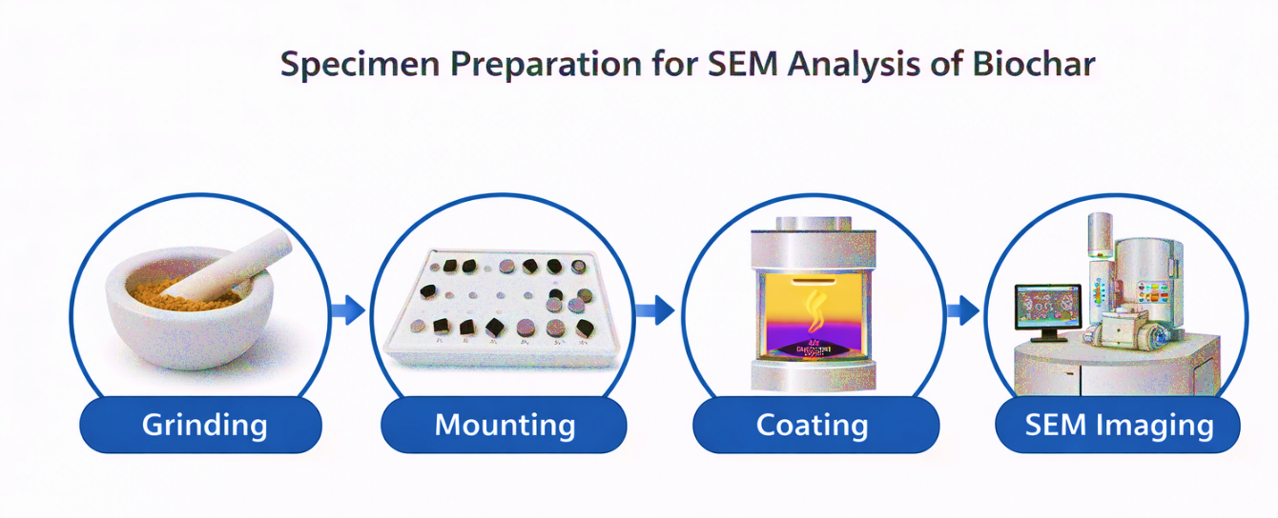
Figure 2: Specimen preparation for SEM analysis of biochar
Scanning electron microscopy has become an essential and widely utilized technique for the structural characterization of diverse materials and biological specimens. With over five decades of development, SEM is now a highly advanced and well-established analytical method. In the context of biochar materials, SEM analysis offers a rapid and straightforward approach for evaluating morphological features, including pore size, shape, and distribution, as well as identifying and mapping the presence of mineral phases within the sample.
3.2 Sample preparation for XRD analysis of Biochar
Bio samples were finely ground by ball mill and also by hand using an agate pestle and mortar. To obtain a random orientation of crystallities, the ground was filled into the cavity and packed using a razor blade. Direct pressing of the ground materials was avoided to minimize the preferred orientation of particles [36].

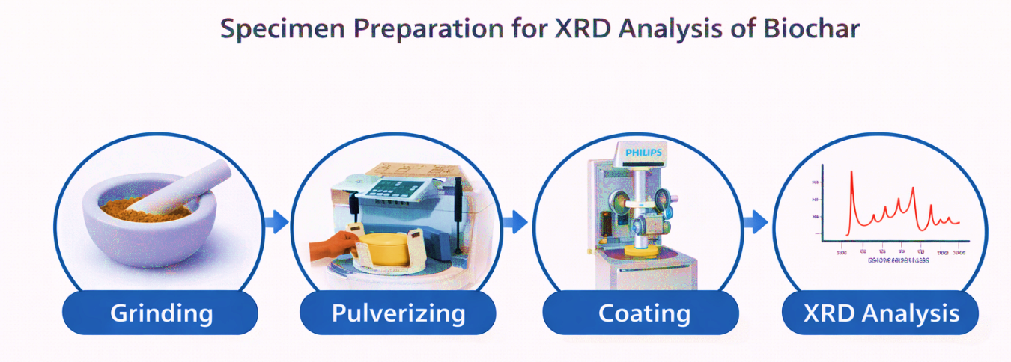
Figure 3: Specimen preparation for XRD analysis of biochar
Knowledge about these crystalline materials is important because crystals (in contrast to amorphous materials) have well-defined physical and chemical properties. In biochar, the marking of crystalline materials may be helpful in assuming the biological availability and release to soil solution of important, non-essential, and toxic elements in biochar-amended soils. Identification of mineral impurities can be possible by mineralogical analysis of biochar that might have been sourced from contamination of the feedstock in the process of making biochar.
3.3 Sampling for nanoparticle analysis and zeta potential
Using the protocol described by Li et al and Tang et al the separation of nano particles of bio-char was performed. All the procedures were performed in triplicate. For physically dispersion of the biochars, a probe-type ultrasonic vibrator was used. Bio-char dispersion was made by vibrating 3 grams of bio-char in 80 ml of water in a 100 ml glass beaker, placed in a cooling bath using a circulating water system, keeping the temperature at [37].
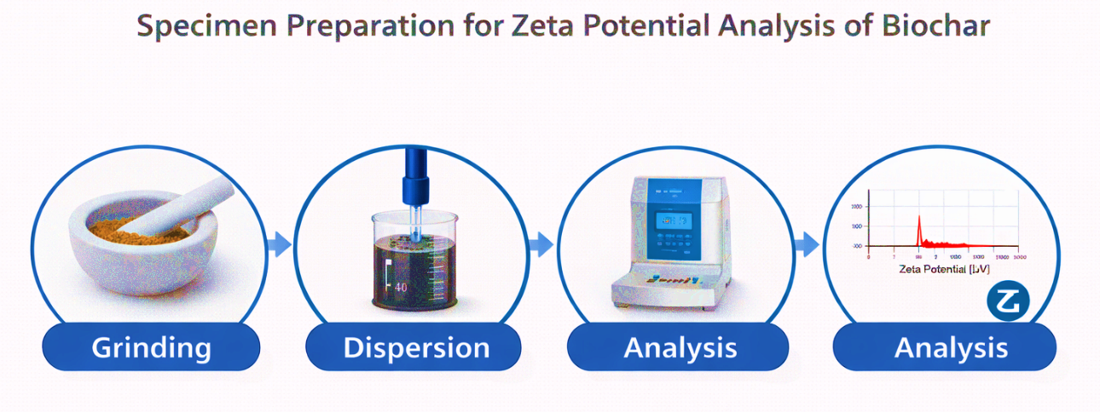
Figure 4: Specimen preparation for Zeta analysis of biochar
3.4 Sample preparation for FTIR analysis
Biochar samples were used for FTIR analysis using two different methods. One is DR- FTIR, and the other is ATR – FTIR. For Dr FTIR analysis, samples were ground and mixed with KBR or run as neat powders. For ATR – FTIR analysis, samples were run as non-diluted powder on the surface. In this studies ATR- FTIR was done. Before analysis, the biochar samples were ground using a granite mortar and pestle [38].
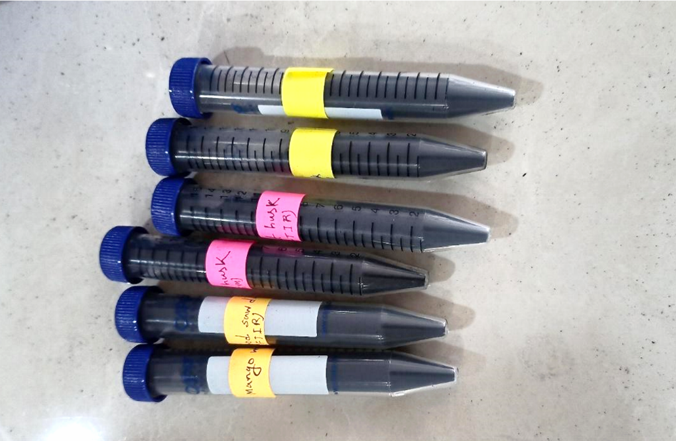
Figure 5: Fine powder sample of BC images for FTIR analysis
ATR-FTIR methods utilize IR-transparent crystals, which are called internal reflection elements (IRE) of different size, shape, and chemical composition, that allow the IR signal to reflect off at least one surface into the sample medium, which could be a pressed sample, in contact with the crystal. The depth of penetration is determined by the index of refraction of the IRE. The larger the index of refraction, the shallower/shorter the penetration depth. A teach reflection, a portion of the IR signal penetrates into the sample and effectively probes the sample. Depending on the type of crystal and angle of incidence, the effective penetration depth at each reflection is 1–2 μm. ATR-FTIR spectra of biochars can be obtained rapidly, and the method lends itself to high-throughput analysis. Similar to DR-FTIR methods, ATR-FTIR methods are being used to characterize.
3.5 Specimen preparation for BET analysis:
BET analysis needs a clean, very pure, quite dry sample. Before conducting analysis, samples were left in a desiccator and oven at low temperature for ensuring as they had as less remaining water vapor as possible [39].

Sample preparation for BET analysis
Sample Weight = 2.4602 g before outgassing.
Sample Weight = 2.4152 after outgassing
Sample outgassed to 20 microns vacuum at 150 C
Rice husk biochar Sample preparation for BET analysis:
Sample Weight = 2.5004 g before outgassing
Sample Weight = 2.438 g after outgassing
Sample outgassed to 20 microns vacuum at 1500 C
List 1- Coconut shell biochar Sample preparation for BET analysis
4. Characterization
4.1 X-ray diffraction:
Crystalline materials possess a highly ordered arrangement of ions or molecules organized in a repeating three-dimensional lattice, whereas amorphous solids lack long-range periodicity, although they may exhibit short-range order. Upon interaction with X-rays, the electrons within a crystalline material are stimulated to oscillate, thereby acting as sources of secondary wave emissions that share the same frequency and wavelength as the incident radiation. These secondary waves propagate outward from individual atoms and interfere with one another, resulting in patterns of constructive and destructive interference. In certain directions, wave cancellation occurs, leading to diminished intensity (destructive interference), while in others, wave reinforcement produces regions of enhanced intensity (constructive interference). Constructive interference is particularly pronounced when the interplanar spacings are comparable to the wavelength of the incident X-rays, and the periodic atomic arrangement amplifies this diffraction effect. X-ray diffraction (XRD) patterns arise from variations in interplanar spacing within the crystal lattice, rendering each crystalline material uniquely identifiable. The angular positions of diffraction peaks are directly related to lattice spacings and can be described by Bragg’s law: nλ = 2d₍hkl₎ sinθ where n represents the order of reflection, λ is the wavelength of the incident X-ray, d₍hkl₎ denotes the spacing between crystallographic planes indexed by (hkl), and θ is the angle between the incident beam and the diffracting plane. Regarding instrumentation, a typical laboratory X-ray diffractometer comprises three principal components: an X-ray source, a sample holder, and a detector. In powder diffraction studies, X-rays with wavelengths on the order of ~0.15 nm are commonly employed. These X-rays are generated within an evacuated tube by accelerating electrons, emitted from a tungsten filament (cathode), toward a metal target (anode) under a high voltage potential. The resulting high-energy electron bombardment ejects inner-shell electrons from the target atoms, prompting outer-shell electrons to transition to lower energy states. This process produces characteristic X-ray radiation specific to the anode material (e.g., Cu or Co), superimposed on a continuous background spectrum known as bremsstrahlung or white radiation. For diffraction applications, a monochromatic beam is selected from the emitted spectrum using filters or crystal monochromators. The collimated X-ray beam is then directed onto the sample, where interaction with the crystalline structure produces a diffraction pattern characteristic of the material. During measurement, the sample is oriented at an angle θ relative to the incident beam, while the detector is positioned to collect diffracted rays at an angle of 2θ. Both the sample and detector are scanned synchronously to maintain the θ–2θ relationship over a defined angular range. This coordinated movement is facilitated by a goniometer. Modern XRD systems utilize a variety of detector technologies, including gas proportional counters, scintillation detectors, solid-state detectors, and charge-coupled device (CCD) detectors, to accurately record diffraction intensities.
4.2 Nano particle analyzer and zeta potential
Dynamic Light Scattering: Dynamic light scattering refers to the measurement and interpretation of light scattering data on a microsecond time range. DLS can be used to determine
1. Particle/molecular size
2. Size distribution DLS optics:
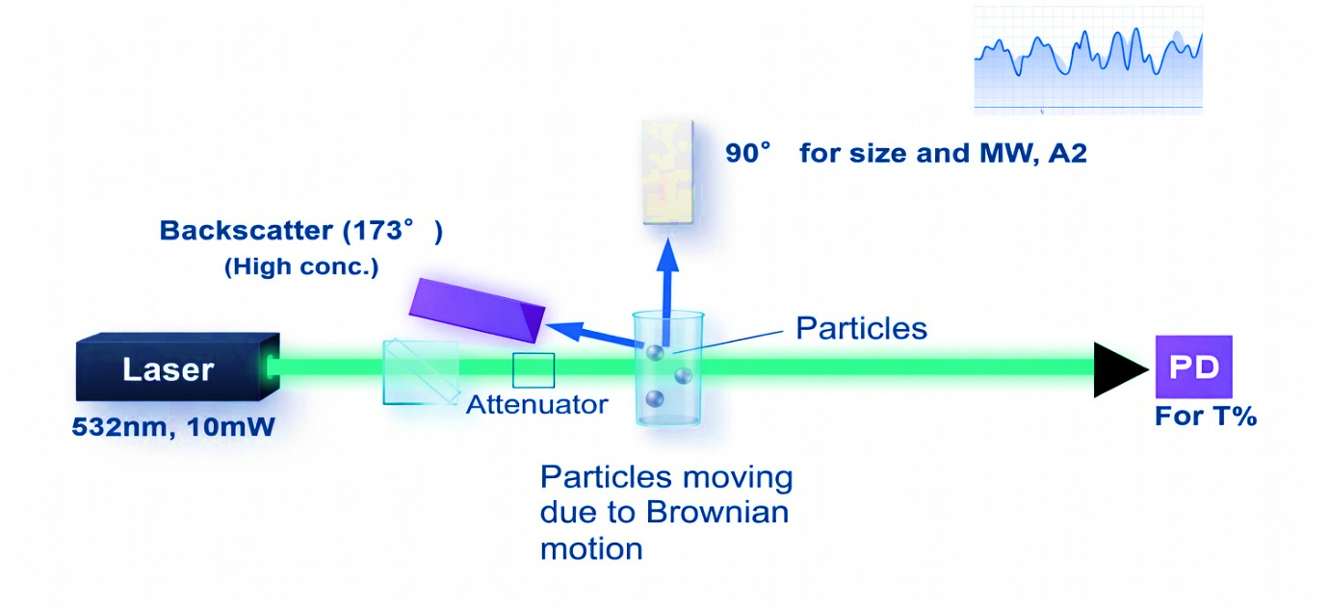
Figure 6: Mechanism of DLS optics

4.3 Brownian motion
Particles in suspension undergo Brownian motion (random thermal motion)
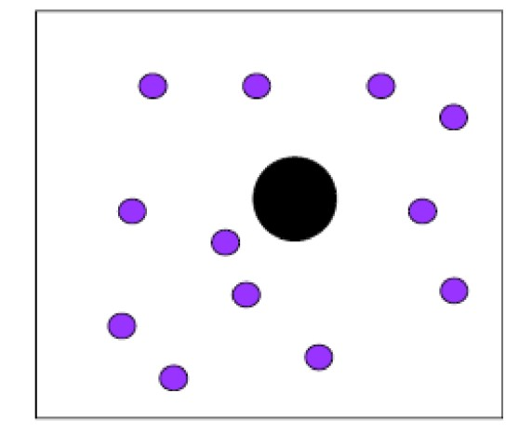

Figure 7: Brownian motion

Brownian motion is connected to Size, viscosity, and Temperature.
4.4 DLS signal
Irregular motion of particles targets random fluctuations in the signal due to the changing constructive and destructive interference of scattered light.
4.4.1 Stokes Einstein
In the Relation of Particle Size to Particle Motion, the particles that are small in suspension undergo random thermal motion is known as Brownian motion. The Stokes-Einstein equation. This random motion is modeled by. Here is the equation is given used for particle size analysis.

$D_{h}$= $\frac{k_{B}T}{3πηD_{t}}$

Dynamic light scattering measures the Stokes-Einstein relation that connects the diffusion coefficient to particle size. Where
● D_{h} is the hydrodynamic diameter
● D_{t} is the translational diffusion coefficient kB is Boltzmann’s constant (we know this)
● T is thermodynamic temperature
● η is dynamic viscosity, the calculations are handled by instrument software.
But the point of this equation is a good reminder of a few things. Firstly, sample temperature is very important, and it actually shows up explicitly in this equation. This fact is amplified by the presence of viscosity, since viscosity is an extremely strong function of temperature. Most importantly, though, it serves as a reminder for the analyst that the particle size determined via dynamic light scattering is the hydrodynamic size. The particle size, therefore, determined by this method is equal to the size of a sphere that will diffuse identically to the actual particle. Those working with the field of protein sizing and others who prefer hydrodynamic radius, take note that the equations developed above were done using diameters. The equations for radius are identical, only off by a factor of two. And lastly, some additional notes for those interested in studying polymer sizes. The hydrodynamic radius is not the same as the radius of gyration. The difference between the two is that the hydrodynamic radius is much easier to measure and over a broader range of particle sizes. However, there is no universal relationship between the two.
4.4.2 Dynamic Light Scattering Optical Setup
A top view of the optical setup for DLS is shown below.
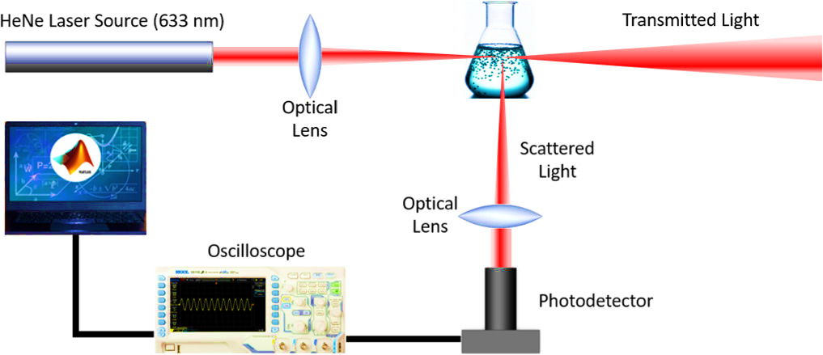

Figure 8: Dynamic light scattering optical setup.

Laser light emitted by the source falls on the sample present in the cell. The scattering signal is detected using either of two detectors placed at an angle of 90 degrees (at right angles) and 173 degrees (back angle) to the direction of incident light. The availability of two detectors facilitates the selection of measurement parameters. Particle dispersion may be performed in different liquids. The refractive index and viscosity of the liquid should be known for the interpretation of measurement results.
The detected signal represents random fluctuations caused by a random change in the relative position of particles.
This is shown schematically in the graph below.
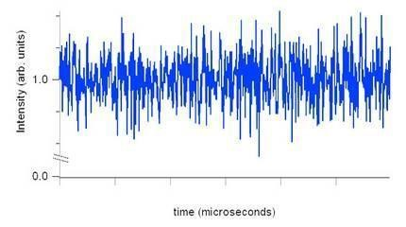
Figure 9: Optical signal on a microsecond timescale from a nanoparticle sample.

The observed “noise” actually results from the movement of particles and is used to determine their size. Unlike laser diffraction, dynamic light scattering (DLS) measurements are usually performed at a single angle, though using multiple angles can provide additional insights. The method is entirely noninvasive, meaning particle motion occurs naturally regardless of whether DLS is applied. The fluctuations in the signal are caused by the particles’ random Brownian motion. How this random signal is analyzed is explained in the following section on determining particle motion.
4.4.3 Dynamic Light Scattering Data Interpretation
The signal can be operated in terms of an autocorrelation system. Obtaining the result is processed in real time with a signal processing device called as a correlator and the autocorrelation function as a function of delay time, τ, is extracted.
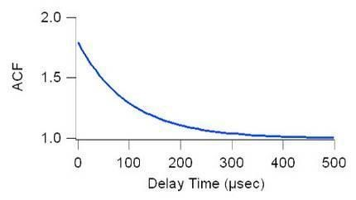
Figure 10: DLS data interpretation

In dynamic light scattering (DLS), the autocorrelation function describes how the scattered light signal changes over time, and its rate of decay is used to determine particle size. A faster decay indicates smaller particles, while a slower decay corresponds to larger ones. For a sample with particles of uniform size, the baseline-corrected autocorrelation function CCC follows a simple exponential decay:
$C=\exp{(-2Γτ}$)

Autocorrelation function exponential decay. The decay constant is directly proportional to the diffusion coefficient. The value of Γ can be easily obtained from experimental results through curve fitting. Diffusion coefficient can be found using Γ=Dtq2 relation, where q is the scattering vector and equals q = (4πn/λ)sin(θ/2). Liquid refractive index is equal to n, laser light wavelength is λ, and scattering angle is equal to θ. Now it is necessary to substitute Dt in the previous formula and find the particle size.
4.5 Analyzing Real Particle Size Distributions I
The cumulants method extends dynamic light scattering (DLS) analysis to main samples that remain particles of varying dimensions. Instead of a simple exponential decay, the autocorrelation function is expressed as a series expansion, but a decay constant can still be extracted and used to estimate particle size. In this approach, the calculated size is called the z-average size, which represents an average value derived from the data. However, this average is not straightforward—it is based on the intensity-weighted diffusion coefficient. Since the diffusion coefficient is inversely related to particle size, this corresponds to an intensity-weighted harmonic mean size.
Although this identification is more complex and differs from other averages (such as the z-average radius of gyration used in polymer studies), the z average size still increases with increasing particle size and is very easy to measure reliably. Because of its consistency and practicality, it has become the standard measure for particle sizing in DLS.
4.5.1 Analyzing Real Particle Size Distributions II
Though it would require an extensive discussion outside the boundaries of this paper, information on the size distribution can be extracted from the DLS measurements. It is feasible to derive an electric field autocorrelation function, g1(τ), from the observed autocorrelation function. Utilize the formula below that relates the electric field autocorrelation function, g1(τ), to the scattered light intensity, S, for all the potential decay rates, Γ. The electric field autocorrelation function will then become an average of the decays from all particles present in the system.
$g_{1}$(τ)=$\int{S\left(Γ\right)\exp\left(-Γτ\right)dΓ}$

The electric field autocorrelation function is considered to be the total of exponential decays. The relation between decay constants and particle size is inversely proportional. The inversion of the equation, or the use of experimentally measured g1(τ) to obtain values of S(Γ), will result in data concerning the particle-size distribution. This method, unlike the calculation of cumulants described above, poses an inverse mathematical problem. Nevertheless, it is still applicable in analyzing DLS measurements.
4.6 SEM analysis
A scanning electron microscope (SEM) forms highly detailed images by using electrons instead of light, allowing for much higher resolution and greater depth of field than conventional optical microscopes. Since its invention, SEM has become an essential tool in fields such as medicine and materials science, enabling researchers to study samples with exceptional clarity. It works by producing a focused electron beam from an electron gun, which passes through electromagnetic lenses within a vacuum chamber. When the beam interacts with the sample, it emits electrons and X-rays that are detected to provide information about the sample’s surface features, composition, and structure.
Because SEM operates in a vacuum, samples require careful preparation. Moisture must be removed to avoid vaporization, and non-conductive samples are coated with a moderately thin metallic layer, typically Au, using a sputtering process. In this process, argon ions knock gold atoms from a target, which then deposit onto the surface of the sample. During analysis, the beam of electron scans the specimen in a raster pattern, while detectors collect secondary and backscattered electrons, as well as X-rays, to produce detailed, three-dimensional-like images. Thanks to its ability to reveal topographical, compositional, and crystallographic details, SEM remains a vital technique in modern research.
4.7 Fourier Transforms Infra-Red spectroscopy (FTIR)
Fourier Transform Infrared Spectroscopy (FTIR) measures infrared spectra by recording an interferogram and converting it into a spectrum using the Fourier transformation. Infrared light passes through an interferometer, interacts with the sample, and the resulting signal is processed to reveal molecular information.
The system includes an infrared source, interferometer, sample interface, and detector. In this study, a Shimadzu IR Prestige-21 with a ZnSe crystal was used, scanning 400–4000 cm⁻¹ with 128 scans. Background correction and multiple replicates ensured accurate results.
4.8 BET (Brunnauer, Emmett, and Teller) analysis
BET (Brunauer–Emmett–Teller) analysis is a technique to measure the specific surface area and porosity of solid materials, particularly porous substances such as biochar and catalysts. It relies on the multilayer adsorption of gases, commonly nitrogen, onto the material’s surface. Before analysis, the sample is degassed to eliminate moisture and contaminants, after which gas adsorption is recorded at different relative pressures. The resulting adsorption–desorption isotherms are evaluated using the BET equation to determine surface area, volume of pore, and distribution of pore size. This method provides essential insights into surface properties that affect adsorption behavior, catalytic performance, and other material characteristics.
5. Result and discussion
5.1 XRD analysis of bio-char
Biochar samples were very finely ground by hand using an agate pestle and mortar. A Philips X’Pert MPD diffractometer equipped with a PW3050 goniometer (Cu Kα radiation) was used to perform X-ray powder diffraction. The X-ray tube was energized at 40 KV and 30 mA. The synthesize samples were scanned from 5.0100ᵒ to 74.9900ᵒ two theta using a step size of 0.0200ᵒ two theta and a scan speed of 0.3000 seconds. The diffraction patterns were processed using X’Pert Data Collector software. Some of the XRD patterns of biochar are shown in the figure.
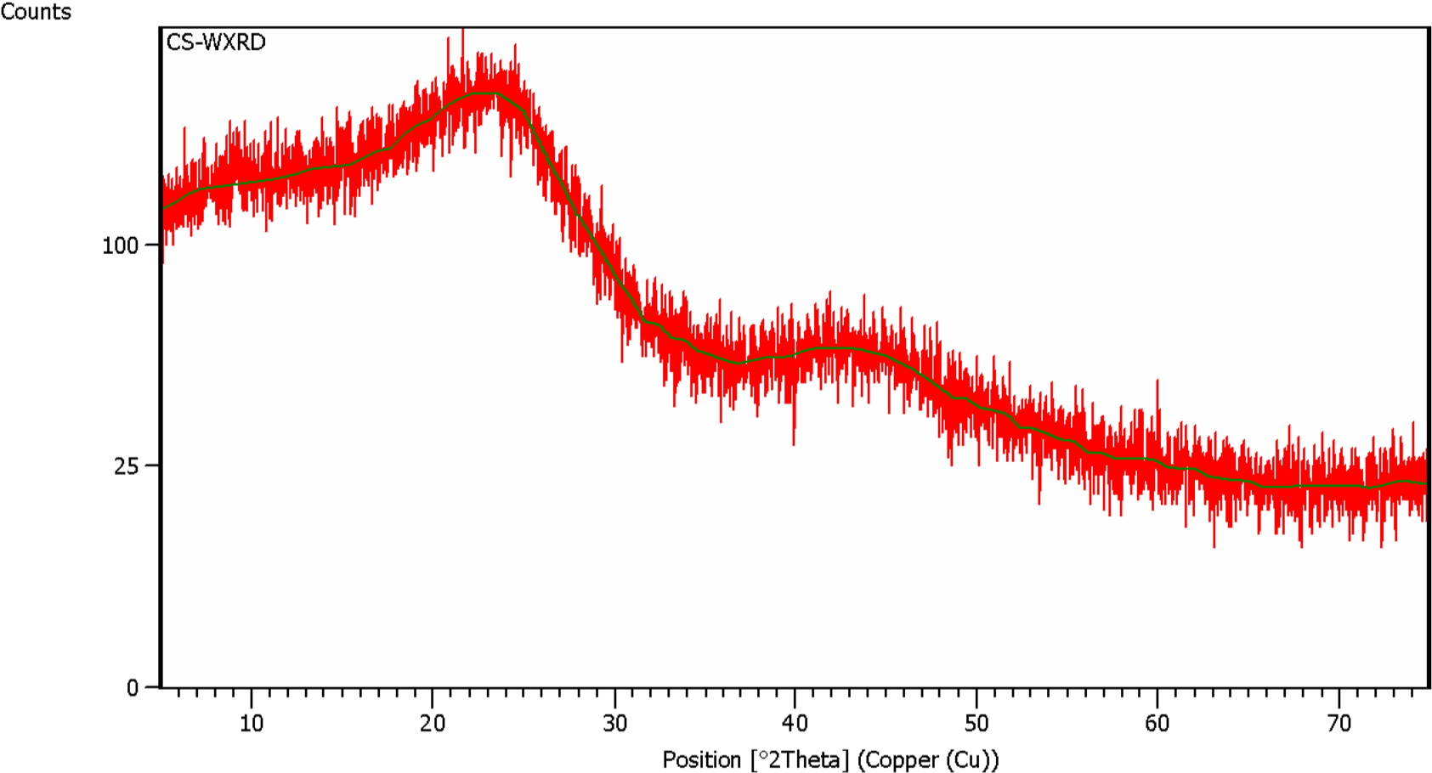
Figure 11: XRD pattern of Coconut Shell Biochar samples
The graph shows a broad "halo" centered around 22° to 24°, which is typical for polymers, indicating the presence of crystalline inorganic phases within the coconut shell matrix. Because there are no sharp crystalline reflections, the values for FWHM and d-spacing represent the broad amorphous humps rather than specific lattice planes.
Table 1: Estimation of the primary peaks (broad maxima) observed in the data
2θ [°] | Height [cps] | FWHM [°] | d-spacing [A°] | Rel. Int. [%]
23.15 | 165.0 | 8.50 | 3.838 | 100.00
43.80 | 62.0 | 12.00 | 2.065 | 37.58
The X-ray Diffraction (XRD) pattern of the sample exhibits a predominantly amorphous profile, characterized by two broad, diffuse halos rather than sharp Bragg reflections. The primary hump (2θ ≈ 23.15°, d = 3.838 Å) is attributed to the (110) and (020) planes, reflecting the short-range ordering of the polymeric chains. A secondary, broader maximum at (2θ ≈ 43.80°, d = 2.065 Å) further confirms the disordered atomic arrangement within the matrix.
High Full Width at Half Maximum (FWHM) values of 8.50° and 12.00° underscore a low degree of crystallinity and significant structural disorder. This "open" molecular framework is highly advantageous for photocatalytic and antimicrobial applications, as the amorphous morphology enhances surface area and facilitates the diffusion of reactants to active sites [40].
Table-2: Calculated Crystallographic Structural Parameters of the CS Sample
Parameter | Value
Peak center (2θ) | 23.15°
d-spacing value (d) | 3.838 A°
Crystallinity Index (CI) | 30.3 %
Inter-chain separation (R) | 4.798 A°
The XRD parameters confirm that the coconut shell (CS) imparts a predominantly amorphous character to the material, reflected by the low Crystallinity Index (CI) of 30.3%. This disorder stems from the lignin and hemicellulose components of the shell, which disrupt the cellulose lattice.
The peak at 23.15°, d-spacing of 3.838 Å, and inter-chain separation (R) of 4.798 Å collectively describe a loosely packed, open-framework structure. This morphology is ideal for functional use, as the disordered CS matrix provides high surface area and accessible sites for nanoparticle stabilization or adsorptive applications.
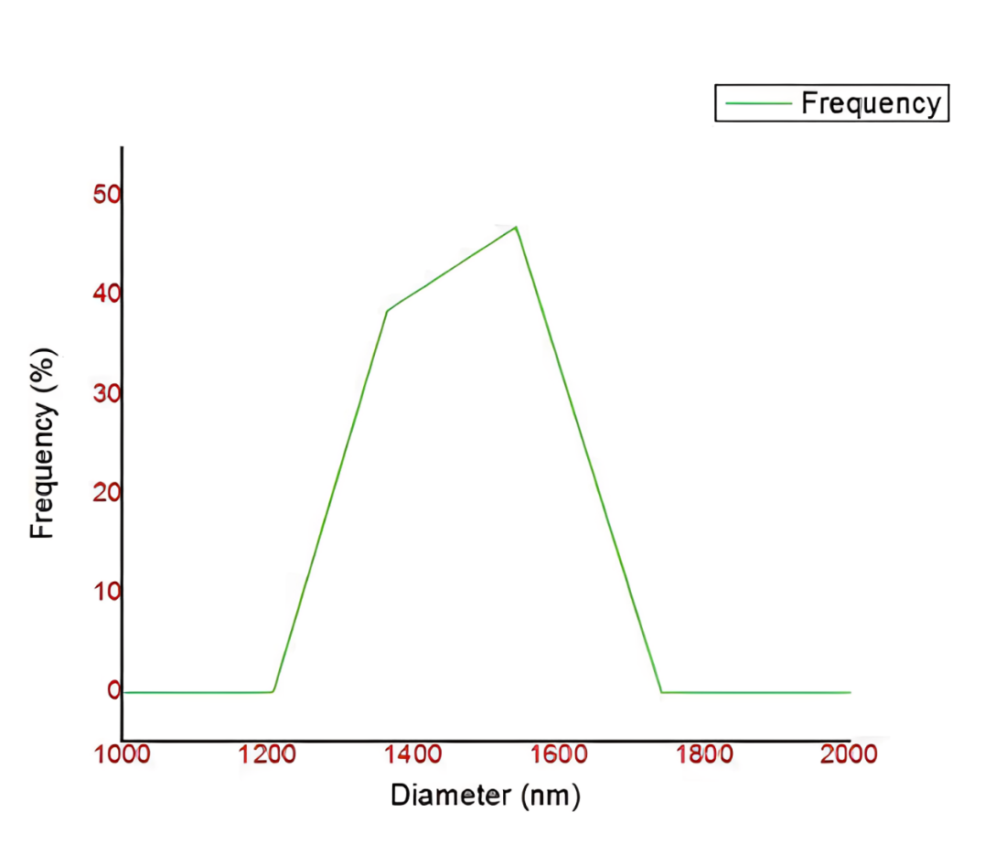
Figure 12: Nanoparticle analysis of Coconut shell biochar
Around 1200 nm to 1800 nm, coconut shell biochar is successfully prepared, and its frequency versus diameter curve is shown above, which is analyzed by the DLS principle from Horiba Scientific Nano particle analyzer. Its maximum frequency is 45%.
The particle size distribution reveals a unimodal and relatively narrow profile, centered at approximately 1550 nm (1.55 µm). The particles range from 1200 nm to 1750 nm, with the dominant peak representing nearly 47% of the population. This homogeneity suggests that the coconut shell (CS) matrix effectively serves as a stabilizing template, preventing uncontrolled macroscopic agglomeration [41].
From a functional perspective, this micron-scale size is highly advantageous [42]. While maintaining an active surface area, these stable micro-clusters offer superior mechanical stability and easier post-reaction recovery via filtration or centrifugation. This makes the material particularly appropriate for sustainable, large-scale implementation in photocatalysis and treatment of wastewater.
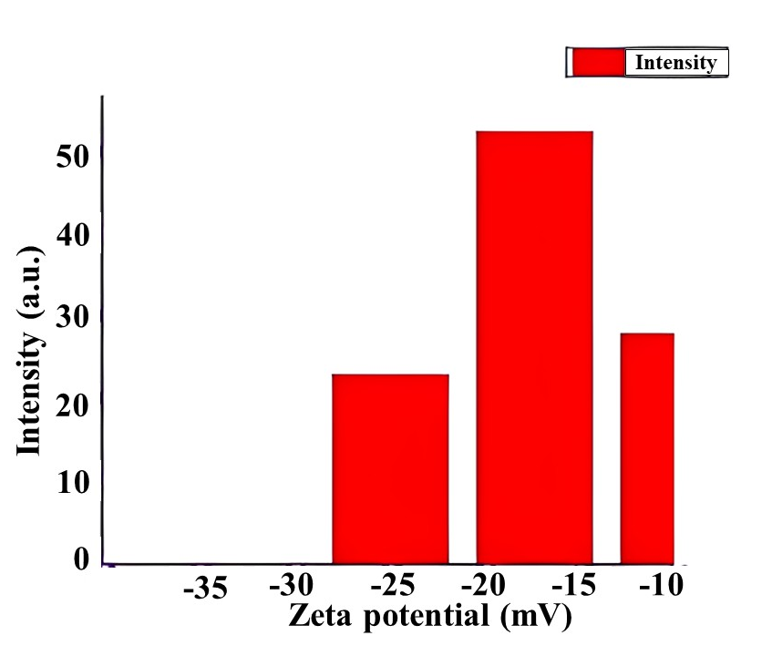

Figure 13: Zeta potential analysis of Coconut shell Biochar
Here, the temperature of the Holder, Dispersion Medium Viscosity, Conductivity, Electrode Voltage are respectively 25.1 °C, 0.893mPa·s, 0.694 mS/cm, 3.3V, and Peak 1 Zeta Potential is 17mV and Zeta Potential (Mean) is -17 mV. The zeta potential analysis reveals a distinctly negative surface charge ranging from -28 mV to -11 mV, with a dominant peak centered between -20 mV and -15 mV. An average value of approximately -17.5 mV characterizes the sample as a meta-stable colloid. Functionally, this negative charge—likely arising from hydroxyl and carboxyl groups—is highly advantageous. It facilitates strong electrostatic interactions, making the material an excellent candidate for the adsorption of cationic pollutants, such as heavy metal ions and dyes, in environmental remediation applications.
5.4 SEM analysis images of Bio-char:
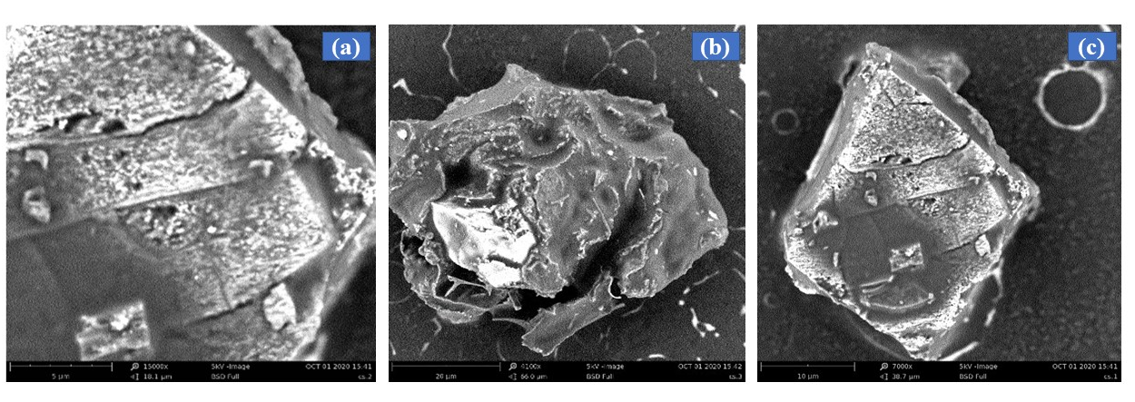
Figure 14: Surface Topography and Morphological Characteristics of the Coconut Shell (CS) Matrix.
The surface structure and architectural features of the synthesized sample were determined using Scanning Electron Microscopy (SEM) [43]. The micrographs reveal a heterogeneous, rugged topography characteristic of processed lignocellulosic biomass [44].
As shown in Figure (a), the surface exhibits a distinct layered, plate-like arrangement with visible micro-cracks and grooves, reflecting the internal structural hierarchy of the coconut shell's cellular framework. Figure (b) illustrates the highly irregular and porous nature of the particles; this jagged, fractured surface is crucial for increasing the effective surface area available for chemical interactions. In Figure (c), a prominent polyhedral micro-cluster is observed, showing a coarse texture with ridges that act as potential "anchor sites." Collectively, these SEM observations confirm that the coconut shell provides a complex, high-surface-area matrix. The combination of porous cavities and rough surface textures makes this material an ideal substrate for nanoparticle stabilization and the electrostatic adsorption of environmental pollutants, supporting the data obtained from zeta potential and XRD analyses.

  - FTIR analysis of bio-char:
The samples were ground and mixed with KBR or run as neat powders for ATR- FTIR analysis. For this analysis, samples were run as non-diluted powder on the surface. In this studies ATR- FTIR was done and FTIR graph of different bio-char is shown figure
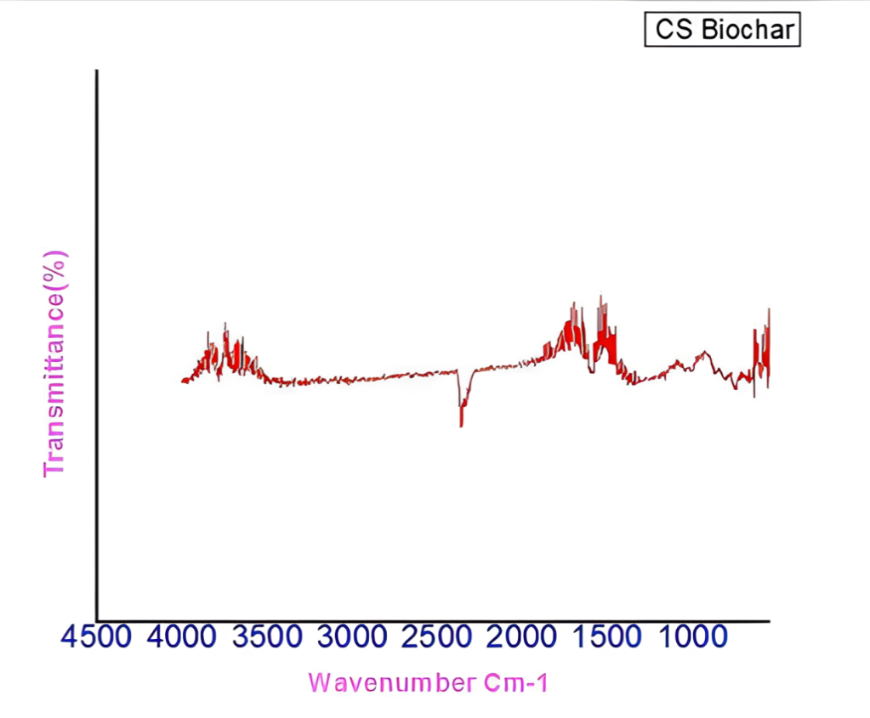
Figure 15: FTIR spectra of coconut shell bio-char sample

Peaks between 1400 cm-1 and 900cm-1 are generally attributed to lignin, mainly due to rings of type C=C [19]; these peaks are slightly more pronounced than those found for hemicellulose and cellulose, which can be attributed to the degradation of lignin at temperatures between 200 °C and 700 °C.
The FTIR spectrum of the Coconut Shell (CS) Biochar confirms the development of a functionalized carbon framework. The broad band at 3400–3600 cm⁻¹ represents hydroxyl (-OH) groups, while peaks near 2900 cm⁻¹ indicate residual aliphatic C-H stretching from the biomass precursor. The presence of aromatic C=C and carbonyl (C=O) groups in the 1500–1700 cm⁻¹ region identifies the formation of a stable aromatic backbone [45]. The signal at 2350 cm⁻¹ is a standard atmospheric CO₂ artifact. Below 1000 cm⁻¹, C-O stretching vibrations confirm that the surface remains chemically active [46]. Collectively, these functional groups act as critical "anchor sites" for nanoparticle stabilization and the adsorption of pollutants.

5.7 BET analysis of biochar:
5.7.1 Cumulative surface area (cc/g) vs diameter (angstrorm) – BJH Desorption for Coconut Shell BC:

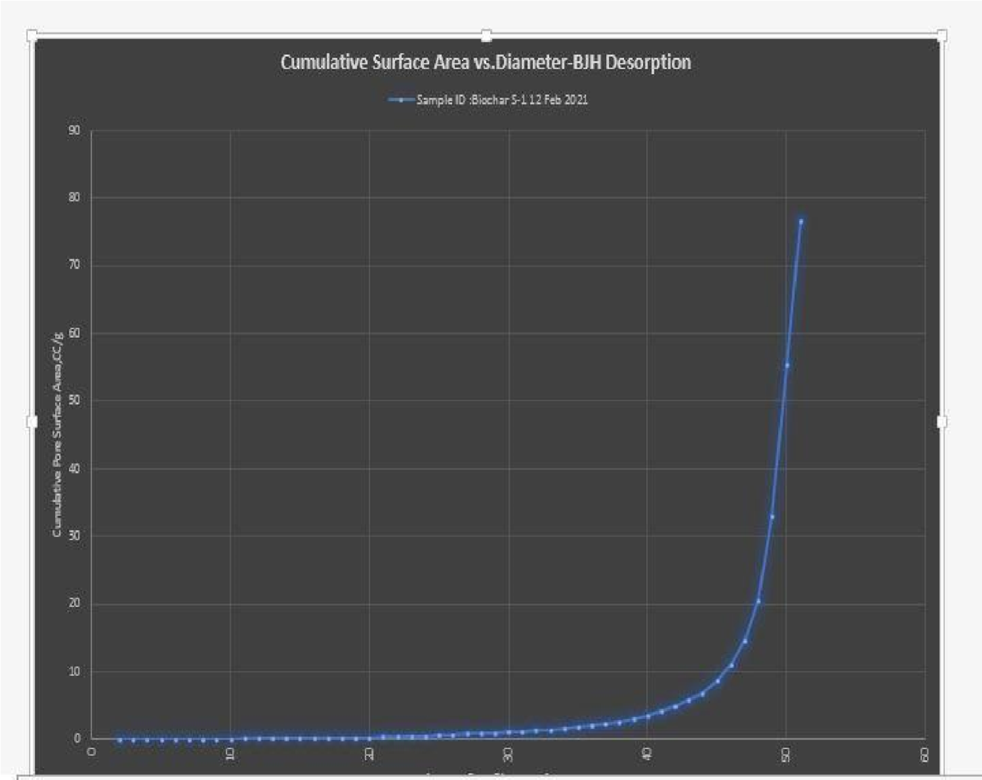
Figure 16: Cumulative surface area (cc/g) vs diameter (angstrorm) – BJH Desorption for Coconut Shell BC
The pore structure of the CS Biochar was characterized using the BJH (Barrett-Joyner-Halenda) desorption method to evaluate the cumulative surface area relative to pore diameter. The resulting curve indicates a predominantly mesoporous to macroporous framework, with negligible surface area contribution from pores smaller than 40 nm. A dramatic, exponential rise in the cumulative pore surface area occurs between 40 nm and 51 nm, peaking at approximately 77 cc/g. This sharp increase within a narrow window suggests a highly uniform distribution of large mesopores [47]. In the context of the coconut shell matrix, this architecture likely represents the inter-particle voids and the preserved vascular channels of the original biomass. From a functional standpoint, this "open-channel" morphology is highly advantageous. The absence of restrictive micropores minimizes mass-transfer limitations, allowing for the rapid diffusion of large molecular species—such as organic dyes or heavy metal complexes—to active sites [48]. This pore hierarchy ensures that the biochar maintains excellent kinetic performance in adsorption and photocatalytic applications, facilitating fast transport while providing a stable structural platform.
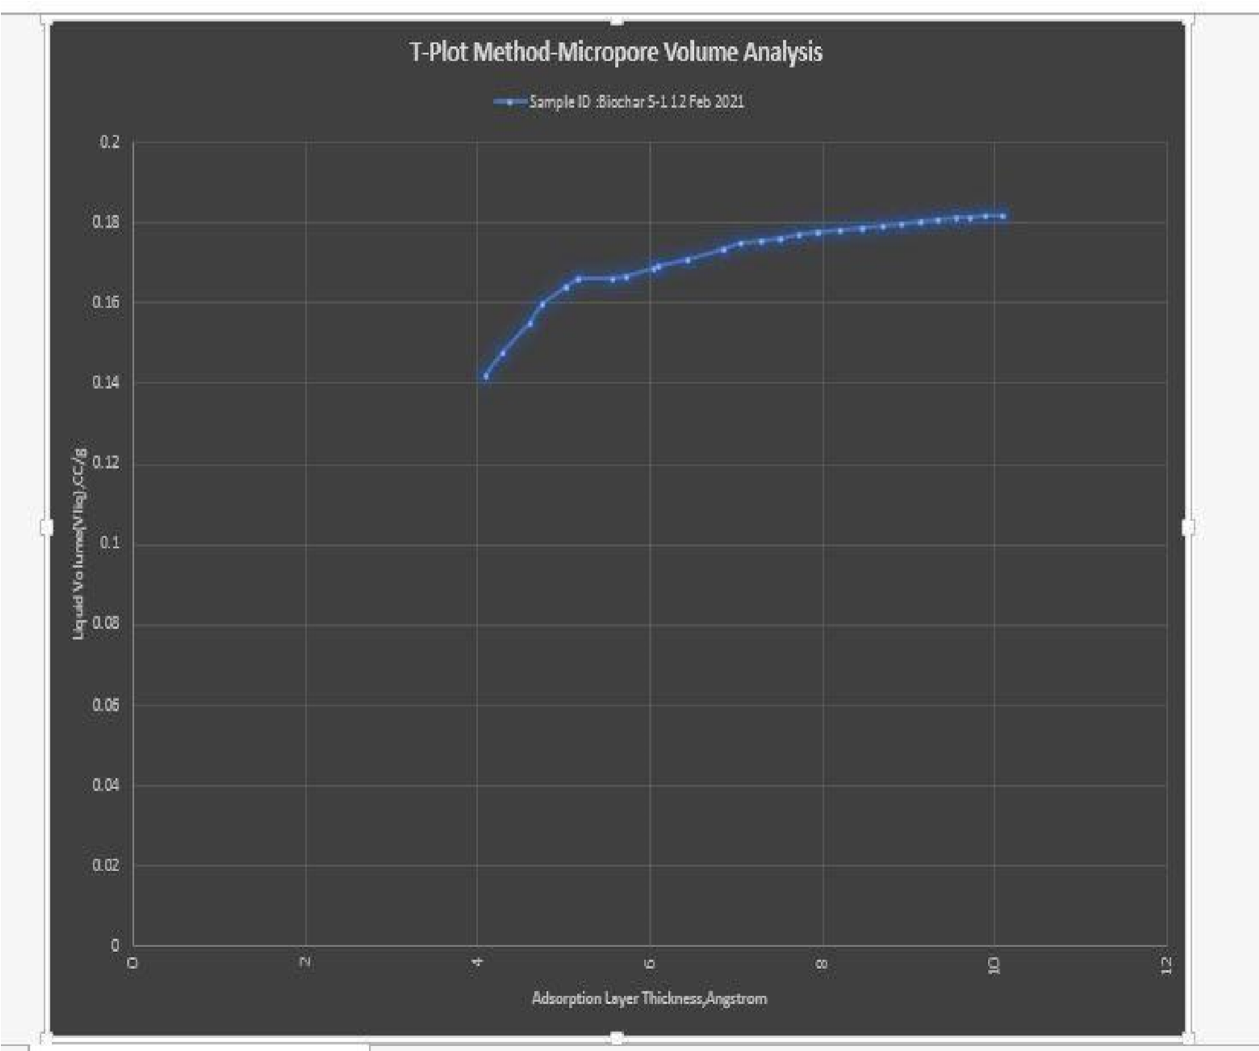
Figure 17: Liquid volume vlq (cc/g) vs adsorption layer thickness (angstrom) for coconut shell BC
The microporous characteristics of the CS Biochar were evaluated using the t-plot method to differentiate internal volume from external surface area [49]. The generated plot of liquid volume versus adsorption layer thickness (t) exhibits a distinctive profile for these samples. A linear regression was applied to the upper thickness range (>5 Å), where multi-layer adsorption dominates. The positive slope of this linear fit reveals a significant external or mesoporous surface area. However, the curve demonstrates a strong positive y-intercept, which is indicative of a robust contribution from micropores (<2 nm). Based on the intercept value on the volume axis, the total micropore volume is approximately 0.13 cc/g, representing a significant fraction of the total porosity within the CS carbon matrix. This high microporosity, typical of steam-activated coconut shell, is a crucial finding, as it is the primary source of the material's large specific surface area and explains its exceptional high-capacity adsorption for small molecules, such as hazardous gases or metal ions.
6. Conclusions
This study demonstrates that coconut shell–derived biochar is a highly promising, sustainable material with significant potential for environmental remediation applications. Controlled pyrolysis at 600°C produced a structurally stable biochar with desirable physicochemical characteristics. The material exhibited a predominantly amorphous carbon framework with a low crystallinity index (30.3%), indicating a highly disordered structure that enhances adsorption performance. The presence of a hierarchical pore architecture, including a cumulative pore volume of ~77 cc g⁻¹ and a micropore volume of ~0.13 cc g⁻¹, provides efficient pathways for mass transfer and abundant active sites. Particle size analysis revealed a relatively uniform distribution centered at ~1550 nm, while the negative surface charge (≈ −17 mV) suggests favorable electrostatic interactions with cationic pollutants. Furthermore, FTIR analysis confirmed the presence of oxygen-containing functional groups (–OH, C=O) and aromatic structures, which play a critical role in surface reactivity and contaminant binding. These combined structural, chemical, and electrokinetic properties contribute to the material’s high adsorption capacity and stability. Overall, the findings highlight coconut shell biochar as a cost-effective, scalable, and environmentally friendly alternative to conventional adsorbents. Future work should focus on surface modification strategies and real wastewater validation to further enhance performance and facilitate large-scale implementation.

7. Reference

[1] | Harris, P. (1999). On charcoal. Interdisciplinary Science Reviews, 24(4), 301-306.
[2] | Kuhlbusch, T. A. J., & Crutzen, P. J. (1995). Toward a global estimate of black carbon in residues of vegetation fires representing a sink of atmospheric CO2 and a source of O2. Global Biogeochemical Cycles, 9(4), 491-501.
[3] | Schmidt, M. W., & Noack, A. G. (2000). Black carbon in soils and sediments: analysis, distribution, implications, and current challenges. Global biogeochemical cycles, 14(3), 777-793.
[4] | Lehmann, J., Gaunt, J., & Rondon, M. (2006). Bio-char sequestration in terrestrial ecosystems–a review. Mitigation and adaptation strategies for global change, 11(2), 403-427.
[5] | Zhao, S. X., Ta, N., & Wang, X. D. (2017). Effect of temperature on the structural and physicochemical properties of biochar with apple tree branches as feedstock material. Energies, 10(9), 1293.
[6] | Bettendorf, T., Wendland, C., & Schuetze, T. (2015). Chapter III: Terra Preta Sanitation systems and technologies. Terra Preta Sanitation, 62.
[7] | Mukherjee, A., Zimmerman, A. R., & Harris, W. (2011). Surface chemistry variations among a series of laboratory-produced biochars. Geoderma, 163(3-4), 247-255.
[8] | Lehmann, J. (2009). Terra preta Nova–where to from here. Amazonian dark earths: Wim Sombroek’s vision, 473-486.
[9] | Robertson, G. P., & Swinton, S. M. (2005). Reconciling agricultural productivity and environmental integrity: a grand challenge for agriculture. Frontiers in Ecology and the Environment, 3(1), 38-46.
[10] | Carpenter, B. H. (2014). Biochar's fitness as an amendment in bell pepper transplant and field production (Master's thesis, Iowa State University).
[11] | Desouky, M. M., Abou-Saleh, R. H., Moussa, T. A., & Fahmy, H. M. (2025). Nano-chitosan-coated, green-synthesized selenium nanoparticles as a novel antifungal agent against Sclerotinia sclerotiorum: in vitro study. Scientific Reports, 15(1), 1004.
[12] | Matteson, G. C., & Jenkins, B. M. (2005). Food and processing residues in California: Resource assessment and potential for power generation. In 2005 ASAE Annual Meeting (p. 1). American Society of Agricultural and Biological Engineers.
[13] | Ackerman, F. (2000). Waste management and climate change. Local Environment, 5(2), 223-229.
[14] | Bicudo, J. R., & Goyal, S. M. (2003). Pathogens and manure management systems: a review. Environmental technology, 24(1), 115-130.
[15] | Lehmann, J. (2007). A handful of carbon. Nature, 447(7141), 143-144.
[16] | Joseph, S., Xu, C. Y., Wallace, H. M., Farrar, M., Nguyen, T. N., Bai, S. H., & Solaiman, Z. M. (2017). Biochar production from agricultural and forestry wastes and microbial interactions. In Current developments in biotechnology and bioengineering (pp. 443-473). Elsevier.
[17] | Brewer, C. E., & a Brown, R. C. L. D. (2012). Biochar characterization and engineering, Grad. Teses Diss, 12284.
[18] | Musyimi, S. M. (2016). Production and characterization of mango (Mangifera indica) fruit wine (Doctoral dissertation, Food Science and Technology, JKUAT).
[19] | Kumar, H., Cai, W., Lai, J., Chen, P., Ganesan, S. P., Bordoloi, S., ... & Mei, G. (2020). Influence of in-house produced biochars on cracks and retained water during drying-wetting cycles: comparison between conventional plant, animal, and nano-biochars. Journal of Soils and Sediments, 20(4), 1983-1996.
[20] | Chen, Z., Xiao, X., Chen, B., & Zhu, L. (2015). Quantification of chemical states, dissociation constants and contents of oxygen-containing groups on the surface of biochars produced at different temperatures. Environmental science & technology, 49(1), 309-317.
[21] | Marmiroli, M., Bonas, U., Imperiale, D., Lencioni, G., Mussi, F., Marmiroli, N., & Maestri, E. (2018). Structural and functional features of chars from different biomasses as potential plant amendments. Frontiers in plant science, 9, 1119.
[22] | LUN, L. W. (2016). ADSORPTION OF COPPER (II) ION BY PALM OIL SLUDGE BIOCHAR PREPARED BY PYROLYSIS: EQUILIBRIUM AND KINETIC STUDIES.
[23] | Alam, M. S., Khanom, R., & Rahman, M. A. (2015). Removal of Congo red dye from industrial wastewater by untreated sawdust. American Journal of Environmental Protection, 4(5), 207-213.
[24] | Barry, D., Barbiero, C., Briens, C., & Berruti, F. (2019). Pyrolysis as an economical and ecological treatment option for municipal sewage sludge. Biomass and Bioenergy, 122, 472-480.
[25] | Odubiyi, O. A., Awoyale, A. A., & Eloka-Eboka, A. C. (2012). Wastewater treatment with activated charcoal produced from cocoa pod husk. Int. J. Environ. Bioenergy, 4(3), 162-175.
[26] | Ndirangu, S. M., Liu, Y., Xu, K., & Song, S. (2019). Risk evaluation of pyrolyzed biochar from multiple wastes. Journal of Chemistry, 2019(1), 4506314.
[27] | Ahmad, M., Rajapaksha, A. U., Lim, J. E., Zhang, M., Bolan, N., Mohan, D., ... & Ok, Y. S. (2014). Biochar as a sorbent for contaminant management in soil and water: a review. Chemosphere, 99, 19-33.
[28] | Singh, B., Macdonald, L. M., Kookana, R. S., van Zwieten, L., Butler, G., Joseph, S., ... & Esfandbod, M. (2014). Opportunities and constraints for biochar technology in Australian agriculture: looking beyond carbon sequestration. Soil research, 52(8), 739-750.
[29] | Singh, B., Macdonald, L. M., Kookana, R. S., van Zwieten, L., Butler, G., Joseph, S., ... & Esfandbod, M. (2014). Opportunities and constraints for biochar technology in Australian agriculture: looking beyond carbon sequestration. Soil research, 52(8), 739-750.
[30] | Pattnaik, d., kumar, s., bhuyan, s. K., & mishra, s. C. (2018, march). Effect of carbonization temperatures on biochar formation of bamboo leaves. In iop conference series: materials science and engineering (vol. 338, no. 1, p. 012054). Iop publishing.
[31] | Singh, B., Fang, Y., & Johnston, C. T. (2016). A fourier‐transform infrared study of biochar aging in soils. Soil Science Society of America Journal, 80(3), 613-622.
[32] | Abdulrazzaq, H., Jol, H., Husni, A., & Abu-Bakr, R. (2014). Characterization and stabilisation of biochars obtained from empty fruit bunch, wood, and rice husk. BioResources, 9(2), 2888-2898.
[33] | Buckman, J., Bankole, S. A., Zihms, S., Lewis, H., Couples, G., & Corbett, P. W. (2017). Quantifying porosity through automated image collection and batch image processing: case study of three carbonates and an aragonite cemented sandstone. Geosciences, 7(3), 70.
[34] | Armynah, B., Tahir, D., Tandilayuk, M., Djafar, Z., & Piarah, W. H. (2019). Potentials of biochars derived from bamboo leaf biomass as energy sources: effect of temperature and time of heating. International Journal of Biomaterials, 2019(1), 3526145.
[35] | Naghdi, M., Taheran, M., Brar, S. K., Rouissi, T., Verma, M., Surampalli, R. Y., & Valero, J. R. (2017). A green method for production of nanobiochar by ball milling-optimization and characterization. Journal of Cleaner Production, 164, 1394-1405.

[36] Sahoo, S. S., Vijay, V. K., Chandra, R., & Kumar, H. (2021). Production and characterization of biochar produced from slow pyrolysis of pigeon pea stalk and bamboo. Clean Eng Technol 3: 100101.
[37] Doane, T. L., Chuang, C. H., Hill, R. J., & Burda, C. (2012). Nanoparticle ζ-potentials. Accounts of chemical research, 45(3), 317-326.
[38] Liu, Y., He, Z., & Uchimiya, M. (2015). Comparison of biochar formation from various agricultural by-products using FTIR spectroscopy. Modern Applied Science, 9(4), 246.
[39] Hung, C. Y., Tsai, W. T., Chen, J. W., Lin, Y. Q., & Chang, Y. M. (2017). Characterization of biochar prepared from biogas digestate. Waste management, 66, 53-60.
[40]. Huang, N. Y., Zheng, Y. T., Chen, D., Chen, Z. Y., Huang, C. Z., & Xu, Q. (2023). Reticular framework materials for photocatalytic organic reactions. Chemical Society Reviews, 52(22), 7949-8004.
[41]. Kumar, A., Nirala, A., Singh, V. P., Sahoo, B. K., Singh, R. C., Chaudhary, R., ... & Liu, X. (2023). The utilisation of coconut shell ash in production of hybrid composite: Microstructural characterisation and performance analysis. Journal of Cleaner Production, 398, 136494.
[42]. Lee, N., & Wiegand, S. (2020). Thermophoretic micron-scale devices: practical approach and review. Entropy, 22(9), 950.
[43]. Kavuran, G. (2021). SEM-Net: Deep features selections with Binary Particle Swarm Optimization Method for classification of scanning electron microscope images. Materials Today Communications, 27, 102198.
[44]. Yan, J., Oyedeji, O., Leal, J. H., Donohoe, B. S., Semelsberger, T. A., Li, C., ... & Tanjore, D. (2020). Characterizing variability in lignocellulosic biomass: a review. ACS Sustainable Chemistry & Engineering, 8(22), 8059-8085.
[45]. Socrates, G. (2004). Infrared and Raman characteristic group frequencies: tables and charts. John Wiley & Sons.
[46]. Elgayyar, T., Azzolina-Jury, F., & Thibault-Starzyk, F. (2025). Infrared spectroscopy at the surface of carbonates. Physical Chemistry Chemical Physics.
[47]. Ren, Y., Ma, Z., Morris, R. E., Liu, Z., Jiao, F., Dai, S., & Bruce, P. G. (2013). A solid with a hierarchical tetramodal micro-meso-macro pore size distribution. Nature communications, 4(1), 2015.
[48]. Wu, W., Wang, Y., & Hu, X. (2026). Mass transfer driven pore engineering of activated carbon from the activation of biomass. Green Chemistry, 28(8), 3486-3511.
[49]. Dou, S., Ke, X. X., Shao, Z. D., Zhong, L. B., Zhao, Q. B., & Zheng, Y. M. (2022). Fish scale-based biochar with defined pore size and ultrahigh specific surface area for highly efficient adsorption of ciprofloxacin. Chemosphere, 287, 131962.

