Review Article
Artificial Intelligence for Restoring Land: A Review of Land Degradation Mapping, Climate Change Prediction, and Ecosystem Service Valuation

Abstract

Land degradation, climate change, and declining ecosystem services are increasingly interconnected challenges that threaten ecological integrity, agricultural productivity, and livelihood security across vulnerable landscapes. At the same time, advances in artificial intelligence (AI), remote sensing, geospatial analytics, and large environmental datasets are reshaping the way these challenges can be assessed, predicted, and managed. This review synthesises the current state of knowledge on AI-based applications in three closely linked domains: land degradation mapping, climate change prediction, and ecosystem service valuation. It examines the use of machine learning, deep learning, hybrid geospatial models, and multi-source data integration for detecting degradation hotspots, assessing desertification and vegetation stress, forecasting climate-linked risks such as drought, heat stress, and fire, and estimating ecosystem services including carbon sequestration, soil retention, water regulation, and forage productivity. The review further evaluates the strengths and limitations of existing approaches in terms of scale, data dependency, transferability, uncertainty, and interpretability. Particular emphasis is placed on the emerging potential of AI to integrate these traditionally separate domains into a unified decision-support framework for land restoration, sustainable land management, and climate-resilient planning. The review is expected to highlight key methodological trends, identify knowledge gaps, and propose future directions for more explainable, integrated, and policy-relevant AI applications. Overall, the study positions AI not merely as a technical tool for analysis, but as a strategic enabler for restoration prioritisation, ecosystem resilience, and evidence-based environmental governance.

Keywords: Artificial Intelligence; Land Degradation; Climate Change; Ecosystem Services; Remote Sensing; Sustainable Land Management

1. Introduction

Land degradation, climate change, and the erosion of ecosystem services are increasingly recognised as interconnected challenges that threaten ecological integrity, agricultural productivity, and livelihood security across the world. The IPCC defines land degradation as a negative trend in land condition, caused by direct or indirect human-induced processes, including anthropogenic climate change, and expressed as a long-term reduction or loss of biological productivity, ecological integrity, or value to humans (IPCC, 2019). Similarly, the IPBES land degradation assessment emphasises that combating land degradation and restoring degraded land is an urgent priority for protecting biodiversity, sustaining ecosystem services, and ensuring human well-being (IPBES, 2018). Peer-reviewed syntheses further show that land degradation is associated with a wide range of environmental consequences, including soil loss, water quality deterioration, biodiversity decline, and the degradation of ecosystem service values, thereby affecting both ecological functioning and socio-economic systems (Pacheco et al., 2018).
The relationship between land degradation and climate change is not one-directional. Land degradation is both affected by climate change and contributes to it, creating reinforcing feedbacks across terrestrial systems (IPCC, 2019). Climate change alters temperature regimes, rainfall patterns, evapotranspiration, drought frequency, and the occurrence of extreme events, all of which can intensify soil degradation, vegetation stress, desertification processes, wildfire risk, and hydrological instability. At the same time, climate change affects land-related ecosystem services such as carbon storage, soil conservation, water yield, and resilience to extreme events, thereby weakening the capacity of landscapes to buffer environmental shocks (IPCC, 2019). This linkage is especially important because ecosystem services are not merely ecological outputs; they are the functional basis through which land condition influences food systems, rural livelihoods, and adaptation capacity. As a result, any meaningful assessment of land degradation increasingly requires simultaneous attention to climatic drivers and ecosystem service outcomes.
Over the past decade, the rapid expansion of Earth Observation systems, cloud computing, and geospatial databases has significantly improved the capacity to monitor environmental change over large areas and long time periods. Remote sensing has become central to land degradation assessment because it enables the observation of direct indicators such as soil moisture, organic matter proxies, and surface condition, as well as indirect indicators such as vegetation dynamics and land-use/land-cover change. Wang et al. (2023), in their review of soil degradation monitoring, show that remote sensing offers strong advantages for large-scale and time-efficient assessment, but they also note persistent challenges, including the absence of a universally accepted indicator system, limited shared datasets, and the need for better decision-support integration. In parallel, reviews of artificial intelligence and satellite remote sensing for land-cover change detection indicate that AI-driven approaches are increasingly being used to process high-volume imagery, improve classification performance, and support more dynamic environmental monitoring across scales (Gu & Zeng, 2023). More broadly, surveys of machine learning and deep learning in remote sensing show that the combination of multi-source imagery, GIS, and advanced data-driven models is opening new possibilities for high-resolution interpretation of complex environmental phenomena.
Artificial intelligence is also gaining importance in climate-related prediction, particularly in forecasting and understanding extremes that shape land-system stress. Recent reviews suggest that AI techniques, including machine learning, deep learning, causal discovery, and hybrid physics–AI approaches, have shown considerable promise in improving the prediction of extreme events and in uncovering links between local conditions and larger-scale climatic drivers (Materia et al., 2024). Related reviews further indicate that machine learning and remote sensing are increasingly used for estimating evapotranspiration, drought forecasting, and other hydroclimatic variables relevant to land degradation and ecosystem functioning (Amani et al., 2023). These developments are particularly relevant for restoration science because land degradation is often driven not only by current land use but also by shifting climatic stress, including drought, heat, and fire regimes. Thus, predictive modelling has become as important as retrospective mapping in designing climate-resilient land management strategies.
A parallel shift is visible in ecosystem service research, where machine learning is increasingly being adopted to model, map, and value ecosystem services under complex socio-ecological conditions. Willcock et al. (2018) argue that machine learning can help ecosystem service science make better use of big data, improve the analysis of non-linear relationships, and generate uncertainty estimates that are directly useful for decision-making. Building on this, Scowen et al. (2021) show that machine learning is now used both for descriptive tasks and predictive modelling across ecosystem service applications, although they caution that many studies still lack methodological rigour, transparent reporting, and adequate testing of model generalisability. Manley et al. (2022) similarly conclude that machine learning and big data can help address major research gaps in ecosystem service mapping by reducing data limitations, handling uncertainty more explicitly, and improving the integration of social and biophysical dimensions. These advances suggest that AI can play an important role not only in biophysical assessment, but also in ecosystem service valuation and planning.
Despite these advances, the literature remains largely fragmented. Studies on AI-based land degradation mapping, climate prediction, and ecosystem service valuation have often developed in parallel rather than within a common analytical framework. As a result, there remains limited synthesis of how these domains can be connected to support restoration prioritisation, sustainable land management, and climate-resilient environmental governance. This gap is important because restoration decisions increasingly require integrated evidence: spatial diagnosis of degradation, predictive understanding of future climatic stress, and assessment of the ecosystem services that may be lost, recovered, or enhanced through intervention. In this context, AI should be seen not only as a set of technical tools for classification or forecasting, but as a potential decision-support framework capable of linking environmental diagnosis, prediction, and valuation.
Against this background, the present review synthesises the emerging role of artificial intelligence in three interconnected domains: land degradation mapping, climate change prediction relevant to land systems, and ecosystem service valuation. The review seeks to examine the evolution of methods, datasets, and applications across these domains; compare the strengths and limitations of current approaches; and identify opportunities for integrating AI into restoration planning and sustainable land management. Particular attention is given to issues of scale, uncertainty, interpretability, and transferability, which remain central to the scientific and policy uptake of AI-based approaches. By bringing these strands together, the paper aims to position AI not merely as an analytical instrument, but as an enabling framework for more targeted, scalable, and policy-relevant land restoration and ecosystem management.

2. Conceptual linkage between land degradation, climate change, and ecosystem services

2.1 Land degradation as a coupled ecological and socio-economic process

Land degradation is increasingly understood as more than a decline in land productivity. It reflects a broader deterioration in land condition that affects ecological integrity, biological productivity, and the value of land to human societies. The Intergovernmental Panel on Climate Change (IPCC) defines land degradation as a negative trend in land condition caused by direct or indirect human-induced processes, including anthropogenic climate change, and expressed as a long-term reduction or loss of biological productivity, ecological integrity, or value to humans (IPCC, 2019). This framing is important because it places land degradation at the interface of ecological change and human well-being rather than treating it as a narrowly biophysical problem.
From this perspective, land degradation involves interacting changes in vegetation cover, soil condition, hydrology, biodiversity, and land-use practices, with implications for food security, livelihood resilience, and ecosystem stability. The IPBES assessment on land degradation and restoration similarly emphasises that degradation affects biodiversity, ecosystem functioning, and the benefits people derive from nature (IPBES, 2018). Thus, land degradation is best viewed as a coupled ecological and socio-economic process, shaped by both environmental pressures and human decisions. A broader systems understanding of land degradation, including its drivers, feedbacks, and consequences for ecological and human systems, is illustrated in Figure 1.
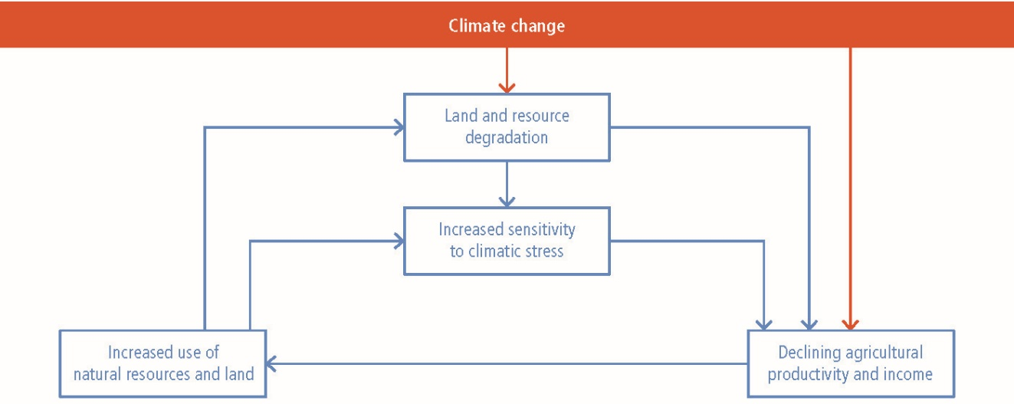
Figure 1. Broad conceptual framework of land degradation and its interactions with climate and human systems (adapted from IPCC, 2019).

As shown in Figure 1, land degradation is not a stand-alone land problem. It is linked with climatic drivers, ecosystem processes, and socio-economic outcomes. This broader framing is essential for understanding why degradation cannot be addressed solely through local land treatment measures, but must be considered within a wider climate and development context.

2.2 Climate change as a driver and amplifier of land degradation

The relationship between land degradation and climate change is reciprocal. Climate change intensifies land degradation through rising temperatures, altered rainfall regimes, drought, higher evapotranspiration, wildfire, and extreme events, while degraded lands in turn contribute to climate change through loss of vegetation cover, reduced soil carbon stocks, and increased greenhouse gas emissions from disturbed ecosystems (IPCC, 2019; Pacheco et al., 2018). This two-way interaction creates reinforcing feedbacks that can accelerate ecological decline, especially in drylands, mountain systems, grazing landscapes, and marginal agricultural regions (IPCC, 2019).
Climate change also alters the temporal and spatial dynamics of degradation. Areas that were once moderately stressed may become highly vulnerable under repeated droughts, heat stress, erratic rainfall, or fire-prone conditions. In such settings, degradation is no longer simply a matter of current land use; it is increasingly shaped by future climatic exposure and reduced adaptive capacity. Recent reviews have shown that climate-linked variables such as drought intensity, temperature anomalies, and hydroclimatic stress are increasingly central to understanding degradation trajectories and to designing restoration or adaptation responses (Wang et al., 2023; Materia et al., 2024). This makes climate-informed land assessment critical for restoration planning, because the resilience of degraded or restored landscapes depends not only on their present condition but also on their capacity to withstand future stress.
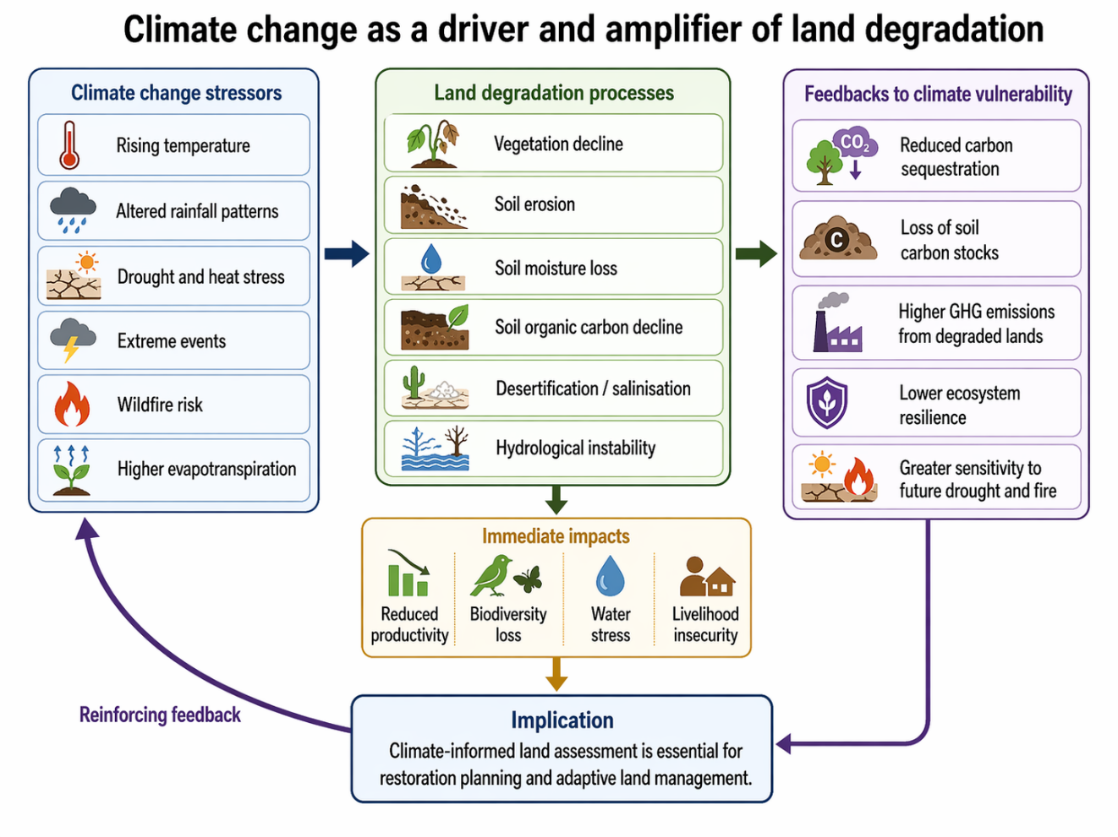
Figure 2. Climate change as a driver and amplifier of land degradation.

Taken together, land degradation and climate change form a tightly linked cycle: climate stress accelerates degradation, while degraded land becomes less capable of buffering climatic impacts. This reinforces the need for integrated assessment approaches that combine land condition analysis with climatic risk understanding (IPCC, 2019; Pacheco et al., 2018).

2.3 Ecosystem services as the functional expression of land condition

Ecosystem services provide the most direct functional link between land condition and human well-being. Changes in soil, vegetation, and hydrology are ultimately expressed through changes in the quantity, quality, and reliability of ecosystem services such as carbon sequestration, soil retention, water regulation, forage provision, habitat support, and biodiversity maintenance. In degraded landscapes, these services often decline together, reducing ecological resilience as well as livelihood security. This is particularly evident in the case of soils. Soil properties and soil processes underpin a wide range of ecosystem services, including nutrient cycling, biomass production, water storage, erosion control, and carbon storage. As a result, land degradation processes such as soil erosion, compaction, salinity, nutrient depletion, and loss of organic matter are not only physical changes in the land surface; they also represent a decline in the functional capacity of ecosystems to support environmental and social systems (Adhikari & Hartemink, 2016).
The linkage between soil condition and ecosystem service delivery provides an important conceptual basis for understanding how land degradation affects ecological functioning and human well-being, as shown in Figure 3.
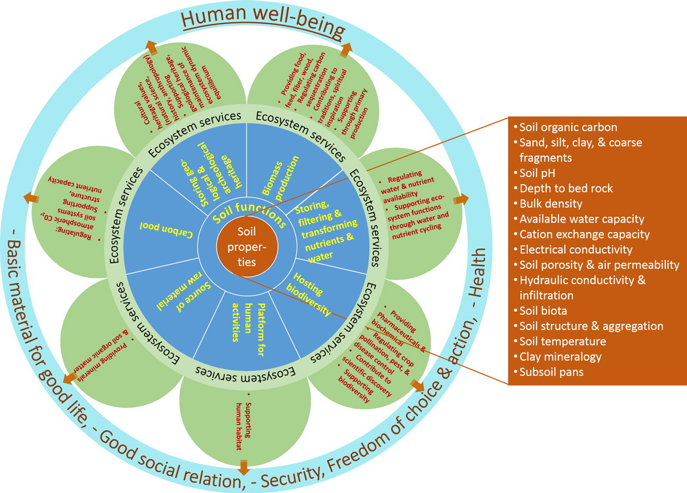
Figure 3. Conceptual linkage between soil properties, soil processes, and ecosystem services (adapted from Adhikari & Hartemink, 2016).

Figure 3 highlights that changes in soil condition influence multiple ecosystem services simultaneously, including carbon storage, water regulation, nutrient cycling, and biomass production. This relationship is particularly relevant in degraded landscapes, where the decline of one soil function often triggers reductions in several ecosystem services at once.

2.4 Feedbacks among land degradation, climate change, and ecosystem services

Land degradation, climate change, and ecosystem services are interconnected through multiple feedback pathways. Degradation reduces vegetation cover, weakens soil structure, and impairs hydrological function, thereby lowering the capacity of ecosystems to regulate water, retain nutrients, support biodiversity, and store carbon (Adhikari & Hartemink, 2016; IPBES, 2018). As these ecosystem services decline, landscapes become more vulnerable to drought, heat, wildfire, and erosion. Climate change further intensifies these pressures by increasing the frequency or severity of climatic stressors, while the reduction in ecosystem services constrains the adaptive capacity of both ecosystems and communities (IPCC, 2019; Pacheco et al., 2018).
The reinforcing feedbacks among land degradation, climate change, ecosystem service decline, and socio-ecological outcomes are illustrated in Figure 4.
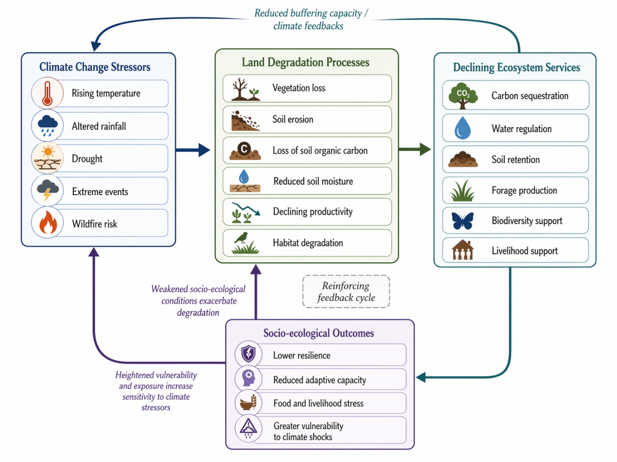
Figure 4. Reinforcing feedbacks among land degradation, climate change, ecosystem services, and socio-ecological outcomes.

Figure 4 shows that climate stressors accelerate land degradation processes, which in turn reduce the flow of ecosystem services and weaken socio-ecological resilience. As resilience declines, landscapes and communities become more sensitive to subsequent climatic shocks, thereby reinforcing degradation and increasing vulnerability over time. This feedback structure is particularly important in climate-sensitive and resource-dependent regions, where the loss of ecological function can quickly translate into livelihood stress and reduced adaptive capacity.
These interactions create a reinforcing cycle in which degraded landscapes become less resilient to climatic shocks, while repeated climatic shocks deepen degradation further. At the same time, the decline in ecosystem services reduces support for agriculture, livestock, water availability, and rural livelihoods, extending degradation impacts into socio-economic systems (IPBES, 2018; Adhikari & Hartemink, 2016). This systems perspective suggests that land degradation cannot be adequately understood through isolated indicators alone. Rather, it should be analysed as a dynamic process in which land condition, climatic stress, ecosystem service delivery, and human well-being are closely interlinked. Such a perspective is especially important for restoration science and sustainable land management. It shifts the analytical focus from treating degradation as a static end-state to understanding it as an evolving process shaped by both current pressures and future risks. It also reinforces the need for integrated assessment frameworks that combine environmental monitoring, climatic prediction, and ecosystem service evaluation (IPCC, 2019; Wang et al., 2023). For restoration planning, this means that interventions must be designed not only to reverse present degradation, but also to strengthen ecosystem resilience and reduce the likelihood of renewed decline under changing climatic conditions.

2.5 Implications for integrated assessment and restoration planning

The conceptual linkages discussed above have important implications for restoration planning and sustainable land management. If land degradation is viewed only as a land cover or productivity problem, major drivers and consequences may be overlooked. A more integrated perspective requires simultaneous attention to three dimensions: the spatial diagnosis of degradation, the climatic risks that influence future land trajectories, and the ecosystem services that are being lost, maintained, or potentially restored. This is where integrated assessment becomes critical. Restoration planning increasingly depends on the ability to combine land condition analysis with climate-risk understanding and ecosystem service evaluation in a single framework. Such an approach allows degraded landscapes to be assessed not only in terms of where degradation has occurred, but also in terms of how future climate stress may affect recovery, and which ecosystem services can be regained through appropriate intervention. Artificial intelligence, remote sensing, GIS, and field-based ecological data offer significant potential in this regard. Together, they can support more comprehensive diagnosis, prediction, and valuation across complex land systems. Conceptually, land degradation assessment provides the diagnostic base, climate change provides the dynamic risk context, and ecosystem services provide the functional and societal lens through which impacts and restoration outcomes can be evaluated.
The integrated relationship among land degradation, climate risk, ecosystem services, and restoration-oriented decision support is summarised in Figure 5.
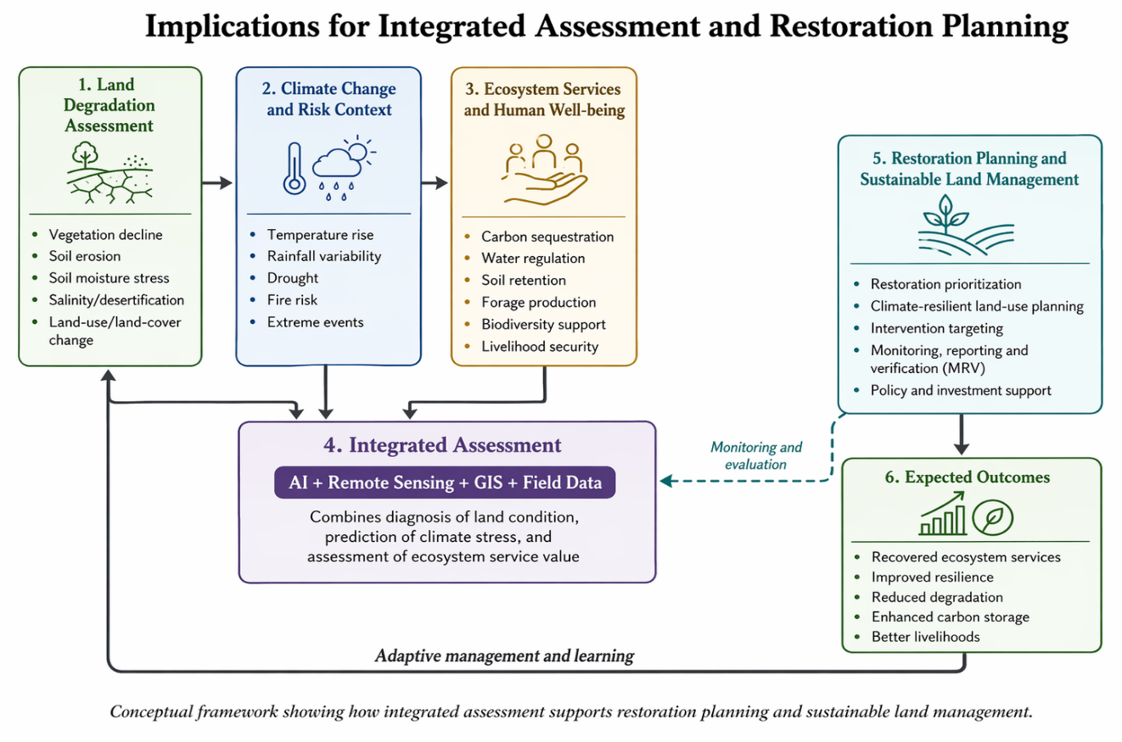

Figure 5. Conceptual framework linking land degradation, climate change, ecosystem services, and integrated restoration planning.

Figure 5 presents the conceptual framework adopted in this review. It shows how degradation assessment, climate-risk understanding, and ecosystem service evaluation can be integrated through AI, remote sensing, GIS, and field data to support restoration prioritisation, sustainable land management, monitoring, and adaptive learning. This integrated perspective provides the conceptual foundation for the subsequent sections of the review, which examine AI applications across each of these domains.

3. Review methodology

This review was undertaken as a structured and transparent synthesis of the literature on artificial intelligence (AI)-based applications in land degradation mapping, climate change prediction, and ecosystem service valuation, with particular emphasis on their relevance for restoration planning and sustainable land management. Given the interdisciplinary nature of the topic, the review combined a systematic search protocol with thematic synthesis in order to capture methodological developments across environmental science, remote sensing, geospatial analytics, climate-risk modelling, and ecosystem assessment. The overall review design was informed by the logic of the PRISMA 2020 framework, which provides updated guidance for identifying, screening, and reporting studies in evidence syntheses (Page et al., 2021).

3.1 Literature search strategy

The literature search was conducted using Scopus, Web of Science, and Google Scholar. Scopus and Web of Science were used as the principal indexed sources because of their broad multidisciplinary coverage and citation-based retrieval structure, while Google Scholar was employed as a supplementary platform to capture additional interdisciplinary and recently published studies. Scopus describes itself as a large multidisciplinary database covering hundreds of disciplines and content selected through an independent advisory board, while Web of Science Core Collection is presented by Clarivate as a multidisciplinary citation index curated through rigorous editorial selection. Google Scholar, in turn, is designed to help users discover scholarly literature across disciplines and publication formats. This combination was therefore considered appropriate for a review that sits at the intersection of AI, land systems, climate science, and ecosystem services (Elsevier, 2025; Clarivate, 2025; Google Scholar, n.d.).
The search covered studies published between 2010 and March 2026. This time window was selected to capture the period during which AI, machine learning, deep learning, cloud-based geospatial processing, and large Earth Observation datasets began to see widespread application in environmental analysis. The search strings were organised around four linked thematic clusters: AI and data-driven methods, land degradation, climate change prediction, and ecosystem services. Keywords such as artificial intelligence, machine learning, deep learning, neural network, and data-driven model were combined with terms including land degradation, soil degradation, desertification, land degradation mapping, climate change prediction, drought prediction, fire risk prediction, temperature prediction, ecosystem service valuation, carbon sequestration, water regulation, remote sensing, GIS, and spatial modelling. Preliminary scoping also confirmed that relevant literature already exists across these thematic domains, including reviews on soil degradation remote sensing, AI for climate extremes, and machine learning in ecosystem service research (Wang et al., 2023; Materia et al., 2024; Manley et al., 2022; Scowen et al., 2021).
In addition to database searches, the reference lists of key review papers and highly cited articles were manually screened in order to identify further relevant studies. This supplementary step was necessary because the review topic spans several disciplinary domains that are not always indexed under identical keyword combinations. For this reason, the search strategy was designed not only to retrieve directly relevant papers but also to reduce the risk of omitting interdisciplinary studies located at the interface of land degradation, climate risk, and ecosystem service science. The literature search strategy adopted in this review is summarised in Figure 6.
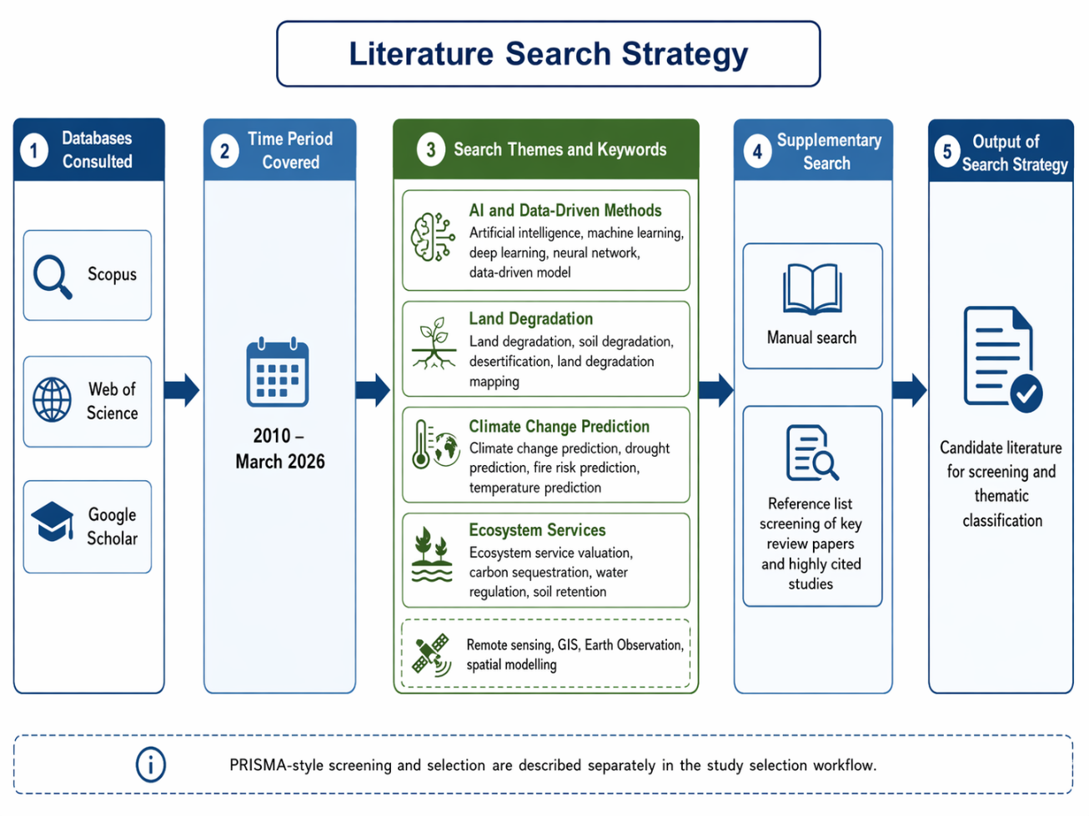
Figure 6. Literature search strategy used in this review, showing the databases consulted, review period, thematic search clusters, and supplementary search procedures.

3.2 Inclusion and exclusion criteria

Explicit inclusion and exclusion criteria were applied to ensure thematic relevance and scientific quality. Only peer-reviewed journal articles published within the review period and written in English were considered for inclusion. Studies were retained if they addressed at least one of the three core domains of the review: AI-based land degradation mapping or monitoring, AI-supported climate prediction or climate-risk assessment relevant to land systems, and AI-based ecosystem service assessment or valuation. In addition, studies were included if they linked two or more of these domains to restoration planning, sustainable land management, resilience assessment, or environmental decision support. Review articles were also included where they provided conceptual or methodological synthesis directly relevant to the objectives of the paper. This approach is consistent with PRISMA-based evidence synthesis, which emphasises transparent eligibility criteria and reproducible selection procedures (Page et al., 2021).
Studies were excluded if they were conference abstracts, editorials, dissertations, technical notes, book reviews, or other non-peer-reviewed materials. Papers were also excluded if they addressed land degradation, climate change, or ecosystem services in general terms but did not contain a meaningful AI, machine learning, deep learning, or comparable data-driven analytical component. Likewise, studies lacking sufficient methodological description or those judged to be outside the thematic scope of the review were not retained. When duplicate or highly overlapping records were encountered, the most comprehensive and methodologically informative version was selected for final synthesis.

3.3 Screening and classification of literature

All records identified through database searching and supplementary screening were first compiled and checked for duplication. After duplicate removal, the remaining papers were screened in a stepwise manner using titles, abstracts, and full texts. Title screening was used to eliminate clearly irrelevant records, while abstract screening was used to assess thematic alignment with the review objectives. Full-text assessment was then undertaken to confirm domain relevance, methodological adequacy, and analytical value. The overall study selection procedure followed the logic of PRISMA-style evidence synthesis and should be presented in the final manuscript using a PRISMA flow diagram showing the number of records identified, screened, excluded, and retained (Page et al., 2021).
The studies retained after full-text review were grouped into four thematic categories. The first category comprised land degradation mapping studies, including AI-based assessments of vegetation decline, soil erosion, desertification, salinity, soil moisture stress, and land-use or land-cover related degradation. The second category included climate change prediction studies, especially those applying AI to rainfall variability, drought, temperature anomalies, evapotranspiration, fire risk, and climate-linked extremes relevant to land systems. The third category covered ecosystem service valuation studies, including AI-supported mapping, modelling, and valuation of ecosystem services such as carbon sequestration, water regulation, soil retention, forage production, and biodiversity support. The fourth category included integrated restoration and planning studies, where AI-supported methods linked degradation, climate risk, and ecosystem services for restoration prioritisation, resilience planning, or decision support. The presence of published reviews and application studies across all four categories supports the analytical feasibility of this classification structure (Wang et al., 2023; Materia et al., 2024; Manley et al., 2022; Scowen et al., 2021).

3.4 Analytical approach

The selected literature was analysed using a comparative thematic framework designed to identify methodological trends, data patterns, domain-specific applications, and research gaps. Each paper was reviewed in relation to the type of AI technique employed, the data sources used, the scale of analysis, the geographic setting, and the practical outputs or applications produced. This framework was adopted to move beyond a purely descriptive review and towards a more critical synthesis of how AI is being used across interconnected environmental domains. Reviews in land degradation, climate extremes, and ecosystem service research all highlight the importance of method comparison, interpretability, validation, and practical decision relevance, which informed the analytical structure adopted here (Wang et al., 2023; Materia et al., 2024; Scowen et al., 2021; Manley et al., 2022).
With respect to AI technique, studies were classified according to whether they used conventional machine learning methods such as Random Forest, Support Vector Machine, decision trees, gradient boosting, and ensemble models, or deep learning approaches such as Convolutional Neural Networks, Recurrent Neural Networks, and Long Short-Term Memory models. Particular attention was also paid to studies that combined AI with GIS, remote sensing indices, process-based models, or multi-criteria decision frameworks. In terms of data source, the literature was compared according to its reliance on satellite imagery, climate datasets, soil and terrain layers, field-based ecological data, socio-economic variables, and multi-source fused datasets. The studies were further examined by spatial scale, ranging from local and watershed-level applications to regional, national, and global analyses, and by geographic context, including drylands, agricultural systems, rangelands, forests, mountain ecosystems, and mixed socio-ecological landscapes. Finally, the selected papers were analysed in terms of their outputs, such as degradation hotspot maps, climate-risk forecasts, ecosystem service maps, valuation estimates, restoration priority zones, and policy-oriented decision-support tools. This analytical structure provides the basis for the thematic synthesis presented in the following sections of the review.

4. AI in land degradation mapping

AI has become increasingly important in land degradation mapping because degradation is a multi-dimensional process that is difficult to capture using a single variable or a single snapshot in time. It may involve vegetation decline, soil erosion, soil organic carbon loss, salinisation, declining productivity, hydrological instability, and land-use change, often occurring simultaneously and at different spatial and temporal scales. Recent reviews show that remote sensing has become central to soil and land degradation assessment because it offers broad spatial coverage, repeat observations, and the ability to derive indicators linked to vegetation, soil condition, moisture status, and land-surface processes. At the same time, AI methods are increasingly used to improve classification, integrate heterogeneous datasets, model non-linear relationships, and generate spatially explicit degradation maps that are more suitable for planning and management than conventional rule-based approaches (Wang et al., 2023; D’Acunto et al., 2024).

4.1 Indicators and dimensions of land degradation

AI-based land degradation mapping depends fundamentally on how degradation is defined and measured. In practice, the literature shows that degradation is rarely mapped directly; instead, it is inferred from combinations of biophysical and environmental indicators. These commonly include vegetation decline, soil erosion, soil moisture stress, salinity, desertification, land-use or land-cover change, declining productivity, and soil organic carbon loss. Wang et al. (2023) note that remote sensing studies on soil degradation increasingly rely on both direct and indirect indicators, including spectral, thermal, radar, and terrain-derived variables, because no single metric is sufficient to represent the full complexity of degradation. Similarly, D’Acunto et al. (2024) emphasise that degradation assessment in rural landscapes generally requires a combination of land cover, vegetation, soil, and management-related indicators rather than a single degradation proxy.
This has important implications for AI applications. Because degradation is a composite phenomenon, AI models are often trained on indicator sets that combine vegetation indices, land-surface characteristics, terrain variables, soil data, climatic parameters, and anthropogenic drivers. For example, Torabi Haghighi et al. (2021) mapped land degradation risk in Iran using topographic, human-induced, and geo-environmental variables together with machine learning algorithms, while Nascimento et al. (2021) developed a soil degradation index by integrating multi-temporal satellite imagery, climate variables, terrain attributes, soil properties, and land use. These studies illustrate that AI-based degradation mapping is not simply an image-classification exercise; it is increasingly an exercise in fusing multiple lines of environmental evidence into a predictive spatial framework.

4.2 Data sources used in AI-based degradation mapping

The data foundation of AI-based degradation mapping is strongly shaped by advances in Earth Observation and geospatial data infrastructures. Satellite platforms such as Landsat, Sentinel, and MODIS are widely used because they provide long temporal coverage, moderate-to-high spatial resolution, and a range of spectral bands useful for vegetation, soil, moisture, and disturbance analysis. Reviews of remote sensing for soil degradation show that optical data remain dominant, but are increasingly complemented by radar, thermal, proximal sensing, terrain data, climate grids, and field observations to improve sensitivity to different degradation dimensions (Wang et al., 2023).
A recurring pattern in the literature is the use of multi-source integration. Nascimento et al. (2021), for instance, combined 35 years of Landsat imagery with climate, terrain, land use, and soil data to construct a soil degradation index, while Torabi Haghighi et al. (2021) integrated topographic, geo-environmental, and human-induced variables to model degradation risk. Moradi et al. (2024) similarly combined hazard and vulnerability modelling to identify land degradation risk in an arid basin, showing that degradation mapping increasingly depends on the joint analysis of biophysical stress and socio-environmental exposure. Such studies indicate that AI performs best not when it relies on imagery alone, but when it is embedded within a broader geospatial data framework that includes field evidence and explanatory variables.

4.3 AI techniques applied

The literature shows a clear shift from conventional threshold-based mapping and simple statistical classification to a broader family of machine learning and deep learning approaches. Among machine learning methods, Random Forest (RF), Support Vector Machine (SVM), classification and regression trees, boosting approaches, and ensemble models are among the most frequently used for degradation-related applications. Their popularity stems from their ability to handle non-linear relationships, mixed data types, and high-dimensional predictor sets. Torabi Haghighi et al. (2021) compared SVM, MARS, GLM, and a Dragonfly Algorithm for land degradation risk mapping and found strong predictive value in machine learning-based approaches. Reviews in remote sensing and degradation assessment likewise indicate that algorithmic flexibility and robustness to complex data structures have made AI increasingly attractive for spatial degradation modelling (Wang et al., 2023; D’Acunto et al., 2024).
Deep learning is also beginning to play a larger role, especially in image-based pattern recognition and automated feature selection. Rukhovich et al. (2021) used deep machine learning together with multi-temporal remote sensing data and vegetation indices to automate the identification of degraded arable land, demonstrating the usefulness of deep learning for scene selection and degradation detection in agricultural landscapes. However, compared with conventional machine learning, deep learning applications in land degradation mapping are still less common, partly because they require larger training datasets and more computational resources, and partly because many degradation studies still depend on relatively small field-calibrated samples rather than very large labelled image corpora. Current evidence therefore suggests that RF, SVM, and hybrid machine learning approaches remain more widespread in operational degradation assessment than fully deep neural architectures (Rukhovich et al., 2021; Wang et al., 2023). The overall workflow of AI-based land degradation mapping, from data inputs and model development to spatial outputs and restoration-oriented applications, is summarised in Figure 7.
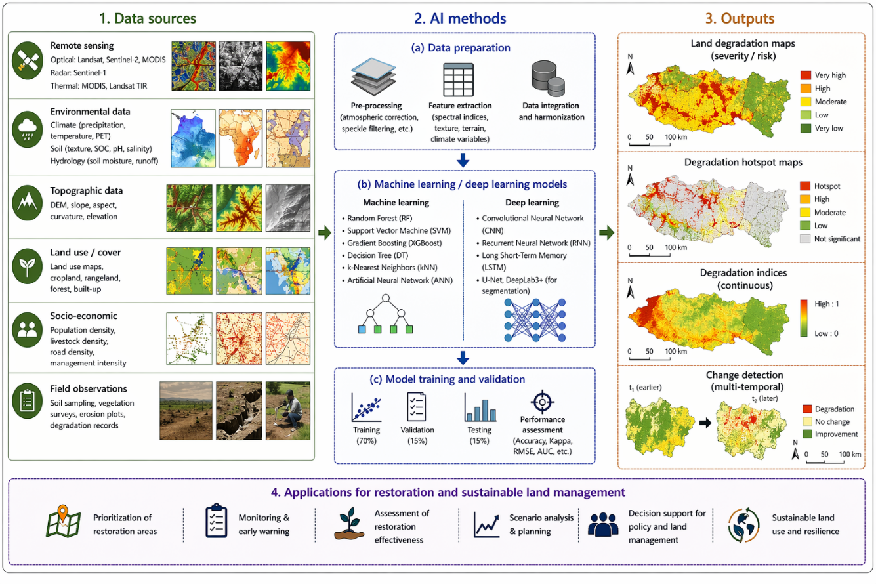
Figure 7. Framework for AI-based land degradation mapping, showing the integration of multi-source data, AI methods, geospatial outputs, and restoration-oriented applications. Developed by the authors based on the reviewed literature.

4.4 Major applications of AI in land degradation mapping

One of the most common applications of AI in this field is degradation hotspot mapping, where models are used to identify areas of higher susceptibility, severity, or risk. In such studies, AI is applied not only to detect existing degradation but also to classify landscapes according to relative vulnerability. Torabi Haghighi et al. (2021) used machine learning algorithms to produce land degradation risk maps, while Moradi et al. (2024) combined hazard and vulnerability modelling to map high-risk degradation zones in an arid and semi-arid ecosystem. These studies demonstrate the growing use of AI for risk-based mapping, which is particularly useful for prioritising restoration interventions and identifying landscapes where preventive action may be most effective.
A second major application is the development of integrated degradation indices from multiple environmental variables. Nascimento et al. (2021) used k-means clustering to derive a soil degradation index from satellite imagery, climate, terrain, soil, and land-use data, illustrating how AI can support composite degradation diagnostics rather than single-variable mapping. A third application is the identification of early warning signals of degradation. Domingo-Marimon et al. (2024) argue that many existing maps emphasise structural land-cover attributes and may miss early degradation signals, and they evaluate ecosystem functional attributes and ecosystem functional types as early warning indicators of ecosystem degradation. This is a significant development because it suggests that AI-supported degradation mapping can move from retrospective diagnosis towards earlier detection of functional decline.

4.5 Strengths, limitations, and uncertainty

The strengths of AI in land degradation mapping are clear. AI methods can integrate large and heterogeneous datasets, model non-linear interactions, improve predictive performance, and produce spatially explicit outputs that are useful for planning and monitoring. They are particularly valuable where degradation results from interacting biophysical and anthropogenic drivers that are difficult to represent using simple statistical relationships. Reviews of soil degradation remote sensing and rural land degradation assessment indicate that AI can enhance the scalability, repeatability, and analytical depth of degradation studies, especially when combined with long-term satellite archives and multi-source geospatial data (Wang et al., 2023; D’Acunto et al., 2024).
At the same time, several limitations remain. First, the definition of degradation itself is often inconsistent across studies, which affects training labels, model transferability, and comparability of outputs. Second, many AI models rely heavily on proxies such as vegetation indices or land-cover classes, which may not fully capture underlying soil and ecosystem processes. Third, field validation remains a major challenge, particularly in large and heterogeneous landscapes where training data are limited. Wang et al. (2023) explicitly identify the lack of universally accepted indicator systems and the need for stronger decision-support integration as ongoing constraints in remote sensing-based soil degradation assessment. Deep learning applications also face limitations linked to training data requirements, model transparency, and interpretability. These issues matter because land degradation mapping for restoration planning requires not only high accuracy but also ecological credibility and practical explainability.
Overall, the literature suggests that AI is significantly improving the ability to map and analyse land degradation, but its greatest value lies in integrated and context-sensitive applications rather than purely algorithmic performance. Models that combine remote sensing, field data, terrain, climate, and socio-environmental variables appear more capable of capturing degradation complexity than those based on imagery alone. The next phase of research is therefore likely to focus on improving model interpretability, strengthening validation, incorporating functional early warning indicators, and linking degradation maps more directly with restoration prioritisation and monitoring systems (Domingo-Marimon et al., 2024; D’Acunto et al., 2024).

5. AI in climate change prediction relevant to land systems

AI is becoming increasingly important in climate-related prediction because many of the variables that shape land degradation and ecosystem dynamics are nonlinear, highly variable across space and time, and influenced by interactions among atmospheric, terrestrial, and anthropogenic factors. Recent review literature shows that AI has significant potential in improving the prediction of climate extremes and associated risks, particularly where conventional approaches struggle with large, high-dimensional, and complex datasets (Materia et al., 2024). This is especially relevant for land systems because drought, heat stress, rainfall variability, evapotranspiration, and wildfire risk are among the most important climatic drivers of land degradation, vegetation decline, and ecosystem instability (Materia et al., 2024).

5.1 Prediction domains relevant to land systems

In the context of land systems, AI applications in climate prediction are concentrated around a set of variables and hazards that directly influence land condition and restoration success. Among the most prominent are drought, temperature and heat stress, rainfall variability, evapotranspiration, and wildfire risk. Drought prediction has received particularly strong attention because drought affects soil moisture, vegetation health, biomass productivity, crop stability, and ecosystem resilience across agricultural, rangeland, and dryland environments. A recent review by Osman et al. (2025) shows that machine learning approaches are now widely used for meteorological, hydrological, and agricultural drought prediction across diverse temporal and spatial scales.
Evapotranspiration is another critical variable because it provides a direct link between climate, water balance, vegetation functioning, and land degradation processes. Amani and Shafizadeh-Moghadam (2023) show that machine learning models are increasingly being used for evapotranspiration estimation through the integration of remote sensing and ground-based data, with strong relevance for understanding moisture stress and land-surface response under changing climate conditions.
Wildfire risk prediction is similarly important for land systems, especially in fire-prone forests, rangelands, and drylands. Reviews indicate that machine learning and deep learning are increasingly being applied to wildfire spread and susceptibility prediction by integrating meteorological variables, vegetation conditions, topographic factors, and human influences. Andrianarivony and Akhloufi (2024) show that these approaches are advancing rapidly and are becoming increasingly relevant for predictive fire management.

5.2 AI methods used in climate prediction

The methods applied in climate-related prediction range from conventional machine learning algorithms to more advanced deep learning and hybrid approaches. Among machine learning models, Random Forest, Support Vector Machine, Artificial Neural Networks, boosting models, and ensemble methods are commonly used for drought prediction, evapotranspiration modelling, and climate-risk mapping. Osman et al. (2025) note that these methods are widely used in drought forecasting because they can handle nonlinearity, multiple predictors, and complex interactions among climatic and environmental variables.
Deep learning approaches are especially prominent in time-series prediction and sequence modelling. Long Short-Term Memory (LSTM) models, recurrent neural networks, and convolution-based temporal architectures are increasingly used in drought and evapotranspiration studies because they can capture temporal dependencies more effectively than many conventional models. Materia et al. (2024) further note that AI for climate extremes is moving toward hybrid physics - AI approaches, causal discovery, and more integrated frameworks that combine multiple sources of observational and model data.

5.3 Relevance for land degradation and restoration planning

The practical value of AI-based climate prediction for land systems lies in its ability to add a forward-looking dimension to degradation assessment and restoration planning. Climatic stress does not affect land uniformly; rather, it interacts with soil properties, vegetation characteristics, topography, hydrology, and land use to shape local degradation trajectories. Predictive AI can therefore help identify where future stress is likely to intensify, which landscapes are more vulnerable to drought or fire, and where restoration interventions may need to be adapted to changing climatic conditions. Materia et al. (2024) highlight that AI-based climate prediction is particularly valuable where decision-making depends on anticipating extremes rather than only describing past conditions.
For restoration planning, this is especially important because degraded landscapes may not recover in the same way under different climate futures. Sites with similar present conditions may diverge substantially depending on future drought exposure, temperature stress, or wildfire regimes. AI-based climate prediction can therefore support early warning, vulnerability assessment, restoration targeting, and adaptive management, making it a useful complement to remote sensing-based land degradation mapping. Osman et al. (2025) and Amani and Shafizadeh-Moghadam (2023) both indicate that the utility of AI in drought and evapotranspiration prediction extends beyond prediction alone and into planning, resource management, and resilience building.

5.4 Key challenges and limitations

Despite its growing promise, AI-based climate prediction for land systems faces several important limitations. One major issue is scale mismatch, as models that perform well at local or regional scales may not transfer reliably across ecosystems, climatic zones, or data environments. Another challenge is data dependency, since model performance is strongly influenced by the quality, continuity, and representativeness of climate, remote sensing, and field observations. These limitations are repeatedly noted in reviews of evapotranspiration estimation and drought forecasting (Amani & Shafizadeh-Moghadam, 2023; Osman et al., 2025). Interpretability is another major concern. As AI models become more complex, especially in deep learning applications, it becomes more difficult to explain why a prediction was produced or which variables contributed most to the outcome. This matters in environmental governance because decision-makers often require not just accurate predictions but also transparent reasoning, uncertainty awareness, and ecological plausibility. Materia et al. (2024) identify trust, explainability, and generalisability as central challenges for the future use of AI in climate prediction of extremes, while Andrianarivony and Akhloufi (2024) similarly point to data constraints, model complexity, and transferability challenges in wildfire prediction.
Overall, the literature suggests that AI has significant potential to improve climate-related prediction relevant to land systems, particularly in drought forecasting, evapotranspiration modelling, and fire-risk assessment. However, its long-term value will depend not only on predictive performance, but also on the development of more interpretable, transferable, and ecologically grounded models. For restoration and sustainable land management, the most promising direction is likely to be the integration of AI-based climate prediction with land degradation mapping and ecosystem service assessment, so that future risk, current land condition, and recovery potential can be considered together within a common decision-support framework (Materia et al., 2024).

6. AI in ecosystem service valuation

Artificial intelligence is increasingly being used not only to map environmental change, but also to estimate, model, and value ecosystem services across heterogeneous landscapes. This is an important development because ecosystem services provide the functional link between ecological condition and human well-being, and their decline often reflects the consequences of land degradation and climate stress in socially meaningful terms. Recent reviews suggest that machine learning is particularly useful in ecosystem service research because it can handle large and multi-source datasets, capture nonlinear relationships, and improve predictive performance in situations where traditional valuation approaches face data or modelling limitations (Willcock et al., 2018; Scowen et al., 2021). As a result, AI is now being used to support both biophysical assessment and spatial valuation of services such as carbon sequestration, water regulation, soil retention, forage production, and biodiversity support (Manley et al., 2022; Scowen et al., 2021).

6.1 Ecosystem services commonly assessed using AI

The ecosystem services most frequently assessed through AI-based approaches are those that can be spatially represented through environmental variables and linked with remotely sensed, climatic, or terrain data. These commonly include carbon sequestration, soil retention, water regulation, biomass or forage productivity, habitat quality, and biodiversity-related support functions. In many studies, AI is used to predict service supply or service potential rather than direct economic value, although such outputs can subsequently support monetary and non-monetary valuation. Willcock et al. (2018) note that ecosystem service science increasingly relies on data-rich approaches because many services emerge from complex and nonlinear interactions among land cover, soil, topography, hydrology, climate, and management. This makes machine learning particularly relevant where service delivery varies across landscapes and where simple linear assumptions are insufficient. Scowen et al. (2021) likewise show that AI applications in ecosystem services are now expanding from descriptive mapping toward prediction, scenario assessment, and decision support.

6.2 AI applications in ecosystem service assessment and valuation

A major strength of AI in this domain lies in its ability to integrate biophysical, remote sensing, and contextual datasets into predictive models of ecosystem service supply. In many cases, machine learning is used to estimate service levels from combinations of land-cover information, vegetation indices, soil characteristics, climatic variables, and terrain attributes. This is particularly useful where field measurements are limited, where service provision is spatially heterogeneous, or where relationships among drivers are nonlinear and difficult to specify a priori. Willcock et al. (2018) argue that machine learning can help ecosystem service research make better use of big data and can support uncertainty estimation that is directly relevant to decision-making. Manley et al. (2022) further show that big data and machine learning applications are helping to address long-standing research gaps in ecosystem service mapping, especially in relation to scaling, data scarcity, and the integration of social and biophysical information.
Another growing application is the use of AI in scenario modelling and decision-support systems. Rather than simply estimating present-day service supply, some studies use AI-based methods to evaluate how ecosystem services may respond to land-use change, degradation, restoration, or climatic stress. This is particularly relevant for restoration planning, because ecosystem service valuation is often most useful when it helps compare alternative interventions or prioritise landscapes according to expected gains. Scowen et al. (2021) note that machine learning is increasingly being used not only to model services themselves, but also to support predictive and comparative analyses across scenarios, making it relevant to policy and planning. In this sense, AI contributes to ecosystem service valuation not only by improving prediction accuracy, but by enhancing the practical usefulness of valuation outputs for landscape-level decision-making.

Table 1 Multi-source geospatial, climatic, ecological, and socio-environmental datasets
Ecosystem service | AI application | Typical data used | Main output
Carbon sequestration | Prediction & mapping | Remote sensing, biomass, land cover, climate | Carbon stock or sequestration map
Water regulation | Modelling & assessment | DEM, rainfall, LULC, soil, hydrology | Water retention & regulation estimate
Soil retention | Susceptibility & service mapping | Terrain, rainfall, soil, vegetation | Soil retention & erosion control map
Forage or biomass production | Productivity modelling | Vegetation indices, climate, field data | Biomass & forage potential
Habitat & biodiversity support | Habitat suitability & service proxy | Land cover, vegetation, terrain | Habitat quality or biodiversity support surface

6.3 Strengths, limitations, and challenges

The main strengths of AI in ecosystem service valuation are its flexibility, predictive capability, and ability to integrate diverse datasets. These strengths are particularly valuable where ecosystem services are shaped by multiple interacting environmental and social drivers. AI is also useful where service measurement is indirect and where proxies from remote sensing, geospatial analysis, or field data must be combined to generate spatially explicit assessments. However, the literature also identifies several important limitations. One concern is that ecosystem service models may achieve high predictive accuracy without adequately representing ecological processes or social meaning. Scowen et al. (2021) caution that methodological rigour, transparent reporting, and generalisability remain uneven across the ecosystem service literature. Manley et al. (2022) similarly emphasise that data richness does not automatically resolve conceptual or valuation challenges.
A second limitation concerns valuation bias and representational gaps. Some services, especially cultural, relational, and place-based services, remain difficult to capture using AI-driven or spatially explicit methods. Machine learning may be better suited to biophysical or regulating services than to social or cultural services that depend on local perceptions, historical meaning, or institutional context. There is also a risk that AI applications may privilege services for which abundant spatial data exist, while underrepresenting those that are harder to quantify. For this reason, AI-based ecosystem service valuation should be seen as a complement to, rather than a replacement for, ecological knowledge, participatory assessment, and contextual interpretation (Willcock et al., 2018; Manley et al., 2022). Despite these constraints, the literature suggests that AI has significant potential to improve ecosystem service assessment and to strengthen the role of valuation in restoration and land-use decision-making, especially when combined with transparent assumptions and multi-source evidence.

7. Integration across domains for restoration planning and sustainable land management

A central argument of this review is that the full value of artificial intelligence (AI) lies not in isolated applications within land degradation mapping, climate prediction, or ecosystem service valuation, but in the integration of these domains within a common decision-support framework. In practice, restoration planning requires simultaneous understanding of where degradation is occurring, how future climatic stress may influence recovery trajectories, and what ecosystem services may be restored or enhanced through intervention. Existing literature suggests that AI is increasingly enabling such integration by combining diagnosis, prediction, and valuation in spatially explicit and data-driven analytical systems (Scowen et al., 2021; Materia et al., 2024).
From a restoration perspective, these domains are inherently complementary. Land degradation mapping helps identify the spatial distribution, severity, and drivers of ecological decline. Climate prediction adds a forward-looking dimension by indicating where future drought, heat stress, evapotranspiration shifts, or fire risk may constrain restoration outcomes. Ecosystem service valuation then connects ecological condition with social and functional relevance by showing what benefits may be lost, sustained, or recovered through restoration and sustainable land management interventions (Manley et al., 2022; Scowen et al., 2021). When these domains are assessed separately, each provides only partial insight. When combined, they offer a stronger basis for restoration prioritisation, site targeting, adaptive management, and climate-resilient planning.
The integrated relationship among these domains for restoration planning and sustainable land management is illustrated in Figure 8.
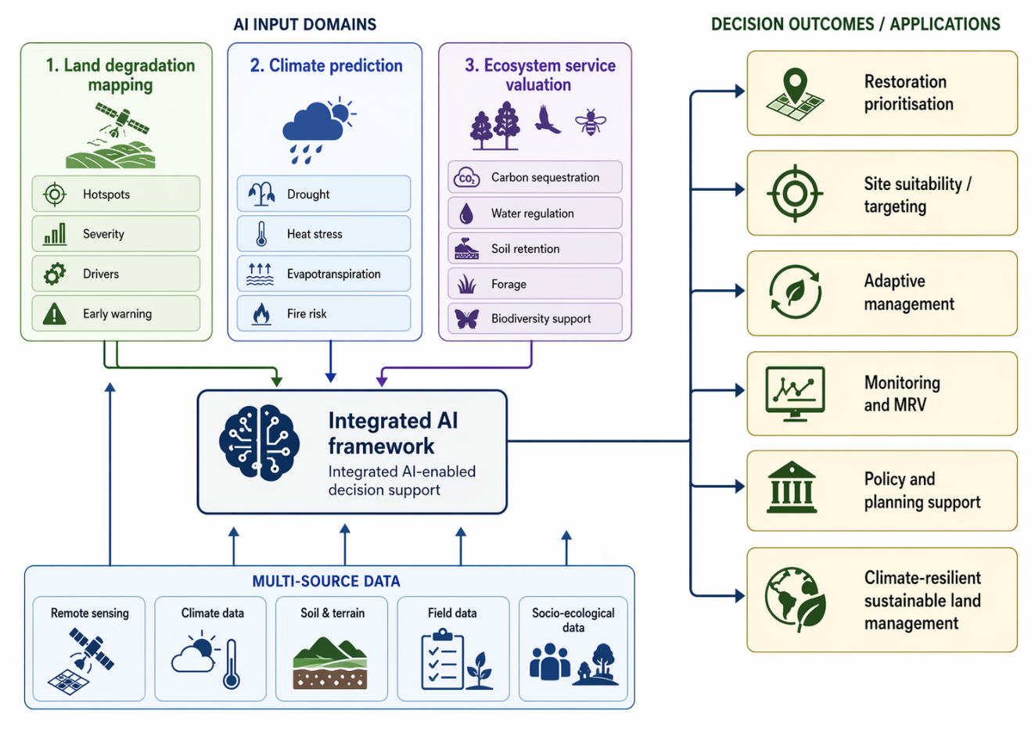
Figure 8. Integrated AI framework for restoration planning and sustainable land management.

AI is particularly valuable in this integrated context because it can combine multi-source data, detect nonlinear interactions, and generate predictive outputs across multiple dimensions of landscape condition. Remote sensing and field observations can be used to map degradation hotspots and monitor land condition, climate and hydro-meteorological data can be used to anticipate future stress, and ecosystem service models can estimate potential gains in carbon sequestration, water regulation, soil retention, forage production, or biodiversity support. When brought together, these outputs can support more targeted and spatially differentiated restoration strategies, reduce uncertainty in planning, and improve the prioritisation of interventions under changing climatic conditions (Materia et al., 2024; Manley et al., 2022). This integration is also highly relevant for monitoring, reporting, and verification (MRV) and for broader land governance. AI-enabled systems can help link baseline assessment, predictive risk analysis, and restoration outcomes within a unified monitoring framework. Such an approach is particularly useful for sustainable land management because it allows planners to move beyond static assessment and adopt more adaptive, evidence-based decision-making. In this sense, AI should be viewed not merely as a technical modelling tool, but as a means of strengthening restoration intelligence by connecting ecological diagnosis, future risk, and ecosystem service outcomes within a common planning architecture (Scowen et al., 2021). The broader implication is that integrated AI frameworks can substantially improve the practical relevance of restoration science. Their value lies not only in analytical efficiency, but in their ability to support ecologically informed and policy-relevant decisions across diverse landscapes. For sustainable land management, the integration of land degradation mapping, climate prediction, and ecosystem service valuation therefore represents one of the most promising directions for future research and operational practice.

8. Research gaps, future directions, and conclusion

Despite the rapid expansion of AI applications in land degradation mapping, climate prediction, and ecosystem service valuation, several important gaps remain. One of the most significant is the continued fragmentation of research across these domains. Many studies still focus on only one component of the problem, such as degradation mapping, drought forecasting, or ecosystem service modelling, without adequately connecting these analytical strands. This limits the practical usefulness of AI for restoration planning, which increasingly requires integrated understanding of present land condition, future climatic risk, and ecosystem service recovery potential. Future research should therefore move towards more unified analytical frameworks that explicitly connect diagnosis, prediction, and valuation within restoration-oriented decision support (Scowen et al., 2021; Materia et al., 2024).
A second major challenge relates to interpretability, transferability, and trust. As AI models become more sophisticated, especially in deep learning and hybrid architectures, their internal logic often becomes less transparent. While such models may offer strong predictive performance, their use in restoration and land governance requires more than numerical accuracy. Decision-makers, practitioners, and policymakers often need models that are ecologically plausible, explainable, and adaptable across landscapes with different climatic, biophysical, and socio-economic conditions. Current literature repeatedly highlights that uncertainty, generalisability, and limited transparency remain central constraints in applying AI more broadly in environmental decision-making (Materia et al., 2024; Wang et al., 2023). Strengthening explainable AI, improving field-based validation, and testing models across diverse ecological settings are therefore essential priorities for future work.
Further opportunities lie in multi-source data fusion, near-real-time environmental monitoring, and the development of digital monitoring, reporting, and verification (MRV) systems that combine remote sensing, climate data, field observations, and socio-ecological indicators. Such systems could significantly improve the ability to monitor restoration progress, assess resilience, and evaluate ecosystem service outcomes over time. There is also growing scope for AI to support scenario analysis, adaptive restoration planning, and ecosystem service assessment under changing climate conditions. However, these advances should not come at the expense of ecological understanding or local context. Future research should make stronger efforts to integrate local ecological knowledge, participatory assessment, and social dimensions that are not always captured through purely data-driven models (Manley et al., 2022; Willcock et al., 2018).
Overall, this review shows that AI is becoming an increasingly valuable component of restoration science. In land degradation mapping, it is improving the capacity to detect hotspots, integrate multiple indicators, and identify early warning signals. In climate prediction, it is supporting more forward-looking assessment of drought, heat, evapotranspiration, and fire-related risks relevant to land systems. In ecosystem service valuation, it is helping to estimate and compare service provision in ways that are increasingly useful for restoration and sustainable land management planning. Yet the greatest promise of AI lies in integration. When land degradation mapping, climate prediction, and ecosystem service valuation are brought together, AI can move beyond technical modelling and function as a strategic tool for restoration prioritisation, resilience building, and evidence-based environmental governance.
The future contribution of AI to restoring land will therefore depend not only on methodological innovation, but also on the extent to which these tools become more interpretable, integrated, and operationally relevant. If these challenges are addressed, AI has the potential to substantially strengthen the scientific and policy foundations of land restoration and sustainable land management in a climate-constrained world.

References

- Adhikari, K., & Hartemink, A. E. (2016). Linking soils to ecosystem services - A global review. Geoderma, 262, 101–111. https://doi.org/10.1016/j.geoderma.2015.08.009
- Amani, S., & Shafizadeh-Moghadam, H. (2023). A review of machine learning models and influential factors for estimating evapotranspiration using remote sensing and ground-based data. Agricultural Water Management, 284, 108324. https://doi.org/10.1016/j.agwat.2023.108324
- Andrianarivony, H. S., & Akhloufi, M. A. (2024). Machine learning and deep learning for wildfire spread prediction: A review. Fire, 7(12), 482. https://doi.org/10.3390/fire7120482
- Clarivate. (2025). Web of Science Core Collection.
https://clarivate.com/webofsciencegroup/solutions/web-of-science-core-collection/
- D’Acunto, F., Marinello, F., & Pezzuolo, A. (2024). Rural land degradation assessment through remote sensing: Current technologies, models, and applications. Remote Sensing, 16(16), 3059. https://doi.org/10.3390/rs16163059
- Domingo-Marimon, C., de Jong, R., Alcaraz-Segura, D., Verger, A., & de Beurs, K. (2024). Developing an early warning land degradation indicator based on geostatistical analysis of ecosystem functional types dynamics. Ecological Indicators, 168, 112500. https://doi.org/10.1016/j.ecolind.2024.112500
- Elsevier. (2025). Scopus content coverage guide.
https://www.elsevier.com/products/scopus/content
- Google Scholar. (n.d.). Google Scholar. https://scholar.google.com/
- Gu, Z., & Zeng, M. (2023). The use of artificial intelligence and satellite remote sensing in land cover change detection: Review and perspectives. Sustainability, 16(1), 274. https://doi.org/10.3390/su16010274
- Intergovernmental Panel on Climate Change. (2019). Land degradation. In Climate change and land: An IPCC special report on climate change, desertification, land degradation, sustainable land management, food security, and greenhouse gas fluxes in terrestrial ecosystems (Chapter 4). https://www.ipcc.ch/srccl/chapter/chapter-4/
- Intergovernmental Science-Policy Platform on Biodiversity and Ecosystem Services. (2018). The IPBES assessment report on land degradation and restoration. https://files.ipbes.net/ipbes-web-prod-public-files/2018_ldr_full_report_book_v4_pages.pdf
- Manley, K., Nyelele, C., & Egoh, B. N. (2022). A review of machine learning and big data applications in addressing ecosystem service research gaps. Ecosystem Services, 57, 101478. https://doi.org/10.1016/j.ecoser.2022.101478
- Materia, S., García, L. P., van Straaten, C., Oh, S., Mamalakis, A., Cavicchia, L., Coumou, D., de Luca, P., Kretschmer, M., & Donat, M. G. (2024). Artificial intelligence for climate prediction of extremes: State of the art, challenges, and future perspectives. WIREs Climate Change, 15(6), e914. https://doi.org/10.1002/wcc.914
- Moradi, E., Rashki, A., Sedighkia, M., Rezaie, F., Rashki, N., Farhadi, A., & Khoshbinfar, S. (2024). Integrated approach to land degradation risk assessment in arid and semiarid ecosystems: Applying SVM and eDPSIR/ANP methods. Ecological Indicators, 169, 112610. https://doi.org/10.1016/j.ecolind.2024.112610
- Nascimento, C. M., Silva, S. H. G., de Menezes, M. D., Curi, N., Gonçalves, M. G. M., Marques, J. J., & Guilherme, L. R. G. (2021). Soil degradation index developed by multitemporal remote sensing images, climate variables, terrain and soil attributes. Journal of Environmental Management, 277, 111364.
https://doi.org/10.1016/j.jenvman.2020.111364
- Osman, A. I. A., AlDahoul, N., Chong, K. L., Huang, Y. F., Ng, J. L., Elshafie, A., Sherif, M., & Ahmed, A. N. (2025). A review on machine learning models for drought monitoring and forecasting. Climate Risk Management, 50, 100758.
https://doi.org/10.1016/j.crm.2025.100758
- Pacheco, F. A. L., Fernandes, L. F. S., Valle Junior, R. F., Valera, C. A., & Pissarra, T. C. T. (2018). Land degradation: Multiple environmental consequences and routes to neutrality. Current Opinion in Environmental Science & Health, 5, 79–86. https://doi.org/10.1016/j.coesh.2018.07.002
- Page, M. J., McKenzie, J. E., Bossuyt, P. M., Boutron, I., Hoffmann, T. C., Mulrow, C. D., Shamseer, L., Tetzlaff, J. M., Akl, E. A., Brennan, S. E., Chou, R., Glanville, J., Grimshaw, J. M., Hróbjartsson, A., Lalu, M. M., Li, T., Loder, E. W., Mayo-Wilson, E., McDonald, S., … Moher, D. (2021). The PRISMA 2020 statement: An updated guideline for reporting systematic reviews. BMJ, 372, n71. https://doi.org/10.1136/bmj.n71
- Rukhovich, D. I., Koroleva, P. V., Vilchevskaya, E. V., Kalinina, N. V., Romanenkov, V. A., Rukhovich, O. V., & Dolgikh, A. V. (2021). The use of deep machine learning for the automated selection of remote sensing data for the determination of areas of arable land degradation processes distribution. Remote Sensing, 13(1), 155. https://doi.org/10.3390/rs13010155
- Scowen, M., Athanasiadis, I. N., Bullock, J. M., Eigenbrod, F., & Willcock, S. (2021). The current and future uses of machine learning in ecosystem service research. Science of the Total Environment, 800, 149263. https://doi.org/10.1016/j.scitotenv.2021.149263
- Torabi Haghighi, A., Darabi, H., Karimidastenaei, Z., Davudirad, A. A., Sadegh, M., & Kløve, B. (2021). Land degradation risk mapping using topographic, human-induced, and geo-environmental variables and machine learning algorithms, for the Pole-Doab watershed, Iran. Environmental Earth Sciences, 80, 1. https://doi.org/10.1007/s12665-020-09327-2
- Wang, J., Zhen, J., Hu, W., Chen, S., Lizaga, I., Zeraatpisheh, M., & Yang, X. (2023). Remote sensing of soil degradation: Progress and perspective. International Soil and Water Conservation Research, 11(3), 429–454. https://doi.org/10.1016/j.iswcr.2023.03.002
- Willcock, S., Martinez-Lopez, J., Hooftman, D. A. P., Bagstad, K. J., Balbi, S., Marzo, A., Prato, C., Sciandrello, S., Signorello, G., Voigt, B., Villa, F., & Bullock, J. M. (2018). Machine learning for ecosystem services. Ecosystem Services, 33, 165–174.
https://doi.org/10.1016/j.ecoser.2018.04.004

