Original Research Article
Appraisal of Dichlorvos Residues in Food Regularly Consumed in Calabar, Nigeria: A Health and Safety Evaluation

ABSTRACT
Aim: The study aimed to evaluate the presence and concentration of dichlorvos residues in regularly consumed food items and compare the results with established safety standards. It assesses the degree of compliance of the public to the campaigns against the use of dichlorvos for food preservation.
Study Design: Samples A, B, and C representing three commonly consumed food items; stock fish (Gardus morhua), beans (Phaseolus vulgaris) and bush mango (Irvingia gabonensis) respectively were bought randomly from the two major markets in Calabar.
Place and Duration of Study: This research was carried out in the Petroleum Technology Development Fund (PTDF) laboratory of the Chemistry Department, University of Calabar, for ten months.
Method: Homogenized samples (2 g of each) were weighed into a conical flask and mixed with 15 mL of a mixture of acetone and ethanol in the ratio of 1:1 and blended. The mixture was centrifuged at 2500 rpm for 5 minutes. The supernatant was collected thrice from each sample and reduced in a rotary evaporator to 5 mL, which was used for GC-MS analysis.
Results: From the results, only sample A showed the presence of dichlorvos while Samples B and C were not within detection limits. These results show that from the food commodities bought, only stockfish had detectable concentration (0.021mg/kg) of dichlorvos, which is above the acceptable limits of 0.01mg/kg (Chinese standard), 0.0144mg/kg (USEPA), but below the European Union limit of 0.05mg/kg.
Conclusion: Findings indicate a gradual reduction in the use of dichlorvos for food preservation following public awareness campaigns and regulatory monitoring. The presence of dichlorvos in stockfish stresses the need for continued effort in pesticide regulation and consumer education, as improper use of pesticides still poses a health risk.

Keywords: Dichlorvos, Pesticide residues, Food safety, Calabar, Health concerns, Food preservation.

- INTRODUCTION
Dichlorvos or 2, 2- dichlorovinyl dimethyl phosphate (DDVP) is an organophosphate pesticide used for pre- and postharvest application for the protection of food crops against pests. It is used against a wide variety of pests, particularly in the preservation of grains (Oshatunberu et al., 2023). Postharvest losses of food account for up to 9 % in developed nations and more than 20 % in developing countries (Saha et al., 2024). It is to curb the menace of these losses to pests that dichlorvos is used. Also, dichlorvos is used for the control of ecto and endoparasites in livestock to increase productivity (Dike-Iheanyi et al., 2024). In forestry, it serves as a good fumigant against insects and diseases retarding the growth of plants. This makes pesticides like dichlorvos a critical component of agriculture aimed at reducing food losses. However, despite its usefulness in pest management, dichlorvos is highly toxic to humans and the environment when not applied correctly.
Recent studies have shown that the public, particularly farmers and food traders, often use dichlorvos irresponsibly due to a lack of awareness or non-adherence to safety guidelines. (FAO-UN., 2013; Yusuf et al., 2018). Ignorant and overzealous farmers and merchants, in an effort to reduce losses and maximize profit, apply large doses of this chemical that are not completely degraded before use (Joseph et al., 2024). Exposure to dichlorvos can occur by inhalation, skin contact with contaminated soil, or during mixture of the chemical, and through oral ingestion of food contaminated with it. According to (Okoroiwu & Iwara, 2018; Penal et al., 2023; Penal et al., 2023), health effects of the chemical are diverse and include respiratory, genotoxic, carcinogenic, neurological, renal, immunological, and hepatic effects.
Research on diclorvos residues in Nigerian foods is very critical in assessing the safety of the nation’s food supply. Reports of food poisoning due to contamination with dichlorvos in Nigeria have been alarmingly frequent. Poisoning due to organophosphate pesticides, including dichlorvos, that result in death globally accounts for more than 100, 000 deaths per annum, with a large percentage of these from Nigeria (Abaukaka et al., 2020). Umar et al., (2010) reported that ota-piapia, whose main chemical component is dichlorvos, has caused the death of many Nigerian families through food contamination. Clement et al., (2021) reported one of the most broadcast cases in 2021 in which two separate families in Imo and Anambra states died due to the consumption of rice contaminated with dichlorvos.
The Nigerian Institute for Food Science and Technology (2018), also noted that the use of this lethal chemical in food preservation has resulted in poor consumer confidence in Nigerian agricultural produce in the international market. In August 2021, the National Agency for Food, Drug Administration, and Control (NAFDAC) warned against the use of sniper and formalin for the preservation of meat and fish. Such practices can result in major organ failure in the human body (Funmilayo, 2021). Meanwhile, in 2019, NAFDAC banned the production, importation, and use of dichlorvos in sizes ≤ 100 mL in response to the public outcry against the use of the chemical for intentional deaths and food preservation. Though NAFDAC has made several attempts to terminate the menace of this pesticide, enforcement remains weak due to the persistence of the chemical in local markets.
This study is targeted at monitoring the use of dichlorvos in commonly consumed food in Calabar, Nigeria. While previous studies have highlighted the use of dichlorvos in food preservation, this research provides updated data on the level of compliance with regulations and awareness campaigns. It assesses the degree of compliance of merchants, traders, and farmers with the campaigns against the use of dichlorvos for the preservation of food. Furthermore, it focuses on food items highly consumed in a popular Nigerian city, a region not widely covered in current literature.
- MATERIALS AND METHODS
2.1 Sample Collection
Three commonly consumed food items: stock fish (Gardus morhua), beans (Phaseolus vulgaris), and bush mango (Irvingia gabonensis) were bought randomly from the two popular markets (Watt and Ika Ika Oqua) in Calabar, the Cross River State capital, Nigeria, and labelled A, B, and C. The samples were bought once a month for the months of June, July, and August 2024 assumed to be the peak period for the consumption of these items. For each sample, five (5) replicates were bought per month, mixed uniformly, and stored in the refrigerator for analysis. The control, labelled as sample D, was also Irvingia gabonensis but was bought from the Department of Crop Production Cross River Ministry of Agriculture, Calabar, where no preservatives were added. Calabar is in South-South Nigeria and lies between longitudes 8°18׳00״E to 8°24׳00״E and latitudes 4°04׳00״N to 4°54׳00״N.
2.2 Sample Preparation.
Sample preparation was done according to Akinneye et al., (2018), with modifications. Dirt was removed and the samples were pulverized and homogenized separately with a pestle and mortar and sieved through a 2mm sieve. 2 g of each sample was measured and deposited in a conical flask and mixed with 15 ml of a mixture of ethanol and acetone in the ratio of 1:1. The mixture was shaken and mixed with a hand mixer for 5 minutes and kept for 40 minutes. The mixture was transferred to a test tube, placed in a centrifuge, and rotated at 2500 rpm for 5 minutes, and the supernatant was collected. The process of centrifugation and collection of supernatant was repeated thrice for each sample. The supernatant collected was reduced in a rotary evaporator to 5 mLs and stored in sealed vials in a refrigerator at 5 °C for analysis.
2.3 Preparation of standard solutions
Analytical grade, 2,2-Dichlorovinyl dimethyl phosphate, popularly called Sniper, marketed in Nigeria by Swiss-Nigerian Chemical Company, was used to prepare the calibration standard. This was done by preparing 1mg/mL, 2mg/mL, and 4mg/mL of the standard solutions as described by Adoga et al., (2018).

  - GC–MS Analysis
The samples were analyzed by a slight modification to the method of Rajeev et al., (2023) on GC-MS-QP2010 Plus (Shimadzu Japan), comprising Shimadzu QP-2010 GC with QP-2010 Mass Selective Detector (MSD), operated in the EI mode, electron energy of 70 eV, scan range of 45-700 amu, and Shimadzu GC-MS solution data system. The Gas chromatography column was an Agilent HP-5 MS fused silica capillary with 5% phenyl-methylpolysiloxane stationary phase, with a length of 30 m, an internal diameter of 0.25 mm, and a film thickness of 0.25 μm. The carrier gas was helium 99.999% with a flow rate of 1.61 mL/min. The program used for the gas chromatography oven temperature was initially kept at 60 ◦C for 1 min, followed by an increment up to 250 ◦C at a rate of 15 ◦C/min, resulting in a total run time of 13.67 min. The injection port temperature was 250°C, the interface temperature was 250°C, while the ion source temperature was 200°C with a solvent delay of 3 min. Mass spectra were obtained in the range of 50–500 amu in full scan mode. The peak of DDVP was observed at 7.136 min in the total ion chromatogram (Figure 1). The standard and samples were filtered through a 0.45 μm Millipore membrane filter before 1.0 μL was injected into the GC using an autosampler and the split mode with a ratio of 25:1. Individual constituents were identified by comparing their mass spectra with known compounds and the NIST Mass Spectral Library. The percentage composition of each chemical constituent was reported as a percentage based on peak area.
- RESULTS AND DISCUSSION
The results of GC-MS based quantitative analysis of dichlorvos in stockfish (Gadus morhua ), beans (Phaseolus vulgaris), and bush mango (Irvingia gabonensis) are presented in Table 1. Figure 1 shows the total ion chromatogram of standard DDVP from sniper, and the peak was observed at 7.135min. Figure 2 represents the chromatogram for sample A, which is stockfish (Gadus morhua), showing dichlorvos at 7.100 min. Samples B, C and D (control ) are represented by Figures 3, 4 and 5, respectively, which do not show any peak at 7.135 or anywhere close to it. The concentration of dichlorvos is represented in Table 1, which shows that only sample A, Gardus morhua, contains dichlorvos at detectable concentrations, while Phaseolus vulgaris (Sample B), Irvingia gabonensis (Sample C) do not contain any dichlorvos at detectable concentrations. Sample D, which is the control, is also Irvingia gabonensis but bought from a source where preservatives have not been added.
Table 1: Showing the amounts of DDVP in the samples
S/N | Samples | Sample Name | Calibration curve | r² | Amount of DDVP (mg/kg)
1 | Sample A | Stockfish | y = 3E+06x – 19305 | 0.9996 | 0.021±0.01
2 | Sample B | Beans | “ | “ | ND
3 | Sample C | Bush mango | “ | “ | ND
4 | Sample D | Bush mango | “ | “ | ND
*ND = Not detected

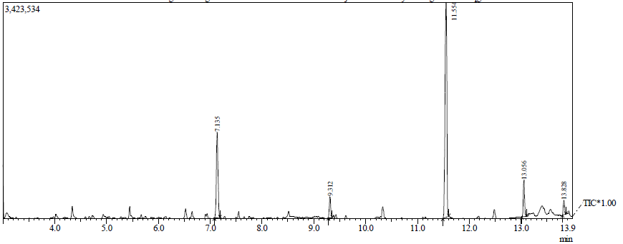Figure 1. Total ion chromatogram (TIC) of standard DDVP from sniper. The peak of DDVP was observed at 7.135 min in the total ion chromatogram.

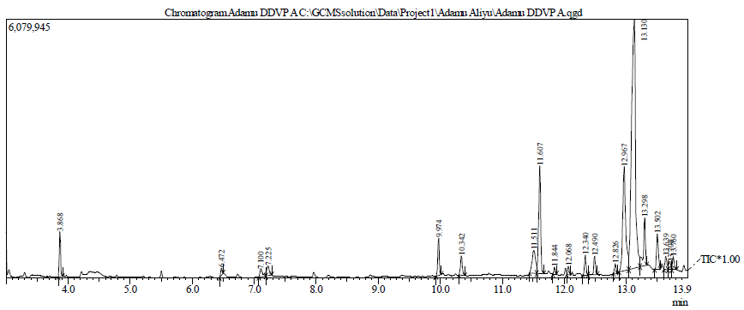
Figure 2. Total ion chromatogram (TIC) of sample A (Stockfish)
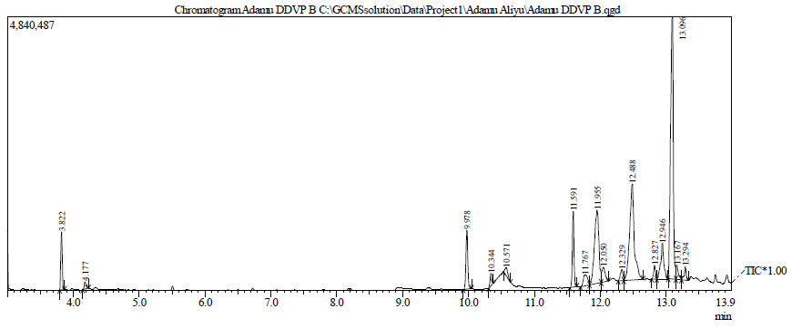
Figure 3. Total ion chromatogram (TIC) of sample B (Beans)

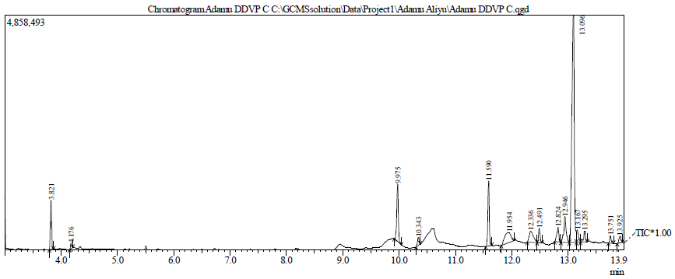
Figure 4. Total ion chromatogram (TIC) of sample C (Bush mango)

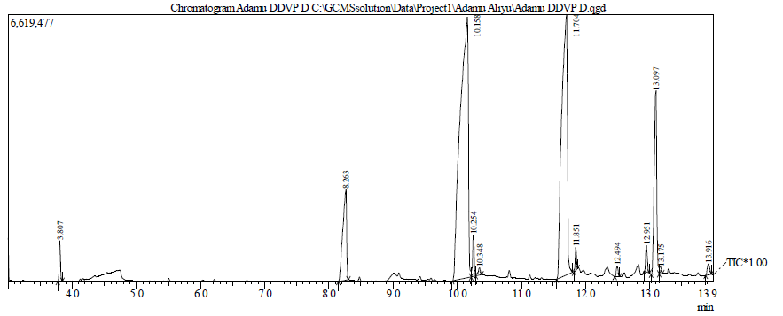
Figure 5. Total ion chromatogram (TIC) of sample D (Control)

Table one shows that only sample A contains detectable concentration of dichlorvos, which is 0.021±0.01 mg/kg out of the three different samples that were gathered from the two markets. Samples B and C were not detected, as seen in Figures 3, 4, and Table 1. This value of detected Organophosphate is above the maximum residue levels (MRL) acceptable in fish for the Chinese standard (0.01mg/kg) (Chen et al., 2002), USEPA (0.0144mg/kg) (USEPA, 2000), but below the European Union limit (0.05mg/kg) of fish containing fats (Binelli and Provin, 2003). This outcome is in conformity with (Joseph et al., 2024; Adetola, 2025), who showed that the food items studied had low concentrations of dichlorvos residues. In contrast to this study, (Adoga et al., 2018), reported significant concentrations of this killer substance, which was shortly before the ban on the chemical, ≤100 mL. Dichlorvos or Organophosphate retention is known to be related to fat accumulation in fish (Adetola, 2025). Lipophilic pesticides like dichlorvos accumulate in substances with high fat content and may have accounted for the presence of the pesticide in stockfish (Trivedi et al., 2021)
Farming has been taken to be occupation of the uneducated, and all kinds of malpractices are observed because of the presence of quacks. Also, the government has little encouragement like training and grants, to upscale the skills of these farmers and boost productivity. Consequently, high doses of dichlorvos, which is the bane of most developing nations, are due to misapplication and untimely release of grains from the stores before the required duration (Davies, 2016), particularly when their prices increase. In this study, because of campaigns and monitoring by the regulatory agency, some level of compliance has been recorded as a result of years of campaigns against the use of harmful pesticides in the preservation of food.
Continuous use of dichlorvos has been observed to lead to the development of resistance by different pests. A study on dichlorvos resistance in the housefly population showed high-level resistance to dichlorvos due to Acetylcholinesterase (AChE) insensitivity and enhanced metabolic detoxification (Ahmadi & Khajehali, 2020; Aminu et al., 2018). In another study on point mutation associated with organophosphate and carbamate resistance of Musca domestica, dichlorvos was recognized as one of the organophosphate insecticides in which house flies have become resistant to (Ahmadi & Khajehali, 2020). Development of resistance leads to an increase in dosage, frequency of application, increase in cost of control, negative impact on the environment, and the overall elimination of the pesticide (Davies, 2016; Bardin et al., 2015).
Because of the regularity and length of time of exposure to these foods, reproductive impairment will likely occur. A study on the effects of dichlorvos on spermatogenesis and sperm count (Akande et al., 2024), showed that dichlorvos suppresses the number of sperms and spermatogenesis, which may occur because of interference with the sex hormone, testosterone. In another study of the effects of pesticides on the female reproductive system (Aina & Igbayilola, 2025), it was observed that even at low concentrations, pesticide exposure disrupts the ovarian cycle and affects hormonal synthesis, storage, and release (Saka et al., 2025), hormonal transport and clearance, and receptor recognition and binding (Mahuta et al., 2024). Again, in a study on haemato-pathological effect of dichlorvos on blood (Brown et al., 2015), anaemia was observed and showed a decrease in erythrocytes, packed cell volume, and haemoglobin. Erythrocytopenia seen in the study was the result of the suppressive effect of dichlorvos on erythropoiesis. In a similar study of neurodegenerative diseases and exposure to pesticides in the elderly (Alexandra et al., 2025), an association was found between past exposure to pesticides and low cognitive performance. The risk of development of Alzheimer’s or Parkinson’s diseases in the elderly increases with the duration of exposure, sometimes long after exposure, even at low levels (Kaisa et al., 2024).
Though dichlorvos does not quite accumulate in the human body, consumption of contaminated food, even at low levels with other pesticides, results in additive or synergistic effects that make the food unsafe. A combination of substances with probably carcinogenic or endocrine-disrupting effects may produce diverse health outcomes. Determination of safe levels of exposure for single pesticides may underestimate the real-life effects when combined (Silvio & Tommaso, 2021). In Nigeria, stockfish is highly valued, and to justify the expenses on it, preservatives including dichlorvos, are used to save it from decomposition.
There was an outcry by institutions, the National Agency for Food, Drug Administration and Control (NAFDAC), the media, and the general public on the mal-handling of dichlorvos for the preservation of food, which resulted in several deaths across the country. This study addressed the level of response of grain merchants, traders, and farmers alike to these campaigns and the results showed that dichlorvos residues are still reasonably present, though in a reduced amount compared to past studies. From the studied food and area, there’s a gradual departure from the use of the lethal chemical for preservation because of health concerns raised by agencies and the Social media. Therefore, the campaigns against the use of this chemical should be sustained to eliminate its use completely.
CONCLUSION
This study indicated a reduction in the use of dichlorvos for food preservation in Calabar, with detectable levels found only in stockfish at levels below international safety standards. The continued presence of dichlorvos residues in food products, though reduced, shows the need for sustained awareness campaigns and regulatory enforcement. The health implications of dichlorvos are enormous and replacing the use of this lethal chemical with organic compounds may be a better option. The campaigns against the use of this hash chemical for the preservation of food should be sustained to eliminate completely this deadly practice. Further studies across different regions and food types are important to fully assess the risk posed by dichlorvos residues to public health in Nigeria.
STRENGTHS AND LIMITATIONS
This work is limited because it focuses on only one pesticide and a single city. It is also limited by the number of items studied based on the broadband of food in the market. The strength is that it educates the public on the safety of food regularly consumed. It reliefs the health concerns of consuming certain foods in the market. The study focuses on dichlorvos because it is one of the major pesticides commonly used for various purposes. Most importantly, it guides the regulatory agencies on the level of compliance to campaigns against the use of harmful substances for food preservation.

DECLARATION OF INTEREST
On behalf of the authors, I hereby attest that this manuscript has not been summited to any other journal for consideration and publication. None of the manuscript contents has been previously published in any other journal or proceedings, and the authors are aware of this submission and have no conflict of interest.

REFERENCES

Abaukaka YA, Sanusi S, Ozigi KA, Malo FU. (2020). Assessment of the cytotoxic and mutagenic potential of dichlorvos (DDVP) using in silico classification model; a health hazard awareness in Nigeria. Environ Anal Health Toxicol. 35(3): e2020016. DOI:10.5620/eaht.2020016
Adetola Mary Olatunji-Ojo (2025). Dichlorvos Residue Levels in Beans and Stockfish from Akungba-Akoko Market, Nigeria, Asian Journal of Biology. 21 (9) : 17-23. DOI: https://doi.org/10.9734/ajob/2025/v21i9548
Adoga SO, Ikese OC, Otache MA, Igbum MA, Otikwu E and Ukah BO (2018). Assessment of 2, 2-Dichlorovinyl Dimethyl phosphate content in selected phaseolus vulgaris samples sold in Benue State Nigeria. Nigerian Annals of Pure and Applied Sciences 1:161-166. DOI: 10.46912/napas.41
Ahmadi E, Khajehali J. (2020). Dichlorvos Resistance in the House Fly Populations, Musca domestica, of Iranian Cattle Farms. J Arthropod Borne Dis. 2020 Dec 31;14(4):344-352. doi: 10.18502/jad.v14i4.5271. PMID: 33954208; PMCID: PMC8053071.
Aina O.S, Igbayilola D.Y (2025). Reproductive Toxicity of DDVP: Endocrine Disruption and Gametotoxic Effects, Trends in Pharmacology and Toxicology Mini Review; 1(2) https://doi.org/10.21124/tpt.2025.103.111
Akande O A, Aladesanmi O T, Akinsomisoye O S, Akano O P., (2024). Assessment of Dichlorvos, Cypermethrin, Synthetic Camphor, Pinenes, and Kerosene: Impact on Testosterone Levels, Glutathione Concentration, and Testicular Histology in Male Wistar Rats. East African Scholars Journal of Medical Sciences. 7 (7) DOI: 10.36349/easms.2024.v07i07.004
Akinneye JO, Adedolapo AO, Adesina FP (2018). Quantification of Organophosphate and Carbamate residue on stored grains in Ondo State, Nigeria. Journal of Biology and Medicine, 2 (1); 001-006. https://dx.doi.org/10.17352/jbm.000006

Alexandra Andreea Botnaru, Ancuta Lupu, Paula Cristina Morariu, Alexandra Jităreanu, Alin Horatiu Nedelcu, Branco Adrian Morariu, Emil Anton, Maria Luisa Di Gioia, Vasile Valeriu Lupu, Oana Maria Dragostin, Madalina Vieriu, Ionela Daniela Morariu (2025), Neurotoxic Effects of Pesticides: Implications for Neurodegenerative and Neurobehavioral Disorders. Journal of Xenobiotics 15 (3): 83 doi: 10.3390/jox15030083

Aminu I., Muhammed A., Wahab IA., Abdulmusawir A., Abdulbasit A., Abdulmumin I., Sadiya G., NiyiAbdulGafar P. (2018). Dichlorvos Induced AChE Inhibition in Discrete Brain Regions and the NeuroCognitive Implications: Ameliorative Effect of Nigella Sativa. Iranian Journal of Toxicology, 12 (5) http://www.ijt.ir
Bardin M, Ajouz S, Comby M, Lopez -Ferber M, Graillot B, Siegwart M, and Nicot PC (2015). Is the Efficacy of Biological Control against Plant Diseases likely to be more Durable than that of Pesticides? Frontiers in Plant Science. 6: 566. doi:10.3389/tpls.201500566
Binelli A and Provin A (2003). POPs in edible clams from different Italian and European markets and possible human health risk. Marine Pollution Bulletin, 46 (7): 879-886 doi: 10.101/s0025-326x(03)00043-2.
Brown H, Kenanagha B, and Onwulli DO. Haemato-Pathological effect of dichlorvos on the blood picture and liver cells of albino rats. Journal of Toxicology and Environmental Health Sciences 2015; 7 (2) ;18-23. Doi:10.5897/JTEHS2015.0327
Chen HJ, Xiao G, Hu J, Zhou H, and Wang X. (2002). Estrogenicity of Organophosphorous and pyrethroid pesticides. Journal of Toxicology and Environmental Health part A., 65, 1419-1435 doi: 10.1080/00984100290071243
Clement A, Haruna I, Mumini A, and Shehu U. (2021). Food poisoning: Killer menace on the prowl. Daily Trust, July 2021.
Davies MS, Boniface M, and Gibso S. Determination of dichlorvos residue levels in vegetables sold in Lusaka, Zambia. Pan-African Medical Journal. 2016; 1-7 doi:10.11604/pamj.2016.23.113.8211
Dike-Iheanyi, E. I., Ifemeje, J. C., Okoye, C. J., Okoroigwe, F. C., & Ezeanyanwu, V. C. (2024). Determination of residual pesticides in selected grains, fruits and vegetables commercially sold in Eke Awka Market, Awka, Anambra State, Nigeria. IDOSR Journal of Biochemistry, Biotechnology and Allied Fields, 9(3), 1–6. https://doi.org/10.59298/IDOSR/JBBAF/24/ 93.16000
FAO-UN: Food and Agriculture Organisation of the United Nations Regional Office for Asia and Pacific (2013). Advancement of Pesticides Regulatory Management in Asia. RAP Publication; 08 pp 298 EISBN 978-92-5-107717-7
Funmilayo B. S (2021). Fish, meat sellers using sniper, dead bodies’ chemicals as preservatives NAFDAC. Retrieved from https://odunews.com/2021/08/nafdac-exposes-fish-meat-sellers-using-chemical-for-dead-bodies-as-preservatives/
Joseph, B., Hickson, S., Gambu, J. W., & Jonathan, N. (2024). Determination of pesticides residues in beans obtained from some locations in Hong Local Government Areas of Adamawa State, Nigeria. International Journal of Interdisciplinary Research and Innovations, 12(3), 60–67. https://doi.org/10.5281/zenodo.13842912

Kajsa Atterling Brolin, Eva Schaeffer, Ashvin Kuri, Isabell Katharina Rumrich, Artur Francisco Schumacher Schuh, Sirwan K.L. Darweesh, et al (2024). Environmental Risk Factors for Parkinson's Disease: A Critical Review and Policy Implications, international Parkinson and Movement Disorder Society, 40 (2): 204-221 https://doi.org/10.1002/mds.30067
Mahuta, M. M., Idris, H., Sidi, S., Adeyeye, A. A., Idris, S. B., Usman, M. D., Yusuf, A., & Tijjani, A. (2024). Effects of Dichlorvos on pregnancy outcomes in Wistar albino rats. Sahel Journal of Veterinary Sciences, 21(3), 57–60. Retrieved from https://www.ajol.info/index.php/sjvs/article/view/280630
Okoroiwu HC and Iwara TA (2018). Dichlorvos toxicity: A Public health perspective. Interdisciplinary Toxicology, 11(2): 129-138 https://doi.10.2478/intox-2018-0009
Olutaller A.(2018). NIFST Advisory response to incidence of sniper in beans. The Nigerian Institute of Food Science and Technology. November, 14 2018.
Oshatunberu, M. A., Oladimeji, A., Sawyerr, O. H., & Raimi, M. O. (2023). Searching for What You Can’t See - Evaluation of Pesticide Residues in Grain Sold at Selected Markets of Southwest Nigeria. Current Research in Public Health, 3(1), 10–36. Retrieved from https://www.scipublications.com/ journal/index.php/crph/article/vie w/566
Panel Sonam Agarwal , Renu Bist , Himani Kuntal , D.K. Bhatt (2023). Effect of dichlorvos on kidney functions with reference to altered AChE gene expression in mice. Advances in Redox Research, vol. 9. 100078: https://doi.org/10.1016/j.arres.2023.100078

PanelKandasamy Saravanakumar, SeonJu Park , Sampathkumar Vijayasarathy, Akila Swaminathan, Sugavaneswaran Sivasantosh, Yebon Kim , Guijae Yoo, Hariharamohan Madhumitha , Davoodbasha MubarakAli and Namki Cho (2023). Cellular metabolism and health impacts of dichlorvos: Occurrence, detection, prevention, and remedial strategies. A review, Environmental Research, vol 242. https://doi.org/10.1016/j.envres.2023.117600
Rajeev J, Bharti J, Vimukti C, Bhawna D, Sukhminder K, Shweta S, and Mohammad A SA (2023). Simple determination of dichlorvos in cases of fatal intoxication by gas Chromatography-Mass spectrometry. Journal of Chromatography B., 1-10 https://doi.org/10.1016/j.jchromb.2022.123582
Saha, A., Roychoudhury, S., Bhadra, K., (2024). A review of insecticidal efficacy of phytochemicals on stored grain insect pests. Notulae Scientia Biologicae, 16 (3): 1-36, 11939. DOI:10.15835/nsb16311939
Saka, W A., Oladipo A. A Kolawole O R Olayioye A., and Akhigbe R E., (2025). Sexual dysfunction in dichlorvos-exposed male Wistar rat is ameliorated by curcumin and associated with the upregulation of testosterone, Naunyn Schmiedebergs Arch Pharmacol; 398 (1) : 1003-1012 DOI: 10.1007/s00210-024-03333-y
Silvio R. V, Tommaso F (2021). Public Health and public law issues for the toxicological risk assessment of chemical mixtures. Public Health Toxicology, 1(2):6 https://doi.org/10.18332/pht/144201
Trivedi SP, Ratn A., Awasthi Y., Kumar M., (2021). In vivo assessment of dichlorvos induced histological and biochemical impairments coupled with expression of p53 responsive apoptotic genes in the liver and kidney of fish, Channa punctatus (Bloch, 1793) Comparative Biochemistry and Physiology Part C Toxicology & Pharmacology 245(1):109032 DOI:10.1016/j.cbpc.2021.109032
Umar Musa, Stephen S. H, Abdullahi Mustapha and Garba Magaji (2010). Dichlorvos concentrations in locally formulated pesticide (Ota-piapia) utilized in northeastern Nigeria. Scientific Research and Essay Vol. 5 (1), pp. 049-054. http://www.academicjournals.org/SRE ISSN 1992-2248
USEPA, (2000). Guidance for Assessing Chemical Contaminants, data for use in fish Advisories. 3rd Edn, EPA, Washington DC, 124-129
Yusuf RB, Lawan SH, Wudil BS, and Sule H. (2018). Detection of Dichlorvos Residue in Cowpea Grains, six months after application using High Performance Liquid Chromatography. Asian Research Journal of Agriculture, 7 (4):1-6 https://doi:10.9734/ARJA/2017/37992

