Elucidating the Pharmacokinetic and Anticancer Properties of Ligands from Common Foods, Spices and Herbs Through Bioinformatics Techniques

ABSTRACT
Background: Cancer is one of the most destructive diseases, claiming millions of lives every year. Oncogenic proteins cause uncontrolled cell growth and potentially result in cancer and are now targets of cancer therapies. The use of in silico molecular biology techniques has sped up drug discovery and development.
Methodology: This research investigated the pharmacokinetic and anticancer properties of 60 phytochemicals (ligands) that are found in commonly consumed foods, fruits, vegetables, spices and medicinal plants, through standard in silico molecular biology techniques. The ligands were screened for their physicochemical properties, drug-likeness (including the Lipinski's Rule of Five), potential drug-drug interactions, and PAINS and Brenk alerts, using the SwissADME software. Thirteen ligands passed Lipinski's rule and the PAINS and Brenk alert tests. They were therefore used for the anticancer studies. The 13 ligands were docked with 10 oncogenic proteins by using the SwissDock software. Two reference anticancer drugs per oncogenic protein, totaling 20 reference drugs, were used as standard drugs for the anticancer molecular docking study. Selected docked protein ligand complexes were visualized for protein-ligand interactions via the Biovia Discovery Studio Visualizer.
Results: Eight of the ligands (Acetogenin, Annonacin, Annopentocin A, Apigenin, Kaempferol, Muricatonin A, Odoratin, & Scopadulciol) exhibited good dockings (binding energies of less than -6.0 kcal/mol) with at least one of the oncogenic proteins. Visualized protein-ligand interactions included hydrogen bonds, Pi-Alkyl, Pi-Sigma, Pi-Pi T-shaped, Amide-Pi Stacked, and Pi-Sulfur bonds. Many of the ligands exhibited good dockings with several oncogenic proteins. Three ligands (apigenin, kaempferol and scopadulciol) were exceptionally excellent in their dockings with most of the oncogenic proteins and they are recommended for further research, including molecular dynamics simulations and translational research studies. Likewise, the Arg V23, His V27, Leu Y174, Pro Y173, and Pro V28 residues of VEGF, and the Asn A557 residue of FGFR4 exhibited molecular interactions with several ligands tested.
Conclusion: This study has identified potential anticancer agents exhibiting favorable pharmacokinetic properties and minimal toxicity using bioinformatic approaches. Given that most anticancer drugs are associated with adverse effects on healthy cells, resulting in various side effects, the discovery of alternatives with reduced or negligible side effects represents a significant advancement. We recommend that further investigations, including molecular dynamics simulations and translational research studies, be carried out on the eight ligands which have demonstrated promising pharmacokinetic profiles and anticancer activity. Additionally, it is advisable to incorporate foods, spices, and herbs containing these ligands into regular diets, as they passed pharmacokinetic and toxicity assessments and exhibited notable anticancer properties.
Keywords: Anticancer, Brenk Alert, Cancer, In Silico, Lipinski’s Rule, Medicinal Plants, Pharmacokinetics, SwissADME, SwissDock, PAINS Alert.
1.0 INTRODUCTION
Cancer can be referred to as any one of many diseases that are characterized by the development of abnormal cells that divide uncontrollably and could infiltrate and destroy normal body tissue (Chunarkar-Patil et al., 2024). Cancers are among the most devastating diseases affecting humans, causing deaths of millions of people yearly (Upadhyay, 2020). Numerous genetic mutations have been linked to the transformation of normal cells that eventually lead to the development of cancer (Mroz & Rocco, 2017; Ujvari et al., 2018).
There has been a vast amount of data that indicates multiple kinds of physical, chemical, biological, genetic, and environmental factors that lead to the transformation of normal cells to cancerous cells (Upadhyay, 2020). An oncogene is a mutated or overexpressed cellular gene that promotes cancer by enhancing cell growth or inhibiting cell death (Brown, 2021).
Oncogenes encode oncogenic proteins that drive unchecked cell growth, potentially causing cancer. These proteins may be mutated, overexpressed, or fusion forms of normal cellular proteins—such as growth factors, receptors, signaling molecules, and transcription factors. Vascular endothelial growth factor (VEGF) is an oncoprotein which has been implicated in cancers of the breasts, lung, renal, colorectal, retinoblastoma, pancreatic, prostate, head & neck, etc. (Bendardaf et al., 2017; Kokkotou et al., 2025). Other oncoproteins implicated or overexpressed in various cancers include B-cell lymphoma-2 (BCL-2) protein (Alam et al., 2021), BCL-2-like protein 1 (BCL2L1) (Magouliotis et al., 2022), nuclear factor kappa-B (NF-KB) (Mao et al., 2025), fibroblast growth factor receptor 4 (FGFR4) (Tang et al., 2018), Jak2 Kinase (Perner et al., 2019), epidermal growth factor receptor (EGFR) tyrosine kinase domain (Dickerson et al., 2024), vascular endothelial growth factor receptor 2 (VEGFR-2) (Guo et al., 2010), cyclin dependent kinase 2 (CDK-2) (Knudsen et al., 2025), cyclin dependent kinase 4 (CDK4) (Baker et al., 2022), phosphatidylinositol 3-kinase (PI3K) (Samuels & Waldman, 2010), human epidermal growth factor receptor 2 (HER2) (Cheng, 2024), mammalian target of rapamycin (mTOR) (Petroulakis et al., 2006), among others.
Many oncogenic proteins are targeted in cancer therapy. Targeted therapies work by inhibiting specific proteins involved in cancer progression, but these proteins may also have roles in normal cellular functions, which can result in side effects. The severity and type of side effects depend on the particular targeted therapy and the characteristics of the patient. In addition, many anticancer drugs harm normal cells, leading to serious side effects to the users. This has necessitated the need for safer anticancer drugs with minimal side effects (Du et al, 2021; Fornasier et al., 2018).
Medicinal plants have been used in various communities across the globe in cancer treatment, and many of them have been documented and shown to be promising and effective (Desai et al., 2008). In addition, many anticancer drugs have been obtained from medicinal plants. Examples are vincristine, vinblastine, camptothecin, cabazitaxel, and paclitaxel (Cardinali & Nervi, 1968; Dhyani et al., 2022; Sousa-Pimenta et al., 2023). Thus, research into the anticancer properties of medicinal plants is expanding.
Computer-aided drug discovery studies have become increasingly prominent, proving highly effective in complementing and enhancing research conducted in wet laboratories (Ivanova & Karelson, 2022). The application of in silico molecular biology methods has accelerated the process of drug discovery and design by uncovering critical insights into the structural and functional properties of nucleic acids, proteins, and prospective drug targets (Magouliotis et al., 2022).
This study used computer-aided drug discovery techniques to evaluate the pharmacokinetic and anticancer potential of 60 ligands from medicinal plants, vegetables, fruits, and spices. In silico analyses included ADME (absorption, distribution, metabolism & excretion) and toxicity studies, aiming to identify safe, effective natural anticancer agents for future use.

2.0 MATERIALS AND METHODS
2.1 Selection and Retrieval of Oncogenic Proteins
Ten oncogenic proteins were retrieved in their Research Collaboratory for Structural Bioinformatics (RCSB) Protein Data Bank (PDB) formats from the PDB Data Bank (https://www.rcsb.org/). Table 1 below provides information on the 10 oncogenic proteins, their PDB IDs, and some of the cancers in which they have been implicated.
Table 1
Oncogenic Proteins Used for Molecular Docking
S/N | PROTEIN | RCSB PDB IDs | CANCERS
1 | Vascular Endothelial Growth Factor (VEGF) | 1FLT | Breast; lung, renal, colorectal, retinoblastoma, pancreatic, prostate, head & neck, etc. (Bendardaf et al., 2017; Kokkotou et al., 2025)
2 | Nuclear factor kappa-B (NF-KB) | 1SVC | Hepatocellular, breast, colon, prostate. (Mao et al., 2025)
3 | Fibroblast growth factor receptor 4 (FGFR4) | 4XCU | Hepatocellular, breast, lung, prostate, rhabdomyosarcoma. (Tang et al., 2018)
4 | Epidermal Growth Factor Receptor tyrosine kinase domain (EGFRK) | 1M17 | Non-small cell lung cancer (NSCLC); breast, ovarian and prostate. (Uribe et al., 2021)
5 | Anti-apoptotic protein BCL-2 | 2O2F | Leukemias, lymphomas, and various solid tumors. (Alam et al., 2021)
6 | Vascular Endothelial Growth Factor Receptor 2 (VEGFR-2) | 4ASD | Breast, ovarian, colon, pancreatic, kidney, liver, leukemia, urothelial, etc. (Guo et al., 2010)
7 | Cyclin Dependent Kinase 4 (CDK4) | 3G33 | Breast; gastrointestinal, small-cell lung. (Baker et al., 2022)
8 | Human Epidermal Growth Factor Receptor 2 (HER2), also known as ErbB2 | 3PP0 | Breast (Cheng, 2024)
9 | Mammalian target of rapamycin (mTOR) | 4JT5 | Lung, breast, liver, renal, pancreatic, and prostate. (Petroulakis et al., 2006)
10 | Cyclin Dependent Kinase 2 (CDK-2) | 6Q4G | Breast, ovarian, lung, and melanoma. (Knudsen et al., 2025)

The oncogenic proteins were selected based on their implications in various cancers, as reported widely in literature.
2.2 Selection and Retrieval of Ligands
Sixty ligands from different medicinal plants, herbs, spices, fruits and vegetables (Appendix 1) were used for the pharmacokinetic and anticancer study, using standard in silico molecular biology techniques. Twenty known anticancer drugs were used as reference ligands for the anticancer study. The 3-D structures of the 80 ligands were retrieved from the National Center for Biotechnology Information (NCBI) PubChem database in their Structure Data Format (SDF) (https://pubchem.ncbi.nlm.nih.gov/).
2.3 ADMET Screening
The SwissADME tool (http://www.swissadme.ch/; Daina et al., 2017) was used to perform the ADME (Absorption, Distribution, Metabolism, Excretion) screening. The SMILES (Simplified Molecular Input Line Entry System) notations of the phytochemical ligands were inputted into the SwissADME tool and the output analyzed (Appendix 2). The output predicted the physicochemical properties, drug-likeness (including the Lipinski's Rule of Five), pharmacokinetic parameters, potential drug-drug interactions, and PAIN and Brenk alerts.
Lipinski's Rule of 5 is a set of guidelines in drug discovery used to estimate the likelihood that a chemical compound will have oral activity, based on its physicochemical characteristics. Typically, an orally active drug does not violate more than one of the following criteria: molecular weight below 500, partition coefficient (LogP or CLogP) less than 5, no more than 5 hydrogen bond donors, and no more than 10 hydrogen bond acceptors (Daina et al., 2017). The ligands were screened using several calculated parameters: Drug-Likeness > GI absorption> BBB permeability > Pgp substrate status > involvement as substrates for metabolizing enzymes (CYP1A2, CYP2C19, CYP2C9, CYP2D6, and CYP3A4). Pain and Brenk alerts (Bisson et al., 2016; Prabha & Ezhilarasi, 2021) were also assessed through the SwissADME software. Ligands that passed the Lipinski’s rule of 5 (having 0 or 1 violation), are non-substrates for P-glycoprotein, and have 0 scores for both PAIN and Brenk alerts were used for the in silico anti-cancer studies.
2.4 Molecular Docking and Visualizations
Thirteen ligands were selected for the molecular docking experiment, based on their excellent ADMET results. The SMILES formats of the selected ligands were retrieved from the open chemistry database (PUBCHEM) of the National Institutes of Health (NIH) (https://pubchem.ncbi.nlm.nih.gov/). The oncogenic proteins were retrieved in their PDB formats from the RCSB PDB Homepage (https://www.rcsb.org/) as earlier stated.
The ligands’ SMILES and the proteins’ PDB formats were converted to their pdbqt (Protein Data Bank, Partial Charge, and Atom Type) formats through the online SwissDock AutoDock Vina software (https://www.swissdock.ch/ ). Each ligand and the corresponding proteins were then subjected to molecular docking using the online SwissDock AutoDock Vina software (Bugnon et al., 2024). The binding energy (kcal/mol) for each ligand-protein docking was noted. Selected docked protein ligand complexes were visualized for protein-ligand interactions via the Biovia Discovery Studio Visualizer ((BIOVIA, San Diego, CA, USA) (Baroroh et al., 2023).

3.0 RESULTS
3.1 ADMET Screening
Sixty ligands were used for the ADMET study, as earlier reported. The results are presented in Appendices 2 and 3. The summary of the results is presented in Table 2. The Molecule column represents the ligands.
Table 2
Summary of ADMET Results
S/N | MOL. # | MOLECULE | LIPINSKI’S VIOLATION | P-gp substrate | PAIN’S ALERT | BRENK’S ALERT | REMARK
1 | 1 | Quercetin | 0 | No | 1 | 1
2 | 2 | Odoratin | 0 | No | 0 | 0 | Selected
3 | 3 | Myricetin | 1 | No | 1 | 1
4 | 4 | Morindone | 0 | No | 2 | 1
5 | 5 | Kaempferol | 0 | No | 0 | 0 | Selected
6 | 6 | Piperine | 0 | No | 0 | 2
7 | 7 | Capsaicin | 0 | No | 0 | 1
8 | 8 | Allicin | 0 | No | 0 | 2
9 | 9 | Alliin | 0 | No | 0 | 1
10 | 10 | Curcumin | 0 | No | 0 | 2
11 | 11 | Gingerol | 0 | No | 0 | 0 | Selected
12 | 12 | Shogaol | 0 | No | 0 | 1
13 | 13 | Harpagoside | 2 | No | 0 | 1
14 | 14 | Psoralidin | 0 | No | 0 | 2
15 | 15 | Momordicin | 1 | No | 0 | 1
16 | 16 | Azadirachtin | 2 | Yes | 0 | 3
17 | 17 | Nimbin | 1 | No | 0 | 2
18 | 18 | Chasmanthin | 0 | Yes | 0 | 2
19 | 19 | Ellagic acid | 0 | No | 1 | 3
20 | 20 | Resveratrol | 0 | No | 0 | 1
21 | 21 | Lycopene | 0 | No | 0 | 1
22 | 22 | Epicatechin | 0 | Yes | 1 | 1
23 | 23 | Thymoquinone | 0 | No | 1 | 1
24 | 24 | Apigenin | 0 | No | 0 | 0 | Selected
25 | 25 | Limonene | 0 | No | 0 | 1
26 | 26 | Vernolic acid | 0 | No | 0 | 2
27 | 27 | Anthraquinone | 0 | No | 1 | 0
28 | 28 | Mangostin | 0 | No | 0 | 2
29 | 29 | Mangiferin | 2 | No | 1 | 2
30 | 30 | Beta-Sitosterol | 1 | No | 0 | 1
31 | 31 | Lupeol | 1 | No | 0 | 1
32 | 32 | Acetogenin | 0 | No | 0 | 0 | Selected
33 | 33 | Annonacin | 1 | No | 0 | 0 | Selected
34 | 34 | Muricatocin A | 1 | No | 0 | 0 | Selected
35 | 35 | Annopentocin A | 1 | No | 0 | 0 | Selected
36 | 36 | Annopentocin B | 1 | No | 0 | 0 | Selected
37 | 37 | Xylopic acid | 0 | No | 0 | 1
38 | 38 | Conessine | 1 | No | 0 | 1

39 | 39 | Terminaline | 0 | Yes | 0 | 0
40 | 40 | Terminalic acid | 3 | Yes | 1 | 3
41 | 41 | Cianidanol | 0 | Yes | 1 | 1
42 | 42 | Scopadulin | 1 | Yes | 0 | 0
43 | 43 | Scoparic acid | 1 | Yes | 0 | 1
44 | 44 | Betulinic acid | 1 | No | 0 | 1
45 | 45 | Coixol | 0 | No | 0 | 0 | Selected
46 | 46 | Scopadiol | 1 | Yes | 0 | 1
47 | 47 | Scopadulciol | 1 | No | 0 | 0 | Selected
48 | 48 | Syringic acid | 0 | No | 0 | 0 | Selected
49 | 49 | Epicatechin | 0 | Yes | 1 | 1
50 | 50 | Chlorogenic acid | 1 | No | 1 | 2
51 | 51 | Sinapic acid | 0 | No | 0 | 1
52 | 52 | Amygdalin | 2 | No | 0 | 0
53 | 53 | Neurosporene | 2 | No | 0 | 0
54 | 54 | Echitamidine | 0 | Yes | 0 | 0
55 | 55 | 4-Hydroxylbenzoic acid | 0 | No | 0 | 0 | Selected
56 | 56 | Kolaviron | 3 | No | 0 | 0
57 | 57 | Luteolin | 0 | No | 1 | 1
58 | 58 | Elaidic acid | 1 | No | 0 | 1
59 | 59 | Beta-Amyrin | 1 | No | 0 | 1
60 | 60 | Isoflavone glycoside | 1 | No | 1 | 1

Table 2 above shows the summary of the ADMET results. Ligands that exhibited drug-likeness (scored 0 or 1 in the Lipinski’s violation), non-substrate for p-glycoprotein, no PAIN alert, and no Brenk alert were selected for the molecular docking experiment. As could be seen in Table 2, 13 ligands qualified based on these criteria. They are Odoratin, Kaempferol, Gingerol, Apigenin, Acetogenin, Annonacin, Muricatocin A, Annopentocin A, Annopentocin B, Coixol, Scopadulciol, Syringic acid and 4-Hydroxylbenzoic acid.
3.2 Molecular Docking
The results of the molecular docking of the 13 ligands with the 10 oncogenic proteins are presented in Appendix 4.
Kaempferol, apigenin and scopadulciol had very good dockings with most of the oncogenic proteins while odoratin has good docking with some of the proteins (Appendix 4). Results of molecular dockings of kaempferol, apigenin and scopadulciol are also presented in Figure 1 below.
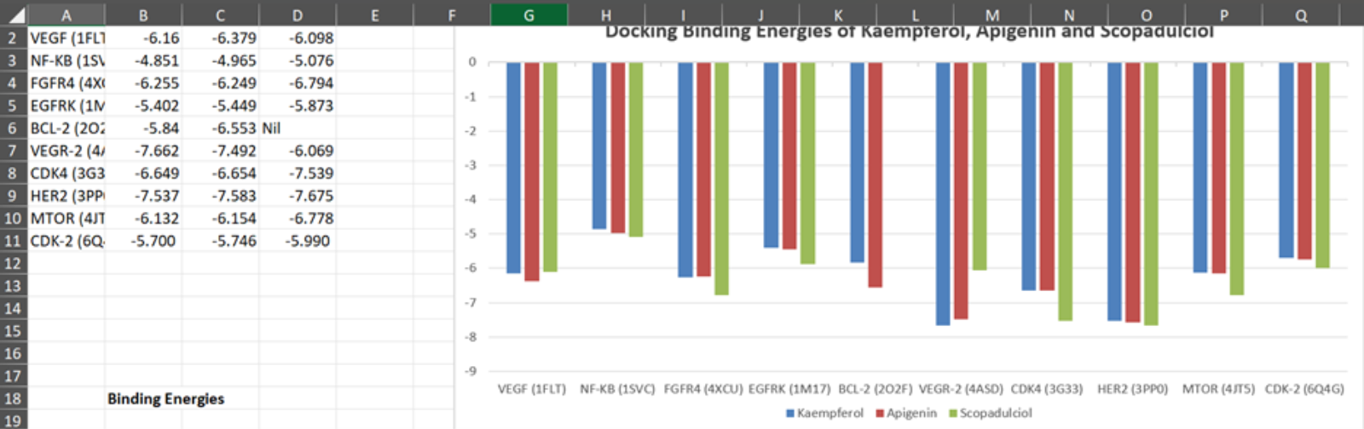
Figure 1: Docking Results for Kaempferol, Apigenin and Scopadulciol

Figure 1 above shows that kaempferol, apigenin and scopadulciol exhibited good binding energies with most of the oncogenic proteins. These three ligands were therefore chosen as the best and their binding energies with most of the proteins were compared with selected anticancer drugs. However, odoratin and coixol were also compared with some selected anticancer drugs regarding their docking with a few of the oncogenic proteins (Table 3).
Table 3 shows the results of the molecular docking of the reference anticancer drugs with their selected oncogenic proteins and compared them with the best three ligand-protein docking results.
Table 3
Molecular Docking Results of Reference Anticancer Drugs with Oncogenic Proteins, as Compared with Selected Ligands.
S/N | PROTEINS | RCSB PDB IDs | LIGAND-1 | LIGAND-2 | LIGAND-3 | REF.-1 | REF.-2
1 | Vascular Endothelial Growth Factor (VEGF) | 1FLT | Kaempferol (-6.160) | Apigenin  (-6.379) | Scopadulciol (-6.098) | Sunitinib  (-5.742) | Sorafenib  (-6.608)
2 | Nuclear factor kappa-B (NF-KB) | 1SVC | Kaempferol  (-4.851) | Apigenin  (-4.965) | Scopadulciol (-5.076) | Carfilzomib (-5.262) | BAY 11-7082  (-3.465)
3 | Fibroblast growth factor receptor 4 (FGFR4) | 4XCU | Kampferol  (-6.255) | Apigenin  (-6.249) | Scopadulciol (-6.794) | Pemigatinib (-5.096) | Erdafitinib (-5.920)
4 | Epidermal growth factor receptor (EGFR) tyrosine kinase domain | 1M17 | Kaempferol (-5.402) | Apigenin  (-5.449) | Scopadulciol (-5.873) | Erlotinib  (-4.888) | Gefitinib  (-4.985)
5 | Apoptosis regulator Bcl-2 | 2O2F | Kaempferol (-5.840) | Apigenin  (-6.553) | Coixol  (-4.432) | HA14-1  (-3.160) | Carboplatin (-3.733)
6 | Vascular endothelial growth factor receptor 2 (VEGF-2) | 4ASD | Kaempferol (-7.662) | Apigenin  (-7.492) | Odoratin  (-6.596) | Sorafenib  (-3.312) | Pazopanib (-5.961)
7 | Cyclin Dependent Kinase 4 (CDK4) | 3G33 | Kaempferol (-6.649) | Apigenin  (-6.654) | Scopadulciol (-7.539) | Palbociclib (-7.470) | Ribociclib (-7.388)
8 | Human epidermal growth factor receptor 2 (HER2) | 3PP0 | Kaempferol (-7.537) | Apigenin  (-7.583) | Scopadulciol (-7.675) | Neratinib  (-7.353) | Tucatinib  (-9.025)
9 | Mammalian target of rapamycin (mTOR) | 4JT5 | Kaempferol (-6.132) | Apigenin  (-6.154) | Scopadulciol (-6.778) | Dactolisib  (-6.638) | β- Elemene (-5.711)
10 | Cyclin Dependent Kinase 2 (CDK-2) | 6Q4G | Odoratin  (-5.750) | Apigenin  (-5.746) | Scopadulciol (-5.990) | Tagtociclib  (-5.586) | Dinaciclib (-5.525)

When the docking results of the best three ligands for each protein were compared with those of selected anticancer drugs, the ligands were seen to have similar or better docking results than the anticancer drugs (Table 3). For instance, while sorafenib (-6.608 kcal/mol) had the best docking with VEGF, the phytochemical ligands had similar dockings: kaempferol (-6.160kcal/mol), apigenin (-6.379 kcal/mol), scopadulciol (-6.098), and they all had better dockings than the other reference anticancer drug, sunitinib (-5.742). All the three best phytochemical ligands for fibroblast growth factor receptor 4 (FGFR4): kampferol (-6.255 kcal/mol), apigenin (-6.249 kcal/mol), and scopadulciol (-6.794) had better dockings than the two reference drugs, pemigatinib (-5.096 kcal/mol) and erdafitinib (-5.920 kcal/mol) (Table 3).
3.3 Biovia Discovery Studio Visualization
Table 4 below shows the interactions of apigenin, kaempferol, and scopadulciol with selected oncogenic proteins through the Biovia discovery studio visualization technique. The types of chemical interactions, e.g., hydrogen bonds, are indicated.
Table 4
Interactions between Selected Ligands and the Oncogenic Proteins
Ligand | Oncogenic Protein | Interactions
Apigenin | 1FLT (VEGF) | Arg V23 (H Bond),  His V27 (Pi-Pi T- shaped),  Leu Y174 (Pi Sigma),  Pro Y173 (Pi-Alkyl),  Pro V28 (Pi-Alkyl)
Apigenin | 4XCU (FGFR4) | Asn A557 (H Bond),  Asn A617 (Pi-Alkyl),  Arg A616 (Pi-Alkyl)
Kaempferol | 1FLT (VEGF) | Arg V23 (H Bond),  Cys V102 (H Bond),  His V27 (Pi-Pi T-shaped),  Phe Y172 (Pi-Pi T-shaped),  Leu Y174 (Pi-Sigma),  Pro V28 (Pi-Alkyl),  Pro Y173 (Pi-Alkyl)
Kaempferol | 1SVC (NF-KB) | Asn P103 (H Bond),  Asn P103 (Amide-Pi Stacked),  Asp P209 (Pi-Anion)
Kaempferol | 4XCU (FGFR4) | Asn A557 (H Bond),  Lys A644 (H Bond),
Scopadulciol | 1FLT (VEGF) | His V27 (Pi-Sigma),  Arg V23 (Pi-Alkyl),  Ile V29 (Pi-Alkyl),  Met V55 (Pi-Sulfur)

Table 4 above shows the interactions between the selected ligands and the amino acid residues of the selected oncogenic proteins (VEGF, FGFR4, & NF-KB). As could been seen, the interactions included hydrogen bonds, Pi-Pi T-shaped bonds, Pi-Alkyl bonds, Pi-Sigma bonds, Pi-Sulfur bond, Amide-Pi Stacked, Halogen (Fluorine) bond, and Pi-Anion bond.
Some of the protein-ligand interaction visualizations are displayed in Figures 2-6.
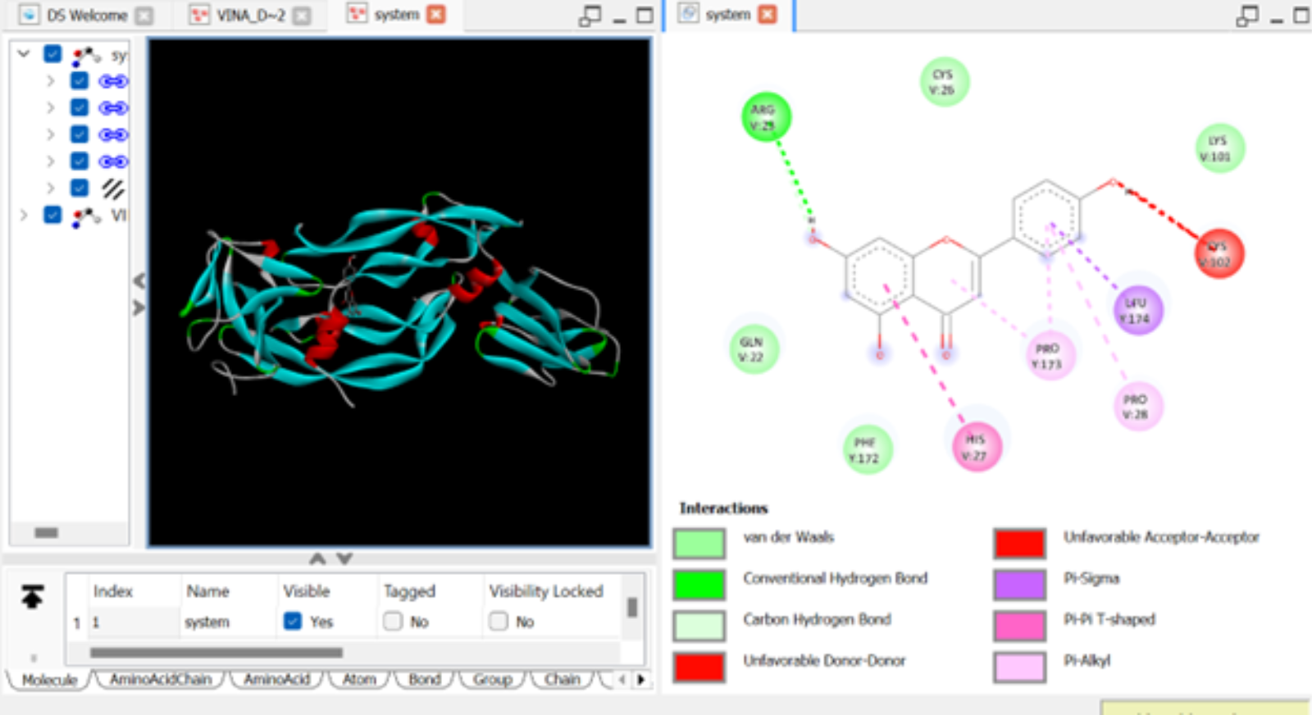
Figure 2. Biovia Discovery Studio Visualization Results for Apigenin with VEGF (1FLT)

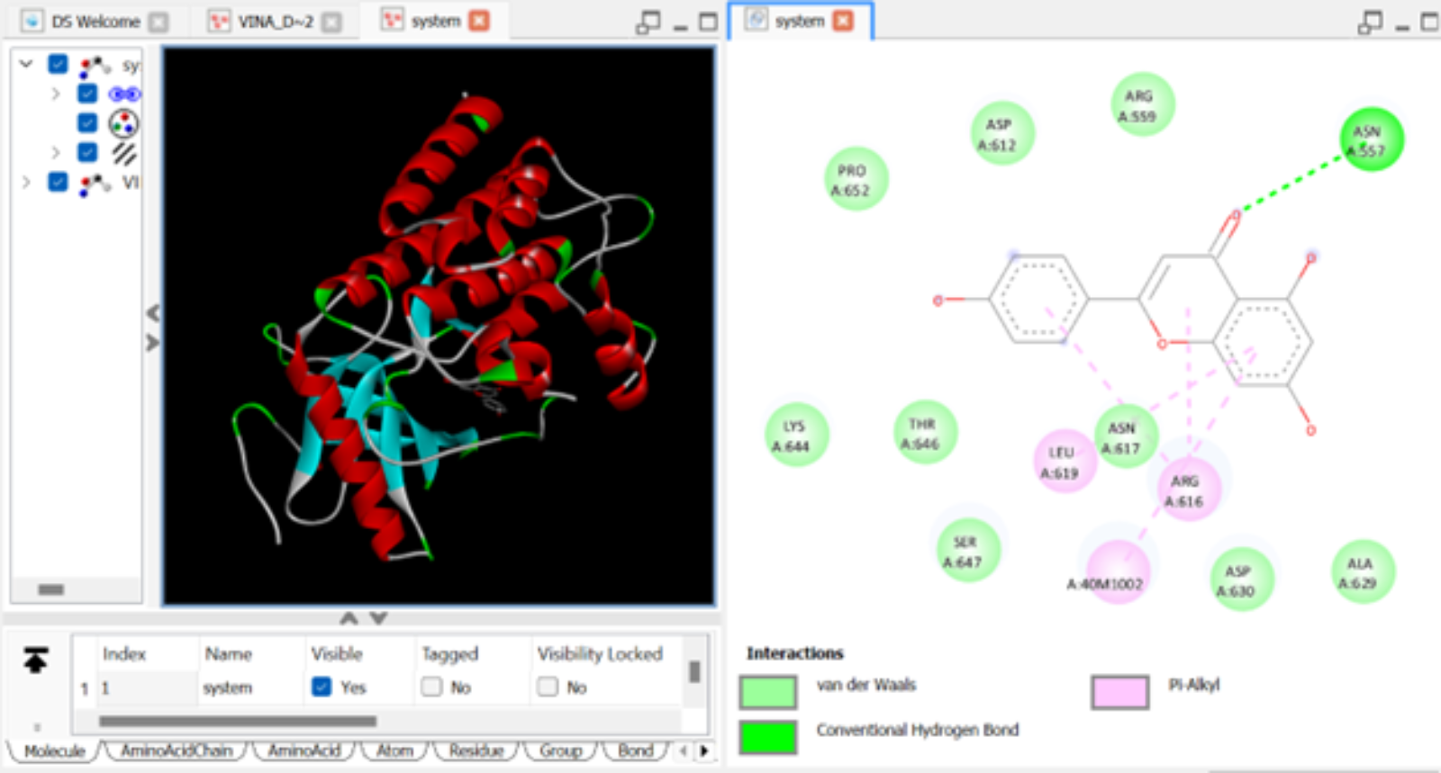
Figure 3. Biovia Discovery Studio Visualization Results for Apigenin with FGFR4 (4XCU)

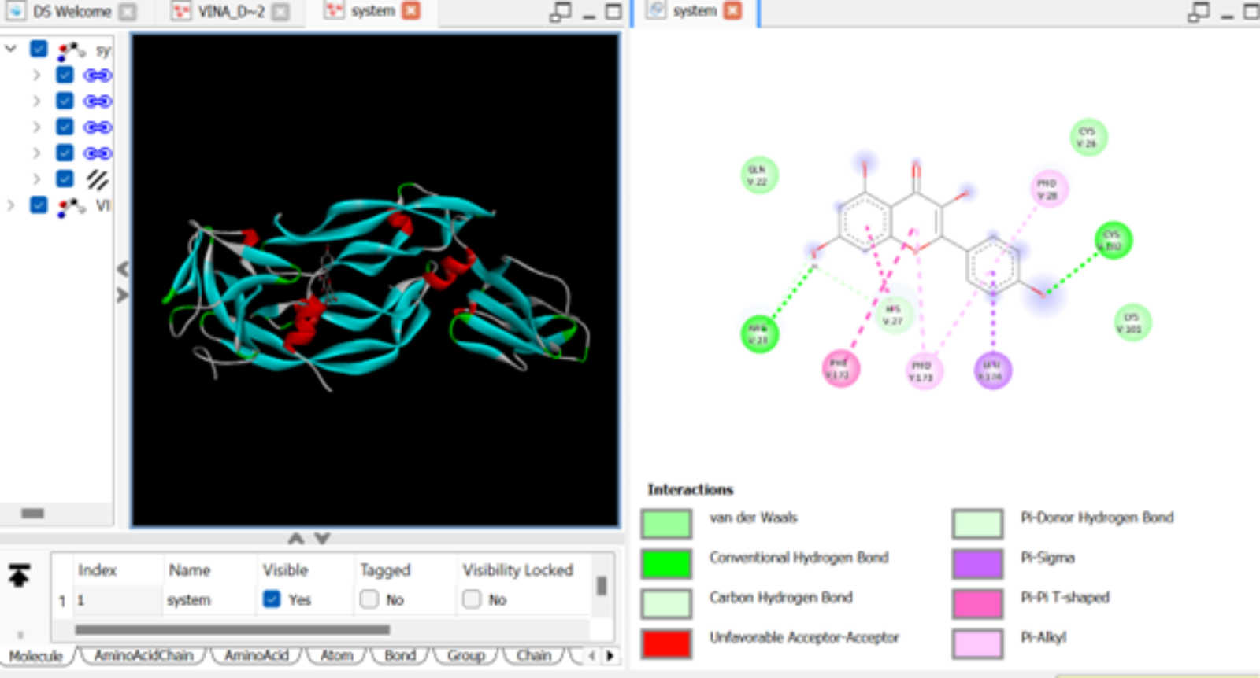
Figure 4. Biovia Discovery Studio Visualization Results for Kaempferol with VEGF (1FLT)

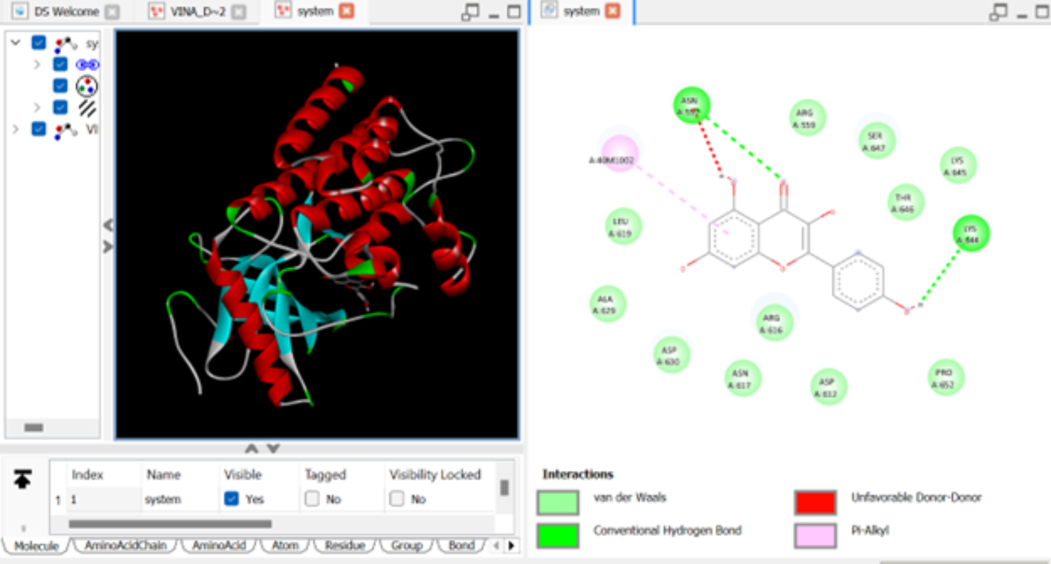
Figure 5. Biovia Discovery Studio Visualization Results for Kaempferol with FGFR4 (4XCU)

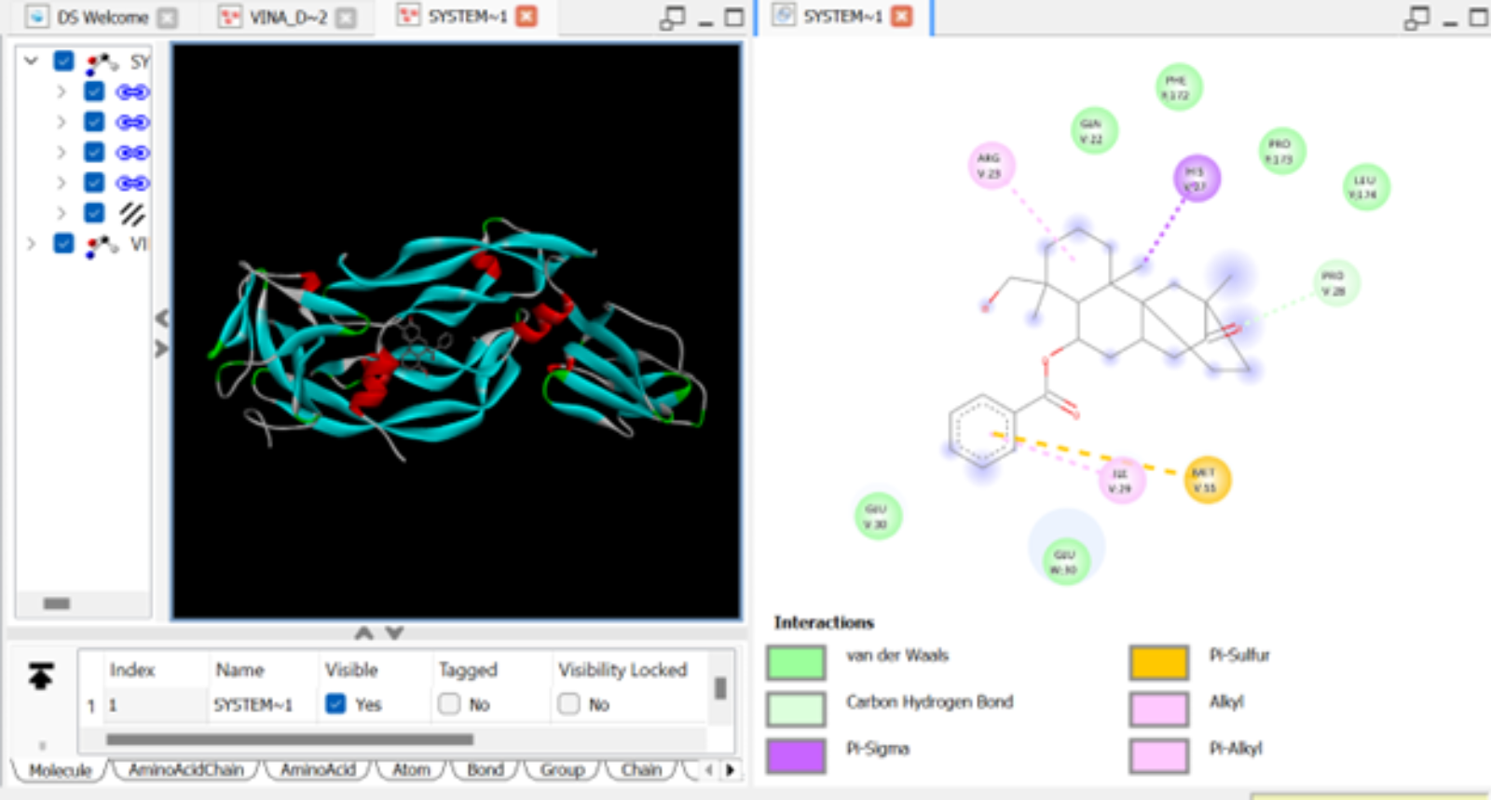
Figure 6. Biovia Discovery Studio Visualization Results for Scopadulciol with VEGF (1FLT)
Figures 2-6 above display the different interactions between the amino acid residues of selected oncogenic proteins with some of the ligands; these complement the information provided in Table 5 above. Table 5 and Figures 2-6 indicate that specific amino acid residues are much involved in the interaction of the proteins with the specific ligands. For instance, Arg V23, His V27, Leu Y174, Pro Y173 of 1FLT (VEGF) were all involved in interacting with apigenin, kaempferol and scopadulciol. Pro V28 of 1FLT also interacted with apigenin and kaempferol. Similarly, Asn A557 residue of 4XCU (FGFR4) interacted with both apigenin and kaempferol (Table 5 & Figure 2).

4.0 DISCUSSION
4.1 Pharmacokinetic Properties of Ligands
The goal of this research is to identify ligands with promising pharmacokinetic properties with little or no toxic effects which would serve as potential anticancer drugs. Therefore, we decided to identify and select ligands that passed Lipinski’s rule of 5, are non-substrates to P-glycoprotein, and have no PAINS and Brenk alerts.
As indicated in Table 2, 13 ligands out of a total of 60 used for the pharmacokinetic screening passed these tests and were there subjected to the anticancer screenings, together with selected reference anticancer drugs. Eight of the selected ligands have no Lipinski’s violation while five have one violation each, which is acceptable (Table 2; Appendices 1 & 2). All 13 ligands were non-substrates of P-glycoprotein, and they had no PAINS and Brenk alerts.
Lipinski's Rule of Five is a guideline used in drug discovery to predict if a molecule is likely to have good oral bioavailability. An orally active drug is expected to have no more than one violation of four criteria: molecular weight < 500 Da, no more than 5 hydrogen bond donors, no more than 10 hydrogen bond acceptors, and an octanol-water partition coefficient (LogP) < 5. It is a rule of thumb for pre-clinical screening to assess a compound's "druglikeness" (Benet et al., 2016; Lipinski et al., 2001).
P-glycoprotein is an ATP-binding cassette (ABC) transporter that expels toxins and xenobiotics from cells, acting as a biological barrier by extruding toxins and xenobiotics out of cells. Studies show it significantly affects drug absorption and disposition, mainly by restricting drug entry into the brain and intestinal cells rather than promoting drug excretion from the liver and kidneys (Lin & Yamazaki, 2003). Being a non-substrate for the P-glycoprotein is therefore a desirable property of any potential drug.
PAINS (Pan-Assay Interference Compounds) are chemical entities known to frequently produce false-positive outcomes in various biological screening assays, presenting a notable obstacle in the field of drug discovery (Baell & Walters, 2014). Bioinformatics tools like SwissADME are used in virtual screening and library design to identify problematic compounds, helping researchers focus on likely drug candidates and avoid false positives. Hence, the incorporation of this parameter in our study is desirable (Daina et al, 2017).
A Brenk alert is a structural warning in medicinal chemistry that flags chemical fragments likely to be toxic, reactive, unstable, or cause poor pharmacokinetics. The system lists 105 problematic fragments identified by Brenk et al. (2008), and tools like SwissADME trigger an alert when these are found in a compound, prompting further review before considering it as a drug candidate. These alerts help researchers focus on compounds with better safety and efficacy prospects early in drug discovery (Daina et al., 2017).
The 13 ligands that passed the Lipinski’s rule, P-glycoprotein non-substrate and PAINS and Brenk alert tests are components of many commonly consumed foods, herbs and spices, and no wonder, these food materials are consumed safely for nutritional and medicinal purposes in different parts of the world. For example, odoratin is a component of Eupatorium odoratum leaves that are traditionally used for wound healing, treating diarrhea, sore throats, and as an insect repellent. Studies confirm their antimicrobial, anti-inflammatory, and antioxidant effects (Sirinthipaporn & Jiraungkoorskul, 2017).
Kaempferol is a phytochemical found in plants such as Moringa oleifera and Sutherlandia frutescens, plants used widely for medicinal purposes. Moringa oleifera is a nutrient-dense plant valued for its protein, vitamins (C, A, B), minerals (calcium, iron, potassium, zinc), and phytochemicals such as kaempferol. Traditionally, its parts are used to treat asthma, high blood sugar, infections, inflammation, and may support heart health and antioxidant activity (Anwar et al., 2007). Sutherlandia frutescens is mainly valued for its potent medicinal properties, especially its antioxidant and anti-inflammatory effects, due to key bioactive compounds rather than nutritional content. It supports traditional use as an adaptogenic tonic (Aboyade et al., 2014).
The same is true for the rest of the ligands: gingerol (found in ginger, Zingiber officinale), apigenin (found in parsley, chamomile, and celery), scopadulciol (found in licorice weed), annonacin (found in Annona muricata, soursop), muricatocin A (found in soursop), annopentocin A (found in soursop), annopentocin B (found in soursop), acetogenin (found in avocado, pawpaw, sugar apple, & soursop), coixol (found in Coix lacryma-jobi or adlay, & Scoparia dulcis or licorice weed), syringic acid (found in pineapples, olives, grapes, dates, & pumpkin), and 4-Hydroxylbenzoic acid (found in Gongronema latifolium). These plants are used extensively for nutritional and/or medicinal purposes across global communities, and nutritional and health benefits of these plants and their phytochemicals have been documented (Anh et al., 2020; Kong et al., 2021; Kooti & Daraei, 2017; Morebise, 2015; Mutakin et al., 2022; Rahmani et al., 2014 Seenak et al., 2021).
4.2 Anticancer Properties
The 13 ligands exhibited varying binding energies (in kcal/mol) when docked with the 10 oncogenic proteins (Appendix 4). There isn't a universal minimum binding energy threshold since it depends on the protein target and docking software used. However, generally, a binding energy below −6.0 kcal/mol is considered favorable, whereas around −4.0 kcal/mol indicates weaker binding (Ivanova & Karelson, 2022).
Eight of the ligands (Acetogenin, Annonacin, Annopentocin A, Apigenin, Kaempferol, Muricatonin A, Odoratin, & Scopadulciol) exhibited docking energies of lower than -6.0 kcal/.mol with at least one oncogenic protein, with some of them having docking energies of less than -6.0 kcal/mol with multiple oncogenic proteins. For instance, kaempferol had a binding energy of -7.662 kcal/mol against VEGR-2, -7.537 kcal/mol against HER2, -6.649 kcal/mol against CDK4, -6.132 kcal/mol against mTOR, -6.255 kcal/mol against FGFR4, and -6.160 kcal/mol against VEGF. The anticancer properties of these eight ligands have been documented through various lab studies: Acetogenin (Jacobo-Herrera et al, 2019), Annonacin (Xiao et al., 2025), Annopentocin A (Rovik et al., 2025), Apigenin (Rahmani et al., 2022), Kaempferol (Kaur et al., 2024), Muricatocin A (Ilango et al., 2022), Odoratin (Omoboyowa et al., 2022), and Scopadulciol (Hasnawati et al., 2023). Three of these ligands (apigenin, kaempferol & scopaldulciol) were exceptionally remarkable in their docking properties, as they exhibited good dockings with most of the oncogenic proteins (Table 3).
4.2.1 Apigenin
Apigenin (4′,5,7-Trihydroxyflavone) belongs to a broad category of plant-based polyphenols known as flavonoids (Abid et al., 2022). Its anticancer effects stem from its ability to arrest angiogenesis, stimulate programmed cell death, antagonize cell proliferation, limit metastasis, activate the immune system, mitigate inflammation (Naponelli et al., 2024; Yan et al., 2017), and enhance the efficacy of chemotherapy (Nozhat et al, 2021).
Apigenin has been reported to downregulate antiapoptotic factors such as BCL2 (2O2F), decrease NF-kB (1SVC) signaling [Naponelli et al., 2024], degrade human epidermal growth factor receptor 2, HER2 (3PP0) (Way et al., 2004) inhibit the mammalian target of rapamycin, mTOR (4JT5) pathway (Yang et al., 2018), and decrease epidermal growth factor receptor (1M17) (Sharma et al., 2022), as part of the mechanisms of its anticancer actions. Our study shows that apigenin had good binding energies with the proteins reported by these authors.
Our study shows that apigenin interacted with the Arg V23 of VEGF via hydrogen bond (H bond). It also interacted with the His V27 (Pi-Pi-T shaped), Leu Y174 (Pi Sigma), Pro Y173 (Pi-Alkyl) and Pro V28 (Pi-Alkyl) residues of VEGF (Figure 1; Table 5). Likewise, apigenin interacted with the Asn A557 (H bond), Asn A617 (Pi-Alkyl) and Arg A616 (Pi-Alkyl) residues of FGR4 (Figure 2; Table 5). These interactions might be part of the molecular mechanisms through which apigenin exhibits its anticancer activities against these proteins.
Further investigation reveals that the binding energies of apigenin with these proteins were comparable, and in some cases, better than those of the reference anticancer drugs used for the study (Table 4). For instance, while apigenin had a binding energy of -7.583 with 3PP0 (HER2), that of Neratinib was -7.353 kcal/mol and that of Tucatinib was -9.025 kcal/mol. Apigenin’s binding energy with mTOR (4JTF) was -6.154 kcal/mol, a value very close to that of Dactolisib (-6.638 kcal/mol) and better than that of the other reference drug, β- Elemene (-5.711 kcal/mol). Similarly, apigenin’s docking binding energy value with VEGF (1FLT) was comparable to that of sorafenib (reference drug-1) and better than that of sunitinib (reference drug-2). Similar results could be seen with the other proteins (Table 3).
4.2.2 Kaempferol
Kaempferol, a flavonoid found in numerous foods and medicinal plants, inhibits cancer cell growth, triggers apoptosis, and reduces metastasis by disrupting cell signaling and affecting the tumor microenvironment. Studies suggest it may help treat breast, liver, and lung cancers and boost chemotherapy effectiveness (Amjad et al., 2022; Imran et al., 2019). Kaempferol has been reported to inhibit cancer by suppressing angiogenesis through downregulation of VEGF expression and its signaling pathways. It reduces both mRNA and protein levels of VEGF in various cancer cells, including ovarian and colon cancers, and blocks VEGFR-2 protein expression and kinase activity, limiting new blood vessel formation for tumor growth (Luo et al., 2012; Yu et.al, 2022).
Luo et al. (2009) reported that kaempferol exhibits minimal cytotoxicity while effectively inhibiting angiogenesis and VEGF expression in human ovarian cancer cells. Kaempferol has been shown to inhibit FGFR4 by binding to its kinase domain, specifically interacting with the ATP-binding pocket. This prevents activation and phosphorylation by fibroblast growth factor (FGF), blocking downstream pathways such as RSK2, PI3K/Akt, and ERK/p38 MAPK. Inhibiting these pathways disrupts cell proliferation, migration, and survival, resulting in anti-cancer effects like apoptosis and cell cycle arrest (Coleman et al., 2014; Zheng et al., 2022).
Our molecular docking and visualization results show that kaempferol interacted with VEGF through the following amino acid residues of the protein: Arg V23 (H bond), Cys V102 (H bond), His V27 (Pi-Pi T-shaped), Phe Y172 (Pi-Pi T-shaped), Leu Y174 (Pi Sigma), Pro V28 (Pi-Alkyl), and Pro Y173 (Pi-Alkyl) (Figure 3; Table 5). Kaempferol also interacted with FGFR4 through the following amino acid residues of the protein: Asn A557 (H bond) and Lys A644 (H bond) (Figure 4; Table 5). This indicates that kaempferol may have a direct inhibitory effect on these proteins and binding to the amino acid residues indicated may be part of the mechanisms for the inhibitory effect.
Our study shows that kaempferol exhibited binding energy of -6.160 kcal/mol when docked with VEGF. This is close to the binding energy of the reference drug sorafenib (-6.608 kcal/mol) and better than that of the other reference drug, sunitinib (-5.742 kcal/mol). (Table 4). Kaempferol also exhibited a better binding energy when docked with FGFR4 (-6.255 kcal/mol) compared with the two reference drugs: pemigatinib (-5.096 kcal/mol) and erdafitinib (-5.920) (Table 5). Kaempferol also exhibited a better binding energy (-7.537 kcal/mol) than the reference drug neratinib (-7.353 kcal/mol) when docked with HER2, though the second reference drug, tucatinib, had a better docking binding energy (-9.025 kcal/mol) (Table 4). Similar results are also seen for the binding of kaempferol with mTOR when the binding energy is compared to those of the reference drugs (Table 3).
4.2.3 Scopadulciol
Laboratory research indicates that scopadulciol (also called dulcinol), a diterpenoid derived from the plant Scoparia dulcis (Licorice weed), demonstrates strong anticancer and cytotoxic effects against several cancer cell lines, mainly based on in vitro and animal experiments). Research has demonstrated its cytotoxic and antiproliferative activities against various cancer cell types, including gastric, prostatic, and HeLa (cervical) cell lines (Hasnawati et al., 2023).
Our study shows that scopadulciol had good docking binding energies with most of the oncogenic proteins and compared well or even better than the reference drugs (Tables 3 & 4). For instance, scopadulciol had better binding energies of -7.539 kcal/mol with CDK4 when compared with the two reference drugs (Palbociclib, -7.470 kcal/mol; Ribociclib, -7.388 kcal/mol). While previous research reports did not link the anticancer effect of scopadulciol to its direct inhibition of the oncogenic proteins, our in silico study shows a good docking binding energy of scopadulciol with the proteins. Therefore, this is an area that may be investigated in future research studies.
5.0 CONCLUSION
This study has demonstrated the pharmacokinetic and toxicity profiles of 60 ligands found in commonly consumed foods, spices, herbs and medicinal plants through in silico molecular biology techniques. Thirteen of the ligands passed the Lipinski’s rule, P-glycoprotein non-substrate and PAINS and Brenk alert tests and were used for anticancer tests. Results of their docking with ten oncogenic proteins showed that most of them exhibited excellent dockings which compared well with reference anticancer drugs while some even had better dockings than the reference drugs.
Acetogenin, Annonacin, Annopentocin A, Apigenin, Kaempferol, Muricatonin A, Odoratin, and Scopadulciol demonstrated docking energies below -6.0 kcal/mol with at least one oncogenic protein. Notably, several of these compounds exhibited docking energies below -6.0 kcal/mol with multiple oncogenic proteins. Apigenin, kaempferol, and scopaldulciol showed strong docking with most oncogenic proteins. Our study supports earlier reports by different authors on the inhibitory effects of apigenin on VEGF, mTOR and BCL2, and the inhibitory effects of kaempferol on VEGF and FGFR4. Thus, blocking these proteins may be part of the mechanisms of anticancer properties of these ligands.
The following amino acid residues of VEGF (1FLT): Arg V23, His V27, Leu Y174, Pro Y173, and Pro V28, and the Asn A557 of FGFR4 (4XCU) are of interest because they exhibited molecular interactions with several of the ligands. They should therefore be investigated further in both wet and in silico research as possible targets for anticancer drugs.
The anticancer mechanisms of scopadulciol have been documented by various authors. While direct inhibition of the oncogenic proteins investigated here were not among the popularly reported mechanisms of scopadulciol’s anticancer activity, our study has shown good docking of this ligand with most of the oncogenic proteins. Thus, it is recommended that more wet lab research works in this area should be conducted to ascertain the direct inhibitory effects of scopadulciol on these oncogenic proteins.
Plant materials which are rich sources of the 13 ligands used for the anticancer study are consumed traditionally for both nutritional and medicinal purposes with little or no reports of harm, and our study has supported their uses for these purposes. Since most anticancer drugs exhibit toxic effects on normal cells thus leading to various side effects, identifying alternatives with minimal or no side effects is a step in a positive direction. We hereby recommend that further research, including molecular dynamics simulations and translational research studies, should be conducted on the eight ligands (acetogenin, annonacin, annopentocin A, apigenin, kaempferol, muricatonin A, odoratin, & scopadulciol) that have demonstrated good pharmacokinetic profiles and promising anticancer activities. We also recommend that the foods, spices and herbs that contain these ligands that passed the pharmacokinetic and toxicity tests and exhibited good anticancer dockings should be incorporated into regular diets owing to their anticancer properties.

References
Abid, R., Ghazanfar, S., Farid, A., Sulaman, S. M., Idrees, M., Amen, R. A., Muzammal, M., Shahzad, M. K., Mohamed, M. O., Khaled, A. A., Safir, W., Ghori, I., Elasbali, A. M., & Alharbi, B. (2022). Pharmacological properties of 4′, 5, 7-Trihydroxyflavone (Apigenin) and its impact on cell signaling pathways. Molecules, 27(13), 4304. https://doi.org/10.3390/molecules27134304
Aboyade OM, Styger G, Gibson D, Hughes G. Sutherlandia frutescens: the meeting of science and traditional knowledge. J Altern Complement Med. 2014 Feb;20(2):71-6. doi: 10.1089/acm.2012.0343. Epub 2013 Jul 9. PMID: 23837689; PMCID: PMC3924790.
Alam, M., Ali, S., Mohammad, T., Hasan, G. M., Yadav, D. K., & Hassan, M. I. (2021). B Cell Lymphoma 2: A Potential Therapeutic Target for Cancer Therapy. International Journal of Molecular Sciences, 22(19), 10442. https://doi.org/10.3390/ijms221910442
Amjad, E., Sokouti, B. & Asnaashari, S. A systematic review of anti-cancer roles and mechanisms of kaempferol as a natural compound. Cancer Cell Int 22, 260 (2022). https://doi.org/10.1186/s12935-022-02673-0
Anh, N. H., Kim, S. J., Long, N. P., Min, J. E., Yoon, Y. C., Lee, E. G., Kim, M., Kim, T. J., Yang, Y. Y., Son, E. Y., Yoon, S. J., Diem, N. C., Kim, H. M., & Kwon, S. W. (2020). Ginger on Human Health: A Comprehensive Systematic Review of 109 Randomized Controlled Trials. Nutrients, 12(1), 157. https://doi.org/10.3390/nu12010157
Anwar, F., Latif, S., Ashraf, M., & Gilani, A. H. (2007). Moringa oleifera: a food plant with multiple medicinal uses. Phytotherapy research : PTR, 21(1), 17–25. https://doi.org/10.1002/ptr.2023
Baell, J., Walters, M. Chemistry: Chemical con artists foil drug discovery. Nature 513, 481–483 (2014). https://doi.org/10.1038/513481a
Baker, S. J., Poulikakos, P. I., Irie, H. Y., Parekh, S., & Reddy, E. P. (2022). CDK4: a master regulator of the cell cycle and its role in cancer. Genes & cancer, 13, 21–45. https://doi.org/10.18632/genesandcancer.221
Baroroh, U., Muscifa, Z.M., Destiarani, W., Rohmatulloh, F.G., & Yusuf, M. (2023). Molecular interaction analysis and visualization of protein-ligand docking using Biovia Discovery Studio Visualizer. Indonesian Journal of Computational Biology, 2(1), 22-30. https://jurnal.unpad.ac.id/ijcb/article/viewFile/46322/20445
Bendardaf, R., El-Serafi, A., Syrjänen, K., Collan, Y., & Pyrhönen, S. (2017). The effect of vascular endothelial growth factor-1 expression on survival of advanced colorectal cancer patients. The Libyan journal of medicine, 12(1), 1290741. https://doi.org/10.1080/19932820.2017.1290741
Benet LZ, Hosey CM, Ursu O, Oprea TI: BDDCS, the Rule of 5 and drugability. Adv Drug Deliv Rev. 2016 Jun 1;101:89-98. doi: 10.1016/j.addr.2016.05.007. Epub 2016 May 13. [Article]
Bisson, J., McAlpine, J. B., Friesen, J. B., Chen, S. N., Graham, J., & Pauli, G. F. (2016). Can Invalid Bioactives Undermine Natural Product-Based Drug Discovery?. Journal of medicinal chemistry, 59(5), 1671–1690. https://doi.org/10.1021/acs.jmedchem.5b01009
Brenk, R., Schipani, A., James, D., Krasowski, A., Gilbert, I., Frearson, J., & Wyatt, P. (2008). Lessons Learnt from Assembling Screening Libraries for Drug Discovery for Neglected Diseases. ChemMedChem, 3, 435-444. DOI: 10.1002/cmdc.200700139

Brown G. (2021). Oncogenes, Proto-Oncogenes, and Lineage Restriction of Cancer Stem Cells. International journal of molecular sciences, 22(18), 9667. https://doi.org/10.3390/ijms22189667
Bugnon, M., Röhrig, U. F., Goullieux, M., Perez, M. A. S., Daina, A., Michielin, O., & Zoete, V. (2024). SwissDock 2024: major enhancements for small-molecule docking with Attracting Cavities and AutoDock Vina. Nucleic acids research, 52(W1), W324–W332. https://doi.org/10.1093/nar/gkae300
Cardinali G, Nervi C. Combined Use of Vinblastine and Vincristine in the Treatment of Tumors. Tumori Journal. 1968;54(5):345-351. doi:10.1177/030089166805400501
Cheng X. (2024). A Comprehensive Review of HER2 in Cancer Biology and Therapeutics. Genes, 15(7), 903. https://doi.org/10.3390/genes15070903
Chunarkar-Patil, P., Kaleem, M., Mishra, R., Ray, S., Ahmad, A., Verma, D., Bhayye, S., Dubey, R., Singh, H. N., & Kumar, S. (2024). Anticancer Drug Discovery Based on Natural Products: From Computational Approaches to Clinical Studies. Biomedicines, 12(1), 201. https://doi.org/10.3390/biomedicines12010201
Coleman S, Grose R, Kocher H. Fibroblast growth factor family as a potential target in the treatment of hepatocellular carcinoma. J Hepatocell Carcinoma. 2014;1:43-54
https://doi.org/10.2147/JHC.S48958
Daina A, Michielin O, Zoete V. SwissADME: a free web tool to evaluate pharmacokinetics, drug-likeness and medicinal chemistry friendliness of small molecules. Sci Rep. 2017 Mar 3;7:42717. doi: 10.1038/srep42717. PMID: 28256516; PMCID: PMC5335600.
Desai, A. G., Qazi, G. N., Ganju, R. K., El-Tamer, M., Singh, J., Saxena, A. K., Bedi, Y. S., Taneja, S. C., & Bhat, H. K. (2008). Medicinal plants and cancer chemoprevention. Current drug metabolism, 9(7), 581–591. https://doi.org/10.2174/138920008785821657
Dhyani, P., Quispe, C., Sharma, E. et al. Anticancer potential of alkaloids: a key emphasis to colchicine, vinblastine, vincristine, vindesine, vinorelbine and vincamine. Cancer Cell Int 22, 206 (2022). https://doi.org/10.1186/s12935-022-02624-9

Dickerson, H., Diab, A., & Al Musaimi, O. (2024). Epidermal Growth Factor Receptor Tyrosine Kinase Inhibitors in Cancer: Current Use and Future Prospects. International Journal of Molecular Sciences, 25(18), 10008. https://doi.org/10.3390/ijms251810008
Du, R., Wang, X., Ma, L., Larcher, L. M., Tang, H., Zhou, H., Chen, C., & Wang, T. (2021). Adverse reactions of targeted therapy in cancer patients: a retrospective study of hospital medical data in China. BMC cancer, 21(1), 206. https://doi.org/10.1186/s12885-021-07946-x
Fornasier, G., Taborelli, M., Francescon, S. et al. Targeted therapies and adverse drug reactions in oncology: the role of clinical pharmacist in pharmacovigilance. Int J Clin Pharm 40, 795–802 (2018). https://doi.org/10.1007/s11096-018-0653-5
Guo, S., Colbert, L. S., Fuller, M., Zhang, Y., & Gonzalez-Perez, R. R. (2010). Vascular endothelial growth factor receptor-2 in breast cancer. Biochimica et biophysica acta, 1806(1), 108–121. https://doi.org/10.1016/j.bbcan.2010.04.004
Hasnawati, H., Wahyuono, S., Susidarti, R. A., Santosa, D., & Arfan, A. (2023). A New Diterpenoid of Indonesian Scoparia dulcis Linn: Isolation and Cytotoxic Activity against MCF-7 and T47D Cell Lines. Molecules (Basel, Switzerland), 28(16), 5960. https://doi.org/10.3390/molecules28165960
Ilango, S., Sahoo, D. K., Paital, B., Kathirvel, K., Gabriel, J. I., Subramaniam, K., Jayachandran, P., Dash, R. K., Hati, A. K., Behera, T. R., Mishra, P., & Nirmaladevi, R. (2022). A Review on Annona muricata and Its Anticancer Activity. Cancers, 14(18), 4539. https://doi.org/10.3390/cancers14184539
Imran, M., Salehi, B., Sharifi-Rad, J., Aslam Gondal, T., Saeed, F., Imran, A., Shahbaz, M., Tsouh Fokou, P. V., Umair Arshad, M., Khan, H., Guerreiro, S. G., Martins, N., & Estevinho, L. M. (2019). Kaempferol: A Key Emphasis to Its Anticancer Potential. Molecules (Basel, Switzerland), 24(12), 2277. https://doi.org/10.3390/molecules24122277
Ivanova, L. & Karelson, M. The Impact of Software Used and the Type of Target Protein on Molecular Docking Accuracy. Molecules. 2022 Dec 18;27(24):9041. doi: 10.3390/molecules27249041. PMID: 36558174; PMCID: PMC9788237.
Jacobo-Herrera, N., Pérez-Plasencia, C., Castro-Torres, V. A., Martínez-Vázquez, M., González-Esquinca, A. R., & Zentella-Dehesa, A. (2019). Selective Acetogenins and Their Potential as Anticancer Agents. Frontiers in pharmacology, 10, 783. https://doi.org/10.3389/fphar.2019.00783
Kaur, S., Mendonca, P., & Soliman, K. F. A. (2024). The Anticancer Effects and Therapeutic Potential of Kaempferol in Triple-Negative Breast Cancer. Nutrients, 16(15), 2392. https://doi.org/10.3390/nu16152392
Knudsen, E. S., Witkiewicz, A. K., Sanidas, I., & Rubin, S. M. (2025). Targeting CDK2 for cancer therapy. Cell reports, 44(8), 116140. https://doi.org/10.1016/j.celrep.2025.116140
Kokkotou, E., Charpidou, A., & Syrigos, N. (2025). Predictive Value of Serum VEGF Levels in Non-Small Cell Lung Cancer: A Review. Oncology research, 33(10), 2657–2672. https://doi.org/10.32604/or.2025.066228
Kong, Y. R., Jong, Y. X., Balakrishnan, M., Bok, Z. K., Weng, J. K. K., Tay, K. C., Goh, B. H., Ong, Y. S., Chan, K. G., Lee, L. H., & Khaw, K. Y. (2021). Beneficial Role of Carica papaya Extracts and Phytochemicals on Oxidative Stress and Related Diseases: A Mini Review. Biology, 10(4), 287. https://doi.org/10.3390/biology10040287
Kooti, W., & Daraei, N. (2017). A Review of the Antioxidant Activity of Celery ( Apium graveolens L). Journal of evidence-based complementary & alternative medicine, 22(4), 1029–1034. https://doi.org/10.1177/2156587217717415
Lin, J. H., & Yamazaki, M. (2003). Role of P-glycoprotein in pharmacokinetics: clinical implications. Clinical pharmacokinetics, 42(1), 59–98. https://doi.org/10.2165/00003088-200342010-00003
Lipinski CA, Lombardo F, Dominy BW, Feeney PJ: Experimental and computational approaches to estimate solubility and permeability in drug discovery and development settings. Adv Drug Deliv Rev. 2001 Mar 1;46(1-3):3-26.
Luo, H., Rankin, G. O., Liu, L., Daddysman, M. K., Jiang, B. H., & Chen, Y. C. (2009). Kaempferol inhibits angiogenesis and VEGF expression through both HIF dependent and independent pathways in human ovarian cancer cells. Nutrition and cancer, 61(4), 554–563. https://doi.org/10.1080/01635580802666281
Luo, H., Rankin, G. O., Juliano, N., Jiang, B. H., & Chen, Y. C. (2012). Kaempferol inhibits VEGF expression and in vitro angiogenesis through a novel ERK-NFκB-cMyc-p21 pathway. Food chemistry, 130(2), 321–328. https://doi.org/10.1016/j.foodchem.2011.07.045
Magouliotis, D., Karamolegkou, A.,Zotos, P., Tatsios, E., Samara, A., Alexopoulou, D., Koutsougianni, F., Sakellaridis, N., Zacharoulis, D.,& Dimas, K. (2022). Bioinformatic Analysis of the BCL-xL/BCL2L1 Interactome in Patients with Pancreatic Cancer. Medicina, 58(11), 1663-1672
Mao, H., Zhao, X. & Sun, Sc. NF-κB in inflammation and cancer. Cellular and Molecular Immunology, 22, 811–839 (2025). https://doi.org/10.1038/s41423-025-01310-w
Morebise, O. (2015). A Review on Gongronema latifolium, an Extremely Useful Plant with Great Prospects. European Journal of Medicinal Plants, 10(1), 1–9. https://doi.org/10.9734/EJMP/2015/19713

Mroz EA, Rocco JW. The challenges of tumor genetic diversity. Cancer, 2017;123(6):917e927, Mroz & Rocco, 2017.
Mutakin, M., Fauziati, R., Fadhilah, F. N., Zuhrotun, A., Amalia, R., & Hadisaputri, Y. E. (2022). Pharmacological Activities of Soursop (Annona muricata Lin.). Molecules (Basel, Switzerland), 27(4), 1201. https://doi.org/10.3390/molecules27041201
Naponelli, V., Rocchetti, M. T., & Mangieri, D. (2024). Apigenin: Molecular Mechanisms and Therapeutic Potential against Cancer Spreading. International journal of molecular sciences, 25(10), 5569. https://doi.org/10.3390/ijms25105569
Nozhat, Z., Heydarzadeh, S., Memariani, Z., & Ahmadi, A. (2021). Chemoprotective and chemosensitizing effects of apigenin on cancer therapy. Cancer cell international, 21(1), 574. https://doi.org/10.1186/s12935-021-02282-3
Omoboyowa, D., Iqbal, M., Balogun, T., Damilola, B., Fatoki, J., & Oyeneyin, O. (2022). Inhibitory Potential of Phytochemicals from Chromolaena odorata L. against Apoptosis Signal-Regulatory Kinase 1: A Computational Model against Colorectal Cancer. Computational Toxicology, 23(1), 100235. DOI:10.1016/j.comtox.2022.100235
Perner, F., Perner, C., Ernst, T., & Heidel, F. H. (2019). Roles of JAK2 in Aging, Inflammation, Hematopoiesis and Malignant Transformation. Cells, 8(8), 854. https://doi.org/10.3390/cells8080854
Petroulakis, E., Mamane, Y., Le Bacquer, O., Shahbazian, D., & Sonenberg, N. (2006). mTOR signaling: implications for cancer and anticancer therapy. British journal of cancer, 94(2), 195–199. https://doi.org/10.1038/sj.bjc.6602902
Prabha, B., & Ezhilarasi, M.R. (2021). Synthesis, Spectral Characterization, in Vitro and in Silico Studies of Benzodioxin Pyrazoline derivatives. Biointerface Research in Applied Chemistry, 11(2), 9126 – 9138. https://biointerfaceresearch.com/wp-content/uploads/2020/09/20695837112.91269138.pdf
Rahmani, A. H., Aly, S. M., Ali, H., Babiker, A. Y., Srikar, S., & Khan, A. A. (2014). Therapeutic effects of date fruits (Phoenix dactylifera) in the prevention of diseases via modulation of anti-inflammatory, anti-oxidant and anti-tumour activity. International journal of clinical and experimental medicine, 7(3), 483–491.
Rahmani, A. H., Alsahli, M. A., Almatroudi, A., Almogbel, M. A., Khan, A. A., Anwar, S., & Almatroodi, S. A. (2022). The Potential Role of Apigenin in Cancer Prevention and Treatment. Molecules (Basel, Switzerland), 27(18), 6051. https://doi.org/10.3390/molecules27186051
Rovik, A., Jenie, R., & Susidarti, R. (2025). The Miracle from The Yard: Annona muricata as Cancer Chemo-Preventive and Co-Chemotherapy. JPSCR: Journal of Pharmaceutical Science and Clinical Research, 10(1), 18-37. doi:http://dx.doi.org/10.20961/jpscr.v10i1.86516
Samuels, Y., & Waldman, T. (2010). Oncogenic mutations of PIK3CA in human cancers. Current topics in microbiology and immunology, 347, 21–41. https://doi.org/10.1007/82_2010_68
Seenak, P., Kumphune, S., Malakul, W., Chotima, R., & Nernpermpisooth, N. (2021). Pineapple consumption reduced cardiac oxidative stress and inflammation in high cholesterol diet-fed rats. Nutrition & metabolism, 18(1), 36. https://doi.org/10.1186/s12986-021-00566-z
Sharma B. Singh V. J. Chawla P. A. Epidermal growth factor receptor inhibitors as potential anticancer agents: an update of recent progress. Bioorg. Chem. 2021;116:105393. Sharma B. Singh V. J. Chawla P. A. Epidermal growth factor receptor inhibitors as potential anticancer agents: an update of recent progress. Bioorg. Chem. 2021;116:105393. https://doi.org/10.1016/j.bioorg.2021.105393
Sirinthipaporn A, Jiraungkoorskul W. Wound Healing Property Review of Siam Weed, Chromolaena odorata. Pharmacogn Rev. 2017 Jan-Jun;11(21):35-38. doi: 10.4103/phrev.phrev_53_16. PMID: 28503052; PMCID: PMC5414454.
Sousa-Pimenta M, Estevinho LM, Szopa A, Basit M, Khan K, Armaghan M, Ibrayeva M, Sönmez Gürer E, Calina D, Hano C and Sharifi-Rad J (2023), Chemotherapeutic properties and side-effects associated with the clinical practice of terpene alkaloids: paclitaxel, docetaxel, and cabazitaxel. Frontiers in Pharmacology. 14:1157306. doi: 10.3389/fphar.2023.1157306
Tang, S., Hao, Y., Yuan, Y., Liu, R., & Chen, Q. (2018). Role of fibroblast growth factor receptor 4 in cancer. Cancer science, 109(10), 3024–3031. https://doi.org/10.1111/cas.13759
Upadhyay A. (2020). Cancer: An unknown territory; rethinking before going ahead. Genes & diseases, 8(5), 655–661. https://doi.org/10.1016/j.gendis.2020.09.002
Ujvari B, Klaassen M, Raven N, et al. Genetic diversity, inbreeding and cancer. Proc Biol Sci. 2018;285(1875):20172589.
Uribe, M. L., Marrocco, I., & Yarden, Y. (2021). EGFR in Cancer: Signaling Mechanisms, Drugs, and Acquired Resistance. Cancers, 13(11), 2748. https://doi.org/10.3390/cancers13112748
Way, T. D., Kao, M. C., & Lin, J. K. (2004). Apigenin induces apoptosis through proteasomal degradation of HER2/neu in HER2/neu-overexpressing breast cancer cells via the phosphatidylinositol 3-kinase/Akt-dependent pathway. The Journal of biological chemistry, 279(6), 4479–4489. https://doi.org/10.1074/jbc.M305529200
Xiao, Y., Wang, Q., Sun, C., Zou, H., Cheng, X., Yao, R., & Zhou, H. (2025). Anticancer Activity of Annonacin and Its Synergistic Enhancement of Docetaxel Efficacy in Prostate Cancer. Journal of cellular and molecular medicine, 29(23), e70972. https://doi.org/10.1111/jcmm.70972
Yan, X., Qi, M., Li, P., Zhan, Y., & Shao, H. (2017). Apigenin in cancer therapy: anti-cancer effects and mechanisms of action. Cell & bioscience, 7, 50. https://doi.org/10.1186/s13578-017-0179-x
Yang, J., Pi, C., & Wang, G. (2018). Inhibition of PI3K/Akt/mTOR pathway by apigenin induces apoptosis and autophagy in hepatocellular carcinoma cells. Biomedicine & pharmacotherapy = Biomedecine & pharmacotherapie, 103, 699–707. https://doi.org/10.1016/j.biopha.2018.04.072
Yu, R., Zhong, J., Zhou, Q., Ren, W., Liu, Z., & Bian, Y. (2022). Kaempferol prevents angiogenesis of rat intestinal microvascular endothelial cells induced by LPS and TNF-α via inhibiting VEGF/Akt/p38 signaling pathways and maintaining gut-vascular barrier integrity. Chemico-biological interactions, 366, 110135. https://doi.org/10.1016/j.cbi.2022.110135
Zheng, J., Zhang, W. Li, L., Wei, Y., Dang, Y., Nie, S., & Guo, Z. (2022). Signaling Pathway and Small-Molecule Drug Discovery of FGFR: A Comprehensive Review.Frontiers In Chemistry, 10 (860985), 1-24. doi: 10.3389/fchem.2022.860985

