Synthesis of zinc oxide-graphite composite for the photocatalytic degradation of ciprofloxacin with sunlight

Abstract
Zinc oxide-graphite nanoparticles were synthesized by the hydrothermal method. Several characterization tests including XRD, IR, SEM, and UV-visible spectroscopy through absorbance were used to characterize nanoparticles. The characterization results highlighted nanoparticles with mixed crystallographic phases and a decrease in the band gap energy. The photocatalytic activities of these materials were tested with sunlight for the photodegradation of ciprofloxacin, an emerging antibiotic. The results showed the performance of ZnO-Gr nanoparticle compared to ZnO depending on the amount of graphite added. A study on the optimal conditions of the reaction medium was conducted, which allowed achieving a 100% ciprofloxacin degradation yield. The results on the stability of photocatalyst showed good stability after four activity cycles.
Keywords: antibiotics, ciprofloxacin, zinc oxide, graphite, photocatalysis
Introduction
The threat to water integrity due to emerging pharmaceutical pollutants constitutes one of the serious environmental problems in the world. The main sources of contamination by pharmaceutical pollutants are the discharges into the environment of wastewater from hospitals, households, pharmaceutical industries, and animals (Bizi & El Bachra, 2020; Marchesini et al., 2026; Pratiwi et al., 2026; Vu et al., 2026). There are different types of pharmaceutical pollutants; hormones, antibiotics, analgesics, antidepressants, parasiticides, etc.

Some listed antibiotics pose a risk to aquatic life and to humans when they are released into the environment (Eapen et al., 2024). One of the most widely used antibiotics in the world is ciprofloxacin, a drug from the fluoroquinolone family (Pratiwi et al., 2026) for the treatment of diseases in humans and domestic animals. Due to its high usage, ciprofloxacin is found in the environment (Barathe et al., 2024; Pratiwi et al., 2026) and causes numerous health problems (Iftikhar et al., 2023). Several techniques have been used to combat environmental pollution by antibiotics, including physico-chemical removal techniques such as coagulation-flocculation (Torogh et al., 2021), adsorption (Bizi & El Bachra, 2020), Fenton processes (Zhu et al., 2025) and the combination of oxidant and UV (Abromaitis et al., 2024; Pratiwi et al., 2026). Also, biological techniques using microorganisms have also been used (Salgado-Bernal et al., 2026),(Salgado-Bernal et al., 2026; X. Wang et al., 2026) to degrade ciprofloxacin. Unfortunately, the conventional degradation processes mentioned above have not proved sufficiently effective for the removal of ciprofloxacin from wastewater (Rout et al., 2021). Researchers are therefore increasingly interested in heterogeneous photocatalysis, which is a low-cost, efficient method applicable to the degradation of organic pollutants. More attention is therefore given to semiconductor materials and transition metal oxides as photocatalysts for the photocatalytic degradation of pharmaceutical pollutants. The choice of metal oxides as a photocatalyst is often motivated by the availability of a renewable energy source (solar energy) and the generation of non-toxic degradation products. Sunlight in photocatalysis constitutes an inexhaustible energy (Nearly 45% of sunlight contains visible photons, while about 4 to 5% of sunlight is in the UV region), which is more economical and promising in terms of efficiency (Rajeswari & Gurumallesh Prabu, 2020) for developing countries. ZnO is considered one of the best available photocatalysts due to its high oxidizing power, non-toxicity, and versatility in preparation methods (Pirhashemi et al., 2018). ZnO has an energy of 3.37 eV at room temperature (Ngaloy et al., 2019b). However, the main limitation of ZnO as a choice of metal oxide is the rapid recombination of photo-generated electron-hole pairs, which hinders the photodegradation reaction. Recently, the combination of carbon-based materials with semiconductors has shown promise for the photocatalytic degradation of antibiotics in water (Barathe et al., 2024) by inhibiting electron-hole recombination (Yatskiv & Grym, 2018a). This new approach for enhancing photocatalytic performance is considered a better solution. The aim of our study is therefore to degrade ciprofloxacin, an emerging antibiotic, by using a mixture of ZnO and graphite nanoparticle as a photocatalyst to achieve photocatalytic method. The choice of graphite as a carbon material is because it contains more charge carriers, which leads to the formation of reactive species for degradation (Ngaloy et al., 2019b). Several methods have been proposed for the synthesis of zinc oxide associated with carbon-based material derivatives, such as solvothermal methods (Wu et al., 2023), sol-gel (Modrić-Šahbazović et al., 2025) , the single-point chemical method (Ngaloy et al., 2019a) and hydrothermal synthesis (Zhang et al., 2023). In our study, the synthesis of the materials was carried out in two steps; the first was the synthesis of zinc oxides by precipitation, followed by the ZnO-Gr composite by the hydrothermal method.

2 Materials and methods
2-1. Synthesis of photocatalysts
Zinc Oxide nanoparticles
ZnO nanoparticles were synthesized by the direct precipitation method using zinc chloride as the precursor and sodium hydroxide as the precipitating agent. In this synthesis, 3.5 g of zinc chloride (ZnCl₂) were dissolved in 50 ml of distilled water under stirring for 30 minutes until complete dissolution. Then, a previously prepared sodium hydroxide (NaOH) solution with a concentration of 4.1 g/l was gently added to the previous solution at 70°C under vigorous stirring for 2 hours until the precipitate was obtained. The precipitate was then centrifuged at 6000 rpm for 15 minutes, washed with distilled water, and dried at 60°C for 24 hours. Zinc oxide particles were obtained after calcination at 500°C for 3 hours in a furnace.
ZnO-Gr(y) nanoparticles
ZnO-Gr nanoparticles were prepared by hydrothermal method. Several solutions containing graphite were prepared by mixing different mass amounts (mg) of graphite in 40 ml of distilled water under strong stirring for 30 minutes. Then, 1 g of zinc chloride (ZnCl₂) was introduced into each of the previous solutions under stirring for 10 minutes at room temperature. A 2M sodium hydroxide solution was gradually added to the solutions until a pH = 11 was obtained. The mixtures were then transferred into Teflon autoclaves (50 mL) and heated at 160°C for 3 hours using an oven. After cooling, the collected filtrates were washed with distilled water and dried at 60 °C for two hours to obtain ZnO-Gr(y) nanoparticles in which y is the mass percentages of graphite used: ZnO-Gr (1%), ZnO-Gr (3%); ZnO-Gr (5%) and ZnO-Gr (7%).
2-2 Characterizations
X-ray powder diffraction of the prepared materials was recorded using a Bruker D8 Advanc X-ray diffractometer with θ/2θ geometry and Cu-Kα radiation (λ = 1.542 Å). Data were collected over a 2θ angular range from 5° to 90° using 0.02° increments and an integration time of 1.3 s per increment with a scintillation detector.
The morphologies of the prepared materials were determined using a Tescan LYRA 3 XMH scanning electron microscope (SEM) equipped with a QUANTAX Compact energy-dispersive X-ray (EDX) detector (X-Flash 6160).
The infrared spectra of the prepared samples were obtained using a Fourier Transform IR (FTIR) spectrometer (Spectrum 65, Perkin Elmer) coupled with an ATR device equipped with an ATR diamond crystal with the following characteristics (type II.a Diamond 45°, size 2 mm X 2 mm, penetration depth of 2.0 µm).
The bandgap structures of the nanoparticles were studied using a UV-visible spectrophotometer (Ocean Optics Flame S-XRI with a resolution of 0.1 nm) by measuring the absorbance in the wavelength range of 200 to 1200 nm,
Photocatalytic test
30 mg of a ZnO-Gr (y) nanoparticle was introduced into a 250 ml capacity glass reactor, followed by 100 ml of ciprofloxacin solution at a concentration of 10 mg/L. The mixture was quickly placed in the dark and stirred for 15 minutes, then exposed to sunlight for 1 hour. Every 10 minutes, 5 ml of the reaction mixture, was sampled using a syringe, then centrifuged at 8000 rpm to separate the nanoparticles from solution. The solution was then analyzed by UV-Vis spectrophotometer at a maximum absorption wavelength of 276 nm to determine the residual concentration after the photocatalytic degradation of ciprofloxacin.

Results & Discussion
XRD
Figure 1 presents the XRD analysis of Zinc Oxide (ZnO) and ZnO-Gr nanoparticles. Figure 1 shows a peak at 2θ = 26.5º corresponding to the (002) plane characteristic of graphite. According to the literature, this graphite structure is attributed to JCPDS reference Nº. 00-008-0415 (H. Wang et al., 2020). High-intensity XRD peaks of ZnO are obtained for the following planes: (100); (002) and (101), indicating a high degree of crystalline. These results lead to particles in the form of rods or sheets. this structure has also been shown by studies (Wojnarowicz et al., 2016) using the same preparation method. According to the literature, Figure 1 shows a hexagonal structure of zinc oxide according to reference JCPDS Nº. 36-1451 (Wojnarowicz et al., 2016). No characteristic impurity peaks are present.

Figure 1∶ XRD of ZnO-Gr (1%); ZnO-Gr (3%); ZnO-Gr (5%) and ZnO-Gr (7%) nanoparticles.
As for the zinc oxide and graphite nanocomposites, ZnO-Gr(y), the diffraction peaks reveal a mixture of zinc oxide and graphite according to the respective references JPCDS Nº. 36-1451 and JCPDS Nº. 00-008-0415. NO peak of graphite was observed in the ZnO sample. However, this peak exists in the nanocomposites, but it is less intense due to the low amount of graphite in the nanocomposites, which is often observed (Vu et al., 2026).
IR
The infrared spectra of zinc oxide and nanocomposites in figure 2 show several absorption bands characteristic of the different bonds present in the nanocomposites and in zinc oxide. The bands observed around 3500 cm⁻¹ are attributed to the stretching vibration of the O-H bond, indicating the presence of hydroxyl groups and/or water molecules adsorbed on the surface of ZnO and the nanocomposites. This band, characteristic of the presence of water, is frequently observed between 3525 and 3588 cm⁻¹ for oxide and graphite powders (de Peres et al., 2019)
Figure 2: Infrared spectrum of ZnO-Gr (1%); ZnO-Gr (3%); ZnO-Gr (5%) and ZnO-Gr (7%)

The large bands at 2294, 2158, 2058, and 2033 cm⁻¹ and then the vibrations at 1088 and 1113 cm⁻¹ are associated respectively with the vibrations of carbon species (triple bonds) or with adsorbed CO/CO₂ molecules, formed on the surface of the ZnO-graphite nanocomposite samples during calcination with atmospheric oxygen (Hadia et al., 2014). Similar bands in the 2000-2300 cm⁻¹ region have been reported in the literature and attributed to the vibrations of carbon triple bonds (Elgayyar et al., 2025). Finally, the band observed around 772 cm⁻¹ corresponds to the stretching vibration of the Zn-O bond characteristic of the ZnO oxide crystal lattice. For the nanocomposites, a shift of the vibration band between 666 and 890 cm⁻¹ is observed due to the presence of graphite in the ZnO matrix. These results are confirmed by the several studies (Kusiak-Nejman et al., 2021), (Boukhoubza et al., 2020).

SEM

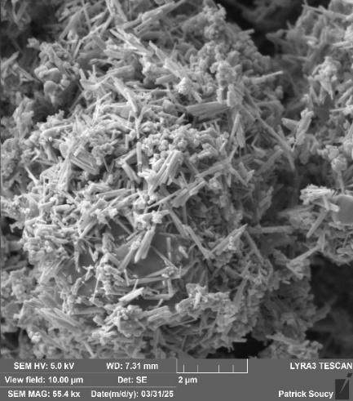
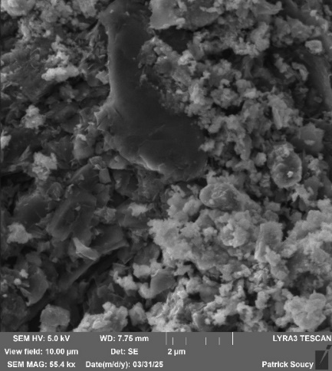
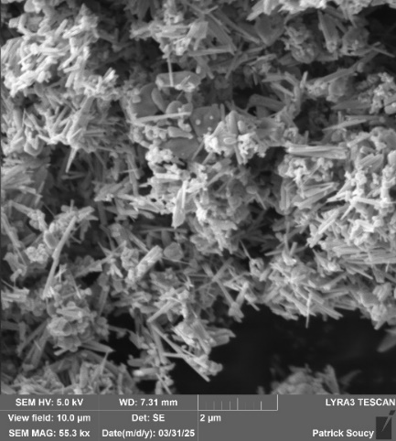
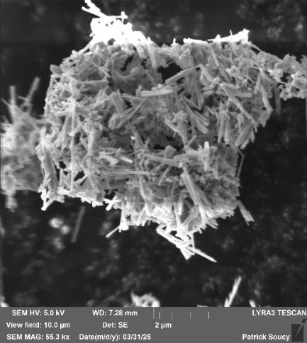
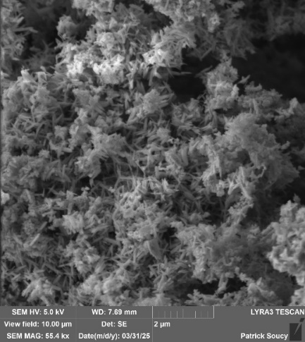
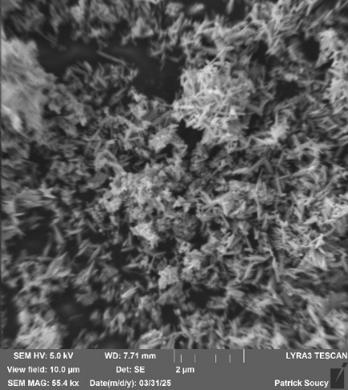
ZnO-Gr (1%)
ZnO-Gr (7%)
ZnO-Gr (5%)
ZnO-Gr (3%)
ZnO
Gr
2µm

2µm

2µm

2µm

2µm

2µm

Figure 3∶ Scanning electron microscopy images of ZnO, ZnO-Gr (1%); ZnO-Gr (3%); ZnO-Gr (5%) and ZnO-Gr (7%).

The analysis of the morphology of the synthesized nanoparticles using scanning electron microscopy revealed rod-shaped zinc oxide particles. These results are consistent with the predictions from the XRD results. The ZnO-Gr nanocomposites exhibit a mixture of rods and flat spherical particles. Images obtained by scanning electron microscopy show a significant change in the particle morphology after the incorporation of graphite into the ZnO matrix. The dominant morphology for graphite is that of large plates or sheets, which are relatively flat and lamellar in appearance. These structures are often seen from the front or slightly tilted, showing a large flat surface and irregular or broken edges. Their appearance is dark and less textured compared to the ZnO rods. ZnO has a structure mainly composed of nanorods forming bundle-like structures. This morphology is typical of ZnO crystals obtained by anisotropic growth. However, some agglomeration is observed, which can reduce the active surface available for photocatalytic reactions. The addition of 1% graphite leads to a partial dispersion of the ZnO nanorods. The particles, however, remain relatively agglomerated, and the distribution of ZnO on the graphite surface still appears limited. The interaction between the two phases therefore remains moderate. For a content of 3% graphite, the microstructure becomes more homogeneous and better dispersed. The ZnO nanorods appear well distributed and less agglomerated, forming an open structure. Regarding the graphite content of 5% in the ZnO-Gr (5%) particle, a compact aggregate of rods and sheets, denser, is observed. Part of the ZnO can be covered by graphite, reducing light absorption. Finally, at a high graphite concentration (7%), individual rod losses and increased graphite coverage are observed. Thus, agglomeration becomes more significant, and the structures become less distinct. The scanning electron microscopy results show that the particle morphology evolves significantly with the introduction of graphite into the ZnO matrix.
Band gap energy and Absorbance
The optical properties of the prepared photocatalysts were measured by UV-visible absorbance. Figure 4 shows the results of the maximum absorbances of the particles. It was found that the maximum absorbance peaks for ZnO, ZnO-Gr (1%); ZnO-Gr (3%); ZnO-Gr (5%) and ZnO-Gr (7%) are respectively 375, 376, 466, 468 and 493 nm. The absorbance wavelengths of the ZnO-Gr (y) nanocomposites are higher than that of ZnO. According to the literature, this difference is attributed to the chemical interaction between graphite and ZnO nanoparticles (Beyene et al., 2026). The Tauc law (Escobedo-Morales et al., 2026; Jubu et al., 2022) below was used to estimate the energy of our materials from the optical absorption spectra obtained by UV-visible spectroscopy.
${\left(αhv\right)}^{1/n}$ = A$\left(hv-Eg\right)$
Where h is Planck's constant, ν the frequency of the photon, Eg the band gap energy, A a constant, and α the absorption coefficient which describes the amount of light of a given color absorbed by a material of a given thickness. The factor n is called the power coefficient, which depends on the nature of the electronic transition and is numerically equal to 1/2, 3/2, 2, or 3 for allowed direct, forbidden direct, allowed indirect, or forbidden indirect transitions, respectively (Jubu et al., 2020)

Figure 4 : Absorption spectra of Zinc Oxide (ZnO) and ZnO-Gr nanocomposites (1%); ZnO-Gr (3%); ZnO-Gr (5%) and ZnO-Gr (7%).

Figure 5 shows the curves obtained by plotting${\left(αhv\right)}^{1/n}$ as a function of Eg. The values of Eg are determined by extending the linear sections of the graph to the end of the curve on the hν axis with n=1/2.

Figure 5: Evolution of (αhν)² as a function of energy (hν) of ZnO nanocomposites, ZnO-Gr (1%); ZnO-Gr (3%); ZnO-Gr (5%) and ZnO-Gr (7%).

According to Figure 5, the band gap energy of ZnO is 3.32 eV, consistent with the literature (Meena et al., 2026). The optical band gap energies of the ZnO-Gr nanocomposites (1%); ZnO-Gr (3%); ZnO-Gr (5%) and ZnO-Gr (7%) are respectively 3.29 eV, 2.97 eV, 2.96 eV and 2.91 eV. These energies are lower than those of ZnO. According to the literature (Shah et al., 2022), it has been shown that when ZnO is doped, chemical elements inserted in small amounts cause a rearrangement of the energy levels of the bands, involving a decrease in the optical band gap energy. The incorporation of graphite favorably modifies the electronic structure of ZnO, making the material more sensitive to visible light and therefore more effective for photocatalytic applications. It has already been shown that a reduction in the energy gap significantly improves the absorption capacity of the solar spectrum and increases the production of reactive species, responsible for the degradation of organic contaminants (Kachere et al., 2022). On the other hand, too high graphite content could lead to a light shielding effect, reducing overall efficiency.
Photocatalytic activities
Figure 6 presents the results of the photocatalytic degradation of ciprofloxacin on ZnO and ZnO-Gr nanocomposites. The analysis of Figure 6 shows that the addition of graphite to zinc oxide significantly improves the photocatalytic efficiency of ciprofloxacin degradation.

Figure 6 : Photocatalytic activities of ZnO and ZnO-Gr nanocomposites on ciprofloxacin with a mass of 0.03g and at pH = 6.8.
The degradation percentages of ciprofloxacin with zinc oxide nanocomposites coupled with graphite vary from 70, 75, 78, and 80%, respectively for ZnO-Gr (7%), ZnO-Gr (1%), ZnO-Gr (5%), and ZnO-Gr (3%), which are higher than that of zinc oxide alone, which is 66%. These results confirm certain studies that attribute this improvement to the ability of graphite to facilitate electron transfer and limit the recombination of electron-hole pairs, while increasing the active surface (Jin et al., 2022; Yatskiv & Grym, 2018b). The characterization results go in the same direction as the studies because the nanocomposites offer better excitation to produce active species due to their lower energy gap values compared to ZnO. Indeed, according to the SEM images, pure ZnO showed strongly agglomerated rods, forming relatively compact structures. However, this agglomeration limits the accessibility of active sites and reduces the specific surface area available for photocatalytic reactions. After the incorporation of a small amount of graphite (ZnO-Gr 1%), the graphite acts as a support onto which some ZnO particles can attach.
However, the distribution remains uneven, and some areas still show a significant agglomeration of particles, which limits the photocatalytic improvement. When the graphite concentration reaches an adequate value of Graphite, this results in good photocatalytic performance, as observed for ZnO-Gr (3%). The morphology of ZnO-Gr (3%) observed in SEM is particularly favorable for photocatalytic processes. It allows an increase in specific surface area, better adsorption of pollutant molecules, and more efficient light diffusion within the material. Indeed, for ZnO-Gr (3%), the optimal photocatalytic performance was an 80% degradation rate of ciprofloxacin.
A decrease in photocatalytic activity was observed beyond the addition of 3% graphite. An excessively high rate of graphite in the nanocomposites further affects sunlight absorption, which disrupts photoexcitation and the catalytic activity of the particles due to the shielding effect (Jallouli et al., 2017). Moreover, morphologies show a tendency toward agglomeration and densification of the structure. The excess graphite leads to partial coverage of the ZnO particles, which reduces light absorption by the catalyst and thus limits the access of pollutant molecules to the active sites. This situation can lead to a relative decrease in photocatalytic efficiency. The performance of the ZnO-Gr (3%) composite material can be optimized by studying certain parameters such as the mass of the photocatalyst, the concentration of ciprofloxacin, and the pH of the reaction medium.
Effect of the mass
Figure 7 shows the curves of the residual concentration rate obtained as a function of the mass of ZnO-Gr (3%). Figure 7 revealed that an increase in the mass of the ZnO-Gr (3%) composite significantly improves the degradation of ciprofloxacin. This improvement is reflected by a strong decrease in the residual concentration rate from 40% to 2.8% for the mass amounts of 10 and 70 mg, respectively. Indeed, an increase in the mass of photocatalysts leads to an increase in the number of active sites present on the surface of the nanocomposite.
Figure 7: Degradation of ciprofloxacin (10 mg/L) as a function of ZnO-Gr (3%) mass at pH=6.8.
Beyond 70 mg, that means at 90 mg, the residual concentration rate of ciprofloxacin increases by 2.8 to 25% due to the increase in the turbidity of the solution, reducing the penetration of light to the active sites of the nanocomposites (Olani et al., 2025). Therefore, the mass of 70 mg represents a balance where the available active sites are efficiently used by the incident light photons.
Effect of concentration
Figure 8 shows that solar irradiation of the ciprofloxacin solution led to 100% degradation (residual concentration rate zero) after 30 and 60 minutes, respectively, for initial concentrations of 3 mg/L and 5 mg/L. After 80 minutes, a respective degradation of 2% and 5% is observed for concentrations of 7 mg/L and 10 mg/L. Indeed, a high concentration results in a large load of ciprofloxacin on the surface of the nanocomposite, which decreases the performance of the photocatalyst.

Figure 8: Effect of the initial concentration of ciprofloxacin under solar irradiation using 70 mg of ZnO-Gr (3%) NPs at pH=6.8.

The residual concentration rate of ciprofloxacin decreases with the decrease in the initial concentration. This result is consistent with the studies (Golmohammadi et al., 2023).
Effect of pH
Figure 9 shows the effect of the pH of the ciprofloxacin solution on the performance of ZnO-Gr (3%). The results of Figure 7 showed that the residual concentration rate of ciprofloxacin decreases with increasing pH. This is consistent with the literature (Onkani et al., 2024).

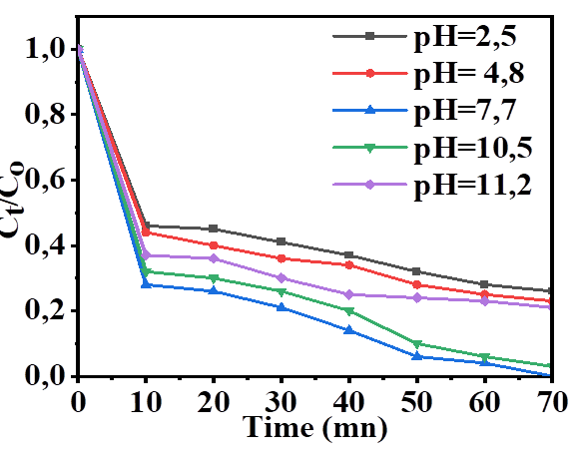

Figure 9: Effect of the solution pH on the degradation of ciprofloxacin under solar irradiation using 70 mg of ZnO-Gr (3%) NPs.

Indeed, the residual concentration rate decreases from 0.3 at pH = 2.5 to zero at pH = 7.7 after 70 minutes. This pH value is the optimal value to achieve better performance of the photocatalyst. These results are consistent with the work of (L. Wang et al., 2019) for respective optimal values of 7.2 and 8. Beyond pH = 7.7, that is for pH values of 10.5 and 11.5, the residual concentration rates are respectively 0.05% and 0.25% above the value at pH = 7.7. Figure 10 shows the comparison of the photocatalytic activity of the ZnO-Gr (3%) nanocomposite in mass proportion, ideal concentration at pH = 7.7. The results showed an excellent performance of the ZnO-Gr (3%) nanocomposite with an optimal degradation rate of 100% compared to ZnO, whose maximum performance is 77% under similar conditions. The addition of graphite therefore effectively improved the photocatalytic degradation efficiency of ciprofloxacin.
Photocatalytic performance
Figure 10: Photocatalytic degradation of ciprofloxacin with catalysts ZnO and ZnO-Gr (3%) at pH = 7.7; m = 70 mg; V = 100 ml and C = 10 mg/L.

Stability
Figure 11 shows a study of the stability of our materials over four activity cycles. It was observed in Figure 11 that the percentage of ciprofloxacin degradation decreases from 100 to 96% after the four cycles. This decrease is relatively small after four activity cycles. We therefore have good stability of the prepared nanocomposites. Nevertheless, it was also observed that after each treatment cycle there is a slight loss of mass, likely due to the leaching of the photocatalyst during washing.
Figure 11: Stability of the ZnO-Gr (3%) photocatalyst with a mass of 70 mg in the degradation of ciprofloxacin at a concentration of 10 mg/L at pH = 7.7.
Conclusion
ZnO-Gr nanoparticles were successfully prepared by the hydrothermal method. Various characterizations showed differences in the energy band gap levels between the different nanocomposites and mixtures of crystalline phases of graphite and zinc oxide. At the microscopic level, a variety of structures were observed. The structures of the different photocatalysts exhibited different photocatalytic activities for the degradation of ciprofloxacin. An appropriate introduction of 3% Graphite into the ZnO matrix proved to be very effective for the degradation of ciprofloxacin. The ZnO-Gr (3%) sample had the best ciprofloxacin degradation rate, reaching 80% in 70 minutes compared to the other nanocomposites and to zinc oxide. This rate was improved under the optimal conditions of pH=7.7 and for a photocatalyst mass of 70 mg to reach an optimal degradation rate of 100%. Stability studies of the photocatalyst showed very good stability of the materials after four activity cycles.

COMPETING INTERESTS DISCLAIMER:
Authors have declared that they have no known competing financial interests OR non-financial interests OR personal relationships that could have appeared to influence the work reported in this paper.

Reference
Abromaitis, V., Oghenetejiro, O. A. M. A., Sulciute, A., Urniezaite, I., Sinkeviciute, D., Zmuidzinaviciene, N., Jankunaite, D., Dzingeleviciene, R., Baranauskis, K., & Martuzevicius, D. (2024). TiO2 nanotube arrays photocatalytic ozonation for the removal of antibiotic ciprofloxacin from the effluent of a domestic wastewater treatment plant: Towards the process upscaling. Journal of Water Process Engineering, 63, 105457. https://doi.org/10.1016/j.jwpe.2024.105457
Barathe, P., Kaur, K., Reddy, S., Shriram, V., & Kumar, V. (2024). Antibiotic pollution and associated antimicrobial resistance in the environment. Journal of Hazardous Materials Letters, 5(8), 100105. https://doi.org/10.1016/j.hazl.2024.100105
Beyene, T. T., Abdulkadir, A., Bekela, N. B., Yai, T., & Efa, M. T. (2026). Synergistic enhancement of photocatalytic, antioxidant, and antimicrobial activities in nitrogen and phosphorus dual-doped ZnO nanoparticles. South African Journal of Chemical Engineering, 56, 100852. https://doi.org/10.1016/J.SAJCE.2026.100852
Bizi, M., & El Bachra, F. E. (2020). Evaluation of the ciprofloxacin adsorption capacity of common industrial minerals and application to tap water treatment. Powder Technology, 362, 323–333. https://doi.org/10.1016/j.powtec.2019.11.047
Boukhoubza, I., Khenfouch, M., Achehboune, M., Leontie, L., Carlescu, A., Doroftei, C., Mothudi, B. M., Zorkani, I., & Jorio, A. (2020). Graphene oxide coated flower-shaped ZnO nanorods: Optoelectronic properties. Journal of Alloys and Compounds, 831, 154874. https://doi.org/10.1016/j.jallcom.2020.154874
de Peres, M. L., Delucis, R. de A., Amico, S. C., & Gatto, D. A. (2019). Zinc oxide nanoparticles from microwave-assisted solvothermal process: Photocatalytic performance and use for wood protection against xylophagous fungus. Nanomaterials and Nanotechnology, 9. https://doi.org/10.1177/1847980419876201
Eapen, J. V., Thomas, S., Antony, S., George, P., & Antony, J. (2024). A review of the effects of pharmaceutical pollutants on humans and aquatic ecosystem. Exploration of Drug Science, 484–507. https://doi.org/10.37349/eds.2024.00058
Elgayyar, T., Azzolina-Jury, F., & Thibault-Starzyk, F. (2025). Infrared spectroscopy at the surface of carbonates. Physical Chemistry Chemical Physics, 27(43), 22871–22879. https://doi.org/10.1039/d5cp02197a
Escobedo-Morales, A., Pedraza-Chan, M. S., Ruiz-López, I. I., Anota, E. C., Salazar-Villanueva, M., & Cortés-Arriagada, D. (2026). Accurate determination of the band gap energy of non-translucent semiconductor materials through the Tauc method: Theoretical framework, limitations, technical hints, and automated algorithms. Next Materials, 10, 101412. https://doi.org/10.1016/J.NXMATE.2025.101412
Golmohammadi, M., Hanafi-Bojd, H., & Shiva, M. (2023). Photocatalytic degradation of ciprofloxacin antibiotic in water by biosynthesized silica supported silver nanoparticles. Ceramics International, 49(5), 7717–7726. https://doi.org/10.1016/j.ceramint.2022.10.261
Hadia, N. M. A., García-Granda, S., & García, J. R. (2014). Effect of the Temperature on Structural and Optical Properties of Zinc Oxide Nanoparticles. Journal of Nanoscience and Nanotechnology, 14(7), 5443–5448. https://doi.org/10.1166/JNN.2014.8861
Iftikhar, N., Konig, I., English, C., Ivantsova, E., Souders, C. L., Hashmi, I., & Martyniuk, C. J. (2023). Sulfamethoxazole (SMX) Alters Immune and Apoptotic Endpoints in Developing Zebrafish (Danio rerio). Toxics, 11(2), 178. https://doi.org/10.3390/toxics11020178
Jallouli, N., Elghniji, K., Trabelsi, H., Ksibi, M., Jallouli, N., Elghniji, K., Trabelsi, H., & Ksibi, M. (2017). Photocatalytic degradation of paracetamol on TiO2 nanoparticles and TiO2/cellulosic fiber under UV and sunlight irradiation. Arabian Journal of Chemistry, 10(2_suppl), S3640–S3645. https://doi.org/10.1016/j.arabjc.2014.03.014
Jin, C., Cheng, Y., Liu, W., & Lv, Y. (2022). Preparation of ZnO-GO nanocomposites and their properties. E3S Web of Conferences, 341, 01001. https://doi.org/10.1051/e3sconf/202234101001
Jubu, P. R., Obaseki, O. S., Nathan-Abutu, A., Yam, F. K., Yusof, Y., & Ochang, M. B. (2022). Dispensability of the conventional Tauc’s plot for accurate bandgap determination from UV–vis optical diffuse reflectance data. Results in Optics, 9, 100273. https://doi.org/10.1016/J.RIO.2022.100273
Jubu, P. R., Yam, F. K., Igba, V. M., & Beh, K. P. (2020). Tauc-plot scale and extrapolation effect on bandgap estimation from UV–vis–NIR data – A case study of β-Ga2O3. Journal of Solid State Chemistry, 290, 121576. https://doi.org/10.1016/J.JSSC.2020.121576
Kachere, A. R., Kakade, P. M., Kanwade, A. R., Dani, P., Mandlik, N. T., Rondiya, S. R., Dzade, N. Y., Jadkar, S. R., & Bhosale, S. V. (2022). Zinc Oxide Graphene Oxide Nanocomposites: Synthesis, Characterization and T heir Optical Properties. ES Materials and Manufacturing, 16, 19–29. https://doi.org/10.30919/esmm5f516
Kusiak-Nejman, E., Wojnarowicz, J., Morawski, A. W., Narkiewicz, U., Sobczak, K., Gierlotka, S., & Lojkowski, W. (2021). Size-dependent effects of ZnO nanoparticles on the photocatalytic degradation of phenol in a water solution. Applied Surface Science, 541, 148416. https://doi.org/10.1016/j.apsusc.2020.148416
Marchesini, G. R., Haasnoot, W., Delahaut, P., Gerçek, H., & Nielen, M. W. F. (2026). A GO-MoS2/Au nanohybrid aptasensor for trace level monitoring of ciprofloxacin in water, food, environmental and pharmaceutical samples. Electrochimica Acta, 548(1-2 SPEC. ISS.), 147844. https://doi.org/10.1016/j.aca.2006.11.013
Meena, P. L., Meena, R., Meena, J., Meena, S., Surela, A. K., Kumar, N., Dhanetia, H. R., & Selvaraj, M. (2026). Green synthesis of spherical ZnO nanoplates possessing lower band gap energy and higher photocatalytic performance. Materials Research Bulletin, 198, 113996. https://doi.org/10.1016/J.MATERRESBULL.2026.113996
Modrić-Šahbazović, A., Smajlagić, A., Sakić, Z., Novaković, M., Latas, N., Popović, M., Đekić, M., Isaković, S., & Salčinović Fetić, A. (2025). Role of synthesis temperature in the formation of ZnO nanoparticles via the Sol-Gel process. Journal of Crystal Growth, 650, 128003. https://doi.org/10.1016/j.jcrysgro.2024.128003
Ngaloy, R. T., Fontanilla, A. M., Soriano, M. S. R., Pascua, C. S., Matsushita, Y., & Agulo, I. J. A. (2019a). Highly Efficient Photocatalysis by Zinc Oxide-Reduced Graphene Oxide (ZnO-rGO) Composite Synthesized via One-Pot Room-Temperature Chemical Deposition Method. Journal of Nanotechnology, 2019. https://doi.org/10.1155/2019/1895043
Ngaloy, R. T., Fontanilla, A. M., Soriano, Ma. S. R., Pascua, C. S., Matsushita, Y., & Agulo, I. J. A. (2019b). Highly Efficient Photocatalysis by Zinc Oxide-Reduced Graphene Oxide (ZnO-rGO) Composite Synthesized via One-Pot Room-Temperature Chemical Deposition Method. Journal of Nanotechnology, 2019(1), 1–11. https://doi.org/10.1155/2019/1895043
Olani, A., Guyasa, J. N., Nemera, D. J., Efa, M. T., & Beyene, T. T. (2025). Impact of graphene oxide integration with ZnO nanoparticles on its photocatalytic, antimicrobial, and antioxidant activities. Bulletin of the Chemical Society of Ethiopia, 39(3), 515–534. https://doi.org/10.4314/bcse.v39i3.10
Onkani, S. P., Akpotu, S. O., Diagboya, P. N., Mtunzi, F., & Osabohien, E. (2024). Enhanced Aqueous Photo-Degradation of Ciprofloxacin and Tetracycline Using Ag-Decorated ZnO Plasmonic Catalyst. ACS Sustainable Resource Management, 1(10), 2294–2303. https://doi.org/10.1021/acssusresmgt.4c00318
Pirhashemi, M., Habibi-Yangjeh, A., & Rahim Pouran, S. (2018). Review on the criteria anticipated for the fabrication of highly efficient ZnO-based visible-light-driven photocatalysts. Journal of Industrial and Engineering Chemistry, 62, 1–25. https://doi.org/10.1016/j.jiec.2018.01.012
Pratiwi, W. Z., Hadiyanto, H., Widayat, W., Darlan, A., & Wahyono, Y. (2026). Revealing the environmental fate of ciprofloxacin in pharmaceutical effluent through UV/O3 degradation tracked by LC-MS/MS and assessed using a risk-based sustainability framework. Kuwait Journal of Science, 53(2), 100538. https://doi.org/10.1016/j.kjs.2026.100538
Rajeswari, R., & Gurumallesh Prabu, H. (2020). Palladium – Decorated reduced graphene oxide/zinc oxide nanocomposite for enhanced antimicrobial, antioxidant and cytotoxicity activities. Process Biochemistry, 93, 36–47. https://doi.org/10.1016/j.procbio.2020.03.010
Rout, P. R., Zhang, T. C., Bhunia, P., & Surampalli, R. Y. (2021). Treatment technologies for emerging contaminants in wastewater treatment plants: A review. Science of The Total Environment, 753, 141990. https://doi.org/10.1016/j.scitotenv.2020.141990
Salgado-Bernal, I., Cejas-Añón, G., Baeza-Fonte, A. N., Martínez-Sardiña, A., Carballo-Valdés, M. E., Sivalingam, P., & Poté, J. (2026). Biodegradation of ciprofloxacin by Exiguobacterium sp. from tropical river sediments: an integrated approach. Watershed Ecology and the Environment, 8, 46–54. https://doi.org/10.1016/j.wsee.2025.11.001
Shah, S. W. A., Rehman, M. ur, Tauseef, M., Islam, E., Hayat, A., Iqbal, S., Arslan, M., & Afzal, M. (2022). Ciprofloxacin Removal from Aqueous Media Using Floating Treatment Wetlands Supported by Immobilized Bacteria. Sustainability, 14(21), 14216. https://doi.org/10.3390/su142114216
Torogh, M. M. S., Azizi, A., Amirsadeghi, M., & Baghdadi, M. (2021). Improvement of the coagulation–flocculation process using graphene oxide for ciprofloxacin removal from surface water. Desalination and Water Treatment, 241(2), 146–158. https://doi.org/10.5004/dwt.2021.27825
Vu, T. T., Lai, D. Van, Pham, K. T., Le, P. Q., Le, T. H., Nguyen, H. T., Dang, T. D., & La, D. D. (2026). Scalable synthesis of spherical graphite/ZnO composite anodes for high-performance lithium-ion batteries. RSC Advances, 16(3), 2754–2766. https://doi.org/10.1039/d5ra09552b
Wang, H., Liu, J., Wang, H., Cai, X., Ye, X., Zhang, L., Chen, Z., & Shen, Z. X. (2020). Supporting Information Cobalt Sulfide Nanoflakes Grown on Graphite Foam for Na-Ion Batteries with Ultrahigh Initial Coulombic Efficiency.
Wang, L., Li, Z., Chen, J., Huang, Y., Zhang, H., & Qiu, H. (2019). Enhanced photocatalytic degradation of methyl orange by porous graphene/ZnO nanocomposite. Environmental Pollution, 249, 801–811. https://doi.org/10.1016/j.envpol.2019.03.071
Wang, X., Zhang, J., Yu, G., Wang, Y., Zheng, A., Cheng, Y., & He, S. (2026). BiOI/microbial coupled system for the degradation of ciprofloxacin: Construction, performance and mechanism. Journal of Environmental Chemical Engineering, 14(1), 121087. https://doi.org/10.1016/j.jece.2026.121087
Wojnarowicz, J., Opalinska, A., Chudoba, T., Gierlotka, S., Mukhovskyi, R., Pietrzykowska, E., Sobczak, K., & Lojkowski, W. (2016). Effect of Water Content in Ethylene Glycol Solvent on the Size of ZnO Nanoparticles Prepared Using Microwave Solvothermal Synthesis. Journal of Nanomaterials, 2016. https://doi.org/10.1155/2016/2789871
Wu, K., Zhou, L., Mao, C., & Chu, Y. J. (2023). Solvothermal synthesis of ZnO with controllable morphology. Materials Letters, 341, 134161. https://doi.org/10.1016/j.matlet.2023.134161
Yatskiv, R., & Grym, J. (2018a). Influence of the Interaction Between Graphite and Polar Surfaces of ZnO on the Formation of Schottky Contact. Journal of Electronic Materials, 47(9), 5002–5006. https://doi.org/10.1007/s11664-018-6244-3
Yatskiv, R., & Grym, J. (2018b). Influence of the Interaction Between Graphite and Polar Surfaces of ZnO on the Formation of Schottky Contact. Journal of Electronic Materials, 47(9), 5002–5006. https://doi.org/10.1007/s11664-018-6244-3
Zhang, X., Zhou, L., Tu, X., & Hu, F. (2023). Hydrothermal synthesis of ZnO Crystals: Diverse morphologies and characterization of the photocatalytic properties. Polyhedron, 246, 116668. https://doi.org/10.1016/j.poly.2023.116668
Zhu, Y., Li, J., Lai, Y., Cao, Y., Li, J., Wei, Z., Yang, L., Chen, Z., & Zou, J. (2025). Accelerated photo-Fenton degradation of ciprofloxacin on CoSx@TiO2 amorphous-crystalline interface with S-O bond bridging. Environmental Research, 279, 121785. https://doi.org/10.1016/j.envres.2025.121785

