Digitalization and Carbon Emissions: A Panel Data Analysis of ICT Development in Emerging Economies

Abstract
This research examines the correlation between digitalization and carbon emissions in the emerging economies in the year 2010-2023. Using the dataset of a balanced panel of 24 emerging countries, the study examines the possibility of the growth of digital infrastructure to promote environmental sustainability. A two-way fixed effects panel regression model with robust standard errors is used to explain country specific heterogeneity and time effects. The dependent variable is the number of carbon emissions per capita, and the digitalization is operationalized by internet penetration and internet subscriptions of broadband. Control variables are economic development, energy usage, and the proportion of renewable energy.
The empiric analysis indicates that GDP per capita and energy consumption have statistically significant positive effect on carbon emission, where energy utilization is the most significant determinant, and renewable energy consumption has a strong mitigating impact on the emission. Nevertheless, the indicators of digitalization do not show a statistically significant direct effect on carbon emissions controlled by income and energy structure. These results suggest that the simple increase in digital technologies does not necessarily lead to environmental improvement in emerging economies. Consequently, effective emission mitigation policies require a combined structural change of energy systems to cleaner ones and digital transformation policies. The paper highlights the necessity of aligning a clean energy policy framework with digital development planning to create sustainable development in emerging markets.
Keywords: Digitalization; Carbon Emissions; Emerging Economies; Renewable Energy; Energy Consumption; Panel Data Analysis; Environmental Sustainability.
1. Introduction
One of the most urgent issues of the twenty-first century globally is climate change. The carbon dioxide emission (CO₂) is on the increase that is caused by industrialization, the use of fossil fuel, as well as the rapid expansion of the urban areas that have increased environmental degradation [6]. At the same time, there is a rapid digital transformation of the world economy. The development of information and communication technologies (ICT), broadband network, and the internet have transformed the way production, services, and economic interaction occur [26]. This concomitant rise of digitalization and environmental pressure brings up one of the central questions, namely, does digital transformation contribute to reduced carbon emission or does it contribute to environmental stress by increasing energy consumption?
The impact of digitalization on the environment is ambiguous. On the one hand, the development of ICT has the potential to make energy consumption more efficient and efficient, optimize logistics and supply chains, develop intelligent infrastructure, and offer information on environmental monitoring [9]. Dematerialization and more fruitful utilization of resources are also possible with the help of these technologies, and they can reduce emissions. The digital infrastructure, including information centers, telecommunication networks and end-user devices, consumes significant amounts of electricity on the other side. Electricity has been generated using sources that are carbon based on most emerging economies. Besides, an increase in internet adoption may stimulate economic activity and consumption that may offset the efficiency gains [28]. This makes the general effect of digitalization on the environment an empirical issue.
This is of particular concern to emerging economies. These nations are simultaneously striving towards growth, industrialization, and digitalization. Most emerging countries, in contrast to developed economies, are still dependent on fossil fuels and have institutional and infrastructural difficulties to contend with. Therefore, digital growth does not necessarily result in environmental benefits. According to the Environmental Kuznets Curve (EKC) hypothesis, there is an increasing level of pollution, which then decreases when the country reaches a particular level of income. What is not clear is whether this trend is accelerating or altering digitalization in emerging economies [34].
Regardless of the increasing studies on ICT and environmental sustainability, there are a number of gaps. The majority of the research is concentrated on developed economies, which reduces the extent of their applicability to emerging ones. Additionally, there is little interest among scholars in the potential nonlinear effects of digitalization on emissions. These gaps can be filled by a panel data methodology that captures cross-country differences and what is happening with time [14].
The research question that is being researched is the impact of ICT development on carbon emission in emerging economies between 2010 and 2023. Internet penetration and broadband subscriptions are used as the measure of digitalization, and CO₂ emission/capita is the dependent variable. The methods of panel regression used by the researchers are fixed and have random effects. The study enlightens the question of whether digital transformation can facilitate environmental sustainability in such economies as it presents current empirical data [7].

2. Literature Review
The current literature review is an analytical assessment of the existing theoretical frameworks and empirical data on the emergent nexus of information and communication technologies (ICTs) and carbon emission with a heavy emphasis on the literature output of developing economies [10] [17]. This part combines the evidence on both direct and indirect effects, questioning the dual potential of ICTs to reduce the environmental degradation due to efficiency gains and the existence of opposing forces of increased energy use and economic stimulation [22] [29].

2.1 ICT Development and Environmental Sustainability
The interplay of information and communication technologies (ICT) and the concept of environmental sustainability have created a lot of scholarly discussions. The two opposing views that exist in the existing literature are the efficiency-enhancement hypothesis, and the energy-intensification hypothesis.
The efficiency enhancement hypothesis assumes that digitalization has positive environmental effects. ICT is used to support real-time monitoring, intelligent energy-management systems, optimization of logistics, and data-driven production processes [10]. These technologies could reduce transaction costs, improve coordination in the supply chains, and also increase efficiency in the process of allocating resources. In industrial applications, automation and intelligent manufacturing have proven to minimize the use of energy and the production of waste [32]. Moreover, online networks create the possibility of dematerialization whereby material processes are replaced by digital equivalents, which have the potential to reduce carbon footprints. In that perspective, ICT serves as a facilitating technology enhancing a structural change to service-based and knowledge-intensive industries, traditionally less carbon-intensive than traditional heavy industries [19].
This positive point of view is not always supported by empirical evidence. Digital infrastructure energy-intensification hypothesis predicts the growing carbon footprint explainable by digital infrastructure. Multiplication of data centers, cloud-computing resources, telecommunications infrastructure, and digital devices requires a lot of electricity. As the level of digital uptake rises, the size of the energy required to run servers, cooling systems, and network maintenance also goes up. In the regions where the production of electricity is still based on fossil fuels, this increased demand can immediately create an increased level of carbon emissions. Additionally, digitalization can lead to carbon-intensive production processes through economic activity and consumption trends that instead of replacing it can support them [12].
One of the side effects is the rebound effect. Efficiency gains generated by digital technology due to expense reduction in operations have the potential to trigger increased output and consumption, thus alleviating the net environmental benefits of efficiency gains [27]. An example would be the utilization of more efficient logistics infrastructure systems, which can reduce transportation costs and subsequently improve trade volumes and cumulatively increase emissions. Similarly, deeper digital connectivity can trigger industrial growth and urbanization, which can be linked to perceivable environmental consequences [20]. Digitalization therefore does not necessarily come with a reduction in emissions, the final effect on the environment depends on whether the complementary policy actions are coordinated, what is the current energy mix and whether the institutions are well-equipped or not.
Recent research attempts to unite these conflicting empirical results by hypothesizing the intrinsic nonlinearity of the relationship between ICT advancement and greenhouse gas emissions. In the early stages of digital adoption, the proliferation of digital infrastructure and the associated increase in energy use seems to take the lead, increasing the emissions [25]. In the long-term perspective, though, the coming of age of technology and the incorporation of cleaner energy sources can make digitalization a force of net environmental amelioration. This dynamic approach points to the need to question both cross-country as well as time heterogeneity, instead of assuming homogeneous effects in different contexts. The consequential inverted-U-shaped pattern, which would be closer to the Environmental Kuznets Curve, would suggest that the initial wave of digitalization might result in the increase of carbon intensity as infrastructure builds up, but as digital technologies become more mature and uptake more widespread, then their efficiency-promoting qualities can lead to a reduction in carbon emissions (Xu et al., 2025).
On balance, there is high heterogeneity in the findings of literature. Differences in data selection, digitalization operationalization, time levels, and samples of countries lead to different outcomes. Such contradictions highlight the importance of additional empirical research, especially in the context of emerging economies where the spread of digital infrastructure and ecological demands are mutually present.

2.2 Environmental Kuznets Curve (EKC) Theory
The Environmental Kuznets Curve (EKC) hypothesis provides a substantive framework for the intensive study of the interrelationship between economic growth and environmental deterioration. The EKC assumes an inverted U-shaped curve of the correlation between national income and the level of pollution [30]. In the early stages of economic progress, degradation of the environment is a common phenomenon that accompanies the increase in the level of industrialization, urbanization, and energy consumption. Above some levels of per capita income, however, the growth of subsequent income is correlated with an increase in environmental quality. This has been made possible through upgrading technology, an increase in the enforcement of regulation and restructuring of advantageous sectors that are clean and more sustainable [24].
Environmental Kuznets Curve (EKC) has widely been used in studying carbon emissions in comparison to economic growth. Advocates argue that higher per-capita income will increase the demand of the population on environmental protection and will bring capital to cleaner technologies. Also, the economy of developed economies is often characterized by a shift towards the service-based economy, which is generally less emissions-intensive [11]. This rearrangement of structure is seen to be a key process of the weakening stage of the inverted U-shaped relationship.
Although it seems intuitive, empirical studies of the Environmental Kuznets Curve (EKC) have a lot of variability. Certain studies find a curvilinear inversely U-shaped relationship between environmental degradation and income; some find monotonic increases, and some find other forms of nonlinear forms [31]. The opponents argue that the EKC does not capture the complex nature of growth environment nexus because it does not consider the global trade dynamics, spread of technology, and institutional heterogeneity. Specifically, it is not always the case that developing and emerging economies follow the same pattern as the developed ones, particularly in cases where the former continues to depend on fossil fuels or in situations where the countries do not have effective environmental governance mechanisms [3].
The Environmental Kuznets Curve (EKC) framework is more complicated in the framework of digitalization. Technological upgrading and efficiency enhancement might be speeded up when information and communication technologies (ICT) are developed, which may in turn potentially reduce the income level at which the emission starts decreasing [29]. On the other hand, digital growth may increase energy needs at growth stages, thus postponing the improvement of the environment. The question of whether or not digitalization supports or changes the EKC pattern therefore remains an unsolved empirical one. The overall dynamic of the interactions between ICT and income levels is needed in assessing sustainable development patterns in the emerging economies [1].

2.3 Research Gap
Despite the fact that enough studies have been conducted on nexus of ICT development, economic growth, and environmental sustainability, there are still a number of gaps. First, empirical data is largely located in developed or OECD areas, thus limiting the knowledge on emerging markets where the digital infrastructure expansion is paralleling the carbon-intensive growth. The institutional capacity, structure of the energy sector, and regulatory systems in both advanced and emerging setups are significantly different and may transform the connection between digitalization and emissions [34].
Second, the available literature is often based on cross-sectional or national case study analyses. Thus, it may fail to capture dynamic temporal impacts and cross-country heterogeneity. It is urgent to have a panel-data structure that takes into account country-specific factors and time variations to provide stronger findings [8].
Third, there has been a visible lack of research on the issue of potential nonlinear impacts of digitalization on emissions. Although theory proposes that information and communication technologies (ICT) can see threshold or inverted U-shaped dynamics similar to the Environmental Kuznets Curve, empirical data to support said dynamics is still lacking [35].
To fill in these gaps, this paper draws on panel data of 2010-2023 of emerging economies to determine linear and nonlinear relationships between information and communications technology (ICT) development and carbon emissions. The study also adds value through the inclusion of digitalization metrics with income and structural control variables to the human comprehension of the impact of digital transformation on environmental sustainability.

3. Methodology / Model Specification
This part outlines the methodology framework and model specifications that will be used to analyze the complex nexus between ICT development and carbon emissions in the emerging economies on the basis of the theoretical frameworks developed earlier. In particular, it will be a full description of the data sources, how variables are operationally defined, and the econometric models used to fill the gaps in the literature review [25].

3.1 Data and Sample Selection
The paper will use a balanced panel data of 24 key emerging economies during the year 2010 and 2023. The sample will consist of the countries referred to as developing or emerging market economies according to international economic groupings [15]. The chosen countries will cover different geographical areas such as Asia, Latin America, Africa, and Eastern Europe hence offering cross-regional coverage.
The data are all collected by World Bank through World Development Indicators (WDI) database [21]. There are indicators that are to do with the internet penetration and the broadband subscriptions sourced to the WDI framework through internationally harmonized ICT statistics built into the WDI (citation). The data was purged and arranged into country-year panel data. The linear interpolation within each country was used to address the missing values so as not to destroy the time-series' continuity [18].
The last dataset comprises 334 observations, which represent 24 countries with 14 years.

3.2 Variable Definition
The amount of carbon emissions is calculated in the form of carbon per capita (CO2 in metric tons per capita), which is the dependent variable. The proxy of economic growth is the population of GDP at constant prices. Digitalization is gauged by two variables, one of which is the percentage of the population who are internet users, and the other is the number of subscribers of the fixed broadband per 100 individuals. On the energy structure, the energy uses per capita and renewable energy consumption as a percentage of the final energy consumption is captured.
CO2 emission, GDP per capita, and energy use per capita are converted to the natural logarithm to reduce skewness and make the interpretation of the elasticity of energy use possible [16].

3.3 Model Specification
A two-way fixed effects panel regression model is estimated to analyse the effect of digitalization on carbon emission in emerging economies. Panel data models permit to control both the country-specific heterogeneity that cannot be observed and the time-specific effects potentially affecting the dynamics of emissions [2].
The baseline model is specified as follows:
Where:
- i denotes country
- t denotes year
- μ_i represents country fixed effects
- λ_t represents time fixed effects
- ε_it is the idiosyncratic error term
Country fixed effects incorporate time-loving structural features like quality of institutions, geography and long-term industrial trends. Time-fixed effects are used to explain shocks in the world, changes in the cost of energy, and international climate agreements, which impact all nations at the same time [5]. In panel designs, powerful standard errors are used to eliminate possible heteroskedasticity and serial correlation errors.

3.4 Model Selection Procedure
The fixed effects model as well as random effects model is estimated in order to decide on the right estimator. Hausman specification test is a test that measures whether the regressors are in correlation with unobserved country specific effects. A statistically significant Hausman test is an indicator of the necessity to use the fixed effects estimator. Also, the F-test of poolability is performed to determine the suitability of pooled OLS [23].

4. Data Analysis and Empirical Results
4.1 Descriptive Trends and Preliminary Analysis
To explain the characteristics of digitalization, energy consumption, and carbon emissions in the new economies, a set of descriptive visualizations up to the year 2023 were created in the following timeframe 2010-2023.
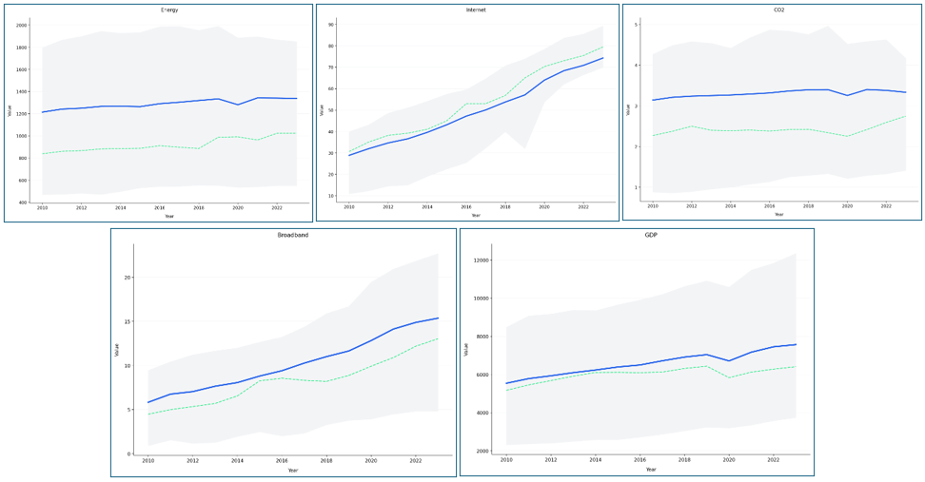Figure 1: Aggregate Trends of Energy Use, Internet Penetration, CO₂ Emissions, Broadband Subscriptions, and GDP (2010–2023)], Source: Author’s calculations based on World Bank, World Development Indicators (WDI), 2010–2023.
Figure 1 illustrates overall trends that are seen in the chosen emerging economies. Internet penetration and broadband subscriptions recorded a steady increasing trend during the study period, which is a sign of rapid digital growth. The usage of the Internet increased and reached at least 70 percent by 2023, as compared to about 30 percent in 2010. In a similar gradual upward trend, broadband subscriptions were going.
GDP per capita also showed a continuous increase though a significant decrease was noted around 2020 which could be due to global economic upheaval. The per-capita energy consumption showed an average upward trend over time, interspersed with a temporary decline in the year 2020. The per capita CO 2 emission showed a slight increasing trend up to 2019, followed by a decrease in 2020 and a partial recovery.
These tendencies show that in developing economies, the promotion of digitalization and economic growth has been accompanied by an increase in both energy demand and emissions.

4.2 Correlation Analysis
The correlation analysis also provides information on the interrelationships between the main variables. The heatmap indicates that the positive relationship between energy consumption and CO₂ emissions (ρ = 0.96) is strong, which supports the significant role of energy consumption in increasing emissions. The GDP per capita also shows that it is significantly positively correlated with the CO₂ emissions (ρ = 0.81).
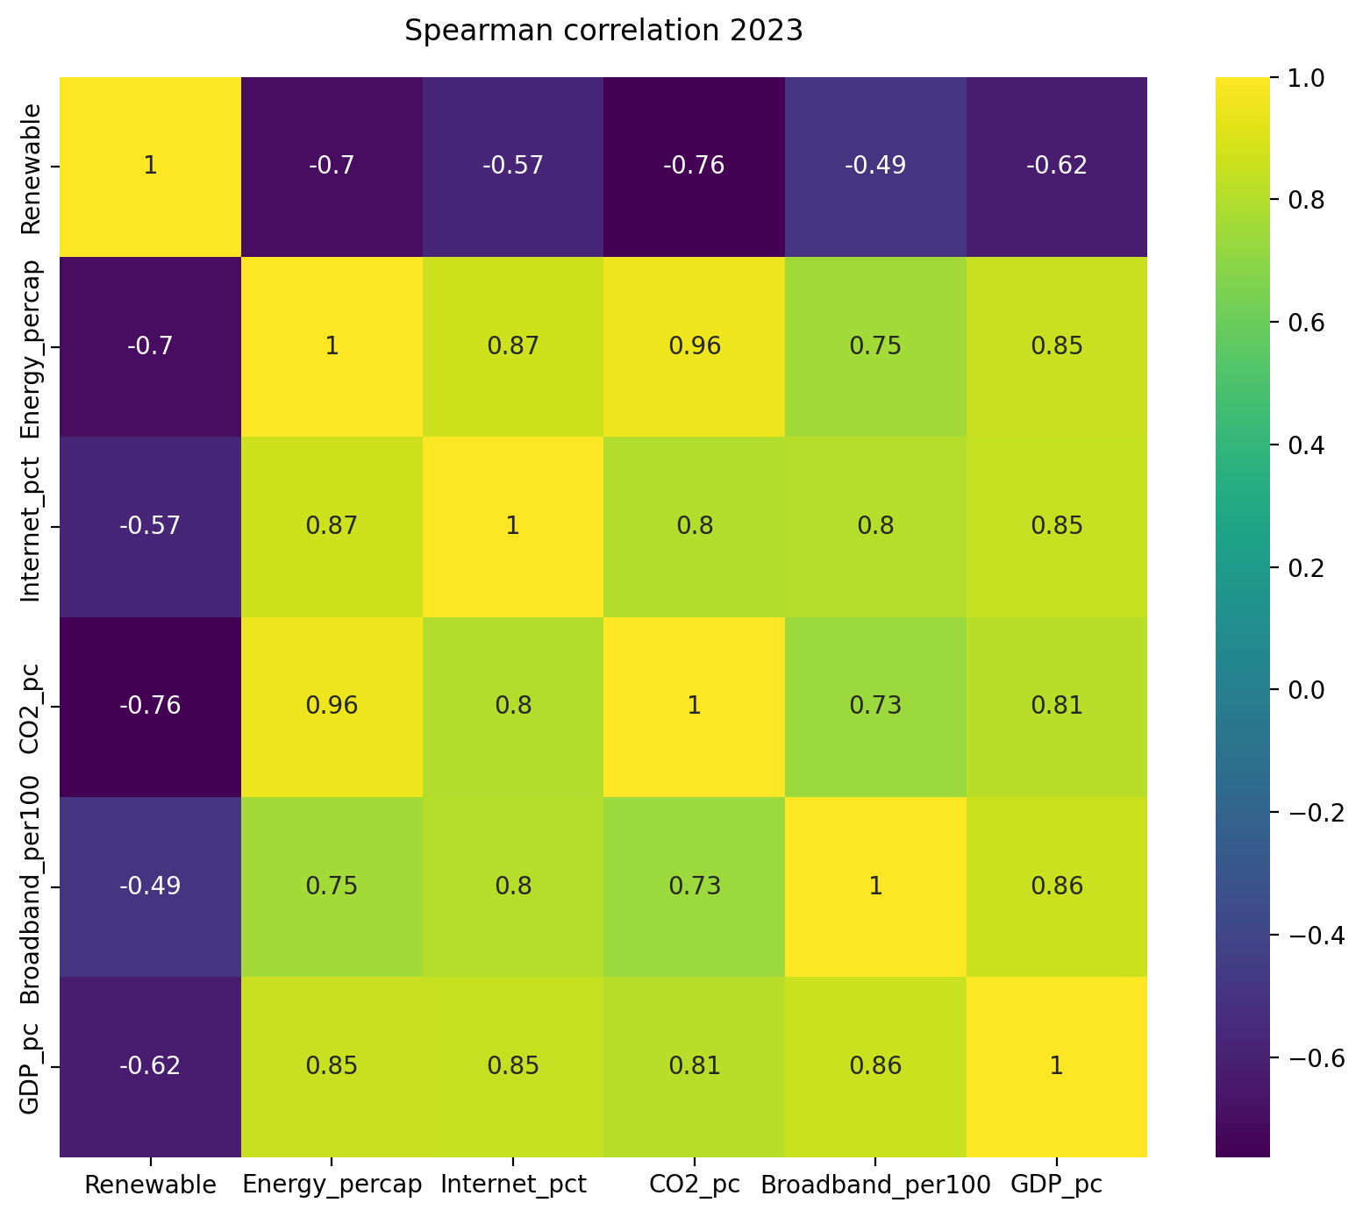
Figure 2: Spearman Correlation Heatmap of Key Variables (2023), Source: Author’s calculations based on World Bank, World Development Indicators, and International Telecommunication Union (ITU), 2023.
There is a significant negative relationship between the consumption of renewable energy and the CO₂ emissions (ρ = -0.76), implying that the greater the share of renewable energy used, the fewer the emissions. The penetration of the internet and subscribing to broadband is positively related to GDP and energy consumption, which implies that digitalization is more likely to grow along with economic growth.
Although correlation does not indicate causation, these provisional results confirm the theoretical hypothesis that energy structure and income levels are among the key determinants of emissions.

4.3 GDP–Emissions Relationship (Graphical Evidence)
The scatter plot that was plotted between GDP per capita and CO₂ emissions per capita shows that there was a definite positive relationship among the countries. The emerging economies that have higher incomes are associated with higher per capita emissions. The estimated curve is convex in nature, which is in line with the initial age of the Environmental Kuznets Curve (EKC) theory.
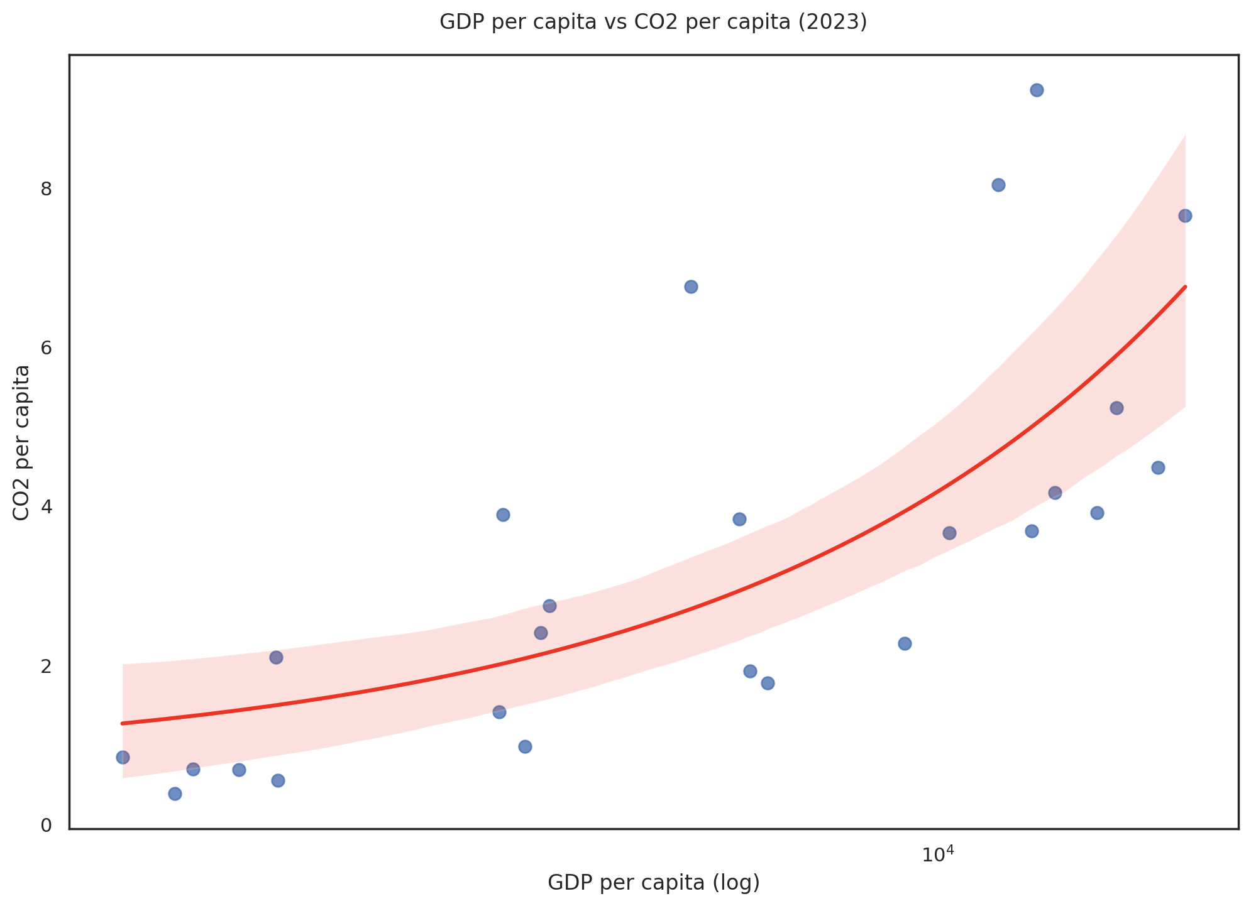
Figure 3: GDP per Capita vs CO₂ per Capita (2023), Source: Author’s calculations based on World Bank, World Development Indicators (2023).
This graphical evidence underlines the necessity of the panel regression analysis to test the hypothesis of whether the impact of income remains when the effects of energy structure and digitalization are controlled.

4.4 Panel Regression Results
A fixed effects panel regression model that included the country's effect and time effect was estimated using robust standard errors in order to provide a formal evaluation of the effect of digitalization on carbon emission.
The estimation results indicate that:
Emissions are positively and significantly influenced by GDP per capita (log_GDP; = 0.2021, p < 0.01). The rise in GDP per capita by 1 per cent will be linked to the rise of CO₂ emission by 0.20 per cent. The energy per capita (log_Energy) has a positive and very significant (0.8149, p < 0.01) effect and it means that energy consumption is the key factor that drives emissions in emerging economies. There exists a significant negative effect of renewable energy consumption (0.0123, p < 0.01) indicating that an upsurge in the proportion of renewable energy sources has a negative impact on the emission levels. Controlling income and energy use, internet penetration, and subscriptions to broadband are not statistically significant. This means that online digitization does not directly decrease emissions when structural energy factors are taken into perception.
Variable | Coefficient | Std. Error | t-Statistic | p-value
log_GDP | 0.2021*** | 0.0465 | 4.3426 | 0.0000
Internet | 0.0005 | 0.0005 | 1.1414 | 0.2547
Broadband | -0.0015 | 0.0011 | -1.4051 | 0.1611
log_Energy | 0.8149*** | 0.0941 | 8.6600 | 0.0000
Renewable | -0.0123*** | 0.0022 | -5.6214 | 0.0000
Constant | -6.1869*** | 0.6100 | -10.143 | 0.0000
Table 1: Fixed Effects Panel Regression Results: Impact of Digitalization on CO₂ Emissions in Emerging Economies (2010–2023), Source: Author’s calculations based on World Bank World Development Indicators (2024).
Estimated Empirical Model:
Replacing the estimated coefficients of Table 1, the empirical specification of the model may be presented as follows:
The model has high explanatory power and within R² is 0.7802. The strong F-test indicates the combination of significance of the regressors (p < 0.01). The probability F-test rejects the pooled OLS model, which is why it is reasonable to use fixed effects to explain the country-specific heterogeneity.
In general, empirical evidence indicates that as economic growth and energy consumption increase, the effect of renewable energy on mitigating effects on carbon emissions is alleviated. Digitalization, on the other hand, does not seem to have an independent effect but rather an indirect effect on emissions, namely through the interaction with economic and energy structures.
Statistic | Value
Observations | 334
Countries | 24
Time Period | 2010–2023
Fixed Effects | Country & Year
R² (Within) | 0.7802
R² (Overall) | 0.9329
F-statistics (Robust) | 166.32
Prob > F | 0.0000
Table 2: Source: Author’s calculations based on World Bank, World Development Indicators (2024), Source: Author’s calculations based on World Bank, World Development Indicators (2024)
Interpretation of the Estimated Model:
Replacing the estimated coefficients, the empirical findings showed that economic growth has a positive and statistically significant influence on carbon emissions of emerging economies. In particular, the coefficient of the log GDP per capita (0.2021, p < 0.01) suggests that an increase in the income per capita by 1 percent will lead to a 0.20 percent rise in the CO₂ emissions, other factors being equal. This observation represents the scale effect of economic growth, whereby an increase in the level of production and consumption increases the rate of environmental pressure. The positive impact is highest in energy consumption per capita (0.8149, p < 0.01), which shows that a 1% change of energy consumption will increase the emissions by approximately 0.81. This outcome endorses the fact that energy structure is the leading factor of emissions in emerging economies.
Conversely, the use of renewable energy shows negative statistically significant correlation with emissions (-0.0123, p < 0.01). The share of renewable energy in total energy consumption increases the contribution to the decrease in per capita CO₂ emissions, and this is why energy transition policies are essential. Nonetheless, the coefficients of internet penetration and broadband subscriptions are statistically insignificant, which demonstrates that digitalization in terms of the ICT diffusion indicators does not have a direct effect of reducing emissions after the controlling variables of income levels and energy consumption are taken into account. This implies that the process of digital transformation may not ensure environmental sustainability without structural alterations in the pattern of energy production and consumption. Generally, the model highlights the primary position of economic size and energy consumption in the formation of carbon emissions, and the introduction of renewable energy turns out to be one of the most important mitigation variables.

4.5 Environmental Kuznets Curve (EKC) Analysis
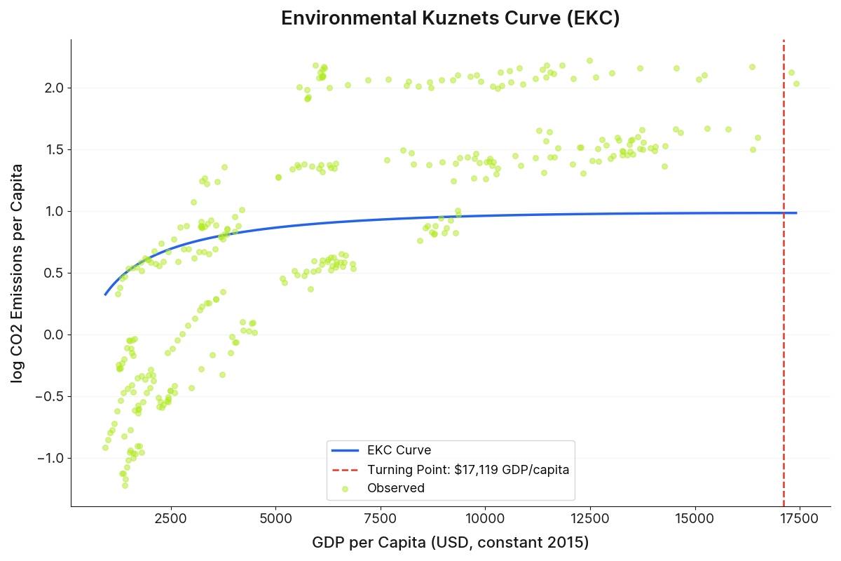
Figure 4: Environmental Kuznets Curve (EKC) for Emerging Economies (2010–2023), Source: Author’s calculations based on World Bank, World Development Indicators (2024).
In order to explore more the non-linear association between economic growth and environmental degradation, we consider the Environmental Kuznets Curve (EKC) hypothesis by incorporating the squared variable of log GDP per capita into a two-way fixed effects panel model. According to the EKC framework, carbon emissions will start increasing with income but after some threshold level of economic development is reached then it will decrease.
The estimation findings provide strong support for the inverted-U structure. The coefficient of the logarithm of GDP per capita is also positive and statistically significant (β = 1.533, p < 0.001) which implies that on lower income levels, economic growth is a factor to an increase in CO₂ emission. However, the quadratic coefficient of logarithm GDP per capita has a negative and statistically significant coefficient (β = −0.079, p = 0.003) and this fact is what supports the presence of a non-linear income-emissions nexus that fits the Environmental Kuznets Curve hypothesis.
Based on the estimated coefficients, the turning point of the Environmental Kuznets Curve (EKC) lies at USD 17,119 (constant 2015 prices) per capita. Accordingly, economic growth in countries with lower incomes is linked to emission growth. At these and higher levels, a rise in income is associated with a reduction in emissions, indicating that structural change, technological modernization, and more environmental regulations may start counteracting the scale of effects of growth.
In line with the findings of the baseline regression, it is clear that energy consumption is a powerful and statistically significant predictor of emissions (β = 0.763, p < 0.001), which reflects the key influence of energy intensity on carbon outcomes. The consumption of renewable energy is still demonstrating a strong mitigating effect (β = −0.010, p < 0.001), which proves the relevance of energy transformation policies in the up-and-coming economies. In the meantime, the digitalization indicators (Internet penetration and broadband subscriptions) are statistically insignificant, which suggests that the ICT expansion does not have a direct effect on the non-linear income-emissions relationship.
The EKC specification is found to have a good amount of explanatory power by demonstrating a within-sample R² of 0.79 and a general R² of 0.93. These statistics suggest that the two-way fixed-effects model is a good model in explaining cross-country heterogeneity and time-specific shock variables. Accordingly, the empirical data points to the fact that in the emerging economies the initial stages of economic growth are linked with the increased levels of environmental degradation; however, the achievement of a higher income level seems to, ultimately, sustain the decline in emissions, as long as the corresponding structural and energy-transition reforms are implemented thereof.
5. Discussion
Empirical evidence gives valuable information on the factors that determine carbon emissions in emerging economies. The beneficial and statistically significant impact of GDP per capita signifies that the growth of the economy is ever increasing the pressure on the environment. This is along with the scale effect argument, according to which the rise in income and production will result in the rise of energy demand and emissions [13]. This finding indicates that most of the emerging economies are still in the development stages of which development is highly dependent on carbon-intensive industrial and energy structures.
The consumption of energy turns out to be the leading cause of emissions. High elasticity of emissions to energy consumption indicates the structural reliance of developing economies on their energy systems that are based on fossil fuels. The discovery aligns with the evidence of the current literature, which shows that the intensity of energy, as well as fuel makeup, are a key factor in the carbon dynamics [4]. The size of the coefficient is an indication that the energy policy is the most critical tool to be used in the reduction of emissions.
Conversely, there is a statistically significant negative correlation between the renewable energy consumption and CO₂ emissions. This finding indicates the relevance of energy transition strategies and justifies the position that raising the proportion of renewable energy is a direct contributor to the emission reduction [2]. The observation supports the policy applicability of increasing the renewable capacity in emerging markets through climate mitigation measures.
Interestingly, indicators of digitalization, such as internet penetration as well as broadband subscriptions, do not show statistically significant direct effects on emissions when variables of economic scale and energy consumption are adjusted. This implies that the growth of digital infrastructure does not necessarily lead to benefits to the environment. The first reason is that the use of digital technologies can raise electricity demand by utilizing data centers, expanding networks, and using their devices, which can compensate for possible efficiency gains [33]. Alternatively, some types of digitalization can have an indirect effect on emissions, impacting a country and productivity, and structural change instead of a direct effect on energy intensity.
In general, the findings show that despite the high speed of digital transformation in emerging economies, these processes have a conditional effect on the environment depending on the energy level of the infrastructure. Economic growth and energy consumption remain the main drivers of emission, and the main mechanism mitigating is the adoption of renewable energy. As such, the implementation of policies that focus on sustainable online development is supposed to be coupled with the strategies of clean energy transitions to be attained to attain significant environmental progress.

6. Conclusion & Policy Implications
This paper investigated the connection between digitalization and carbon emissions in 24 emerging economies between the year 2010 and 2023 as a two-way fixed effects panel model. According to the empirical results, economic growth and energy consumption are still the major sources of carbon emissions within the emerging markets. Specifically, the impact of energy consumption on emissions is the most significant, which proves that the growth structures reliant on fossil fuels remain the overwhelming factor of environmental performance.
However, similar to renewable energy consumption, the statistical significance of mitigating effect is observed. A rise in the proportion of renewable energy in overall energy consumption helps to reduce CO₂ emissions per capita by a measurable amount. The research results highlight the urgent need to promote energy transition processes in non-developed economies.
On the contrary, digitalization as an indicator based on internet penetration and broadband network does not have a statistically significant direct effect on carbon emissions after income levels and energy consumption are accounted. This implies that digital growth cannot be used to realize environmental sustainability. Although digital technologies can enhance efficiency and productivity, their benefits to the environment seem to be conditional upon the energy structure and regulatory framework.
Combined, the findings suggest that sustainable development in developing economies is an integrated process that must bring digital transformation with clean energy transition. The policies of digitalization must be supported by investments into renewable energy infrastructure, energy efficiency, and the regulatory incentives that encourage low-carbon innovation.
There are three implications that can be drawn from a policy perspective. To start with, emission reduction strategies in emerging markets should still focus on energy transition. Increasing the size of renewable energy and lessening the dependence on fossil fuels can generate powerful environmental benefits. Second, environmental protection should be part of digitalization strategies, including the promotion of data centers that are energy-efficient and low-carbon digital infrastructure. Third, the policies should be coordinated to combine economic growth, digital innovation, and environmental regulation in order to achieve stability between development goals and climate commitments.
In general, this research is valuable to the current body of literature on digitalization and environmental sustainability because it emphasizes the point that digital transformation does not necessarily result in a reduction of emissions. Rather, structural energy reform is the key determinant in the determination of environmental performance in emerging economies.

References
- Abdi, A. H., Zaidi, M. A. S., Hassan, M. K., & Ahmed, S. (2025). Accelerating sustainable transformation in sub-Saharan Africa: the role of clean energy, digitalization, foreign direct investment, and industrialization. Frontiers in Environmental Science, 13. https://doi.org/10.3389/fenvs.2025.1624721
- AKYOL, H., & AĞIRKAYA, M. B. (2024). The Relationship between CO2 Emissions, Economic Growth, Labor Force, Digitalization, Urbanization and Renewable Energy Consumption: Evidence from the EU and Selected Developing Countries. Research Square (Research Square). https://doi.org/10.21203/rs.3.rs-4382921/v1
- Althouse, J. (2022). Ecological Macroeconomics For a Shared Planet: Towards a Political Ecology of Money, Finance and Production. HAL (Le Centre Pour La Communication Scientifique Directe). https://hal.science/tel-03835611
- Amadei, C., Dosi, C., & Pintus, F. (2024). Energy Intensity and Structural Changes: Does Offshoring Matter? SSRN Electronic Journal. https://doi.org/10.2139/ssrn.5027436
- Barbieri, N., Consoli, D., Napolitano, L., Perruchas, F., Pugliese, E., & Sbardella, A. (2022). Regional technological capabilities and green opportunities in Europe. The Journal of Technology Transfer, 48(2), 749. https://doi.org/10.1007/s10961-022-09952-y
- Chen, L., Huang, L., Hua, J., Chen, Z., Wei, L., Osman, A. I., Fawzy, S., Rooney, D. W., Dong, L., & Yap, P. (2023). Green construction for low-carbon cities: a review [Review of Green construction for low-carbon cities: a review]. Environmental Chemistry Letters, 21(3), 1627. Springer Science+Business Media. https://doi.org/10.1007/s10311-022-01544-4
- Dai, J., Zhou, B., & Meng, W. (2025). The impact of digitization on environmental sustainability: New insights from G20 nations. Journal of Environmental Management, 394, 127225. https://doi.org/10.1016/j.jenvman.2025.127225
- Durlauf, S. N. (2001). Manifesto for a growth econometrics. Journal of Econometrics, 100(1), 65. https://doi.org/10.1016/s0304-4076(00)00055-5
- Dźwigoł, H., Кwilinski, A., Lyulyov, O., & Pimonenko, T. (2024). Digitalization and Energy in Attaining Sustainable Development: Impact on Energy Consumption, Energy Structure, and Energy Intensity. Energies, 17(5), 1213. https://doi.org/10.3390/en17051213
- Fang, L. (2024). Does Digitalization Lead to Environmental Sustainability and Energy Efficiency in China? Engineering Economics, 35(2), 182. https://doi.org/10.5755/j01.ee.35.2.33428
- Glavina, A., Mišić, K., Baleta, J., Jin, W., & Mikulčić, H. (2025). Economic development and climate change: Achieving a sustainable balance. Cleaner Engineering and Technology, 26, 100939. https://doi.org/10.1016/j.clet.2025.100939
- Gritsenko, D., Aaen, J., & Flyvbjerg, B. (2024). Rethinking digitalization and climate: don’t predict, mitigate. Npj Climate Action, 3(1). https://doi.org/10.1038/s44168-024-00127-z
- Hasan, Md. M., & Adnan, A. (2023). Nexus between environmental sustainability, energy intensity and food security: evidence from emerging economies. Journal of Business and Socio-Economic Development. https://doi.org/10.1108/jbsed-05-2023-0044
- Hosan, S., Karmaker, S. C., Rahman, Md. M., Uddin, A., & Saha, B. B. (2021). Digitalization, Energy Intensity and Economic Growth: A Panel Study on South Asian Economies. Proceedings of International Exchange and Innovation Conference on Engineering & Sciences (IEICES), 7, 19. https://doi.org/10.5109/4738553
- Hu, S., Jie, Y., & Zhu, S. (2025). Digitalization and configurational effects on regional income inequality: analysis of panel data from 134 economies. Technological and Economic Development of Economy, 1. https://doi.org/10.3846/tede.2025.23950
- Idroes, G. M., Hardi, I., Noviandy, T. R., Sasmita, N. R., Hilal, I. S., Kusumo, F., & Idroes, R. (2023). A Deep Dive into Indonesia’s CO2 Emissions: The Role of Energy Consumption, Economic Growth and Natural Disasters. Ekonomikalia Journal of Economics, 1(2), 69. https://doi.org/10.60084/eje.v1i2.115
- Karaki, B. A., Al-Kasasbeh, O., Alassuli, A., & Alzghoul, A. (2023). The Impact of the Digital Economy on Carbon Emissions using the STIRPAT Model. International Journal of Energy Economics and Policy, 13(5), 139. https://doi.org/10.32479/ijeep.14513
- Khalid, A. A. (2015). World Development indicators. Data Archiving and Networked Services (DANS), 1. https://doi.org/10.17632/zcvgc6m58h.1
- Li, P. (2024). Digital Technologies, Environmental Governance and Environmental Performance: Empirical Evidence from China. Engineering Economics, 35(2), 236. https://doi.org/10.5755/j01.ee.35.2.33429
- Lyu, Y., Xiang, Y., & Wang, D. (2024). The impacts of digital value chain embeddedness on trade-related carbon emissions intensity. Frontiers in Environmental Science, 11. https://doi.org/10.3389/fenvs.2023.1256544
- Máté, D., Erdei, E., Lorestani, V. Z., Popp, J., & Oláh, J. (2020). Can internet in schools and technology adoption stimulate productivity in emerging markets? Economics & Sociology, 13(1), 182. https://doi.org/10.14254/2071-789x.2020/13-1/12
- Nauman, M., Naheed, R., & Khan, J. (2023). Sustainable Development and Financial Resilience: Linking Greenhouse Gas Emissions, Risk, and Green Growth with Innovation, Inclusion, Renewables, and Infrastructure. Research Square (Research Square). https://doi.org/10.21203/rs.3.rs-3246034/v1
- Papke, L. E., & Wooldridge, J. M. (2022). A simple, robust test for choosing the level of fixed effects in linear panel data models. Empirical Economics, 64(6), 2683. https://doi.org/10.1007/s00181-022-02337-y
- Pearson, P. J. G. (1995). Energy, Externalities and Environmental Quality: Will Development Cure the Ills It Creates? Energy Studies Review, 6(3). https://doi.org/10.15173/esr.v6i3.345
- Qamruzzaman, Md., & Kor, S. (2024). Navigating the path to environmental sustainability: Insights from CIVETS on the intersection of ICT diffusion, natural resources, and green technological innovation. PLoS ONE, 19(12). https://doi.org/10.1371/journal.pone.0309264
- Quaglione, D., D’Ingiullo, D., & Meleo, L. (2023). Fixed and mobile broadband penetration and CO2 emissions: evidence from OECD countries. Economia Politica, 40(3), 795. https://doi.org/10.1007/s40888-023-00307-w
- Sareen, S., & Müller, K. (2022). Digitisation and Low-Carbon Energy Transitions. https://doi.org/10.1007/978-3-031-16708-9
- Sharma, P., & Dash, B. (2022). The Digital Carbon Footprint: Threat to an Environmentally Sustainable Future. International Journal of Computer Science and Information Technology, 14(3), 19. https://doi.org/10.5121/ijcsit.2022.14302
- Si, H., & Rahman, Z. U. (2024). Embracing the digital revolution: Examining the relationship between ICT adoption and carbon emissions in the Persian Gulf. PLoS ONE, 19(6). https://doi.org/10.1371/journal.pone.0304088
- Sinha, A., Shahbaz, M., & Balsalobre‐Lorente, D. (2017). Exploring the relationship between energy usage segregation and environmental degradation in N-11 countries. Journal of Cleaner Production, 168, 1217. https://doi.org/10.1016/j.jclepro.2017.09.071
- Stern, D. I. (2004). Environmental Kuznets Curve. In Elsevier eBooks (p. 517). Elsevier BV. https://doi.org/10.1016/b0-12-176480-x/00454-x
- Verdolini, V. (2023). Interlinkages between the Just Ecological Transition and the Digital Transformation. SSRN Electronic Journal. https://doi.org/10.2139/ssrn.4329226
- Xu, S., Li, J., Ya, J., Li, H., Xia, D. M., & Song, Z. (2025). Digital technological innovation and urban carbon emission intensity: a nonlinear path toward sustainability. Frontiers in Environmental Science, 13. https://doi.org/10.3389/fenvs.2025.1579459
- Yue, M., Ren, B., Zhu, T., & Jin, Z. (2025). Asymmetric decarbonization in the digital age: divergent pathways of advanced versus emerging economies. Frontiers in Environmental Science, 13. https://doi.org/10.3389/fenvs.2025.1659906
- Zhao, X., Jiang, M., & Zhou, Y. (2023). The impact of the digital economy on carbon emission intensity: Evidence from China. Frontiers in Environmental Science, 11. https://doi.org/10.3389/fenvs.2023.1119246

