Case Report
Simultaneous Morgagni and Bochdalek Hernias in an Adult: A Rare Case Diagnosed Radiologically and Treated by Laparoscopic Repair

Abstract:
Introduction: Diaphragmatic hernias are typically congenital and diagnosed in neonates or infants (1,2). Their discovery in adulthood is rare and often incidental (2,9). The simultaneous presence of a Morgagni hernia and a Bochdalek hernia in an adult is exceptionally uncommon. (4,13).
Case presentation: We report the case of a 47-year-old male, with no significant medical history, who presented with prolonged fever, asthenia, anorexia, and weight loss. Thoracoabdominal CT scans revealed a right anterolateral diaphragmatic hernia, later identified as a Morgagni hernia. Surgical exploration revealed two diaphragmatic defects, consistent with a Morgagni and a Bochdalek hernia. Both were treated successfully by laparoscopic repair. Postoperative recovery was uneventful.
Discussion: Double diaphragmatic hernia in adults is extremely rare and may remain asymptomatic or present with nonspecific gastrointestinal or respiratory symptoms (4,9,13). Computed tomography is the gold standard for diagnosis, enabling precise localization and characterization of the herniated contents. (9,13). Laparoscopy provides both diagnostic and therapeutic benefits, offering direct visualization of the diaphragm and minimally invasive repair with excellent outcomes (10,11,15).
Conclusion: This case underscores the importance of detailed imaging in atypical clinical presentations and highlights the safety and efficacy of laparoscopic management for dual congenital diaphragmatic hernias in adults (10,15).
Keywords: Morgagni, Bochdalek, Adult, Diaphragmatic hernia, Laparoscopic repair, Case report.
Introduction:
Congenital diaphragmatic hernias (CDH) arise from defective fusion or malformation of the diaphragmatic components during fetal development (1,3). They are most commonly diagnosed in the neonatal period, typically presenting with respiratory distress due to pulmonary hypoplasia or visceral herniation. However, a minority of cases may remain asymptomatic until adulthood, where diagnosis is often incidental during imaging for unrelated symptoms (2,9).
Morgagni hernias account for approximately 2–5% of congenital diaphragmatic hernias and are located in the anterior parasternal region (4,10). In contrast, Bochdalek hernias, which represent the majority of CDH cases in neonates, occur in the posterolateral region of the diaphragm, predominantly on the left.(13–16).
The concurrent presence of both Morgagni and Bochdalek hernias in the same adult patient is exceptionally rare. To date, fewer than ten such cases have been reported in the medical literature (Horton et al., 2008; Beyrouti et al., 2009).
We report a rare case of concomitant right-sided Morgagni and Bochdalek hernias in an adult, identified and successfully repaired through a laparoscopic approach.
This case highlights the diagnostic importance of computed tomography and the feasibility of minimally invasive management in rare dual diaphragmatic defects (10,11).
Case Report:
A 47-year-old male with no no prior medical history was referred for evaluation of unexplained systemic symptoms. The patient had a body mass index (BMI) of 19 and worked as a military sergeant. There was no history of trauma, chronic cough, or other precipitating factors. The diagnosis was established in May, and surgical repair was performed on October 14.
The patient initially presented with a 15-day history of low-grade fever, progressive fatigue, anorexia, and unintentional weight loss of 5 kg. He was first evaluated by a general practitioner and subsequently referred to a pulmonologist. A chest CT scan revealed a right anterolateral diaphragmatic hernia containing adipose and digestive structures. The patient was then referred to our department for surgical management.
A Postero-anterior chest X-ray revealed elevation of the right hemi-diaphragm compared to the left, with an abnormal air–fluid level and mottled gas pattern projecting over the right lower thoracic cavity, suggesting intra-thoracic herniation of abdominal contents.
(Figure 1)
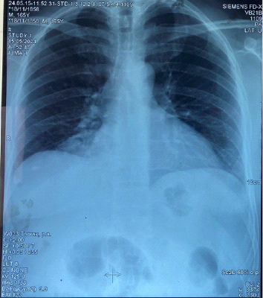
Figure 1. Posteroanterior chest X-ray showing right-sided diaphragmatic elevation and air fluid level.

The lateral chest view showed a clear right anterior diaphragmatic elevation with a softtissue density containing air-filled structures located just behind the sternum and anterior to the cardiac silhouette, while the posterior diaphragmatic contour remains normal. (Figure 2)
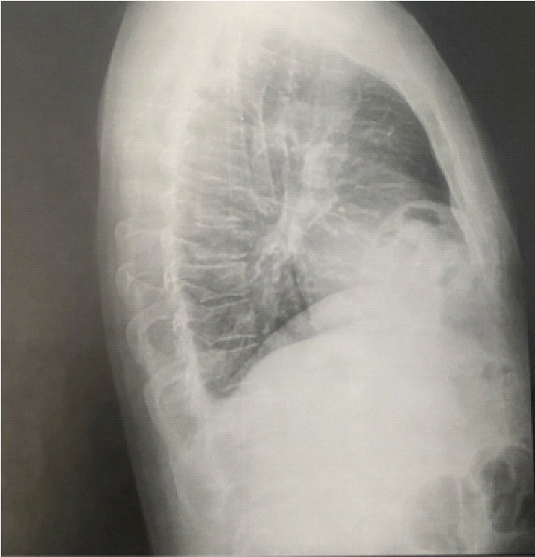
Figure 2. Lateral chest X-ray showing an anterior mediastinal opacity with air–soft tissue interface

A contrast-enhanced thoraco-abdominal computed tomography (CT scan) confirmed the presence of a right-sided anterior diaphragmatic hernia containing omental fat and bowel loops consistent with a Morgagni-type diaphragmatic hernia: (Figure 3, 4)
The right anterior hemi-thorax shows a heterogeneous soft-tissue and air-containing mass located just anterior to the heart and adjacent to the right cardiophrenic angle. This mass is composed of gas-filled structures consistent with herniated bowel loops, confirming herniation of abdominal contents into the thoracic cavity. The diaphragmatic defect is visible at the right anterior costophrenic junction.
The lung parenchyma remains normally aerated bilaterally, with no pleural effusion or compression atelectasis.
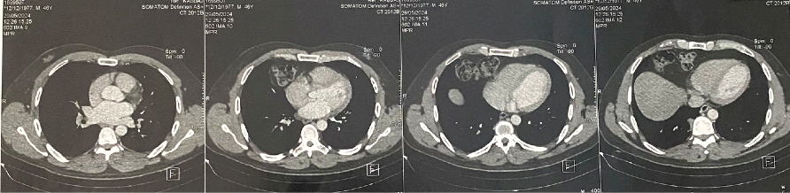
Figure 3. Axial contrast-enhanced CT scans clearly demonstrate the right anterior diaphragmatic defect (Morgagni hernia) containing omental fat and transverse colon loops, compressing the adjacent right lung base.
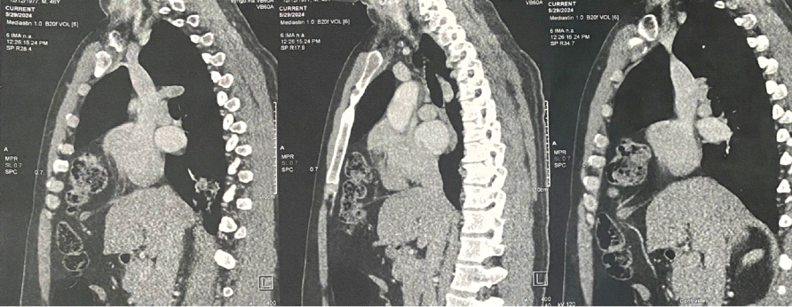
Figure 4. Sagittal contrast-enhanced CT images showing Morgagni hernia. The defect margins and hernia sac are clearly delineated

Intraoperative exploration identified two distinct right-sided diaphragmatic defects: an anterior Morgagni hernia measuring approximately 2 cm, and a posterior Bochdalek hernia measuring 1.5 cm. The herniated omentum and bowel loops were reduced, and both defects were closed with non-absorbable sutures using the raphy technique. Owing to the small size of the defects and healthy tissue margins, primary repair without mesh reinforcement was deemed sufficient.
Postoperative recovery was uneventful.
The patient remained conscious, hemodynamically stable and pain-free. The abdomen was soft and non-tender, and surgical dressings were clean and intact.
Surgical dressings remained clean and intact. Bowel function resumed early, with passage of flatus on postoperative day one.
A post-operative chest X-ray showed restoration of the right diaphragmatic contour to its normal position, with clear lung bases and no residual air–fluid levels or mass effect, confirming successful repair. (Figure 5)
The patient was discharged on postoperative day two with follow-up scheduled in outpatient clinic. At fifteen days and three-month follow-up, the patient remained well and fully asymptomatic.
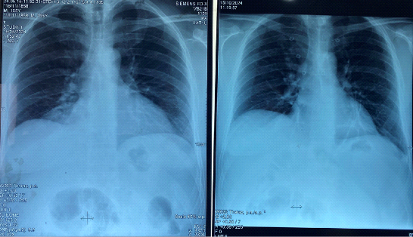
Figure 5. Comparison of preoperative (left) and postoperative (right) chest radiographs. The postoperative image demonstrates complete resolution of the previously herniated content, with normal diaphragmatic contour and lung expansion and no residual diaphragmatic opacity.

Discussion:
Congenital diaphragmatic hernias are uncommon developmental anomalies resulting from incomplete fusion of the pleuroperitoneal membranes during embryogenesis (1,3). They may occur in isolation or in association with other congenital malformations or chromosomal abnormalities, such as trisomy 21 (1,2).
While Congenital diaphragmatic hernias are typically diagnosed in neonates presenting with respiratory distress, delayed presentations in adulthood have been reported and are often discovered incidentally (9,13).
Anatomically, diaphragmatic hernias are classified into two main types:
Bochdalek hernias, which occur posterolaterally and account for the majority of neonatal cases (13,16), and Morgagni hernias, located anteriorly through the sternocostal hiatus, typically on the right side (4,10).
In adults, Morgagni hernias are usually asymptomatic but may present with vague gastrointestinal or respiratory complaints. Rarely, they may lead to complications such as bowel obstruction or strangulation (5).
Radiological imaging plays a crucial role in diagnosis. Chest X-rays may reveal elevation of the hemidiaphragm or air–fluid levels in the thoracic cavity, whereas computed tomography (CT) provides definitive confirmation by visualizing the herniated fat or bowel loops and identifying the diaphragmatic defect (9,11).
Similarly, adult Bochdalek hernias are exceedingly rare and may remain clinically silent until complicated by volvulus, strangulation, or ischemia (14).
Multidetector CT is the imaging modality of choice for their detection and anatomical characterization (13,15).
The simultaneous presence of Morgagni and Bochdalek hernias in a single adult patient is exceptionally rare. Fewer than ten such cases have been reported in the literature (Horton et al., 2008; Beyrouti et al., 2009).
In our case, the patient presented with nonspecific constitutional symptoms, prompting CT evaluation, which identified a right anterior Morgagni hernia.
The coexisting posterior Bochdalek defect was discovered intraoperatively. This underscores the importance of maintaining a high index of suspicion and conducting meticulous intraoperative exploration when diaphragmatic abnormalities are suspected (9,13).
Surgical repair remains the treatment of choice for all Morgagni and Bochdalek hernias, regardless of symptomatology, due to the risk of incarceration or strangulation (4,10). Laparoscopic and thoracoscopic approaches have largely replaced open repair, offering the advantages of reduced postoperative pain, shorter hospital stay, and quicker recovery (8,15).
The fundamental objectives of surgery are reduction of herniated viscera and closure of the diaphragmatic defect—either by primary suture repair or prosthetic mesh reinforcement in larger or tension-prone defects.
In our patient, both hernias were successfully repaired laparoscopically using primary non-absorbable sutures. The small size of the defects and healthy tissue margins obviated the need for mesh placement. The postoperative course was uneventful, with early return of bowel function and discharge on postoperative day two.
This case highlights the clinical and surgical significance of recognizing atypical presentations of congenital diaphragmatic hernias in adults. Early and accurate imaging followed by minimally invasive repair can prevent potentially fatal complications and achieve excellent outcomes, even in rare cases involving multiple defects (10,15).
Conclusion:
This case highlights an exceptional presentation of dual congenital diaphragmatic hernias Morgagni and Bochdalek diagnosed in adulthood. Thorough preoperative imaging enabled accurate diagnosis, and the laparoscopic approach allowed for effective and simultaneous repair of both defects with an excellent postoperative outcome.
A high index of suspicion is essential when evaluating adults with atypical or nonspecific thoracoabdominal symptoms, as delayed diagnosis can lead to life-threatening complications.
Surgical repair remains the gold standard for all diaphragmatic hernias, regardless of symptomatology, due to the potential risk of incarceration or strangulation (4,10).
Minimally invasive approaches such as laparoscopy offer significant advantages, including reduced morbidity, faster recovery, and superior visualization of the diaphragm (10,11).
Author Statements:
Right to Privacy and Informed Consent: Written informed consent was obtained from the patient for the publication of this case report. All data were anonymized to preserve confidentiality.
Conflicts of Interest:
The authors declare no conflicts of interest related to this article.

Consent :
As perinternational standard or university standard, patient’s written consent has been collected and preserved by the author(s).

Ethical Approval :
As perinternational standard or university standard, written ethical approval has been collected and preserved by the author(s).

COMPETING INTERESTS DISCLAIMER:
Authors have declared that they have no known competing financial interests OR non-financial interests OR personal relationships that could have appeared to influence the work reported in this paper.

References:
- Chandrasekharan PK, Rawat M. Congenital diaphragmatic hernia – a review. Matern Health Neonatol Perinatol. 2017;3:6.
- Haute Autorité de Santé. Congenital diaphragmatic hernia – National protocol for diagnosis and care of rare diseases. HAS Guidelines. October 2012.
- Sapin E. Congenital malformations of the abdominal wall diagnosed antenatally. Monograph of the National College of Pediatric Visceral Surgery. Sauramps Médical; 2010.
- Horton JD, Hofmann LJ, Hetz SP. Presentation and management of Morgagni hernias in adults: a review of 298 cases. Surg Endosc. 2008;22(6):1413–1420.
- Kukcuoglu I, Eroglu A, Karaoglanoglu N, et al. Diagnosis and surgical treatment of Morgagni hernia: report of three cases. Surg Today. 2003;33(7):525–528.
- De Lagausie P, Couchot E, Benachi A, et al. Surgical treatment of diaphragmatic hernia. Rev Med Perinat. 2009;1:37–41.
- Kherbouche S. Congenital diaphragmatic hernia: a case series of 7 patients. Thesis, Faculty of Medicine and Pharmacy, Sidi Mohamed Ben Abdellah University, Fez; 2000.
- Favre JP, Cheynel N, Chirurgie J, et al. Surgical treatment of rare diaphragmatic hernias. Encycl Med Chir, Digestive Surgical Techniques. 2006;40-247.
- Beyrouti MI, Beyrouti R, Ben Amar M, et al. Adult congenital diaphragmatic hernias: about 8 cases. Médecine du Maghreb. 2009;(168).
- Abraham V, Myla Y, Verghese S, et al. Morgagni–Larrey hernia: a review of 20 cases. Indian J Surg. 2012;74:391–395.
- Arikan S, Dogan MB, Kocakusak A, et al. Morgagni’s hernia: analysis of 21 patients. Indian J Surg. 2018;80:239–244.
- Rodríguez Hermosa JI, Tuca Rodríguez F, Ruiz Feliu B, et al. Morgagni–Larrey diaphragmatic hernia in adults: analysis of 10 cases. Gastroenterol Hepatol. 2003;26:535–540.
- Mullins ME, Stein J, Saini SS, Mueller PR. Prevalence of incidental Bochdalek’s hernia in a large adult population. AJR Am J Roentgenol. 2001;177:363–366.
- Giannoulis K, Sutton R. Bochdalek hernia presenting in adult life: report of an unusual case and literature review. Ann Gastroenterol. 2004;17:109–112.
- Yamaguchi M, Kuwano H, Hashizume M, et al. Thoracoscopic treatment of Bochdalek hernia in an adult: case report. Ann Thorac Cardiovasc Surg. 2002;8:106–108.
- Ying C, Guofei Z, Gang S. Adult Bochdalek hernia complicated with perforated colon. J Thorac Cardiovasc Surg. 2005;130:1729–1730.

