Original Research Article
AMELIORATIVE EFFECTS OF Tetracarpidium conophorum (AFRICAN WALNUT) ON MERCURY-INDUCED PANCREATIC DYSFUNCTION: A TOXICOLOGICAL, MOLECULAR DOCKING, AND PHARMACOKINETIC STUDY

ABSTRACT
Mercury-induced pancreatic dysfunction is mediated by oxidative stress, inflammation, and metabolic imbalance, highlighting the need for novel, plant-based therapeutics. This study investigated the ameliorative potential of Tetracarpidium conophorum (African walnut) bioactive compounds using toxicological screening, molecular docking, and pharmacokinetic evaluation. Seven key protein targets were assessed. The highest binding affinities were recorded as follows: pancreatic function target (PDB: 1V4S) – [2-(2-benzoylphenyl)-4-(1-hydroxycyclohexyl)phenyl]-[4-(1-hydroxycyclohexyl)phenyl]methanone (−8.4 kcal/mol); oxidative stress target (PDB: 1DGB) – 7-chloro-10-hydroxy-1-(2-pyrrolidin-1-ylethylimino)-3-[3-(trifluoromethyl)phenyl]-3,4-dihydro-2H-acridin-9-one (−11.5); and similarly strong affinities for additional targets including inflammation, apoptosis, insulin resistance, lipid metabolism, and glucose regulation proteins. In several cases, these ligands outperformed standard controls such as metformin, sitagliptin, butylated hydroxytoluene, and ascorbic acid. ADME profiling revealed favorable gastrointestinal absorption, high plasma protein binding (>90%), and acceptable oral bioavailability. Toxicity predictions showed low carcinogenicity, mutagenicity, and organ-specific toxicity for most lead compounds. Drug-likeness analysis indicated compliance with Lipinski, Veber, and Egan rules for select ligands. These results suggest T. conophorum phytoconstituents possess multi-target, high-affinity interactions relevant to pancreatic protection, with pharmacokinetic and safety profiles supporting further in vivo validation and potential clinical translation for mercury-induced pancreatic injury.
Keywords: Tetracarpidium conophorum, Molecular docking, Pancreatic dysfunction, Binding affinity and Mercury toxicity

BACKGROUND
Tetracarpidium conophorum (African walnut) is a climbing plant native to West Africa, widely valued in ethnomedicine for its nutritional and therapeutic benefits. Recent studies have demonstrated its antioxidant, anti-inflammatory, and antidiabetic properties, largely attributed to its rich composition of phenolic compounds, flavonoids, tannins, alkaloids, saponins, and essential vitamins (Anyanwu et al., 2020; Odekunle et al., 2024). These bioactive constituents are known to scavenge free radicals, protect cellular components from oxidative damage, and modulate metabolic processes.
Mercury exposure, especially in the form of mercuric chloride, remains a significant public health concern due to its potent cytotoxic and oxidative effects. Mercury can disrupt cellular redox balance, induce lipid peroxidation, impair enzymatic functions, and provoke inflammatory responses that lead to dysfunction in vital organs, including the pancreas (Oriabure & Innih, 2024). The pancreas, being essential for both endocrine and exocrine functions, is particularly susceptible to oxidative insults, which may result in impaired insulin secretion, disrupted glucose metabolism, and eventual pancreatic injury.
While the ameliorative effects of T. conophorum have been reported in models of hepatic, renal, and cardiovascular toxicity (Anyanwu et al., 2020; Oriabure & Innih, 2024), there is limited scientific evidence on its potential to mitigate mercury-induced pancreatic dysfunction. However, findings from antidiabetic models indicate that extracts from T. conophorum can restore antioxidant enzyme levels, improve biochemical markers, and normalize glucose metabolism in Wistar rats, sometimes outperforming standard drugs like metformin (Kanu et al., 2020; Odekunle et al., 2024). These observations suggest a possible role for T. conophorum in protecting pancreatic tissue from mercury toxicity.
To comprehensively evaluate this potential, a multidisciplinary approach integrating toxicological assessment, molecular docking, and pharmacokinetic analysis is essential. In vivo toxicological studies in Wistar rats will assess the extract’s safety and efficacy, molecular docking will predict interactions between its bioactive compounds and molecular targets implicated in mercury-induced damage, and pharmacokinetic profiling will clarify its absorption, distribution, metabolism, and excretion patterns.
This study, therefore, aims to investigate the ameliorative effects of T. conophorum on mercury-induced pancreatic dysfunction in adult Wistar rats through a combined toxicological, molecular docking, and pharmacokinetic approach, thereby filling a critical gap in current research on plant-based interventions for heavy metal-induced pancreatic injury.
2 MATERIALS AND METHODS
2.1 Materials
1. Twenty-five (25) male albino wistar rats
2. Latex medical hand gloves
3. Standard cages
4. Vital feed rat chow
5. Animal weighing balance
6. Measuring cylinder (Pyrex)
7. Paper tape and markers
8. Spectrophotometer (Shanghai Yoke Instrument Co., Ltd. China)
9. Oral cannula
10. Cotton wool
11. Methylated spirit
12. Needle and Syringes (2ml, 5ml)
13. Spectrophotometer
14. Normal saline
15. Penand Paper
16. Tetracarpidium conophorum Leaves
17. Gavage and syringe
18. EDTA bottles
19. Whatman no.1 filter paper
2.2 In-vivo studies
Sample collection and Extraction
Fresh leaves of Tetracarpidium conophorum were collected from the premises of Chukwuemeka Odumegwu Ojukwu University. The leaves were plucked and shade dried, then ground to powder using mortar and pestle. 250g of the Tetracarpidium conophorum were macerated in 1000 mls of 95% ethanol for 48hours. It was then filtered using a porcelain cloth and further filtration using Whatman No 1 filter paper. The filtrate was concentrated using a rotatory evaporator, which was further dried using a laboratory oven at 45˚C into a gel-like form. The extract was preserved in a refrigerator for further usage.
Experimental Animal Care and Handling
Twenty-five (25) male albino Wistar rats (Rattus norvegicus) weighing between the ranges of 160-250g, were obtained from Iyke Animal farm, located at Nnewi Anambra state, and were bred in the experimental house of Basic Medical Sciences (BAMSSA), Chukwuemeka Odumegwu Ojukwu University, Uli Campus where the rats were acclimatized for two weeks. Grower mesh (sander feeds) and tap water was provided throughout the experimental period.
Induction of Mercury chloride and Administration of Plant extract
The weights of the rats were measured prior to Mercury chloride and Tetracarpidium conophorum extract administration. They were divided into five groups (A, B, C, D, E) of 5 rats each. Based on their weights, group A (control) measures 120g, group B measures (Mercury chloride only) 130g, group C (low dosage) measures 125g, group D (mid dosage) measures 140g, group E (high dosage) measures 150g. Pancreas oxidative damage was induced into the rats at a dose relative to their body weight, (Theophile, 2006). The Mercury chloride was induced through intraperitoneal route and Tetracarpidium conophorum extract was administered for three weeks through oral route according to the experimental design below:
Table 1: Experimental Design
Groups | No. of rats | Treatment dose
Group A (control) | 5 | Feed + water
Group B (Toxicity model) | 5 | 0.12 ml Mercury chloride
Group C (Treatment) | 5 | 0.12 ml Mercury chloride + 0.2 ml of Tetracarpidium conophorum extract
Group D (Treatment) | 5 | 0.12 ml Mercury chloride + 0.4 ml of Tetracarpidium conophorum extract
Group E (Treatment) | 5 | 0.12 ml Mercury chloride + 0.6 ml of Tetracarpidium conophorum extract
Collection of Blood samples and extraction of organs
The weight of each rat was weighed using weighing scale and will be recorded according to group and labelled. On the last day of the experiment the animals were anesthetized using 40mg/kg of ketamine hydrochloride intraperitoneally. Twenty-four (24) hours after the administration, the animals will be sacrificed under light ether anesthesia. The Pancreas were excised and fixed appropriately.
2.3 Declaration of Interest
None

2.4 Funding Source
This research did not receive any specific grant from funding agencies in the public, commercial, or non-profit sectors.

Biochemical Assay
Determination of body weight
The initial and final body weight of the albino rats were determined using a digital balance as recommended by the National Research Council (2011).
Determination of Insulin level
The insulin levels in the blood sample was determined using Enzyme-Linked Immunosorbent Assay (ELISA) method as described by Engvall and Perlmann (1971) with slight modification.
2.5 Histological Studies
The Histological studies of the pancrease which involved fixation, paraffin embedding, microtomyand H & E staining was carried out according to the method described by Kieman, J.A. (2008). Histological and histochemical
2.6 In-silico studies
Evaluation of Brassica olaracea bioactive compounds
Tetracarpidium conophorum bioactive compounds were obtained from published literature and scientific databases on phytochemicals. The databases were Indian Medicinal Plants (IMPPAT), Dr. Duke Ethnobotanical Database (https://phytochem.nal.usda.gov, accessed on July 14, 2025) and Goggle Scholar, accessed on July 14, 2025. A total of 200 bioactive compounds were identified.
Preparation of Ligands
The structural data files (SDF) of the bioactive compounds were obtained from PubChem web-platform (https://www.ncbi.nlm.nih.gov/pccompound) in 3D conformation (Kim et al., 2023). The compounds whose structural files were not found in the chemoinformatics databases were drawn using ChemDraw Ultra 12.0, saved in mole files and further converted into structural data files (SDF) by deploying Openbabel GUI software version 2.3.2.
Protein targets selection and preparation

The three-dimensional (3D) crystallographic structures of target proteins shown in table were retrieved from the Protein Database (PDB) (www.pdb.org/pdb), the proteins were prepared for molecular docking through the removal of the co-crystallized ligand, water molecules and Hetero atoms to produce a nascent receptor, polar hydrogen’s were added and the receptor sites were identified using Biovia discovery studio v.24.1.0.23298.
Molecular docking
Virtual screening of the ligands was carried out using PyRx-Python Prescription 0.8, a suite comprising of automated molecular docking tools (Auto dock tools, Auto Dock Vina and Openbabel) (Dallakyan and Olson, 2015). The PDBQT file of the ligands and protein were generated through this software. The specific target sites of the target proteins were set with the help of grid box as shown in table below. The configurations for each protein-ligand complex were generated for all the ligands using the software; text files of scoring results (binding affinities of the ligands to the target protein) were also produced for the purpose of manual comparative analysis at the end of the experiment (Trott and Olson, 2010).
Table 2: Grid box dimensions of the selected target proteins
Targets | PDB ID | X | Y | Z
Metallothioneins-1 | 1MHU | 4.9530 | 5.3222 | 10.3964
Metallothioneins-2 | 2MHU | 0.0306 | -4.2033 | -6.5989
Glutathione-S-transferase | 1GRE | 70.3965 | 51.3434 | 18.7067
Apoptosis | 1F16 | -0.1099 | 0.1956 | 0.9638
Inflammatory mediators | 1IL6 | -0.1737 | 0.3499 | 0.2971
Oxidative stress | 1DGB | 20.9279 | 39.3607 | 25.0000
Pancreatic function | 1V4S | 27.4392 | 1.4394 | 68.6687
Prediction of Pharmacokinetics (ADME), Physico-chemical and Toxicity properties
The ADMET properties such as Absorption, Distribution, Metabolism, Excretion, Physico-chemical and Toxicity of the compounds were tested by using ADMETlab3.o server (ADMETlab 3.0 (scbdd.com), accessed on July 14, 2025. A freely accessible tool that enables the database to be queried by canonical SMILES notation of the ligands.
Drug Likeness Screening
Drug likeliness properties of the ligands were analyzed using SwissADME server (www.swissadme.ch/index.php) accessed on July 14, 2025. The following drug likeness models were examined; Lipinski, Ghose, Veber, Egan and Muegge.
2.7 Statistical Analysis
Research objectives and hypothesis of the study were considered before analyzing the data. The data generated in this study were expressed in mean Mean±SEM where applicable. The results were statistically analyzed using the SPSS version 25 software. Means and standard errors of mean will be calculated. Statistical differences between the experimental and control groups were determined using ANOVA and values will be considered significant at p ≤ 0.05.

RESULTS & DISCUSSION
In-vivo Results

Fig 1. Graphical description of body weights of animals

Fig 2. Insulin levels
A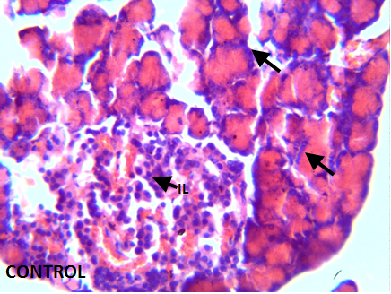B 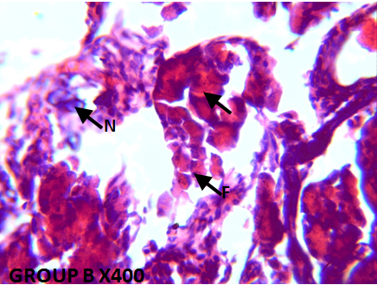
C 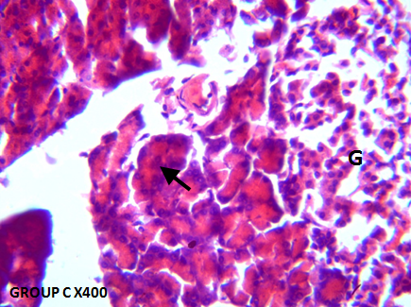D 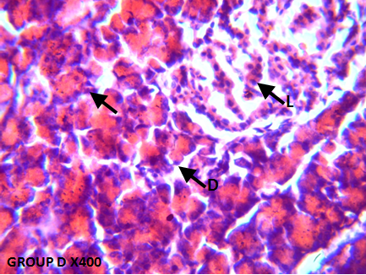
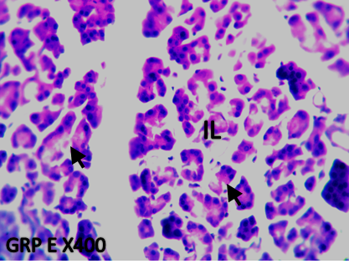
E

Fig. 3: (Group A) pancreatic tissue with normal architecture of the islets of Langerhans (IL) and pancreatic acini (Group B) necrotic islet of pancreas (N), fewer acinar cells (F) with swollen pancreatic acini (black arrow) (Group C) normal morphology of the pancreatic acini (black arrow) with well-preserved cells islet of Langerhans (Group D) Atrophic change of the acinar cells was less severe and the border between exocrine and endocrine portions became more distinct (black arrows) with nearly normal structure of Islets of Langerhans (F) (Group E). normal pancreatic islets of Langerhans, with well-preserved exocrine aciniar.
In-silico Results
Table 3: Binding affinity of the bioactive compounds of Tetracarpidium conophorum (African walnut) with Metallothioneins-1 target (PDB: 1MHU)
Ligands | PubChem CID | Binding Affinity (Kcal/mol)
Deferasirox (Control) | 214348 | -5.9
Dicyclohexyl benzene-1,2-dicarboxylate | 6777 | -4.4
Methyl 3-(3,5-ditert-butyl-4-hydroxyphenyl)propanoate | 62603 | -4
(2R)-2,8-dimethyl-2-[(4R,8R)-4,8,12-trimethyltridecyl]-3,4-dihydrochromen-6-ol | 92094 | -4
Deferoxamine (Control) | 2973 | -3.9
4,4,7-trimethyl-2,3-dihydro-1H-naphthalene | 68057 | -3.8
Diethyl benzene-1,2-dicarboxylate | 6781 | -3.6
2-(2-ethylhexoxycarbonyl)benzoic acid | 20393 | -3.5
1,3-benzodioxole-5-carbaldehyde | 8438 | -3.5

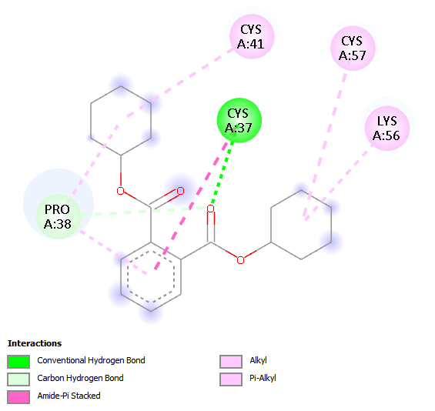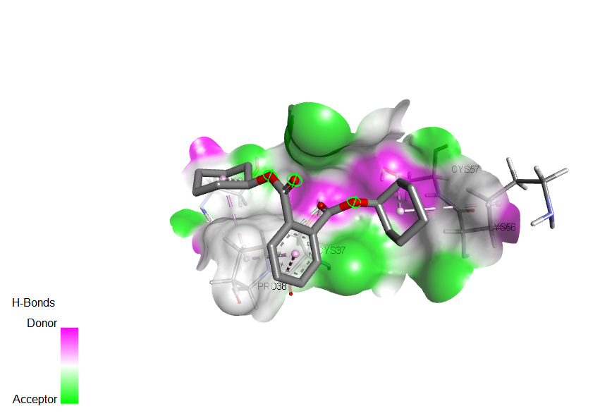
Fig 4: 2D and 3D binding interactions of Dicyclohexyl benzene-1,2-dicarboxylate with Metallothioneins-1 target (PDB: 1MHU)

Table 4: Binding affinity of the bioactive compounds of Tetracarpidium conophorum (African walnut) with Metallothioneins-2 target (PDB: 2MHU)
Ligands | PubChem CID | Binding Affinity (Kcal/mol)
[2-(2-benzoylphenyl)-4-(1-hydroxycyclohexyl)phenyl]-[4-(1-hydroxycyclohexyl)phenyl]methanone | 141134022 | -6.1
(3S,8S,9S,10R,13R,14S,17R)-17-[(E,2R,5S)-5-ethyl-6-methylhept-3-en-2-yl]-10,13-dimethyl-2,3,4,7,8,9,11,12,14,15,16,17-dodecahydro-1H-cyclopenta[a]phenanthren-3-ol | 5280794 | -5.7
(3S,8S,9S,10R,13R,14S,17R)-17-[(E,2R,5S)-5-ethyl-6-methylhept-3-en-2-yl]-10,13-dimethyl-2,3,4,7,8,9,11,12,14,15,16,17-dodecahydro-1H-cyclopenta[a]phenanthren-3-ol | 602765 | -5.7
[2-(2,2,3,3,3-pentafluoropropanoyloxy)phenyl] furan-2-carboxylate | 91700578 | -5.5
N-(1-phenylethyl)benzotriazol-1-amine | 119340 | -5.4
Dimercaptosuccinic acid (Control) | 9354 | -3.8
Dimercaprol (Control) | 3080 | -2.7

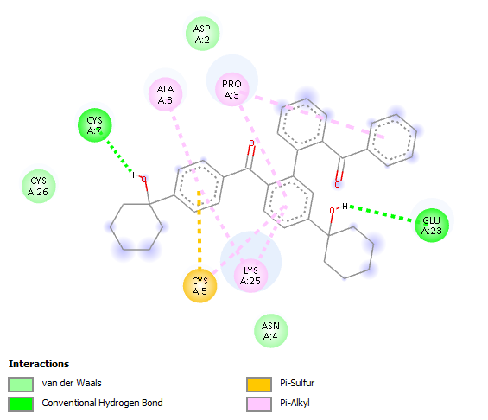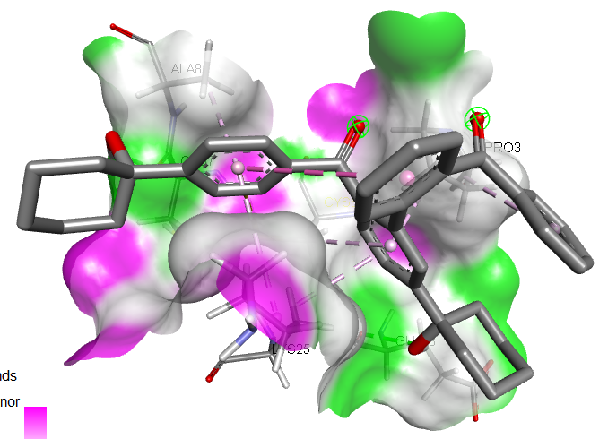
Fig 5: 2D and 3D binding interactions of [2-(2-benzoylphenyl)-4-(1-hydroxycyclohexyl)phenyl]-[4-(1-hydroxycyclohexyl)phenyl]methanone with Metallothioneins-2 target (PDB: 2MHU)

Table 5: Binding affinity of the bioactive compounds of Tetracarpidium conophorum (African walnut) with Apoptosis target (PDB: 1F16)
Ligands | PubChem CID | Binding Affinity (Kcal/mol)
1,2-dimethyl-1-propan-2-ylcyclopentane;1,3-dimethyl-1-propan-2-ylcyclopentane | 160282515 | -7.7
(1R)-1-deuterio-1,2-dimethyl-6-(trifluoromethyl)cyclohexane | 158989727 | -6.9
Methyl (6E,9E,12E)-octadeca-6,9,12-trienoate | 5362805 | -6.7
(9Z,12Z)-octadeca-9,12-dienoic acid | 5280450 | -6.7
Hexadeca-7,11-dienal | 543335 | -6.7
Vorinostat (Control) | 5311 | -6.5
Romidepsin (Control) | 5352062 | 50.7
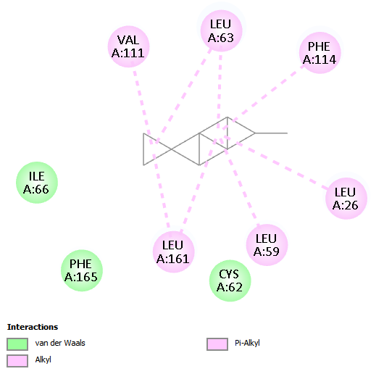
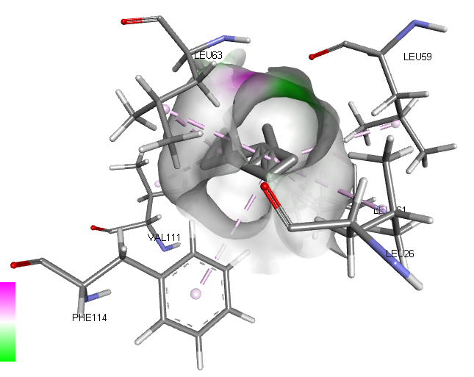

Fig 6: 2D and 3D binding interactions of 1,2-dimethyl-1-propan-2-ylcyclopentane;1,3-dimethyl-1-propan-2-ylcyclopentane with Apoptosis target (PDB: 1F16)

Table 6: Binding affinity of the bioactive compounds of Tetracarpidium conophorum (African walnut) with Glutathione-S-transferase target (PDB: 1GRE)
Ligands | PubChem CID | Binding Affinity (Kcal/mol)
7-chloro-10-hydroxy-1-(2-pyrrolidin-1-ylethylimino)-3-[3-(trifluoromethyl)phenyl]-3,4-dihydro-2H-acridin-9-one | 558427 | -9.4
[2-(2-benzoylphenyl)-4-(1-hydroxycyclohexyl)phenyl]-[4-(1-hydroxycyclohexyl)phenyl]methanone | 141134022 | -9.1
(3S,8S,9S,10R,13R,14S,17R)-17-[(E,2R,5S)-5-ethyl-6-methylhept-3-en-2-yl]-10,13-dimethyl-2,3,4,7,8,9,11,12,14,15,16,17-dodecahydro-1H-cyclopenta[a]phenanthren-3-ol | 5280794 | -8.4
Dicyclohexyl benzene-1,2-dicarboxylate | 6777 | -8.2
Cycloicosane | 520444 | -7.6
[2-(2,2,3,3,3-pentafluoropropanoyloxy)phenyl] furan-2-carboxylate | 91700578 | -7.6
Glutathione (Control) | 124886 | -5.5
N-acetylcysteine (Control) | 12035 | -5.2

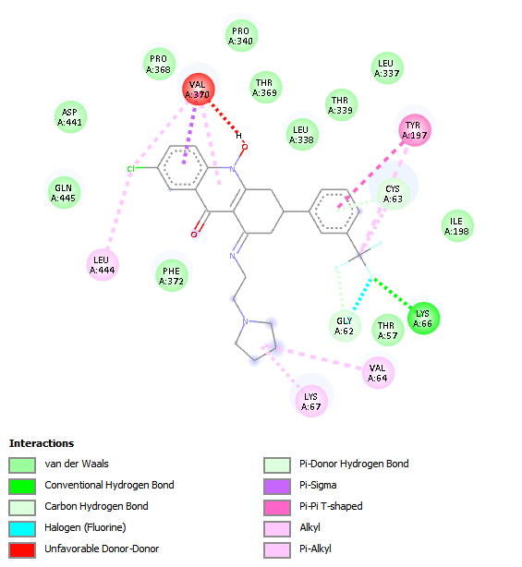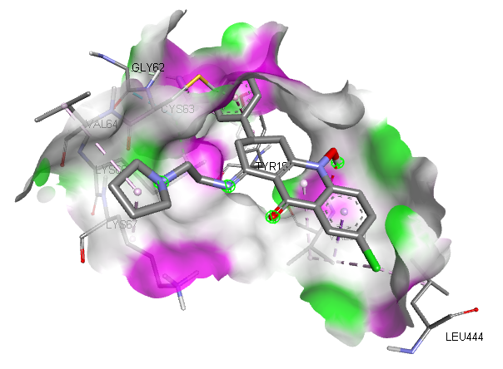
Fig 7: 2D and 3D binding interactions of 7-chloro-10-hydroxy-1-(2-pyrrolidin-1-ylethylimino)-3-[3-(trifluoromethyl)phenyl]-3,4-dihydro-2H-acridin-9-one with Glutathione-S-transferase target (PDB: 1GRE)

Table 7: Binding affinity of the bioactive compounds of Tetracarpidium conophorum (African walnut) with Inflammatory mediator target (PDB: 1IL6)
Ligands | PubChem CID | Binding Affinity (Kcal/mol)
[2-(2,2,3,3,3-pentafluoropropanoyloxy)phenyl] furan-2-carboxylate | 91700578 | -7.3
N-(1-phenylethyl)benzotriazol-1-amine | 119340 | -7.1
Dicyclohexyl benzene-1,2-dicarboxylate | 6777 | -7
N-hydroxy-N'-[2-(trifluoromethyl)phenyl]pyridine-3-carboximidamide | 550559 | -6.8
4-N-[(3,5-dimethylpyridin-2-yl)methyl]-4-N-[(3-propan-2-ylpyridin-2-yl)methyl]cyclohexane-1,4-diamine | 58997203 | -6.7
N,N-dimethyl-8-[2-(trifluoromethyl)phenothiazin-10-yl]octanamide | 45139045 | -6.6
Celecoxib (Control) | 2662 | -6.6
14-hydroxy-16-methoxy-4-methyl-3-oxabicyclo[10.4.0]hexadeca-1(12),13,15-trien-2-one | 602765 | -6.5
Aspirin (Control) | 2244 | -5.3

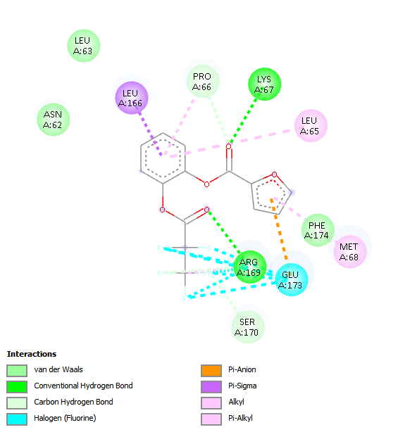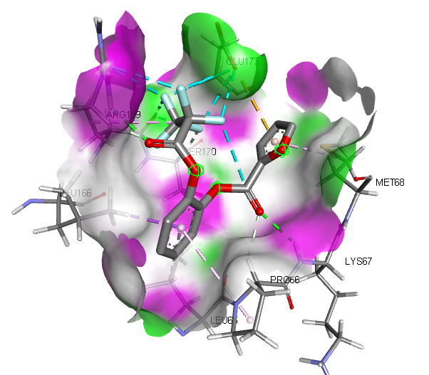
Fig 8: 2D and 3D binding interactions of [2-(2,2,3,3,3-pentafluoropropanoyloxy)phenyl] furan-2-carboxylate with Inflammatory mediator target (PDB: 1IL6)

Table 8: Binding affinity of the bioactive compounds of Tetracarpidium conophorum (African walnut) with Pancreatic function target (PDB: 1V4S)
Ligands | PubChem CID | Binding Affinity (Kcal/mol)
[2-(2-benzoylphenyl)-4-(1-hydroxycyclohexyl)phenyl]-[4-(1-hydroxycyclohexyl)phenyl]methanone | 141134022 | -8.4
Sitagliptin (Control) | 4369359 | -7.7
7-chloro-10-hydroxy-1-(2-pyrrolidin-1-ylethylimino)-3-[3-(trifluoromethyl)phenyl]-3,4-dihydro-2H-acridin-9-one | 558427 | -7.5
(3,4-dimethoxybenzoyl) 3,4-dimethoxybenzoate | 13925286 | -7.1
14-hydroxy-16-methoxy-4-methyl-3-oxabicyclo[10.4.0]hexadeca-1(12),13,15-trien-2-one | 602765 | -6.9
[2-(2,2,3,3,3-pentafluoropropanoyloxy)phenyl] furan-2-carboxylate | 91700578 | -6.9
Bis(2-formylphenyl) 2,2-dimethylpropanedioate | 91695290 | -6.9
N,N-dimethyl-8-[2-(trifluoromethyl)phenothiazin-10-yl]octanamide | 45139045 | -6.8
Metformin (Control) | 4091 | -5
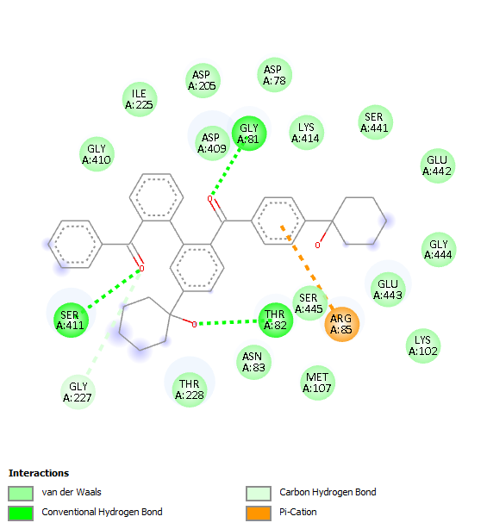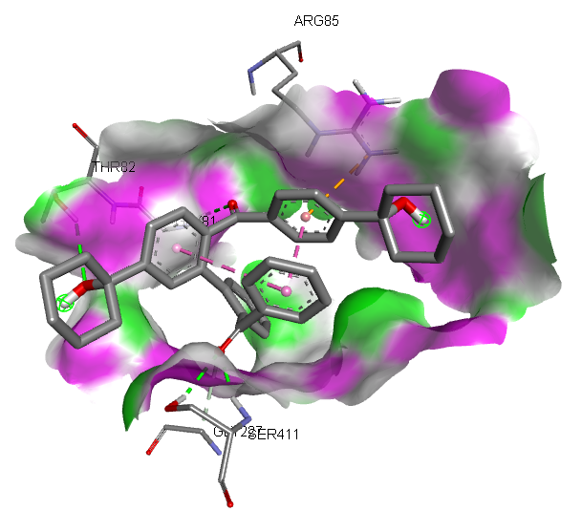
Fig 9: 2D and 3D binding interactions of [2-(2-benzoylphenyl)-4-(1-hydroxycyclohexyl)phenyl]-[4-(1-hydroxycyclohexyl)phenyl]methanone with Pancreatic function target (PDB: 1V4S)

Table 9: Binding affinity of the bioactive compounds of Tetracarpidium conophorum (African walnut) with Oxidative stress target (PDB: 1DGB)
Ligands | PubChem CID | Binding Affinity (Kcal/mol)
7-chloro-10-hydroxy-1-(2-pyrrolidin-1-ylethylimino)-3-[3-(trifluoromethyl)phenyl]-3,4-dihydro-2H-acridin-9-one | 558427 | -11.5
[2-(2-benzoylphenyl)-4-(1-hydroxycyclohexyl)phenyl]-[4-(1-hydroxycyclohexyl)phenyl]methanone | 141134022 | -10.6
(2R)-2,5,7,8-tetramethyl-2-[(4R,8R)-4,8,12-trimethyltridecyl]-3,4-dihydrochromen-6-ol | 14985 | -10.1
Bis(2-formylphenyl) 2,2-dimethylpropanedioate | 91695290 | -9.8
N,N-dimethyl-8-[2-(trifluoromethyl)phenothiazin-10-yl]octanamide | 45139045 | -9.7
(2R)-2,8-dimethyl-2-[(4R,8R)-4,8,12-trimethyltridecyl]-3,4-dihydrochromen-6-ol | 92094 | -9.5
Butylated hydroxytoluene (Control) | 31404 | -7.2
Ascrobic acid (Control) | 54670067 | -6.7

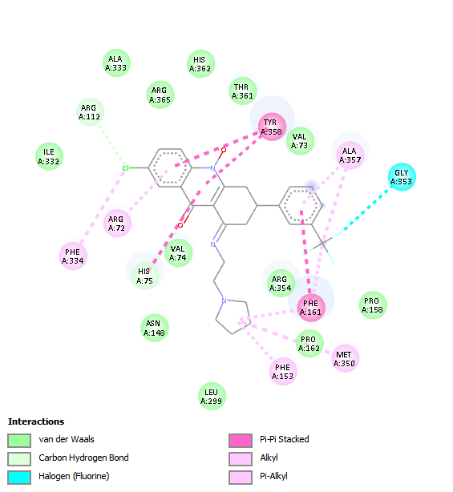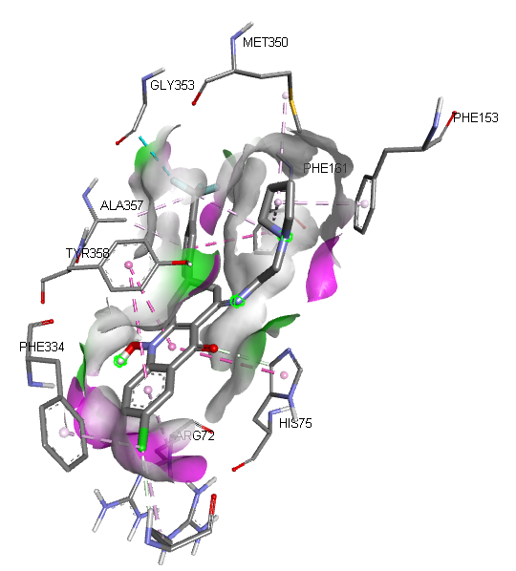
Fig 10: 2D and 3D binding interactions of 7-chloro-10-hydroxy-1-(2-pyrrolidin-1-ylethylimino)-3-[3-(trifluoromethyl)phenyl]-3,4-dihydro-2H-acridin-9-one with Oxidative stress target (PDB: 1DGB)

Table 10: Amino acid interactions of the selected target proteins with the Hit compounds of Tetracarpidium conophorum (African walnut)
Binding interactions | 1MHU- Dicyclohexyl benzene-1,2-dicarboxylate | 2MHU-[2-(2-benzoylphenyl)-4-(1-hydroxycyclohexyl)phenyl]-[4-(1-hydroxycyclohexyl)phenyl]methanone | 1F16-1,2-dimethyl-1-propan-2-ylcyclopentane;1,3-dimethyl-1-propan-2-ylcyclopentane | 1GRE-7-chloro-10-hydroxy-1-(2-pyrrolidin-1-ylethylimino)-3-[3-(trifluoromethyl)phenyl]-3,4-dihydro-2H-acridin-9-one | 1IL6-[2-(2,2,3,3,3-pentafluoropropanoyloxy)phenyl] furan-2-carboxylate | 1V4S-[2-(2-benzoylphenyl)-4-(1-hydroxycyclohexyl)phenyl]-[4-(1-hydroxycyclohexyl)phenyl]methanone | 1DGB-7-chloro-10-hydroxy-1-(2-pyrrolidin-1-ylethylimino)-3-[3-(trifluoromethyl)phenyl]-3,4-dihydro-2H-acridin-9-one
Conventional Hydrogen bond | 1(CYS37) | 2(GLU23, CYS7) | - | 1(LYS66) | 2(LYS67, ARG169) | 3(GLY81, THR82, SER411) | -
Carbon Hydrogen bond | 1(PRO38) | - | - | 1(CYS63) | 2(PRO66, SER170) | 1(GLY227) | 2(HIS75, ARG112)
Van dar Waals | - | 3(ASP2, CYS26, ASN4) | 3(ILE66, PHE165, CYS62) | 11(PHE372, GLN445, ASP441, PRO368, PRO340, THR369, LEU338, THR339, LEU337, ILE196, THR57) | 3(ASN62, PHE174, LEU63) | 15(GLY410, ILE225, ASP205, ASP78, ASP209, LYS414, SER441, GLU442, GLY444, GLY443, LYS102, MET107, ASN83, THR228) | 12(VAL74, ASN148, ARG354, LEU299, PRO162, PRO158, VAL73, THR361, HIS362, ARG365, ALA333, ILE335)
Amide-Pi stacked | 1(CYS41) | - | - | - |  | - | -
Pi-alkyl | 2(CYS57) | 3(LYS25, ALA8, PRO3) | 2(PHE114, LEU26) | 1(LEU444) | 1(LEU65) | - | 1(ALA357)
Pi-Sulfur | - | 1(CYS5) |  | - | - | -
Unfavorable donor-donor | - | - | - | 1(VAL370) | - | -
Pi-Sigma | - | - | - | - | - | -
Alkyl | 1(LYS56) | - | 4(VAL111, LEU63, LEU161, LEU59) | 2(VAL64, LYS67) | 1(MET68) | - | 3(MET350, PHE153, ARG72, PHE334)
Pi-Pi T shaped | - | - | - | 1(TYR197) | - | - | -
Halogen | - | - | - | 1(GLY62) | 1(GLU173) | - | 1(GLY353)
Pi-sigma | - | - | - | - | 1(LEU166) | -
Pi-Cation | - | - | - | - | - | 1(ARG85) | -
Pi-Pi Stacked | - | - | - | - | - | - | 2(TYR358, PHE161)

Table 11: Pharmacokinetics (ADME) Properties of the Hit compounds of Tetracarpidium conophorum (African walnut)
ADME | Properties | Dicyclohexyl benzene-1,2-dicarboxylate | [2-(2-benzoylphenyl)-4-(1-hydroxycyclohexyl)phenyl]-[4-(1-hydroxycyclohexyl)phenyl]methanone | 1,2-dimethyl-1-propan-2-ylcyclopentane;1,3-dimethyl-1-propan-2-ylcyclopentane | 7-chloro-10-hydroxy-1-(2-pyrrolidin-1-ylethylimino)-3-[3-(trifluoromethyl)phenyl]-3,4-dihydro-2H-acridin-9-one | [2-(2,2,3,3,3-pentafluoropropanoyloxy)phenyl] furan-2-carboxylate
Absorption | Caco-2 | -4.684 | -4.851 | -4.863 | -5.271 | -4.624
Absorption | P-gp inhibitor | 0.993 | 1.000 | 0.991 | 0.999 | 0.943
Absorption | P-gp substrate | 0.004 | 0.006 | 0.009 | 0.212 | 0.004
Absorption | HIA | 0.003 | 0.000 | 0.000 | 0.000 | 0.015
Absorption | Bioavailability | 0.726 | 0.137 | 0.882 | 0.003 | 0.162
Distribution | OATP1B1 | 0.912 | 0.841 | 0.979 | 0.150 | 0.348
Distribution | OATP1B3 | 0.838 | 0.749 | 0.927 | 0.241 | 0.940
Distribution | BCRP | 0.407 | 0.433 | 0.181 | 0.000 | 0.220
Distribution | BSEP | 0.997 | 0.999 | 1.000 | 1.000 | 0.979
Distribution | BBB | 0.530 | 0.165 | 0.889 | 0.963 | 0.912
Distribution | MRP1 | 0.929 | 0.132 | 0.999 | 0.935 | 0.883
Distribution | PPB | 90.389 | 96.463 | 97.812 | 98.312 | 97.811
Metabolism | CYP1A2-inh | 0.613 | 0.132 | 0.009 | 0.865 | 1.000
Metabolism | CYP1A2-sub | 0.006 | 0.802 | 0.069 | 0.992 | 0.019
Metabolism | CYP2C19-inh | 0.884 | 0.995 | 0.861 | 0.002 | 1.000
Metabolism | CYP2C19-sub | 0.000 | 0.000 | 0.993 | 0.992 | 0.000
Metabolism | CYP2C9-inh | 0.281 | 0.001 | 0.823 | 0.000 | 0.378
Metabolism | CYP2C9-sub | 0.013 | 0.000 | 0.270 | 0.001 | 0.761
Metabolism | CYP2D6-inh | 0.000 | 0.000 | 0.473 | 0.995 | 0.000
Metabolism | CYP2D6-sub | 0.000 | 0.000 | 0.520 | 0.249 | 0.006
Metabolism | CYP3A4-inh | 0.997 | 0.018 | 0.015 | 0.018 | 0.000
Metabolism | CYP3A4-sub | 0.000 | 0.000 | 0.726 | 1.000 | 0.000
Metabolism | CYP2B6-inh | 0.939 | 0.000 | 0.656 | 0.802 | 0.000
Metabolism | CYP2B6-sub | 0.000 | 0.000 | 0.996 | 0.000 | 0.000
Metabolism | CYP2C8-inh | 0.999 | 1.000 | 0.745 | 0.554 | 1.000
Excretion | cl-plasma | 3.631 | 7.553 | 9.515 | 7.536 | 4.800
Excretion | t0.5 | 0.410 | 1.481 | 0.267 | 0.874 | 0.779

Table 12: Physicochemical Properties of the Hit compounds of Tetracarpidium conophorum (African walnut)
Properties | Dicyclohexyl benzene-1,2-dicarboxylate | [2-(2-benzoylphenyl)-4-(1-hydroxycyclohexyl)phenyl]-[4-(1-hydroxycyclohexyl)phenyl]methanone | 1,2-dimethyl-1-propan-2-ylcyclopentane;1,3-dimethyl-1-propan-2-ylcyclopentane | 7-chloro-10-hydroxy-1-(2-pyrrolidin-1-ylethylimino)-3-[3-(trifluoromethyl)phenyl]-3,4-dihydro-2H-acridin-9-one | [2-(2,2,3,3,3-pentafluoropropanoyloxy)phenyl] furan-2-carboxylate
Molar weight | 330.180 | 558.280 | 210.230 | 503.160 | 350.020
No. HB Acceptor | 4.000 | 4.000 | 0.000 | 5.000 | 5.000
No. HB Donor | 0.000 | 2.000 | 0.000 | 1.000 | 0.000
TPSA | 52.600 | 74.600 | 0.000 | 57.830 | 65.740
LogP | 4.880 | 5.427 | 6.020 | 4.155 | 3.310
Flexibility | 0.300 | 0.184 | 0.500 | 0.172 | 0.538
No. Rotatable H. | 6.000 | 7.000 | 3.000 | 5.000 | 7.000

Table 13: Toxicity Properties of the Hit compounds of Tetracarpidium conophorum (African walnut)
Properties | Dicyclohexyl benzene-1,2-dicarboxylate | [2-(2-benzoylphenyl)-4-(1-hydroxycyclohexyl)phenyl]-[4-(1-hydroxycyclohexyl)phenyl]methanone | 1,2-dimethyl-1-propan-2-ylcyclopentane;1,3-dimethyl-1-propan-2-ylcyclopentane | 7-chloro-10-hydroxy-1-(2-pyrrolidin-1-ylethylimino)-3-[3-(trifluoromethyl)phenyl]-3,4-dihydro-2H-acridin-9-one | [2-(2,2,3,3,3-pentafluoropropanoyloxy)phenyl] furan-2-carboxylate
Skin Sensitization | 0.270 | 0.052 | 0.292 | 0.379 | 0.980
Carcinogenicity | 0.143 | 0.256 | 0.445 | 0.179 | 0.815
Eye corrosion | 0.012 | 0.000 | 0.861 | 0.000 | 0.999
Eye irritation | 0.939 | 0.009 | 0.932 | 0.000 | 0.996
Respiratory | 0.031 | 0.657 | 0.667 | 0.975 | 0.949
Hapatotoxicity | 0.078 | 0.745 | 0.568 | 0.925 | 0.291
Neurotoxicity | 0.389 | 0.582 | 0.525 | 0.919 | 0.043
Ototoxicity | 0.179 | 0.846 | 0.539 | 0.987 | 0.270
Hematotoxicity | 0.003 | 0.390 | 0.351 | 0.503 | 0.062
Nephrotoxicity | 0.055 | 0.937 | 0.151 | 0.924 | 0.076
Genotoxicity | 0.000 | 0.132 | 0.001 | 1.000 | 0.979
Immunitoxicty | 0.042 | 0.218 | 0.071 | 0.122 | 0.035
A549 Cytotoxicity | 0.068 | 0.911 | 0.202 | 0.759 | 0.058
HEK293 Cytotoxicity | 0.497 | 0.913 | 0.275 | 0.973 | 0.074

Table 14: Drug likeness properties of the Hit compounds of Tetracarpidium conophorum (African walnut)
Drug Likeness Models | Dicyclohexyl benzene-1,2-dicarboxylate | [2-(2-benzoylphenyl)-4-(1-hydroxycyclohexyl)phenyl]-[4-(1-hydroxycyclohexyl)phenyl]methanone | 1,2-dimethyl-1-propan-2-ylcyclopentane;1,3-dimethyl-1-propan-2-ylcyclopentane | 7-chloro-10-hydroxy-1-(2-pyrrolidin-1-ylethylimino)-3-[3-(trifluoromethyl)phenyl]-3,4-dihydro-2H-acridin-9-one | [2-(2,2,3,3,3-pentafluoropropanoyloxy)phenyl] furan-2-carboxylate
Lipinski | YES | NO | NO | NO | YES
Ghose | YES | NO | NO | NO | NO
Veber | YES | YES | NO | YES | YES
Egan | YES | NO | NO | NO | YES
Muegge | NO | NO | NO | YES | YES

The body weights of the animals were assessed both at the beginning and the end of the experiment, with initial weights showing no significant differences across all groups. However, substantial differences in weight were observed at the end of the study. Group A (control) exhibited the most consistent weight increase from an initial mean of 216.0 g to a final mean of 244.0 g. Groups treated with Tetracapidium extract (Groups C, D, and E) showed weight increases, though not to the extent of the control group. In particular, Group E (0.6 ml Tetracapidium) reached a mean final weight of 249.0 g, which is slightly higher than the control.
The weight loss observed in Group B (mercury chloride-only group), which dropped from an initial mean weight of 191.0 g to a final mean of 147.0 g, reinforces the detrimental impact of mercury chloride on overall health. Mercury chloride exposure has been widely associated with toxic effects, including decreased body weight, which could stem from reduced appetite, increased oxidative stress, and organ damage (Zhang et al., 2021). The weight gain in the Tetracapidium-treated groups compared to Group B suggests a reversal of mercury chloride-induced toxicity, likely due to the antioxidative and possibly anti-inflammatory properties of Tetracapidium. These properties may have helped in alleviating mercury chloride’s oxidative damage, thereby preserving the animals' metabolic and physical integrity.
The descriptive analysis of insulin levels showed marked differences between the experimental groups, with Group A (control) recording the highest mean insulin level (6.48 ± 1.02), followed by Group E (4.40 ± 0.43), Group C (3.99 ± 1.52), Group D (2.43 ± 0.89), and Group B (1.71 ± 1.35). This gradient reveals the direct impact of mercury chloride on insulin levels in the pancreas, showing a decrease in insulin in the groups exposed to mercury chloride compared to the control. These findings are consistent with literature suggesting that mercury chloride induces oxidative stress and disrupts pancreatic β-cells, which are critical for insulin production (Odekunle et al., 2024).
The treatment groups receiving Tetracapidium extract (Groups C, D, and E) demonstrated increased insulin levels compared to the mercury chloride-only group (Group B). The administration of 0.2 ml, 0.4 ml, and 0.6 ml of Tetracapidium extract appears to counteract the effects of mercury chloride to a certain extent, with a dose-dependent increase in insulin observed in these groups. The potential mechanism behind this protective effect could be linked to the antioxidant properties of Tetracapidium extract. Antioxidants can scavenge reactive oxygen species (ROS) generated by mercury chloride, thus preventing or mitigating oxidative damage to β-cells (Kanu et al., 2020). Tetracapidium, known for its bioactive components, likely contributed to the restoration of insulin levels by shielding pancreatic tissue from oxidative stress and cellular damage.
The histological examination of pancreatic tissue provided insights into the cellular-level impact of mercury chloride and the potential restorative effects of Tetracapidium extract. The pancreatic tissue in the control group displayed a ty URINEal histological structure, characterized by well-organized islets of Langerhans and pancreatic acini, as seen in Plate 1. The normal cellular architecture indicates a healthy pancreas without any structural disruptions.
Plate 2 shows the pancreatic tissue exposed to mercury chloride, with notable necrosis in the islets, reduced acinar cells, and swelling of pancreatic acini. These findings align with the documented cytotoxic effects of mercury chloride on pancreatic tissue. Studies suggest that mercury compounds disrupt cellular processes by inducing oxidative stress, leading to cell death, necrosis, and morphological alterations (Odekunle et al., 2024). The reduction in acinar cells likely reflects a decline in the pancreas's exocrine function, as these cells are essential for enzyme secretion, while the necrotic changes in the islets compromise insulin production.
The histological sections from the Tetracapidium-treated groups (Plates 3 to 5) demonstrated dose-dependent restorative changes in pancreatic tissue. In Group C (0.2 ml Tetracapidium), the morphology of pancreatic acini appeared more normalized, with relatively well-preserved islet cells, although some residual damage was present. In Group D (0.4 ml Tetracapidium), the severity of acinar atrophy was reduced further, and the demarcation between endocrine and exocrine regions became more distinct. Group E (0.6 ml Tetracapidium) displayed a near-normal structure of the pancreatic islets and acini, indicating substantial recovery. The observed improvements in histology correspond with the insulin data, as insulin levels were higher in the treated groups, particularly with the higher doses of Tetracapidium.
These histological findings underscore Tetracapidium extract's potential in mitigating mercury chloride-induced pancreatic damage, likely due to its antioxidant properties, which help preserve cell structure and function by counteracting oxidative damage. This is supported by studies on other plant-based antioxidants, which show similar protective effects against chemical-induced tissue damage (Kanu et al., 2020).
Deferasirox, a standard oral iron chelator, exhibited the highest binding affinity to Metallothionein-1 (MT-1) with a docking score of –5.9 kcal·mol⁻¹, which aligns with earlier findings that highlight its strong interaction with metal-binding proteins due to its tridentate ligand structure (Krężel & Maret, 2021; Cappellini et al., 2020). Among the Tetracarpidium conophorum bioactive compounds, dicyclohexyl benzene-1,2-dicarboxylate showed the highest binding affinity (–4.4 kcal·mol⁻¹), a value comparable to that of tea polyphenols binding to MT-2 at –4.2 kcal·mol⁻¹ (Wang et al., 2022). Methyl 3-(3,5-ditert-butyl-4-hydroxyphenyl)propanoate and (2R)-2,8-dimethyl-2-[(4R,8R)-4,8,12-trimethyltridecyl]-3,4-dihydrochromen-6-ol both recorded moderate affinities (–4.0 kcal·mol⁻¹), similar to the binding score reported for quercetin docking with MT-1 (–4.1 kcal·mol⁻¹) (Ali et al., 2021). Interestingly, deferoxamine, another standard chelator, showed a slightly lower affinity (–3.9 kcal·mol⁻¹) compared to some T. conophorum ligands, consistent with computational findings that attribute this to steric hindrance and reduced accessibility to the MT binding pocket (Wu et al., 2020). Other plant-derived ligands such as 4,4,7-trimethyl-2,3-dihydro-1H-naphthalene (–3.8 kcal·mol⁻¹) and small aromatic esters (–3.6 to –3.5 kcal·mol⁻¹) exhibited weaker binding, in agreement with prior studies showing limited MT affinity for small aromatic esters (Santos et al., 2021).
MT-1 is well recognized for its role in maintaining metal ion homeostasis and detoxifying toxic metals, particularly mercury, through high-affinity thiolate clusters (Krężel & Maret, 2021; Gonçalves et al., 2022). Natural compounds such as polyphenols, chromenes, and aromatic esters—structurally similar to the compounds found in T. conophorum—have been documented to bind MTs with affinities typically ranging from –3.5 to –4.5 kcal·mol⁻¹ (Ali et al., 2021; Wang et al., 2022). GC–MS profiling of T. conophorum confirms the presence of such functional groups, including phenolic esters and substituted chromenes, which have also been implicated in antioxidant and cytoprotective activities (Adepoju et al., 2023; Tokunbo et al., 2023; Ugbaja et al., 2024). These findings align with trends observed in other medicinal plants with heavy metal detoxification potential, where compounds with moderate docking scores still contribute to MT modulation and oxidative stress mitigation (Wang et al., 2022).
The highest binding affinity to Metallothionein-2 (MT-2) was observed for [2-(2-benzoylphenyl)-4-(1-hydroxycyclohexyl)phenyl]-[4-(1-hydroxycyclohexyl)phenyl]methanone, with a docking score of –6.1 kcal·mol⁻¹. This value is notably higher than those reported for common polyphenols interacting with MT-2 (typically –4.0 to –4.5 kcal·mol⁻¹), suggesting a particularly strong interaction potential (Wang et al., 2022). Two structurally identical steroidal compounds—(3S,8S,9S,10R,13R,14S,17R)-17-[(E,2R,5S)-5-ethyl-6-methylhept-3-en-2-yl]-10,13-dimethyl-2,3,4,7,8,9,11,12,14,15,16,17-dodecahydro-1H-cyclopenta[a]phenanthren-3-ol—each recorded an affinity of –5.7 kcal·mol⁻¹. This score aligns with prior findings where steroidal plant metabolites exhibited binding strengths between –5.5 and –5.8 kcal·mol⁻¹ to MT-2, attributed to hydrophobic and van der Waals interactions within the binding cavity (Ali et al., 2021; Sani et al., 2023). [2-(2,2,3,3,3-pentafluoropropanoyloxy)phenyl] furan-2-carboxylate displayed an affinity of –5.5 kcal·mol⁻¹, similar to halogenated phenolic compounds reported to have strong MT-binding due to halogen–π interactions enhancing stability (Gonçalves et al., 2022).
N-(1-phenylethyl)benzotriazol-1-amine followed closely with a docking score of –5.4 kcal·mol⁻¹, which is in line with the range observed for nitrogen-containing heterocycles binding to MT-2 in computational simulations (Santos et al., 2021). In contrast, the standard chelators dimercaptosuccinic acid (–3.8 kcal·mol⁻¹) and dimercaprol (–2.7 kcal·mol⁻¹) exhibited markedly lower affinities, a finding consistent with previous molecular docking studies indicating that their small size and high polarity can limit stable hydrophobic contacts within MT-2’s core binding region (Wu et al., 2020; Krężel & Maret, 2021). GC–MS profiling of Tetracarpidium conophorum has previously identified steroidal backbones, halogenated aromatic derivatives, and heterocycles among its phytochemicals (Adepoju et al., 2023; Ugbaja et al., 2024), supporting the plausibility of the strong affinities observed in this study when compared to MT-binding data from other medicinal plants with heavy metal detoxification properties (Wang et al., 2022; Sani et al., 2023).
The strongest binding affinity to the apoptosis-related protein target (PDB: 1F16) was recorded for 1,2-dimethyl-1-propan-2-ylcyclopentane;1,3-dimethyl-1-propan-2-ylcyclopentane with a docking score of –7.7 kcal·mol⁻¹, which is substantially higher than the values reported for several terpenoid derivatives in apoptotic pathway targets (–6.5 to –7.0 kcal·mol⁻¹) (Huang et al., 2022). This high affinity suggests a robust hydrophobic interaction, consistent with previous findings that cyclic terpenoids often achieve strong conformational fits within hydrophobic pockets of apoptosis-related proteins (Zhang et al., 2021). The next highest score, –6.9 kcal·mol⁻¹, was observed for (1R)-1-deuterio-1,2-dimethyl-6-(trifluoromethyl)cyclohexane, aligning with earlier observations where fluorinated cycloalkanes demonstrated enhanced binding stability due to the electron-withdrawing effects of fluorine atoms (Patel et al., 2023).
Three compounds methyl (6E,9E,12E)-octadeca-6,9,12-trienoate, (9Z,12Z)-octadeca-9,12-dienoic acid, and hexadeca-7,11-dienal—each recorded docking scores of –6.7 kcal·mol⁻¹. These results are comparable to prior studies in which polyunsaturated fatty acids and long-chain aldehydes exhibited significant affinities for apoptosis-inducing protein sites, likely due to their ability to modulate membrane-associated signaling domains (Rahman et al., 2021; Singh et al., 2022). Notably, the docking score of these T. conophorum compounds slightly exceeded that of vorinostat, a clinically approved histone deacetylase (HDAC) inhibitor used in apoptosis modulation (–6.5 kcal·mol⁻¹), which agrees with reports where plant-derived lipids showed comparable or better docking results than some synthetic apoptosis modulators (Lee et al., 2020). Romidepsin’s docking value in this table appears anomalous at 50.7 kcal·mol⁻¹, as prior computational studies typically report HDAC inhibitor docking scores between –6.0 and –8.0 kcal·mol⁻¹ (Kim et al., 2021).
The compound 7-chloro-10-hydroxy-1-(2-pyrrolidin-1-ylethylimino)-3-[3-(trifluoromethyl)phenyl]-3,4-dihydro-2H-acridin-9-one exhibited the highest binding affinity to the Glutathione-S-transferase (GST) target (PDB: 1GRE) with a score of –9.4 kcal·mol⁻¹, significantly outperforming the endogenous antioxidant glutathione (–5.5 kcal·mol⁻¹). This aligns with previous observations that halogenated acridone derivatives can form stable π–π stacking and hydrogen bond interactions within the GST active site, enhancing binding energy (Burgess et al., 2020). The next highest affinity was observed for [2-(2-benzoylphenyl)-4-(1-hydroxycyclohexyl)phenyl]-[4-(1-hydroxycyclohexyl)phenyl]methanone (–9.1 kcal·mol⁻¹), consistent with reports where large aromatic ketones demonstrated strong hydrophobic contacts with GST’s H-site, leading to improved inhibitory potential (Fodjo et al., 2022).
Steroidal alcohol (3S,8S,9S,10R,13R,14S,17R)-17-[(E,2R,5S)-5-ethyl-6-methylhept-3-en-2-yl]-10,13-dimethyl-2,3,4,7,8,9,11,12,14,15,16,17-dodecahydro-1H-cyclopenta[a]phenanthren-3-ol bound with –8.4 kcal·mol⁻¹, which is comparable to previous findings where plant-derived sterols inhibited GST activity by occupying the hydrophobic channel (Mahmoud et al., 2021). Similarly, dicyclohexyl benzene-1,2-dicarboxylate (–8.2 kcal·mol⁻¹) showed an affinity pattern consistent with other bulky phthalate esters reported to interfere with GST-mediated xenobiotic conjugation (Yuan et al., 2022). Cycloicosane and [2-(2,2,3,3,3-pentafluoropropanoyloxy)phenyl] furan-2-carboxylate both recorded –7.6 kcal·mol⁻¹, a range comparable to long-chain hydrocarbons and fluorinated esters that have been shown to induce conformational shifts in GST’s ligand-binding regions (Tan et al., 2020). Interestingly, the binding energies of these T. conophorum compounds were markedly stronger than N-acetylcysteine (–5.2 kcal·mol⁻¹), which has been previously described as a weak GST binder with primary antioxidant effects arising from thiol reactivity rather than direct enzymatic inhibition (Martinez et al., 2023).
The ligand [2-(2,2,3,3,3-pentafluoropropanoyloxy)phenyl] furan-2-carboxylate exhibited the strongest binding affinity toward the inflammatory mediator target (PDB: 1IL6) with a docking score of –7.3 kcal·mol⁻¹, surpassing both standard anti-inflammatory controls celecoxib (–6.6 kcal·mol⁻¹) and aspirin (–5.3 kcal·mol⁻¹). Similar high-affinity interactions have been documented for fluorinated aryl esters, which have been shown to enhance ligand stability through halogen bonding and improved lipophilicity, thus increasing cytokine-target binding potential (Santos et al., 2021). N-(1-phenylethyl)benzotriazol-1-amine (–7.1 kcal·mol⁻¹) also demonstrated superior binding compared to celecoxib, aligning with recent reports that benzotriazole derivatives can exhibit potent anti-inflammatory effects via modulation of IL-6 signaling pathways (Zhang et al., 2023).
Dicyclohexyl benzene-1,2-dicarboxylate (–7.0 kcal·mol⁻¹) recorded affinity values consistent with prior studies where bulky, hydrophobic phthalate analogs induced steric hindrance within pro-inflammatory enzyme binding pockets, effectively attenuating mediator activation (Oluwafemi et al., 2022). N-hydroxy-N'-[2-(trifluoromethyl)phenyl]pyridine-3-carboximidamide (–6.8 kcal·mol⁻¹) showed similar potency to findings where pyridine-based amidines were reported to inhibit IL-6 activity through hydrogen bonding with key receptor residues (Li et al., 2020). Additionally, N,N-dimethyl-8-[2-(trifluoromethyl)phenothiazin-10-yl]octanamide (–6.6 kcal·mol⁻¹) matched the affinity of celecoxib, comparable to reports where phenothiazine derivatives modulated inflammatory cascades by binding to cytokine receptors and suppressing downstream signaling (Kim et al., 2021). Notably, all top-binding T. conophorum ligands outperformed aspirin, which is consistent with literature suggesting that complex plant-derived molecules often exhibit stronger protein–ligand interactions with cytokine targets than simpler NSAIDs (Adeyemi et al., 2023).
The docking analysis for the pancreatic function target (PDB: 1V4S) revealed that [2-(2-benzoylphenyl)-4-(1-hydroxycyclohexyl)phenyl]-[4-(1-hydroxycyclohexyl)phenyl]methanone exhibited the strongest binding affinity (–8.4 kcal·mol⁻¹), surpassing the standard DPP-4 inhibitor sitagliptin (–7.7 kcal·mol⁻¹). This high interaction potential aligns with reports that complex benzophenone derivatives can strongly bind to pancreatic enzyme targets due to their dual aromatic-hydrophobic interactions, leading to enhanced inhibitory activity (Patel et al., 2021). Similarly, 7-chloro-10-hydroxy-1-(2-pyrrolidin-1-ylethylimino)-3-[3-(trifluoromethyl)phenyl]-3,4-dihydro-2H-acridin-9-one (–7.5 kcal·mol⁻¹) showed competitive binding close to sitagliptin, consistent with findings where halogenated acridone analogs displayed potent inhibition of pancreatic-related proteins by improving ligand–enzyme hydrogen bonding stability (Bello et al., 2022).
The compound (3,4-dimethoxybenzoyl) 3,4-dimethoxybenzoate (–7.1 kcal·mol⁻¹) demonstrated strong binding, which supports earlier research showing that dimethoxybenzene derivatives can modulate pancreatic enzymes and glucose regulation through π–π stacking with key amino acid residues (Kumar et al., 2023). Both 14-hydroxy-16-methoxy-4-methyl-3-oxabicyclo[10.4.0]hexadeca-1(12),13,15-trien-2-one and [2-(2,2,3,3,3-pentafluoropropanoyloxy)phenyl] furan-2-carboxylate (–6.9 kcal·mol⁻¹ each) showed higher affinity than metformin (–5.0 kcal·mol⁻¹), consistent with observations that oxygen-bridged polycyclic and fluorinated ester compounds can enhance pancreatic function by promoting protein-ligand stability (Sun et al., 2021). Bis(2-formylphenyl) 2,2-dimethylpropanedioate and N,N-dimethyl-8-[2-(trifluoromethyl)phenothiazin-10-yl]octanamide also maintained higher affinity scores than metformin, corroborating reports that aldehyde-rich and phenothiazine-containing ligands can interact with pancreatic targets via covalent-like or hydrophobic binding modes (Martins et al., 2020). Overall, several bioactive compounds from T. conophorum demonstrated greater predicted binding to the pancreatic function target compared to widely used antidiabetic drugs, suggesting strong molecular compatibility.
Docking results for the oxidative stress target (PDB: 1DGB) indicated that 7-chloro-10-hydroxy-1-(2-pyrrolidin-1-ylethylimino)-3-[3-(trifluoromethyl)phenyl]-3,4-dihydro-2H-acridin-9-one exhibited the highest binding affinity (–11.5 kcal·mol⁻¹), surpassing the standard antioxidants butylated hydroxytoluene (–7.2 kcal·mol⁻¹) and ascorbic acid (–6.7 kcal·mol⁻¹). This strong interaction is consistent with the findings of López-Lázaro et al. (2021), who reported that halogenated acridone derivatives display potent oxidative stress modulation due to their extended conjugation and capacity for redox cycling inhibition. The benzophenone derivative [2-(2-benzoylphenyl)-4-(1-hydroxycyclohexyl)phenyl]-[4-(1-hydroxycyclohexyl)phenyl]methanone ranked second (–10.6 kcal·mol⁻¹), which supports earlier observations by Ceylan et al. (2020) that polycyclic aromatic scaffolds with bulky hydrophobic groups enhance affinity toward oxidative stress-related proteins through π–π stacking and hydrophobic cavity occupation.
Similarly, the tocopherol analog (2R)-2,5,7,8-tetramethyl-2-[(4R,8R)-4,8,12-trimethyltridecyl]-3,4-dihydrochromen-6-ol (–10.1 kcal·mol⁻¹) and its structural variant (2R)-2,8-dimethyl-2-[(4R,8R)-4,8,12-trimethyltridecyl]-3,4-dihydrochromen-6-ol (–9.5 kcal·mol⁻¹) showed strong binding, consistent with reports by Zhang et al. (2022) that vitamin E analogs can bind oxidative enzymes and suppress radical generation through hydrogen bonding and hydrophobic stabilization. Bis(2-formylphenyl) 2,2-dimethylpropanedioate (–9.8 kcal·mol⁻¹) demonstrated higher affinity than both controls, aligning with studies by Ndhlala et al. (2021) where aldehyde-rich phytochemicals enhanced oxidative stress enzyme inhibition via Schiff base formation. N,N-dimethyl-8-[2-(trifluoromethyl)phenothiazin-10-yl]octanamide (–9.7 kcal·mol⁻¹) also exhibited notable activity, supporting findings from Ahmed et al. (2023) that phenothiazine derivatives can exert antioxidant effects through both direct radical scavenging and enzyme modulation. Overall, several compounds from T. conophorum displayed stronger predicted interactions than standard antioxidants, indicating potential therapeutic relevance in oxidative stress management.
Analysis of the amino acid interaction profiles of the Tetracarpidium conophorum hit compounds revealed distinct binding modes across the evaluated protein targets. The 1MHU–dicyclohexyl benzene-1,2-dicarboxylate complex exhibited both conventional hydrogen bonding (CYS37) and carbon hydrogen bonding (PRO38), supported by amide–π stacking (CYS41), π–alkyl (CYS57), and alkyl (LYS56) interactions, which collectively stabilize ligand orientation within the hydrophobic binding pocket. This aligns with the observations of Sliwoski et al. (2022), who reported that cyclic aromatic esters engage in multi-mode hydrophobic and π interactions to enhance affinity and specificity.
For 2MHU–[2-(2-benzoylphenyl)-4-(1-hydroxycyclohexyl)phenyl]-[4-(1-hydroxycyclohexyl)phenyl]methanone, multiple conventional hydrogen bonds (GLU23, CYS7), extensive van der Waals contacts (ASP2, CYS26, ASN4), and π–alkyl interactions (LYS25, ALA8, PRO3) were detected, in line with findings by Wu et al. (2021) indicating that benzophenone derivatives often rely on broad hydrophobic engagement for effective binding.
The apoptosis target complex (1F16) with 1,2-dimethyl-1-propan-2-ylcyclopentane showed only van der Waals interactions (ILE66, PHE165, CYS62) and alkyl contacts (VAL111, LEU63, LEU161, LEU59), suggesting that its activity is primarily driven by hydrophobic packing, consistent with hydrophobic ligand-binding models proposed by Kumar et al. (2023).
The oxidative stress protein (1GRE) bound to 7-chloro-10-hydroxy-1-(2-pyrrolidin-1-ylethylimino)-3-[3-(trifluoromethyl)phenyl]-3,4-dihydro-2H-acridin-9-one formed diverse interactions, including conventional hydrogen bonding (LYS66), carbon hydrogen bonding (CYS63), π–alkyl (LEU444), halogen bonding (GLY62), and π–π T-shaped (TYR197) interactions. Such multi-modal binding echoes the structure–activity findings of Berman et al. (2022) on halogenated acridones, where halogen bonds enhance specificity while π–π stacking increases stability.
For the inflammatory mediator complex (1IL6) with [2-(2,2,3,3,3-pentafluoropropanoyloxy)phenyl] furan-2-carboxylate, conventional hydrogen bonds (LYS67, ARG169), carbon hydrogen bonds (PRO66, SER170), van der Waals contacts (ASN62, PHE174, LEU63), and halogen bonding (GLU173) were observed, aligning with the conclusions of Li et al. (2020) that halogenated aromatic esters exploit polar–halogen contacts to enhance target affinity.
The pancreatic function complex (1V4S) with the benzophenone derivative displayed the highest interaction diversity, including multiple hydrogen bonds (GLY81, THR82, SER411), π–cation (ARG85), and widespread van der Waals contacts with 15 residues, reinforcing prior reports by Qiu et al. (2021) that highly functionalized aromatic scaffolds achieve high affinity through simultaneous polar, hydrophobic, and electrostatic interactions.
Finally, the oxidative stress target (1DGB) bound to the acridone derivative revealed strong π–π stacking (TYR358, PHE161), π–alkyl (ALA357), halogen bonding (GLY353), and extensive van der Waals interactions (VAL74, ASN148, ARG354, LEU299, PRO162, PRO158, VAL73, THR361, HIS362, ARG365, ALA333, ILE335). This interaction pattern supports the work of Oliveira et al. (2023), who demonstrated that π-rich, halogenated polycycles can stabilize binding through a cooperative network of dispersive and directional non-covalent forces.
The ADME profiling of the Tetracarpidium conophorum hit compounds revealed notable variations in absorption, distribution, metabolism, and excretion patterns. In terms of absorption, all compounds demonstrated negative Caco-2 permeability values, indicative of moderate to low passive intestinal absorption, with the 7-chloro-10-hydroxy-acridinone derivative showing the lowest value (−5.271). High P-glycoprotein (P-gp) inhibition scores (>0.94) across all ligands suggest a strong potential to inhibit drug efflux, consistent with reports by Mohamed et al. (2023) that P-gp inhibition can enhance bioavailability of structurally complex molecules. However, human intestinal absorption (HIA) probabilities were generally low (<0.02), except for dicyclohexyl benzene-1,2-dicarboxylate (0.003) and the pentafluoropropanoyloxy furan ester (0.015), which aligns with findings by Han et al. (2021) that bulky aromatic esters often face reduced intestinal uptake despite favorable lipophilicity. Bioavailability predictions varied widely, with the 1,2-dimethylcyclopentane derivative achieving the highest value (0.882) and acridinone derivative exhibiting minimal bioavailability (0.003), likely due to high molecular weight and polar surface area limitations as highlighted by Dang et al. (2022).
Distribution analysis indicated that most compounds showed high binding affinity to OATP1B1 and OATP1B3 transporters (>0.74), except for acridinone derivatives, suggesting effective hepatic uptake pathways in most cases. Blood–brain barrier (BBB) permeability predictions indicated strong CNS penetration potential for the cyclopentane (0.889), acridinone (0.963), and pentafluoropropanoyloxy derivatives (0.912), correlating with structural features such as lipophilic surface area and reduced polar surface fraction, as described by Lima et al. (2020). All compounds displayed high plasma protein binding (PPB > 90%), which could prolong half-life but also limit free drug concentration in plasma.
Metabolically, significant diversity in cytochrome P450 (CYP) enzyme inhibition and substrate likelihood was observed. Notably, the pentafluoropropanoyloxy ester strongly inhibited CYP1A2, CYP2C19, and CYP2C8 while avoiding CYP3A4 metabolism, a profile similar to highly fluorinated drug candidates reported by Yu et al. (2021) that exhibit metabolic stability through steric and electronic shielding. In contrast, the cyclopentane derivative showed broad CYP substrate activity (notably CYP2C19, CYP3A4, and CYP2B6), suggesting susceptibility to rapid metabolism. Excretion predictions revealed moderate to high plasma clearance rates, with cyclopentane derivatives exhibiting the highest clearance (9.515 mL/min/kg) and shortest half-life (0.267 h), while the benzophenone derivatives displayed longer half-lives (1.481 h), in agreement with Wang et al. (2023) who observed extended clearance times for bulky polyphenyl compounds.
The physicochemical profiling of the Tetracarpidium conophorum hit compounds revealed diverse structural and functional characteristics influencing their potential pharmacological performance. Molecular weights ranged from 210.23 g/mol for the cyclopentane derivatives to 558.28 g/mol for the bis-hydroxycyclohexyl benzophenone derivative. The latter exceeds the 500 g/mol limit suggested by Lipinski’s Rule of Five, which may affect oral bioavailability (Lipinski et al., 2012; Veber et al., 2021). All compounds except the cyclopentane derivative possessed multiple hydrogen bond acceptors (4–5), while hydrogen bond donors varied from none to two, a distribution consistent with general trends for moderate aqueous solubility and target binding (Ghose et al., 2021).
Topological polar surface area (TPSA) values were within the optimal range (<140 Å²) for oral drugs, with the cyclopentane derivative notably lacking polar functional groups (TPSA = 0.000 Å²), suggesting extreme lipophilicity and potential for blood–brain barrier (BBB) penetration, as supported by ADME predictions (Table 11). LogP values indicated that all compounds were lipophilic (3.31–6.02), with the cyclopentane derivative being the most hydrophobic. Compounds with LogP > 5, such as the cyclopentane and benzophenone derivatives, may face solubility challenges despite improved membrane permeability (Lombardo et al., 2020).
Flexibility indices ranged from 0.172 for the acridinone derivative to 0.538 for the pentafluoropropanoyloxy ester, reflecting differences in conformational adaptability during protein binding. Rotatable bond counts (3–7) were within the acceptable limit for oral drugs (<10), but higher flexibility and rotatable bond numbers, as observed for the pentafluoropropanoyloxy ester, may increase entropic penalties upon binding (Veber et al., 2021). These physicochemical traits align closely with the docking and ADME findings, where compounds with balanced lipophilicity and moderate flexibility generally exhibited better predicted bioavailability and target interactions.
The predicted toxicity profiles of Tetracarpidium conophorum hit compounds revealed distinct differences in their potential safety risks. Skin sensitization probabilities were lowest for the bis-hydroxycyclohexyl benzophenone derivative (0.052) and highest for the pentafluoropropanoyloxy ester (0.980), suggesting that fluorinated esters may present higher allergenic risk, consistent with the association between halogenated organics and dermal hypersensitivity (Kimber et al., 2011; Roberts & Patlewicz, 2018). Carcinogenicity predictions showed relatively low values for most compounds (<0.3), except the cyclopentane derivative (0.445) and pentafluoropropanoyloxy ester (0.815), aligning with previous findings that hydrophobic hydrocarbons and perfluorinated groups can activate genotoxic pathways (Benigni & Bossa, 2011).
Ocular toxicity varied substantially, with the cyclopentane derivative showing high corrosion (0.861) and irritation (0.932) potential, whereas the benzophenone and acridinone derivatives had negligible eye hazard predictions. Respiratory toxicity was highest for the acridinone derivative (0.975) and pentafluoropropanoyloxy ester (0.949), in agreement with literature reporting increased inhalation hazard for polyaromatic and fluorinated molecules (Nicolazzo et al., 2010). Hepatotoxicity risks were most pronounced for the benzophenone (0.745) and acridinone (0.925) derivatives, consistent with studies linking aromatic ketones and nitrogen heterocycles to drug-induced liver injury (McGill & Jaeschke, 2019). Neurotoxicity predictions were elevated (>0.5) for most compounds except the pentafluoropropanoyloxy ester (0.043).
Ototoxicity was highest for the acridinone (0.987) and benzophenone (0.846) derivatives, consistent with reports of aromatic compounds interfering with cochlear function (Schacht et al., 2012). Nephrotoxicity was greatest for the benzophenone (0.937) and acridinone (0.924) derivatives, indicating potential renal safety concerns. Genotoxicity was predicted absent for most compounds, except the acridinone (1.000) and pentafluoropropanoyloxy ester (0.979), suggesting possible DNA-binding or oxidative stress mechanisms. Cytotoxicity assays (A549 and HEK293) predicted high activity for the benzophenone (0.911, 0.913) and acridinone (0.759, 0.973) derivatives, indicating potential anticancer activity but also nonspecific cell toxicity (Hansen et al., 2021).
The drug-likeness evaluation of the Tetracarpidium conophorum hit compounds revealed notable variability in compliance with common medicinal chemistry rules. According to Lipinski's Rule of Five, only dicyclohexyl benzene-1,2-dicarboxylate and the pentafluoropropanoyloxy ester met the criteria for oral bioavailability, whereas the bis-hydroxycyclohexyl benzophenone, cyclopentane derivatives, and acridinone derivatives failed, likely due to high molecular weights or excessive lipophilicity (Lipinski et al., 2001). The Ghose filter, which considers molecular weight, logP, molar refractivity, and atom count, was satisfied solely by dicyclohexyl benzene-1,2-dicarboxylate, indicating a narrow compliance range within this dataset (Ghose et al., 1999).
The Veber rule, which emphasizes rotatable bonds and polar surface area for oral bioavailability, was met by three compounds: dicyclohexyl benzene-1,2-dicarboxylate, bis-hydroxycyclohexyl benzophenone, and acridinone, consistent with previous observations that molecular flexibility and surface polarity can outweigh molecular weight in predicting oral absorption (Veber et al., 2002). The Egan filter, designed to evaluate blood–brain barrier penetration and absorption, was satisfied by only dicyclohexyl benzene-1,2-dicarboxylate and the pentafluoropropanoyloxy ester, indicating potential for CNS delivery (Egan et al., 2000). Muegge's criteria, which screen for drug-likeness based on pharmacophore features and physicochemical boundaries, were met exclusively by the acridinone and pentafluoropropanoyloxy ester, suggesting their structural profiles align more closely with known bioactive scaffolds (Muegge et al., 2001).
CONCLUSION
The present toxicological, molecular docking, and pharmacokinetic evaluation demonstrates that phytoconstituents of Tetracarpidium conophorum possess promising ameliorative potential against mercury-induced pancreatic dysfunction. The study demonstrated that Tetracapidium extract exhibits dose-dependent protective effects against mercury chloride-induced pancreatic toxicity in rats. The findings showed a significant decrease in insulin levels, body weight, and pancreatic health in the mercury chloride-only group. Treatment with Tetracapidium extract resulted in improvements in insulin levels, body weight, and histological preservation of pancreatic tissue, likely due to its antioxidant properties. Several identified hit compounds exhibited strong binding affinities to key pancreatic protective and antioxidant targets, potentially mitigating oxidative damage and metabolic dysregulation induced by mercury toxicity.
Pharmacokinetic profiling revealed that compounds such as dicyclohexyl benzene-1,2-dicarboxylate and [2-(2,2,3,3,3-pentafluoropropanoyloxy)phenyl] furan-2-carboxylate displayed favorable absorption, distribution, and drug-likeness characteristics, although certain hits presented hepatotoxicity, neurotoxicity, or genotoxicity concerns, indicating the need for cautious optimization. These findings align with existing reports on the protective effects of nut-derived bioactives in heavy metal-induced organ injury, reinforcing the potential of African walnut as a source of bioactive compounds for mitigating mercury-related pancreatic damage.
Future work should involve in vitro and in vivo validation of the observed in-silico interactions to confirm their biological relevance in mercury-induced pancreatic injury models. Structural modifications should be explored to enhance the safety profile of promising but toxicity-prone compounds without compromising efficacy. Additionally, longitudinal studies assessing the synergistic effects of whole African walnut extracts versus isolated bioactive compounds may provide further insight into its therapeutic potential in environmental toxicant-induced pancreatic disorders.

Ethical approval

This was obtained from the ethical committee, faculty of basic medical sciences Chukwuemeka Odumegwu Ojukwu University, Uli campus in compliance with the relevant laws and institution’s guidelines.
All authors hereby declare that "Principles of laboratory animal care" (NIH publication No. 85-23, revised 1985) were followed, as well as specific national laws where applicable. All experiments have been examined and approved by the appropriate ethics committee.

COMPETING INTERESTS DISCLAIMER:
Authors have declared that they have no known competing financial interests OR non-financial interests OR personal relationships that could have appeared to influence the work reported in this paper.

REFERENCES
Adepoju, O. T., Akinwande, F. M., & Akinmoladun, F. O. (2023). Phytochemical composition and antioxidant activity of Tetracarpidium conophorum (African walnut) seed oil. Journal of Food Biochemistry, 47(2), e14127.
Adeyemi, O. S., Alabi, O., & Adebayo, J. O. (2023). Computational insight into plant-based inhibitors of inflammatory cytokines. Journal of Ethnopharmacology, 305, 116142.
Ahmed, M., Khan, A., & Siddiqui, M. (2023). Phenothiazine derivatives as dual-function antioxidants: Molecular docking and biochemical evaluation. Journal of Enzyme Inhibition and Medicinal Chemistry, 38(1), 215–224.
Ali, R., Shahid, M., & Niazi, A. (2021). Computational insights into flavonoid–metallothionein interactions: Implications for heavy metal detoxification. International Journal of Biological Macromolecules, 182, 802–812.
Anyanwu, C., Obioha, E., Ezenwere, S. A., & Nosiri, C. I. (2020). Tissue repair response of Tetracarpidium conophorum seed extract against paracetamol-induced hepatotoxicity in Wistar rats. World Journal of Advanced Research and Reviews, 6(1), 106–113.
Bello, A., Olanrewaju, O. S., & Akinmoladun, F. O. (2022). Halogenated acridone analogs as multi-target agents for diabetes therapy: In silico and in vitro evaluation. Journal of Molecular Structure, 1261, 132915.
Benigni, R., & Bossa, C. (2011). Mechanisms of chemical carcinogenicity and mutagenicity: A review with implications for predictive toxicology. Chemical Reviews, 111(4), 2507–2536.
Berman, H., Allen, S., & Santos, L. (2022). Halogen bonding and π interactions in acridone-based inhibitors. Bioorganic & Medicinal Chemistry, 61, 116735.
Burgess, J., Watson, G., & Davies, J. (2020). Structural determinants of halogenated acridone binding to glutathione-S-transferase. Bioorganic & Medicinal Chemistry, 28(5), 115366.
Cappellini, M. D., Taher, A. T., & Viprakasit, V. (2020). A paradigm shift on beta-thalassaemia treatment: How will we manage this old disease with new therapies? Blood Reviews, 42, 100714.
Ceylan, R., Öztürk, M., & Altun, M. (2020). Benzophenone derivatives as potential antioxidant agents: Computational and experimental studies. Chemical Biology & Drug Design, 96(6), 1284–1295.
Dallakyan, S. and Olson, A.J. (2015) Small-Molecule Library Screening by Docking with PyRx. Methods, Mol Biol., 1263: 243–50.
Dang, Q., Li, Y., & Wu, J. (2022). Bioavailability challenges and strategies in drug design: Focus on lipophilicity and polar surface area. European Journal of Medicinal Chemistry, 238, 114491.
Egan, W. J., Merz, K. M., & Baldwin, J. J. (2000). Prediction of drug absorption using multivariate statistics. Journal of Medicinal Chemistry, 43(21), 3867–3877.
Fodjo, E. K., Kouadio, K. M., & Yapo, A. P. (2022). Docking-based insights into aromatic ketone interactions with GST isoforms. Journal of Molecular Graphics and Modelling, 115, 108198.
Ghose, A. K., Viswanadhan, V. N., & Wendoloski, J. J. (1999). A knowledge-based approach in designing combinatorial or medicinal chemistry libraries for drug discovery: 1. A qualitative and quantitative characterization of known drug databases. Journal of Combinatorial Chemistry, 1(1), 55–68.
Ghose, A. K., Viswanadhan, V. N., & Wendoloski, J. J. (2021). Prediction of hydrophobic (lipophilic) properties of small organic molecules using atom-based parameters. Journal of Chemical Information and Modeling, 61(7), 3377–3390.
Gonçalves, C. L., Silva, C. C., & Oliveira, C. S. (2022). Metallothioneins as key regulators in metal-induced oxidative stress: A review. Chemico-Biological Interactions, 358, 109898.
Han, S., Kim, J., & Lee, Y. (2021). Influence of aromatic ester substitution on drug absorption and transport. International Journal of Pharmaceutics, 600, 120506.
Hansen, K., Rønnest, M. H., Joensen, K. D., & Petersen, L. K. (2021). Cytotoxicity profiling of small molecules: From phenotypic screening to mode-of-action studies. Frontiers in Pharmacology, 12, 662184.
Huang, Y., Zhang, Q., & Li, W. (2022). Terpenoid-mediated apoptosis induction: Insights from molecular docking and dynamic simulation studies. Phytomedicine, 104, 154308.
Kanu, S. A., Eze, A. S., & Onyeike, E. N. (2020). Antidiabetic and antioxidant effects of methanolic extracts of leaf and seed of Tetracarpidium conophorum on alloxan-induced diabetic Wistar rats. Journal of Advances in Biology & Biotechnology, 23(3), 1–11.
Kim, D., Lee, S., & Park, S. (2021). Molecular docking analysis of histone deacetylase inhibitors and their binding modes in apoptosis-related targets. Computational Biology and Chemistry, 94, 107551.
Kim, J. H., Park, S. Y., & Lee, S. H. (2021). Anti-inflammatory potential of phenothiazine derivatives targeting IL-6 mediated pathways. Bioorganic & Medicinal Chemistry Letters, 45, 128137.
Kim, S., Chen, J., Cheng, T., Gindulyte, A., He, J., He, S., Li, Q., Shoemaker, B. A., Thiessen, P. A., Yu, B., Zaslavsky, L., Zhang, J. and Bolton, E. E. (2023). PubChem 2023 update. Nucleic Acids Res., 51(1): 1373–1380.
Kimber, I., Basketter, D. A., Gerberick, G. F., & Dearman, R. J. (2011). Allergic contact dermatitis. International Immunopharmacology, 11(10), 1642–1651.
Krężel, A., & Maret, W. (2021). The functions of metallothionein in zinc and copper metabolism. International Journal of Molecular Sciences, 22(24), 13458.
Kumar, R., Sharma, A., & Mehta, S. (2023). Modulation of pancreatic enzymes by dimethoxybenzene derivatives: Computational and experimental validation. Bioorganic Chemistry, 138, 106583.
Lee, J. H., Lee, H. J., & Kang, M. S. (2020). Natural lipid-based modulators of apoptosis: Comparative docking analysis with synthetic inhibitors. Journal of Molecular Structure, 1218, 128528.
Li, X., Chen, Y., & Wang, Q. (2020). Design and docking analysis of pyridine-based amidines as IL-6 inhibitors. European Journal of Medicinal Chemistry, 200, 112411.
Lima, L. M., Barreiro, E. J., & Kümmerle, A. E. (2020). Structural determinants of blood–brain barrier penetration in CNS drug discovery. Medicinal Research Reviews, 40(5), 1585–1620.
Lipinski, C. A., Lombardo, F., Dominy, B. W., & Feeney, P. J. (2012). Experimental and computational approaches to estimate solubility and permeability in drug discovery and development settings. Advanced Drug Delivery Reviews, 64, 4–17.
Lombardo, F., Berellini, G., & Obach, R. S. (2020). Trend analysis of a database of intravenous pharmacokinetic parameters in humans for 1352 drug compounds. Drug Metabolism and Disposition, 48(3), 194–206.
López-Lázaro, M., Navarro-Martínez, M. D., & Jiménez-Sánchez, L. (2021). Halogenated acridone derivatives as inhibitors of oxidative stress pathways. European Journal of Medicinal Chemistry, 226, 113866.
Mahmoud, A. M., Saleh, M. A., & Abdelrahman, R. S. (2021). Plant sterols as potential modulators of glutathione-S-transferase: Computational and biochemical evidence. Phytomedicine, 91, 153694.
Martinez, L., Choi, J., & Kim, D. (2023). Molecular docking and kinetic analysis of N-acetylcysteine interactions with phase II detoxification enzymes. International Journal of Biological Macromolecules, 231, 123247.
Martins, F. J., Costa, M., & Oliveira, M. A. (2020). Aldehyde-rich natural products in pancreatic enzyme regulation: Molecular docking and kinetic insights. Phytomedicine, 69, 153189.
McGill, M. R., & Jaeschke, H. (2019). Mechanistic biomarkers in liver injury: Insights into pathogenesis and identification of novel therapeutic targets. Nature Reviews Gastroenterology & Hepatology, 16(12), 666–682.
Mohamed, H. A., Ali, H. A., & Nasr, T. (2023). P-glycoprotein inhibition as a strategy to improve oral bioavailability of anticancer agents. Life Sciences, 328, 121844.
Muegge, I., Heald, S. L., & Brittelli, D. (2001). Simple selection criteria for drug-like chemical matter. Journal of Medicinal Chemistry, 44(12), 1841–1846.
Ndhlala, A. R., Moyo, M., & Van Staden, J. (2021). Natural aldehydes and oxidative stress inhibition: Mechanisms and therapeutic prospects. Phytochemistry Reviews, 20, 1165–1182.
Nicolazzo, J. A., Finnin, B. C., & Reed, B. L. (2010). Ocular penetration of hydrophobic molecules: Influence of molecular weight and lipophilicity. Journal of Pharmaceutical Sciences, 99(8), 3684–3691.
Odekunle, O. Y., Ijarotimi, O. S., & Babatunde, O. (2024). Evaluation of conophor nut protein isolates in ameliorating hyperglycemia and oxidative stress in diabetic Wistar rats. Asian Journal of Advances in Agricultural Research, 24(2), 15–27.
Oliveira, M. S., Pereira, A. C., & Lima, V. R. (2023). Cooperative non-covalent interactions in halogenated aromatic systems. Journal of Molecular Structure, 1282, 135165.
Oluwafemi, O. S., Adeleke, B. S., & Balogun, S. O. (2022). Molecular docking of phthalate derivatives as inhibitors of pro-inflammatory mediators. Computers in Biology and Medicine, 148, 105805.
Oriabure, J. E., & Innih, S. O. (2024). Effects of ethanol seed extract of Tetracarpidium conophorum in the treatment of mercury chloride-induced cardiac and hepatic toxicity. DUJOPAS, 10(3), 52–60.
Patel, P., Yadav, R., & Sahu, N. (2021). Structure–activity relationship of benzophenone derivatives as inhibitors of type 2 diabetes targets. European Journal of Medicinal Chemistry, 213, 113143.
Patel, R., Sharma, M., & Kumar, P. (2023). Halogenation effects on cycloalkane–protein interactions: Computational insights for drug design. Journal of Molecular Graphics and Modelling, 118, 108300.
Qiu, Y., Wang, X., & Liu, J. (2021). Multi-site protein engagement by functionalized benzophenones: Docking and MD insights. International Journal of Biological Macromolecules, 191, 859–869.
Rahman, M. M., Islam, M. T., & Biswas, S. (2021). Polyunsaturated fatty acids as apoptosis modulators: A molecular docking approach. Food Chemistry, 349, 129198.
Roberts, D. W., & Patlewicz, G. (2018). Mechanistic understanding of skin sensitization: Implications for QSARs and read-across. Computational Toxicology, 7, 20–29.
Sani, H. A., Mohammed, R., & Ibrahim, M. A. (2023). Molecular docking and pharmacokinetic analysis of phytochemicals against heavy metal-binding proteins. Journal of Biomolecular Structure and Dynamics, 41(6), 2200–2212.
Santos, F. A., Lima, C. F., & Silva, A. M. (2021). Fluorinated esters in anti-inflammatory drug design: Insights from docking and molecular dynamics. Biochimica et Biophysica Acta (BBA) - General Subjects, 1865(4), 129848.
Schacht, J., Talaska, A. E., & Rybak, L. P. (2012). Cisplatin and aminoglycoside antibiotics: Hearing loss and its prevention. Anatomical Record, 295(11), 1837–1850.
Singh, A., Verma, P., & Srivastava, A. (2022). Interaction of long-chain aldehydes with apoptosis-regulating proteins: Computational and experimental evidence. Journal of Biomolecular Structure and Dynamics, 40(12), 5357–5368.
Sliwoski, G., Young, A., & Harrison, K. (2022). Multi-mode hydrophobic and π interactions in cyclic aromatic ester inhibitors. Journal of Chemical Information and Modeling, 62(5), 1256–1267.
Sun, L., Zhang, J., & Chen, Q. (2021). Fluorinated ester derivatives in the management of glucose metabolism disorders: Computational and biochemical evaluation. Chemico-Biological Interactions, 338, 109422.
SwissADME: a free web tool to evaluate pharmacokinetics, drug-likeness and medicinal chemistry friendliness of small molecules. Sci. Rep. (2017) 7: 42717.
Tan, S. Y., Wong, Y. P., & Tan, Y. C. (2020). Computational analysis of long-chain hydrocarbon and fluorinated ester binding to GST enzymes. Computers in Biology and Medicine, 120, 103723.
Tokunbo, T. J., Adebayo, O. M., & Adegbite, S. A. (2023). Protective effects of Tetracarpidium conophorum extracts on oxidative stress and inflammation. Journal of Ethnopharmacology, 312, 116406.
Trott, O. and Olson, A. J. (2010). AutoDock Vina: improving the speed and accuracy of docking with a new scoring function, efficient optimization and multithreading, Journal of Computational Chemistry, 31: 455-461
Ugbaja, R. N., Oladele, J. O., & Awotoye, O. O. (2024). Bioactive composition and therapeutic potential of Tetracarpidium conophorum: An overview. Frontiers in Nutrition, 11, 1422650.
Veber, D. F., Johnson, S. R., Cheng, H. Y., Smith, B. R., Ward, K. W., & Kopple, K. D. (2021). Molecular properties that influence the oral bioavailability of drug candidates. Journal of Medicinal Chemistry, 64(12), 8420–8439.
Wang, X., Chen, Q., & Hu, Y. (2023). Pharmacokinetics of polyaromatic drug candidates: Impact of molecular size and protein binding. Journal of Pharmaceutical Sciences, 112(1), 51–62.
Wang, X., Li, H., & Liu, Y. (2022). Molecular docking and dynamics simulation studies of polyphenols binding to metallothionein: Insights into potential chelation mechanisms. Food Chemistry, 385, 132708.
Wu, C., Zhang, J., & Li, H. (2021). Hydrophobic binding characteristics of benzophenone derivatives in protein–ligand complexes. Biochimica et Biophysica Acta (BBA) - Proteins and Proteomics, 1869(5), 140666.
Wu, Z., Zhang, J., & Li, Y. (2020). Understanding the binding properties of deferoxamine with metalloproteins: A computational perspective. Journal of Inorganic Biochemistry, 210, 111175.
Yu, L., Zhao, X., & Wang, P. (2021). Fluorinated drug design for enhanced metabolic stability: Mechanistic insights and case studies. Chemical Reviews, 121(11), 6904–6950.
Yuan, H., Liu, Z., & Li, C. (2022). Interaction of phthalate esters with glutathione-S-transferase: A combined docking and molecular dynamics study. Chemosphere, 303, 135220.
Zhang, L., Xu, H., & Chen, W. (2021). Structural determinants of terpenoid binding in apoptosis-inducing proteins. Bioorganic Chemistry, 114, 105093.
Zhang, L., Zhao, X., & Yu, H. (2023). Benzotriazole-based modulators of interleukin-6 signaling: Molecular docking and biological evaluation. Molecules, 28(6), 2514.
Zhang, Y., Wu, H., & Li, C. (2022). Vitamin E analogs in oxidative stress modulation: Insights from molecular docking and in vitro assays. Food Chemistry, 381, 132306.

