Case Report
A RARE CASE OF NEONATAL MUMPS IN A HEALTH FACILITY IN SOUTH-SOUTH NIGERIA

_____________________________________________
ABSTRACT
Aim: The aim of the study is to report a case of Neonatal Mumps which is scarcely reported in Africa, and Nigeria.
Case presentation: We report a rare case of neonatal mumps infection in a 2-week-old Nigerian girl, who presented with high fever and swelling of both parotid glands. The mother recalled a mild febrile illness a few weeks before delivery. The patient recovered well, with parotitis resolving before discharge.
Conclusion: Neonatal mumps is uncommon and usually benign, primarily affecting infants born to unimmunized mothers. Thus, clinicians should maintain a high suspicion for mumps in neonates with fever and bilateral jaw swelling, emphasizing the need for mumps vaccination.
Key words: neonate, mumps, neonatal mumps, parotitis

INTRODUCTION
Mumps is an acute disease of children, and could occur in neonates, as well as young adults. It is a self-limiting, systemic viral illness that is mainly characterized by swelling of the parotid salivary glands, or, less commonly, other salivary glands, and can eventually lead to unilateral orchitis, aseptic meningitis, respiratory distress syndrome and myocarditis (World Health Organization, 2024; Defandi, 2025). Global incidence rates have been on the decline since the introduction of the MMR (Mumps, Measles and Rubella) vaccine in the 1990s and because worldwide variations exist in vaccination take-up, reported estimates of affected cases similarly differ (Defandi, 2025). However, in Nigeria, data on neonatal mumps have scarcely been reported.
Neonatal Mumps is caused by the Rubulavirus (genus: Orthorubulavirus) of the Paramyxovirus family, and is spread vertically from an infected, non-immunised mother to the foetus in utero, or horizontally in the immediate postnatal period (Defandi, 2025; Gothard, 2013). It manifests as fever, parotid swelling, restlessness, poor feeding in the neonate; and although mostly self-limited, neonatal mumps could become complicated and require prolonged hospitalization (Gothard, 2013; Lacour et al, 1993). Clinical diagnosis is usually based on parotid swelling, whilst laboratory diagnosis is based on isolation of the virus on culture or detection of viral nucleic acid, or presence of mump-specific IgM antibodies through tests such as Enzyme-Linked Immunosorbent Assay (ELISA), immunofluorescence assay; as well as other ancillary tests (Centers for Disease Control and Prevention, 2008; Niizuma et al, 2004). Treatment is often conservative in neonates, and isolation and admission indicated for the treatment of complicated cases (Lacour et al, 1993). Although mumps remains vaccine-preventable (and routine vaccinations have indeed proven highly effective), outbreaks still occur and mother-to-child transmission is commonly reported in non-immunised mothers.
CASE PRESENTATION
A 2-week-old female neonate presented at the outpatient clinic of a secondary health facility in Southern Nigeria with complaints of fever and poor feeding of 2 days' duration, and bilateral jaw swelling and vomiting for a day before presentation.
The fever was high grade, intermittent, and transiently relieved by paracetamol given by the mother at home. Bilateral jaw swelling was of insidious onset, gradually increasing in size and painful, and the baby had two bouts of non-bilious, non-bloody, non-projectile, post-prandial, small-volume vomiting.
The patient was delivered 2-weeks earlier via an emergency caesarean section on account of a non-reassuring foetal status and was subsequently managed for perinatal asphyxia and discharged after 5 days. Nil history of jaw swelling (mumps) in mother nor known contact with a mumps patient. Mother vaguely recalled a history of fever prior to her delivery.
Antenatal care was at a peripheral hospital and the antenatal period was said to be mostly uneventful.
Mother and father are 28years old and 32years old respectively. Both are commercial traders with a secondary level of education.
The baby had already received BCG, OPV₀, and HBV₀ as appropriate for age, according to the National Programme for Immunization at the time of presentation.
Her clinical examination findings revealed that she was febrile (38.5 °C), not pale, anicteric, capillary refill time was < 2 secs, moist buccal mucosa, not in respiratory distress and had no significant lymph node swellings or dysmorphic features.
Anthropometry: weight: 3kg, length: 45cm, occipitofrontal circumference: 33.5cm.
HEENT examination revealed bilateral firm, mildly tender masses – 3cm x 3cm over the parotid area, mobile, not adherent to the overlying skin, nil hyperemia over swelling. Hyperemic stencil’s duct. Abdominal examination was notable for a 2cm non-tender hepatomegaly. Other systemic examinations were nil of note.
She was admitted as a case of Neonatal Mumps with ? Neonatal Malaria.
A full blood count done showed Packed cell volume of 45%, Haemoglobin of 15g/dl, total white cell count of 8.0 x 10⁹/L with relative Lymphocytosis (56%). Band forms were negative, and Malaria Parasite test showed a (+) of Plasmodium falciparum. Erythrocyte Sedimentation Rate (ESR) was elevated. Ultrasonographic scan of the parotid glands (Figure 1) revealed moderately enlarged glands with increased colour flow on Doppler (Figure 2).
Child received intravenous Artesunate (3 doses), intravenous Ceftriaxone daily for 5 days, and mother was encouraged to continue exclusive breastfeeding with cold pack application over parotid swelling.
By the 5th day of admission, fever and vomiting had resolved, and parotid swelling was gradually receding. The patient was discharged on oral antibiotics and antimalarials, recovered completely, and remained stable at follow-up.
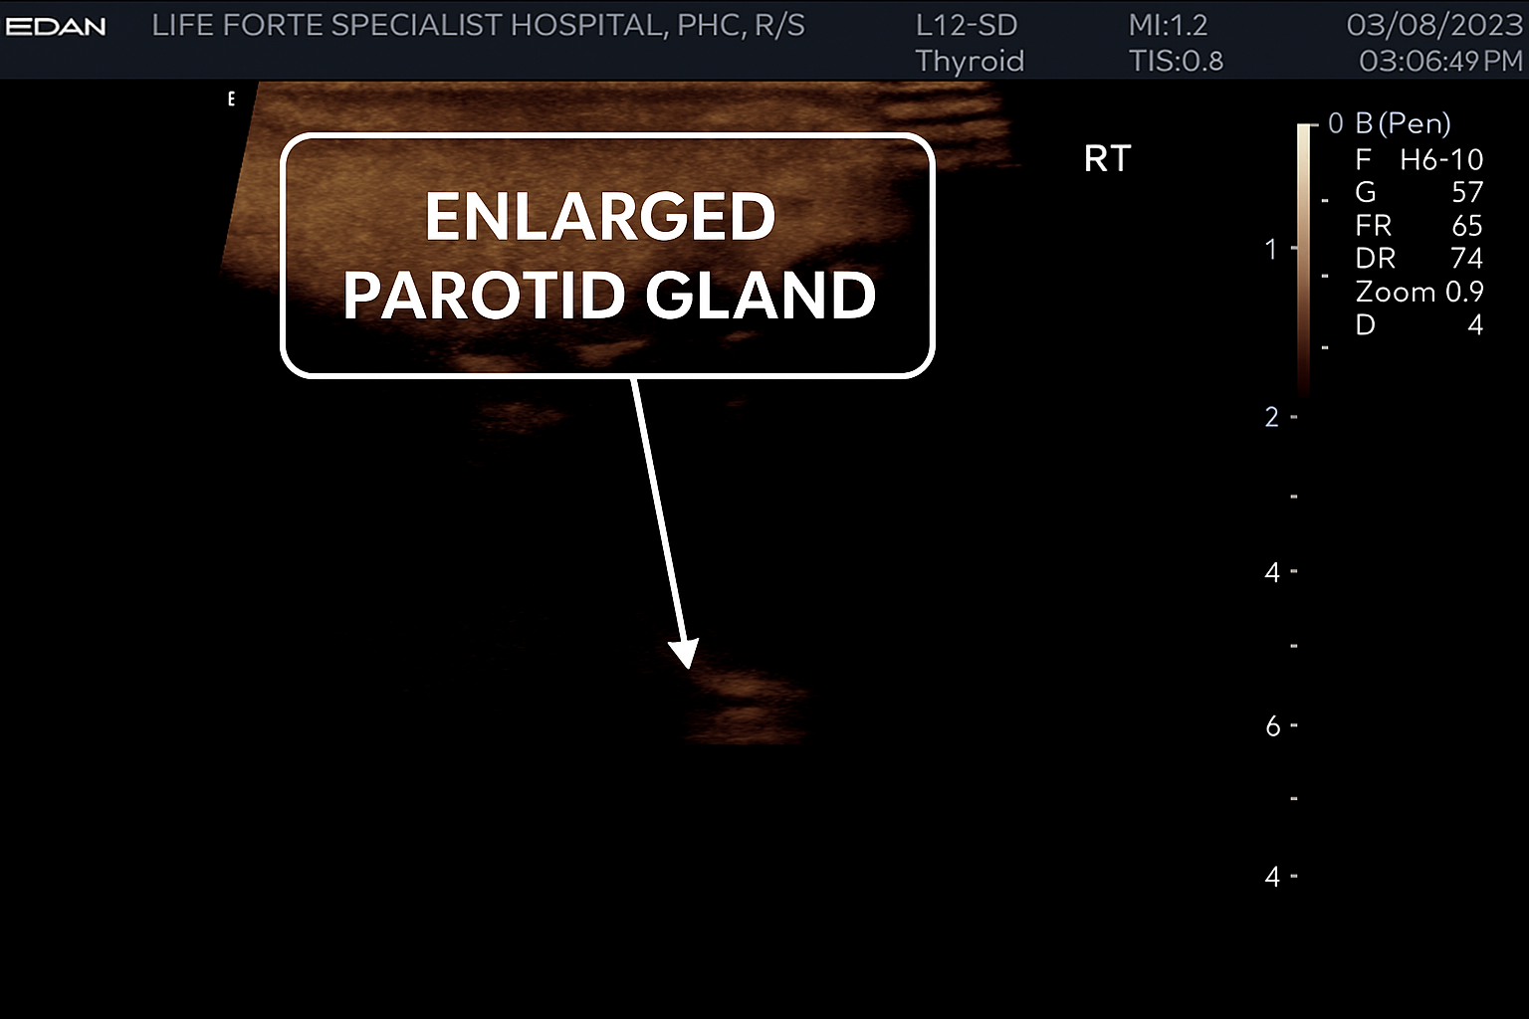
Figure 1: USG showing enlarged parotid gland, which appears as a broad, relatively homogeneous echogenic structure just beneath the skin.
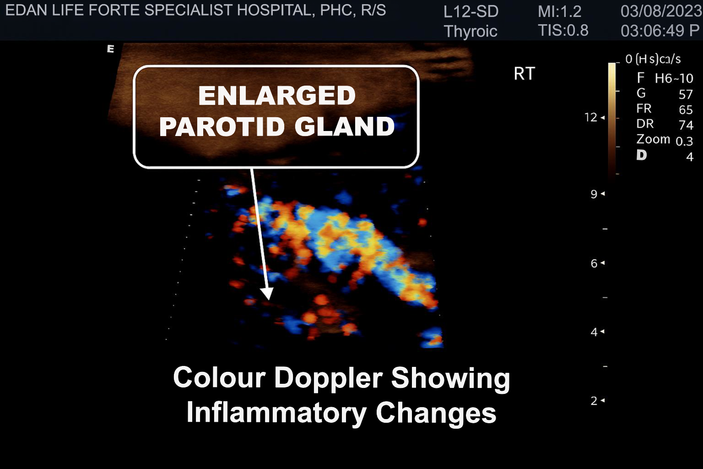
Figure 2: USG demonstrating diffuse, prominent colour flow within the gland in keeping with parotitis
DISCUSSION
Mumps primarily affects children aged 5 to 14 years and is rarely seen in newborns (Defandi, 2025). This has been well-documented in the literature, with few epidemiological studies and case reports on neonatal mumps (Sahdev et al, 2011). A study done in Rivers State, South Nigeria reported an incidence of 3 per 1000 children of which none was in the neonatal period, supporting its rarity (Okari et al, 2025). This rarity is likely due to the passive immunity provided to the foetus in utero through the mother’s vaccination (Defandi, 2025; Sato et al, 1979). Consequently, cases of neonatal or congenital mumps are expected to be more common among unvaccinated mothers who may contract mumps during pregnancy (Schwarz, 2017). Research indicates that women infected during pregnancy with certain pathogens and viruses, such as coxsackie virus, echovirus, measles, and mumps, can transmit these infections across the placenta to the foetus (World Health Organization, 2024; Ornoy and Tenenbaum, 2006).
In a case of congenital mumps reported by Takashaki et al., it was noted that the mother had been diagnosed with mumps 4 weeks and 5 days before delivery (Takahashi et al, 1998). This observation is supported by another report which described a case of neonatal mumps complicated by severe respiratory distress in the newborn (Groenendaal et al, 1990). The mother's symptoms included a self-limited febrile illness occurring approximately 2 weeks before delivery.
Additionally, a case reported by Lacour and colleagues noted that the mother developed bilateral parotitis starting on the day of delivery (Lacour et al, 1993). It has also been reported that neonatal mumps infection can be acquired postnatally. (Sahdev et al, 2011)
In yet another study by Ray and Fulginiti, where three isolated cases of neonatal mumps were reported, there was a clear pattern of maternal mumps preceding neonatal infection (Jones et al, 1980). Case 1 reported parotid swelling in a neonate born to a mother actively febrile with clinical mumps at the time of delivery, but no complications. Case 2 reported fever, cough, and poor feeding in a 7-day-old neonate born to a mother who had clinical mumps and fever at the time of delivery, and developed hypoxia and respiratory complications after 3 days of admission. Case 3 reported an asymptomatic neonate born to a mother with symptomatic mumps (Jones et al, 1980).
In our index patient, the mother was unaware but claimed to have been fully immunised in her childhood with the MMR vaccine and was vaguely aware of a self-limiting febrile illness a few weeks before delivery. Even though the maternal MMR vaccine has resulted in the incidence of mumps during pregnancy declining, vaccine immunity may wane over time (Sahdev et al, 2011).
Mumps in neonates has varied presentations; mostly fever, parotid swelling, poor feeding and restlessness, as demonstrated in the cases reported above (Jones et al, 1980). Our index case presented with fever, poor feeding, parotid swelling and vomiting, which was in keeping with the classical presentation of mumps in the neonatal period.
On the contrary, few cases have been reported where the neonate did not present with a parotid swelling, as expected. Such a case was reported in Switzerland, where the neonate presented with fever, splenomegaly and thrombocytopenia (Lacour et al, 1993). In another case reported by Reman et al, the neonate presented with fever, cough, tachypnea and hepatomegaly (Reman et al, 1986). Thus, highlighting the need for thorough history taking and a high index of suspicion.
Other cases have been reported in abortuses and stillbirths whose mothers were actively infected with mumps, and mumps is the cause of intra-uterine foetal deaths following autopsy. These were reported by Kurtz et al and Ni J et al., respectively (Kurtz et al 1982, Ni J et al, 1997). In both cases, viral cultures for mumps in foetal tissues, direct immunofluorescence and Polymerase Chain Reaction (PCR) for mumps viral genomes carried out confirmed mumps virus infection (Kurtz et al 1982, Ni J et al, 1997).
Existing literature has demonstrated that clinical mumps in neonates often has a benign course (Sahdev et al, 2011), as was observed in our index patient. However, despite the generally mild natural history of mumps infection in neonates, literature has demonstrated significant complications, particularly respiratory in nature, that can manifest in neonatal mumps. The commonest complications reported are Mumps pneumonia (Sahdev et al, 2011; Groenendaal et al, 1990), persistent pulmonary hypertension of the newborn (PPHN) (Sahdev et al, 2011; Takahashi et al, 1998), pulmonary haemorrhage (Takahashi et al, 1998), and thrombocytopenia (Lacour et al, 1993).
Groenendaal et al reported a neonate with severe respiratory distress needing immediate ventilation (Groenendaal et al, 1990). Autopsy showed bilateral pneumo-thoraces, pneumopericardium, and viral-like interstitial pneumonia (Groenendaal et al, 1990). Sahdev and his colleagues described a neonate with fever, cyanosis, and respiratory distress requiring ventilation. Echocardiography indicated pulmonary hypertension (Sahdev et al, 2011). Takahashi et al reported a similar mumps case with severe distress and pulmonary hypertension (Takahashi et al, 1998). Jones et al observed hypoxia and respiratory issues after three days, with chest X-ray showing bilateral infiltrates (Jones et al, 1980).
Neonatal mumps often presents with cardiac issues, involving recurrent cough, tachypnea, cyanosis, and cardiogenic shock due to myocarditis (Kadivar et al, 2008). Similar cases include a report by Baandrup U et al with severe heart failure and death, and an autopsy case by Ni J et al showing endocardial elastosis (Baandrup and Mortensen, 1984; Ni J et al, 1997).
Due to the cardiac and pulmonary complications, mumps pneumonia, PPHN, and myocarditis should be considered in neonates with severe respiratory distress, especially if maternal exposure is suspected (Takahashi et al, 1998; Groenendaal et al, 1990; Kurtz et al 1982). Treatment may include high-frequency ventilation, nitric oxide, and surfactant (Takahashi et al, 1998; Jones et al, 1980). Diagnosis involved clinical assessment, mumps IgM/IgG, immunofluorescence, PCR, viral cultures, and supportive tests like blood work, ultrasound, echocardiography, chest X-ray, and ESR (Sahdev et al, 2011; Sato et al, 1979; Takahashi et al, 1998; Kurtz et al 1982). Our case was primarily clinical, with some supportive tests, limited by resource constraints.
Our patient recovered well and was discharged after five days without complications. Outcomes can vary from full recovery to sequelae or death (Sahdev et al, 2011; Sato et al, 1979; Takahashi et al, 1998; Kurtz et al 1982).
^{CONCLUSION}
This study emphasizes the importance for paediatricians and general practitioners to maintain a high index of suspicion for neonatal mumps and its potential complications in infants presenting with fever and jaw swelling, particularly if their mothers are suspected of exposure. Additionally, there is a need to reinforce mumps vaccination efforts to address the rising incidence of mumps across all age groups, especially among adolescents and young adults. Routine vaccination has proven to be highly effective in reducing the incidence of mumps.
DISCLOSURE
The authors contributed equally to this work, and report no conflict of interest. Consent was obtained from patient caregivers before this publication.

REFERENCES
- Baandrup U, Mortensen SA. (1984). Fatal Mumps Myocarditis. Act Med Scand;216(3):331-3. doi: 10.1111/j.0954-6821.1984. tb03813.x. PMID: 6496191.
- Centers for Disease Control and Prevention. (2008). Updated Recommendations for Isolation of Persons with Mumps. MMWR. Morb Mortal Wkly Rep. 2008 Oct 10.57(40):1103-5
- Defandi GL. (2025). Mumps. Medscape Online Resources. Online: https://reference.medscape.com/article/966678-overview
- Gothard P. Mumps. In: Mabey D, Gill G, Parry E, Weber MW, Whitty CJM, eds. (2013). Principles of Medicine in Africa. Cambridge University Press:398-99.
- Groenendaal F, Rothbarth PH, Van Den Anker JN, Spritzer R. (1990). Congenital Mumps Pneumonia: a rare case of neonatal respiratory distress. Acta Paediatrica. 79(12):1252-54. doi: 10.1111/j.1651-2227.1990. tb11421.x. PMID:2085116.
- Jones JF, Ray CG, Fulginiti VA. (1980). Perinatal Mumps Infection. J Pediatr. 96(5):912-4. doi:10.1016/s0022-3476(80)80577-4. PMID:7365601.
- Kadivar M, Sadighi M, Kiani A, Kocharian A. (2008). Mumps Myocarditis as a case of Neonatal Cardiogenic Shock. Acta Medica Iranica. 46(2):159-162.
- Kurtz JB, Tomlinson AH, Pearson J. (1982). Mumps virus isolated from a fetus. Br Med J (Clin Res Ed). 13; 284(6314):471. doi:10.1136/bmj.284.6314.471.
- Lacour M, Mahurzi M, Vienny H, Suter S. (1993). Thrombocytopenia in a case of neonatal mumps infection: evidence for further clinical presentation. Eur. J pediatr. 152:739-41
- Ni J, Bowles NE, Demmler G, Kearney D, Bricker JT, Towbin JA. (1997). Viral Infection of the Myocardium in endocardial fibroelastosis. Molecular evidence for the role of mumps virus as an etiologic agent. Circulation. 95(1):133-9.
- Niizuma T, Terada K, Kosaka Y et al. (2004). Elevated Serum C-Reactive Protein in Mumps Orchitis. Pediatr Infect Dis J. 23(10):971
- Okari TG, Onubogu UC and Tella-Editang SA. (2025). Incidence and Seasonal Pattern of Mumps Parotitis in a Paediatric clinic, Nigeria. Asian Journal of Research in Infectious Diseases. 16(3):47-53. https://doi.org/10.9734/ajrid/2025/v16i3430.
- Ornoy A, Tenenbaum A. (2006). Pregnancy outcomes following infections by coxsackie, echo, measles, mumps, hepatitis, polio and encephalitis viruses. Reproductive toxicology. 21(4):446-457
- Reman O, Freymuth F, Laloum D, Bonte JF. (1986) Neonatal Respiratory Distress due to Mumps. Arch Dis Child. 61(1):80-81. doi:10.1136/adc.61.1.80. PMCID: PMC1777549|PMID:3954423
- Sahdev S, Roth P, Arroyo SE. (2011). Congenital Mumps Pneumonia and Persistent Pulmonary Hypetension. Ped Inf Dis J. 30(3):272
- Sato H, Albecht P, Reynolds DW, Stegno S, Ennis FA. (1979). Transfer of measles, mumps and rubella antibodies from mother to infant: its effect on measles, mumps and rubella immunization. Am. J. disease chil. 133(12):1240-43
- Schwarz ER. (2017) Consequences of perinatal infections with rubella, measles and mumps. J. Co viro. 27:71-77
- Takahashi Y, Teranishi A, Yamadi Y, et al. (1998). A case of congenital mumps infection complicated with persistent pulmonary hypertension. Amer. J Peri. 15(07):409-12.
- World health organization (WHO). (2024). Health products, policy and standards: Mumps.
Available online: https://who.int/teams/health-product-policy-and-standards/standards-and-specifications/vaccine-standardization
Accessed: January 2024

