Case study
Pelvic Bone Tumor Resection with Limb Preservation:
Prosthetic Reconstruction, Osteosynthesis, and Conservative Surgical Approaches
– A Six-Case Series

ABSTRACT
Aims: To report the diagnostic and therapeutic features of six patients managed for pelvic bone tumors in a Moroccan tertiary orthopedic unit, highlighting surgical approaches, reconstructive choices, functional outcomes, and specific challenges in a resource-limited setting.
Study Design: Retrospective descriptive case series.
Place and Duration of Study: Department of Orthopedic Surgery and Traumatology, Mohammed VI University Hospital, Tangier, Morocco, January 2023 – December 2025.
Methodology: Six patients (5 women, 1 man; mean age 35.7 years; range 16–67) operated for histologically confirmed pelvic bone tumors. Data on clinical presentation, multimodal imaging, histological diagnosis, neoadjuvant and adjuvant treatments, surgical resection type (Enneking–Dunham classification), reconstructive strategy, complications, functional outcomes (MSTS score), and follow-up were collected via REDCap database.
Results: Histological subtypes: Ewing sarcoma (n=3), chondrosarcoma (n=1), aneurysmal bone cyst (n=1), bone metastasis from breast carcinoma (n=1). Mean diagnostic delay: 17 months. All patients underwent limb-sparing surgery. Reconstructions: ilio-femoral ice-cream cone prosthesis (n=1), plate osteosynthesis (n=2), cement + T-plate (n=1), hernia mesh filling (n=1), no reconstruction (n=1). Four patients (67%) in complete remission (7 months to 2 years follow-up). One death from Ewing sarcoma metastatic relapse. One locoregional recurrence (metastatic carcinoma). Functional recovery satisfactory in survivors.
Conclusion: Limb-preserving pelvic surgery is achievable across diverse histological subtypes and reconstructive needs. The 17-month mean diagnostic delay remains the primary obstacle in the Moroccan context. Multidisciplinary tumor boards, improved imaging access, and national referral networks are essential.
Keywords: pelvic bone tumors; internal hemipelvectomy; limb preservation; prosthetic reconstruction; ice-cream cone prosthesis; Ewing sarcoma; chondrosarcoma; Enneking–Dunham classification; Morocco
1. INTRODUCTION
Pelvic bone tumors represent a heterogeneous group of rare lesions arising from the skeletal constituents of the pelvic ring — the ilium, ischium, pubis, and sacrum. Their anatomical location, which serves weight-bearing, locomotion, and visceral protection, makes both diagnosis and treatment particularly challenging [1]. Proximity of major neurovascular structures, biological variability across histological subtypes, and insidious symptom onset consistently lead to delayed presentation at locally advanced stages [2].
The imaging workup is central to management: plain radiography provides initial orientation; CT delineates osseous architecture and matrix; MRI maps medullary involvement, extra-osseous extension, and neurovascular relationships; bone scintigraphy or PET-CT completes systemic staging. Definitive diagnosis always rests on image-guided or open biopsy, planned with surgical resection trajectory in mind [3,4].
Wide surgical resection with histologically clear margins (R0) remains the cornerstone of curative treatment, directly correlated with local control and survival. Chemotherapy is indispensable in Ewing sarcoma; chondrosarcoma is primarily managed surgically given its chemoresistance; radiotherapy plays an adjuvant role in selected cases. The Enneking–Dunham anatomosurgical classification divides the pelvis into four zones — Zone I (ilium), Zone II (periacetabular), Zone III (ischiopubic ramus), Zone IV (sacrum) — guiding resection planning and reconstructive decision-making [5,6,7].
Reconstructive options after acetabular or combined pelvic resections include endoprostheses (saddle prosthesis, ice-cream cone, custom implants), proximal femoral autografts, allografts, arthrodesis, and non-reconstruction in selected cases. Anract et al. emphasized that the less anatomically complex the reconstruction, the lower the risk of infection and mechanical failure; iliac wing or obturator ring resections rarely require bony reconstruction [8]. Local recurrence rates after pelvic sarcoma resection range from 17% to 45% in published series [1,8], reflecting the inherent difficulty of achieving wide margins in this region.
In resource-limited settings such as Morocco, additional barriers — delayed access to advanced imaging, limited specialized surgical infrastructure, and incomplete follow-up adherence — further compromise outcomes. We report here six patients managed for pelvic bone tumors between 2023 and 2025 at a Moroccan tertiary center, analyzing the spectrum of histological entities, surgical approaches, reconstructive strategies, complications, and short-term outcomes.
2. MATERIAL AND METHODS
2.1 Study Design and Setting
Retrospective, descriptive, single-center case series. Department of Orthopedic Surgery and Traumatology, Mohammed VI University Hospital, Tangier, Morocco. Study period: January 2023 – December 2025.
2.2 Inclusion and Exclusion Criteria
Included: patients operated for histologically confirmed primary or secondary pelvic bone tumor; age ≥15 years; documented ≥6 months postoperative follow-up. Excluded: incomplete records; tumors not requiring surgery; insufficient follow-up.
2.3 Data Collection
Data retrieved from the ENOVA Santé electronic medical records and the department's oncology database. A standardized REDCap form captured: demographics, clinical presentation, multimodal imaging, Enneking–Dunham topography, biopsy type, histological diagnosis and grade, MDT decisions, neoadjuvant/adjuvant therapies, resection type, reconstructive technique, operative time, blood loss and transfusion, postoperative complications, Huvos–Rosen necrosis grading, MSTS functional score, oncological outcome, and follow-up.
2.4 Ethical Considerations
Conducted in accordance with the Declaration of Helsinki (2013). Institutional authorization obtained. Written informed consent collected from all patients or guardians. Patient anonymity strictly maintained.
2.5 Statistical Analysis
Descriptive analysis only: proportions and arithmetic means. No inferential statistical testing was required.
3. RESULTS AND DISCUSSION
3.1 Epidemiological Data and Diagnostic Delay
The cohort comprised five women and one man. Mean age was 35.7 years (range 16–67). Mean diagnostic delay from symptom onset to specialized consultation was 17 months (range: 1 month – 5 years). This substantially exceeds the 3–12 months reported in international series [11,12]. Kotrych et al. documented a median pelvic tumor delay of 10 months in Europe [13]. Our prolonged delay reflects limited access to advanced imaging outside university centers and insufficient primary care awareness of pelvic sarcoma warning signs.
3.2 Clinical Presentation
Pelvic or iliac pain was the universal presenting symptom (6/6), frequently associated with partial lower-limb functional impairment (4/6). Weight loss was noted in two cases. No neurological compression signs were detected at initial examination in any patient. A palpable mass was present in only one case, confirming the diagnostic value of early imaging in this anatomically deep region [15].
3.3 Imaging and Tumor Topography
All patients underwent plain pelvic radiography first, revealing osteolytic lesions. CT and MRI provided complementary information: CT mapped cortical integrity, matrix calcifications, and pathological fractures, and guided biopsies; MRI established the full extent of medullary and soft-tissue involvement, vascular relationships, and articular infiltration [14,15]. PET-CT was performed in Case 2, confirming hypermetabolism without distant metastases. Enneking–Dunham zones: Type I (ilium) in 2 cases; Type I+II in 1; Type II+III in 1; Type I+II+III in 1; Type IV (sacrum) in 1. Clinical and imaging data are summarized in Table 1.
Table 1. Clinical, radiological, and histological data for all six cases.
Case | Age/Sex | Symptom Duration | Chief Complaint | Imaging Findings | Enneking–Dunham Zone | Biopsy Type | Histological Diagnosis | Tumor Grade
1 | 16 / F | 7 months | Right iliac pain + swelling + functional impairment | X-ray: osteolytic right ilium. CT: 78×91 mm, locally invasive. MRI follow-up: progression 121×115×161 mm (Fig. 4A–B) | I + II | CT-guided + open biopsy | Intraosseous cavernous hemangioma with aneurysmal changes | Benign
2 | 20 / M | 10 months | Right hip pain + functional impairment | X-ray: osteolytic cotyle + ischion. MRI: 92×54 mm (Fig. 1A–B). PET-CT: hypermetabolic (Fig. 1C) | II + III | Open biopsy | Ewing sarcoma (CD99+, FLI-1+; EWSR1 rearrangement) | High grade
3 | 48 / F | 5 years | Right pelvic pain | X-ray: osteolytic right ilium. CT+MRI: 85×65×50 mm, soft tissue extension. Bone scan: localized uptake | I | CT-guided biopsy | Ewing sarcoma (CD99+, FLI-1+; EWSR1) | High grade
4 | 28 / F | 7 months | Right pelvic pain (postpartum) | X-ray: right iliac lytic lesion. MRI: 128×127×162 mm, iliac vessel displacement (Fig. 5A) | I | CT-guided + IHC | Ewing sarcoma (CD99+) | High grade
5 | 35 / F | 4 months | Pelvic pain + functional impairment + 8 kg weight loss | CT+MRI: sacral mass 108×61×42 mm (Fig. 3A–B). CT TAP: no distant metastases | IV (sacrum) | CT-guided biopsy | Well-differentiated chondrosarcoma grade II | Grade II
6 | 67 / F | 1 month | Left pelvic pain + partial functional impairment | CT: periacetabular lytic lesion + pathological fracture 30×25×31 mm. Bone scan: left iliac uptake | I + II + III | Open biopsy | Bone metastasis from breast carcinoma | Metastatic
Figure 1. Case 2 – Ewing Sarcoma, right periacetabular zone (Type II+III). Preoperative imaging.
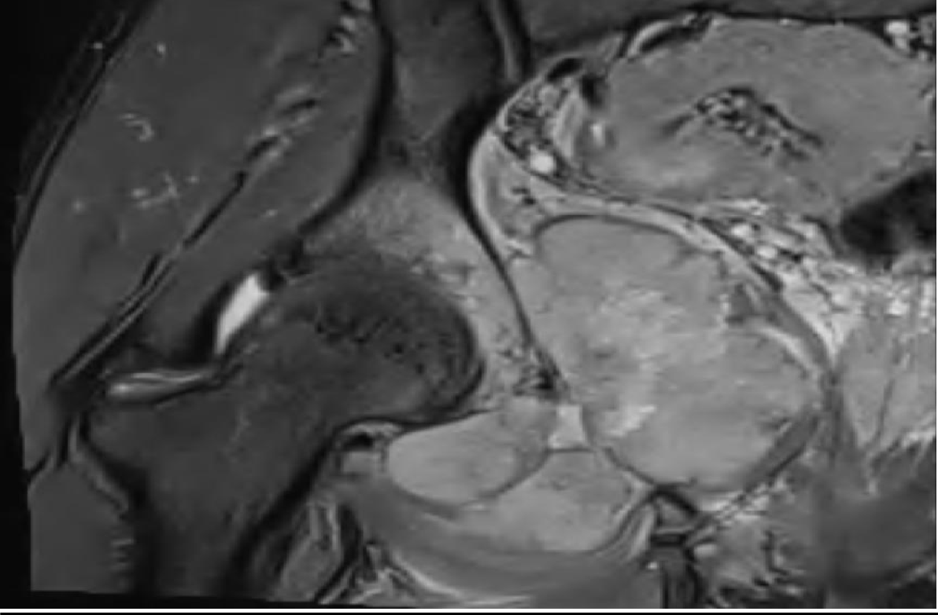  Fig. 1A – MRI STIR coronal: large hyperintense mass (92×54 mm) at right cotyle and ischion with medullary infiltration and cortical breach. | 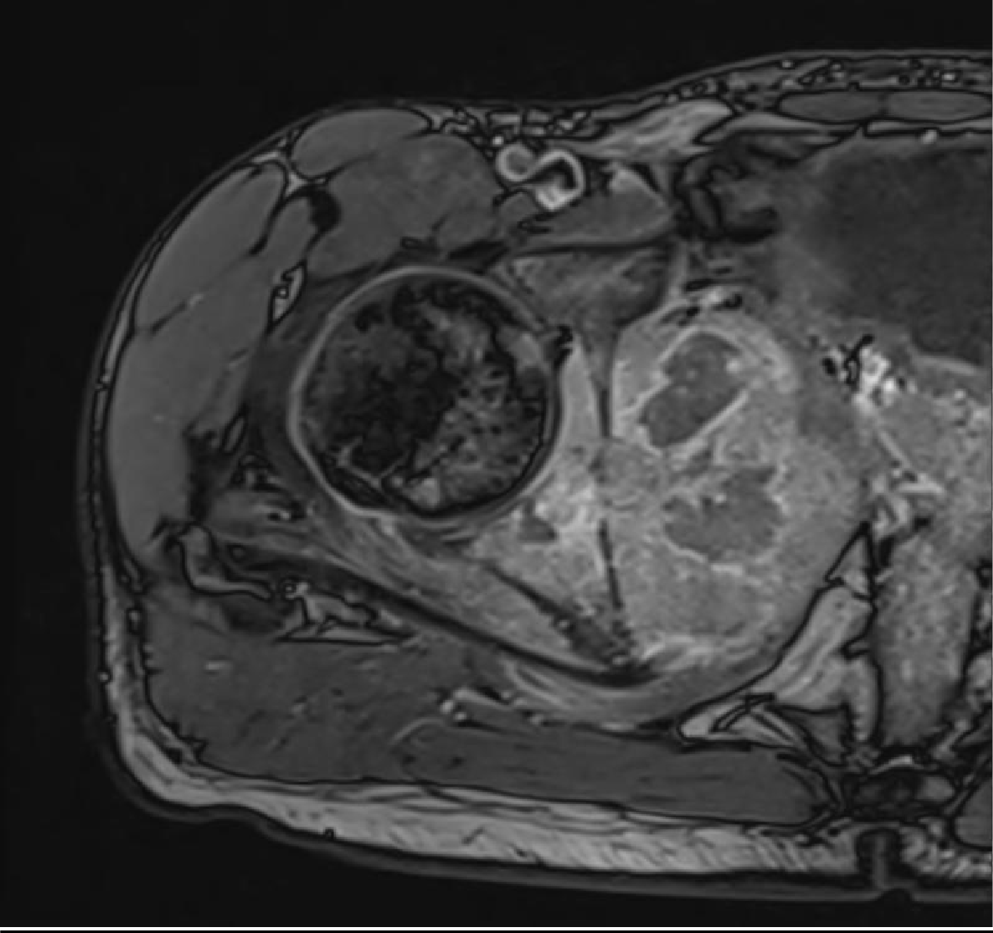  Fig. 1B – MRI T1 post-gadolinium axial: heterogeneous soft-tissue mass infiltrating coxo-femoral joint and periacetabular muscles. | 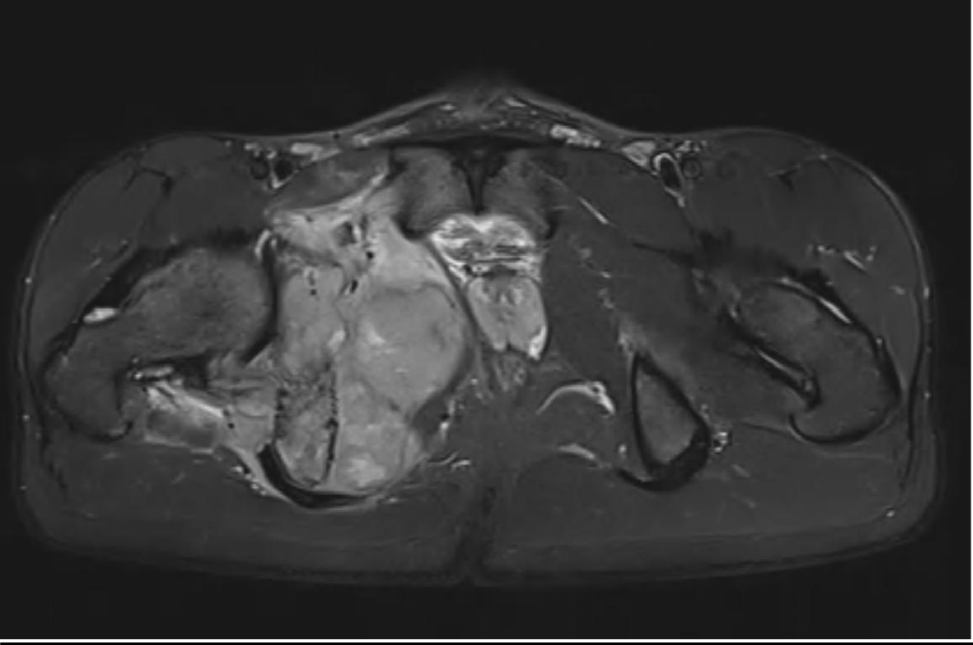  Fig. 1C – MRI STIR axial: large hyperintense mass at right cotyle and ischion with medullary infiltration and cortical breach.
Figure 2. Case 2 – Postoperative imaging after Type II+III internal hemipelvectomy with ice-cream cone ilio-femoral prosthesis.
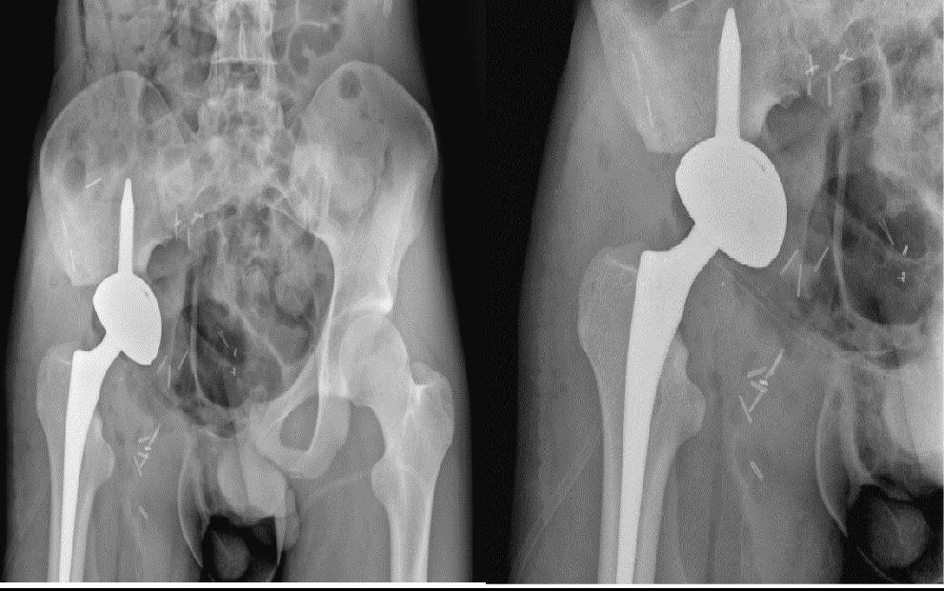
Fig. 2 – Anteroposterior pelvic X-ray: ice-cream cone ilio-femoral prosthesis in place. The cone stem is anchored in the residual posterior iliac column; the femoral component articulates with a modular femoral stem.
Note: Readers are requested to insert their own pre- and postoperative imaging files (IRM/X-ray/CT) in the grey placeholder frames above. Replace each placeholder by inserting your image (Insert > Picture) aligned to the frame dimensions. Legends are provided above each frame.
3.4 Histological Distribution and Biopsy
Subtypes: Ewing sarcoma (n=3, Cases 2–4), chondrosarcoma Grade II (n=1, Case 5), intraosseous cavernous hemangioma with aneurysmal changes (n=1, Case 1), and periacetabular bone metastasis from breast carcinoma (n=1, Case 6). CT-guided percutaneous biopsy was the primary approach in four patients. Radio-histological discordance in Case 1 (aggressive imaging pattern vs. giant cell-rich benign histology) prompted open biopsy; final resection pathology confirmed a benign hemangioma — a rare presentation highlighting the importance of correlating all diagnostic modalities before committing to a major resection.
Ewing sarcoma was confirmed by CD99/FLI-1 immunopositivity and FISH-confirmed EWSR1 rearrangement in all three cases [18]. Chondrosarcoma diagnosis rested on the sacral location, bicellular architecture, and nuclear atypia, classified Grade II.
3.5 Surgical Strategy and Resection Types
All six patients underwent limb-sparing surgery after MDT discussion, with no amputations performed. This outcome reflects the combined use of navigation, 3D planning, and multidisciplinary coordination, and is noteworthy given the resource-limited context.
Type I resections (Cases 1, 3, 4) targeting the ilium without acetabular involvement carried the most favorable functional profile. Case 1 required no reconstruction (acetabular joint and pelvic ring integrity maintained). Cases 3 and 4 used plate stabilization — double-face abdominal plate and visceral plate respectively — consistent with the principle that iliac wing resections not involving the acetabulum do not require bony reconstruction [8]. Figure 4A–B shows the preoperative CT and postoperative X-ray for Case 1.
Figure 3. Case 5 – Grade II sacral chondrosarcoma (Type IV). Preoperative imaging and 3D-printed cutting guide.
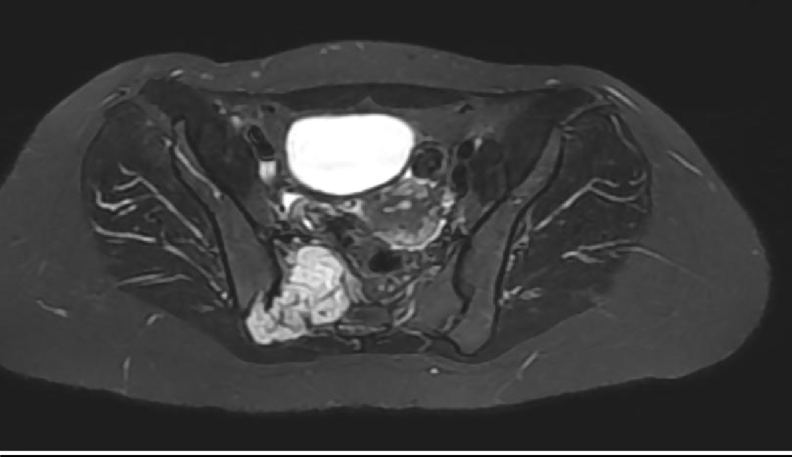  Fig. 3A – MRI STIR axial: right sacral mass 108×61×42 mm with high signal intensity and invasion of piriformis muscle. | 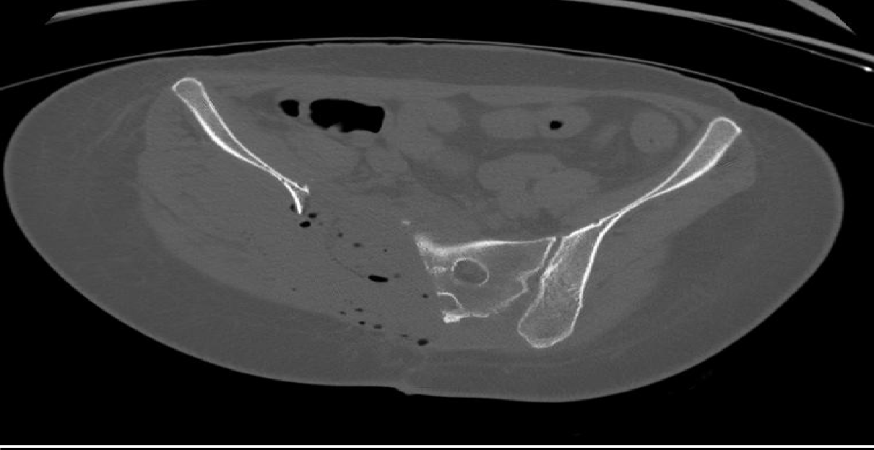  Fig. 3B – CT osseous window axial: destructive sacral lytic lesion with cortical breach and soft-tissue extension. | 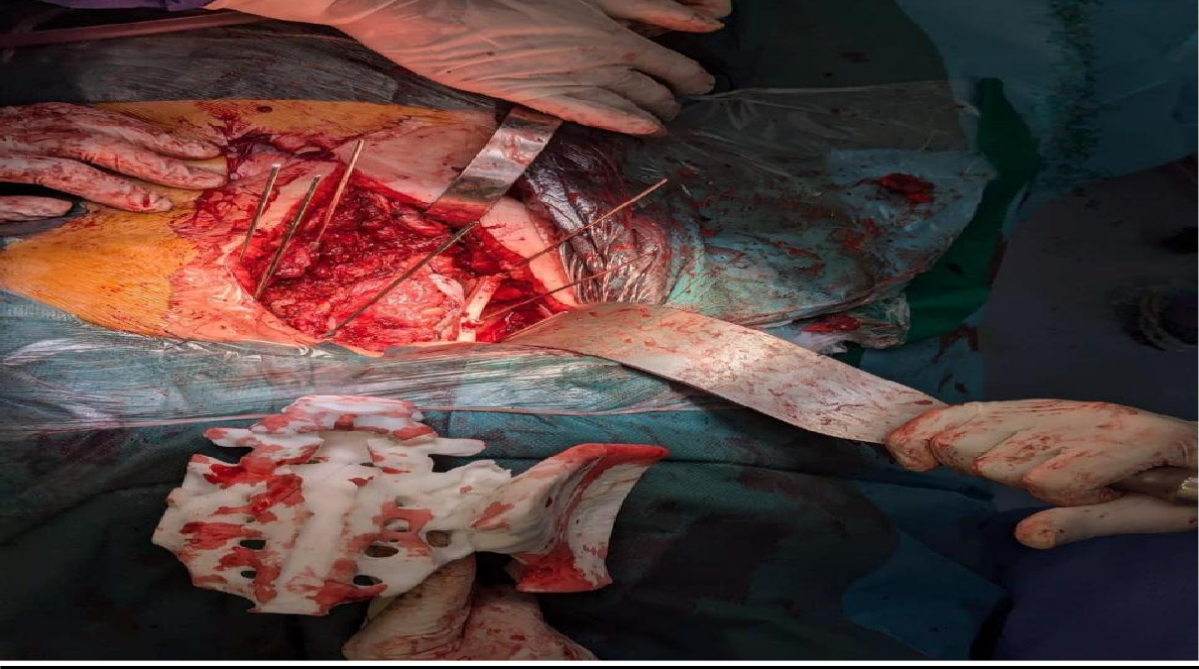  Fig. 3C – Intraoperative: 3D-printed patient-specific cutting guide applied to sacral osteotomy plane, ensuring the planned 7 mm margin around the tumor.
Case 2 (Type II+III, Ewing sarcoma) received navigation-assisted hemipelvectomy with ice-cream cone ilio-femoral prosthetic reconstruction (Figures 1–2). This device — a metallic acetabular floor with an iliac extension stem — provides immediate mechanical stability. Navigation-assisted periacetabular resection has been shown to improve margin accuracy [20]. The histological response was poor (Grade I, 85.6% viable cells; margins <1 mm), contributing to early metastatic relapse.
Case 5 (sacral chondrosarcoma, Type IV) exemplifies 3D-guided surgery: a patient-specific cutting guide designed from MRI/CT data was used to execute sacral osteotomies with 5 mm margins despite the high hemorrhagic risk of this region (Figure 3C). The osseous defect was filled with hernia mesh, subsequently requiring removal due to local infection — a known risk of non-biological fillers in sacral resections.
Figure 4. Case 1 – Aneurysmal bone cyst / cavernous hemangioma (Type I+II). Preoperative CT and postoperative X-ray (no reconstruction).
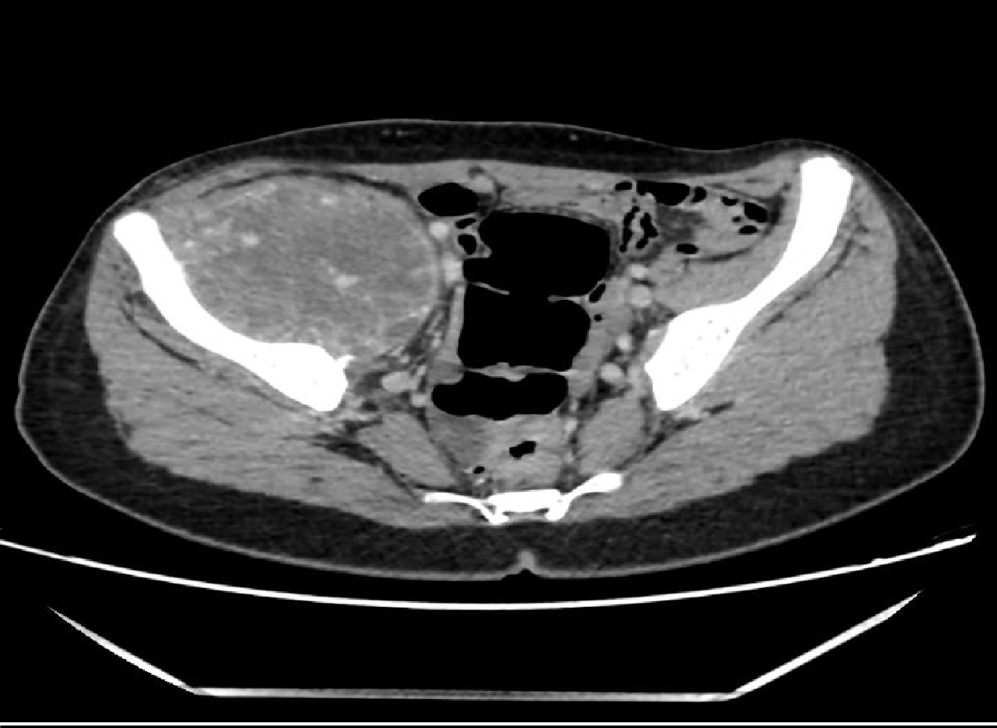  Fig. 4A – CT axial (portal phase): aggressive osteolytic mass 78×91 mm of the right ilium with hypervascularized content and local soft-tissue invasion. | 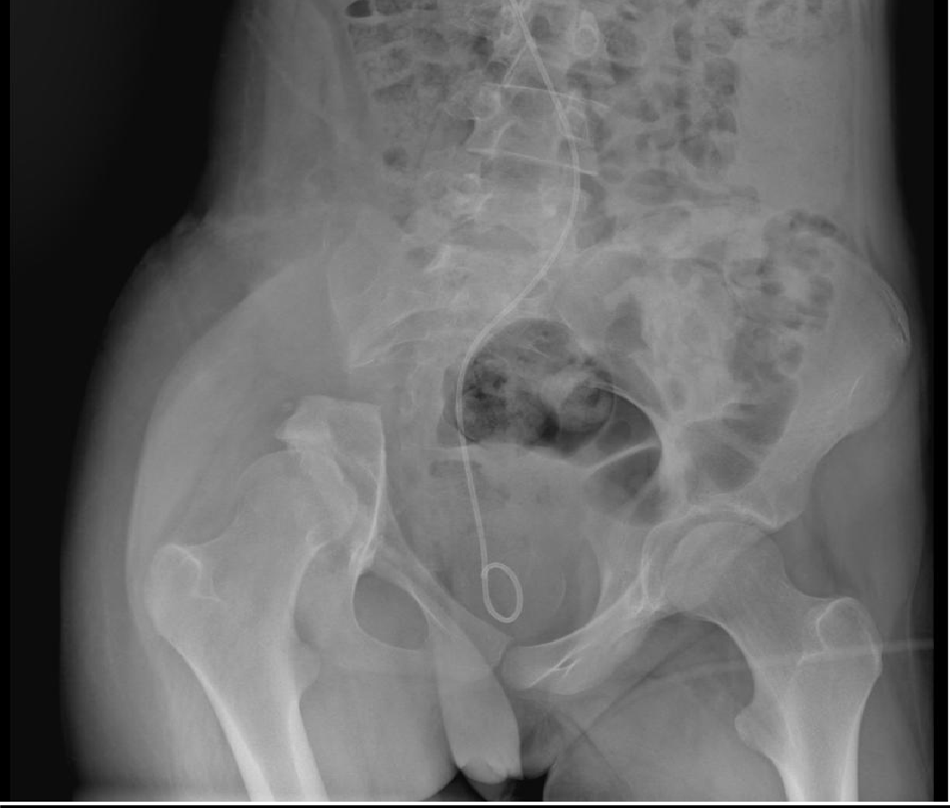  Fig. 4B – Postoperative AP pelvic X-ray: periacetabular osseous defect after Type I internal hemipelvectomy without reconstruction. No osteosynthesis material visible. Double-J ureteral stent visible.
Figure 5. Case 4 – Ewing Sarcoma, right ilium (Type I). Preoperative MRI and postoperative CT (osteosynthesis plate).
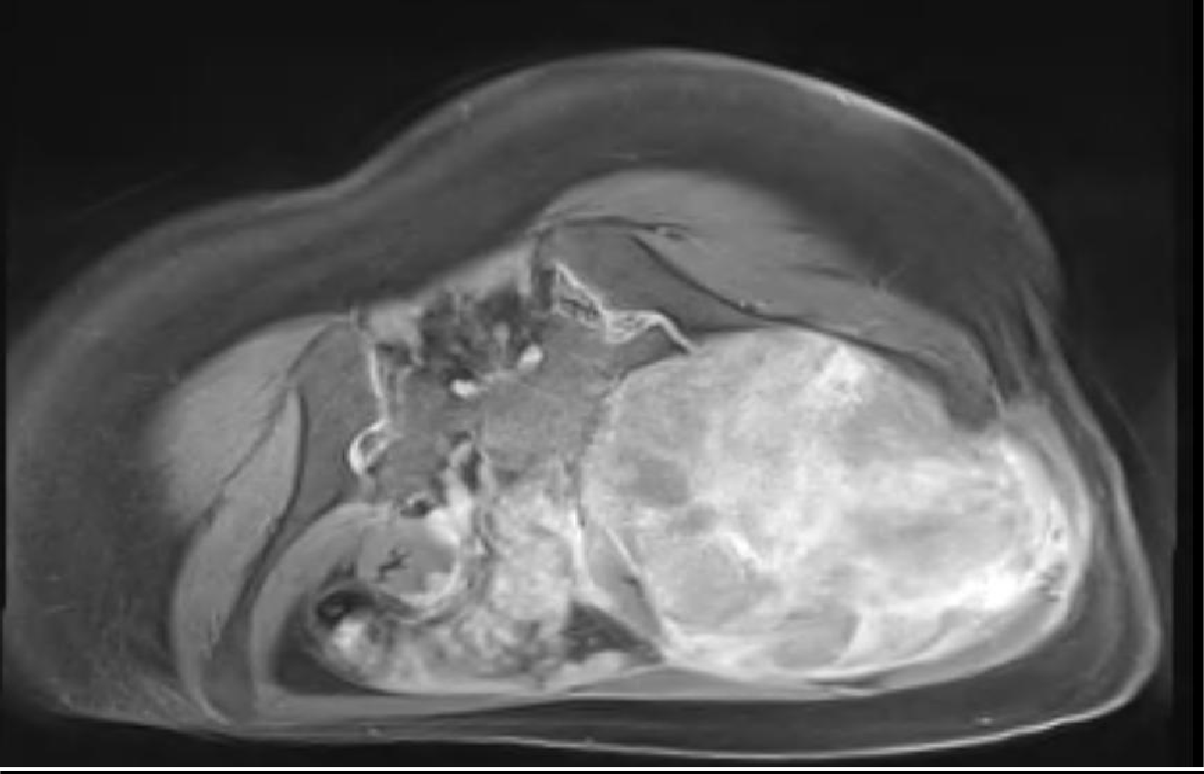  Fig. 5A – MRI T1+Gd axial (preoperative): large iliac tumor 128×127×162 mm compressing and displacing iliac vessels and iliopsoas muscle. Following 3 cycles of neoadjuvant VAC-IE chemotherapy, lesion showed partial regression. | 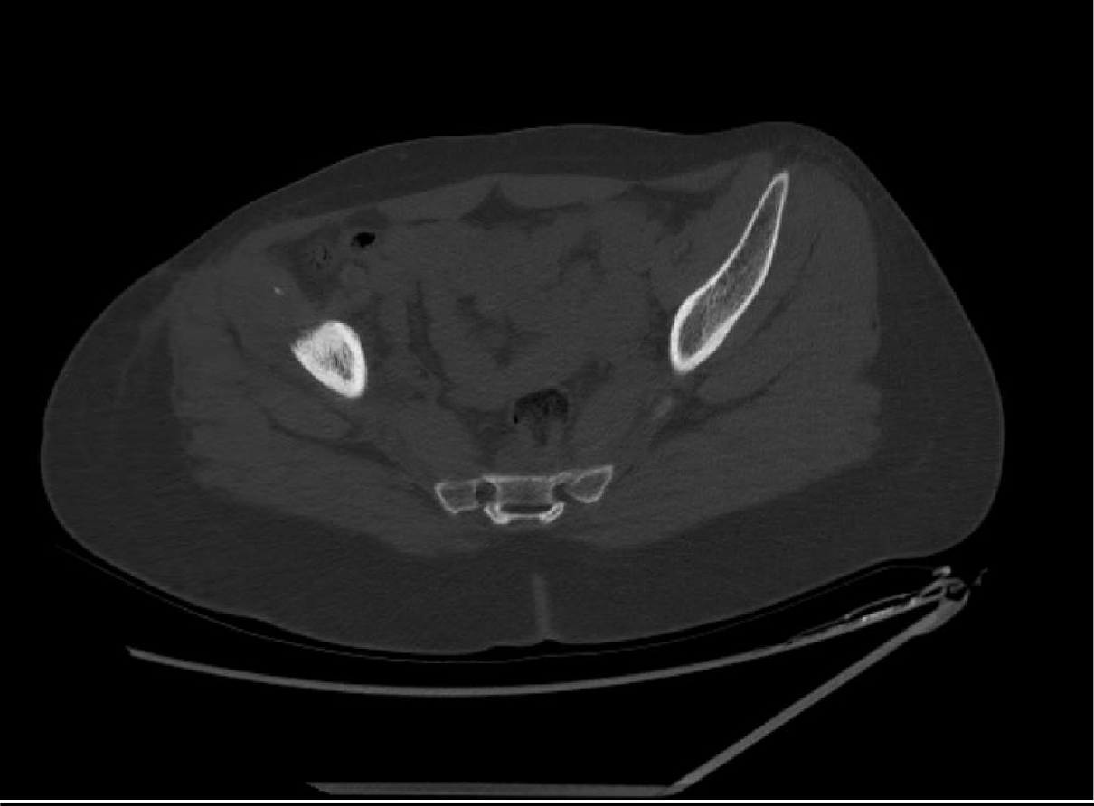  Fig. 5B – Postoperative CT axial: visceral plate osteosynthesis in situ after iliac crest osteotomy and tumor resection. No residual tumor mass. Complete histological necrosis (Huvos Grade IV) confirmed at final pathology.
3.6 Adjuvant Therapies
All three Ewing sarcoma patients received VDC-IE or VAC-IE multiagent chemotherapy with G-CSF support [23]. Histological response ranged from Grade IV (complete necrosis, Case 4 — excellent prognosis) to Grade I (14% necrosis, Case 2 — fatal relapse), confirming the paramount prognostic value of neoadjuvant chemotherapy response described by Wunder et al. [24]. Chondrosarcoma received no chemotherapy (chemoresistant histotype) and adjuvant radiotherapy at 60 Gy/30 fractions for the sacral location [25].
3.7 Complications and Outcomes
Surgical complications: hemorrhagic instability (n=2), hemorrhagic shock with 10-day ICU stay (Case 5, 2,000 mL blood loss), pelvic lymphocele (Case 2), and infected hernia mesh requiring revision (Case 5). These rates are consistent with published data for internal hemipelvectomy: Ogura et al. report wound complications in over one-third of patients, with infection rates of 10–50% depending on reconstruction type [26]. Anract et al. note infection rates of 12–19% for saddle prostheses in their series [8].
Four patients (67%) are in complete remission. One patient died from Ewing sarcoma relapse (Case 2, Grade I histological response, margins <1 mm). One patient (Case 6, breast metastasis) developed locoregional recurrence and was lost to follow-up. Two patients (33%) developed reactive depressive episodes, consistent with published prevalence of ~30% psychological distress among bone sarcoma survivors [28]. Functional outcomes, complications, and follow-up are detailed in Tables 2 and 3.
Table 2. Neoadjuvant therapy, surgical resection, reconstruction, postoperative histology, and adjuvant treatment.
Case | Neoadjuvant Therapy | Resection Type | Reconstruction | Op. Time / Transfusion | Postop Histology & Margins | Adjuvant Therapy
1 | None | Internal hemipelvectomy Type I (ring interrupted) | None (Fig. 4B) | 311 min / 2 RBC units | Cavernous hemangioma; no malignancy; clear margins | None
2 | VDC-IE × 4 cycles | Internal hemipelvectomy Type II+III (navigation-guided) | Ice-cream cone ilio-femoral prosthesis (Fig. 2A–B) | 480 min / 3 RBC + 3 FFP | Ewing sarcoma 11 cm; 85.6% viable (Huvos Grade I); margins <1 mm | VDC-IE × 10 + RTH 50.4 Gy/28 fr
3 | VAC-IE × 4 cycles | Internal hemipelvectomy Type I (partial ring interruption) | Double-face abdominal plate | 150 min / no transfusion | Ewing sarcoma 8 cm; 24% viable (Huvos Grade II); clear margins | VAC-IE × 7 + RTH 50 Gy/25 fr
4 | VAC-IE × 3 cycles | Iliac crest osteotomy + tumor resection | Visceral plate osteosynthesis (Fig. 5B) | 120 min / no transfusion | Complete necrosis (Huvos Grade IV); margin 5 mm; R0 | VAC-IE × 4 + RTH 50 Gy/25 fr
5 | None | Hemipelvectomy Type IV (3D-printed guide, Fig. 3C) | Hernia mesh filling of osseous defect | 356 min / 2000 mL; 10 RBC + 10 FFP + 12 Plt | Chondrosarcoma Grade II; clear margins (5 mm) | RTH 60 Gy/30 fr
6 | None | Intralesional resection (ring interrupted, palliative) | Cement + T-plate osteosynthesis | 120 min / no transfusion | Metastatic carcinoma; palliative intent | Palliative RTH 60 Gy/30 fr + chemotherapy
Table 3. Complications, oncological outcomes, follow-up duration, and functional results.
Case | Surgical Complications | Adjuvant Toxicities | Oncological Outcome | Follow-up | Functional Outcome (MSTS)
1 | Postoperative reactive depression | N/A | Complete remission; no recurrence | 7 months | Autonomous ambulation; satisfactory MSTS
2 | Pelvic lymphocele. Reactive depression. | Peripheral neuropathy (vincristine) | Bone metastases at 8 months. Death 09/08/2025. | 12 months | Progressive deterioration prior to death
3 | Intraoperative hemodynamic instability; 1 day ICU | None significant | Complete remission at 2 years | 2 years | Ambulation with intermittent cane; good MSTS
4 | None | Neutropenia (G-CSF controlled); stable pulmonary micronodules | Complete remission at 2 years | 2 years | Near-normal ambulation; excellent MSTS
5 | Hemorrhagic shock (10-day ICU). Infected mesh => surgical revision. | Grade 3 radiodermatitis; radiation proctitis (APC); lymphedema; neuropathic pain | No local recurrence at last follow-up | 1 year | Ambulation with cane; progressive recovery
6 | None immediate | Not specified | Locoregional recurrence at 1 year; lost to follow-up | 1 year | Transient improvement after surgery
3.8 Contextual Challenges and Practical Implications
The 17-month mean diagnostic delay — more than double most international benchmarks — is the most actionable finding of this series, reflecting limited MRI access in regional centers and insufficient primary care awareness. Priority interventions include: (1) training primary care physicians to refer any chronic unexplained pelvic pain to orthopedic oncology; (2) establishing clear referral pathways from peripheral hospitals to university orthopedic oncology units; (3) expanding CT-guided biopsy and MRI capacity; and (4) implementing 5–10-year structured follow-up programs. International guidelines unanimously recommend management of pelvic sarcomas in expert multidisciplinary centers [31].
3.9 Limitations
Small sample size (n=6); retrospective single-center design; histological heterogeneity; variable and in some cases insufficient follow-up duration. These results are illustrative observations rather than the basis for generalizable conclusions.
4. CONCLUSION
Pelvic bone tumors encompass a heterogeneous spectrum requiring individualized, multidisciplinary management. This six-case series demonstrates that limb-preserving surgery — including diverse resection types and reconstructive strategies (ice-cream cone prosthesis, plate osteosynthesis, 3D-guided sacral resection, and non-reconstruction) — is achievable across different histological subtypes with satisfactory functional recovery in surviving patients. Histological response to neoadjuvant chemotherapy and quality of surgical margins remain the primary oncological determinants. A 17-month mean diagnostic delay is the most critical challenge in our context. Strengthening multidisciplinary infrastructure, imaging access, and referral networks remains an essential priority for pelvic oncology in Morocco.

CONSENT
Written informed consent was obtained from all patients or legal guardians for publication of clinical data and images. Documentation is available upon editorial request.
ETHICAL APPROVAL
Conducted in accordance with the Declaration of Helsinki (2013). Institutional authorization obtained from Mohammed VI University Hospital, Tangier, Morocco.
REFERENCES
1. Aydinli U, Ozturk C, Yalcinkaya U, et al. (2004). Limb-sparing surgery for primary malignant tumours of the pelvis. Acta Orthopaedica Belgica, 70(5), 489–498.
2. Campanacci M. (1990). Bone and Soft Tissue Tumors. 2nd ed. Springer.
3. Mintz DN, Hwang S. (2014). Bone tumor imaging, then and now. HSS Journal, 10(3), 230–239.
4. Leflot L, Ducou Le Pointe H, Lenoir M, et al. (2005). Bonnes pratiques en imagerie dans les tumeurs osseuses. EMC Rhumatologie-Orthopédie, 2(1), 59–79.
5. Deloin X, Dumaine V, Biau D, et al. (2009). Pelvic chondrosarcomas: surgical treatment options. Orthopaedics & Traumatology: Surgery & Research, 95(6), 393–401.
6. Tsuda Y, Evans S, Stevenson JD, et al. (2019). Surgical margin width and outcome in pelvic chondrosarcoma. Clinical Orthopaedics and Related Research, 477(11), 2432–2440.
7. Enneking WF, Dunham WK. (1978). Resection and reconstruction for primary neoplasms involving the innominate bone. Journal of Bone and Joint Surgery (American), 60(6), 731–746.
8. Anract P, Biau D, Babinet A, Tomeno B. (2014). Reconstructions du bassin après résection tumorale chez l'adulte. Bulletin du Cancer, 101(2), 184–194.
9. Han I, Lee YM, Cho HS, et al. (2010). Outcome after surgical treatment of pelvic sarcomas. Clinics in Orthopedic Surgery, 2(3), 160–166.
10. Shi Q, Guo W, Ji T, Tang X. (2024). Lumbar functional evaluation of pelvic bone sarcomas after resection. Cancer Medicine, 13(11), e7282.
11. Kotrych D, Ciechanowicz D, Pawlik J, et al. (2023). Delay in diagnosis of primary bone tumors. Ortopedia Traumatologia Rehabilitacja, 25(1), 9–22.
12. Wurtz LD, Peabody TD, Simon MA. (1999). Delay in diagnosis and treatment of primary bone sarcoma of the pelvis. Journal of Bone and Joint Surgery (American), 81(3), 317–325.
13. Letaief F, Khrouf S, Yahiaoui Y, et al. (2020). Prognostic factors in high-grade localized osteosarcoma: the Tunisian experience. Journal of Orthopaedic Surgery Hong Kong, 28(3).
14. Morbée L, Vereecke E, Laloo F, et al. (2022). MR imaging of the pelvic bones: current and cutting-edge techniques. Journal of the Belgian Society of Radiology, 106(1).
15. Laitinen MK, Parry MC, Morris GV, Jeys LM. (2023). Pelvic bone sarcomas, prognostic factors, and treatment: a narrative review. Scandinavian Journal of Surgery, 112(3), 206–215.
16. Breden S, Stephan M, Knebel C, et al. (2024). Chondrosarcoma of the pelvis: a review of 77 cases. Diagnostics, 14(19), 2166.
17. Williams AE, Ho JW, Sundaram N. (2024). Bone biopsies: practical considerations and technical tips. Seminars in Interventional Radiology, 41(5), 444–454.
18. Mata Fernández C, Sebio A, Orcajo Rincón J, et al. (2024). Clinical practice guidelines for Ewing sarcoma treatment (GEIS). Clinical and Translational Oncology, 27(3), 824–836.
19. Zomalhèto Z, Biaou O, Yekpe P, et al. (2015). Profil des tumeurs osseuses malignes primitives à Cotonou (Bénin). Journal Africain du Cancer, 7.
20. Fujiwara T, Kaneuchi Y, Stevenson J, et al. (2021). Navigation-assisted pelvic resections for periacetabular chondrosarcomas. European Journal of Surgical Oncology, 47(2), 416–423.
21. Ould Slimane M, Thong P, Perez A, et al. (2016). Apport de l'imagerie 3D naviguée en chirurgie de résection tumorale osseuse pelvienne. Revue de Chirurgie Orthopédique et Traumatologique, 102.
22. Chimutengwende-Gordon M, Coomber R, Peat F, et al. (2022). Harrington plus reconstruction for pelvic and acetabular metastases. Journal of Bone Oncology, 33, 100414.
23. Ewing Sarcoma Treatment (PDQ®) – NCI. (2025). https://www.cancer.gov/types/bone/hp/ewing-treatment-pdq
24. Wunder JS, Paulian G, Huvos AG, et al. (1998). Histological response to chemotherapy as predictor of outcome in Ewing sarcoma. Journal of Bone and Joint Surgery (American), 80(7), 1020–1033.
25. Hogendoorn PCW, Athanasou N, Bielack S, et al. (2010). Bone sarcomas: ESMO clinical practice guidelines. Annals of Oncology, 21(Suppl 5), v204–v213.
26. Ogura K, Boland PJ, Fabbri N, Healey JH. (2020). Rate and risk factors for wound complications after internal hemipelvectomy. Bone & Joint Journal, 102-B(3), 280–284.
27. Schmid MP, Harrabi S, Herfarth K, et al. (2022). Particle therapy in pelvic Ewing sarcoma. Cancers, 14(24), 6045.
28. Suhag A, Sharma KK, Tiwari SK, et al. (2024). Health-related quality of life and psychological concerns among sarcoma survivors. ecancermedicalscience.
29. Brown JM, Rakoczy K, Tokson JH, et al. (2022). Ewing sarcoma of the pelvis: clinical features and overall survival. Cancer Treatment and Research Communications, 33, 100634.
30. Lehner B, Bollmann J, Geisbüsch A, et al. (2025). Functional outcomes after internal hemipelvectomy for primary sarcoma of the bony pelvis. Diagnostics, 15(12), 1452.
31. Strauss SJ, Frezza AM, Abecassis N, et al. (2021). Bone sarcomas: ESMO–EURACAN–GENTURIS clinical practice guideline. Annals of Oncology, 32(12), 1520–1536.

