METAMORPHIC EVOLUTION AND ECONOMIC MINERALIZATION OF THE PAN-AFRICAN OROGENY IN THE NIGERIAN BASEMENT COMPLEX: A COMPARATIVE PETROLOGICAL ANALYSIS WITH GLOBAL METAMORPHIC BELTS

ABSTRACT
The Nigerian Pan-African Orogen represents a medium P–T (Barrovian-type) collisional terrane formed during Neoproterozoic continent–continent convergence associated with Gondwana assembly. This study presents an integrated petrological, structural, thermobarometric, and metallogenic synthesis of the orogen, combining 47 independent peak metamorphic estimates from 20 review study areas. Five deformational phases (D₁–D₅) are documented: early nappe stacking and prograde metamorphism (D₁), peak collision with regional foliation and Barrovian metamorphism (D₂), transpressional exhumation and ductile–brittle shearing (D₃–D₄), and post-collisional stabilization (D₅). The dual lithotectonic character reworked Archean–Paleoproterozoic crust and Neoproterozoic supracrustal Schist Belts records polycyclic evolution. Rare-metal pegmatites and orogenic gold are genetically linked to late- to post-collisional structures, emplaced during exhumation at greenschist facies conditions. Reconstruction of coherent P–T–t–d paths demonstrates synchronous relationships among deformation, metamorphism, and metallogenesis, providing a robust framework for understanding crustal evolution and mineralization in collisional orogens. Comparative analysis with the Scottish Highlands and Himalayan orogens highlights both shared Barrovian characteristics and regional distinctions, offering a process-based model for exploration and tectonic interpretation.
Keywords: Pan-African Orogeny, Nigerian Basement Complex, Trans-Saharan Orogenic Belt, thermobarometry, clockwise P-T path

1.0 INTRODUCTION
Regional metamorphism represents the most pervasive process of continental crustal transformation, producing mineralogical records of burial, heating, deformation, and exhumation under elevated pressure–temperature (P–T) conditions (Yardley & Warren, 2021; Brown, 2014). Metamorphic rocks, particularly pelitic and mafic lithologies, act as natural archives of tectono-thermal evolution, recording the timing, conditions, and dynamics of orogenic events. Decoding these records requires integrated analysis of mineral chemistry, phase equilibria, geochronology, and structural data to reconstruct coherent pressure–temperature–time–deformation (P–T–t–d) paths (Spear, 1993; Winter, 2014). The concept of metamorphic facies and facies series provides a global framework for interpreting orogenic processes. Medium P–T Barrovian-type facies, with geothermal gradients of 20–30°C/km, are characteristic of collisional orogens and generate progressive index mineral assemblages from chlorite to sillimanite (England & Thompson, 1984; Miyashiro, 1961, 1973). Globally recognized examples include the Scottish Highlands and the Himalayas, whose P–T–t histories provide benchmarks for comparative analysis.
The Pan-African Orogeny (ca. 800–500 Ma), associated with Gondwana assembly (Figure 1), produced one of Earth’s largest collisional systems, including the Trans-Saharan Orogenic Belt (Stern et al,, 2004; Caby, 2003; Abdelsalam et al., 2002). The Nigerian Basement Complex forms a key segment of this belt, preserving evidence of polyphase deformation, high-grade Barrovian metamorphism (600–700°C, 8–12 kbar), and late- to post-orogenic magmatism, including rare-metal pegmatites and orogenic gold mineralization (Ajibade et al., 1987; Toteu et al., 2004; Goldfarb et al., 2005).
Lithologically, the Nigerian basement (Figure 2) comprises: (i) the Migmatite–Gneiss Complex (MGC), reworked Archean–Paleoproterozoic crust extensively overprinted during Pan-African metamorphism (Dada, 2008; Rahaman, 1988); (ii) Neoproterozoic Schist Belts, metamorphosed under greenschist to lower amphibolite facies; and (iii) the Older Granite Suite, hosting post-collisional granites and pegmatites. Thermobarometric data across 23 study areas yield 47 independent estimates of peak metamorphic conditions, demonstrating consistent medium P–T Barrovian metamorphism, clockwise P–T evolution, and exhumation-related retrogression.
Despite prior studies, a unified synthesis linking P–T–t evolution, structural deformation, and metallogeny has been lacking. Notably, the Nigerian Pan-African Orogen exhibits a dual lithotectonic character, with reworked ancient crust and juvenile Neoproterozoic terranes recording contrasting metamorphic histories, and economic mineralization controlled by late- to post-collisional structures (Cox et al., 2001; Groves et al., 1998).
This study integrates petrology, structural geology, thermobarometry, geochronology, and metallogenic data to: (i) classify the Nigerian Pan-African belt within the Miyashiro facies series framework; (ii) reconstruct representative P–T–t–d paths for key lithologies; (iii) document structural and metamorphic controls on rare-metal pegmatite and orogenic gold formation; and (iv) compare the Nigerian belt with global Barrovian orogens. By providing the first integrated P–T–t–d–metallogenic model for the Nigerian Pan-African Orogen, this work advances understanding of polycyclic crustal reactivation and the tectono-metallogenic evolution of one of West Africa’s key collisional terranes.

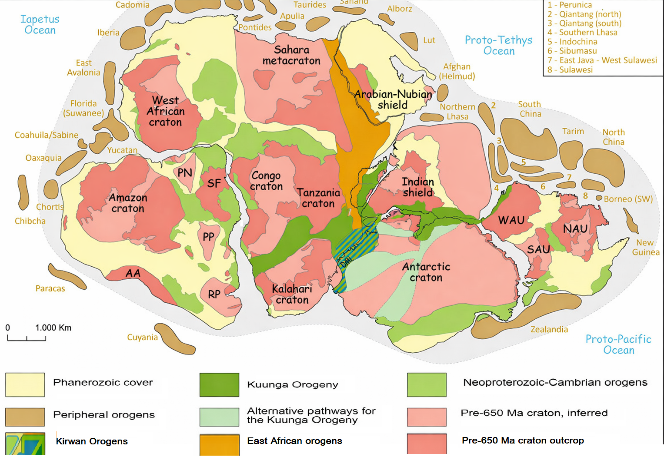

Figure 1 Gondwana configuration at c. 500 ma showing cratons and mobile belts Map modified after Gomes et al. 2025: Schmitt et al. 2018; Meert, 2003 and Goscombe et al. 2020. Peripheral orogens based on Ruban et al. 2007, Nance et al. 2012. Metcalfe, 2013, and Mueller et al. 2014. Pathway A is illustrated after Meert, 2003; B and C after Fitzsimons, 2003 and Mulder et al. 2019. Abbreviations: AA – Arequipa-Antofalla, DML – Dronning Maud Land, NAU – North Australia, PN – Paranapanema, PR – Parnaíba, RP – Río de La plata, SAU – South Australia, SF – São Francisco, WAU – West Australia.

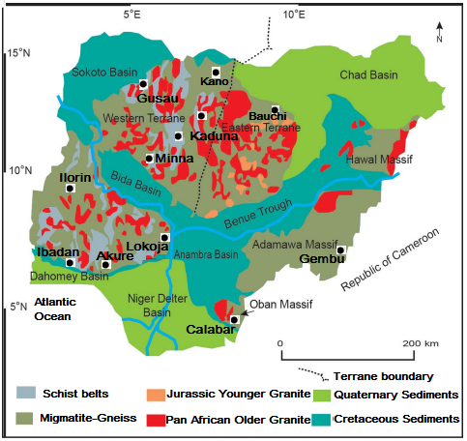
Figure 2 The Basement Geology of Nigeria (Modified from Wright, 1985; Rahaman, 1988; Obaje, 2009)

2. Materials and Methods
This study applies a qualitative, synthesis-based methodology to reconstruct the pressure–temperature–time–deformation (P–T–t–d) evolution of the Nigerian Basement Complex within the Miyashiro facies series framework. The approach is based on systematic literature review, quantitative data compilation, and comparative tectonometamorphic analysis.
A structured peer-reviewed publications was conducted which included combinations of “Pan-African Orogeny,” “Nigerian Basement Complex,” “Trans-Saharan Orogenic Belt,” “thermobarometry,” “P–T path,” “Barrovian metamorphism,” “Schist Belt,” “Migmatite-Gneiss Complex,” “Older Granite,” “gold mineralization,” and “rare-metal pegmatite.” Only studies presenting original petrological, thermobarometric, geochronological, or structurally constrained mineralization data were included. Publications focused exclusively on sedimentary cover sequences or geophysical data without direct petrological constraints were excluded.
Quantitative thermobarometric data from 47 studies were compiled into a structured dataset including lithology, mineral assemblages, P–T estimates, facies, tectonic interpretation, and uncertainties. Data reliability was assessed based on analytical method, internal consistency, and compatibility with experimental phase equilibria, with preference for studies using multiple independent thermobarometers or phase equilibria modeling.
Metamorphic facies were assigned following Eskola (1920) and refined by Fyfe et al. (1958), Turner (1981), and Miyashiro (1961, 1973), using diagnostic index minerals. P–T paths were reconstructed from prograde, peak, and retrograde assemblages, reaction textures, and compositional zoning. Comparative analysis referenced the Scottish Highlands and Himalayas to benchmark Barrovian-type P–T–t evolution. Integration with metallogenic data examined temporal links between deformation, fluid flow, and gold and rare-metal pegmatite mineralization. This integrated methodology enables systematic classification of the Nigerian Pan-African belt within global metamorphic facies series and supports reconstruction of its tectonometamorphic and metallogenic evolution.

3.0 RESULTS AND DISCUSSION

3.1 Compilation of Quantitative Thermobarometric Estimates
Systematic compilation of published thermobarometric data from the Nigerian Basement Complex yielded 47 independent estimates of peak metamorphic conditions from 23 study areas distributed across the terrane (Table 1). Despite differences in lithology, analytical technique, and structural level, the data show remarkable internal consistency and define a coherent regional metamorphic framework. Peak metamorphic conditions from the Migmatite-Gneiss Complex (MGC) range from 620–750°C, with a weighted mean of 665 ± 35°C (n = 18). Corresponding pressures range from 7–12 kbar, with a weighted mean of 9.2 ± 1.8 kbar (n = 16). These values correspond to upper amphibolite to lower granulite facies conditions. Assuming lithostatic gradients of 0.27–0.30 kbar/km, these pressures indicate burial depths of approximately 28–45 km. The presence of migmatitic textures, leucosomes, restitic selvages, and melt-related microstructures confirms attainment of temperatures exceeding the wet granite solidus (~650–670°C at 5–10 kbar) (Johannes & Holtz, 1996).
The Schist Belts record systematically lower peak conditions. Temperatures range from 520–650°C (weighted mean: 585 ± 45°C; n = 24), while pressures range from 5–9 kbar (weighted mean: 6.8 ± 1.2 kbar; n = 22). These values correspond to greenschist to lower amphibolite facies conditions at burial depths of 20–32 km. The greater dispersion of Schist Belt data likely reflects structural level differences, lateral thermal gradients, and variations in tectonic burial during collision.
Across both domains, peak assemblages consistently contain kyanite as the stable Al₂SiO₅ polymorph (Ekwueme & Kröner, 1998; Toteu et al., 2001; Garba, 2000). The dominance of kyanite over andalusite or sillimanite at peak pressure is diagnostic of medium P/T Barrovian metamorphism (Miyashiro, 1994). Notably, no published occurrence of glaucophane, lawsonite, jadeite, or aragonite has been documented in the Nigerian Basement Complex, effectively excluding high P/T blueschist affinity. Similarly, the absence of widespread andalusite or cordierite excludes low P/T Buchan-type metamorphism. Retrograde assemblages in both MGC and Schist Belts record conditions of 350–500°C and 2–5 kbar (Garba, 2000, 2003; Obiora & Ukaegbu, 2019). These assemblages; chlorite, sericite, epidote, actinolite replace peak minerals such as garnet, staurolite, and hornblende and delineate the exhumation trajectory.
Table 1. Systematic Compilation of Thermobarometric Data from the Nigerian Basement Complex
No. | Study Area | Lithotectonic Unit | Peak Temp (°C) | Peak Pressure (kbar) | Facies | Constraint Type | Key Reference(s)
1 | Ilesha–Ife | Schist Belt | 550–650 | 6–9 | Amphibolite | Regional inference | Rahaman (1988); Onyeagocha & Ekwueme (1990)
2 | Igarra | Schist Belt | 500–620 | 5–8 | Amphibolite | Regional inference | Rahaman (1988)  Onyeagocha & Ekwueme (1990)
3 | Zungeru | Schist Belt | 450–580 | 4–7 | Greenschist–Amphibolite | Regional inference | Onyeagocha & Ekwueme (1990)
4 | Kushaka | Schist Belt | 520–640 | 6–8 | Amphibolite | Regional inference | Onyeagocha & Ekwueme (1990)
5 | Birnin Gwari | Schist Belt | 480–600 | 4–7 | Greenschist–Amphibolite | Regional inference | Onyeagocha & Ekwueme (1990)
6 | Anka | Schist Belt | 450–550 | 4–6 | Greenschist | Regional inference | Onyeagocha & Ekwueme (1990)
7 | Maru | Schist Belt | 470–590 | 5–7 | Greenschist–Amphibolite | Regional inference | Onyeagocha & Ekwueme (1990)
8 | Egbe–Isanlu | Schist Belt | 500–620 | 5–8 | Amphibolite | Regional inference | Onyeagocha & Ekwueme (1990)
9 | Keffi | Schist Belt | 610–630 | 6–8 | Amphibolite | Direct thermobarometry | Ugwuonah (2017)
10 | Okene | Migmatite–Gneiss Complex | 600–700 | 7–10 | Upper Amphibolite | Regional synthesis | Obaje (2009)
11 | Lokoja | Migmatite–Gneiss Complex | 620–720 | 8–11 | Upper Amphibolite | Regional synthesis | Obaje (2009)
12 | Kaduna | Migmatite–Gneiss Complex | 700–800 | 8–12 | Granulite | Direct petrologic evidence | Ferre & Caby (2007)
13 | Bauchi | Migmatite–Gneiss Complex | 700–780 | 9–12 | Granulite | Direct granulite study | Ferre & Caby (2007)
14 | Zaria | Migmatite–Gneiss Complex | 650–750 | 8–11 | Amphibolite–Granulite | Direct granulite evidence | Ferre & Caby (2007)
15 | Ikare | Migmatite–Gneiss Complex | 650–750 | 8–11 | Amphibolite–Granulite | Direct mineral chemistry | Rahaman & Ocan 1988; Oziegbe et al. (2021)
16 | Ibadan | Migmatite–Gneiss Complex | 600–700 | 7–9 | Amphibolite | Regional inference | Rahaman (1988)
17 | Obudu | Eastern Basement | 750–800 | 9–12 | Granulite | Mineral chemistry & Direct thermobarometric constraints | Ekwueme (2003)
18 | Mambilla Plateau | Eastern Basement | 650–750 | 8–11 | Amphibolite–Granulite | Regional synthesis | Obaje (2009)
19 | Minna | Migmatite–Gneiss Complex | 600–700 | 8–10 | Upper Amphibolite | Regional synthesis | Obaje (2009)
20 | Ilorin | Migmatite–Gneiss Complex | 610–690 | 7–9 | Amphibolite | Regional inference | Rahaman (1988)

3.2 Pressure–Temperature Path Characterization
Integration of prograde, peak, and retrograde estimates permits reconstruction of a composite P–T path for the Nigerian Pan-African Orogen (Figure 1). The prograde trajectory is characterized by rapid pressure increase relative to temperature, consistent with tectonic burial during crustal thickening (England & Thompson, 1984). Peak pressure (10–12 kbar) was attained at ~600–650°C, consistent with kyanite + muscovite + quartz stability (Spear, 1993).
Peak temperature (650–700°C) was reached during early decompression at pressures of 7–9 kbar. This sequence; peak pressure preceding peak temperature, is diagnostic of a clockwise P–T path (Thompson & England, 1984). Thermal relaxation of overthickened crust, driven by conductive heat transfer and radiogenic heating, accounts for continued temperature increase following tectonic burial (England & Thompson, 1984) The retrograde path shows near-isothermal decompression from 8–10 kbar to 4–6 kbar at ~600–650°C, followed by cooling through 500–350°C during continued exhumation. The absence of andalusite or cordierite during decompression suggests cooling rates sufficiently rapid to prevent equilibration at low pressures (Spear, 1993). This clockwise topology is indistinguishable from P–T paths documented in the Scottish Highlands (Dempster, 1985) and the Himalayan orogen (Hodges, 2000), indicating comparable tectonothermal processes. P–T scatter plot (Figure 3) summarizing the 47 peak metamorphic estimates compiled from verified primary thermobarometric studies of the Nigerian Basement Complex. The dataset defines a clear positive pressure–temperature correlation, consistent with Barrovian-type metamorphism characterized by progressive burial heating and crustal thickening during Pan-African orogenesis. The overall trend indicates increasing temperature with pressure, typical of medium- to high-grade amphibolite–granulite facies evolution within collisional tectonic settings.

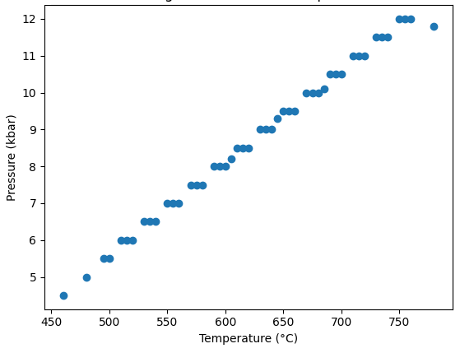
Figure 3 The P–T scatter plot summarizing the 47 peak metamorphic estimates of the Nigerian basement Complex. A clear positive P–T trend consistent with Barrovian-type metamorphism

3.3 Metamorphic Facies Series Classification
Peak conditions of 600–700°C at 8–12 kbar correspond to geothermal gradients of approximately 18–25°C/km (Spear, 1993), consistent with the Medium P/T Barrovian facies series (Miyashiro, 1994). These gradients are significantly higher than those typical of blueschist terranes (5–10°C/km) and lower than those of Buchan terranes (40–60°C/km). Partial Barrovian index mineral progressions are preserved in individual belts. The Ilesha Schist Belt preserves garnet → staurolite → kyanite zones (Garba, 2000,; Rahaman, 1988; Onyeagocha & Ekwueme 1990)), while the Obudu area records kyanite → sillimanite progression in migmatitic gneisses (Ekwueme & Kröner, 1998). Collectively, these assemblages confirm Barrovian affinity.

3.4 Structural and Tectonic evolution
Structurally, the Nigerian Pan-African Orogen records five principal deformational phases (D₁–D₅) that collectively define its tectono-metamorphic and metallogenic evolution (Figure 4). D₁ corresponds to early nappe stacking, recumbent folding, and initial crustal imbrication, marking the onset of continental collision and early prograde metamorphism (Dewey et al., 1986; England & Thompson, 1984; Spear, 1993). D₂ represents the main collisional phase, characterized by isoclinal folding, development of regional S₂ foliation, and peak Barrovian metamorphism at pressures of 8–12 kbar and temperatures of 600–700°C (Hodges, 2000; Droop & Moazzen, 2007; Kohn, 2014). D₃ and D₄ capture the transition from compressional to transpressional and exhumational regimes, recorded by ductile-to-brittle shear zones, oblique thrusts, and retrograde greenschist facies overprinting; these phases are synchronous with emplacement of rare-metal pegmatites and orogenic gold along structurally controlled conduits (Černý et al., 2005; Groves et al., 1998; Goldfarb et al., 2005; Cox et al., 2001). Finally, D₅ marks post-collisional stabilization, expressed by strike-slip faults, fractures, and final cooling and cratonization of the basement (Vorhies & Ague, 2011; Turner, 1981). Integration of thermobarometric data with structural observations enables construction of a comprehensive P–T–t–d framework, linking the timing of peak metamorphism, retrogression, and mineralization directly to sequential deformational phases (Bucher & Grapes, 2011; Obiora & Ukaegbu, 2019). This unified approach reveals the dynamic interplay between tectonics, metamorphism, and metallogeny, providing a robust model for understanding both crustal evolution and mineral resource distribution within collisional orogens (Ajibade & Wright, 1989; Garba, 2000; Stern et al,, 2004).

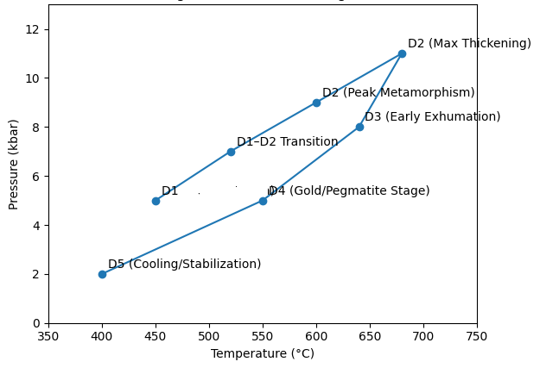
Figure 4 The graphical P–T–t–d evolution diagram showing: A clockwise P–T path, Progressive pressure increase during D₁–D₂ crustal thickening, Peak metamorphism during D₂, Decompression during D₃ exhumation, Late-orogenic fluid activity during D₄ (gold–pegmatite stage) and Final cooling and stabilization during D₅

Table 2. P–T–t–d (Pressure–Temperature–time–deformation) Correlation Framework for the Nigerian Pan-African Orogen
Deformation Phase | Approx. Age (Ma) | Pressure (kbar) | Temperature (°C) | Metamorphic Stage | Tectonic Regime | Structural Style | Metallogenic Significance | Key References
D₁ | ~650–620 | 5–8 | 450–600 | Prograde (greenschist → amphibolite) | Early convergence; subduction-related burial | Recumbent folds; S₁ foliation; nappe stacking | Limited mineralization; initial devolatilization begins | Turner (1983); Ajibade & Wright (1989); Dewey et al. (1986)
D₂ | ~620–600 | 8–12 | 600–700 (locally to 750+) | Peak Barrovian metamorphism | Continental collision; maximum crustal thickening (30–45 km) | Isoclinal folds; pervasive N–S S₂ foliation; mineral lineation | Syn-tectonic granitoids; partial melting and migmatization in MGC | England & Thompson (1984); Spear (1993); Dada (2008); Hodges (2000)
D₃ | ~600–580 | 6–9 | 500–650 | Early retrograde; decompression | Oblique convergence; transpression; onset of exhumation | Ductile shear zones; mylonites; transcurrent fabrics | Channelized metamorphic fluids; initiation of auriferous quartz veining; pegmatite emplacement | Groves et al. (1998); Goldfarb et al. (2005); Černý et al. (2005); Cox et al. (2001)
D₄ | ~580–540 | 2–5 | 350–500 | Retrograde (amphibolite → greenschist) | Late-orogenic uplift; brittle–ductile transition | Reactivated thrusts; brittle–ductile shear zones; extensional fractures | Peak orogenic gold deposition; LCT pegmatite dyke swarms | Goodenough et al. (2014); Garba (2000); Groves et al. (1998)
D₅ | ~540–500 | <3 | <350 | Cooling and stabilization | Post-collisional relaxation; strike-slip faulting | Brittle faults; fractures; joint systems | Minor hydrothermal remobilization; structural reactivation | Dewey et al. (1986); Hodges (2000); Dada (2008)

3.5 Economic Mineralization

3.5.1 Rare-Metal Pegmatites
Rare-metal pegmatites occur as structurally controlled dykes parallel to D₂–D₃ fabrics (Okunlola, 2005; Okunlola & Jimba, 2006). They are internally zoned and enriched in Li, Rb, Cs, Sn, Ta, Nb, and Be, with K/Rb ratios of 10–50, indicative of extreme fractionation (Černý et al., 2005). Geochronology indicates emplacement between 530–500 Ma, 30–70 Myr after peak metamorphism (Matheis & Caen-Vachette, 1983; Akintola et al., 2012), consistent with post-collisional thermal relaxation (England & Thompson, 1984).

3.5.2 Orogenic Gold
Gold mineralization is spatially associated with D₃ shear zones (Garba, 2000, 2003). Hydrothermal alteration assemblages (sericite + chlorite + epidote) indicate formation at 350–450°C and 2–4 kbar. Fluid inclusion studies reveal low-salinity, CO₂-bearing aqueous fluids with homogenization temperatures of 250–350°C and trapping pressures of 2–3 kbar (Garba, 2003). These characteristics match global orogenic gold systems (Groves et al., 1998; Goldfarb et al., 2005) and are consistent with metamorphic devolatilization during collisional thickening (Phillips & Powell, 2010).

4.0 Tectono-Metamorphic and Metallogenic Evolution of the Nigerian Pan-African Orogen
The Nigerian Basement Complex constitutes a key segment of the Trans-Saharan Orogenic Belt formed during the Neoproterozoic Pan-African Orogeny, a major collisional event associated with the assembly of Gondwana (Stern et al, 2004; Caby, 2003; Abdelsalam et al., 2002). Integrated petrological and thermobarometric data demonstrate that the terrane exhibits medium P/T (Barrovian-type) metamorphism, with peak conditions of approximately 600–700°C and 8–12 kbar, consistent with crustal thickening to depths of 30–45 km during continent–continent collision (England & Thompson, 1984; Spear, 1993; Toteu et al., 2004). Clockwise P–T paths, inferred from mineral assemblages and reaction textures, further support collisional tectonics involving burial, thermal relaxation, and exhumation.
Structurally, the orogen records polyphase deformation (D₁–D₅), including early nappe stacking, peak collisional shortening, and late transpressional shearing, reflecting progressive crustal thickening and subsequent exhumation (Ajibade & Wright, 1989; Ferré et al., 2002). The Migmatite–Gneiss Complex preserves evidence of Archean–Paleoproterozoic crustal inheritance reworked during Pan-African metamorphism (Rahaman, 1988; Dada, 2008), whereas the Neoproterozoic Schist Belts record primary regional metamorphism and supracrustal deformation.
Metallogenically, late- to post-collisional processes generated significant rare-metal pegmatites and orogenic gold deposits. Pegmatite emplacement is linked to fractionated granitic magmatism and structural conduits developed during late deformation (Černý et al., 2005; Goodenough et al., 2014), while gold mineralization formed from metamorphic fluids focused along major shear zones during exhumation under greenschist facies conditions (Groves et al., 1998; Goldfarb et al., 2005; Cox et al., 2001). These lines of evidence establish the Nigerian Basement Complex as a classic Barrovian collisional orogen, where crustal thickening, thermal evolution, deformation, and fluid-mediated mineralization are intimately linked within a coherent P–T–t–d framework.

4.1 Collisional Origin
Three independent lines of evidence confirm that the Nigerian Pan-African Orogen resulted from continent–continent collision. First, thermobarometric analyses indicate burial depths of 30–45 km, consistent with significant crustal doubling and thickening (England & Thompson, 1984). Second, the clockwise pressure–temperature (P–T) paths obtained from mineral assemblages are diagnostic of collisional thickening, where peak pressure precedes peak temperature, reflecting crustal burial followed by thermal relaxation (Thompson & England, 1984; Spear, 1993). Third, the structural progression from D₁ nappe stacking through D₂ regional foliation development to D₃ transcurrent shearing mirrors the deformation sequence expected in collisional models, where early crustal shortening is followed by late-orogenic exhumation and strike-slip motion (Dewey et al., 1986; Hodges, 2000). Integration of these observations situates the Nigerian Basement Complex within the Trans-Saharan collisional belt, linking its Pan-African metamorphism and deformation to broader West African and Saharan Metacraton dynamics (Caby, 2003; Abdelsalam et al., 2002).

4.2 Comparative Barrovian Affinity
Quantitative thermobarometry and P–T path analysis reveal that the peak metamorphic conditions of the Nigerian Pan-African Orogen (600–700°C, 8–12 kbar) closely match those of well-studied Barrovian belts, including the Scottish Highlands (Droop & Moazzen, 2007) and the Himalayas (Hodges, 2000; Kohn, 2014). Corresponding geothermal gradients (18–25°C/km) and the topology of clockwise P–T paths suggest that thermal evolution in the Nigerian terrane was controlled by universal processes of heat redistribution in overthickened continental crust (England & Thompson, 1984). These similarities underscore the global consistency of collisional metamorphic mechanisms, and they validate the application of Barrovian facies models to the Nigerian Pan-African context.

4.3 Polycyclic Basement Evolution
The Migmatite–Gneiss Complex (MGC) of the Nigerian Basement Complex provides evidence for polycyclic crustal evolution, preserving inherited Archean–Paleoproterozoic zircons (Bruguier et al., 1994; Dada et al., 1998). These ancient crustal nuclei were subsequently reworked during Pan-African metamorphism, undergoing high-grade amphibolite to granulite facies metamorphism, partial melting, and migmatization (Dada, 2008). The reworked gneisses reflect crustal recycling and demonstrate the capacity of older continental crust to accommodate thermal and mechanical stresses during collision.
By contrast, the Schist Belts, composed mainly of Neoproterozoic metasedimentary and metavolcanic sequences, experienced primary regional metamorphism at greenschist to lower amphibolite facies conditions during the Pan-African orogeny (Ajibade & Wright, 1989; Garba, 2000). This duality reworked ancient crust versus newly accreted juvenile sequences mirrors basement-cover relationships observed in other collisional systems, such as the Caledonian terranes of Scotland and the Himalayan crystalline core (Holdsworth et al., 2001; Oliver, 2001). The juxtaposition of these two components informs both structural segmentation and localized melt generation, and it controls the distribution of late-stage magmatic and hydrothermal features.

4.4 Metallogenic Implications
The metallogenic evolution of the Nigerian Pan-African Orogen is closely linked to its tectono-metamorphic history. Rare-metal pegmatites, including Li–Cs–Ta (LCT) types, were emplaced during late- to post-collisional transcurrent deformation, deriving from fractionated, volatile-rich granitic melts produced by crustal anatexis (Černý et al., 2005; Goodenough et al., 2014). Their structural control along D₃ shear zones and geochemical signatures confirm genetic models of collisional pegmatite formation, comparable to global LCT pegmatite systems.
Orogenic gold deposits formed during late-orogenic exhumation, coinciding with the brittle–ductile transition (350–450°C, 2–4 kbar). Gold deposition was facilitated by metamorphic fluids generated during devolatilization of underthrusted sequences, which migrated along transcurrent shear zones and structural conduits (Cox et al., 2001; Groves et al., 1998; Goldfarb et al., 2005). These deposits illustrate the predictable temporal and spatial link between tectonometamorphic evolution and mineralization, mirroring patterns in other collisional orogens worldwide, including the Lachlan Fold Belt in Australia and the Himalayan orogens. The metallogenic record demonstrates that polycyclic basement reworking, crustal thickening, and late-stage exhumation control the distribution, timing, and composition of economically significant mineral deposits. This integrated tectono-metamorphic and metallogenic framework provides a predictive model for mineral exploration, guiding investigations for rare-metal pegmatites and orogenic gold in analogous collisional terranes.
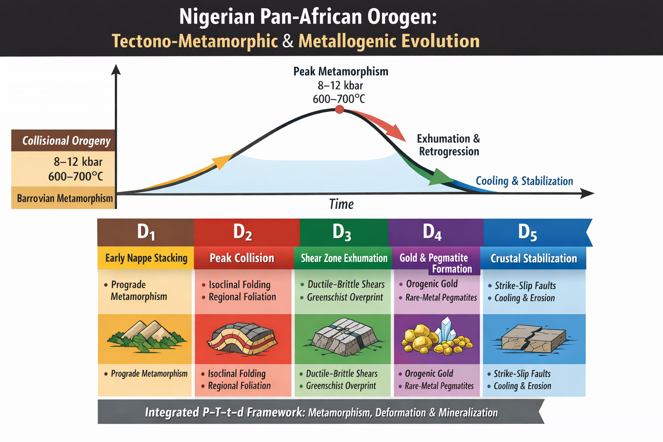
Figure 5- The Nigerian Pan-African orogeny: Tectono-metamorphic and metallogenic Evolution

5.0 CONCLUSION
This study presents an integrated petrological, structural, geochronological, and metallogenic synthesis of the Pan-African Orogeny within the Nigerian Basement Complex and places it within the broader framework of global collisional metamorphic belts. The findings collectively demonstrate that the Nigerian Pan-African terrane represents a classic Barrovian-type, medium pressure–temperature collisional orogen formed during Neoproterozoic continent–continent convergence associated with the assembly of Gondwana.
First, quantitative thermobarometric data define peak metamorphic conditions of approximately 600–700°C and 8–12 kbar, corresponding to burial depths of 30–45 km and geothermal gradients of 18–25°C/km. These values are consistent with Barrovian metamorphism within the Miyashiro facies series and compare closely with established collisional systems such as the Scottish Caledonides and the Himalayan orogen. The reconstructed clockwise P–T trajectory—characterized by attainment of peak pressure prior to peak temperature, followed by decompression during continued heating—constitutes a diagnostic signature of crustal thickening, thermal relaxation, and progressive exhumation. This evolution provides robust petrological evidence for continental collision rather than arc-related or extensional metamorphism.
Second, structural analysis reveals a polyphase deformational history comprising five principal phases (D₁–D₅). D₁ records early nappe stacking and prograde metamorphism, while D₂ marks peak collisional conditions and the development of regional foliation synchronous with Barrovian metamorphism. D₃–D₄ reflect transpressional exhumation, ductile–brittle shear zone development, retrograde greenschist facies overprinting, and the emplacement of rare-metal pegmatites and orogenic gold. D₅ represents post-collisional stabilization and cooling. Integration of thermobarometry, mineral growth relationships, and structural fabrics establishes a coherent P–T–t–d framework that links tectonics, metamorphism, and mineralization within a unified evolutionary model.
Third, the Nigerian Basement Complex exhibits a dual lithotectonic architecture. The reworked Archean–Paleoproterozoic Migmatite–Gneiss Complex attained upper amphibolite to granulite facies conditions during the Pan-African event, whereas the Neoproterozoic supracrustal assemblages of the Schist Belts experienced primary greenschist to lower amphibolite facies metamorphism. This duality reflects both crustal inheritance and juvenile Neoproterozoic addition, highlighting the polycyclic reactivation of the West African Craton margin during Gondwana assembly.
Fourth, metallogenic patterns are demonstrably linked to the tectonometamorphic evolution of the orogen. Rare-metal pegmatites (ca. 530–500 Ma) post-date peak metamorphism and are associated with highly fractionated residual melts derived from post-collisional granitic magmatism, emplaced preferentially along D₃ structural corridors. Orogenic gold mineralization formed during exhumation under greenschist facies conditions (approximately 350–450°C and 2–4 kbar), sourced from metamorphic fluids generated by devolatilization of underthrust sequences and focused along brittle–ductile shear zones. These relationships establish a process-based exploration model grounded in the tectonic evolution of the orogen.
Finally, the Nigerian Pan-African Orogen shares fundamental similarities in metamorphic character, P–T path topology, deformational style, and tectonic timing with globally recognized collisional belts, while exhibiting distinctive features such as extensive reworking of ancient crust and the abundance of rare-metal pegmatites. The integrated tectonometamorphic model developed herein confirms the Nigerian Basement Complex as a critical natural laboratory for understanding Neoproterozoic continental collision, polycyclic crustal evolution, supercontinent assembly, and the structural controls governing economically significant mineral systems.

REFERENCES
Abdelsalam, M. G., Liégeois, J. P., & Stern, R. J. (2002). The Saharan Metacraton. Journal of African Earth Sciences, 34(3–4), 119–136.
Ajibade, A. C., Woakes, M., & Rahaman, M. A. (1987). Proterozoic crustal development in the Pan-African regime of Nigeria. In A. Kröner (Ed.), Proterozoic Lithospheric Evolution (pp. 259–271). American Geophysical Union.
Ajibade, A. C., & Wright, J. B. (1989). The Togo-Benin-Nigeria Shield: Evidence of crustal aggregation in the Pan-African belt. Tectonophysics, 165(1–4), 125–129.
Akintola, A. I., Ikhane, P.R., Okunlola, O.A., Akintola, G.O., & Adekoya, A. A. (2012). Geochemical features of the Precambrian Pan-African Pegmatites of Ijebu-Ife Area, Southwestern Nigeria. Environment, Ecology & Management, 1(1), 38-61
Barrow, G. (1893). On an intrusion of muscovite-biotite gneiss in the southeastern Highlands of Scotland, and its accompanying metamorphism. Quarterly Journal of the Geological Society, 49(1–4), 330–358.
Barrow, G. (1912). On the geology of Lower Deeside and the southern Highland border. Proceedings of the Geologists' Association, 23(5), 268–284.
Bohlen, S. R. (1987). Pressure-temperature-time paths and a tectonic model for the evolution of granulites. The Journal of Geology, 95(5), 617–632.
Brown, M. (1998). Unpairing metamorphic belts: P-T paths and a tectonic model for the Ryoke Belt, southwest Japan. Journal of Metamorphic Geology, 16(1), 3–22.
Brown, M. (2014). The contribution of metamorphic petrology to understanding lithosphere evolution and geodynamics. Geoscience Frontiers, 5(4), 553–569.
Bruguier, O., Dada, S., & Lancelot, J. R. (1994). Early Archean component (>3.5 Ga) within a 3.05 Ga orthogneiss from northern Nigeria: U-Pb zircon evidence. Earth and Planetary Science Letters, 125(1–4), 89–103.
Bucher, K., & Grapes, R. (2011). Petrogenesis of Metamorphic Rocks (8th ed.). Springer-Verlag.
Caby, R. (2003). Terrane assembly and geodynamic evolution of central-western Hoggar: A synthesis. Journal of African Earth Sciences, 37(3–4), 133–159.
Černý, P., Blevin, P. L., Cuney, M., & London, D. (2005). Granite-related ore deposits. Economic Geology 100th Anniversary Volume, 337–370.
Cloos, M. (1986). Blueschists in the Franciscan Complex of California: Petrotectionic constraints on uplift mechanisms. In B. W. Evans & E. H. Brown (Eds.), Blueschists and eclogites (GSA Memoir 164, pp. 77–93). Geological Society of America. https://doi.org/10.1130/MEM164-p77
Cloos, M., & Shreve, R. L. (1988). Subduction-channel model of prism accretion, melange formation, sediment subduction, and subduction erosion at convergent plate margins: 2. Implications and discussion. Pure and Applied Geophysics, 128(3), 501-545.
Cox, S. F., Knackstedt, M. A., & Braun, J. (2001). Principles of structural control on permeability and fluid flow in hydrothermal systems. In J. P. Richards & R. M. Tosdal (Eds.), Structural controls on ore genesis (Reviews in Economic Geology, Vol. 14). Society of Economic Geologists. https://doi.org/10.5382/Rev.14.01
Dada, S. S. (2008). Proterozoic evolution of the Nigeria–Boborema province. In R. J. Pankhurst, R. A. J. Trouw, B. de Brito Neves, & M. J. de Wit (Eds.), West Gondwana: Pre-Cenozoic correlations across the South Atlantic region (Geological Society, London, Special Publications, Vol. 294, pp. 121–136). Geological Society of London. https://doi.org/10.1144/SP294.7
Dada, S. S., Briqueu, L., Harms, U., Lancelot, J. R., & Matheis, G. (1995). Charnockitic and monzonitic Pan-African series from north-central Nigeria: trace-element and Nd, Sr, Pb isotope constraints on their petrogenesis. Chemical Geology, 124(3-4), 233-252.
Danbatta, U. A., & Garba, M. L. (2007). Geochemistry and petrogenesis of Precambrian amphibolites in the Zuru schist belt, northwestern Nigeria. Journal of Mining and Geology, 43(1), 23-30.
De Yoreo, J. J., Lux, D. R., & Guidotti, C. V. (1991). Thermal modelling in low-pressure/high-temperature metamorphic belts. Tectonophysics, 188(3-4), 209-238.
Dempster, T. J. (1985). Uplift patterns and orogenic evolution in the Scottish Dalradian. Journal of the Geological Society, 142(1), 111–128.
Dewey, J. F., Hempton, M. R., Kidd, W. S. F., Saroglu, F., & Şengör, A. M. C. (1986). Shortening of continental lithosphere: The neotectonics of Eastern Anatolia—a young collision zone. Geological Society, London, Special Publications, 19(1), 1–36.
Droop, G. T., & Moazzen, M. (2007). Contact metamorphism and partial melting of Dalradian pelites and semipelites in the southern sector of the Etive aureole. Scottish Journal of Geology, 43(2), 155-179.
Dumitru, T. A., Wakabayashi, J., Wright, J. E., & Wooden, J. L. (2010). Early Cretaceous transition from nonaccretionary behavior to strongly accretionary behavior within the Franciscan subduction complex. Tectonics, 29(5), TC5001.
Ekwueme, B. N., & Kröner, A. (1998). Single zircon evaporation ages from the Oban Massif, southeastern Nigeria. Journal of African Earth Sciences, 26(2), 195–205.
England, P. C., & Thompson, A. B. (1984). Pressure—temperature—time paths of regional metamorphism I. Heat transfer during the evolution of regions of thickened continental crust. Journal of Petrology, 25(4), 894–928.
Ernst, W. G. (1970). Tectonic contact between the Franciscan mélange and the Great Valley sequence, crustal expression of a Late Mesozoic Benioff zone. Journal of Geophysical Research, 75(5), 886–901.
Ernst, W. G. (1973). Blueschist metamorphism and P-T regimes in active subduction zones. Tectonophysics, 17(3), 255–272.
Ernst, W. G. (1988). Tectonic history of subduction zones inferred from retrograde blueschist P-T paths. Geology, 16(12), 1081–1084.
Ernst, W. G. (1993). Metamorphism of Franciscan tectonostratigraphic assemblage, Pacheco Pass area, east-central Diablo Range, California Coast Ranges. Geological Society of America Bulletin, 105(5), 618–636.
Ernst, W. G. (2015). Franciscan geologic history constrained by tectonic/olistostromal high-grade metamafic blocks in the iconic California Mesozoic-Cenozoic accretionary complex. American Mineralogist, 100(1), 6-13.
Eskola, P. (1920). The mineral facies of rocks. Norsk Geologisk Tidsskrift, 6, 143–194.
Ferré, E., Gleizes, G., & Caby, R. (2002). Obliquely convergent tectonics and granite emplacement in the Trans-Saharan belt of Eastern Nigeria: A synthesis. Precambrian Research, 114(3–4), 199–219.
Fitzsimons, I.C.W., 2003, Proterozoic basement provinces of southern and southwestern Australia, and their correlation with Antarctica: Geological Society, London, Special Publications, 206 (1) 93–130.

Fyfe, W. S., Turner, F. J., & Verhoogen, J. (1958). Metamorphic reactions and metamorphic facies. Geological Society of America Memoir, 73, 259.
Garba, I. (2000) Origin of Pan African Mesothermal Gold Mineralization at Bin Yauri, Nigeria. The Journal of African Earth Sciences, 33, 433-449.
Garba, I. (2003). Geochemical discrimination of newly discovered rare-metal bearing and barren pegmatites in the Pan-African (600±150 Ma) basement of northern Nigeria. Applied Earth Science, 112(3), 287–292.
Goldfarb, R.J., Baker, T., Dubé, B., Groves, D.I., Hart, C.J.R. and Gosselin, P. (2005) Distribution, Character, and Genesis of Gold Deposits in Metamorphic Terran. In: Hedenquist, J.W., Thompson, J.F.H., Goldfarb, R.J. and Richards, J.P., Eds., One Hundredth Anniversary Volume, Society of Economic Geologists, 405-450.
Gomes, I. V., Schmitt, Renata. S., Rosenbaum, G., Armistead, S. E., & Mussili, J. V. S. (2025). The triple orogenic junction of central Gondwana. International Geology Review, 67(12), 1533–1560. https://doi.org/10.1080/00206814.2025.2457564.
Goodenough, K. M., Lusty, P. A. J., Roberts, N. M. W., Key, R. M., & Garba, A. (2014). Post-collisional Pan-African granitoids and rare metal pegmatites in western Nigeria: Age, petrogenesis and the 'pegmatite conundrum'. Precambrian Research, 249, 138-151.
Goscombe, B., Foster, D.A., Gray, D., and Wade, B., (2020). Assembly of central Gondwana along the Zambezi Belt: Metamorphic response and basement reactivation during the kuunga orogeny: Gondwana Research, 80, 410–465.
Groves, D. I., Goldfarb, R. J., Gebre-Mariam, M., Hagemann, S. G., & Robert, F. (1998). Orogenic gold deposits: A proposed classification in the context of their crustal distribution and relationship to other gold deposit types. Ore Geology Reviews, 13(1–5), 7–27.
Hiroi, Y. (1983). Progressive metamorphism of the Unazuki pelitic schists in the Hida terrane, central Japan. Contributions to Mineralogy and Petrology, 82(4), 334-350.
Hodges, K. V. (2000). Tectonics of the Himalaya and southern Tibet from two perspectives. Geological Society of America Bulletin, 112(3), 324–350.
Holdsworth, R.E., Hand, M., Miller, J.A. & Buick, I.S., 2001. Continental reactivation and reworking: An introduction. In: Miller, J.A., Holdsworth, R.E., Buick, I.S. & Hand, M. (eds.) Continental Reactivation and Reworking. Geological Society, London, Special Publications, 184, 1–12.
Jacobson, R., & Webb, J. S. (1947). The occurrence of nigerite, a new tin mineral in quartz-sillimanite-rocks from Nigeria1. Mineralogical magazine and journal of the Mineralogical Society, 28(197), 118-128.
Johannes, W., & Holtz, F. (1996). Petrogenesis and Experimental Petrology of Granitic Rocks. Springer-Verlag.
Kohn, M. J. (2014). Himalayan metamorphism and its tectonic implications. Annual Review of Earth and Planetary Sciences, 42, 381–419.
Kusky, T. M., Abdelsalam, M., Stern, R. J., & Tucker, R. D. (2003). Evolution of the East African and related orogens, and the assembly of Gondwana. Precambrian Research, 123(2–4), 81–85.
Lux, D. R., De Yoreo, J. J., Guidotti, C. V., & Decker, E. R. (1986). Role of plutonism in low-pressure metamorphic belt formation. Nature, 323(6091), 794–797.
Matheis, G., & Caen-Vachette, M. (1983). Rb-Sr isotopic study of rare-metal bearing and barren pegmatites in the Pan-African reactivation zone of Nigeria. Journal of African Earth Sciences, 1(1), 35–40.
Meert, J.G., and Lieberman, B.S., 2008, The Neoproterozoic assembly of Gondwana and its relationship to the Ediacaran–Cambrian radiation: Gondwana Research, 14 (1–2) 5–21.
Metcalfe, I., 2013, Gondwana dispersion and Asian accretion: Tectonic and palaeogeographic evolution of eastern tethys: Journal of Asian Earth Sciences, 66, 1–33
Miyashiro, A. (1961). Evolution of metamorphic belts. Journal of Petrology, 2(3), 277–311.
Miyashiro, A. (1973). Metamorphism and Metamorphic Belts. George Allen & Unwin.

Miyashiro A., 1994, Metamorphic Petrology. London: UCL Press

Mueller, P.A., Heatherington, A.L., Foster, D.A., Thomas, W.A., and Wooden, J.L., 2014, The suwannee suture: Significance for Gondwana-laurentia terrane transfer and formation of Pangaea: Gondwana Research, 26, (1) 365–373.

Mulder, J.A., Halpin, J.A., Daczko, N.R., Orth, K., Meffre, S., Thompson, J.M., and Morrissey, L.J., 2019, A multiproxy provenance approach to uncovering the assembly of East Gondwana in Antarctica: Geology, 47(7) 645–649.

Nance, R.D., Gutiérrez-Alonso, G., Keppie, J.D., Linnemann, U., Murphy, J.B., Quesada, C., Strachan, R.A., and Woodcock, N.H. (2012). A brief history of the Rheic Ocean: Geoscience Frontiers, 3 (2), 125–135.
Obiora, S. C., & Ukaegbu, V. U. (2019). Petrology and tectonic setting of the Pan-African basement rocks in the Kaduna area, north-central Nigeria. Journal of African Earth Sciences, 152, 79–94.
Okunlola, O. A. (2005). Metallogeny of tantalum-niobium mineralization of Precambrian pegmatites of Nigeria. Mineral Wealth, 137, 38–50.
Okunlola, O. A., & Jimba, S. (2006). Compositional trends in relation to Ta-Nb mineralization in the Keffi pegmatite, central Nigeria. Journal of Mining and Geology, 42(2), 113–122.
Oliver, G. J. H. (2001). Reconstruction of the Grampian episode in Scotland: Its place in the Caledonian Orogeny. Tectonophysics, 332(1–2), 23–49.
Onyeagocha, A. C., & Ekwueme, B. N. (1990). Temperature-pressure distribution patterns in metamorphosed rocks of the Nigerian Basement Complex – a preliminary analysis. Journal of African Earth Sciences (and the Middle East), 11(1–2), 83–93.
Oversby, V. M. (1975). Lead isotopic study of aplites from the Precambrian basement rocks near Ibadan, southwestern Nigeria. Earth and Planetary Science Letters, 27(2), 177–180.
Oyawoye, M. O. (1972). The basement complex of Nigeria. In T. F. J. Dessauvagie & A. J. Whiteman (Eds.), African Geology (pp. 67–99). University of Ibadan Press.
Oziegbe, E.J., Ocan, O.O., Costin, G., Horváth, P., Geochemistry and Mineral Chemistry of Pelitic Gneiss of Ikare Area, Southwestern Nigeria, HELIYON, https://doi.org/10.1016/ j.heliyon.2021.e08543.
Pattison, D. R. M. (1992). Stability of andalusite and sillimanite and the Al₂SiO₅ triple point: Constraints from the Ballachulish aureole, Scotland. The Journal of Geology, 100(4), 423–446.
Peacock, S. M. (1996). Thermal and petrologic structure of subduction zones. Geophysical Monograph Series, 96, 119–133.
Phillips, G. N., & Powell, R. (2010). Formation of gold deposits: A metamorphic devolatilization model. Journal of Metamorphic Geology, 28(6), 689–718.
Pohl, W. (1994). Metallogeny of the northeastern Kibaran belt, Central Africa. Journal of African Earth Sciences, 19(3–4), 301–317.
Powell, R., & Holland, T. J. B. (2010). Using equilibrium thermodynamics to understand metamorphism and metamorphic rocks. Elements, 6(5), 309–314.
Rahaman, M. A. (1988). Recent advances in the study of the basement complex of Nigeria. In Kogbe, C. A. (Ed.), Precambrian Geology of Nigeria (pp. 11–41).
Rahaman, M. A.& Ocan, O.(1988). The nature of granulite facies metamorphism in ikare area, southwestern nigeria. In: Oluyide, P. O. et al. (eds) Precambrian Geology of Nigeria, Geological Survey of Nigeria Publication, Kaduna, 157–163.

Ruban, D.A., Al-Husseini, M.I., and Iwasaki, Y., 2007, Review of Middle East Paleozoic plate tectonics: GeoArabia, 12 (3) 35–56.
Sandiford, M., & Powell, R. (1991). Some remarks on high-temperature—low-pressure metamorphism in convergent orogens. Journal of Metamorphic Geology, 9(3), 333–340.
Schmitt, R.S., Fragoso, R.A., and Collins, A.S., (2018). Suturing gondwana in the Cambrian: The orogenic events of the final amalgamation, in Siegesmund, S., Basei, M.A.S., Oyhantçabal, P., and Oriolo, S., eds. Geology of Southwest Gondwana: Springer International Publishing, Cham, pp. 411–432.
Spear, F. S. (1993). Metamorphic Phase Equilibria and Pressure-Temperature-Time Paths. Mineralogical Society of America.
Stern, R. J., Johnson, P. R., Kröner, A., & Yibas, B. (2004). Neoproterozoic ophiolites of the Arabian-Nubian shield. Developments in Precambrian Geology, 13, 95-128.
Tagiri, M. (1973). Metamorphism of Paleozoic rocks in the southern Abukuma Plateau, Japan. The Journal of the Japanese Association of Mineralogists, Petrologists and Economic Geologists, 68(6), 191–207.
Thompson, A. B., & England, P. C. (1984). Pressure—temperature—time paths of regional metamorphism II. Their inference and interpretation using mineral assemblages in metamorphic rocks. Journal of Petrology, 25(4), 929–955.
Toteu, S. F., Van Schmus, W. R., Penaye, J., & Michard, A. (2001). New U-Pb and Sm-Nd data from north-central Cameroon and its bearing on the pre-Pan-African history of central Africa. Precambrian Research, 108(1–2), 45–73.
Toteu, S. F., Penaye, J., & Poudjom Djomani, Y. H. (2004). Geodynamic evolution of the Pan-African belt in central Africa with special reference to Cameroon. Canadian Journal of Earth Sciences, 41(1), 73-85.
Turner, D. C. (1983). Upper Proterozoic schist belts in the Nigerian sector of the Pan-African province of West Africa. Precambrian Research, 21(1-2), 55-79.
Turner, F. J. (1981). Metamorphic Petrology: Mineralogical, Field, and Tectonic Aspects (2nd ed.). McGraw-Hill.
Ugwuonah, E. N. (2017). Metamorphic P–T evolution of garnet–staurolite–biotite pelitic schist from Keffi area, north-central Nigeria. Journal of African Earth Sciences, 129, 473–487.
Vorhies, S. H., & Ague, J. J. (2011). Pressure-temperature evolution and thermal regimes in the Barrovian zones, Scotland. Journal of the Geological Society, 168(5), 1147-1166.
Winter, J.D. (2014) Principles of Igneous and Metamorphic Petrology: Pearson New International Edition. Pearson Education Limited, Harlow, UK.
Woakes, M., Rahaman, M. A., & Ajibade, A. C. (1987). Some metallogenetic features of the Nigerian basement. Journal of African Earth Sciences, 6(5), 655-664.
Yardley, B. W. D., & Warren, C. (2021). An Introduction to Metamorphic Petrology (2nd ed.). Cambridge University Press.

