Original Research Article
Physical And Chemical Properties of Synthesized Polyurethane from Starches

ABSTRACT
The advancement of sustainable polyurethanes (PUs) derived from renewable resources is imperative for mitigating environmental degradation and diminishing dependence on fossil fuels. This research investigates the synthesis and characterization of bio-based polyurethane (PU) foams. The foams are synthesized utilizing toluene diisocyanate (TDI) in conjunction with polyols procured from locally sourced Nigerian starches, specifically corn, cassava, and cocoyam. The foams underwent meticulous analysis employing Fourier Transform Infrared (FTIR) spectroscopy, Differential Scanning Calorimetry (DSC), as well as tensile and flexural mechanical testing. Mechanical evaluations revealed that the cassava starch-derived PUs exhibited the highest tensile strength of 4.29 MPa, representing a 109% enhancement compared to the petroleum-based reference material. In contrast, the corn starch-derived PUs demonstrated a superior flexural strength of 6.42 MPa. The results underscore the significant influence of the starch source on the architecture of the polymer network and the corresponding material characteristics, thereby validating the feasibility of producing high-performance, eco-friendly PUs from agricultural resources through the utilization of non-toxic ZnO catalysis. This study contributes to the advancement of sustainable polymer science and offers a viable methodology for the application of bio-based polyurethanes within industrial contexts.

Keywords: Polyurethanes; toluene diisocyanate; starch; zinc oxide; polyol

1. INTRODUCTION
Polyurethanes (PUs) constitute an exceptionally adaptable category of polymers that are indispensable for contemporary industrial applications, encompassing coatings, adhesives, elastomers, composites, foams, and biomedical devices, primarily due to their distinctive mechanical, thermal, and chemical attributes (Akindoyo et al., 2016; Gama et al., 2018). Conventionally, PUs are produced through the polyaddition reaction involving polyols and polyisocyanates, with precursors derived from petroleum predominating in industrial manufacturing (Abboud & Hanoosh, 2022; Tenorio-Alfonso et al., 2020). Nevertheless, the persistent dependence on finite fossil-fuel-based precursors alongside the non-biodegradable characteristics of petrochemical polymers presents substantial environmental challenges, compounded by the volatility of petroleum markets, which has exacerbated the quest for sustainable alternatives (Adetunji et al., 2021; Skoczinski et al., 2021). Consequently, the advancement of bio-based polyurethanes synthesized from renewable resources has emerged as a crucial strategy aimed at minimizing carbon emissions and fostering the principles of a circular economy (Marturano et al., 2023; Santos et al., 2025; Zagaria et al., 2023).
In regions such as Nigeria, renewable feedstocks, including starches obtained from crops like corn, cassava, and cocoyam, exhibit significant potential as bio-polyol sources due to their abundance, economic viability, and inherent hydroxyl groups (Barikani & Mohammadi, 2007; Barmi Hartesi et al., 2016; Ikegwu et al., 2009). The presence of hydroxyl groups in these starches facilitates chemical interactions with conventional diisocyanates or urethane prepolymers (Noreen et al., 2016). However, the direct integration of native starches into polyurethane formulations is frequently impeded by obstacles such as elevated viscosity, inadequate miscibility with isocyanates, and inconsistent reactivity resulting from their semi-crystalline structures (Jiang et al., 2020; Zhang et al., 2017). Therefore, the formulation of efficient catalytic strategies to surmount these challenges is imperative for the progression of starch-based PU technologies (Rahman, 2020; Silva & Bordado, 2004).
In addition to the selection of polyol, catalysis assumes a vital role in the synthesis of Pus (Silva & Bordado, 2004). Traditional catalysts, including organotin compounds and tertiary amines, raise considerable concerns regarding toxicity and environmental persistence (Dubalska et al., 2013; Silva & Bordado, 2004). Zinc oxide (ZnO) has surfaced as a commendable "green" alternative that is also cost-effective, exhibiting significant catalytic efficacy for urethane formation (Rahman, 2020; Tung et al., 2025). Its ability to facilitate the reaction between bio-polyols and isocyanates without the introduction of hazardous residues positions it as an optimal candidate for sustainable polymer production (Jayalath et al., 2025; Rahman, 2020).
Despite encouraging advancements, there exists a deficiency in systematic investigations that amalgamate locally sourced starch-based polyols with an environmentally benign catalytic system for PU synthesis. Furthermore, the impacts of starch origin on the physicochemical and mechanical properties of the resultant polymers remain inadequately understood. Addressing these knowledge gaps is essential for the design of high-performance bio-based PUs.
This research endeavors to explore the synthesis of environmentally friendly polyurethanes utilizing toluene diisocyanate (TDI) in conjunction with a mixture of locally sourced bio-polyols (corn, cassava, and cocoyam starch) catalyzed by ZnO. Through the characterization of the resultant materials via Fourier Transform Infrared (FTIR) spectroscopy, Differential Scanning Calorimetry (DSC), and mechanical testing, this study aims to elucidate the manner in which varying starch sources affect the macromolecular architecture and final properties of the polymer (ASTM International, 2022; Brown, 1997). By harnessing underutilized agricultural resources and a non-toxic catalytic system, this work contributes to the expanding corpus of research in sustainable polymer science, providing a feasible pathway towards eco-friendly polyurethane materials that exhibit competitive performance for industrial applications (Gurunathan et al., 2015).

2. MATERIALS AND METHODS
2.1 Materials
Toluene diisocyanate (TDI, industrial grade), alongside conventional petroleum-based polyol (caradol), was utilized as the primary reference reactant in this study. Fresh tubers of cassava (Manihot esculenta), Cocoyam (Colocasia esculenta), and Maize grains (Zea mays) were procured from local agricultural producers in Kogi State, Nigeria. Zinc oxide (ZnO, reagent grade) was employed as the catalytic agent. Additionally, other supplementary substances comprised silicone oil (acting as a surfactant), dimethylaminoethanol (DMAE, serving as a co-catalyst), and distilled water (functioning as a blowing agent).

2.2 Extraction of Starch
Starch was isolated from cassava, corn, and cocoyam employing a traditional slurry and sedimentation methodology (Aina et al., 2012; Otegbayo et al., 2014). The tubers and grains underwent washing, grating, and subsequent mixing with water. The resultant slurry was subjected to filtration through muslin cloth, allowing the starch milk to settle for a duration of 24 hours. The supernatant was decanted, and the wet starch cake was subjected to sun-drying for a period of 48 hours (Srichuwong et al., 2005). Subsequently, the dried starch was milled into a fine powder utilizing a laboratory grinder and stored in hermetically sealed containers.

2.3 Synthesis of Polyurethanes
The synthesis of polyurethane foam was carried out using a one-shot, free-rise polymerization technique (Akindoyo et al., 2016). In a standard procedure, DMAE was initially dissolved in water (Mills, 2007). Subsequently, silicone oil was introduced into the aqueous mixture under moderate agitation to yield a homogeneous, slightly opaque emulsion (Zhang et al., 1999). This emulsion was then integrated into the polyol phase under continuous mechanical stirring. The ZnO catalyst was incorporated into the polyol-emulsion amalgamation, resulting in a uniform, creamy suspension (Rahman, 2020).
The reaction was initiated by the rapid introduction of TDI into the catalyzed polyol mixture while maintaining vigorous stirring (Gama et al., 2018). An immediate increase in viscosity was noted, followed by rapid foaming within mere seconds. The expanding reaction mixture was promptly transferred to an open paper mold to facilitate unrestricted expansion. The foam formation was completed within a span of 2 minutes, after which the sample was permitted to cure at ambient temperature in a well-ventilated environment for 24 hours before characterization (Amos & Pashameah, 2023; Li et al., 2015).

2.4 Characterization of Polyurethane
The mechanical, thermal, and chemical characteristics of the synthesized PU foams were assessed. Fourier Transform Infrared (FTIR) spectroscopy was used to examine the functional groups (Gurunathan et al., 2015). Differential Scanning Calorimetry (DSC) was used to evaluate thermal stability and transitions. Mechanical performance was determined using tensile strength and flexural (Three-point bending) testing (ASTM International, 2017, 2022).

3. RESULT AND DISCUSSION
3.1 FTIR-Spectra studies of Polyurethanes (PPS, PCS, PCVS, PCYS)
The FTIR spectra of the synthesized polyurethane foams (PPS, PCS, PCVS, PCYS) are shown in Fig. 1 - 4. The analysis of these spectra showed that urethane bonds were formed successfully through the reaction between toluene diisocyanate (TDI) and the starch-based polyols.
The unique vibration patterns of the urethane bond were seen in every sample tested. A wide absorption band ranging from 3282 - 3291 cm⁻¹ was linked to N-H stretching vibrations, showing the presence of hydrogen-bonded secondary amines that form during the creation of urethane bonds (Chahar et al., 2023). The carbonyl (C=O) stretching band was found at 1705-1707 cm-1, which specifically matches hydrogen-bonded urethane carbonyl groups (García-Pacios et al., 2011). The lack of a strong free carbonyl signal around 1730cm-1 indicates that there is a lot of hydrogen bonding in the hard parts of the polymer structure. The strong amide II band between 1533-1534 cm⁻¹, which comes from the bending of N-H bonds and stretching of C-N bonds, gave more evidence that urethane bonds were formed (Das et al., 2013).
The spectra showed distinct peaks that are linked to the aromatic diisocyanate part. A steady peak at 1597 cm⁻¹, which is due to the stretching of aromatic C=C bonds in a ring, along with C-H stretches above 3000 cm⁻¹, showed that TDI was used in the synthesis process (Zhang et al., 2017).
A clear difference was seen in the spectrum in the O-H stretching area, which is between 3450 and 3600 cm⁻¹. The corn starch-based polyurethane (PCS) showed a clear, sharp peak at 3568 cm⁻¹, which is typical of hydroxyl groups that are not bonded to hydrogen (Dulyanska et al., 2024). This implies that there is a larger amount of chain ends that did not react or that the structure has a different branching pattern in the corn starch polyol. In contrast, the polyurethanes made from cassava (PCVS) and cocoyam (PCYS) showed only weak, broad O-H signals centered around 3464-3494 cm⁻¹, which is typical of moisture absorption and weakly hydrogen-bonded hydroxyl groups, suggesting that these materials might have a higher cross-link density or a more complete reaction (Wang et al., 2015).
The fingerprint region, which spans from 1000 to 1150 cm⁻¹ and includes overlapping signals from C-O-C and C-O stretching vibrations, displayed slight differences in the position and strength of the peaks across the samples. These differences, with peaks between 1011 and 1015 cm⁻¹, act as unique spectral markers that show the specific carbohydrate structure of each starch source (Dulyanska et al., 2024).
The ongoing appearance of urethane characteristic bands in all starch-based samples shows that ZnO works well as a catalyst for the reaction between TDI and different starch-derived polyols, no matter where the starch comes from.

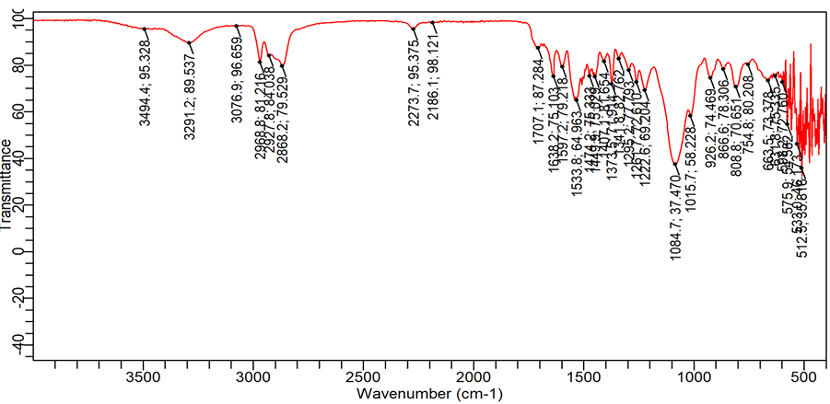
Fig. 1. FTIR spectra of PPS

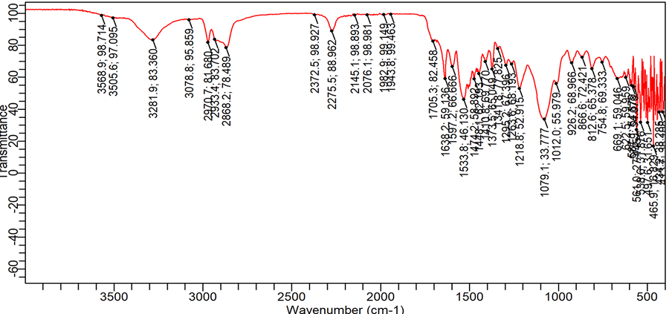
Fig. 2. FTIR spectra of PCS

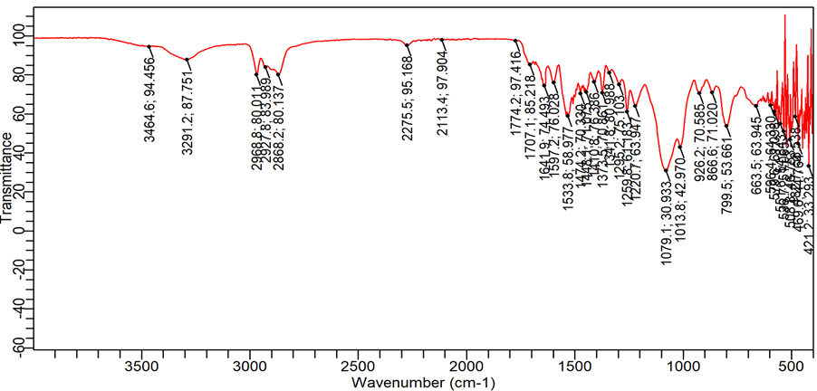
Fig. 3. FTIR spectra of PCVS

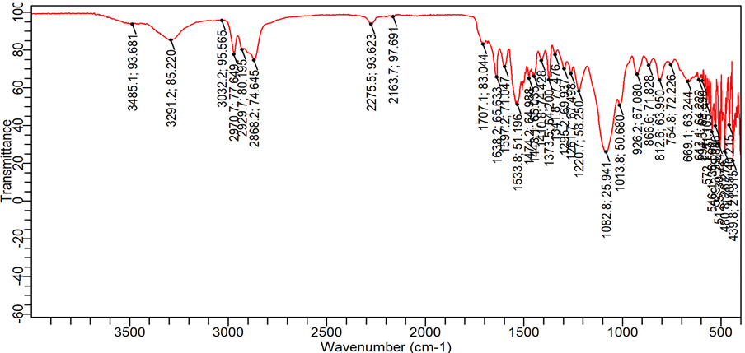
Fig. 4. FTIR spectra of PCYS

3.2 Mechanical Properties
3.2.1 Tensile Strength and Ductility
The mechanical characteristics of the synthesized polyurethanes are summarized in Table 1. Tensile strength (Fig. 5 – 6) refers to the maximum stress that a material can endure under tensile forces before failure (Maiuolo et al., 2021). The findings illustrate a notable improvement compared to the petroleum-derived polyol control (PPS).
A distinct hierarchy in tensile strength was noted: PPS (2.05 Mpa) < PCYS (2.43 Mpa, +19%) < PCS (2.98 Mpa, +45%) < PCVS (4.29 Mpa, +109%). This trend suggests that the starch-derived polyols, especially cassava (PCVS), facilitate the development of a more resilient and cohesive polymeric framework. The enhanced strength of cassava starch-derived Pus (PCVS) is ascribed to a more thorough reaction with isocyanates, resulting in a greater density of urethane linkages and a more integrated hard-segment domain, bolstered by the robust hydrogen-bonding network corroborated through FTIR analysis (Stefanović et al., 2023; Vieira et al., 2023). This observation indicates that bio-based Pus can surpass the mechanical efficacy of traditional counterparts (Gurunathan et al., 2015).
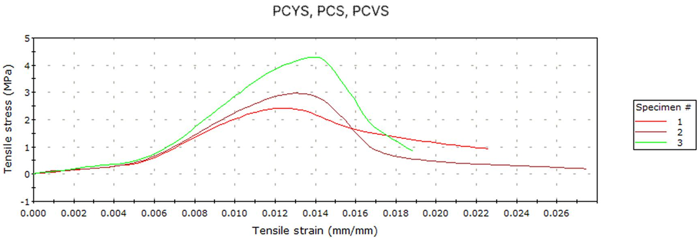
Fig. 5. Tensile Strength for PCYS, PCS, and PCVS

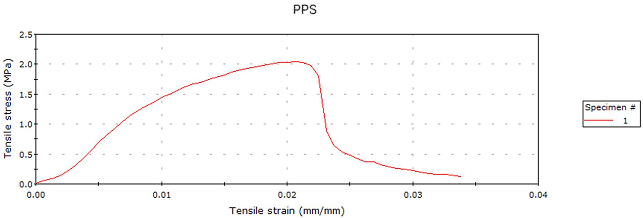
Fig. 6. Tensile Strength for PPS

Elongation at break serves as an indicator of the material’s ductility, reflecting the extent to which it can undergo plastic deformation before fracture (Atnurkar et al., 2023). A classical trade-off between strength and ductility is evident in Table 1.
Elongation at break diminished concomitantly with the increase in tensile strength, with the following order: PPS (3.38%) > PCS (2.75%) > PCYS (2.26%) > PCVS (1.86%). This inverse correlation is typical of augmented cross-linking, which limits the mobility of polymer chains and enhances strength at the cost of ductility (Noreen et al., 2016). Notwithstanding this reduction in ductility, the energy at break (+59%, a measure of toughness) increased for all starch-based Pus (PCYS: +59%, PCS: +62%, PCVS: +103%). This suggests that the substantial increases in strength culminated in an overall enhancement in fracture resistance, resulting in tougher materials (Das et al., 2013).

Table 1. Tensile stress and elongation at break properties for PPS, PCS, PCYS, and PCVS.
Properties | PPS (Polyol) | PCYS (Yam) | PCS (Corn) | PCVS (Cassava)
Tensile Stress (MPa) | 2.046 | 2.429 (+19%) | 2.979 (+45%) | 4.294 (+109%)
Elongation at Break (%) | 3.375 | 2.26 (-33%) | 2.745 (-19%) | 1.862 (-45%)

3.2.2 Flexural Testing Analysis
The results of the flexural testing are delineated in Table 2, which elucidates substantial variances in bending resistance amongst the starch-derived polyurethanes, underscoring the impact of the polyol source on the network configuration (Brzoska et al., 2024). The entirely biobased foams demonstrated significantly enhanced flexural strength in comparison to the petroleum-derived control (PPS, 2.05 MPa).
The corn starch-based polyurethane (PCS) exhibited the highest flexural strength (6.42 MPa), signifying a network characterized by an optimal equilibrium of rigidity and resilience, thereby effectively redistributing multi-axial stresses during bending (He et al., 2016). Conversely, the cassava-based polyurethane (PCVS), which registered the highest tensile strength (4.29 MPa), manifested a lower flexural strength (5.41 MPa) and strain at maximum stress (6.84% vs 7.25% for PCS). This implies that while the highly cross-linked PCVS network performs exceptionally well under uniaxial tension, it may demonstrate increased vulnerability to micro-crack development during flexural loading (Brzeska et al., 2021). The cocoyam-based polyurethane (PCYS) recorded the lowest flexural strength (5.13 MPa) among the starch-based specimens, which is in alignment with its inferior tensile performance (Cao et al., 2020).

Table 2. Flexural strength for the starch-based Pus and control.
Sample | Starch source | Flexural strength  (MPa) | Flexural strain at max stress (%)
PCYS | Coco Yam | 5.13 | 8.33
PCS | Corn | 6.42 | 7.25
PCVS | Cassava | 5.41 | 6.84
PPS | Polyol | 2.05 | 2

3.3 Thermal Analysis by Differential Scanning Calorimetry (DSC)
The thermal behavior of the polyurethanes was studied using DSC, as shown in Fig. 7, with the numerical findings data summarized in Table 3. No clear melting points were seen, suggesting that the hard parts are not crystalline but instead are disordered and held together by hydrogen bonds rather than a structured crystal arrangement (Brzoska et al., 2024). Broad endothermic transitions, which are linked to the breaking of hydrogen bonds in the hard segments, were observed in all the samples (Mishra et al., 2012). The lack of a distinct glass transition temperature (Tg) for the soft segments indicates that there is a lot of mixing between the starch-based polyols and the hard regions (Gurunathan et al., 2015).
Fig. 7. DSC Thermograms of the synthesized polyurethanes.

The temperature at which the hard segments start to separate changed depending on the type of starch used. The reference polyol, PPS, and corn starch-based PU, PCS, showed the highest onset temperature of around 175°C, suggesting that their hard segments have similar thermal stability (Zhang et al., 2017). The cassava-based PU (PCVS) had a significantly lower onset temperature at 125°C, which is related to its higher tensile strength, indicating a tightly cross-linked structure, but also suggests that the network is less thermally stable (Brzeska et al., 2021). The cocoyam-based PU (PCYS) showed a moderate start temperature (150 °C) with a strong, pronounced endotherm, suggesting a more even distribution of hard segments (Zhang et al., 2017).
All the samples showed significant thermal breakdown at temperatures higher than 250 °C, which shows that adding starch polyols and a ZnO catalyst doesn't reduce the natural heat resistance of the polyurethane structure (Rahman, 2020).

Table 3. Quantitative Summary of Key DSC Transitions
Sample | Onset of HS  Dissociation (°C) | Minimum Heat Flow (mW/mg) | Temperature (°C)
PPS | 175 | -3.6 | 225
PCS | 175 | -3.5 | 250
PCVS | 125 | -3.5 | 225
PCYS | 150 | -3.8 | 200

4. CONCLUSION
This study explores the production of eco-friendly polyurethane (PU) foams using starch-based polyols from corn, cassava, and cocoyam, with ZnO as a non-toxic catalyst. FTIR spectroscopy demonstrated effective urethane linkages and hydrogen-bonding networks in all samples, confirming ZnO's catalytic role. Notably, cassava-derived PUs exhibited superior tensile strength (4.29 MPa), and corn-based PUs showed the highest flexural strength (6.42 MPa), indicating better flexibility. Thermal analysis confirmed these bio-based foams maintained thermal stability beyond 250°C. The research emphasizes that combining underutilized starches with ZnO catalysis can yield high-performance bio-based PUs, contributing to sustainable practices and reducing dependence on fossil fuels. Future work will focus on starch modification and long-term environmental impact assessments.

REFERENCES
Abboud, A., & Hanoosh, W. (2022). Synthesis of composites based on waste natural Products and Polyurethane. Egyptian Journal of Chemistry, 0–0. https://doi.org/10.21608/ejchem.2022.149464.6456
Adetunji, C. O., Olaniyan, O. T., Anani, O. A., Inobeme, A., & Mathew, J. T. (2021). Environmental Impact of Polyurethane Chemistry (pp. 393–411). https://doi.org/10.1021/bk-2021-1380.ch014
Aina, A. J., Falade, K. O., Akingbala, J. O., & Titus, P. (2012). Physicochemical Properties of Caribbean Sweet Potato (Ipomoea batatas (L) Lam) Starches. Food and Bioprocess Technology, 5(2), 576–583. https://doi.org/10.1007/s11947-009-0316-6
Akindoyo, J. O., Beg, M. D. H., Ghazali, S., Islam, M. R., Jeyaratnam, N., & Yuvaraj, A. R. (2016). Polyurethane types, synthesis and applications – a review. RSC Advances, 6(115), 114453–114482. https://doi.org/10.1039/C6RA14525F
Amos, O., & Pashameah, R. A. (2023). Preparation of Starch-Fatty Acid Esters from Agro-Based Raw Materials (Corn Starch, Cassava Starch, Coconut Oil, and Castor Seed Oil). Starch/Staerke, 75(11–12). https://doi.org/10.1002/star.202200205
ASTM International. (2017). Standard Test Methods for Flexural Properties of Unreinforced and Reinforced Plastics and Electrical Insulating Materials (D790). ASTM International.
ASTM International. (2022). Test Method for Tensile Properties of Plastics. ASTM International. https://doi.org/10.1520/D0638-22
Atnurkar, V., Schuster, J., & Pasha Shaik, Y. (2023). Increased Elongation at Breaking Point with Improved Mechanical Characteristics in PLA. Open Journal of Composite Materials, 13, 13–28. https://doi.org/10.4236/ojcm.2023.131002
Barikani, M., & Mohammadi, M. (2007). Synthesis and characterization of starch-modified polyurethane. Carbohydrate Polymers, 68(4), 773–780. https://doi.org/10.1016/j.carbpol.2006.08.017
Barmi Hartesi, Sriwidodo, Marline Abdassah, & Anis Yohana Chaerunisaa. (2016). Starch as Pharmaceutical Excipient AReviewArticle. Int. J. Pharm. Sci. Rev. Res, 41(2), 59–64.
Brown, M. (1997). Differential scanning calorimetry — An introduction for practitioners. Thermochimica Acta, 303(1), 117. https://doi.org/10.1016/S0040-6031(97)82223-X
Brzeska, J., Tercjak, A., Sikorska, W., Mendrek, B., Kowalczuk, M., & Rutkowska, M. (2021). Degradability of Polyurethanes and Their Blends with Polylactide, Chitosan and Starch. Polymers, 13(8), 1202. https://doi.org/10.3390/polym13081202
Brzoska, J., Datta, J., Konefał, R., Pokorný, V., & Beneš, H. (2024). The influence of bio-based monomers on the structure and thermal properties of polyurethanes. Scientific Reports, 14(1), 29042. https://doi.org/10.1038/s41598-024-80358-6
Cao, C., Shen, M., Hu, J., Qi, J., Xie, P., & Zhou, Y. (2020). Comparative study on the structure-properties relationships of native and debranched rice starch. CyTA - Journal of Food, 18(1), 84–93. https://doi.org/10.1080/19476337.2019.1710261
Chahar, M., Vashisht, U., Preeti, M., Chahar, U., Vashisht, A., & Ahlawat, P. (2023). Synthesis and characterisation of two component polyurethane coatings blended with phthalic anhydride formed with TDI. ~ 21 ~ International Journal of Materials Science, 4(1). https://www.mechanicaljournals.com/materials-science
Das, B., Konwar, U., Mandal, M., & Karak, N. (2013). Sunflower oil based biodegradable hyperbranched polyurethane as a thin film material. Industrial Crops and Products, 44, 396–404. https://doi.org/10.1016/j.indcrop.2012.11.028
Dubalska, K., Rutkowska, M., Bajger-Nowak, G., Konieczka, P., & Namieśnik, J. (2013). Organotin Compounds: Environmental Fate and Analytics. Critical Reviews in Analytical Chemistry, 43(1), 35–54. https://doi.org/10.1080/10408347.2012.743846
Dulyanska, Y., Cruz-Lopes, L., Esteves, B., Guiné, R., & Domingos, I. (2024). FTIR Monitoring of Polyurethane Foams Derived from Acid-Liquefied and Base-Liquefied Polyols. Polymers, 16(15), 2214. https://doi.org/10.3390/polym16152214
Gama, N. V., Ferreira, A., & Barros-Timmons, A. (2018). Polyurethane Foams: Past, Present, and Future. Materials, 11(10), 1841. https://doi.org/10.3390/ma11101841
García-Pacios, V., Iwata, Y., Colera, M., & Miguel Martín-Martínez, J. (2011). Influence of the solids content on the properties of waterborne polyurethane dispersions obtained with polycarbonate of hexanediol. International Journal of Adhesion and Adhesives, 31(8), 787–794. https://doi.org/10.1016/j.ijadhadh.2011.05.010
Gurunathan, T., Mohanty, S., & Nayak, S. K. (2015). A review of the recent developments in biocomposites based on natural fibres and their application perspectives. Composites Part A: Applied Science and Manufacturing, 77, 1–25. https://doi.org/10.1016/j.compositesa.2015.06.007
He, M., Yang, T., Niu, X., & Du, Y. (2016). Experimental Investigation of the Three-point Bending Fatigue Properties of Carbon Fiber Composite Laminates. Advances in Material Science, 1(1), 1. https://doi.org/10.18686/ams.v1i1.1
Ikegwu, O. J., Nwobasi, V. N., Odoh, M. O., & Oledinma, N. U. (2009). Evaluation of the pasting and some functional properties of starch isolated from some improved cassava varieties in Nigeria. Electronic Journal of Environmental, Agricultural and Food Chemistry, 8(8), 657–665.
Jayalath, P., Ananthakrishnan, K., Jeong, S., Shibu, R. P., Zhang, M., Kumar, D., Yoo, C. G., Shamshina, J. L., & Therasme, O. (2025). Bio-Based Polyurethane Materials: Technical, Environmental, and Economic Insights. Processes, 13(5), 1591. https://doi.org/10.3390/pr13051591
Jiang, T., Duan, Q., Zhu, J., Liu, H., & Yu, L. (2020). Starch-based biodegradable materials: Challenges and opportunities. Advanced Industrial and Engineering Polymer Research, 3(1), 8–18. https://doi.org/10.1016/j.aiepr.2019.11.003
Li, Y., Luo, X., & Hu, S. (2015). Bio-based Polyols and Polyurethanes. Springer International Publishing. https://doi.org/10.1007/978-3-319-21539-6
Maiuolo, L., Olivito, F., Algieri, V., Costanzo, P., Jiritano, A., Tallarida, M. A., Tursi, A., Sposato, C., Feo, A., & De Nino, A. (2021). Synthesis, Characterization and Mechanical Properties of Novel Bio-Based Polyurethane Foams Using Cellulose-Derived Polyol for Chain Extension and Cellulose Citrate as a Thickener Additive. Polymers, 13(16), 2802. https://doi.org/10.3390/polym13162802
Marturano, V., Marotta, A., Salazar, S. A., Ambrogi, V., & Cerruti, P. (2023). Recent advances in bio-based functional additives for polymers. Progress in Materials Science, 139(May), 101186. https://doi.org/10.1016/j.pmatsci.2023.101186
Mills, N. (2007). Polyurethane foams: processing and microstructure. In Polymer Foams Handbook (pp. 19–37). Elsevier. https://doi.org/10.1016/B978-075068069-1/50003-9
Mishra, A. K., Narayan, R., Raju, K. V. S. N., & Aminabhavi, T. M. (2012). Hyperbranched polyurethane (HBPU)-urea and HBPU-imide coatings: Effect of chain extender and NCO/OH ratio on their properties. Progress in Organic Coatings, 74(1), 134–141. https://doi.org/10.1016/j.porgcoat.2011.11.027
Noreen, A., Zia, K. M., Zuber, M., Tabasum, S., & Zahoor, A. F. (2016). Bio-based polyurethane: An efficient and environment friendly coating systems: A review. Progress in Organic Coatings, 91, 25–32. https://doi.org/10.1016/j.porgcoat.2015.11.018
Otegbayo, B., Oguniyan, D., & Akinwumi, O. (2014). Physicochemical and functional characterization of yam starch for potential industrial applications. Starch - Stärke, 66(3–4), 235–250. https://doi.org/10.1002/star.201300056
Rahman, M. M. (2020). Polyurethane/Zinc Oxide (PU/ZnO) Composite—Synthesis, Protective Property and Application. Polymers, 12(7), 1535. https://doi.org/10.3390/polym12071535
Santos, M., Mariz, M., Tiago, I., Alarico, S., & Ferreira, P. (2025). Bio-Based Polyurethane Foams: Feedstocks, Synthesis, and Applications. Biomolecules, 15(5), 680. https://doi.org/10.3390/biom15050680
Silva, A. L., & Bordado, J. C. (2004). Recent developments in polyurethane catalysis: Catalytic mechanisms review. Catalysis Reviews - Science and Engineering, 46(1), 31–51. https://doi.org/10.1081/CR-120027049
Skoczinski, P., Krause, L., Raschka, A., Dammer, L., & Michael Carus. (2021). Current status and future development of plastics: Solutions for a circular economy and limitations of environmental degradation (pp. 1–26). https://doi.org/10.1016/bs.mie.2020.11.001
Srichuwong, S., Sunarti, T. C., Mishima, T., Isono, N., & Hisamatsu, M. (2005). Starches from different botanical sources II: Contribution of starch structure to swelling and pasting properties. Carbohydrate Polymers, 62(1), 25–34. https://doi.org/10.1016/j.carbpol.2005.07.003
Stefanović, I. S., Džunuzović, J. V., Džunuzović, E. S., Stevanović, S., Dapčević, A., Savić, S. I., & Lama, G. C. (2023). The impact of the polycaprolactone content on the properties of polyurethane networks. Materials Today Communications, 35, 105721. https://doi.org/10.1016/j.mtcomm.2023.105721
Tenorio-Alfonso, A., Sánchez, M. C., & Franco, J. M. (2020). A Review of the Sustainable Approaches in the Production of Bio-based Polyurethanes and Their Applications in the Adhesive Field. Journal of Polymers and the Environment, 28(3), 749–774. https://doi.org/10.1007/s10924-020-01659-1
Tung, C.-C., Lin, Y.-H., Chen, Y.-W., & Wang, F.-M. (2025). Mechanical performance and aging resistance analysis of zinc oxide-reinforced polyurethane composites. RSC Advances, 15(35), 28358–28366. https://doi.org/10.1039/D5RA03748D
Vieira, F. R., Gama, N. V., Evtuguin, D. V., Amorim, C. O., Amaral, V. S., Pinto, P. C. O. R., & Barros-Timmons, A. (2023). Bio-Based Polyurethane Foams from Kraft Lignin with Improved Fire Resistance. Polymers, 15(5), 1074. https://doi.org/10.3390/polym15051074
Wang, C., Zheng, Y., Xie, Y., Qiao, K., Sun, Y., & Yue, L. (2015). Synthesis of bio-castor oil polyurethane flexible foams and the influence of biotic component on their performance. Journal of Polymer Research, 22(8), 145. https://doi.org/10.1007/s10965-015-0782-7
Zagaria, L., Caramia, G., & Amirante, R. (2023). The role of biomass in energy transition to net zero carbon emissions due to climate change: the Apulia case. Journal of Physics: Conference Series, 2648(1), 012013. https://doi.org/10.1088/1742-6596/2648/1/012013
Zhang, C., Garrison, T. F., Madbouly, S. A., & Kessler, M. R. (2017). Recent advances in vegetable oil-based polymers and their composites. Progress in Polymer Science, 71, 91–143. https://doi.org/10.1016/j.progpolymsci.2016.12.009
Zhang, X. ., Macosko, C. ., Davis, H. ., Nikolov, A. ., & Wasan, D. . (1999). Role of Silicone Surfactant in Flexible Polyurethane Foam. Journal of Colloid and Interface Science, 215(2), 270–279. https://doi.org/10.1006/jcis.1999.6233

