ROENTGENOGRAPHIC CARPAL MORPHOMETRY: ASSESSMENT OF SEX- AND AGE-RELATED VARIATIONS IN NORMATIVE POSTEROANTERIOR WRIST RADIOGRAPHIC MEASUREMENTS AMONG ADULT NIGERIANS

ABSTRACT
Background: In orthopedic surgery, accurate anthropometric measurements of the carpal bones is essential for the correction of post-traumatic deformities during corrective osteotomies. Likewise, accurate radiographic evaluation of carpal bone dimensions plays a critical role in the diagnostic assessment of carpal collapse syndromes observed in conditions such as Kienböck’s disease and rheumatoid arthritis. Despite the clinical relevance of these carpal parameters, limited normative radiographic data exist for the adult Nigerian population. This study, therefore, aimed to establish population-specific normative reference values for carpal bone dimensions based on posteroanterior wrist radiographs in adult Nigerians. Methods:
This retrospective observational study utilized 201 posteroanterior wrist radiographs archived in the Radiology Department of Delta State University Teaching Hospital, Oghara, Nigeria. Measurements of carpal height, lunate width, capitate length, and the scapholunate gap were obtained from the eight carpal bones using the Picture Archiving and Communication System (PACS). Data were analyzed using SPSS version 25. Sex-related differences were assessed using the independent-samples t-test, while age-group variations were evaluated with one-way ANOVA. Pearson’s correlation analysis was employed to determine associations among measured carpal parameters. A p-value ≤ 0.05 was considered statistically significant. Results: Obtained mean values for carpal height (3.215 cm), capitate length (2.153 cm), lunate width (14.032 mm), and scapholunate gap (0.202 cm), reflected a pronounced range of sex variation with males exhibiting significantly larger mean values. Age-specific analysis of mean values across the five age groups showed minimal variation in carpal bone dimensions, with carpal height ranging from 3.19 to 3.24 cm, capitate length from 2.144 to 2.157 cm, lunate width from 14.003 to 14.143 mm, and the scapholunate gap from 0.195 to 0.207 cm. Corresponding p-values for all inter-group comparisons exceeded 0.05 in all parameters, indicating no statistically significant differences attributable to age. Conclusion:
This study reveals marked sexual dimorphism alongside a high degree of age-independent consistency in adult carpal morphometric parameters. These outcomes hold important implications for forensic identification, anthropometric investigations, orthopedic decision-making, and radiologic assessment. Moreover, the findings enrich the existing repository of population-specific skeletal data in Delta State, building on prior regional anatomical research and enhancing the accuracy of clinical and forensic interpretations.
Keywords: Carpal morphometry; Carpal height; Capitate length; Lunate width; Scapholunate gap; Nigeria
Introduction
In chronic systemic inflammatory disorders such as rheumatoid arthritis (RA), the radiocarpal joint and the carpal bones are among the earliest and most severely affected musculoskeletal structures, owing largely to their intricate anatomical configuration and extensive synovial lining.^{1,2} Persistent synovitis within the carpus may lead to cartilage degradation, cortical erosion, and carpal collapse, all of which can be objectively evaluated using standard roentgenographic and morphometric techniques, thereby underscoring the critical diagnostic value of radiographic carpal morphometry in the early detection and monitoring of disease progression.^{3,4}
Clinical evaluation of radiographic carpal measurements remains a cornerstone in the diagnosis and follow-up of RA, as it provides objective evidence of joint space narrowing, bone erosion, and deformity. Quantitative carpal measurements such as the Carpal Height Ratio (CHR) and Revised Carpal Height Ratio (RCHR) have been established as reliable indicators of carpal collapse and disease progression.^{5,6,7} A reduction in carpal height has been shown to correlate with disease duration and radiologic severity, reflecting cumulative structural damage.⁸ Similarly, widening of the scapholunate gap and alterations in ulnar translocation reflect ligamentous instability secondary to chronic inflammatory destruction.⁴
Beyond diagnosis, carpal morphometric analysis provides valuable information for longitudinal monitoring and therapeutic assessment, as radiographic parameters offer reproducible indicators of progression even when clinical symptoms fluctuate.² In advanced cases, these measurements guide preoperative planning for procedures such as carpectomy, arthrodesis, or total wrist arthroplasty, and serve as benchmarks for evaluating postoperative outcomes.⁹
Despite the established diagnostic significance of carpal morphometry in evaluating wrist pathology, there remains a paucity of population-specific normative data for carpal bone dimensions among adult Nigerians. Ethnic and anatomical variations have been shown to influence skeletal morphology, including carpal configuration, which may impact the interpretation of radiographic indices across populations.^{10,11} The absence of standardized reference values can therefore hinder accurate diagnosis, impede comparison with pathological states such as rheumatoid arthritis and Kienböck’s disease, and limit the precision of orthopedic and reconstructive interventions.
Establishing normative radiographic parameters for the Nigerian population is thus essential to enhance diagnostic accuracy, facilitate population-based comparisons, and provide a reliable baseline for future clinical and anthropometric studies involving the wrist and hand. This need is further underscored by previous regional radiographic anthropometric studies, such as the evaluation of frontal sinus morphology among patients in Delta State,⁵ which highlight the importance of developing population-specific reference data for clinical and forensic applications.
Materials and Methods
This retrospective descriptive observational study was conducted at the Delta State University Teaching Hospital (DELSUTH), Oghara, Delta State, Nigeria. The study utilized 201 hand radiographs obtained from the Radiology Department archives, representing patients aged 18-60 years who had attended the hospital within the last five years. A purposive sampling technique was employed to select radiographs that met the inclusion criteria of clear wrist images within the specified age range and time frame. Radiographs showing skeletal immaturity, fractures, or congenital anomalies such as carpal bone aplasia or hypoplasia were excluded.
Radiographic parameters measured included carpal height, lunate width, capitate length, and scapholunate gap. Carpal height was measured from the base of the third metacarpal to the distal articular surface of the radius along the third metacarpal axis. ¹²
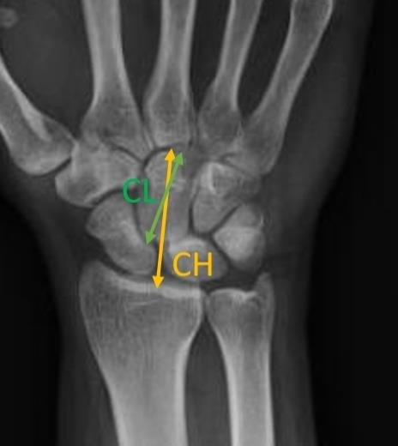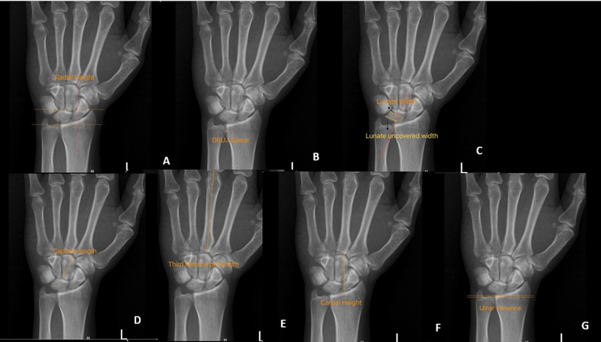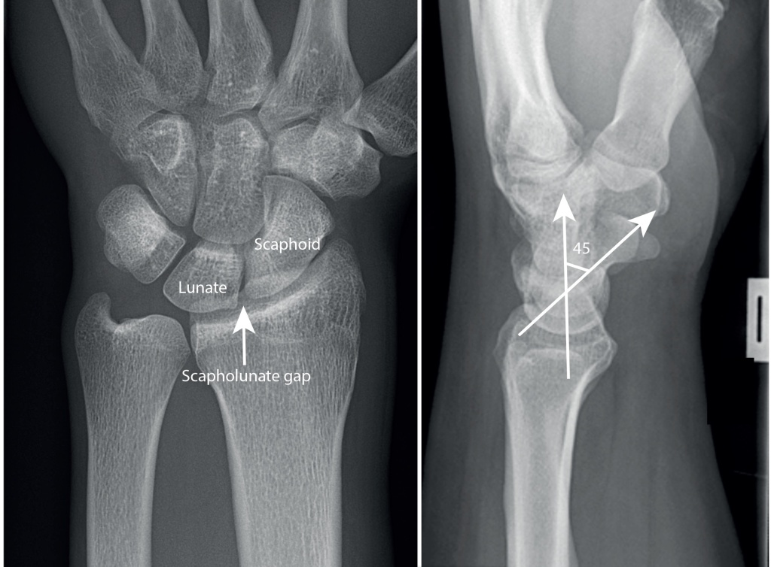
Figure 3. Scapholunate gap¹⁵
Figure 1. Capitate length and carpal height (CH) radiograph ¹³

Figure 2. Lunate width¹⁴

Capitate length was measured from the intersection of the capitate articular facets for the second and third metacarpals to the proximal subchondral cortex of the capitate head. Lunate width was determined as the transverse distance between the medial and lateral margins of the lunate.¹⁴ The scapholunate gap represented the interspace between the scaphoid and lunate bones. All linear measurements were obtained using a digital ruler integrated into the Picture Archiving and Communication System (PACS).¹⁶
Ethical approval for the study was obtained from the Research and Ethics Committees of the Faculty of Basic Medical Sciences, Delta State University, Abraka (Ref: RBC/FBMC/DELSU/25/911), and the Delta State University Teaching Hospital, Oghara (Ref: HREC/PAN/2025/0400/0729).
Data were analyzed using the Statistical Package for Social Sciences (SPSS) version 26. Descriptive statistics (mean, standard deviation, range) were computed for all continuous variables. Independent sample t-tests were performed to evaluate sex differences, while one-way ANOVA assessed variations across age groups. Pearson’s correlation coefficient (r) was calculated to determine relationships among carpal dimensions, with statistical significance set at p < 0.05.

Results
A total of 201 wrist radiographs were evaluated in this retrospective study. Of these, 108 radiographs (53.7%) were from female participants, while 93 radiographs (46.3%) were from male participants. Participants’ ages ranged from under 18 to 60 years. The distribution of participants across age groups is presented in Table 1. The largest proportion of participants fell within the 31-40 years age group (28.4%), followed by the 21-30 years group (26.9%). The smallest group comprised participants under 21 years of age (4.5%).

Table 1: Age Demographic of Participants
Age Group (years) | Number of Participants | Percentage (%)
<21 | 9 | 4.5
21–30 | 54 | 26.9
31–40 | 57 | 28.4
41–50 | 44 | 21.9
51–60 | 37 | 18.4
Total | 201 | 100
This distribution highlights a predominance of participants in the younger to middle adult age ranges, providing a representative sample for evaluating wrist anthropometry and radiological characteristics.
Table 2 provides a summary of all analyzed variables in the studied population, including age, carpal height (CH), capitate length (CL), lunate width (LW) and scapholunate gap (SLG). The relatively low standard deviations indicate a consistent measurement pattern across participants, with little variability.
Table 2: Descriptive statistics of all analyzed variables in the total studied population.
 | N | Minimum | Maximum | Mean | Std. Deviation
Age | 201 | 18 | 60 | 38.00 | 11.524
Carpal Height | 201 | 2.90 | 3.61 | 3.2154 | .14565
Capitate Length | 201 | 2.03 | 2.29 | 2.1531 | .05034
Lunate Width | 201 | 13.58 | 14.65 | 14.0323 | .18948
Scapholunate Gap (SLG) | 201 | .13 | .27 | .2017 | .02686

Table 3 shows the distribution of measured parameters among male and female participants. Note that all bone measurements were higher in males than females. This reflects natural sexual dimorphism in carpal bone anatomy. Differences are especially notable in CH and SLG, highlighting larger carpal structures and spacing in males.
SEX |  | N | Minimum | Maximum | Mean | Std. Deviation
F | AGE | 108 | 19 | 60 | 38.69 | 11.816
F | CH | 108 | 2.90 | 3.36 | 3.1144 | .08863
F | CL | 108 | 2.03 | 2.28 | 2.1418 | .04887
F | LW | 108 | 13.58 | 14.51 | 14.0058 | .18483
F | SLG | 108 | .13 | .24 | .1847 | .02025
M | AGE | 93 | 18 | 59 | 37.20 | 11.186
M | CH | 93 | 3.06 | 3.61 | 3.3328 | .10517
M | CL | 93 | 2.06 | 2.29 | 2.1663 | .04901
M | LW | 93 | 13.72 | 14.65 | 14.0630 | .19115
M | SLG | 93 | .18 | .27 | .2215 | .01888
M | Valid N (listwise) | 93
Table 3: Sex-specific distribution of the measured parameters for the study population.
SEX |  | N | Minimum | Maximum | Mean | Std. Deviation
F | AGE | 108 | 19 | 60 | 38.69 | 11.816
F | CH | 108 | 2.90 | 3.36 | 3.1144 | .08863
F | CL | 108 | 2.03 | 2.28 | 2.1418 | .04887
F | LW | 108 | 13.58 | 14.51 | 14.0058 | .18483
F | SLG | 108 | .13 | .24 | .1847 | .02025
M | AGE | 93 | 18 | 59 | 37.20 | 11.186
M | CH | 93 | 3.06 | 3.61 | 3.3328 | .10517
M | CL | 93 | 2.06 | 2.29 | 2.1663 | .04901
M | LW | 93 | 13.72 | 14.65 | 14.0630 | .19115
M | SLG | 93 | .18 | .27 | .2215 | .01888
M | Valid N (listwise) | 93

Table 4 summarizes the distribution of all measured parameters according to studied age groups. It suggests that age has little influence on adult carpal bone dimensions.
Table 4: Summary distribution of all measured parameters across various age groups.
Age Group |  | N | Minimum | Maximum | Mean | Std. Deviation
<21 | AGE | 9 | 18 | 20 | 19.56 | .726
<21 | CH | 9 | 3.10 | 3.37 | 3.2111 | .09333
<21 | CL | 9 | 2.08 | 2.27 | 2.1444 | .06106
<21 | LW | 9 | 13.84 | 14.40 | 14.1433 | .20408
<21 | SLG | 9 | .16 | .25 | .2011 | .03621
21-30 | AGE | 54 | 21 | 30 | 25.91 | 3.030
21-30 | CH | 54 | 2.95 | 3.58 | 3.2424 | .14996
21-30 | CL | 54 | 2.03 | 2.29 | 2.1519 | .05191
21-30 | LW | 54 | 13.68 | 14.49 | 14.0407 | .19316
21-30 | SLG | 54 | .14 | .27 | .2050 | .02793
31-40 | AGE | 57 | 31 | 40 | 35.04 | 2.738
31-40 | CH | 57 | 2.90 | 3.61 | 3.1986 | .16690
31-40 | CL | 57 | 2.07 | 2.27 | 2.1504 | .04367
31-40 | LW | 57 | 13.64 | 14.51 | 14.0032 | .17823
31-40 | SLG | 57 | .13 | .27 | .1995 | .02793
41-50 | AGE | 44 | 41 | 50 | 46.34 | 3.110
41-50 | CH | 44 | 3.01 | 3.49 | 3.2293 | .12097
41-50 | CL | 44 | 2.05 | 2.28 | 2.1573 | .05634
41-50 | LW | 44 | 13.60 | 14.65 | 14.0393 | .20546
41-50 | SLG | 44 | .14 | .26 | .2066 | .02505
51-60 | AGE | 37 | 51 | 60 | 54.81 | 2.675
51-60 | CH | 37 | 2.95 | 3.58 | 3.1865 | .13913
51-60 | CL | 37 | 2.06 | 2.26 | 2.1565 | .04957
51-60 | LW | 37 | 13.58 | 14.38 | 14.0295 | .17558
51-60 | SLG | 37 | .15 | .24 | .1949 | .02244

Fig. 4. Illustrates the variation in carpal height (CH)
Figure 4 illustrates the variation in carpal height (CH) across the different age groups, presenting the corresponding mean values and associated p-values for each comparison. Mean carpal height values ranged from 3.19 to 3.24 across all age categories, while minimum values varied between 2.90 and 3.10, and maximum values ranged from 3.37 to 3.61. Notably, the p-value was consistently 0.347 for all age brackets, indicating no statistically significant difference in carpal height among the studied age groups. These findings suggest that carpal height remains stable across adult age divisions, with negligible fluctuation in mean values between cohorts. The absence of significant p-values demonstrates that age does not exert a marked influence on carpal height within this population. Consequently, reference intervals derived from this dataset may be applied broadly across adults without the need for age-based adjustments.

Figure 5. Depicts the comparative analysis of capitate length

Figure 5 depicts the comparative analysis of capitate length across the various age groups, highlighting the mean values and associated p-values for each category. Across all age groups, the minimum and maximum values show only marginal fluctuations (minimum: 2.03–2.08 cm; maximum: 2.26–2.29 cm), indicating a narrow range of variation within the population. The mean capitate length likewise demonstrates remarkable consistency, varying only between 2.1444 cm and 2.1573 cm. This minimal variation suggests that capitate morphology remains largely stable throughout adulthood.
Importantly, the p-values for all age groups are identical (p = 0.921), far exceeding the 0.05 threshold for statistical significance. This confirms that there is no meaningful age-related difference in capitate length among the participants. The high p-value demonstrates that any observed fluctuations in minimum, maximum, or mean values are incidental rather than indicative of a developmental or degenerative pattern. Taken together, these findings underscore the relative morphological constancy of the capitate bone across adult age ranges.

Figure 6. The comparative analysis of lunate width

Figure 6 presents the comparative analysis of lunate width across the five age categories. The minimum values range narrowly from 13.58 mm to 13.84 mm, while maximum values vary between 14.38 mm and 14.65 mm. Similarly, the mean lunate width demonstrates only subtle fluctuations, with values spanning from 14.0032 mm to 14.1433 mm across all groups. This tight clustering of minimum, maximum, and mean values suggests a high degree of morphological consistency in lunate width throughout adulthood.
The p-value for all age groups is 0.331, which exceeds the 0.05 threshold for statistical significance. This indicates that the observed differences are not statistically meaningful. Accordingly, lunate width does not exhibit an age-dependent pattern within the sampled population. As with the capitate measurements, this finding reinforces the stability of carpal dimensions across adult life stages, further supporting the reliability of the lunate bone as an age-independent anthropometric parameter.
Overall, the results demonstrate that lunate width remains relatively constant from early adulthood to late middle age, with no significant age-related variation. This morphological stability enhances the forensic, clinical, and anthropometric applicability of lunate measurements, particularly in contexts such as skeletal profiling, sex estimation, and radiographic standardization.

Figure 7. Comparative analysis of measured scapholunate gap
Figure 7 presents a comparative analysis of measured scapholunate gap across five age groups. The minimum scapholunate gap values fluctuate slightly across age groups, ranging from 0.13 in the 31-40 age group to 0.16 in the <21 group. This suggests that the lowest measurements in each age group are relatively consistent, with only minor variations. Maximum values range from 0.24 in the 51-60 group to 0.27 in the 21-30 and 31-40 groups. The slight decrease in maximum values in older age groups might indicate a plateau or minor decline with age. The mean scapholunate gap values remain very similar across all groups, from 0.1949 (51-60) to 0.2066 (41-50). The small differences in means suggest that there is no strong age-related trend in this measurement. All age groups report a p-value of 0.282, which is above the conventional significance threshold of 0.05. This indicates that differences between age groups are not statistically significant, and any variation observed could be due to random chance rather than a systematic age effect.
Table 5 presents the inter-variable relationships among the measured parameters, as determined by Pearson correlation coefficients. The strongest positive correlation was observed between CH and SLG (r = 0.512).
 |  | AGE | CH | CL | LW | SLG
AGE | Pearson Correlation | 1 | -.050 | .065 | -.017 | -.048
AGE | P-value |  | .479 | .356 | .810 | .501
AGE | N | 201 | 201 | 201 | 201 | 201
CH | Pearson Correlation | -.050 | 1 | .274 | .092 | .512
CH | P-value | .479 |  | .000 | .192 | .000
CH | N | 201 | 201 | 201 | 201 | 201
CL | Pearson Correlation | .065 | .274 | 1 | .122 | .130
CL | P-value | .356 | .000 |  | .085 | .065
CL | N | 201 | 201 | 201 | 201 | 201
LW | Pearson Correlation | -.017 | .092 | .122 | 1 | .173
LW | P-value | .810 | .192 | .085 |  | .014
LW | N | 201 | 201 | 201 | 201 | 201
SLG | Pearson Correlation | -.048 | .512 | .130 | .173 | 1
SLG | P-value | .501 | .000 | .065 | .014
SLG | N | 201 | 201 | 201 | 201 | 201

Discussion
In this observational study, postero-anterior wrist radiographs from 201 adult subjects were retrospectively analysed to characterise key carpal bone dimensions and to evaluate sex- and age-related variations in selected radiographic morphometric parameters, including carpal height (CH), capitate length (CL), lunate width (LW), and the scapholunate gap (SLG). The demographic distribution of participants showed a predominance of young and middle-aged adults, which is consistent with the age groups most frequently utilizing radiological services for occupational screening and musculoskeletal complaints.^{17,18} Because carpal ossification is complete by late adolescence, this age spread offers a reliable basis for assessing stable adult carpal dimensions.¹⁹
Descriptive statistics (table 1) revealed relatively low standard deviations across all measured parameters, indicating consistency in dataset, with mean values of 3.215 cm for carpal height (CH), 2.153 cm for capitate length (CL), 14.032 mm for lunate width (LW), and 0.202 cm for the scapholunate gap (SLG), reflecting a narrow variation range comparable to previous normative studies.^{20,21} Sex-specific analyses (table 2-3) further demonstrated clear sexual dimorphism, with males exhibiting significantly larger mean values for CH, CL, LW, and SLG than females, consistent with established anatomical patterns attributed to hormonal influences, differential biomechanical loading, and broader skeletal proportions.^{16,22,23} The particularly pronounced differences in CH and SLG support earlier radiographic findings showing larger carpal bone volume and wider intercarpal spacing in males,^{24,25} underscoring clinically relevant implications for radiology and orthopaedics, including wrist instability assessment, implant sizing, and the interpretation of scapholunate alignment to avoid misdiagnosis.²⁶
Analysis of mean values across the five age groups (Table 4) revealed minimal variation in carpal bone dimensions, with carpal height ranging from 3.19 to 3.24 cm, capitate length from 2.144 to 2.157 cm, lunate width from 14.003 to 14.143 mm, and the scapholunate gap from 0.195 to 0.207 cm. Corresponding p-values for inter-group comparisons exceeded 0.05 in all cases, confirming the absence of statistically significant age-related differences. These results support the known biological pattern in which adult carpal morphology remains relatively stable after skeletal maturity unless influenced by degenerative, traumatic, or systemic pathologies.²⁷ These findings are consistent with prior studies reporting minimal degenerative or age-dependent changes in adult carpal dimensions.^{28,29} Such stability enhances the utility of these measurements in clinical, forensic, and anthropometric applications, including skeletal profiling, sex estimation, and radiographic standardization. Prior research has noted that age-related changes in the adult wrist tend to affect cortical thickness and trabecular patterning rather than external dimensions, which remain relatively constant.³⁰ Therefore, the findings reinforce the premise that normative carpal morphometry in healthy adults is largely age-independent. Inter-variable correlations (Table 5) highlighted a strong positive relationship between CH and SLG (r = 0.512, p < 0.001), indicating that increases in carpal height are associated with larger scapholunate gaps. Other correlations were weak and non-significant, suggesting that these parameters largely vary independently. The observed relationship between CH and SLG is consistent with biomechanical principles of carpal architecture, where increased carpal height may influence ligamentous spacing and carpal kinematics.^{31,32}
The documented sexual dimorphism and age-related stability of carpal dimensions highlight their potential application in forensic anthropology. Carpal measurements, being relatively resistant to post-maturity morphological change, are valuable for sex estimation in skeletal remains, particularly when long bones or pelvis are unavailable.³³ Measurements such as CH and capitate metrics have previously been shown to enhance the accuracy of sex prediction models.³⁴ These findings contribute population-specific baseline data, an important consideration given that skeletal sexual dimorphism varies significantly across ethnic groups.³⁵ The normative values generated in this study provide a reference framework for radiologists and clinicians evaluating wrist abnormalities. Variations in carpal height, scapholunate spacing, or carpal bone proportions are important indicators of wrist pathology, including inflammatory arthritis, scapholunate dissociation and characteristic carpal collapse patterns such as Scaphoid Nonunion Advanced Collapse (SNAC) and Scapholunate Advanced Collapse (SLAC) wrists.³⁶ Furthermore, stable morphometric parameters across adult age groups suggest that deviations detected radiographically are more likely to represent disease processes rather than physiological aging. This reinforces the utility of carpal indices in early diagnosis of degenerative and post-traumatic wrist disorders.
Conclusion
Overall, this study demonstrates significant sexual dimorphism and age-independent stability in adult carpal morphometry. The sex-specific differences observed emphasize the need for gender-adjusted reference values in clinical practice, while the stability across age groups reinforces the usefulness of carpal measurements in anthropological, forensic, and diagnostic contexts. These findings deepen the understanding of normative wrist anatomy and provide a foundation for improved interpretation of radiological variations within the studied population.
Limitations
The authors acknowledge that the findings of this study were obtained from a single location using a cross-sectional research design. Consequently, the results have limited generalizability and do not allow for the establishment of causal relationships.
Ethical Approval
All authors declare that ethical approval was obtained from the Research and Ethical committee of the Faculty of Basic Medical Sciences, College of Health Sciences, Delta State University, Abraka (with ethical reference number: RBC/FBMC/DELSU/25/911) and also from the Research and Ethics Committee of Delta State University Teaching Hospital, Oghara (with ethical reference number: HREC/PAN/2025/0400/0729).
Disclaimer (Artificial Intelligence)
The authors hereby declare that no generative artificial intelligence tools or technologies were utilized at any stage of this study, including study design, data acquisition, analysis, interpretation, or manuscript preparation. All aspects of the work were carried out solely by the authors.
Competing Interests
Authors have declared that there were no competing interests.

References
- Goldbach-Mansky, R., Robinson, W.H. and Firestein, G.S. Rheumatoid arthritis: pathogenesis, clinical features, and diagnosis. In: Firestein, G.S., Budd, R.C., Gabriel, S.E., McInnes, I.B. and O’Dell, J.R. (eds.) Kelley and Firestein’s Textbook of Rheumatology. 11th ed. Philadelphia: Elsevier, pp, 2020; 1115-1166.
- McQueen, F.M., Dalbeth, N. and Doyle, A. Imaging in rheumatoid arthritis. Best Practice & Research Clinical Rheumatology, 23(3), pp, 2009; 299-318. https://doi.org/10.1016/j.berh.2009.02.003.
- McQueen, F.M., Østergaard, M., Peterfy, C.G., Lassere, M., Ejbjerg, B., Bird, P., O’Connor, P. and Conaghan, P.G. Pitfalls in scoring radiographic progression in rheumatoid arthritis. Annals of the Rheumatic Diseases, 2015; 74(8), 1448-1453. https://doi.org/10.1136/annrheumdis-2014-206372.
- Karabay, Ö., Kaya, A. and Altay, H. Radiographic evaluation of carpal bone morphometry in patients with rheumatoid arthritis. Skeletal Radiology, 2015; 44(12), 1729-1736.
- Enaowho, T.M. and Okoro, O.G. Anthropometric study of the frontal sinus on plain radiographs in Delta State University Teaching Hospital. Journal of Experimental and Clinical Anatomy, 2018; 17(2), 49-52.
- Ugochukwu, O., Mamerhi, E., Abimbola E. Study of the cranial (cephalic) and facial (prosopic) indexes of Ukwuani indigenes in Nigeria, Annals of Bioanthropology, 2016; 4(2):71.
- Naranje, S.M., Mittal, R. and Saini, R. ‘Carpal height ratio and revised carpal height ratio: a radiographic study’, Journal of Clinical Orthopaedics and Trauma, 2016; 7(4), 245-249.
- Chung, K.C., Petruska, E.A. and Kozin, S.H. ‘Carpal height ratio revisited: its clinical relevance in rheumatoid arthritis’, Journal of Hand Surgery (American Volume), 2000; 25(6), 1129-1135.
- Owen, R.J.T., Bayne, C. and Yanni, D.H. ‘Radiological evaluation of wrist arthrodesis in rheumatoid arthritis’, Skeletal Radiology, 2018; 47(12), 1735-1742.
- Abdel-Malek, A.K., Ahmed, A.M., el-Sharkawi, S.A. and el-Shahed, G.S. ‘Sexual dimorphism of hand measurements in Egyptian population’, Human Biology, 1990; 62(3), 435-445.
- Ibegbu, A.O., Danborno, B., Igwenagu, E., Hamman, W.O. and Musa, S.A. ‘Hand and foot dimensions in Nigerians: their relationship to height’, Annals of Bioanthropology, 2013; 1(1), 46-54.
- Vaezi, T., Hassankhani, G.G., Ebrahimzadeh, M.H. & Moradi, A. Evaluation of normal ranges of wrist radiologic indexes in Mashhad population. Archives of Bone and Joint Surgery, 2017; 5(6), 451-456.
- Rabie, H., Angelliaume, A., Sharafi, M.H. & Nabian, M.H. A stepwise approach for interpretation of wrist X-ray: a practical guideline. Journal of Orthopedic and Spine Trauma, 2018; 4(2), 26-31.
- Anil B.K., Pandey, A.K., Pai, M., Raghavendra, M.S., Kumar, C. & Singh, S.V. Normative data of carpal bone measurements in the sample adult Indian population. Indian Journal of Plastic Surgery, 2024; 57(4), 278-286.
- Fife Virtual Hand Clinic. Scapholunate ligament injuries. (Accessed 13 June 2025), 2023.
- Ominde BS, Enakpoya P, Ogheneyoma E, Igbigbi PS. Retrospective Study on the Radiographic Wrist Indices in a Nigerian Population. Online J Health Allied Scs, 2022;21(2):12.
- Al Shammari, M., Alghadir, A., Anwer, S., Alotaibi, A. and Iqbal, Z.A. Musculoskeletal symptoms among radiologists: A multi-center cross-sectional study. BMC Musculoskeletal Disorders, 2019; 20(1), 1-9.
- Allen, K.D., Golightly, Y.M., Helmick, C.G., Renner, J.B. and Jordan, J.M. Race, age, gender, and body mass index associations with musculoskeletal pain in the joints of the upper extremities: the Johnston County Osteoarthritis Project. The Journal of Rheumatology, 2010; 37(4), 753-762.
- Standring, S. (2021). Gray’s Anatomy: The Anatomical Basis of Clinical Practice (42nd ed.). Elsevier.
- Agarwal, A., Kumar, R., & Singh, P. Morphometric analysis of carpal bones in adults: Clinical and forensic perspectives. Journal of Anatomy and Physiology, 2020; 3(2), 45-52.
- Gupta, S., Sharma, V., & Agarwal, N. Radiographic anthropometry of wrist bones: Normative data for adult populations. International Journal of Morphology, 2022; 40(1), 23-30.
- Gonzalez, P. N., et al. Sexual dimorphism in human skeletal morphology. American Journal of Physical Anthropology, 2020; 171(2), 305-317.
- Krishan, K., et al. Skeletal sexual dimorphism: A review. Journal of Forensic and Legal Medicine, 2016; 44, 43-49.
- Hove, L. M. Scapholunate ligament injuries: diagnosis and treatment. Journal of Hand Surgery, 1995; 20(5), 705-709.
- Moore, K. L., Dalley, A. F., & Agur, A. M. Clinically Oriented Anatomy (8th ed.). Wolters Kluwer, 2018.
- Watson, H. K., & Ballet, F. The SLAC wrist: Scapholunate advanced collapse. Journal of Hand Surgery, 1984; 9(3), 358-365.
- Resnick, D., & Kransdorf, M. J. Bone and Joint Imaging. Elsevier, 2005.
- Cakir, O., Karabacakoglu, A., & Onur, M. Morphometric evaluation of the carpal bones: A radiographic study. Surgical and Radiologic Anatomy, 2009; 31(4), 305-311.
- Schmid, T., Reichenbach, S., & Schmid, M. Radiographic measurement of carpal bones: Adult normative data. Skeletal Radiology, 2010; 39(7), 639-646.
- Björk, M. A., & Kahn, K. M. Age-related anatomical changes in the adult wrist. Clinical Anatomy, 2018; 31(5), 675-684.
- Garcia-Elias, M., Lluch, A. A., & Stanley, J. K. Biomechanics of the carpus: Implications for surgical reconstruction. Hand Clinics, 2006; 22(2), 153-165.
- Wolfe, S. W., Hotchkiss, R. N., & Pederson, W. C. Green’s Operative Hand Surgery (7th ed.). Philadelphia: Elsevier, 2012.
- Krishan, K., & Kanchan, T. Anthropometry and forensic identification: sex estimation. Forensic Science International, 2013; 222(1–3), 165.e1-165.e13.
- Barrier, I. L., et al. Sex determination using carpal bone measurements. Journal of Forensic Sciences, 2009; 54(4), 803-808.
- Krogman, W. M., & İşcan, M. Y. The Human Skeleton in Forensic Medicine. Charles C Thomas, 1986.
- Weiss, A.-P. C., et al. Carpal instability and collapse patterns. Journal of Hand Surgery, 2017; 42(3), 203-213.

