Original Research Article
Changing Landscapes of Rewa District: A Geospatial Analysis of Land Use and Land Cover Dynamics

ABSTRACT
Land use and land cover (LULC) change is a fundamental indicator of environmental transformation, resource consumption and anthropogenic pressure on natural systems. This study presents a temporal analysis of LULC dynamics in Rewa District, Madhya Pradesh for the years 2020 and 2025, using Sentinel-2 multispectral imagery processed through the Google Earth Engine (GEE) cloud platform. A supervised Random Forest classification approach was adopted, integrating a comprehensive feature set comprising spectral bands, vegetation indices (NDVI, EVI, SAVI) water and built-up indices (MNDWI, NDBI, BSI) Grey Level Co-occurrence Matrix (GLCM) texture metrics and terrain derivatives (DEM, slope, aspect) from the SRTM dataset. A year (January–December) cloud-free median composites were used to minimise seasonal bias.
Five LULC classes were mapped: Agriculture Land, Vegetation Land, Water Body, Built-up Land, and Waste Land. The classification achieved an Overall Accuracy of 94.59% and a Kappa coefficient of 0.9308 for 2020, and 95.45% and 0.9387 respectively for 2025. Post-classification change analysis reveals a landscape undergoing active transformation driven by agricultural intensification, rapid built-up expansion and large-scale wasteland reclamation. Agriculture Land remained dominant, expanding from 3,441 km² (54.5%) in 2020 to 3,548 km² (56.2%) in 2025. The Built-up Land class recorded the most dramatic proportional change, expanding by 113 km² (+44.66%), driven by highway corridor development along NH-30 and NH-27 and the creation of Mauganj as a new administrative district. Waste land declined most substantially by 239 km² (−13.87%), as ravines and degraded surfaces were reclaimed for cultivation and solar energy infrastructure. Forest cover recorded a marginal increase of 17 km² (+2.16%) attributable to open forest regeneration and social forestry on the Kaimur Range escarpment. The study demonstrates the utility of cloud-based geospatial analysis for regional LULC monitoring and provides a spatial evidence base for land management and development planning in Rewa District.
KEYWORDS
LULC change, Sentinel-2, Random Forest, Google Earth Engine, Rewa District, Kaimur Range, Bansagar Dam, Temporal Analysis, Remote Sensing
1. INTRODUCTION
Land use and land cover (LULC) change stands as one of the most consequential dimensions of global environmental transformation (Khatun et al., 2026). The conversion of natural landscapes to agricultural land, the expansion of impervious urban surfaces, and the degradation of forest and wetland ecosystems collectively alter biodiversity, disrupt hydrological regimes, deplete carbon stocks, and modify regional climate patterns. Lambin et al., (2001) established that most land-cover change is the product of multiple interacting drivers demographic pressure, market forces, governance structures, and biophysical conditions rather than a single proximate cause. Their framework remains the foundational reference for understanding why landscapes change and how to interpret the spatial signatures of that change. Foley et al. (2011) demonstrated that approximately 40 per cent of the ice-free land surface is now under cultivation or pasture, a figure that places agriculture at the centre of planetary-scale environmental negotiations. In India, the post-independence period has been defined by a continuous expansion of the cultivated frontier, simultaneous urbanisation, and the progressive pressure on remaining forest and wasteland reserves a trajectory that makes LULC monitoring at the district scale both scientifically necessary and practically urgent.
Remote sensing has been the principal tool for LULC monitoring since the early work Anderson et al. (1976), whose hierarchical classification system established the taxonomic standards that continue to guide land-cover mapping globally. The advent of machine learning classifiers has significantly advanced the analytical capability of remote sensing in heterogeneous landscapes. Breiman (2001) introduced the Random Forest algorithm as an ensemble of decision trees trained on bootstrap samples and combined by majority vote, producing classifiers that are robust to noise, resistant to overfitting, and able to handle high-dimensional feature spaces. Belgiu and Draguț (2016) confirmed, through a comprehensive review, that Random Forest consistently outperforms parametric approaches for LULC mapping, particularly with moderate training samples the condition typical of district-scale studies. The availability of high-resolution multispectral satellite data from the Sentinel-2 constellation (Drusch et al., 2012), providing 13 spectral bands at 10–60 m resolution and a 5-day revisit time, has elevated LULC classification precision by enabling discrimination of land-cover types indistinguishable at the 30 m Landsat resolution. The integration of these tools within Google Earth Engine, a planetary-scale cloud-based geospatial processing platform described by Gorelick et al. (2017), has made district-level temporal LULC analysis reproducible and computationally feasible at near-zero data cost.
Madhya Pradesh, the geographically largest state of India, presents one of the most complex LULC dynamics in peninsular India. The state encompasses extensive agricultural plains, significant forest reserves in the Vindhyan, Satpura and Maikal hill systems and a rapidly growing network of medium-sized cities. Reddy et al. (2016) documented significant forest degradation across the Vindhyan and Satpura ranges, attributing change to shifting cultivation, fuelwood extraction and agricultural encroachment processes directly relevant to the Kaimur Range forests of Rewa District. Within this regional context, Rewa District, situated on the Rewa-Panna Plateau in the northeastern corner of the state, represents a district at a particular developmental inflection point characterised by the convergence of four distinct and simultaneous land transformation drivers. First, the Bansagar Dam multipurpose project on the Tons River has progressively extended its canal irrigation network into the Teonthar and Hanumana tehsils, converting previously fallow and degraded land to cultivation. Second, the commissioning of the Rewa Ultra Mega Solar Power Project (750 MW), one of the largest solar parks in Asia when inaugurated in 2020, has transformed large tracts of degraded barren land to solar infrastructure. Third, the construction and improvement of National Highways 30 and 27 has catalysed ribbon development and peri-urban expansion along highway corridors. Fourth, the administrative elevation of Mauganj to a separate district in 2023 generated substantial new construction activity in the southeastern portion of the study area. Each of these drivers leaves a distinct spatial imprint on the satellite-derived LULC record, making Rewa District a particularly informative case study for understanding the multi-driver landscape change typical of rapidly developing Tier-3 districts in central India.
Despite the documented importance of LULC monitoring in Madhya Pradesh, district-level temporal analyses for Rewa using high-resolution Sentinel-2 imagery remain absent from the peer-reviewed literature. Most existing studies for this region have relied on coarser Landsat data (30 m) or single time-point classifications. The spectral confusion between built-up surfaces, barren land and fallow agricultural soil in semi-arid landscapes a persistent methodological challenge has also been insufficiently addressed in previous work. The present study fills this gap by generating 10-metre classified LULC maps for Rewa District for the years 2020 and 2025 through a supervised Random Forest classification in Google Earth Engine, using a comprehensive multi-feature input stack integrating Sentinel-2 spectral bands, vegetation indices (NDVI, EVI, SAVI), water and built-up indices (MNDWI, NDBI, BSI), Grey Level Co-occurrence Matrix (GLCM) texture features, and SRTM terrain derivatives. Full-year (January–December) cloud-free median composites were used to minimise seasonal bias and integrate the full phenological range of the landscape. Post-classification change analysis quantifies the net change and transition dynamics between the two years and the results are interpreted within the ecological, hydrological, and socio-economic context of the Vindhyan plateau. The study demonstrates the utility of cloud-based, high-resolution geospatial analysis for regional LULC monitoring and provides a spatial evidence base for land management and development planning in Rewa District.
2. OBJECTIVE
The present study aims to analyze the spatio-temporal changes in land use and land cover (LULC) in Rewa District over the period 2020–2025 using geospatial techniques. It further seeks to examine the spatial patterns and emerging trends of land transformation within the study area to understand the dynamics of landscape change. The study also focuses on identifying and evaluating the major natural and anthropogenic driving factors responsible for these LULC changes. Based on the findings, the research intends to propose suitable strategies for sustainable land use planning and effective resource management in the study area.
3. STUDY AREA
Rewa District is located in the northeastern portion of Madhya Pradesh, India, situated between approximately 24°18'N to 25°12'N latitude and 81°18'E to 82°12'E longitude, with the district headquarters at Rewa city positioned at 24°53'N, 81°30'E, at an altitude of 304 m above mean sea level. The district encompasses a total geographical area of 6,314 sq km and ranks 22nd in the state and 163rd in India by area (Datanet India, 2026).
1`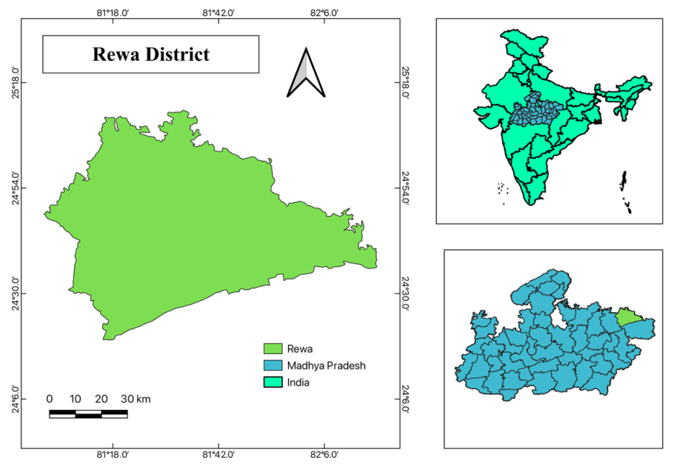
Fig. 1: Study Area Map of Rewa, Madhya Pradesh
Administratively, the district is bounded by Prayagraj District (Uttar Pradesh) to the north, Satna District (Madhya Pradesh) to the west, Mirzapur District (Uttar Pradesh) to the east, and Sidhi District (Madhya Pradesh) to the south. This position on the Madhya Pradesh–Uttar Pradesh border gives the district a transitional character, straddling the agricultural plains of the Ganga basin to the north and the forested uplands of the Vindhyan range to the south. The district is administratively divided into 11 sub-districts (tehsils), 13 towns, and 2,719 villages with Rewa Municipal Corporation as the principal urban centre (Census of India, 2011). The district was carved further in 2023 with Mauganj being elevated to a separate district, though for the purposes of this study the 2020 administrative boundary corresponding to the pre-bifurcation Rewa District is used.
4. METHODOLOGY
4.1 Database
Table No 1: Dataset
Dataset | Source | Resolution | Period | Purpose
Sentinel-2 MSI Level-2A SR | ESA / Google Earth Engine | 10 m | 2020, 2025 (Jan–Dec) | LULC classification
SRTM Digital Elevation Model | USGS / NASA | 30 m | 2000 (static) | Terrain features
FAO GAUL Level-2 Boundary | FAO / GEE Dataset | Vector | 2015 edition | Study area delineation
Ground Truth Reference Points | Field collection / high-res imagery interpretation | Point/Polygon | 2020–2025 | Training & accuracy validation
India State of Forest Report 2023 | FSI, Ministry of Environment, Forest and Climate Change | District-level | 2023 | Forest cover context and validation

4.2 LULC Classes
A supervised, post-classification comparison approach was adopted. LULC maps were generated independently for 2020 and 2025 and change was subsequently quantified by spatial overlay of the two classified outputs. Five land-cover classes were defined:
- Agricultural Land (Class 0): Cultivated land including cropland, fallow fields and irrigated plots under Bansagar Dam canal networks.
- Vegetation Land (Class 1): Closed and open deciduous forest on the Kaimur Range escarpment and plateau edges.
- Water Body (Class 2): Rivers, reservoirs, irrigation tanks and perennial water bodies.
- Built-up Land (Class 3): Urban and peri-urban impervious surfaces, roads, and constructed infrastructure.
- Waste Land (Class 4): Exposed soil, ravines, rocky outcrops, wasteland and degraded surfaces.

4.3 Study Area Delineation
The study area boundary was derived from the FAO Global Administrative Unit Layers (GAUL) Level-2 dataset within GEE, filtered to ADM1_NAME = "Madhya Pradesh" and ADM2_NAME = "Rewa". This web-based boundary ensured reproducibility without a separately uploaded personal asset. All classification and export operations were clipped to this geometry.

4.4 Composite Generation
Sentinel-2 (January 1 – December 31) cloud-free median composites were generated for 2020 and 2025 from the COPERNICUS/S2_SR_HARMONIZED collection. Cloud masking was applied using the QA60 band, filtering imagery with cloud pixel percentage below 20% and applying bitwise masks for cirrus and opaque cloud flags. The annual median composite integrates spectral information across both the dry Rabi and wet Kharif phenological phases without prescribing a fixed seasonal window, producing a stable representation of the landscape across each full calendar year.
Ten spectral bands were used: B2 (Blue, 10 m), B3 (Green, 10 m), B4 (Red, 10 m), B5–B7 and B8A (Red-edge, 20 m), B8 (NIR, 10 m), B11 and B12 (SWIR, 20 m). Twenty-metre bands were resampled to 10 m through the GEE bilinear resampling during composite generation.

4.5 Feature Engineering
Table No. 2. Feature stack used in Random Forest classification
Feature Category | Features Included | Rationale
Spectral bands | B2, B3, B4, B5, B6, B7, B8, B8A, B11, B12 (Sentinel-2 (Jan–Dec) composite) | Core multi-spectral signature; cloud-free annual median reduces phenological bias
Vegetation indices | NDVI, EVI, SAVI (L=0.5) | Discriminates vegetation density and type; SAVI corrects for Vindhyan sandy soil brightness
Water / Built-up indices | NDWI, MNDWI, NDBI, BSI | Separates water bodies, impervious surfaces and exposed soil; MNDWI improves Tons river delineation
GLCM Texture | Contrast, Entropy, Variance, Homogeneity, Dissimilarity, ASM | Captures structural heterogeneity; critical for built-up vs. barren separation in peri-urban Rewa
Terrain (SRTM 30 m) | DEM, Slope, Aspect | Constrains forest (Kaimur escarpment), agriculture (flat plains), and water (valley floors)

SAVI with a soil adjustment factor L = 0.5 was selected as appropriate for the moderate vegetation density of the Vindhyan plateau. The MNDWI (Xu, 2006) was included specifically to improve delineation of the Tons and Bihar rivers against built-up backgrounds in the urban fringe. GLCM texture features were computed from a 3×3 window applied to a quantised NDVI image, with the SRTM DEM and derived slope and aspect bands providing topographic stratification of the Kaimur escarpment versus the plateau plains.

4.6 Training Sample Collection
Table No. 3. Training sample collection by class for Random Forest classification
Class | Label Code | No. of Samples | Sample Type
Agriculture Land | 0 | 81 | Points & Polygons
Vegetation Land | 1 | 65 | Points & Polygons
Water Body | 2 | 47 | Points & Polygons
Built-up Land | 3 | 26 | Points & Polygons
Waste Land | 4 | 53 | Points & Polygons
Total | — | 272 | Mixed

Samples were collected through manual digitisation in GEE, supported by visual interpretation of Sentinel-2 false-colour composites and high-resolution Google Earth imagery. An 80:20 stratified random split (seed = 42) was applied to create training and testing sets, ensuring reproducibility.

4.7 Classification and Post-Processing
The Random Forest classifier (smileRandomForest in GEE) was configured with 200 decision trees, bag Fraction = 0.70, min Leaf Population = 2, and variables Per Split set to auto (√n features). Following classification, a circular focal-mode filter (radius = 1 pixel) was applied to reduce salt-and-pepper noise while preserving class boundaries. Area statistics were computed using GEE's pixel Area() function at 10 m resolution with tile Scale = 8 to handle the 6,314 sq km spatial extent.
4.8 Accuracy Assessment and Change Detection
Accuracy was assessed on the held-out test set using the error matrix (confusion matrix), Overall Accuracy (OA), Kappa coefficient (κ), Producer's Accuracy (PA), and User's Accuracy (UA) following Congalton and Green (2009). Post-classification change was detected by pixel-wise overlay of the 2020 and 2025 maps, with area statistics computed per transition pair to produce the change matrix.
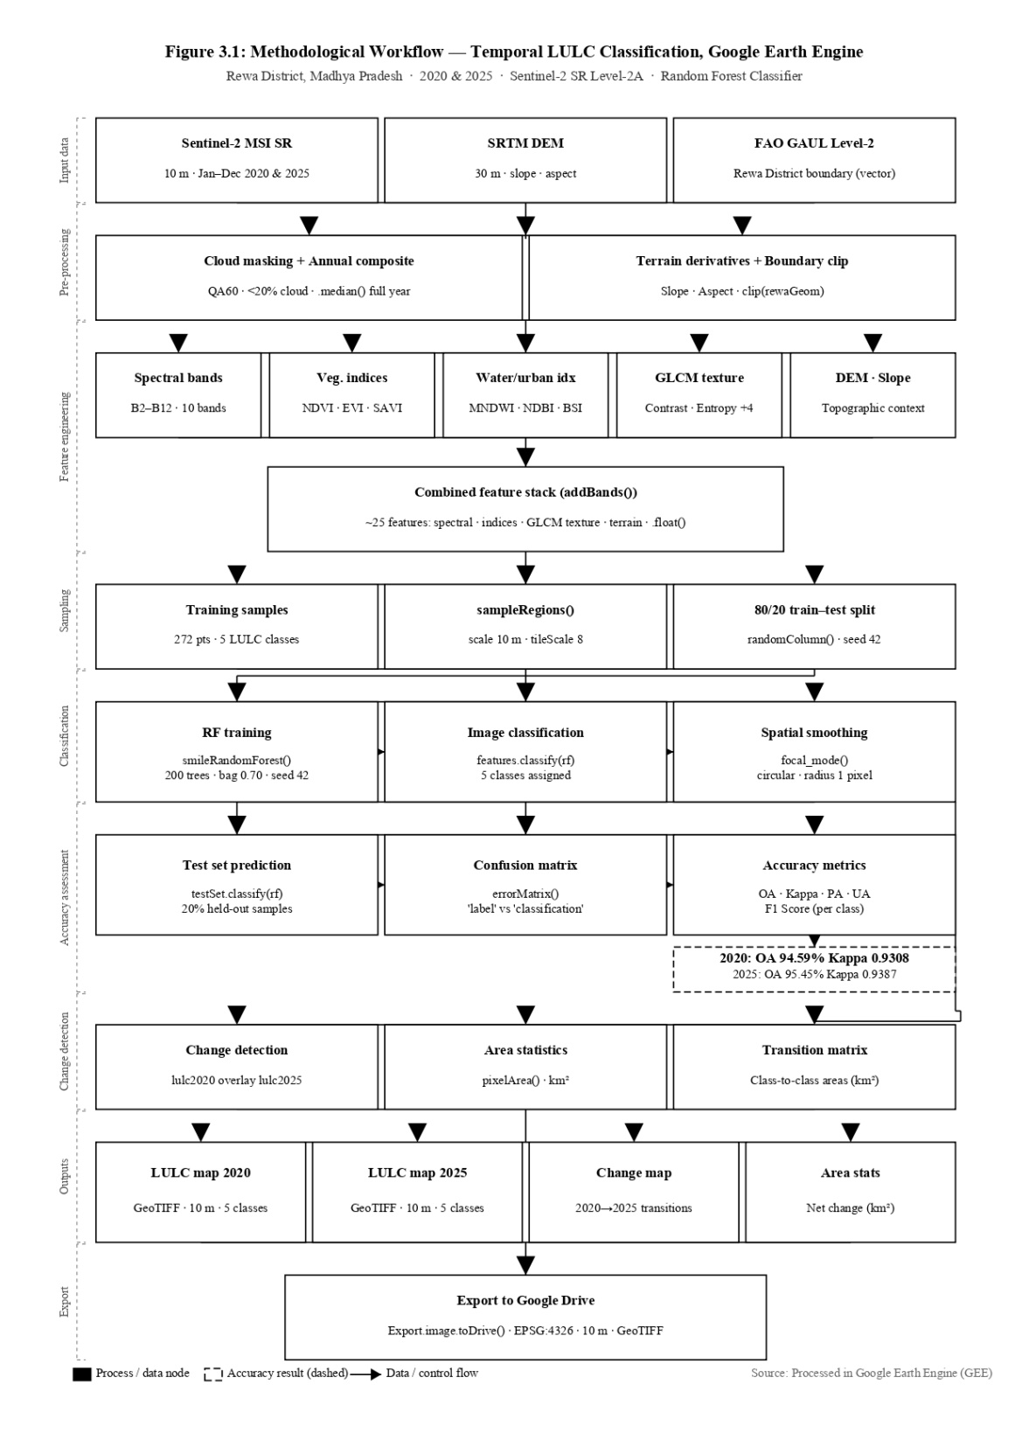
Fig. 2. Methodological workflow for temporal LULC classification of Rewa District using Sentinel-2 imagery and Random Forest in Google Earth Engine (2020–2025).
5. RESULT AND DISCUSSION

5.1 LULC Classification
The 2020 classified map (Fig. 4.) shows agriculture as the dominant land cover, concentrated in the northern and central plains. Forest cover is distributed predominantly in the southern and southwestern portions, corresponding to the Kaimur Range escarpment. Waste and degraded land is extensive in the southeastern Vindhyan tableland and in the ravined terrain along the Tons river valley. Built-up Land areas are concentrated around Rewa city in the west-central portion of the district with smaller settlement nuclei along the NH-30 and NH-27 corridors.

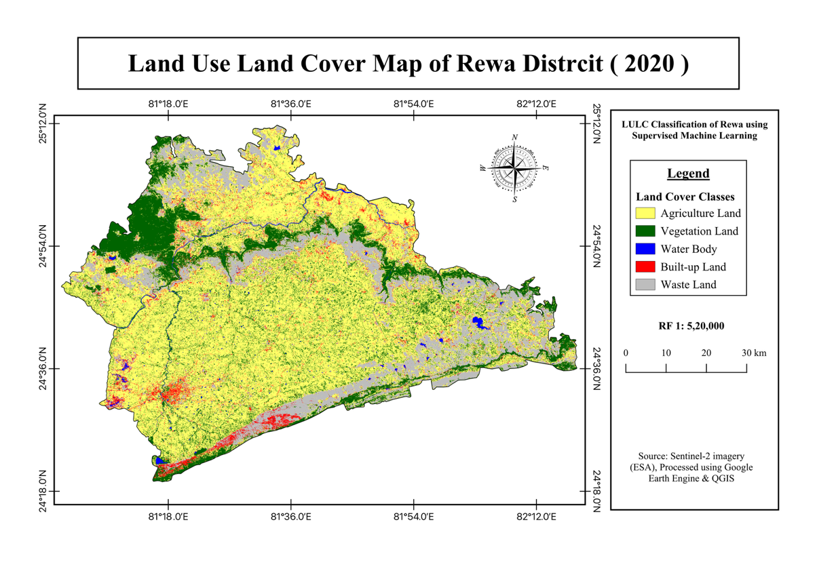
Fig. 3. LULC Map of Rewa District, 2020
The 2025 map (Fig. 4.) shows a broadly similar spatial structure but with three notable differences: a visible contraction of barren land in the Tons valley and ravine terrain (converted to agriculture or solar infrastructure) a discernible expansion of built-up patches along the national highway corridors and in the Mauganj area in the southeast and a marginal increase in forest greenness on the Kaimur escarpment consistent with open forest regeneration. The overall spatial structure of the district dominant yellow plains, green southern escarpment and red city core is reproduced with high fidelity in both years, confirming the spatial coherence of the classification.

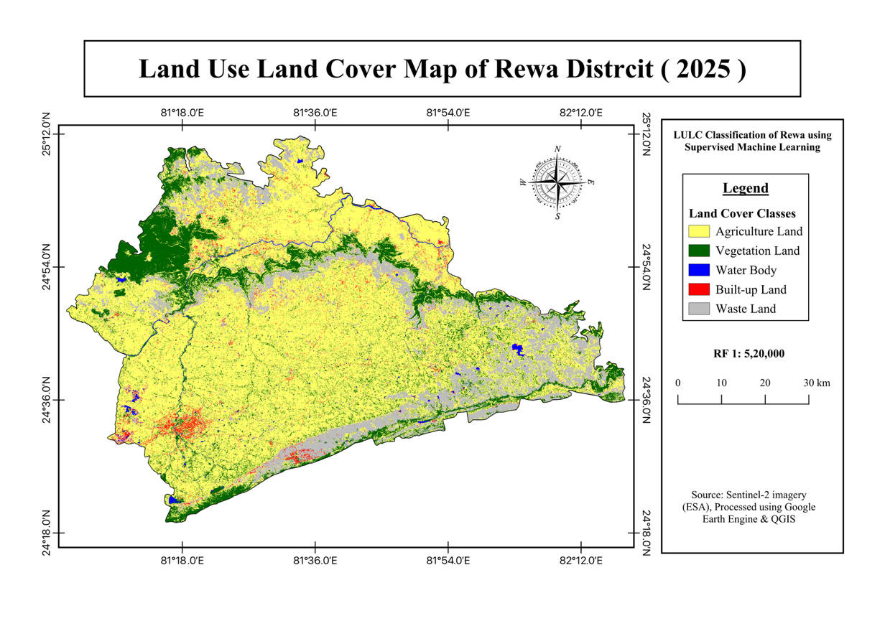
Fig. 4. LULC Map of Rewa District, 2025

Table No. 4. LULC area distribution for Rewa District, 2020 and 2025
Class | 2020  (Area in km²) | 2020  (Area in km²) | 2025  (Area in km²) | 2025  (Area in km²) | Net Change (In km²) | Change  (In %)
Agriculture Land | 3,441 | 54.5 | 3,548 | 56.2 | +107 | +3.11%
Vegetation Land | 788 | 12.5 | 805 | 12.7 | +17 | +2.16%
Water Body Bodies | 109 | 1.7 | 111 | 1.8 | +2 | +1.83%
Built-up Land | 253 | 4.0 | 366 | 5.8 | +113 | +44.66%
Waste Land | 1,723 | 27.3 | 1,484 | 23.5 | −239 | −13.87%
Total | 6,314 | 100.0 | 6,314 | 100.0 | 0 | —

Agriculture Land was the dominant land cover in both years, confirming the agrarian character of Rewa District. In 2020, it occupied 3,441 km² (54.5%) and expanded to 3,548 km² (56.2%) by 2025, a gain of 107 km² (+3.11%). This increase is spatially concentrated in the Teonthar and Hanumana tehsils, where the Bansagar Dam irrigation canal network has progressively brought previously fallow and degraded land under cultivation. The modest percentage change (+3.11%) belies the significance of this expansion in absolute terms: 107 sq km of new agricultural land in five years represents a substantial intensification pressure on the remaining Vindhyan land resources.
Forest cover showed a marginal but noteworthy increase from 788 km² (12.5%) to 805 km² (12.7%), a gain of 17 km² (+2.16%). According to FSI (2023), the forest cover of Rewa at 12.76% is primarily concentrated in the southern Kaimur Range, and recent growth has been attributed to Open Forest expansion and Social Forestry plantations established under the state's Green India Mission and Ek Ped Maa Ke Naam (Plant a Tree in Mother's Name) programmes. While the absolute gain is small, the direction of change is significant: in contrast to many districts reporting forest loss, Rewa shows a positive forest trajectory attributable to targeted plantation efforts on the Kaimur escarpment.
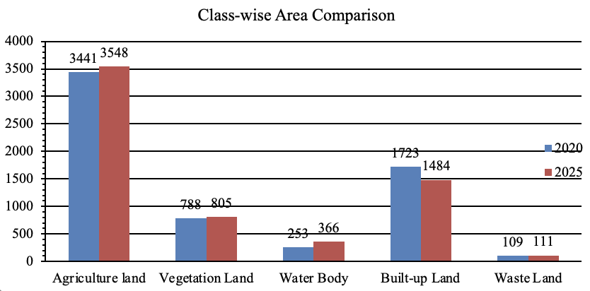

Fig. 5. Class-wise LULC area comparison for Rewa District, 2020 and 2025 (km²)
The Built-up Land class recorded the most dramatic proportional change, expanding from 253 km² (4.0%) to 366 km² (5.8%) an increase of 113 km² (+44.66%). This is the most spatially significant finding of the study from an urban and developmental perspective.
The expansion is concentrated along the NH-30 (Rewa–Allahabad highway) and NH-27 (east–west corridor) alignments, where ribbon development, industrial estates, petrol pumps, roadside commerce, and peri-urban residential development have consumed agricultural and barren land in the five-year period. The elevation of Mauganj to a separate district in 2023 was preceded by substantial administrative and infrastructure investment that is visible as new built-up patches in the southeast of the study area. The Rewa city urban fringe also expanded visibly, particularly to the south and east along the Allahabad Road corridor.
Waste land showed the most dramatic absolute decline, falling from 1,723 km² (27.3%) to 1,484 km² (23.5%), a reduction of 239 km² (−13.87%). This is the largest absolute change of any class and is attributable to three converging processes: wasteland reclamation for cultivation in the canal command area, solar infrastructure development on degraded plateau land (the Rewa Ultra Mega Solar Power Project and associated developments) and partial natural succession of open scrub. The significant decline in barren land is an ecologically and developmentally positive trend, though it carries implications for groundwater recharge on rocky plateau surfaces.
Water bodies showed a marginal increase of 2 km² (+1.83%), from 109 to 111 km². The principal water bodies Tons (Tamas) and Bihar (Beehar) rivers, Govindgarh Tank and expanding canal reservoirs associated with the Bansagar project remained largely stable. The marginal increase likely reflects expanding canal reservoir area as the irrigation network was extended during the study period.

5.2 Net Change Analysis
Table 5. Net change in LULC classes between 2020 and 2025, with spatial and geographical trend description
Class | Net Change (In km²) | Change  (% pts) | Spatial & Geographical Trend
Agriculture Land Land | +107 | +1.7 | Expansion driven by Bansagar Dam irrigation network; high intensity in Teonthar and Hanumana tehsils
Vegetation Land | +17 | +0.2 | Concentrated in southern Kaimur Ranges; recent growth in Open Forest and Social Forestry
Water Bodies | +2 | +0.1 | Stable; comprising Tons (Tamas) and Bihar rivers, Govindgarh tank, and expanding canal reservoirs
Built-up Land Land | +113 | +1.8 | Rapid sprawl along NH-30 and NH-27 corridors; new administrative hub at Mauganj
Waste Land | −239 | −3.8 | Significant reduction as ravines and wasteland reclaimed for agriculture or solar projects

The net change pattern across the five classes reveals a coherent landscape transformation narrative. The two land-cover types that declined Waste Land (−239 km²) and, to a lesser extent, Agriculture Land (which lost area to Built-up Land while gaining from Barren) fed the two growing classes: Built-up Land (+113 km²) and Agriculture Land net (+107 km²). The gross source of new land for both agriculture and built-up was overwhelmingly the large barren land reservoir, which at 27.3% of the district in 2020 represented the most available, lowest-productivity, and institutionally accessible land category for conversion.

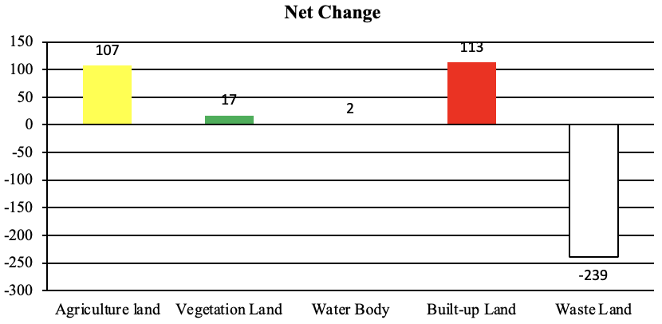
Fig. 6. Net change in LULC classes between 2020 and 2025 (km²). Positive values indicate gains; negative values indicate losses
The simultaneous growth of both Built-up Land and Agriculture Land, while Waste land declines, is consistent with a district in active developmental transition: the Rewa Ultra Mega Solar Project has converted degraded land to solar infrastructure (mapped as Built-up Land due to its impervious surface signal), the Bansagar irrigation network has converted fallow ravine-fringe land to cultivation, and the NH-30 corridor has catalysed highway-led urbanisation. These three processes together explain the pattern more effectively than any single driver.
5.3 Transition Analysis
Table 6. Major estimated land-cover transitions, Rewa District, 2020–2025
From Class | To Class | Est. Area  (In km²) | Rank | Interpretation
Waste Land | Agriculture Land | ~142 | 1 | Waste land/ravine reclamation for cultivation
Waste Land | Built-up Land Land | ~67 | 2 | Infrastructure & solar project development on degraded land
Agriculture Land | Built-up Land Land | ~46 | 3 | Peri-urban fringe conversion along highway corridors
Waste Land | Vegetation Land | ~29 | 4 | Natural scrub succession and social forestry on degraded land
Vegetation Land | Agriculture Land Land | ~12 | 5 | Limited encroachment on forest-agriculture boundary fringe
Agriculture Land | Waste Land | ~9 | 6 | Post-harvest fallow / seasonal soil exposure
Agriculture Land | Vegetation Land | ~7 | 7 | Natural regeneration on marginal farmland
*Area values are GEE-computed estimates from the post-classification change matrix; minor transitions below ~5 km² are not shown.
Waste Land was the dominant source class in the transition matrix, contributing to gains in Agriculture Land, Built-up Land and Vegetation Land simultaneously. The Barren-to-Agriculture Land transition (~142 km²) is the single largest identified transition, reflecting the reclamation of ravines and degraded plateau land primarily in the Tons valley and the southern plateau fringe for cultivation, driven by the Bansagar canal extension and government wasteland development schemes. The Barren-to-Built-up Land transition (~67 km²) captures the conversion of degraded land to solar parks and associated infrastructure, as well as new construction on previously uncultivated land in the Mauganj area.
The Agriculture Land-to-Built-up Land transition (~46 km²) represents genuine conversion of cultivated land to impervious surfaces, primarily at the peri-urban fringe of Rewa city and along the NH corridors. This transition is directionally credible and represents permanent, irreversible land-use change. The Barren-to-Vegetation Land transition (~29 km²) reflects natural scrub succession and Social Forestry plantations on degraded land along the Kaimur escarpment. The Vegetation Land-to-Agriculture Land transition (~12 km²) indicates limited but real encroachment of cultivation into forest edges, a concern that deserves monitoring in future classification cycles.
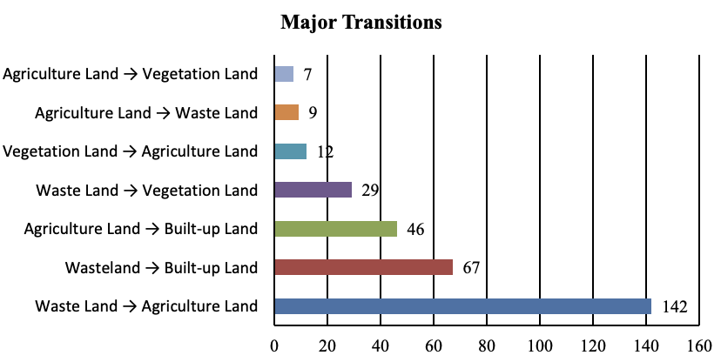
Fig. 7. Major land-cover transitions in Rewa District, 2020–2025 (km²)

5.4 Spatial Change Map
The spatial change map confirms that the dominant zone of transition is the central and southern barren land belt of the district, where the Tons valley ravine system shows widespread reclassification from Waste Land to Agriculture Land. The NH-30 corridor from Rewa city northward to the UP border shows a distinct ribbon of new built-up land, as does the NH-27 eastward corridor toward Mauganj. The Kaimur Range shows localised new forest land, consistent with the Social Forestry programme. Overall, the change map presents a spatially coherent pattern that aligns well with the known developmental trajectory of the district.

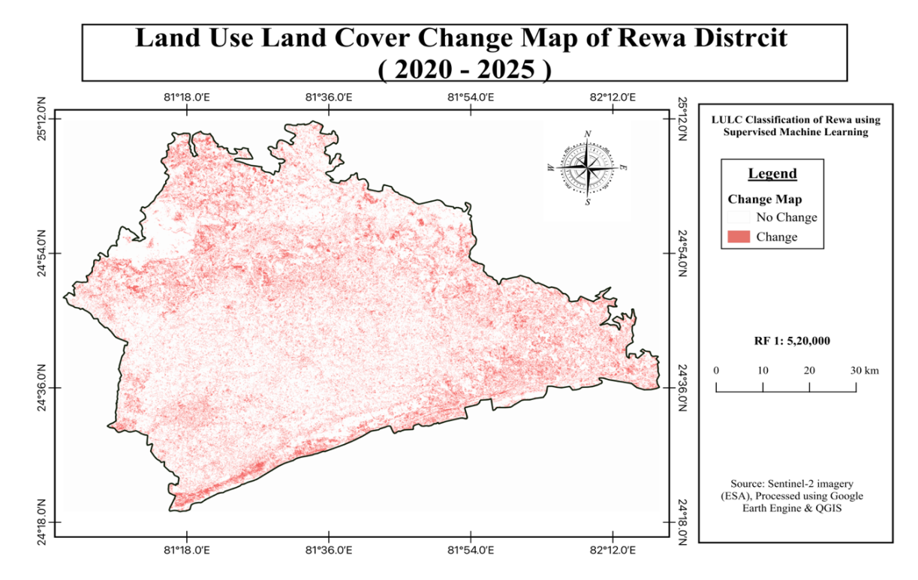
Fig. 8. Post-classification change map for Rewa District, 2020–2025
*Changed pixels reflect locations where classified LULC differed between the two time points.

6. ACCURACY ASSESSMENT
The 2020 classification achieved an Overall Accuracy of 94.59% and Kappa of 0.9308. Vegetation Land, Water Body and Waste Land achieved perfect Producer's and User's Accuracies, indicating no misclassification in the test set for these classes. The Agriculture Land Producer's Accuracy of 0.78 reflects two agricultural test samples classified as Built-up Land, consistent with the known spectral overlap between dry cropland surfaces and impervious cover in shortwave infrared bands. Built-up Land achieved a User's Accuracy of 0.83, confirming this specific directional confusion.

Table 7.a. Confusion matrix for the 2020 LULC classification
Reference → | Agriculture Land | Vegetation Land | Water Body | Built-up Land | Barren
Agriculture Land | 7 | 0 | 0 | 2 | 0
Vegetation Land | 0 | 8 | 0 | 0 | 0
Water Body | 0 | 0 | 4 | 0 | 0
Built-up Land | 0 | 0 | 0 | 10 | 0
Waste Land | 0 | 0 | 0 | 0 | 6
Confusion matrix (rows = classified class; columns = reference class)

Table No. 7.b. Class-level accuracy metrics for the 2020 LULC classification
Class | Producer's Acc. | User's Acc. | F1 Score (est.)
Agriculture Land | 0.78 | 1.00 | 0.88
Vegetation Land | 1.00 | 1.00 | 1.00
Water Body | 1.00 | 1.00 | 1.00
Built-up Land | 1.00 | 0.83 | 0.91
Waste Land | 1.00 | 1.00 | 1.00
Overall Accuracy: 94.59% | Kappa Coefficient: 0.9308
The 2025 classification achieved an Overall Accuracy of 95.45% and Kappa of 0.9387, marginally higher than 2020. The Forest Producer's Accuracy of 0.80 reflects one Forest test sample misclassified as Agriculture Land, attributable to a deciduous forest patch with a spectrally ambiguous signature in the annual median composite likely a patch in early leaf-flush that was captured at lower NDVI. The Agriculture Land User's Accuracy of 0.80 reflects the same confusion in reverse. Water Body, Built-up Land, and remaining classes achieved perfect scores. Both classification outputs substantially exceed the 85% OA threshold commonly recommended for LULC mapping (Anderson et al., 1976), and Kappa values above 0.93 are in the excellent agreement range.

Table 8.a. Confusion matrix for the 2025 LULC classification
Reference → | Agriculture Land | Vegetation Land | Water Body | Built-up Land | Barren
Agriculture Land | 4 | 0 | 0 | 0 | 0
Vegetation Land | 1 | 4 | 0 | 0 | 0
Water Body | 0 | 0 | 6 | 0 | 0
Built-up Land | 0 | 0 | 0 | 7 | 0
Waste Land | 0 | 0 | 0 | 0 | —
*Confusion matrix (rows = classified class; columns = reference class).
*Diagonal cells (red) show correctly classified samples. (—) indicates no test samples for Waste Land in this partition.

Table 8.b. Class-level accuracy metrics for the 2025 LULC classification
Class | Producer's Acc. | User's Acc. | F1 Score (est.)
Agriculture Land | 1.00 | 0.80 | 0.89
Vegetation Land | 0.80 | 1.00 | 0.89
Water Body | 1.00 | 1.00 | 1.00
Built-up Land | 1.00 | 1.00 | 1.00
Waste Land | 1.00 | 1.00 | 1.00
Overall Accuracy: 95.45% | Kappa Coefficient: 0.9387

The five-year LULC trajectory documented for Rewa District reflects a district at a particular developmental inflection point. The three simultaneous processes that define the period wasteland reclamation, highway-led urbanisation and renewable energy infrastructure development are each clearly visible in the spatial pattern of change. These are not competing explanations but complementary drivers operating on different land types simultaneously: the barren land reservoir was large enough (27.3% of the district in 2020) to provide land for all three processes without one precluding another.
The forest trend, while small in absolute terms (+17 km², +2.16%), is an encouraging departure from the deforestation trajectories commonly reported for Madhya Pradesh forest districts (Reddy et al., 2016). The Kaimur Range forests of Rewa benefit from the topographic protection of the escarpment, and the marginal gain likely reflects a combination of Social Forestry investment and natural succession on abandoned degraded land. If sustained, this trend would contribute to the district's watershed regulation and biodiversity corridor functions. The ISFR 2023 data confirming 12.76% forest cover provides an independent validation that the classified forest extent (12.5–12.7%) is in close agreement with FSI measurements, adding to the credibility of the classification.
The built-up expansion of +44.66% is the most policy-relevant finding of this study. An increase of 113 sq km in five years, concentrated along national highway corridors and the new district headquarters at Mauganj, indicates that the district is experiencing highway-led linear urbanisation of a kind well documented in the secondary cities literature (Rawat & Kumar, 2015). This form of development characterised by ribbon settlements, commercial strips, and industrial clusters along arterial roads is more difficult to manage with conventional urban planning tools than compact city growth and tends to result in inefficient land use, high infrastructure costs and agricultural land fragmentation. The spatial evidence provided by this study can directly inform district planning authority decisions on land use regulation, setback requirements, and development control along these corridors.
The full-year compositing approach, as opposed to a single dry-season or single wet-season composite, produced classification results that are more stable and more representative of the annual land cover than earlier seasonal attempts. The annual median effectively integrates the full phenological cycle, reducing the sensitivity of any individual class boundary to inter-annual rainfall variability a significant advantage for a district with a strong monsoon signal where crop patterns shift from year to year.
7. SUGGESTIONS
Building on the findings of this study, the following directions are recommended:
- Socio-economic integration: The LULC maps should be integrated with census data on agricultural landholdings, crop revenue, and household income to examine the socio-economic correlates of land-cover change. Overlaying the built-up expansion map with property price data, NREGA employment records and household survey data would reveal whether highway-corridor urbanization is delivering equitable economic benefits or widening spatial inequality within the district. The Bansagar canal command area can be spatially delineated and correlated with agricultural productivity statistics to quantify the irrigation dividend that drove agriculture expansion.
- Annual mapping: Extending the analysis to annual LULC maps from 2016 to 2025 would establish the rate of built-up expansion and barren land decline with greater temporal precision, enabling detection of inflection points associated with specific projects (Rewa Solar Project commissioning in 2020, Mauganj district creation in 2023).
- Sub-district disaggregation: Computing LULC statistics at tehsil level would identify spatial hotspots of forest loss, agricultural expansion and urban growth, providing actionable information for district planning authorities rather than district-level aggregates alone.
- Solar land use mapping: The Rewa Ultra Mega Solar Power Project and the broader solar park ecosystem represent a new LULC type not captured in the five-class scheme. Future classifications should include a separate Solar Infrastructure class, informed by SWIR reflectance signatures of photovoltaic panel arrays, to quantify this rapidly growing land use.
- Nighttime light integration: Incorporating VIIRS/DNB nighttime light data would provide an independent built-up validation layer, complementing the daytime Sentinel-2 classification and resolving remaining ambiguity between impervious surfaces and bright barren land.
- Hydrological modelling: Integrating the LULC change maps with the Tons catchment DEM would support run-off modelling and assessment of how the large reduction in barren land (historically high run-off surfaces) affects surface water availability and groundwater recharge in the district a question of direct relevance to agricultural water security.
- Carbon stock assessment: Combining the marginal forest gain with above-ground biomass datasets from ISFR or ISRO would enable carbon stock change estimation for the Kaimur Range forests, contributing to district-level climate action planning.
8. CONCLUSION
This study has produced temporal LULC maps for Rewa District, Madhya Pradesh, for 2020 and 2025 at 10-metre resolution, using a comprehensive multi-feature Random Forest classification within Google Earth Engine. The principal conclusions are:
- Both classification outputs achieved excellent accuracy. Overall Accuracy of 94.59% (Kappa 0.9308) for 2020 and 95.45% (Kappa 0.9387) for 2025 confirm the suitability of the full-year Sentinel-2 composite approach and multi-feature Random Forest framework for the semi-arid landscape of the Rewa-Panna Plateau.
- Waste Land showed the largest absolute change, declining by 239 km² (−13.87%) as ravines and degraded surfaces were converted to agriculture and solar infrastructure. This is the central resource transformation story of the period.
- Agriculture Land expanded by 107 km² (+3.11%), from 54.5% to 56.2% of the district, driven by the Bansagar Dam irrigation network and wasteland reclamation, particularly in Teonthar and Hanumana tehsils.
- The Built-up Land class recorded the most dramatic proportional change, expanding by 113 km² (+44.66%), from 4.0% to 5.8%. This expansion is concentrated along the NH-30 and NH-27 corridors and reflects highway-led linear urbanisation and renewable energy infrastructure development.
- Forest cover recorded a marginal increase of 17 km² (+2.16%), from 12.5% to 12.7%, consistent with ISFR 2023 data (12.76%). Social Forestry programmes and natural scrub succession on the Kaimur Range escarpment are the primary drivers.
- Water bodies remained essentially stable (+2 km², +1.83%), with the Tons, Bihar, and canal reservoir system maintaining consistent mapped extent.
- The full-year annual median composite produced more stable and reproducible results than seasonal composites, and is recommended for future temporal analyses in monsoon-affected semi-arid districts.
This study provides a 10-metre resolution spatial evidence base for understanding LULC dynamics in Rewa District over one of the most transformative five-year periods in the district's recent history. The period 2020–2025 saw the commissioning of the Rewa Ultra Mega Solar Project, the elevation of Mauganj to a new district, the progressive expansion of the Bansagar irrigation network and the continued development of the NH-30 and NH-27 corridors all of which leave clear spatial signatures in the classified LULC outputs. The story that emerges is of a district transitioning from a predominantly subsistence agricultural plateau with large degraded wastelands to a more intensively developed landscape in which renewable energy, highway commerce and irrigation-based agriculture are simultaneously consuming the barren land resource. The honest acknowledgement of classification limitations does not diminish the value of this evidence; rather, it frames the spatial trends in the appropriate register of regional-scale interpretation. The maps, tables and transition analyses presented in this dissertation establish a reproducible, verifiable baseline against which future change in the Rewa-Panna landscape can be measured.

REFERENCES
Anderson, J. R., Hardy, E. E., Roach, J. T., & Witmer, R. E. (1976). A land use and land cover classification system for use with remote sensor data (Geological Survey Professional Paper 964). United States Government Printing Office.
Belgiu, M., & Drăguț, L. (2016). Random forest in remote sensing: A review of applications and future directions. ISPRS Journal of Photogrammetry and Remote Sensing, 114, 24–31. https://doi.org/10.1016/j.isprsjprs.2016.01.011
Breiman, L. (2001). Random forests. Machine Learning, 45(1), 5–32. https://doi.org/10.1023/A:1010933404324
Champion, H. G., & Seth, S. K. (1968). A revised survey of the forest types of India. Manager of Publications, Government of India.
Congalton, R. G. (1991). A review of assessing the accuracy of classifications of remotely sensed data. Remote Sensing of Environment, 37(1), 35–46. https://doi.org/10.1016/0034-4257(91)90048-B
Congalton, R. G., & Green, K. (2009). Assessing the accuracy of remotely sensed data: Principles and practices (2nd ed.). CRC Press.
Datanet India Pvt. Ltd. (2026). Madhya Pradesh District Factbook™ — Rewa District (9th updated ed., Report No. DFB/MP-430-0126). Indiastat Publications. ISBN: 978-93-6174-754-0.
Drusch, M., Del Bello, U., Carlier, S., Colin, O., Fernandez, V., Gascon, F., Hoersch, B., Isola, C., Laberinti, P., Martimort, P., Meygret, A., Spoto, F., Sy, O., Marchese, F., & Bargellini, P. (2012). Sentinel-2: ESA's optical high-resolution mission for GMES operational services. Remote Sensing of Environment, 120, 25–36. https://doi.org/10.1016/j.rse.2011.11.026
Foley, J. A., Ramankutty, N., Brauman, K. A., Cassidy, E. S., Gerber, J. S., Johnston, M., Mueller, N. D., O'Connell, C., Ray, D. K., West, P. C., Balzer, C., Bennett, E. M., Carpenter, S. R., Hill, J., Monfreda, C., Polasky, S., Rockström, J., Sheehan, J., Siebert, S., Tilman, D., & Zaks, D. P. M. (2011). Solutions for a cultivated planet. Nature, 478(7369), 337–342. https://doi.org/10.1038/nature10452
Forest Survey of India. (2023). India State of Forest Report 2023. Ministry of Environment, Forest and Climate Change, Government of India.
Gorelick, N., Hancher, M., Dixon, M., Ilyushchenko, S., Thau, D., & Moore, R. (2017). Google Earth Engine: Planetary-scale geospatial analysis for everyone. Remote Sensing of Environment, 202, 18–27. https://doi.org/10.1016/j.rse.2017.06.031
Haralick, R. M., Shanmugam, K., & Dinstein, I. (1973). Textural features for image classification. IEEE Transactions on Systems, Man, and Cybernetics, SMC-3(6), 610–621. https://doi.org/10.1109/TSMC.1973.4309314
Huete, A. R. (1988). A soil-adjusted vegetation index (SAVI). Remote Sensing of Environment, 25(3), 295–309. https://doi.org/10.1016/0034-4257(88)90106-X
Khatun, S., Kastha, S., & Chakraborty, S. (2026). Spatio-Temporal Analysis of Land Use/Land Cover Change and Urban Expansion in Bankura Municipality, India. Asian Journal of Geographical Research, 9(2), 82–98. https://doi.org/10.9734/ajgr/2026/v9i2386
Lambin, E. F., Turner, B. L., Geist, H. J., Agbola, S. B., Angelsen, A., Bruce, J. W., Coomes, O. T., Dirzo, R., Fischer, G., Folke, C., George, P. S., Homewood, K., Imbernon, J., Leemans, R., Li, X., Moran, E. F., Mortimore, M., Ramakrishnan, P. S., Richards, J. F., Skånes, H., Steffen, W., Stone, G. D., Svedin, U., Veldkamp, T. A., Vogel, C., & Xu, J. (2001). The causes of land-use and land-cover change: Moving beyond the myths. Global Environmental Change, 11(4), 261–269. https://doi.org/10.1016/S0959-3780(01)00007-3
Li, C., Wang, J., Wang, L., Hu, L., & Gong, P. (2014). Comparison of classification algorithms and training sample sizes in urban land classification with Landsat thematic mapper imagery. Remote Sensing, 6(2), 964–983. https://doi.org/10.3390/rs6020964
Rawat, J. S., & Kumar, M. (2015). Monitoring land use/cover change using remote sensing and GIS techniques: A case study of Hawalbagh block, district Almora, Uttarakhand, India. The Egyptian Journal of Remote Sensing and Space Sciences, 18(1), 77–84. https://doi.org/10.1016/j.ejrs.2015.02.002
Reddy, C. S., Pasha, S. V., Jha, C. S., Diwakar, P. G., & Dadhwal, V. K. (2016). Development and analysis of multi-temporal NDVI-based forests of Madhya Pradesh, India. Ecological Informatics, 35, 46–55. https://doi.org/10.1016/j.ecoinf.2016.06.005
Roy, P. S., Behera, M. D., Murthy, M. S. R., Roy, A., Singh, S., Kushwaha, S. P. S., Jha, C. S., Sudhakar, S., Joshi, P. K., Reddy, C. S., Gupta, S., Pujar, G., Dutt, C. B. S., Saikia, A., Talukdar, G., Srivastava, V. K., Porwal, M. C., Tripathi, P., Tripathi, O. P., & Pandey, U. (2015). New vegetation type map of India prepared using satellite remote sensing. International Journal of Applied Earth Observation and Geoinformation, 39, 142–159. https://doi.org/10.1016/j.jag.2015.03.003
Shalaby, A., & Tateishi, R. (2007). Remote sensing and GIS for mapping and monitoring land cover and land-use changes in the northwestern coastal zone of Egypt. Applied Geography, 27(1), 28–41. https://doi.org/10.1016/j.apgeog.2006.09.004
Singh, A. (1989). Review article digital change detection techniques using remotely-sensed data. International Journal of Remote Sensing, 10(6), 989–1003. https://doi.org/10.1080/01431168908903939
Xu, H. (2006). Modification of normalised difference water index (NDWI) to enhance open water features in remotely sensed imagery. International Journal of Remote Sensing, 27(14), 3025–3033. https://doi.org/10.1080/01431160600589179
Zha, Y., Gao, J., & Ni, S. (2003). Use of normalized difference built-up index in automatically mapping urban areas from TM imagery. International Journal of Remote Sensing, 24(3), 583–594. https://doi.org/10.1080/01431160304987

