Original Research Article

HEALTHY STOCK CONDITION OF Lutjanus gibbus DURING TRANSITION SEASON I IN THE ALAS STRAIT, INDONESIA

.
ABSTRACT

The Alas Strait is one of the major fishing grounds in West Nusa Tenggara Province, Indonesia, and supports commercially important fisheries resources, including Lutjanus gibbus (humpback red snapper). Increasing fishing pressure on this species has raised concerns regarding stock sustainability in the region. This study aimed to assess the stock health status of Lutjanus gibbus in the Alas Strait during the first transitional season. Data were collected from March to May 2025 at the Tanjung Luar Fish Market, East Lombok Regency, using accidental sampling on 221 individuals. The collected data included total length, landing site, fishing ground, and fishing gear type. Length-frequency analysis was conducted using Microsoft Excel and compared with the length at first maturity (Lm) obtained from the Scientific Forum for Sustainable Fisheries Management of West Nusa Tenggara Province. Stock status was further evaluated using the Length-Based Spawning Potential Ratio (LBSPR) approach through the Barefoot Ecologist’s Toolbox. The results showed that 84% of the sampled individuals were below the length at first maturity (<Lm), whereas only 16% exceeded the maturity threshold (>Lm). The dominant size class ranged from 25.8 to 29.3 cm total length, indicating that the catch composition was dominated by immature individuals. The SPR analysis yielded a value of approximately 10%, indicating that the stock status of Lutjanus gibbus in the Alas Strait during the first transitional season was overexploited. These findings demonstrate that current fishing activities predominantly target immature fish and may threaten long-term stock sustainability. Therefore, management measures regulating fishing activities during March–May are necessary to support the sustainable utilization of Lutjanus gibbus resources in the Alas Strait.

Keywords: Alas Strait, Catch Size, Fish Stock, Lutjanus gibbus, Spawning Potential Ratio (SPR), Transitional Season.

1. INTRODUCTION

The Alas Strait is an important water area in West Nusa Tenggara Province (WNT) that connects the Flores Sea with the Indian Ocean, as well as serving as a fish migration route and a main fishing area for local fishermen. The Alas Strait is also known as the center of the distribution of red snapper because of its geographical conditions that have many coral reefs (Himawan et al., 2021; Santoso, 2016). These coral reefs are important habitats for various types of economically valuable fish such as baronang fish, snapper, grouper, napoleon, and others (Prihatiningsih et al., 2020). The existence of economically important fish habitats in these waters is the reason for the increase in fishing activities in these waters in recent years, so that some species of economically valuable fish show indications of utilization that are close to or even exceeding the limit of sustainability (Santoso et al., 2015). Therefore, the factors of geographical conditions and exploitation pressure in these waters make the Alas Strait significant to be used as a research location for fish stocks to support scientific recommendations for fish resource management policies by the provincial government.

Lutjanus gibbus, known by its commercial name as humpback red snapper or has a local name in WNT Province as snapper, is one of the economically important fish found in the Alas Strait (Limmon et al., 2024). Lutjanus gibbus can grow up to 500 mm in length with an average size of about 350 mm (Anisa et al., 2024). Of the many species included in the Lutjanidae family, the species Lutjanus gibbus is one of the snapper species that has high economic value in the fisheries sector in Indonesia. This causes this fish to be often traded, especially for consumption (Oktaviyani, 2018; Astrid et al., 2024). Based on research by Wahyuningsih (2013), red snapper, including Lutjanus gibbus, is in great demand because of its good taste and meat quality. This type of fish is also one of the fishery export commodities with increasing demand.

Based on the Decree of the Minister of Maritime Affairs and Fisheries Number 123 of 2021, the export value of Indonesian snapper shows a fluctuating trend in 2014–2020. From Rp 171 billion in 2014 it decreased to Rp 154 billion in 2020 (−9.9%). The peak occurred in 2016 with a value of USD 20.95 million (with a volume of 6.09 million kg), then decreased again to USD 11.67 million in 2019. This condition indicates that although the international market is quite large, snapper exports tend to weaken due to demand for certain sizes and reduced stocks in nature. Meanwhile, based on statistical data on fisheries production from the Ministry of Marine Affairs and Fisheries of the Republic of Indonesia in 2025, it is known that the volume of snapper catched in 2021 reached 306,942.72 tons, in 2022 it reached 326,365.56 tons, and in 2023 it reached 329,842.96 tons from the marine capture fisheries sector. This also indicates that the demand for snapper continues to increase over time which can affect the condition of snapper stocks in nature.

Several studies in the Banten, Kupang, Biak, and Spermonde regions have identified the biological parameters of Lutjanus gibbus, including length-weight relationships, gonad maturity levels, fecundity, and size distribution. The results show that there is spatial variation in the population dynamics of the species, meaning that the population characteristics of Lutjanus gibbus are different in each body of water (Prihatiningsih et al., 2017; Panggabean et al., 2023; Anisa et al., 2024; Ernaningsih et al., 2023). However, data related to the condition of Lutjanus gibbus stocks in the Alas Strait is still relatively limited, while this water is one of the main fishing areas for fishermen around East Lombok Regency, WNT Province.

Base on some of the factors mentioned earlier, seasonal factors also affect the distribution and abundance of fish, including in the transitional season I, where changes in aquatic environmental conditions (temperature, current, and feed availability) have an impact on population dynamics and the availability of demersal fish stocks. According to the research of Priatna & Natsir (2017) which states that the density of demersal fish in the western season is recorded to be higher than the transition season. This is related to the availability of bentos as the main source of feed, where its abundance in the western season is more abundant than in the transitional season. Therefore, research on the health of Lutjanus gibbus stock in the waters of the Alas Strait in the first transition season is important to obtain an up-to-date picture of the health of Lutjanus gibbus stocks. The information produced in this study is expected to be useful for fishermen, coastal communities, and the government in supporting the formulation of sustainable fish resource management policies.

2. METHODOLOGY

2.1 Study area

The collection of total length data on the body of Lutjanus gibbus in this study was conducted at the Tanjung Luar Fish Market, East Lombok Regency, WNT Province, both at the collector and sellers of at the study site. The recorded specimens of Lutjanus gibbus were caught from the waters of the Alas Strait and subsequently sold and/or collected at the Tanjung Luar Fish Market. Figure 1 illustrates the data collection site and the location of the Alas Strait waters included in this study.
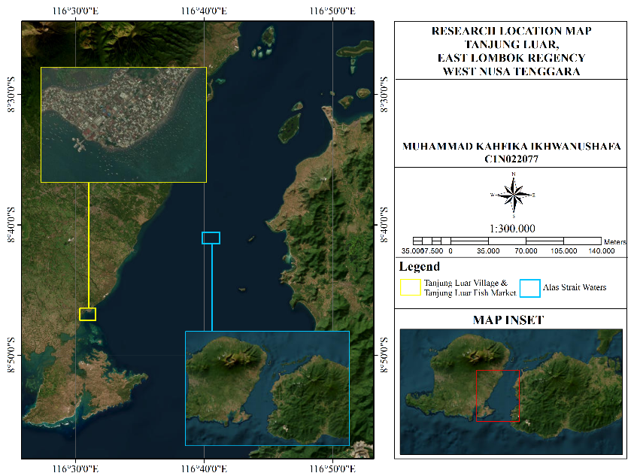
Figure 1. Study Area Map

2.2 Data collection

Data collection in this study was conducted on March-May 2025. The data collected in this study consisted of primary data and secondary data. According to Arif et al. (2017), primary data is obtained through direct observation or measurement in the field, which can also be in the form of structured interviews using questionnaires. Meanwhile, secondary data is collected from various official documents sourced from relevant and authorized agencies. The primary data collected in this study were the number of Lutjanus gibbus individuals caught and landed, the size of the total length, the area of capture, the type of fishing gear used, and the landing location of L. gibbus. Then, secondary data were collected in the form of information on the size of the first mature gonads (Lm), natural death (M), growth coefficient (k), theoretical maximum length (L∞), length at 50% sexual maturity (L50), and length at 95% sexual maturity (L95). The secondary data was obtained from the Scientific Forum for Sustainable Fisheries Management of WNT Province and a literature study of previous research.
The sampling technique used for sampling Lutjanus gibbus individuals in this study is accidental sampling, which is a sample determination technique by selecting individuals or objects that are coincidentally encountered at the research site and are considered relevant as data sources (Sukmanawati & Purwati, 2022). The number of L. gibbus individuals that were successfully recorded in this study was 221 individuals. All of the individuals of L. gibbus were photographed one by one using a mobile phone camera.
Individual photographs of Lutjanus gibbus were then measured in total length using WCS Image Tools software. Measurements of total length in individual Lutjanus gibbus were carried out by measuring the length of the body from the tip of the mouth to the tip of the tail of the fish (Figure 2). According to Gigentika et al. (2025), the measurement of the total length of the fish's body is carried out by taking measurements from the outermost tip of the mouth to the outermost tail. The stages in measuring the total length of Lutjanus gibbus individuals with WCS Image Tools software are:
- Set up a folder containing a collection of photos of the fish on a measuring board.
- The photo is imported by pressing Ctrl+O, then the photo will appear.
- The photos that have appeared in the app are then calibrated to the original size of the measuring board.
- Each fish was measured in total length from the mouth to the tip of the tail.
- The measurement results that appear are recorded and input into the Microsoft Excel file.

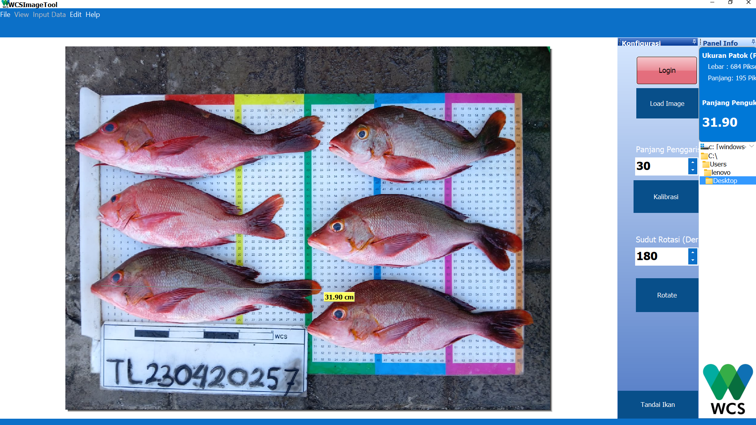
Figure 2. Total length (TL) measurement of Lutjanus gibbus

2.3 Data analysis

2.3.1 Analysis of Fish Length Distribution
Fish length distribution analysis is a method used to describe the distribution of individual length sizes in a fish population (Agustinawati et al., 2023). In this study, the analysis of the length distribution of Lutjanus gibbus was carried out using a histogram through the Data Analysis feature in Microsoft Excel. At this stage, the number of classes and class widths are determined for the preparation of fish length histograms. The formula from Ashari et al. (2024) used to calculate the number and width of classes is as follows:
K= 1 + (3.32 x (log(n))
$$Lebar kelas= \frac{nilai maksimum-nilai minimum}{K}$$
Remarks: K = number of classes, n = number of data
After that, the results of histogram analysis will be compared with the size of the fish when the gonads first mature (Lm) for Lutjanus gibbus so that the proportion of the size of Lutjanus gibbus caught by fishermen who have matured gonads can be known.
2.3.2 Fish Stock Health Analysis
The approach to fish stock health analysis in this study uses the Spawning Potential Ratio (SPR) method with the Length-Based Spawning Potential Ratio (LBSPR) approach accessed through the www.barefootecologist.com.au/lbspr (Hordyk et al., 2014). The biological parameters used for the LBSPR method include growth coefficient (k), theoretical maximum length (L∞), natural death (M), first caught size (Lc), and first mature gonad size (Lm). The biological parameters are quoted from previous research that has been conducted by the Scientific Forum for Sustainable Fisheries Management of WNT Province. The following are the steps carried out in conducting an LBSPR analysis on the website www.barefootecologist.com.au/lbspr:
- The results of the total length measurements that have been entered into Microsoft Excel are imported in csv file format.
- The csv file containing numerical data on the total length of the fish is then uploaded to the "Upload data" option.
- Select the "Plot data and fit model" option, then enter the fish life history parameters (M/k, L∞, L50 and L95).
- Select the length unit you want to use.
- Click the Data plot section and wait for the process to complete and bring up the LB-SPR graph.
The results of the LB-SPR analysis were then compared with the reference values based on the 3 existing fisheries status groups according to Walters and Martel (2004) and Prince (2015), namely: under exploited (SPR>40%), moderately exploited (20<SPR<40%) and over exploited (SPR<20%).

3. results and discussion

3.1 Length Frequency Distribution Conditions of Lutjanus gibbus

Based on the results of the analysis conducted in March 2025, a total of 12 individuals of Lutjanus gibbus were landed. This relatively low number was likely influenced by unfavorable weather conditions at the beginning of the first transitional season, which reduced fishing activity as fewer fishermen went to sea. Furthermore, all captured individuals were below the length at first maturity (Lm), indicating that 100% of the L. gibbus landed from the Alas Strait waters were categorized as < Lm. The highest total length of L. gibbus caught by fishermen in March 2025 was 27.82 cm, while the lowest recorded length was 15.2 cm. The average total length of the captured individual was 22.84 cm. The dominance of immature individuals in the catch of may pose a serious threat to the sustainability of wild stock of L. gibbus. According to Hountcheme et al. (2025), the dominance of fish catches sizes below the length of the first maturity (<Lm) can threaten stock sustainability because these individuals have not yetcontributed to the reproductive process. Fishing pressure on indivduals before reaching gonadal maturity is known to reduce population recruitment potential and accelerate stock decline in natural water. The frequency distribution of fish length observed in this study is pressented in Figure 3.
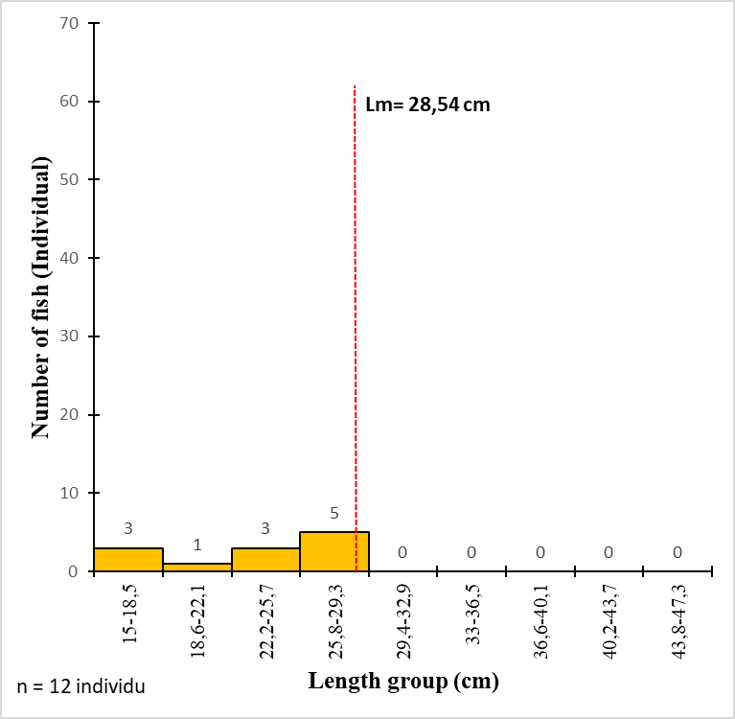
Figure 3. Length Frequency Distribution Graph of Fish in March 2025

In contrast to March 2025, the number of Lutjanus gibbus individuals landed in April 2025 increased to 88 individuals. The improvement in weather conditions during this month likely encouraged more fishermen to conduct fishing activities. The proportion of L. gibbus caught at size below the length at first maturity (Lm) was 72% (63 individuals), while only 28% (25 individuals) were recorded at size above Lm. The maximum total length recorded was 43.47 cm, whereas to the minimum length was 18.04 cm. The average total length of L. gibbus caught by fishermen in April 2025 was 27.29 cm. These results indicate that with the majority of the captured individuals consisted ofimmature fish. Such conditions may threaten the sustainability of L. gibbus stocks in the Alas Strait waters The capture of fish that have not yet reached gonadal maturity may reduce the reproductive capacity of the population and hinder stock recruitment in natural waters. This practice can leaad to growth overfishing and recruitment overfishing, which subsequently contributeto decline in biomass and fish abundance. As a result, fish stocks become increasingly vulnerable, thereby threatening and the sustainability of fisheriesresources(Kholis, 2023; Nurhakim 2017). The length frequency distribution of Lutjanus gibbus in April 2025 is presented in Figure 4.
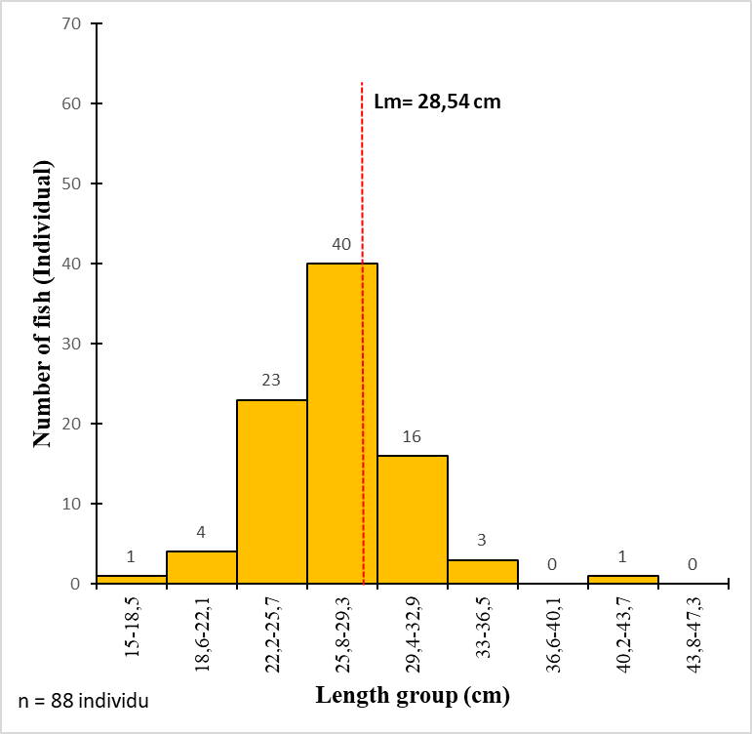
Figure 4. Length Frequency Distribution Graph of Fish in April 2025

Based on the results of the analysis conducted in May 2025, the number of Lutjanus gibbus individuals landed was higher than that recorded in March and April 2025, reaching a total of 121 individuals. This increase was likely influenced by the relatively more stable weather conditions during the final month of the firdt transitional season, which allowed more fisherman to conduct fishing activities. The proportion of L. gibbus at the size below the length at first maturity (Lm) was 92% (111 individuals), while only 8% (10 individuals) were recorded at sizes above Lm. The maximum total length recorded was 43.95 cm, whereas the minimum length was 16.06 cm. The average total length of L. gibbus caught by fishermen in the Alas Strait during May 2025 was 22.52 cm. The dominance of individuals caught at sizes below Lm indicates that most of the capture fish were biologically immature and therefore not suitable for harvest. According to Dewi et al. (2026), fish captured at sizes smaller than their Lm value are considered biologically unsuitable for capture because they have not yet spawned, This condition may negatively affect the sustainability offish stocks in the Alas Strait waters, considering that only 10 individuals, or 8% of the total catch, were categoriezed as sutable for harvest (>Lm). The lenght frequencies distribution of Lutjanus gibbus in May 2025 presented in Figure 5.

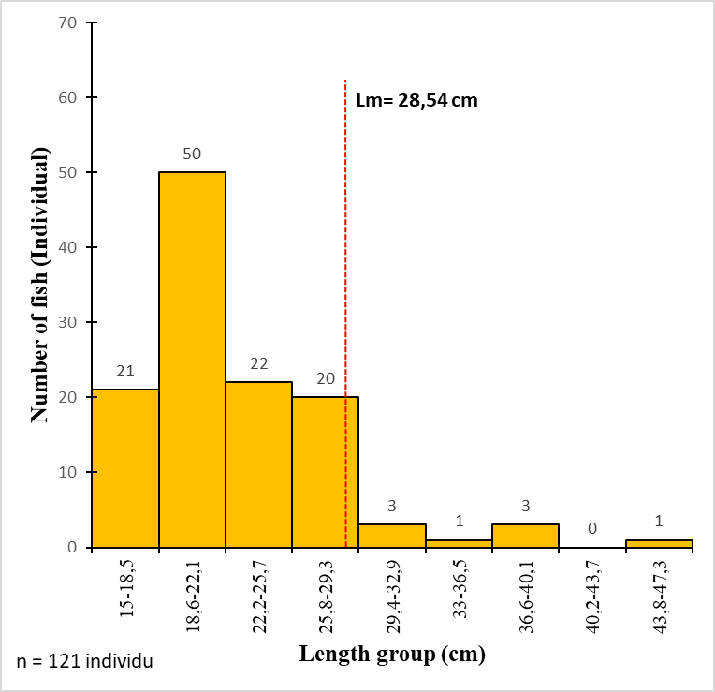
Figure 5. Length Frequency Distribution Graph of Fish in May 2025

In total, the number of Lutjanus gibbus individuals landed during the first transition season of 2025 reaced 221 individuals. This number was relatively lower compared to catches recorded during other seasons. This condition was likely influenced by unstable weather patterns during the first transitional season, which are generally characterized by fluctuating weather conditions, weak and irregular wind directions, and uneven rainfall distribution, often accompanied by strong local winds caused by atmospheric instability during the monsoonal transition period (Siregar et al., 2017; Taufiq & Anjasmara, 2025). As a result, many fishermen around Tanjung Luar reduced their fishing activities during this period.overall, during the first transitional season of 2025, the proportion of Lutjanus gibbus individuals with total lengths below the length at first maturity (Lm) reached 84% (186 individuals), whereas only 16% (35 individuals) of the captured individuals were above Lm. The maximum total length recorded was 43.95 cm, while the minimum length was 15.2 cm. The average total length of Lutjanus gibbus caught during the first transitional season of 2025 was 24.44 cm. These findings indicate that most of the captured individuals were biologically immature and therefore unsuitable for harvest. Such conditions may threaten the sustainability of L. gibbus stocks in the Alas Strait waters. The dominance of catches below the length at first maturity (<Lm) was likely influenced by the selectivity of the fishing gear used to capture L. gibbus. Differences in mesh size, fishing gear design, and fishing methods determine the ability of the gear to selectively capture fish of certain sizes. Non selective fishing gear tends to capture a wide range of fish sizes, including juvenile individuals (<Lm), whereas more selective fishing gear primarily captures adult individuals (>Lm). The continued use of less selective fishing gear may increase the proportion of juvenile fish in the catch, thereby accelerating the occurrence of growth overfishing and threatening the sustainability of fish stocks (Tuda et al., 2016; Chaves, 2022). The length-frequency distribution during the first transitional season of 2025 is presented in Figure 6.
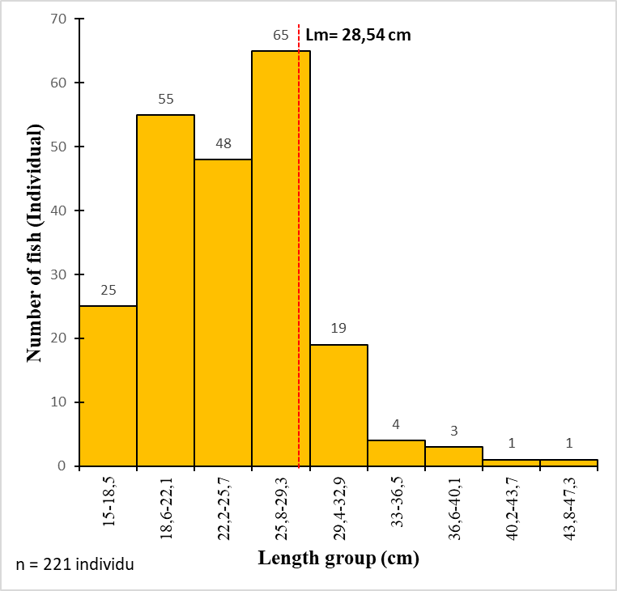
Figure 6. Length Frequency Distribution Graph of Fish During the First Transitional Season

Lutjanus gibbus is a demersal fish that lives in associated with benthic habitats and possesses significant economic value in Indonesian capture fisheries. This species is characterized by relatively slow growth and a comparatively large size at first gonadal maturity (Anisa et al., 2024). The results of this study indicate that the majority of captured L. gibbus individuals in each month of observation were below the length at first maturity (Lm), suggesting that most individuals had not yet entered the reproductive phase. This condition is consistent with the life history characteristics of snapper species, which are generally associated with coral reef ecosystems that function as important feeding grounds and nursery habitats before individuals reach adulthood (Panggabean et al., 2023). Furthermore, variations in fish length distribution among observation months were likely influenced by the dynamics of the transitional season, which trigger changes in oceanographic conditions such as current patterns and sea surface temperature. These environmental variations may affect the spatial distribution of fish populations and the availability of natural food resources, ultimately influencing the size composition of the catch (Priatna & Natsir, 2017). The increase in the average fish size observed in April 2025 may indicates a a temporary shift in population distribution toward fishing grounds in response to relatively more stable environmental conditions. Nevertheless, the dominance of small to medium sized individuals throughout the study period suggests that fishing pressure was primarily concentrated on younger age classes. Such conditions may negatively affect the long-term sustainability of L. gibbus stocks in the Alas Strait waters.
3.2 Stock Condition of Snapper Lutjanus gibbus in the Alas Strait waters

Based on the results of the SPR analysis (Spawning Potential Ratio) analysing using Length-based Spawning Potential Ratio (LBSPR) approach through the www.barefootecologist.com.au/lbspr, several output were obtained, including the length-frequency distribution, the proportion of Lc relative to Lm, and the estimated SPR value. The histogram presented in Figure 7 illustrates the length-frequency distribution of Lutjanus gibbus captured in the Alas Strait during the first transitional season of 2025. The histogram exhibits a left-skewed distribution pattern, indicating that the catch composition during the study period was dominated by small- to medium-sized Lutjanus gibbus individuals, whereas larger-sized individuals were relatively rare (Indrawati et al., 2020). The results of the length distribution analysis presented in Figure 7 are consistent with the Microsoft Excel based histogram analysis described in the previous section, both of which demonstrate that the dominant length class of L. gibbus ranged of 18–28 cm. This consistency the validity of the findings, indicating that the population structure of L. gibbus captured in the Alas Strait during the first transitional season of 2025 was dominated by individuals below the length at first maturity (<Lm).

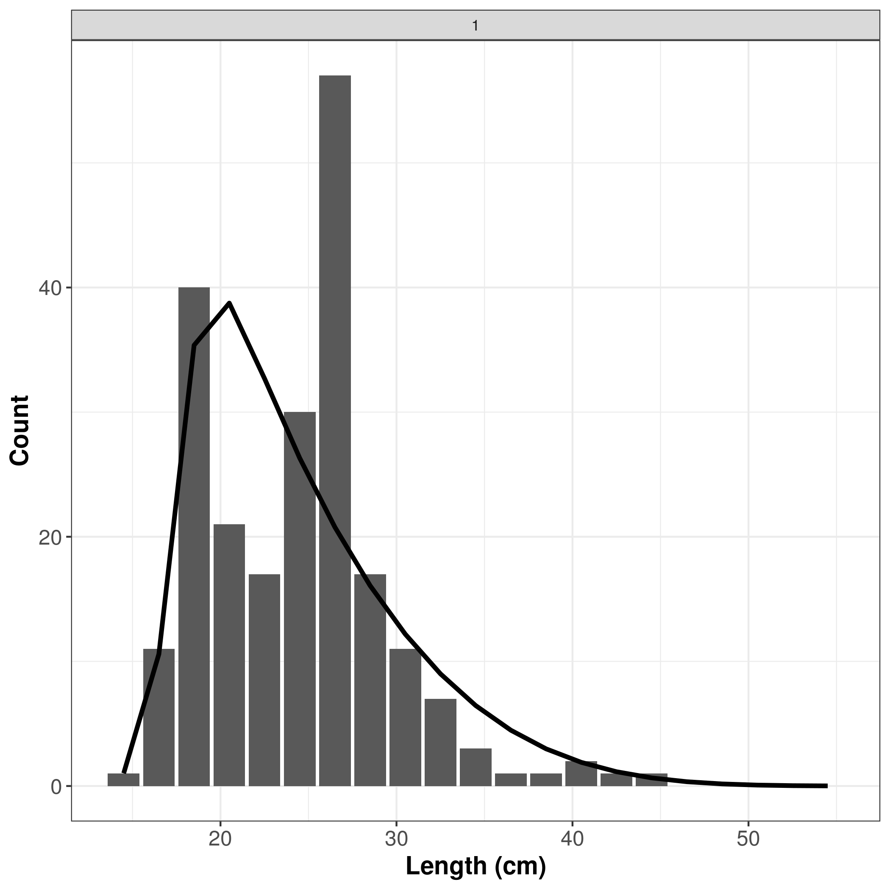
Figure 7. Histogram Graph of Length Size Distribution for Lutjanus gibbus in Alas Strait During the First Transitional Season at 2025

The graph presented in Figure 8 illustrated the relationship between the selectivity curve and gonadial maturity in Lutjanus gibbus. The figure shows that the length at first capture (Lc) was estimated to be within the range of approximately 18–19 cm, corresponding to the point at which the selectivity proportion reached 0.5. In contrast, the length at first maturity (Lm) was estimated to be within the range of approximately 29–30 cm, indicated by the gonadal maturity curve when the maturity proportion reached 0.5. The comparison between these two parameters demonstrates that the Lc value was lower than the Lm value (Lc < Lm). This finding indicates that most individuals of L. gibbus were captured before reaching gonadal maturity (Agustina et al., 2018). Such conditions suggest that the fish did not have sufficient opportunity to reproduce or spawn prior to being captured by fishing gear (Sari et al., 2024). If this condition continues over time, it may reduce the recruitment capacity of the population and potentially threaten the sustainability of L. gibbus stocks in the Alas Strait waters (Anas et al., 2023; Kurnia et al., 2022).
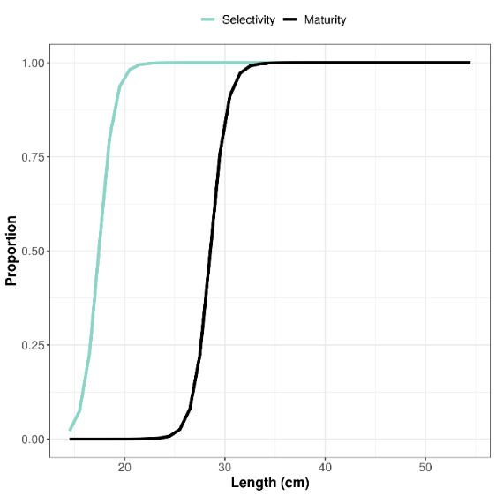
Figure 8. Graph of Lc and Lm Proportions for Lutjanus gibbus in Alas Strait During the First Transitional Season at 2025

The diagram presented in Figure 9 illustrates the results of the Spawning Potential Ratio (SPR) analysis, which describes the exploitation status of L. gibbus stocks in the Alas Strait waters during the first transitional season of 2025. The analysis showed that the SPR value of L. gibbus was approximately 10%, which is below the biological reference point threshold of 20%. This low SPR value indicates that the spawning potential of the population in the wild was relatively limited due to high fishing pressure (Wujdi et al., 2020). According to the classification proposed by Walters and Martell (2004) and Prince (2015), an SPR value of 10% categorizes the stock condition of L. gibbus in the Alas Strait waters as overexploited. This overexploited status indicates that fishing pressure on the population has reached a relatively high level, resulting in the majority of individuals being captured before attaining optimal reproductive maturity (Saranga et al., 2019). If such conditions continue persistently, they may lead to a decline in spawning potential and reduce the recruitment capacity of L. gibbus populations in the Alas Strait waters, thereby threatening the long-term sustainability of the stock(Zedta & Madduppa, 2021).

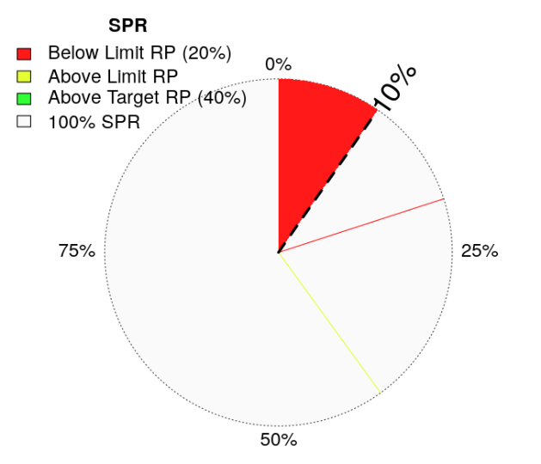
Figure 9. SPR Value Diagram of Lutjanus gibbus during The First Transitional Season at 2025

The SPR value of 10% obtained in this study indicates that the remaining stock of Lutjanus gibbus in the Alas Strait waters represents only a small fraction of its natural reproductive potential (Hordyk et al., 2014; Prince et al., 2015). This condition is closely associated with the dominance of catches consisting of individuals below the length at first maturity (<Lm), indicating that most fish had not yet contributed to the spawning process before being captured. Lutjanus gibbus fish exhibits a reproductive strategy strongly influenced by body size and age, in which larger individuals contribute more significantly to egg production (Prihatiningsih et al., 2020). Therefore, fishing activities dominated by small-sized individuals (<Lm) have the potential to cause growth overfishing, a condition in which fish are harvested before reaching their optimal biological and economic size (Ben-Hasan et al., 2021).

The first transitional season, which coincided with the research period, was also suspected to contribute to the low SPR value observed in this study. Previous studies have reported that January–February represents the peak spawning period of L. gibbus (Prihatiningsih et al., 2020), indicating that the March–May period corresponds to the post-spawning phase of the species. During this phase, fish populations in natural waters are generally dominated by newly recruited individuals that remain within the juvenile to pre-adult stages and have not yet reached gonadal maturity biologically (Rida et al., 2026). This condition is consistent with the findings of the present study, which demonstrated that 91% of the total sampled individuals of L. gibbus were below the length at first maturity (<Lm). The dominance of immature individuals in the catch may further reduce spawning potential and recruitment success in the population. Therefore, fisheries management authorities should consider implementing a seasonal closure policy for L. gibbus fishing activities in the Alas Strait waters during March–May each year as part of a sustainable fisheries management strategy aimed at protecting post-spawning and juvenile populations.

4. Conclusion

The stock condition of Lutjanus gibbus in the waters of the Alas Strait during the first transitional season in 2025 shows high exploitation pressure. This is evidenced by the dominance of catches consisting of individuals below the length of the first maturity (Lm) accounting for 84% (186 individuals) of the total catch, while only 9% (35 individuals) individuals were considered suitable for harvest. The size distribution, which was concentrated within the range of 18–28 cm, together with the length of the first capture (Lc) being the lower than the length at the first maturity (Lm), indicates that the most individuals were captured before reaching reproductive maturity. The Spawning Potential Ratio (SPR) analysis, which yielded a value of approximately 10%, further indicated that the exploitation level of Lutjanus gibbus stock was classified as overexploited. This condition may reduce the population’s recruitment potential and threaten stock sustainability. Therefore, more adaptive and sustainable fisheries management measures are required, including the implementation of minimum catch size regulation, improvement of fishing gear selectivity, and controlling catch intensity, particulary during the first transitional season,in order to maintain the sustainability of Lutjanus gibbus stocks in the waters of the Alas Strait.

Consent

Informed consent was obtained from all fishers, fish collectors, and fish vendors involved in this study prior to data collection. All participants voluntarily permitted field observations, interviews, photographic documentation, and the use of fisheries-related information for research and scientific publication purposes.

Ethical approval

This Study Did Not Involve Experiments On Live Animals, Human Clinical Trials, Or Protected Species. Fish Samples Were Obtained From Commercial Catches Landed At The Tanjung Luar Fish Market, East Lombok Regency, West Nusa Tenggara Province, Indonesia. Data Collection Was Conducted Through Non-Invasive Observations And Measurements In Accordance With Applicable Fisheries Research And Ethical Standards. Permission To Conduct The Study And Collect Fisheries-Related Data Was Obtained From Relevant Local Stakeholders And Fishers Prior To The Research Activities.

References

Agustina, S., Natsir, M., Boer, M., & Yulianto, I. (2018). Population Parameters Of Sunu Grouper (Plectropomus sp.) And Its Management Options In Karimunjawa Waters. Marine Fisheries: Journal Of Marine Fisheries Technology And Management, 9(2), 119-131.
Agustinawati., Ernaningsih., & Ihsan. (2015). Composition, Type And Distributionsize Of Results Caught With Trap Nets In The Coastal Waters Of Segeri District, Pangkep Regency. Pelagic Journal, 1(2), 182-192.
Anas, A., Gigentika, S., Marliana, I., Aini, M., & Hilyana, S. (2023). Condition Of Reef Fish Stocks In The Gita Nada Twp Marine Conservation Area, West Nusa Tenggara Province. Marine Fisheries: Journal Of Marine Fisheries Technology And Management, 14(2), 169–181.
Anisa, A., Handayani, T., Demena, Y. E., Mangando, S., Jamaludin, J., Dan, F. C. E., & Rumbino, F. N. (2024). Distribution Of The Size And Maturity Of The Gonads Of Red Snapper (Lutjanus gibbus) In The Padaido Biak Conservation Area. Indonesian Aquatics, 9(2), 111-124.
Arif, D. A., Giyarsih, S. R., & Mardiatna, D. (2017). Vulnerability Of Urban Communities To Flood Hazards In Legok Village, Telanipura District, Jambi City. Indonesian Geography Magazine, 31(2), 79-87.
Ashari, R., Gigentika, S., Hilyanan, S., & Martanina. (2024). Capture Fisheries Utilization Patterns In The Limited Utilization Zone Of The Gili Matra Waters Conservation Area, West Nusa Tenggara Province. Journal Of Fisheries And Marine Sciences, 14(1), 98-114.
Astrid, Ernaningsih, & Jamal, M. (2024). Inventory Of Snapper Species (Lutjanidae Family) Landed In TPI Pontap And PPI Balambang. Pelagic Journal, 1(3), 236–245.
Ben‐Hasan, A., Walters, C., Hordyk, A., Christensen, V., & Al‐Husaini, M. (2021). Alleviating Growth And Recruitment Overfishing Through Simple Management Changes: Insights From An Overexploited Long‐Lived Fish. Marine And Coastal Fisheries, 13(2), 87-98.

Chaves, P. T. C. (2022). Juveniles And Undersized Fish In Small-Scale Fisheries: Gillnets Are Not Less Implied Than Trawling. Marine & Fishery Sciences (Mafis), 35(2), 165-180.
Dewi, D. E., Mandika, S., Wijayanti, S. O., & Riza, A. H. A. (2026). Size Structure And Length At First Capture (Lc) Of Squid (Loligo spp.) Landed At Ujung Batu Fish Auction Place In Jepara, Indonesia. Egyptian Journal Of Aquatic Biology And Fisheries, 30(2), 1333-1349.
Ernaningsih, E., Jamal, M., Hasnidar, H., Asni, A., & Kamawati, K. (2023). Biological Characteristics Of Red Snapper (Lutjanus gibbus) Caught In The Spermonde Islands, South Sulawesi. Journal Of Capture Fisheries Research, 15(3), 163-171.
Scientific Forum for Sustainable Fisheries Management at West Nusa Tenggara Province. 2025. [October 25, 2025]. Https://Data.Fip2b-Ntb.Org/Kerapu/Frekuensi
Gigentika, S., Ikhwanushafa, M. K., Ramadani, B. I. R., & Aini, M. (2025). Education On Measuring The Body Length Of Snapper And Grouper At Tanjung Luar Fish Market, East Lombok Regency. Journal Of Artificial Intelligence, 12(7), 2340-2355.
Himawan, M. R., Hidayati, E., Buhari, N., Hilyana, S., & Syahdina, M. (2021). The Current Status Of Coral Reef Cover In The Shallow Waters Of Bedil Island, Labuan Bajo Village, Sumbawa Regency, NTB. Journal Of Science, Technology & Environment,
Hordyk, A., Ono, K., Valencia, S., Loneragan, N., & Prince, J. (2014b). A Novel Length-Based Empirical Estimation Method Of Spawning Potential Ratio (Spr), And Tests Of Its Performance, For Small-Scale, Data-Poor Fisheries. Ices Journal Of Marine Science, 72(1), 217–231.
Hountcheme, C. A. I., Montcho, S. A., Agadjihouede, H., & Bănăduc, D. (2025). The Temporal Dynamics Of The Impact Of Overfishing On The Resilience Of The Sarotherodon melanotheron (Rüppel, 1858) Fish Species' Population In The West African Lake Toho. Fishes, 10(7), 357.
Kholis, M. N. (2023). Length-Base Spawning Potential Ratio (Lb-SPR) Approach Of Kurau Fish (Eleutheronema tetradactylum) In The Waters Of Bengkalis Island, Riau Province. Semah Journal Of Aquatic Resources Management, 7(1), 38-47.
Kurnia, R., Boer, M., Yati, I., & Suryana, A. A. H. (2022). Management Indicators Of Layur Fish (Trichiurus lepturus linnaeus, 1758) In The Sunda Strait. Journal Of Tropical Fisheries Management, 6(2), 143-151.
Limmon, G. V., Tetelepta, J. M., Pattikawa, J. A., Natan, J., Laimeheriwa, B. M., & Leatemia, B. M. (2024). Study Of Lutjanus gibbus Connectivity In Conservation Areas And Fishing Areas In The State Fisheries Management Area Of The Republic Of Indonesia (Wpp-NRI) 714 Using DNA Barcoding. Triton: Journal Of Aquatic Resource Management, 20(1), 16-27.
Nurhakim, S. (2017). Implications Of IUU Fishing In Fish Resources Management In Indonesia. Journal Of Indonesian Fisheries Policy, 1(1), 61-66.
Oktaviyani, S. (2018). Getting To Know The Lutjanus Clan, One Of The Leading Commodities In Capture Fisheries. Oceanic Journal, 43(3), 29-39.
Panggabean, A. S., Prihatiningsih, P., Taufik, M., Nurdin, E., Mahulette, R. T., Nurulluddin, N., ... & Pane, A. R. (2023). The Stock Status Of Lutjanus gibbus (Forsskal, 1775) In Kupang Waters, East Nusa Tenggara. In E3s Web Of Conferences (Vol. 442, P. 01001). EDP Sciences.
Priatna, A., & Natsir, M. (2017). Fish Distribution Patterns In The Western Season And Transition In The Northern Waters Of Central Java. Indonesian Journal Of Fisheries Research, 14(1), 67-76.
Prihatiningsih, P., Kamal, M. M., Kurnia, R., & Suman, A. (2017). Long-Weight Relationships, Food Habits, And Reproduction Of Red Snapper (Lutjanus gibbus: Famli Lutjanidae) In The Southern Waters Of Banten. Fisheries Research Journal, 9(1), 21-32.
Prihatiningsih, P., Kamal, M. M., Kurnia, R., & Suman, A. (2020). The Spawning Season, Growth, And Mortality Of Humpback Red Snapper (Lutjanus gibbus (Forsskal, 1775)) In The Southern Banten Waters, Indonesia. Aacl Bioflux, 13(2), 1079-1089.
Prince, J., S. Victor, K. Kloulchad, And A. Hordyk. 2015. Length Based Spr Assessment Of Eleven Indo-Pacific Coral Reef Fish Populations In Palau. Fish.Res, 171:42-58.

Rida, D. Y. A., Karnan, K., & Santoso, D. (2026). Morphometric And Meristic Aspects Of Lemuru Fish (Sardinella lemuru) Landed On Pancer Beach Banyuwangi. Journal Of Tropical Biology, 26(1), 166-175.
Santoso, D. (2016). Sustainable Potential And Utilization Status Of Red Snapper And Grouper In The Alas Strait, West Nusa Tenggara Province. Journal Of Tropical Biology, 16(2). 1-8.
Santoso, D., Badrudin, B., & Sumiono, B. (2015). The Status Of Fish Resources Utilization In The Alas Strait, West Nusa Tenggara Province. Indonesian Journal Of Fisheries Research, 21(3), 151–160.
Saranga, R., Simau, S., & Kalesaran, J. (2019). The Size Was First Caught, The Size Of The First Mature Gonads And The Status Of The Boops Selar Business In Bitung Waters. Jfmr (Journal Of Fisheries And Marine Research), 3(1), 67-74.
Sari, A. F. R., Pranajaya, A., Anam, K., Marliana, I., Tarigan, S. A., Kartawijaya, T., ... & Prasetia, R. (2024). Utilization Status Of Snapper (Lutjanus spp.) Based On Long Data Of Fish In The Waters Of Taka Bonerate National Park. Marine Fisheries: Journal Of Marine Fisheries Technology And Management, 15(1), 37-53.
Siregar, S. N., Sari, L. P., Purba, N. P., Pranowo, W. S., & Syamsuddin, M. L. (2017). The Water Mass Exchange In Java Sea Due To Periodicity Of Monsoon And Itf In 2015. J. Depik, 6(1), 44-59.
Sukmanawati, S., & Purwati, S. (2022). The Effect Of Service Quality, Price, And Promotions On Grab Customer Satisfaction. Journal Of Almatama Management, 1(1), 61-84.
Taufiq, M., & Anjasmara, I. M. (2025). Analysis Of Seasonal Pattern Data In Indonesia Using Equivalent Water Height (Ewh) Data From The Grace Satellite. Insology: Journal Of Science And Technology, 4(6), 1649-1662.
Tuda, P. M., Wolff, M., & Breckwoldt, A. (2016). Size Structure And Gear Selectivity Of Target Species In The Multispecies Multigear Fishery Of The Kenyan South Coast. Ocean & Coastal Management, 130, 95-106.
Wahyuningsih, W., Prihatiningsih, P., & Ernawati, T. (2013). Population Parameters Of Red Snapper (Lutjanus malabaricus) In The Waters Of The Eastern Part Of The Java Sea. Journal Of Fisheries Research, 5(3), 175-179.
Walters, C.J. And S.J.D. Martel. 2004. Fisheries Ecology And Management. Princeton University Press. Princeton, Usa. 448p.

Wujdi, A., Hartaty, H., & Setyadji, B. (2020). Estimation Of Population Parameters And Spawning Potential Ratio Of Komo Cob (Euthynnus affinis, Cantor 1849) In The Southern Waters Of Lombok. Indonesian Journal Of Fisheries Research, 26(2), 93-107.
Zedta, R. R., & Madduppa, H. (2021). The Level Of Resource Utilization Of Madidihang (Thunnus albacares) In The Indian Ocean With A Spawning Potential Ratio Analysis Approach. Indonesian Journal Of Fisheries Research, 27(1), 33-41.

