Original Research Article

Unveiling PUV Apprehensions: Examining Public Utility Vehicle Franchise-related Violations in Davao Region from 2017 to 2022 through Quantitative Analysis

.
ABSTRACT

Public land transportation remains essential to mobility and economic activity in the Philippines, yet persistent franchise-related violations among Public Utility Vehicles (PUVs) raise concerns regarding regulatory compliance and public safety. This study examines recorded PUV franchise-related apprehensions in the Davao Region from 2017 to 2022 using quantitative methods. Secondary data were obtained from the Land Transportation Franchising and Regulatory Board (LTFRB) Regional Franchising and Regulatory Office XI. The study identifies the top five violations, determines the leading PUV denomination involved in overloading violations, and assesses whether significant differences exist in the mean number of violations across the six-year period. Normality testing using the Kolmogorov–Smirnov test indicated non-normal data distribution; thus, the Kruskal–Wallis H test was employed. Findings reveal that overloading was the most frequently recorded violation, with Public Utility Jeepneys emerging as the primary denomination involved. Results further indicate a statistically significant difference in the mean number of overall franchise-related violations across years, while no significant difference was observed in the mean number of top overloading violators. These findings provide empirical insights to inform policy review and strengthen enforcement strategies aimed at enhancing regulatory compliance in the Davao Region.

Keywords: Public Utility Vehicles, Franchise-related violations, Regulatory Compliance

1. INTRODUCTION

1.1 Background of the Problem

Public land transportation fulfills an important role in both developed and developing countries globally (Muromachi et. al., 2015). It accomplishes the mobility needs of those people who could not meet the expense of owning a private mode of transportation. While the significance of public land transportation cannot be overstated, it is essential to acknowledge the numerous challenges associated with it.
According to The Korea Transportation Institute (2015), in their comparative study on Urban Public Transportation Policies, there is a recorded, sweeping increase of 53.8 percent in vehicle ownership in Southeast Asian countries, as logged by the Association of Southeast Asian Nations (ASEAN), with 26 vehicles recorded per 1,000 people in 2000 and 40 vehicles per 1,000 people in 2010. The authors explained that this significant increase in car ownership in the ASEAN region poses considerable alarm to international leaders. This condition, moreover, without proper action to improve the quality of public land transportation services, is seen to exacerbate the region’s environmental problems on a much larger scale. From this standpoint, it becomes apparent that there are numerous issues surrounding public land transportation from a global perspective.
In the Philippine context, public land transportation plays a significant role in the country as it continues to cater to the mobility needs of the community. In its very essence, public transportation gives Filipinos an affordable and accessible method of mobility (Narboneta & Teknomo 2016). To date, public land transportation continues to be regarded as a significant factor in driving economic development, serving as a means to transport not only goods but, crucially, the labor workforce.
The pivotal role played by public land transportation in the country is of paramount importance. However, it is imperative to acknowledge that there are several existing problems intricately linked to public land transportation in the Philippines.
Given the various challenges identified in many research studies related to public transportation, such as the rise in vehicle ownership, which contributes to air pollution due to heavy reliance on fuel (Ieda, 2010), and government priority issues and institutional arrangements (Perez et al., 2022) across various countries, particularly the Philippines, this research paper specifically concentrated on studying apprehensions concerning public utility vehicles (PUV) and recommending insights for seamless and more effective enforcement against the said violations.
As a background, the Land Transportation Franchising and Regulatory Board (LTFRB) is a national government agency operating under the Department of Transportation (DOTr), tasked with the duty to formulate, administer, enforce, and oversee the adherence of all PUV franchise holders and operators to existing policies, laws, and regulations governing public land transportation services (LTFRB, n.d.). LTFRB is entrusted with the task of conducting traffic enforcement operations tailored to PUVs, including the supervision of franchise-related violations of PUV denominations in the Davao region. Specifically, this research paper sought to answer the following research questions:
- What are the top 5 recorded PUV franchise-related violations in the Davao region from 2017 to 2022?
- Which denomination is the top violator for recorded PUV overloading violations in the Davao region from 2017 to 2022?
- Is there a significant difference in the mean number of recorded PUV franchise-related violations in the Davao region from 2017 to 2022?
- Is there a significant difference in the mean number of the top violators for recorded overloading violations in the Davao region from 2017 to 2022?
1.2 Scope
The scope and limitations of this study revolved around the analysis of acquired data on the recorded franchise-related violations of PUV denominations in the Davao region from 2017 to 2022. Specifically, the research study focused on determining if there is a significant difference pertaining to these violations. The findings aimed to give valuable insights to policymakers and implementing government bodies such as the LTFRB to improve enforcement operations on franchise-related violations.
A notable limitation of this study is that it does not provide an extensive analysis of the possible factors contributing to the identified PUV franchise-related violations. Additionally, this study does not propose specific recommendations but seeks to stimulate a comprehensive review of the existing policies and strategies on enforcement and enthuse the creation of strategies to improve enforcement operations against overloading violations.
1.3 Hypothesis
Ho: There is no significant difference in the mean number of recorded PUV franchise-related violations in the Davao region from 2017 to 2022.

Ha: There is a significant difference in the mean number of recorded PUV franchise-related violations in the Davao region from 2017 to 2022.

Ho: There is no significant difference in the mean number of the top violators for recorded overloading violations in the Davao region a span from 2017 to 2022.

Ha: There is a significant difference in the mean number of the top violators for recorded overloading violations in the Davao region a span from 2017 to 2022.

2. material and methods
2.1 Data Description
The secondary data acquired for this study is obtained from the LTFRB Regional Franchising and Regulatory Office XI (RFRO XI), specifically focusing on the franchise-related violations of PUV in the Davao region from 2017 to 2022. The data set encapsulated a collection of recorded franchise-related infractions as well as the number of corresponding PUV denominations apprehended for those violations over six years. The main variable used for this study is the recorded number of PUV franchise-related violations, allowing the researcher to have a quantifiable data of non-compliance with the existing regulations of LTFRB among the PUV drivers and operators in the region.
Ethical considerations in terms of data acquisition and handling were observed in the making of this research paper. For this study, researcher adhered to specific guidelines that prioritize the privacy and confidentiality of individuals involved with the records obtained from LTFRB RFRO XI. Overall, this dataset is a good resource for gaining insights into the patterns of PUV franchise-related violations in Davao region.

2.2 Data Analytic Technique
Because of the nature of the distribution of the data presented in this study which was explored using the Kolmogorov-Smirnov (KS) Test in SPSS, the analysis of the acquired dataset from LTFRB RFRO XI used a non-parametric analysis of variance (ANOVA) or the Kruskal-Wallis H Test to effectively answer two research questions. To elaborate, the Kruskal-Wallis H test is employed to assess whether statistically significant differences exist among two or more groups of an independent variable concerning a continuous or ordinal dependent variable (Laird Statistics, 2018).
Through these analytical methods in SPSS, this research paper aimed to investigate and provided insights on the different dynamics present within the dataset that effectively contribute to the readers’ understanding of franchise-related compliance among PUV drivers and operators in Davao region and moreover, allows as well to determine the existence of significant differences among the top PUV denomination violators for overloading from the years 2017 to 2022.

3. results and discussion

3.1 Recorded PUV Franchise-Related Apprehensions for the Years 2017–2022
From 2017 up to 2022, a total of 799 recorded PUV franchise-related violations have been logged based on the data obtained from the Enforcement Unit of LTFRB RFRO XI. These franchise-related violations were identified according to the provisions under the 2011 Revised Terms and Conditions of CPC and Providing Penalties for Violations Thereof and the DOTr Joint Administrative Order (JAO) No. 2014-01, also known as the Revised Schedule of Fines and Penalties for Violations of Laws, Rules, and Regulations Governing Land Transportation. Both references stipulate the basis for the procedures of apprehension and adjudication for violating PUV denominations. Presented in Table 1 is the list of recorded PUV franchise-related violations with the corresponding number of apprehensions in the Davao region from 2017 to 2022.
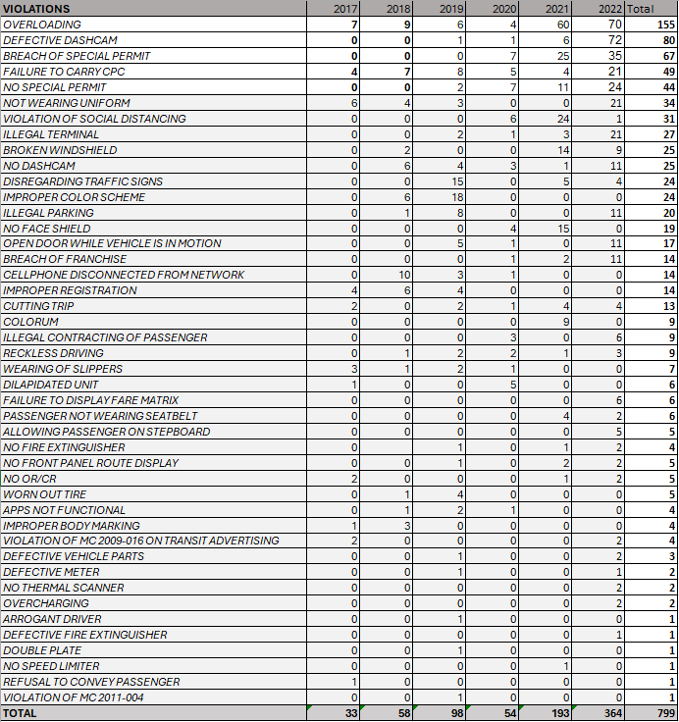

Table 1. Recorded PUV Franchise-Related Violations in Davao region from 2017-2022
]

3.2 Determining the Top 5 PUV Franchise-related Violations (2017–2022)
With reference to the data gathered from LTFRB RFRO XI, the top five violations have been identified for this research study. Table 2 below depicts the top five recorded PUV franchise-related violations in terms of the number of apprehensions from 2017 to 2022.
Violations | 2017 | 2018 | 2019 | 2020 | 2021 | 2022 | Total
Overloading | 7  (21.20%) | 9  (15.52%) | 6  (6.12%) | 4  (7.41%) | 60  (31.09%) | 70  (19.23%) | 155  (19.40%)
Defective Dashcam | 0  (0%) | 0  (0%) | 1  (1.02%) | 1  (1.85%) | 6  (3.13%) | 72  (19.78%) | 80  (10.01%)
Breach of Special Permit (SP) | 0  (0%) | 0  (0%) | 0  (0%) | 7  (12.96%) | 25  (13.02%) | 35  (9.62%) | 67  (8.39%)
Failure to Carry Certificate of Public Convenience (CPC) | 4  (12.10 %) | 7  (12.07%) | 8  (8.16%) | 5  (9.26%) | 4  (2.08%) | 21  (5.77%) | 49  (6.13%)
No Special Permit (SP) | 0  (0%) | 0  (0%) | 2  (2.04%) | 7  (12.96%) | 11  (5.73%) | 24  (6.59%) | 44  (5.51%)
Overloading, described as the deliberate act of exceeding the maximum passenger capacity in PUVs, ranked first among the PUV franchise-related violations recorded in the Davao region from 2017 to 2022. This type of violation constitutes 19.40% of the total number of logged violations in six years, with the highest count recorded in 2021 and 2022. This is followed by Defective Dashcam, which represents 10.01% of the total violations from 2017 to 2022. The Breach of Special Permit (SP), Failure to Carry Certificate of Public Convenience (CPC), and No Special Permit (SP) were close runner-ups, making up 8.39%, 6.13%, and 5.51% of the total violations recorded across six years, respectively.

Table 2. Top 5 PUV Franchise-Related Violations in Davao region from 2017-2022

3.3 Identifying the Top PUV Denomination Violator for Overloading (2017–2022)
Moreover, the researcher further investigated the PUV denominations in the Davao region that exhibited patterns of overloading. This part of the study aimed to provide insights into the specific denominations that consistently violate capacity limits, hence contributing to the safety challenges of overloading in the public land transportation landscape of the region. The charts presented below serve as visual representations of the identified PUV denominations and their corresponding instances of overloading in the Davao Region.

Figures 1 and 2. Overloading Violations in 2017 and 2018

Figure 3. Overloading Violations in 2019

Figure 4. Overloading Violations in 2020

Figure 5. Overloading Violations in 2021

Figure 6. Overloading Violations in 2022
Figures 1–6 provide the study with a nuanced understanding of the extent to which specific PUV denominations contribute to the prevalent issue of overloading in the region. As far as the record shows, public utility jeepneys (PUJ) ranked first as the primary denominator to violate passenger capacity limits, with 63 recorded apprehensions in the last six years. This is followed by Utility Van Express (UVE), Public Utility Bus (PUB), and Taxi, with 56, 29, and 7 records of overloading violations, respectively.
3.4 Analysis of Variance
To investigate the potential trend of the aforementioned PUV franchise-related violations in the region, the researcher compared the average number of violations across six years. The researcher first determines if the dataset has a normal distribution, which is performed through a non-parametric Kolmogorov-Smirnov (K-S) test. According to the National Institute of Standards and Technology (n.d.), the K-S test is utilized for non-parametric data and is used to decide if a selected sample comes from a population with a specific distribution. For this specific data set, this KS test of normality reveals, as shown in Figure 1, that the p-value of the recorded number of PUV franchise-related violations stands at 0.00, therefore indicating that the distribution is not normal.
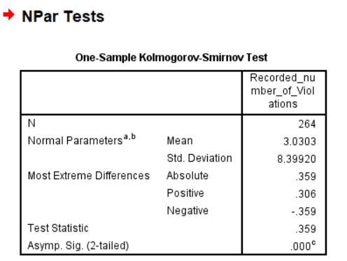

Figure 7. One Sample Kolmogorov-Smirnov Test

Gleaning from this finding on the normality of the data, the researcher proceeded to utilize the non-parametric Analysis of Variance (ANOVA) or an Independent Samples Kruskal-Wallis test through the Statistical Package for Social Science (SPSS) tool to determine the significant difference in the mean number of PUV franchise-related violations from 2017 to 2022 in the Davao region. The variables focused on in this stage of the study are the number of PUV franchise-related violations and the corresponding year for each violation. Figure 2 below indicates that the p-value of the Kruskal-Wallis test is 0.005, hence recommending rejecting the first hypothesis in this study. Given this observation, it can be concluded that there is a significant difference in the recorded average number of PUV-franchise-related violations in the Davao region from
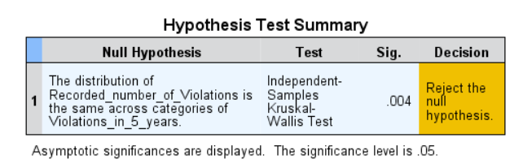
Figure 8. Non-parametric ANOVA or Kruskal Wallis Test

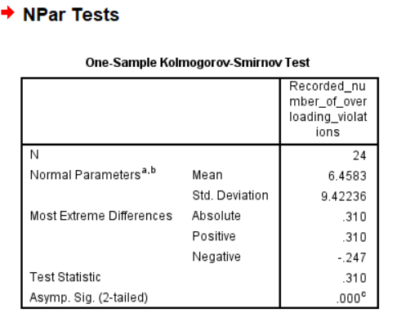
Conversely, the significant difference in the mean number of the top violators for recorded overloading violators in the Davao region from 2017 to 2022 is also examined in this study. In a similar process, the researcher initially determined the distribution through the KS test. In this dataset, the p-value is 0.00, therefore indicating that the distribution is not normal.

Figure 9. One Sample Kolmogorov-Smirnov Test

Now that the distribution of the data has been identified, a non-parametric ANOVA, or Kruskal-Wallis, is similarly utilized to determine if there is a significant difference in the mean number of the top violators for recorded overloading violations in the region from 2017 to 2022. Figure 10 below suggests that the null hypothesis must be retained as the p-value is at 0.200. With this, it can be concluded that there is no significant difference in the mean number of the top violators for overloading violations.
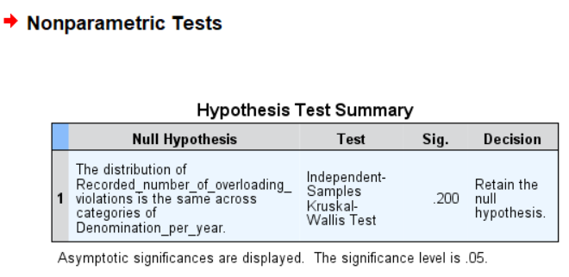

Figure 10. Non-parametric ANOVA or Kruskal Wallis Test

4. Conclusion
This study demonstrates that franchise-related violations among Public Utility Vehicles in the Davao Region remain a persistent regulatory concern, with overloading emerging as the most frequently recorded offense from 2017 to 2022. Statistical analysis confirms a significant variation in the mean number of overall violations across the six-year period, although no significant difference was observed among the top overloading violators. These findings underscore the need for sustained, data-driven enforcement strategies and periodic policy review to strengthen regulatory compliance and promote safer public transportation operations.
4.1 Recommendations

4.1.1 Foresight Based on the Analyses
While there has been significant progress in terms of addressing PUV franchise-related violations in the Davao region in the last six years (2017–2022) through the collaboration of various government agencies (i.e., DOTr, LTFRB, LTO, etc.), the persistent issues still identified in this paper thoroughly require focused interventions. The findings from the analyses conducted for this paper underscore the need to craft these interventions in an effort to enhance regulatory compliance among the PUV denominations in the region. It is also important to highlight the critical role of the enforcement body of LTFRB, as they are the ones implementing the rules and regulations, especially concerning the top five recorded violations: 1) overloading, 2) defective dashcams, 3) breach of special permits (SP), 4) failure to carry CPC, and 5) the absence of SP.
4.1.2 Strengthening Enforcement Operations
In addressing the top five violations as primarily identified in this study, it is imperative that regulatory authorities (i.e., the LTFRB RFRO XI Enforcement Unit) prioritize enhanced enforcement measures and penalties. The LTFRB RFRO XI could advocate for the imposition of stringent penalties for overloading, paired with collaboration with the local media to highlight its dangers and repercussions. Moreover, stricter enforcement operations can ensure routine checks of PUV dashcams and enhanced inspections of relevant documents, specifically SP and CPC
4.1.3 Targeted Approach for PUJ Operators and Drivers on Overloading
Given that the PUJ denomination emerged as the top violator for overloading apprehensions, PUJ-focused initiatives against overloading violations should target the operators and drivers of this denomination. Communication campaigns can be implemented to educate drivers, operators, and passengers on the importance of following passenger capacity limits.
4.1.4 A Comprehensive Review of the Enforcement Framework

The significant difference in the average number of recorded franchise-related violations requires a thorough assessment of the existing and regulatory processes. This comprehensive review should put emphasis on identifying the strengths and weaknesses, gaps, and current policies that may or may not contribute to the increase in violations across six years. Potential policy adjustments and improvements are vital to aligning the rules and regulations with the ever-changing landscape of public transportation in the region.
Moreover, despite the absence of a significant difference in the mean number of top violators for overloading, it is pivotal to conduct routine assessments that will allow the implementing body to review and forecast emerging trends that will help the authorities promptly address the violations.
In conclusion, the recommendations set forth in this study are designed to create a multi-faceted strategy addressing various dimensions of regulatory compliance among PUV operators in the Davao region. Truly, fostering a culture of safety through consistent education and encouraging public participation will empower all involved stakeholders.

COMPETING INTERESTS DISCLAIMER:
Authors have declared that they have no known competing financial interests OR non-financial interests OR personal relationships that could have appeared to influence the work reported in this paper.
REFERENCES

Laird Statistics. (2018). Introduction to Kruskal-Wallis H test. Retrieved 18 December 2023 from https://statistics.laerd.com/spss-tutorials/kruskal-wallis-h-test-using-spss-statistics.php

LTFRB. (n.d.). PUV modernization program. Retrieved 18 December 2023 from https://ltfrb.gov.ph/puv-modernization-program/

Narboneta, C., & Teknomo, K. (2016). A Study of Metro Manila's Public Transportation Sector: Implementing a Multimodal Public Transportation Route Planner. Asian Transport Studies. 460-477. DOI: 10.11175/eastsats.4.460.

National Institute of Standards and Technology. (n.d.). Kolmogorov – Smirnov goodness-of-fit test. Retrieved 23 December 2023 from https://www.itl.nist.gov/div898/handbook/eda/section3/eda35g.htm

Muromachi, Y., Lim I., Wicaksono A., Vergel, K.N., Choocharukul, K., Tan V.H., Terai, K., Fukuda, D., & Yai, T., (2015). A comparative study on road-based urban public transport policies in six asian countries from the viewpoint of governance, urabn planning, and financial aspects. Journal of the Eastern Asia Society for Transportation Studies (11).

Perez, R.C., Ng, A.C., & Tiglao, N. C. (2022). Enhancing policy capacity through Co-design: the case of local public transportation in the Philippines, Policy Design and Practice, 5:1, 103-121, DOI: 10.1080/25741292.2021.1930689.

The Korea Transport Institute. (2014). Current Status of Public Transportation in ASEAN Megacities. The Korea Transport Institute. ISBN 978-89-5503-665-7 93320

