Review Article

A Review on Carbon Dots in Wastewater Treatment: Properties, Mechanisms and Overcoming Challenges

.

ABSTRACT

The growing global water crisis emphasizes the dire need for sustainable and eco-friendly technological innovations to ensure clean water availability not only for the current generations but also for future generations. In this context, carbon dots (CDs) have emerged as a promising class of carbon based nanomaterials (CBNs) that offer a sustainable solution for wastewater treatment because of their distinctive physicochemical and biological properties. This review discusses the production routes of CDs, ranging from top-down to bottom-up methodologies and analyzes their properties. CDs present benefits such as low toxicity, high dispersibility in water, photoluminescence tunability and environmental acceptability, making them promising for pollutant detection and pollutant removal by processes viz. adsorption, catalysis, membrane separation and biological treatment. A bibliometric study highlights an expanding research interest; however, real-world limitations such as reproducibility, stability and purification still need to be addressed. This review also includes a comparative evaluation of CDs and other nanomaterials and how their cost-effectiveness, sustainability and multifunctionality make them stand out. Emerging technology and trends highlight the vast potential of CDs in driving environmentally friendly and efficient wastewater treatment technologies.

Keywords: wastewater treatment, technology, carbon dots, nanoparticles, pollutants.

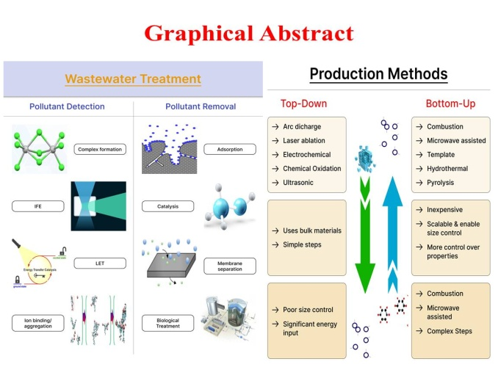

1. INTRODUCTION

In the 21st century, one of the most pressing environmental challenges is water pollution which results from rapid industrialization, urbanization and intensive agricultural activities. Polluted water bodies, filled with organic and inorganic pollutants, pose a severe threat to the biodiversity of aquatic ecosystems and human health (Shukla et al., 2023). Pathogens, chemicals, heavy metals, etc. are commonly found in untreated or inadequately treated wastewater, compounding the risks involved. This growing global water crisis emphasizes the dire need for sustainable and eco-friendly technological innovations to ensure clean water availability not only for the current generations but also for future generations. Conventional wastewater treatment technologies, such as biological treatments, adsorption processes and chemical precipitation, often face limitations in terms of operational costs, energy consumption, incomplete removal of pollutants and secondary pollution. These shortcomings have encouraged researchers to explore new materials and technologies that are not only highly effective, but also environmentally benign and economically viable. Among the various emerging solutions, nanotechnology, particularly carbon-based nanomaterials (CBNs) has tremendous potential in wastewater treatment technologies, owing to its unique properties. In this context, carbon dots (CDs) have emerged as a promising class of CBNs that offer a sustainable solution for wastewater treatment.
Carbon dots (CDs) are a novel fluorescent, zero-dimensional (0-D) CBNs that are generally characterized by a size smaller than 10 nm (Xu et al., 2004) discovered accidentally during the purification of single-walled carbon nanotubes (SWCNTs) by oxidation with nitric acid and have since then gained immense attention. Compared to other nanomaterials, such as metallic nanoparticles or metal oxides, CDs offer several significant advantages. Furthermore, CDs can be produced from abundant biomass waste using ‘green chemistry’ approaches, making them a sustainable alternative to conventional nanomaterials. CDs possess remarkable physicochemical and biological properties that make them ideal candidates for wastewater treatment. These properties include strong and tunable photoluminescence, high water dispersibility (Hu et al., 2019), a large surface area, rich surface chemistry, photocatalytic activity (Feizoor et al., 2020), chemical stability, cost-effective, biocompatible and less toxic (Ramanan et al., 2018), photobleaching resistance and multi-photon excitation capabilities, all useful in enhancing their versatility in wastewater treatment applications. The green production of CDs using renewable and biodegradable sources such as agricultural waste, kitchen waste, fruit peels and even plastics has amplified their relevance for sustainable environmental applications (Shukla et al., 2023) as it minimizes the environmental footprint as well as transforms waste into high-value materials, promoting a circular economy. Given their outstanding multifunctionality, CDs play a critical role in the future of wastewater treatment technologies while also achieving the ‘net zero emission’ targets. Their application potential spans pollutant detection, photocatalytic degradation of organic pollutants, membrane filtration enhancement and antimicrobial action.
This review focuses on exploring the current trends in the production of CDs, their unique physicochemical and biological properties, use of biomass for the sustainable production of CDs, their mechanism in the application of wastewater treatment, comparative analysis of CDs v/s other nanomaterials, challenges associated and recent and future trends, aiming to highlight their critical role in future sustainable wastewater treatment technologies.

2. Bibliometric analysis of carbon dots-based research
Unlike other CBNs, data on carbon dots (CDs) are very limited, particularly for their application in wastewater treatment. In addition to its promising uses, studies on CDs production and use in treatment of wastewater are in their infancy. Therefore, there is a need for a comprehensive review for future guidelines and optimizations. A scientometric analysis conducted via Scopus database to access the articles, reviews, book chapters and conference papers provided by publisher on the topic “Biomass-derived carbon dots in wastewater treatment: properties, production, mechanisms, advantages and overcoming technical challenges”. The search query filters on Scopus used were: duration- 2021 to 2026; subject areas- Environmental science and Materials science; keywords- carbon dots, wastewater treatment, wastewater, pollutant degradation, pollutant removal, mechanism, challenges, future prospects; language- English. VOSviewer software (version 1.6.20) was used for analysing and constructing bibliographic network of the obtained 785 scientific publications. None of the publications were available on the topic “Biomass-derived carbon dots in wastewater treatment: properties, production, mechanisms, advantages and overcoming technical challenges”. A keywords assessment showing a huge attention around the use of carbon dots in wastewater treatment their advantages and overcoming technical challenges in wastewater treatment is depicted in Figure 1(a) for co-occurrence network visualization and 1(b) for overlay visualization.
This review summarizes the methods used for CDs production, their properties and the mechanism used by CDs for wastewater treatment. To the best of our knowledge, there is no in-depth discussion on the comparative study of CDs with other nanomaterials and the limitations of CDs in wastewater treatment technology applications. This review provides information about recent advancements and trends in CDs because of their unique inherent properties. This review also explores the suitability of CDs over other nanomaterials for similar applications, the challenges associated within the application of CDs in wastewater treatment technologies and further implications for future in-depth research approaches.

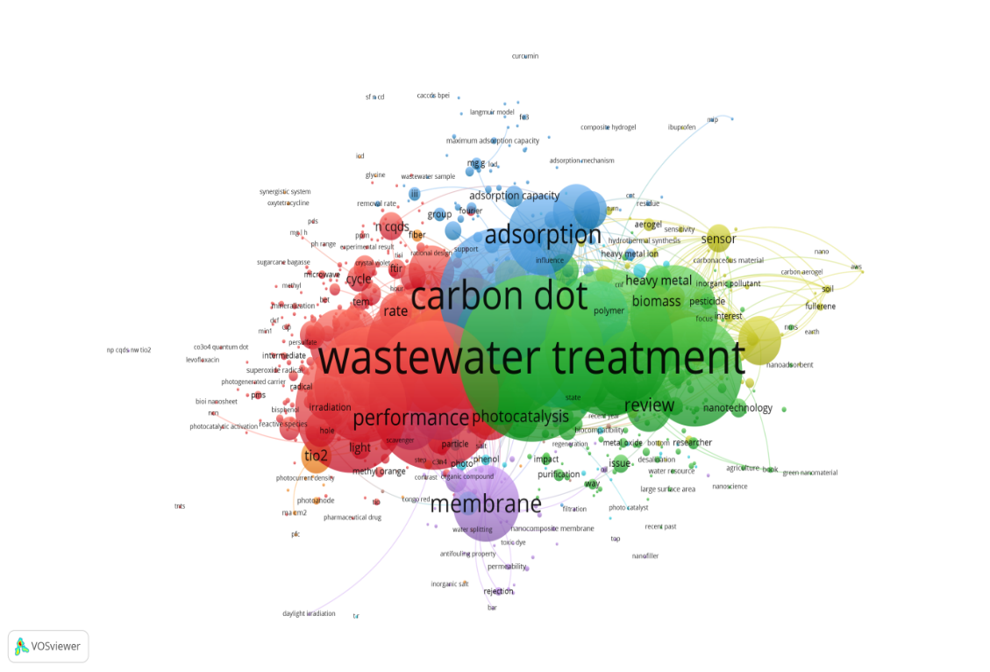
(a)
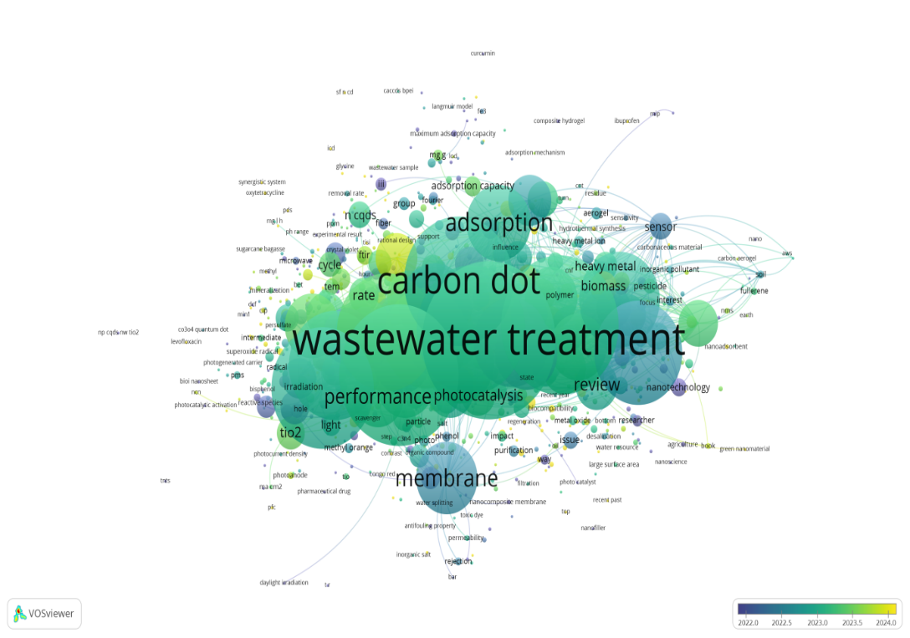
(b)

Fig. 1. Keyword analysis concerning the application of carbon dots for wastewater treatment (a) co-occurrence network visualization, and (b) overlay visualization.

3. Production of Carbon dots
Numerous production methods have been reported, which may be broadly divided into two types (Figure 2): "top-down" and "bottom-up" methods.

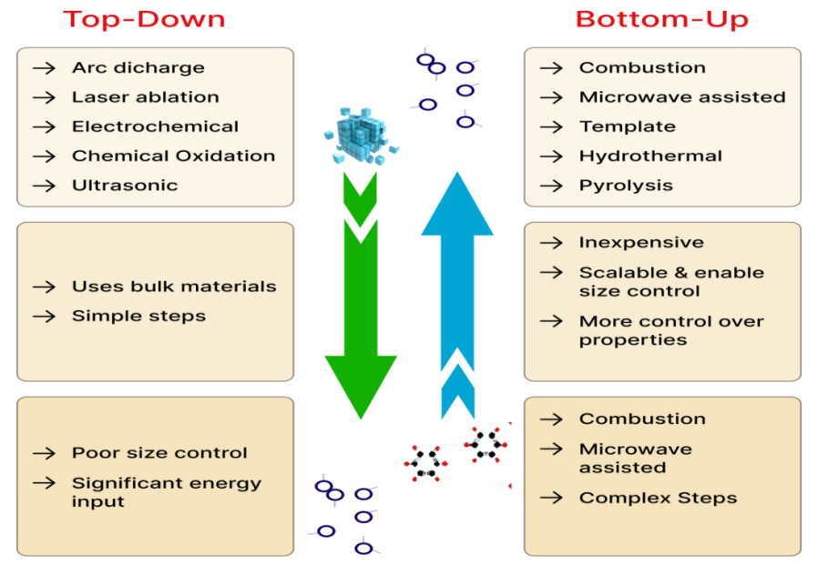
Fig. 2. Methods for producing carbon dots.

3.1 Top-down production method
The top-down method for the production of CDs involves deconstructing massive carbon materials into nanoparticles through physical or chemical means (Cui et al., 2021). The most commonly used processes in this method include arc discharge, laser ablation, electrochemical oxidation and exfoliation, chemical oxidation and ultrasonic treatment (Table 1). Of these, arc discharge is widely used owing to its simplicity and efficacy in regulating particle morphology, as demonstrated by Xu et al. in 2004. Electrochemical oxidation is also widely applied, offering advantages such as a high yield, low cost, tunable size and reproducibility (Long et al., 2021). Nevertheless, top-down methods usually function under severe conditions such as high acidity, high potential and significant energy input, rendering them more cumbersome than bottom-up methods (Mansuriya and Altintas, 2021). Additionally, most top-down methods are based on non-selective chemical cutting, which limits the exact control over the size and shape of the produced CDs and this diversity can also lead to a variety of properties (Wu et al., 2017).

Table 1. Comparison of top-down production methods for carbon dots
Method | Details
Arc discharge | - Oldest and most common.  - Relies on the formation of plasma between two electrodes in high-temperature and high-pressure environments to decompose bulk carbon substances at the anode and reassemble them as nanostructures at the cathode.  - This method has notable drawbacks, including low quantum yields (QYs), limited overall material yields and the production of complex by-products that are difficult to extract and purify.  - Large-scale or high-purity applications is further hindered by the complexity of the residues left and the requirement for severe operational conditions.
Laser ablation | - Most commonly used and powerful techniques.  - Involve exposing carbonaceous materials to highly intense laser pulses.  - Ionizes the carbon material, producing rapid heating, formation of small pits and production of plasma at the surface.  - Advantage of a simple operating process, short processing time and the ability to produce CDs with different shapes and nanostructures which facilitates the tuning of the surface states of the resulting CDs.  - Disadvantages, including a typically low quantum yield, poor control over particle size and the requirement for a large quantity of carbon precursor material to form the target.  - Promising method for the synthesis of nanomaterials because it can enable the rapid and flexible production of CDs.
Electrochemical oxidation and exfoliation | - Most effective ways to produce CDs.  - Similar to arc discharge.  - Utilizes a high oxidation potential to oxidize the carbon source from the electrode surface, thereby producing CDs.  - The configuration of the CDs produced can vary depending on the precursor material and desired properties.  - Offer a scalable, reproducible and comparatively environmentally friendly process for the production of CDs.  - More work is required to improve the yield and structural integrity of CDs produced via this process.
Chemical oxidation | - Most favoured and efficient processes.  - Advantageous owing to its simplicity, low cost, reproducibility and lack of complex equipment requirements, making it useful for large-scale production.  - The treatment of carbon precursors with strong oxidizing agents which rupture the covalent links in the carbon source leading to the gradual building of tiny carbon structures that finally produce CDs.  - CDs extraordinary hydrophilicity and controllable optical properties.  - Produce CDs with high quantum yield and purity even under relatively mild conditions.  - Some major disadvantages which typically involve multi-step protocols and severe reaction conditions, resulting in environmental issues owing to the use of expensive and corrosive oxidants.
Ultrasonic treatment | - Simple, low-cost and extensively used method.  - The use of ultrasonic waves to create cycles of alternating high and low pressures inside a liquid medium.  - Process effectively disintegrates bulk carbon materials into particles of nanometer diameter, generating high hydrodynamic shear stresses and mechanical disruption.  - Favours the uniform dispersion of the produced CDs and prevents their agglomeration.  - One limitation of ultrasonic treatment is that the produced CDs tend not to be monodisperse, which can affect their consistency across different uses; however, this process has great advantages in terms of ease, speed and scalability.
(References: Chan et al., 2018; Cui et al., 2021; Khayal et al., 2021; Wu et al., 2017; Yao et al., 2022).

3.2 Bottom-up production method
The bottom-up uses methods, such as solvothermal/hydrothermal treatment, pyrolysis, template method, microwave-assisted production and combustion/thermal decomposition, for the production of CDs via converting molecular or polymeric precursors into carbon dots (Table 2). This method is becoming increasingly popular because it is simple, inexpensive, scalable and enable accurate control of the size distribution and surface properties of CDs (Döring et al., 2022). The general precursors used in this method are organic acids, carbohydrates, biomass waste and candle or natural gas burner combustion soot, indicating the adaptability of the method to utilize any source of carbon, especially renewable and sustainable ones. Of the entire above mentioned bottom-up methods, the hydrothermal method is particularly preferred because it is environmentally friendly, easy to use and suitable for mass production (Long et al., 2021). Additionally, the bottom-up method provides more control over the structural and optical properties of CDs than top-down methods, thereby enhancing product quality and yield (Khairol et al., 2021).

Table 2. Comparison of bottom-up production methods for carbon dots
Method | Details
Combustion/thermal decomposition | - Advantages such as ease, low cost and suitability for mass production.  - Organic carbon sources are processed in a series of steps involving heating, dehydration, degradation and carbonization in an inert environment or vacuum.  - Endothermic processes and strong bases or acids can also be used.  - Properties of the produced CDs could be accurately tuned by varying the reaction temperature, pH and reflux time.  - Flexibility of involves high temperatures and the resulting CDs tend to have a large size range, which may pose problems with scalability and uniformity.  - High yield and ease of use.
Microwave-assisted synthesis | - Conventional and efficient process.  - Multiple advantages including scalability, high-rate processing, low equipment demands, eco-friendly chemistry, low energy consumption, time consumption and operational simplicity compared to conventional techniques such as solvothermal/hydrothermal processes.  - Electromagnetic waves, which usually range from a wavelength of 1 mm to 1m, cause molecular collisions and vibrations, transferring energy into heat which enables the production of CDs.  - One major benefit of microwave-assisted synthesis is its capacity to temporarily warm materials in situ ability allows for rapid temperature increases and even heating, leading to high yields and stable product quality, which can typically be completed in a matter of minutes.  - Improves the reproducibility and quality of the final product.  - Potential for commercial-scale manufacture of fluorescent CDs.
Template method | - More specialized processes.  - Mesoporous silicon spheres serve as structural templates in conjunction with a particular support material.  - The process involves two major steps: first, small molecules of carbon are built and carbonized on or in the support material; second, the support is dissolved by acid etching.  - Produce CDs with large surface areas and well-defined porous architectures.  - Provides exact control over the shape and structure of the produced CDs.  - Process is expensive and time-consuming, it is difficult to eliminate the template material entirely, and it is difficult to recover and purify the final product.  - Not scalable and usually yields a low quantum yield; hence it is not ideal for mass production.  - Limited practical use.
Solvothermal/ hydrothermal treatment | - Most widely used and successful bottom-up methods because of their ease, cost, environmental sustainability and the ease with which precursors can be selected.  - Constitute techniques for using carbon precursors along with a solvent that is heat-treated in an autoclave.  - CDs are produced through polymerization and carbonization reactions and their properties can be easily adjusted by changing factors such as temperature, reaction time and precursor composition.  - Simple operation, low energy consumption, small environmental impact and ability to produce high-quality, monodispersed CDs with desirable fluorescence characteristics.  - Scalability and flexibility of the CDs produced by this process make them popular in basic large-scale research.
Pyrolysis | - Effective and widely applied method.  - Converts carbon-rich organic compounds into carbon-rich solid residues or nanoparticles via crucial steps, such as heating, dehydration, breakdown and carbonization.  - Advantages, including cost-effectiveness, absence of solvent usage, scalability and fast reaction rates.  - Large-scale production of fluorescent CDs.  - Formation of carbon cores and surface functional groups that enhance the optical and structural properties of the produced CDs.  - By controlling critical parameters such as the pyrolysis temperature, time and pH of the reaction environment, which dictate the final product size, surface chemistry and quantum yield, the characteristics of the produced CDs may be carefully controlled.  - High-performance CDs from different sustainable and environmentally friendly precursors, demonstrating its status as a versatile synthesis route.
(References: Huang and Ren, 2025; Kang et al., 2020; Khayal et al., 2021; Perumal et al., 2021; Yao et al., 2022).

4. Properties of Carbon dots

CDs are a fascinating type of CBNs, typically characterized by their small particle sizes, which are approximately 10 nm. They exhibit unique physical, biological and chemical properties, which are discussed in detail in this section of the review.

4.1 Physical properties
The top-down method for the production of CDs involves deconstructing massive carbon materials

4.1.1 Morphological properties
When it comes to the morphology of the CDs, it is found that they are either quasi-spherical or spherical in shape, with diameters generally ranging from 2 to 10 nm. However, CDs created through top-down methods often using graphite or graphene-based materials as precursors; tend to exhibit crystalline cores because of the inherent properties of their precursors (Döring et al., 2022). Mainly CDs are either amorphous or nano-crystalline with sp²-hybridized carbon clusters. Some studies have also observed presence of diamond-like structures made up of sp³ carbon atoms, along with rare instances of CDs with hollow structures (Zheng et al., 2015).
4.1.2 Optical properties
Optical properties can be correlated with the electronic structure of the core and surface states, as well as with external environmental factors such as solvent polarity and pH (Li et al., 2021). In general, CDs display characteristic optical absorption predominantly in the ultraviolet (UV) region, with an absorption tail extending into the visible spectrum (Wang & Hu, 2014). However, the exact absorption features vary considerably depending on the carbon precursors, heteroatom doping and the solvents employed during production (Cui et al., 2021). Beyond absorption, CDs exhibit 2 types of photoluminescence (PL), primarily in the form of fluorescence (down-conversion emission) and anti-Stokes (up-conversion emissions), both of which originate from radiative recombination via emissive core and surface states. In addition to these PL phenomena, CDs can also demonstrate other optical emission behaviours viz. electroluminescence and chemiluminescence. Collectively, these optical properties are governed by the distribution of electronic energy levels and the dynamics of charge carrier generation, migration and recombination within the CDs. Further, elaboration of optical properties of CDs is provided in Table 3.
Table 3. Comparison of bottom-up production methods for carbon dots
Optical property | Mechanism
Optical absorption  (UV–Vis) | - Characteristic bands ~230–340 nm (π→π* of sp² domains).  - Broader tail into the visible arising from surface chromophores/oxygenated groups.  - Absorption defines excitation windows and is strongly influenced by core structure and surface functional groups.
Photoluminescence-  Fluorescence  (down-conversion emission) | - Also called Stokes-shifted visible emission (longer-wavelength emission on shorter-wavelength excitation).  - Emission originates from a combination of quantum-confinement of sp² domains, emissive surface/defect states and molecular fluorophore-like moieties.  - Shows solvent/surface sensitivity.
Photoluminescence-  Anti-Stokes  (up-conversion emission) | - Also called anti-Stokes emission (shorter-wavelength emission on longer-wavelength excitation).  - Reported mechanisms include multi-photon absorption and re-absorption artefacts.
Electroluminescence (EL) | - Light emission driven by electrical excitation (charge injection and recombination in device stacks).  - Its performance depends on the surface, electron transport layers and aggregation control of produced CDs.
Chemiluminescence (CL) | - Light produced by chemical reactions (e.g., peroxyoxalate, luminol systems) where CDs may act as emitters or catalysts/enhancers.  - Used for sensitive assays in sensors.  - Mechanism is chemical-energy → excited state → photon emission (no optical excitation).

4.1.3 Quantum yield (QY)
Quantum yield (QY) is a critical parameter reflecting the brightness and efficiency of PL in CDs and is highly sensitive to surface chemistry and electronic structure. Higher QY values indicate more efficient radiative recombination, which is essential for enhancing pollutant detection sensitivity and signal reliability in practical applications (Rawat et al., 2023). Modified CDs via heteroatom doping, surface passivation and metal coordination can significantly improve QY by reducing non-radiative recombination pathways and stabilizing emissive states (Zhang et al., 2025). However, unmodified CDs often exhibit dominant surface emissive traps limiting quantum efficiency and emission instability. Overall, the tunable QY of CDs arise from a complex interplay between core structure, surface states and coordination chemistry and this versatility enables their broad applicability in wastewater treatment and environmental remediation.
4.2 Biological properties
CDs are impressive in terms of biocompatibility, making them safe for use in biological settings (Li et al., 2023).

4.2.1 Biocompatible and less toxic
CDs are typically biocompatible and biodegradable, which helps reduce their environmental footprint and minimize ecological risks because of their ability to be naturally degraded or metabolized by living organisms which contributes to their safety and compatibility for applications in wastewater treatment technologies, especially in secondary treatment. Moreover, CDs produced from renewable and non-toxic materials further reduces reliance on harmful chemicals (Azam et al., 2021) which results in CDs having low level of toxicity, even at higher concentrations. In addition, when nitrogen is doped onto the CDs, it enhances their safety profile while making their biodegradability and improving how well the cells take them up along with their optical properties (Park et al., 2020). Furthermore, safety tests conducted on mammals have showed no significant toxic effects by CDs at any dosage supporting their practical use in photodynamic wastewater treatment technologies (Wang et al., 2013).

4.2.2 Inherent biological activity
CDs exhibit a range of natural biological activities, including antimicrobial, anticancer, antioxidant and anti-inflammatory properties (Li et al., 2023). These impressive traits are often tied to their surface characteristics, addition of heteroatoms such as nitrogen and sulfur and the bioactive elements they retain from their natural sources. CDs made from medicinal plants or amino acids, such as L-/D-cysteine and ascorbic acid, exhibit strong antimicrobial effects by disrupting membranes and generating reactive oxygen species (ROS). Additionally, some CDs possess inherent antioxidant capabilities that enable them to neutralize free radicals and reduce oxidative stress in living cells (Mansuriya and Altintas, 2021).

4.2.3 Environmental compatibility
CDs are photostable and show great resistance to photobleaching and are chemically inert. They have ability to maintain their structural integrity across different pH levels, temperatures and ionic environments highlighting their value in complex physiological and ecological situations. Typically, these green-synthesized CDs remain in the environment for less time and pose fewer ecological risks. Their ability to break down naturally or be metabolized in living organisms adds to their appeal for safe use in wastewater treatment. The sustainable production of CDs aligns perfectly with the principles of green chemistry and circular economy, making them a promising alternative to traditional inorganic nanomaterials that can have a heavy environmental impact.

4.2 Chemical properties

4.3.1 Surface functionalization
CDs have complex surface chemistry with many functional groups, including carboxyl (–COOH), hydroxyl (–OH), amino (–NH₂) and carbonyl (–C=O) groups formed either during production or added afterward and useful for wastewater treatment applications. The variety of surface functionalization allows easy modification of CDs with biomolecules and polymers, thus, significantly expanding their potential use in biosensing and PL imaging (Elugoke et al., 2024). The ionizable nature of these surface functional groups also makes CDs responsive to changes in the environmental pH and ionic strength. This quality makes them suitable for use in stimuli-responsive systems. Additionally, the surface charge depends on the type and amount of the functional groups, influences how CDs interact with biological systems (Mukharjee et al., 2022). CDs rich in amino groups (positively charged) tended to promote better cellular uptake. In contrast, CDs abundant in carboxyl groups (negatively charged) usually exhibit lower toxicity and longer circulation times in biological fluids. The hydrophilic nature of these surface functionalities ensures better water solubility and also improves compatibility with various polar solvents, increasing their applicability in a wide range of chemical and biological treatment for wastewater treatment.

4.3.2 Elemental composition and doping
CDs mainly consist of elemental carbon; however, they can also contain elements such as oxygen, nitrogen, sulfur and phosphorus, depending on the sources of production and methods used for producing them (Mukherjee et al., 2022). This variety of elements is essential for determining the physical and chemical properties of CDs, including solubility, charge distribution, photostability and biocompatibility essential for efficient wastewater treatment. These properties can be enhanced by adding other atoms, such as nitrogen (N), sulfur (S), phosphorus (P) or boron (B), into the carbon structure achieved by doping or surface modification (Kumar et al., 2022). These changes can significantly affect the band gap, improve the QY and increase surface reactivity. Adding nitrogen introduces lone pair electrons and π-conjugated structures increasing the electron density and enhance PL efficiency. Similarly, adding sulfur and phosphorus enhances the catalytic and electrochemical functions of CDs, making them suitable for applications in biosensing and photocatalysis. Dual- or co-doping strategies (e.g., N–S and N–P) can also be employed to synergistically tune properties such as fluorescence, conductivity and redox activity. Surface engineering through passivation or functionalization further expands the scope of their applications by introducing targeting ligands or pollutant sensing probes in wastewater.

4.3.3 Stability and reactivity
CDs exhibit chemical and thermal stability allowing them to maintain their structural, optical and dispersion nature across a wide range of pH levels, temperatures and ionic strengths (Elugoke et al., 2024). Their durability originates mainly from their graphitic or partially crystalline carbon cores and protective surface coatings, which improve their ability to resist oxidative degradation. This strength makes CDs useful in industrial applications. In addition, CDs show strong resistance to photobleaching. This remarkable photostability makes them ideal for real-time and long-term PL imaging, ongoing monitoring, super-resolution microscopy and various optoelectronic applications, where consistent and reliable luminescence is essential.
4.2 Electronic properties
CDs possess electrical properties, primarily owing to their unique core structures and diverse surface states. The emission behaviour of CDs, whether excitation-dependent or independent, is influenced by several factors, including the particle size, degree of surface functionalization and extent of conjugation within the carbon core. Additionally, CDs exhibit quantum confinement effects which alter the bandgap structure, resulting in size-dependent electrical properties. The incorporation of heteroatoms such as nitrogen, sulfur or phosphorus, along with surface dopants, enhances charge separation and facilitates efficient charge transfer (Elugoke et al., 2024). These enhancements not only improve the electrical properties but also significantly enhance their electro-catalytic performance. As a result, CDs have strong potential for advanced applications such as electro-catalysis and biosensing which can be effectively applied in wastewater treatment technologies.
5. Mechanisms involved for wastewater treatment using carbon dots
Carbon dots (CDs), with their remarkable properties discussed in the previous section, have considerable potential for applications in wastewater treatment. Thus, they can effectively detect and remove pollutants present in wastewater. These mechanisms of CDs interacting with the various pollutants in wastewater are discussed in detail in this section (Figure 3).

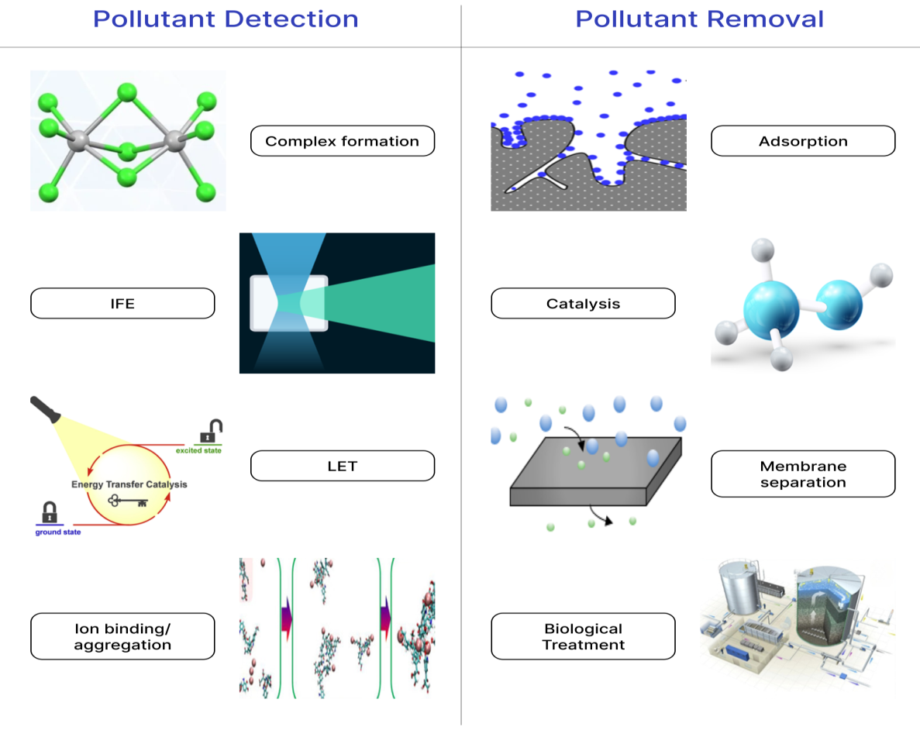

Fig. 3. Diagrammatic representation of mechanisms in wastewater treatment using carbon dots.
4.2 Electronic properties
The various mechanisms involved in pollutant removal by CDs are adsorption, catalysis, membrane separation and biological treatments. In the adsorption processes, the surface modification of CDs can significantly enhance their pollutant-binding capabilities. Moreover, CDs can catalyse the degradation of organic pollutants, thereby boosting the wastewater treatment efficiency. In addition, CDs contribute to membrane separation and biological treatment, enhance the selectivity of treatment processes and offer innovative solutions for sustainable wastewater treatment.

5.1.1 Adsorption
Adsorption is a highly effective and cost-efficient physical method of wastewater treatment. CDs remove pollutants from wastewater via adsorption mainly through interactions between the heavy metal ions, dyes, chemicals, etc. and the various functional groups on the surface of CDs. Dyes interact with CDs via adsorption, often resulting in shifts in the emission spectra of CDs depending on the nature of the binding and the specific dye involved. These dyes may compete with heavy metal ions for similar binding sites on the surface of the CDs, which can alter the fluorescence response. Bisphenol, a commonly used industrial chemical, poses potential bio-toxicity risk to humans was found to be adsorbed onto the surface of modified CDs composite via adsorption mechanism onto CDs surface primarily involves π–π interactions, hydrophobic forces, hydrogen bonding and van der Waals forces (Gong et al., 2020).
5.1.2 Catalysis
CDs can act as catalysts or catalyst enhancers in chemical reactions. CDs alone exhibit weak catalytic properties but when heavy metals (such as Hg²⁺, Cu²⁺, Fe³⁺, etc.) bind to CDs, modifying the catalytic sites on their surface either activating or inhibiting their catalytic properties. The change in colour and rate of reaction was proportional to the concentration of the heavy metal. The catalysis is induced by either light (photocatalysis) or electrons (electrocatalysis). CDs are utilized in photocatalysis because of their conjugated sp²/sp³ hybrid structures and plentiful surface and edge sites, which exhibit remarkable photoelectric properties and catalytic activities. Photocatalysis enables the degradation of organic pollutants present in wastewater into carbon dioxide and water, without the need for harmful oxidizing agents, making it an efficient and cost-effective approach for wastewater treatment. The effectiveness of the photocatalytic processes depends on three critical factors: efficient light absorption and exciton generation, prolonged exciton lifetime and swift surface reactions. The unique properties of CDs make them excellent candidates for facilitating a range of electrochemical reactions. By improving the electron transfer kinetics of photo-electro-catalysts, CDs significantly enhance the overall reaction efficiency, making them highly valuable in advanced wastewater treatment technologies.
5.1.3 Membrane separation
CDs increasing been used for the preparation of high-performance wastewater treatment membranes in the past few years. However, membranes with CDs have common problems viz. surface hydrophilicity, permeability, solute selectivity, stability and antifouling properties which can be easily improved by modifying these membranes. Furthermore, concentration polarization and pollutant accumulation on the membrane are the two main reasons for the performance degradation of these nano-filter membranes made of CDs. These problems can be resolved by constructing an interlayer between the substrate and selective layer of traditional composite membranes by synergistically regulating CDs and poly-dopamine. This results in the creation of a nano-filter membrane with dual functions, that is, mitigation of concentration polarization and self-cleaning properties. Additionally, the photoactive CDs in the interlayer can adsorb and photodegrade organic pollutants on the membrane surface. Hence, the novel dual-functional nano-filtration membrane has promising potential for fouling remediation and for treating wastewater containing complex pollutants (Shao et al., 2019).
5.1.4 Biological treatment
In biological treatment of wastewater, several processes often encounter difficulties such as light-induced inhibition and low substrate conversion rates which can be overcome using CDs owing to their unique photoactive properties and excellent biocompatibility. Their ability to interact effectively with activated sludge offers several advantages. CDs can mitigate the adverse effects of photolytic damage by absorbing or scattering harmful light, thereby protecting the microbial communities responsible for biological (aerobic and anaerobic) of wastewater treatment. In addition, their interaction with sludge can facilitate better electron transfer and metabolic activity, ultimately leading to improved substrate conversion rates, thereby boosting the overall performance and stability of wastewater treatment systems.
5.1.4.1 Anammox
Anammox is an anaerobic low-carbon technology for wastewater treatment because of its minimal requirement of external carbon sources, low aeration demand, reduced greenhouse gas emissions and high nitrogen removal efficiency. Anammox bacteria are anaerobic, non-phototrophic and highly susceptible to light exposure leading to the accumulation of reactive oxygen species (ROS). When ROS levels surpass the cell’s antioxidant defence system, they can damage biomolecules, including proteins, nucleic acids and lipids, ultimately causing oxidative stress. Combining photoactive and biocompatible CDs these microbes can enable new functionalities and contribute to in a better understanding of how anammox responds metabolically to light and supports the advancement of resilient and eco-friendly wastewater treatment technologies.
5.1.4.2 Anaerobic digestion
During anaerobic digestion, symbiotic microorganisms can form conductive aggregates and facilitate direct interspecies electron transfer through pili structures or cytochrome C proteins. Introducing as conductive materials CDs into this system can enhance electron transfer, stimulate microbial metabolic activities and improve the degradation rates of pollutants.
5.1.4.3 Denitrification
Denitrification, a traditional biological nitrogen removal method that plays a key role in treating nitrate-rich wastewater, is hindered by its low nitrogen removal efficiency and the production of nitrous oxide (N2O), a potent greenhouse gas with a global warming potential that is much greater than CO2. The incorporation of CDs as an electronic media is a promising solution for reducing N2O accumulation and enhancing denitrification process. Furthermore, nitrogen and iron co-doped CDs (N/Fe-CDs) can enter bacterial cells and promote extracellular electron transfer by interacting directly with the C-type cytochrome on the outer membrane of Shewanella oneidensis and support anaerobic biological nitrogen removal by adding more active sites on the surface and enhancing electrochemical properties of CDs (Li et al., 2024).
Significant findings in the production of CDs derived from various types of biomass or chemical precursors, dopants, pollutant removal efficiencies and the mechanisms involved are presented in Table 4.

Table 4. Production of carbon dots from various precursors for pollutant removal and mechanisms involved for wastewater treatment
Precursor | Production Method | Specific Property | Target pollutant | Removal Efficiency | Mechanism | References
Lemon leaves | Hydrothermal | QY ⁓ 12.5% | Detect Hg2⁺ ions | - | Dynamic quenching | Kumari et al., 2025
Moringa oleifera leaf extract | Hydrothermal | SnO₂/carbon dots nanocomposites | Congo red  &  Crystal Violet | 99.28%  &  91.14% | Photocatalysis | Balamurugan et al., 2025
Garlic | Pyrolysis | N-doped | Crystal Violet | 99.13% (max.) | Photocatalytic degradation | Singh et al., 2025
Sugarcane bagasse | Microwave | Magnetic CDs | Chromiun (VI) | 93.86% | Adsorption | Tohamy, 2025
Groundnut shell | Hydrothermal | carbon dots/chitosan hydrogel-modified TiO₂ | Chromium (VI) | 90.38% | Photocatalytic degradation | Ma et al., 2025
Phenanthroline | Hydrothermal | Fe-doping | Tetracycline | 74.1 % | Photo-Fenton degradation | Shen et al., 2024
Sorghum | Pyrolysis | - | Rose bengal | 86.10% | Photocatalysis | Tripti et al., 2025
5-Hydroxymethylfurfural and o-phenylenediamine | Hydrothermal | N-doped applied to bioelectrochemical systems | sulfamethoxazole,  phenols  and  organic matter in papermaking wastewater was | 4.4,  3.4  and  1.9 times that of the blank group | Oxidative degradation | Zhang et al., 2025
Chitosan and acetic acid | Ultrasonic | - | Beryllium | From 2.5 mg/L to below 5 µg/L. | Adsorption | Zhao et al., 2025
Brewing waste | Hydrothermal | N-doping | Methylene blue | - | Adsorption and photocatalytic degradation | Cailotto et al., 2022
Sodium alginate | Hydrothermal | Hydrogel | Lead (II) | - | Adsorption | Xu et al., 2024
L-cysteine and polyethylene glycol | Hydrothermal | Cu-doped | Methyl Orange,  Orange II,  Reactive Black 5  and  Remazol Brilliant Blue R | 90% | Ozone Advanced Oxidation Process | Cardoso et al., 2022
Microcrystalline cellulose | Acid-assisted carbonization | - | Chromium (VI) | - | Photocatalysis | Aggarwal et al., 2022
Avocado seeds | Carbonization | - | Copper (II)  Chromium (VI) | High sensitivity for detection | Detection through IFE and flocculation/sedimentation | Ávila et al., 2022
Chitosan | Microwave | PET-cellulose nanofiber composite membranes | Organic oils | >97% | Filtration | Bhuyan et al., 2023

5.2 Pollutant detection mechanisms
Specific mechanisms for pollutant detection (especially heavy metal-ion sensing) by CDs involve complex formation, inner filter effect (IFE), light-induced electron transfer (LET), ion binding and/or aggregation, etc.
5.2.1 Fluorescence-based
Fluorescence-based pollutant detection approaches offer significant advantages over conventional analytical methods for tracking pollutants, particularly in terms of rapid response, user-friendliness and high sensitivity as CDs exhibit strong and tunable PL properties, making them highly appropriate for pollutant detection approaches that utilize CDs and can be classified into two primary categories. The first involves direct interaction between the analyte (pollutants) and the CDs surface, resulting in noticeable changes in fluorescence intensity or emission characteristics of CDs. The alternative approach relies on the surface modification of CDs with specific recognition elements, enabling the targeted detection of pollutants through indirect interactions. The engagement between CDs and pollutants influences the detection response, possibly leading to either fluorescence quenching or enhancement depending on the nature of the interaction. These changes arise from several core processes, including dynamic quenching (DQE), static quenching (SQE), förster resonance energy transfer (FRET), inner filter effect (IFE), photoinduced electron transfer (PET), and surface energy transfer (SET) and dexter energy transfer (DET), which collectively form the basis for fluorescence-based pollutant detection utilizing CDs (Table 5).

Table 5. Mechanistic pathways for the detection of targeted pollutants using carbon dots
Mechanism | Working Principle | Target pollutants | Examples | Key characteristics of the mechanism | References
Static quenching effect  (SQE) | Ground-state complex formation between CDs and analyte results in fluorescence quenching.; reduces excited-state population | Fe³⁺, Pb²⁺, Cr3⁺, Se(IV), Hg²⁺, Cu²⁺. antibiotics | Detection of Hg²⁺ occurs via strong coordination with CD surface functional groups, resulting in non-fluorescent complex formation and subsequent fluorescence quenching. | Requires strong binding; verified by unchanged fluorescence lifetime, stability of the complex is temperature sensitive | Zu et al., 2017  He, et al., 2018  Dai et al., 2022  Shaw et al., 2023
Dynamic quenching effect  (DQE) | Collisional interactions between excited CDs and quenchers introduce a non-radiative decay pathway, resulting in fluorescence quenching without ground-state complex formation. | Pb²⁺, small ions | Pb²⁺ sensing following Stern–Volmer behavior | Depends on diffusion and temperature; lifetime decreases | Vervald et al., 2023  Sohal et al., 2023
Photoinduced electron transfer  (PET) | Electron transfer between CDs and analyte [HOMO (Highest unoccupied molar orbit /LUMO ( Lowest unoccupied molar orbit) interaction] | Cu²⁺, Hg²⁺, Fe3+  Antibiotics like Furazolidone (FRZ), Nitrofurantoin (NFT), Nitrofurazone (NFZ) | Antibiotic Sensing in Drinking Water and Biological Systems | Highly sensitive to pH, Efficient PET requires multiple redox-active sites with closely aligned energy levels within the system. | Sun et al., 2023  Kumari and Sandhu, 2026  Sayyad et al., 2024
Förster resonance energy transfer  (FRET) | Non-radiative energy transfer.  FRET (CD–analyte system)  Energy transfer from CDs (donor) to analyte (acceptor), enabling pollutant detection via fluorescence quenching.  FRET (nanomaterial–nanomaterial system)  Energy transfer between nanomaterials (e.g., GQDs–CDs), where one acts as donor and the other as acceptor, leading to fluorescence modulation. | As5+, Hg2+, Al2+, Fe3+  Glyphosate, Zn²⁺, antibiotics, ochratoxin A | Glyphosate detection via CDs–glyphosate spectral overlap | Requires spectral overlap and 10-100 Å donor–acceptor distance | Gopal et al., 2024  Chini et al., 2019  Kalaiarasi et al., 2025
Inner filter effect  (IFE) | Absorption of excitation/emission light by the analyte without direct interaction | Cu²⁺, Cr⁶⁺, Fe3+ tetracycline | Tetracycline detection due to absorption overlap with CDs | Simplest mechanism; no lifetime change | Kaur et al., 2023  Molaei, 2020  Yan et al., 2020
Surface energy transfer  (SET) | Energy transfer from CDs to adjacent nanoparticle surfaces (e.g., gold nanoparticles), leading to fluorescence quenching via surface-mediated interactions. | Pb²⁺, Hyaluronidase | Pb²⁺ detection via surface-bound interactions | Distance-dependent; occurs at the CD surface | MP et al., 2022
Dexter energy transfer  (DET) | Electron exchange requires wave function overlap | Nitrobenzene | Nitrobenzene sensing via short-range interaction | Requires direct contact; less common | Hoffman et al., 2014

5.2.2 Complex formation
CDs have oxygen-containing groups (–OH, –COOH, –OR, C=O, etc.) on their surface along with doping of nitrogen, sulphur and other dopants containing other functional groups (like –NH2, –NO2, –CN, –SH and –SOH), which can donate their lone pair of electrons to the heavy metal ions present in the wastewater and form a complex, resulting in the physical/chemical adsorption of these heavy metal-ions onto the surface of the CDs. The complex formation can be easily observed using Fourier Transform Infrared Spectroscopy- FTIR (Batool et al., 2022).
5.2.3 Ion-binding
CDs possess many binding sites on their surface which are specific for particular ions. The ion-binding mechanism is responsible for the interaction between heavy metal ions with modified CDs which can be easily confirmed by FTIR and X-ray Photoelectron Spectroscopy (XPS) data (Rong et al., 2017).

5.2.4 Aggregation
Sometimes, CDs aggregate together upon the introduction of heavy metal ions as these ions act as cross-linkers by binding to functional groups present on their surface. This process alters fluorescence behavior (quenching or enhancement) of the CDs, making this mechanism valuable for pollutant detection in the monitoring of pollutants in wastewater.

6. Comparative Analysis: Carbon Dots v/s Other Nanomaterials
Among various nanomaterials, CDs, silver nanoparticles (Ag-NPs), graphene-based nanoparticles (GNPs), plant-based nanoparticles (PBNs) and titanium dioxide nanoparticles (TiO2-NPs) have gained significant attention because of their unique physical, chemical and biological properties. Table 6 provides an in-depth analysis of the composition, size, optical properties, biocompatibility, advantages, limitations and applications of these nanomaterials, helping researchers and professionals to understand their potential and suitability for specific uses in wastewater treatment for removal and detection. Table 6 reveals the superiority of CDs over Ag-NPs, GNPs, PBNs and TiO2-NPs, each offering distinct advantages. This superiority of CDs is not defined by a single metric but by a unique convergence of small size, composition, optical properties, biocompatibility, high water dispersibility and photocatalytic properties. Unlike Ag-NPs, which risk secondary environmental toxicity through ion leaching, CDs provide an environmentally benign profile with excellent biocompatibility. Furthermore, they overcome the critical industrial barriers that hinder GNPs and PBNs which are specifically the high costs of large-scale production and the lack of structural stability in wastewaters with complex set of pollutants. By leveraging "waste-to-wealth" synthesis from sustainable precursors, CDs also align with the circular economy, offering a high-performance, low-cost and solar-active platform that can effectively bridge the gap between laboratory research and real-world industrial application in wastewater technologies.
Table 6. Comparative overview of carbon dots v/s other nanoparticles.
Feature | Carbon dots (CDs) | Silver nanoparticles (Ag-NPs) | Graphene based nanoparticles (GNPs) | Plants based nanoparticles (PBNs) | Titanium dioxide nanoparticles (TiO2-NPs)
Composition | Structure: sp2 and sp3 carbon atoms  Surface: covered with many chains of polymer or functional groups. | Core of elemental silver.  Stabilisation: natural compounds like plant extracts or polymers to prevent agglomeration and maintain their effectiveness in aqueous environments. | Structure: Layer of sp2-hybridized carbon atoms arranged in a benzene ring configuration,  Two-dimensional carbon nanomaterial. | Synthesized from different parts of the plant such as the leaves, barks, roots, fruits, seeds and stem. | Crystalline metal oxide (Anatase/Rutile)
Size | <10 nm. | 1-100 nm. | 10s’ of nm in thickness.  Size: from a few to 100s’ of nm . | 1–100 nm. | Variable (20 to 100 nm).
Optical and photocatalytic property | UV to Visible (broadband).  High rate due to upconversion & electron transfer. | Visible (LSPR dependent).  Moderate rate via surface plasmon resonance. | Wide (IR to UV).  Moderate (acts as an electron sink/co-catalyst). | Variable.  Low to Moderate depending on phytochemical capping. | Primarily UV (Eg​≈3.2 eV).  High rate under UV, negligible under visible light.
Biocompatibility | Excellent | Moderate (can be cytotoxic) | High/Moderate | High | High (but concerns over toxicity)
Applications | Potential use in pollutant detection and photocatalysis of pollutants in wastewater. | Useful in a variety of wastewater treatment processes which includes pollutant remediation, pollutant catalysis and detection. | Appropriate for wastewater treatment and are used to remove various pollutants from wastewater are adsorption, photocatalysis and electrochemistry. | Wastewater treatment by heavy metal sorption, antimicrobial activity and catalytic degradation of pollutants. | Used in wastewater treatment via photocatalysis, self-cleaning surfaces and mineralization of recalcitrant organic pollutants.
Wastewater treatment efficiency | Efficiency is >90% under sunlight. | Efficient in removing bacteria but low efficiency in degradation of organic matter. | Highly efficient for heavy metals because of their exceptional adsorption capacity. | The efficiency is highly variable and primarily depends on the plant precursor used. | High efficiency under UV and low under visible light.
Reusability / Stability | Highly reusable without losing its stability. | Less reusability and can be prone to leaching and oxidation. | Reusable in moderation can be prone to restacking/aggregation. | Low reusability and often degrades in complex media | Highly reusable and thermo-chemically robust
Limitations | Structural and compositional inconsistencies can be found resulting in unclear photoluminescence properties in some cases. | High cost and leaching toxicity. | Hydrophobicity hampering wastewater treatment process and high production costs. | Scalability issues in large-scale production and aggregation resulting in decreased efficiency of wastewater treatment. | Recovery is not possible and exhibit low efficiency for wastewater treatment in absence of light.
(Rezania et al., 2024; Dheyab et al., 2024; Eid et al., 2023; Epelle et al., 2022; Göçer et al., 2022; Que et al., 2018; Rana et al., 2024; Saravanan et al., 2022; Yang et al., 2023).

7. Challenges associated with Carbon Dots
Currently, CDs are receiving much attention because of their special qualities and there are several production methods, however, there are still a number of challenges with their practicality. These technical and environmental challenges and there are few suggestions in this section to overcome them are listed below:
- The insufficient reproducibility of CDs in terms of size, QY, fluorescence, etc., hampers their commercial mass production. To overcome this challenge the CDs production transition to microfluidic production or automated flow chemistry can be found to be useful as these systems allow for precise size and QY control over residence time, temperature gradients, mixing and other parameters. Furthermore, use of machine learning (ML) algorithms to map the relationship between precursor chemistry and the resulting CD properties can also be helpful (Sezer et al., 2025).
- The stability of CDs is a crucial concern in real-world applications. Their photocatalytic degradation is affected by the wastewater matrix and environmental factors. As organic and inorganic components of catalytic active sites, the effectiveness of pollution removal decreases with the complexity of the wastewater matrix (Singh et al., 2023). Most CDs utilized for photocatalysis have been reported to emit either blue or green light, suggesting that their potential to gather light is restricted. To ensure that environmental influences do not impact their performance, it is essential to improve the stability and durability of CDs in complicated wastewater treatment facilities, thoroughly comprehend the interference of sample matrices on sensors and identify efficient anti-interference technologies. This can overcome using core-shell structuring or encapsulation that includes coating CDs in a protective shell (e.g., SiO2 or metal-organic frameworks or polymer matrix) which can shield the core from pH fluctuations and interfering ions while maintaining optical transparency (Shen et al., 2018). Embedding CDs in solid matrices improves thermal and chemical stability for detection applications (Kiryakov et al., 2024).
- Another important challenge when considering the use of CDs in wastewater treatment is their safety, as any possible toxicity may have an impact on both human health and the environment. CDs-based wastewater treatment has environmental implications owing to its potential infiltration into effluents, surface water bodies or sludge. The production of CDs can also generate hazardous wastes or emissions (Khan et al., 2024). The best way to handle this challenge is through utilizing waste-derived precursors (e.g., agro-waste) for production of CDs and conducting standardized life cycle assessments (LCA) like in-vivo toxicity screening using zebra-fish models to ensure environmental safety (Fernandes et al., 2021).
- The solubility of CDs is influenced by their surface functionalization groups which is difficult to regulate because it requires a large amount of energy and is expensive. However, the ideal biomass content and production parameters require further investigation.
- CDs are uses intrinsic fluorescence as the output signal for environmental pollutant detection as well as removal. However, practical applications face challenges owing to probe concentration, detection environment, excitation light and spectrometer parameter settings. This can overcome by designing ratiometric fluorescence sensors (dual-emission) which measures the ratio of two different wavelengths, the sensor becomes self-calibrating and immune to fluctuations in probe concentration or turbidity (Ravishankar et al.,2025).
- CDs have adsorption properties but the relationship between their adsorption capacities and the precursors remain uncertain. Predictions on their adsorption capacities can be made using ML algorithms (like Random Forest or XGBoost) which are built to predict models that link precursor chemistry (C/N/O ratios) directly to the resulting adsorption capacity for pollutants in wastewater matrix (Yan et al., 2025).
- The CDs and nano-composites made from CDs also face challenges in recycling applications. To obtain precise control of their characteristics and produce effective CDs and their nano-composites for wastewater treatment, it is crucial to thoroughly examine the impact of production process temperature and nature of precursors on the performance of the CDs. Adopting zero liquid discharge (ZLD) frameworks, integrating CDs into thin-film composite (TFC) membranes or immobilizing the CDs within the membrane matrix ensures effective wastewater treatment without being entering to the output stream (Zhao and Chung, 2018). Furthermore, the recovery of magnetic CDs nano-composites from treated effluent using an external magnetic field is a simple physical process which can help in preventing secondary pollution caused by CDs and ultimately reducing their cost of production and recycling the adsorbent used (Liu et al., 2017).
- CDs purification continues to be a major challenge and current techniques such as gel electrophoresis, centrifugation followed by filtration, dialysis, column chromatography, solvent extraction and high-performance liquid chromatography (HPLC) are found to be insufficient to guarantee excellent purity. Reliable purification may require a combination of methods rather than a single method. Standardization of the purification process is crucial for further CD research and for guaranteeing study repeatability (Mandal and Das, 2022).
- Additionally, the solvent interactions and the IFE significantly affect the emission optical properties of CDs. A standardized understanding of their fluorescence mechanisms is essential for advancing their applicability in effective wastewater treatment (Mandal and Das, 2022).
- Although some studies have demonstrated that CD-based photocatalysts significantly improve the photocatalytic degradation of pollutants in wastewater matrix but a number of challenges still require further research. The main aim is to shift from trial and error methods to the predictive modelling and standardized engineering.

8. Recent Advances and Emerging Trends
As studies have advanced, it has been shown that CDs with surface functionalization have strong adsorption qualities for organic pollutants, heavy metals and dyes, allowing for the efficient removal of wastewater pollutants. The efficacy of CDs in breaking down pollutants through advanced oxidation processes (AOP) has significantly increased in recent years owing to their combination with photocatalytic materials (Xiao et al., 2025). Combining CDs with metals, metal oxides, polymers and/or other nanoparticles can significantly change their characteristics and make them appropriate adsorbent. The use of hazardous conventional chemical reagents for the production of CDs is time-consuming and costly and may pose environmental risks. Therefore, it is necessary to reduce the reliance on these chemicals (Varadharajan et al., 2024). New methods are increasing the control and efficiency of the CDs production, increasing its dependability for applications not only in wastewater treatment but also in biomedical, environmental monitoring and energy storage sectors (Khayal et al., 2021). Conventional methods for pollutant detection which includes atomic absorption spectroscopy (AAS) and inductively coupled plasma mass spectrometry (ICP-MS), etc., are costly, complicated and ineffective, limiting their immediate use in field settings in CDs. A good substitute for field applications, fluorescence-based sensors which tent to be comparatively are inexpensive, simple to operate and have great selectivity and sensitivity (Qureshi et al., 2024). The surface chemistry of the CDs can be adjusted for the production of polymer nano-composite membranes to improve the membrane performance and stability. Furthermore, these functional groups on the surface of the CDs have a strong natural tendency to cling to the polar groups found in polymers and therefore, facilitate the membrane construction process and improve membrane performance (Jani et al., 2020). The redox capability of CDs has prompted research on their use as photocatalysts. The electrons and holes of the valence band shift to the conduction band when exposed to light, creating hydroxyl and superoxide radicals on the surface of CDs. Pollutants may interact with these radicals on the photocatalyst CDs surface, become mineralized. This photocatalytic activity can further be increased by modifying their surface with semiconductor heterojunctions or by chemical doping (Sakdaronnarong et al., 2020). Gas sensor devices have become increasingly important in recent years to protect human health and monitor air pollution. This has increased the need for innovative approaches that go beyond conventional sensor technology. Utilizing distinct electrical and optical properties of CDs, their incorporation can completely transform this field for which research is to be done (Qureshi et al., 2024).

9. Conclusion
Carbon dots (CDs) are an emerging area in nanomaterials not only for wastewater treatment but also for air quality monitoring and protection of human health potential to provide optical tenability and biocompatibility. Their eco-friendly nature synchronizes with the worldwide trend toward sustainable environmental technologies. CDs are highly versatile and efficient in dealing with intricate wastewater issues by adopting multifaceted mechanisms such as pollutant detection and pollutant removal via various mechanisms. Top-down and bottom-up production methods offer diverse approaches for the modification of CDs' properties particularly which are particularly useful for mass-scale and eco-friendly fabrication. CDs when compared with other nano-materials are because of their relatively low cost, environmental benignity and versatility in composite membrane, sensor applications, etc.
Notwithstanding their promise, various challenges need to be overcome to achieve large-scale implementation of CDs in efficient wastewater treatment. These challenges involve variability in the QY, difficulties in scalability, incomplete purification and limited knowledge of their long-term stability and PL mechanisms. Additionally, actual wastewater matrices introduce interference challenges that require further investigation. Future work must focus on standardizing production and purification methods, enhancing the QY and increasing the selectivity and stability of CDs under actual environmental conditions.
In summary, CDs have proven to be multi-functional, green nanomaterials with vigorous potential to revolutionize conventional wastewater treatment. Concerted interdisciplinary efforts are needed to surpass the present challenges (both technical and environmental) and enable their realignment from laboratory studies to practical environmental use.

Competing interests

Authors have declared that no competing interests exist.

Disclaimer (Artificial intelligence)
Author(s) hereby declare that no generative AI technologies and text-to-image generators have been used during the writing or editing of this manuscript: “Nishtha Naudiyal declares that there is no use of generative AI technologies and text-to-image generators such as large language models (chatGPT, copilot, etc.)

References

- Aggarwal, R., Saini, D., Sonkar, S. K., Sonker, A. K., and Westman, G. (2022). Sunlight promoted removal of toxic hexavalent chromium by cellulose derived photoactive carbon dots. Chemosphere, 287, 132287.
- Rezania, S., Darajeh, N., Rupani, P. F., Mojiri, A., Kamyab, H., and Taghavijeloudar, M. (2024). Recent Advances in the Adsorption of Different Pollutants from Wastewater Using Carbon-Based and Metal-Oxide Nanoparticles. Applied Sciences, 14(24), 11492.
- Ávila, J. M., Ayala, M. R., Kumar, Y., Pérez-Tijerina, E., Robles, M. A., and Agarwal, V. (2022). Avocado seeds derived carbon dots for highly sensitive Cu (II)/Cr (VI) detection and copper (II) removal via flocculation. Chemical Engineering Journal, 446, 137171.
- Azam, N., Najabat Ali, M., and Javaid Khan, T. (2021). Carbon quantum dots for biomedical applications: review and analysis. Frontiers in Materials, 8, 700403.
- Balamurugan, A., Suresh, K. C., Jagan, K. S. G., Sivagurunathan, G. S., Marnadu, R., Naren Vidaarth, T. M., Surendhiran, S., and Khadar, Y. S. (2025). Detoxification of textile industry effluents using SnO₂/carbon dots nanocomposites synthesized by green fabrication using Moringa leaves extract. Journal of Materials Science: Materials in Electronics, 36(18), 1125.
- Batool, M., Junaid, H. M., Tabassum, S., Kanwal, F., Abid, K., Fatima, Z., and Shah, A. T. (2022). Metal ion detection by carbon dots—a review. Critical reviews in analytical chemistry, 52(4), 756-767.
- Bhuyan, C., Konwar, A., Bora, P., Rajguru, P., and Hazarika, S. (2023). Cellulose nanofiber-poly (ethylene terephthalate) nanocomposite membrane from waste materials for treatment of petroleum industry wastewater. Journal of Hazardous Materials, 442, 129955.
- Cailotto, S., Massari, D., Gigli, M., Campalani, C., Bonini, M., You, S., Vomiero, A., Selva, M., Perosa, A., and Crestini, C. (2022). N-Doped Carbon Dot Hydrogels from Brewing Waste for Photocatalytic Wastewater Treatment. ACS Omega, 7(5), 4052–4061.
- Cardoso, R. M., Cardoso, I. M., da Silva, L. P., and Esteves da Silva, J. C. (2022). Copper (II)-doped carbon dots as catalyst for ozone degradation of textile dyes. Nanomaterials, 12(7), 1211.
- Chini, M. K., Kumar, V., Javed, A., and Satapathi, S. (2019). Graphene quantum dots and carbon nano dots for the FRET based detection of heavy metal ions. Nano-Structures & Nano-Objects, 19, 100347.
- Cui, L., Ren, X., Sun, M., Liu, H., and Xia, L. (2021). Carbon dots: Synthesis, properties and applications. Nanomaterials, 11(12), 3419.
- Dai, D., Zhang, C., Thuy, N. T. D., Zhao, G., Lu, W., and Fan, J. (2022). Strong fluorescence quenching of carbon dots by mercury (II) ions: Ground-state electron transfer and diminished oscillator strength. Diamond and Related Materials, 126, 109076.
- Dheyab, M. A., Oladzadabbasabadi, N., Aziz, A. A., Khaniabadi, P. M., Al-ouqaili, M. T., Jameel, M. S., Braim, F. S., Mehrdel, B., and Ghasemlou, M. (2024). Recent advances of plant-mediated metal nanoparticles: Synthesis, properties, and emerging applications for wastewater treatment. Journal of Environmental Chemical Engineering, 12(2), 112345.
- Döring, A., Ushakova, E., and Rogach, A. L. (2022). Chiral carbon dots: synthesis, optical properties, and emerging applications. Light: Science & Applications, 11(1), 75.
- Eid, A. M., Fouda, A., Hassan, S. E. D., Hamza, M. F., Alharbi, N. K., Elkelish, A., Alharthi, A., and Salem, W. M. (2023). Plant-based copper oxide nanoparticles; biosynthesis, characterization, antibacterial activity, tanning wastewater treatment, and heavy metals sorption. Catalysts, 13(2), 348.
- Elugoke, S. E., Uwaya, G. E., Quadri, T. W., and Ebenso, E. E. (2024). Carbon quantum dots: basics, properties, and fundamentals. In Carbon dots: recent developments and future perspectives (pp. 3-42). American Chemical Society.
- Epelle, E. I., Okoye, P. U., Roddy, S., Gunes, B., and Okolie, J. A. (2022). Advances in the applications of nanomaterials for wastewater treatment. Environments, 9(11), 141.
- Feizpoor, S., Habibi-Yangjeh, A., Seifzadeh, D., and Ghosh, S. (2020). Combining carbon dots and Ag₆Si₂O₇ nanoparticles with TiO₂: Visible-light-driven photocatalysts with efficient performance for removal of pollutants. Separation and Purification Technology, 248, 116928.
- Fernandes, S., da Silva, J. C. E., and da Silva, L. P. (2021). Comparative life cycle assessment of high-yield synthesis routes for carbon dots. NanoImpact, 23, 100332.
- Göçer, S., Kozak, M., Ayranpınar, İ., Duyar, A., Köroğlu, E. O., and Cırık, K. (2022). Application of titanium dioxide (TiO₂) nanoparticle materials on domestic wastewater: removal of pollutants. Kahramanmaraş Sütçü İmam Üniversitesi Mühendislik Bilimleri Dergisi, 25(4), 570-576.
- Gong, Y., Su, J., Li, M., Zhu, A., Liu, G., and Liu, P. (2020). Fabrication and adsorption optimization of novel magnetic core-shell chitosan/graphene oxide/β-cyclodextrin composite materials for bisphenols in aqueous solutions. Materials, 13(23), 5408.
- Gopal, A. R., Joy, F., Dutta, V., Devasia, J., Dateer, R., and Nizam, A. (2024). Carbon dot‐based fluorescence resonance energy transfer (FRET) systems for biomedical, sensing, and imaging applications. Particle & Particle Systems Characterization, 41(1), 2300072.
- He, Y., Zhao, D. L., and Chung, T. S. (2018). Na⁺ functionalized carbon quantum dot incorporated thin-film nanocomposite membranes for selenium and arsenic removal. Journal of Membrane Science, 564, 483-491.
- Hoffman, J. B., Choi, H., and Kamat, P. V. (2014). Size-Dependent Energy Transfer Pathways in CdSe Quantum Dot–Squaraine Light-Harvesting Assemblies: Förster versus Dexter. The Journal of Physical Chemistry C, 118(32), 18453-18461.
- Hu, Y., Gao, Z., Yang, J., Chen, H., and Han, L. (2019). Environmentally benign conversion of waste polyethylene terephthalate to fluorescent carbon dots for “on-off-on” sensing of ferric and pyrophosphate ions. Journal of colloid and interface science, 538, 481-488.
- Huang, Z., and Ren, L. (2025). Large scale synthesis of carbon dots and their applications: a review. Molecules, 30(4), 774.
- Jani, M., Arcos-Pareja, J. A., and Ni, M. (2020). Engineered zero-dimensional fullerene/carbon dots-polymer based nanocomposite membranes for wastewater treatment. Molecules, 25(21), 4934.
- Kalaiarasi, G., Shanmughan, A., Jegadeesan, Y., Noushija, M. K., Krishna, A. V., Gangadharan, H., Umadevi, D., and Shanmugaraju, S. (2025). Recent progress in fluorescence-based chemosensing of pesticides. Sensors & Diagnostics, 4(6), 460-488.
- Kang, C., Huang, Y., Yang, H., Yan, X. F., and Chen, Z. P. (2020). A review of carbon dots produced from biomass wastes. Nanomaterials, 10(11), 2316.
- Kaur, H., Sareen, S., Verma, M., Vashisht, A., Sharma, A., Kataria, R., Mehta, S. K., Park, J., and Mutreja, V. (2023). Effect of synthesis methods and conditions on properties and applications of carbon dots for the detection of potential water contaminants: a review. Critical reviews in analytical chemistry, 53(4), 751-774.
- Khairol Anuar, N. K., Tan, H. L., Lim, Y. P., So’aib, M. S., and Abu Bakar, N. F. (2021). A review on multifunctional carbon-dots synthesized from biomass waste: design/fabrication, characterization and applications. Frontiers in energy research, 9, 626549.
- Khan, R., Shukla, S., Kumar, M., Barceló, D., Zuorro, A., and Bhargava, P. C. (2024). Progress and obstacles in employing carbon quantum dots for sustainable wastewater treatment. Environmental Research, 261, 119671.
- Khayal, A., Dawane, V., Amin, M. A., Tirth, V., Yadav, V. K., Algahtani, A., Khan, S. H., Islam, S., Yadav, K. K., and Jeon, B. H. (2021). Advances in the methods for the synthesis of carbon dots and their emerging applications. Polymers, 13(18), 3190.
- Kiryakov, A., Kuznetsova, Y., Sivaganesh, D., Dyachkova, T., Aleksandr, C., Murugan, J., and Tyutyunnik, A. (2024). Carbon dots embedded in solid-state optically transparent matrices. Applied Materials Today, 36, 102067.
- Kumar, P., Dua, S., Kaur, R., Kumar, M., and Bhatt, G. (2022). A review on advancements in carbon quantum dots and their application in photovoltaics. RSC advances, 12(8), 4714-4759.
- Kumari, P., Singh, P., Kumar, A., Kumar, A., and Kumari, A. (2025). Green Synthesis of Carbon Dots from Lemon Leave: A Fluorescent Probe for Mercury (ii) Ion Detection and Biological Applications. Journal of Fluorescence, 1-15.
- Kumari, S., and Sandhu, N. (2026). Review on Tailored Carbon Dots for High‐Performance Heavy Metal Ion Sensing in Aquatic Systems. Luminescence, 41(2), e70438. https://doi.org/10.1002/bio.70438
- Li, D., Ushakova, E. V., Rogach, A. L., and Qu, S. (2021). Optical properties of carbon dots in the deep‐red to near‐infrared region are attractive for biomedical applications. Small, 17(43), 2102325.
- Li, Q., Lu, H., Tian, T., Fu, Z., Dai, Y., Li, P., and Zhou, J. (2024). Insights into the acceleration mechanism of intracellular N and Fe Co-doped carbon dots on anaerobic denitrification using proteomics and metabolomics techniques. Environmental Science & Technology, 58(5), 2393-2403.
- Li, X., Yu, L., He, M., Chen, C., Yu, Z., Jiang, S., Wang, Y., Li, L., Li, B., Wang, G., Shen, A., and Fan, J. (2023). Review on carbon dots: Synthesis and application in biology field. BMEMat, 1(4), e12045.
- Liu, H., Zhong, X., Pan, Q., Zhang, Y., Deng, W., Zou, G., Hou, H., and Ji, X. (2024). A review of carbon dots in synthesis strategy. Coordination Chemistry Reviews, 498, 215468.
- Liu, J., Bi, H., Cesar Morais, P., Zhang, X., Zhang, F., and Hu, L. (2017). Room-temperature magnetism in carbon dots and enhanced ferromagnetism in carbon dots-polyaniline nanocomposite. Scientific Reports, 7(1), 2165.
- Long, C., Jiang, Z., Shangguan, J., Qing, T., Zhang, P., and Feng, B. (2021). Applications of carbon dots in environmental pollution control: A review. Chemical Engineering Journal, 406, 126848.
- Ma, R., Zhu, J., Xu, Z., Shi, Q., Zhang, L., and Fan, J. (2025). Novel biomass carbon dots/chitosan hydrogel-modified TiO₂: An effective reduction of Cr (VI) in various wastewater under sunlight. Separation and Purification Technology, 357, 130082.
- Mandal, S., and Das, P. (2022). Are carbon dots worth the tremendous attention it is getting: challenges and opportunities. Applied materials today, 26, 101331.
- Mansuriya, B. D., and Altintas, Z. (2021). Carbon dots: classification, properties, synthesis, characterization, and applications in health care—an updated review (2018–2021). Nanomaterials, 11(10), 2525.
- Molaei, M. J. (2020). Principles, mechanisms, and application of carbon quantum dots in sensors: a review. Analytical Methods, 12(10), 1266-1287.
- MP, A., Pardhiya, S., and Rajamani, P. (2022). Carbon dots: an excellent fluorescent probe for contaminant sensing and remediation. Small, 18(15), 2105579.
- Mukherjee, P., Chakraborty, A., Chakraborty, M., and Mukhopadhyay, G. (2022). Carbon Dot-An Updated Review. International Journal of Pharmaceutical Investigation, 12(2).
- Ozyurt, D., Al Kobaisi, M., Hocking, R. K., and Fox, B. (2023). Properties, synthesis, and applications of carbon dots: A review. Carbon Trends, 12, 100276.
- Park, Y., Kim, Y., Chang, H., Won, S., Kim, H., and Kwon, W. (2020). Biocompatible nitrogen-doped carbon dots: synthesis, characterization, and application. Journal of Materials Chemistry B, 8(39), 89
- Perumal, S., Atchudan, R., Edison, T. N. J. I., and Lee, Y. R. (2021). Sustainable synthesis of multifunctional carbon dots using biomass and their applications: A mini-review. Journal of Environmental Chemical Engineering, 9(4), 105802.
- Que, Z. G., Torres, J. G. T., Vidal, H. P., Rocha, M. A. L., Pérez, J. C. A., López, I. C., Romero, D. L. C., Reyna, A. E. E. D. L. M., Sosa, J. G. P., Pavón, A. A. S., and Hernández, J. S. F. (2018). Application of silver nanoparticles for water treatment. In Silver Nanoparticles-Fabrication, Characterization and Applications. IntechOpen.
- Qureshi, Z. A., Dabash, H., Ponnamma, D., and Abbas, M. K. G. (2024). Carbon dots as versatile nanomaterials in sensing and imaging: Efficiency and beyond. Heliyon, 10(11).
- Ramanan, V., Siddaiah, B., Raji, K., and Ramamurthy, P. (2018). Green synthesis of multifunctionalized, nitrogen-doped, highly fluorescent carbon dots from waste expanded polystyrene and its application in the fluorimetric detection of Au3+ ions in aqueous media. ACS Sustainable Chemistry & Engineering, 6(2), 1627-1638.
- Rana, K., Kaur, H., Singh, N., Sithole, T., and Siwal, S. S. (2024). Graphene-based materials: Unravelling its impact in wastewater treatment for sustainable environments. Next Materials, 3, 100107.
- Ravishankar, S., Kalai, T., Machina, A., and Chandra, A. (2025). Elongated Carbon Dots with Ratiometric Fluorescence for Biomedical pH Sensing. ACS Applied Nano Materials, 8(40), 19483-19496.
- Rawat, P., Nain, P., Sharma, S., Sharma, P. K., Malik, V., Majumder, S., Verma, V. P., Rawat, V., and Rhyee, J. S. (2023). An overview of synthetic methods and applications of photoluminescence properties of carbon quantum dots. Luminescence, 38(7), 845-866.
- Rong, M. C., Zhang, K. X., Wang, Y. R., and Chen, X. (2017). The synthesis of B, N-carbon dots by a combustion method and the application of fluorescence detection for Cu2+. Chinese chemical letters, 28(5), 1119-1124.
- Sakdaronnarong, C., Sangjan, A., Boonsith, S., Kim, D. C., and Shin, H. S. (2020). Recent developments in synthesis and photocatalytic applications of carbon dots. Catalysts, 10(3), 320.
- Saravanan, A., Kumar, P. S., Hemavathy, R. V., Jeevanantham, S., Jawahar, M. J., Neshaanthini, J. P., and Saravanan, R. (2022). A review on synthesis methods and recent applications of nanomaterial in wastewater treatment: Challenges and future perspectives. Chemosphere, 307, 135713.
- Sayyad, U. S., Waghmare, S., and Mondal, S. (2024). A proton-coupled electron transfer process from functionalized carbon dots to molecular substrates: the role of pH. Nanoscale, 16(39), 18468-18476.
- Sezer, E., UlucanKarnak, F. U. L. D. E. N., and Akgöl, S. (2025). Green carbon dots in the era of AI: sustainable synthesis, intelligent drug delivery, advanced diagnostics, and bioimaging. Turkish Journal of Biology, 49(5), 498-533.
- Shao, D. D., Yang, W. J., Xiao, H. F., Wang, Z. Y., Zhou, C., Cao, X. L., and Sun, S. P. (2019). Self-cleaning nanofiltration membranes by coordinated regulation of carbon quantum dots and polydopamine. ACS applied materials & interfaces, 12(1), 580-590.
- Shaw, M., Samanta, D., Shaik, M. A. S., Bhattacharya, A., Basu, R., Mondal, I., and Pathak, A. (2023). Solvent-induced switching between static and dynamic fluorescence quenching of N, S Co-doped carbon dots in sensing of Crotonaldehyde: A detailed systematic study. Optical Materials, 137, 113600.
- Shen, C. L., Lou, Q., Liu, K. K., Dong, L., and Shan, C. X. (2020). Chemiluminescent carbon dots: Synthesis, properties, and applications. Nano Today, 35, 100954.
- Shen, C. L., Zang, J. H., Lou, Q., Su, L. X., Li, Z., Liu, Z. Y., Dong, L., and Shan, C. X. (2018). In-situ embedding of carbon dots in a trisodium citrate crystal matrix for tunable solid-state fluorescence. Carbon, 136, 359-368.
- Shen, Y., Wang, Y., Shan, P., Xu, R., Sun, X., Hou, J., Guo, F., Li, C., and Shi, W. (2024). Boosted photo-self-Fenton degradation activity by Fe-doped carbon dots as dual-function active sites for in-situ H2O2 generation and activation. Separation and Purification Technology, 353, 128529.
- Shukla, V., Panchal, D., Prakash, O., Mondal, P., Hiwrale, I., Dhodakar, R.S. and Pal, S. (2023). Magnetically engineered sulfurized peat-based activated carbon for remediation of emerging pharmaceutical contaminants. Bioresource Technology. 369: 128399.
- Singh, P., Kumar, S., and Kumar, K. (2025). Biogenic synthesis of novel N-doped carbon-dots photocatalyst for remediation of wastewater. Diamond and Related Materials, 152, 111974.
- Singh, P., Rani, N., Kumar, S., Kumar, P., Mohan, B., Pallavi, Bhankar, V., Kataria, N., Kumar, R., and Kumar, K. (2023). Assessing the biomass-based carbon dots and their composites for photocatalytic treatment of wastewater. Journal of Cleaner Production, 413, 137474.
- Sohal, N., Basu, S., and Maity, B. (2023). Deciphering the mechanism of undoped and heteroatom doped-carbon dots for detection of lead ions at nanomolar level. Microchemical Journal, 185, 108287.
- Sun, W., Jiang, L., Hao, X., Fan, X., Qin, Y., Huang, T., Lou, Y., Liao, L., Zhang, K., Chen, S., and Qin, A. (2023). Cane Molasses derived N-doped graphene quantum dots: Dynamic quenching synergistically photoinduced electron transfer for the instant detection of nitrofuran antibiotics. Langmuir, 39(12), 4394-4405.
- Tohamy, H. A. S. (2025). Speedy synthesis of magnetite/carbon dots for efficient chromium removal and reduction: a combined experimental and DFT approach. Emergent Materials, 8(4), 2425-2437.
- Tripti, T., Arpita, A., Kumar, S., and Kumar, P. (2025). Optimization of Photocatalytic Degradation Conditions of Rose Bengal Dye Using Biomass-Derived Carbon Dots. Water, Air, & Soil Pollution, 236(7), 471.
- Varadharajan, S., Vasanthan, K. S., Mathur, V., Hariperumal, N., and Mazumder, N. (2024). Green synthesis and multifaceted applications: challenges and innovations in carbon dot nanocomposites. Discover Nano, 19(1), 205.
- Vervald, A. M., Laptinskiy, K. A., Chugreeva, G. N., Burikov, S. A., and Dolenko, T. A. (2023). Quenching of photoluminescence of carbon dots by metal cations in water: Estimation of contributions of different mechanisms. The Journal of Physical Chemistry C, 127(44), 21617-21628. https://doi.org/10.1021/acs.jpcc.3c05231
- Wang, B., and Lu, S. (2022). The light of carbon dots: From mechanism to applications. Matter, 5(1), 110-149. https://doi.org/10.1016/j.matt.2021.10.016
- Wang, K., Gao, Z., Gao, G., Wo, Y., Wang, Y., Shen, G., and Cui, D. (2013). Systematic safety evaluation on photoluminescent carbon dots. Nanoscale research letters, 8(1), 122.
- Wang, Y., and Hu, A. (2014). Carbon quantum dots: synthesis, properties and applications. Journal of Materials Chemistry C, 2(34), 6921-6939.
- Wu, Z. L., Liu, Z. X., and Yuan, Y. H. (2017). Carbon dots: materials, synthesis, properties and approaches to long-wavelength and multicolor emission. Journal of Materials Chemistry B, 5(21), 3794-3809.
- Xiao, Y., Wang, Z., Fu, J., Zhang, J., He, Q., Lu, H., Zhou, Q., and Wang, H. (2025). Recent Advances in the Synthesis, Characterization, and Application of Carbon Dots in the Field of Wastewater Treatment: A Comprehensive Review. Water, 17(2), 210.
- Xu, J., Miao, Y., Zheng, J., Wang, H., Yang, Y., and Liu, X. (2018). Carbon dot-based white and yellow electroluminescent light emitting diodes with a record-breaking brightness. Nanoscale, 10(23), 11211-11221. https://doi.org/10.1039/C8NR01834K
- Xu, X., Ray, R., Gu, Y., Ploehn, H. J., Gearheart, L., Raker, K., and Scrivens, W. A. (2004). Electrophoretic analysis and purification of fluorescent single-walled carbon nanotube fragments. Journal of the American Chemical Society, 126(40), 12736-12737.
- Xu, Y., Li, Y., Wang, G., Zhang, M., Peng, X., Yang, F., and Cheng, K. (2024). Dual-use of sodium alginate to prepare sodium algenate-derived carbon dots sodium algenate hydrogel composite for Pb2+ removal. Applied Surface Science, 654, 159416.
- Yan, F., Sun, Z., Pang, J., Jiang, Y., and Zheng, W. (2020). Functionalized carbon dots of thiazole derivatives based on inner filter effect for tetracyclines detection. Dyes and Pigments, 183, 108673.
- Yan, Z., Li, J., Zhou, S., and Yang, X. (2025). Machine learning-assisted controllable preparation of multicolor phosphorescent carbon dots. Carbon, 120394.
- Yang, H. L., Bai, L. F., Geng, Z. R., Chen, H., Xu, L. T., Xie, Y. C., Wang, D. J., Gu, H. W., and Wang, X. M. (2023). Carbon quantum dots: Preparation, optical properties, and biomedical applications. Materials Today Advances, 18, 100376.
- Yi, H., Liu, J., Yao, J., Wang, R., Shi, W., and Lu, C. (2022). Photoluminescence mechanism of carbon dots: Triggering multiple color emissions through controlling the degree of protonation. Molecules, 27(19), 6517.
- Zhang, G., Chen, B., Wang, T., Ning, W., Du, B., Lv, J., Guo, J., Yang, C., Li, J., Liu, S., Chen, Z., Li, S., and Yang, C. (2025). Nitrogen-doped carbon dots enhanced pollutant degradation and bioelectricity generation in bioelectrochemical systems. Journal of Environmental Chemical Engineering, 13(2), 115451.
- Zhao, D. L., and Chung, T. S. (2018). Applications of carbon quantum dots (CQDs) in membrane technologies: A review. Water research, 147, 43-49.
- Zhao, X., Lei, Z., Hou, H., Lin, G., Sun, Y., Li, H., Yang, X., Su, Y., Ali, K. M. Y., Hu, E., Wang, Q., and Hu, F. (2025). Purification of high–toxicity beryllium–containing water resources using carbon dot–enhanced phosphoric acid/chitosan composite gels. Separation and Purification Technology, 358, 130299.
- Zheng, X. T., Ananthanarayanan, A., Luo, K. Q., and Chen, P. (2015). Glowing graphene quantum dots and carbon dots: properties, syntheses, and biological applications. Small, 11(14), 1620-1636.
- Zu, F., Yan, F., Bai, Z., Xu, J., Wang, Y., Huang, Y., and Zhou, X. (2017). The quenching of the fluorescence of carbon dots: a review on mechanisms and applications. Microchimica Acta, 184(7), 1899-1914.

