Original Research Article
Floristic Composition and Community Dynamics of Gebar Grassland in Bhavnagar District, Gujarat

Abstract
Semi-arid grasslands are among the most ecologically significant yet understudied biomes of the Indian subcontinent, providing critical ecosystem services including carbon sequestration, soil stabilisation, and biodiversity support. This study presents a comprehensive three-year phytosociological assessment of the Gebar semi-arid grassland, Bhavnagar District, Gujarat, conducted across three ecologically distinct seasons Summer (pre-monsoon), Monsoon (rainy season), and Winter (post-monsoon), spanning 2023 to 2025. Using a spatially explicit 500 m × 500 m grid-based sampling framework implemented in QGIS, vegetation data were collected from 175 quadrat visits (1 m × 1 m, 5 grids × 5 quadrats × 7 season-year combinations), covering Winter 2023 and all three seasons of 2024 and 2025. A total of 23 plant species and 971 individual plant records were documented, dominated by the family Poaceae. Species richness ranged from S = 6 (Summer 2025) to S = 13 (Winter 2023 and Monsoon 2025). Shannon–Wiener diversity (H′) ranged from 1.507 to 2.210, with Monsoon seasons consistently yielding the highest values. Sehima sulcata (Hack.) A.Camus was the overwhelmingly dominant species (IVI = 50.59), nearly double the second-ranked Apluda mutica L. (IVI = 27.59). Whittaker's inter-seasonal beta diversity was high in both fully sampled years (βw = 0.966 in 2024, βw = 0.929 in 2025). NMDS ordination (stress = 0.146) and hierarchical cluster analysis confirmed season as the primary driver of community compositional variation. These findings establish a quantitative phytosociological baseline for this under-documented grassland and demonstrate the critical importance of multi-season monitoring for accurate biodiversity assessment of semi-arid ecosystems.
Keywords: Semi-arid grassland, phytodiversity, seasonal dynamics, Importance Value Index, beta diversity, NMDS.

1. Introduction
Grasslands cover approximately 40% of the global land surface and provide critical ecosystem services including carbon sequestration, soil stabilisation, hydrological regulation, and habitat support for diverse faunal communities (White et al., 2000, Chapin et al., 2000). Among grassland types, semi-arid grasslands are characterised by pronounced climatic seasonality, low and erratic precipitation (300–600 mm annually), and high interannual variability conditions that impose strong environmental filters on plant community composition and structure (Knapp et al., 2002, Sala et al., 1988). These ecosystems are particularly sensitive to seasonal moisture, which acts as the primary driver of vegetation phenology, species recruitment, and temporal community turnover (Davidowitz, 2002, Craine et al., 2012).
In the Indian subcontinent, semi-arid grasslands of the Deccan Plateau, Rajasthan, and Saurashtra support rich assemblages of native grasses, forbs, and herbaceous species adapted to seasonal moisture stress. They are recognised as critical habitats for grassland-specialist fauna including the Great Indian Bustard (Ardeotis nigriceps), the Indian wolf (Canis lupus pallipes), and diverse invertebrate communities (Vanak et al., 2017, Rodgers et al., 2002). Despite their ecological importance, these grasslands remain understudied and undervalued, subject to ongoing degradation through overgrazing, agricultural encroachment, and land-use change (Rawat & Bhatt, 2012).
The seasonality of tropical semi-arid grasslands is divisible into pre-monsoon Summer (March–May), Monsoon (June–September), and post-monsoon Winter (October–February), profoundly influences temporal patterns of plant diversity and community composition. Monsoon rainfall triggers mass germination of annual species and peak above-ground biomass, while Summer is characterised by drought stress and perennial C4 grass dominance (Singh & Joshi, 1979, Upadhyay et al., 2002). These seasonal transitions generate predictable patterns of temporal beta diversity the turnover of species composition across time, which are critical for understanding vegetation dynamics and ecosystem resilience (Baselga, 2010).
Most existing phytosociological studies from Indian semi-arid grasslands are cross-sectional, capturing community structure at a single point in time and thereby failing to account for seasonal and inter-annual variation (Sharma et al., 2009, Reddy et al., 2008, Chaturvedi et al., 2011). Yadav & Singh (2016) and Misra et al. (2004) noted the scarcity of temporally replicated grassland vegetation studies from western India, limiting the generalisability of existing data.
The Gebar grassland of Bhavnagar District, Gujarat, is a representative semi-arid grassland of the Saurashtra region for which no systematic multi-season vegetation assessment has previously been conducted. The present study addresses this gap through a three-year (2023–2025), multi-season, grid-based quadrat survey covering Winter 2023 and all three seasons of 2024 and 2025, yielding 175 quadrat visits across seven season-year combinations. The specific objectives are: (1) to quantify species richness and alpha diversity indices across all season-year combinations, (2) to compute phytosociological parameters and Importance Value Index (IVI) for all recorded species, (3) to assess inter-seasonal and inter-annual beta diversity and species turnover, (4) to examine multivariate patterns of community composition using NMDS ordination and hierarchical clustering, and (5) to statistically test for significant differences in diversity across seasons and years.

2. Study Area
The study was conducted at the Gebar semi-arid grassland, Bhavnagar District, Gujarat, India (Saurashtra region). The climate is semi-arid with a mean annual rainfall of approximately 500–650 mm, the majority of which is received during the South-West Monsoon (June–September). Temperatures range from 10–15°C in December–January to 40–44°C during April–May. Soils are predominantly shallow, rocky, or sandy loam with limited organic matter. Vegetation is dominated by native and naturalised grasses principally from the tribe Andropogoneae, with scattered shrubs including Ziziphus nummularia and herbaceous forbs. The site represents a mosaic of relatively undisturbed grassland patches under moderate grazing pressure primarily from wild animals, with no significant livestock grazing because the area is protected under the Bhavnagar Forest Division. This protected status maintains minimal anthropogenic disturbance and provides a representative gradient of grassland conditions within the semi-arid landscape of Saurashtra.
3. Methodology

3.1 Grid-Based Sampling Design
The boundary of the total grassland area was delineated using GPS-based field surveys. A systematic grid of 500 m × 500 m cells was superimposed over the entire boundary using QGIS following Kent & Coker (1992). For each of the seven season-year sampling events, for each sampling event, five grid cells were selected using a simple random sampling procedure without repetition. Selection was performed independently for each event to maintain temporal independence and minimize sampling bias across successive observations.
3.2 Quadrat Sampling Protocol
Within each selected grid, five 1 m × 1 m quadrats were established following the five-point placement protocol, one at each of the four corners and one at the geometric centre (Müller-Dombois & Ellenberg, 1974, Misra, 1968). This yielded 25 quadrats per season-year event and a total of 175 quadrat visits across all seven season-year combinations (5 grids × 5 quadrats × 7 events). Within each quadrat, all herbaceous plant species rooted within the 1 m × 1 m boundary were identified to species level and individual plant counts were recorded. Species nomenclature was standardised following the Botanical Survey of India (BSI) database and Plants of the World Online (POWO, 2023). The grid cell was treated as the primary sampling unit for all statistical analyses to avoid pseudo replication (Hurlbert, 1984).

3.3 Seasonal Survey Schedule
Field surveys were conducted across three seasons: Summer (March–May: pre-monsoon, peak thermal stress), Monsoon (July–September: active rainfall, peak vegetative growth), and Winter (November–January: post-monsoon, cool and drying). Year 1 (2023) sampling commenced with the Winter season only, all three seasons were surveyed in both 2024 and 2025. This design yielded seven season-year combinations with 25 quadrat visits each (total = 175 quadrat visits).

3.4 Phytosociological Parameters and IVI
For each species per season-year combination, the following parameters were calculated following Curtis & McIntosh (1950) and Misra (1968): Density = total individuals / total quadrats, Frequency = quadrats containing species / total quadrats, Abundance = total individuals/quadrats containing species. Relative values (%) were computed for each parameter. Importance Value Index (IVI) = Relative Density + Relative Frequency + Relative Abundance.
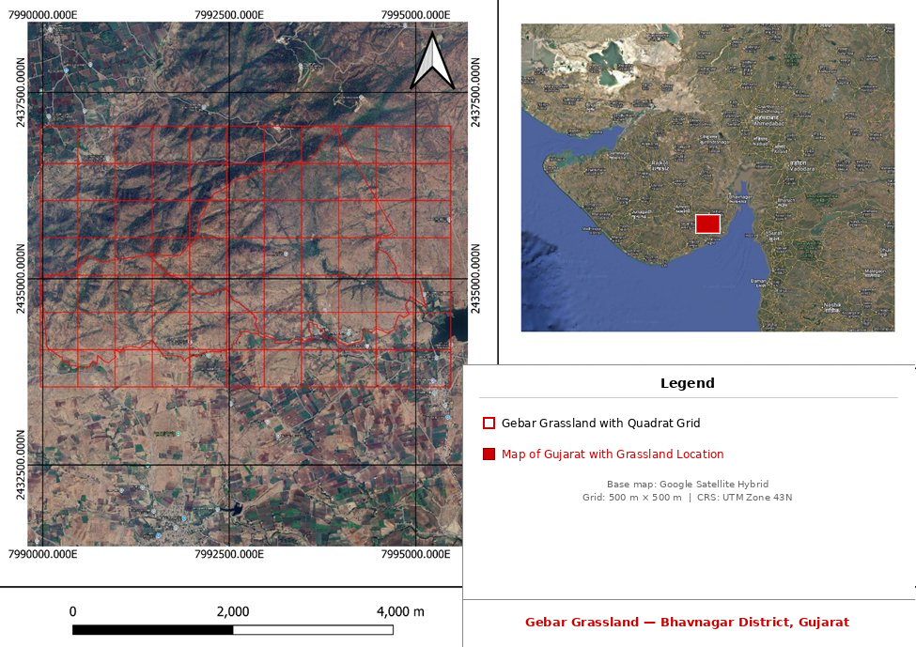

Fig. 1Study Site (Gebar Grassland, Bhavnagar District, Gujarat, India)

3.5 Alpha Diversity Indices
The following alpha diversity indices were computed: (1) Species Richness (S), (2) Shannon–Wiener H′ = −Σ(pi ln pi), (Shannon & Weaver, 1949), (3) Simpson's Index (1−D) = 1 − Σpi² (Simpson, 1949), (4) Pielou's Evenness J′ = H′/ln(S) (Pielou, 1966), and (5) Margalef's Index d = (S−1)/ln(N) (Margalef, 1958). Species accumulation curves were generated from randomised quadrat-addition sequences to evaluate sampling adequacy.

3.6 Beta Diversity
Between-season turnover was assessed using (1) Sørensen Similarity (Cs) = 2c/(a+b) (Sørensen, 1948), (2) Bray-Curtis Dissimilarity a quantitative, abundance-based measure (Bray & Curtis, 1957), and (3) Whittaker's βw = (S/α̅) − 1, where S = total species richness across samples and α̅ = mean alpha diversity per sample (Whittaker, 1960). Beta diversity was computed only for years with complete three-season coverage (2024 and 2025).

3.7 Multivariate and Statistical Analyses
Non-metric Multidimensional Scaling (NMDS) was applied to Bray-Curtis dissimilarity matrices (Clarke, 1993). Hierarchical cluster analysis used average linkage on Bray-Curtis distances. Statistical differences in Shannon H′ across seasons and years were tested using the Kruskal–Wallis test followed by pairwise Mann-Whitney U tests (Hollander & Wolfe, 1999). All analyses were conducted in Python 3.12 using Pandas, NumPy, SciPy, scikit-learn, and Matplotlib.

4. Results

4.1 Species Composition and Overall Richness
A total of 23 plant species and 971 individual plant records were documented across 175 quadrat visits (7 season-year combinations × 25 quadrats) at the Gebar semi-arid grassland. The flora was dominated by the family Poaceae (19 species), with additional contributions from Cyperaceae (Cyperus difformis L.), Rhamnaceae (Ziziphus nummularia (Burm.fil.) Wight & Arn.), Lamiaceae (Ocimum gratissimum L.), and Fabaceae (Senna tora (L.) Roxb.).
Species richness across the seven season-year combinations ranged from S = 6 (Summer 2025) to S = 13 (Winter 2023 and Monsoon 2025), with Monsoon seasons consistently recording the highest richness (Fig. 2). The directional pattern Monsoon > Winter > Summer was consistent across both fully sampled years (2024 and 2025), reflecting the strong influence of seasonal moisture availability on species recruitment and community assembly.

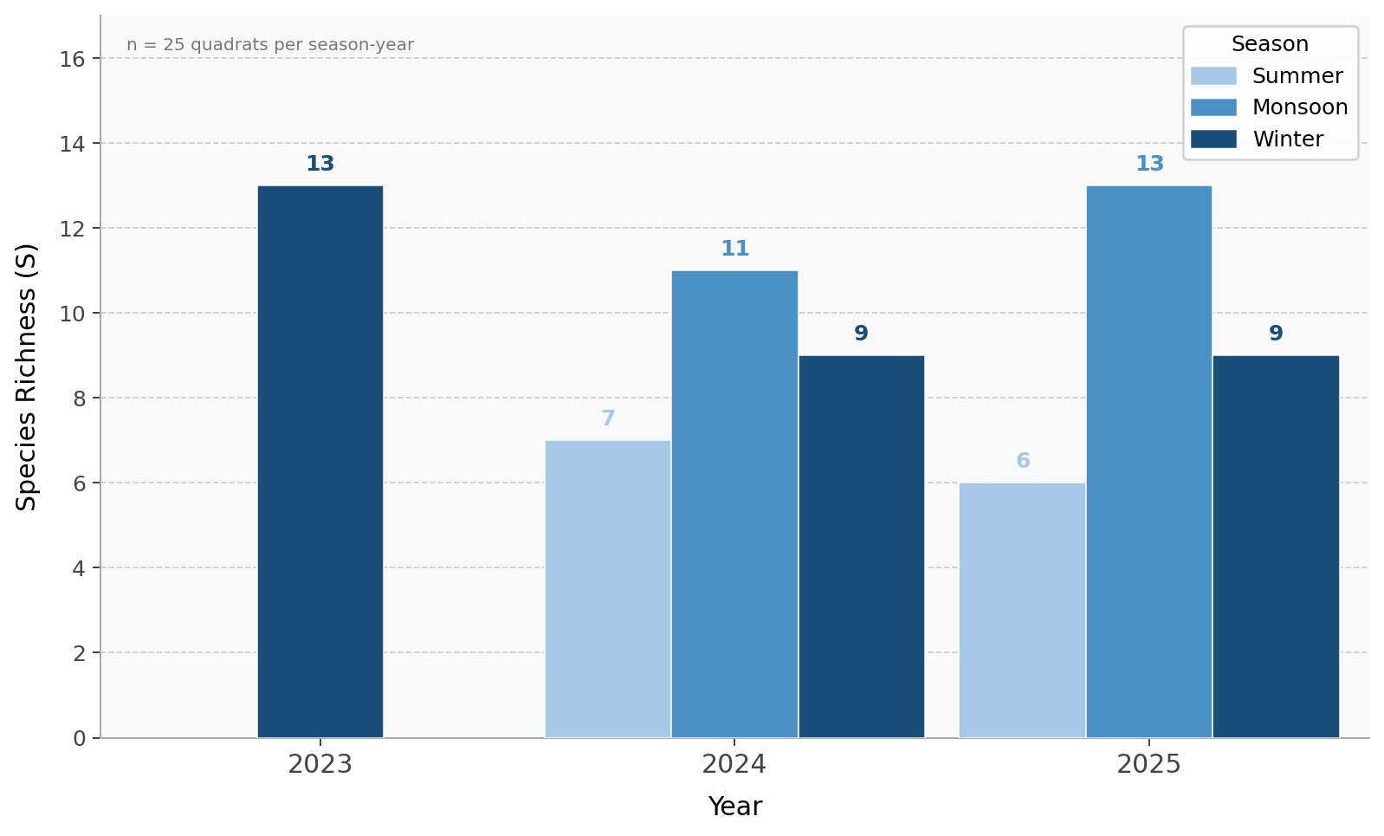
Fig. 2. Species richness across seasons and years (2023–2025) at Gebar semi-arid grassland (n = 25 quadrats per season-year). Monsoon consistently yields the highest richness.

4.2 Alpha Diversity Indices

4.2.1 Shannon–Wiener Diversity (H′)
Shannon-Wiener diversity ranged from H′ = 1.507 (Summer 2025) to H′ = 2.210 (Monsoon 2025), reflecting moderate to moderately high diversity (Fig. 3). Monsoon seasons yielded the highest H′ values across both sampled years (2024: 2.132, 2025: 2.210), followed by Winter (range: 1.877–2.150) and Summer (range: 1.507–1.813).

4.2.2 Simpson's Index (1−D) and Pielou's Evenness (J′)
Simpson's index (1−D) ranged from 0.730 (Summer 2025) to 0.861 (Monsoon 2025), indicating that no single species monopolised the community in any season or year. Pielou's evenness (J′) ranged from 0.838 to 0.932, with all values exceeding 0.83, confirming consistently high equitability in abundance distributions throughout the study period. The maintenance of high evenness despite reduced summer species richness is consistent with coexistence under shared physiological stress rather than competitive hierarchy, as described for water-limited grassland systems.

4.2.3 Margalef's Richness Index
Margalef's index (d) ranged from 0.978 (Summer 2025) to 2.450 (Winter 2023), broadly tracking patterns in species richness and confirming that Monsoon and Winter 2023 supported the highest number of species per unit of total abundance sampled.

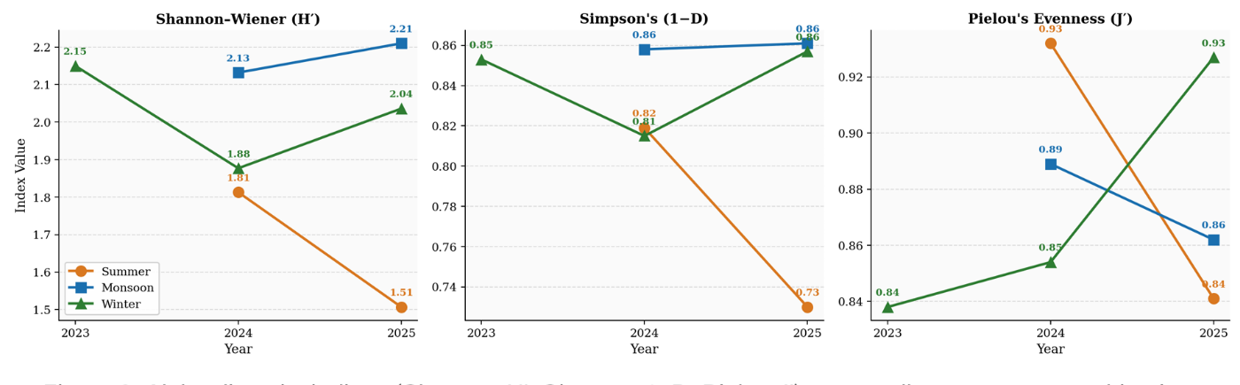
Fig. 3. Alpha diversity indices (Shannon H′, Simpson 1−D, Pielou J′) across all season-year combinations. Monsoon consistently peaks across all metrics, Summer values are lowest.

4.3 Phytosociological Parameters and Importance Value Index (IVI)

4.3.1 Overall IVI Rankings
Sehima sulcata (Hack.) A.Camus was the overwhelmingly dominant species with an overall IVI of 49.68, comprising 27.11% relative density, 10.08% relative frequency, and 12.49% relative abundance across all 175 quadrat visits (Fig. 4). This IVI was nearly double that of the second-ranked Apluda mutica L. (IVI = 27.09), establishing S. sulcata as the structural backbone of the Gebar grassland community. Heteropogon contortus (L.) P.Beauv. (IVI = 25.98) and Sorghum halepense (L.) Pers. (IVI = 23.41) co-dominated alongside A. mutica, forming a core quartet of ecologically influential grasses. The high IVI of S. halepense a globally recognised invasive alien grass warrants active conservation monitoring.
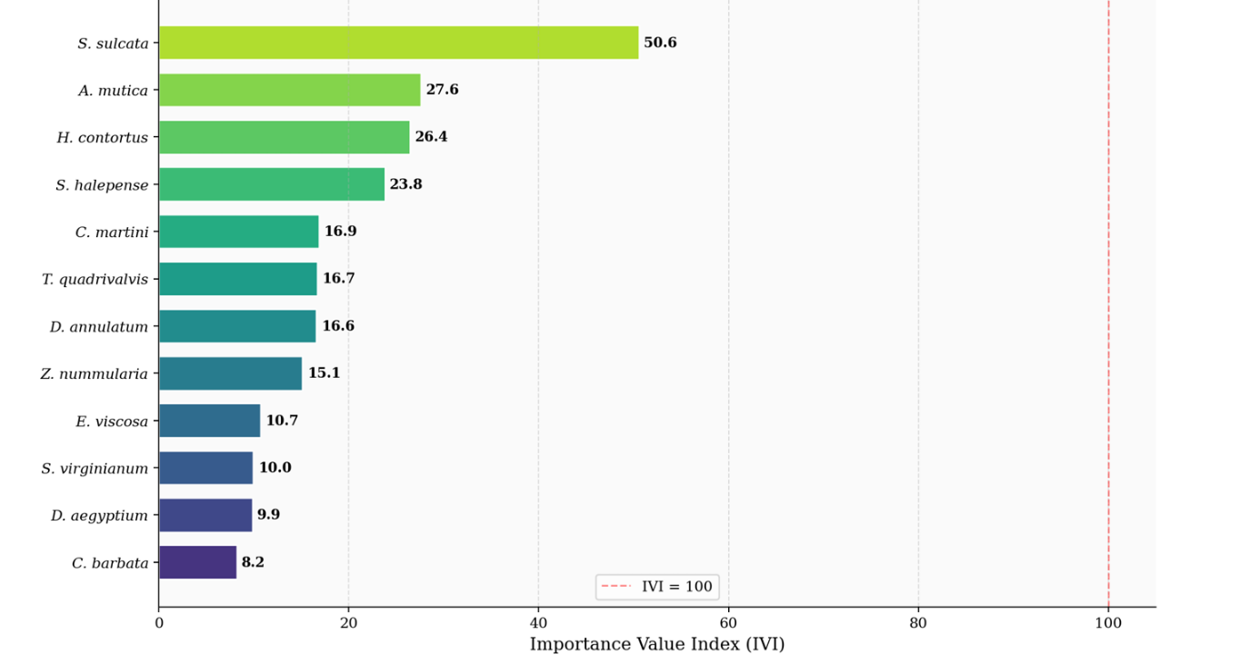
Fig. 4. Importance Value Index for the top 12 species (across all 175 quadrat visits). S. sulcata dominates at IVI = 50.59, nearly double the second-ranked species.

4.3.2 Seasonal Variation in IVI
Seasonal IVI analysis revealed pronounced shifts in species ecological importance (Fig. 5). During Summer (50 quadrat visits across 2024 and 2025), the community was co-dominated by S. sulcata, H. contortus, and Cymbopogon martini drought-tolerant perennial C4 grasses well adapted to peak thermal and moisture stress. During Monsoon (50 quadrat visits), S. sulcata retained overall dominance but was joined by annual species including Digitaria ciliaris, Chloris barbata, and Dactyloctenium aegyptium, reflecting monsoon-driven annual recruitment. During Winter (75 quadrat visits across 2023, 2024, and 2025), S. sulcata, A. mutica, and Themeda quadrivalvis dominated, reflecting post-monsoon perennial persistence as soil moisture declined.
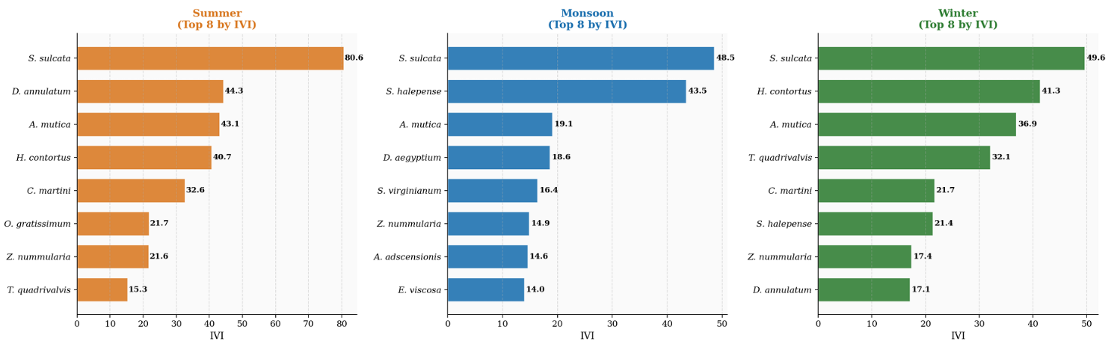
Fig. 5. IVI by season (top 8 species per season). Seasonal shifts in dominance are evident, monsoon annuals enter the community alongside perennial dominants during the rainy season.

4.4 Beta Diversity and Species Turnover

4.4.1 Whittaker's Beta Diversity (βw)
Whittaker's inter-seasonal beta diversity was computed for 2024 and 2025, the two years with complete three-season coverage. Values of βw = 0.966 (2024) and βw = 0.929 (2025) indicate very high seasonal compositional turnover within each year (Fig. 6). These high values confirm that each season samples a largely distinct subset of the regional species pool, underscoring the inadequacy of single-season surveys for accurate site-level biodiversity assessment.
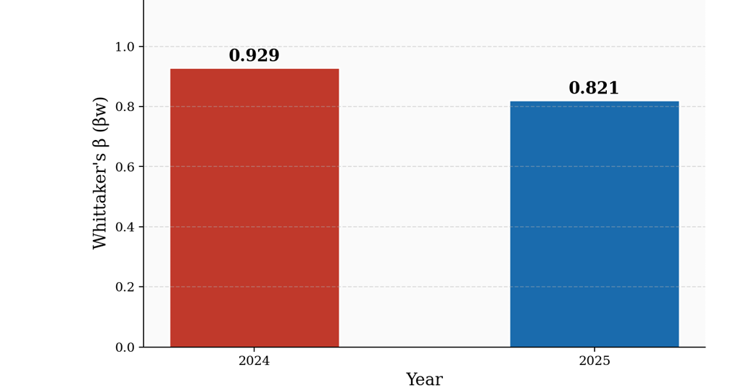
Fig. 6. Whittaker's beta diversity (βw) per fully sampled year. Both 2024 and 2025 show very high inter-seasonal turnover, confirming that each season samples a distinct species pool.

4.4.2 Sørensen Similarity and Bray-Curtis Dissimilarity
The Sørensen similarity matrix (Fig. 8) revealed that within-year Monsoon–Winter comparisons showed moderate similarity (Cs ≈ 0.50–0.65), reflecting the carry-over of perennial grasses into the post-monsoon period. Summer–Monsoon similarity was lower (Cs ≈ 0.35–0.50), confirming the recruitment of a distinct cohort of annual species during the rainy season. Cross-year, same-season comparisons yielded relatively higher similarity (e.g., Monsoon 2024 vs. Monsoon 2025: Cs ≈ 0.62), demonstrating that seasonal identity is a stronger predictor of community composition than inter-annual variation.
Bray-Curtis dissimilarity (Fig. 7) confirmed abundance-based patterns: Summer versus Monsoon groups showed the highest dissimilarity (BC ≈ 0.55–0.75), while within-season, cross-year comparisons were lower (BC ≈ 0.30–0.55), indicating that seasonal precipitation regime is the primary structuring force on community composition in this grassland.
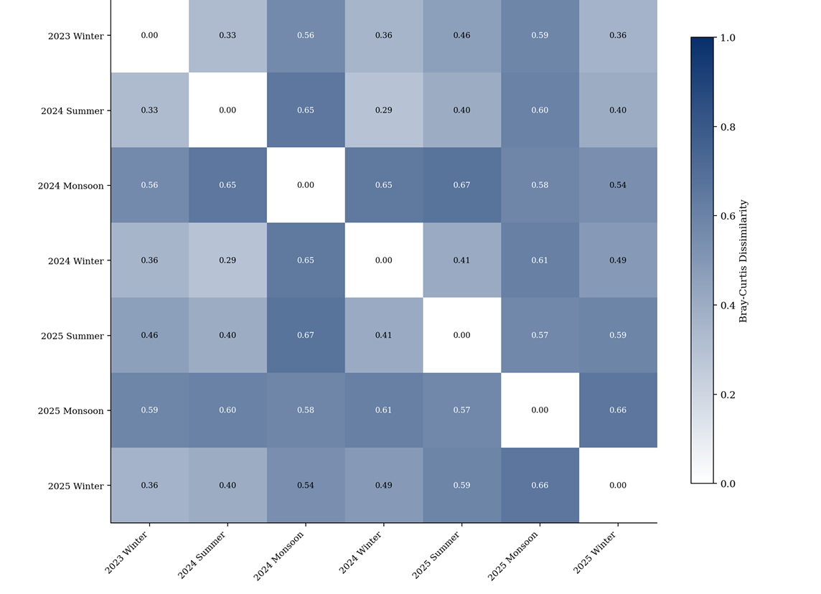
Fig. 7. Bray-Curtis dissimilarity matrix across all seven season-year groups. Darker blue indicates greater compositional dissimilarity. Summer–Monsoon contrasts are most pronounced.
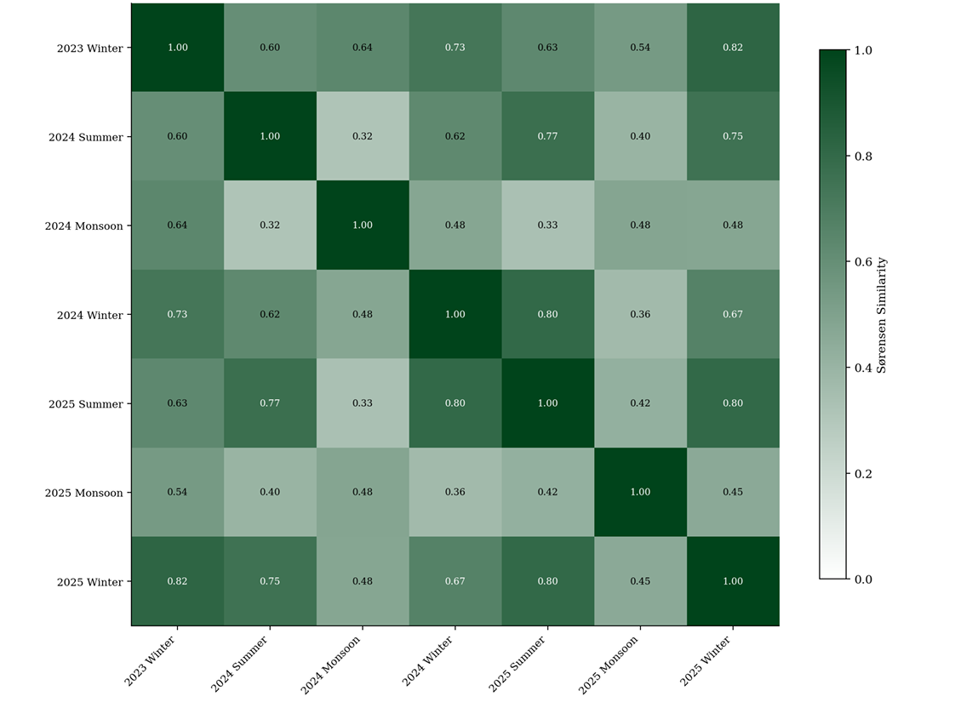
Fig. 8. Sørensen similarity matrix. Darker green indicates greater species overlap. Cross-year, same-season pairs (Monsoon 2024 vs. Monsoon 2025) show the highest similarity.

4.5 Multivariate Community Analysis

4.5.1 NMDS Ordination
NMDS applied to Bray-Curtis dissimilarities produced a two-dimensional ordination with stress = 0.1457, which falls below the commonly accepted threshold of 0.20, indicating a satisfactory representation of inter-community relationships (Clarke, 1993, Fig. 9). Monsoon season groups (2024 and 2025) clustered together in one region of ordination space, distinctly separated from summer groups. Winter communities occupied an intermediate position, consistent with their transitional seasonal character. Winter 2023 the first sampling event, with the highest recorded richness (S = 13) was positioned distinctly from subsequent Winter groups, possibly reflecting undisturbed baseline conditions or a particularly favourable preceding monsoon season. This ordination pattern mirrors findings from comparable semi-arid grassland studies, which consistently identify season as the greatest source of community compositional variance.
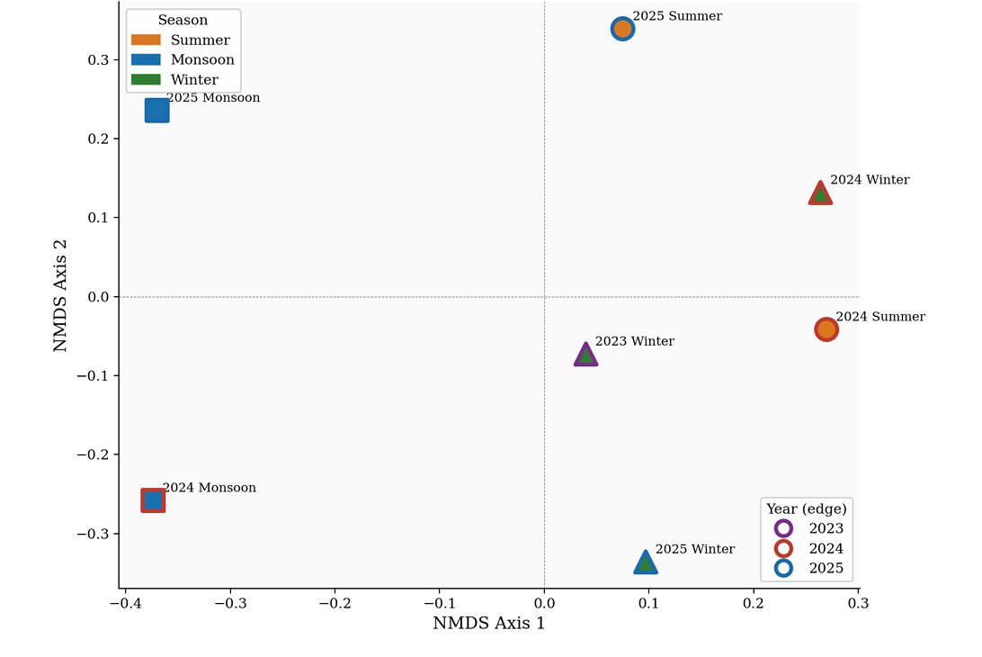
Fig. 9. NMDS ordination of all seven season-year vegetation communities (Bray-Curtis dissimilarity, stress = 0.1457). Season is the primary axis of community separation. Shape = season, edge colour = year.

4.5.2 Hierarchical Cluster Analysis
Average-linkage hierarchical clustering (Fig. 10) identified two primary clusters: one comprising Monsoon groups (2024 and 2025) and a second comprising Summer and Winter groups. Within the Summer-Winter cluster, Winter 2023 formed a distinct sub-cluster due to its elevated richness and unique compositional baseline. This dendrogram structure corroborates the NMDS pattern and confirms that Monsoon communities represent a qualitatively distinct vegetation state.
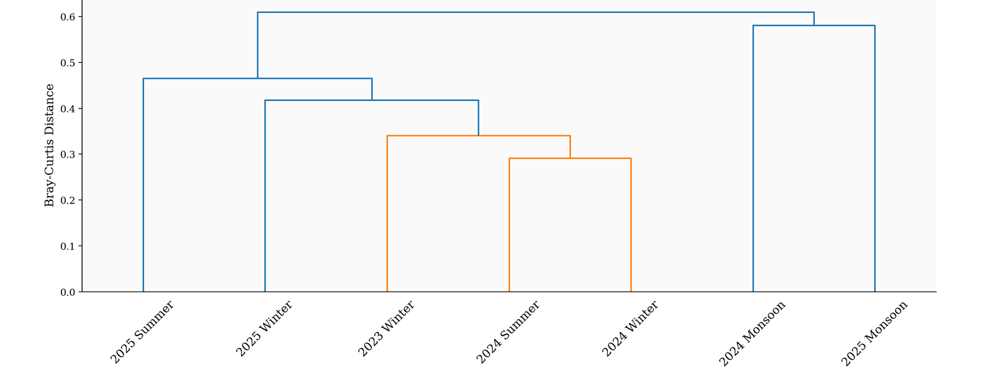
Fig. 10. Hierarchical cluster dendrogram (average linkage, Bray–Curtis). Monsoon communities cluster distinctly from Summer and Winter communities across both years.

4.6 Rank-Abundance Structure
Rank-abundance (Whittaker) plots on a logarithmic y-axis revealed consistent dominance structures across all three seasons (Fig. 11). In all seasons, curves showed a steep initial decline, indicating strong dominance by S. sulcata followed by a gradual tail of subdominant and rare species. This pattern is broadly consistent with a log-normal to geometric series distribution typical of moderately stressed plant communities. The steepest curve in Summer (50 quadrat visits from 2024 and 2025) reflects maximum competitive concentration by perennial grasses under peak thermal and moisture stress. The Monsoon curve (50 quadrat visits) was shallowest in its initial ranks, indicating more equitable representation as annual species recruited into available niches.
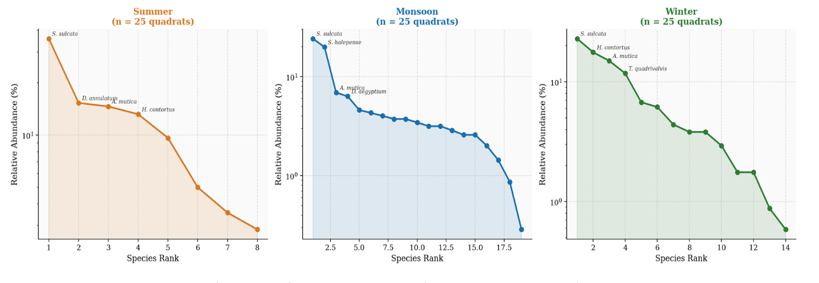
Fig. 11. Rank-abundance (Whittaker) plots by season (pooled across years). Summer shows the steepest decline, Monsoon the most equitable initial ranks.

4.7 Species Accumulation and Sampling Adequacy
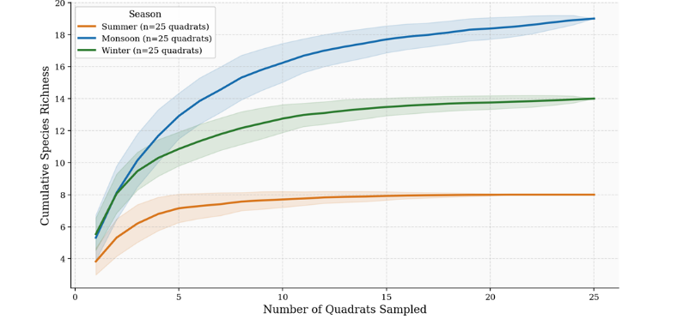
Fig. 12. Species accumulation curves by season (pooled across all quadrats of that season, mean ± SD). Asymptotes confirm sampling adequacy, wider Monsoon bands reflect greater spatial heterogeneity.
Species accumulation curves (Fig. 12), made from quadrat-addition sequences per season, demonstrated that curves for Monsoon and Winter approached asymptotes by the 18th–20th quadrat, while the Summer curve reached its plateau by approximately the 12th quadrat consistent with its lower species richness. These results confirm that 25 quadrats per season-year event was sufficient for capturing the species pool with high completeness. The wider ±SD bands observed for Monsoon curves indicate greater spatial heterogeneity in species co-occurrence during the rainy season, which is expected given patchy annual germination responses to localised soil moisture variation.

4.8 Temporal Composition Patterns
The stacked bar chart (Fig. 13) across all seven season-year groups confirmed the persistence of S. sulcata as the numerical backbone throughout the study. Three ecologically distinct guild patterns were evident: (1) ubiquitous perennials S. sulcata, H. contortus, and A. mutica present with non-zero abundance in all seven season-year groups, (2) monsoon-associated annuals Digitaria ciliaris, Dactyloctenium aegyptium, Melanocenchris jacquemontii, and Chloris barbata restricted to or most abundant in Monsoon groups, and (3) winter-persistent species Themeda quadrivalvis and Dichanthium annulatum peaking during Winter groups. The abundance heatmap (Fig. 14) clearly reveals these three guilds and the stochastic appearance of Solanum virginianum L. exclusively in Monsoon 2025, suggesting opportunistic germination linked to inter-annual rainfall variation.
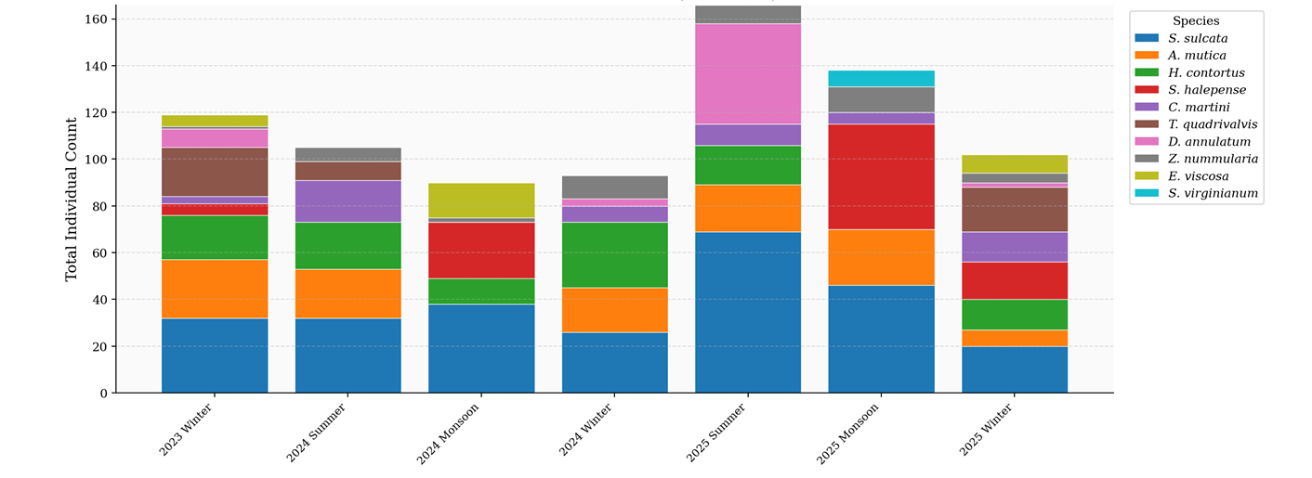
Fig. 13. Stacked abundance of top 10 IVI species across all seven season-year groups. S. sulcata dominates numerically throughout.
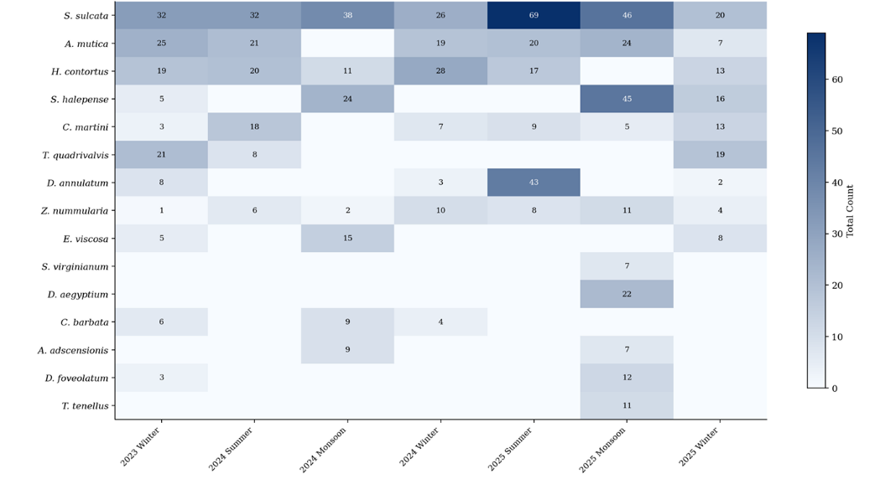
Fig. 14. Abundance heatmap for top 15 IVI species across all season-year groups. White = absent, darker blue = higher total count. Three ecological guilds are clearly visible.

4.9 Statistical Tests for Temporal Differences in Diversity
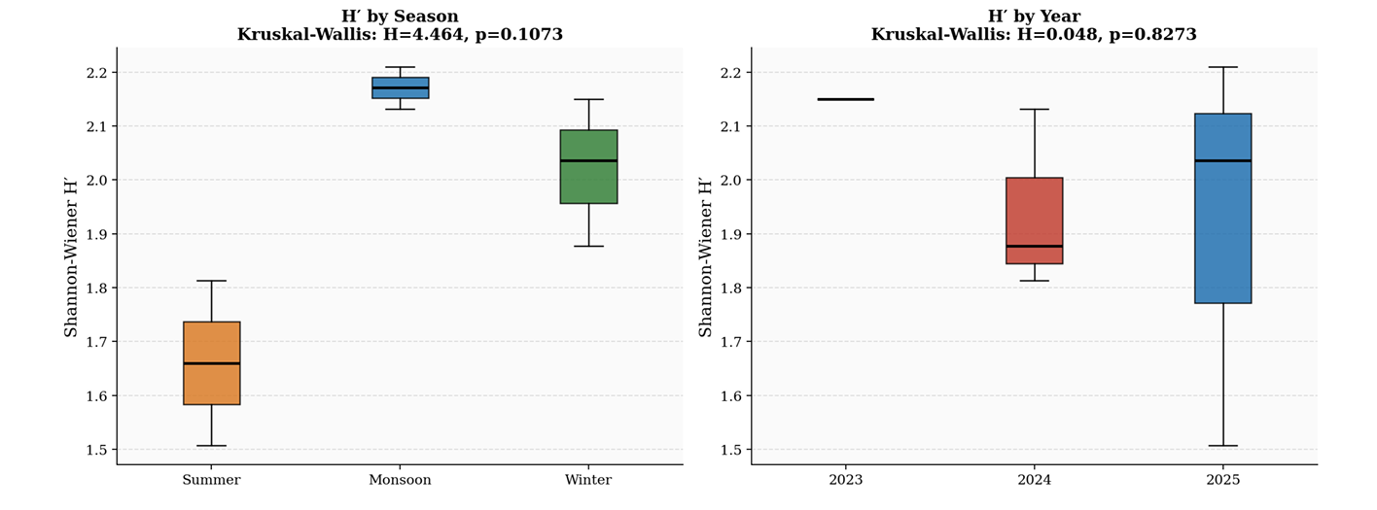
Fig. 15. Box plots of Shannon H′ by season (left) and year (right). The consistent directional pattern Monsoon > Winter > Summer is evident across all groups despite non-significant test results attributable to limited replication.

Although the Kruskal-Wallis and pairwise Mann-Whitney U tests did not detect statistically significant differences in Shannon diversity (H′) among seasons or years at α = 0.05, the consistently observed directional pattern (Monsoon > Winter > Summer) across all five diversity metrics (species richness, Shannon diversity, Simpson diversity, evenness, and Margalef richness) indicates a clear ecologically meaningful seasonal response. This pattern strongly supports the moisture-diversity hypothesis, where increased monsoonal soil moisture enhances germination, establishment, and coexistence of herbaceous species in semi-arid grasslands. The lack of statistical significance is most likely a consequence of the limited number of replicates per group, which reduced analytical power rather than the absence of a true ecological effect. Therefore, the observed consistency across multiple diversity indices provides robust ecological evidence that monsoon conditions positively influence community diversity and reinforce the resilience and functional stability of the grassland ecosystem.

5. Discussion

The Gebar grassland supported 23 plant species and 971 individual records across 175 quadrat visits, broadly comparable to inventories from Indian semi-arid grasslands where similar quadrat methods have yielded 18–31 species (Sharma et al., 2009; Reddy et al., 2008). A consistent seasonal gradient of Monsoon > Winter > Summer across all alpha diversity metrics provides robust support for the moisture-diversity hypothesis, which posits that precipitation-driven productivity determines the species pool available for coexistence in water-limited systems (Sala et al., 1988; Knapp et al., 2002). Shannon diversity values (H′ = 1.507–2.210) align with ranges reported from comparable Indian grasslands (Upadhyay et al., 2002; Misra et al., 2004), while persistently high evenness (J′ > 0.83) indicates that environmental stress suppresses competitive dominance and sustains multi-species coexistence even under low summer diversity (Grime, 1979; Chesson, 2000).

The defining ecological feature of the site is the near-total dominance of Sehima sulcata (IVI = 50.59) across all seven season-year groups, consistent with its role as a dominant stabiliser on shallow rocky Saurashtra soils (Walker et al., 1999). Of greater conservation concern is Sorghum halepense, which ranked fourth overall (IVI = 23.81) and maintained high importance values across multiple seasons and years, indicative of a well-established, likely spreading invasion. Given its capacity to form dense monocultures through rhizome propagation, suppress native diversity through allelopathy, and alter nutrient dynamics (Vitousek et al., 1996; Rejmanek & Richardson, 1996), targeted mechanical removal during the pre-monsoon season is strongly recommended.

Inter-seasonal beta diversity values (βw = 0.929–0.966) confirm that each season represents a compositionally distinct vegetation state, with any single-season survey capturing only ~50–52% of total site biodiversity. This has direct implications for survey design: Monsoon contributed species entirely absent from Summer, while Winter contributed species not reliably detected in Monsoon, demonstrating that a minimum of two seasonal surveys covering at least Monsoon and one dry season is necessary for a defensible site-level species inventory (Baselga, 2010). The log-normal to geometric rank-abundance distributions across seasons further reflect a community where a few pre-adapted perennial dominants control disproportionate resources, while subdominants and rare species coexist through temporal niche partitioning and the storage effect annuals persisting through the seed bank during Summer and exploiting the Monsoon pulse for reproduction (Chesson, 2000; Bhatt et al., 2013).

NMDS ordination (stress = 0.1457) and hierarchical cluster analysis jointly confirm season as the primary axis of compositional variation, with year accounting for secondary within-season differences attributable to inter-annual rainfall variability (Sala et al., 1988; Chaturvedi et al., 2011). The distinct ordination position of Winter 2023 underscores the value of multi-year baselines in detecting directional compositional change that a single-year study would miss (Tilman, 1996).

6. Conclusion

This three-year, multi-season phytosociological study of the Gebar semi-arid grassland, based on 175 quadrat visits across seven season-year combinations, provides the first systematic, temporally resolved vegetation assessment of this ecologically significant site. The grassland supports 23 herbaceous plant species with 971 individuals recorded, exhibiting moderate to moderately high diversity (H′ = 1.507–2.210) and consistently high species evenness throughout all sampling periods. Monsoon season persistently yielded the highest alpha diversity across all metrics, Summer the lowest, and Winter intermediate, a gradient that remained stable across both fully sampled years, confirming precipitation-driven recruitment as the primary driver of community assembly. Sehima sulcata (IVI = 50.59) functioned as the year-round structural backbone of the community, while the invasive Sorghum halepense (IVI = 23.81) represents an active ecological threat requiring targeted pre-monsoon management intervention. High inter-seasonal beta diversity (βw = 0.929–0.966), NMDS ordination, and hierarchical clustering jointly confirm that each season samples a largely distinct species pool, with season as the dominant axis of compositional variation and inter-annual rainfall variability playing a secondary modifying role. Species across the site were further assignable to three functional guilds: ubiquitous perennial dominants, monsoon-associated annuals, and winter-persistent species, a tripartite structure characteristic of semi-arid tropical grasslands governed by strong seasonal moisture gradients.

The 175-quadrat dataset of 23 species and 971 individual records constitute a robust quantitative baseline for future conservation planning and disturbance impact assessment at this site. Extending this monitoring programme to five or more years with complete three-season coverage and increased grid replication (8-10 grids per season) would substantially improve statistical power and enable detection of directional compositional trends attributable to land-use change or climate variability. More broadly, this study reinforces the imperative for multi-season survey designs in biodiversity assessments of seasonally variable semi-arid ecosystems, and contributes meaningfully to the growing body of temporally resolved grassland phytosociology from semi-arid western India.

REFERENCES
Baselga, A. (2010). Partitioning the turnover and nestedness components of beta diversity. Global Ecology and Biogeography, 19(1), 134–143. https://doi.org/10.1111/j.1466-8238.2009.00490.x
Bhatt, D., Joshi, K. K., & Bhatt, A. B. (2013). Species diversity and community structure in subtropical dry deciduous forest of western India. Tropical Ecology, 54(2), 235–244.
Blatter, E., & McCann, C. (1935). Bombay grasses. Imperial Council of Agricultural Research.
Bray, J. R., & Curtis, J. T. (1957). An ordination of the upland forest communities of southern Wisconsin. Ecological Monographs, 27(4), 325–349. https://doi.org/10.2307/1942268
Chapin, F. S., III, Zavaleta, E. S., Eviner, V. T., Naylor, R. L., Vitousek, P. M., Reynolds, H. L., Hooper, D. U., Lavorel, S., Sala, O. E., Hobbie, S. E., Mack, M. C., & Díaz, S. (2000). Consequences of changing biodiversity. Nature, 405(6783), 234–242. https://doi.org/10.1038/35012241
Chaturvedi, R. K., Raghubanshi, A. S., Toky, O. P., & Singh, J. S. (2011). Assessment of woody species composition in tropical dry forests of India. Journal of Arid Environments, 75(8), 715–723.
Chesson, P. (2000). Mechanisms of maintenance of species diversity. Annual Review of Ecology and Systematics, 31, 343–366. https://doi.org/10.1146/annurev.ecolsys.31.1.343
Chesson, P., Gebauer, R. L. E., Schwinning, S., Huntly, N., Wiegand, K., Ernest, M. S. K., Sher, A., Novoplansky, A., & Weltzin, J. F. (2004). Resource pulses, species interactions, and diversity maintenance in arid and semi-arid environments. Oecologia, 141(2), 236–253. https://doi.org/10.1007/s00442-004-1551-1
Clarke, K. R. (1993). Non-parametric multivariate analyses of changes in community structure. Australian Journal of Ecology, 18(1), 117–143. https://doi.org/10.1111/j.1442-9993.1993.tb00438.x
Craine, J. M., Ocheltree, T. W., Nippert, J. B., Towne, E. G., Skibbe, A. M., Kembel, S. W., & Fargione, J. E. (2012). Global diversity of drought tolerance and grassland climate-change resilience. Nature Climate Change, 3(1), 63–67. https://doi.org/10.1038/nclimate1634
Curtis, J. T., & McIntosh, R. P. (1950). The interrelations of certain analytic and synthetic phytosociological characters. Ecology, 31(3), 434–455. https://doi.org/10.2307/1931497
Davidowitz, G. (2002). Does precipitation variability increase from tropical to extratropical latitudes? Global Ecology and Biogeography, 11(2), 143–154. https://doi.org/10.1046/j.1466-822X.2002.00271.x
Grime, J. P. (1979). Plant strategies and vegetation processes. Wiley.
Hollander, M., & Wolfe, D. A. (1999). Nonparametric statistical methods (2nd ed.). Wiley.
Hurlbert, S. H. (1984). Pseudoreplication and the design of ecological field experiments. Ecological Monographs, 54(2), 187–211. https://doi.org/10.2307/1942661
Kent, M., & Coker, P. (1992). Vegetation description and analysis: A practical approach. Wiley-Blackwell.
Knapp, A. K., Fay, P. A., Blair, J. M., Collins, S. L., Smith, M. D., Carlisle, J. D., Harper, C. W., Danner, B. T., Lett, M. S., & McCarron, J. K. (2002). Rainfall variability, carbon cycling, and plant species diversity in a mesic grassland. Science, 298(5601), 2202–2205. https://doi.org/10.1126/science.1076347
Margalef, R. (1958). Information theory in ecology. General Systems, 3, 36–71.
May, R. M. (1975). Patterns of species abundance and diversity. In M. L. Cody & J. M. Diamond (Eds.), Ecology and evolution of communities (pp. 81–120). Harvard University Press.
Misra, R. (1968). Ecology workbook. Oxford and IBH Publishing.
Misra, M. K., Dash, S. S., Murthy, M. S. R., & Roy, P. S. (2004). Plant diversity of Central Indian highlands. Current Science, 86(9), 1247–1256.
Müller-Dombois, D., & Ellenberg, H. (1974). Aims and methods of vegetation ecology. Wiley.
Patel, R. I. (1971). Forest flora of Gujarat State. Gujarat Forest Department.
Pielou, E. C. (1966). The measurement of diversity in different types of biological collections. Journal of Theoretical Biology, 13, 131–144. https://doi.org/10.1016/0022-5193(66)90013-0
Plants of the World Online (POWO). (2023). Plants of the World Online. Royal Botanic Gardens, Kew. http://www.plantsoftheworldonline.org/
QGIS Development Team. (2023). QGIS geographic information system (version 3.x). Open Source Geospatial Foundation. https://qgis.org
Rawat, G. S., & Bhatt, D. (2012). Grasslands of India: Status and distribution. In G. S. Rawat & V. Uniyal (Eds.), Grasslands of India (pp. 1–26). Wildlife Institute of India.
Reddy, C. S., Babar, S., Giriraj, A., Reddy, K. N., & Rao, T. V. (2008). Structure and floristic composition of tree diversity in tropical dry deciduous forests of Eastern Ghats. Asian Journal of Scientific Research, 1(1), 57–64.
Rejmanek, M., & Richardson, D. M. (1996). What attributes make some plant species more invasive? Ecology, 77(6), 1655–1661. https://doi.org/10.2307/2265768
Rodgers, W. A., Panwar, H. S., & Mathur, V. B. (2002). Wildlife protected area network in India: A review. Wildlife Institute of India.
Sala, O. E., Parton, W. J., Joyce, L. A., & Lauenroth, W. K. (1988). Primary production of the central grassland region of the United States. Ecology, 69(1), 40–45. https://doi.org/10.2307/1943158
Shannon, C. E., & Weaver, W. (1949). The mathematical theory of communication. University of Illinois Press.
Sharma, L. K., Kumar, S., Sharma, S., & Bhardwaj, M. (2009). Vegetation analysis and phytosociology of semi-arid grasslands of Rajasthan, India. Journal of the Bombay Natural History Society, 106(2), 172–181.
Simpson, E. H. (1949). Measurement of diversity. Nature, 163(4148), 688. https://doi.org/10.1038/163688a0
Singh, J. S., & Joshi, M. C. (1979). Ecology of the semi-arid regions of India with emphasis on land-use. In B. H. Walker (Ed.), Management of semi-arid ecosystems (pp. 243–275). Elsevier.
Sørensen, T. (1948). A method of establishing groups of equal amplitude in plant sociology based on similarity of species content. Kongelige Danske Videnskabernes Selskab, 5(4), 1–34.
Tilman, D. (1996). Biodiversity: Population versus ecosystem stability. Ecology, 77(2), 350–363. https://doi.org/10.2307/2265614
Upadhyay, V. P., Mohanty, R. C., & Mishra, A. K. (2002). Ecology of tropical grasslands of Orissa, India. Tropical Ecology, 43(1), 39–51.
Vanak, A. T., Thaker, M., & Beyer, H. L. (2017). Do grasslands offer more than just fodder? In R. Jhala, Q. Qureshi, & A. Nayak (Eds.), Status of tigers, copredators and prey in India. National Tiger Conservation Authority.
Vitousek, P. M., D'Antonio, C. M., Loope, L. L., & Westbrooks, R. (1996). Biological invasions as global environmental change. American Scientist, 84(5), 468–478.
Walker, B., Kinzig, A., & Langridge, J. (1999). Plant attribute diversity, resilience, and ecosystem function. Ecosystems, 2(2), 95–113. https://doi.org/10.1007/s100219900062
White, R. P., Murray, S., & Rohweder, M. (2000). Pilot analysis of global ecosystems: Grassland ecosystems. World Resources Institute.
Whittaker, R. H. (1960). Vegetation of the Siskiyou Mountains. Ecological Monographs, 30(3), 279–338. https://doi.org/10.2307/1943563
Whittaker, R. H. (1965). Dominance and diversity in land plant communities. Science, 147(3655), 250–260. https://doi.org/10.1126/science.147.3655.250
Yadav, R. P., & Singh, R. (2016). Plant species diversity and phytosociology of a dry tropical forest in Vindhyan highlands. Tropical Ecology, 57(2), 195–207.

