Discovering the Capacity of Bacillus infantis, Atlantibacter hermannii and Stutzerimonas stutzeri in Synergistic Consortium for Enhanced Degradation of Phthalic Acid Esters

.
ABSTRACT

Phthalic Acid Esters (PAEs) are persistent pollutant and endocrine disruptors used as plasticizers. Due to excessive use of plastic, these phthalates are polluting environment as they are leached out from the plastic matrix. This study reports rapid, 24 h degradation of two derivatives of phthalates, Dibutyl Phthalate (DBP) and Benzyl Butyl Phthalate (BBP) by a novel four-member bacterial consortium, JPN. Current literature typically identifies strains with narrow substrate specificity which is limited to either low molecular weight (LMW) or high molecular weight (HMW) derivatives. Consortium JPN has exceptional capacity for degrading both structural analogues with 99% efficiency. A significant taxonomic discovery of the work is reporting of Bacillus infantis, Atlantibacter hermannii, and Stutzerimonas stutzeri as active participants in phthalate biodegradation. Organisms were isolated from plastic polluted samples. Process parameters were optimized by OFAT method and statistical validation was obtained by Box-Behnken Design (BBD). 99% degradation was obtained with pH- 8.0, 25 °C temperature in 24 h incubation time with 10% v/v inoculum size and statistical analysis confirms the model to be significant. Degradation analysis with High Performance Liquid Chromatography (HPLC) and Fourier Transform Infrared Spectroscopy (FTIR) confirmed the breakdown of these compounds. These findings contribute the field of bioremediation by exploring novel strain’s capability to overcome the structural resistance of diverse phthalates in waste

Keywords: dibutyl phthalate, benzyl butyl phthalate, endocrine disruptors, biodegradation

1. INTRODUCTION

Emerging use of plastic in everyday life has massively contributed in polluting the environment. Plastic is extensively used in manufacturing various commodities like toys, products packaging, cable coatings, automobile parts as well as in many industries such as pharmaceuticals, cosmetics, textiles, etc. Use of plastic has increased greatly because it is flexible, durable, inert, cost effective, easy to produce and has multipurpose use (Proshad et al. 2018). India produces >12 x 10⁹ tons of plastic every year out of which > 6 tons is wasted which is projected to reach 20 x 10⁹ tons per annum (Ramzi et al. 2020). Plasticizers are precursors of plastic. They percolate out of the plastic products and cause harm to environment and living organisms. Many compounds are used as plasticizer which majorly includes Phthalic Acid Esters (PAEs), flame retardants and Bisphenol A. In 2017, 16 billion pounds of plasticizers were used which costed 15 billion USD to global economy and is estimated to reach 24 billion US (Xiong and Pei 2021)(Sheikh and Beg 2019). Out of total plasticizers used around the world; 65 % of it consists of phthalates (Xiong and Pei 2021) because it provides flexibility, stability, and durability to the plastic (Hu et al. 2020). PAEs are phthalic acid derivatives synthesized by Fischer esterification of phthalic anhydride and specific alcohols (Huang et al. 2021). Phthalates are colourless liquid poorly soluble in water but are soluble in organic solvents and oils, it has low volatility and high boiling point (Gani, Tyagi, and Kazmi 2017). PAEs are easily leached out in the surrounding environment because they are not chemically bounded to the polymer matrix (Hu et al. 2020) therefore, are found in water, soil, dust, and air. Since the first production of phthalate in 1920s, they are extensively used to manufacture various goods and as there is no alternate option available till date; the demand is predicted to be high in near future (Hu et al. 2021)(Gao et al. 2017). Global PAE’s production is estimated to be 300 million tons currently and is predicted to reach 500 million tons by 2050 (Huang et al. 2021). Considering the toxicity and use of PAEs; United States Environmental Protection Agency (USEPA), European Union (EU) and Chinese National Environmental Monitoring Center (CNEMC) listed 6 PAEs i.e., dimethyl phthalate, diethyl phthalate, di-(2-ethyl hexyl) phthalate, di-n-butyl phthalate, di-n-octyl phthalate, and benzyl butyl phthalate as priority pollutants (Long et al. 2024). Like every xenobiotic compound; phthalates also majorly contribute in polluting environment and disturbing ecosystems. Fig. (1) depicts the toxic effect of phthalates.
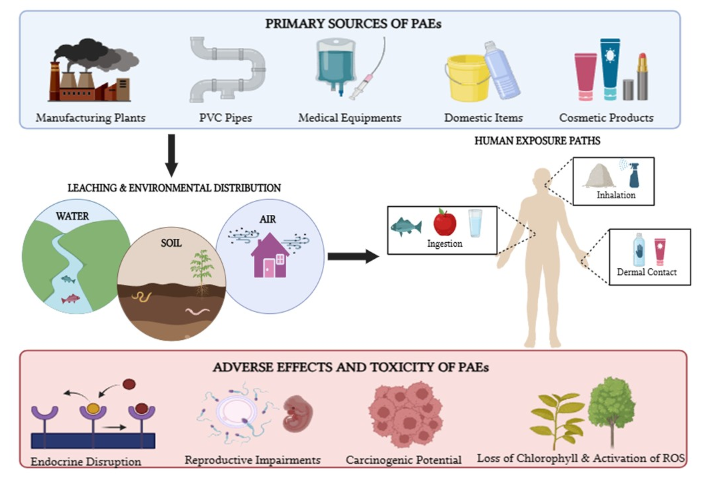
Fig. 1 Occurrence and toxicity of Phthalates. Created in https://BioRender.com
Based on the side chain attached to phthalic acid, PAEs can be divided into two groups; low molecular weight (LMW) and high molecular weight (HMW) phthalates. Toxicity of PAE derivatives depends upon the side chain attached. LMW derivatives (DMP, DEP, DBP, etc.) are less toxic than HMW (DEHP, DOP, BBP, etc.) (Xiong and Pei 2021). They enter the soil through wastewater irrigation, agricultural plastic films, municipal biosolids, etc. (He et al. 2015). Phthalates from soil enters ground water and are accumulated in plants by absorption, these plants and water; when consumed led to toxic effects in living organisms. Various derivatives of PAEs causes misfunctioning of reproductive system in fish, developmental imperfections in frog and zebra fish, and (Luo et al. 2021). It can enter human body through ingestion, dermal contact, inhalation from food packets, cosmetics, cloths, shoes and household goods. Human urine, hair, blood, milk, amniotic fluid etc. were detected with derivatives of PAEs (He et al. 2015). Phthalates are major disrupter of hormones; they make reproductive and developmental issues by mimicking estrogen and androgen hormones. It adversely affects humans across all stages of life, including prenatal, neonatal, infancy, childhood, adolescence, and adulthood, leading to reduced semen quality in males, infertility, and breast cancer (Xiong and Pei 2021). By disturbing hormones it holds back the pubertal development in boys and speed up the process of pubertal onset in girls (Xie et al. 2015)(Shi et al. 2015). Phthalates also promotes carcinogenesis, teratogenesis, and organ toxicity, etc. (Sheikh and Beg 2019). This research focuses on microbial degradation of two among various derivatives of PAEs: Dibutyl Phthalate (DBP) and Benzyl Butyl Phthalate (BBP) by using novel consortium JPN. The reports explore the capability of Bacillus infantis, Atlantibacter hermannii and Stutzerimonas stutzeri for degradation of phthalates. It is observed that strains have narrow substrate specificity which is limited to either LMW or HMW derivatives of phthalates and can degrade either of it efficiently. While, consortium JPN shows significant degradation efficiency towards both the phthalates in similar time.

2. material and methods

2.1 Media and Chemicals
Dibutyl Phthalate (DBP) (98%) Benzyl Butyl Phthalate (BBP) (98%) were purchased from HiMedia Laboratories Pvt. Ltd. (Mumbai, India). Tween 80 was purchased from Sisco Research Laboratories Pvt. Ltd. (Mumbai, India). All other media, reagents and chemicals were of analytical grade.

2.2 Screening and Isolation
Plastic polluted samples were collected from local dumping yard (Lat. 23.0991788, Long. 70.0492221) of Kachchh, Gujarat, India. Screening of PAEs degrading organisms was carried out with Mineral Salt Medium (MSM) containing (g/L) MgSO₄⸳7H₂O 0.40, KH₂PO₄ 1.0, NH₄NO₃ 1.0, CaCl₂ 0.02, Na₂HPO₄⸳12H₂O 6.0, FeCl₃⸳6H₂O 0.08 was prepared according to (Nandi et al. 2021) with slight modifications. Tween 80 was added to the medium to increase the solubility of PAEs (Xu et al. 2017). For screening; 10 g of soil and 10 mL of water sample was added in 100 mL MSM containing 100 mg/L DBP and BBP individually. Flasks were incubated in shaking condition at 25˚C for 5 days. Culture was transferred into the fresh medium at regular time intervals for 3 months and maintained at 4˚C. Degradation was confirmed by HPLC analysis.
2.3 Identification of Potent Cultures
Identification of potent bacterial cultures was done by 16S rRNA gene sequencing. DNA quality was checked by 1% Agarose gel electrophoresis. 16S rRNA gene fragments were amplified by PCR and purified by column purification. This PCR amplicon was subjected to DNA Sequencing by 27F & 1391R primers using BDT v3.1 Cycle Sequencing Kit on ABI 3500xl Genetic Analyzer. This sequence was used to carry out BLAST analysis with NCBI GenBank database.
2.4 Optimization and Statistical Study
Effect of environmental parameters was checked on the degradation; DBP and BBP were employed as sole source of carbon for every parameter. These parameters included pH (3.0 to 11.0 with increment of 2.0 each), temperature (15 to 40˚C with the increment of 5˚C), inoculum size (2 to 14 % v/v with 2% v/v increase) and PAEs’s concentration (100 to 500 mg/L with the increase of 100 mg/L). For control; uncultured MSM with 100 mg/L DBP and BBP individually was used. Preliminary optimization study was carried out by one factor at time (OFAT) method. To validate these data, statistical analysis was accomplished by Response Surface Methodology employed with Box-Behnken design (BBD). Statistical tool used was Design Expert version 13.0 (Stat-Ease, Inc.). Three variables were chosen for statistical analysis- pH, temperature and inoculum size. Range of parameters considered for the study are mentioned in Table 1.
Table 1 Range of Parameters
Factors | Range | Minimum (-1) | Optimum (0) | Maximum (+1)
pH | 3.0,5.0,7.0,8.0,9.0,11.0 | 7.0 | 8.0 | 9.0
Temperature (˚C) | 15,20,25,30,35,40 | 20 | 25 | 30
Inoculum size (% v/v) | 2,4,6,8,10,12,14 | 8 | 10 | 12

2.5 Degradation Study
Degradation was analyzed by HPLC (Perkin Elmer series 200 pump and UV-vis detector). HPLC system, including wavelength, flow rate and mobile phase concentration was controlled by Total Chrome Navigator software. Separation was performed on C18 column (250 × 4.6 mm) and sample injection loop size of 10 µL was employed. Mobile phase contained methanol and water’s linear gradient in the ratio 90:10. Flow rate was set to 0.5 mL/min. Column effluents were detected at 228 nm by UV-Vis detector. Degradation amount was calculated by formula given below (1). Degradation was further studied by FTIR (scan from 4000 to 400 cm⁻¹) analysis for prediction of pathway for the degradation.
Degradation (%) = (Ci-Cf/Ci) × 100 ……………………………………………………………………………………………..Eq. (1)
Where Ci and Cf are initial and final concentration of PAE respectively.
3. results and discussion

3.1 Sub Screening, Isolation and Identification
Organisms were enriched from plastic-contaminated dumping sites with the objective of isolating strains that were environmentally adapted for degradation of phthalates. A robust four membered consortium, designated as JPN was screened. In which, two out of four strains were gram positive and two gram negative. Identification by 16S rRNA sequencing showed these four strains to be Bacillus infantis JP_1 (NCBI Accession no. PX459930), Atlantibacter hermannii JP_2 (NCBI Accession no. PX459933), Bacillus subtilis JP_3 (NCBI Accession no. PX459936) and Stutzerimonas stutzeri JP_4 (NCBI Accession no. PX459937). Bacillus subtilis has been previously reported for phthalate degradation (Xu et al. 2020). Phylogenetic tree has been given in fig. S1. This represents the first report documenting the involvement of Bacillus infantis, Atlantibacter hermannii, and Stutzerimonas stutzeri in the biodegradation of phthalic acid ester derivatives. The identification of these previously unreported bacterial species highlights the potential novelty of the present study. It also suggests the existence of species which are still unexplored for phthalate biodegradation.

3.2 Optimization and Statistical Study

It is important to check the effect of environmental parameters. The capability of consortium JPN to degrade DBP and BBP was examined over a wide range of pH (3.0 – 11.0). The effect of pH on degradation of DBP and BBP by consortium JPN is shown in Fig. 2 (A). With the increase in pH from 3.0 to 9.0; the percentage of degradation increased from 11.21 % to 98.57 % and 22.54 % to 95.84 % for DBP and BBP respectively exhibiting pH 8.0 as optimum. Alkalinity was favored by consortium over acidity. These results are in association with (Xu et al. 2020) (He et al. 2013). Hydrogen ion concentration plays a significant role in bacterial growth by limiting its enzyme activity, hence, lower pH decreases PAEs’s degradation (Fang et al. 2010). Esterase enzyme which breaks the ester bonding in both the compounds also works efficiently at alkaline pH than acidic (Jensen et al. 2016). Temperature is also considered an important factor as it affects growth and degradability by microorganisms (He et al. 2013). Fig. 2 (B) shows the effect of temperature on degradation. Results obtained indicated that consortium JPN was able to degrade DBP and BBP over the wide range of temperature (20 - 35˚C) with an optimum being 25˚C. At 40˚C the degradation efficiency of consortium JPN was observed decreased. This may be associated with enzyme denaturation due to higher temperature. Similar results were obtained by (Kaur et al. 2021). Increasing the inoculum size enhanced degradation; with optimum being 10 % (v/v). At 14 % (v/v) a substantial decline was observed which may be due to increased competition and accumulation of metabolic byproducts which caused cell death. Fig. 2 (C) shows the effect of inoculum size. Studies have shown that degradability of phthalates depends upon its side chain and molecular weight (Nahurira et al. 2017). Structural complexity and longer side chains of HMW limits the rate of degradation due to steric hindrance and enzyme accessibility (Hu et al. 2021) (Kanaujiya et al. 2023). Numerous studies have reported that many bacterial strains exhibit substrate specificity toward a single type of phthalate ester. Strains which are capable of efficiently degrading short side chain & LMW phthalates often demonstrate comparatively lower degradation efficiency toward long side chain & HMW phthalates (Kaur et al. 2021) (Li, Jinlong.; Zhang, Jingfan.; Yadav, P.; Li 2019) (Maitra 2016). Study reported by (He et al. 2013) showed that even the consortium was not able to degrade mixture of both types of phthalates efficiently. But it was observed that when different concentrations of DBP and BBP from 100 to 500 mg/L with the increment of 100 mg/L was subjected to degradation by consortium JPN, 100 mg/L DBP and BBP near-complete (99%) degradation was observed. For 200 mg/L; 85.62 % DBP and 98.87 % BBP was degraded. This reveals that novel strains could also degrade complex structured phthalate at higher concentration. The consortium was also able to degrade more than 50 % of both phthalates up to 300 mg/L in 24 h. This robustness might be due to diversity in the strains of consortium. Gram positive bacteria are proved to be more efficient in degrading HMW phthalates than gram negative which effectively degrades LMW phthalates (Qiao et al. 2024). Therefore, consortium JPN serves as an excellent system to optimally degrade both DBP (LMW) and BBP (HMW) simultaneously. Fig. 2 (D) graphically represents this data.
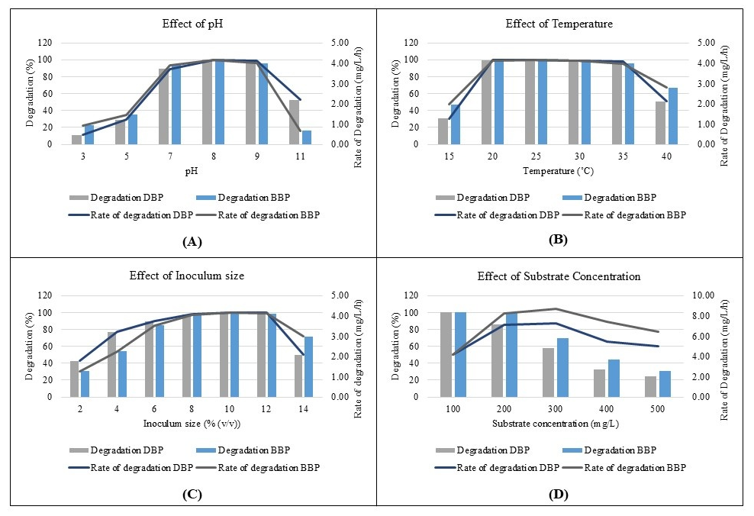
Fig. 2 Optimization of environmental parameters by OFAT. Effect of pH (A), effect of temperature (B), effect of inoculum size (C), and Effect of substrate concentration (D)

The statistical analysis resulted in a valid model with significant p value and non-significant lack of fit for DBP & BBP. Final equations from ANOVA table for degradation (%) are mentioned below.
DBP Degradation (%) Y = -84.99 + 15.57 X₁ + 4.86 X₂ + 10.63 X₃ - 0.01 X₁ X₂ + 0.17 X₁ X₃ + 0.29 X₂ X₃ - 0.88 X₁² - 0.16 X₂² - 0.98 X₃² ……………………………………...……………………………………………………………………………………Eq. (2)
BBP Degradation (%) Y = -8.39 + 5.56 X₁ + 2.74 X₂ + 9.33 X₃ + 0.04 X₁ X₂ -0.03 X₁ X₃+ 0.24 X₂ X₃ - 0.28 X₁² - 0.11 X₂² - 0.76 X₃² ….……………………………….………………………………………………………………………………………..Eq. (3)
Where X₁ = pH, X₂ = Temperature and X₃ = Inoculum size
Tables S1 and S2 are the ANOVA tables of DBP and BBP respectively. Analysing statistical data from ANOVA table and equation shows that X₁ (pH) is serving as dominant linear factor, confirming the necessity of alkaline pH for optimum degradation which also correlates with the OFAT data. The consistent interaction between X₂X₃ validates the synergistic effect between temperature and biomass. The significant quadratic terms X₂² & X₃² defines the peak limit, which indicates exceeding the value beyond limit will drastically decreases the amount of degradation. Fig. (3) & (4). shows 3D relationship between different factors for optimization of DBP & BBP respectively.
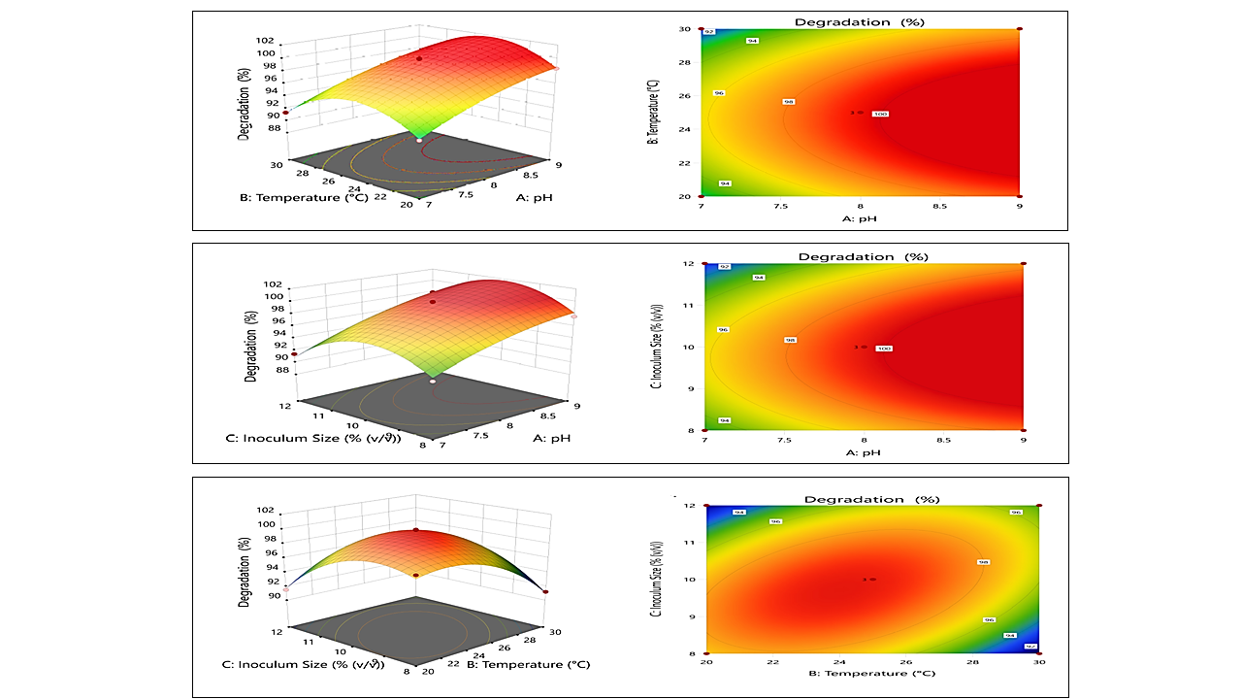

Fig. 3 3D plots showing the relationship between pH, temperature and inoculum size for DBP optimization

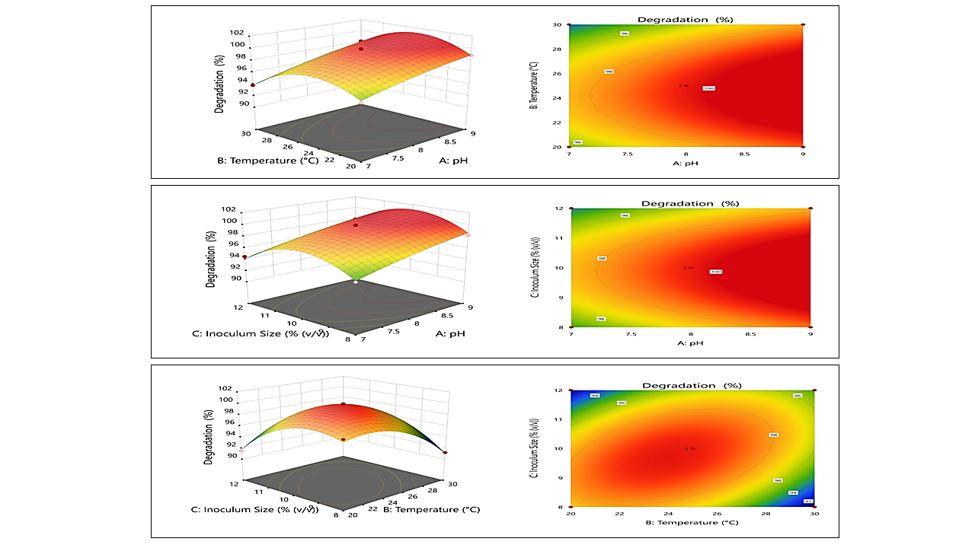
Fig. 4 3D plots showing the relationship between pH, temperature and inoculum size for BBP optimization

3.3 Degradation Study

Chromatographic analysis of control of DBP and BBP gave peak at retention time of 12.5 min. and 11.9 min. respectively. In treated samples, this peak area decreased substantially which indicates the reduction in the amount of PAEs. In both the treated sample appearance of peaks between 6 to 8 min. indicates generation of metabolites after degradation. Similar pattern of peak in treated samples suggests similar degradation pattern for DBP and BBP.
The FTIR spectrum of untreated DBP exhibited a characteristic ester carbonyl stretching vibration at 1728 cm⁻¹, consistent with phthalate diester structures. After bacterial treatment, the carbonyl peak decreased which indicates substantial cleavage of ester linkages. Parallel reduction of ester C–O stretching vibrations in the 1280–1120 cm⁻¹ region further confirms disruption of the carbonyl bond. The appearance of broad O–H stretching bands at 3300–2500 cm⁻¹ and sharp hydroxyl signals near 3624 cm⁻¹ supports the formation of alcohol and carboxylic acid intermediates. Mechanistically, DBP degradation proceeds via esterase-mediated hydrolysis reaction. This is due to nucleophilic attack of water on the electrophilic carbonyl carbon of the ester bond. The reaction forms a tetrahedral intermediate, which breaks down to release n-butanol and generate monobutyl phthalate (MBP). The second hydrolytic reaction yields phthalic acid. Such sequential hydrolysis has been reported as the primary pathway in bacterial degradation of phthalate esters (Feng et al. 2018). Subsequently, phthalic acid undergoes dioxygenase-mediated oxidation to protocatechuate and leads to complete mineralization via the TCA cycle (Fuchs, Boll, and Heider 2011). Equation (4) represents the stoichiometric reaction of DBP
$C_{16}H_{22}O_{4}+2H_{2}O→C_{8}H_{6}O_{4}+2C_{4}H_{10}O$ ………………………………………………………………………………………...Eq. (4)
BBP showed a strong ester carbonyl band at 1724 cm⁻¹ which represents asymmetric phthalate diesters containing benzyl and butyl substituents. Post-treatment, the carbonyl peak decreased, this confirms cleavage of ester bonds. Significant decreases in the ester C–O stretching region (1280–1040 cm⁻¹) also validate hydrolytic bond cleavage. Aromatic skeletal vibrations around 1550–1600 cm⁻¹ were reduced which indicates structural destabilization or oxidative transformation of the aromatic core. Emergence of O–H stretching bands near 3813 and 3624 cm⁻¹ indicates generation of benzyl alcohol, butanol, and phthalic acid metabolites. Similar to DBP, BBP degradation also initiated via nucleophilic attack of water on the ester carbonyl carbon which is catalysed by microbial esterases. Due to its asymmetric structure, sequential hydrolysis liberates benzyl alcohol and butanol and forms phthalic acid. Reduction in aromatic ring vibrations observed suggests subsequent oxidative metabolism, this could be due to phthalate 4,5-dioxygenase activity leading to protocatechuate formation (Liang, Zhang, and Fang 2008). Equation (5) represents the stoichiometric reaction of DBP
$C_{19}H_{20}O_{4}+2H_{2}O→C_{8}H_{6}O_{4}+C_{7}H_{8}O+C_{4}H_{10}O$…………………………...………………………………………………...…Eq. (5)
Fig. (5) shows the FTIR graph. Proposed degradation pathway of DBP and BBP are displayed in fig (6) and (7) respectively.

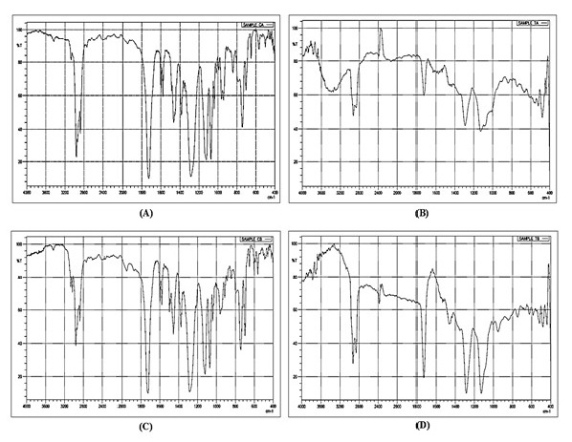
Fig. 5 FTIR analysis of DBP control (A), DBP treated (B), BBP control (C) and BBP treated (D)
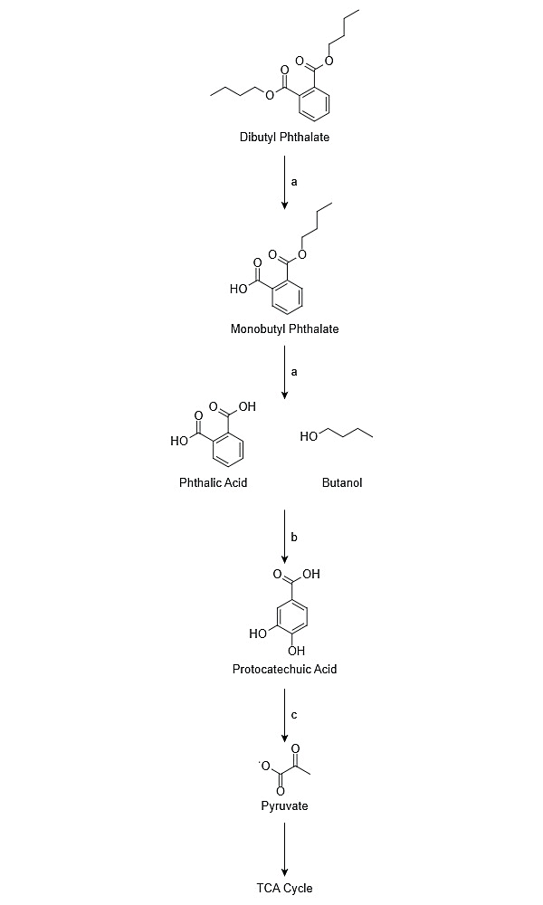`
Fig. 6 Proposed Pathway for DBP degradation by consortium JPN by FTIR analysis. a- Hydrolysis, b- Decarboxylation, c- Ring Cleavage
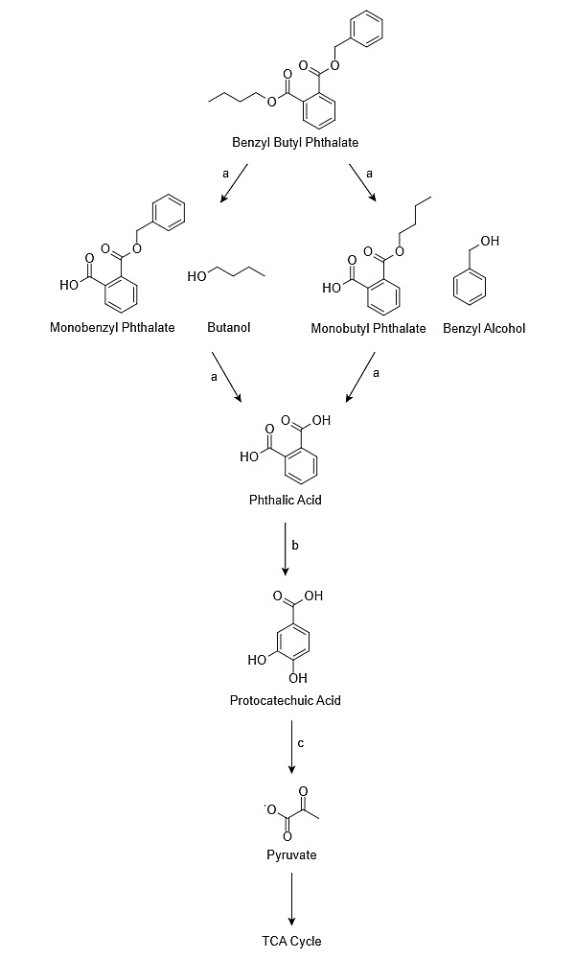
Fig. 7 Proposed Pathway for BBP degradation by consortium JPN by FTIR analysis. a- Hydrolysis, b- Decarboxylation, c- Ring Cleavage

4. Conclusion

DBP and BBP are derivatives of Phthalic acid esters used in the manufacturing of plastic to provide it flexibility. These are not covalently bonded to its matrix and hence are leached out due to external pressure polluting water, and soil. Considering the toxicity of the compounds; they are listed amongst the 6 priority pollutants by various international environmental agencies. Therefore, it becomes essential to remove it from the environment. This study aimed to degrade the derivatives microbially, rather than physically or chemically; a step towards sustainable treatment of xenobiotic pollutants. Consortium JPN capable of degradation consisted four bacterial species, Bacillus infantis, Atlantibacter hermanii, Bacillus subtilis and Stutzerimonas stutzeri. HPLC and FTIR analysis was performed to check degraded metabolites. It confirmed the degradation of the compounds and predicted pathway was also revealed by FTIR analysis. Consortium JPN proved to be efficient in degrading both LMW and HMW exhibiting its robustness towards biodegradation.

Competing interests

The authors declare that they have no known competing financial interests or personal relationships that could have appeared to influence the work reported in this paper.

References

Fang, Cheng Ran, Jun Yao, Yuan Ge Zheng, Chen Jing Jiang, Li Fang Hu, Yu Yong Wu, and Dong Sheng Shen. 2010. “Dibutyl Phthalate Degradation by Enterobacter Sp. T5 Isolated from Municipal Solid Waste in Landfill Bioreactor.” International Biodeterioration and Biodegradation 64(6):442–46. doi: 10.1016/j.ibiod.2010.04.010.
Feng, Nai-xian, Jiao Yu, Ce-hui Mo, Hai-ming Zhao, Yan-wen Li, Bing-xiao Wu, and Quan-ying Cai. 2018. “Science of the Total Environment Biodegradation of Di-n-Butyl Phthalate ( DBP ) by a Novel Endophytic Bacillus Megaterium Strain YJB3.” Science of the Total Environment 616–617:117–27. doi: 10.1016/j.scitotenv.2017.10.298.
Fuchs, Georg, Matthias Boll, and Johann Heider. 2011. “Microbial Degradation of Aromatic Compounds — from One Strategy to Four.” Nature Reviews Microbiology 9(11):803–16. doi: 10.1038/nrmicro2652.
Gani, Khalid Muzamil, Vinay Kumar Tyagi, and Absar Ahmad Kazmi. 2017. “Occurrence of Phthalates in Aquatic Environment and Their Removal during Wastewater Treatment Processes: A Review.” Ience and Pollution ResearchEnvironmental Science and Pollution Research 24(21):17267–84. doi: 10.1007/s11356-017-9182-3.
Gao, Hai Tao, Run Xu, Wei Xin Cao, Liang Liang Qian, Min Wang, Lingeng Lu, Qian Xu, and Shu Qin Yu. 2017. “Effects of Six Priority Controlled Phthalate Esters with Long-Term Low-Dose Integrated Exposure on Male Reproductive Toxicity in Rats.” Food and Chemical Toxicology 101:94–104. doi: 10.1016/j.fct.2017.01.011.
He, Lizhi, Gerty Gielen, Nanthi S. Bolan, Xiaokai Zhang, Hua Qin, Huagang Huang, and Hailong Wang. 2015. “Contamination and Remediation of Phthalic Acid Esters in Agricultural Soils in China: A Review.” Agronomy for Sustainable Development 35(2):519–34. doi: 10.1007/s13593-014-0270-1.
He, Zhixing, Hailong Xiao, Lu Tang, Hang Min, and Zhenmei Lu. 2013. “Biodegradation of Di-n-Butyl Phthalate by a Stable Bacterial Consortium, HD-1, Enriched from Activated Sludge.” Bioresource Technology 128:526–32. doi: 10.1016/j.biortech.2012.10.107.
Hu, Hongmei, Lingling Mao, Shuhong Fang, Jiahui Xie, Meirong Zhao, and Hangbiao Jin. 2020. “Occurrence of Phthalic Acid Esters in Marine Organisms from Hangzhou Bay, China: Implications for Human Exposure.” Science of the Total Environment 721:137605. doi: 10.1016/j.scitotenv.2020.137605.
Hu, Ruiwen, Haiming Zhao, Xihui Xu, Zhigang Wang, Ke Yu, Longfei Shu, Qingyun Yan, Bo Wu, Cehui Mo, Zhili He, and Cheng Wang. 2021. “Bacteria-Driven Phthalic Acid Ester Biodegradation: Current Status and Emerging Opportunities.” Environment International 154. doi: 10.1016/j.envint.2021.106560.
Huang, Ling, Xunzhi Zhu, Shixing Zhou, Zhenrui Cheng, Kai Shi, Chi Zhang, and Hua Shao. 2021. “Phthalic Acid Esters: Natural Sources and Biological Activities.” Toxins 13(7):495. doi: 10.3390/toxins13070495.
Jensen, Mai-britt V, Louise E. Horsfall, Caroline Wardrope, Peter D. Togneri, Jon Marles-wright, and Susan J. Rosser. 2016. “Characterisation of a New Family of Carboxyl Esterases with an OsmC Domain.” PLoS ONE 1–22. doi: 10.7488/ds/1320.
Kanaujiya, Dipak Kumar, Atharva More, Ajay Kumar Chhantyal, Rama Karn, and Kannan Pakshirajan. 2023. “Biodegradation of Low , Medium and High Molecular Weight Phthalate by Gordonia Sp . in a Batch System : Kinetics and Phytotoxicity Analyses.” Bioengineered 14(1):195–211. doi: 10.1080/21655979.2023.2229094.
Kaur, R., A. Kumari, G. Sharma, D. Singh, and R. Kaur. 2021. “Biodegradation of Endocrine Disrupting Chemicals Benzyl Butyl Phthalate and Dimethyl Phthalate by Bacillus Marisflavi RR014.” Journal of Applied Microbiology (Iarc 2000):1–15. doi: 10.1111/jam.15045.
Li, Jinlong.; Zhang, Jingfan.; Yadav, P.; Li, Xiuting. 2019. “Biodegradability and Biodegradation Pathway of Di-(2-Ethylhexyl) Phthalate by Burkholderia Pyrroci Nia B1213.” Chemoshpere. doi: 10.1016/j.chemosphere.2019.02.194.
Liang, Da-wei, Tong Zhang, and Herbert H. P. Fang. 2008. “Phthalates Biodegradation in the Environment.” Applied Microbial Thechnology 183–98. doi: 10.1007/s00253-008-1548-5.
Long, Fangyun, Yanqin Ren, Yuanyuan Ji, Junling Li, Haijie Zhang, Zhenhai Wu, Rui Gao, Fang Bi, Zhengyang Liu, and Hong Li. 2024. “Pollution Characteristics, Toxicological Properties, and Health Risk Assessment of Phthalic Acid Esters in Water, Soil, and Atmosphere.” Atmosphere 15(9):1071. doi: 10.3390/atmos15091071.
Luo, Xin, Shu Shu, Hui Feng, Hua Zou, and Yun Zhang. 2021. “Seasonal Distribution and Ecological Risks of Phthalic Acid Esters in Surface Water of Taihu Lake, China.” Science of the Total Environment 768:144517. doi: 10.1016/j.scitotenv.2020.144517.
Maitra, Vinay Kumar S. S. 2016. “Biodegradation of Endocrine Disruptor Dibutyl Phthalate ( DBP ) by a Newly Isolated Methylobacillus Sp . V29b and the DBP Degradation Pathway.” 3 Biotech 6(2):1–12. doi: 10.1007/s13205-016-0524-5.
Nahurira, Ruth, Lei Ren, Jinlong Song, Yang Jia, and Junhuan Wang. 2017. “Degradation of Di ( 2-Ethylhexyl ) Phthalate by a Novel Gordonia Alkanivorans Strain YC-RL2.” Current Microbiology. doi: 10.1007/s00284-016-1159-9.
Nandi, Moumita, Dipak Kumar Kanaujiya, Kannan Pakshirajan, Tanushree Paul, Kannan Pakshirajan, G. Pugazhenthi, Divya Baskaran, and G. Pugazhenthi. 2021. “Biodegradation of Benzyl Butyl Phthalate and Dibutyl Phthalate by Arthrobacter Sp. via Micellar Solubilization in a Surfactant-Aided System.” Water Supply 21(5):2084–98. doi: 10.2166/ws.2020.347.
Proshad, Ram, Tapos Kormoker, Md. Saiful Islam, Mohammad Asadul Haque, Md. Mahfuzur Rahman, and Md. Mahabubur Rahman Mithu. 2018. “Toxic Effects of Plastic on Human Health and Environment : A Consequences of Health Risk Assessment in Bangladesh.” International Journal of Health 6(1):1. doi: 10.14419/ijh.v6i1.8655.
Qiao, Pei, Tongtong Ying, Mengjie Gu, Jiahong Zhu, Chengyu Mei, Tong Hu, Tengfei Liu, and Haixia Wang. 2024. “Assimilation of Phthalate Esters in Bacteria.” Applied Microbiology and Biotechnology. doi: 10.1007/s00253-024-13105-6.
Ramzi, A., T. R. Gireeshkumar, K. Habeeb Rahman, K. K. Balachandran, K. Shameem, Jacob Chacko, and N. Chandramohanakumar. 2020. “Phthalic Acid Esters – A Grave Ecological Hazard in Cochin Estuary, India.” Marine Pollution Bulletin 152(January):110899. doi: 10.1016/j.marpolbul.2020.110899.
Sheikh, Ishfaq A., and Mohd A. Beg. 2019. “Structural Characterization of Potential Endocrine Disrupting Activity of Alternate Plasticizers Di-(2-Ethylhexyl) Adipate (DEHA), Acetyl Tributyl Citrate (ATBC) and 2,2,4-Trimethyl 1,3-Pentanediol Diisobutyrate (TPIB) with Human Sex Hormone-Binding Globu.” Reproductive Toxicology 83:46–53. doi: 10.1016/j.reprotox.2018.11.003.
Shi, Huijing, Yang Cao, Qing Shen, Yan Zhao, Zhe Zhang, and Yunhui Zhang. 2015. “Association between Urinary Phthalates and Pubertal Timing in Chinese Adolescents.” Journal of Epidemiology 25(9):574–82. doi: 10.2188/jea.JE20140205.
Xie, Changming, Yan Zhao, Lianlian Gao, Jiao Chen, Depei Cai, and Yunhui Zhang. 2015. “Elevated Phthalates’ Exposure in Children with Constitutional Delay of Growth and Puberty.” Molecular and Cellular Endocrinology 407:67–73. doi: 10.1016/j.mce.2015.03.006.
Xiong, Yang-hui, and De-sheng Pei. 2021. “A Review on Ef Fi Cient Removal of Phthalic Acid Esters via Biochars and Transition Metals-Activated Persulfate Systems.” Chemosphere 277:130256.
Xu, Jiaming, Qihong Lu, Renata Alves de Toledo, and Hojae Shim. 2017. “Degradation of Di-2-Ethylhexyl Phthalate (DEHP) by an Indigenous Isolate Acinetobacter Sp. SN13.” International Biodeterioration and Biodegradation 117:205–14. doi: 10.1016/j.ibiod.2017.01.004.
Xu, Wen Jun, Qun Wan, Wen Feng Wang, Ya Wang, Fa yun Feng, Jin Jin Cheng, Jian Jun Yuan, and Xiang Yang Yu. 2020. “Biodegradation of Dibutyl Phthalate by a Novel Endophytic Bacillus Subtilis Strain HB-T2 under in-Vitro and in-Vivo Conditions.” Environmental Technology (0):1–27. doi: 10.1080/09593330.2020.1858181.

