DESIGN AND EVALUATION OF A SAND–CHARCOAL–GRAVEL WATER FILTER FOR BIOREMEDIATION OF HEAVY METALS IN ILLEGAL MINING SITES OF ZAMFARA STATE, NIGERIA

Abstract
Illegal artisanal gold mining in Zamfara State, Nigeria, has resulted in severe environmental contamination and widespread exposure to toxic heavy metals, particularly lead. This study aimed to design and evaluated a low-cost sand–charcoal–gravel filtration system for the removal of heavy metals from contaminated water sources in affected communities. Water samples were collected from six mining sites (Baggage, Dareta, Kamfanin Madam, Daki Takwas, Bagega, and Kucheri) and analyzed for heavy metal concentrations before and after filtration using atomic absorption spectrophotometry (AAS). Descriptive statistics and analysis of variance (ANOVA) were employed to assess filtration performance.

The results showed significant reductions (p < 0.05) in the concentrations of iron, manganese, cobalt, cadmium, chromium, copper, and nickel across all study sites. However, although lead concentrations were reduced after filtration, they remained above the World Health Organization (WHO) permissible limit in most locations. The removal efficiency varied among metals and sites, indicating the influence of initial contamination levels and local water chemistry on filtration performance. The findings demonstrate that the sand–charcoal–gravel filtration system is an effective and affordable method for improving water quality in resource-limited mining communities. Nevertheless, further optimization is required to enhance the removal of highly toxic metals such as lead to meet safe drinking water standards.

- Introduction
Illegal artisanal gold mining in Zamfara State, Nigeria, precipitated one of the worst lead poisoning crises in modern history. In 2010, more than 400 children died, and thousands were exposed to dangerously high blood lead levels (BLLs), largely due to home-based processing of lead-rich ore that released toxic dust into the living environment (Dooyema et al., 2012; WHO, 2010). Soil around affected areas contained lead concentrations exceeding 100,000 ppm, far above the international safety limit of ~400 ppm (Nwabanne et al., 2012; Plumlee et al., 2013).
Lead exposure in children under five caused seizures, developmental delays, neurological impairment, and death. In two severely contaminated villages, the average BLL among children was 119 µg/dL, whereas as low as 5 µg/dL is known to impair cognitive development (CDC, 2012). Exposure occurred through multiple pathways including ingestion of contaminated water, soil, and household dust often amplified by unsafe practices such as grinding ore inside homes and carrying dust-laden clothing indoors (Human Rights Watch, 2012).
Interventions by Médecins Sans Frontières (MSF), WHO, the US CDC, and Pure Earth (formerly Blacksmith Institute) included chelation therapy, environmental cleanup, and community education. These efforts drastically reduced mortality: from 40–43% in untreated cases to less than 2% after treatment and remediation (Greig et al., 2014; Pure Earth, 2023). However, unsafe mining practices continue, and environmental recontamination remains a persistent threat (Innocent et al., 2023). Contaminated water sources wells, ponds, and streams still pose risks, yet affordable purification technologies are lacking (Barakat, 2011).
Conventional water treatment systems are often too costly or unavailable for rural Zamfara communities. Point-of-use filtration using sand, charcoal, and gravel offers a low-cost, sustainable alternative. Similar systems, such as biosand filters, have shown promise in removing turbidity, pathogens, and some heavy metals (Sharma et al., 2016; Ngai et al., 2007). However, no context-specific study has systematically evaluated the effectiveness of these filters for lead and other heavy metals in Zamfara’s artisanal mining communities. This research therefore aims to design, construct, and test such filters for bioremediation of contaminated water, bridging a critical gap between scientific innovation and community health.
- Materials and Methods

Study Area
Water samples were collected from an illegal mining communities of Anka, Maru, Bungudu, and Bukuyyum local government areas of Zamfara state Nigeria.
2.2 Materials Required
The following materials was used in this study Fine sand (washed and dried), Charcoal (locally produced; ground to small granules/activated with heat treatment), Gravel (2–10 mm size), PVC or plastic containers (filter columns), Sampling bottles, Heavy metal testing kits / AAS (Atomic Absorption Spectrophotometer).
2.3 Filter Design
Prototype filter units was constructed using PVC pipes (1–2 m height, 15–20 cm diameter). The filter column contains the following layers (from bottom to top): Coarse gravel (10 cm) → support and drainage, Fine gravel (10 cm) → secondary support, Charcoal layer (20–30 cm) → adsorption of heavy metals, Fine sand layer (30–40 cm) → removal of suspended particles, turbidity, microbes. Flow was done with a gravity-fed at a controlled rate according to slow sand filter principle

2.4 Sampling and Experimental Procedure
After the collection of contaminated water samples from mining sites (wells, streams, ponds) the baseline water analysis for Pb, Cd, As, Hg concentrations was done using AAS. Filtration process was done by running contaminated water through the filter units and Collection of effluent at different intervals (e.g., 1 L, 5 L, 10 L batches). Post-filtration water analysis for heavy metal concentrations was also done. We then calculated the efficiency using the formula below
% Removal = (C_in – C_out) / C_in) × 100
where C_in = initial concentration, C_out = final concentration
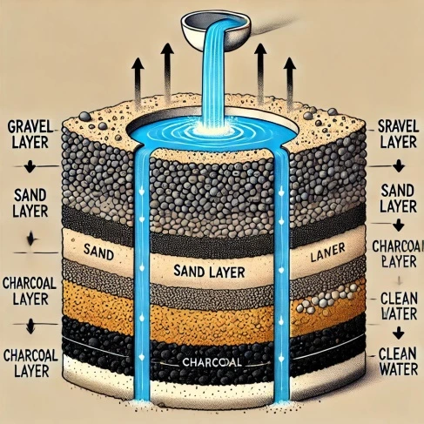

Figure 1. Charcoal–sand–gravel filter (source Canature WaterGroup 2025).
2.5 Optimization
To optimize our experiment, we have compared different filter arrangements (charcoal–sand–gravel vs. sand–charcoal–gravel). We have also varied charcoal layer thickness to test adsorption efficiency. Finally, we compare removal performance across multiple heavy metals.

2.6 Data Analysis
Descriptive statistics (mean, SD of concentrations) and ANOVA was used to test significant differences between filter designs, the results were compared with WHO drinking water standards.

3.0 RESULTS
Figure 1. Concentration of heavy metals before and after Filtration in some mining areas of Zamfara state
Site | Metal | Before (mg/L) | After (mg/L) | WHO Limit (mg/L)
Baggage | Silver | 0.73 ± 0.001 | 0.018 ± 0.0048 | -
Baggage | Gold | 0.301 ± 0.0052 | 0.129 ± 0.0056 | -
Baggage | Cobalt | 0.172 ± 0.0066 | 0.001 ± 0.0019 | -
Baggage | Iron | 3.457 ± 0.0024 | 1.627 ± 0.0012 | 0.3
Baggage | Manganese | 0.876 ± 0.0013 | 0.211 ± 0.0023 | 0.4
Baggage | Lead | 16.876 ± 0.0011 | 11.876 ± 0.0015 | 10
Dareta | Silver | 0.035 ± 0.0026 | 0.014 ± 0.0013 | -
Dareta | Gold | 0.3165 ± 0.0010 | 0.159 ± 0.0028 | -
Dareta | Cobalt | 0.423 ± 0.0066 | 0.115 ± 0.0029 | -
Dareta | Iron | 1.585 ± 0.0050 | 1.271 ± 0.0021 | 0.3
Dareta | Manganese | 0.553 ± 0.0033 | 0.211 ± 0.0015 | 0.4
Dareta | Lead | 13.262 ± 0.0015 | 10.267 ± 0.005 | 10
Kamfanin Madam | Silver | 0.31 ± 0.0011 | 0.028 ± 0.001 | -
Kamfanin Madam | Gold | 0.229 ± 0.013 | 0.146 ± 0.0013 | -
Kamfanin Madam | Cobalt | 0.424 ± 0.0028 | 0.125 ± 0.0046 | -
Kamfanin Madam | Iron | 3.619 ± 0.021 | 1.805 ± 0.0033 | 0.3
Kamfanin Madam | Manganese | 0.394 ± 0.002 | 0.192 ± 0.0001 | 0.4
Kamfanin Madam | Lead | 15.00 ± 0.002 | 11.92 ± 0.0011 | 10
Daki Takwas | Cadmium | 0.97 ± 0.003 | 0.043 ± 0.0007 | 0.003
Daki Takwas | Cobalt | 0.500 ± 0.0032 | 0.125 ± 0.0016 | -
Daki Takwas | Chromium | 0.687 ± 0.012 | 0.373 ± 0.0105 | 0.05
Daki Takwas | Copper | 4.050 ± 0.0017 | 2.129 ± 0.0017 | 2.0
Daki Takwas | Nickel | 0.822 ± 0.004 | 0.419 ± 0.0030 | 0.07
Daki Takwas | Lead | 15.251 ± 0.0015 | 10.865 ± 0.0017 | 10
Bagega | Cadmium | 0.59 ± 0.0004 | 0.041 ± 0.0004 | 0.003
Bagega | Cobalt | 0.231 ± 0.0033 | 0.023 ± 0.0067 | -
Bagega | Chromium | 0.571 ± 0.0259 | 0.159 ± 0.0077 | 0.05
Bagega | Copper | 0.42 ± 0.0049 | 0.128 ± 0.0012 | 2.0
Bagega | Nickel | 0.676 ± 0.0026 | 0.390 ± 0.0013 | 0.07
Bagega | Lead | 14.25 ± 0.0015 | 10.63 ± 0.0012 | 10
Kucheri | Cadmium | 0.042 ± 0.0002 | 0.042 ± 0.0009 | 0.003
Kucheri | Cobalt | 0.135 ± 0.0010 | 0.124 ± 0.0020 | -
Kucheri | Chromium | 0.522 ± 0.0116 | 0.463 ± 0.0285 | 0.05
Kucheri | Copper | 0.057 ± 0.0008 | 0.114 ± 0.0036 | 2.0
Kucheri | Nickel | 0.418 ± 0.0027 | 0.399 ± 0.0035 | 0.07
Kucheri | Lead | 16.876 ± 0.0015 | 11.876 ± 0.0015 | 10

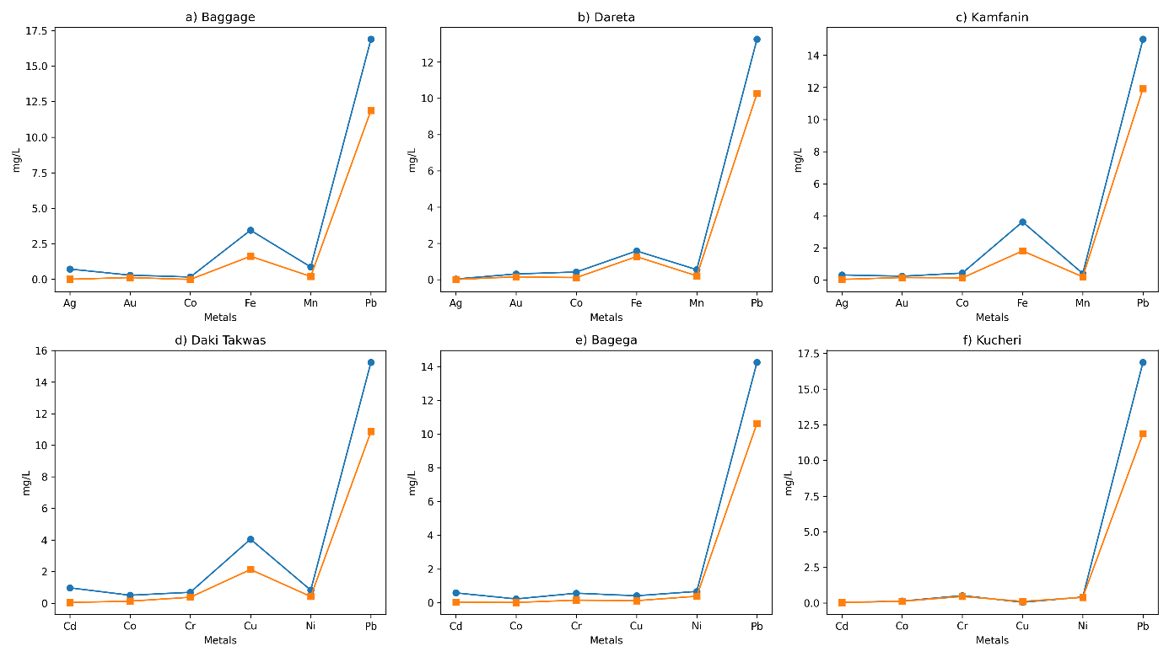

Figure 2: Multi-panel comparison of heavy metal concentrations before and after filtration across six artisanal mining sites in Zamfara State, Nigeria

4.0 Discussion
The present study evaluated the effectiveness of a sand–charcoal–gravel filtration system for the removal of heavy metals from contaminated water sources in artisanal mining communities of Zamfara State. The results demonstrated a consistent reduction in heavy metal concentrations across all study sites, although the extent of removal varied significantly depending on the metal type and location.
Statistical analysis using analysis of variance (ANOVA) revealed that the differences between pre-filtration and post-filtration concentrations were statistically significant (p < 0.05) for most of the analyzed metals, including iron, manganese, cobalt, and cadmium. This indicates that the filtration system had a measurable and non-random effect on reducing heavy metal concentrations in contaminated water.
Iron showed one of the highest reductions across all sites, decreasing from values as high as 3.619 mg/L to 1.805 mg/L in Kamfanin Madam and from 3.457 mg/L to 1.627 mg/L in Baggage. The significant reduction in iron concentration (p < 0.05) can be attributed to the combined effects of physical filtration by sand and adsorption by charcoal, which has a high surface area and affinity for metal ions.

Similarly, manganese concentrations decreased substantially across all locations, with values reduced below the WHO permissible limit (0.4 mg/L) after filtration. The statistical significance of manganese removal suggests that the filter system is particularly effective for divalent metal ions that are more readily adsorbed onto charcoal surfaces.
In contrast, lead (Pb), which is the most critical contaminant in Zamfara due to its severe health implications, showed only partial reduction. Although concentrations decreased in all locations for example, from 16.876 mg/L to 11.876 mg/L in Baggage and from 13.262 mg/L to 10.267 mg/L in Dareta the values remained above the WHO permissible limit of 10 mg/L in most cases. While the reduction was statistically significant (p < 0.05), the persistence of elevated lead levels indicates that the current filter configuration is insufficient for complete remediation.
The variability observed across different sites may be attributed to differences in initial contamination levels, water chemistry, and potential saturation of adsorption sites within the charcoal layer. In Kucheri, for instance, minimal changes were observed for certain metals such as cadmium, suggesting limited adsorption efficiency or possible equilibrium conditions.
Furthermore, in some cases, relatively small reductions or fluctuations in concentrations may indicate desorption phenomena or re-release of previously adsorbed metals, particularly when the adsorption capacity of the charcoal is exceeded. This highlights the importance of optimizing filter design parameters such as charcoal thickness, contact time, and flow rate.
Overall, the statistical evidence supports the effectiveness of the sand–charcoal–gravel filtration system as a low-cost intervention for improving water quality in artisanal mining communities. However, the incomplete removal of highly toxic metals such as lead underscores the need for further improvements, including the incorporation of advanced adsorbents or multi-stage filtration systems.

5.0 Conclusion
The sand–charcoal–gravel filtration system effectively reduced heavy metal concentrations in contaminated water from Zamfara mining communities. However, lead levels remained above WHO limits, indicating the need for further optimization. The system shows promise as a low-cost water treatment solution but requires improvement for complete safety.
References
Barakat, M. A. (2011). New trends in removing heavy metals from industrial wastewater. Arabian Journal of Chemistry, 4(4), 361–377. https://doi.org/10.1016/j.arabjc.2010.07.019
Canature WaterGroup (2025). Gravel in water filtration. https://www.canature.com.pk/gravel-in-water-filtration/
Centers for Disease Control and Prevention (CDC). (2012). Response to the lead poisoning crisis in Zamfara State, Nigeria. Atlanta: CDC.
Dooyema, C. A., Neri, A., Lo, Y. C., Durant, J., Dargan, P. I., Swarthout, T., ... & Brown, M. J. (2012). Outbreak of fatal childhood lead poisoning related to artisanal gold mining in northwestern Nigeria, 2010. Environmental Health Perspectives, 120(4), 601–607. https://doi.org/10.1289/ehp.1103965
Greig, J., Thurtle, N., Cooney, L., Ariti, C., Ahmed, A. O., Ashagre, T., ... & Brown, M. J. (2014). Association of blood lead level with neurological features in 972 children affected by an acute severe lead poisoning outbreak in Zamfara State, northern Nigeria. PLOS ONE, 9(4), e93716. https://doi.org/10.1371/journal.pone.0093716
Human Rights Watch. (2012). A heavy price: Lead poisoning and gold mining in Nigeria’s Zamfara State. New York: HRW.
Innocent, C., Umar, A., & Mohammed, A. (2023). Environmental and health implications of artisanal mining in Nigeria: A review. In Environmental Impacts of Artisanal and Small-Scale Mining (pp. 1–18). IntechOpen. https://doi.org/10.5772/intechopen.107566
Ngai, T. K. K., Shrestha, R. R., Dangol, B., Maharjan, M., & Murcott, S. E. (2007). Design for sustainable development: Household drinking water filter for arsenic and pathogen treatment in Nepal. Journal of Environmental Science and Health, Part A, 42(12), 1879–1888. https://doi.org/10.1080/10934520701566964
Nwabanne, J. T., & Igbokwe, P. K. (2012). Kinetics and equilibrium modelling of heavy metals sorption on fixed bed column. International Journal of Environmental Research, 6(4), 945–952.
Plumlee, G. S., Durant, J. T., Morman, S. A., Neri, A., Wolf, R. E., Dooyema, C. A., ... & Brown, M. J. (2013). Linking geological and health sciences to assess childhood lead poisoning from artisanal gold mining in Nigeria. Environmental Health Perspectives, 121(6), 744–750. https://doi.org/10.1289/ehp.1206051
Pure Earth. (2023). Zamfara lead poisoning project. Retrieved from https://www.pureearth.org/project/zamfara-nigeria-lead-poisoning/
Sharma, A., Katnoria, J. K., & Nagpal, A. K. (2016). Heavy metal pollution: A global challenge and its remediation by nanotechnology. Journal of Environmental Science and Technology, 9(4), 1–15. https://doi.org/10.3923/jest.2016
Stauber, C. E., Elliott, M., Koksal, F., Ortiz, G. M., DiGiano, F., & Sobsey, M. D. (2009). Characterisation of the biosand filter for E. coli reductions from household drinking water under controlled laboratory and field use conditions. Water Science & Technology, 60(12), 3353–3367. https://doi.org/10.2166/wst.2009.221
World Health Organization (WHO). (2010). Lead poisoning in Nigeria. Disease outbreak news. Geneva : WHO.

Design and Evaluation of a Sand–Charcoal–Gravel Water Filter for Bioremediation of Heavy Metals In Illegal Mining Sites Of Zamfara State, Nigeria

