Original Research Article
A Comparative Analysis of Returns from Direct Equity and Mutual Fund Investments in India

Abstract
This study examines the comparative performance of direct equity investment and mutual fund investment in India, using the NIFTY 50 as a proxy for direct equity and selected large-cap mutual funds. The analysis is based on secondary data covering a five-year period from 2020 to 2025, using monthly returns. Key performance indicators such as average return and standard deviation are used to evaluate risk and return, while analysis of variance (ANOVA) is applied to test the statistical significance of differences in returns.
The results indicate that mutual funds generate slightly higher average returns and exhibit marginally lower volatility compared to the NIFTY 50. However, the ANOVA results reveal that these differences are not statistically significant, suggesting that both investment avenues deliver similar performance over the study period. The findings imply that investment decisions should be based on individual risk preferences rather than expectations of significantly higher returns from either option.
Keywords: Direct Equity, Mutual Funds, NIFTY 50, Risk and Return, Investment Performance, Indian Stock Market
Introduction
The Indian financial market has witnessed a significant transformation over the past decade, driven by increasing financial awareness, technological advancements, and the growing participation of retail investors. With the expansion of digital trading platforms and easier access to financial information, individuals are increasingly exploring various investment avenues to optimise their returns. Among these, direct equity investment and mutual fund investment have emerged as two of the most prominent choices for retail investors in India.
Direct equity investment involves purchasing shares of companies listed on stock exchanges such as the National Stock Exchange, allowing investors to directly participate in the ownership and performance of firms. This form of investment offers the potential for higher returns but is often associated with higher risk and volatility due to market fluctuations. On the other hand, mutual funds pool resources from multiple investors and invest in a diversified portfolio of securities, managed by professional fund managers. Institutions such as the Association of Mutual Funds in India regulate and promote transparency in the mutual fund industry, making it a relatively safer and more structured investment option.
In recent years, India has seen a rapid increase in the number of demat accounts and systematic investment plans (SIPs), indicating a shift in investor preference towards financial assets. While some investors prefer direct equity for its higher return potential and control over investment decisions, others opt for mutual funds due to diversification benefits and professional management. This divergence in investment choices raises an important question regarding the comparative performance of these two avenues in terms of returns and risk.
Despite the growing popularity of both investment options, there remains a lack of clear understanding among retail investors regarding their relative performance over time. Many investors make decisions based on limited information or short-term trends rather than a comprehensive analysis of returns and associated risks. Therefore, a systematic comparison between direct equity and mutual fund investments becomes essential to provide empirical evidence that can guide informed investment decisions.
This study aims to conduct a comparative analysis of returns generated from direct equity investments, represented by the NIFTY 50, and selected large-cap mutual funds in India. By analysing historical data over a specified period, the study evaluates key performance indicators such as average returns, analysis of variance (ANOVA), and risk (standard deviation). The findings of this study are expected to offer valuable insights for retail investors, financial advisors, and policymakers, contributing to a better understanding of the effectiveness of these investment avenues in the Indian context.

Literature Review
1. Aniruddh Sahai and Ravinder Kumar (2020) conducted the study titled “Variation in Mutual Fund Performance: A Comparative Study of Selected Equity Schemes in India for the Period 1995–2020.” The study focuses on evaluating and comparing the performance of 34 equity mutual fund schemes over a long-term period. Using empirical analysis, the authors compared the returns of these funds with their respective benchmark indices. To measure performance, they applied several financial indicators such as average returns, standard deviation, beta, coefficient of determination, and risk-adjusted measures like the Sharpe, Jensen, and Treynor ratios. The objective was to examine both cross-sectional and time-based variations in fund performance to identify consistent trends. The findings revealed that the CRISIL and AMFI equity fund performance indices outperformed major benchmarks like the S&P BSE SENSEX (TRI), NIFTY 50 (TRI), and NIFTY 500 (TRI) over the study period.
2. Shivam Tripathi and Dr. Gurudutta P. Japee (2020) conducted the study titled “Performance Evaluation of Selected Equity Mutual Funds in India.” The study focuses on analysing the performance of 15 selected equity mutual fund schemes across large-cap, mid-cap, and small-cap categories over the period 2015 to 2019. The research is based on secondary data collected from fund fact sheets and historical NAV data. To evaluate performance, the authors used key statistical measures such as Jensen’s Alpha, Beta, Standard Deviation, and Sharpe Ratio to examine the risk-return relationship of the funds. The findings indicate that a majority of the funds performed well despite market volatility, with 10 out of 15 schemes showing satisfactory performance. However, some funds underperformed due to higher risk and lower risk-adjusted returns. The study highlights that relying only on returns is not sufficient; investors should also consider risk indicators while making investment decisions. Overall, the research emphasises the importance of evaluating mutual funds using both return and risk parameters to ensure better and more consistent investment outcomes.
3. Sharma Komal B. and Dr. Prashant Joshi (2021) conducted the study titled “A Comparative Study on Performance Evaluation of Selected Debt, Equity and Hybrid Mutual Fund Schemes in India.” The study aims to compare the performance of different categories of mutual funds—debt, equity, and hybrid—by analyzing their risk-return relationship and market volatility over a five-year period (2016–2020). The research is based on secondary data collected from official fund websites and fact sheets. To evaluate performance, the authors used various financial and statistical tools such as rate of return, standard deviation, beta, Sharpe ratio, Jensen ratio, and Treynor ratio. The study considered 15 mutual fund schemes, with five schemes from each category. The findings reveal that most funds delivered average or below-average performance according to CRISIL rankings, although many funds showed better results in risk-adjusted performance measures like Sharpe, Jensen, and Treynor ratios. The study concludes that debt mutual funds performed relatively better compared to equity and hybrid funds during the study period. It also emphasizes that investors should not rely solely on returns but must consider risk-adjusted measures to make informed investment decisions and achieve consistent performance.
4. Dr. Anurag Kumar Jha (2020) conducted the study titled “Comparative Study of Mutual Fund and Traditional Investment.” The study focuses on comparing mutual funds with traditional investment avenues such as bank deposits, insurance, and other fixed-income instruments. The objective is to understand investor preferences, risk-return trade-offs, and the growing importance of mutual funds in the Indian financial market. The study highlights that mutual funds pool investors’ money and invest in diversified financial instruments, offering professional management, diversification, and relatively lower costs. It emphasizes that with rising inflation and increasing financial awareness, investors are gradually shifting from traditional savings instruments to mutual funds and capital market investments. The findings suggest that mutual funds have emerged as an important investment avenue due to their flexibility, liquidity, and potential for higher returns compared to traditional options. However, unlike traditional investments that provide more stable and assured returns, mutual funds are subject to market risk. The study concludes that while traditional investments are preferred by risk-averse investors, mutual funds are gaining popularity among investors seeking better returns and diversification benefits, making them a significant component of modern investment portfolios.

5. Dr. Vinay Kandpal and Prof. P. C. Kavidayal (2014) conducted the study titled “A Comparative Study of Selected Public & Private Sector Equity Diversified Mutual Fund Schemes in India,” which focuses on evaluating the performance of 18 equity diversified mutual fund schemes from both public and private sectors. The study is based on secondary data and analyzes fund performance using key risk-return measures such as Sharpe ratio, Treynor ratio, Jensen’s alpha, beta, and standard deviation. The objective was to understand how these funds influence
investor decision-making and how they perform relative to market risk and returns. The findings indicate that private sector mutual funds generally outperform public sector funds due to better fund management, efficient portfolio allocation, and superior risk-adjusted returns. The study also highlights that higher beta funds carry greater risk, while funds with better Sharpe and Jensen values deliver superior performance. Additionally, it points out the lack of awareness about mutual funds in rural and semi-urban areas, limiting their adoption. Overall, the research concludes that mutual funds, particularly from the private sector, offer better investment opportunities for investors seeking higher returns with efficient risk management.

6. Anupam Thakuria and Shikha Kashyap (2017) conducted the study titled “Comparative Performance Analysis of Public Sector Sponsored and Private Sector Sponsored Mutual Funds in India,” which examines the growth and performance of mutual funds across public and private sectors in the Indian financial market. The study is based on secondary data and evaluates performance using various risk-return measures such as Sharpe ratio, Treynor ratio, Jensen’s alpha, beta, standard deviation, and CAGR. It also analyzes trends in assets under management (AUM), resource mobilization, and investor participation. The findings reveal that private sector mutual funds generally take higher risks and are able to generate comparatively higher returns, while public sector funds tend to be more conservative. The study also highlights the significant growth of the mutual fund industry in India, driven by increasing financial awareness, rising income levels, and a gradual shift of household savings from traditional investments to market-linked instruments. Overall, the research concludes that mutual funds have emerged as a key financial intermediary in capital markets, with private sector funds showing relatively better performance in terms of risk-return efficiency and innovation.
7. Dr. Girija Nandini (2014) conducted the study titled “Performance Evaluation of Select Mutual Fund Schemes in India – A Comparative Study,” which examines the performance of selected mutual fund schemes over a five-year period from April 2007 to March 2012. The study is based on secondary data, where yearly NAV values were used to calculate returns, and the NSE Nifty was taken as the benchmark portfolio. To evaluate fund performance, the study applied key risk-adjusted measures such as Sharpe ratio, Treynor ratio, and Jensen’s alpha. The analysis, supported by tables (as shown on pages 4–7), compares different funds like ING, IDFC, and HSBC across multiple years and market conditions. The findings indicate that mutual fund performance varies significantly depending on market trends, with certain periods (such as 2007–08 and 2010–11) showing better investment opportunities, while other periods reflected weaker performance due to unfavorable market conditions. The study concludes that mutual funds remain an effective investment avenue by offering diversification, professional management, and liquidity, but emphasizes that investors should evaluate fund performance using risk-adjusted measures rather than relying solely on returns for better investment decision-making.
8. CMA Dr. Samyabrata Das (2018) conducted the study titled “An Empirical Study on the Performance of Selected Diversified Equity Mutual Funds in India,” which focuses on evaluating the performance of diversified equity mutual fund schemes over a ten-year period from March 2004 to March 2014. The study is based on secondary data collected from various sources, including fund houses and market reports, and considers 8 schemes from 5 major asset management companies. Using benchmark indices such as the S&P BSE Sensex, th++e study applies multiple risk-return measures like Sharpe ratio, Treynor ratio, Jensen’s alpha, and Sharpe Differential Measure, along with beta and R-squared to assess market risk and diversification. The analysis (as seen in tables on pages 5–10) shows that most schemes outperformed the benchmark in terms of risk-adjusted returns, with several funds consistently delivering superior performance across different time horizons. The findings also highlight that fund managers demonstrated strong stock-picking ability, most schemes were adequately diversified and relatively defensive in nature, and SIP returns were consistently positive and satisfactory for long-term investors. Additionally, the study finds an inverse relationship between fund size and expense ratio, indicating that larger funds tend to have lower costs. Overall, the research concludes that diversified equity mutual funds are an effective investment option, particularly when evaluated using comprehensive risk-adjusted performance measures rather than just absolute returns.
Objectives of the Study
- To compare the returns generated from direct equity investment, represented by the NIFTY 50, and selected large-cap mutual funds in India.
- To identify which investment avenue performs better in terms of consistency and overall returns.
Limitations of the Study
The study is based on secondary data and considers only a limited number of large-cap mutual funds, which may not fully represent the entire market. It does not explicitly account for macroeconomic factors such as inflation, interest rates, or major events like the COVID-19 pandemic that may influence returns. Additionally, advanced risk-adjusted measures such as the Sharpe ratio are not included. Therefore, the findings are limited to the selected time period (2020–2025) and may not be generalizable across different market conditions.

Research Methodology
The present study adopts a quantitative, descriptive, and comparative research design to evaluate the performance of direct equity and mutual fund investments in India using secondary data. Direct equity is represented by the NIFTY 50, with data obtained from the National Stock Exchange (NSE), while Net Asset Value (NAV) data for selected large-cap mutual funds such as SBI Large Cap Fund Regular Growth, HDFC Large Cap Direct Fund, and ICICI Prudential Large Cap Fund Direct Plan Growth is collected from Investing.com India and the Association of Mutual Funds in India (AFMI). The study covers a five-year period from 2020 to 2025 using monthly data and employs purposive sampling to ensure comparability between large-cap mutual funds and the benchmark index. Returns are calculated using periodic return formulas, while performance is evaluated through average return and standard deviation (risk). Data analysis is conducted using Microsoft Excel, applying descriptive statistics and comparative techniques to assess the risk–return trade-off and determine the relative performance of the selected investment avenues, subject to limitations such as reliance on secondary data, restricted sample size, and exclusion of macroeconomic variables.
Figure 1: The monthly return series of the benchmark index, NIFTY 50, and selected large-cap mutual funds during 2020 to 2025
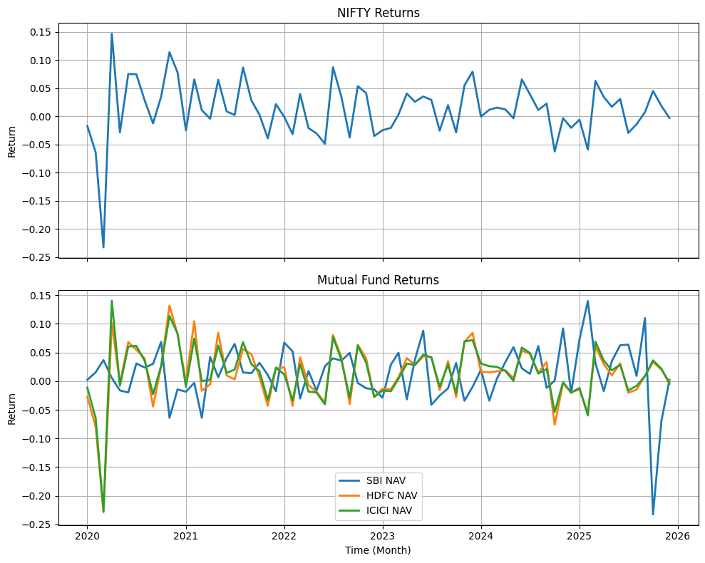
Figure 1 presents the monthly return series of the benchmark index, NIFTY 50, and selected large-cap mutual funds (SBI, HDFC, and ICICI) over a five-year period from 2020 to 2025. The upper panel illustrates the fluctuations in benchmark index returns, while the lower panel depicts the return patterns of the mutual funds.

Data Analysis and Interpretation
Table 1. Descriptive Statistics
 |  | NIFTY Price |  | SBI NAV |  | HDFC NAV |  | ICICI NAV
Mean |  | 0.012 |  | 0.013 |  | 0.014 |  | 0.015
Std. Deviation |  | 0.051 |  | 0.050 |  | 0.051 |  | 0.049
Minimum |  | -0.233 |  | -0.233 |  | -0.229 |  | -0.227
Maximum |  | 0.147 |  | 0.140 |  | 0.132 |  | 0.141

The descriptive statistics reveal that the NIFTY 50 recorded a mean monthly return of 1.2%, while the selected mutual funds generated slightly higher average returns ranging from 1.3% to 1.5%, with ICICI Prudential Large Cap Fund Direct Plan Growth delivering the highest mean return, indicating better overall performance. In terms of risk, as measured by standard deviation, all investment avenues exhibit similar volatility levels of around 5%, although mutual funds show marginally lower risk, suggesting improved stability due to diversification benefits. The minimum return values indicate the worst monthly performance, where the NIFTY 50 experienced the highest decline of -23.3%, while mutual funds showed slightly lower negative returns, reflecting limited downside protection. On the other hand, the maximum return values represent the best monthly performance, with the NIFTY 50 achieving the highest gain of 14.7%, compared to slightly lower peaks for mutual funds. Overall, the interpretation suggests that while direct equity offers higher upside potential along with greater fluctuations, mutual funds provide more consistent returns with marginally lower risk, making them relatively more stable investment options.

Anova: Single Factor
Table 2. SUMMARY
Groups | Count | Sum | Average | Variance
NIFTY Price | 72 | 0.8643 | 0.012004 | 0.002625
SBI NAV | 72 | 0.9369 | 0.013013 | 0.002479
HDFC NAV | 72 | 0.9969 | 0.013846 | 0.002623
ICICI NAV | 72 | 1.0845 | 0.015063 | 0.002366
Table 3.ANOVA
Source of Variation | SS | df | MS | F | P-value | F crit
Between Groups | 0.000363 | 3 | 0.000121 | 0.047886 | 0.986096 | 2.636391
Within Groups | 0.716639 | 284 | 0.002523
Total | 0.717002 | 287
Explanation of ANOVA Terms
- SS (Sum of Squares): Measures variation in the data (between groups and within groups).
- df (Degrees of Freedom): Number of independent observations used in calculation.
- MS (Mean Square): Average variation (SS ÷ df).
- F-value: Ratio of between-group variance to within-group variance.
- P-value: Indicates significance (p < 0.05 = significant).
- F-critical: Threshold value for decision (F > F crit = significant).

A One-Way ANOVA was conducted to examine whether there are significant differences in mean monthly returns among the NIFTY 50 and the selected mutual funds— SBI Large Cap Fund Regular Growth, HDFC Large Cap Direct Fund, and ICICI Prudential Large Cap Fund Direct Plan Growth. The results show that the difference in mean returns is not statistically significant (F = 0.0479, p = 0.986 > 0.05), and therefore the null hypothesis cannot be rejected. This indicates that, despite slight variations in average returns observed across the investment options, these differences are not strong enough to be considered statistically meaningful. In practical terms, it suggests that all selected investment avenues deliver broadly similar return performance over the study period, and the observed variations are likely due to normal market fluctuations rather than any inherent superiority of one investment type over another.

Discussion
The descriptive statistics indicate that the NIFTY 50 recorded an average monthly return of 1.20%, while the selected mutual funds, SBI Large Cap Fund Regular Growth, HDFC Large Cap Direct Fund, and ICICI Prudential Large Cap Fund Direct Plan Growth generated slightly higher mean returns ranging from 1.30% to 1.50%, with ICICI Prudential Large Cap Fund Direct Plan Growth showing the highest average return. The standard deviation values for all investment options were found to be nearly similar (around 5%), indicating comparable levels of risk, although mutual funds exhibited marginally lower volatility. The minimum and maximum return analysis reveals that the NIFTY 50 experienced slightly higher downside (-23.3%) as well as higher upside potential (14.7%), whereas mutual funds demonstrated relatively lower fluctuations, suggesting better stability due to diversification. However, the results of the One-Way ANOVA indicate that these differences in mean returns are not statistically significant (F = 0.0479, p = 0.986 > 0.05), implying that the observed variations in returns across the investment avenues are not statistically meaningful.

Conclusion
The study concludes that although selected large-cap mutual funds marginally outperform the NIFTY 50 in terms of average returns and exhibit slightly lower volatility, these differences are not statistically significant, as confirmed by the ANOVA results. This indicates that both direct equity investment and mutual fund investment deliver comparable performance over the selected time period. While direct equity offers higher potential returns along with greater volatility, mutual funds provide relatively more stable and consistent returns due to diversification and professional management.
From a practical perspective, the findings suggest that investors should base their investment decisions primarily on their risk tolerance, investment horizon, and financial objectives rather than expecting significantly superior returns from either avenue. Risk-averse investors may prefer mutual funds for their stability, whereas risk-seeking investors may opt for direct equity to capture higher return potential.
From an academic standpoint, the study supports the notion of market efficiency in the large-cap segment, where consistently outperforming the benchmark becomes challenging. Future research can extend this analysis by incorporating mid-cap and small-cap funds, longer time horizons, and advanced risk-adjusted performance measures to provide a more comprehensive understanding of investment performance in the Indian financial market.

References
- Sahai, A., & Kumar, R. (2020). Variation in mutual fund performance: a comparative study of selected equity schemes in India for the period 1995-2020. Pacific Business Review International, 13(2).
- Tripathi, S., & Japee, D. G. P. (2020). Performance evaluation of selected equity mutual funds in India. gap gyan-a global journal of social sciences.
- Sharma, K., & Joshi, P. (2021). A comparative study on performance evaluation of selected debt, equity and hybrid mutual fund schemes in India. Gap Gyan-A Global Journal Of Social Sciences, 4(2), 34-40.
- Jha, A. K. (2020). Comparative study of mutual fund and traditional investment. Int J Adv Res Innov Ideas educ, 6(5), 105-116.
- Kandpal, V., & Kavidayal, P. C. (2014). A comparative study of selected public & private sector equity diversified mutual fund schemes in India. IOSR Journal of Business and Management, 16(1), 92-101.
- Thakuria, A., & Kashyap, S. (2017). Comparative Performance Analysis of Public Sector Sponsored and Private Sector Sponsored Mutual Funds in India. European Journal of Economics and Business Studies, 3(1), 7-16.
- Nandini, G. (2014). Performance Evaluation of Select Mutual Fund Schemes in India-A Comparative Study. Adarsh Journal of Management Research, 7(2), 1-9.
- Das, C. D. S. An Empirical study on the Performance of Selected Diversified Equity Mutual Funds in India.

