EFFECT OF HEAT-TREATED AND CONVENTIONAL RETREATMENT FILES ON REMOVAL OF GUTTA PERCHA AND REMAINING DENTIN THICKNESS BY CBCT ANALYSIS: AN INVIVO STUDY

Abstract
The success of endodontic treatment emphasizes shaping, chemo-mechanical debridement, and a three-dimensional hermetic seal. Despite a high degree of success (97%), failure may occur in root canal therapy. This study aims to evaluate remaining dentin thickness and removal of Guttapercha using PROTAPER RETREATMENT FILES, SOLITE RETREATMENT FILES and R ENDO by CBCT analysis. Sixty infected , single rooted (60 mandibular premolars) teeth will be taken which will be diagnosed with post treatment apical periodontitis . Randomization is achieved using sealed envelope into the following groups.Group 1 : Protaper universal retreatment files ,Group 2 : SOLITE RS3 retreatment files , Group 3 : R-ENDO retreatment files. Pre treatment cbct will be taken. Local anesthesia (2% lidocaine with 1:100,000 epinephrine) will be administered . Rubber dam isolation will be done following which re-access cavity preparation was done with sterile high-speed round diamond bur. All three retreatment files will be used according to the corresponding group. Final irrigation will be done using normal saline .Then all patients will be sent for CBCT analysis . Conclusion : To conclude the study samples in every experimental group demonstrated remnants of filling material. Solite rs3 and R ENDO was significantly more effective than Protaper universal retreatment group in removal of gutta percha. In R ENDO group remaining dentin thickness was more compare to solite rs3 group.
Keywords: Endodontic retreatment, Gutta-percha removal, Remaining dentin thickness, ProTaper retreatment files, Solite RS3, R-Endo, CBCT analysis, Apical periodontitis

INTRODUCTION :-
Despite the continuous advancements in technology and materials, endodontic treatment failures remain a common phenomenon . Most of these failures are attributed to the presence of microflora in the root canal system, primarily due to insufficient debridement. Due to inadequate cleaning, untreated canals, insufficient filling, or coronal or apical microleakage, bacteria present in the canal system may persist. The main purpose of non-surgical endodontic retreatment is to restore healthy periapical tissue . The objective of this procedure is to thoroughly eliminate the filling material from the root canal system. The manual removal of gutta-percha can be a tedious process, more so when the root-filling material is compacted and resin-based sealers are used for obturation . In such cases, the nickel-titanium (NiTi) rotary instrument proves highly effective in shaping the root canal and removing the endodontic filling from the curved canal during retreatment. ProTaper Universal rotary retreatment file system, It includes three instruments with different lengths and tapers. These instruments are used in following sequence for removal of filling material: D1 with taper 30/09 and length 16mm for coronal one third removal,D2 with taper 25/08 and length 18mm for middle one third removal and D3 with taper 20/07 and length 22mm for apical one third removal. R-Endo files are NiTi rotary instruments designed to facilitate the removal of gutta-percha and other obturation materials from curved root canals. These files feature advanced cutting geometries and flexible properties, enabling precise and efficient removal of filling materials while minimizing the risk of procedural errors or instrument fracture. The SOLITE RS3 retreatment files are designed for endodontic retreatment, specifically for removing gutta-percha from root canals. The set includes three files made of Nickel-Titanium (NiTi) and features heat-treated technology to enhance flexibility and efficiency. These files are particularly useful for negotiating curved canals and maintaining the canal anatomy while removing gutta-percha. The 3D volumetric evaluation of the remaining obturation materials and the efficacy of retreatment files. Remaining dentin thickness before and after retreatment procedure will be evaluate in protaper , R endo and Solite RS3. Apical , middle and coronal one third of the roots
will be viewed and GP removal and RDT of all walls will be calculated in axial plane using measurement tool in the CBCT software.

AIM:
Evaluation of remaining dentin thickness and removal of Guttapercha using PROTAPER RETREATMENT FILES, SOLITE RETREATMENT FILES and R ENDO by CBCT analysis.

OBJECTIVES OF THE STUDY
1.To evaluate the efficacy of Protaper universal, SOLITE RS3 and R-ENDO retreatment files for removing Gutta Percha
2. To compare the remaining dentin thickness and gutta percha removal after using all three retreatment files by CBCT analysis
MATERIALS AND METHODS
SOURCE OF DATA
Sixty infected , single rooted (60 mandibular premolars) teeth was selected which was diagnosed with post treatment apical periodontitis.
SETTING / VENUE:
This in-vivo study was conducted in the Department of Conservative Dentistry and Endodontics, S.J.M. Dental College and Hospital, Chitradurga.
Sixty infected , single rooted (60 mandibular premolars) cases were taken from the Department of Conservative Dentistry and Endodontics, S.J.M. Dental College and Hospital, Chitradurga.
CBCT analysis was done.

METHOD OF DATA COLLECTION (INCLUDING SAMPLING PROCEDURE IF ANY):
Inclusion criteria:
- Medically fit patients with no systemic disease: (American Society of Anesthesiologists / (ASA Class I or II).
- Patients from 20 years to 50 years of age
- No sex predilection.
- Positive patient’s acceptance for participating in the study

Exclusion criteria:
- Patients with any systemic condition that is uncontrolled.
- Patients who were preoperatively using any form of medication, such as analgesics or non-steroidal or steroidal anti-inflammatory treatments.
- Pregnant patients and patients in lactation period
- Declining participation in the study

(a) MATERIALS
- Protaper universal retreatment files (Dentsply)
- Solite RS3 retreatment files ( Solite dental )
- R- endo retreatment files ( Micro mega )
- Distilled water
- Normal saline
- High-speed motor and handpiece.
- K files (Dentsply)
- X Smart Endomotor (Dentsply)
- Ultrasonic Scaler (Woodpecker)
- CBCT
METHODOLOGY
SAMPLING:
Sixty infected , single rooted (60 mandibular premolars) teeth were taken which were diagnosed with post treatment apical periodontitis [by G-POWER Software]
Randomization (simple random sampling)was achieved using sealed envelope into the following groups.
Group 1 : Protaper universal retreatment files
Group 2 : SOLITE RS3 retreatment files
Group 3 : R-ENDO retreatment files

CLINICAL PROCEDURE
- Pre treatment cbct was taken.
- Local anesthesia (2% lidocaine with 1:100,000 epinephrine) was administered
- Rubber dam isolation was done following which re-access cavity preparation was done with sterile high-speed round diamond bur
1] Group 1: Pro Taper Universal Retreatment System in the Pro Taper Universal Retreatment (PTUR) group,
The coronal one-third of GP was retrieved using the Pro Taper D1file (size 30, 0.09 taper).
The middle portion of GP was retrieved with Pro Taper D2(size 25,0.08 taper) and the
The apical portion of GP was retrieved with Pro Taper D3 (size 20, 0.07 taper).
All of them utilized with brushing action and lateral pressing movements (500 revolutions per minute [rpm] and 3Ncm torque)

2] Group 2: The Solite RS3 retreatment files are designed for endodontic retreatment, specifically for removing gutta-percha from root canals. There are three different files, each with different characteristics:
- RS1: 0.30 cutting tip, 8% taper, 15mm length.
- RS2: 0.25 cutting tip, 7% taper, 18mm length, heat-treated.
- RS3: 0.20 non-cutting tip, 6% taper, 23mm length, heat-treated.

3] Group 3 : R-Endo (Bensons Surgico, Delhi, India):
- The Rm stainless steel hand file (4% taper and 17 mm in length) was first used to full working length, followed by rotary instruments
- Re (taper l2%), R1 (taper 8%), R2 (taper 6%), and R3 (taper 4%) to working length. The R-Endo instruments were operated at 300 rpm with a torque of 1.2 Ncm2.

Final irrigation was done using normal saline .Then all patients were sent for CBCT analysis .
Analysis of Remaining dentin thickness and Gutta percha removal
Cbct images was taken in axial plane after removal of the GP for all retreated teeth in 3 groups . Remaining dentin thickness before and after retreatment procedure was evaluate in protaper , R endo and Solite RS3. Apical , middle and coronal one third of the roots were viewed and GP removal and RDT of all walls calculated in axial plane using measurement tool in the CBCT software.
1. Coronal (9 mm from apex),
2. Middle (6 mm from apex),
3. Apical (3 mm from apex) .

STATISTICAL ANALYSIS:
SAMPLE SIZE ESTIMATION
Analysis: A priori: Compute required sample size
Input: Effect size f = 0.42
α err prob = 0.05
Power (1-β err prob) = 0.80
Number of groups = 3
Output: Noncentrality parameter λ = 10.5840000
Critical F = 3.1588427
Numerator df = 2
Denominator df = 57
Total sample size = 60
Actual power = 0.8169259
The sample size for the present study was estimated using GPower software (latest ver. 3.1.9.7; Heinrich-Heine-Universi-ta ̈t Du ̈sseldorf, Du ̈sseldorf, Germany).
The sample size estimation was performed at 5% alpha error (α = 0.05), with an effect size of 42% [Based on the findings from the previous literature by Kapil Dasaram Wahane et al, 2021 for the mean difference in the mean in remaining dentin thickness] & the power of the study at 80%, demonstrated that a minimum of 60 samples will be needed for the present study. Each group, consist of 20 samples. [20 samples x 3 groups = 60 samples].
Statistical Package for Social Sciences [SPSS] for Windows, Version 22.0 Released 2013 Armonk, NY: IBM Corp., will be used to perform statistical analyses.
Descriptive Statistics:
- Descriptive analysis includes expression of Gutta percha removal and Remaining dentin thickness in terms of mean and standard deviation for each group.
Inferential Statistics:
- If data is in normal distribution, ANOVA test is done. If not, Kruskal Wallis test followed by Dunn's post hoc analysis will be used to compare the remaining dentin thickness scores between 3 groupsThe level of significance [P-Value] will be set at
- P<0.05 And any other relevant test, if found appropriate during the time of data analysis will be dealt with accordingly.

Results :-
FIGURE A:- The measurement of the pre- and post measurements of the shortest distance between the edge of the root and canal in the PTUR group at 3, 5, and 7 mm levels
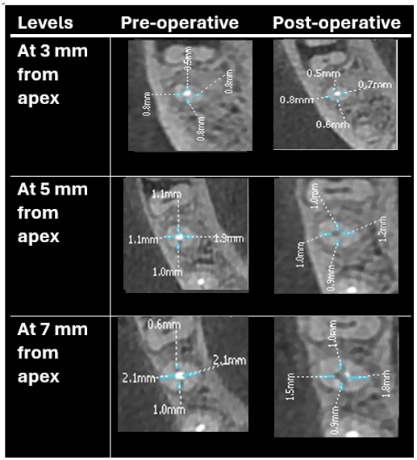
FIGURE B:- The measurement of the pre- and post measurements of the shortest distance between the edge of the root and canal in the Solite RS3 group and R-endo group at 3, 5, and 7 mm levels.
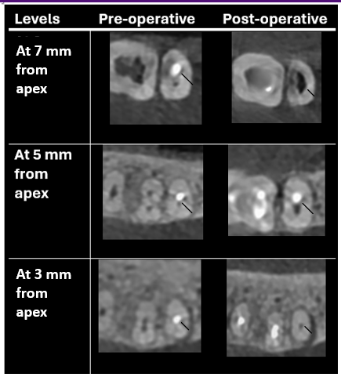

FIGURE C :- The measurement of the pre- and post measurements of the shortest distance between the edge of the root and canal in the R-endo group at 3, 5, and 7 mm levels.
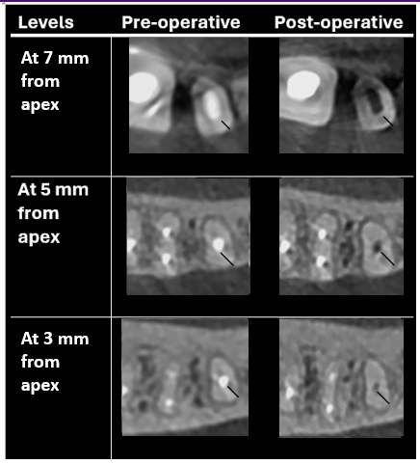

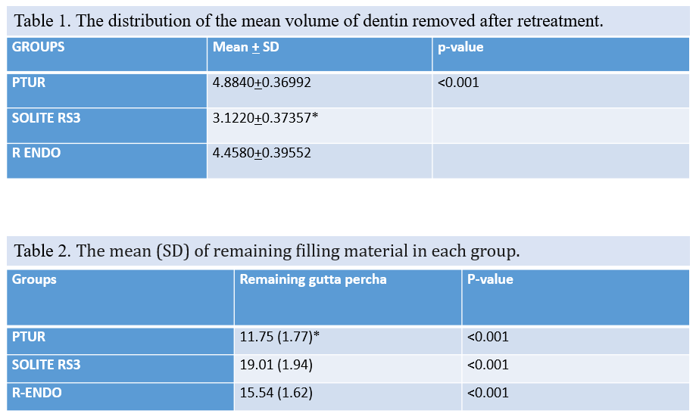

Graph 1
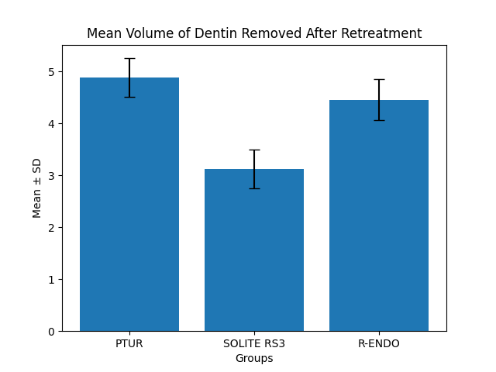
Graph 2

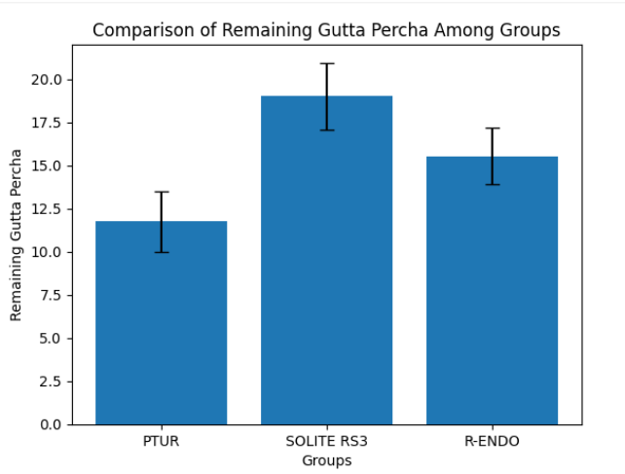

The present study demonstrated a statistically significant difference in both dentin removal and efficacy of gutta-percha (GP) removal among the three retreatment systems evaluated (p < 0.001).
The mean volume of dentin removed was highest in the ProTaper Universal Retreatment (PTUR) group (4.8840 ± 0.36992), followed by the R-Endo system (4.4580 ± 0.39552), whereas the Solite RS3 system showed the least dentin removal (3.1220 ± 0.37357). These findings indicate that PTUR and R-Endo systems are comparatively more aggressive in dentin removal, while Solite RS3 demonstrates a more conservative approach, preserving a greater amount of radicular dentin.
With respect to the remaining filling material, PTUR exhibited the least residual gutta-percha (11.75 ± 1.77), indicating superior cleaning efficiency. In contrast, Solite RS3 showed the highest amount of remaining filling material (19.01 ± 1.94), suggesting comparatively lower efficacy in removal. The R-Endo system demonstrated intermediate performance (15.54 ± 1.62). The differences among all groups were highly statistically significant (p < 0.001).
Further analysis using Dunn’s post hoc test revealed a statistically significant difference between Solite RS3 and R-Endo in terms of dentin removal, with Solite RS3 preserving more dentin. However, no statistically significant difference was observed between PTUR and R-Endo in terms of remaining filling material.
Overall, PTUR demonstrated superior efficacy in gutta-percha removal but at the expense of increased dentin loss, whereas Solite RS3 preserved dentinal structure more effectively but exhibited reduced cleaning efficiency. R-Endo showed intermediate behavior in both parameters.

DISCUSSION:-
The success of endodontic retreatment largely depends on complete removal of the existing filling material while preserving maximum root dentin, as excessive dentin loss may compromise tooth strength and increase susceptibility to vertical root fracture. The findings of the present study highlight the critical balance between cleaning efficiency and dentin preservation.
The results demonstrated that PTUR removed the maximum dentin, followed by R-Endo, whereas Solite RS3 preserved significantly more dentin. These findings are consistent with the study by Plotino et al., who reported that conventional NiTi rotary retreatment systems tend to be more aggressive due to their design and taper, leading to greater dentin removal¹⁰. Similarly, Versiani et al. emphasized that excessive instrumentation during retreatment can significantly reduce root dentin thickness, particularly in the danger zones of the root⁶.
The conservative behavior of Solite RS3 observed in the present study may be attributed to its heat-treated NiTi alloy and enhanced flexibility, which allows better canal negotiation with reduced lateral stress on dentinal walls. This is in agreement with Elnaghy and Elsaka, who reported that heat-treated NiTi instruments exhibit improved flexibility and cyclic fatigue resistance, thereby minimizing unnecessary dentin removal¹¹.
In terms of gutta-percha removal efficiency, PTUR demonstrated superior performance, which may be due to its progressive taper design and active cutting efficiency, facilitating rapid engagement and removal of obturation material. These findings are in accordance with Silva et al., who concluded that rotary retreatment systems such as ProTaper are more efficient in removing filling materials compared to other systems, although none achieve complete removal¹. Likewise, Alakshar et al. using micro-CT analysis reported that all systems leave residual material, particularly in the apical third, despite improved instrumentation techniques².
The R-Endo system showed intermediate results in both dentin removal and cleaning efficiency. This may be attributed to its less aggressive cutting design and sequence-based instrumentation, which balances dentin preservation and material removal. Kumar et al. similarly reported that R-Endo preserves more dentin compared to ProTaper but may be slightly less efficient in GP removal³.
The higher residual filling material observed in the Solite RS3 group suggests that while flexibility enhances dentin conservation, it may reduce cutting efficiency. This finding aligns with studies by Nevares et al., who reported that increased flexibility in rotary instruments may compromise debris removal efficiency due to reduced cutting aggressiveness⁵.
The use of CBCT in the present study allowed a reliable three-dimensional assessment of both dentin thickness and remaining filling material. Previous studies by Rathi et al. and PradeepKumar et al. have validated CBCT as an effective non-destructive tool for volumetric analysis in retreatment studies⁸⁷.
Overall, the present study reinforces the concept that no single retreatment system is ideal, and clinicians must choose instruments based on clinical priorities. When maximum cleaning is required, PTUR may be preferred, whereas in structurally compromised teeth, a conservative system like Solite RS3 may be advantageous to preserve dentin and prevent fracture.

CONCLUSION:-
From the above results, all three retreatment systems—ProTaper Universal Retreatment (PTUR), R-Endo, and Solite RS3—were effective in removing root canal filling material; however, none of the systems achieved complete elimination of gutta-percha from the canal system. PTUR demonstrated superior efficacy in the removal of gutta-percha, resulting in the least amount of residual filling material. However, this increased efficiency was associated with greater removal of radicular dentin, which may compromise the structural integrity of the tooth. R-Endo exhibited intermediate performance in both dentin removal and cleaning efficiency.
Solite RS3 showed the least dentin removal, thereby preserving maximum root dentin thickness, but was comparatively less efficient in removing filling material. This highlights its conservative nature, making it a potentially suitable option in cases where preservation of dentinal structure is of paramount importance.
Therefore, the choice of retreatment system should be guided by the clinical scenario, balancing the need for effective canal debridement with the preservation of tooth structure to ensure long-term success of endodontic retreatment.

Clinical Significance:
An ideal retreatment system should effectively remove obturation material while preserving maximum dentin. PTUR offers superior cleaning efficiency, whereas Solite RS3 provides better dentin conservation. Clinicians should select the system based on the structural condition of the tooth and treatment objectives.
Key Clinical Message
Effective endodontic retreatment requires complete removal of gutta-percha while preserving the structural integrity of the root canal system. Heat-treated retreatment files, owing to their superior flexibility and cutting efficiency, demonstrate enhanced gutta-percha removal with minimal compromise of remaining dentin thickness compared to conventional files. CBCT analysis provides a precise three-dimensional assessment, aiding clinicians in selecting retreatment systems that ensure optimal cleaning while reducing the risk of excessive dentin removal and subsequent root fracture.

REFERENCES :-
- Schilder H. Cleaning and shaping the root canal. Dent Clin North Am. 1974;18(2):269–296.¹
- Siqueira JF Jr, Rôças IN. Microbiology and treatment of endodontic infections. Int Endod J. 2008;41(6):509–520.²
- Nair PN. On the causes of persistent apical periodontitis: a review. Int Endod J. 2006;39(4):249–281.³
- Torabinejad M, Corr R, Handysides R, Shabahang S. Outcomes of nonsurgical retreatment and endodontic surgery: a systematic review. J Endod. 2009;35(7):930–937.⁴
- Friedman S, Stabholz A. Endodontic retreatment—case selection and technique. Part 1: criteria for case selection. J Endod. 1986;12(1):28–33.⁵
- Hülsmann M, Bluhm V. Efficacy, cleaning ability and safety of different rotary NiTi instruments in root canal retreatment. Int Endod J. 2004;37(7):468–476.⁶
- Gu LS, Ling JQ, Wei X, Huang XY. Efficacy of ProTaper Universal rotary retreatment system for gutta-percha removal. Int Endod J. 2008;41(4):288–295.⁷
- Tasdemir T, Er K, Yildirim T, Celik D. Efficacy of three rotary NiTi instruments in removing gutta-percha from root canals. Int Endod J. 2008;41(3):191–196.⁸
- Rödig T, Hausdörfer T, Konietschke F, Dullin C, Hahn W, Hülsmann M. Efficacy of D-RaCe and ProTaper retreatment systems in removing gutta-percha: a micro-CT study. Int Endod J. 2012;45(6):580–588.⁹
- Neelakantan P, Subbarao C, Subbarao CV. Comparative evaluation of modified canal staining and clearing technique, cone-beam computed tomography, peripheral quantitative computed tomography, spiral computed tomography, and plain and contrast medium–enhanced digital radiography in studying root canal morphology. J Endod. 2010;36(9):1547–1551.¹⁰
- Versiani MA, Pécora JD, Sousa-Neto MD. Microcomputed tomography analysis of the root canal morphology of human teeth. Int Endod J. 2011;44(5):399–404.¹¹
- Peters OA. Current challenges and concepts in the preparation of root canal systems: a review. J Endod. 2004;30(8):559–567.¹²
- Zogheib C, Sfeir G, Plotino G, Grande NM, Baba NZ. Impact of endodontic instrumentation on root dentin thickness and fracture resistance. J Endod. 2018;44(7):1099–1104.¹³
- Kim HC, Kwak SW, Cheung GS, Ko DH, Chung SM, Lee W. Cyclic fatigue and torsional resistance of two new nickel-titanium instruments used in retreatment. J Endod. 2012;38(4):541–544.¹⁴
- Plotino G, Grande NM, Cordaro M, Testarelli L, Gambarini G. A review of cyclic fatigue testing of nickel-titanium rotary instruments. J Endod. 2009;35(11):1469–1476.¹⁵
- Bürklein S, Schäfer E. Critical evaluation of root canal transportation by instrumentation. Int Endod J. 2015;48(1):1–15.¹⁶
- De-Deus G, Belladonna FG, Silva EJNL, Marins J, Souza EM, Neves AA. Micro-CT evaluation of non-instrumented canal areas after retreatment procedures. Int Endod J. 2015;48(10):951–959.¹⁷
- Gergi R, Sabbagh C. Effect of rotary retreatment files on dentin thickness and canal transportation. J Endod. 2007;33(3):320–323.¹⁸
- Paqué F, Balmer M, Attin T, Peters OA. Preparation of oval-shaped root canals in mandibular molars using nickel-titanium rotary instruments: a micro-CT study. J Endod. 2010;36(4):703–707.¹⁹
- Çelik Ünal G, Keçeci AD, Kaya BU, Tac AG. Quality of root canal fillings performed with different techniques and retreatment efficiency: a CBCT study. J Endod. 2009;35(10):1392–1395.²⁰
- Silva EJNL, Sá L, Belladonna FG, Neves AA, Accorsi-Mendonça T, Vieira VTL, et al. Efficacy of rotary and reciprocating systems for gutta-percha removal during root canal retreatment: a systematic review and meta-analysis. Int Endod J. 2020;53(7):857–869.²¹
- Alakshar A, Alrushoudi A, Alshaikh A, Alharbi F. Micro-CT evaluation of remaining filling material after retreatment using different NiTi systems. J Endod. 2021;47(3):389–395.²²
- Kumar M, Sharma V, Gupta S, Kumar R. Comparative evaluation of ProTaper retreatment and R-Endo systems in removal of gutta-percha using CBCT. J Conserv Dent. 2022;25(2):123–128.²³
- Topçuoğlu HS, Topçuoğlu G, Akti A, Düzgün S. Efficiency of different retreatment systems in curved root canals: a micro-CT study. Clin Oral Investig. 2020;24(2):1051–1058.²⁴
- Nevares G, de Albuquerque DS, Freire LG, Romeiro K, Fogel HM, dos Santos M. Effectiveness of rotary retreatment instruments in removing root canal filling materials: a micro-CT analysis. Restor Dent Endod. 2021;46(1):e10.²⁵
- Bhate M, Solete P, Mohan A. Comparative evaluation of heat treated retreatment files on canal transportation and dentin thickness in endodontically treated teeth: an in vitro CBCT study. Int Arab J Dent. 2025;16(2).²⁶
- Singh KB, Akhtar MS, Nagar R, Agarwal A, Azhar S, Singh V. Comparative analysis of the efficacy of various retreatment file systems in the removal of gutta-percha in retreatment cases and time taken during the procedure: an in vitro cone beam CT study. Cureus. 2024;16(3):e55551.²⁷
- Katle E, Zandi H, Pedersen D, Sunde PT, Torgersen GR, Ørstavik D. Radiographic outcome of endodontic treatment and retreatment of teeth with apical periodontitis using two different root canal irrigants: a prospective cohort study. Int Endod J. 2024;57(3):297–304.²⁸
- Chib A, Seth T, Bhatt M, et al. Nonsurgical retreatment of endodontically treated teeth: a prospective cohort study on success rates and quality of life. J Conserv Dent Endod. 2025.²⁹
- Baruah D, Bansal P, Sharma N, Sarma N, Palakal ND, Gupta I, et al. Forging flexibility: the science and innovation behind modern NiTi rotary endodontic files. IP Indian J Conserv Endod. 2025;10(3):138–145.³⁰
- Grande NM, Castagnola R, Minciacchi I, Marigo L, Plotino G. A review of the latest developments in rotary NiTi technology and root canal preparation. Aust Dent J. 2023;68(Suppl 1):S24–S38.³¹
- Agrawal PR, Chandak M, Nikhade PP, Patel AS, Bhopatkar JK. Revolutionizing endodontics: advancements in nickel–titanium instrument surfaces. J Conserv Dent Endod. 2024;27(2):126–133.³²
- Işık M, Aydın ZU. Effect of different obturation techniques on treatment results in single-visit non-surgical endodontic retreatment: randomized controlled clinical study. BMC Oral Health. 2024;24:1449.³³
- Nawabi H. Advancements in endodontic techniques: enhancing precision and patient outcomes. J Clin Dent Oral Health. 2024;8(5):222.³⁴Kumar M, Sharma V, Gupta S, Kumar R.
Comparative evaluation of ProTaper retreatment and R-Endo systems in removal of gutta-percha using CBCT. J Conserv Dent. 2022;25(2):123–128.
- Topçuoğlu HS, Topçuoğlu G, Akti A, Düzgün S.
Efficiency of different retreatment systems in curved root canals: a micro-CT study. Clin Oral Investig. 2020;24(2):1051–1058.
- Nevares G, de Albuquerque DS, Freire LG, Romeiro K, Fogel HM, dos Santos M.
Effectiveness of rotary retreatment instruments in removing root canal filling materials: a micro-CT analysis. Restor Dent Endod. 2021;46(1):e10.
- Bhate M, Solete P, Mohan A. Comparative evaluation of heat treated retreatment files on canal transportation and dentin thickness in endodontically treated teeth: an in vitro CBCT study. Int Arab J Dent. 2025;16(2).
- Singh KB, Akhtar MS, Nagar R, Agarwal A, Azhar S, Singh V. Comparative analysis of the efficacy of various retreatment file systems in the removal of gutta-percha in retreatment cases and time taken during the procedure: an in vitro cone beam CT study. Cureus. 2024;16(3):e55551.
- Katle E, Zandi H, Pedersen D, Sunde PT, Torgersen GR, Ørstavik D. Radiographic outcome of endodontic treatment and retreatment of teeth with apical periodontitis using two different root canal irrigants: a prospective cohort study. Int Endod J. 2024;57(3):297–304.
- Chib A, Seth T, Bhatt M, et al. Nonsurgical retreatment of endodontically treated teeth: a prospective cohort study on success rates and quality of life. J Conserv Dent Endod. 2025.
- Baruah D, Bansal P, Sharma N, Sarma N, Palakal ND, Gupta I, et al. Forging flexibility: the science and innovation behind modern NiTi rotary endodontic files. IP Indian J Conserv Endod. 2025;10(3):138–145.
- Grande NM, Castagnola R, Minciacchi I, Marigo L, Plotino G. A review of the latest developments in rotary NiTi technology and root canal preparation. Aust Dent J. 2023;68(Suppl 1):S24–S38.
- Agrawal PR, Chandak M, Nikhade PP, Patel AS, Bhopatkar JK. Revolutionizing endodontics: advancements in nickel–titanium instrument surfaces. J Conserv Dent Endod. 2024;27(2):126–133.
- Işık M, Aydın ZU. Effect of different obturation techniques on treatment results in single-visit non-surgical endodontic retreatment: randomized controlled clinical study. BMC Oral Health. 2024;24:1449.
- Nawabi H. Advancements in endodontic techniques: enhancing precision and patient outcomes. J Clin Dent Oral Health. 2024;8(5):222.

