Case report
PRESERVED CONDUCTION IN EBSTEIN’S ANOMALYREVEALED BY DUAL ACCESSORY PATHWAY ABLATION

ABSTRACT
Aims: To report a unique case of Ebstein's Anomaly (EA) where successful ablation of two accessory pathways revealed a remarkably preserved conduction system, and to discuss the role of thyrotoxicosis as a metabolic trigger in destabilizing congenital substrates leading to acute symptomatic presentation.
Case Presentation: A 13-year-old female with EA and Wolff-Parkinson-White syndrome (QRS 170 ms) presented with palpitations exacerbated by thyrotoxicosis. EPS and 3D mapping identified two right-sided pathways. Following successful radiofrequency ablation (RFA), the post-procedural ECG revealed a narrow QRS of 78 ms with an absence of the expected right bundle branch block (RBBB).
Discussion: EA is typically associated with intrinsic conduction system disease. This case challenges the "universal" RBBB paradigm. Thyrotoxicosis served as a metabolic "second hit," increasing myocardial excitability and triggering symptomatic tachycardia.
Conclusion: Conduction disease in EA is heterogeneous. Clinicians must remain vigilant for extracardiac metabolic triggers when a previously stable arrhythmic substrate becomes acute.
Keywords: Ebstein’s anomaly, Accessory Pathway, Pre-excitation, WPW syndrome, Radiofrequency Ablation, Right Bundle Branch Block, Thyrotoxicosis.

1.Introduction
Ebstein’s anomaly (EA) is a complex congenital heart defect characterized by the failure of tricuspid leaflet delamination, resulting in apical displacement of the functional annulus and a thinned, "atrialized" right ventricle. This structural disruption creates a fertile substrate for electrical abnormalities, with accessory pathways (APs) facilitating pre-excitation in approximately 30% of cases [1,2].
In his foundational work, Perloff noted that EA is nearly universally associated with right bundle branch block (RBBB) due to the stretching and fibrosis of the right-sided conduction system. In the presence of Wolff-Parkinson-White (WPW) syndrome, this underlying conduction delay is often "masked" by the AP [1]. Successful ablation is traditionally expected to "unmask" the underlying RBBB. We describe a rare case where ablation of dual accessory pathways revealed a strikingly narrow QRS of 78 ms, suggesting a preserved conduction system despite significant anatomical displacement.

2.Case Presentation
A 13-year-old female presented with intensified palpitations. Examination revealed a wide-split second heart sound and a mildly enlarged thyroid. The electrocardiogram (ECG) showed classic pre-excitation with positive delta waves in V1–V4 with QRS 170 msec (Figure 1a). Echocardiography confirmed EA with 28 mm septal leaflet displacement. Laboratory screening revealed biochemical thyrotoxicosis (TSH <0.01 mIU/L; elevated Free T3/T4) with negative TSH-receptor antibodies, suggesting thyroiditis.
While awaiting elective electrophysiology study (EPS), she developed acute palpitations. ECG confirmed narrow-complex SVT at 190 bpm, which terminated with 6mg of adenosine. Subsequent electrophysiology mapping utilized 3D electro anatomical reconstruction to identify two right sided accessory pathways- inferior and anterior- marked by the red ablation clusters at the successful lesion sites (Figure 2). Intracardiac electrograms recorded during mapping demonstrated “fusion” of atrial and ventricular signals at the distal ablation electrode (ABL d) confirming the bypass tract location (Figure 3). Following the first ablation, persistent pre-excitation confirmed the independent nature of the second pathway (Figure 4). Both were successfully eliminated via radiofrequency ablation (Figure 5), followed by antithyroid therapy. Notably, the post-procedural ECG revealed normal sinus rhythm with a narrow QRS of 78 ms and no evidence of RBBB (Figure 1b)—a striking departure from the expected "unmasking" of conduction delay in EA. She remained asymptomatic and euthyroid at one-month and three- month follow-up.

3.Discussion
This case highlights the unpredictability of the EA substrate. As Perloff notes, the atrialized ventricle creates a thinned, dysfunctional segment prone to re-entrant circuits [1]. The spontaneous SVT and its response to adenosine underscored a hyper-excitable state catalysed by thyrotoxicosis. Mapping in EA is technically demanding due to the displaced annulus and fragmented electrograms. The discovery of two pathways aligns with findings that EA often involves multiple bypass "strands" [3].
Intriguingly, RBBB—a hallmark of the diseased, stretched right-sided conduction system in EA—was absent post-ablation. Successfully ablating a masking AP typically reveals underlying RBBB; its absence here suggests a remarkably preserved conduction system despite structural displacement [1] and thus challenging the long-standing paradigm that significant structural displacement always necessitates conduction system disease.
The identification and elimination of two independent bypass tracts were necessary to reveal the true underlying electrical state of the heart. The resulting 78 ms QRS complex serves as a "medical curiosity" that demonstrates that even in the face of severe anatomical deformity, the specialized conduction tissue can remain functionally intact. Combined with the "second hit" of thyrotoxicosis, this illustrates EA's clinical heterogeneity.
Thyrotoxicosis acted as the catalyst, enhancing excitability by upregulating beta-adrenergic receptors and shortening refractory periods [4]. Perloff emphasized that in congenital heart disease, "unnatural" symptomatic changes should prompt a search for extracardiac factors [1]. In paediatrics, metabolic triggers can transform a manageable substrate into a crisis [5]. This case reinforces that while general rules apply, individual anatomical and physiological variations like the lack of RBBB or the presence of metabolic triggers dictate the clinical course and discusses the multifaceted nature of EA beyond just the valve morphology [6].
4.Conclusion
Ebstein’s anomaly frequently involves multiple accessory pathways [1]. The diagnosis and management of arrhythmias in Ebstein’s Anomaly must account for significant clinical heterogeneity. While RBBB is a hallmark of the disease, its absence post-ablation highlights that the conduction system may occasionally be spared [1]. Clinicians must also screen for metabolic triggers like thyrotoxicosis, which can transform stable congenital cardiac substrates into peri-procedural emergencies [4].

Consent
All authors declare that written informed consent was obtained from the patient’s legal guardians for publication of this case report and the accompanying images.
Ethical Approval
As per international or university standards, written ethical approval has been collected and preserved by the authors.
Disclaimer (Artificial Intelligence)
The authors hereby declare that no generative artificial intelligence tools (ChatGPT, Copilot, etc.) were used in the writing, editing, or production of this manuscript.
Competing Interests
Authors have declared that no competing interests exist.
Abbreviations
ABL D: Distal Ablation
AP: Accessory Pathway
EA: Ebstein’s anomaly
ECG: Electrocardiogram
EPS: Electrophysiology Study
RBBB: Right Bundle Branch Block
RFA: Radiofrequency Ablation
SVT: Supraventricular Tachycardia
TSH: Thyroid Stimulating Hormone
WPW: Wolff- Parkinson-White Syndrome

References
1. Perloff JK, Marelli AJ. Perloff's Clinical Recognition of Congenital Heart Disease. 7th ed. Elsevier; 2023; 13:176-195.
2. Attenhofer Jost CH, et al. Ebstein's anomaly: review of a multifaceted congenital cardiac condition. Swiss Med Wkly. 2005; 135:269-281.
3. Wei W, et al. Catheter ablation of accessory pathways in Ebstein's anomaly. J Cardiovasc Electrophysiology. 2022;33(9):2011-2018.
4. Klein I, Danzi S. Thyroid Disease and the Heart. Circulation. 2007;116(15):1725-1735.
5. Osman F, et al. The effects of treatment of hyperthyroidism on radiofrequency ablation of supraventricular tachycardia. BMC Cardiovascular Disorders. 2024; 24:112.
6. Hebe J. Ebstein's Anomaly in Children: Is It All About the Valve? J Am Coll Cardiol. 2021;77(11):1420-1422.

Figures:

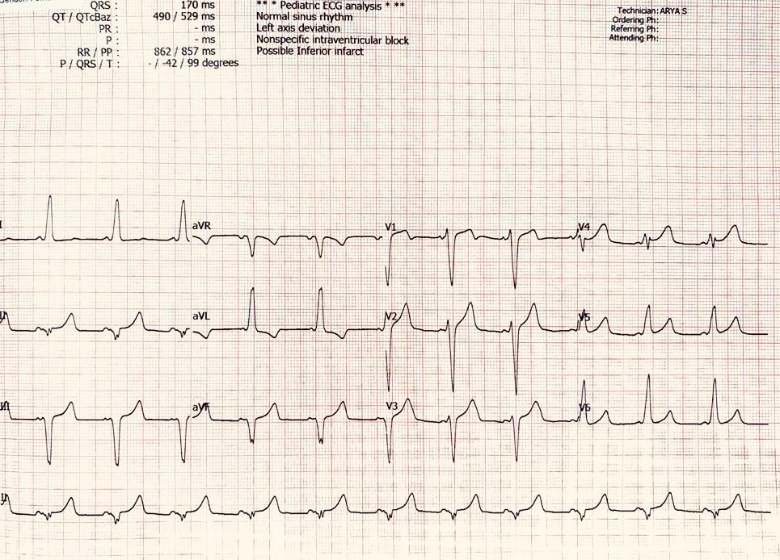
Figure 1a: Baseline 12-Lead ECG demonstrates sinus rhythm with hallmark features of WPW syndrome including shortened PR interval, widened QRS (170 ms), positive delta waves in leads V1-V4 and the predominantly negative QRS in the inferior leads suggests a right sided accessory pathway.
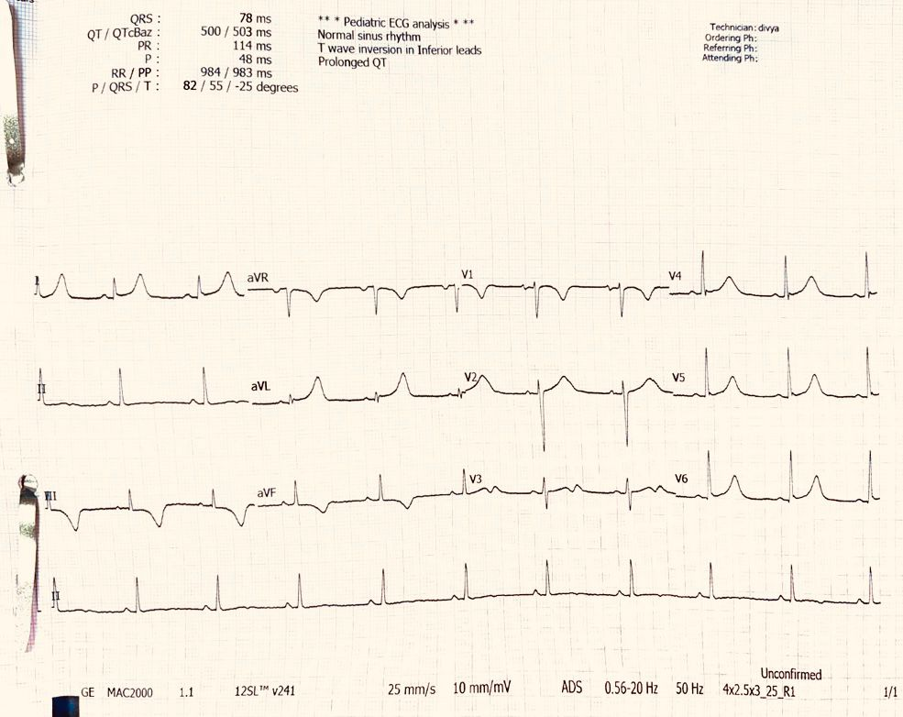
Figure 1b: 12-Lead ECG taken post ablation showing normal sinus rhythm with normal PR interval of 114 ms, narrow QRS (78ms), normalisation of conduction with disappearance of delta waves and the striking feature of absence of RBBB.
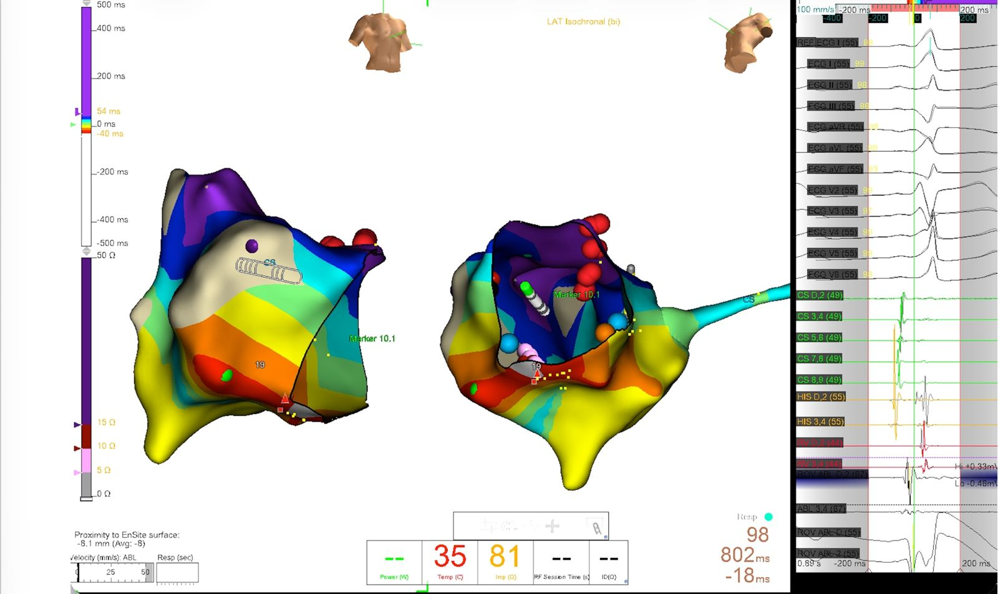
Figure 2: 3D electroanatomical mapping provides a precise spatial reconstruction of the “atrialized” right ventricle, with red clusters marking the successful radiofrequency ablation sites.

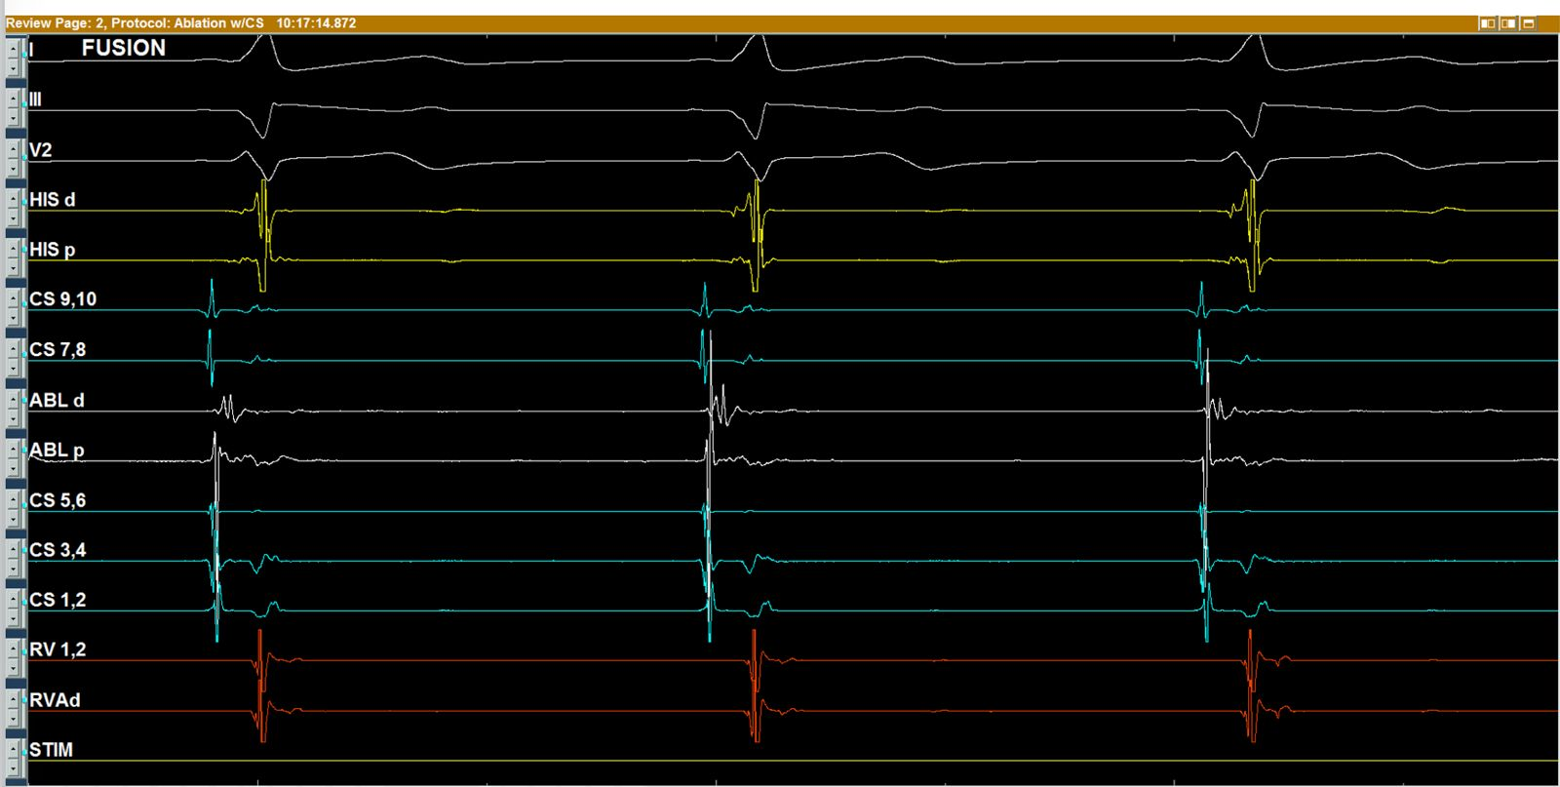
Figure 3: Intracardiac electrogram demonstrating pre- excitation through “fusion” of atrial and ventricular signals at the distal ablation electrode (ABL d), confirming the precise location of accessory pathway.
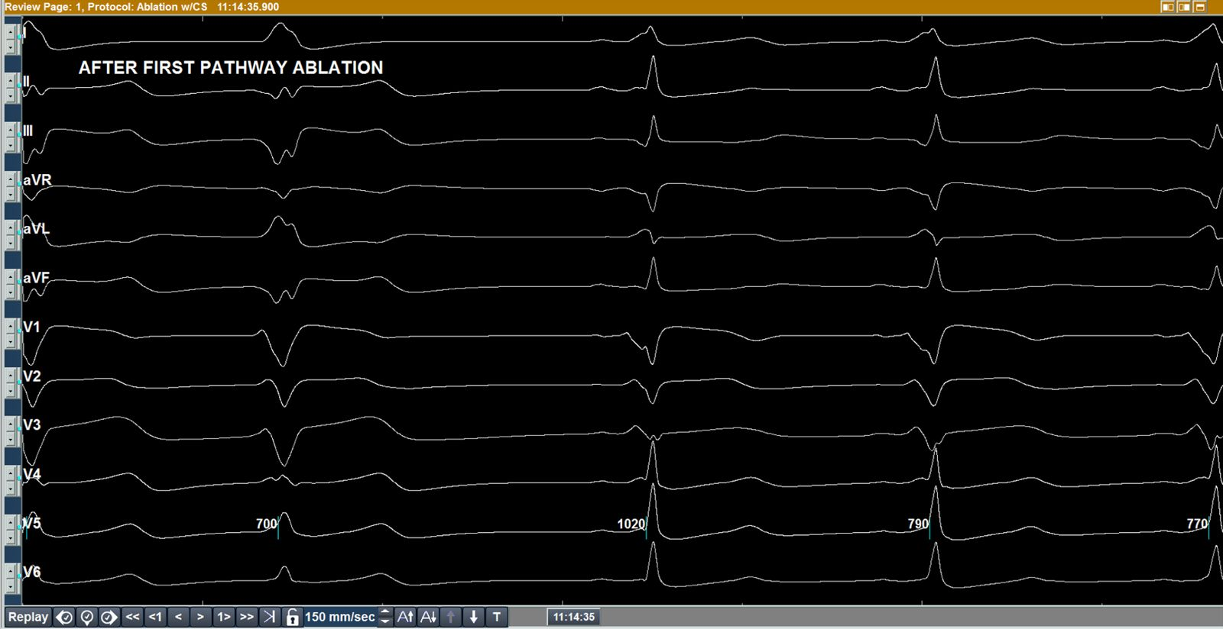
Figure 4: Intermediate tracing recorded after the first ablation, showing a shift in QRS morphology but persistent pre-excitation, confirming the presence of a second, independent accessory pathway.

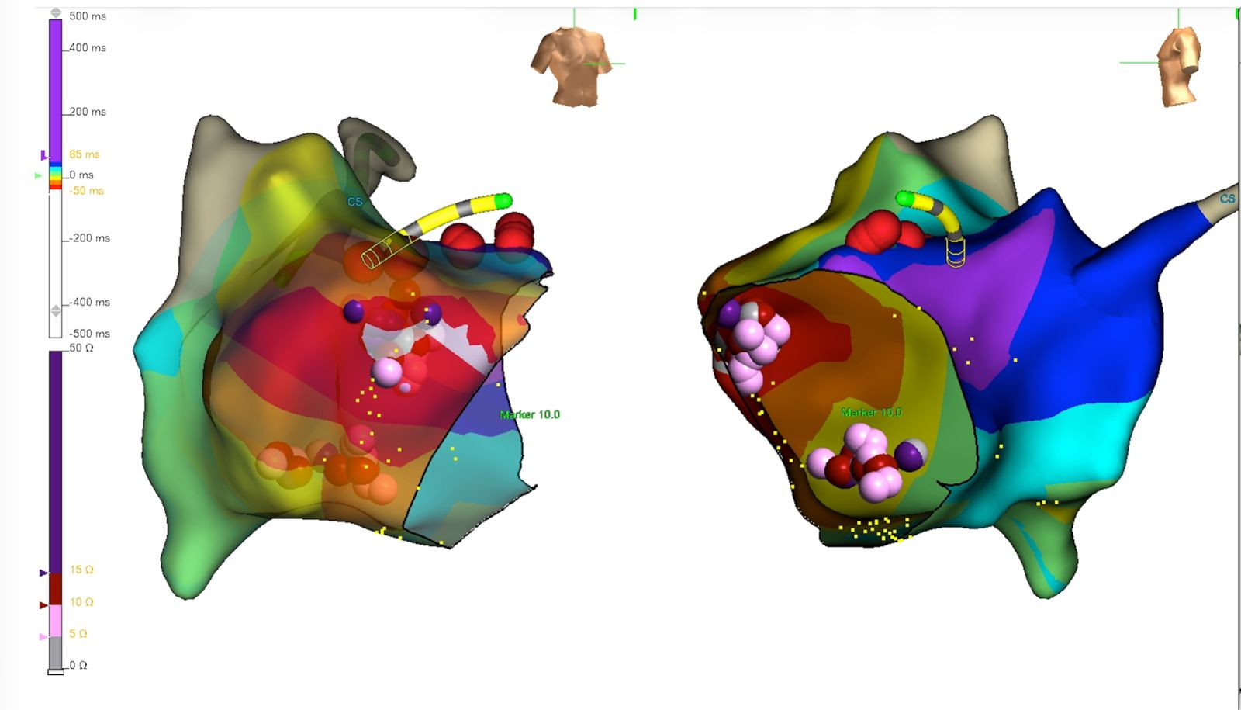
Figure 5: Final 3D map confirming the successful localization and elimination of the dual- pathway substrate along the right anterior and inferior tricuspid annulus.

