Case report
Dilated Cardiomyopathy Induced by Hypocalcemia Secondary to Iatrogenic Hypoparathyroidism: A Reversible and Underrecognized Entity

Abstract
Dilated cardiomyopathy (DCM) is a heterogeneous myocardial disorder frequently linked to ischemic, hypertensive, or idiopathic etiologies. However, metabolic causes such as hypocalcemia, though rare, can lead to reversible myocardial dysfunction. Hypocalcemia-induced cardiomyopathy (HIC), particularly secondary to iatrogenic hypoparathyroidism, is an underrecognized but treatable condition.
We report the case of a 51-year-old woman with a history of breast and thyroid cancer, who developed recurrent symptomatic hypocalcemia following total thyroidectomy, consistent with iatrogenic hypoparathyroidism. She presented with paresthesias, muscle cramps, and positive Chvostek and Trousseau signs, repeatedly requiring hospitalizations. Her poor adherence to calcium and vitamin D therapy was identified as the main cause of recurrent hypocalcemic episodes. She was admitted for decompensated heart failure with a left ventricular ejection fraction (LVEF) of 25%. Cardiac MRI excluded ischemic, valvular, or toxic causes of cardiomyopathy. Severe hypocalcemia (serum calcium 54 mg/L) was again noted during admission. Following intravenous calcium replacement and optimized oral supplementation, her LVEF improved to 55% at three months, confirming the diagnosis of HIC.Hypocalcemia should be considered in the differential diagnosis of unexplained DCM, especially in patients with a history of thyroidectomy. The pathophysiology involves impaired myocardial excitation-contraction coupling due to calcium deficiency. If recognized early, HIC has an excellent prognosis with normalization of cardiac function upon calcium correction.
This case underscores the importance of identifying reversible metabolic causes of DCM. Hypocalcemia secondary to hypoparathyroidism, although rare, should not be overlooked, particularly in non-compliant patients. Prompt recognition and correction of calcium levels can lead to full recovery of cardiac function.
Keywords: Hypocalcemia, Hypoparathyroidism, Dilated cardiomyopathy, Reversible cardiomyopathy, Heart failure, Calcium metabolism

Introduction
Dilated cardiomyopathy (DCM) is a myocardial disease defined by ventricular chamber enlargement and systolic dysfunction in the absence of abnormal loading conditions or coronary artery disease sufficient to explain the observed degree of dysfunction. It represents a significant cause of heart failure, arrhythmia, and sudden cardiac death. The etiologies of DCM are diverse, including genetic, infectious, toxic, metabolic, and autoimmune causes, as well as tachyarrhythmia-induced or ischemic forms [1,2].
Among metabolic causes, electrolyte disturbances are seldom implicated in clinical practice. However, hypocalcemia, particularly when chronic, can severely impair myocardial contractility. Although rare, hypocalcemia-induced cardiomyopathy (HIC) is a potentially reversible condition if appropriately diagnosed and treated [3].
Hypocalcemia secondary to hypoparathyroidism—especially of iatrogenic origin following thyroidectomy—is a recognized but underreported cause of reversible DCM. Its timely identification is crucial, as early treatment of hypocalcemia can restore cardiac function, avoiding unnecessary interventions or prolonged heart failure therapy [4].

Case report
A 51-year-old female with a medical background notable for well-controlled arterial hypertension and type 2 diabetes mellitus was admitted to our cardiology department for acute decompensated heart failure. Her oncologic history included left-sided breast cancer diagnosed in 2015, managed by partial mastectomy, followed by adjuvant chemotherapy (doxorubicin and paclitaxel), radiation therapy, and a five-year course of hormonal therapy with favorable oncological outcomes.
In 2020, she was diagnosed with papillary thyroid carcinoma and underwent total thyroidectomy with subsequent radioactive iodine ablation. Approximately two weeks postoperatively, she developed overt symptomatic hypocalcemia, attributed to iatrogenic hypoparathyroidism. Clinically, she presented with perioral paresthesias, generalized muscular cramps, and classic signs of Chvostek and Trousseau, confirming neuromuscular irritability. Biochemical analysis revealed profound hypocalcemia, necessitating intravenous calcium supplementation and subsequent initiation of oral calcium and active vitamin D.
Despite medical management, the patient experienced four hospitalizations over the following two years for recurrent, severe hypocalcemia, consistently associated with poor adherence to the prescribed treatment regimen. She frequently omitted doses or prematurely discontinued therapy, resulting in suboptimal biochemical control.
In early 2023, she presented with progressive exertional dyspnea, orthopnea, and peripheral edema. Echocardiographic evaluation demonstrated a dilated left ventricle with severely impaired systolic function (LVEF 30%). She was found to be in atrial fibrillation, which was successfully cardioverted to sinus rhythm. This cardiac decompensation occurred shortly after another endocrine hospitalization for severe hypocalcemia.
A comprehensive etiologic work-up was undertaken. Cardiac magnetic resonance imaging (CMR) excluded ischemic, infiltrative, and inflammatory etiologies, revealing no late gadolinium enhancement, no myocardial fibrosis, and no segmental wall motion abnormalities suggestive of ischemia or myocarditis. Coronary artery disease was also deemed unlikely due to the absence of ischemic patterns on imaging and lack of typical anginal symptoms.

Several differential diagnoses were systematically excluded:
- Ischemic cardiomyopathy was ruled out based on CMR findings.
- Valvular disease was excluded by the absence of significant valvular dysfunction on echocardiography and physical examination.
- Hypertensive cardiomyopathy was unlikely given normal blood pressure readings (92/60 mmHg) and the absence of left ventricular hypertrophy.
- Arrhythmia-induced cardiomyopathy was considered but deemed improbable due to persistent LV dysfunction despite rhythm control.
- Toxic cardiomyopathy was contemplated, considering prior exposure to anthracyclines and chest irradiation. However, the absence of myocardial fibrosis on CMR diminished the likelihood of chemotherapy- or radiation-induced myocardial damage.
- Thyrotoxic cardiomyopathy was excluded based on the timeline; cardiac dysfunction manifested more than three years after the hyperthyroid phase.
During the current admission, the patient again exhibited marked hypocalcemia (serum calcium 54 mg/L) with undetectable parathyroid hormone levels (<4 pg/mL). Clinically, she reported paresthesias and painful muscle cramps, and examination reaffirmed the positive Chvostek and Trousseau signs. ECG revealed sinus rhythm with a prolonged QTc interval (517 ms) (figure 1). Transthoracic echocardiography reconfirmed a globally hypokinetic and dilated LV with a persistently reduced LVEF of 25%(figure 2).
Given the exclusion of structural, ischemic, and toxic causes, and in light of the recurrent symptomatic hypocalcemia temporally associated with heart failure exacerbations, a diagnosis of hypocalcemia-induced dilated cardiomyopathy (HIC) was strongly considered.
The patient received intravenous calcium gluconate, followed by high-dose oral calcium carbonate and calcitriol. Therapeutic compliance was emphasized through patient education and structured endocrinology-cardiology co-management.The patient was also started on heart failure therapy.
At three-month follow-up, the patient was asymptomatic,the ECG demonstrated normalization of the QTc interval(figure 3), concomitant with normalization of serum calcium levels at 88 mg/L.with significant echocardiographic improvement in LV systolic function (LVEF 55%) (figure 4), confirming the reversible nature of her cardiomyopathy and supporting the diagnosis of HIC secondary to iatrogenic hypoparathyroidism.

Discussion
DCM remains a challenging diagnosis due to its heterogeneous etiologies and variable prognostic implications. Identification of reversible causes is crucial in optimizing patient outcomes [5].

Etiologies of Dilated Cardiomyopathy
DCM may be idiopathic or secondary to identifiable causes such as:
- Ischemic heart disease
- Valvular pathologies
- Hypertension
- Tachyarrhythmias
- Infections (e.g., myocarditis)
- Toxins (e.g., alcohol, chemotherapeutic agents)
- Endocrine/metabolic disorders [6].
In our patient, extensive investigations excluded ischemia, valvular disease, arrhythmia-induced dysfunction, and cardiotoxicity. The absence of structural abnormalities on cardiac MRI and the normalization of LVEF after calcium correction pointed toward a metabolic etiology.

Hypocalcemia-Induced Cardiomyopathy
Hypocalcemia, though rare, is a recognized cause of reversible cardiomyopathy. It alters excitation-contraction coupling by reducing calcium influx into myocytes, impairing myocardial contractility [7]. Prolonged QT interval and heart failure symptoms are common presentations. In severe cases, cardiogenic shock may occur [8].
The most frequent cause of acquired hypocalcemia in adults is iatrogenic hypoparathyroidism, usually post-thyroidectomy [9]. Chronic hypocalcemia leads to systolic dysfunction, sometimes reversible with adequate calcium and vitamin D supplementation. A review by Cummings et al. identified 25 cases of HIC, with iatrogenic hypoparathyroidism accounting for over 40% [10].

Pathophysiology
Calcium ions are essential for myocardial excitation-contraction coupling. Hypocalcemia reduces calcium-induced calcium release from the sarcoplasmic reticulum, decreasing contractility [11]. It may also affect myocardial repolarization, explaining the QT prolongation observed in ECGs [12].
Hypocalcemia may lead to:
- Decreased stroke volume and cardiac output
- Compensatory sympathetic activation
- Progressive LV dilatation and remodeling if chronic
Correction of hypocalcemia typically leads to functional recovery, distinguishing HIC from structural forms of DCM.

Diagnosis and Management
Clinicians must consider serum calcium in any patient presenting with unexplained systolic dysfunction, especially in the context of recent thyroid/parathyroid surgery. Diagnosis relies on:
- ECG findings (QT prolongation)
- Echocardiographic evidence of LV dysfunction
- Biochemical confirmation of hypocalcemia and low PTH
- Exclusion of other causes (via MRI or coronary angiography)
Treatment includes:
- IV calcium in acute settings
- Oral calcium/vitamin D analogs for long-term maintenance
- PTH analogs in refractory cases [13]

Prognosis
The prognosis of HIC is favorable when identified early and treated effectively. Cardiac function typically normalizes within weeks to months [14]. However, delayed treatment or recurrent hypocalcemia may result in irreversible myocardial damage [15].

Conclusion
This case illustrates a rare but reversible cause of DCM secondary to iatrogenic hypoparathyroidism-induced hypocalcemia. The restoration of LV function following calcium supplementation emphasizes the need for clinicians to consider metabolic causes—particularly in patients with relevant surgical histories.
While ischemia remains the most common etiology of DCM, less frequent but treatable conditions like HIC must not be overlooked. Systematic diagnostic evaluation, including electrolyte profiling, is essential in every new case of DCM to guide appropriate, and sometimes curative, therapy.
Abbreviation:
DCM: Dilated cardiomyopathy
HIC: Hypocalcemia-induced cardiomyopathy

Ethical approval: N/a.
Consent Statement
Written informed consent was obtained from the patient for the publication of this case report, including all clinical data and accompanying images. All authors have read and approved the final manuscript and agree with its submission.

References
- Arbelo E, Protonotarios A, Gimeno JR, et al. 2023 ESC Guidelines for the management of cardiomyopathies. Eur Heart J. 2023;44(37):3503–3626. doi:10.1093/eurheartj/ehad194.
- Pinto YM, Elliott PM, Arbustini E, et al. Proposal for a revised definition of dilated cardiomyopathy. Eur Heart J. 2016;37(23):1858–1870. doi:10.1093/eurheartj/ehv727.
- Wen Y, Luo X. Hypocalcemic cardiomyopathy: a case report. Front Cardiovasc Med. 2022;9:999550. doi:10.3389/fcvm.2022.999550.
- Clarke BL, Vokes TJ, Bilezikian JP, et al. Hypoparathyroidism: update of guidelines from the 2022 International Task Force. J Bone Miner Res. 2022;37(12):2568–2602. doi:10.1002/jbmr.4683.
- McKenna WJ, Judge DP. Epidemiology, etiology, and diagnosis of dilated cardiomyopathy. Lancet. 2021;398(10248):1520–1533. doi:10.1016/S0140-6736(21)01576-7.
- Caforio AL, Pankuweit S, Arbustini E, et al. Current state of knowledge on aetiology, diagnosis, management, and therapy of myocarditis: a position statement of the European Society of Cardiology Working Group on Myocardial and Pericardial Diseases. Eur Heart J. 2013;34(33):2636–2648. doi:10.1093/eurheartj/eht210.
- Albakri A. Electrolyte/renal abnormalities cardiomyopathy: a review and pooled analysis of pathophysiology, diagnosis and clinical management. Clin Med Invest. 2020;5:1–7. doi:10.15761/CMI.1000202.
- Xie Y, Yang J, Li K, et al. Case report: a case of hypocalcemic cardiomyopathy with non-reversible cardiac fibrosis. Front Cardiovasc Med. 2023;10:1166600. doi:10.3389/fcvm.2023.1166600.
- Zhang W, Xue F, Bu Q, Liu X. Hypocalcemic cardiomyopathy after parathyroidectomy in a patient with uremia: a case report and literature review. J Int Med Res. 2020;48(7):300060520942115. doi:10.1177/0300060520942115.
- Baqi DH, Al-Mashhadani SA, Al-Taie ZH. Hypocalcemia as a cause of reversible heart failure. J Med Case Rep. 2022;16(1):1. doi:10.1186/s13256-022-03112-7.
- Bers DM. Cardiac excitation-contraction coupling. Nature. 2002;415(6868):198–205. doi:10.1038/415198a.
- Vatta M, Towbin JA. Arrhythmias and dilated cardiomyopathy: the role of calcium and other electrolytes. Prog Cardiovasc Dis. 2020;63(2):119–126. doi:10.1016/j.pcad.2020.05.001.
- Bilezikian JP, Khan AA, Potts JT, et al. Evaluation and management of primary hyperparathyroidism: Fifth International Workshop Guidelines. J Bone Miner Res. 2022;37(11):2293–2314. doi:10.1002/jbmr.4652.
- Cusano NE, Rubin MR, Bilezikian JP. Hypoparathyroidism: clinical features, skeletal microstructure and parathyroid hormone replacement. Best Pract Res Clin Endocrinol Metab. 2018;32(6):913–924. doi:10.1016/j.beem.2018.10.001.
- Avsar A, Dogan A, Tavli T. A rare cause of reversible dilated cardiomyopathy: hypocalcemia. Echocardiography. 2004;21(7):609–612. doi:10.1111/j.0742-2822.2004.03149.x.

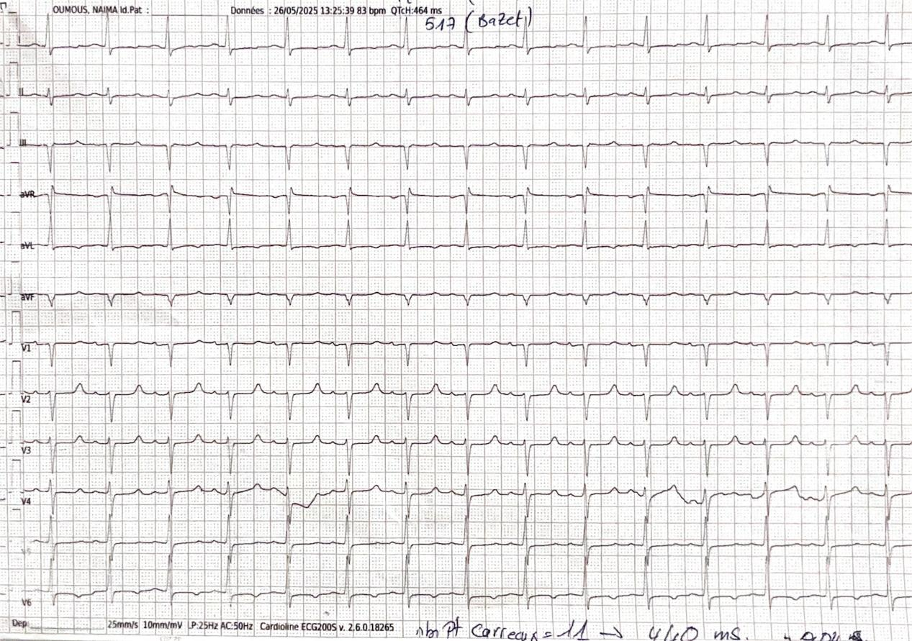
Figure 1: Electrocardiogram revealed sinus rhythm with a prolonged QTc interval (517 ms) before correction of hypocalcemia

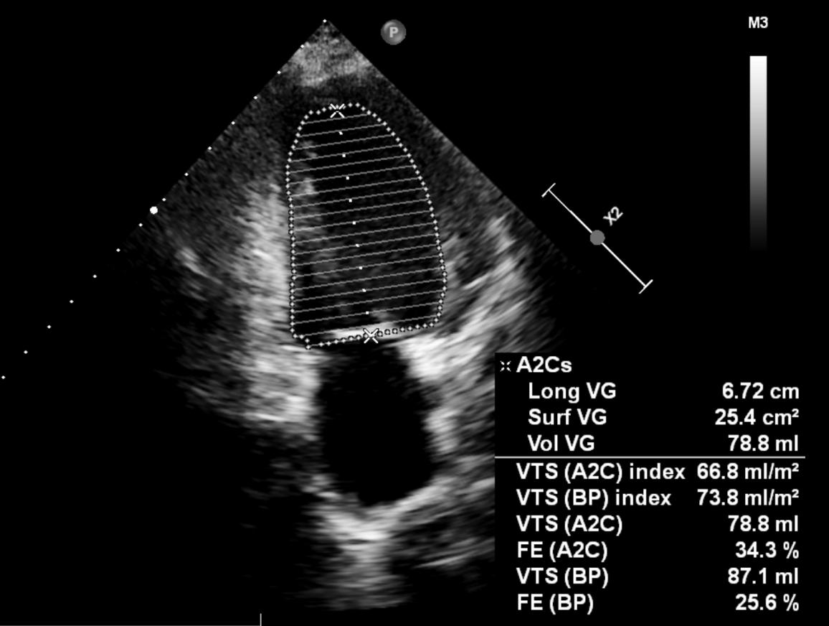
Figure 2: Echocardiographic image showing a dilated left ventricle with a left ventricular ejection fraction estimated at 25% using the biplane Simpson’s method

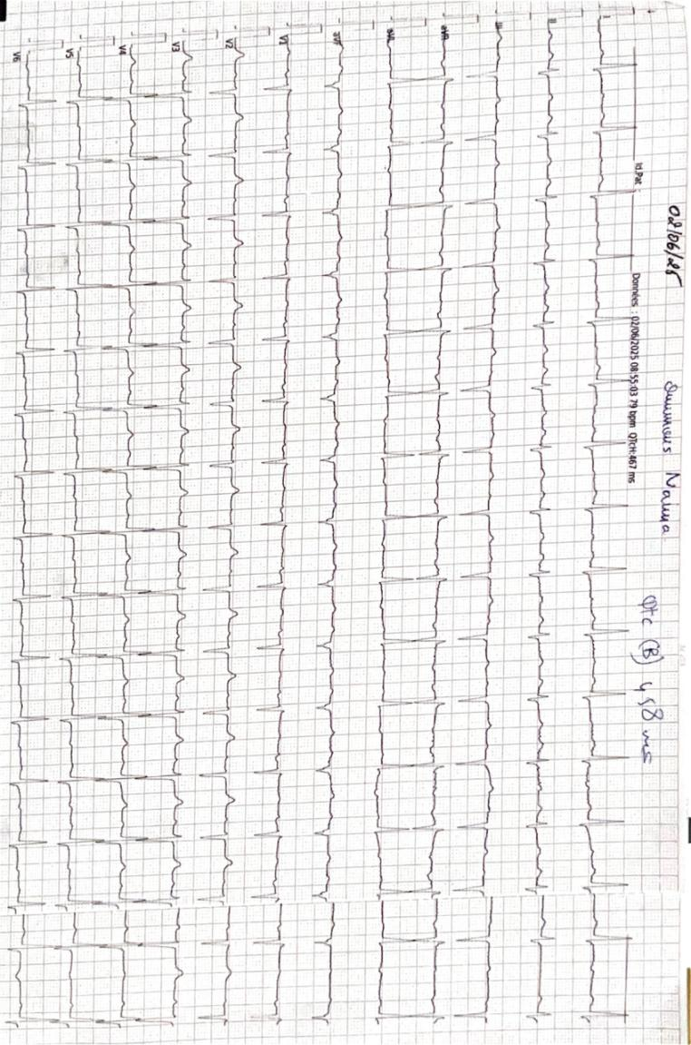
Figure 3: Electrocardiogram showing normal QTc interval (458 ms) after correction of hypocalcemia

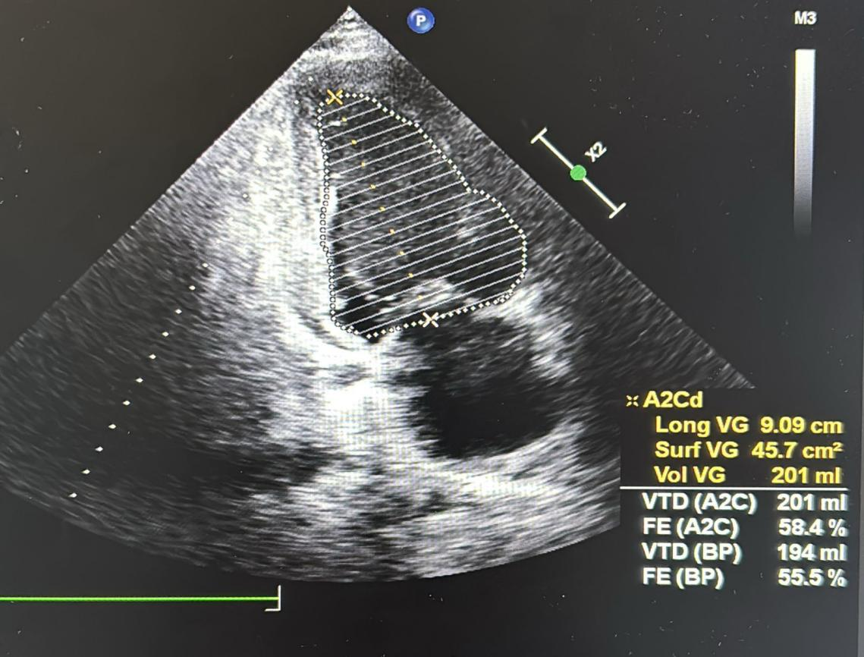
Figure 4:Echocardiographic image demonstrating improvement of the left ventricular ejection fraction after treatment. The LVEF is estimated at 55% using the biplane Simpson’s method

