Case report

Inguinal Dermoid Cyst Mimicking Hernia with Cough Impulse: A Diagnostic Pitfall in an Elderly Female

.
ABSTRACT

Aim:
To highlight the rare occurrence of an inguinal dermoid cyst in an elderly female clinically mimicking an inguinal hernia with cough impulse, emphasizing the diagnostic challenges, role of imaging, and importance of surgical excision with histopathological confirmation for definitive diagnosis.

Presentation of Case:
A 76-year-old woman presented with a progressively enlarging left inguinal swelling over one year. The mass was soft, mobile, and non-tender, measuring approximately 6 × 4 cm and extending toward the labia majora. Despite being non-reducible, a cough impulse was elicited, raising suspicion of an inguinal hernia. Contrast-enhanced CT revealed a well-defined 7 × 4 cm cystic lesion along the round ligament, suggestive of a Canal of Nuck hydrocele. Intraoperatively, a thick-walled cyst containing sebaceous and keratinous material was identified. Complete excision was performed, followed by reinforcement of the posterior wall using a modified Bassini repair with Prolene darning. Histopathology confirmed a mature cystic teratoma without malignant features. Recovery was uneventful.

Discussion:
The presence of a cough impulse in this case created a significant diagnostic pitfall, as this sign is typically associated with hernias. Here, it was likely transmitted through a weakened inguinal floor rather than a true hernial sac. Even with imaging, differentiating dermoid cysts from other cystic lesions remains challenging.

Conclusion:
This case highlights the need to consider rare entities in atypical groin swellings. Surgical exploration remains both diagnostic and therapeutic, particularly when clinical and radiologic findings are inconclusive.

Keywords: Inguinal dermoid cyst, Canal of Nuck, Mature cystic teratoma, Inguinal swelling, Surgical excision

1. INTRODUCTION

Inguinal swellings in female patients can be diagnostically complex, owing to the diversity of underlying conditions that range from frequently encountered hernias to uncommon developmental abnormalities. One such entity involves the canal of Nuck, an embryological remnant representing the persistent processus vaginalis that accompanies the round ligament. When obliteration fails, it may give rise to cystic lesions or hydroceles that manifest as groin swellings in adult females [1, 2].
These lesions can closely simulate inguinal hernias in clinical practice, particularly when their size or prominence fluctuates with changes in intra-abdominal pressure. Such overlap often complicates accurate preoperative identification [3, 4]. While imaging modalities—including ultrasonography, computed tomography (CT), and magnetic resonance imaging (MRI)—are valuable in characterizing lesion morphology and anatomical relationships, they may not always yield a definitive diagnosis, which is frequently established only at the time of surgical exploration [2,5].
Dermoid cysts, also referred to as mature cystic teratomas, are benign lesions derived from ectodermal tissue and typically contain keratinized epithelium along with adnexal structures such as sebaceous glands and hair follicles. Although commonly encountered in gonadal sites, their presence within the inguinal canal is exceptionally uncommon and can further obscure diagnostic clarity [8].
The present case is distinguished by an atypical presentation of an inguinal cystic lesion associated with a demonstrable cough impulse, thereby closely imitating an inguinal hernia or a canal of Nuck hydrocele. This unusual combination underscores the importance of considering less common etiologies, particularly in elderly female patients with incongruent clinical findings.

2. PRESENTATION OF CASE

A 76-year-old woman presented with a one-year history of a progressively enlarging swelling in the left inguinal region. The onset was gradual, and the mass increased steadily in size over time. One week prior to evaluation, she began experiencing a localized dull ache over the swelling. There were no associated features suggestive of bowel obstruction, including vomiting or abdominal distension. She did report intermittent low-grade fever over the preceding year and increased urinary frequency for one month. There was no history of trauma, chronic cough, or unintentional weight loss. Her medical background included well-controlled hypertension. She had undergone an open hysterectomy approximately 30 years earlier and was concurrently being evaluated for cholelithiasis and an incidental left adrenal lesion. On physical examination, the patient was hemodynamically stable. Inspection and palpation of the left groin revealed a solitary, well-circumscribed swelling measuring approximately 6 × 4 cm, extending towards the labia majora. The lesion was soft, cystic in consistency, non-tender, and mobile. It was nonreducible and did not exhibit transillumination. Notably, a cough impulse was appreciable despite the cystic nature of the swelling, presenting an apparent clinical inconsistency. No overlying skin changes or regional lymphadenopathy were identified. Based on these findings, a provisional diagnosis of canal of Nuck hydrocele was considered. Differential diagnoses included inguinal hernia, lipoma, and dermoid cyst. Contrast-enhanced CT imaging of the abdomen and pelvis demonstrated a well-defined, thin-walled cystic structure measuring approximately 7 × 4 cm within the left inguinal canal, extending along the course of the round ligament into the labia majora (Fig. 1). Surgical exploration was performed. Intraoperatively, a thick-walled cystic lesion was identified within the inguinal canal and meticulously separated from adjacent structures (Fig. 2). Upon incision, the cyst contained dense, greyish-brown sebaceous material rather than serous fluid, suggesting a dermoid origin (Fig. 3). The lesion was completely excised further inspection revealed attenuation of the posterior wall of the inguinal canal, which likely accounted for the preoperative cough impulse. Reinforcement was achieved using a modified Bassini repair supplemented with Prolene darning (Fig. 4). The postoperative course was uneventful. The patient recovered without complications. Histopathological evaluation demonstrated a cyst lined by keratinized stratified squamous epithelium with associated adnexal elements, including sebaceous glands and hair follicles, confirming the diagnosis of a mature cystic teratoma (Fig. 5). No malignant transformation was observed. Patient remained symptom-free on follow-up, with no evidence of recurrence.

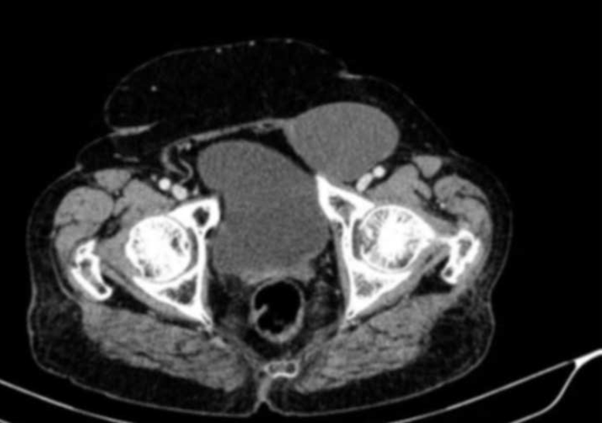

Figure 1: Axial CT pelvis shows a well-defined rounded anterior pelvic soft-tissue lesion adjacent to the urinary bladder.

Figure 2: Intraoperative image demonstrating surgical exposure and dissection of the lesion.

Figure 3: Lesion being delivered/excised with clear identification from surrounding tissues.

Figure 4: Excised specimen showing a well-defined lobulated soft tissue mass.

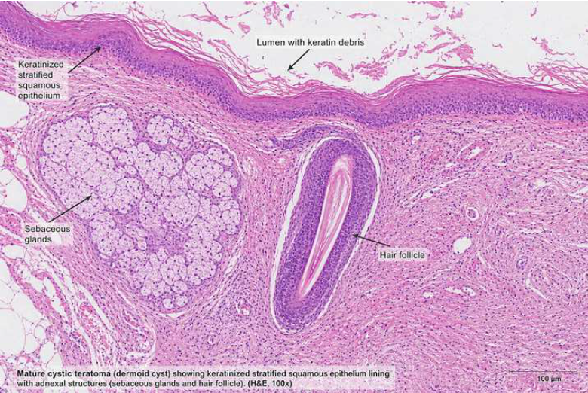

Figure 5: Cyst lined by keratinized stratified squamous epithelium with adnexal structures and luminal keratin, consistent with Mature cystic teratoma

3. Discussion

Assessment of inguinal masses in female patients requires a nuanced approach, given the broad differential diagnosis and the relative rarity of certain conditions. While hernias account for the majority of cases, less common entities such as canal of Nuck cysts and ectopic dermoid cysts warrant consideration, particularly when clinical features do not align with typical patterns [2,6]. From an embryological standpoint, the canal of Nuck represents a patent processus vaginalis extending alongside the round ligament. Persistence of this structure may predispose to fluid accumulation and cyst formation, presenting as a groin mass in adult women [2, 4]. Classically, such lesions are described as non-reducible and lacking a cough impulse, features that help distinguish them from hernias. In this case, the presence of a cough impulse proved misleading. Although commonly regarded as indicative of a hernia, this sign may occasionally arise through alternative mechanisms. A plausible explanation in this instance is the transmission of intra-abdominal pressure across a weakened inguinal floor rather than through a true hernial sac. This observation highlights the limitations of relying solely on traditional clinical signs when evaluating atypical presentations [3, 7]. Imaging plays an important adjunctive role in preoperative assessment. Ultrasonography and CT typically identify well-circumscribed cystic lesions, while MRI may offer superior soft tissue characterization. Nonetheless, distinguishing among canal of Nuck cysts, dermoid cysts, and other cystic entities based exclusively on imaging findings remains challenging. Consequently, definitive diagnosis is frequently achieved only during operative intervention [5]. Dermoid cysts occurring in the inguinal region are exceptionally rare. Originating from ectodermal inclusions, these lesions contain keratinous debris and adnexal structures. Their atypical location often leads to diagnostic ambiguity, as they can mimic more prevalent conditions such as hydroceles, lipomas, or hernias on both clinical and radiological evaluation [8]. Complete surgical excision remains the cornerstone of management and is typically curative. In addition to resolving the lesion, excision permits histopathological confirmation, which is essential to exclude the rare possibility of malignant transformation. When associated with structural weakness of the inguinal canal, simultaneous repair should be undertaken to reduce the risk of recurrence and optimize functional outcomes. This case offers several important considerations: uncommon pathologies should remain within the differential when clinical findings are inconsistent; a cough impulse, although traditionally associated with hernias, may not be pathognomonic; and definitive diagnosis often depends on intraoperative assessment supported by histopathology.

4. Conclusion

This report describes a rare inguinal dermoid cyst presenting with clinical features suggestive of a canal of Nuck hydrocele, further complicated by a misleading cough impulse. It illustrates the limitations of relying exclusively on clinical examination and imaging in atypical cases. Maintaining diagnostic vigilance and considering less common etiologies are essential, particularly in elderly female patients. Surgical exploration not only establishes the diagnosis but also facilitates definitive management, with complete excision resulting in favourable outcomes.

References

1. Alhashim A, Almuslim A, Alhakeem R, Aldossary H, Alburaih A, Alsaleh F, Alkishi T, Alhashim A. Encysted hydrocele of the canal of Nuck in a 7-year-old female: A case report. Radiol Case Rep. 2025 Jul 22;20(10):5070-5073. doi: 10.1016/j.radcr.2025.06.102. PMID: 40735065; PMCID: PMC12305697.

2. Prodromidou A, Paspala A, Schizas D, Spartalis E, Nastos C, Machairas N. Cyst of the Canal of Nuck in adult females: A case report and systematic review. Biomed Rep. 2020 Jun; 12(6):333-338. doi:10.3892/br.2020.1295. Epub 2020 Mar 27. PMID: 32346477; PMCID: PMC7184959.

3. Topal U, Sarıtaş AG, Ülkü A, Akçam AT, Doran F. Cyst of the Canal of Nuck mimicking inguinal hernia. Int J Surg Case Rep. 2018; 52:117-119. doi: 10.1016/j.ijscr.2018.09.053. Epub 2018 Oct 10. PMID: 30342391; PMCID: PMC6197703.

4. Keeratibharat N, Chansangrat J. Hydrocele of the Canal of Nuck: A Review. Cureus. 2022 Apr 2;14(4):e23757. doi: 10.7759/cureus.23757. PMID: 35402114; PMCID: PMC8980195.

5. Maharjan S, Shrestha S, Gimire SK, Rijal D, Pandey SR. Encysted hydrocele of the canal of Nuck- A rare cause of inguinal swelling in an adult female: A case report. Int J Surg Case Rep. 2025 Aug;133:111562. doi: 10.1016/j.ijscr.2025.111562. Epub 2025 Jun 24. PMID: 40580897; PMCID: PMC12269877.

6. Gkioulos F, Theodoridou S, Abay B, Engledow AH. A Case Report of Female Hydrocele of the Canal of Nuck (Type I): A Diagnostic Challenge and Surgical Solution. Cureus. 2023 Oct 29;15(10):e47926. doi: 10.7759/cureus.47926. PMID: 37908696; PMCID: PMC10613587.

7. Khadim B, AlNuaimi D, Abdulghaffar S, AlKetbi R. Hydrocele of the canal of Nuck: a rare differential diagnosis for an inguinal hernia. J Ultrason. 2024 Feb 27;24(96):20240007. doi: 10.15557/jou.2024.0007. PMID: 38419838; PMCID: PMC10897368.

8. Ba-Shammakh SA, Almaletti M, Aqel BA. Beyond the Norm: Unveiling a Dermoid Cyst in an Inguinal Hernia Case. Cureus. 2023 Aug 19;15(8):e43736. doi: 10.7759/cureus.43736. PMID: 37727175; PMCID: PMC10505832.

