Case report
Mc swain type V Appendiceal Intussusception as a Lead Point in Infantile Ileocolic Intussusception: A report on A rare Case.

Abstract
Appendiceal intussusception is a rare condition, particularly in infants, and may serve as a pathological lead point for ileocolic intussusception. We report a 5-month-old male presenting with abdominal pain, red currant jelly stools, and a palpable abdominal mass. Imaging suggested ileo-colic intussusception, and surgical exploration revealed a markedly elongated appendix (~10 cm) acting as the lead point. Appendectomy with vice versa reduction of intussusception was performed successfully. This case highlights the importance of considering rare lead points in atypical presentations of intussusception in infancy².
Keywords: Intussusception, appendix, lead point, infant, McSwain classification
Introduction
Intussusception is one of the most common causes of intestinal obstruction in infants. Most cases are idiopathic; however, pathological lead points are identified only in a few cases, especially in atypical age groups or presentations¹. Appendiceal intussusception is rare, with an incidence of approximately 0.01%². Its occurrence as a lead point in infants is extremely uncommon and often diagnosed intraoperatively⁶.
Case Report
A 5-month-old male presented with a 2-day history of intermittent abdominal pain and excessive crying, followed by passage of blood-stained stools for 1 day. There was no history of vomiting or fever.
On examination, the infant had tachycardia. Abdominal examination revealed a palpable sausage-shaped mass in the left iliac region with an empty right iliac fossa. Digital rectal examination showed blood-stained mucoid discharge.
Ultrasonography demonstrated a target sign suggestive of intussusception. (Fig 1)
Given the clinical findings, a trial of pneumostatic reduction was attempted which failed to reduce the intussusception. Therefore, emergency surgical exploration was undertaken.
Intraoperative Findings
Ileocolic intussusception of approximate length 5 cm was identified. After reduction of the intussusception, a markedly elongated appendix (~10 cm) was found acting as the lead point, (fig 2) with invagination into the cecum—consistent with appendiceal intussusception.
Appendectomy was done. The reduced bowel was viable.
Postoperative Course
The postoperative period was uneventful. The child was started on oral feeds on post operative day (POD) 2. He tolerated feeds well. He was discharged in stable condition on POD 4. Histopathological examination of the excised appendix revealed no specific pathology.
Discussion
Appendiceal intussusception is an uncommon entity and an even rarer cause of ileocolic intussusception in infants⁶. While most pediatric intussusceptions are idiopathic, the likelihood of a pathological lead point increases in younger infants, atypical presentations, or cases with bleeding per rectum¹˒³˒⁴.
The present case is distinctive due to the presence of a markedly elongated appendix (~10 cm) acting as a lead point in a 5-month-old infant—an association that is only sparsely described in the literature. The lowest reported age of occurrence of this pathology in literature is 27 months as reported by Cocomazzi R et al.⁸ To the best of our knowledge, this is the first reported case of intussusception with the appendix as the lead point in a patient of this age.
Previously reported pediatric cases have implicated appendiceal inflammation, infection, or associated bowel pathology as predisposing factors³˒⁴˒⁵. In contrast, our case did not demonstrate any underlying inflammatory or neoplastic pathology on histopathology, suggesting that anatomical factors such as marked appendiceal elongation alone may predispose to intussusception.
Preoperative identification of an appendiceal lead point remains challenging, as ultrasonography typically confirms intussusception but rarely can the sonologist delineate the appendix as the causative structure⁵. Most of them confirm the diagnosis of intussusception by viewing the ‘target sign’ classical of intussusception. (Fig 1) Consequently, in most cases the lead point is often found intraoperatively, as in our case.
From a surgical standpoint, the presence of a pathological lead point necessitates operative management rather than non-operative reduction. Since pre-operatively we were unaware of the lead point, we performed pneumostatic reduction as is the protocol. However, pneumostatic reduction failed to reduce the intussusception. Thus, the decision of operative intervention was made. It is well established now, that in cases with a pathological lead point, excision of the lead point is curative and prevents recurrence. So, appendectomy was done in this case⁶. The child did not have any recurrence and is doing well on post-operative follow up. The timing of surgery is crucial as any undue delay leads to compromised bowel viability and increased morbidity and/or mortality.
Thus, this case contributes to the limited literature on appendiceal intussusception and highlights marked appendiceal elongation as a potential independent risk factor, expanding current understanding of lead points in infantile intussusception. It also emphasises on the need of performing appendectomy as a definitive procedure in these type of cases.
McSwain Classification⁷
According to the McSwain classification of appendiceal intussusception, appendiceal intussusception is classified into five types:
• Type I: Invagination of the appendiceal tip
• Type II: Invagination along the length
• Type III: Invagination at the base into the cecum
• Type IV: Retrograde intussusception
• Type V: Complete invagination into the cecum
The present case corresponds to Type V, given involvement of the appendiceal base and its role as a lead point.

References
1. Stringer MD, Pablot SM, Brereton RJ. Paediatric intussusception. Br J Surg. 1992;79(9):867–76.
2. Collins DC. 71,000 human appendix specimens: a final report. Am J Proctol. 1963;14:365–81.
3. Adane B, Kebede T, Ayalew M. Appendiceal intussusception as a lead point for ileocolic intussusception in children. Afr J Paediatr Surg. 2019;16(2):45–8.
4. El Yaagoubi M, et al. Appendiceal intussusception in children: a rare cause of acute abdomen. J Pediatr Surg Case Rep. 2017;25:20–3.
5. Furlong H, et al. Recurrent intussusception due to appendiceal lead point. Pediatr Radiol. 2007;37(3):280–3.
6. Chaar CI, Wexelman B, Zuckerman K, Longo W. Intussusception of the appendix: comprehensive review of the literature. Am J Surg. 2009;198(1):122–8.
7. McSwain B. Intussusception of the appendix. South Med J. 1941;34:263–71.
8. Cocomazzi R, et al. Appendiceal intussusception in pediatric patients: case report and review. Pediatr Surg Int. 1999;15(5–6):384–6.

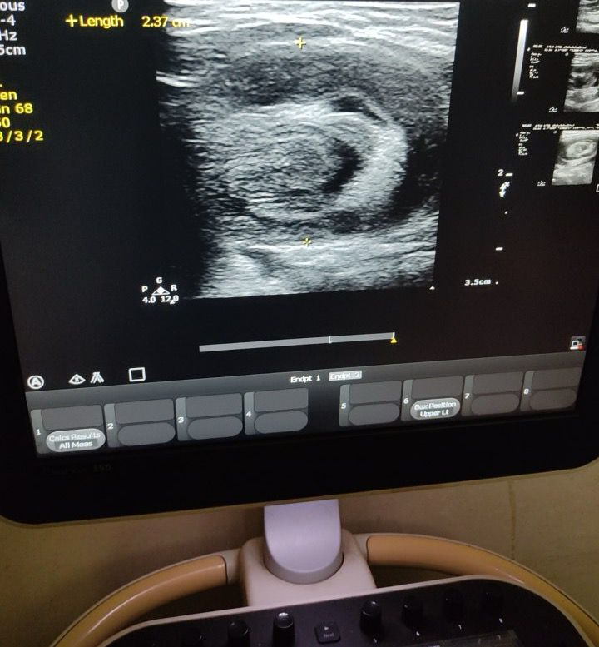
Fig 1- Ultrasound picture of the patient demonstrating the classical ‘Target Sign’ of Intussusception.
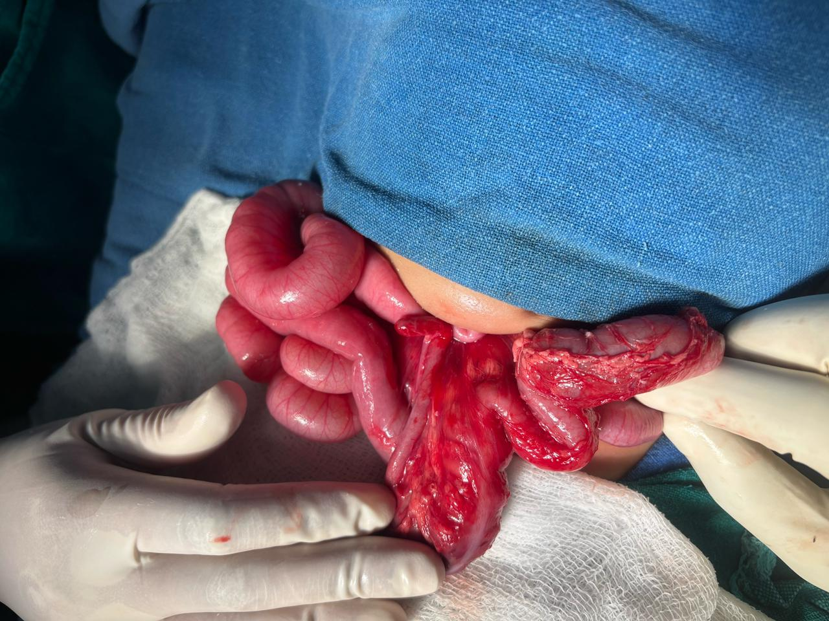
Fig 1- Ultrasound picture demonstrating the ‘Target Sign’ classical of Intussusception.
Fig 2- Intra- operative picture of reduced intussusception mass showing elongated appendix (Mc Swain type V) as the lead point.

