Case report
ENTEROBIUS VERMICULARIS: A RARE PRESENTATION AS ACUTE APPENDICITIS

ABSTRACT
Enterobius vermicularis, commonly known as pinworm, is a leading cause of gastrointestinal parasitic infections globally, with a high prevalence in developing regions. Although the parasite's role in triggering acute appendicitis remains a subject of clinical debate, documented cases confirm that it can induce symptoms indistinguishable from surgical emergencies.
We present the case of an 18-year-old female who presented with a clinical triad of Persistent lower abdominal pain, nausea, Loss of appetite (anorexia)
Diagnostic Challenge Preoperative diagnosis proved difficult as the patient's ultrasonography (USG) was unremarkable, showing no classic signs of appendiceal inflammation or wall thickening. Despite the negative imaging, the persistence of clinical symptoms led to surgical intervention.
Intraoperative Findings and Diagnosis The definitive diagnosis of Appendiceal Enterobiasis was made intraoperatively. Upon excision and examination of the appendix, adult worms were demonstrated within the lumen.
Keywords- Enterobiasis, Appendicitis, laparoscopic appendectomy, anti helminthic therapy

INTRODUCTION
Acute appendicitis is one of the commonest causes of emergency operations worldwide with a prevalence rate of 6% in age group of 10-30 yrs and a cumulative lifetime incidence rate of 9%.(1)
Appendicitis is defined as an inflammation of the appendix characterized by abdominal pain. The diagnosis of acute appendicitis is based on the patient’s history, physical examination, laboratory evaluation, and abdominal imaging. The classic symptoms are periumbilical pain, anorexia, nausea, migration of pain to the right lower quadrant of the abdomen, and low-grade fever. In approximately 90% of patients presenting with these symptoms, the diagnosis of acute appendicitis has been made. The most common treatment is laparoscopic appendectomy [2]. A wide spectrum of cases have been cited as causes of appendicitis, and among the rarest are neuroendocrine tumors, serrated adenomas, low-grade appendicular mucinous neoplasms, hyperplastic polyps, and intestinal parasites [3]
Enterobius vermicularis is one of the most prevalent intestinal helminth infection, particularly in paediatric populations. Global estimates, reported in a recent meta-analysis, indicate that 12.9% of children around the world are infected with E. vermicularis, with the highest rates observed in regions with inadequate hygiene and sanitation (4).
Transmission of E. vermicularis occurs primarily via the faecal-oral route, with infective eggs acquired through contaminated hands, fomites, or, less commonly, inhalation followed by swallowing. After ingestion, larvae hatch in the small intestine and migrate to the colon, particularly the cecum and appendix, where they mature. Gravid females then migrate nocturnally to the perianal region to deposit eggs, which become infective within a few hours and facilitate both autoinfection and person-to-person spread (5).
Although E. vermicularis infection is generally considered benign and self-limiting, often asymptomatic or associated with non-specific symptoms such as perianal pruritus or irritability, it can occasionally lead to more serious clinical complications. Appendiceal involvement, while relatively uncommon, has been increasingly reported (6-9) and is thought to result from several potential mechanisms, including mechanical obstruction of the appendiceal lumen by adult worms or ova, mucosal irritation, and activation of local immune response (10,11). In some cases, the parasite may represent an incidental finding; in others, it may directly contribute to the inflammatory cascade leading to acute appendicitis (12).
The presence of E. vermicularis in appendectomy specimens, particularly in paediatric patients presenting with abdominal pain, should therefore be interpreted with careful integration of both clinical and histopathological findings.
Reported rates of association between E. vermicularis infestation and acute appendicitis vary widely, ranging from 0.2% to 41.8% among patients undergoing appendectomy for suspected appendicitis (13). This marked heterogeneity likely reflects geographic, socioeconomic, and methodological differences, and underscores the need for region-specific epidemiological data.
With this case report we aim to document such findings in a resource poor setting in eastern india to better understand and establish a relationship between parasitic infections and acute appendicitis.
Clinical Presentation
A 18-year-old female, presented to the Outpatient Department with a primary complaint of persistent lower abdominal pain, accompanied by nausea, anorexia, and a low-grade fever.
On physical examination, the patient was febrile and appeared clinically pale. Abdominal palpation revealed mild tenderness localized to the right iliac fossa (RIF); however, there were no clinical markers of peritonitis, such as guarding, rigidity, or rebound tenderness.
Diagnostic Evaluation
Initial laboratory investigations revealed anemia (hemoglobin-7.7g/dl) . Other biochemical markers—including Serum Urea, Creatinine, Liver Function Tests (LFTs), and C-Reactive Protein (CRP)—were within normal limits. Routine urinalysis was also unremarkable.
Ultrasonography (USG) of the abdomen and pelvis identified a left-sided hemorrhagic ovarian cyst. Following a gynecological consultation, the cyst was deemed clinically insignificant and unrelated to the patient's symptoms. Notably, the USG provided no definitive findings regarding the status of the appendix.

Management and Surgical Intervention
Based on clinical suspicion, a provisional diagnosis of acute appendicitis was made. The patient was initially managed conservatively with intravenous fluids and broad-spectrum antibiotics. During this period, she also received a one-unit blood transfusion to address her anemia.
After five days of conservative therapy, the patient’s condition failed to improve, with persistent dull aching pain in the RIF. Consequently, the surgical team proceeded with a diagnostic laparoscopy.
Intraoperative Findings:
- Upon insertion of the laparoscope, the appendix appeared significantly dilated, elongated, and inflamed.
- A standard laparoscopic appendectomy was performed using a three-port technique.
- Key Finding: Upon transection of the appendiceal base, a live worm was visualized emerging from the lumen, confirming parasitic involvement.
Histopathology and Postoperative Course
The appendix was successfully retrieved and sent for histopathological examination. The report later confirmed non-specific chronic inflammatory changes, a common finding in cases where parasites cause luminal obstruction (appendiceal colic) rather than primary bacterial infection.
Postoperative Recovery:
- The patient transitioned to a liquid diet on Day 1 and a solid diet on Day 2.
- To treat the underlying parasitic infection, she was prescribed Albendazole (400 mg daily) for 14 days, starting on the first postoperative day.
- The patient was discharged on Day 3 in stable condition.
At the two-week follow-up, she showed complete resolution of symptoms, normal dietary habits, and no recurrence of abdominal pain.

DISCUSSION
The presence of E. vermicularis within the human appendix has been widely reported in histopathological studies (13,14); however, its pathogenic role in appendiceal disease remains controversial.
While some authors interpret its detection as an incidental finding, particularly in cases lacking neutrophilic infiltration or other defining features of acute appendicitis, others have proposed that E. vermicularis may contribute to appendiceal pathology through a range of processes, including lymphoid hyperplasia, luminal obstruction, or low-grade inflammatory responses that do not necessarily fulfill conventional histological criteria for acute appendicitis (2–4, 7, 15). Importantly, these two interpretations are not mutually exclusive, and E. vermicularis may act either as an incidental colonizer or as a contributing factor, depending on host and local tissue responses.
Recent evidence further supports this dual role, emphasizing that parasitic appendicitis represents a heterogeneous entity in which helminths may act as true pathogens or incidental findings depending on the interplay between parasite burden, host response, and luminal obstruction (16).
The Limitations of Conventional Diagnostics
This case underscores a profound clinical challenge: the frequent failure of routine laboratory and radiological investigations to detect parasitic appendicitis. In our case the presentation was markedly non-specific; the absence of leukocytosis, peripheral eosinophilia, and elevated inflammatory markers, coupled with an unremarkable ultrasonography, created a significant diagnostic dilemma.
In many such instances, the pathology is intraluminal (obstruction by the parasite) rather than transmural (infection of the appendiceal wall). Consequently, standard tests—which are designed to detect systemic inflammation or macroscopic tissue changes—often remain silent, leading to the underrecognition of parasitic etiologies.
The Role of Diagnostic Laparoscopy
The lack of symptomatic resolution despite aggressive antibiotic therapy was a key clinical pivot. It demonstrates that when conservative management fails in the face of "negative" imaging, diagnostic laparoscopy remains the gold standard for definitive diagnosis. In this case, the direct visualization of the whitish, slender Enterobius vermicularis emerging from the appendiceal lumen provided the only conclusive evidence of the disease.
The immediate improvement in the patient’s condition following anthelmintic therapy confirms that the symptoms were primarily driven by the parasitic load rather than a bacterial process.
Socio-Epidemiological Barriers and Underreporting
Enterobius vermicularis remains a significant public health concern in regions with developing socioeconomic infrastructure, where fecal-oral transmission is common. However, the true prevalence is likely obscured by two factors:
- Variable Symptomatology: The absence of "classic" signs like perianal pruritus often leads clinicians to exclude parasites from their differential diagnosis.
- Social Stigmata: The perceived stigmata associated with parasitic infections can prevent patients from providing a full history, leading to delayed treatment.

CONCLUSION
"In conclusion, this case highlights that Enterobius vermicularis remains a noteworthy, albeit rare, cause of appendiceal symptoms that can mimic acute appendicitis. The diagnostic dilemma encountered—characterized by unremarkable ultrasonography and the absence of classic markers like eosinophilia—underscores the limitations of routine investigations in parasitic etiologies. Surgical intervention and direct visualization remain the definitive means of diagnosis in such presentations. Furthermore, the patient’s successful recovery following appendectomy and anthelmintic therapy reinforces the necessity of a dual treatment approach. Clinicians should maintain a high index of suspicion for parasitic infestations in pediatric and adolescent patients from endemic or resource-limited areas to ensure timely management and appropriate public health follow-up."

PREOPERATIVE INVESTIGATIONS
Fig 1 : Complete blood count showing anemia with hemoglobin of 7.3g/dl
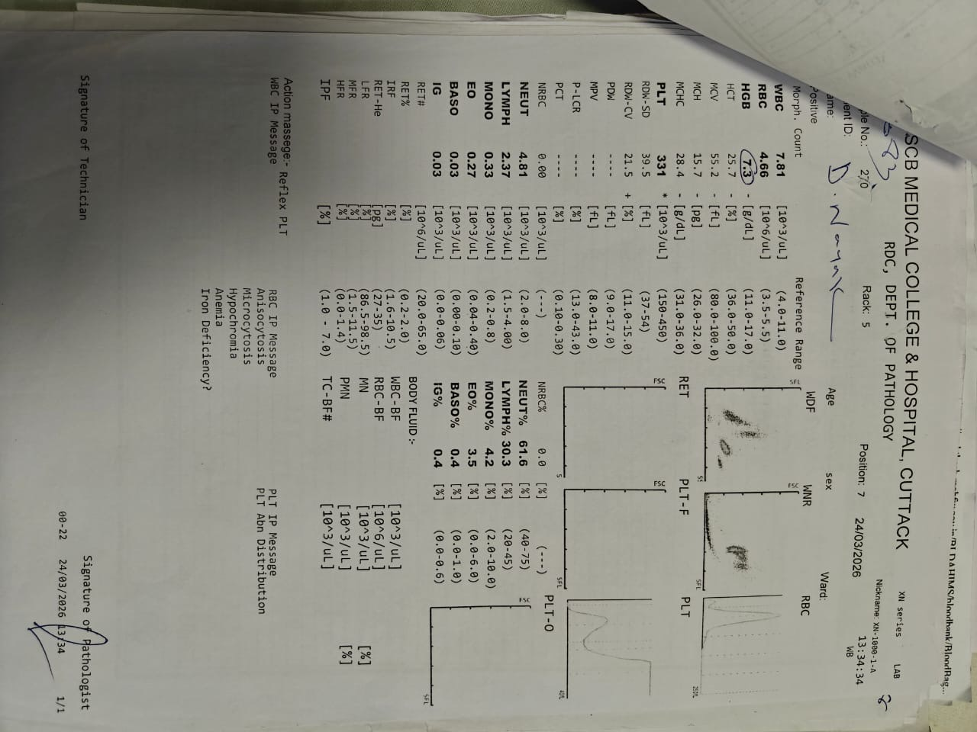

Fig 2 : ULTRASOUND OF ABDOMEN AND PELVIS
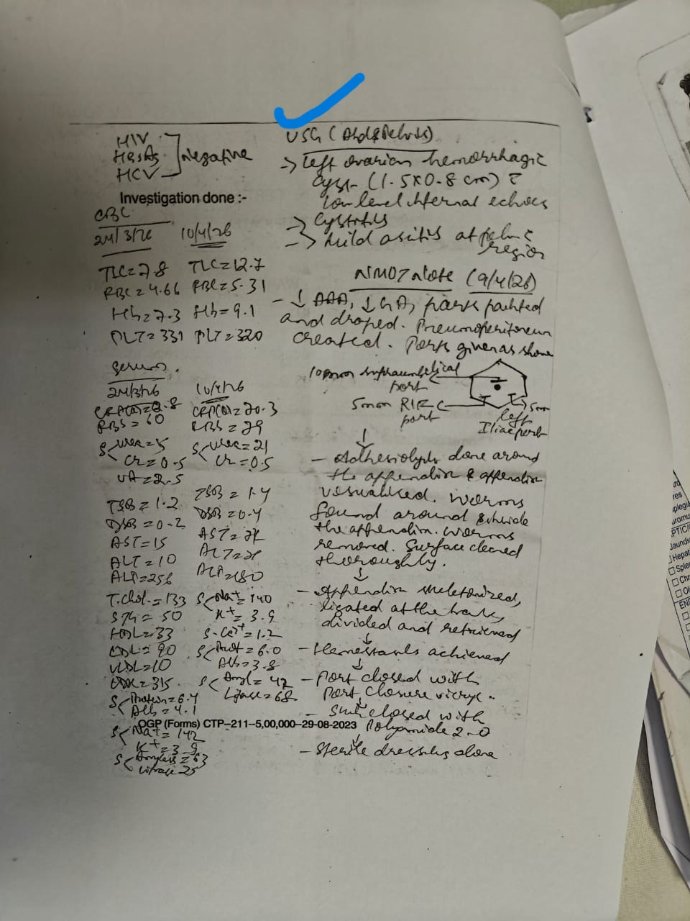

Fig 3 : INTRA OPERATIVE IMAGES SHOWING WORMS COMING OUT OF THE LUMEN OF APPENDIX
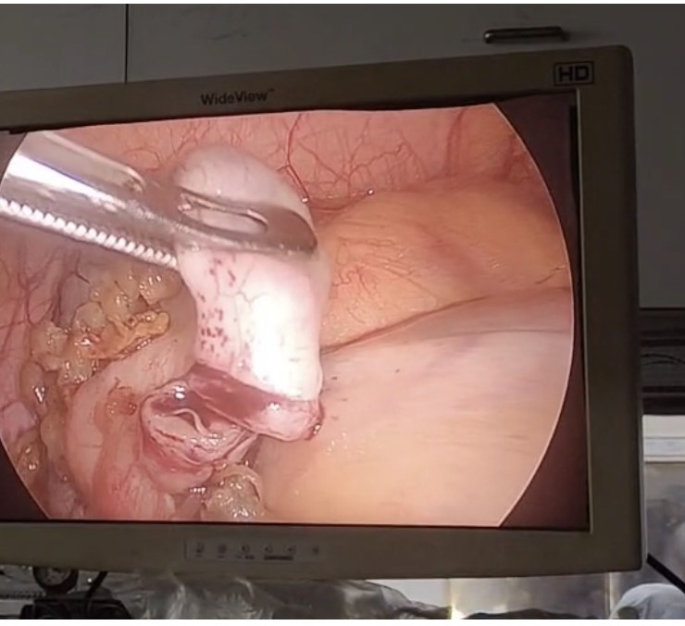

ETHICS APPROVAL – NOT NEEDED AS IT IS A SINGLE CASE AND CONSENT WAS TAKEN FROM PATIENT TO USE THE PHOTOGRAPHS AND DATA

REFERENCES
1.M. Podda, C. Gerardi, N. Cillara, N. Fearnhead, C.A. Gomes, A. Birindelli, et al.
Antibiotic treatment and appendectomy for uncomplicated acute appendicitis in adults and children: a systematic review and meta-analysis
Ann. Surg. (2019)

2.Moris D., Paulson E.K., Pappas T.N. Diagnosis and Management of Acute Appendicitis in Adults: A Review. JAMA. 2021;326:2299–2311. doi: 10.1001/jama.2021.20502. [DOI] [PubMed] [Google Scholar]

3.Kamalı G.H., Ulusoy C., Nikolovski A., Eğin S., Kamalı S. Uncommon causes of acute appendicitis: Retrospective analysis of 6785 histopathological findings in a tertiary center. Turk. J. Trauma Emerg. Surg. 2022;28:1708–1715. doi: 10.14744/tjtes.2022.84937. [DOI] [PMC free article] [PubMed] [Google Scholar]

4.Lashaki EKMizani AHosseini SAHabibiB Taherkhani KJavadiAet al. Global prevalence of enterobiasis in young children over the past 20 years: a systematic review and meta-analysis.Osong Public Health Res Perspect. (2023) 14:441–50. 10.24171/j.phrp.2023.0204

5.Leung AKCLam JMBarankin BWong AHCLeong KFHonKL. Pinworm (Enterobius Vermicularis) infestation: an updated review.Curr Pediatr Rev. (2025) 21:333–47. 10.2174/0115733963283507240115112552

6.LampsLW. Infectious causes of appendicitis.Infect Dis Clin North Am. (2010) 24:995–1018. 10.1016/j.idc.2010.07.012

7.ChhetriSAl Mamari AHAl Awfi MMAl Khaldi NHNAbed NM Pandak Net al. Enterobius vermicularis related acute appendicitis: a case report and review of the literature.Infect Dis Rep. (2023) 15:417–24. 10.3390/idr15040042

8.Flores Uribe APérez Macías JPGonzález ArévaloJAFlores UribeOA. Diagnosis and surgical intervention of acute appendicitis secondary to enterobius vermicularis: case report.Int J Surg Case Rep. (2022) 99:107678. 10.1016/j.ijscr.2022.107678

9.RazzaghiMRezaeiHMohammadiFSalehiAM. Enterobius vermicularis in the appendiceal lumen: a case report.Case Rep Surg. (2024) 2024:7806541. 10.1155/2024/7806541

10.Taghipour A Olfatifar M Javanmard E Norouzi M MirjalaliHZaliMR. The neglected role of Enterobius vermicularis in appendicitis: a systematic review and meta-analysis.PLoS One. (2020) 15:e0232143. 10.1371/journal.pone.0232143

11.MatthewsBKAuldM. Enterobius vermicularis infection at time of appendicectomy: is it a neglected risk factor?Int Surg J. (2024) 11:545–8. 10.18203/2349-2902.isj2024059

12.Pehlivanoğlu BİşlerSÖzdaş SAbesM. Findings in appendectomies with Enterobius vermicularis infection: pinworm is not a cause of appendicitis.Turkiye Parazitol Derg. (2019) 43:21–5. 10.4274/tpd.galenos.2019.6177
13.IssinG DemirF SimsekHA Cagatay DVT ayfur MKandemir Aet al. Seeds or parasites? Clinical and histopathological features of seeds and parasites in the appendix.Turk Patoloji Derg. (2023) 39:42–54. 10.5146/tjpath.2022.01586

14.AydinO. Incidental parasitic infestations in surgically removed appendices: a retrospective analysis.Diagn Pathol. (2007) 2:16. 10.1186/1746-1596-2-16

15.GetzlaffJ MFulghumGH. Enterobius vermicularis (Pinworm) appendicitis: the real vermiform appendix.Mil Med. (2024) 189:e894–6. 10.1093/milmed/usad357

16.LaorBHassanAS. Parasitic appendicitis, what do we know? -a literature review.Transl Gastroenterol Hepatol. (2025) 10:32. 10.21037/tgh-24-148

