Case report

Late-Presenting Congenital Diaphragmatic Hernia in an adolescent with Gastric Volvulus and Intrathoracic Ectopic Kidney: A Case Report

ABSTRACT

Background:
Late-presenting congenital diaphragmatic hernia (CDH) is a rare condition in adolescents, often manifesting with non-specific gastrointestinal symptoms that mask the underlying diagnosis. The simultaneous occurrence of gastric volvulus, pancreatitis due to herniation, and intrathoracic ectopic kidney in a single patient represents an exceptionally rare constellation of findings.

Case Presentation:
A 15-year-old male presented with a three-day history of acute-onset abdominal pain and recurrent non-bilious vomiting following an episode of heavy lifting. Examination was normal except for the elevated serum amylase (625 U/L) and lipase (723 U/L), suggestive of pancreatitis. Contrast-enhanced computed tomography revealed a large left-sided defect (96 mm) with herniation of the stomach, jejunal loops, splenic flexure/descending colon, spleen, pancreas and an intrathoracic ectopic kidney, along with marked gastric distension indicating volvulus. A laparoscopic approach was attempted but converted to open laparotomy due to the bulk of herniated contents. The herniated viscera were reduced into the abdominal cavity. Primary diaphragmatic repair was achieved using interrupted non-absorbable sutures without prosthetic mesh. Postoperative recovery was uneventful with normal renal and pancreatic markers. The patient was discharged on postoperative day five.

Conclusion:
This case highlights the importance of maintaining a high suspicion for CDH in adolescents presenting with unexplained gastrointestinal obstruction. The concurrent findings of gastric volvulus, pancreatitis due to herniation, and intrathoracic ectopic kidney reflect the wide spectrum of visceral involvement possible in late-presenting CDH. Cross-sectional imaging plays an important role in diagnosis, and appropriate surgical intervention leads to favourable outcomes.

Keywords: Congenital diaphragmatic hernia, Bochdalek hernia, late presentation, gastric volvulus, traction pancreatitis, intrathoracic ectopic kidney, adolescent

INTRODUCTION:
Congenital Diaphragmatic Hernia (CDH) is a developmental defect of the diaphragm that leads to herniation of abdominal viscera into the thoracic cavity. The incidence is approximately 2-3 per 10,000 live births. It commonly presents as a left-sided posterolateral (Bochdalek) defect (Gallot et al., 2007).
Most cases present with acute neonatal respiratory distress, but a few patients remain undiagnosed until later in childhood. Such patients might remain asymptomatic for years and might present later due to the mechanical effect of herniated abdominal viscera (Bianchi et al., 2013). The diagnosis can be difficult as the presentation is often non-specific and includes features such as abdominal pain and vomiting (Haynes et al., 2025). Contrast-enhanced computed tomography (CECT) is important in assisting diagnosis by identifying the defect, its contents, and associated complications (Puligandla et al., 2024). Surgery remains the definitive treatment (Jank et al., 2024).
Herniation of unusual viscera, such as the pancreas or an ectopic kidney, is rarely reported. We report a unique case of late-presenting CDH in an adolescent with gastric volvulus, pancreatitis, and intrathoracic ectopic kidney.

CASE PRESENTATION:
A 15-year-old male presented with acute-onset abdominal pain and recurrent non-bilious vomiting for three days, which began after lifting a heavy weight. There was no history of fever, jaundice, diarrhea, shortness of breath, or prior similar complaints. On examination, the patient was hemodynamically stable. The abdomen was soft and non-distended, with no tenderness, guarding, or rigidity. Initial laboratory investigations were within normal limits. However, serum amylase (625 U/L) and lipase (723 U/L) were elevated, consistent with pancreatitis. This pancreatitis was likely secondary to a traction due to herniation.
The patient was born via normal vaginal delivery, with no history of neonatal intensive care unit admission. The pregnancy was not complicated by polyhydramnios or any other significant event. No history of developmental delay or congenital anomalies was present.
Initial abdominal ultrasonography was inconclusive due to overlying bowel gas, but it suggested possible splenic displacement in the epigastric region (splenic ptosis). Subsequently, contrast-enhanced computed tomography (CECT) of the abdomen revealed a large left-sided posterolateral diaphragmatic defect (Bochdalek hernia) measuring approximately 96 mm. The imaging also showed herniation of the stomach, jejunal loops, the splenic flexure/descending colon, the spleen, part of the pancreas and an ectopic kidney (Fig. 1). Marked gastric distension was observed, indicating gastric volvulus. A bilateral mild pneumothorax was also identified, which resolved spontaneously without any intervention.
The patient underwent surgery. An initial laparoscopic approach was attempted but was converted to an open exploratory laparotomy due to the bulk and volume of herniated contents, which hindered adequate visualisation and safe reduction. Intraoperatively, the pancreas appeared inflamed, which was consistent with the elevated serum pancreatic enzymes. All herniated contents were reduced, including the ectopic kidney. Re-expansion of the compressed left lung was observed, indicating restoration of thoracic volume (Fig. 2a, 2b). The diaphragmatic defect was closed primarily by interrupted Prolene 2-0 (round body) non-absorbable sutures. No prosthetic patch was required due to adequate diaphragmatic margins.
There were no postoperative complications. Bowel movements returned early (postoperative day 1). The oral intake was well tolerated. Postoperative investigations, including renal function tests, amylase, and lipase, were within normal limits. The patient was discharged in stable condition on postoperative day 5 and remained asymptomatic at the 2-week follow-up. A repeat chest X-ray showed complete resolution with no residual pneumothorax.

DISCUSSION:
As illustrated in our case, the clinical presentation of CDH varies markedly with age. In neonates, it typically manifests with severe respiratory distress due to pulmonary hypoplasia and pulmonary hypertension. They are primary determinants of morbidity and mortality (de Buys Roessingh & Dinh-Xuan, 2009). Whereas adolescents and adult patients usually have well-developed lungs with no hypoplasia and may remain asymptomatic for years before presenting with mechanical symptoms of herniated viscera (Bianchi et al., 2013). Therefore, patients often present with misleading symptoms such as intermittent abdominal pain and vomiting that might lead to a delay in diagnosis (Haynes et al., 2025). Our patient presented with symptoms of acute gastrointestinal tract obstruction due to gastric volvulus in the thoracic cavity. This mechanism is well described in late-presenting CDH, where altered anatomical positioning of the stomach predisposes it to torsion and functional obstruction (Mawson et al., 2019). Some studies have reported that CDH might even mimic acute thoracic conditions, such as pneumothorax, which is another reason to consider CDH in the differential diagnosis (Dalton et al., 2004). Our case highlights this variability as well.
Imaging plays a pivotal role in the diagnosis. Ultrasonography and prenatal imaging are crucial in neonatal cases but not in adult-onset cases. Plain radiographs may be inconclusive or misleading. In contrast, CECT remains the most reliable modality because it confirms the diagnosis by defining the extent of herniation and associated complications (Puligandla et al., 2024). These findings are similar to our case, in which CT imaging alone clearly demonstrated the complex visceral herniation within the defect. Herniation of the stomach, bowel, and spleen is commonly described in existing literature, but herniation of the pancreas is rare and clinically significant. The associated pancreatitis can be explained by traction or vascular compromise of the pancreas due to its anatomical location, highlighting the altered anatomical environment created by CDH (Khalyfa et al., 2022). An additional noteworthy aspect of our case is the presence of an intrathoracic ectopic kidney, which was functionally normal. There are a few cases in the literature which reported similar findings (Orlandi et al., 2023).
In cases of late-presenting CDH, surgical management remains the cornerstone of treatment. Current evidence supports surgical repair following appropriate stabilisation, rather than routine emergency intervention in all cases (Puligandla et al., 2024). The fundamental principles include reducing the herniated contents and attaining a tension-free closure of the diaphragmatic defect (Jank et al., 2024). The choice of repair technique depends on defect size and tissue availability. A primary closure is preferred when adequate margins are present, whereas a patch repair is preserved for larger defects (Puligandla et al., 2024). In our case, primary repair was successfully achieved without the need for prosthetic material, indicating adequate diaphragmatic margins. This approach is advantageous as it avoids complications associated with foreign prosthetic material (Jank et al., 2024). Although minimally invasive approaches are increasingly utilized, open surgeries continue to play an important role in complex cases (Abbastanira et al., 2025) The need to convert from laparoscopy to open laparotomy in our patient underscores the importance of intraoperative flexibility Masuya et al., 2024)
The ectopic kidney in our case was repositioned into the abdominal cavity. Whereas certain existing reports suggest that the ectopic kidney was left inside the thorax and was managed conservatively (Sarac et al., 2018). In one of the reported cases, reduction of intrathoracic kidney led to subsequent severe hydronephrosis and ureteral obstruction due to ureteral folding, which led to repeated surgical interventions (Mustafa et al., 2022). This signifies the importance of preoperative urological assessment and planned imaging of renal vascular anatomy before any surgical intervention involving intrathoracic kidneys. In our case, postoperative renal function tests were within the normal range, which suggests successful reduction of the ectopic kidney. Long-term urological follow-up remains advisable, as there might be risk for complications such as hydronephrosis, calculi, and renal cell carcinoma (Schnell et al., 2025).

CONCLUSION:
This case demonstrated how adult-onset congenital diaphragmatic hernia can present with misleading symptoms such as those of acute gastrointestinal tract obstruction due to gastric volvulus. The unique combination of symptoms – gastric volvulus, pancreatitis due to traction, and intrathoracic ectopic kidney in a 15-year-old male with CDH – has never been documented before. This case also emphasises the significance of cross-sectional imaging in the diagnosis of this illness and the favourable outcome of appropriate surgical intervention.

DISCLAIMER (ARTIFICIAL INTELLIGENCE):
The author(s) hereby declare that NO generative AI technologies such as large language models (ChatGPT, Copilot, etc.) and text-to-image generators have been used during the writing or editing of this manuscript.

CONSENT:
As per international standards or university standards, the patient's written consent has been collected and preserved by the author(s).

ETHICAL APPROVAL:
It is not applicable.

COMPETING INTERESTS:
Authors have declared that no competing interests exist.

REFERENCES:
Gallot, D., Boda, C., Ughetto, S., Perthus, I., Robert-Gnansia, E., Francannet, C., et al. (2007). Prenatal detection and outcome of congenital diaphragmatic hernia: A French registry-based study. Ultrasound in Obstetrics & Gynecology, 29(3), 276–283. https://doi.org/10.1002/uog.3863
Bianchi, E., Mancini, P., De Vito, S., Pompili, E., Taurone, S., Guerrisi, I., et al. (2013). Congenital asymptomatic diaphragmatic hernias in adults: A case series. Journal of Medical Case Reports, 7, 125.
https://doi.org/10.1186/1752-1947-7-125
Puligandla, P., Skarsgard, E., Baird, R., Guadagno, E., Dimmer, A., Ganescu, O., et al. (2024). Diagnosis and management of congenital diaphragmatic hernia: A 2023 update from the Canadian Congenital Diaphragmatic Hernia Collaborative. Archives of Disease in Childhood - Fetal and Neonatal Edition, 109, F239–F252.
https://doi.org/10.1136/archdischild-2023-325865
Jank, M., Boettcher, M., & Keijzer, R. (2024). Surgical management of the diaphragmatic defect in congenital diaphragmatic hernia: A contemporary review. World Journal of Pediatric Surgery, 7, e000747.
https://doi.org/10.1136/wjps-2023-000747
de Buys Roessingh, A. S., & Dinh-Xuan, A. T. (2009). Congenital diaphragmatic hernia: Current status and review of the literature. European Journal of Pediatrics, 168(4), 393–406.
https://doi.org/10.1007/s00431-008-0904-x
Haynes, C. V., Thaxton, C. T., Shaughnessy, M. P., & Stitelman, D. H. (2025). Atypical presentation of occult congenital diaphragmatic hernia as intermittent obstructive symptoms: A case report. Journal of Pediatric Surgery Case Reports, 117, 103018.
https://doi.org/10.1016/j.epsc.2025.103018
Mawson, R., Murdoch, J., Kenwright, D., & Stringer, M. D. (2019). Gastric outlet obstruction associated with congenital diaphragmatic hernia. Journal of Pediatric Surgery Case Reports, 47, 101241.
https://doi.org/10.1016/j.epsc.2019.101241
Dalton, A. M., Hodgson, R. S., & Crossley, C. (2004). Bochdalek hernia masquerading as a tension pneumothorax. Emergency Medicine Journal, 21, 393–394.
https://doi.org/10.1136/emj.2002.004697
Khalyfa, A. A., Randhawa, N., Gabbert, D., & Al-Ghanoudi, A. (2022). Missed at Birth: A Rare Case of Acute Pancreatitis Secondary to Congenital Diaphragmatic Hernia. Case Reports in Gastrointestinal Medicine, 2022(1), 7580807. https://doi.org/10.1155/2022/7580807
Orlandi, G., Toscano, P., Gabrielli, O., Di Lella, E., Lettieri, A., Manzo, L., ... & Di Meglio, A. (2023). Prenatal diagnosis of an intrathoracic left kidney associated with congenital diaphragmatic hernia: case report and systematic review. Journal of Clinical Medicine, 12(11), 3608. PMC10253368.
https://doi.org/10.3390/jcm12113608
Abbastanira, S., Almarzouqi, O., Al Rawi, S., Kannas, S., Bashier, S., Mrayyan, H., et al. (2025). Surgical repair of large adult Bochdalek hernia: Case series and literature review. Frontiers in Surgery, 12, 1713049. https://doi.org/10.3389/fsurg.2025.1713049
Masuya, R., Nakame, K., Munakata, S., Takeno, S., Nanashima, A., & Ieiri, S. (2024). A case of late-presenting congenital diaphragmatic hernia diagnosed at 5 years with acute abdomen. Surgical Case Reports, 10(1), 177. PMCID: PMC11289203. https://doi.org/10.1186/s40792-024-01980-0
Sarac, M., Bakal, U., Tartar, T., Canpolat, S., Kara, A., & Kazez, A. (2018). Bochdalek hernia and intrathoracic ectopic kidney: Presentation of two case reports and review of the literature. Nigerian journal of clinical practice, 21(5), 681-686. PMID: 29735873.
http://doi.org/10.4103/njcp.njcp_217_17
Mustafa Y, Zaher A, Alkhaled H. Intrathoracic ectopic kidney: surgical intervention and its consequences. Journal of Pediatric Surgery Case Reports. 2022 Sep 1;84:102371.
https://doi.org/10.1016/j.epsc.2022.102371
Schnell, E. C., Becker, M. E., McQuillen, P. G., Foster, A. P., Allen, E. A., Bransky Jr, J. E., ... & Mullins, J. K. (2025). Papillary renal cell carcinoma in an ectopic intrathoracic kidney within Bochdalek hernia: A case report. Urology Case Reports, 103217. http://doi.org/10.1016/j.eucr.2025.103217

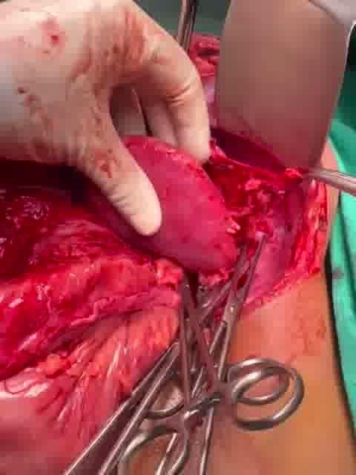
Fig. 1 Intraoperative image showing the ectopic kidney following reduction into the abdominal cavity

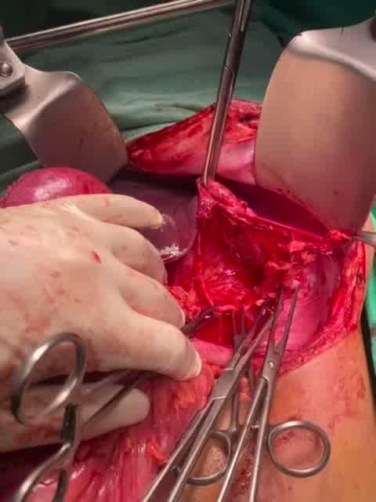  (a) | 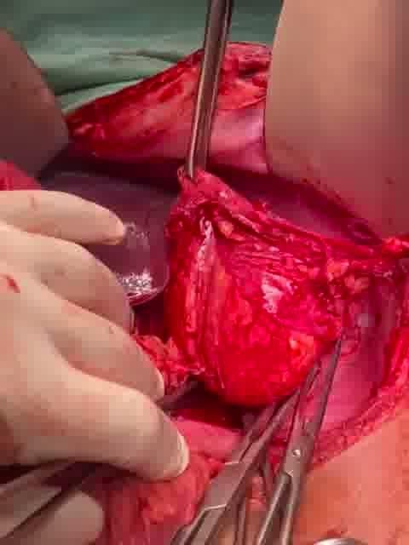  (b)
Fig. 2 Intraoperatively, a collapsed left lung was noted due to herniation of abdominal contents (a), which re-expanded following reduction of viscera (b)

supplementary video

