Case report
COMPLEX SURGICAL RECONSTRUCTION OF AN EXTENSIVE AXILLARY CYSTIC HYGROMA IN A 4 DAY OLD NEONATE: A CASE REPORT

ABSTRACT
Cystic hygroma is a benign developmental malformation of the lymphatic system resulting from a lack of communication between the lymphatic and venous systems. Most common site of occurrence of a cystic hygroma is the neck (about 75%) followed by the axilla (20%) and about 1% in the mediastinum, groin and retroperitoneum. Small, simple cystic hygromas can be managed conservatively, whereas massive, complex cystic hygromas most often need surgical intervention. Here we have a case of a neonate born with an extensive cystic hygroma of the axilla extending medially onto the chest wall upto the 8th rib and laterally till elbow, that was managed via surgical excision.

INTRODUCTION
Cystic hygroma is a rare form of lymphangioma most commonly found in the cervico-facial region.¹ Other less common sites for the occurrence are the axilla, mediastinum, pelvis and retroperitoneum². A Cystic hygroma usually presents at birth as a painless mass, which can be grossly disfiguring or functionally impairing. The diagnosis can be made pre-natally through USG and should be supported with an anomaly scan to rule out other associated abnormalities in the baby. Amniocentesis and chromosomal analysis along with genetic and family couseling may be performed.³
A cystic hygroma can be conservatively managed by sclerotherapy, radiation, simple drainage, laser therapy or cauterization, or can require surgical excision, which is the preferred modality of treatment in cases where an extensive mass or risk of complications is in question.

PRESENTATION OF CASE
A male neonate born at 38 weeks, 2 days of gestation, birth weight 3.24 kg with a massive swelling extending from the left side of chest wall till left elbow was referred to the Department of Plastic Surgery post-delivery. The baby was born to a 27 y/o primipara (natural conception) with no previous significant medical or surgical history and no history of consumption of teratogenic drugs or ante-natal exposure to radiation.

A cystic mass was initially diagnosed on USG at 20 weeks, 6 days of IUL as a 4 x 2 cm axillary swelling. No other congenital anomaly was noted in the head, neck, spine, face, thorax, abdomen, limbs and long bones in the anomaly scan performed on the same day. The cystic lesion was found to grow in size in the subsequent ante-natal USG scans, with a size of 10.2 x 8.3 x 6.9 cm and 309 cc volume at 30 weeks, 6 days [Fig. 1]
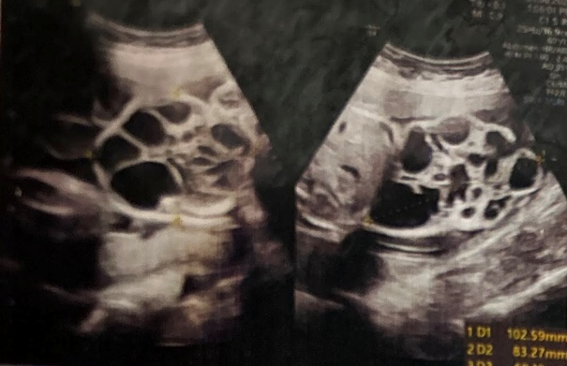
[Fig. 1 - Antenatal scan at 30 weeks, 6 days showing cystic mass of size 10.2 x 8.3 x 6.9 cm with a volume of 309 cc]

Based on the ante-natal findings, an elective LSCS was planned. The baby was kept under observation in the NICU post-delivery, and was found to be vitally stable with no signs of infection or haemorrhage. On examination of the CVS, CNS, Respiratory system and on per-abdomen examination, the patient was found to be clinically well.

The extensive mass, about 10.2 x 7.4 x 9.4 cm in size, was found stuck with the chest wall muscles medially and to involve the neurovascular and soft tissue structures of the left arm laterally. Patient’s left upper limb was in hyperabduction [Fig. 2 & 3]. No associated history of fever and no visible skin changes were seen. The mass was tense and hard on palpation with a negative transillumination test (rare reports of a negative transillumination test in a cystic hygroma have been reported in literature), was non-pulsatile and non-fluctuant.
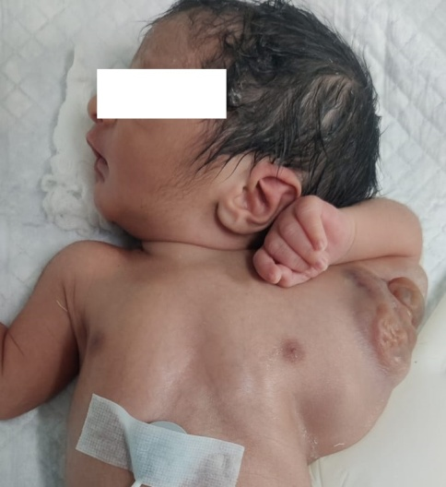
[Fig. 2 - Extensive mass of size 10.2 x 7.4 x 9.4 cm pushing the left upper limb in hyper abduction]

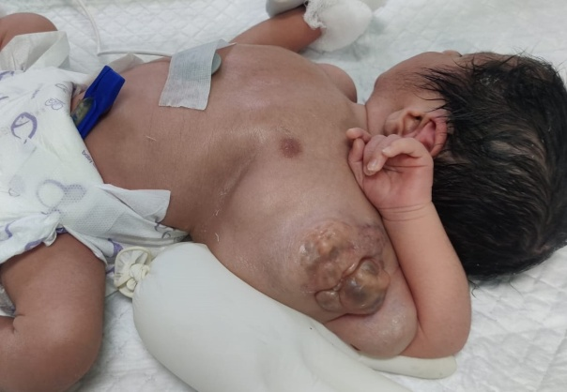
[Fig. 3 - Extensive mass extending from left elbow till lateral chest wall]

On investigating post-natally with Ultrasonography (USG), a predominantly cystic mass was seen in left axillary region extending to the chest wall medially, to the left arm laterally and superiorly till the lower left cervical region. with multiple septations and numerous cystic compartments of varied sizes with a volume of about 309 cc [Fig. 4].
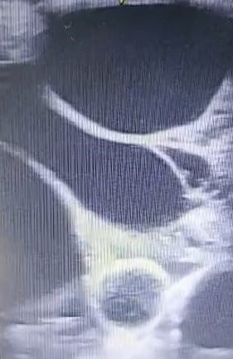
[Fig. 4 - Post-natal USG scan showing cystic mass with multiple septations]

Surgical excision was planned for the patient on day 4 of life with integrated Paediatric surgery and Plastic surgery approach, where excision of the cystic lesion was done under general anaesthesia via a curvilinear elliptical incision [Fig. 5]. Subcutaneous dissection was done, and the cystic mass was found to be extending below the muscles of the chest wall, including the Pectoralis major & minor and the Latissimus dorsi, but with no intrathoracic extension [Fig. 6]. An attempt to isolate the locules was made and excision of multiple locules was done. Walls of the already ruptured cysts were also excised [Fig. 7].
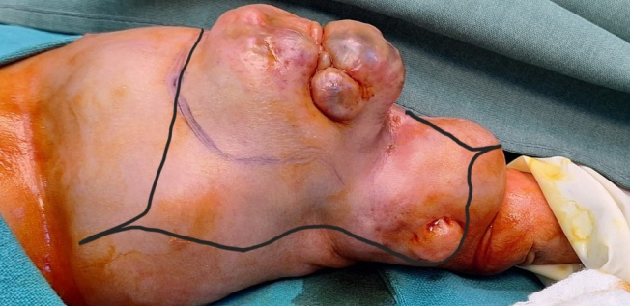
[Fig 5 - Intra-operative image showing curvilinear elliptical marking for excision of the mass]

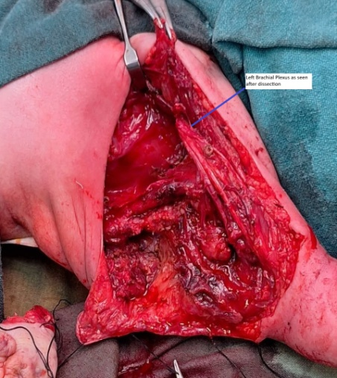
[Fig. 6 - Cystic mass found stuck to the cords and terminal branches of Brachial plexus and extending below the muscles of chest wall]

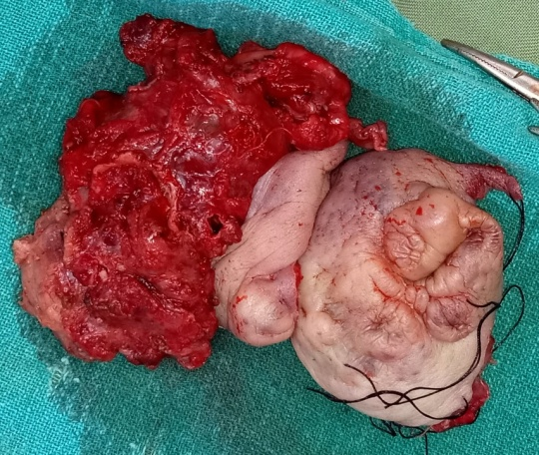
[Fig. 7 - Excised locules which were sent for histopathology]

On the lateral side, the locules were found stuck to the cords and the terminal branches of the Left brachial plexus as well as the Brachial Artery, which were carefully dissected. On further exploration, Biceps and Coracobrachialis muscles were found to be involved. Biceps was detached from its point of origin and later reattached to ensure complete disjunction from the locules. Excess skin present at the end was then removed and closure was done under Mini vac suction drain FG 8.

On sending the gross specimen for HPE, the mass was found to comprise multiple dilated interconnecting lymphatic spaces lined by flat endothelial cells with a few cystic spaces also containing RBCs [Fig. 8]. No evidence of malignancy was seen. A final diagnosis of Cystic Hygroma was, thus, reached.
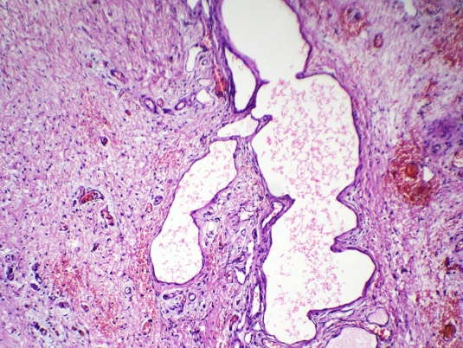
[Fig. 8 - Histopathology of excised tissue showing multiple dilated interconnecting lymphatic spaces lines by flat endothelial cells with a few cystic spaces also containing RBC’s]

Patient was shifted to the NICU post-surgery with mechanical ventilatory support and with Orogastric tube in situ. After careful monitoring, patient was extubated on post-op day 2, and orogastric tube was removed on post-op day 5. Patient was discharged on post-op day 7 under stable general conditions. Sutures were removed on post-op day 18 after no evidence of infection or haemorrhage was seen [Figure 9].

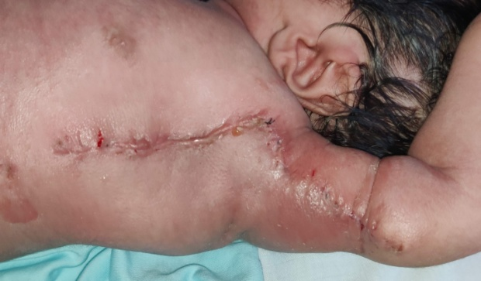
[Fig. 9 - Post-op day 18, after removal of sutures; no operative site infection or haematoma was noted]

One episode of recurrence was noted about 3 months after the excision, which was treated via sclerotherapy with Bleomycin. On 4 month follow-up, patient was found to be healthy and performing most movements of the left upper limb with ease.

DISCUSSION
Cystic hygroma (moist tumour) was first described by Redenbacher in 1828.⁴ Cystic hygromas are benign congenital soft cystic masses lined by endothelial cells, that can distort the surrounding structures.⁵
An incidence of nearly 1 in 6,000 live births has been reported in previous studies.⁶ Foetal axillary cystic hygromas have been rarely reported, and usually as a mid-gestation ultrasonographic finding.⁷ About two-thirds of these cases with a visible cystic mass are asymptomatic. Sudden enlargement, infection, respiratory symptoms or feeding difficulties can occur in other cases.⁸ A cystic hygroma usually presents in paediatric age group, but can also appear later in adults.¹ If seen early in fetal life, cystic hygromas usually have a high association with chromosomal abnormalities, most common of which are trisomies 13, 18 and 21. However, even if aneuploidy is ruled out, the fetus may have other associated congenital deformities or syndromes that would require appropriate management.

CONCLUSION
On examination, cystic hygromas are known to be characteristically brilliantly transilluminant, but bleeding into a lymphangioma can cause confusion with a haemangioma, sometimes resulting in a negative transillumination test.³ A negative test can also, as in our case, be found in massive multicystic swellings. Management of a cystic hygroma depends upon its size, location and surrounding structures. Conservative management of the swelling can be done by sclerotherapy, laser therapy, simple drainage or radiation. Surgical excision is the preferred modality of treatment in large or complex cystic hygromas. However, complete resection may be difficult owing to the insinuating nature of the cystic lesion, and thus, a good follow up is important to rule out recurrences.⁹ In cases where there is risk of damaging surrounding structures or to obviate poor cosmetic results, sclerotherapy can be considered.¹⁰

COMPETING INTERESTS - None

CONSENT - Informed written consent was obtained from the subject’s parents for the publication of the present case report.

ETHICAL APPROVAL - N/A

REFERENCES
- Kamath BS, Chatterjee AS, Chandorkar I,et al. Giant Recurrent Cystic Hygroma: A Case Report. J West Afr Coll Surg 2014 Apr-Jun;4(2):100-11.
- Temizkan O, Abike F, Ayvaci H, et al. Fetal axillary cystic hygroma: a case report and review. Rare Tumors 2011 Oct 21;3(4):e39.
- Kaur N, Singh R, Malodiya A, et al. Giant cystic hygroma of the neck with spontaneous rupture. Journal of Indian Association of Pediatric Surgeons Jul-Sept 2007; 12(3):154-155
- Masood S.N., Masood M.F. Case report of fetal axillo-thoraco-abdominal cystic hygroma. Arch Gynecol Obstet 2010; 281, 111–115.
- Townsend J. C. M., Baeuchamp R. D., Evers B. M., Mattox K. L. Sabiston textbook of Surgery: The Biological Basis of Modern Surgical Practice (1st South Asia ed.). Elsevier; 2017: 1860-1861
- Aggrawal R, Naik T, Ambey R, et al. Cystic Hygroma in a Newborn. Inter J Medical Sci Res Prac 2014; 1 (2): 20-22.
- Manikoth P, Mangalore GP, Megha V. Axillary Cystic Hygroma. Journal of Postgraduate Medicine Jul-Sept 2004;50(3): 215-216
- Glasson MJ, Taylor SF. Cervical, cervicomediastinal and intrathoracic lymphangioma. Prog Pediatr Surg. 1991;27:62-83.
- Adam A., Dixon A. K., Gillard J. H., Schaefer-Prokop C. Grainger and Allison’s Diagnostic Radiology (7th edition). Elsevier; 2020
- Al-Salem AH. Lymphangiomas in infancy and childhood. Saudi Med J. 2004 Apr;25(4):466-469

