Case report

GALLSTONE ILEUS WITH CHOLECYSTODUODENAL FISTULA:A RARE CAUSE OF SMALL BOWEL
OBSTRUCTION

Abstract: Gallstone ileus predominantly affects older adults, particularly women, and is regarded as a late complication of chronic gallstone disease. We report the case of a 60-year-old Malay woman with no known comorbidities who presented to the emergency department with a one-week history of worsening abdominal pain associated with colicky abdominal pain, bilious vomiting and obstipation. Clinical examination revealed abdominal distension with sluggish bowel sounds but no signs of peritonism. Laboratory investigations showed mild leukocytosis and evidence of dehydration, while liver function tests and serum amylase were within normal limits.Subsequent contrast-enhanced computed tomography of the abdomen confirmed the diagnosis by revealing dilated proximal small bowel loops with a transition point in the proximal jejunum, where a 2.9 cm intraluminal calcified mass consistent with a gallstone was identified. Associated findings of pneumobilia and a cholecystoduodenal fistula established the classical features of gallstone ileus. The postoperative course was uneventful, with early return of bowel function and discharge on postoperative day three. This case highlights the importance of maintaining a high index of suspicion for gallstone ileus even in patients without known biliary disease. It also supports the role of computed tomography in early diagnosis and demonstrates that enterolithotomy alone remains a safe and effective treatment option in selected patients, minimising operative risk while achieving favourable outcomes.
Keywords: Gallstone ileus, Cholecystoduodenal fistula, Small bowel obstruction, Gallstone disease

Introduction
Gallstone ileus is a rare but important cause of mechanical small bowel obstruction, accounting for 1–5% of all intestinal obstruction cases, yet its prevalence rises to 25% among elderly patients. It predominantly affects older adults, particularly women, and is regarded as a late complication of chronic gallstone disease. The condition results from the migration of a gallstone into the gastrointestinal tract through a cholecystoenteric fistula, which develops secondary to long-standing inflammation. Over time, repeated episodes of cholecystitis lead to adhesion formation between the gallbladder and adjacent bowel loops. Continued inflammatory insult and pressure necrosis from an impacted gallstone gradually erode the gallbladder wall, forming a fistulous tract. The most common communication is a cholecystoduodenal fistula, although cholecystocolic, cholecystogastric, and cholecystojejunostomy fistulas have also been described.
Once a gallstone enters the intestinal lumen, its ability to progress depends on its size and the diameter of the bowel. Stones larger than 2–2.5 cm often become impacted at narrow or physiologically angulated segments, most commonly the terminal ileum and the ileocecal valve, due to their reduced luminal diameter and slower peristalsis. This impaction results in varying degrees of obstruction, which may present acutely or with intermittent symptoms due to the shifting position of the stone—a phenomenon known as “tumbling obstruction.”
Clinically, gallstone ileus poses a diagnostic challenge because its symptoms frequently mimic other causes of small bowel obstruction. Patients may present with progressive abdominal distension, crampy abdominal pain, nausea, vomiting, or altered bowel habits. Imaging plays a critical role in diagnosis, with CT being the most sensitive modality in identifying Rigler’s triad: pneumobilia, small bowel obstruction, and an ectopic gallstone. Early recognition is essential to guide appropriate surgical management and improve outcomes in this often frail and comorbid patient population.
Case Presentation
We report the case of a 60-year-old Malay woman with no known comorbidities who presented to the emergency department with a one-week history of worsening abdominal pain associated with persistent vomiting and obstipation. The abdominal pain was colicky, centrally located, and progressively increasing in intensity. She reported multiple episodes of bilious vomiting and complete absence of bowel movements and flatus for the preceding week. There was no history of fever, jaundice, previous abdominal surgery, or known gallstone disease. She denied prior episodes of biliary colic, dyspepsia, or weight loss.
On examination, the patient appeared dehydrated but remained afebrile and hemodynamically stable. Her abdomen was markedly distended, soft, and non-tender without signs of peritonism. Bowel sounds were sluggish, and no hernias were palpable. Digital rectal examination revealed an empty rectum with no masses. Initial laboratory tests demonstrated mild leukocytosis (11.8 × 10⁹/L) and elevated serum urea consistent with dehydration; liver enzymes and serum amylase were within normal limits, and no electrolyte derangements.
A plain abdominal X-ray was performed and demonstrated multiple central, dilated small bowel loops with prominent valvulae conniventes, suggestive of small bowel obstruction.
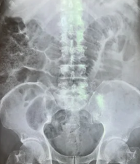
Figure 1: Abdominal Xray shows dilated small bowel

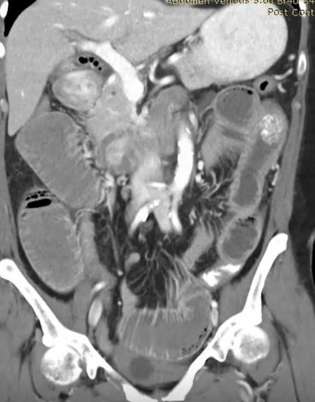
Figure 2: Contrast-enhanced CT scan of the abdomen
A contrast-enhanced CT scan of the abdomen was then performed to further evaluate the obstruction. Imaging revealed diffuse dilatation of proximal small bowel loops with a clear transition point in the proximal jejunum. At this site, a 2.9 cm, well-defined, calcified intraluminal mass consistent with a gallstone was identified. Additional key findings included pneumobilia and a thick-walled, chronically inflamed gallbladder forming a fistulous communication with the adjacent duodenum, confirming the presence of a cholecystoduodenal fistula. Together, these radiological features established the diagnosis of gallstone ileus.
Discussion
Gallstone ileus is a rare but significant cause of mechanical bowel obstruction, representing approximately 1–5% of obstruction cases overall and reaching up to 25% in elderly individuals. It is more commonly seen in older women with a long history of cholelithiasis, although many patients may not have had prior biliary symptoms. The pathogenesis involves prolonged inflammation of the gallbladder, which leads to adhesion formation between the gallbladder and an adjacent segment of the gastrointestinal tract. Over time, continuous pressure necrosis caused by an impacted gallstone results in a cholecystoenteric fistula, enabling the passage of gallstones into the bowel lumen. The duodenum is the most frequent site of fistulation, consistent with the findings in our patient.
Once the stone enters the gastrointestinal tract, its size largely determines whether obstruction occurs. Stones larger than 2–2.5 cm are more likely to become impacted, particularly at points of physiological narrowing such as the terminal ileum or ileocecal valve. In this case, the obstructing stone measured 2.9 cm and was identified in the proximal jejunum, which, although less common than ileal impaction, has been described in up to 20% of cases. The variable location of impaction contributes to the diversity of clinical presentations and can complicate diagnosis.
Clinically, gallstone ileus often presents with symptoms of small bowel obstruction such as abdominal distension, colicky pain, vomiting, and obstipation. However, the symptoms may be intermittent if the stone changes position, which may delay diagnosis. Many patients do not exhibit signs of acute cholecystitis or jaundice, further obscuring the underlying aetiology. Therefore, a high degree of suspicion is necessary, particularly in elderly patients with no previous surgical history presenting with bowel obstruction.
Radiological evaluation plays a central role in diagnosis. While plain abdominal radiography may identify Rigler’s triad (pneumobilia, small bowel obstruction, and ectopic gallstone), it has limited sensitivity. CT scanning significantly improves diagnostic accuracy by directly visualizing the ectopic gallstone, identifying the fistulous tract, determining the level of obstruction, and assessing bowel viability. In this case, CT findings clearly demonstrated the obstructing stone, pneumobilia, and cholecystoduodenal fistula, allowing prompt diagnosis and early surgical planning.
Surgical intervention remains the definitive treatment. The primary goal is the relief of obstruction, and several operative strategies exist: (1) enterolithotomy alone, (2) enterolithotomy with cholecystectomy and fistula repair in a single stage, and (3) enterolithotomy followed by interval biliary surgery in selected cases. Studies increasingly support enterolithotomy alone as an appropriate first-line option, particularly in hemodynamically stable patients or those with significant comorbidities, as it reduces operative time, postoperative complications, and mortality without compromising outcomes. Residual stones and recurrence of gallstone ileus are uncommon, occurring in fewer than 5–10% of cases, and can be managed electively if needed.
A one-stage procedure that includes cholecystectomy and fistula repair is generally reserved for fit patients with active gallbladder disease, suspicion of malignancy, or persistent biliary symptoms. However, this approach carries increased morbidity and mortality due to the greater complexity and longer operating time, especially in elderly or frail patients. In the present case, the patient was stable but had no evidence of ongoing gallbladder inflammation or residual intraluminal stones. Therefore, enterolithotomy alone was the safest, most appropriate option.
The postoperative course is typically favorable following enterolithotomy alone, with rapid recovery and low rates of complications. Our patient demonstrated complete resolution of bowel obstruction following removal of the gallstone and recovered without postoperative morbidity.

Management and Outcome
The patient underwent an emergency exploratory laparotomy for definitive management of the small bowel obstruction. Intraoperatively, markedly dilated proximal jejunal loops were noted, with a firm intraluminal mass palpated approximately 80 cm distal to the ligament of Treitz. There was no evidence of bowel ischemia or perforation. A longitudinal enterotomy was made directly over the impacted segment, allowing successful extraction of a single hard, 2.9 cm faceted gallstone. The enterotomy was then closed in a transverse fashion to prevent luminal narrowing, followed by a standard two-layer primary small bowel repair. The adjacent bowel appeared viable with adequate perfusion.

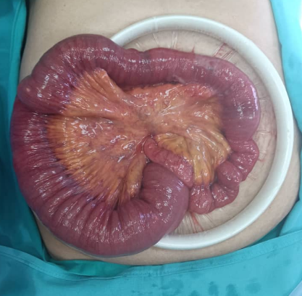
Figure 3: Dilated Small bowel loop

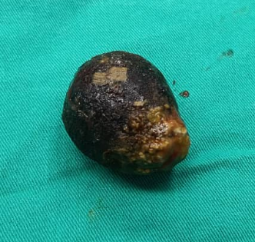
Figure 4: Retrieved stone

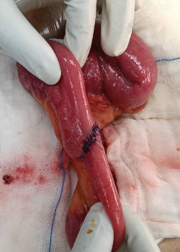
Figure 5: Repair post enterotomy
Inspection of the right upper quadrant revealed a densely adherent gallbladder with chronic inflammatory changes and a cholecystoduodenal fistula consistent with the preoperative imaging. Given the absence of acute cholecystitis, the patient’s favorable intraoperative status, and in accordance with current evidence supporting limited intervention in stable patients, the decision was made not to address the fistula or perform cholecystectomy during this initial surgery.
The patient had an uncomplicated postoperative recovery. Nasogastric decompression was discontinued on postoperative day one, and she was gradually started on oral intake. She passed stool by postoperative day two, with full resolution of obstructive symptoms. She was discharged home on postoperative day three in stable condition with advice for outpatient follow-up to monitor for potential biliary symptoms or recurrence.
Conclusion
Early recognition and prompt surgical management of gallstone ileus are crucial in reducing morbidity, particularly in elderly patients who often have multiple comorbidities and nonspecific clinical presentations. Because the symptoms frequently mimic other causes of bowel obstruction, diagnosis is easily delayed unless clinicians maintain a high index of suspicion. Computed tomography (CT) plays a pivotal role in early detection, as it can identify hallmark features such as pneumobilia, ectopic gallstones, and a transition point, as well as demonstrate the presence of a cholecystoenteric fistula.
In terms of management, enterolithotomy alone has emerged as a safe and effective surgical strategy in selected patients. By focusing on immediate relief of obstruction without attempting fistula repair or cholecystectomy during the same procedure, this approach minimizes operative time and postoperative complications, especially in older or hemodynamically compromised individuals. When appropriate, enterolithotomy offers favorable clinical outcomes and remains a validated, pragmatic intervention for gallstone ileus.

References
- Chou JW, Hsu CH, Liao KF, Lai HC. Gallstone ileus: report of two cases and review of the literature. World J Gastroenterol. 2007;13(8):1295-1298. PMC
- Inukai K, Sakurai T, Ogawa H, et al. Gallstone ileus: a review. BMJ Open Gastroenterol. 2019;6(1):e000344. bmjopengastro.bmj.com
- Turner AR, Law R, Reber HA. Gallstone ileus. StatPearls [Internet]. 2022. Treasure Island (FL): StatPearls Publishing. NCBI
- Ploneda-Valencia CF, Gallo-Morales M, Rinchon C, et al. Gallstone ileus: An overview of the literature. Revista de Gastroenterología de México. 2016;81(1):20-28. revistagastroenterologiamexico.org
- Dunphy L, Grolman R, Kavanagh D. Gallstone ileus managed with enterolithotomy. BMJ Case Rep. 2019;12(3):e231581. Ovid
- Elgazar A, et al. “Case report Gallstone ileus: What to do, when, and why”. International Surgery Journal. 2025;11(5): … doi:10.18203/2349-2902.isj20241144. ScienceDirect
- Blaz Zavala RA, Trejo SL, Gracia Cerda AE, Chávez DJ. One-step approach by enterolithotomy as surgical treatment of biliary ileus associated with bridle: case report and literature review. Int Surg J. 2024;11(5):797-800. International Surgery Journal

