Case report

Lemmel Syndrome Mimicking Choledocholithiasis: A Rare Cause of Obstructive Jaundice

.
ABSTRACT

Lemmel syndrome is a rare but important cause of obstructive jaundice, resulting from extrinsic compression of the common bile duct (CBD) by a periampullary duodenal diverticulum, often in the absence of choledocholithiasis or malignancy. We report a case of a 60-year-old Malay woman presenting with right hypochondriac pain and cholestatic features, initially suspected to have biliary obstruction due to sludge or stone. Contrast-enhanced CT, endoscopic ultrasound (EUS), and MRCP revealed compression of the distal CBD by a periampullary diverticulum. The patient improved with conservative management. This case highlights the importance of considering Lemmel syndrome in the differential diagnosis of obstructive jaundice and the utility of advanced imaging in diagnosis.

Keywords: Lemmel syndrome, obstructive jaundice, periampullary diverticulum, MRCP, case report

1. INTRODUCTION
Lemmel syndrome is a rare cause of obstructive jaundice characterized by extrinsic compression of the distal common bile duct (CBD) by a periampullary duodenal diverticulum (PAD), in the absence of choledocholithiasis or malignancy. PAD is characterized by the presence of extraluminal outpouchings of the duodenal wall located within a 2–3-cm radius from the ampulla of vater (2). This condition was first described by Gerhard Lemmel in 1934 and most of their presentation is found in asymptomatic patients, and they can be identified incidentally in up to 22% of the population, of which <10% will present with symptoms (1). PAD is usually asymptomatic, but in about 5% of cases it can show complications, such us right upper quadrant pain, elevated bilirubin, liver enzymes and/or pancreatic enzymes levels (7). This report describes a case of Lemmel syndrome in a diabetic woman with an atypical presentation of obstructive jaundice and no radiological evidence of stones, initially misinterpreted as sludge. Advanced imaging was critical in establishing the diagnosis.

2. CASE PRESENTATION
A 60-year-old Malay female with a background of type 2 diabetes mellitus and dyslipidemia presented with a one-week history of right hypochondrium pain and two weeks of tea-colored urine. She reported feeling feverish but denied pale stools, pruritus, nausea, or weight loss. On physical examination, she was alert with a full Glasgow Coma Scale (GCS) and appeared clinically well. Her vital signs were stable. Abdominal examination revealed mild tenderness over the right hypochondrium region on deep palpation, without signs of peritonism. Initial laboratory investigations revealed total white blood cell count of 7.5 x 10⁹/L, total bilirubin of 121 µmol/L with direct predominant and normal serum amylase of 26 U/L. An ultrasound of the hepatobiliary system showed gallbladder sludge with no biliary ductal dilatation. Persistent symptoms prompted further evaluation. A contrast-enhanced CT of the abdomen revealed a dilated CBD (1.1 cm) with a distal iso- to hyperdense intraductal lesion suggestive of a soft stone, and focal air locules near the pancreatic head, raising suspicion of a periampullary diverticulum ( Figure 1 )

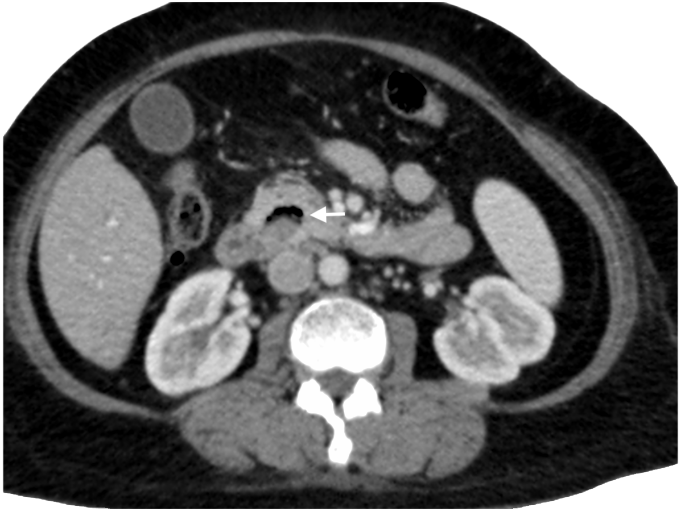
Figure 1 : Axial contrast-enhanced computed tomography (CT) scan of the abdomen shows presence of air locules (arrow) near the common bile duct without demonstrable cholelithiasis
An ERCP was attempted but failed due to unsuccessful cannulation. Subsequent endoscopic ultrasound (EUS) revealed a dilated CBD and a large periampullary diverticulum compressing the distal duct. MRCP confirmed the diagnosis of Lemmel syndrome, showing CBD narrowing due to external compression by the diverticulum. (Figure 2)
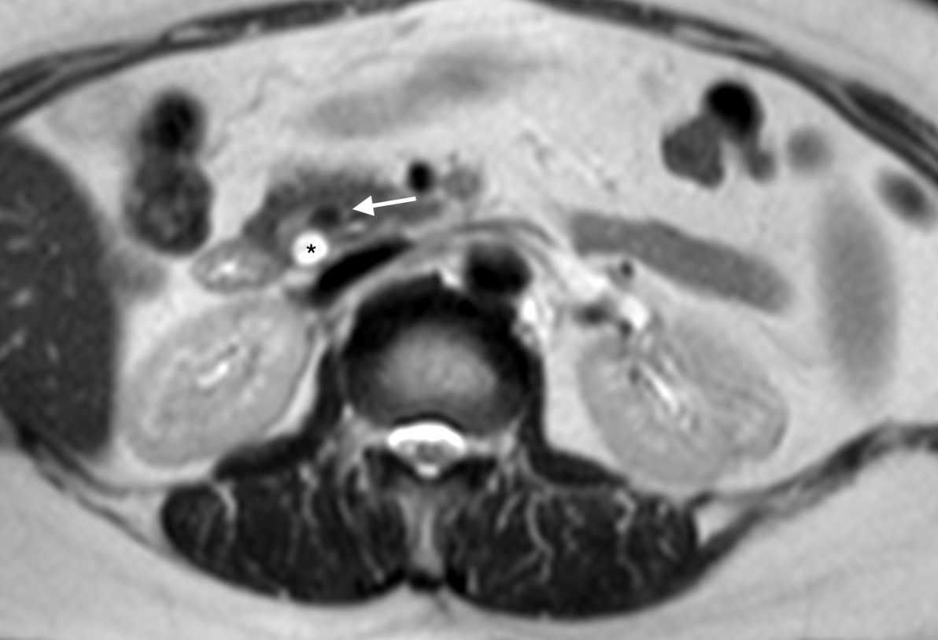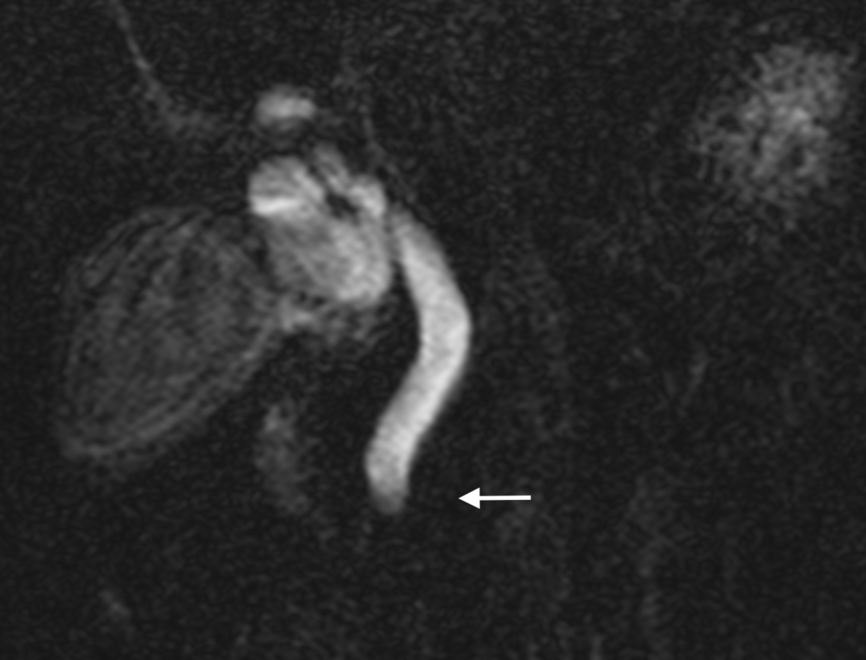
Figure 2 : Coronal T2-weighted magnetic resonance imaging of the abdomen shows an periampullary diverticulum (arrow) mechanically compressing the biliary duct with distal common bile duct (CBD) dilatation (asterisk)
The patient was managed conservatively due to clinical improvement and down-trending bilirubin levels. No surgical or endoscopic decompression was required. She was followed up for one year, during which liver function tests remained normal and she remained asymptomatic.
3. discussion

Gastrointestinal diverticula are protrusions of the intestinal wall that can develop anywhere along the gastrointestinal tract, most commonly in the colon and, to a lesser extent, the duodenum. The most common type of duodenal diverticulum is a PAD. Patients with PADs are usually asymptomatic. Complications can occur in about 5% of patients and include hemorrhage, perforation, fistula formation, diverticulitis, cholangitis, pancreatitis, gallstone formation, and rarely obstructive jaundice (2). Periampullary diverticula (PADs) are mucosal out-pouchings located within 2–3 cm of the ampulla of Vater, found in up to 22% of individuals, especially in older populations (1). Although the majority are asymptomatic, complications such as biliary obstruction, pancreatitis, and even perforation may arise.
Lemmel syndrome is a rare condition where a PAD causes extrinsic compression of the distal common bile duct (CBD), resulting in obstructive jaundice in the absence of choledocholithiasis or malignancy (2). This makes diagnosis particularly challenging, as routine imaging such as ultrasound may not detect the diverticulum or the nature of the obstruction. Various pathogenesis of Lemmel syndrome have been proposed, including the following. One possible pathogenesis involves chronic fibrosis of the papilla (papillitis chronica fibrosa) caused by direct mechanical irritation due to chronic inflammation of the papilla or chronic periampullary diverticulitis.[8] Second, a PAD may cause dysfunction of the sphincter of Oddi[6]. Third, the CBD or ampulla may be mechanically compressed by the PAD, resulting in obstructive jaundice as occurred in our patient.(5). Lemmel syndrome can cause bile stasis leading to cholangitis. Both mild and severe cases of Lemmel syndrome–associated cholangitis have been reported. Rare pathogenic organisms have also been identified, including Edwardsiella tarda, as documented by Shinji Miyajima in 2018 (4).
Imaging plays a key role in diagnosing Lemmel syndrome. Ultrasound can detect biliary duct dilatation but is limited in assessing bowel pathology. CT and MRCP are the preferred imaging modalities, as they allow accurate diagnosis and help exclude stones or other periampullary conditions. (2)
In our case, initial ultrasound showed only gallbladder sludge without biliary dilatation. However, persistent symptoms led to further evaluation. CT scan revealed a dilated CBD and suggested a periampullary diverticulum, which was confirmed by EUS and MRCP. Contents such as stones, debris, or bile within a periampullary diverticulum may block the pancreatic or biliary ducts and cause complications like choledocholithiasis, pancreatitis, or cholangitis. However, their exact role in causing these complications is unclear. Further studies are needed to determine their clinical significance in diagnosis and management.
In high-risk patients, ERCP may be the preferred therapeutic option, as it is associated with reduced morbidity and mortality. However, technical failure and procedure-related complications should be considered, since the papilla is often located within or adjacent to the diverticulum. (9) . For this patient, ERCP was performed but cannulation failed due to difficulty in identifying the ampulla. Failed ERCP cannulation can also be a diagnostic clue, as PADs may distort the anatomy around the ampulla of Vater, making access difficult. In such cases, EUS and MRCP are valuable diagnostic tools.
Management of Lemmel syndrome depends on the severity of obstruction and the patient’s overall clinical status. Although some cases require endoscopic sphincterotomy or surgical diverticulectomy, conservative management may be sufficient in clinically stable patients with improving biochemical parameters, as demonstrated in our patient. In contrast, patients who develop obstructive pancreaticobiliary complications such as cholangitis, obstructive jaundice, or pancreatitis require urgent intervention with endoscopic sphincterotomy or stenting, with diverticulectomy reserved for selected cases. Diverticulectomy is a complex procedure and is associated with higher morbidity and mortality. (7,10)
As a temporary measure before definitive diverticulectomy, less invasive endoscopic techniques such as simple tap-water lavage may provide adequate symptomatic relief and should be considered as an initial approach. However, it remains unclear whether different types of Lemmel syndrome affect outcomes or influence treatment strategies, as this information is rarely reported and difficult to determine from published case reports. (3)
Current literature recognizes the endoscopic approach as the gold standard for diagnosis and a useful therapeutic option, while surgical intervention is reserved for complex cases or those with associated complications.

4. Conclusion
Lemmel syndrome is a rare but important differential in patients presenting with obstructive jaundice without gallstones or tumors. High clinical suspicion and the use of appropriate imaging modalities such as MRCP and EUS are essential for diagnosis. Selected patients can be managed conservatively with good outcomes. Early recognition and appropriate imaging are key to avoiding unnecessary interventions and ensuring timely, effective management.

Competing interests

Authors have declared that no competing interests exist.”.

Consent (where ever applicable)

As per international standards , patient written consent has been collected and preserved by the authors

Ethical approval (where ever applicable)

As per international standards , patient written ethical approval has been collected and preserved by the authors

References

- Goroztieta-Rosales LM, Gómez-Farías J, López-García KD, Davila-Rodriguez DO. Lemmel syndrome: an extraordinary cause of obstructive jaundice-a case report. J Surg Case Rep. 2022 Jan 17;2022(1):rjab593. doi: 10.1093/jscr/rjab593. PMID: 35047177; PMCID: PMC8763606.
- Krisem M, Hirunpat P, Tungtrongchitr N. Lemmel syndrome, a rare cause of obstructive jaundice by periampullary duodenal diverticulum: Case report and review of the literature. J Clin Imaging Sci. 2023 Apr 21;13:11. doi: 10.25259/JCIS_9_2023. PMID: 37152440; PMCID: PMC10159321.
- Love JS, Yellen M, Melitas C, Yazici C, Zar F. Diagnosis and Management of Lemmel Syndrome: An Unusual Presentation and Literature Review. Case Rep Gastroenterol. 2022 Dec 16;16(3):663-674. doi: 10.1159/000528031. PMID: 36605730; PMCID: PMC9808136.
- Miyajima S, Yamakawa G, Ohana M. Edwardsiella tarda-associated cholangitis associated with Lemmel syndrome. IDCases 2018;11:94–6Published 2018 Feb 2. 10.1016/j.idcr.2018.01.009.
- Nishida K, Kato M, Higashijima M, Takagi K, Akashi R. A case of Lemmel’s syndrome caused by a large diverticular enterolith at the peripapillary portion of the duodenum Nihon Ronen Igakkai Zasshi 1995;32:825-9
- Tomita R, Tanjoh K. Endoscopic manometry of the sphincter of Oddi in patients with Lemmel’s syndrome. Surg Today 1998;28:258-61.
- Volpe A, Risi C, Erra M, Cioffi A, Casella V, Fenza G. Lemmel's syndrome due to giant periampullary diverticulum: report of a case. Radiol Case Rep. 2021 Oct 4;16(12):3783-3786. doi: 10.1016/j.radcr.2021.08.068. PMID: 34659600; PMCID: PMC8502835.
- Venkatanarasimha N, Yong YR, Gogna A, Tan BS. Case 265: Lemmel syndrome or biliary obstruction due to a periampullary duodenal diverticulum. Radiology 2019;291:542-5.
- Yanagaki M, Shiba H, Hagiwara S, Hoshino M, Sakuda H, Furukawa Y, et al. A successfully treated case of Lemmel syndrome with pancreaticobiliary maljunction: a case report. Int J Surg Case Rep 2020;72: 560–3
- Yoneyama, F., Miyata, K., Ohta, H. et al. Excision of a juxtapapillary duodenal diverticulum causing biliary obstruction: report of three cases. J Hepatobiliary Pancreat Surg 11, 69–72 (2004). https://doi.org/10.1007/s00534-003-0854-7

