Case report

Schwannoma of Psoas Muscle - An unusual cause of Abdominal Pain

.
ABSTRACT

Background: Schwannomas are benign nerve sheath tumours that rarely occur in the retroperitoneum, with involvement of the psoas muscle being particularly uncommon. Due to their deep location and nonspecific presentation, they often mimic more common pathologies, leading to diagnostic uncertainty.

Case Presentation: A 47-year-old male presented with dull aching pain in the left lower abdomen and flank for four months, radiating to the lateral thigh and associated with mild numbness. Clinical examination revealed a vague, non-tender mass in the left lumbar region with features suggestive of psoas irritation. Imaging studies demonstrated a well-defined cystic lesion within the left psoas muscle, provisionally diagnosed as a hydatid cyst. The patient underwent open surgical excision via a lateral approach. Intraoperatively, a well-encapsulated intramuscular cystic lesion was identified and completely excised. Histopathological examination revealed spindle cells with S-100 positivity, confirming the diagnosis of schwannoma. Postoperatively, the patient developed transient thigh weakness and numbness, which resolved with physiotherapy. At three-month follow-up, the patient remained asymptomatic with no recurrence.

Conclusion: Psoas schwannoma is a rare differential diagnosis for chronic abdominal pain and retroperitoneal cystic lesions. Imaging may be inconclusive, and definitive diagnosis requires histopathological confirmation. Complete surgical excision is curative, and the lateral approach provides effective access with minimal morbidity in selected cases. Early recognition and appropriate surgical management result in excellent outcomes.

Keywords: [Psoas schwannoma, retroperitoneal tumor, abdominal pain, lateral approach, nerve sheath tumor]

1. INTRODUCTION

Schwannomas are benign, slow-growing tumours that arise from Schwann cells forming the sheath of peripheral nerves (Makhoul, E., 2017). They may occur as isolated lesions or, less commonly, in association with conditions such as Neurofibromatosis. Typically, these tumours are well-encapsulated and grow in a way that displaces adjacent nerve fibres rather than invading them. They are most frequently seen in the head and neck region and along the flexor aspects of the extremities. Because of their indolent nature, patients often remain asymptomatic for long periods, and the diagnosis is frequently delayed until the lesion becomes large enough to cause pressure-related symptoms.
When schwannomas arise in the retroperitoneum, they present an even greater diagnostic challenge. These account for only about 0.7–3% of all schwannomas, and involvement of the psoas muscle is particularly rare. The retroperitoneal space allows such tumours to grow silently, often reaching a considerable size before producing noticeable symptoms. As a result, patients usually present with vague, dull abdominal or flank pain that is difficult to localize. In some cases, as in ours, the pain may radiate to the thigh due to proximity to the lumbar plexus, and may be accompanied by subtle sensory symptoms such as numbness. These features can easily be mistaken for more common musculoskeletal or intra-abdominal conditions, contributing to diagnostic uncertainty.
Imaging studies are helpful in identifying the presence and extent of a lesion but are often not definitive. On ultrasonography and cross-sectional imaging, these tumours may appear cystic or heterogeneous, frequently mimicking conditions such as psoas abscess or hydatid cyst. This overlap in radiological appearance means that a confident preoperative diagnosis is rarely possible. In most cases, the true nature of the lesion becomes evident only after surgical excision and histopathological examination.
We present the case of a 47-year-old male who came with persistent, dull aching pain in the left lower abdomen, radiating to the lateral aspect of the ipsilateral thigh. His symptoms were subtle but progressive, ultimately leading to further evaluation. This case illustrates how an uncommon pathology can present in an unassuming manner, and highlights the importance of keeping rare diagnoses in mind when common explanations do not fully account for the clinical picture. It also reinforces the role of surgery not only as definitive treatment but as the key step in establishing the diagnosis (D’Silva, 2003) (Latino, R., 2017).

2. Case presentation

A 47-year-old male with no significant comorbidities or prior surgical history presented with dull aching pain in the left lower abdomen and flank for four months. The pain was insidious in onset, radiated to the lateral aspect of the thigh, and was not associated with any aggravating or relieving factors. The patient also reported mild numbness over the thigh but denied fever, weight loss, or gastrointestinal symptoms.
On clinical examination, a vague, non-tender mass was palpable in the left lumbar region with associated lumbar fullness. Pain intensity mildly increased on hip extension, suggestive of psoas irritation. Neurological examination was largely unremarkable except for subjective numbness in the thigh.
Based on clinical findings, differential diagnoses included hydatid cyst, psoas abscess, retroperitoneal soft tissue tumor, hydronephrosis, renal cell carcinoma, and lymphoma/sarcoma.
Laboratory investigations, including complete blood count and inflammatory markers, were within normal limits. Ultrasonography revealed a cystic lesion with septations in the left psoas muscle measuring approximately 9 × 7 cm. Contrast-enhanced computed tomography and magnetic resonance imaging confirmed a well-defined cystic lesion within the psoas muscle without involvement of adjacent structures (Beaman, F. D., 2004) (Goh, B. K., 2006).
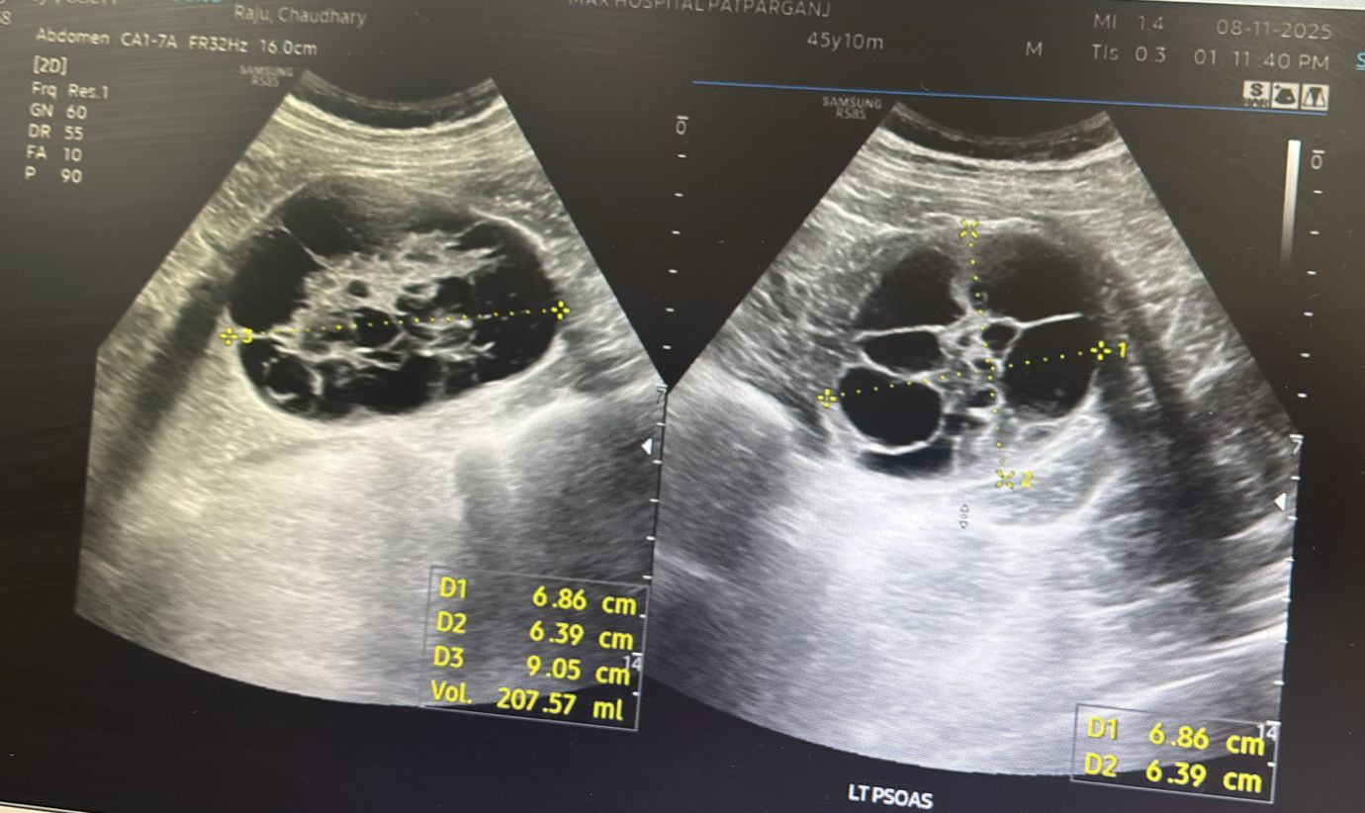
Fig. 1, Ultrasonography image of left psoas muscle showing cystic lesion with internal septations and echogenic sludge like material

A provisional diagnosis of hydatid cyst was made based on imaging characteristics.
The patient underwent open surgical excision via a left lateral approach. Intraoperatively, a well-encapsulated cystic lesion was identified within the psoas muscle. The lesion was intramuscular, with no involvement of the ureter or major vessels. No daughter cysts or typical hydatid features were observed. Complete excision of the lesion was performed without spillage, and the operative field was irrigated with 3% normal saline as a precaution.
Gross examination revealed a globular soft tissue specimen measuring 9.5 × 7 × 5 cm. Cut section showed a multilocular cyst filled with grey-brown mucoid material. An additional smaller cystic lesion measuring 0.5 × 3 cm was also identified.
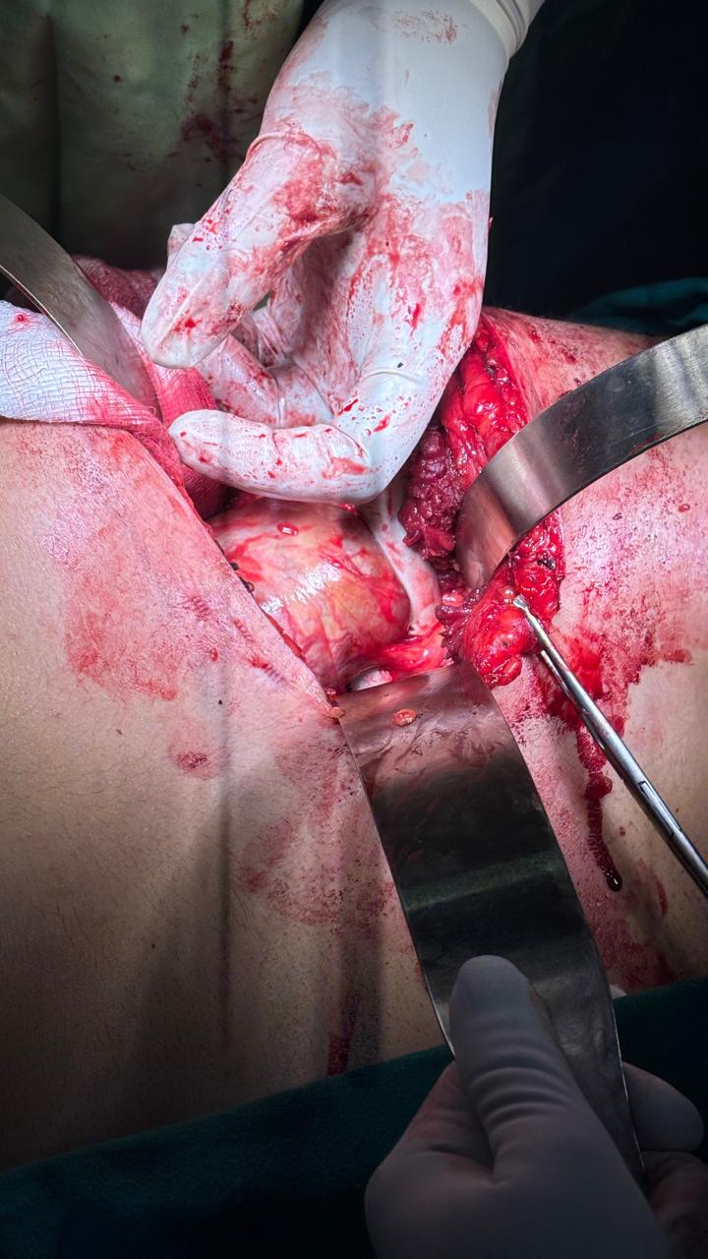
Fig. 2, Lateral incision in left flank region.

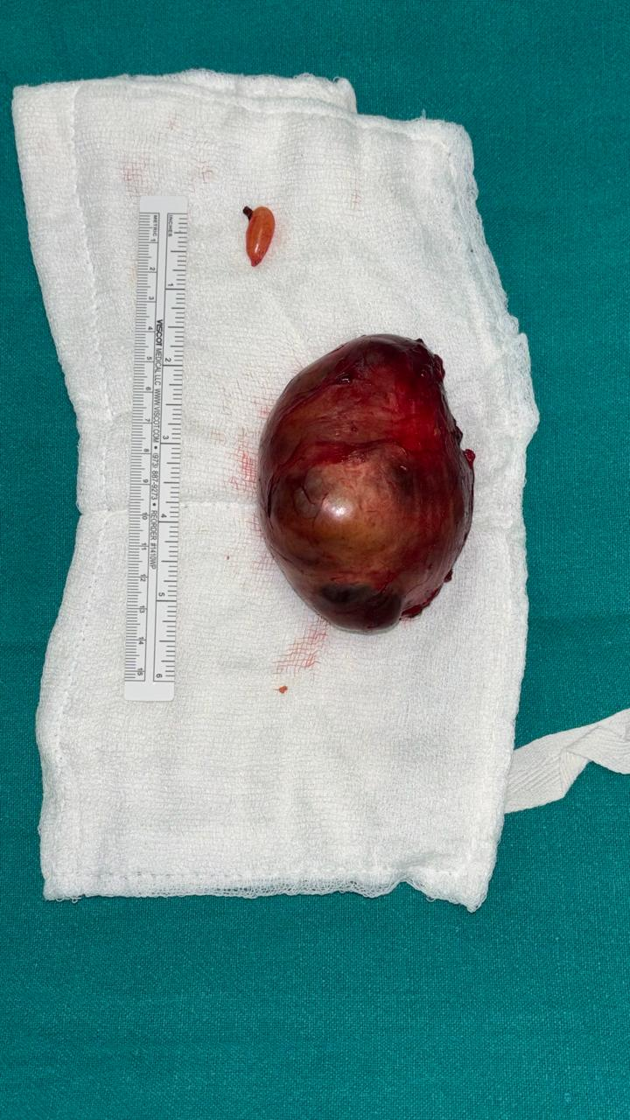
Fig. 3, Excised cystic lesion from psoas with smaller cystic lesion by the side from abdominal wall with scale for comparison

Microscopic examination demonstrated cystic structures surrounded by spindle cells arranged haphazardly, with rare mitoses and no evidence of necrosis. Thick-walled blood vessels were noted. Immunohistochemistry showed strong S-100 positivity, while markers including cytokeratin (CK), smooth muscle actin (SMA), desmin, CD34, and caldesmon were negative. The Ki-67 proliferation index was approximately 4–5%. These findings confirmed the diagnosis of schwannoma.
Postoperatively, the patient developed transient weakness of the left thigh lasting for two days, followed by numbness that gradually improved over two months with physiotherapy. At three-month follow-up, the patient was asymptomatic with no evidence of recurrence (Liang, J., 2025).

3. discussion

Schwannomas arising within the psoas muscle are rare entities, and their clinical behavior often makes them diagnostically elusive. Unlike more common intra-abdominal pathologies, these tumors tend to grow silently within the capacious retroperitoneal space, only becoming symptomatic when they reach a size sufficient to cause mass effect. As seen in this case, patients frequently present with vague, poorly localized abdominal or flank pain, which can delay diagnosis and lead to initial misattribution to more common gastrointestinal or musculoskeletal conditions. This underscores the importance of maintaining a broad differential when evaluating persistent, unexplained abdominal pain.
From a diagnostic standpoint, imaging provides valuable anatomical detail but lacks specificity. While CT and MRI can delineate a well-circumscribed retroperitoneal mass and suggest neural origin through features such as encapsulation and cystic degeneration, they rarely establish a definitive diagnosis. Consequently, histopathological evaluation remains essential. The identification of Antoni A and Antoni B areas, along with strong S-100 positivity, confirms the diagnosis and distinguishes schwannomas from other retroperitoneal neoplasms.
Surgical excision remains the cornerstone of management, with the primary goal being complete resection while preserving adjacent neurovascular structures. Given the deep-seated location of psoas schwannomas, multiple surgical approaches have been described, each with its own technical considerations and advantages.
The open anterior (transperitoneal) approach provides a wide operative field and familiar anatomical landmarks, making it particularly useful for large tumors or when malignancy cannot be excluded. It allows excellent exposure of major vascular structures; however, it involves bowel handling, increased risk of postoperative ileus, and longer recovery times.
The posterior (retroperitoneal) approach avoids entering the peritoneal cavity, thereby reducing intra-abdominal complications and facilitating direct access to the psoas muscle. However, the working space is limited, visualization can be suboptimal, and there is a higher risk of inadequate exposure for larger lesions.
Minimally invasive techniques, including laparoscopic and robotic approaches, have gained popularity due to reduced postoperative pain, shorter hospital stay, and faster recovery. These approaches offer enhanced visualization, particularly with robotic platforms, but require advanced expertise and may be technically demanding in cases where the tumor is closely related to major vessels or nerves.
The lateral (transpsoas or direct lateral) approach offers a distinct anatomical advantage in selected cases. By accessing the tumor through a muscle-splitting approach along the flank, it provides a more direct route to the psoas without traversing the peritoneal cavity. This minimizes visceral manipulation and reduces the risk of postoperative ileus. Importantly, the lateral approach allows better alignment with the longitudinal axis of the psoas muscle, facilitating controlled dissection along tissue planes and potentially improving nerve preservation. It also provides a relatively bloodless field and shorter operative time in appropriately selected patients. For tumors confined within the psoas and not encasing major vessels, this approach can therefore be more efficient and less morbid compared to traditional anterior routes. (Benjamin, C. G., 2016) (Ramos-Fresnedo, A., 2022).
In the present case, the postoperative transient neurological deficit likely reflects manipulation of adjacent lumbar plexus elements, a known and generally self-limiting complication. The gradual recovery observed with physiotherapy aligns with the benign and non-infiltrative nature of schwannomas, where nerve fibers are typically displaced rather than invaded (Ahmadian, A., 2013).
Overall, this case emphasizes that although rare, psoas schwannoma should be considered in the differential diagnosis of atypical abdominal pain. Equally important is the thoughtful selection of surgical approach, tailored to tumor characteristics and anatomical considerations. Among the available options, the lateral approach offers a compelling balance of direct access, reduced morbidity, and favorable functional outcomes in carefully chosen patients
4. Conclusion

Psoas muscle schwannoma is a rare and often under-recognized cause of chronic abdominal or flank pain, frequently masquerading as more common retroperitoneal pathologies such as hydatid cyst or psoas abscess. This case highlights the diagnostic challenge posed by such lesions, where clinical presentation and imaging findings may be misleading despite thorough evaluation.
Definitive diagnosis relies on histopathological and immunohistochemical confirmation, emphasizing the importance of complete surgical excision not only as a therapeutic intervention but also as a diagnostic necessity. Careful intraoperative assessment is essential, particularly when preoperative suspicion favors alternative diagnoses, as seen in this case.
The lateral approach, in appropriately selected patients, offers a safe and effective route for tumor excision, providing direct access to the psoas muscle while minimizing intra-abdominal morbidity. Although transient neurological deficits may occur due to proximity to the lumbar plexus, these are typically self-limiting with favorable functional recovery (Li, Q., 2007).
Overall, this case underscores the need for a high index of suspicion for rare retroperitoneal tumors in patients with atypical, persistent abdominal pain, and supports tailored surgical planning to achieve optimal outcomes with minimal morbidity.
COMPETING INTERESTS
Authors have declared that no competing interests exist.

CONSENT
All authors declare that ‘written informed consent was obtained from the patient (or other approved parties) for publication of this case report and accompanying images. A copy of the written consent is available for review by the editorial office/chief editor/editorial board members of this journal.

ETHICAL APPROVAL
It is not applicable.

References

Makhoul, E., Abi Saad, G., Sader-Ghorra, C., & Haddad, M. C. (2017). Schwannoma of the psoas: An unusual cause of abdominal pain. Arab Journal of Gastroenterology, 18(1), 44–46. https://doi.org/10.1016/j.ajg.2017.01.005

D’Silva, K. J., Dwivedi, A. J., & Shetty, P. (2003). Schwannoma of the psoas major presenting with abdominal and back pain. Southern Medical Journal, 96(7), 720–722. https://doi.org/10.1097/01.SMJ.0000066814.11788.5F

Latino, R., Bosco, D., Frattallone, M. E., Amico, A., Lanteri, R., & Di Cataldo, A. (2017). Unusual presentation of retroperitoneal schwannoma: Case report. Giornale di Chirurgia, 38(6), 295–298. https://doi.org/10.11138/gchir/2017.38.6.295

Beaman, F. D., Kransdorf, M. J., & Menke, D. M. (2004). Schwannoma: radiologic-pathologic correlation. Radiographics, 24(5), 1477-1481.

Goh, B. K., Tan, Y. M., Chung, Y. F. A., Chow, P. K., Ooi, L. L., & Wong, W. K. (2006). Retroperitoneal schwannoma. The American Journal of Surgery, 192(1), 14-18.

Liang, J., Wei, Y., & Deng, J. (2025). A 3-year follow-up case report of rare intramuscular schwannoma of psoas major: Insights into progression and management. Medicine, 104(26), e42918. https://doi.org/10.1097/MD.0000000000042918

Benjamin, C. G., Oermann, E. K., Thomas, J. A., Distaso, C. T., & Sandhu, F. A. (2016). Minimally Invasive Direct Lateral Transpsoas Approach for the Resection of a Lumbar Plexus Schwannoma: Technique Report. Surgery journal (New York, N.Y.), 2(3), e66–e69. https://doi.org/10.1055/s-0036-1587692

Ramos-Fresnedo, A., Perez-Vega, C., Ravindran, K., & Fox, W. C. (2022). MIS lateral retroperitoneal transpsoas approach allows gross total resection of a giant L4 schwannoma. Neurosurgical focus: Video, 7(1), V10. https://doi.org/10.3171/2022.3.FOCVID2220

Ahmadian, A., Deukmedjian, A. R., Abel, N., Dakwar, E., & Uribe, J. S. (2013). Analysis of lumbar plexopathies and nerve injury after lateral retroperitoneal transpsoas approach: diagnostic standardization. Journal of neurosurgery. Spine, 18(3), 289–297. https://doi.org/10.3171/2012.11.SPINE12755

Li, Q., Gao, C., Juzi, J. T., & Hao, X. (2007). Analysis of 82 cases of retroperitoneal schwannoma. ANZ journal of surgery, 77(4), 237-240.

