Case report

An Uncommon Foreign Body in the Leg: Scooter Kick Lever Impalement Injury

.
ABSTRACT

Penetrating injuries of the lower limb from unusual foreign bodies are uncommon and can be alarming at presentation, especially when the object lies close to important neurovascular structures. This report presents the case of a 62-year-old female patient who presented 3 hours after being struck by a scooter while crossing the road. On arrival, she had a scooter kick lever visibly impaled in her right lower leg, approximately 4–5 cm above the ankle. She complained of significant pain, bleeding, and was unable to bear weight. Despite the dramatic presentation, clinical examination was reassuring, with palpable distal pulses and intact motor and sensory function. Only mild bleeding was noted from the entry and exit wounds. An X-ray confirmed that the metallic foreign body was lodged between the tibia and fibula, with no associated fracture. Given its close proximity to major vessels, a CT angiography was performed to exclude vascular injury, which showed no compromise. The patient was taken up for surgery under general anaesthesia. The foreign body was carefully removed, followed by wound exploration and thorough debridement. The wounds were left open with stay sutures to allow for healing and monitoring, and intravenous antibiotics were administered. The postoperative recovery was smooth. With regular dressings, the wound showed healthy healing, and the patient gradually regained full function of the limb without any complications. This case illustrates how even striking and unusual injuries can have favourable outcomes when approached systematically. Careful clinical assessment, appropriate imaging, and timely surgical intervention remain key to ensuring safe and effective management in such rare presentations.

Keywords: Penetrating injury, Foreign body, Lower limb trauma, Road traffic accident, Impalement injury, Unusual mechanism, Limb salvage

1. INTRODUCTION

Penetrating injuries of the lower limb are frequently seen in trauma practice, most commonly following road traffic accidents or contact with sharp objects. However, encountering a large and unusual retained foreign body is rare and can be both clinically challenging and striking in presentation. Such cases demand careful evaluation, particularly when the object lies close to important neurovascular structures, where the risk of serious complications is significant.
Impalement injuries, in which an object becomes lodged through a part of the body, form a distinct and dramatic subset of penetrating trauma. Despite their alarming appearance, outcomes can be favourable if they are managed in a systematic and controlled manner. Initial assessment should focus on the patient’s overall stability and a thorough examination of distal circulation and neurological function. Imaging plays a crucial role in understanding the exact position and trajectory of the foreign body. While plain radiographs are often sufficient to identify metallic objects, advanced imaging such as CT angiography may be necessary when there is concern for vascular involvement (Pina G, 2021).
Injuries caused by vehicle components are usually blunt in nature, and penetrating trauma from such objects is uncommon. In particular, impalement by a scooter kick lever is an extremely rare mechanism, with very few cases described in the literature. Management requires avoidance of hasty removal, followed by careful extraction under controlled surgical conditions along with adequate wound cleaning to reduce the risk of infection (Ezomike U, 2011).
In this report, we present a rare case of a retained scooter kick lever in the lower leg following a road traffic accident, highlighting the importance of a structured approach in ensuring a safe and successful outcome.

2. Case presentation

A 62-year-old female patient presented to the emergency department approximately 3 hours after a road traffic accident. She had been crossing the road when she was struck by a scooter and sustained a penetrating injury to her lower leg. On arrival, she was conscious and hemodynamically stable but in significant pain. A metallic scooter kick lever was visibly impaled in her right lower leg, approximately 4–5 cm above the ankle, with both entry and exit wounds present (B., E. R. and S., R., 2017).
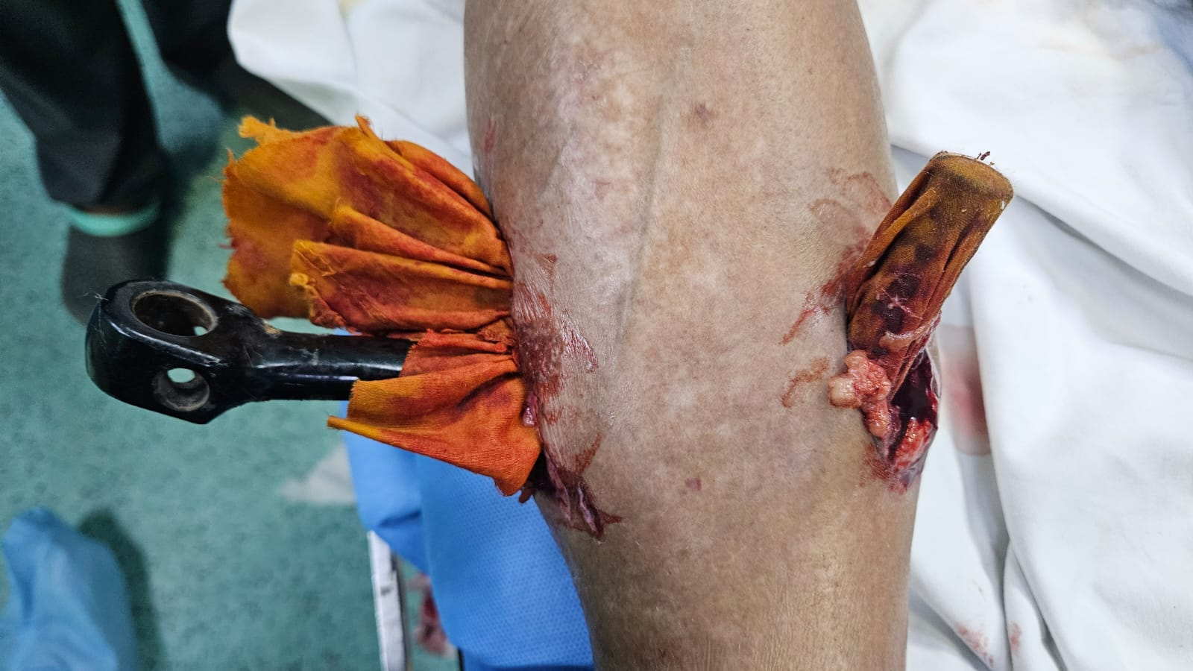
Fig. 1. Impaled foreign body on arrival in Emergency Room

As part of the initial trauma evaluation, an ultrasound FAST examination was performed and was negative for intra-abdominal injury. A chest X-ray revealed an associated left clavicle fracture. Locally, the patient complained of pain, mild bleeding, and inability to bear weight. On examination, distal pulses were palpable, and motor and sensory functions were intact, with no evidence of neurovascular deficit. There was no active severe hemorrhage or expanding hematoma. An X-ray of the leg demonstrated the foreign body lodged between the tibia and fibula without any associated fracture. Given its proximity to major vessels, CT angiography was performed and showed no vascular injury.
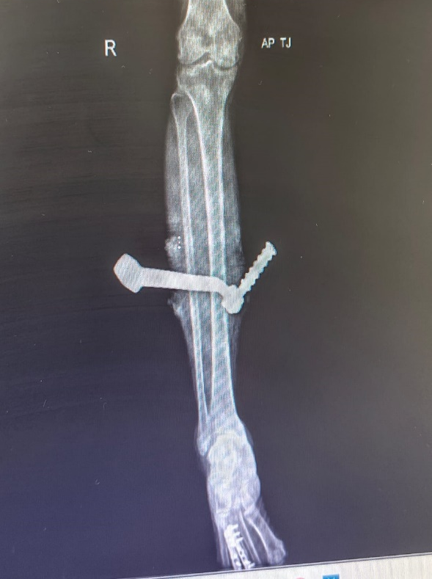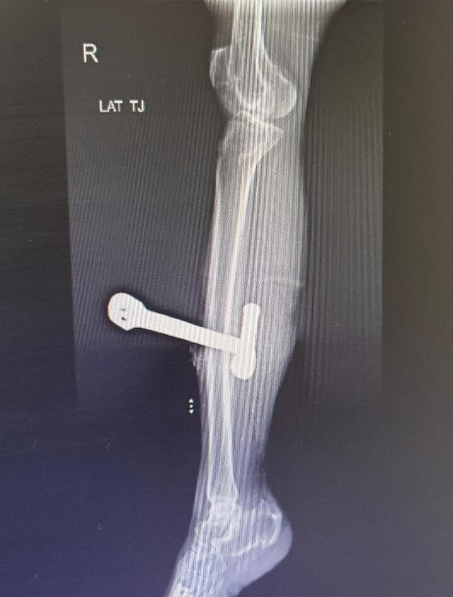
Fig. 2. X Ray of Right Leg, AP and Lateral views

The patient was taken up for surgery under general anaesthesia. A longitudinal incision was made between the entry and exit wounds to improve exposure, and both wounds were slightly extended. The kick lever was carefully removed along the same path of impalement to avoid further tissue damage. This was followed by thorough wound exploration, irrigation, and debridement. No significant injury to bone, major vessels, or nerves was identified intraoperatively. The wounds were left open with stay sutures in place (Yu-Ping Liu, 2025).

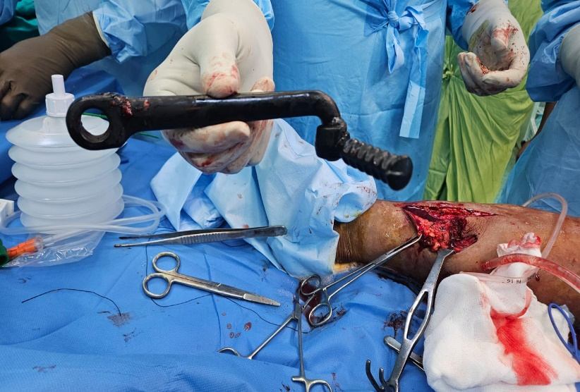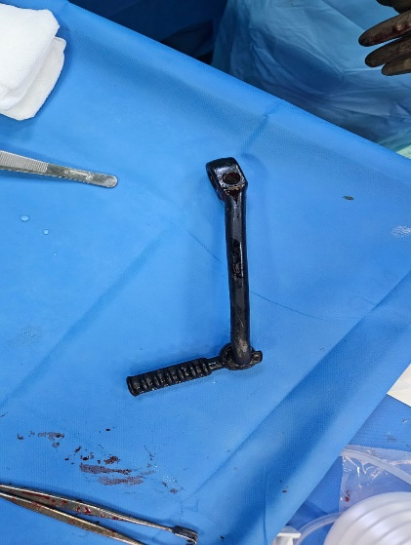
Fig. 3. Foreign body removed from the leg

Following recovery from the initial procedure, the left clavicle fracture was addressed surgically and fixed with plates and screws after 2 days.
The postoperative course was otherwise uneventful. The patient received intravenous antibiotics and regular wound care with daily dressings, with healthy progression of wound healing. On follow-up, she regained full function of the limb with no residual neurovascular deficit.

3. discussion

3.1 Unique Trajectory and Anatomical Considerations
The most notable feature of this case is the trajectory of the foreign body, which traversed the interosseous space between the tibia and fibula without causing any bony or neurovascular injury. This is particularly striking given the confined anatomical space and the close proximity of the anterior tibial vessels and deep peroneal nerve. Injuries in this region are typically associated with a higher risk of structural damage. The preservation of both vascular and neurological integrity in this patient highlights the unpredictable nature of penetrating trauma. It is likely that the foreign body followed a path of least resistance along soft tissue planes, allowing it to pass between critical structures without direct injury.

3.2 Absence of Fracture in Penetrating Trauma
Another important observation is the absence of fracture despite the size and rigidity of the metallic object. In many penetrating injuries involving long bones, the energy transmitted is sufficient to cause cortical disruption. However, this case demonstrates that the direction, angle, and velocity of impact play a crucial role in determining the pattern of injury. The orientation of the kick lever may have allowed it to bypass the cortical surfaces of the tibia and fibula, instead occupying the interosseous space. This finding reinforces that the external severity of an injury does not always correlate with internal structural damage.

3.3 Role of Imaging in Evaluation
Radiological evaluation was central to both diagnosis and management planning. Plain radiography provided immediate information regarding the position and orientation of the foreign body and ruled out associated fractures. However, given the anatomical course of the object, further evaluation with CT angiography was justified. Even in the absence of hard signs of vascular injury, the close relationship to major vessels necessitated exclusion of occult injury. Selective use of CT angiography in extremity trauma improves diagnostic confidence and helps guide safe and effective management (Michael J Ginsburg, 1990).

3.4 Principles of Surgical Management
From a surgical perspective, adherence to fundamental principles was key to achieving a favourable outcome. Controlled removal of the foreign body in the operating room minimized the risk of sudden haemorrhage. Extending the entry and exit wounds, along with a longitudinal incision, provided adequate exposure and facilitated removal along the original path of impalement. This approach reduces the likelihood of iatrogenic injury to surrounding tissues. Thorough irrigation and debridement were essential, particularly in the context of a contaminated road traffic injury.

3.5 Wound Management Strategy
Leaving the wound open with stay sutures allowed for adequate drainage, monitoring, and gradual healing. This approach is especially useful in contaminated wounds, where primary closure may increase the risk of infection. Regular wound care and antibiotic coverage contributed to the favourable healing observed in this patient (Jarolia M, 2024).

3.6 Importance of Comprehensive Trauma Evaluation
This case also underscores the importance of maintaining a systematic approach to trauma. The identification of an associated clavicle fracture during the initial evaluation highlights the need for a complete primary and secondary survey. Even when a dramatic local injury is present, clinicians must remain vigilant for additional injuries that may otherwise be overlooked.

3.7 Clinical Implications
An important clinical takeaway from this case is that the absence of overt neurovascular compromise does not eliminate the need for further evaluation when the trajectory of injury raises concern. Imaging decisions should be guided not only by clinical findings but also by anatomical considerations. Overall, this case demonstrates that a structured approach combining careful assessment, appropriate imaging, and sound surgical technique can lead to excellent outcomes even in rare and unusual penetrating injuries (Cruz DM, 2025).

4. Conclusion

This case highlights how even dramatic and unusual penetrating injuries can have good outcomes when managed in a systematic and thoughtful manner. The presence of a large foreign body such as a scooter kick lever can be alarming, but careful clinical assessment, appropriate imaging, and controlled surgical intervention are key to safe management. Avoiding premature removal, ensuring adequate exposure during surgery, and performing thorough debridement all play an important role in preventing complications.
Equally important is maintaining a broad trauma perspective. Associated injuries, such as the clavicle fracture in this case, can be easily overlooked if attention is focused only on the obvious wound. A complete primary and secondary survey remains essential in all trauma patients.
Overall, this case reinforces that adherence to basic surgical principles and a stepwise approach can lead to excellent functional outcomes, even in rare and visually striking injuries.

COMPETING INTERESTS
Authors have declared that no competing interests exist.

CONSENT
All authors declare that ‘written informed consent was obtained from the patient (or other approved parties) for publication of this case report and accompanying images. A copy of the written consent is available for review by the editorial office/chief editor/editorial board members of this journal.

ETHICAL APPROVAL
It is not applicable.

References

Pina G, Vaz MR, Vaz A, Borralho N. Leg Impalement – A Rare Injury Pattern Case Report. J Orthop Case Rep. 2021 Oct;11(10): 9-12. Doi:10.13107/jcor.2021.v11.i10.2444. PMID:35415085; PMCID: PMC8930303.

Ezomike U, Ituen M, Ekpemo S. Unusual presentation of foreign body in the thigh - a case report. J West Afr Coll Surg. 2011 Oct;1(4):53-9. PMID: 25452972; PMCID: PMC4170278.

B., E. R. and S., R. (2017) An unusual case of metallic foreign body in the left knee: a rare case report, International Journal of Research in Orthopaedics, 3(4), pp. 895–897. doi: 10.18203/issn.2455-4510.IntJResOrthop20172893.

Yu-Ping Liu, Ming-Ming Wang, Xiu-Fang Duan, Xue-Qiang Yuan, Zhi-Wei Zhang, Hao Liu, et al. Retrieval of ferrous metal foreign body from limbs soft tissue aided by a permanent magnet: A surgical technique and case series, Injury Volume 56, Issue 7, 2025, 112412, ISSN 00201383, https://doi.org/10.1016/j.injury.2025.112412.
Michael J Ginsburg, George L Ellis, Lynda L Flom, Detection of soft-tissue foreign bodies by plain radiography, xerography, computed tomography, and ultrasonography, Annals of Emergency Medicine, Volume19, Issue 6, 1990, Pages 701703, ISSN 01960644, https://doi.org/10.1016/S0196-0644(05)82483-7.
Jarolia M, Garika SS, Mahadevuni V, Sharma V, Gamnagatti S. Decade Later Presentation of an Intraosseous Metallic Foreign Body in the Pelvis: A Case Report and Literature Review. J Orthop Case Rep. 2024 Jun;14(6):152-156. doi: 10.13107/jocr.2024.v14.i06.4536. PMID: 38910972; PMCID: PMC11189079.
Cruz DM, Seara JM, Gonçalves DF. An Unusual Foreign Body Causing Symptoms After 40 Years: A Case Report. Cureus. 2025 Sep 2;17(9):e91451. doi: 10.7759/cureus.91451. PMID: 41049966; PMCID: PMC12489519.

