Case report
3D Microvascular Reconstruction of cheek after excision of Fibro sarcoma: A rare entity for head and neck.

Abstract
Fibrosarcomas are rare malignant tumor of fibroblasts, known for its ability to reccur and metastasize . Fibrosarcomas constitutes only 1% of malignancy of all malignancies studied in human. Most common site for fibrosarcomas are retroperitoneum, thigh , knee, and distal extremities. Head and neck is very uncommon site for fibrosarcomas and comprises 0.05% of all fibrosarcomas. Having poor prognosis , patients have 20-35% survival rate for 5 years. Radical excision of tumor with negative margin is most preferred mode of treatment,which lead to significant soft tissue or bony defect of varied dimensions, resulting into anatomical and functional deficiencies.Microvascular reconstruction is one of reliable and pre-eminent alternative for reconstruction giving satisfactory aesthetics and functionality.

Introduction
Fibrosarcoma is rare, but very aggressive in nature ,which accounts for 3.6% of soft tissue sarcomas (1,2). Fibrosarcomas can occur in any age group, but major occurrence is seen in peak age group of 3rd and 6th decade of life.
Fibrosarcomas has ability of local invasion as well as metastasis; resulting into poor prognosis and poor survival rate. Therefore early diagnosis and respective treatment depending upon size and stage of tumor is very essential for increasing the chances of survival of patient. According to literature 80% of reported fibrosarcomas are higher grades and 20% low grade lesions progress to high grade with time (3). Wide surgical excision with negative margin is treatment of choice.
ALT flap has been a valuable tool for reconstructive surgeries for over 40 years and is now increasingly used for reconstruction of facial defects (4,5). ALT flaps are preferred by majority of reconstructive surgeons because it can be tailored with various components like fascia, adipose and cutaneous tissue to meet different purpose such as covering, padding, and recreating 3D structures (4,5).

Case Report
A 32 years male patient presented with the complaint of swelling over left cheek associated with heaviness , and no other significant symptom. Patient gave history of having small swelling on left cheek about 9-10 months back, which rapidly increased in size, not interferring with any physiological functioning.

FNAC was done showing sheets and clusters of oval to spindle cells with peripheral nuclear palisading . After this he was operated and a mass of 3 x 2.5 cm was removed and sent for biopsy. The findings of this HPE showed spindle cell neoplasm. But even after the excision of swelling ,it recurred back and this time growth was fast and aggressive .

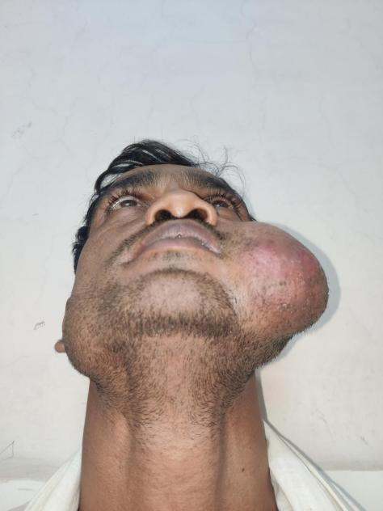
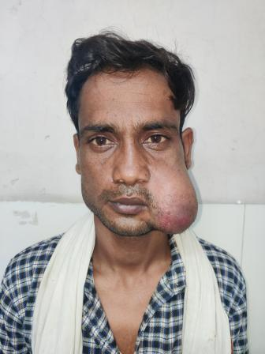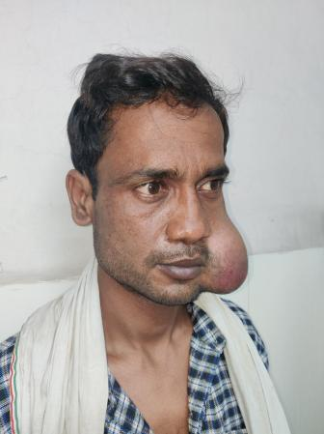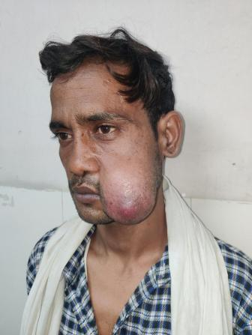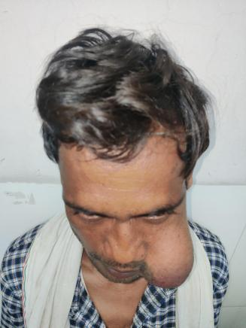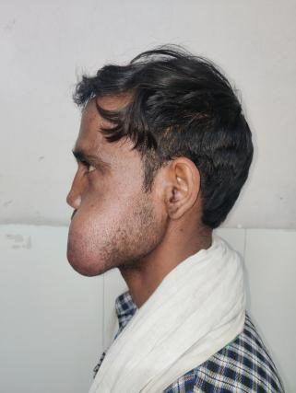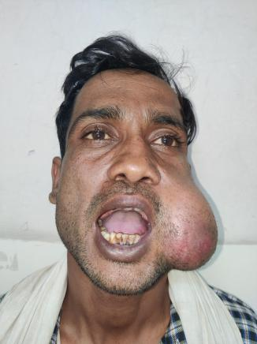

Fig 1:- pre-operative photographs of patient

On examination, 8 x 7 cm spherical swelling was present on left cheek , of which on antero-posterior dimension was 8cm from left oral comissure to 3 cm in front of tragus and 7cm on supero-inferior dimension. There was erythema over the lower part of swelling . Intraoral examination didn’t show any significant finding. On palpation it was firm ,mobile and and local temperature was slightly raised. Swelling was non-fluctuant, non-transilluminant , and non palpable for any pulsations. Mouth opening was of 2 finger breadth .
For further investigation CECT of face was done showing irregular enhancing soft tissue mass measuring approx 70mm x 60mm involving left buccal mucosa likely neoplastic . Involvement of left buccal mucosal fat pad was seen. There , extension. On MRI finding ,it was 65mm(vertical) x 75mm(A.P) x 35mm (trans) subcutaneous tissue in left cheek involving buccal fat pad. Superiorly it was extending upto left malar region & lateral aspect of lip , and inferiorly upto left submandibular region. There were few upper cervical lymph nodes, seen in level Ib & II, largest measuring approx. 16 x 8.5 mm in left level II.

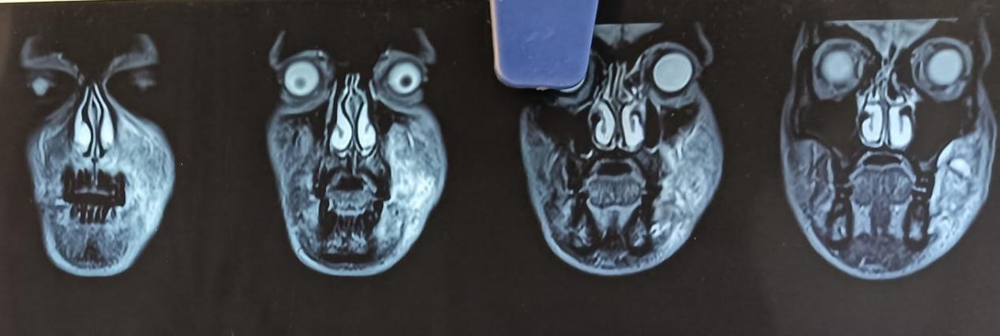

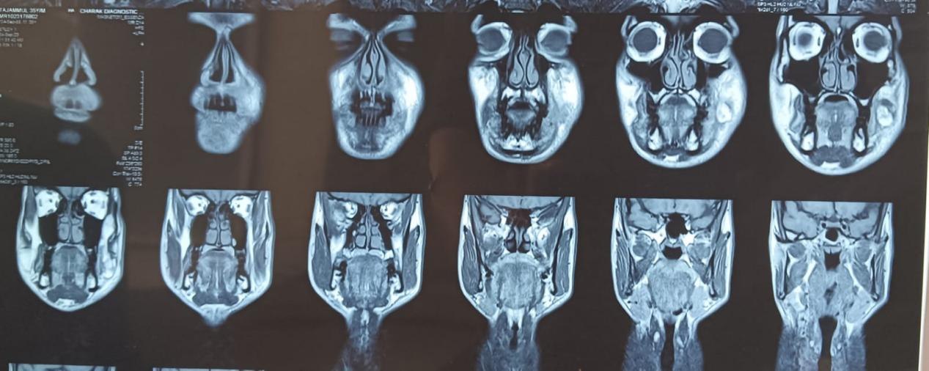

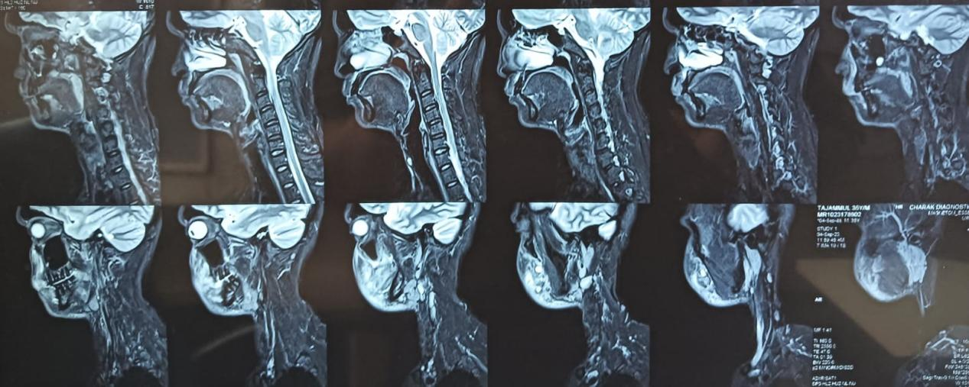

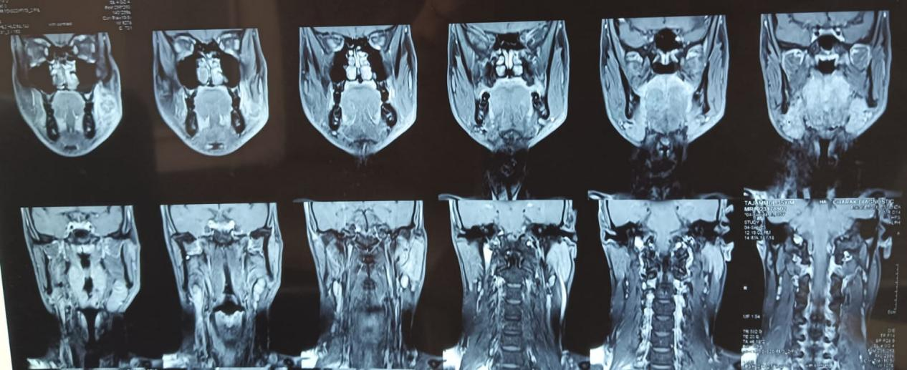

Fig 2. Pre operative MRI of patient

Depending on all these findings and investigations, Wide local incision with neck dissection for removal of these lymph nodes was planned.

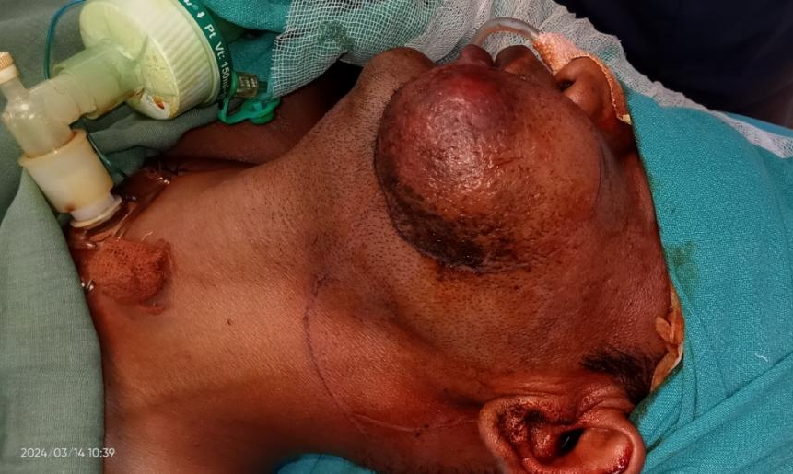
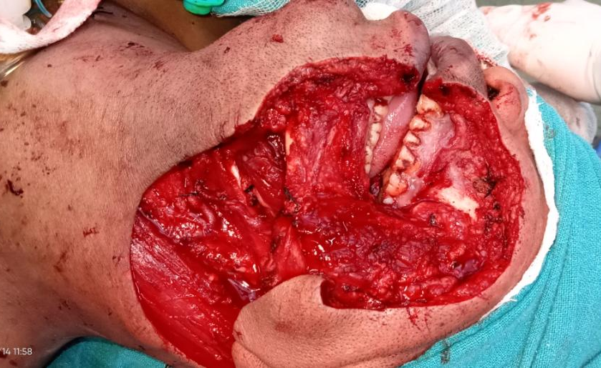

Fig 3. After excision of tumor mass and neck dissection

Patient under general anaesthesia with supine position , tracheostomy was done to secure the airway , wide local excision of tumor mass was done measuring 9 x 7 x 4 cm including a part of buccal mucosa achieving negative margins . Along with this neck dissection was done to remove level I, II & III cervical lymph nodes. Both primary tumor and neck tissue were sent for biopsy. This procedure led to significant defect over left cheek measuring about 9 x 4 cm involving left oral comissure. To cover this defect ALT fasciocutaneous flap was planned.

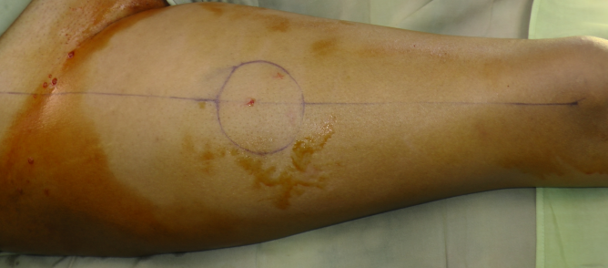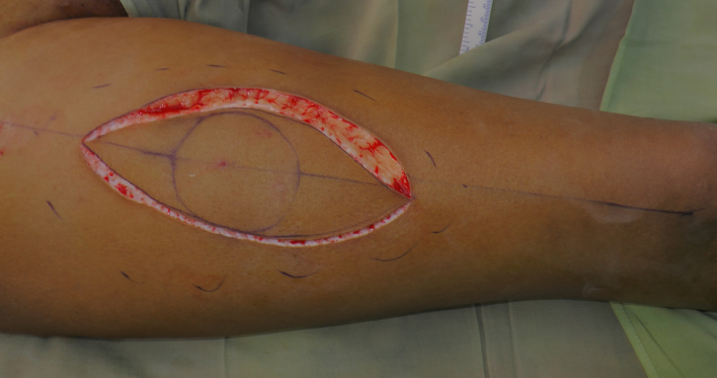

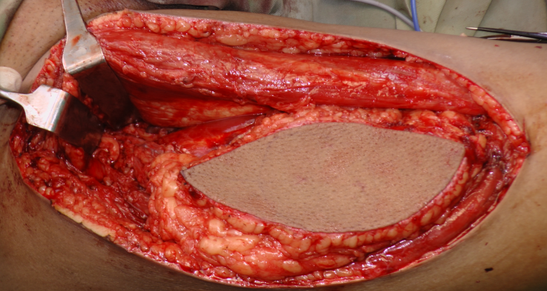

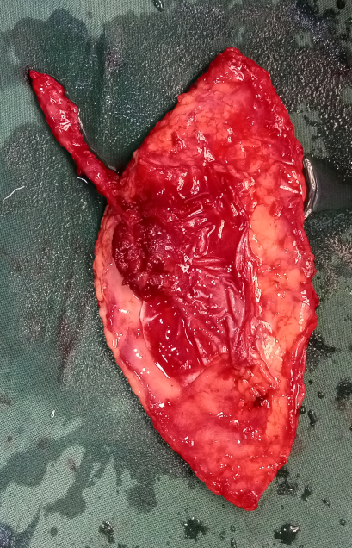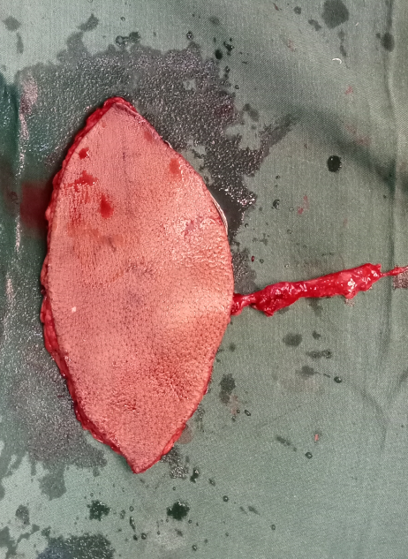

Fig 4.Intra operative antero-lateral thigh flap harvest

For reconstruction of defect , marking of donor area was done using hand held doppler to locate the perforators. Two team aproach was opted to save time. First team was preparing recepient vessels an local region. Other team was harvesting ALT flap.

ALT flap (fasciocutaneous) of required dimension was harvested depending on descending branch of lateral circumflex femoral artery . After flap harvest ,donor area closed primarily in 2 layers with suction drain. And left over area was covered with SSG harvested from posterior aspect of thigh.
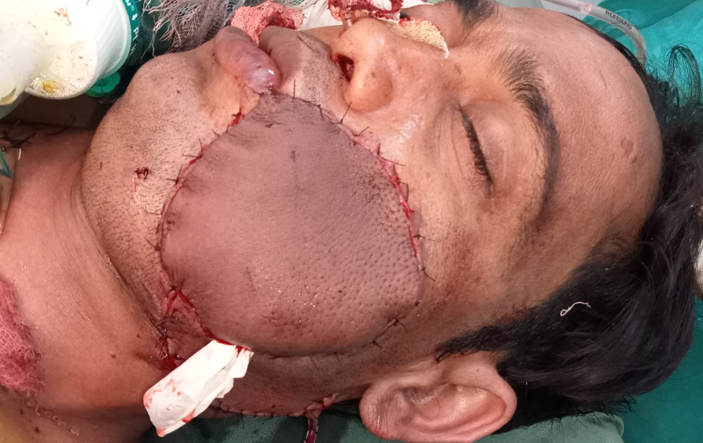

Fig 5. Intra operative flap insetting

Flap insetted over the defect to reconstruct the left cheek and left commissure with following anastomis done :-
Facial artey - Decseding branch of lateral circumflex femoral artery
Tributary of IVC - 1 vena commitent
Other tributery - 1 vena commitent
Exposed neck was closed primarily in 2 layers with suction drain.
In post op and follow up period :- monitoring of flap was done depending on colour , turgor and pin prick.

Along with this proper antibotic coverage was given. Tracheostomy was removed on 5th day and patient was discharged on 8th day after removal of donar drain. On follow up, local drain was removed and sutures were removed.

REPORT of HPE :-
- Fibrosarcoma left cheek (low grade) pT3 pN0 pM.
- All lymph nodes were free from tumor invasion.

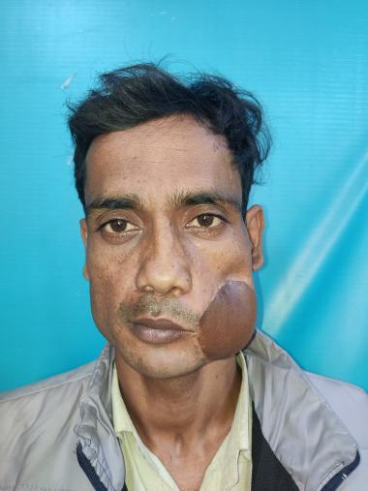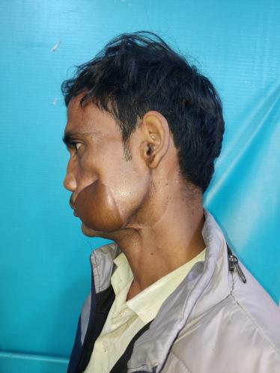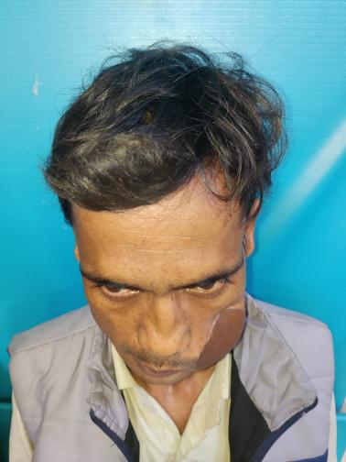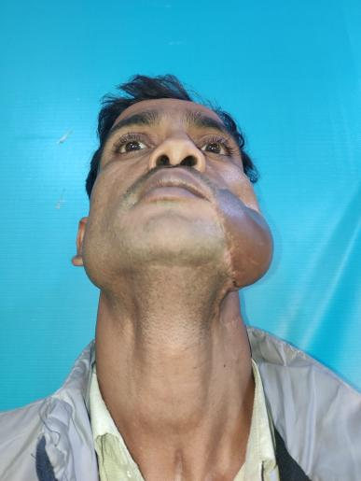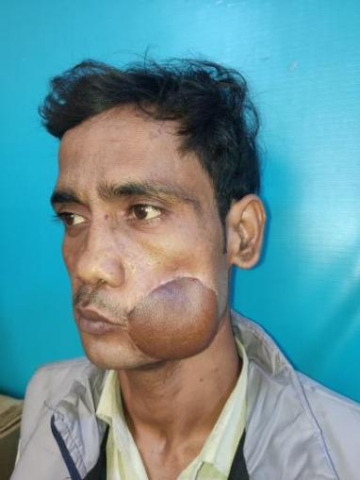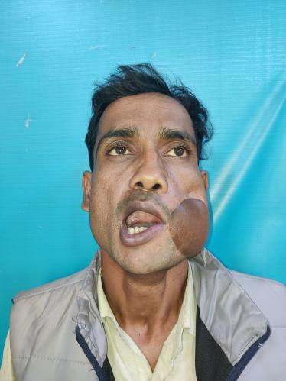

Fig 6. Follow up photographs of patient

Discussion
Fibrosarcoma being aggressive pathology, after its early diagnosis , needs to get excised as early possible, to increase the survival rate of patient . Diagnosing fibrosarcoma depending only on clinical findings and radiographic images is not feasible, because history and symptoms of patient can head us towards broad differential diagnosis of Sarcomas ; and radiography can show us the extents of pathology. But histopathology is the only test for confirmation of fibrosarcoma. It is wise step to check for the metastasis before planning for surgery.

Radical wide excision of tumor with neck dissection for removal of involved cervical lymph nodes is preferred modality of treatment. This led to significant soft tissue loss over left cheek which causes anatomical and physiological defect .
Before the evolution of perforator based free flap, surgeons were limited to use pedicled flap or traditional free flap , which were either very thin or very bulky, and not fit for textrure matching. But after introduction of microvascular single stage reconstruction, its practical for surgeon to have anatomically constant flap with long and sizeable pedicle. Its also possible to take flap which has good match in characteristic for recepient site. Sometimes problem with these flap may be extra bulk which surgeon generally don’t want to thin in primary stage to assure the survival of flap. For solution sugeons prefers debulking in secondary stages to ensure flap survival during primary surgery(7,8).But this multiple thinning stages burdens patient’s financially and psychologically.

Conclusion
Microvascular reconstruction using perforator based free flap for significant soft tissue defect in head and neck followed by radical wide excision of rare & aggressive carcinomas like fibrosarcoma (as in our case) is a great option as it not only restores normal physiology but also provides better 3 dimensional aesthetic.

References

- Folpe AL. Fibrosarcoma: A review and update. Histopathology 2014;64:12-25.

- Bahrami A, Folpe AL. Adult-type fibrosarcoma: A reevaluation of 163 putative cases diagnosed at a single institution over a 48-year period. Am J Surg Pathol 2010;34:1504-13.

- Shaw RJ, et al. The anterolateral thigh flap in head and neck reconstruction: pearls and pitfalls. Br J Oral Maxillofac Surg. 2010;48(1):5–10.

- Makitie AA, et al. Head and neck reconstruction with anterolateral thigh flap. Otolaryngol Head Neck Surg. 2003;129(5):547–55.

- Chana JS, Wei FC. A review of the advantages of the anterolateral thigh flap in head and neck reconstruction. Br J Plast Surg. 2004;57(7):603–9.

- . Kuo YR, et al. Versatility of the free anterolateral thigh flap for reconstruction of soft-tissue defects: review of 140 cases. Ann Plast Surg. 2002;48(2):161–6.

- Cigna E, et al. An experience on primary thinning and secondary debulking of anterolateral thigh flap in head and neck reconstruction. Eur Rev Med Pharmacol Sci. 2012;16(8):1095–101

- Kim TG, Choi MK. Secondary contouring of flaps. Arch Plast Surg. 2018;45(4):319–24.

